Supporting Information

Sustainable three-dimensional printing of waste paper -based functional materials and constructs

Chengcheng Cai^{1 #}, Pei Zhang^{1 #}, Yafei Wang¹, Yun Tan¹, Yue Tao¹, Iek Man Lei ^{2,3 *}, Ben Bin Xu^{4*}, Ji Liu^{1,5 *}

# Chengcheng Cai and Pei Zhang contributed equally to this work as the first authors.
* Corresponding authors
E-mail: ieklei@um.edu.mo
E-mail: ben.xu@northumbria.ac.uk
E-mail: liuj9@sustech.edu.cn
¹ Department of Mechanical and Energy Engineering, Southern University of Science and Technology, Shenzhen, 518055, China
² Department of Electromechanical Engineering, University of Macau, Macao, 999078, China
³ Centre for Artificial Intelligence and Robotics, University of Macau, Macao, 999078, China
⁴ Mechanical and Construction Engineering, Faculty of Engineering and Environment, Northumbria University, Newcastle Upon Tyne, NE1 8ST, UK
⁵ Shenzhen Key Laboratory of Intelligent Robotics and Flexible Manufacturing Systems, Southern University of Science and Technology, Shenzhen, 518055, China

Supplementary Table 1| Table summarising the degradation time and cost of papers, conventional engineering materials and natural materials.
Polymers | Degradation time  (years) | Cost ª  (USD/kg) | ref
Paper | 0.17~0.42 | 0.96~1.18 | This work
PLA | 2 | 2.76~3.51 | [1-3]
ABS | Not biodegradable | 2.53~2.66 | [4,5]
PC | Not biodegradable | 2.38~2.42 | [6,7]
Nylon | 30~40 | 4.24~6.26 | [8,9]
Methyl Meth Acrylate (PMMA) | Not biodegradable | 2.30~3.08 | [10,11]
Polyethylene Terephthalate | 450 | 1.31~1.89 | [3,12]
Polycaprolactone (PCL) | 2~3 | 2.1~3.5 | [13]
UP(Polyester) | 100 | 2.56~2.65 | [14,15]
Silicone elastomer | 50~500 | 4.97~5.31 | [16]
Wood | 1.25 | 0.60~2.60 | _{b, c, d}
Cotton | 0.5 | 1.75~5.04 | _{b, c, d}
Bamboo | 0.5~1 | 1.30~1.95 | _{b, c, d}
Micro fibrillated cellulose (MFC) | 0.4~1.5 | 800~1.15e3 | _{e,f}
Cellulose Nanofiber (CNF) | 0.5~2 | 1.3e3~3.0e4 | _{e,f}
Cellulose Nanocrystals (CNC) | 0.5~2.5 | 1.6e3~5.0e4 | _{e,f}
_{a} Data compiled from software Granta EduPack 2023R1 Version: 23.1.1
_{b} Data compiled from Better Meets Reality. (2019, October 12). How Long It Takes For Different Materials & Everyday Items To Break Down/Degrade - Better Meets Reality. https://bettermeetsreality.com/how-long-it-takes-for-different-materials-everyday-items-to-break-down-degrade/
_{c} Data compiled from Conserve Energy Future. Is Bamboo Biodegradable? (And Bamboo Plastic?). Retrieved September 15, 2023, from https://www.conserve-energy-future.com/is-bamboo-biodegradable.php
_{d} Data compiled from Recycle Track Systems. (2022, August 15). How Long Does It Take for Common Materials to Decompose? - Recycle Track Systems. https://www.rts.com/blog/how-long-does-it-take-for-common-materials-to-decompose/
_{e} Data compiled from Cellulose Lab Inc. Nanocellulose Product Price https://celluloselab.com/price/Cellulose%20Lab%20Inc%20Product%20Price.htm
f Data compiled from Degradation of Cellulose Derivatives in Laboratory, Man-Made, and Natural Environments - PMC (nih.gov). https://www.ncbi.nlm.nih.gov/pmc/articles/PMC9277587/

Supplementary Table 2 | Table summarizing the embodied energy and the CO₂ footprint per kg of conventional 3D printing and engineering materials.

Polymers | Embodied energy (MJ/kg) | CO₂ footprint (kg/kg) | Ref.
PAPER | 21 ~ 23.2 | 1.13 ~ 1.25 | Data refer to software Granta EduPack 2023R1 Version: 23.1.1
Acrylonitrile butadiene styrene (ABS) | 88.9 ~ 98.3 | 3.41 ~ 3.77 | Data refer to software Granta EduPack 2023R1 Version: 23.1.1
Polycarbonate (PC) | 100 ~ 111 | 5.6 ~ 6.18 | Data refer to software Granta EduPack 2023R1 Version: 23.1.1
Polyethylene terephthalate (PET) | 68.7 ~ 76.8 | 2.54 ~ 2.82 | Data refer to software Granta EduPack 2023R1 Version: 23.1.1
Polylactide (PLA) | 42.5 ~ 47.2 | 2.15 ~ 2.4 | Data refer to software Granta EduPack 2023R1 Version: 23.1.1
Polyurethane (tpPUR) | 78 ~ 86 | 3.05 ~ 3.37 | Data refer to software Granta EduPack 2023R1 Version: 23.1.1
Silicone elastomers (SI. Q) | 118 ~ 130 | 6.2 ~ 6.83 | Data refer to software Granta EduPack 2023R1 Version: 23.1.1
Polyethylene (PE) | 76.1 ~ 83.9 | 1.77 ~ 1.95 | Data refer to software Granta EduPack 2023R1 Version: 23.1.1
Polymethyl methacrylate (PMMA) | 107 ~ 118 | 5.85 ~ 6.45 | Data refer to software Granta EduPack 2023R1 Version: 23.1.1
Polypropylene (PP) | 64.6 ~ 71.4 | 2.72 ~ 3.01 | Data refer to software Granta EduPack 2023R1 Version: 23.1.1
Polystyrene (PS) | 77.8 ~ 85.9 | 2.76 ~ 3.05 | Data refer to software Granta EduPack 2023R1 Version: 23.1.1
Polyvinylchloride (tpPVC) | 60.9 ~ 67.2 | 2.63 ~ 2.9 | Data refer to software Granta EduPack 2023R1 Version: 23.1.1

Supplementary Note 1: Comparison of our work and existing works on 3D printing cellulose- or lignocellulose-based materials.

Existing works on 3D printing of cellulose- or lignocellulose-based materials typically employ one of the following strategies:
- Nanocellulose extracted from biomass (e.g. cellulose nanocrystals, cellulose nanofiber)
- 3D printing of bacteria-laded inks that biosynthesize nanocellulose
- 3D printing of lignin derived from woody biomass

- Compared to studies on nanocellulose extracted from biomass, our approach offers the advantages of the utilization of waste materials, improved environmental friendliness, quick preparation and economic viability.

- The utilization of waste materials - Numerous literatures have demonstrated the use of nanocellulose for 3D printing[17-20]. However, these studies typically rely on virgin nanocellulose as the starting material. In contrast, our work utilizes waste papers, which are abundant and readily available, as a source of cellulose fibres to develop inks with excellent printability. This approach is a more sustainable approach and also better aligns with the circular economy practices.

- Improved environmental friendliness – Although nanocellulose is derived from renewable and sustainable resources, current methods for producing nanocellulose, such as CNCs, are not environmentally friendly. They are typically highly energy-intensive, time-consuming and require the use of toxic chemicals (see Supplementary Table 3 for a comparison of the preparation procedure). To extract cellulose from plants, energy-demanding and environmentally harmful processes, such as alkalization, bleaching and acidic hydrolysis, are required[21]. Additionally, manufacturing nanocellulose fibrils requires either high-pressure mechanical treatments or chemical treatments, such as carboxymethylation or TEMPO-mediated oxidation. The mechanical treatments demand a huge amount of energy, exceeding 30 MWh/tonnes[22], while chemical treatments require solvents, such as crude oil, strong acids and strong alkalis.

In contrast, our ink preparation approach does not require energy-intensive or the use of toxic chemicals. We estimated the carbon footprint of our ink preparation methods and compared it to the carbon footprint of nanocellulose-based inks (see Supplementary Tables 4 – 5 for the calculation). The carbon footprint of our method is 300 times lower than that of the nanocellulose inks. This indicates the improved environmentally friendliness compared to nanocellulose-based inks.

- Quick preparation and economic viability
The preparation of nanocellulose is a time-consuming and expensive process, which takes usually more than 192~387 hours[19,23,24], involving several steps such as hydrolysis and purification[25]. Although commercial nanocellulose materials are available, their costs are considerably high, ranging from 165 USD to 16500 USD per kilogram. In contrast, our ink preparation procedure is simple, cheap and eco-friendly, relying only on simple mechanical treatments and home-available solvents, like water. Our process can be easily adopted even at home, and the cost of waste paper is 0.02~0.71 USD per kilogram. Therefore, our method is a more economical and straightforward approach.

- Compared with bacteria-laded inks that biosynthesize nanocellulose in constructs, our approach is microorganism-free, economic feasible and scalable.

Prior works on 3D printing of bacteria-laden inks primarily focus on soft and hydrogel-based constructs[26-28]. Several limitations have hindered their use for daily 3D printing, including time-consuming bacterial culture, safety concern, expensive production costs and limited scalability for mass production.

- Compared with lignocellulose derived from woody biomass, our approach offers improved eco-friendliness and colour-tuneability of the constructs.

Several studies have utilized lignocellulose extracted from wood sources for 3D printing[24,29] However, the key drawback of these materials is their intrinsic dark colour, which makes the ink difficult to achieve colour tuneability[30,31]. In addition, these studies also rely on virgin resources and might require chemical treatments, which limited their sustainability credentials[29].

Overall, although our approach is also based on cellulose fibre materials, our approach offers several notable advantages. Firstly, our work utilises waste paper materials, which are abundant resources. This allows for scalability, and eliminates the need for additional costs and energy associated with the production of 3D printing materials, aligning with the sustainability goals of 3Rs. Secondly, our ink preparation is simple, economical and does not require excessive time for production. Thirdly, our ink formulation demonstrates remarkable printability, allowing for the creation of high-fidelity 3D prints.

Supplementary Table 3| Comparison of the paper pulp preparation method employed in this work with the exemplar procedures for the preparation of cellulose nanofibers and bacterial cellulose, in terms of solvents used, required electricity and time.

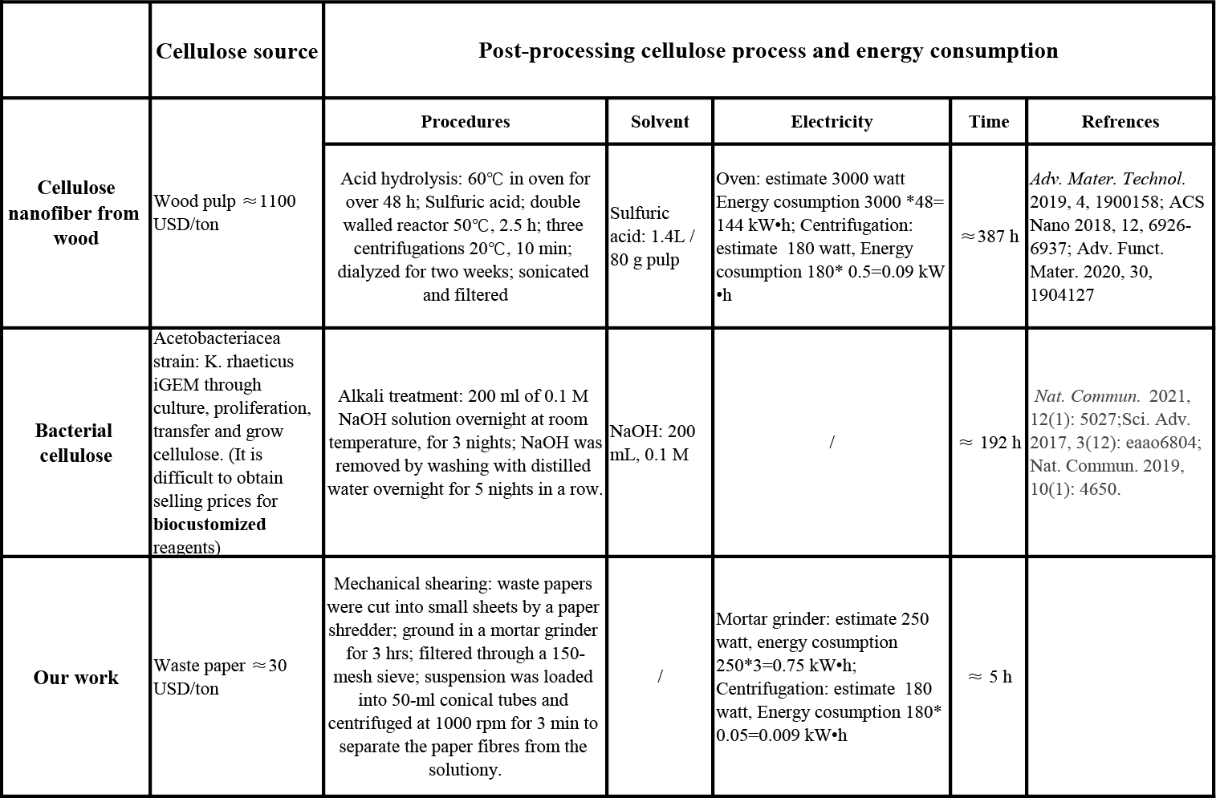

Supplementary Table 4| Estimated energy consumption and carbon footprint of the preparation of cellulose nanofibers.

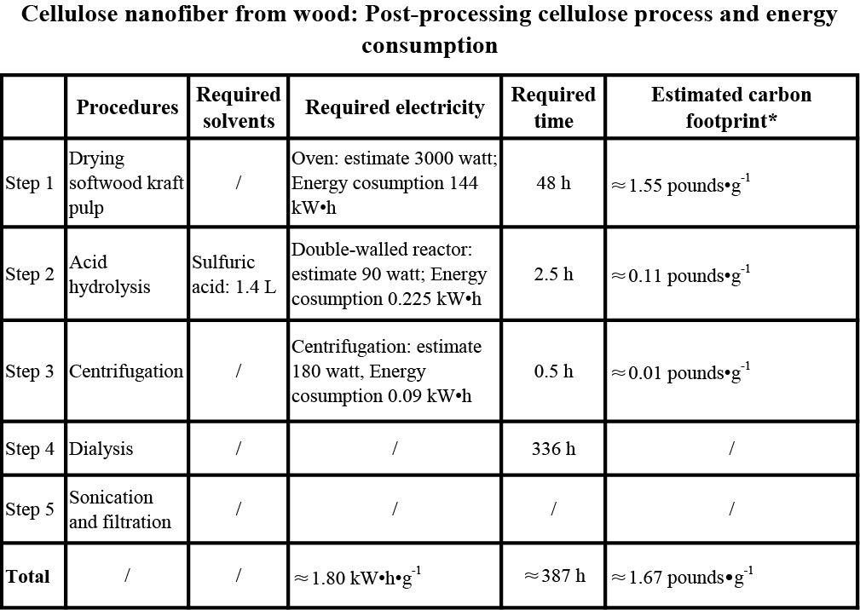
*The estimated carbon footprint of electricity is calculated using the Greenhouse gases equivalencies calculators suggested by the United States Environmental Protection Agency, which assumes an emission rate of 0.86 pounds of CO₂ per KWh of electricity ª. The estimated carbon footprint of sulfuric acid is based on Boliden public limited company annual summary, which assumes an emission rate of 0.055 pounds of CO₂ per kg of sulfuric acid ^{b}.

ª Greenhouse Gases Equivalencies Calculator - Calculations and References | US EPA., from https://www.epa.gov/energy/greenhouse-gases-equivalencies-calculator-calculations-and-references

^{b} Lowcarbon Sulphuric Acid-Boliden, from https://www.boliden.com/news/low-carbon-sulphuric-acid/

Supplementary Table 5| Estimated energy consumption and carbon footprint of the ink preparation method using waste papers in our work.

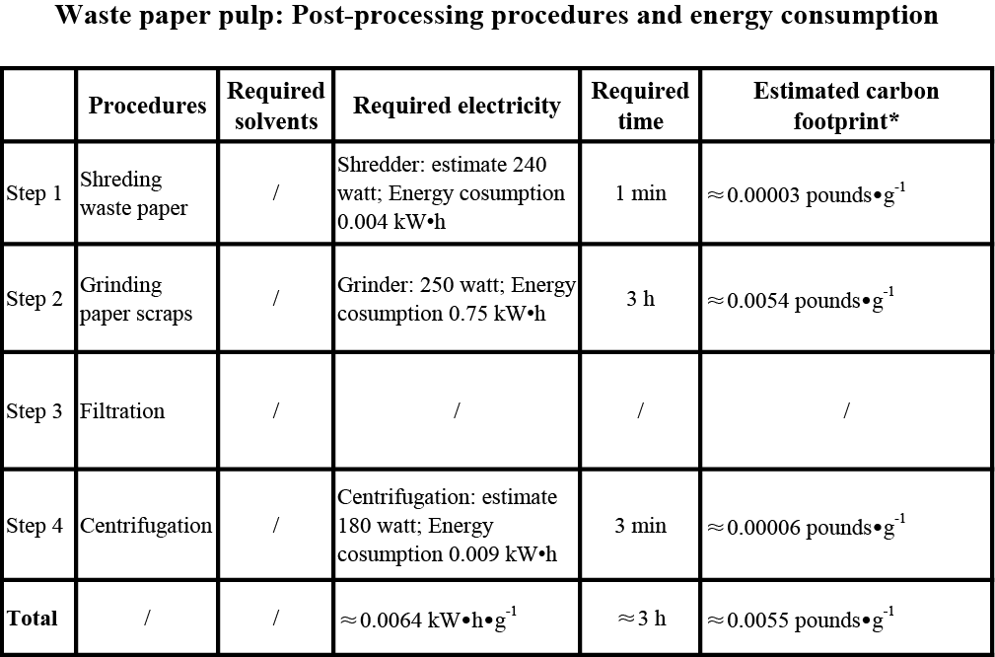
*The estimated carbon footprint of electricity is calculated using the Greenhouse gases equivalencies calculators suggested by the United States Environmental Protection Agency, which assumes an emission rate of 0.86 pounds of CO₂ per KWh of electricity ª.

ª Greenhouse Gases Equivalencies Calculator - Calculations and References | US EPA., from https://www.epa.gov/energy/greenhouse-gases-equivalencies-calculator-calculations-and-references

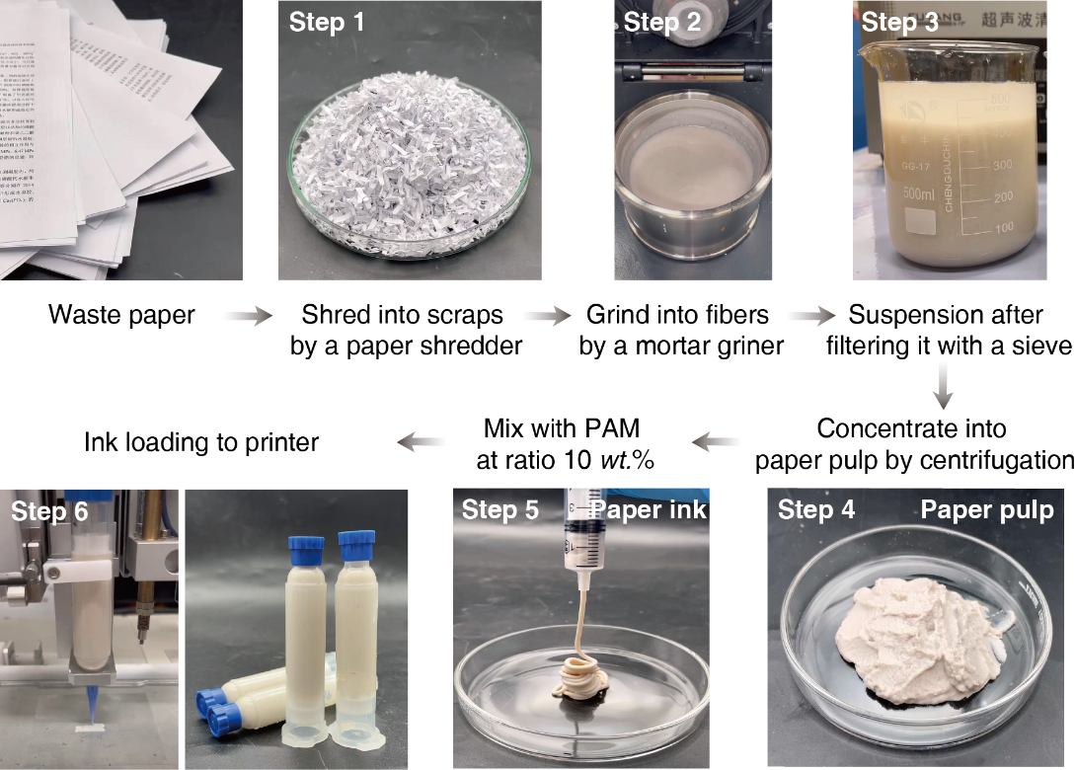
Supplementary Fig. 1 Our ink preparation process to convert various types of waste papers into 3D printing inks

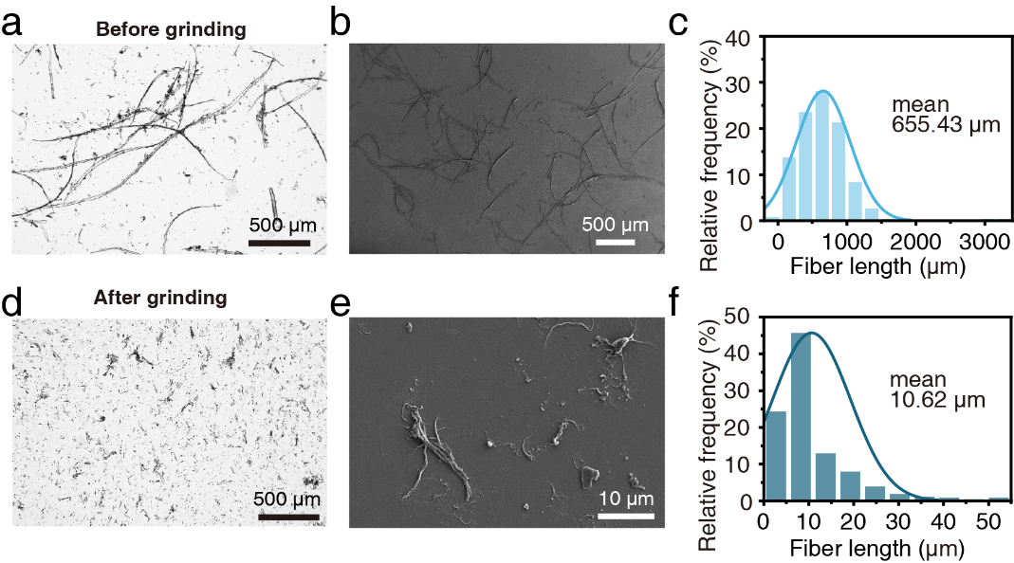
Supplementary Fig. 2 The morphologies of the paper fibres and their length statistics before and after grinding. (a) Micrograph, (b) SEM picture, and (c) fiber length statistical results before grinding. (d) Micrographs, (e) SEM images and (f) fiber length statistics after grinding. n > 500 for the fibre length measurements

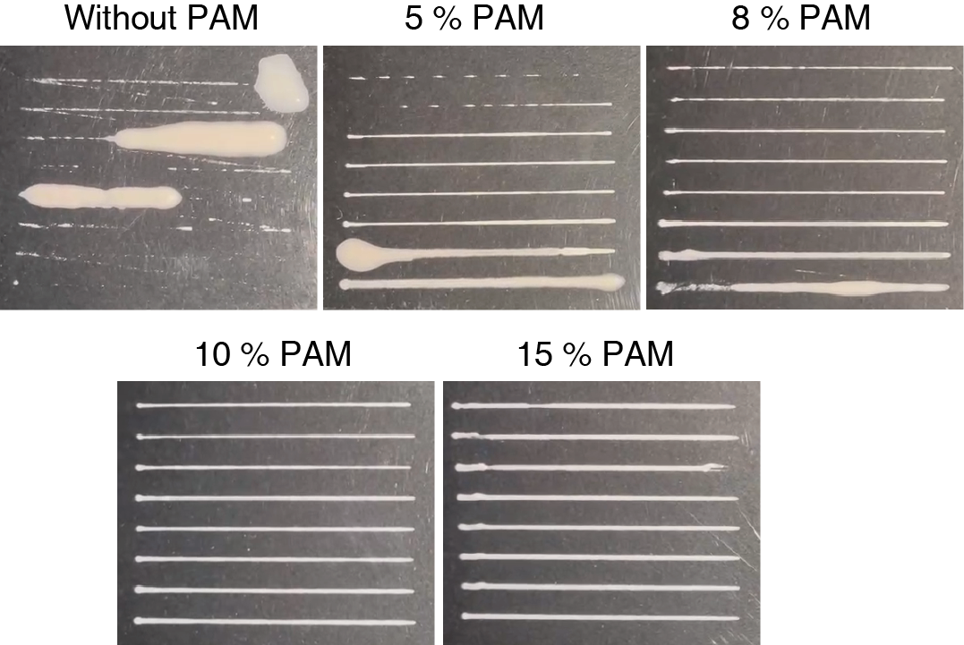

Supplementary Fig. 3 Improved printability with the addition of PAM. Nozzle clogging issues occurred when PAM was not added in the ink

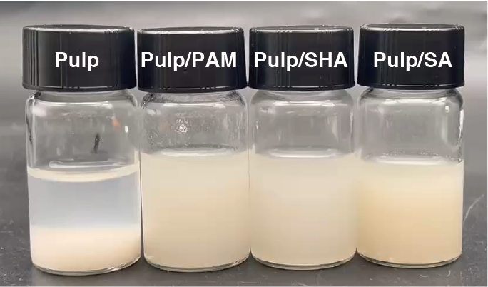

Supplementary Fig. 4 Photo showing the sedimentation effect of paper fibers in the ink when a dispersant is not added, and the stability of the inks when a dispersant is added (i.e., 1 w/v% PAM, sodium hyaluronate (SHA) and sodium alginate (SA). The photos were taken 30 minutes after the solutions were prepared

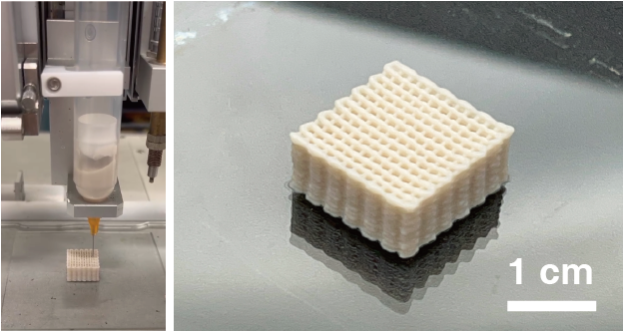

Supplementary Fig. 5 Printability of the waste paper ink with 10 w/v% sodium alginate added as a dispersant

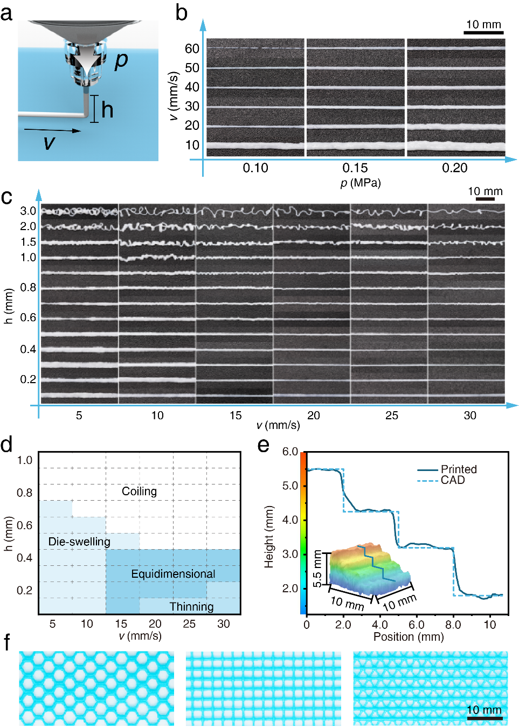

Supplementary Fig. 6 Ink printability. (a) Schematic showing the factors that dominate the 3D printability, including print rate (v), nozzle-to-stage distance (h), and extrusion pressure (p). (b) The influence of the print speed (v) and the extrusion pressure (p) on the printability of the waste paper ink. (c) The influence of the print speed (v) and the nozzle-to-stage distance (h) on the printability. (d) Printability diagram illustrating the printing settings (v and h) for different filament morphologies. (e) Comparison of the front view dimensions between the CAD geometry and the as-printed staircase sample. (f) High-fidelity 3DP samples of different infill patterns with the use of the optimized 3DP settings found in (d)
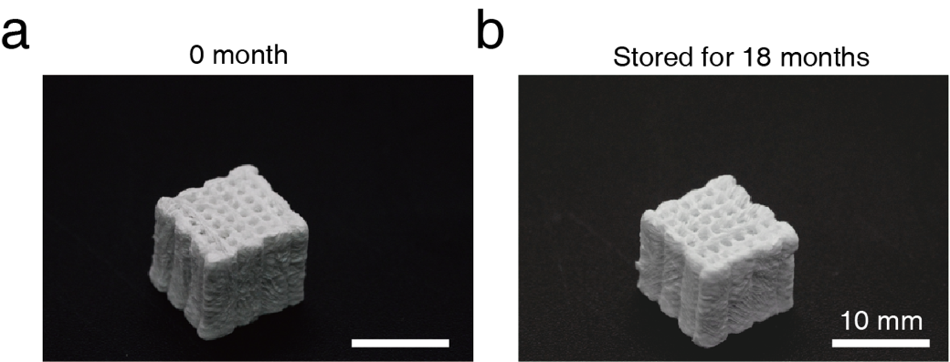
Supplementary Fig. 7 Longevity of the 3D printed paper constructs. Photographs showing the appearance of (a) the as-fabricated construct and (b) the same construct stored for 18 months. No notable change in appearance was observed

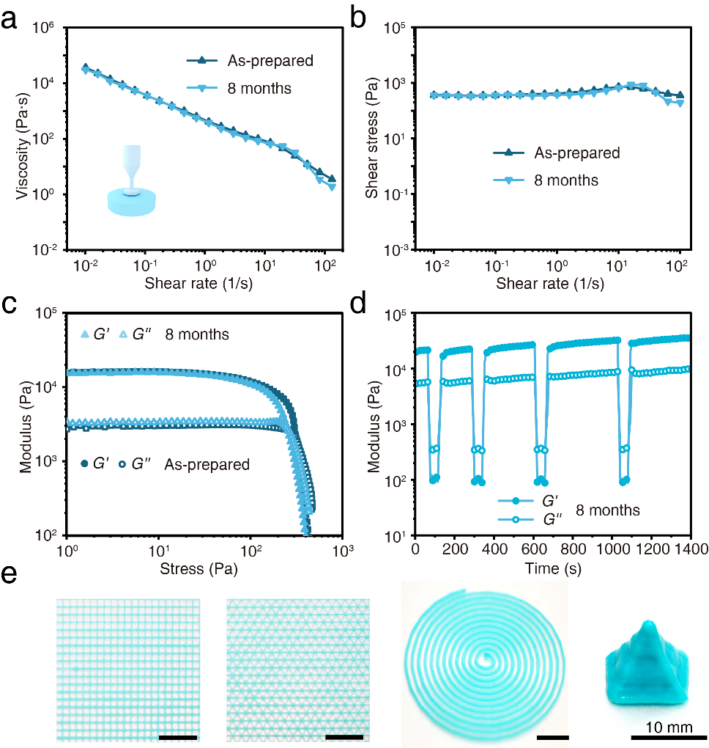
Supplementary Fig. 8 Long shelf-life of the 3DP paper inks. (a) Viscosity profile of the as-prepared waste paper ink and the ink stored for 8 months. (b) Plot of the shear stress vs shear rate. (c) Plot of the shear modulus (G’ and G’’) vs shear stress. (d) Cyclic dynamic time sweep between an alternative strain of 0.1% and 200%. Data were collected at 1.0 rad/s and were measured at 25 ºC. (e) Shape fidelity of the 3DP samples fabricated using the paper inks stored for 8 months

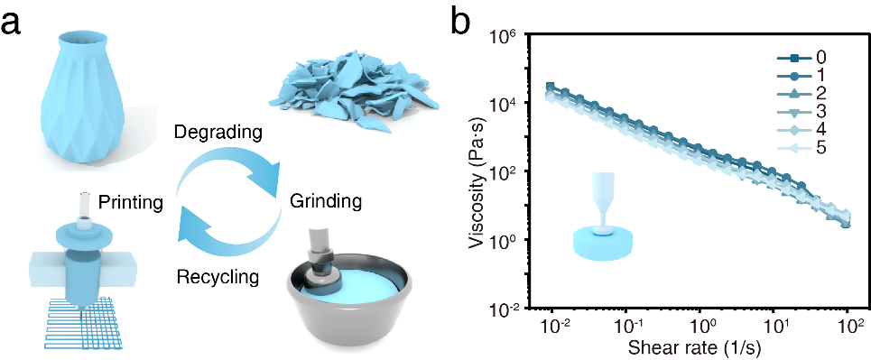

Supplementary Fig. 9 Recyclability of the paper constructs. (a) Schematics illustrating the recycling route for transforming 3DP paper constructs into paper inks at the end of their lifespan. (b) Viscosity profiles of the paper inks during the five-cycle recycling

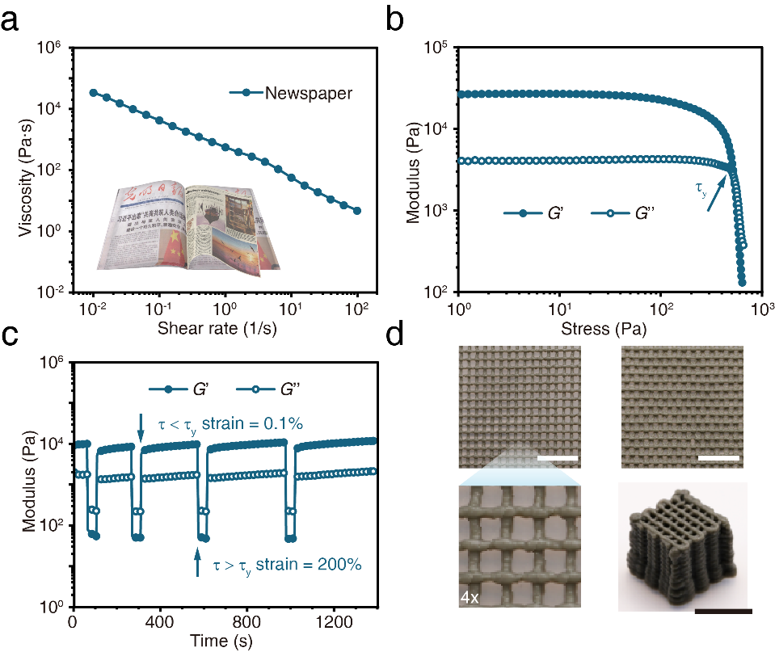
Supplementary Fig. 10 Rheological properties and 3D printability of the paper inks produced from newspapers. (a) Viscosity profile. (b) Shear modulus profile. (c) Plot of G’ and G’’ under an alternative shear strain of 0.1 % and 200 %. (d) Ink printability and appearance of the 3DP constructs produced from newspapers inks. Scale bars = 10 mm

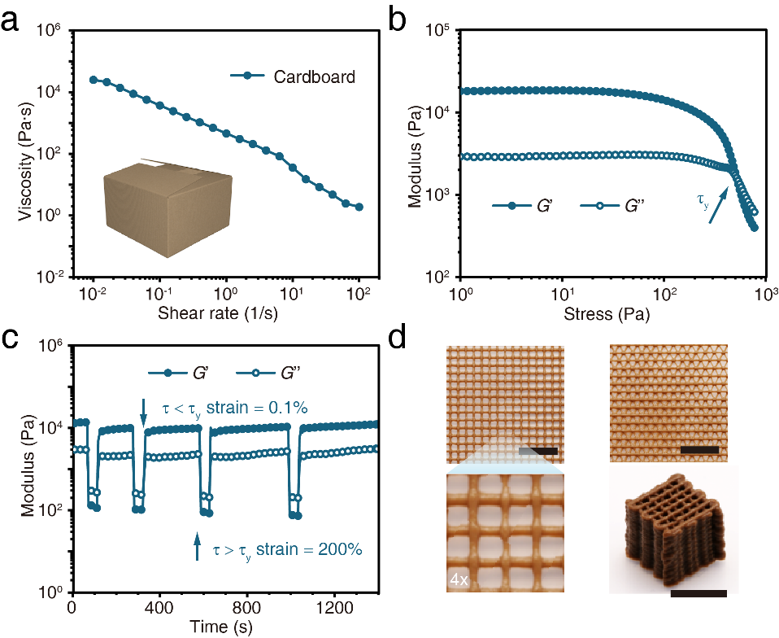
Supplementary Fig. 11 Rheological properties and printability of the paper inks produced from cardboards. (a) Viscosity profile. (b) Shear modulus profile. (c) Plot of G’ and G’’ under an alternative shear strain of 0.1 % and 200 %. (d) Ink printability and appearance of the 3DP construct produced from the cardboards inks. Scale bars = 10 mm

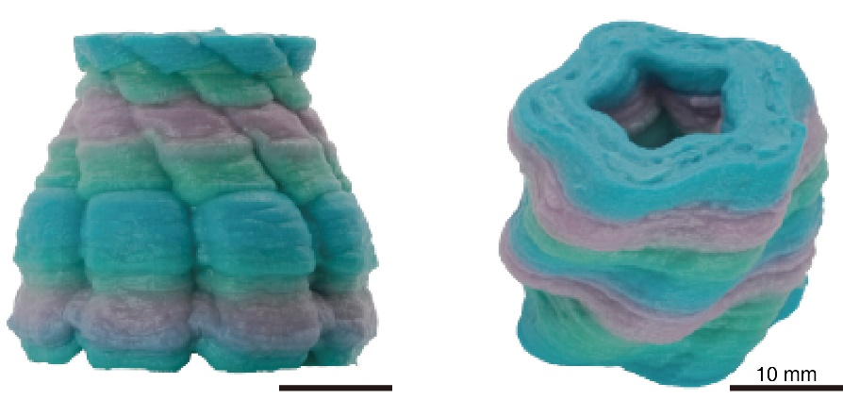
Supplementary Fig. 12 Photographs of the colourful paper vase construct produced via multimaterial 3D printing using office paper inks supplemented with two different colour dyes. Scale bars = 10 mm

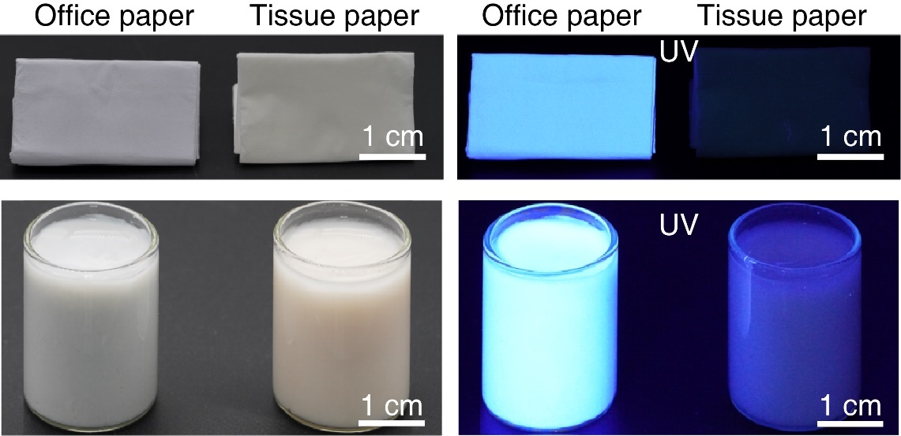
Supplementary Fig. 13 Photographs of high brightness office paper, tissue paper, and their corresponding pulp solutions. The office paper and its pulp aqueous suspension demonstrate a blue fluorescence under UV irradiation, while the tissue paper and its pulp solution exhibit no fluorescence. Scale bars = 1 cm

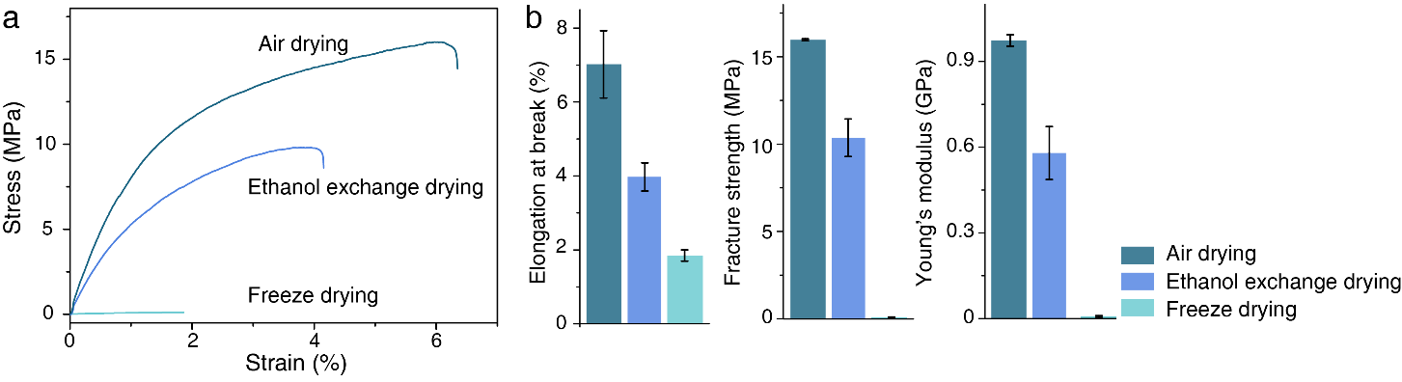
Supplementary Fig. 14 Mechanical properties of the paper constructs dried by different methods. (a) Representative stress-strain curves and (b) summary of the elongation at break, fracture strength and Young’s modulus of the constructs dried by different methods. n = 5

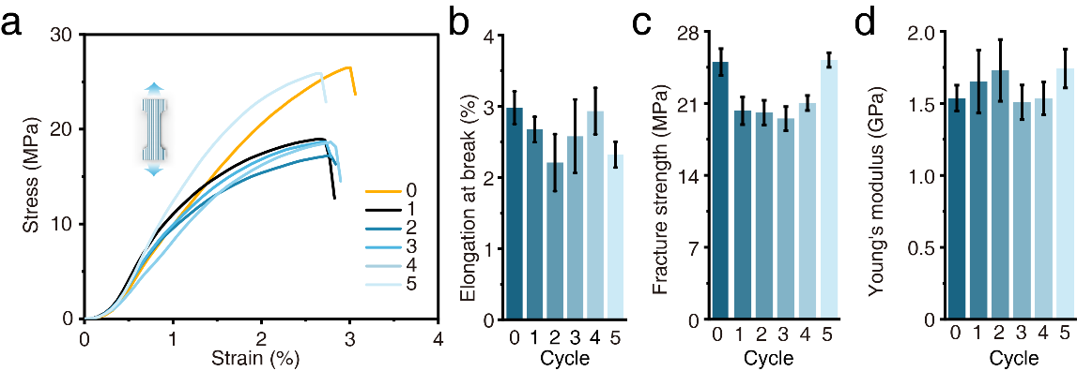

Supplementary Fig. 15 Mechanical properties of the 3DP constructs made from the office paper inks before and after five times of recycling. (a) Stress-strain curves of the constructs fabricated with the pristine ink (denoted as ‘0’ in the graph) and the recycled inks. (b-d) Summary of the mechanical parameters of the constructs fabricated with the pristine ink and the recycled inks (i.e., elongation at break, fracture strength and Young’s modulus). Data in b, c, and d are means ± S.D., n = 3 independent samples

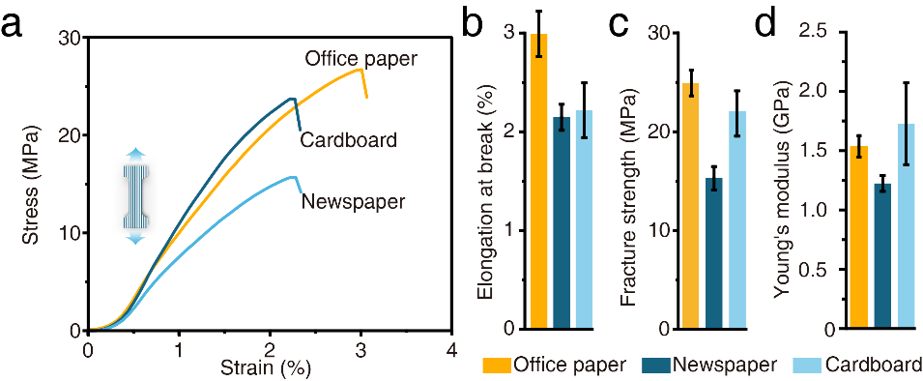

Supplementary Fig. 16 Mechanical properties of the 3DP constructs made from paper inks derived from office papers, cardboard and newspapers. (a) Stress-strain curves of the constructs fabricated from various paper type inks. (b-d) Summary of the mechanical parameters of the 3DP constructs (i.e., elongation at break, fracture strength and Young’s modulus). Data in b, c, and d are means ± S.D., n = 3 independent samples

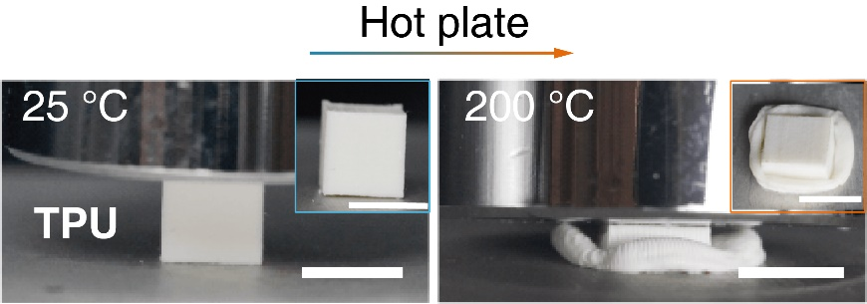

Supplementary Fig. 17 Thermal stability of the 3DP constructs made from commercial TPU when it was placed on a hot plate at 200 ºC for 2 hours. TPU: thermoplastic polyurethane. Scale bars = 10 mm

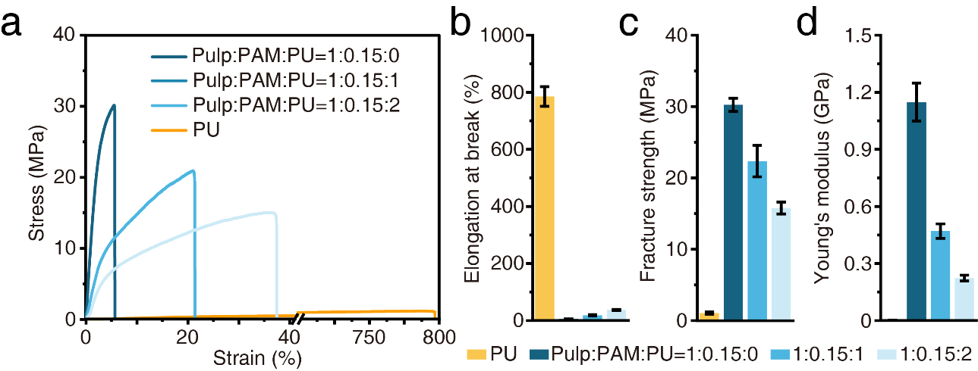

Supplementary Fig. 18 Mechanical properties of the 3DP constructs made from the composite of waterborne polyurethane inks (PU) and paper fibre fillers. (a) stress-strain curves. (b-d) Summary of the mechanical parameters of the 3DP constructs (i.e., elongation at break, fracture strength and Young’s modulus). Data in b, c, and d are means ± S.D., n = 3 independent samples

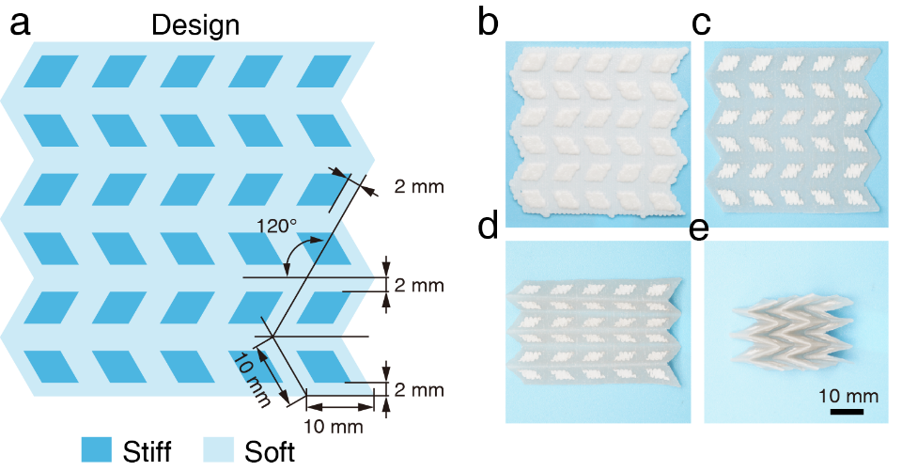

Supplementary Fig. 19 (a) Miura-origami constructs composed of soft domains and hard domains. (b - e) show the folding process of the 3DP construct.

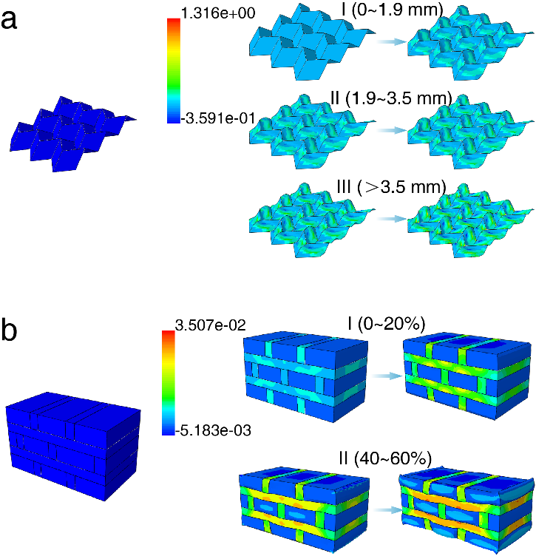
Supplementary Fig. 20 (a) Strain distribution within the heterogeneous origami construct during a z-axis compression obtained from finite element simulation. (b) Simulated strain distribution within the heterogeneous tessellated construct during a z-axis compression. Regions I, II and III are denoted in Figure 4e and Figure 4h

Supplementary Table 6 | Table summarising the stability temperature and the processing temperature of papers and conventional thermoplastics.
Materials | Stability temperature  (℃) | Processing temperature  (℃) | ref
Paper | 200 | 25 | _{a}
PLA | 60 | 180 | [1-3]
ABS | 117 | 235 | [4,5]
PC | 147 | 288~316 | [6,7]
TPU | -60 | 185~220 | [32-34]
Nylon | 97 | 220 | [8,9]
PVA | 70 | 225 | [35]
Ethylene Vinyl Acetate (EVA) | 35 | 90 | [36]
Methyl Meth Acrylate (PMMA) | 105 | 185 | [10,11]
Polybutylene Terephthalate (PBT) | 43 | 225 | [37]
Polystyrene | 100 | 270 | [3,38,39]
Polyamide | 70 | 320~345 | [40]
High Density Polyethylene | -100 | 130 | [3,41-43]
Polypropylene | -20 | 171 | [3,44,45]
Polyethylene Terephthalate | 75 | 250 | ^{[3,12]}
Poly Vinyl Chloride (PVC) | 82 | 100~260 | ^{[3,46,47]}
PLA + softwood lignin (20–40%) | 179.2~186.6 | 59~71 | ^{[48]}
PLA + microcrystalline cellulose (MCC) (1–5%) | 159~161 | 60 | ^{[48]}
PLA + wood flour (5%) | 167 | 60 | ^{[48]}
PLA + lignin (5–15%) | 147~152 | 56~61 | ^{[48]}
Poly (L-lactic acid) + lignin (10–40%) | 161~170 | 57~64 | ^{[48]}
PNIPAAM | 25 | 32~35 | ^{[49]}
Cellulose hydrogel | 37 | 60 | ^{[50]}
Gelatin | 25 | 121 | ^{[51]}
poly(MAAc-co-NPAM) | 25 | 70 | ^{[52]}
_{a} Data refer to software Granta EduPack 2023R1 Version: 23.1.1

Supplementary video captions
Supplementary Video 1 | 3D printing process of the paper ink to produce a high-fidelity construct
Supplementary Video 2 | 3D printing process of the paper ink printed with a 45º rectilinear infill
Supplementary Video 3 | 3D printing process of the paper ink printed with a 90º rectilinear infill
Supplementary Video 4 | Multimaterial 3D printing process of a multicoloured vase construct produced by waste paper inks.
Supplementary Video 5 | Robust mechanical properties of an information embedded print under mechanical deformation of bending, rolling and folding
Supplementary Video 6 | Finite element simulation of the stress distribution of the heterogeneous Miura origami construct under compression.
Supplementary Video 7 | Finite element simulation of the stress distribution of the heterogeneous tessellated construct under compression.

References
1. Chen CC, Chueh JY, Tseng H, Huang HM, Lee SY (2003) Preparation and characterization of biodegradable PLA polymeric blends. Biomaterials 24(7):1167-1173 https://doi.org:10.1016/s0142-9612(02)00466-0
2. Wang S, Ma Y, Deng Z, Zhang S, Cai J (2020) Effects of fused deposition modeling process parameters on tensile, dynamic mechanical properties of 3D printed polylactic acid materials. Polymer Testing 86 https://doi.org:10.1016/j.polymertesting.2020.106483
3. Chamas A, Moon H, Zheng J, Qiu Y, Tabassum T, Jang JH, Abu-Omar M, Scott SL, Suh S (2020) Degradation Rates of Plastics in the Environment. ACS Sustainable Chemistry & Engineering 8(9):3494-3511 https://doi.org:10.1021/acssuschemeng.9b06635
4. Billah KMM, Lorenzana FAR, Martinez NL, Wicker RB, Espalin D (2020) Thermomechanical characterization of short carbon fiber and short glass fiber-reinforced ABS used in large format additive manufacturing. Additive Manufacturing 35 https://doi.org:10.1016/j.addma.2020.101299
5. Huang G, Huo S, Xu X, Chen W, Jin Y, Li R, Song P, Wang H (2019) Realizing simultaneous improvements in mechanical strength, flame retardancy and smoke suppression of ABS nanocomposites from multifunctional graphene. Composites Part B: Engineering 177 https://doi.org:10.1016/j.compositesb.2019.107377
6. Brunella V, Rossatto BG, Mastropasqua C, Cesano F, Scarano D (2021) Thermal/Electrical Properties and Texture of Carbon Black PC Polymer Composites near the Electrical Percolation Threshold. Journal of Composites Science 5(8) https://doi.org:10.3390/jcs5080212
7. Vidakis N, Petousis M, Velidakis E, Spiridaki M, Kechagias JD (2021) Mechanical Performance of Fused Filament Fabricated and 3D-Printed Polycarbonate Polymer and Polycarbonate/Cellulose Nanofiber Nanocomposites. Fibers 9(11) https://doi.org:10.3390/fib9110074
8. Baji A, Mai Y-W, Wong S-C, Abtahi M, Du X (2010) Mechanical behavior of self-assembled carbon nanotube reinforced nylon 6,6 fibers. Composites Science and Technology 70(9):1401-1409 https://doi.org:10.1016/j.compscitech.2010.04.020
9. Guessasma S, Belhabib S, Nouri H (2020) Effect of printing temperature on microstructure, thermal behavior and tensile properties of 3D printed nylon using fused deposition modeling. Journal of Applied Polymer Science 138(14) https://doi.org:10.1002/app.50162
10. Evans CM, Torkelson JM (2012) Determining multiple component glass transition temperatures in miscible polymer blends: Comparison of fluorescence spectroscopy and differential scanning calorimetry. Polymer 53(26):6118-6124 https://doi.org:10.1016/j.polymer.2012.10.038
11. Arabeche K, Delbreilh L, Adhikari R, Michler GH, Hiltner A, Baer E, Saiter J-M (2012) Study of the cooperativity at the glass transition temperature in PC/PMMA multilayered films: Influence of thickness reduction from macro- to nanoscale. Polymer 53(6):1355-1361 https://doi.org:10.1016/j.polymer.2012.01.045
12. Xing L, Wang Y, Wang S, Zhang Y, Mao S, Wang G, Liu J, Huang L, Li H, Belfiore LA, Tang J (2018) Effects of Modified Graphene Oxide on Thermal and Crystallization Properties of PET. Polymers (Basel) 10(6) https://doi.org:10.3390/polym10060613
13. Suzuki Y, Duran H, Akram W, Steinhart M, Floudas G, Butt H-J (2013) Multiple nucleation events and local dynamics of poly(ε-caprolactone) (PCL) confined to nanoporous alumina. Soft Matter 9(38) https://doi.org:10.1039/c3sm50907a
14. Papageorgiou GZ, Tsanaktsis V, Papageorgiou DG, Chrissafis K, Exarhopoulos S, Bikiaris DN (2015) Furan-based polyesters from renewable resources: Crystallization and thermal degradation behavior of poly(hexamethylene 2,5-furan-dicarboxylate). European Polymer Journal 67:383-396 https://doi.org:10.1016/j.eurpolymj.2014.08.031
15. Cho H-W, Koo H-J, Kim H, Kim K-J (2020) Lifetime Prediction of High Tenacity Polyester Yarns for Hydrolytic Degradation Used for Soil Reinforcement. Fibers and Polymers 21(8):1663-1668 https://doi.org:10.1007/s12221-020-9583-7
16. Bosq N, Guigo N, Persello J, Sbirrazzuoli N (2014) Melt and glass crystallization of PDMS and PDMS silica nanocomposites. Phys Chem Chem Phys 16(17):7830-7840 https://doi.org:10.1039/c4cp00164h
17. Gladman AS, Matsumoto EA, Nuzzo RG, Mahadevan L, Lewis JA (2016) Biomimetic 4D printing. Nat Mater 15(4):413-418 https://doi.org:10.1038/nmat4544
18. Siqueira G, Kokkinis D, Libanori R, Hausmann MK, Gladman AS, Neels A, Tingaut P, Zimmermann T, Lewis JA, Studart AR (2017) Cellulose Nanocrystal Inks for 3D Printing of Textured Cellular Architectures. Advanced Functional Materials 27(12) https://doi.org:10.1002/adfm.201604619
19. Hausmann MK, Ruhs PA, Siqueira G, Lauger J, Libanori R, Zimmermann T, Studart AR (2018) Dynamics of Cellulose Nanocrystal Alignment during 3D Printing. ACS Nano 12(7):6926-6937 https://doi.org:10.1021/acsnano.8b02366
20. Wang J, Chiappone A, Roppolo I, Shao F, Fantino E, Lorusso M, Rentsch D, Dietliker K, Pirri CF, Grutzmacher H (2018) All-in-One Cellulose Nanocrystals for 3D Printing of Nanocomposite Hydrogels. Angew Chem Int Ed Engl 57(9):2353-2356 https://doi.org:10.1002/anie.201710951
21. Morán JI, Alvarez VA, Cyras VP, Vázquez A (2007) Extraction of cellulose and preparation of nanocellulose from sisal fibers. Cellulose 15(1):149-159 https://doi.org:10.1007/s10570-007-9145-9
22. Ramakrishnan A, Ravishankar K, Dhamodharan R (2019) Preparation of nanofibrillated cellulose and nanocrystalline cellulose from surgical cotton and cellulose pulp in hot-glycerol medium. Cellulose 26(5):3127-3141 https://doi.org:10.1007/s10570-019-02312-4
23. Hausmann MK, Siqueira G, Libanori R, Kokkinis D, Neels A, Zimmermann T, Studart AR (2019) Complex‐Shaped Cellulose Composites Made by Wet Densification of 3D Printed Scaffolds. Advanced Functional Materials 30(4) https://doi.org:10.1002/adfm.201904127
24. Kam D, Layani M, BarkaiMinerbi S, Orbaum D, Abrahami BenHarush S, Shoseyov O, Magdassi S (2019) Additive Manufacturing of 3D Structures Composed of Wood Materials. Advanced Materials Technologies 4(9) https://doi.org:10.1002/admt.201900158
25. M. Nasir RH, O. Sulaiman, M. Asim, Cellulose-Reinforced Nanofibre Composites: Production, Properties and Applications.
26. Schaffner M, Ruhs PA, Coulter F, Kilcher S, Studart AR (2017) 3D printing of bacteria into functional complex materials. Sci Adv 3(12):eaao6804 https://doi.org:10.1126/sciadv.aao6804
27. Shin S, Kwak H, Shin D, Hyun J (2019) Solid matrix-assisted printing for three-dimensional structuring of a viscoelastic medium surface. Nat Commun 10(1):4650 https://doi.org:10.1038/s41467-019-12585-9
28. Moore GWK, Howell SEL, Brady M, Xu X, McNeil K (2021) Anomalous collapses of Nares Strait ice arches leads to enhanced export of Arctic sea ice. Nat Commun 12(1):1 https://doi.org:10.1038/s41467-020-20314-w
29. Jiang B, Yao Y, Liang Z, Gao J, Chen G, Xia Q, Mi R, Jiao M, Wang X, Hu L (2020) Lignin-Based Direct Ink Printed Structural Scaffolds. Small 16(31):e1907212 https://doi.org:10.1002/smll.201907212
30. Nguyen NA, Barnes SH, Bowland CC, Meek KM, Littrell KC, Keum JK, Naskar AK (2018) A path for lignin valorization via additive manufacturing of high-performance sustainable composites with enhanced 3D printability. Sci Adv 4(12):eaat4967 https://doi.org:10.1126/sciadv.aat4967
31. Kaschuk JJ, Al Haj Y, Rojas OJ, Miettunen K, Abitbol T, Vapaavuori J (2022) Plant-Based Structures as an Opportunity to Engineer Optical Functions in Next-Generation Light Management. Adv Mater 34(6):e2104473 https://doi.org:10.1002/adma.202104473
32. Xiao J, Gao Y (2017) The manufacture of 3D printing of medical grade TPU. Progress in Additive Manufacturing 2(3):117-123 https://doi.org:10.1007/s40964-017-0023-1
33. Choi EY, Kim CK (2023) Degradation and lifetime prediction of thermoplastic polyurethane encapsulants in seawater for underwater acoustic sensor applications. Polymer Degradation and Stability 209 https://doi.org:10.1016/j.polymdegradstab.2023.110281
34. Mosleh Y, Ebrahimi NG, Mahdavian A, Ashjari M (2013) TPU/PCL/nanomagnetite ternary shape memory composites: studies on their thermal, dynamic-mechanical, rheological and electrical properties. Iranian Polymer Journal 23(2):137-145 https://doi.org:10.1007/s13726-013-0209-4
35. Angjellari M, Tamburri E, Montaina L, Natali M, Passeri D, Rossi M, Terranova ML (2017) Beyond the concepts of nanocomposite and 3D printing: PVA and nanodiamonds for layer-by-layer additive manufacturing. Materials & Design 119:12-21 https://doi.org:10.1016/j.matdes.2017.01.051
36. Kumar N, Jain PK, Tandon P, Pandey PM (2018) The effect of process parameters on tensile behavior of 3D printed flexible parts of ethylene vinyl acetate (EVA). Journal of Manufacturing Processes 35:317-326 https://doi.org:10.1016/j.jmapro.2018.08.013
37. Furushima Y, Kumazawa S, Umetsu H, Toda A, Zhuravlev E, Schick C (2017) Melting and recrystallization kinetics of poly(butylene terephthalate). Polymer 109:307-314 https://doi.org:10.1016/j.polymer.2016.12.053
38. Gao S, Koh YP, Simon SL (2013) Calorimetric Glass Transition of Single Polystyrene Ultrathin Films. Macromolecules 46(2):562-570 https://doi.org:10.1021/ma3020036
39. Kremer F, Tress M, Mapesa EU (2015) Glassy dynamics and glass transition in nanometric layers and films: A silver lining on the horizon. Journal of Non-Crystalline Solids 407:277-283 https://doi.org:10.1016/j.jnoncrysol.2014.08.016
40. Francisco DL, Paiva LB, Aldeia W (2018) Advances in polyamide nanocomposites: A review. Polymer Composites 40(3):851-870 https://doi.org:10.1002/pc.24837
41. Erbetta CDAC, Manoel GF, Oliveira APLR, Silva MESRe, Freitas RFS, Sousa RG (2014) Rheological and Thermal Behavior of High-Density Polyethylene (HDPE) at Different Temperatures. Materials Sciences and Applications 05(13):923-931 https://doi.org:10.4236/msa.2014.513094
42. Pelto J, Verho T, Ronkainen H, Kaunisto K, Metsäjoki J, Seitsonen J, Karttunen M (2019) Matrix morphology and the particle dispersion in HDPE nanocomposites with enhanced wear resistance. Polymer Testing 77 https://doi.org:10.1016/j.polymertesting.2019.105897
43. Vera-Sorroche J, Kelly AL, Brown EC, Gough T, Abeykoon C, Coates PD, Deng J, Li K, Harkin-Jones E, Price M (2014) The effect of melt viscosity on thermal efficiency for single screw extrusion of HDPE. Chemical Engineering Research and Design 92(11):2404-2412 https://doi.org:10.1016/j.cherd.2013.12.025
44. Gu J, Xu H, Wu C (2013) Thermal and Crystallization Properties of HDPE and HDPE/PP Blends Modified with DCP. Advances in Polymer Technology 33(1) https://doi.org:10.1002/adv.21384
45. Purohit PJ, Huacuja-Sánchez JE, Wang D-Y, Emmerling F, Thünemann A, Heinrich G, Schönhals A (2011) Structure–Property Relationships of Nanocomposites Based on Polypropylene and Layered Double Hydroxides. Macromolecules 44(11):4342-4354 https://doi.org:10.1021/ma200323k
46. Sterzyński T, Tomaszewska J, Andrzejewski J, Skórczewska K (2015) Evaluation of glass transition temperature of PVC/POSS nanocomposites. Composites Science and Technology 117:398-403 https://doi.org:10.1016/j.compscitech.2015.07.009
47. Qian S, Wang H, Zarei E, Sheng K (2015) Effect of hydrothermal pretreatment on the properties of moso bamboo particles reinforced polyvinyl chloride composites. Composites Part B: Engineering 82:23-29 https://doi.org:10.1016/j.compositesb.2015.08.007
48. Ji A, Zhang S, Bhagia S, Yoo CG, Ragauskas AJ (2020) 3D printing of biomass-derived composites: application and characterization approaches. RSC Adv 10(37):21698-21723 https://doi.org:10.1039/d0ra03620j
49. Han D, Lu Z, Chester SA, Lee H (2018) Micro 3D Printing of a Temperature-Responsive Hydrogel Using Projection Micro-Stereolithography. Sci Rep 8(1):1963 https://doi.org:10.1038/s41598-018-20385-2
50. Cui Y, Jin R, Zhang Y, Yu M, Zhou Y, Wang LQ (2021) Cellulose Nanocrystal-Enhanced Thermal-Sensitive Hydrogels of Block Copolymers for 3D Bioprinting. Int J Bioprint 7(4):397 https://doi.org:10.18063/ijb.v7i4.397
51. Du J, Dai H, Wang H, Yu Y, Zhu H, Fu Y, Ma L, Peng L, Li L, Wang Q, Zhang Y (2021) Preparation of high thermal stability gelatin emulsion and its application in 3D printing. Food Hydrocolloids 113 https://doi.org:10.1016/j.foodhyd.2020.106536
52. Zhou Q, Yang K, He J, Yang H, Zhang X (2019) A novel 3D-printable hydrogel with high mechanical strength and shape memory properties. Journal of Materials Chemistry C 7(47):14913-14922 https://doi.org:10.1039/C9TC04945B

