Supporting Information
Engineering few-layer MoS₂ and rGO heterostructure composites for high‐performance supercapacitors
Yi Zhangª, Jing Xuª, Shun Lu^{b,*}, Han Li^{a,*}, Taner Yonar^{c}, Qingsong Hua^{d*}, Terence Liu^{e*}, Yongxing Zhang^{a,*}
a Anhui Province Key Laboratory of Pollutant Sensitive Materials and Environmental Remediation, Anhui Province Key Laboratory of Intelligent Computing and Applications, Anhui Province Industrial Generic Technology Research Center for Alumics Materials, Huaibei Normal University, Anhui 235000, China
b Chongqing Institute of Green and Intelligent Technology, Chinese Academy of Sciences, Chongqing 400714, China
c Environmental Engineering Department, Engineering Faculty, Bursa Uludag University, Bursa, Turkey
d College of Physics and Astronomy, Beijing Normal University, Beijing 100875, China
e Department of Mechanical and Construction Engineering, Faculty of Engineering and Environment, Northumbria University, Newcastle upon Tyne, NE1 8ST, UK

* Corresponding authors:
lushun@cigit.ac.cn (S. Lu)
lh2017@mail.ustc.edu.cn (H. Li)
q.hua@bnu.edu.cn (Q. Hua)
terence.liu@northumbria.ac.uk (T. Liu)
zyx07157@mail.ustc.edu.cn (Y. Zhang)

Table of Contents
1. Experimental methods 4
1.1 Synthesis of few-layered 1T-MoS₂ 4
1.2 Preparation of GO dispersion 4
1.3 Materials characterizations 5
1.4 Computational detail 5
1.5 Electrochemical measurements 6
2 Figure list 9
Fig. S1 SEM images of rGO nanosheets and FL-MoS₂@rGO heterostructures. 9
Fig. S2 SEM images of rGO nanosheets. 10
Fig. S3 TEM images of rGO nanosheets. 11
Fig. S4 AFM images of rGO and FL-MoS₂ nanosheets. 12
Fig. S5 (a) N₂ adsorption-desorption isotherms curves and (b) the corresponding pore size distribution curves of FL-MoS₂, rGO, FL-MoS₂@rGO-2 heterostructure. 13
Fig. S6 TGA curve of FL-MoS₂@rGO-2 heterostructures. 14
Fig. S7 The Zeta potential diagram of FL-MoS₂, rGO, FL-MoS₂@rGO-2 heterostructure. 15
Fig. S8 The contact angle of rGO, FL-MoS₂ nanosheet and FL-MoS₂@rGO heterostructure. 16
Fig. S9 CV and GCD curves of the FL-MoS₂, rGO, FL-MoS₂@rGO-1, FL-MoS₂@rGO-2, and FL-MoS₂@rGO-3 electrodes. 17
Fig. S10 AFM images of rGO nanosheet and FL-MoS₂@rGO heterostructure 18
Fig. S11. EIS FL-MoS₂, FL-MoS₂@rGO-1, FL-MoS₂@rGO-2, and FL-MoS₂@rGO-3 electrodes. 19
Fig. S12. (d) The correlation between Z′ and u^{−1/2} in the low frequency area. (e) A comparison of the Bode plots of the FL-MoS₂, FL-MoS₂@rGO-1, FL-MoS₂@rGO-2, and FL-MoS₂@rGO-3 electrodes. 20
Fig. S13. Potential drop associated with the IR drops of FL-MoS₂@rGO electrode vs. different discharge current densities. 21
Fig. S14. Comparisons about the specific capacitance of FL-MoS₂@rGO electrodes with those of multilayer MoS₂-based heterostructures electrode materials reported recently. 22
Fig. S15 SEM images of the FL-MoS₂@rGO heterostructures (a) before long-term cycling and (b) after long-term cycling 23
Fig. S16. Band structure of model (a) FL-MoS₂ and (c) FL-MoS₂@rGO, Density of states for model (b) FL-MoS₂ and (d) FL-MoS₂@rGO. 24
Fig. S17. SEM images of the FL-MoS₂@rGO heterostructure (a) and, mixture of rGO + FL-MoS₂ (b). (c) CV curves of FL-MoS₂@rGO heterostructure and, mixture of rGO + FL-MoS₂. (d) GCD curves of FL-MoS₂@rGO heterostructure and, mixture of rGO + FL-MoS₂. 25
Fig. S18. The b value for FL-MoS₂ (a) and FL-MoS₂@rGO-2 (b). The CV partition analysis shows the capacitive contribution to the whole current at 10 and 50 mV s⁻¹ for FL-MoS₂ (c) and FL-MoS₂@rGO (d) 26
Fig. S19. CV and GCD curves of FL-MoS₂@rGO-2//AC single ASC device. 27
Fig. S20. (a) CV and (b) GCD curves of three FL-MoS₂@rGO-2//AC ASCs devices in series. 28
Fig. S21. (a) CV and (b) GCD curves of three FL-MoS₂@rGO-2//AC ASCs devices in parallel. 29
3 Table list 30
Table S1. Comparisons about the specific capacitance at 1 A g⁻¹ and capacitance retention of fitting results of FL-MoS₂@rGO electrode with multilayer MoS₂-based heterostructures reported recently. 30
Table S2. The adsorption energy of FL-MoS₂ and FL-MoS₂@rGO. 31
Table S3. Comparisons about the specific capacitance of Fitting results of FL-MoS₂@rGO-2//AC FASC with those of asymmetric devices reported recently. 32

1. Experimental methods

1.1 Synthesis of few-layered 1T-MoS₂
1.7 mmol sodium molybdate dihydrate (0.4113 g, Na₂MoO₄⋅2H₂O), 4.9 mmol thioacetamide (0.3685 g, C₂H₅NS) and 6.86 mmol sodium borohydride (0.2596 g, NaBH₄) were dissolved into a mixed solution of water and alcohol. The volume of water is 12 mL. Furthermore, the volume of alcohol was 8 mL, respectively. Subsequently, the mixed solution was transferred to reactor lined with polytetrafluoro ethylene. The reactor was heated at 200 C for 20 h, then cooled it to room temperature. The black substances were obtained after centrifugal washing for several times by deionize and alcohol. Finally, the target samples were dried at 60 C for 12 h at vacuum oven.

1.2 Preparation of GO dispersion
Graphene oxide was synthesized using a modified Hummer's method. In brief, graphite flakes (5 g) and H₂SO₄ (25 mL) were in an ice bath while stirring continuously. Afterward, NaNO₃ and KMnO₄ (30 g) were added gently, keeping the temperature below 20 °C to avoid explosion. The suspension was vigorously stirred for 2 h at ambient temperature. The solution was chilled in an ice bath and gradually diluted with ice water keeping the temperature below 70 °C. Also, 45 mL of H₂O₂ (35 wt%) was added to ensure that the reaction was completed with KMnO₄. The resultant suspension was centrifuged, and rinsed with 3.5% HCl solution and distilled water multiple times to remove the acid until its pH value reached neutral. Finally, the graphene oxide (GO) was collected and kept in cold storage.

1.3 Materials characterizations
Phase, crystal structure, and microscopic morphology characterizations of samples were conducted by X-ray diffraction (XRD, PANalytical Empyrean) patterns with Cu K radiation, λ = 0.15406 nm, Field emission scanning electron microscope (FE-SEM, HiTACHI Regulus8220) and Energy- dispersive X-ray spectroscopy (EDX, Oxford EDX, with INCA software), transmission electron microscope (TEM, JEOL JEM-2100) with configured EDX, X-ray photoelectron spectroscopy (XPS, AXIS SUPRA+ equipped with monochromatic Al Kα source). Raman spectroscopy was carried out by a LabRAMHR800 UV NIR spectrometer with 532 nm laser excitation. The surface area of the as-obtained sample was computed from the results of N₂ physisorption at 77 K (model: Micromeritics ASAP 2460 version 3.01) using the BET.

1.4 Computational detail
DFT calculations were conducted through the Vienna ab initio Simulation Package (VASP) with the projector-augmented wave method. A generalized gradient approximation of the Perdew-Burke-Ernzerhof (PBE) functional was used as the exchange-correlation functional. The cutoff energy was set as 500 eV, and structure relaxation was performed until the convergence criteria of energy and force reached 1 × 10^{–5} eV and 0.03 eV Å^{–1}, respectively. A vacuum layer of 15 Å was constructed to eliminate interactions between periodic structures of surface models. The van der Waals (vdW) interaction was amended by the zero damping DFT-D3 method of Grimme. The adsorption energy (ΔE_{ads}) of Na adsorption on the surface is defined as
ΔE_{ads} = E(*Na) − E(*) − E(Na)
where E(*Na) and E(*) are the total energy of surface systems with and without Na atoms, respectively, and E(Na) is the energy of an isolated Na atom. According to this definition, negative adsorption energy suggests that the adsorption process is exothermic, and the adsorption system is thermodynamically stable. Contrarily, a positive value corresponds to endothermic and unstable adsorption.

1.5 Electrochemical measurements
For the electrochemical tests of FL-MoS₂, rGO, FL-MoS₂@rGO-1, FL-MoS₂@rGO-2, and FL-MoS₂@rGO-3 electrodes, the working electrodes in a three-electrode configuration were fabricated as followings: a mixture of active material (FL-MoS₂, rGO, FL-MoS₂@rGO-1, FL-MoS₂@rGO-2, and FL-MoS₂@rGO-3), polyvinylidene fluoride (PVDF) and Super P with a weight ratio of 8: 1: 1 was uniformly cast on carbon papers. The conductivity of the carbon paper (Toray, Japan) can reach ~ 17 240 S m⁻¹, The area of the working electrodes is ~1 cm², and the mass of loading of electrodes is 1~1.5 mg. Then the electrodes were dried in a vacuum oven at 60 °C for 24 hours. Platinum sheet as the counter electrode and Ag/AgCl (Saturated KCl) as the reference electrode. The gravimetric specific capacitance calculated from the galvanostatic charge-discharge (GCD) curves is given by:
C = it/ΔV （1）
and it can be calculated from the cyclic voltammetry (CV) curves given by:
$C=\frac{1}{ΔV}∫\frac{jⅆV}{V}$ （2）
Here, C is the specific capacitance (F g⁻¹), ΔV is the potential window (V), v is the scan rate (V s⁻¹), V is the potential (V), j is the current density (A g⁻¹), and t is time (s). All tests were performed using the lvium Vertex.C.EIS electrochemical workstation in 1 M Na₂SO₄ electrolyte.
To prepare the flexible electrodes, the slurry of the negative material FL-MoS₂@rGO-2 and the positive material AC is uniformly coated on the flexible carbon cloth, respectively. Then the carbon cloth coated with slurry is dried in a vacuum drying oven at 60℃ for 24 hours. Subsequently, a FL-MoS₂@rGO-2 flexible electrode and a AC electrode which are coated with PVA-Glucose-Na₂SO₄ gel were assembled into a supercapacitor by sandwiching cellulose membrane as the separator between them. To achieve the best electrochemical performance of the AC//FL-MoS₂@rGO-2 flexible asymmetric supercapacitor (FASC) device, the charge balance is determined as q⁺= q⁻. To achieve q⁺ = q⁻, the mass of the active material on the electrode definitely is:
$\frac{m_{+}}{m_{-}}=\frac{C_{electrode-}×{∆v}_{-}}{C_{electrode +}×∆v_{+}}$ (3)
The areal-specific capacitance of the device based on the area of the active material was calculated from charge-discharge curves according to the following equation:
$C=\frac{I×Δt}{S×ΔV}$ (4)
where I is the constant discharge current (A); Δt is the time for a full discharge (s); S is the facing area of the active material on the two working electrodes (cm²); and ΔV is the voltage drop on discharge (V). The areal energy densities (E = μWh cm⁻²) and power densities (P = μW cm⁻²) of the FASC device were calculated using the following equations:
$E=1∕\left(2×3.6\right)×C×{∆V}^{2}$ (5)
$P=3600×E/∆t$ (6)
Here, C is the areal-specific capacitance of the FASC device, ΔV is the potential window during the discharging process, Δt is the time for a full discharge of the device. The CV, GCD and cyclic stability tests of FASC devices assembled with FL-MoS₂@rGO-2 and AC as electrodes were performed using the lvium Vertex.C.EIS electrochemical workstation.

2 Figure list
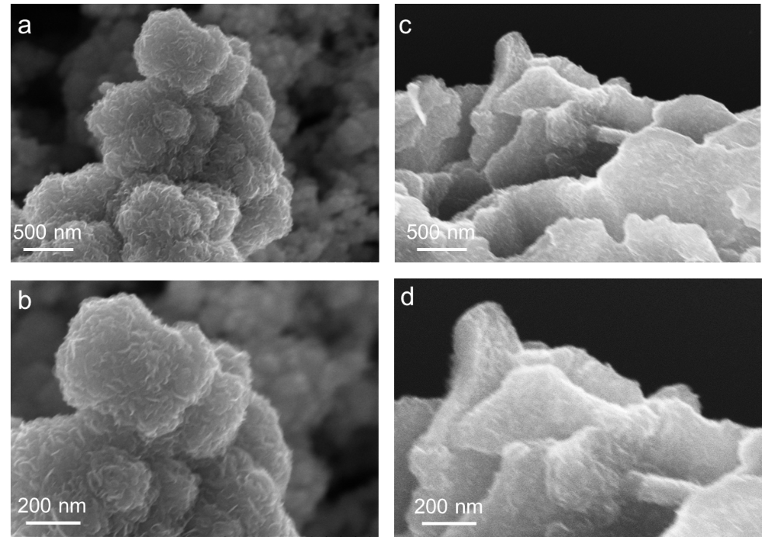

Fig. S1 SEM images of rGO nanosheets and FL-MoS₂@rGO heterostructures.

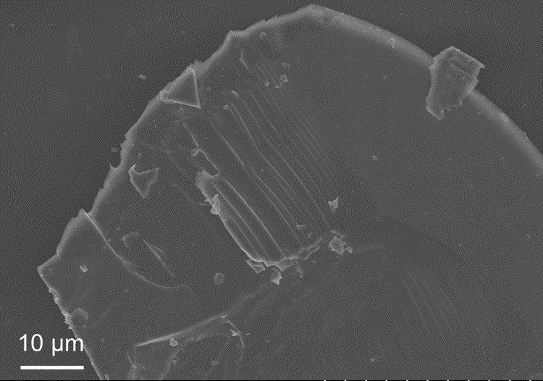

Fig. S2 SEM image of rGO nanosheets.

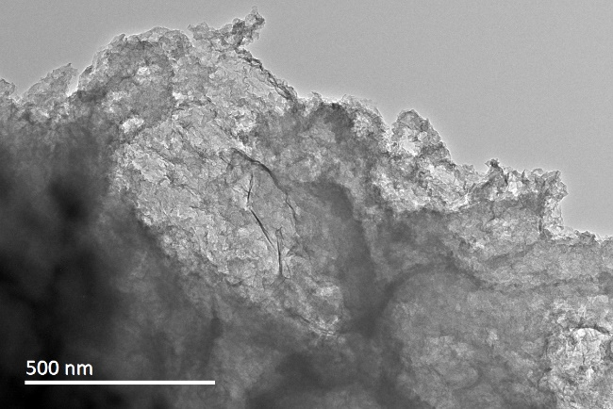

Fig. S3 TEM image of rGO nanosheets.

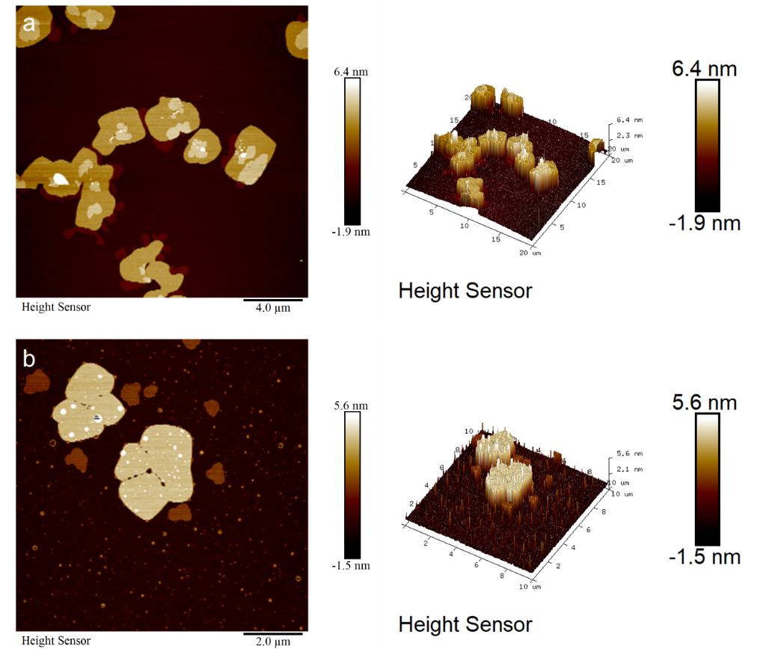

Fig. S4 AFM images of rGO and FL-MoS₂ nanosheets.

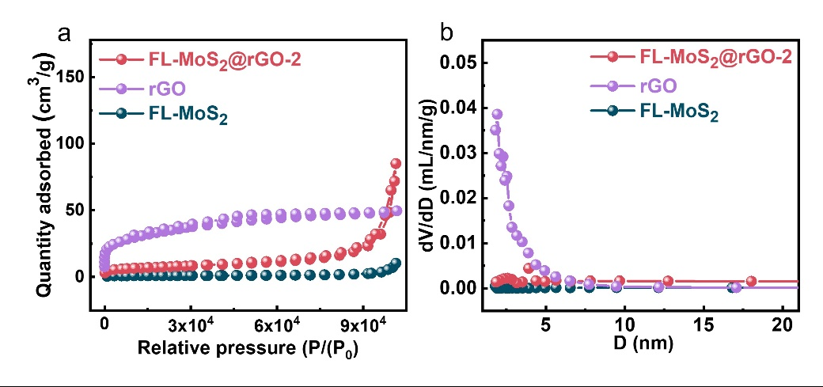

Fig. S5 (a) N₂ adsorption-desorption isotherms curves and (b) the corresponding pore size distribution curves of FL-MoS₂, rGO, FL-MoS₂@rGO-2 heterostructure.

Fig. S6 TGA curve of FL-MoS₂@rGO-2 heterostructures.

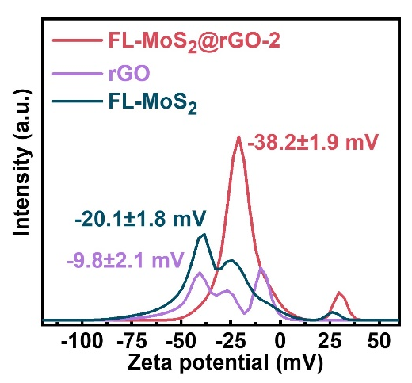

Fig. S7 The Zeta potential diagram of FL-MoS₂, rGO, FL-MoS₂@rGO-2 heterostructure.

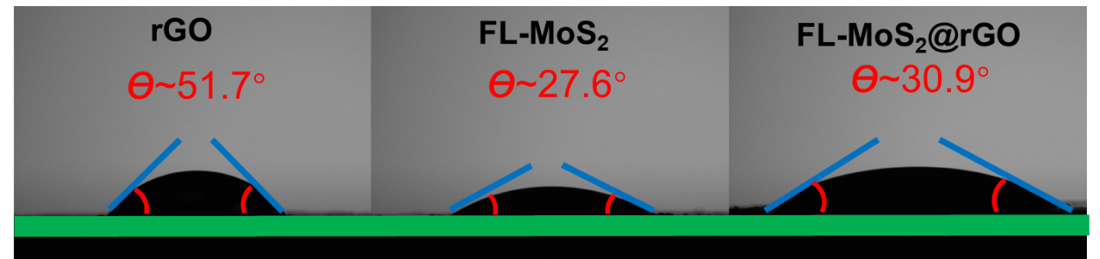

Fig. S8 The contact angle of rGO, FL-MoS₂ nanosheet and FL-MoS₂@rGO heterostructure.

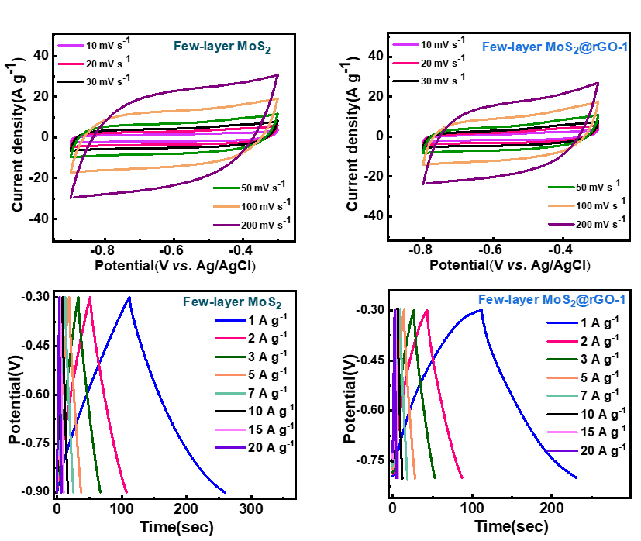
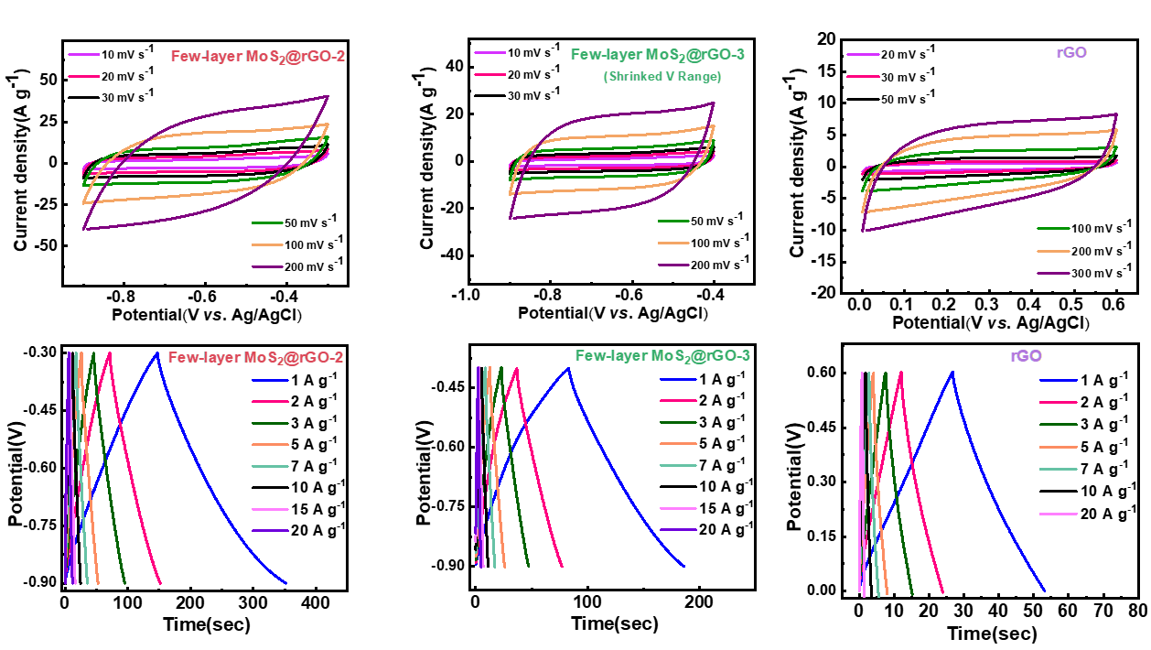

Fig. S9 CV and GCD curves of the FL-MoS₂, rGO, FL-MoS₂@rGO-1, FL-MoS₂@rGO-2, and FL-MoS₂@rGO-3 electrodes.

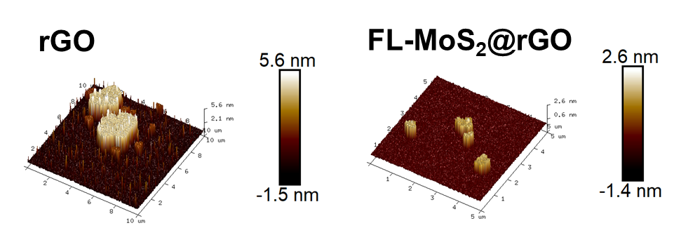

Fig. S10 AFM images of rGO nanosheet and FL-MoS₂@rGO heterostructure

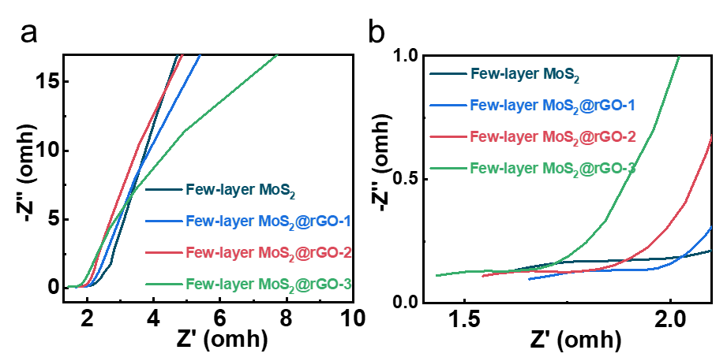

Fig. S11. EIS FL-MoS₂, FL-MoS₂@rGO-1, FL-MoS₂@rGO-2, and FL-MoS₂@rGO-3 electrodes.

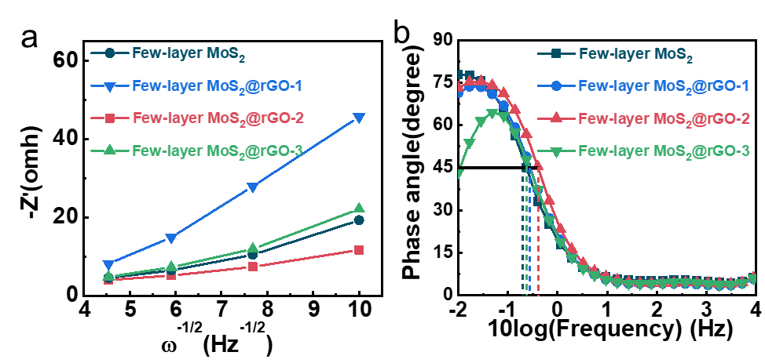

Fig. S12. (d) The correlation between Z′ and u^{−1/2} in the low frequency area. (e) A comparison of the Bode plots of the FL-MoS₂, FL-MoS₂@rGO-1, FL-MoS₂@rGO-2, and FL-MoS₂@rGO-3 electrodes.

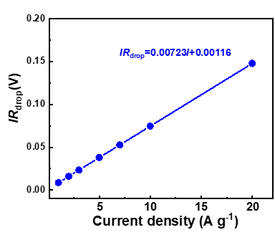

Fig. S13. Potential drop associated with the IR drops of FL-MoS₂@rGO electrode vs. different discharge current densities.

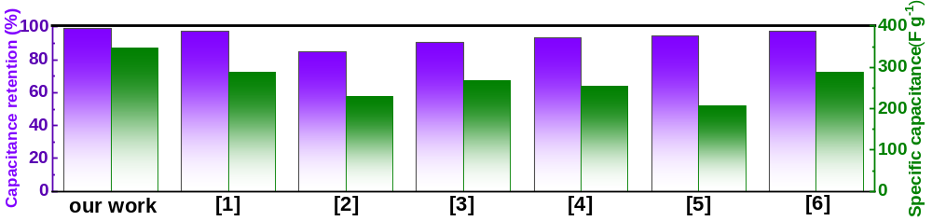

Fig. S14. Comparisons about the specific capacitance of FL-MoS₂@rGO electrodes with those of multilayer MoS₂-based heterostructures electrode materials reported recently.

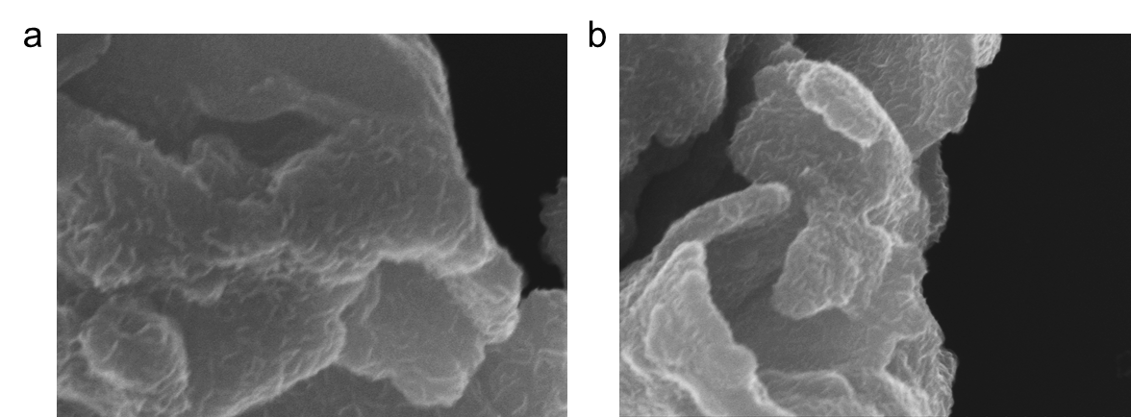

Fig. S15 SEM images of the FL-MoS₂@rGO heterostructures (a) before long-term cycling and (b) after long-term cycling

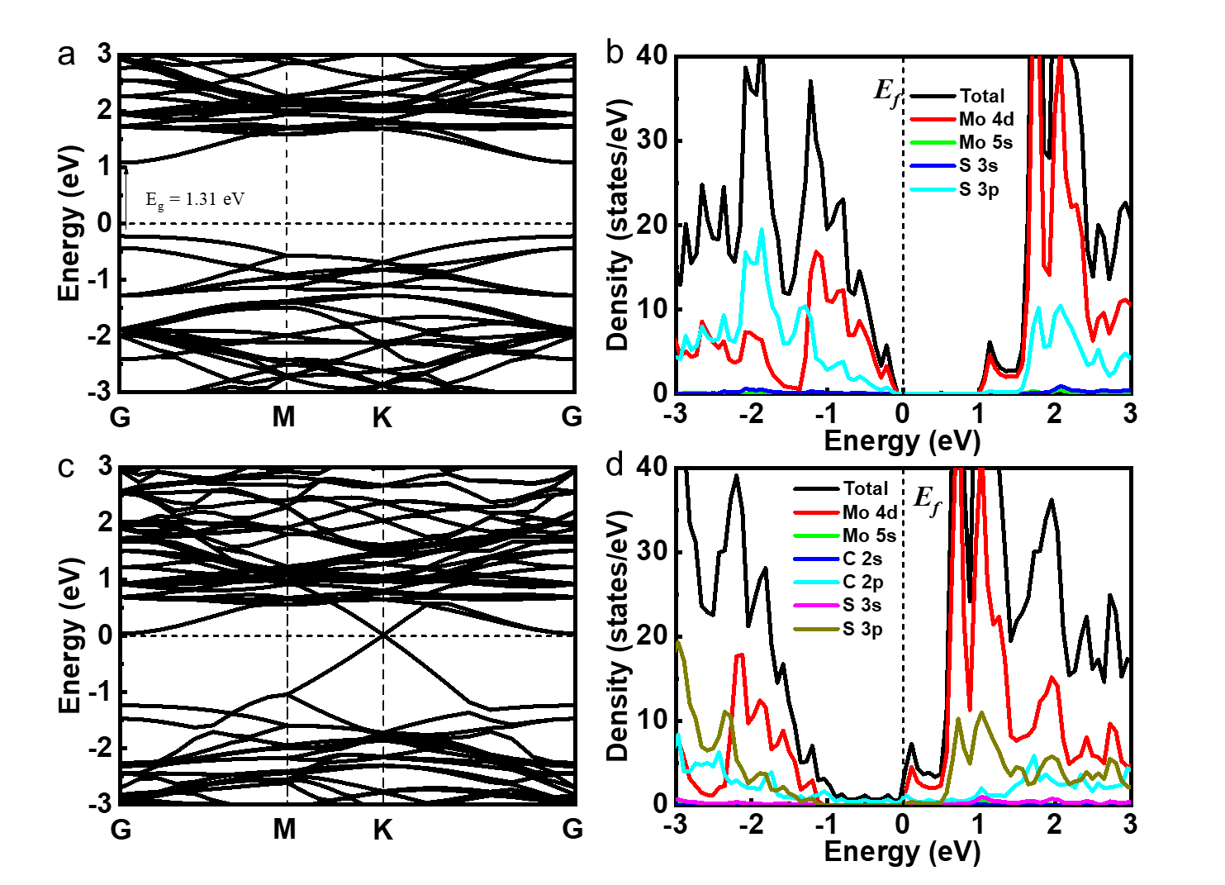

Fig. S16. Band structure of model (a) FL-MoS₂ and (c) FL-MoS₂@rGO, Density of states for model (b) FL-MoS₂ and (d) FL-MoS₂@rGO.

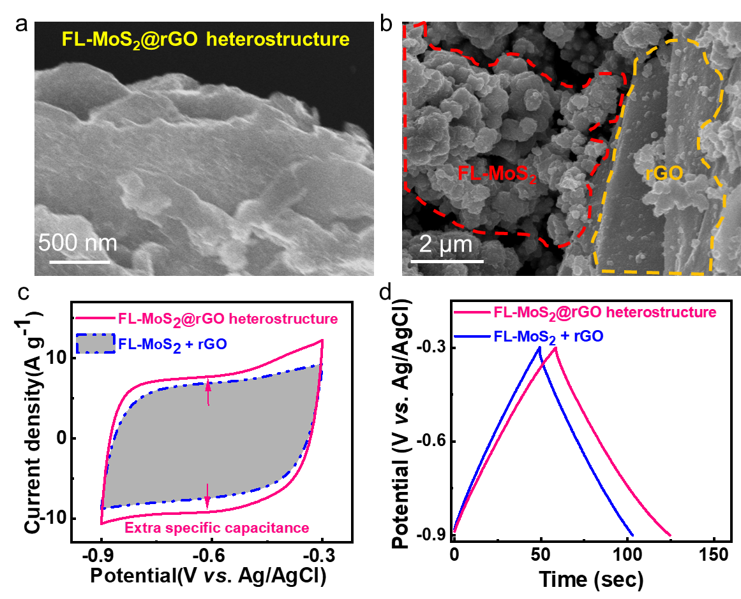

Fig. S17. SEM images of the FL-MoS₂@rGO heterostructure (a) and, mixture of rGO + FL-MoS₂ (b). (c) CV curves of FL-MoS₂@rGO heterostructure and, mixture of rGO + FL-MoS₂. (d) GCD curves of FL-MoS₂@rGO heterostructure and, mixture of rGO + FL-MoS₂.

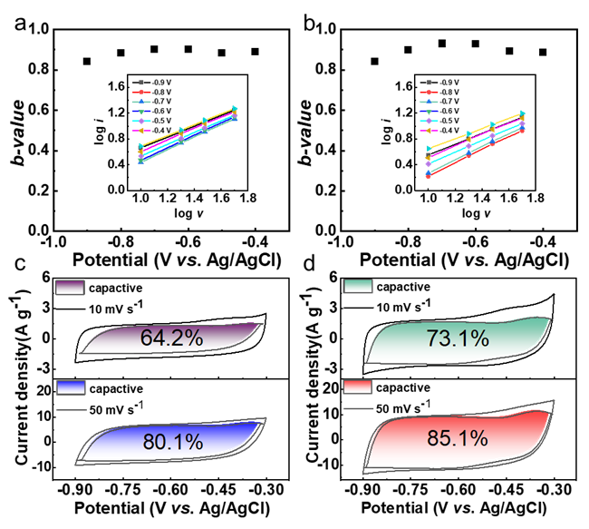

Fig. S18. The b value for FL-MoS₂ (a) and FL-MoS₂@rGO-2 (b). The CV partition analysis shows the capacitive contribution to the whole current at 10 and 50 mV s⁻¹ for FL-MoS₂ (c) and FL-MoS₂@rGO (d)

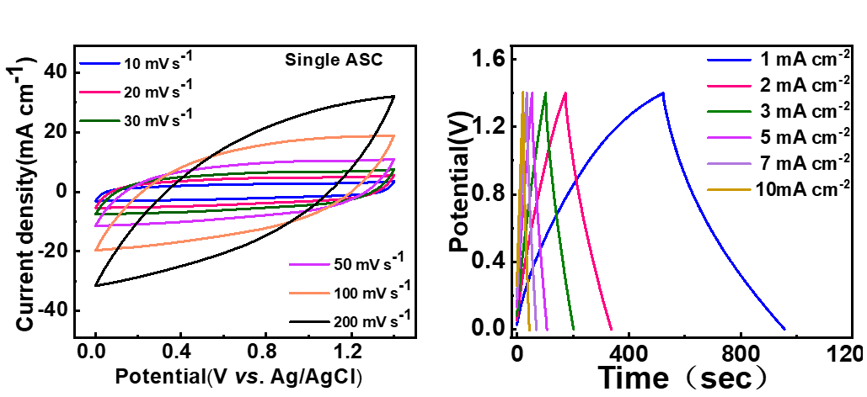

Fig. S19. CV and GCD curves of FL-MoS₂@rGO-2//AC single ASC device.

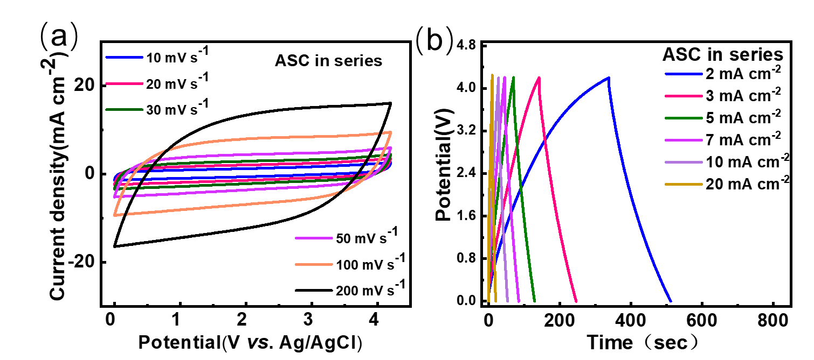

Fig. S20. (a) CV and (b) GCD curves of three FL-MoS₂@rGO-2//AC ASCs devices in series.

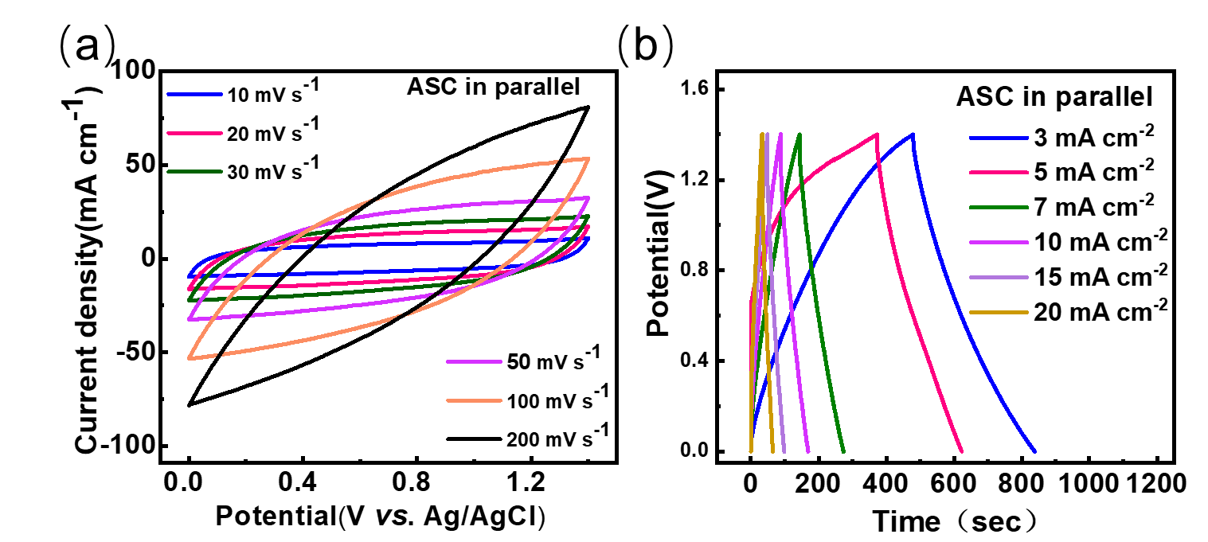

Fig. S21. (a) CV and (b) GCD curves of three FL-MoS₂@rGO-2//AC ASCs devices in parallel.

3 Table list

Table S1. Comparisons about the specific capacitance at 1 A g⁻¹ and capacitance retention of fitting results of FL-MoS₂@rGO electrode with multilayer MoS₂-based heterostructures reported recently.
Materials | Specific capacitance at 1 A g⁻¹ and capacitance retention | Refs.
FL-MoS₂@rGO | 346.1 F g⁻¹  99.1% after 10000 cycles | Our work
NiO/MoS₂ | 289 F g⁻¹  97.1% after 2000 cycles | Energies  2023, 16, 335
rGO/MoS₂ | 230 F g⁻¹  85% after 1500 cycles | Mater. Sci. Eng. B  2024, 300, 117129
CuO/MoS₂ | 268 F g⁻¹  90.2% after 5000 cycles | J. Energy Storage  2021, 42, 103140
MoS₂-PPy@rGO | 253 F g⁻¹  93.5% after 10000 cycles | Surfaces and Interfaces 2024, 48, 104373
1T-MoS₂/Ti₃C₂T_{x} | 206.3 F g⁻¹  94.4% after 10000 cycles | J. Mater. Chem. A, 2022, 10, 12258–12268
MoS₂/MoO₃ | 287.1 F g⁻¹  97.4% after 1000 cycles | Mater. Res. Lett.  2018, 6, 432–441

Table S2. The adsorption energy of FL-MoS₂ and FL-MoS₂@rGO.
System | E(*) |  | E(Na) | E(*Na) | ΔEads
FL-MoS₂ |  | -200.79 | -1.46 | -203.06 | -0.80
FL-MoS₂@rGO |  | -497.84 | -1.46 | -500.45 | -1.16

Table S3. Comparisons about the specific capacitance of Fitting results of FL-MoS₂@rGO-2//AC FASC with those of asymmetric devices reported recently.
Asymmetric devices | Energy and power density |  | Refs.
FL-MoS₂@rGO-2//AC |  | 84.31 μWh cm⁻² at 700 μW cm⁻²  51.75 μWh cm⁻² at 3500 μW cm⁻² | Our work
s-MnO₂/MoS₂ |  | 5.7 μWh cm⁻² at 100 μW cm⁻²  4.5 μWh cm⁻² at 1000 μW cm⁻² | Journal of Power Sources  2020,450,227616
1T/2H-MoS₂/GFT |  | 8.16 μWh cm⁻² at 260 μW cm⁻²  5.5 μWh cm⁻² at 1000 μW cm⁻² | Nano Res.  2021,14,114–121
P-TiON//VN |  | 21.9 μWh cm⁻² at 4500 μW cm⁻² | Adv. Energy Mater.  2020, 10, 2001873
MnO₂/CDCC |  | 30.1 μWh cm⁻² at 150 μW cm⁻² | Electrochim. Acta.  2018, 285, 262.
CC/MnO₂//MM/MoS₂/Fe₂O₃ |  | 101 μWh cm⁻² at 502 μW cm⁻² | Small.  2018, 14, 1801809
CO/CNFs |  | 44.2 μWh cm⁻² at 2800 μW cm⁻² | Chem. Eng. J.  2020, 402, 126294
MoS₂//PEDOT:PSS |  | 50 μWh cm⁻² at 500 μW cm⁻²  22.2 μWh cm⁻² at 8000 μW cm⁻² | ACS Appl. Mater. Interfaces  2021, 13, 7285−7296
CNT/PPy MSCs |  | 4.5 μWh cm⁻² at 176 μW cm⁻² | Nano Energy  2018,49,644–654
MnO₂/rGO/PEDOT:PSS |  | 35 μWh cm⁻² at 800 μW cm⁻² | Adv. Mater.  2019, 31, 1804285.
Cu(OH)₂@FeOOH/Cu |  | 18.07 μWh cm⁻² at 800 μW cm⁻²  16 μWh cm⁻² at 1600 μW cm⁻²  15.2 μWh cm⁻² at 2000 μW cm⁻² | Energy Environ. Sci.  2019, 12, 194--205

