Enhanced Electrochemical Performance of Zinc-Ion Batteries Using Functionalized Nano-Chitin Separators
Chengwei Linª, Sainan Ou^{#,a}, Baobin Liuª, Yao Niu^{b}, Xian Wangª, Huiping Linª, Ran Li^{*,a}, Meng An^{*,b}, Xinxiang Zhang^{*,a}, Zhanhui Yuan^{*,a}
ª College of Materials Engineering, Fujian Agriculture and Forestry University, Fuzhou 350002, P. R. China
^{b} College of Mechanical and Electrical Engineering, Shaanxi University of Science and Technology, Xi’an 710021, China

Experimental Section
Preparation of deacetylated chitin:The commercial α-chitin extracted from crab shells is crushed into a powder, and then chitin powder, 33 wt% NaOH solution, and NaBH₄ are added successively at a ratio of 1g:25 ml:0.03 g (w/v/w). The mixture is heated to 90 °C and stirred. The reaction times are 0, 1, 2, 3 and 4 h. After the reaction is complete, the product is repeatedly washed with deionized water until it reaches a neutral pH, and then dried to prepare chitin with different degrees of deacetylation.
Preparation of chitin nanofibers: Different degrees of deacetylated chitin powder are poured into acetic acid solution with a pH=3 to prepare a 1.5 wt% chitin suspension. After grinding in a colloidal mill for 1.5 h, a 1.5 wt% chitin nanofiber suspension can be collected.
Preparation of chitin nanofiber separator: Dilute the chitin nanofiber suspension from a concentration of 1.5 wt% to 0.2 wt%, take 50 g of it and add 1 M NaOH solution to adjust the suspension to neutrality (pH=7). Subsequently, the resulting uniform dispersion is vacuum filtered through a filter membrane, forming a wet chitosan nanofiber film. Finally, place the wet film in an oven at 60 °C and pressurize it at 0.003 MPa for 24 h to obtain the chitin nanofiber separator.
Preparation of NH₄V₄O₁₀ (NVO) cathode material: 2.34 g of NH₄VO₃ is added to 140 mL of deionized water and placed under conditions of 70 °C to dissolve. After complete dissolution, 3.782 g of H₂C₂O₄·2H₂O solid powder is added to the solution. The solution is then transferred to a hydrothermal synthesis reactor and kept in an oven at 140 °C for 12 h. The product is collected, and the sample is naturally cooled to room temperature and repeatedly washed with deionized water. The final product is dried at 80 °C for 8 h to obtain NH₄V₄O₁₀.
Materials characterizations: The sample morphology was observed using Scanning Electron Microscopy (SEM, Zeiss Sigma 300), Transmission Electron Microscopy (TEM, FEI Tecnai G2 F20), and Confocal Laser Scanning Microscopy (CLSM, Zeiss LSM700). X-ray powder diffraction (XRD) was tested by Rigaku Ultima Ⅳ and Fourier transform infrared spectroscopy (FT-IR) was recorded by a PerkinElmer Spectrum 3 spectrometer. The tensile stress–strain curves were collected by SENS CMT6203 universal testing machine. Zeta potential measurements were conducted on the Malvern Nano-ZEN3690.
Battery assembly and electrochemical measurements: NVO powder, acetylene black, and polyvinylidene fluride (PVDF) were weighed and mixed in a ratio of 7:2:1 in a small beaker. An appropriate amount of N-methyl-2-pyrrolidone (NMP) solvent was added dropwise, and the mixture was stirred for 8 hours to form a uniform NVO cathode slurry. This slurry was then evenly applied onto a stainless steel foil and dried at 80°C for 12 hours to obtain the NVO cathode.
The electrodes and separator were cut to dimensions of Φ12 mm and Φ16 mm, respectively, and assembled into CR2032 coin-type cells to test the electrochemical performance. Cells with GF separators were dropwise added with 60 μL of electrolyte, while D-x-ChNF membranes were prepared using a pre-soaking method. Assembled Zn//Zn symmetric cells, Zn//Cu asymmetric cells, and Zn//Ti asymmetric cells using a 2 M ZnSO4 electrolyte, and assembled Zn//NVO full cells using a 3 M ZnSO4 electrolyte.
The NEWARE CT-4008Tn testing system can effectively measure the long cycle and rate performance of Zn//Zn symmetric cells at different currents, as well as the coulombic efficiency of Zn//Cu asymmetric cells. Additionally, the long cycle and rate tests for Zn//NVO full cells have a voltage range of 0.4-1.4V. CV tests for Zn//NVO full batteries are performed between 0.4 V and 1.4 V at a scan rate of 1 mV s⁻¹. Furthermore, electrochemical measurements include EIS, Tafel, CV, and CA tests, which can be conducted using the Admiral Squidstat Plus electrochemical workstation. This workstation supports a variety of electrochemical testing techniques and offers excellent performance-to-price ratio and portability. EIS tests cover a frequency range from 10⁻¹ to 10⁴ Hz, while Tafel tests are conducted between -0.2 V and 0.2 V at a scan rate of 1 mV s⁻¹. CV tests for Zn//Ti half-cells are carried out between -0.2 V and 0.6 V at a scan rate of 1 mV s⁻¹.
Determination of deacetylation degree：
The determination of deacetylation degree is conducted by performing infrared spectroscopy on nanocrystalline chitosan, correcting the baseline of the spectrum, and then calculating the deacetylation degree using the following peak area formula.
$$\frac{A_{1560}}{A_{2880}}=-0.0123×DD+1.4165 (R=0.9860)$$
Where A₁₅₆₀ refers to the corrected peak area at 1560 cm⁻¹, A₂₈₈₀ refers to the corrected peak area at 2880 cm⁻¹; DD% represents the degree of deacetylation of chitin.
Calculation of crystallinity: Determine the XRD of chitosan and measure the degree of crystallinity (CI) using the following equations.
$$CI=[\left(I_{100}-I_{am}\right)]×100$$
Where I₁₀₀ is the maximum absorption intensity (100) at approximately 2θ=19°, and I_{am} is the amorphous diffraction intensity at 2θ=12.6°.
Calculation of ionic conductivity: The ionic conductivity (σ) was performed on a Admiral Squidstat Plus electrochemistry workstation via testing the resistance of SS//SS symmetric cell ranging from 10⁻¹ Hz to 10⁴ Hz, and the ionic conductivity was calculated via the following equations.
$$σ=\frac{L}{RS}$$
where L is the thickness of the separator, 𝑅 is the resistance based on EIS test, and S is the contact area between the separator and the stainless steel plate.
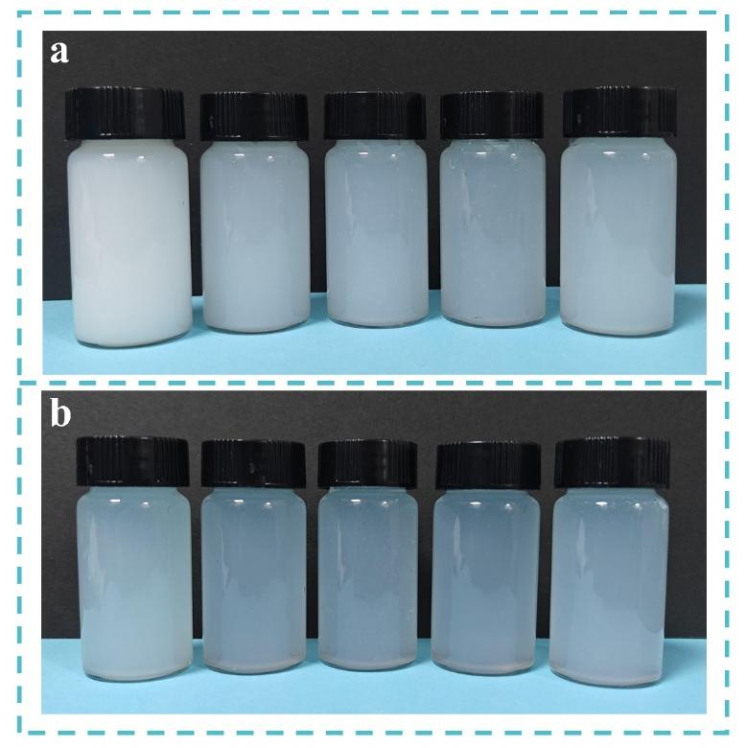
Figure S1. Photos of a) 1.5 wt% nano-chitin suspensions at pH=3, and b) 0.2 wt% nano-chitin suspensions at pH=7.

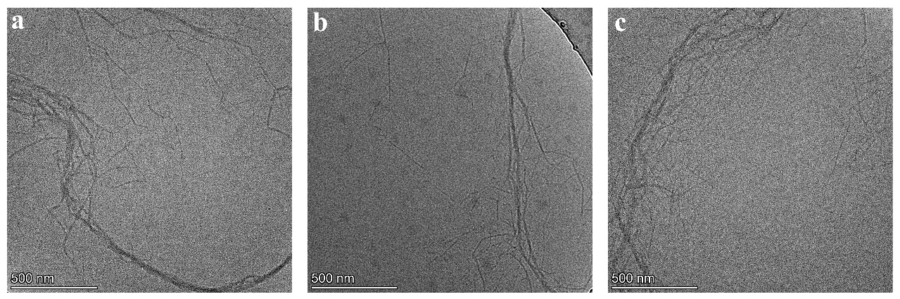
Figure S2. TEM images of a) D-1-ChNF, b) D-2-ChNF and c) D-3-ChNF.

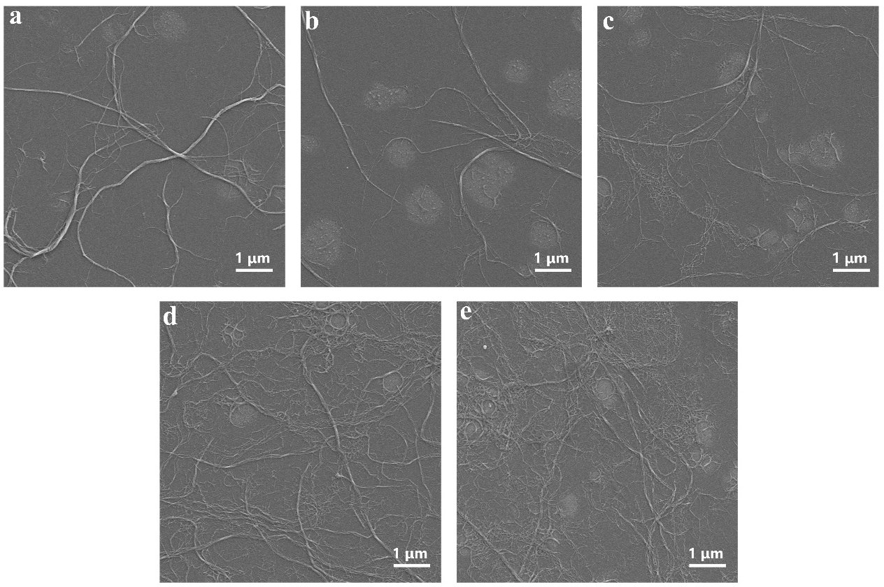
Figure S3. SEM images of a) D-0-ChNF, b) D-1-ChNF, c) D-2-ChNF, d) D-3-ChNF and e) D-4-ChNF.

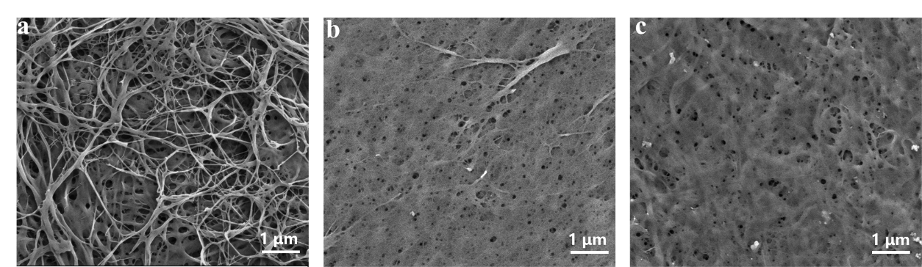
Figure S4. SEM images of a) D-0-ChNF separator, b) D-1-ChNF separator, c) D-2-ChNF separator, d) D-3-ChNF separator and e) D-4-ChNF separator.

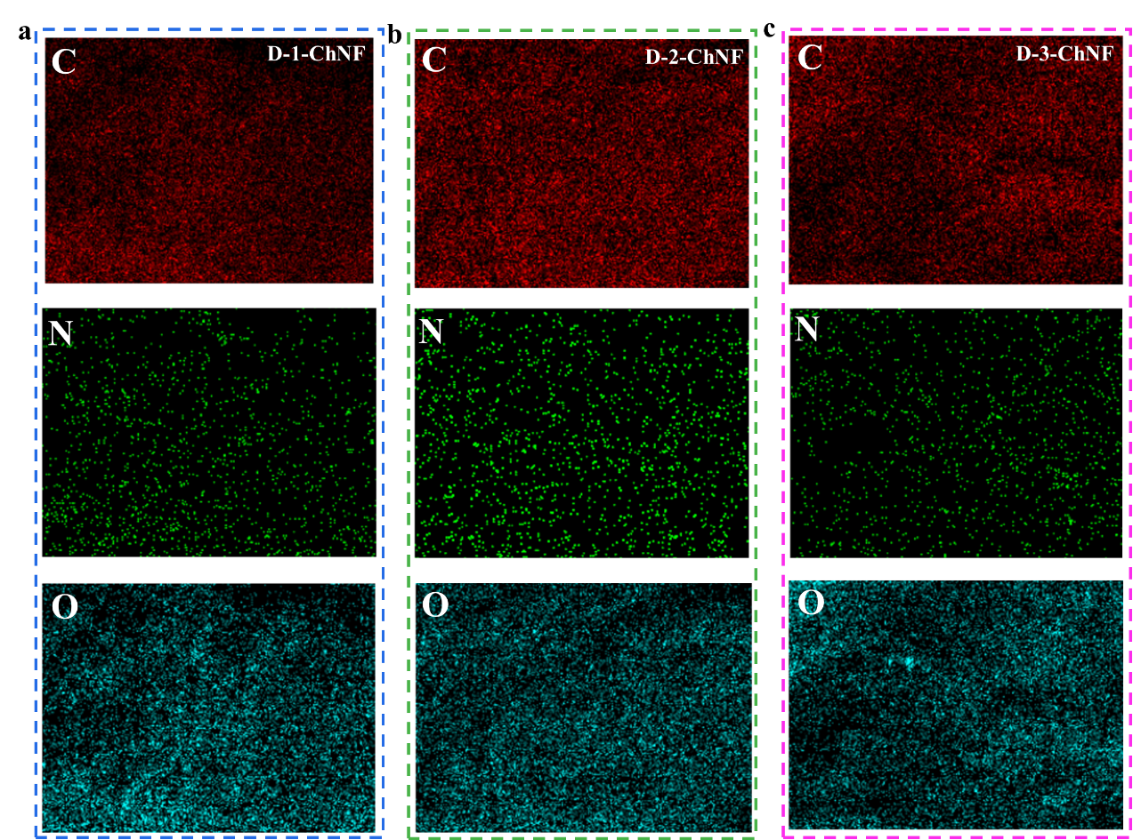
Figure S5. EDS images of b) D-1-ChNF separator, c) D-2-ChNF separator and d) D-3-ChNF separator.

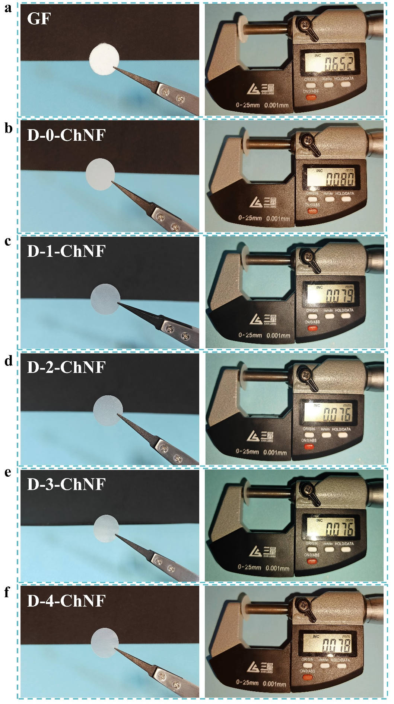
Figure S6. Photographs and thickness mearsure of a) GF, b) D-0-ChNF, c) D-1-ChNF, d) D-2-ChNF, e) D-3-ChNF, f) D-4-ChNF separator.

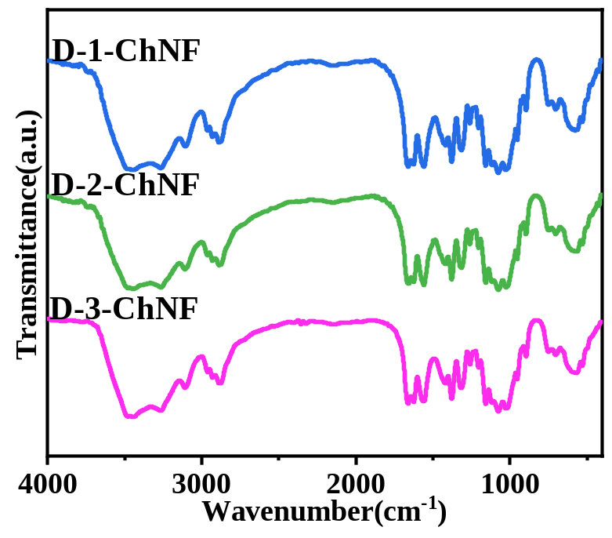
Figure S7. FTIR spectra of D-1-ChNF, D-2-ChNF and D-3-ChNF.

Table S1. Calculate the degree of deacetylation of D-x-ChNF using the FTIR method.
Separator | DD%
D-0-ChNF | 14.60
D-1-ChNF | 21.54
D-2-ChNF | 24.10
D-3-ChNF | 31.08
D-4-ChNF | 35.09

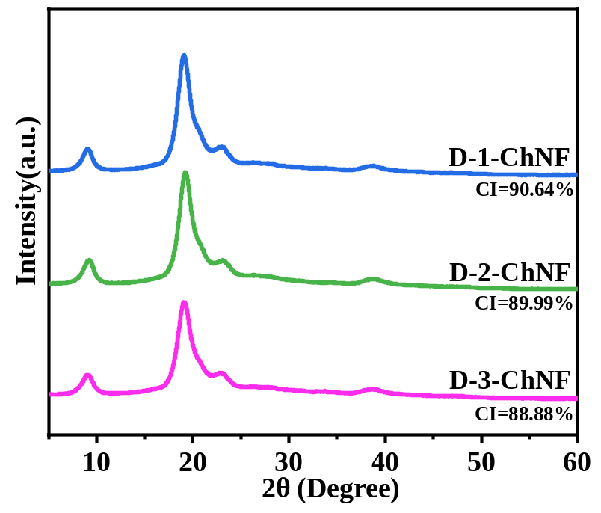
Figure S8. XRD patterns of D-1-ChNF, D-2-ChNF and D-3-ChNF.

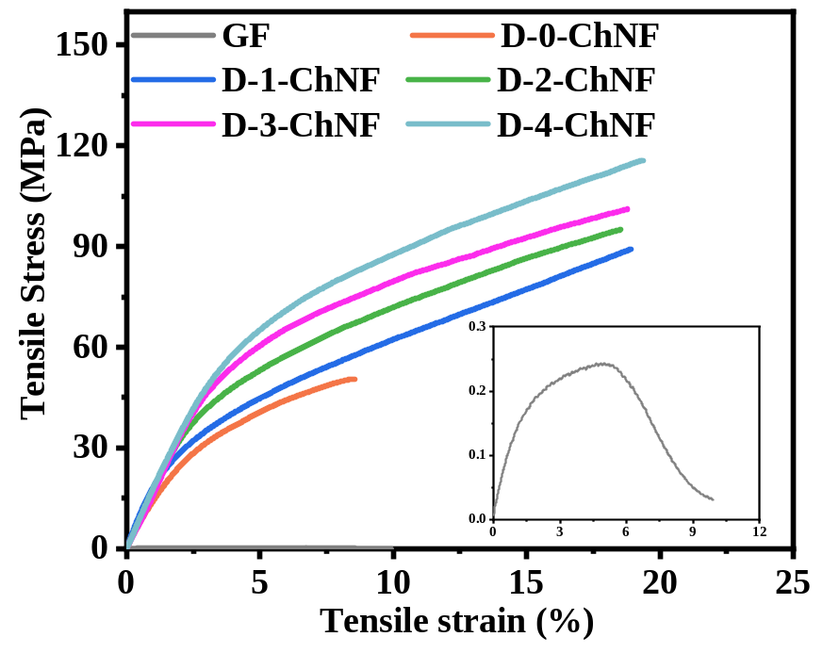
Figure S9. Dry stress-strain curves of different separators.

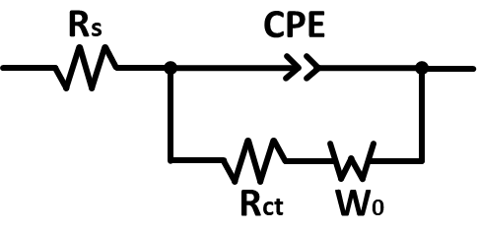
Figure S10. Fit the equivalent circuit diagram of EIS.

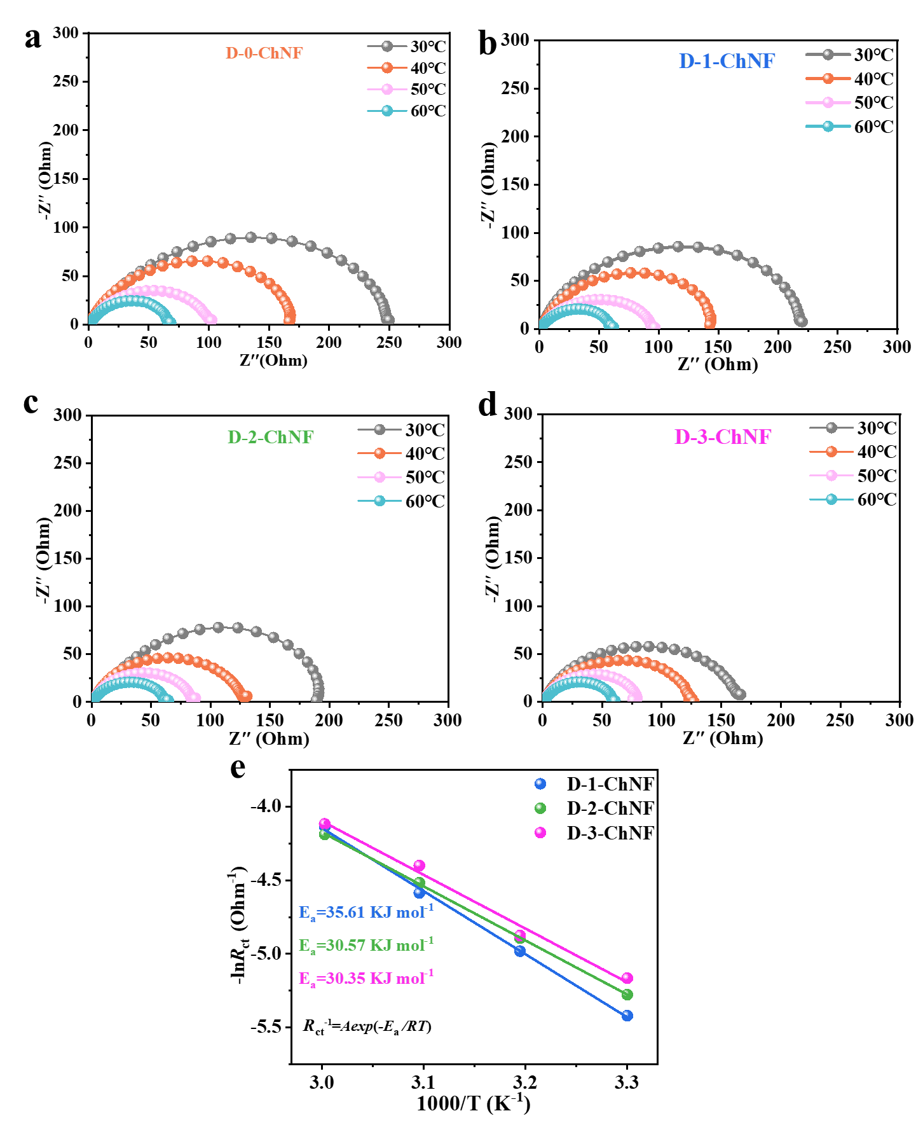
Figure S11. Nyquist plots of Zn//Zn cells at 30−60℃ when using a) D-0-ChNF, b)D-1-ChNF, c) D-2-ChNF and d) D-3-ChNF separator. f) Arrhenius curves and corresponding desolvation activation energy values of Zn symmetrical cells with D-1-ChNF, D-2-ChNF and D-3-ChNF separators.
Table S2. R_{ct} values of Zn//Zn cells with different separators at varying temperatures.
Temperature | GF | D-0-ChNF | D-1-ChNF | D-2-ChNF | D-3-ChNF | D-4-ChNF
30℃ | 535.6 | 256.4 | 226.1 | 195.9 | 175.2 | 164.3
40℃ | 336.1 | 155.0 | 145.8 | 133.5 | 131.1 | 116.6
50℃ | 193.5 | 107.7 | 98.1 | 91.6 | 81.5 | 80.79
60℃ | 101.8 | 70.18 | 62.59 | 65.94 | 61.41 | 63.08

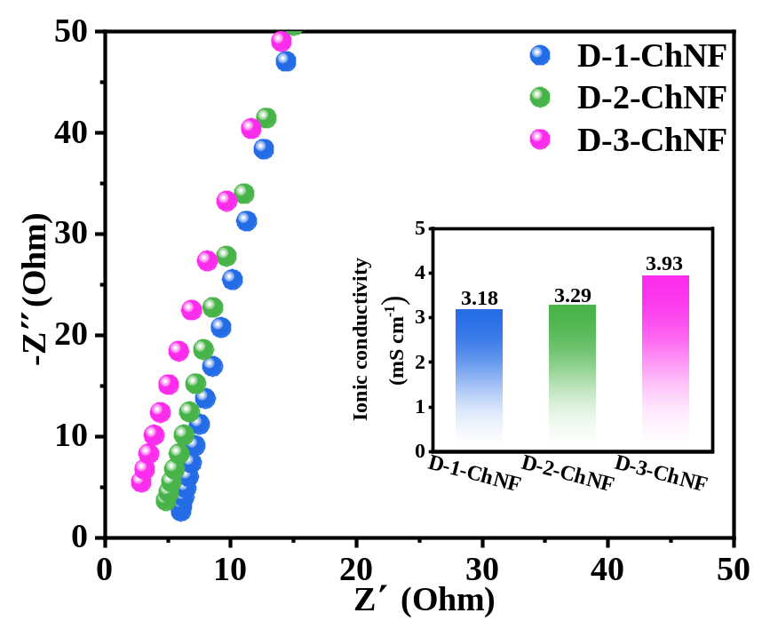
Figure S12. The Nyquist plot and ionic conductivity of the D-1-ChNF, D-2-ChNF and D-3-ChNF separators.
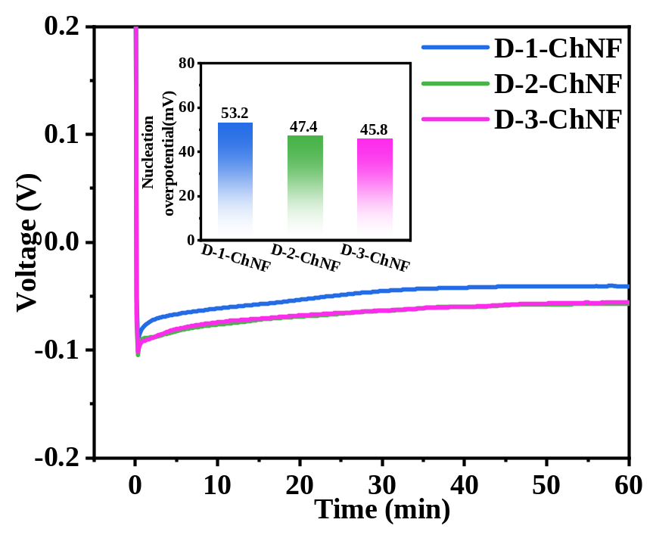
Figure S13. Voltage-time profiles of Zn//Cu cells with D-1-ChNF, D-2-ChNF and D-3-ChNF separators at 1 mA cm⁻¹ (the inset shows nucleation overpotential values).

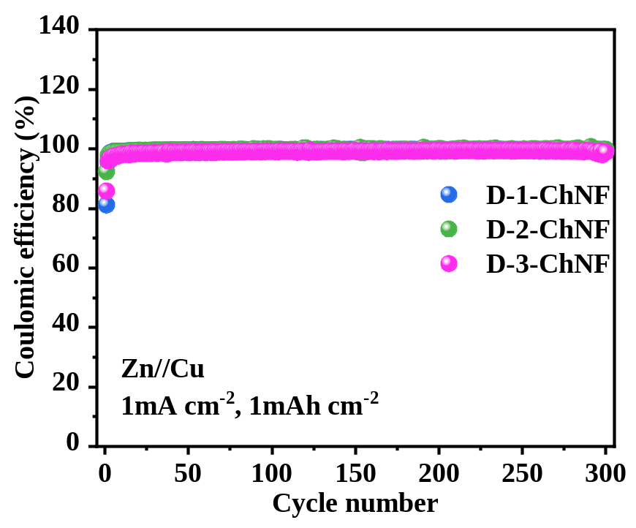
Figure S14. evolutions of CE values of the Zn//Cu cells with D-1-ChNF, D-2-ChNF and D-3-ChNF separators.

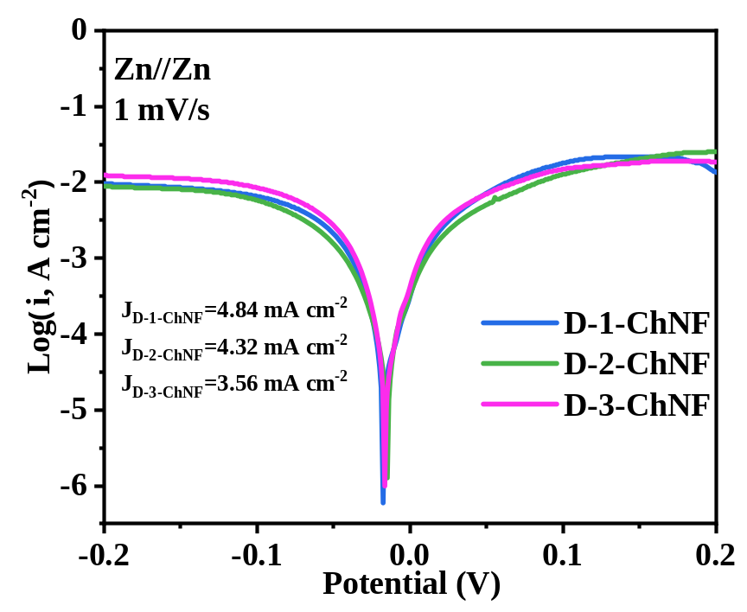
Figure S15. Tafel plots at 1 mV s⁻¹ of Zn electrodes protected by D-1-ChNF, D-2-ChNF and D-3-ChNF separators.
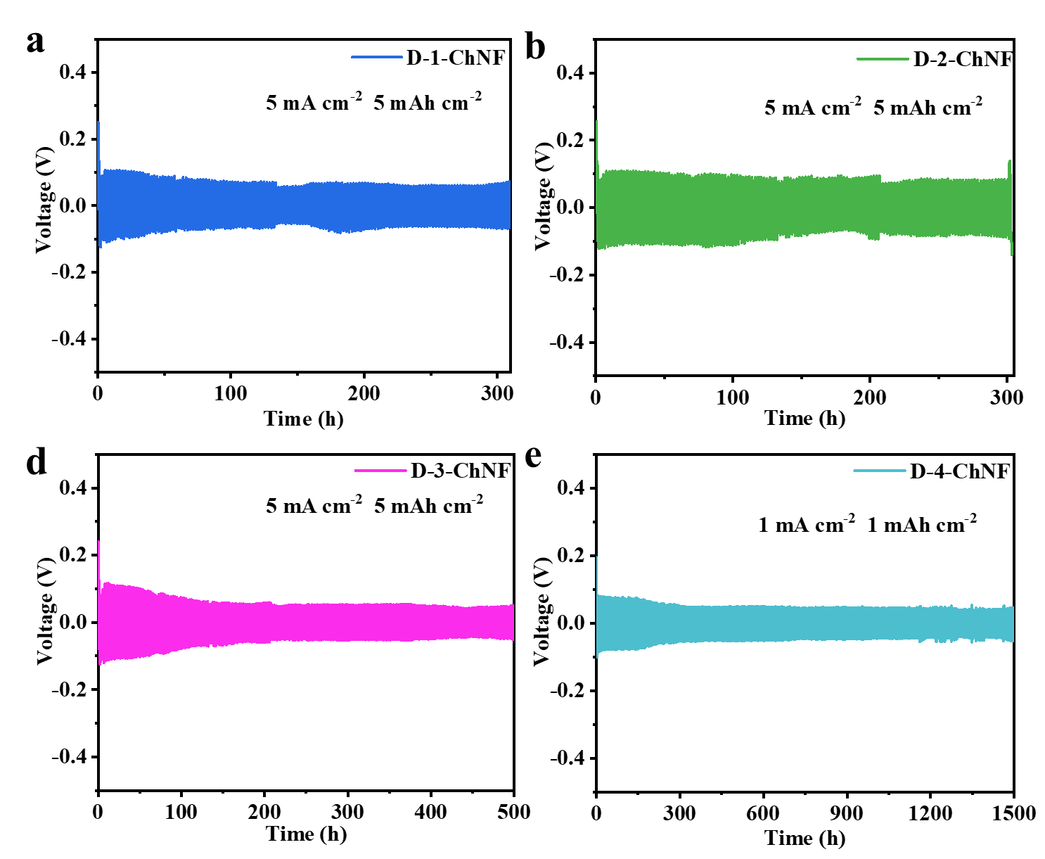
Figure S16. Cycling performances at 5 mA cm⁻² and 5 mAh cm⁻² of Zn//Zn cells with a) D-1-ChNF, b) D-2-ChNF and c) D-3-ChNF separators. Cycling performances at 1 mA cm⁻² and 1 mAh cm⁻² of Zn//Zn cells with d) D-4-ChNF

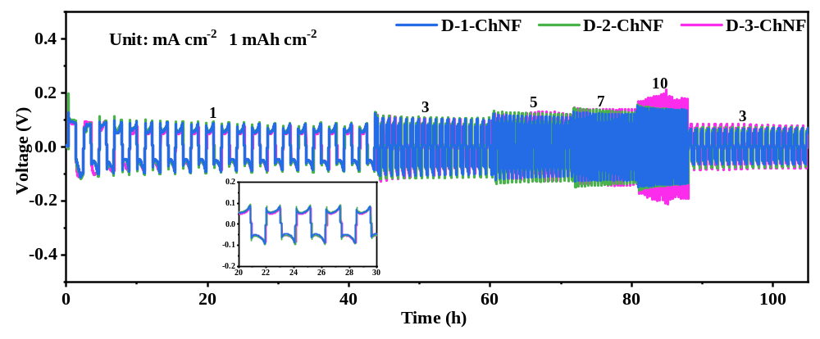
Figure S17. Rate performances of battery with D-1-ChNF, D-2-ChNF and D-3-ChNF separators ranging from 1 to 3, 5 , 7 and 10 mA cm⁻²
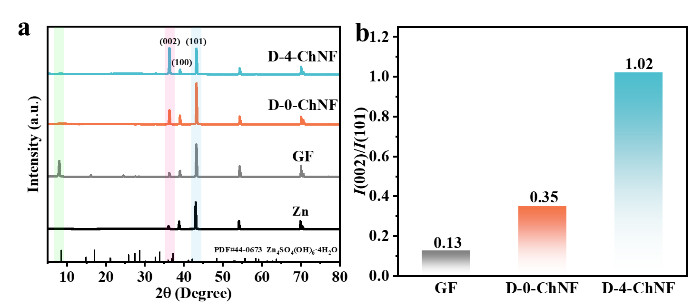
Figure S18. a) XRD patterns of the Zn anodes with GF, D-0-ChNF and D-4-ChNF separators after 60 cycles at 5 mA cm⁻² and 5 mAh cm⁻². b) The intensity ratios of the XRD diffraction peaks between Zn (002) and (101).

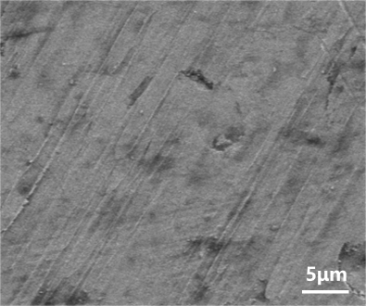
Figure S19. SEM image of the pristine Zn electrode.

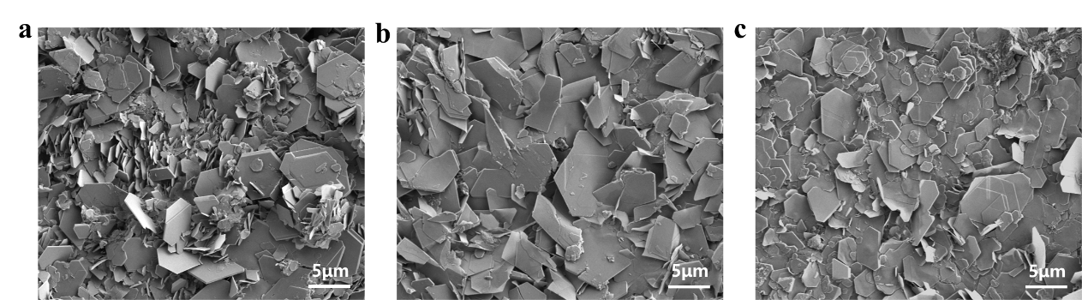
Figure S20. SEM images of Zn anodes in various Zn symmetric cells with a) D-1-ChNF, b) D-2-ChNF and c) D-3-ChNF separators after 60 cycles at 5 mA cm⁻² with 5mAh cm⁻².

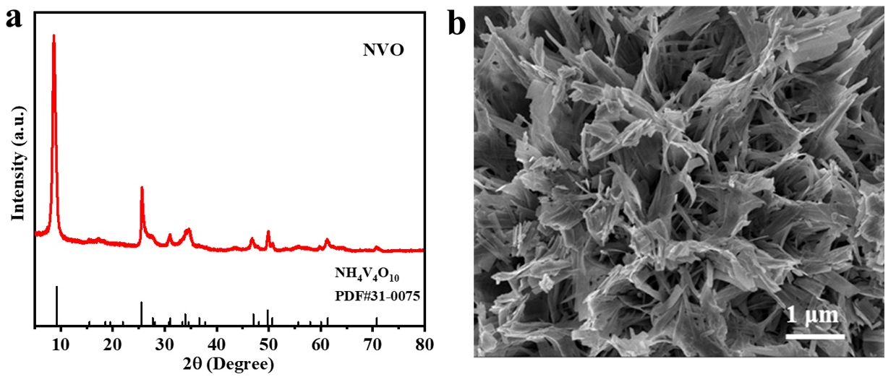
Figure S21. a) XRD pattern for NH₄V₄O₁₀. b) SEM image of NH₄V₄O₁₀.

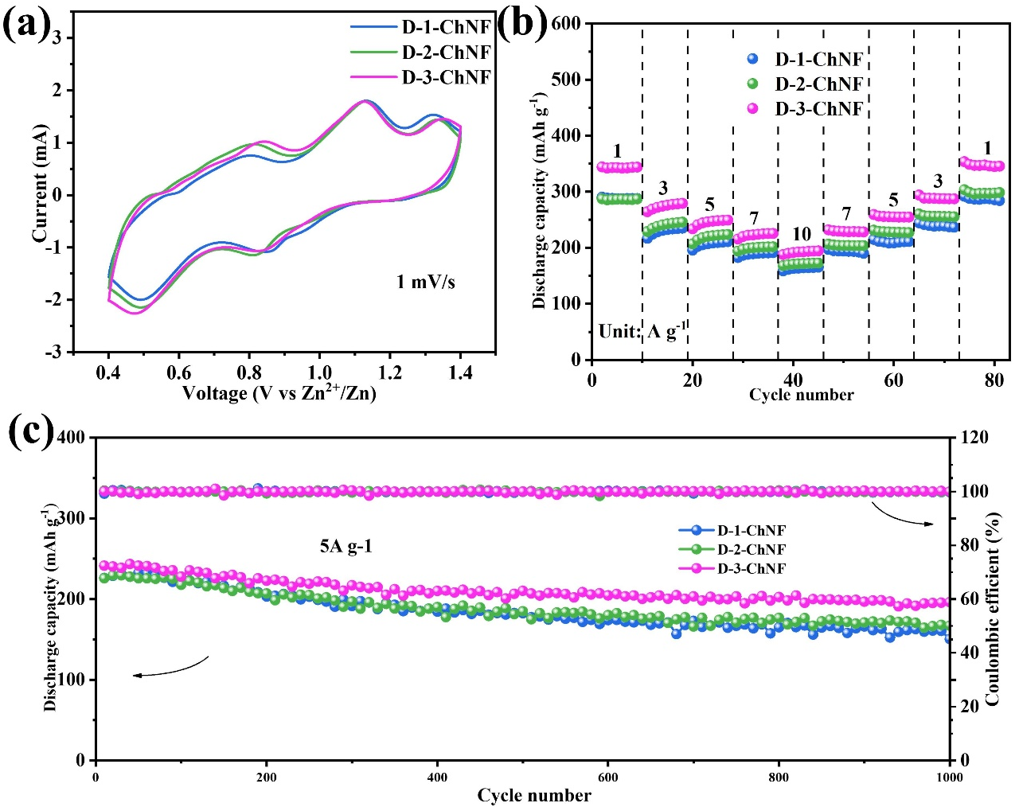
Figure S22. Electrochemical behaviors of Zn//NVO full cells with D-1-ChNF, D-2-ChNF and D-3-ChNF separators. a) CV curves at 1 mV s⁻¹, b) rate capability an f) cycling performance at 5 A g⁻¹,
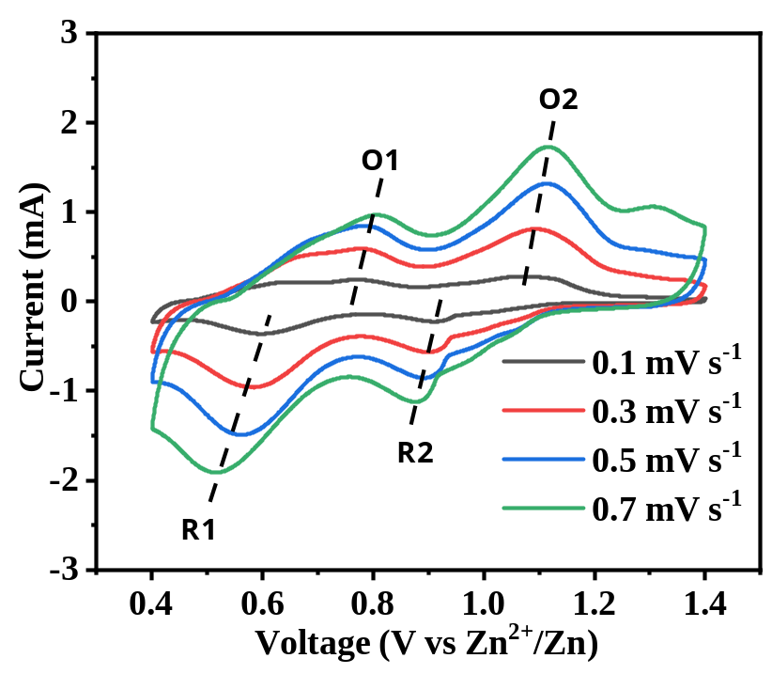
Figure S23. CV profiles of the Zn//NVO battery in a potential range of 0.4−1.4 V at various scan rates of 0.1−0.7 mV s⁻¹.
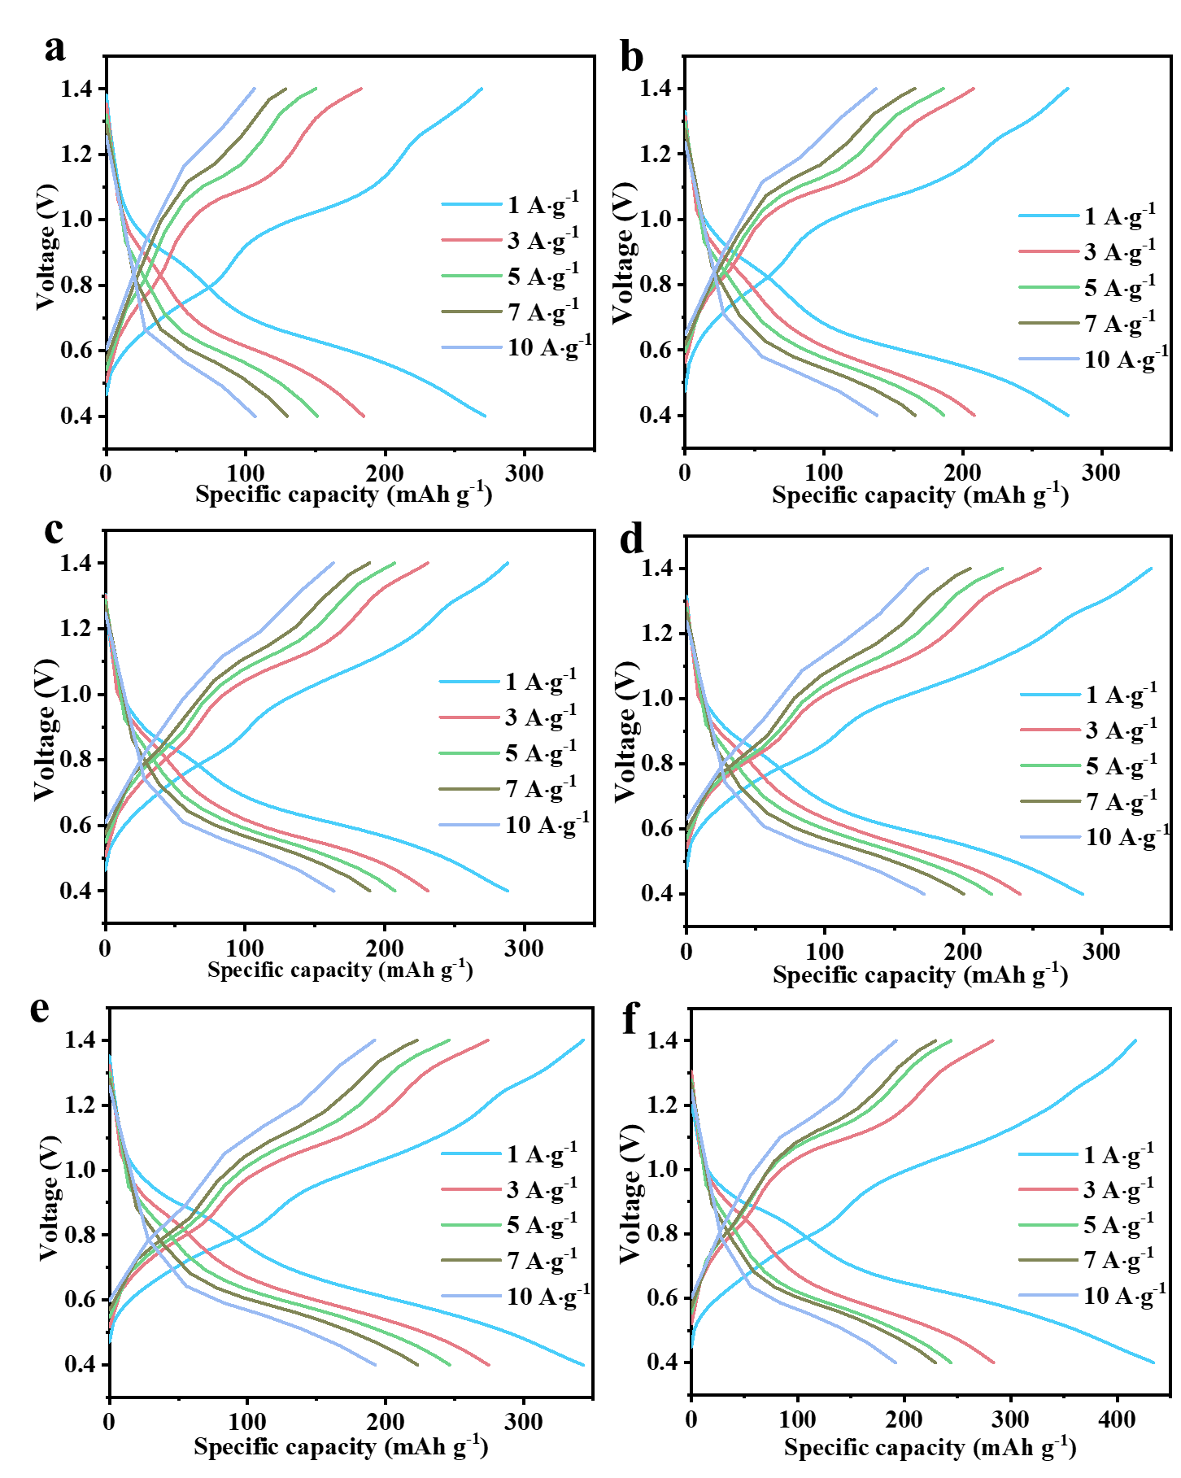
Figure S24. Charge–discharge curves with a) GF, b) D-1-ChNF, c) D-2-ChNF, d) D-3-ChNF separators at various currents.

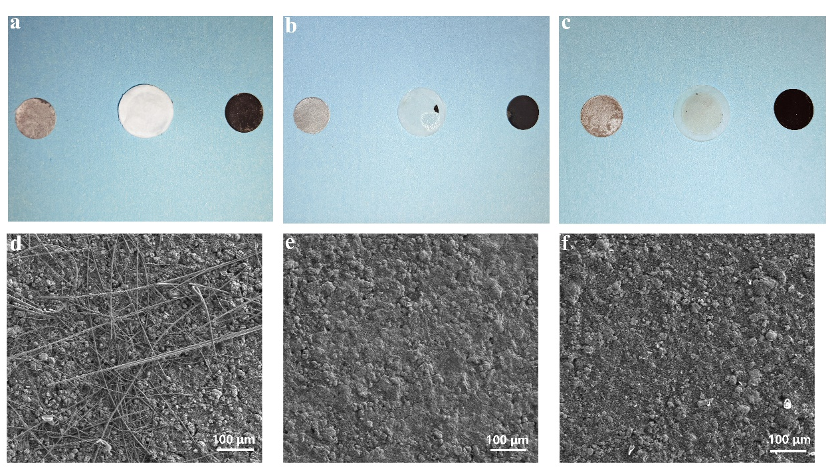
Figure S25. The full cells assembled with a) GF, b) D-0-ChNF and c) D-4-ChNF separators were cycled 1000 cycles at 0.5 A g⁻¹, and the resulting anode, cathode plates and the separators are presented. SEM image of the Zn anode after 1000 cycles with d) GF, e) D-0-ChNF and f) D-4-ChNF separators.

