A novel disposable dual-sensing platform based on DNA-aptamer amplified with gold nanoparticles/Nb₄C₃-MXene for simultaneous detection of lead and cadmium

Hassan Karimi-Maleh^{a,b,c}*, Zhouxiang Zhang^{b*}, Najmeh Zare^{b*}, Onur Karaman,^{d} Yangpin Wen^{e}, Tao Wu,^{b} Nianbing Zhong^{f} and Li Fu^{g}

ª The Quzhou Affiliated Hospital of Wenzhou Medical University, Quzhou People's Hospital, Quzhou, 324000, China
^{b} School of Resources and Environment, University of Electronic Science and Technology of China, 611731, Xiyuan Ave, Chengdu, China
^{c} School of Chemistry, Damghan University, Damghan, 36716-45667, Iran
^{d} Department of Physics, Akdeniz University, Antalya, Turkey
^{e} Institute of Functional Materials and Agricultural Applied Chemistry, Jiangxi Agricultural University, Nanchang, 330045, China
^{f} Chongqing University of Technology, School of Electrical and Electronic Engineering, Chongqing, China
^{g} College of Materials and Environmental Engineering, Hangzhou Dianzi University, Hangzhou, 310018, PR China

Corresponding author’s e-mail:
hassan@uestc.edu.cn (HKM); zhangzhouxiangzzx@163.com (ZZ), najmeh.zare.1997@gmail.com (NZ); postal code: 611731, Phone number: +8613088085375

Sequences
- Pb²⁺ aptamer（Pb²⁺ Apt）: 5’-GGT TGG TGT GGT TGG-MB-3’;
  - complementary sequence（Pb²⁺ CP）: 5’-SH-TAG TTT AGC CCA ACC ACA CCA ACC-3’;
- Cd²⁺ aptamer（Cd²⁺ Apt）: 5’-CTC AGG ACG ACG GGT TCA CAG TCC GTT GTC-Fc-3’;
  - complementary sequence (Cd²⁺ CP): 5’-SH- ACT AAT GAC AAC GGA CTG TGA ACC CGT CGT CCT GAG-3’

Supplementary Figures:
Fig. S1 The size of customized SPCE (left), the obtained SPCE (center) and the adaptor for SPCE (right).
Fig. S2 (A) The fabrication processes of AuNPs/Nb₄C₃-MXene/SPCE; (B) The preparation processes of the proposed aptasensor.

Fig. S3 AFM of Nb₄C₃-MXene
Fig.S4 The FTIR (A) and Raman (B) of Nb₄C₃-MXene.

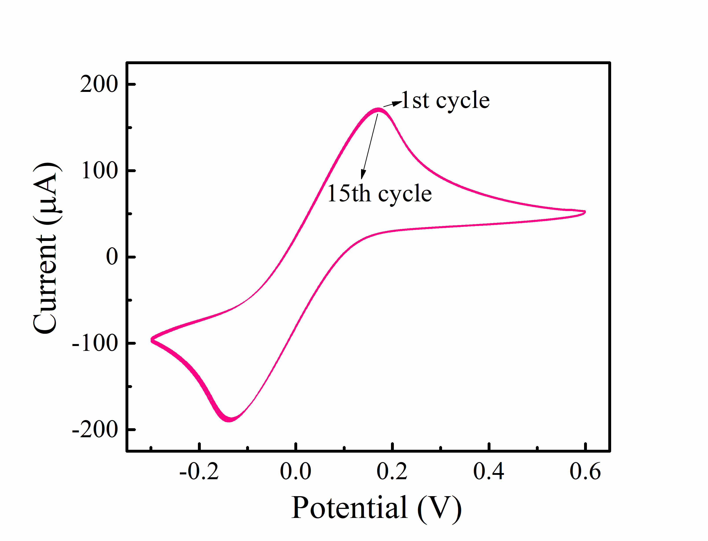
Fig.S5 The stability test (CVs of fifteenth times) of AuNPs/Nb₄C₃-MXene/SPCE in a solution contain 5 mmol.L⁻¹ [Fe(CN)₆]^{3-/4-} and 0.1 mol. L⁻¹ KCl. Scan rate: 0.05 V/s; number of cycles: 15; potential range: -0.3 ~ 0.6 V.

Fig. S6 Effect of varied operating conditions towards the current signals of the electrochemical aptasensor: AuNPs electrodeposition time (A), hybridization time between CP and Apt (B), pH (C) and metal ions incubation time (D).

Fig. S7 (A) Selectivity of the electrochemical aptasensor towards Pb²⁺ (red) and Cd²⁺ (blue). All of ions were kept at 5.0 × 10⁻⁹ M. (B) the repeatability and the stability (C) of the proposed aptasensor.

Fig. S8 SWVs of the proposed aptasensor towards real environmental samples including Minjiang river (A) and Qinglong lake (B). Potential range: -0.6 ~ 0.4 V; Incr E: 0.004 V; Amplitude: 0.025 V; Frequency: 15 Hz.

Table S1 Compared with other different simultaneous detection methods for Pb²⁺ and Cd²⁺
Sensor type | Detection techniques | Pb²⁺/Cd²⁺ linear range (mol/L) | Pb²⁺/Cd²⁺ detection limit (pmol/L) | References
N@LEG modified GCE | SWASV | 2.4×10⁻⁹~8.9×10⁻⁸ | 770/9610 | (Lin et al. 2018)
GQDs modified GCE | SWASV | 1.78×10⁻⁸~1.78×10⁻⁶ | 40980/100520 | (Pizarro et al. 2020)
FeNi modified GCE | SWASV | 8.9×10⁻⁹~5.79×10⁻⁷ | 1930/1890 | (Malakootian et al. 2020)
RGO-CS modified GCE | DPASV | 8.9×10⁻⁸~4.46×10⁻⁷ | 35220/20750 | (Zhang et al. 2020)
Aptasensor of Pb²⁺ and Cd²⁺ | SWV | 1×10⁻¹⁰~1×10⁻⁶ | 16/89 | (Yuan et al. 2022)
Co@NC/MWCNT modified GCE | SWV | 1.2×10⁻⁷~2.5×10⁻⁶ | 4900/4500 | (Zhao et al. 2023)
Aptasensor of Pb²⁺ and Cd²⁺ | SWV | 1×10⁻¹⁰~1×10⁻⁷ | 59.8/146.2 | This work

Table S2 Intra-day and inter-day precision for detecting Pb²⁺/Cd²⁺ (n = 3).
Added (nM) | Intra-day |  |  |  | Inter-day
Added (nM) | Foundª (nM)  Pb²⁺/Cd²⁺ |  | Precision^{b} Pb²⁺/Cd²⁺ |  | Foundª (nM)  Pb²⁺/Cd²⁺ |  | Precision^{b}  Pb²⁺/Cd²⁺
1 | 1.02±0.04 | 1.03±0.05 | 3.67 | 4.98 | 0.99±0.05 | 1.01±0.07 | 5.49 | 7.41
5 | 5.07±0.13 | 4.99±0.19 | 2.49 | 3.73 | 5.02±0.19 | 5.00±0.24 | 3.87 | 4.71
ªMean±standard deviation;
^{b}Precision%: relative standard deviation (RSD).

Lin, X., Lu, Z., Dai, W., Liu, B., Zhang, Y., Li, J., Ye, J., 2018. Laser engraved nitrogen-doped graphene sensor for the simultaneous determination of Cd(II) and Pb(II). Journal of Electroanalytical Chemistry 828, 41-49.
Malakootian, M., Hamzeh, S., Mahmoudi-Moghaddam, H., 2020. A new electrochemical sensor for simultaneous determination of Cd (II) and Pb (II) using FeNi3/CuS/BiOCl: RSM optimization. Microchemical Journal 158.
Pizarro, J., Segura, R., Tapia, D., Navarro, F., Fuenzalida, F., Jesús Aguirre, M., 2020. Inexpensive and green electrochemical sensor for the determination of Cd(II) and Pb(II) by square wave anodic stripping voltammetry in bivalve mollusks. Food chemistry 321.
Yuan, M., Qian, S., Cao, H., Yu, J., Ye, T., Wu, X., Chen, L., Xu, F., 2022. An ultra-sensitive electrochemical aptasensor for simultaneous quantitative detection of Pb²⁺ and Cd²⁺ in fruit and vegetable. Food. Chem. 382, 132173.
Zhang, Y., Li, C., Su, Y., Mu, W., Han, X., 2020. Simultaneous detection of trace Cd(II) and Pb(II) by differential pulse anodic stripping voltammetry using a bismuth oxycarbide/nafion electrode. Inorganic Chemistry Communications 111.
Zhao, J., Long, Y., He, C., Yang, H., Zhao, S., Luo, X., Huo, D., Hou, C., 2023. Simultaneous Electrochemical Detection of Cd2+ and Pb2+ Based on an MOF-Derived Carbon Composite Linked with Multiwalled Carbon Nanotubes. ACS Sustainable Chemistry & Engineering 11(6), 2160-2171.

