Defect-engineered C,N-ZnO/Co₃O₄/CoFe₂O₄/Fe₃O₄ for ultra-fast tetracycline degradation and environmental impact assessment using an in-silico mathematical model

Abhivyaktiª, Paramdeep Kaurª, Diksha Aggarwalª, Nitanshª and Sonal Singhalª*
ª Department of Chemistry, Panjab University, Chandigarh, 160014, India.
*sonal1174@gmail.com ; sonal@pu.ac.in
CORRESPONDING AUTHOR:
Sonal Singhal
Professor,
Department of Chemistry,
Panjab University
Chandigarh, India (160014)
Ph. No. +91-172-2534421(o)
+91-9872118810(m)
E-mail: sonal1174@gmail.com

Supplementary information

Text S1
Tetracycline (TC) was chosen as a model pollutant to test the photocatalytic performance of synthesized heterostructures. In a typical procedure, 100 mL TC solution (15 mg/L) was taken in a 250 mL beaker, into which 150 mg/L catalyst was dispersed ultrasonically. The reaction mixture was then monitored for 30 min in the dark to attain adsorption-desorption equilibrium. Subsequently, an optimized amount of H₂O₂ (4.4 mM) was added to the reaction mixture before placing it under the 150 W Xenon lamp (a visible light source). The distance between the light source and the surface of the reaction mixture was 16 cm. Afterward, fixed aliquots were withdrawn from the reaction mixture at specific intervals. After separating the catalyst via centrifugation, the supernatant was analyzed using a UV-vis spectrophotometer to monitor the extent of degradation. The absorbance maxima (λ_{max}) of TC was observed at 380 nm.
Text S2
This predictive model is based on Quantitative Structure Activity Relationship (QSAR) methodology and estimates the toxicity using physical characteristics or the molecular descriptors of the chemical. The present study utilized consensus method which estimates toxicity based on the average predicted toxicity by different QSAR methods. In this study, the values of several toxicity endpoints were estimated:
- 96 h Fathead minnow LC₅₀ (concentration of chemical in water (mg/L) that is lethal to 50% of fathead minnows after 96 h)
- 48 h Daphnia magna LC₅₀ (concentration of chemical in water (mg/L) that is lethal to 50% of Daphnia magna after 48 h)
- 48 h Tetrahymena pyriformis IGC₅₀ (concentration of chemical in water (mg/L) that causes 50% growth inhibition to Tetrahymena pyriformis after 48 h)
- Bioconcentration factor (It is the ratio of chemical’s concentration in fish, on account of absorption via respiratory and dermal surface, to that in water at steady state)
- Developmental toxicity (Whether or not a chemical can cause developmental toxicity effects in humans and animals)
- Ames mutagenicity (a chemical is mutagenic if it induces revertant colony growth in any strain of Salmonella typhimurium)
Text S3
Powder X-ray diffractograms (XRD) were obtained using PANalytical’s X’Pert Pro diffractometer (Cu Kα radiations (λ = 1.54 Å)). Field emission scanning electron microscopy (FE-SEM) was done using Hitachi- SU 8010 instrument. Thermo gravimetric analysis (TGA) and differential scanning calorimetry (DSC) was performed on Setaram instrument (Model: Setsys). CHNS analysis was performed using Thermo Scientific CHNS-O elemental analyzer (Model: Flash 2000). X-ray photoelectron spectroscopy (XPS) data was obtained from Thermo Fisher Scientific instrument (Model: Nexsa base). Brunauer Emmett Teller (BET) surface area analyses was done using Quantachrome instrument (Anton Paar) (Model: Autosorb IQ-XR-XR-XR Viton). Vibrating Sample Magnetometry (VSM) was performed on Microsense EZ7 vibrating sample magnetometer. UV-vis diffuse reflectance spectroscopic studies (UV-vis DRS) were done on JASCO (Model: V-750) UV-Visible spectrophotometer. Zeta potential measurements were recorded by Particle size analyzer (Model: Litesizer 500). Photoluminescence (PL) studies were recorded on Agilent Cary Eclipse fluorescence spectrometer. Liquid chromatography mass spectrometry (LC-MS) studies were performed on Waters Micromass Q-Tof Micro mass spectrometer. High resolution transmission electron microscopy (HR-TEM) was performed using Hitachi (H-7500) 120 kV which was equiped with CCD Camera. EPR spectra were recorded using BRUKER BIOSPIN, Germany (Model- EMXmicro A200-9.5/12/S/W).
Text S4
The standard parameters for EPR analysis were set as follows: Center field 3350 G, sweep width 500 G, microwave frequency 9.375 GHz, Attenuator 25 dB, modulation amplitude 5 G, modulation frequency 100 KHz, time constant 40.96 msec, sweep time 46.08 s, conversion time 45 msec. The solution for EPR analysis was prepared in acetonitrile (ACN). For time t=0 min, no H₂O₂ was added to the reaction mixture. And for other time intervals, [catalyst]= 0.2 g/L, [H₂O₂]= 5 mM, and [DMPO]= 100 mM.

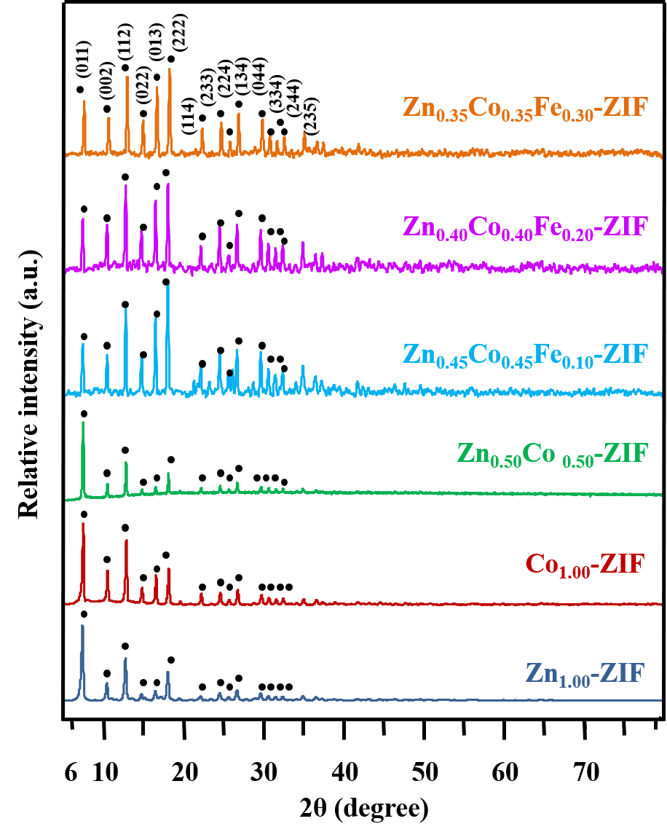
Fig. S1 Powder XRD patterns of all the synthesized ZIF materials

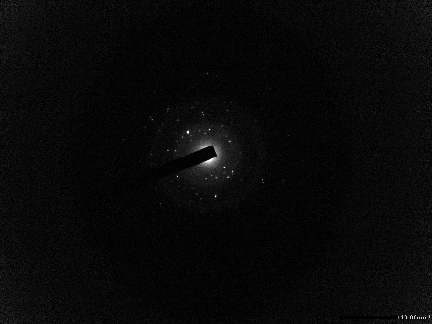
Fig. S2 SAED pattern of C,N(ZCo-CF-Fe)-HT2 nanocomposite

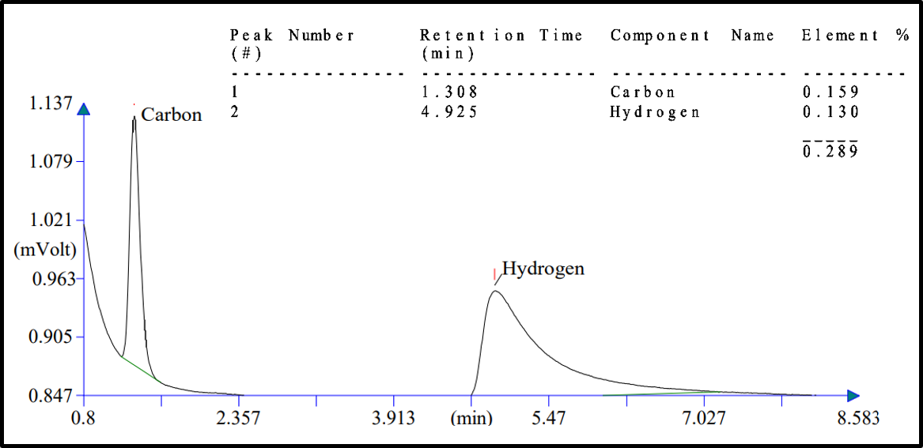
Fig. S3 CHNS analysis of the sample C,N(ZCo-CF-Fe)-HT2

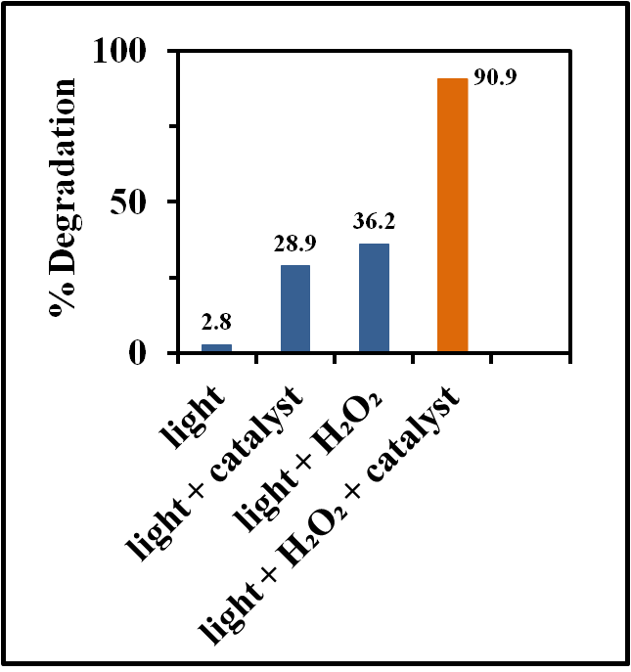
Fig. S4 % Degradation of TC in the presence of light, C,N(ZCo-CF-Fe)-HT2, H₂O₂, and all three at once

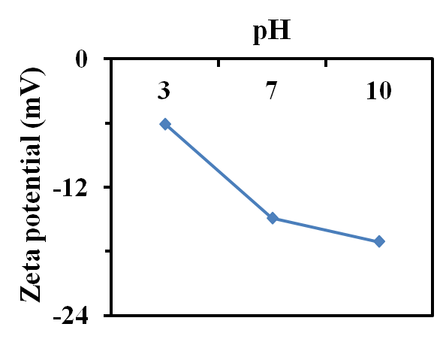
Fig. S5 Mean zeta potentials of C,N(ZCo-CF-Fe)-HT2 at pH 3, 7, and 10

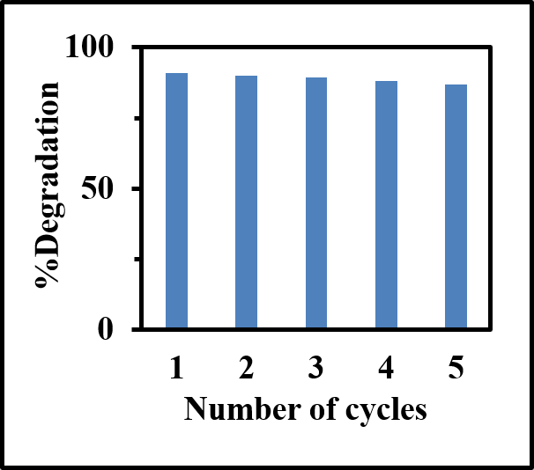
Fig. S6 Recyclability studies of C,N(ZCo-CF-Fe)-HT2 upto five consecutive cycles

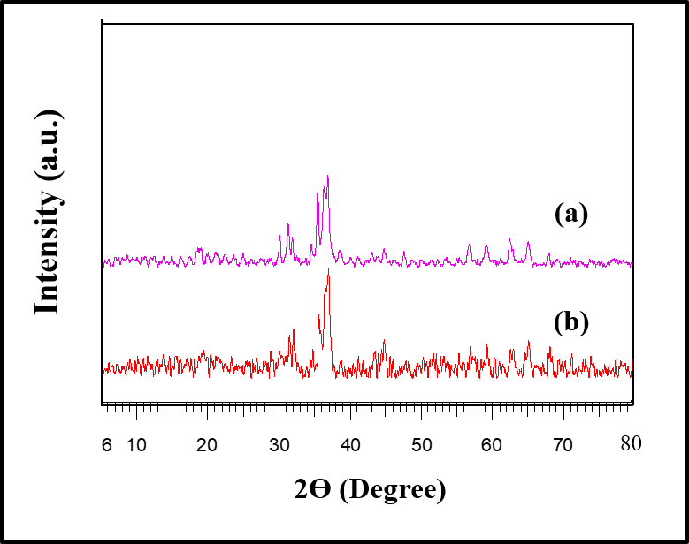

Fig. S7 Powder XRD patterns of (a) regenerated and (b) fresh C,N(ZCo-CF-Fe)-HT2

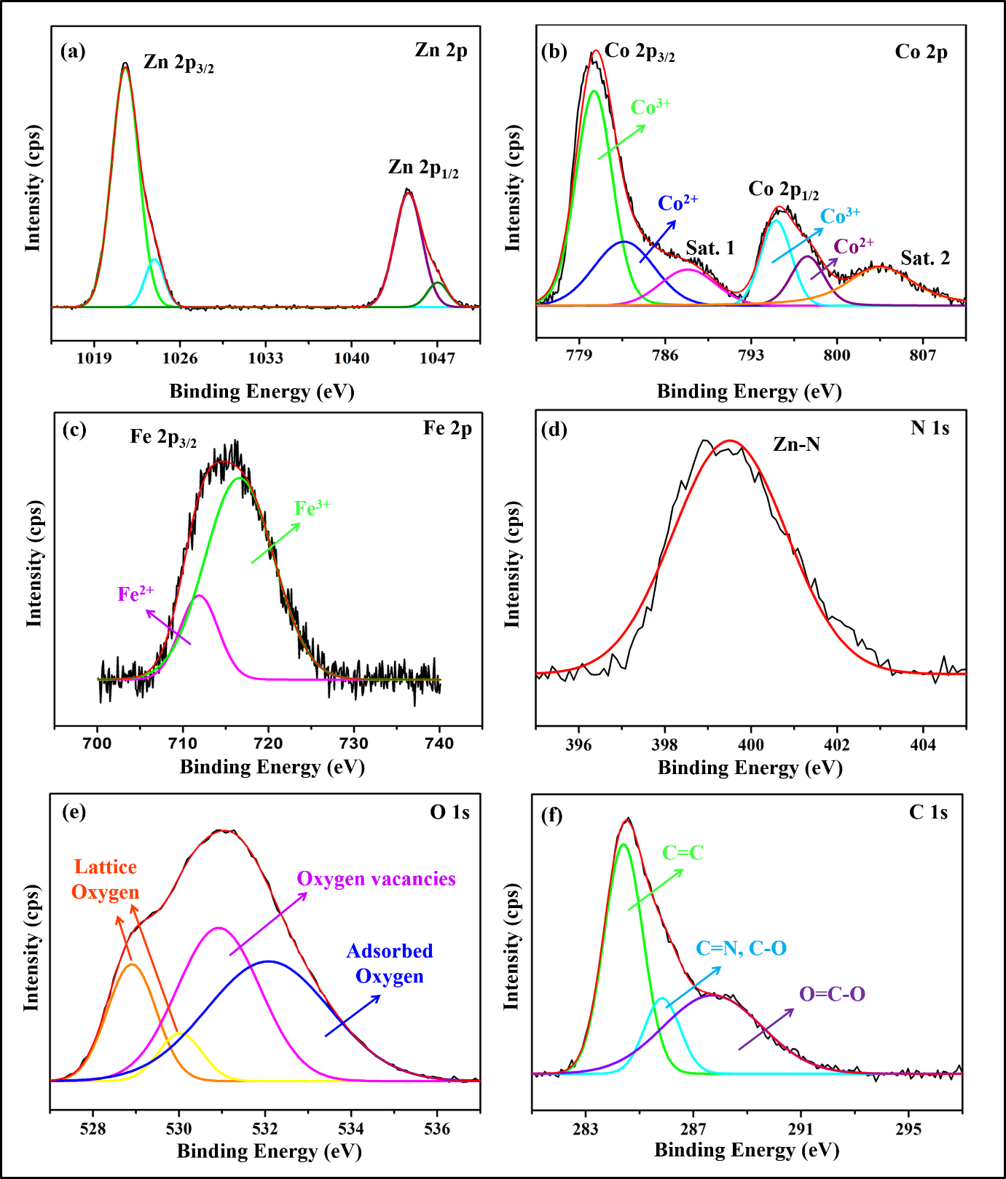
Fig. S8 XPS high resolution spectra of elements constituting recycled C,N(ZCo-CF-Fe)-HT2: (a) Zn 2p, (b) Co 2p, (c) Fe 2p, (d) N 1s, (e) O 1s and (f) C (1s)

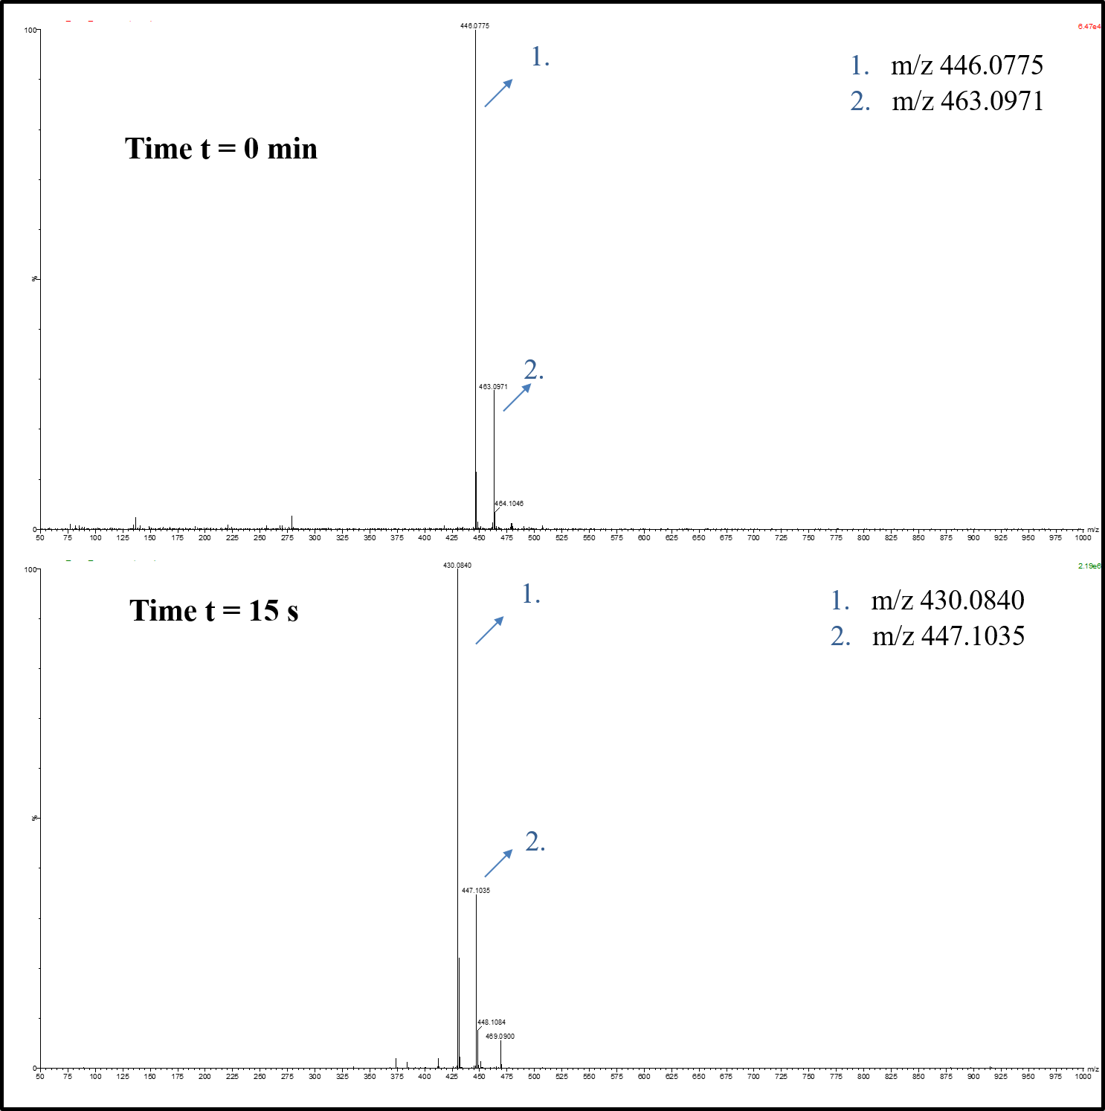
Fig. S9 LC-MS spectra of TC degradation at 0 min and after 15 s of visible light illumination

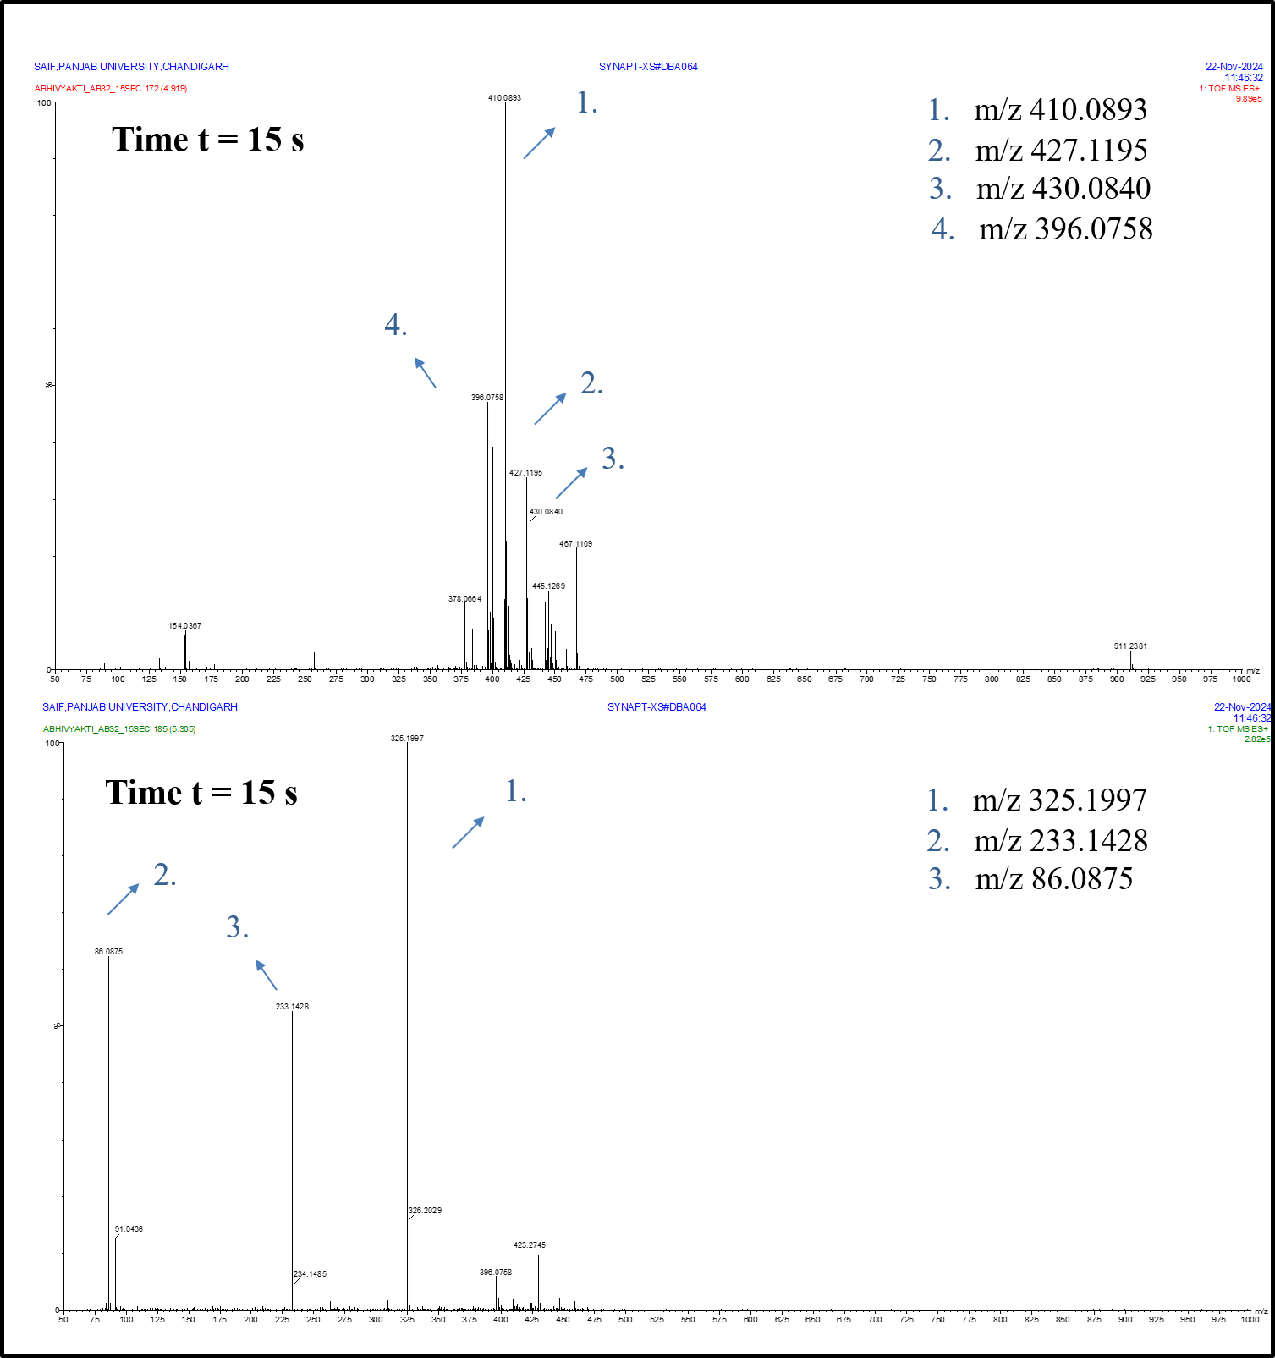
Fig. S10 LC-MS spectra of TC degradation after 15 s of visible light illumination

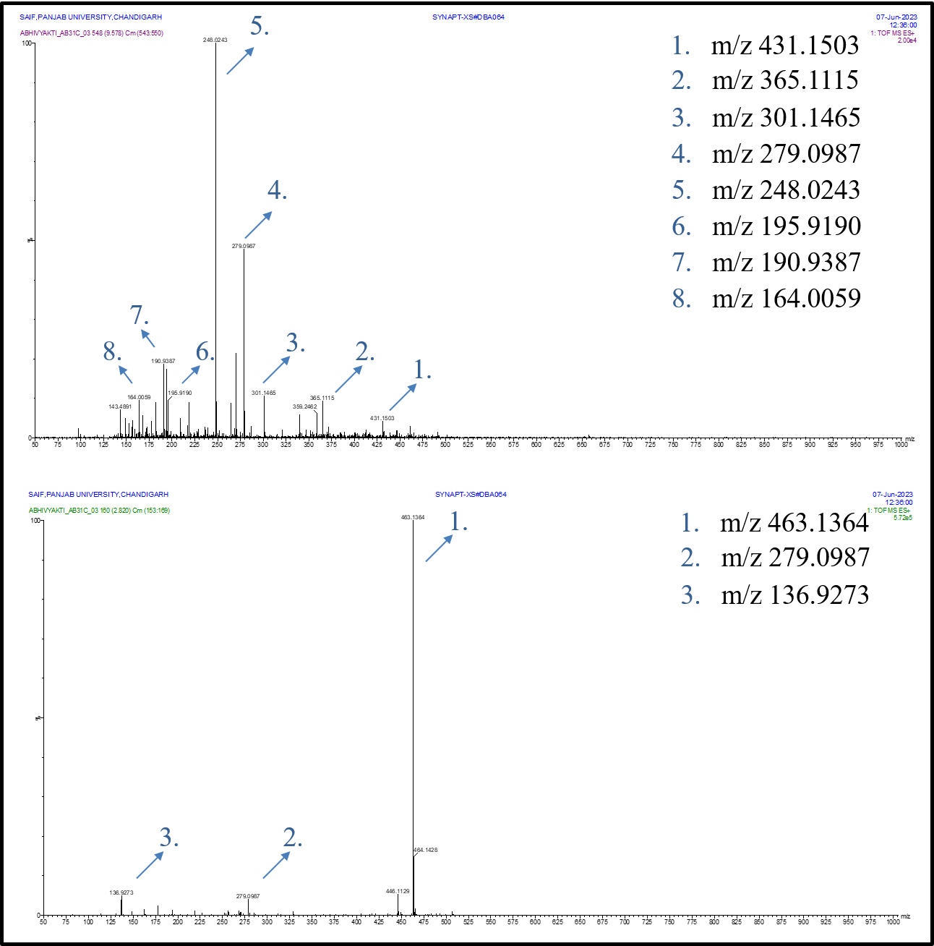
Fig. S11 LC-MS spectra of TC degradation after 6 min of visible light illumination

Table S1 Band gap values obtained from UV-vis DRS for C,N(Z)-HT, C,N(Co)-HT, C,N(ZCo)-HT, C,N(ZCo-CF-Fe)-HT1, C,N(ZCo-CF-Fe)-HT2, and C,N(ZCo-CF-Fe)-HT3
Material | Band Gap (eV)
C,N(Z)-HT | 3.05
C,N(Co)-HT | 1.50
C,N(ZCo)-HT | 1.50
C,N(ZCo-CF-Fe)-HT1 | 1.45
C,N(ZCo-CF-Fe)-HT2 | 1.55
C,N(ZCo-CF-Fe)-HT3 | 1.50

Table S2 Comparison of the photocatalytic efficacy of C,N-ZnO/Co₃O₄/CoFe₂O₄/Fe₃O₄ with other state of the art materials
Material | Pollutant | Pollutant conc. (mg/L) | Catalyst dosage (mg/L) | Degradation time (min) | % Degradation | Ref.
g-C₃N₄ nanofilm | TC | 20 | 20 | 60 | 83.1 | [1]
MIL-125 (Ti)/GO | TC | 10 | 100 | 90 | 81.1 | [2]
Carbon doped Bi₂WO₆ | TC | 50 | 500 | 60 | 84.6 | [3]
HPW_{x}@Fe₂O₃-CNT Nanobox | TC | 10 | 200 | 100 | 100 | [4]
Lignin derived C doped g-C₃N₄ | TC | 10 | 500 | 60 | 86.6 | [5]
Co-MoS₂@BC | TC | 20 | 100 | 30 | 98.8 | [6]
Iron/cobalt oxide | TC | 50 | 300 | 50 | 83.5 | [7]
NiCo/CoNiO₂@CNTs | TC | 20 | 200 | 30 | 95.9 | [8]
C,N- ZnO/Co₃O₄/CoFe₂O₄/Fe₃O₄ | TC | 15 | 150 | 6 | 90.9 | Present work

References:
- Wang S, Hou M, Fu H, Ruan Z, Sun T, Zhu Y, Wang L, Wang Y, Zhang S (2023) Synthesis of ultrathin porous g-C3N4 nanofilm via template-free method for photocatalytic degradation of tetracycline. Journal of Alloys and Compounds 939:168738. https://doi.org/10.1016/j.jallcom.2023.168738
- Tang J, Gao G, Luo W, Dai Q, Wang Y, Elzilal HA, Abo-Dief HM, Algadi H, Zhang J (2023) Z-scheme metal organic framework@ graphene oxide composite photocatalysts with enhanced photocatalytic degradation of tetracycline. Advanced Composites and Hybrid Materials 6(6):190. https://doi.org/10.1007/s42114-023-00771-9
- Jiang X, Chen S, Zhang X, Qu L, Qi H, Wang B, Xu B, Huang Z (2023) Carbon-doped flower-like Bi2WO6 decorated carbon nanosphere nanocomposites with enhanced visible light photocatalytic degradation of tetracycline. Advanced Composites and Hybrid Materials 6(1):47. https://doi.org/10.1007/s42114-022-00616-x
- Sun P, Zhou S, Yang Y, Liu S, Cao Q, Wang Y, Wågberg T, Hu G (2022) Artificial chloroplast-like phosphotungstic acid—iron oxide microbox heterojunctions penetrated by carbon nanotubes for solar photocatalytic degradation of tetracycline antibiotics in wastewater. Advanced Composites and Hybrid Materials 5(4):3158-75. https://doi.org/10.1007/s42114-022-00462-x
- Xu Y, Li W, Xu T, Wang G, Huan W, Si C (2023) Straightforward fabrication of lignin-derived carbon-bridged graphitic carbon nitride for improved visible photocatalysis of tetracycline hydrochloride assisted by peroxymonosulfate activation. Advanced Composites and Hybrid Materials 6(6):197. https://doi.org/10.1007/s42114-023-00779-1
- Zheng H, Mo Q, Song L, Zhang X, Huang J, Sheng G (2024) Co-MoS2@ BC catalyzed ultrafast degradation of tetracycline by peroxymonosulfate: Domination of non-radical pathway based on 1O2. Journal of Organometallic Chemistry 1018:123293. https://doi.org/10.1016/j.jorganchem.2024.123293
- Nie M, Li Y, Li L, He J, Hong P, Zhang K, Cai X, Kong L, Liu J (2021) Ultrathin iron-cobalt oxide nanosheets with enhanced H2O2 activation performance for efficient degradation of tetracycline. Applied Surface Science 535:147655. https://doi.org/10.1016/j.apsusc.2020.147655
- Zang J, Chen L, Zhong S, Fan G (2024) Joule-heating-assisted ultrafast fabrication of CoNi/CoNiO2 heterojunction integrated with carbon nanotubes for efficient tetracycline destruction through peroxymonosulfate activation. Journal of Environmental Chemical Engineering 113844.

