Supplementary Information
Cu-Zn@HA Bimetallic Nanozymes: A Novel Approach for ROS Clearance and Macrophage Polarization in Colitis Therapy

Materials
Zinc chloride (ZnCl₂, Aladdin, Lot# I2328602) and sodium hyaluronate were utilized in the preparation of the formulations. Copper(II) sulfate pentahydrate (CuSO₄·5H₂O, Sigma-Aldrich, BCCJ9581) was also employed in the synthesis. Ascorbic acid (Aladdin, Lot# G2223071) served as an essential reagent for the reactions conducted.
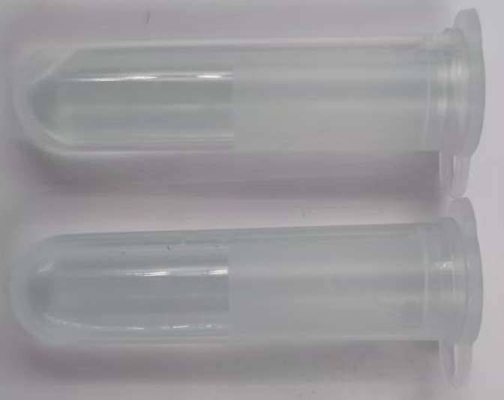
Supplementary Fig. 1 shows Solution 1 on the left (before dialysis) and Solution 2 on the right (after dialysis).

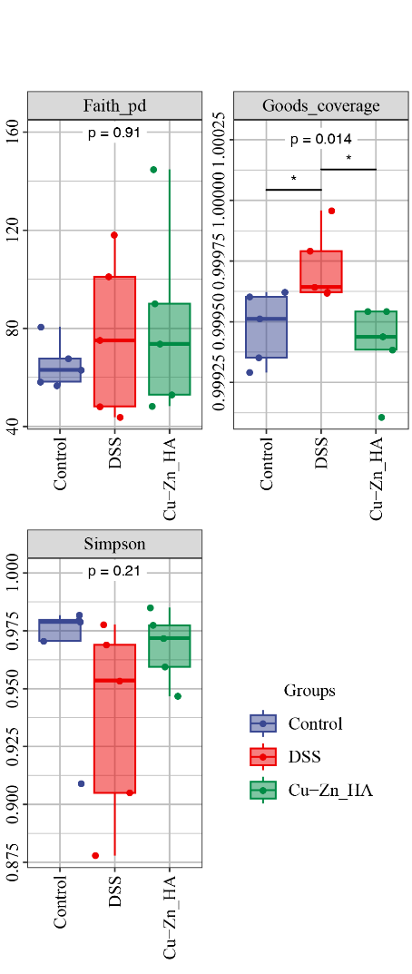
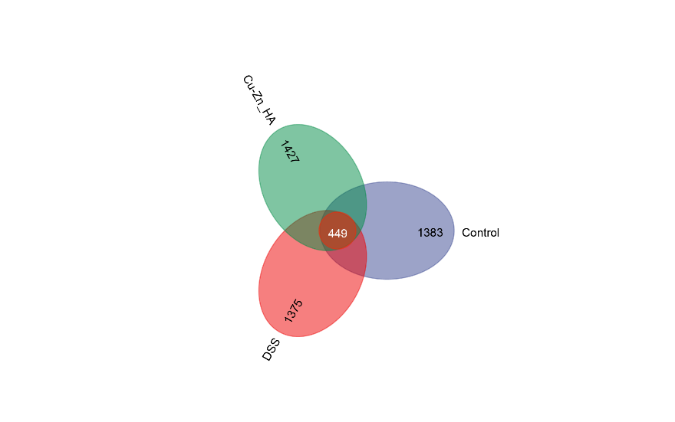
Supplementary Fig. 2 Venn diagram of species differences and biomarker analysis.

Supplementary Fig. 3 Assessment of α-diversity in microbial communities, evaluated using Faith’s PD, Good’s Coverage, and Simpson indices.

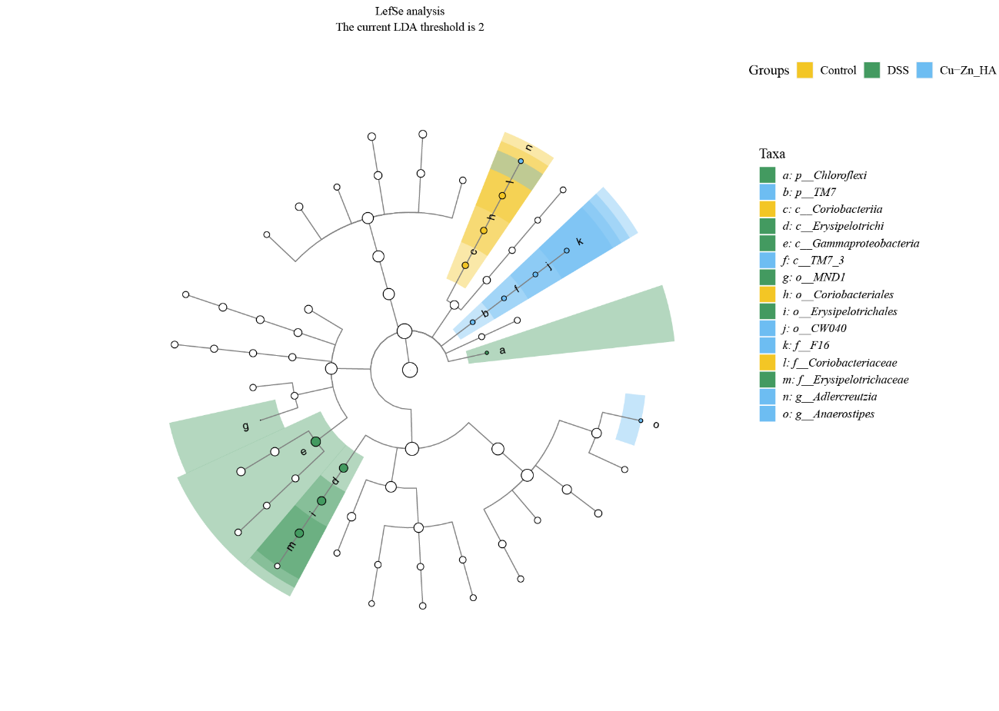
Supplementary Fig. 4 Differential species analysis and biomarker identification using LEfSe (Linear Discriminant Analysis Effect Size).
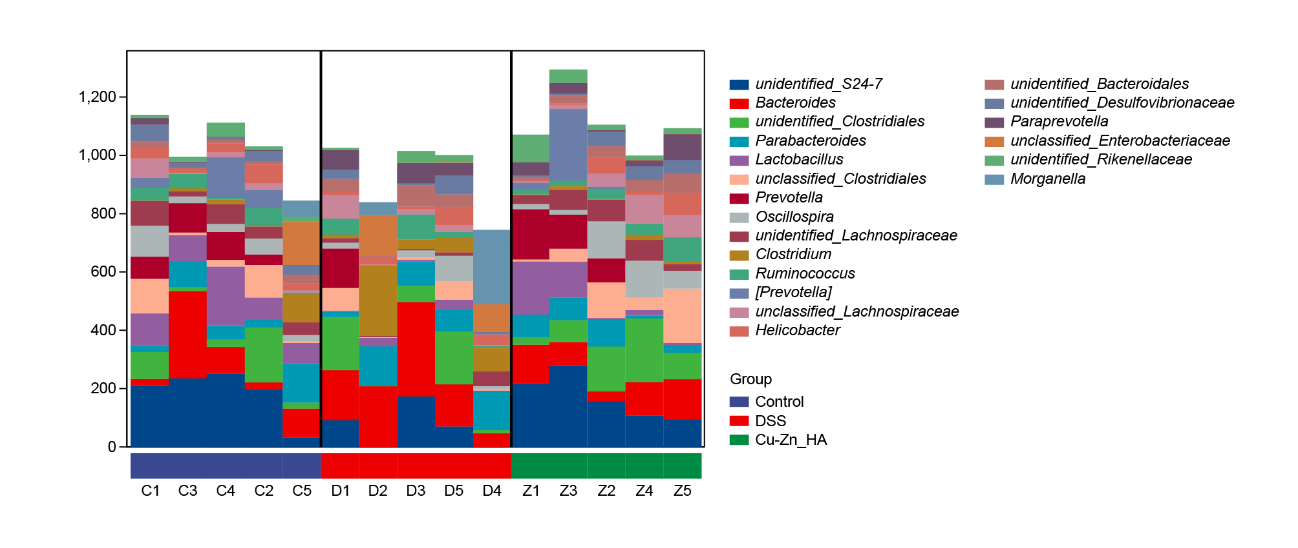
Supplementary Fig. 5 Functional potential prediction and metabolic pathway composition of microbial communities.

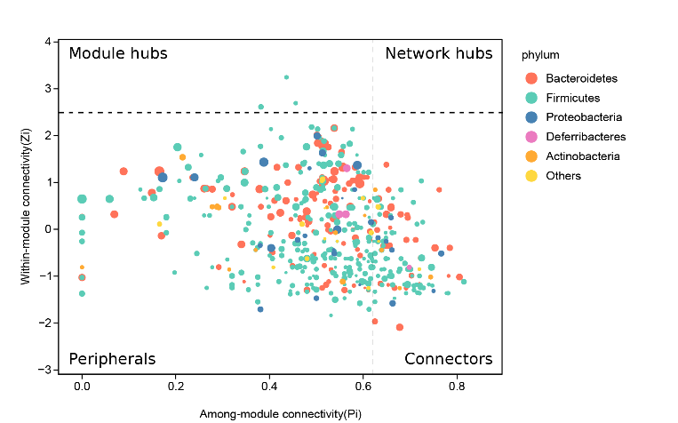
Supplementary Fig. 6 Beta diversity analysis and hierarchical clustering of microbial communities.

Supplementary Fig. 7 Correlation network analysis and ZIPI plot. This figure presents a correlation network illustrating the interactions among key microbial taxa and their functional potentials.
