Mechanically Robust Polyacrylamide/Gelatin Ionic Hydrogels Reinforced by Sodium Alginate for Wearable Device Applications
Dapeng Cui,^{a, b*} Yunlong Sun,^{a, b} Tuo Li^{c}, Zhiwei Hu,^{c} Yi Zhao,^{c} Xuanye Wang,^{c} Shengxi Chen,^{c} Zhexenbek Toktarbay,^{d, e} Huige Wei,^{b, c*}
ª State Key Laboratory of Bio-based Fiber Materials, Tianjin University of Science and Technology, Tianjin 300457, China
^{b} College of Light Industry Science and Engineering, Tianjin University of Science and Technology, Tianjin 300457, China
^{c} Tianjin Key Laboratory of Brine Chemical Engineering and Resource Eco-utilization, Tianjin Key Laboratory of Multiplexed Identification for Port Hazardous Chemicals, College of Chemical Engineering and Materials Science, Tianjin University of Science and Technology, Tianjin 300457, China
^{d} Department of Сhemistry, Faculty of Natural Sciences and Geography, Abai Kazakh National Pedagogical University, Dostyk Ave. 13, 050040, Almaty, Kazakhstan
^{e} Laboratory of Engineering Profile, Satbayev University, Satbayev St. 22a, Almaty 050013, Kazakhstan

* Email:dapeng@tust.edu.cn; (D. Cui)
* Email: huigewei@tust.edu.cn (H. Wei)

Figure. S1 Cross-sectional SEM images of (a) pure PAM hydrogel, (b) PAM/Geltain hydrogel, (c) PGS hydrogel, and (d) PGS-Ca²⁺ hydrogel. (e) Top-view of SEM image and (f) elemental mapping of PGS-Ca²⁺/LiCl.
Figure. S2 FT-IR spectra of PAM, PG, PGS hydrogels.
Figure. S3 Toughness and tensile strength of PG, PGS, PGS-Ca²⁺/LiCl hydrogels.
Figure. S4 Mechanical properties of PGS-Ca²⁺/LiCl hydrogels. (a) and (c) Resistance change under the curve period of 200 consecutive tensile load cycles. (b) and d) Relationship between maximum residual stress strain and tensile cycle under different strains. (e) and (g) Load resistance changes under cycle curve cycles for 200 consecutive compression cycles. (f) and (h) Changes in maximum stress and residual strain with compression cycles.
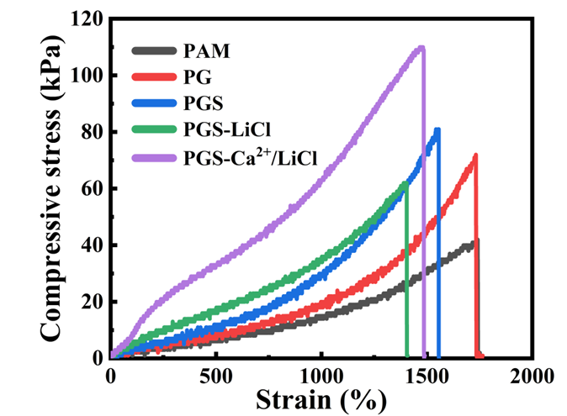
Figure. S5 Stress-strain curves of different hydrogels.
Figure. S6 Digital photographs showing the excellent mechanical properties of PGS-Ca²⁺/LiCl hydrogels: (a) for stretching, (b) for compression, and (c) for puncture.
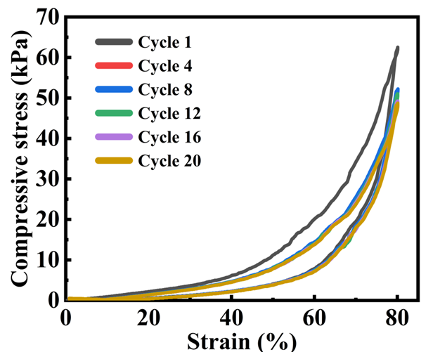
Figure. S7 PGS-Ca²⁺/LiCl hydrogel at a compression strain of 80% for 20 cycles.
Figure. S8 Transmittance of hydrogels with different concentrations of SA.
Figure. S9 Conductivity of hydrogels with different concentrations of LiCl.

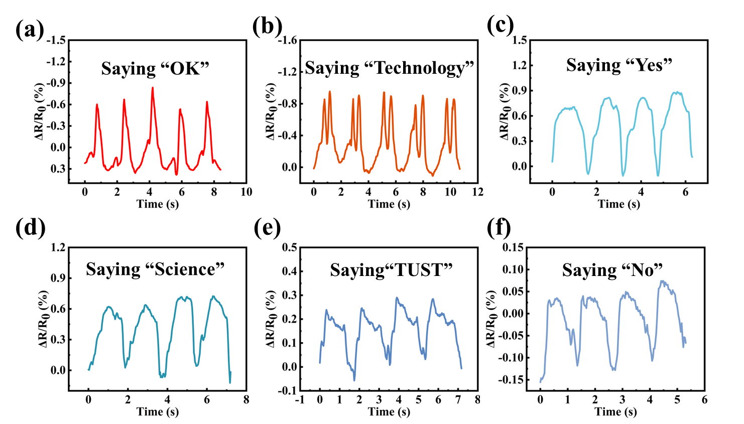
Figure. S10 The resistance change of hydrogel with different speech of volunteers.
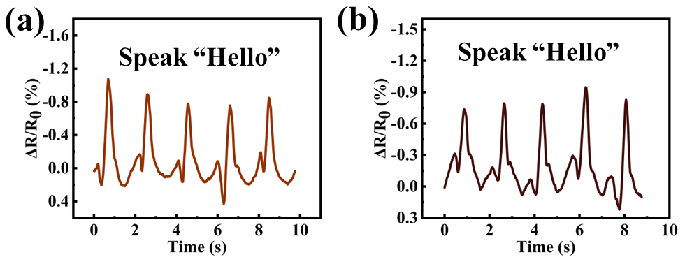
Figure. S11 Two volunteers say "hello" for five times.
Figure. S12 The resistance changes of the hydrogel with different movements of the volunteer.
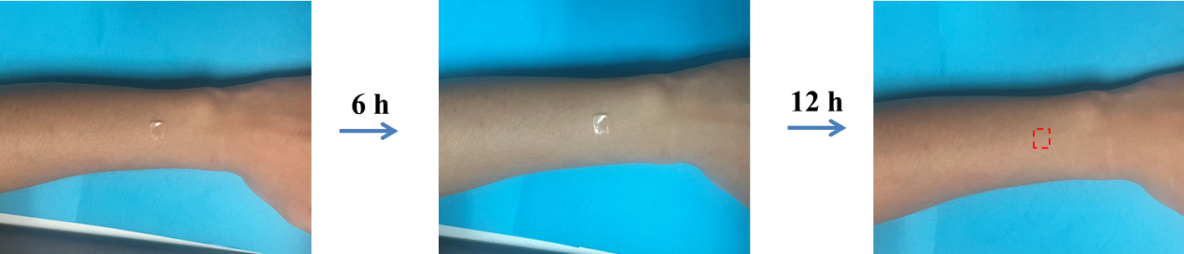
Figure. S13 Biocompatibility test of PGS-Ca²⁺/LiCl hydrogel.

Figure. S14 Relative resistance changes of writing (a) “Yes” and (b) “No”.
Figure. S15 Word recognition accuracies for these two words calculated from 16 writings of each word of “Yes” and “No”.

