Supporting Information for
Ultra-high Thermal Conductive Multifunctional Composites with Uniaxially Oriented Boron Nitride Nanosheets for Future Wireless Charging Technology

Yiwei Zhou et al.

Correspnding author: Jinhong Yu, Yixiang Xu, Nan Jiang
Email: yujinhong@nimte.ac.cn, Yixiang.Xu@nottingham.edu.cn, jiangnan@nimte.ac.cn

This PDF file includes:

Notes. S1 to S5
Figs. S1 to S11
Tables. S1 to S6
References

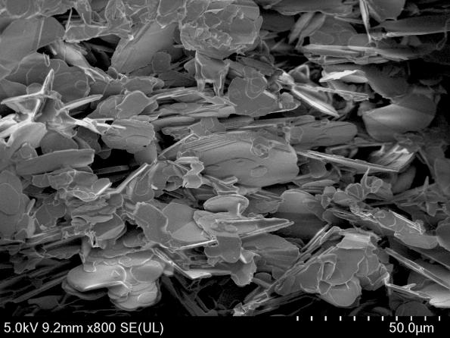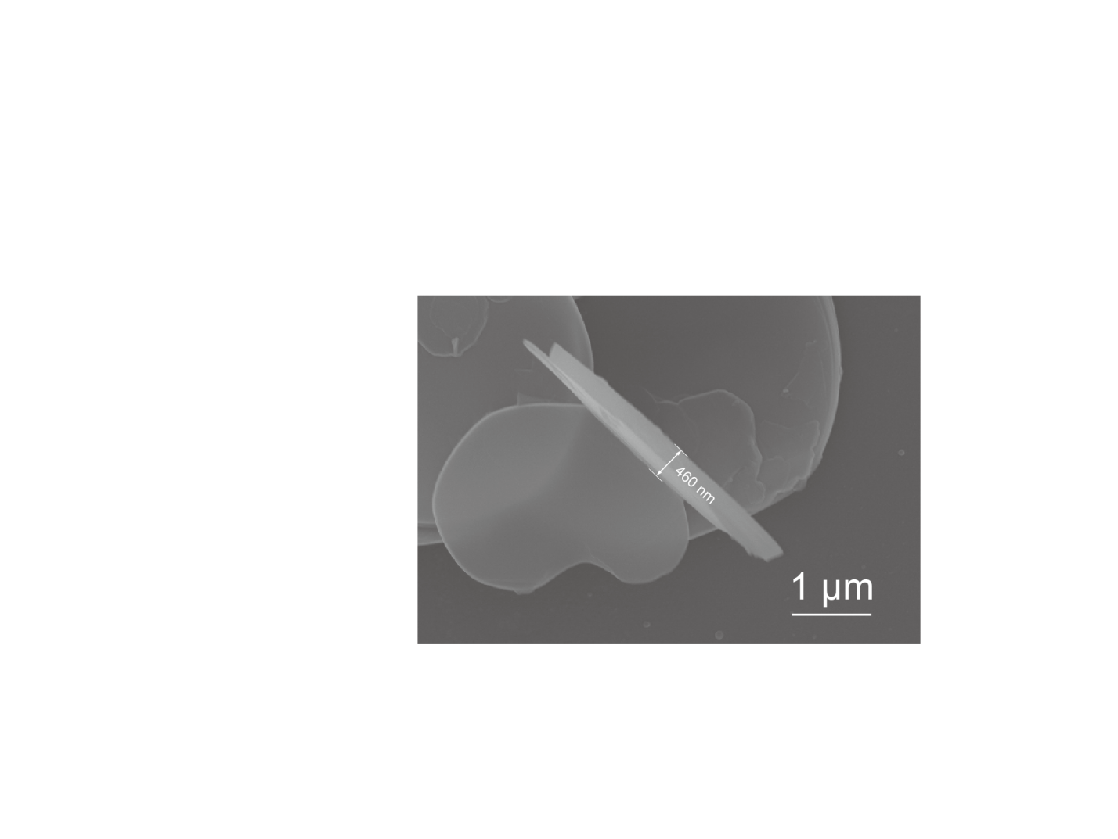
50 μm
(a)
(b)
Fig. S1. SEM pictures of h-BN. The average thickness of h-BN is 460 nm. Figure S1b shows the typical thickness of h-BN.

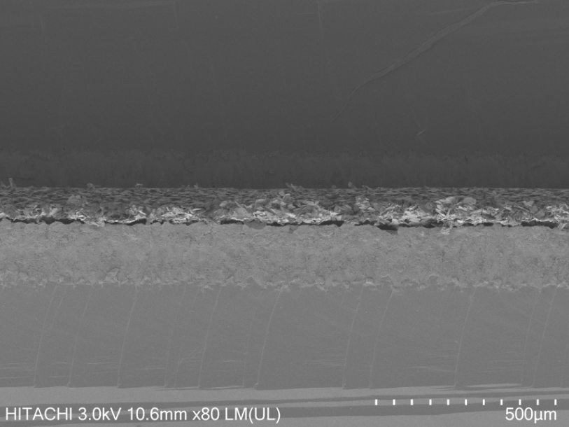
250 μm
54.4 μm
Fig. S2. Typical thickness of BN/TPU film.

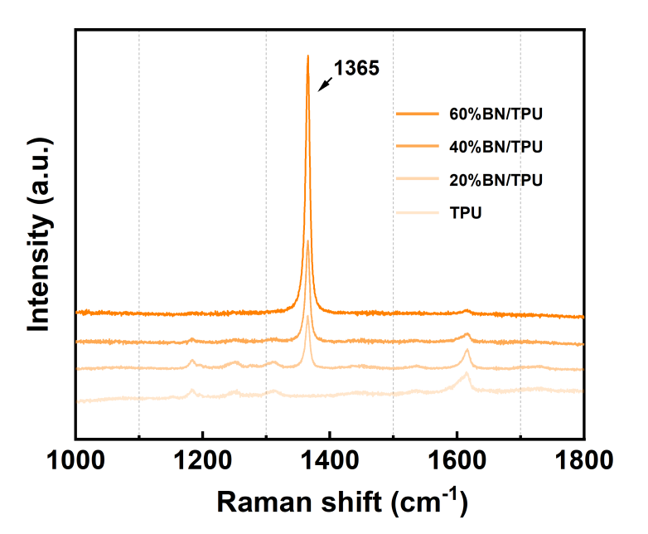

Fig. S3. Raman spectra of BN/TPU film with different h-BN loading.

Note S1.
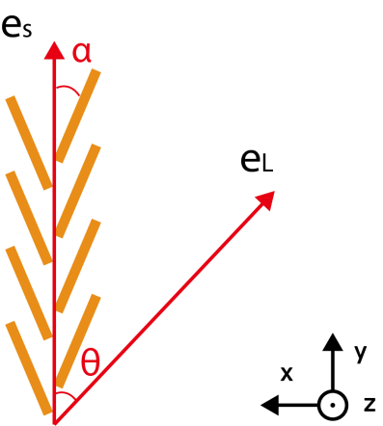
Fig. S4. Schematic diagram of BNNSs alignment and the angle-resolved polarized Raman configuration.

Figure S4 illustrates a simplified model of the alignment of BNNSs and the arrangement of angle-resolved polarized Raman measurements. The laboratory coordinate (x, y, z) was represented by black vectors, with the y and x axes aligned parallel and perpendicular, respectively, to the basal plane direction of the 67 vol% BN/TPU composite. The laser travels in the z direction at an angle θ relative to the polarized laser and the basal plane. The BNNS was presumed to have a homogeneous distribution with an average alignment angle α relative to the basal plane (y). The unit electric field vectors of the incident laser and scattered Raman signal were denoted as e_{L} and e_{S}, respectively. The angle θ, which represents the deviation between the direction of the incident laser's polarization and the basal plane, was modified using a half-wave plate with a step size of 7.5 degrees. Furthermore, measurements were also taken at θ=90° and 180°. The equation provided calculates the cumulative Raman intensity of the E2g mode contributed by all the BNNSs: [1–3]
I_{E2g} (θ)=1/2 c² cos²α{2+cos[2 (α-θ)]+cos[2 (α+θ)]} （S1.1）
I_{E2g} would reach the maximum and minimum when the electric field vector of the incident polarized laser e_{L} was parallel (θ= 0º and 180°, I_{E2g} (‖)) and perpendicular (θ=90° and 270°, I_{E2g} (⊥)) to the basal plane of the 67 vol% BN/TPU composite, respectively. The ratio of I_{E2g} (‖)/I_{E2g} (⊥) was equal to cot²α and showed an increasing trend with decreasing α, where α was the alignment angle between average BNNS and length direction (y), as shown in Figure S4.

Note S2. The calculation of the index of Hermans orientation factor ultilizing WXRD results.
To quantify the lattice orientation information of the BN/TPU composite, we extended the diffraction peak azimuth to obtain the azimuth angle x (x=2θ) and analyzed the index of Hermans orientation factor (f) derived from the WAXS. Details of the analysis for index f are as follows.
$f=\frac{1}{2}(3 \left\langle \cos^{2}\right.\left.x\right\rangle −1)$ （S2.1）
$\left\langle \cos^{2}\right.\left.x\right\rangle =\int_{0}^{\frac{π}{2}}{{(cos}^{2}x) dx}$ （S2.2）
where f = 1.00 is perfect face-on orientation, f = - 0.5 is perfect edge-on orientation and f = 0 is a completely random, isotropic structure. Based on this, we found that for 80% BN/TPU composite, f was -0.5, suggesting that the excellent structural alignment was achieved in the out-of-plane direction.

120 μm
Fig. S5. Structure of dried 80% BN/TPU films after hot pressing.

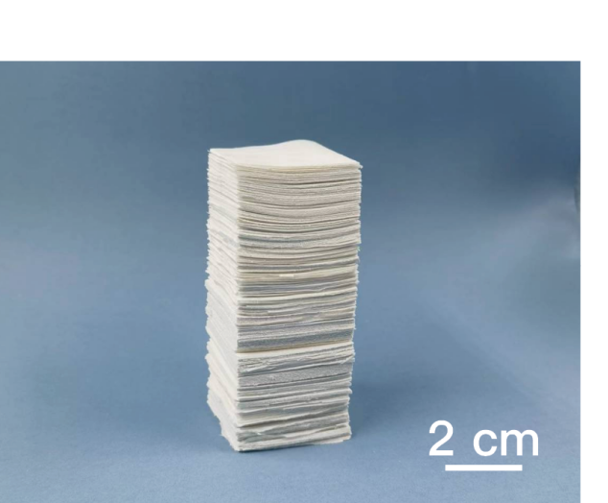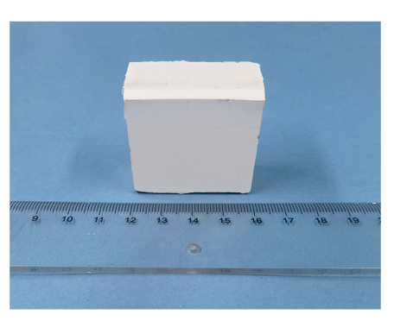
4 cm
(a)
(b)
Fig. S6. Larger sample made of 40 mm× 40 mm films.

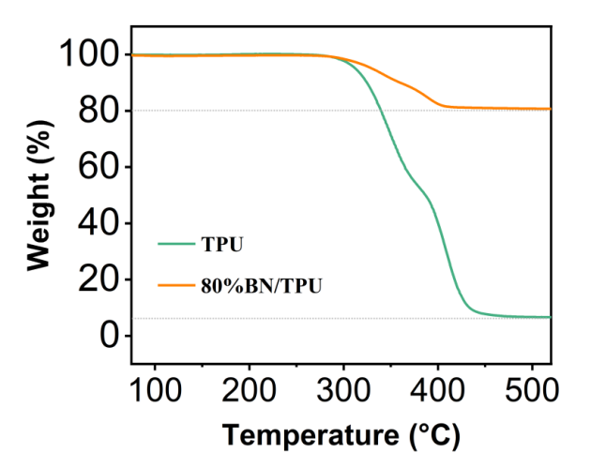
Fig. S7. Thermogravimetry Analysis (TGA) curves of TPU and 80% BN/TPU composite.

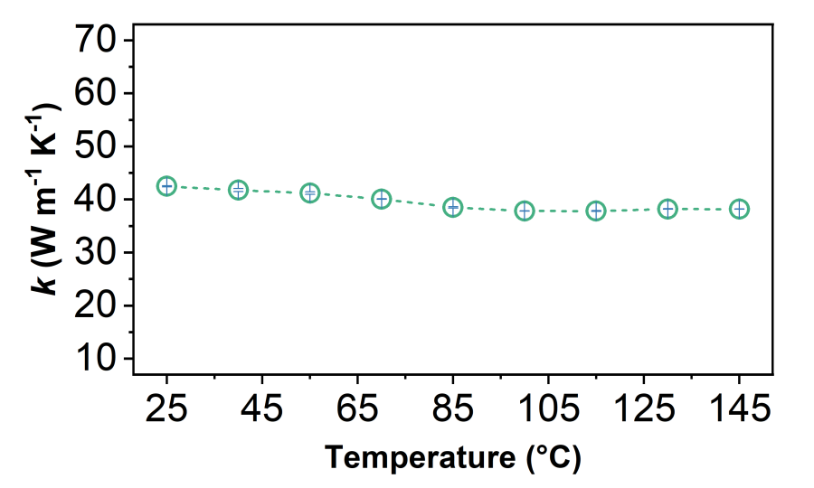
Fig. S8. The curve showed a decreasing trend with increasing environmental temperature.

Table S2. The parameters for the calculation of through-plane thermal conductivity of neat TPU and the h-BN composites. The specific heat capacity (Cp) of all samples was evaluated using a differential scanning calorimeter (DSC) analysis.
The volume content of the h-BN in the BN/TPU composites were calculated, where ρ_{BN} = 2.250 g/cm³, ρ_{TPU} = 1.1477 g/cm³.
h-BN content  (wt%) | Volume content  (vol%) | Thickness  (mm) | Thermal diffusivity  (mm² s⁻¹) | Specific heat capacity  (J g⁻¹ K⁻¹) | Density  (gcm⁻³) | Thermal conductivity  (W m⁻¹ K⁻¹)
80 | 67.11 | 1.60 | 23.52 | 0.98 | 1.88 | 43.33
70 | 54.39 | 2.11 | 12.07 | 1.06 | 1.73 | 22.13
60 | 43.34 | 2.17 | 7.55 | 1.17 | 1.60 | 14.14
50 | 33.55 | 2.15 | 4.24 | 1.26 | 1.50 | 8.01
40 | 25.38 | 1.95 | 1.85 | 1.39 | 1.40 | 3.61
30 | 17.90 | 1.06 | 1.16 | 1.47 | 1.35 | 2.31
20 | 11.31 | 1.81 | 1.09 | 1.47 | 1.30 | 2.08
6 | 3.15 | 2.41 | 0.61 | 1.52 | 1.20 | 1.11
0 | 0 | 2.60 | 0.16 | 1.65 | 1.15 | 0.30

Small BN plate content  (wt%) | Volume content  (vol%) | Thickness  (mm) | Thermal diffusivity  (mm² s⁻¹) | Specific heat capacity  (J g⁻¹ K⁻¹) | Density  (gcm⁻³) | Thermal conductivity  (W m⁻¹ K⁻¹)
80 | 67.11 | 1.00 | 7.96 | 0.91 | 1.21 | 8.76

Table S3. Comparison of through-plane thermal conductivity between our BN/TPU composites with BN-based composites reported in the literature.
Composite | BN Volume content  (vol%) | Thermal conductivity  (W m⁻¹ K⁻¹) | Year | Publication | Reference
BN/PDMS | 10 | 1.15 | 2019 | Adv Funct Materials 2019, 29 (37), 1902575 | 24
BN/PU | 0.85 | 1.54 | 2024 | ACS Nano 2024, 18 (11), 8199–8208 | 41
BN/PDMS/PVA | 15.60 | 1.94 | 2017 | ACS Appl. Mater. Interfaces 2017, 9 (36), 30909–30917 | 42
BN/PVA/EP | 17.2 | 2.073 | 2024 | Chemical Engineering Journal 2024, 489, 151170 | 16
BN/SR | 39.80 | 5.4 | 2019 | Materials & Design 2019, 165, 107580 | 29
BN/SG | 40 | 5.65 | 2022 | ACS Nano 2019, 13 (11), 12653–12661 | 46
BN/EP | 59.43 | 6.11 | 2020 | Chemical Engineering Journal 2020, 397, 125447 | 28
BN/PTFE | 20 | 7.4 | 2023 | ACS Nano 2023, 17 (5), 4886–4895 | 45
BN/EP | 44 | 9 | 2017 | Composites Part A: Applied Science and Manufacturing 2017, 98, 25–31. | 44
BN/PU | 80 | 11.5 | 2022 | ACS Nano 2022, 16 (11), 18959–18967 | 18
BN/PDMS | 30.62 | 12 | 2024 | Nat Commun 2024, 15 (1), 2905 | 47
BN/PDMS | 40.24 | 22 | 2024 | Nat Commun 2024, 15 (1), 2905 | 47
BN/PDMS | 50.4 | 28 | 2024 | Nat Commun 2024, 15 (1), 2905 | 47
BN/PDMS | 63.29 | 32 | 2024 | Nat Commun 2024, 15 (1), 2905 | 47
BN/PDMS | 74.4 | 50 | 2024 | Nat Commun 2024, 15 (1), 2905 | 47
This work | 67.11 | 43.33 | - | - | -

Note S3. Calculation of the thermal resistance of the BN/TPU composites using the Maxwell-Garnett type effective medium approximation (MG-EMA).
$k=k_{TPU}\frac{3+f(β_{∥}+β_{⊥})}{3−fβ_{⊥}}$ (S3.1)
$β_{⊥}=\frac{2(d(k_{BN}−k_{TPU})−2R{k_{BN}k}_{TPU})}{d(k_{BN}+k_{TPU})+2R{k_{BN}k}_{TPU}}$ (S3.2)
$β_{∥}=\frac{L(k_{BN}−k_{TPU})−2R{k_{BN}k}_{TPU}}{Lk_{TPU}+2R{k_{BN}k}_{TPU}}$ (S3.3)
where $k_{BN}$ is 200 W/(mK), $k_{TPU}$ is 0.3 W/(mK), $f$ is the BN volume fraction, L is the lateral size of BN (43.51 μm) and d is the thickness of BN platelets (460 nm). Since the MG-EMA model doesn’t take contact thermal resistance into account, it is hardly used in predicting thermal conductivity of composites with high filler volume fraction. As a result, we fit the experimental data of h-BN filling below 40 vol% into the equation. While the MG-EMA model fits well with the experimental data as presented in Figure 4i, we applies the value of $β_{∥}$ (58.41) into equation (3) and then obtain the value of $R_{boundary}$ (1.12 × 10⁻⁶ Km² W⁻¹) for BN/TPU composites.

Note S4. The analysis of the thermal resistance of the BN/TPU composites using the Agari heat conduction model.
The Agari heat conduction model is introduced based on the the parallel conduction model and the series conduction model for calculating the thermal conductivity in which the ease in forming conductive chains of particles and the effect of particles on the crystallinity, crystal size and thermal conductivity of polymer are included. According to the Agari heat conduction model[4]:
$log {[k}_{com}/(C_{1}· { k}_{TPU}) ]=fC_{2}·$ $log({ k}_{TPU}{/C}_{1}{ k}_{TPU})$ (S4.1)
where $k_{com}$, ${ k}_{BN}$ and ${ k}_{TPU}$ are the thermal conductivity of composite, h-BN, and TPU matrix, respectively; $f$ is the volume fraction of h-BN; Critical volume fraction (CVF) refers to the content of fillers present at the inflection point of the S-shaped curve obtained by plotting logarithms of thermal conductivity of BN/TPU composites, against the volume content of fillers; $C_{1}$ is a parameter to evaluate the effect of h-BN on the crystallinity, crystal size and thermal conductivity of TPU matrix. Because $CVF$ decreased with increasing ease in forming conduction paths, there is:
$C_{2}=log (1/CVF)$ (S4.2)
where $C_{2 }$> 0, 0<$CVF$<1. By substituting equation (S4.1) and (S4.2), there is:
$log {[k}_{com}/(C_{1}· { k}_{TPU}) ]=flog(1/CVF)·$ $log({ k}_{TPU}{/C}_{1}{ k}_{TPU})$ (S4.3)
$log k_{com}=log(1/CVF)·$ $log({ k}_{BN}{/C}_{1}{ k}_{TPU})·f+log (C_{1}· { k}_{TPU})$ (S4.4)
In the BN/TPU composites, ${ k}_{BN}$= 200 W m⁻¹ K⁻¹, ${ k}_{TPU}$= 0.3 W m⁻¹ K⁻¹. Then, we fit the experimental thermal conductivity BN/TPU composites using Equation (S4.4), as the resulting shown as follows, where the independent variable is $f$, the dependent variable is $log k_{com}$, the slope is [$log(1/CVF)·$ $log({ k}_{TPU}{/C}_{1}{ k}_{TPU})]$ and the intercept is $log (C_{1}· { k}_{TPU})$.
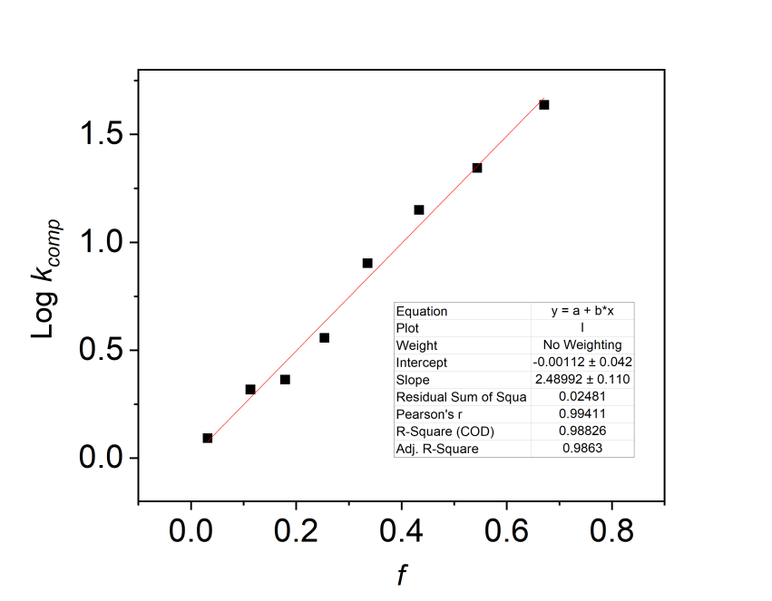
Based on the results of the linear fit, we can calculate that for the BN/TPU composites, C₁ = 3.326, CVF = 0.0827, C₂ = 1.08 >0.

Table S4. Parameters obtained from Foygel’s model for BN/TPU and small BN plate/TPU composites.
 | V_{f} | k₀ | V_{c} | τ | $R_{contact}$ (m² /(mK))
BN/TPU composite | 0.67 | 134.12 | 0.08 | 2.20 | 2.50×10⁴
Small BN plate/TPU composite | 0.67 | 39.12 | 0.16 | 2.19 | 3.16×10⁵

Note S5. Monte Carlo calculation.
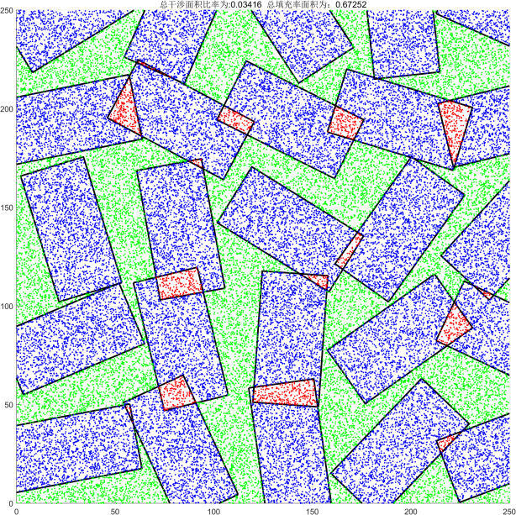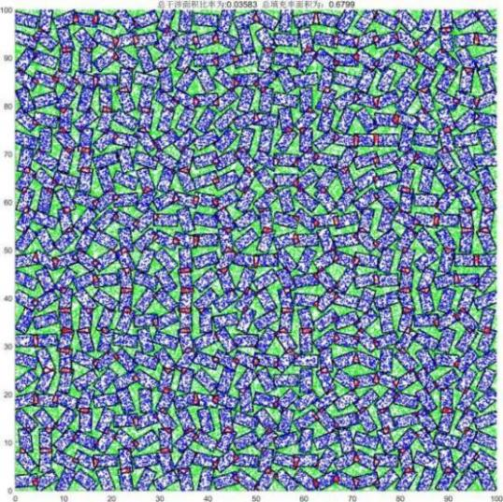
(a)
(b)
Fig. S9. Distribution models of the BN/TPU composite (a) and the small BN plate/TPU composite (b) at BNNS volume fraction of 67% utilizing Monte Carlo method.
Our calculation built a layered structure, where the sizes of RVE are 250 × 250 × 20 μm³ and 100 × 100 × 20 μm³, respectively. According to the actual aspect ratio of BNNS in the experiment, the lateral dimensions are set as 86 × 43 μm² and 6 × 3 μm² with the same thickness for the systems of BN/TPU composite and the small BN plate composite. Considering that the volume fraction of BNNS in the system is 67%, there are 500 sheets randomly distributed in the RVE with large-lateral-size BNNS, which are separated in 5 layers with 100 sheets per layer (Figure S9a). Similarly, 2420 sheets are dispersed in the RVE of small-lateral-size BNNS, which are separated in 5 layers with 484 sheets per layer, as presented in Figure S9b. Initially, BNNSs are systematically positioned on the plane based on their coordinates with no overlapping areas. Subsequently, the orientation of the chosen BNNS are defined by the random parameter: Δα∈ [0, Π]. The overlapping areas are calculated by randomly generating points inside a specified region and determining if these points lie within the intersection of two or more geometric shapes while ensuring that the volume percentage of BNNS is precisely 67%. Based on this, a total of 5 layers of models are created to produce the entire geometry. Our calculation results indicate that the total overlapping ratio of the BNNSs in the BN/TPU composite and the small BN plate composite with the same volume fraction are almost the same (≈0.036). However, the quantity of BNNSs in the small BN plate composite surpasses that in the BN/TPU composite, thus leading to more interfaces in the system.

Note S6.
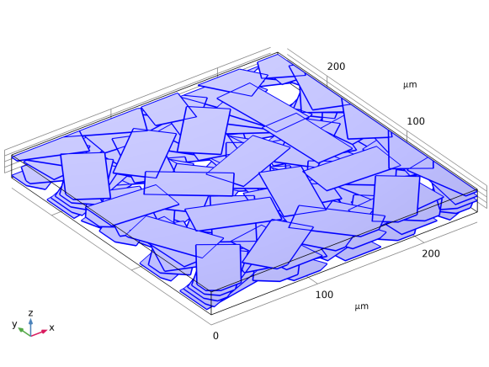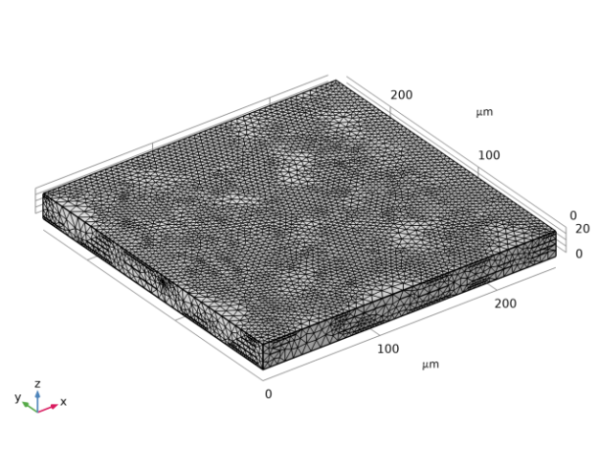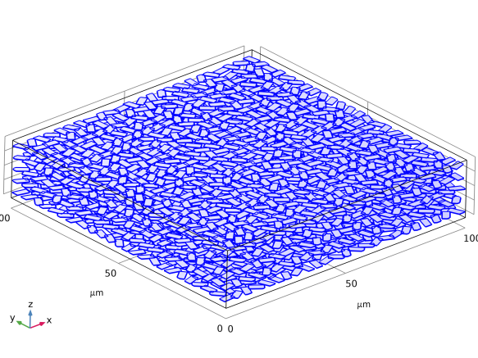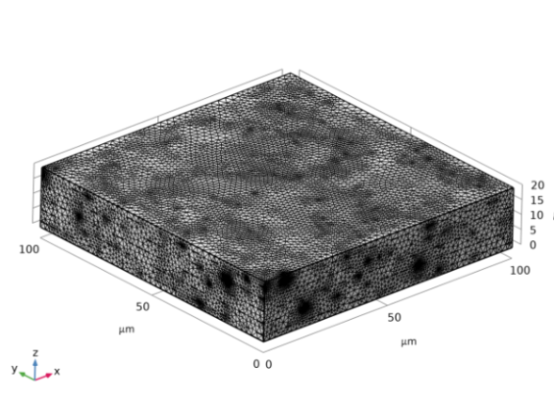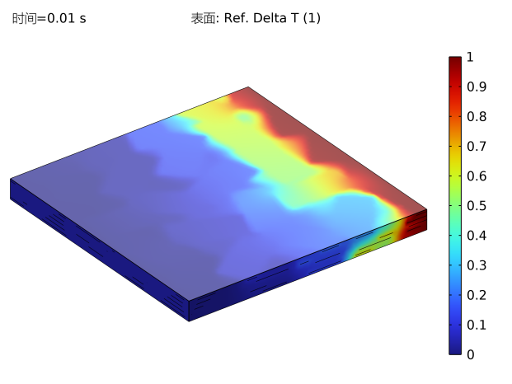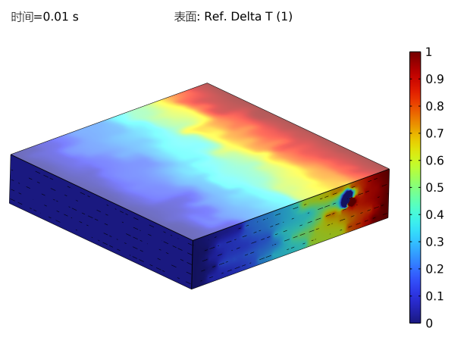
(a)
(b)
(c)

Fig. S10. Finite Element Analysis. a, b) The models and corresponding grid divisions of the BN/TPU composite and the small BN plate composite at BNNS volume fraction of 67% used in the Finite Element Analysis. c) The simulating results of the BN/TPU composite and the small BN plate composite at 0.1s of transient state heat transfer.
Initially, we simulate the distribution of heat flux during steady-state heat transfer (Figure 3j). Given the boundary condition (25K for the BN/TPU composite and 10K for the small BN plate composite according to the different transfer distance), we subsequently examined the thermal performance between the BN/TPU composite and the small BN plate composite. Based on the transient state heat transfer of both models at 0.1s presented in Figure S10c, the BN/TPU composite has a better thermal performance than the small BN plate composite.
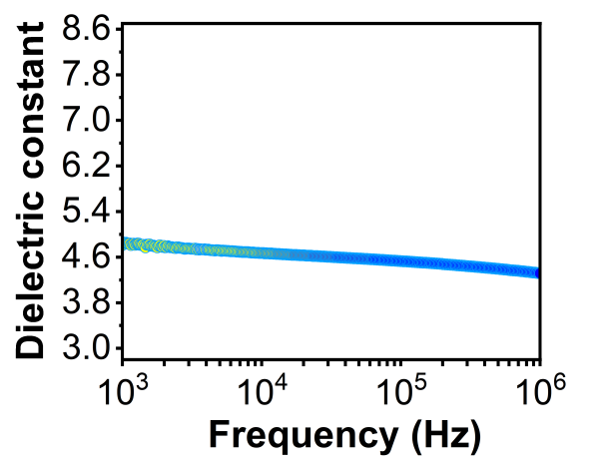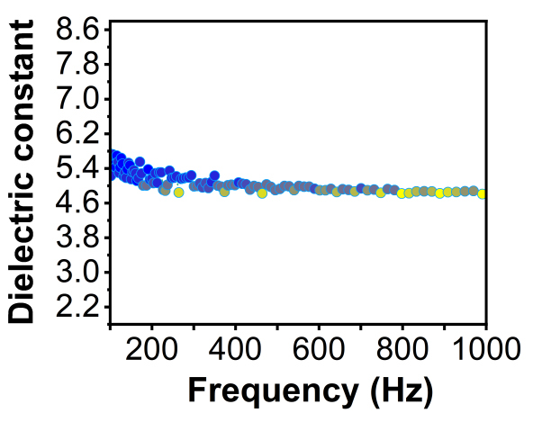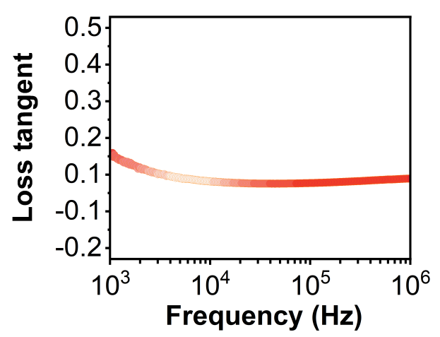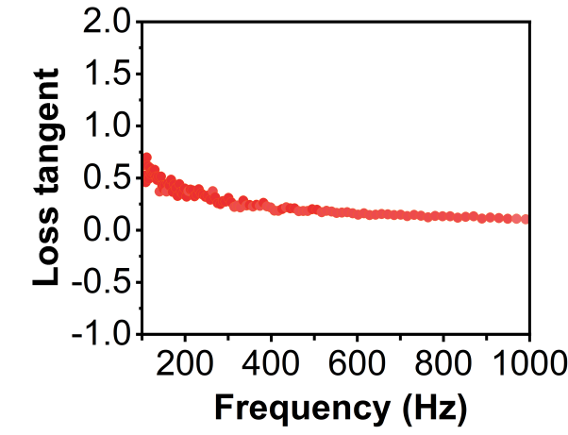
(a)
(b)

Fig. S11. The frequency related dielectric constant and loss tangent of 67 vol% BN/TPU composite.

Table S5. Parameters of BN/TPU composites and commercial products.
 | Thermal conductivity (W/mK) | Volume resistivity  (Ω•m) | Breakdown voltage  (KV) | Dielectric constant | Specific gravity (g/cm³)
Gap pad 5000s35 | 5 | 1.0×10⁹ | 5 | 7.5 | 3.6
Gap pad HC5000 | 5 | 1.0×10¹⁰ | 5 | 8 | 2
TIP 3500 | 1.5 | 1.0×10¹³ | 6 | 5.5 | 2.21
This work | 43 | 5.0×10¹⁰ | 75 | 4.97 | 1.88

Table S6. Main parameters of BN/TPU composites
 | Thermal conductivity (W/mK) | Volume resistivity  (Ω•m) | Breakdown voltage  (KV) | Dielectric constant | Specific gravity (g/cm³) | Tensile stress  (MPa) | Cost  ($)
This work | 43 | 5×10¹⁰ | 75 | 4.97 | 1.88 | 1.19 | 0.6

SI References
- Liu, X.-L., Zhang, X., Lin, M.-L. & Tan, P.-H. Different angle-resolved polarization configurations of Raman spectroscopy: A case on the basal and edge plane of two-dimensional materials. Chinese Phys. B 26, 067802 (2017).
- Yan, J.-X. et al. Highly Conductive Graphene Paper with Vertically Aligned Reduced Graphene Oxide Sheets Fabricated by Improved Electrospray Deposition Technique. ACS Appl. Mater. Interfaces 11, 10810–10817 (2019).
- Wen, P. et al. Anisotropic Shubnikov-de Haas effect in topological Weyl semimetal MoTe2. Applied Physics Letters 119, 243501 (2021).
- Agari, Y. & Uno, T. Estimation on thermal conductivities of filled polymers. J of Applied Polymer Sci 32, 5705–5712 (1986).

