Advanced Composites and Hybrid Materials
Integrated design and performance of microwave absorbing-mechanical load bearing: Metasurface aramid unidirectional cloth composites based on PEDOT: PSS conductive ink
Qian Yang, Jiaxu Sun, Yi Gao, Yongxi Lu, Zihao Shen, Li Ma, Tian Yang*, and Fanbin Meng*
Key Laboratory of Advanced Technologies of Materials (Ministry of Education), School of Materials Science and Engineering, Southwest Jiaotong University, Chengdu, 610031, China
* Corresponding author. E-mail: [yangtian509@163.com]; [mengfanbin_wing@126.com].

Supplementary Information

Experimental Section
Mechanical Performance Test: Tensile performance test standard GB 1447-2005, loading rate of 2 mm/min, continuous loading until the destruction of the specimen, record the maximum load value of the destruction of the specimen. Short beam interlaminar shear method test standard is ASTM D2344, the sample length is 6 times the thickness, the width is 2 times the thickness, the span is 4 times the thickness, the loading rate is 1 mm/min, continuous loading until the specimen is destroyed, and record the maximum load value of the destruction of the specimen. Simply supported beam impact performance test standard GB/T1043-2008, sample specification 80 mm×10 mm, pendulum impact energy 5 J, the front for the frequency-selective surface (FSS) layer facing up, the reverse for the reflective layer facing up. Each group of specimens to test 5 samples, and record the average value.

Microwave absorption (MA) performance test:
1. Electromagnetic parameter testing of aramid/epoxy (AF/EP) composite
To test the complex permittivity and complex permeability of AF/EP composites for subsequent simulation design by substituting into the EM simulation software CST Microwave Studio, the waveguide method is adopted as the test method. The waveguide method measurement process within the frequency range of 2～18 GHz needs to be carried out in six test frequency bands, and the detailed segmentation is shown in Table S1. The thickness and size of the waveguide fixtures used in different frequency bands are not the same. Therefore, when measuring, the six sets of waveguide kits need to be calibrated respectively. The sample size needs to be cut and ground according to the size of the waveguide fixture to obtain test specimens of six sizes. The detailed dimensions of the fixtures for each frequency band are shown in Table S1.
2. Test method for MA performance of composites
Because the size of the waveguide fixture at high frequency (12.5～18 GHz) is smaller than the unit size of the designed FSS structure, the MA characteristics of the composite in the range of 2 to 18 GHz were tested by the bow frame method. The schematic diagram of the test process is shown in Fig. S4. The size of the test sample is 180 mm×180 mm×thickness, which has exceeded the wavelength limit within the tested frequency range. Therefore, using this method to test reflection loss is accurate.

Preparation of AF/EP composite: The AF/EP composite was prepared by layup and hot-pressing process with 14 layers of AF plain/EP prepreg. The molds were cleaned with acetone and dried, and the surface was coated with a mold release agent 2 to 3 times, each time at an interval of 10 min. The preforms obtained through the lay-up process were cut to the size of the molds (200 mm × 200 mm), and the molds with the preforms were placed in a hot press. Hot-pressing conditions: vacuum of -0.75 Bar, 8 ℃/min heating to 150℃, pressurization 5 MPa, insulation and holding pressure for 25 min, and demolding and removing by natural cooling below 50℃ under holding pressure. The thickness of the composite was 5.35 mm, and the waveguide sizes corresponding to each waveband in the range of 2 to 18 GHz were cut by a cutting machine.

Supplementary Tables
Table S1. The waveguide method is used to measure the six frequency bands and the dimensions of the waveguide fixture.
Wave band | L | S | C |  | X | Ku
Frequency/GHz | 1.72～2.61 | 2.61～3.94 | 3.94～5.99 | 5.99～8.17 | 8.17～12.5 | 12.5～18.0
Size/mm*mm | 109.22×54.61 | 72.14×34.04 | 47.55×22.15 | 34.85×15.80 | 22.86×10.16 | 15.8×7.9

Table S2. Basic parameters of composites.
 | Thickness/mm | Density/g·cm⁻³ | Resin content/%
PI film substrate | 3.140 | 1.146 | 30.99
A_{UD}C substrate | 3.175 | 1.190 | 26.70
Composite without FSS | 3.220 | 1.270 | 23.50

Supplementary Figures
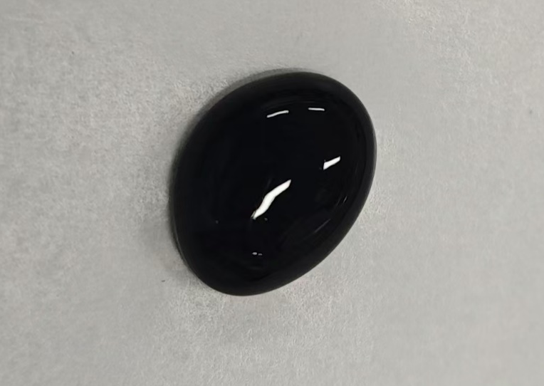
Fig. S1 Photograph of PEDOT: PSS conductive ink with 7% solid content.

Fig. S2 Tensile specimen size diagram

Fig. S3 Complex dielectric constant versus frequency curves of AF/EP composite, the inset shows the photographs corresponding to the size of the AF/EP composite at different wavelength bands.
Fig. S4 Schematic diagram of the bow frame method test

Fig. S5 SEM images of the sides of PEDOT: PSS films with different DMSO concentrations: (a) 0 %; (b) 5 %; (c) 10 %; (d) 15 %; (e) 20 %; (f) 25 %.

Fig. S6 Photographs of MSC on PI film substrate: (a) Front side before tensile testing; (b) During tensile testing; After tensile testing: (c) front, (d) side, (e) reverse.
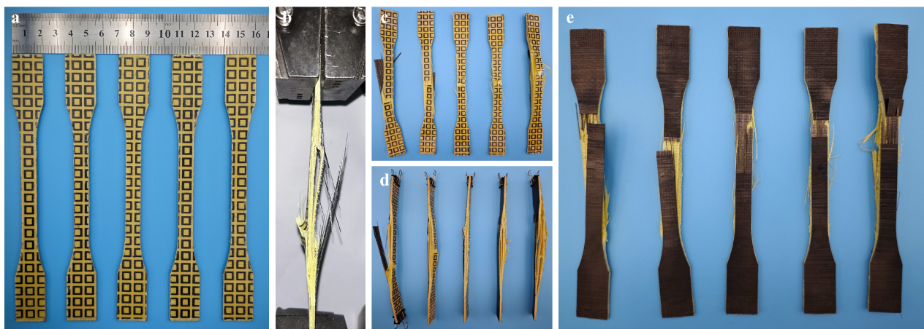
Fig. S7 Photographs of MSC on A_{UD}C substrate: (a) Front side before tensile testing; (b) During tensile testing; After tensile testing: (c) front, (d) side, (e) reverse.

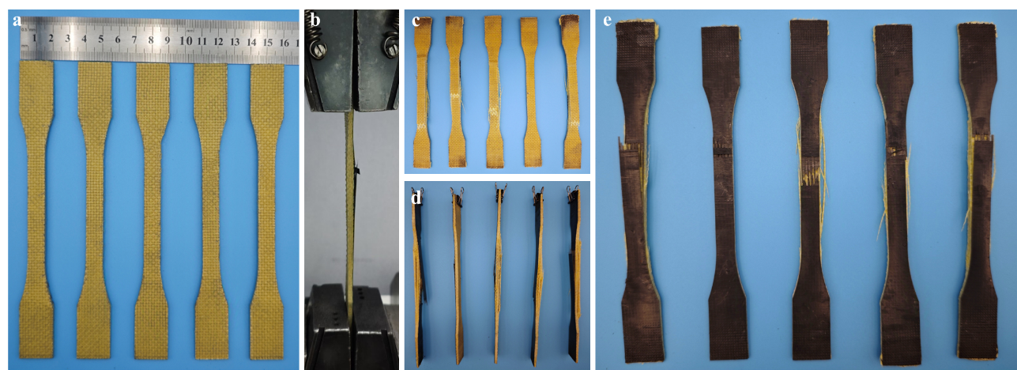
Fig. S8 Photographs of composite without FSS: (a) Front side before tensile testing; (b) During tensile testing; After tensile testing: (c) front, (d) side, (e) reverse.

