Supporting Information

Phase Transition and Mechanochemistry Enabled Lightweight Liquid Metal Skeleton for Multifunctional Conductive Composites

Jinyang Lu†, Biao Ma†*, Gangsheng Chen, Yi Chen, Yakun Gao, Yanjie Chen, Haoran Deng, Bo Lu and Hong Liu*

State Key Laboratory of Digital Medical Engineering, School of Biological Science and Medical Engineering, Southeast University, Nanjing 210096, China
E-mail: biaom@seu.edu.cn; liuh@seu.edu.cn

Fig. S1 Adhesion of the pristine LM and the oxidized LM to the salt substrate. a) Photographs showing a pristine LM droplet with a mass of 0.08 g on a disc-shaped salt substrate. When the salt substrate was tilted, the pristine LM droplet rolled down, indicating poor adhesion between LM and salt. b) Photographs showing an oxidized LM droplet with a mass of 0.08 g on the salt substrate. The oxidized LM droplet was collected by stirring LM with salt and then removing the salt in ice water followed by drying. When we turned over the salt substrate, the oxidized LM droplet adhered firmly to the salt substrate, indicating that mechanochemistry-induced oxidation can enhance the adhesion between LM and salt. Scale bar: 1 cm.

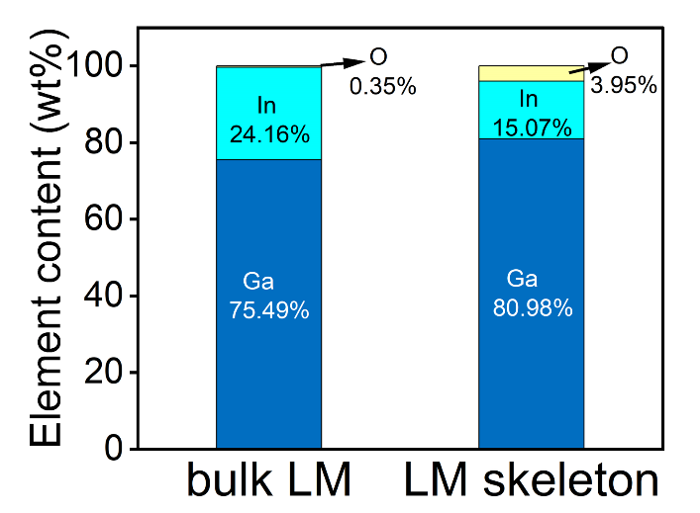
Fig. S2 Oxygen concentration of the bulk LM and the LM skeleton from the energy dispersive spectrum analysis. The LM skeleton displays a higher oxygen concentration which is ten times that of the bulk LM.

Fig. S3 a) Unconfined compressive strength curves of the LM-salt mixture (cylinders of 8 mm diameter and 8.8 mm height at liquid phase and solid phase. b) Enlarged drawing of unconfined compressive strength curve of the LM-salt mixture at solid phase. The stiffness of the LM-salt mixture experiences a 40-fold increase when LM undergoes a liquid-solid phase transition.

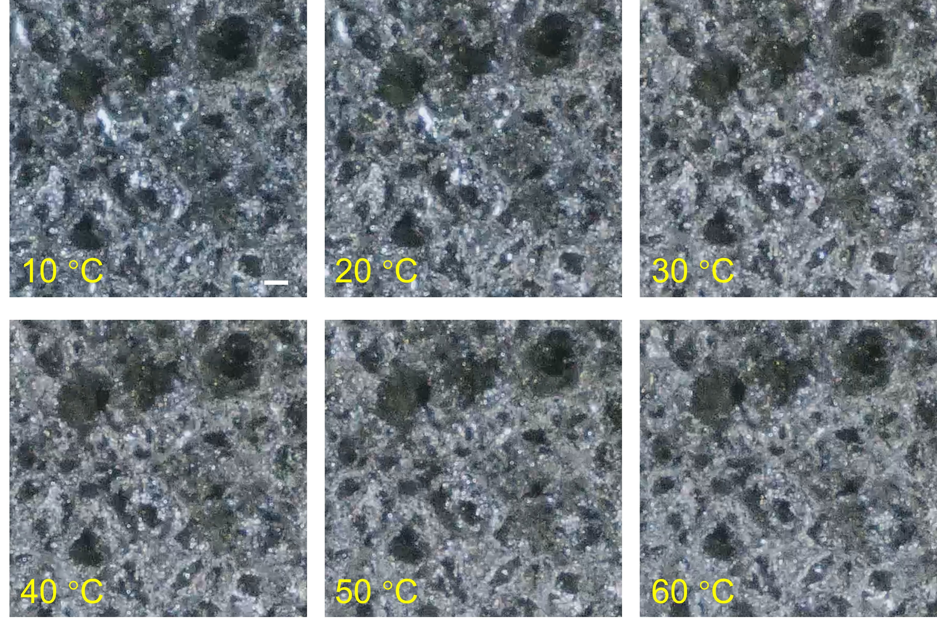
Fig. S4 Optical microscopic images of the LM skeleton embedded in the PDMS precusor at different temperatures from 10℃ to 60℃. Scale bars: 250 µm.

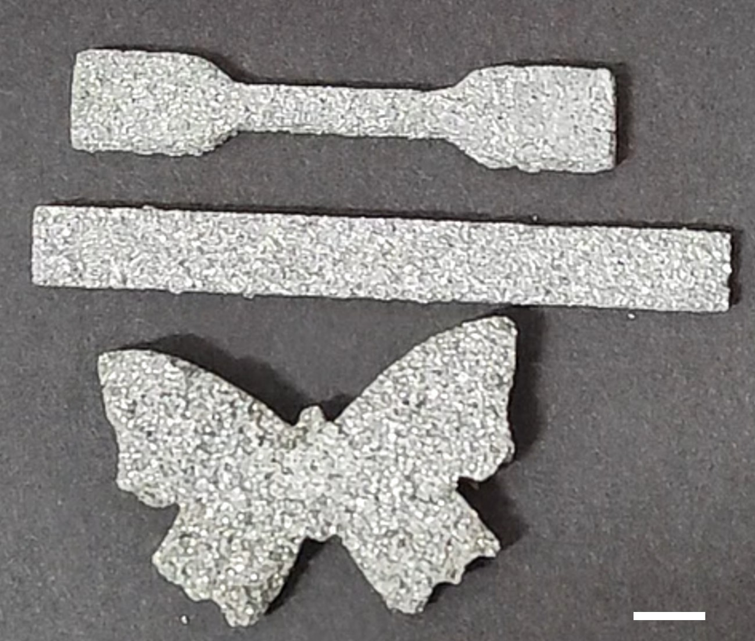
Fig. S5 Liquid-state LM skeletons shaped like a dumbbell, a rectangle, and a butterfly maintain structural integrity at room temperature, even without the polymer matrix. Scale bar: 5 mm.

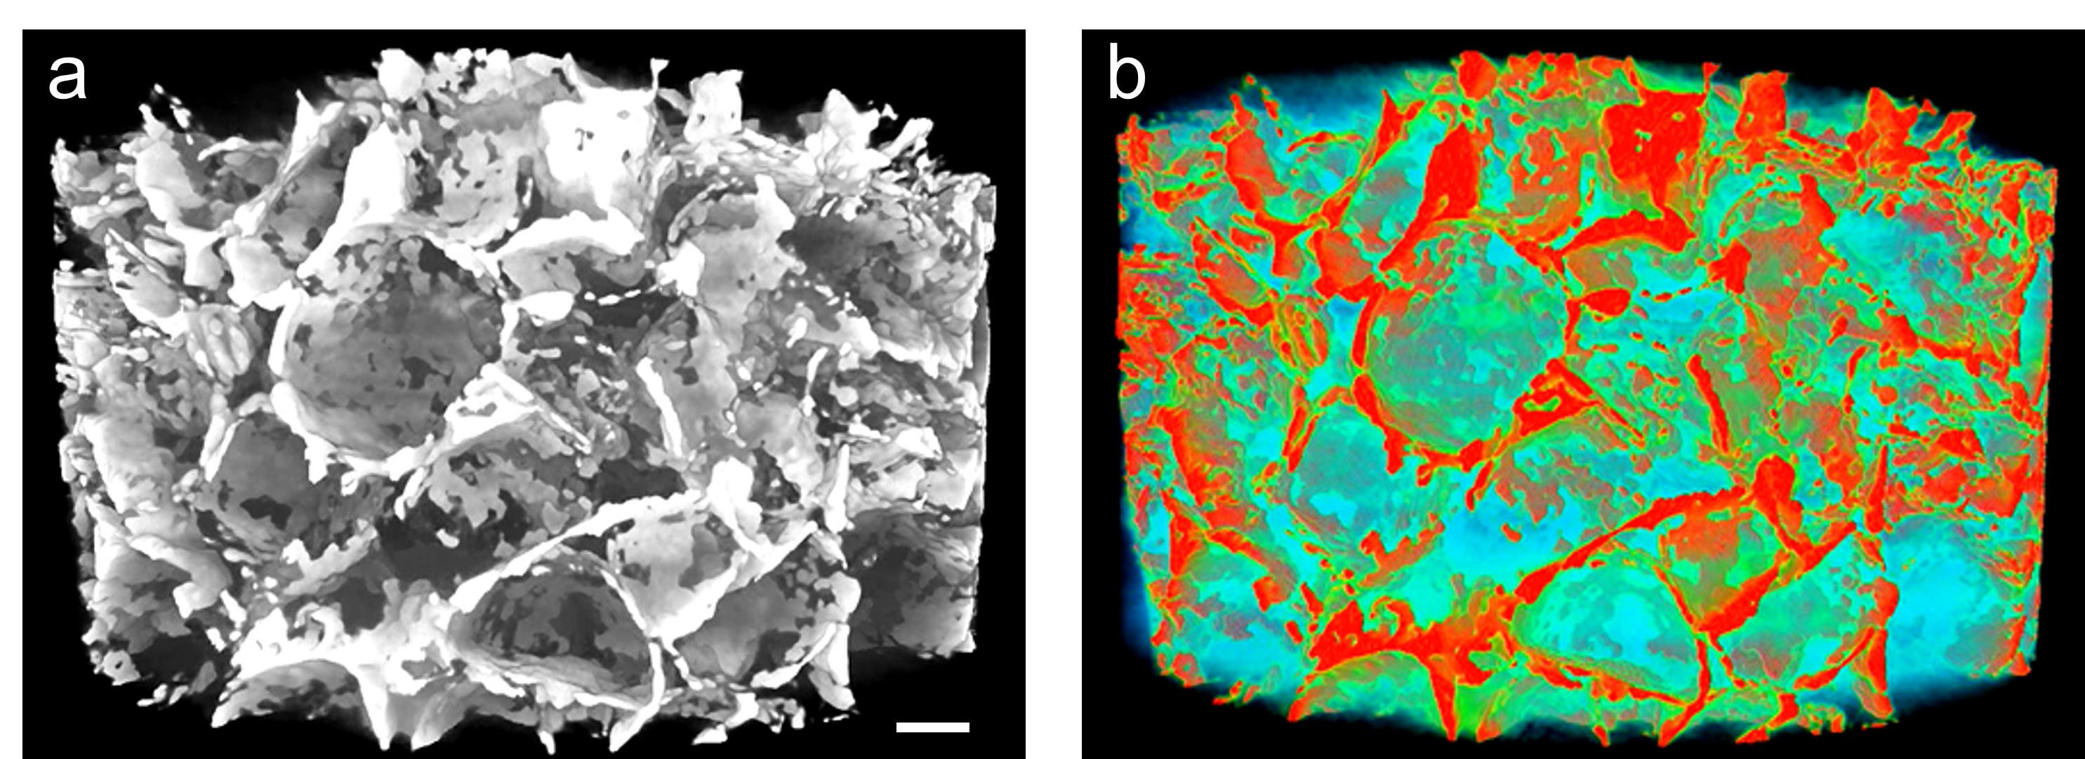
Fig. S6 The 3D reconstructed structure of the LM-polymer composite by micro-CT. a) Grayscale image; b) Corresponding pseudocolored image, where red indicates LM and blue represents the polymer matrix. Scale bar: 200 µm.

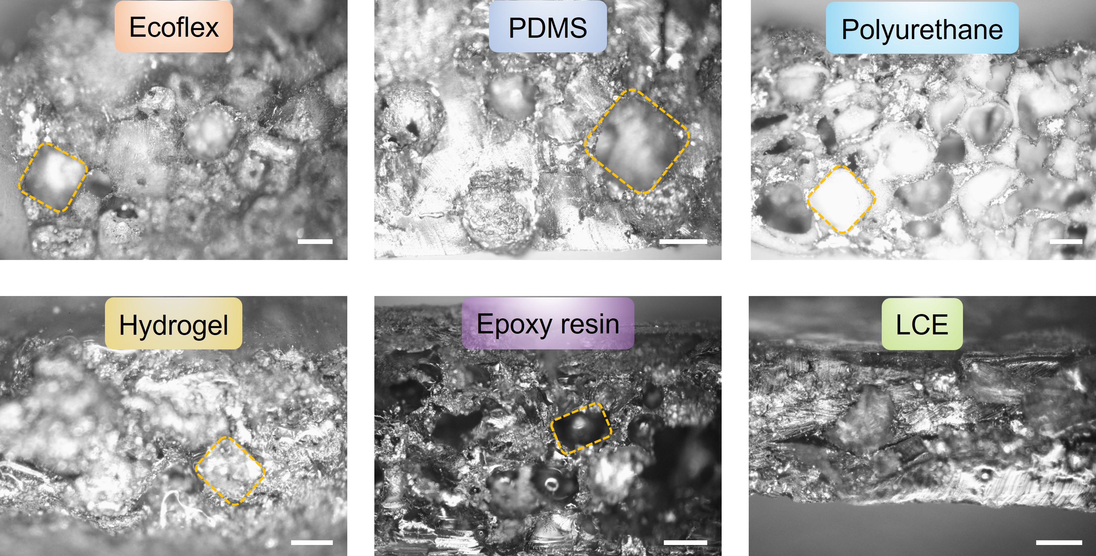
Fig. S7 Cross-sectional images of different polymer matrices. The yellow dashed line represents the replication of the salt particles' microcellular structures. Scale bar: 200 µm.

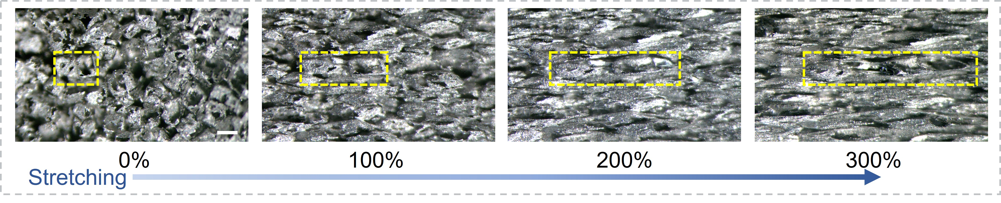
Fig. S8 Microscope photographs in situ of the LM-Ecoflex composite at 0%, 100%, 200% and 300% strain. Scale bar: 200 µm.

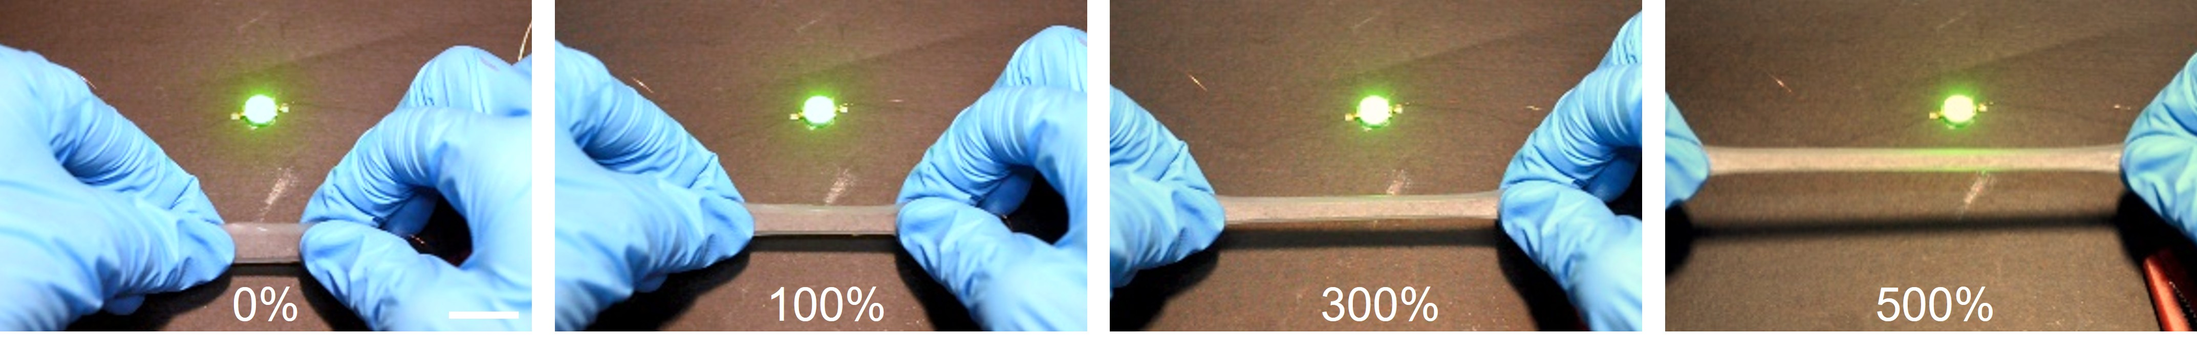
Fig. S9 LED circuit with the LM-Ecoflex composite under 0-500% strain. Scale bar: 1 cm.

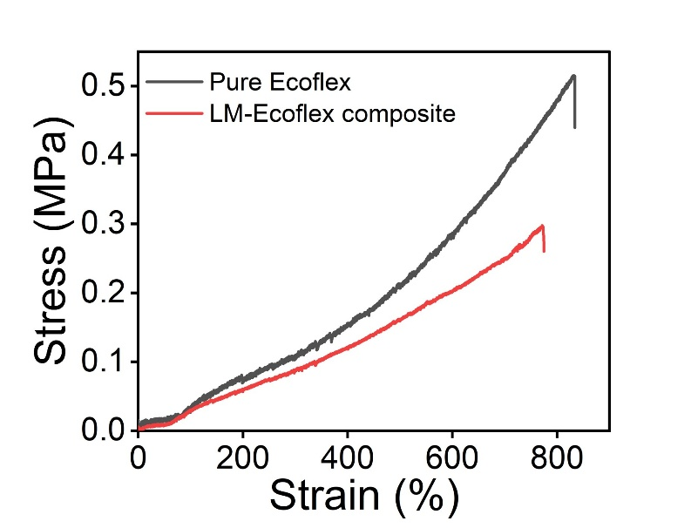
Fig. S10 Tensile stress-strain curves of the pure Ecoflex and LM-Ecoflex composite.

Fig. S11 Resistance of the LM-Ecoflex composite during storage of 15 months at ambient conditions.

Fig. S12 Voltage-current curve of the LM-SMP gripper. The voltage varies linearly with the current, indicating that the LM skeleton in the LM-SMP gripper serves as an Ohmic conductor.

Fig. S13 Photographs of the work platform including the gripper, the object, the original position, and the target position. The illustration in the upper right corner is a top view of the gripper.

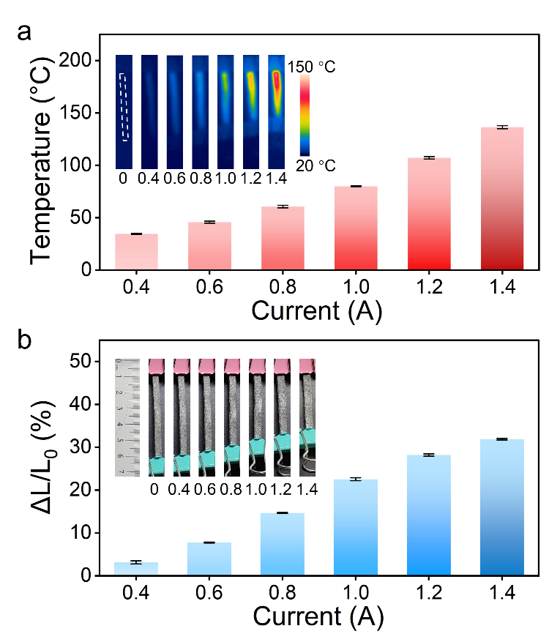
Fig. S14 Electrothermal response of the LM-LCE actuator to different currents. a) Equilibrium temperature of the LM-LCE composite. The illustrations are the thermal images of the LM-LCE actuator. b) Contraction strain of the LM-LCE composite. The illustrations are the optical photographs of the LM-LCE actuator.

Fig. S15 Resistance-time of the LM-LCE actuator at the current of 1.4 A. The resistance decreases slightly with the contraction strain and remains constant after reaching the maximum contraction strain.

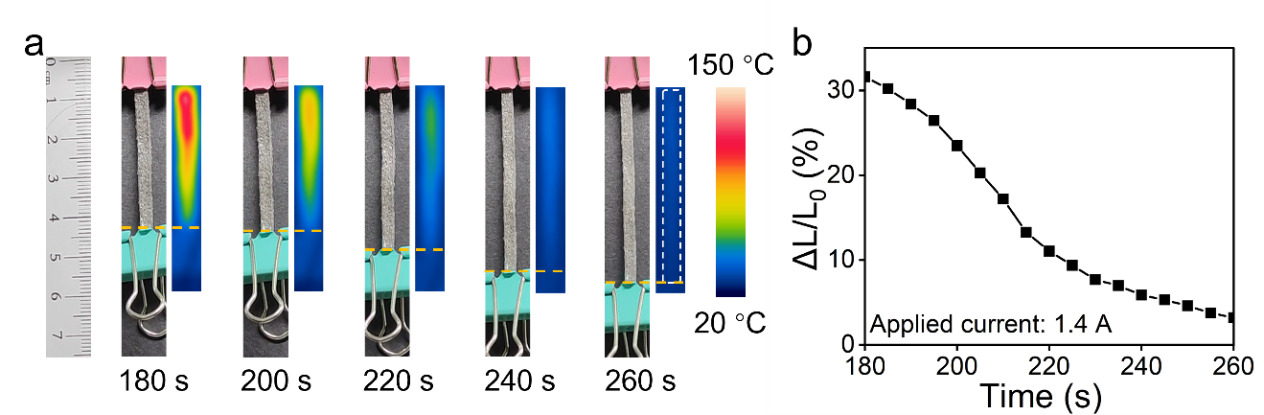
Fig. S16 a) Optical photographs and corresponding thermal images of the LM-LCE actuator during cooling. b) Contraction strain-time curve of the LM-LCE actuator during cooling.

Fig. S17 Temperature-time and contraction strain-time curves of the LM-LCE actuator during a heating and cooling cycle. The applied current was 1.4 A and was cut off at 180 s.

Table S1 Performance comparison of our LM-Ecoflex composite with other LM-polymer composites in terms of conductivity and LM content.

Type | Materials | LM Content (vol%) | Conductivity (S/mm) | Reference number in the main text
0D LM composite | GaInSn/PDMS | 50 | 10.5 | 18
0D LM composite | EGaIn/PDMS | 50 | 137 | 19
0D LM composite | GaInZn/Sulfur polymer | 30 | 0.43 | 20
0D LM composite | EGaIn/Liquid crystal elastomers | 50 | 20 | 21
0D LM composite | EGaIn/PDMS | 50 | 1 | 22
0D LM composite | EGaIn/SBS polymer | 40 | 8 | 23
0D LM composite | EGaIn/SIS/PBD | 60 | 15 | 24
0D LM composite | EGaIn/TPU | 49.2 | 74.5 | 25
0D LM composite | GaInSn/PDMS/PDMS particles | 40 | 0.00668 | 26
3D LM composite | GaInSn/PDMS | 75 | 1620 | 30
3D LM composite | GaInSn/PU | 65 | 1890 | 31
3D LM composite | EGaIn/Ecoflex | 30 | 530 | 34
3D LM composite | Ga/Ecoflex | 25 | 180 | 35
3D LM composite | EGaIn/Ecoflex | 3.7 | 1.3 | This work

Table S2 The high-resolution XPS analysis of Ga 3d and Ga 2p for bulk LM and the LM-salt mixture.

 | Material | Region | Binding energies (eV) | Area ratio
Ga 3d | Bulk LM | In⁰ | 15.88 | 13.9%
Ga 3d | Bulk LM | Ga⁰ | 17.58 | 53.0%
Ga 3d | Bulk LM | Ga⁺ | 18.76 | 8.7%
Ga 3d | Bulk LM | Ga³⁺ | 19.78 | 24.4%
Ga 3d | LM-salt mixture | In⁰ | 15.9 | 19.0%
Ga 3d | LM-salt mixture | Ga⁰ | 17.54 | 36.3%
Ga 3d | LM-salt mixture | Ga⁺ | 18.76 | 8.4%
 |  | Ga³⁺ | 19.78 | 36.3%
Ga 2p | Bulk LM | Ga⁰ | 1115.7 | 34.0%
Ga 2p | Bulk LM | Ga⁺ | 1116.8 | 6.9%
Ga 2p | Bulk LM | Ga³⁺ | 1117.73 | 59.1%
Ga 2p | LM-salt mixture | Ga⁰ | 1115.55 | 15.2%
Ga 2p | LM-salt mixture | Ga⁺ | 1116.65 | 6.8%
Ga 2p | LM-salt mixture | Ga³⁺ | 1117.58 | 78.0%

Table S3 An LM-salt mixture with a 20 wt% LM content was obtained by mixing 0.25 g of EGaIn with 0.996 g of salt microparticles. This mixture was divided into four equal parts, and then compressed into a cylindrical shape with an 8 mm diameter under a uniform pressure of ~25 kPa. The heights of these cylinders were measured, and their total volume was calculated to be 1.09 cm³. Given the LM mass (0.25 g) and its density (6.25 g/cm³), the LM volume was determined as 0.04 cm³. Consequently, the LM volume fraction in the 3D LM skeleton was calculated to be 3.7 vol%.

 | Height (cm) | Volume (cm³)
Cylinder1 | 0.52 | 0.26
Cylinder2 | 0.56 | 0.28
Cylinder3 | 0.56 | 0.28
Cylinder4 | 0.53 | 0.27

Movie S1 Mixing LM with salt microparticles in argon or air.
Movie S2 Capillary filling of the polymer precursor into the LM skeleton.
Movie S3 3D microstructure of the LM-polymer composite by micro-CT.
Movie S4 Response of the LM-LCE actuator during a heating and cooling cycle.
Movie S5 Electromagnetic shielding effect of the films without LM, with 0D LM, and with 3D LM.

