Supporting information
Synergistically enhanced safety and energy density of energetic materials via interfacial constraint
Xu Zhao¹, Minghui Yu³, Dan Liu¹, Haorui Zhang^{1,2}, Junru Wang¹, Guansong He¹, Qi-Long Yan², Zhijian Yang^{1*}
¹ Institute of Chemical Materials, China Academy of Engineering Physics (CAEP), Mianyang 621900, China. Email: zhijianyang@caep.cn
² Science and Technology on Combustion, Internal Flow and Thermo-structure Laboratory, Northwestern Polytechnical University, Xi’an 710072, China.
³ State Key Lab of Metal Matrix Composites, School of Materials Science and Engineering, Shanghai Jiao Tong University, Shanghai 200240, China.

Characterization techniques
The microstructure and morphologies of LLM-105 and hd-LLM-105 were carried out by scanning electron microscopy (SEM). Transmission electron microscopy (TEM) was conducted using JEM-ARM 200F instrument at 80 kV to deeply observe the microstructure of hd-LLM-105. X-ray diffraction (XRD) using Cu Kα radiation (λ = 0.154056 nm) between two-theta of 10º to 30º were used to analyze the phase purity and potential crystal orientation. Raman spectra of products were carried out using the light at 532 cm⁻¹ for measuring the characteristic vibration modes. The X-ray photoelectron spectroscopy (XPS) equipped with monochromatic Al Kα radiation (1486.6 eV) was conducted to determine the chemical state of samples.

The gaseous products from thermal decomposition of samples were detected by using the TG-DSC/MS technique. This experiment was realized on a simultaneous thermos-analyzer STA 449 F3 coupled with a quadrupole mass spectrometer QMS 403C Aëolos. An alumina pan with a pin-hole cover was used. The sample masses for these measurements were about 3 mg with a heating rate of 10 °C/K using the argon atmosphere (gas ﬂow: 50 ml/min). The element content was tested by combustion method (Vario EL/micro cube). The combustion heat was measured by bomb calorimetry with an oxygen pressure of ∼3.0 MPa, where the samples were ignited by an electric-heated nickel-chromium wire (∼0.5 mm in diameter). Generally adopted Bundesanstalt-für-Materialforschung (BAM) impact and friction sensitivity were conducted to evaluate the safety performance of as-prepared products.
Decomposition kinetics analysis
Thermal gravimetric analysis (TGA) and differential scanning calorimetry (DSC) techniques were used to study the thermal decomposition behavior of the involved samples herein, performed on a simultaneous TGA/DSC Instrument under 50 mL/min Ar atmosphere. The heating rates were 5, 7.5, 10 and 15 °C/K in the temperature range of 50°C to 500 °C. Samples used for DSC tests were about 2.5 mg. Kinetics were analyzed using different methods. The Friedman method offers a more precise correlation between the activation energy variation with the conversion rate while mitigating the impact of the model on calculation outcomes. On the other hand, the CKA method considers factors such as decomposition peak temperature, peak width, peak height, and symmetry to derive comprehensive kinetic parameters and decomposition models. Hence, the results obtained from both the CKA and Friedman methods are utilized in the subsequent discussion to delve deeper into the decomposition model and the activation energy variation.

The models in kinetic analysis could be concluded in Table S1. Among them, some commonly used models include D2, two-dimensional diffusion; R2, phase boundary-controlled reaction (contracting area); R3, phase-boundary controlled reaction (contracting volume); F1, first-order reaction, so-called unimolecular decay law, where random nucleation occurs followed by an instantaneous growth of nuclei; A2 and A3, random two- and three-dimensional nucleation and nucleus growth models; L2, random chain scission model.
Table R1. The ideal physical decomposition model
Abbr. | Ideal Physical Model | f(α)
F1 | Unimolecular decay law | 1-α
D2 | 2D diffusion (bidimensional particle shape) | [-ln(1-α)]⁻¹
D3 | 3D diffusion (tridimensional particle shape) | [3(1-α)^{2/3]}/2[1-(1-α)^{1/3}]
R2 | Phase boundary-controlled reaction (bidimensional shape) | (1-α)^{1/2}
R3 | Phase boundary-controlled reaction (tridimensional shape) | (1-α)^{2/3}
A2 | Random instant nucleation and 2D growth of nuclei | 2(1-α) [-ln(1-α)]^{1/2}
A3 | Random instant nucleation and 3D growth of nuclei | 3(1-α) [-ln(1-α)]^{2/3}
C2 | Cylinder contraction | 2(1-α)^{1/2}
C3 | Sphere contraction | 3(1-α)^{2/3}
P1 | Power law | 2α^{1/2}
P2 | Power law | 3α^{2/3}
P3 | Power law | 4α^{3/4}
P4 | Power law | 2/3α^{1/2}
A4 | Nucleation-nuclear growth | 4(1-α) [-ln(1-α)]^{3/4}
L2 | Random scission | 2(α^{1/2}-α)
AC | First order autocatalytic (self-heating) model | α(1-α)^{0.5}

Detonation performances tests
Explosives used in the polymer-bonded-explosive (PBX) composites consisted of as-prepared hd-LLM-105 and F2314 polymer binder at a ratio of 95:5 in weight. They were fabricated following a standard manufacturing process for water slurry. F2314 binder with a concentration of 6 ​wt% was prepared by dissolving fluoropolymer in a mixed organic solvent consisting of ethyl acetate and butyl acetate. The hd-LLM-105 was added into water, yielding an explosive/water mixture at a ratio of 1:1 in weight. The explosive mixture was stirred for complete immersion. Within an hour, the polymer solution containing nanofillers was added to the stirred mixture in the reactor, where the explosive mixture was coated with the polymer solution, forming molding powder granules. Then, the granules were carefully dried in a vacuum oven at 60 ​°C for 48 ​h to eliminate moisture thoroughly. Afterward, dry granules were hot pressed in a mold with a desired geometry under 125 ​°C and 320 ​MPa for the future tests.

The reckoned crystal velocity could be calculated from real tested PBX velocity, the press density. Reckoning velocity_{crystal}=(Real-tested Velocity_{PBX}-1500*Volume Raio_{air}-5400*Volume Ratio_{binder})/Volume Ratio_{crystal}

The volume ratio (%) of air, binder and crystal calculated from press density, binder density (2.02 g/cm³) and crystal density. In hd-LLM-105 PBX, the binder and crystal consist of 5% and 95% in weight. Using the PBX real tested velocity and the press density, the volume of whole PBX cylinder, the volume ratio of binder, crystal and air could be calculated. From the equation, the reckoning velocity could be calculated.

Theoretical calculation details
The first-principles simulations were performed using the CP2K software package. This comprehensive approach encompassed the calculation of binding energy, differential charge density, and the interaction region indicator (IRI), all of which are vital for elucidating the interactions between TAGP and LLM-105. For the electronic structure calculations, the Goedecker-Teter-Hutter (GTH) pseudopotentials were employed, which are efficient for core electron treatment, in conjunction with the Perdew Burke Ernzerhof (PBE) generalized gradient approximation. the DZVP-MOLOPT basis set was employed. Long-range interactions inherent in the system under investigation, dispersion corrections were integrated through Grimme’s DFT-D3 method. The wave function energy cutoff was set at 900.

Binding energy refers to the energy released when two or more particles in a free state come together to form a composite particle. In chemistry, it often refers to the energy released when free atoms combine to form a molecule, which is also known as chemical binding energy. The higher the binding energy, the more stable the structure of the molecule. This is because during the combination process, the sum of the masses of the individual particles is greater than the mass of the composite particle they form. Binding energy can be expressed by the following formula:
$$E_{\text{binding }}=E_{\text{molecule }}-∑E_{\text{atom }}$$
where $E_{\text{binding }}$ is the binding energy, $E_{\text{molecule }}$ is the total energy of the molecule, and $E_{\text{atom }}$is the energy of the individual atoms that make up the molecule.

Difference charge density is a method for analyzing the redistribution of charge within materials. It can reveal the movement of charge and the direction of polarization during bonding and electron coupling processes. The calculation formula for difference charge density is usually defined as:
$$∆ρ=ρ\left(AB\right)-ρ\left(A\right)-ρ\left(B\right)$$
Where, $ρ\left(AB\right)$represents the total charge density of the optimized system, $ρ\left(A\right)$ is the charge density of material A, and $ρ\left(B\right)$ is the charge density of material B. By subtracting the charge densities of materials A and B from the total charge density of the system, the differential charge density upon the formation of a composite of materials A and B were obtained.

For the analysis of non-covalent interaction energies, the IRI calculation can be used to assess these interactions. The IRI function is defined as:
$$IRI⁡(r)=\frac{|∇ρ(r)|}{[ρ(r)]^{a}}$$
where ρ is the electron density, ∇ρ is the gradient of the electron density, and a is a parameter critical for distinguishing different types of interactions (with a standard value of 1.1).

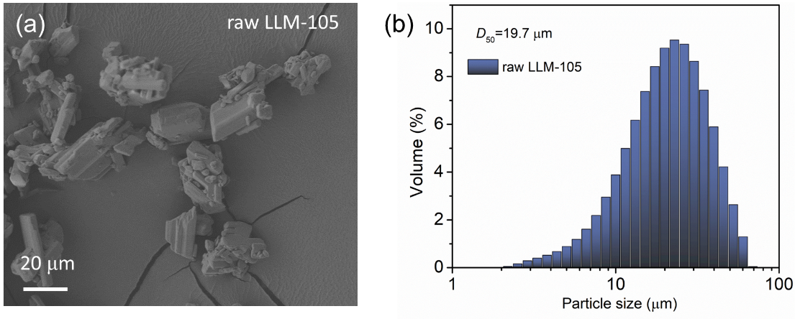
Figure S1. The SEM image of raw LLM-105 and the particle size distributions.

Figure S2. The particle size distributions of hd-LLM-105.
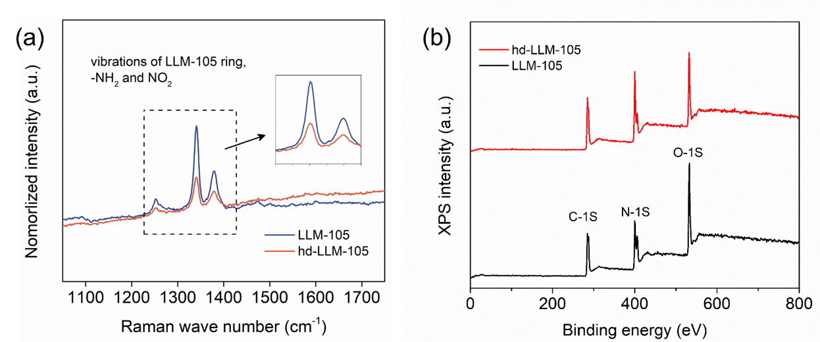
Figure S3. (a) Raman spectra of Raman spectra of hd-LLM-105 and LLM-105, the inset is the enlarged area of the typical vibration comparation. (b) XPS peaks of raw LLM-105 and hd-LLM-105

Figure S4. TG and DSC of LLM-105.

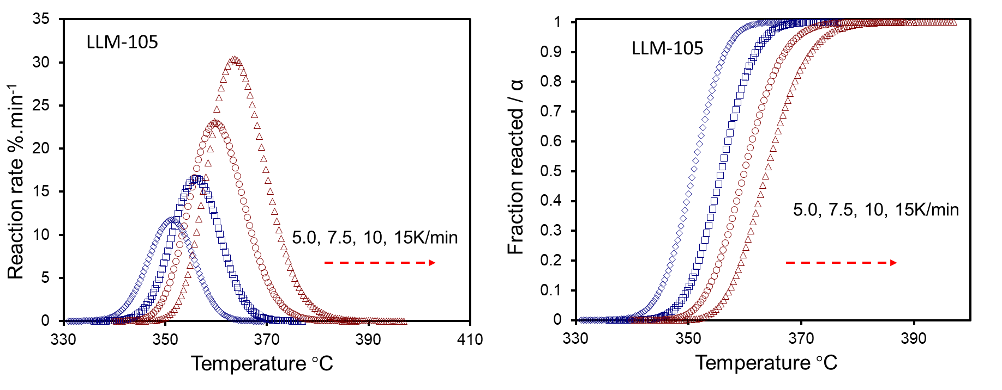
Figure S5. DSC of LLM-105 at different heating rates.

Figure S6. Mass spectra with the minimum retention time at 300 °C.
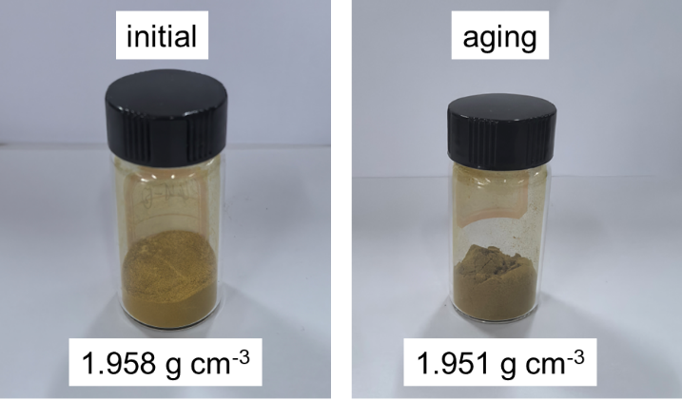
Figure S7. Images of hd-LLM-105 sample before and after aging process. Inset is the density.

Table S2. Elemental formula, heat of formation, density and detonation performances of LLM-105 and hd-LLM105.
Sample | Formula | ΔH_{f}/kJ·mol⁻¹ | Density/g·cm⁻³ | velocity m/s | pressure GPa
LLM-105 | C₄H₄O₅N₆ | -115.26 | 1.905 | 8600 | 31.6
hd-LLM-105 | C₄H_{3.52}O_{5.06}N_{6.01} | -111.75 | 1.958 | 8770 | 33.4
Notes: ΔH_{f}, the heat of formation. Velocity and pressure are calculated results.

