Oxygen vacancies and N-doped carbon layer synergistically enhance singlet oxygen generation over BiOCl for efficient pollutant degradation
Chenyu Zhang^{a b}, Zeyan Zhou^{c}, Chenhong Wuª, Hao Zeng^{d}, Qiongfang Wanª, Hui Li^{b}, Hanbo Yu^{e}, Haoliang Pangª, Jinhui Huangª *, Xingzhong Yuanª *

ª College of Environmental Science and Engineering, Key Laboratory of Environmental Biology and Pollution Control, Hunan University, Changsha 410082, China
^{b} State Key Laboratory of Utilization of Woody Oil Resource and Institute of Biological and Environmental Engineering, Hunan Academy of Forestry, Changsha 410004, P.R. China
^{c} College of Materials Science and Engineering, Hunan Joint International Laboratory of Advanced Materials and Technology for Clean Energy, Hunan University, Changsha, Hunan 410082, China
^{d} College of Environment and Ecology, Hunan Agricultural University, Changsha 410082, P.R. China
^{e} School of Hydraulic and Environmental Engineering, Changsha University of Science & Technology, Changsha 410114, China

* (J.H. Huang) E-mail: huangjinhui@hnu.edu.cn, huangjinhui_59@163.com
* (X.Z. Yuan) E-mail: yxz@hnu.edu.cn

Supplementary Text S1. Details of materials and characterizations
All chemicals used were analytical reagent grade and purchased from commercial suppliers without further purification unless otherwise mentioned. All solutions were prepared in ultrapure 18.25 MΩ·cm Milli-Q water (Millipore). Powder X-ray diffraction (XRD) patterns were measured on Bruker D8A A25 X X-ray diffractometer with Cu Kα radiation source. The Fourier transform infrared (FTIR) spectra were acquired on Thermo Scientific Nicolet iS20 in the range of 4000~400 cm^{–1} with a resolution of 4 cm⁻¹ to identify the surface functional groups. The microstructure and element distribution of the samples were studied by scanning electron microscopy (SEM) on ZEISS Sigma 300. High-resolution transmission electron microscopy (HRTEM) images were acquired by a JEM-F200 transmission electron microscope (Japan) operated at an acceleration voltage of 300 kV, coupled with energy dispersive X-ray spectroscopy (EDS). Organic element analyzer (Elementar UNICUBE) was used to determinate the element content. X-ray photoelectron spectroscopy (XPS) data were obtained on a Thermo Scientific ESCALAB Xi+ with an Al Kα radiation. The N₂ adsorption-desorption isotherms of the samples were collected at 77 K using Micromeritics ASAP 2460 system. The UV-Vis diffuse reflectance spectroscopy (DRS) was performed on Shimadzu UV-3600 instrument with an integrating sphere attachment from 200-800 nm, referenced to BaSO₄. The Nano ZS90 zeta potential analyzer was employed to determine zeta potential of samples. Electron paramagnetic resonance (EPR) (Bruker EMX PLUS) was used to investigate the reactive species generated during the experiment.
Steady-state prompt fluorescence (PF), steady-state phosphorescence (PH), time-resolved fluorescence decay spectra (TRPF) and time-resolved phosphorescence decay spectra (TRPH) were obtained on a steady-state and time-resolved Fluorescence Spectrometers (FLS-1000, Edinburgh Instruments). The excitation wavelengths of all spectra were 270 nm. The average lifetimes were fitted by the following exponential Eqs. (1, 2):
${\text{I}}_{\text{(t)}}\text{=}{\text{I}}_{\text{0}}\text{+}{\text{A}}_{\text{1}}\text{exp}\left({\text{-}\text{t}\text{/τ}}_{\text{1}}\right)\text{+}{\text{A}}_{\text{2}}\text{exp}\left({\text{-}\text{t}\text{/τ}}_{\text{2}}\right)\text{+}{\text{A}}_{\text{3}}\text{exp}\left({\text{-}\text{t}\text{/τ}}_{\text{3}}\right)$ (1)
${\text{τ}}_{\text{ave}}\text{=}{\text{τ}}_{\text{1}}{\text{×I}}_{\text{1}}\text{+}{\text{τ}}_{\text{2}}\text{×}{\text{I}}_{\text{2}}\text{+}{\text{τ}}_{\text{3}}\text{×}{\text{I}}_{\text{3}}$ (2)
Where I₀ is the baseline correction value, A₁, A₂ and A₃ are the pre-exponential factors, τ₁, τ₂ and τ₃ are the lifetime (ns) in different photo-processes, and τ_{ave} represents the average lifetime.

Supplementary Text S2. Preparation of samples
Synthesis of N-doped hollow carbon spheres (NHCS)
0.06 g SDS, 2.88 g glucose and 0.08 g melamine were together dissolved in 30 mL of distilled water by ultrasonic dissolution 1 h, the mixture was transferred into autoclave and heated at 160 °C for 10 h. The resulting solid precipitates were washed with deionized water and absolute ethanol for several times and dried overnight in vacuum at 60 ℃.
Synthesis of N-doped carbon layer coated BiOCl (BNC)
In a typical synthesis procedure, the mixture containing 1.94 g Bi(NO₃)₃·5H₂O, a certain amount of NHCS, and 60 mL ethylene glycol (EG) was sonicated for 30 min and stirred for 30 min. Then, 0.2982 g KCl was added into the above mixture and further stirred for 30 min. The prepared precursor solution was transferred into a 100 mL Teflon-lined autoclave and heated for 12 h at 160 °C. The products were collected by centrifugation, washed with distilled water and absolute ethanol for three times to neutral pH, and finally dried under vacuum at 60 °C for 12 h. The NHCS contents were adjusted to 0, 0.05, 0.1, 0.15, and 0.2 g, which are labeled as BOC, BNC5, BNC10, BNC15, and BNC20, respectively.

Supplementary Text S3. Calculation of photodegradation efficiency
The photocatalytic performance was calculated using the following equation:
$\text{η=}{\text{(C}}_{\text{0}}\text{-}{\text{C}}_{\text{t}}\text{)/}{\text{C}}_{\text{0}}$ (3)
where η, C₀, and C_{t} represent the photocatalytic efficiency, the initial concentration before illumination, and the concentration after illumination time, respectively.
The pseudo-first order kinetic model was used to fit the degradation curves of contaminants in different systems:
$\text{-}\text{ln}{\text{(}{\text{C}}_{\text{t}}\text{/}{\text{C}}_{\text{AE}}\text{)}}\text{=}\text{k }\text{t}$ (4)
where $C_{AE}$ represents concentration at adsorption equilibrium, k is the apparent rate constant.

Supplementary Text S4. Photocatalytic activity experiments
All experiments were carried out in triplicate for a given condition. The visible-light-driven degradation performance of organic pollutants by the prepared samples was examined through a Xenon arc lamp with a UV cutoff filter (Beijing Perfectlight, PLS-SXE300D/300DUV, λ ≥ 420 nm). The intensity on the surface of the reaction suspension was measured to be 30 ± 2 mW·cm^{–2}. In a typical batch test, 20 mg of the sample was added into a quartz vessel containing 50 mL ciprofloxacin (CIP) aqueous solution at a concentration of CIP (10 mg L^{–1}). Before illumination, the suspension was kept stirring in the dark for 30 min to ensure adsorption–desorption equilibrium. At predetermined time intervals, 1 mL aliquot was collected and filtrated through 0.22 µm filter membrane for further analysis. The photo-degradation efficiency of CIP was measured by high-performance liquid chromatography (HPLC, Agilent 1260). The test procedure for other model pollutants (including ACE, BPA, and TC) was the same as above, and the concentrations are all 10 mg L^{–1}. The radical capture experiments were conducted as the similar program mentioned-above with certain amounts of scavengers, in which EDTA-2Na (20 mM), furfuryl alcohol (FFA) (10 mM), tert-butyl alcohol (TBA) (5 mM), superoxide dismutase (SOD) (200 μL, 5000 unit/mL) were added as scavengers of holes (h⁺), singlet oxygen (¹O₂), hydroxyl radical (•OH), and superoxide radical (•O₂–), respectively. Details about HPLC determination can be found in Table S1.
The influence of water parameters including pH, anions species, and humic acid on the photocatalytic activity of BNC10 towards CIP degradation were investigated by batch experiments. For the experiments concerning the influence of pH values, either 0.5 M HCl or 0.5 M NaOH solution was used to adjust the pH from 4 to 10. To evaluate the effects of coexisting anion species, 25 mM each of anions (Cl⁻, NO₃⁻, SO₄²⁻, and HCO₃²⁻) were added into CIP solution. Regarding the influence of humic acid (HA), 1 to 10 mg L⁻¹ of HA suspension was introduced into CIP solution.

Supplementary Text S5. Molecular oxygen activation measurements
The activation of O₂ performance by prepared samples was examined by using 3,3′,5,5′-tetramethylbenzidine (TMB) as the probe molecule. 20 mg of the as-prepared samples and 5 mg of 3,3′,5,5′-tetramethylbenzidine (TMB) (0.25 g L⁻¹ aqueous solution) were dispersed in 20 mL of HAc/NaAc buffer solution (0.6 M: 0.2 M). The mixture was illuminated after the adsorption and desorption equilibrium by employing a 300 W Xe lamp with a 420 nm cutoff filter as light source. To evaluate the oxidation of TMB molecules, the mixture was taken at different time intervals for UV–vis spectrophotometer, monitored at 370 nm. The measurements were also performed under various atmospheres to research molecular oxygen activation properties. The type of reactive oxygen species (ROS) was verified by scavenger tests adding different amounts of scavengers prior to the UV–vis measurements a (UV-2700, SHIMADZU Corporation, Japan): (i) 200 μL of 100 mM mannitol; (ii) 200 μL of 2000 unit/mL catalase (CAT); (ii) 100 μL of 5000 unit/mL superoxide dismutase (SOD); (iv) 10 mg L-histidine (L-his).

Supplementary Text S6. Determination of singlet oxygen concentration
Furfuryl alcohol (FFA) was widely employed as a highly soluble and efficient probe molecular for ¹O₂ determinations in water [1-3]. Brieﬂy, 20 mg of catalyst was mixed with 10 mL of FFA solution (0.2 mM) with stirring for adsorption saturation prior to irradiation. At certain intervals, 1 mL aliquot was collected and filtrated through 0.22 µm filter membrane for HPLC detection: 80/20 (v/v) water/methanol as the mobile phase at a flow rate of 1.0 mL min⁻¹, with detection wavelength at 219 nm.
Herein, FFA solution was used to quantitatively analyze the amounts of ¹O₂. The reaction rate between FFA and ¹O₂ could be calculated via Eqs (5, 6):
$\frac{\text{-}\text{d}\left[\text{FFA}\right]}{\text{dt}}\text{=}{{\text{k}}_{\text{obs,FFA}}\text{ [}{}_{}^{\text{1}}{\text{O}}}_{2}\text{] [FFA]}$ (5)
${\left[{{}_{}^{\text{1}}{\text{O}}}_{\text{2}}\right]}_{\text{ss}}\text{=}\frac{{\text{k}}_{\text{obs,FFA}}}{{\text{k}}_{\text{a,FFA}}}$ (6)
Where [¹O₂]_{ss} is the steady-state concentration of ¹O₂ and k_{obs,FFA} [M⁻¹ sec⁻¹] is the experimentally measured quasi-first order rate of FFA degradation.

Supplementary Text S7. Photocatalytic production of H₂O₂
Generally, 20 mg catalyst was dispersed in 50 mL ultrapure water. During the process, 1 mL reaction solution was obtained and filtered at a specific reaction time. Then 1 mL 0.1 M C₈H₅KO₄ solution and 1 mL 0.4 M KI solution were added to the reaction solution, immediately. Once the C₈H₅KO₄ and KI solution was added, the produced H₂O₂ in the solution will immediately react with the to produce, which arises a strong absorption peak at 350 nm allowing quantification of the H₂O₂. After 20 min complete reaction, the solution absorption at 350 nm was estimated by a UV–vis spectrometer (UV-2700, SHIMADZU Corporation, Japan).

Supplementary Text S8. Details of EPR analysis
The generation of reactive species including photogenerated electrons (e⁻), •O₂⁻, and ¹O₂ by BOC and BNC10 during the photocatalytic degradation processes were investigated by ESR measurements. ESR trapping of ¹O₂ and •O₂–/•OH was conducted using the standard spin trap 2,2,6,6-tetramethylpiperidine (TEMP) and 5,5-dimethyl-1-pyrroline-N-oxide (DMPO), respectively. Briefly, a 50 μL amount of an aqueous suspension of samples (5 g L^{–1}) was mixed with 20 μL of TEMP (100 mM) aqueous solution or DMPO (100 mM) in methanol (for •O₂–)/water (for •OH). The mixture under dark condition or light irradiation was characterized using a Bruker EMX plus model spectrometer operating at room temperature. Moreover, 50 μL sample suspension (5 g L^{–1} in water) was mixed with 20 μL 4-hydroxy-2,2,6,6-tetramethylpiperidinyloxy (TEMPO) for the determination of e⁻.

Supplementary Text S9. Photoelectrochemical measurements
Photocurrent measurement was completed in the standard three-electrode system through CHI 760E electrochemical workstation (Chenhua Instrument, China), in which photocatalyst-coated FTO was used as the working electrode, Pt plate as the counter electrode, and Ag/AgCl as the reference electrode. The electrolyte was a 0.2 M Na₂SO₄ solution. A 300 W xenon lamp with a visible-light cutoff filter (>420 nm) was used as the light source. The as-fabricated catalyst (10 mg) was added into 100 μL of Nafion and 1 mL of ethanol mixture. Subsequently, a 40 μL of the above suspension was uniformly dropped onto the surface of a FTO plate and dried at room temperature, with the exposed area of the electrode was 0.49 cm². The photoresponsive signals of the samples were measured under chopped illumination. Electrochemical impedance spectra (EIS) were carried out in a frequency range from 1^{–1} to 10⁵ Hz. The frequency of the Mott Schottky plots was 0.5 to 2000 kHz.

Supplementary Text S10. UV-vis DRS spectra for the calculation of bandgap energy.
The bandgap energy (E_{g}) of the as-prepared samples can be calculated from the Kubelka-Munk function vs. the energy of incident light plots (Eq. 7) [4, 5].
$\text{(}{\text{ahν)}}^{\text{n}}\text{=A(hν-}{\text{E}}_{\text{g}}\text{)}$ (7)
Where a, h, ν, E_{g}, and A are the absorption coefficient, Planck’s constant, light frequency, bandgap energy, and a constant, respectively. Additionally, the value of n is determined by the characteristic of optical transition in a semiconductor. The n value here is 1/2 since BiOCl is a typical indirect semiconductor.

Supplementary Text S11. Calculation of the positions of the conduction band and valence band.
The potentials of valence band and conduction band are calculated by the following equation:
E_{VB} = E_{g} + E_{CB} (8)
E_{VB,NHE} = Φ + E_{VB,XPS} – 4.44 (9)
where Φ is the work function of the XPS instrument (4.20 eV), E_{VB,XPS} is the binding energy of the valence band maximum (VBM) relative to the Fermi level (measured from VB-XPS), 4.44 eV is the potential of the normal hydrogen electrode (NHE) relative to the absolute vacuum level.

Supplementary Text S12. UPLC-MS/MS for the determination of intermediate products
Gradient elution procedures of UPLC-MS/MS. To identify of CIP and its degradation intermediates, gradient elution procedures of UPLC-MS/MS (1290/6460, Agilent Technologies, US) were conducted as following, in which formic acid-H₂O eluant contained 0.1% formic acid: 90% formic acid-H₂O + 10% acetonitrile elute for initial; 90% formic acid-H₂O + 10% acetonitrile elute for 2 min; 70% formic acid-H₂O + 30% acetonitrile elute for 4 min; 50% formic acid-H₂O + 50% acetonitrile elute for 4 min; 10 formic acid-H₂O + 90% acetonitrile elute for 4 min; 90 formic acid-H₂O + 10% acetonitrile elute for 4 min.

Supplementary Text S13. Calculations of quantum yields
Quantum yields (Φ) of the photocatalytic system at equivalent catalyst doses were calculated as follows [6-8]:
$\text{Φ }\text{=}\frac{{\text{k}\text{V[M}}_{\text{CIP}}\text{]}}{{\text{I}}_{\text{abs}}}$ (10)
where k is the quasi-first order reaction rate of CIP degradation in photocatalytic system (s⁻¹), V is the solution volume (L), [M_{CIP}] represents the initial CIP concentration (mol L⁻¹), and I_{abs} is the light intensity absorbed by the prepared samples (mol s⁻¹).
${\text{I}}_{\text{abs}} \text{=}\frac{{\text{[}\text{mol}}_{\text{photons}}\text{]}}{\text{T}}$ (11)
where [mol_{photons}] is the molar number of photons (mol), T is the reaction time.
$\text{[}{\text{mol}}_{\text{photons}}\text{]=}\frac{\text{PT}{\text{η}}_{\text{abs}}\text{λ}}{hc{\text{N}}_{\text{A}}}$ (12)
where P is the light source power (W), η_{abs} is the photon absorption efficiency of the photocatalyst, λ is the wavelength of light (m), h is Planck's constant (6.626×10⁻³⁴ J·s), c is the speed of light (3.0×10⁸ m s⁻¹), N_{A} is Avogadro's constant (6.022×10²³ mol⁻¹).
${\text{η}}_{\text{abs}}\text{=1}{−\text{10}}^{−\text{A}}$ (13)
where A is the absorbance of photocatalyst at a specific wavelength.

Supplementary Text S14. Details of structure modeling and theoretical calculations
First-principal calculations were performed by the density functional theory (DFT) using the Vienna Ab-initio Simulation Package (VASP) package to better understand the activation and electron transfer of O₂ molecules at the catalyst interface. The electron-electron correlations were described using the Perdew-Burke-Ernzerhof (PBE) generalized gradient approximation (GGA) in conjunction with a semi-localized correction model [9]. The plane wave cutoff energy for all calculations in this work was set to 400 eV. A vacuum layer of approximately 15 Å was included. Utilized was a 3 × 3 × 1 k-point mesh to sample the Brillouin zone of the system. The model structure is optimized to the force per atom below 0.03 eV⋅Å⁻¹. Charge transfers were calculated and analyzed using the Bader charge method.
Additionally, the adsorption energy (E_{ad}) was defined as follow:
E_{ad} = E_{adsorbate}/_{support} – (E_{adsorbate} + E_{support}) (14)
where E_{adsorbate}, E_{support}, and E_{adsorbate}/_{support} are the energies of the free adsorbate, the corresponding support, and the total energies of the support with the adsorbate in the same slab, respectively.
The calculations for CIP molecular in this study were conducted using Gaussian 16 software based on density functional theory [10], and geometric optimization and frequency calculation were performed at the M06-2X and 6-311+G(d,p) basis set [11]. Considering that the reaction takes place in water, an implicit solvent model based on solute electron density (SMD) was used to simulate the oxidation of CIP in water [12]. The specific structure and distribution of solvent molecules near the solute were not specifically described through SMD, and the solvent was simply regarded as a continuous polarizable body. The use of SMD simplifies the calculation process and reduces computation time. The average local ionization energy (ALIE) and Fukui function are combined to plot molecular surfaces using Multiwfn 3.8 and VMD 1.9.3 [13-15]. The Fukui function has been widely used in predicting reaction sites. The Fukui function can be divided into three types of reactions, as follows:
Electrophilic reaction: ${\text{f }}^{−}\left(\text{r}\right)\text{ = }{\text{ρ}}_{\text{N}}\left(\text{r}\right)−{\text{ρ}}_{\text{N}−\text{1}}\left(\text{r}\right)$ (15)
Nucleophilic reaction: ${\text{f }}^{\text{+}}\left(\text{r}\right)\text{ =}{\text{ ρ}}_{\text{N+1}}\left(\text{r}\right)−{\text{ρ}}_{\text{N}}\left(\text{r}\right)$ (16)
Radical reaction: ${\text{f }}^{\text{0}}\left(\text{r}\right)\text{=}\frac{{\text{f }}^{\text{+}}\left(\text{r}\right)\text{ + }{\text{f}}^{\text{-}}\left(\text{r}\right)}{\text{2}}\text{ = }\frac{{\text{ρ}}_{\text{N+1}}\left(\text{r}\right)−{\text{ρ}}_{\text{N}−\text{1}}\left(\text{r}\right)}{\text{2}}$ (17)
Where 𝜌(𝑟) represents electron density at a certain 𝑟 in space. N represents the number of electrons in present system, N+1 and N−1 respectively represent the number of electrons in present system that bind one electron and ionize one electron.

1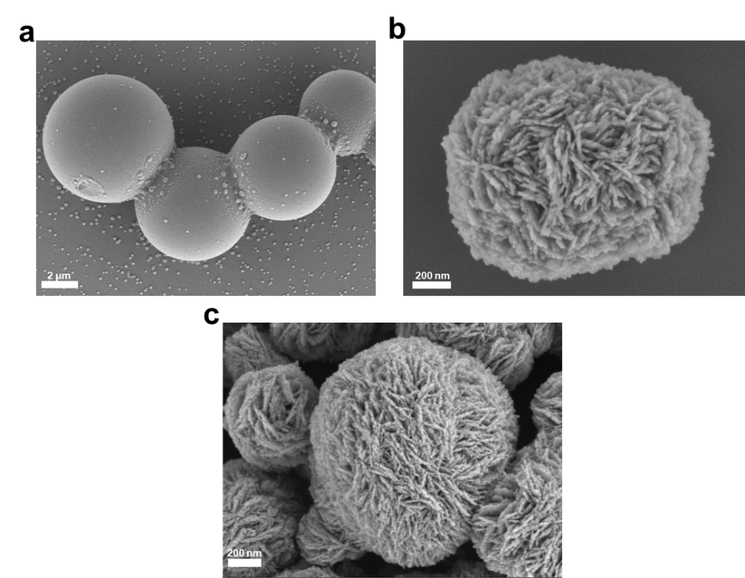

Fig. S1. SEM images of (a) NHCS, (b) BOC, (c) BNC10.
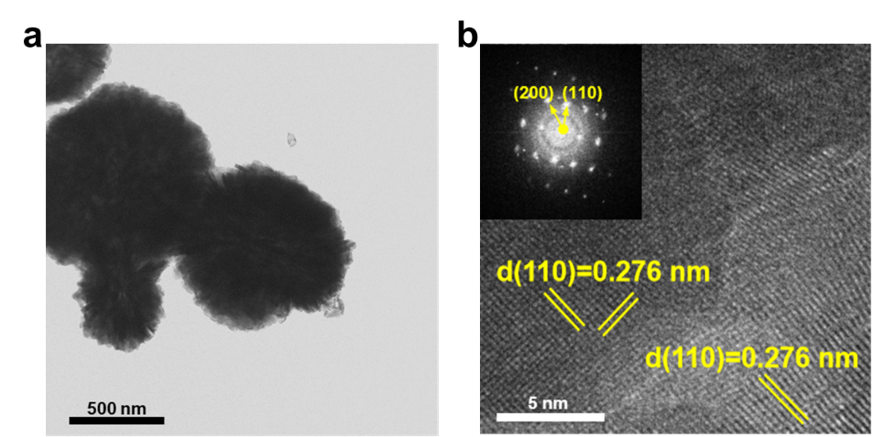

Fig. S2. HRTEM images of BOC.

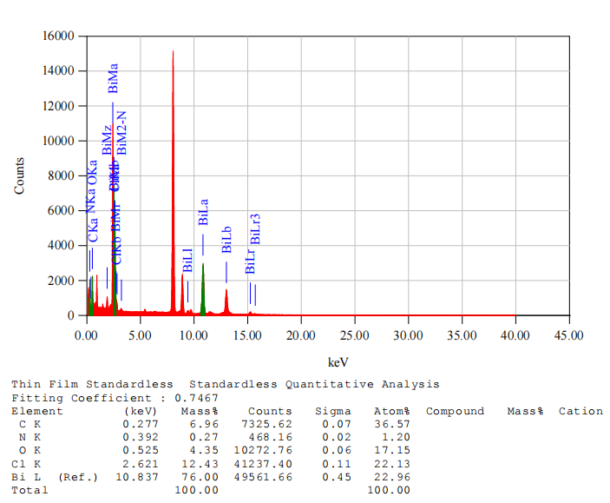

Fig. S3. Standardless quantitative analysis of BNC10 by EDS.
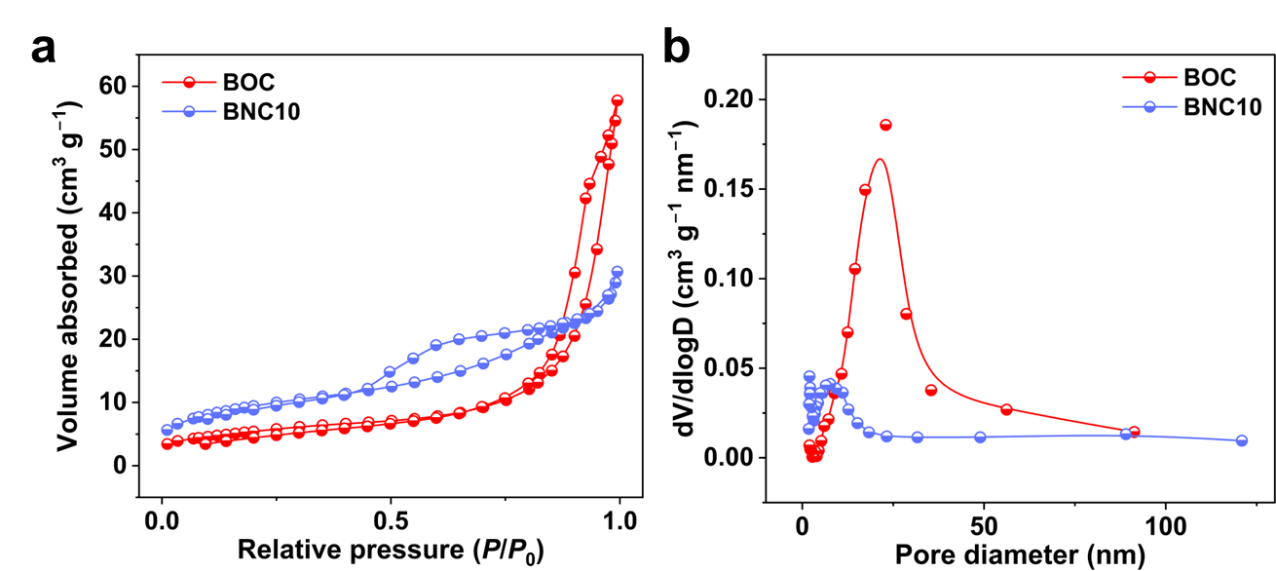

Fig. S4. (a) Nitrogen adsorption-desorption isotherms and (b) pore size distribution of BOC and BNC10 samples.
Different from a H3 typical hysteresis cycle presented in pristine BOC, BNC10 shows the typical IV pattern with a type H4 hysteresis loop at relative pressure of 0.5 to 0.8, suggesting the decrease of micro-mesopores.

Fig. S5. (a) XPS survey spectra. High-resolution spectra of (b) C 1s, (c) Cl 2p, and (d) N 1s with BOC and BNC10.
As shown in Fig. S5a, the survey spectrum of the as-prepared samples confirm the presence of Bi, O, Cl, N, and C elements. To investigate the chemical modification of the BOC surface by the N-doped carbon coated layer (NCL), the high-resolution C 1s spectra of BOC, BNC10, and NHCS were compared (Fig. S5b). The C 1s spectrum of the pristine BOC primarily consists of a peak at 284.8 eV (attributed to C−C/C=C) and a peak at 286.5 eV (attributed to C−O). In contrast, the C 1s spectrum of BNC10 exhibits characteristic peaks at 284.8 eV (C−C/C=C) and 286.2 eV (C−O/C−N), and notably, two distinct new peak appears at 288.2 eV and 288.5 eV, which can be assigned to C=O and O−C=O/N−C=N, respectively [16, 17]. These significant differences in the C 1s spectra between BOC and BNC10 directly demonstrate that the NCL coating successfully introduced more oxygen- and nitrogen-containing functional groups onto the BOC surface. In the fitting of the N 1s spectrum (Fig. S5c), BNC10 shows four peaks existing in NHCS, assigned to the pyridinic N at 398.3 eV, the pyridinic N at 399.1 eV, the graphitic N at 400.2 eV, and the oxidized N at 401.4 eV, respectively [18]. Notably, as the NCL, the proportion of N species has changed (Table S5). Unlike the pyridinic and pyrrolic N species that are always located at the edges of graphite, graphitic N (also as a quaternary N) is typically confined within the carbon lattice. Therefore, an increase in the content of graphitic N implies a decrease in defects and disordered structures. Intriguingly, all convolved N 1s peaks in BNC10 shift toward lower binding energies. All these results clearly demonstrate the close chemical interactions between the N-doped carbon layer and BOC. The two peaks located at 198.0 and 199.6 eV in BNC10 correspond to Cl 2p3/2 and Cl 2p1/2, respectively, and are shifted towards higher binding energies by 0.2 eV (Fig. S5d). This phenomenon indicates a significant charge transfer in the double [Cl]– layers [19].
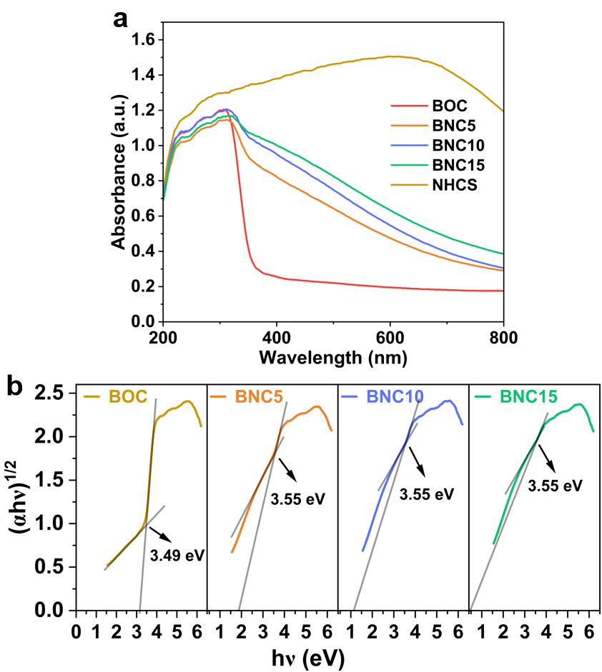

Fig. S6. (a) UV-DRS spectra of prepared samples. (b) Transformed Kubelka-Munk function of the prepared samples.
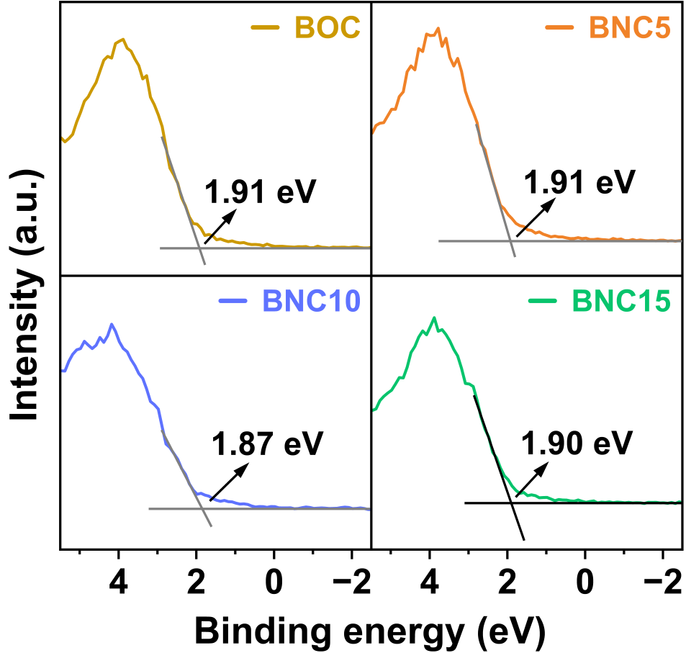

Fig. S7. VB position measurement of the prepared samples.

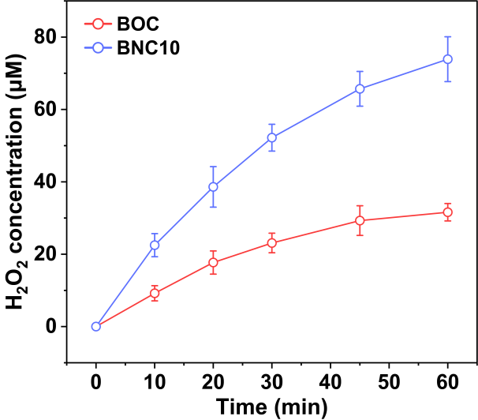

Fig. S8. H₂O₂ concentration of BOC and BNC10 under visible-light irradiation.
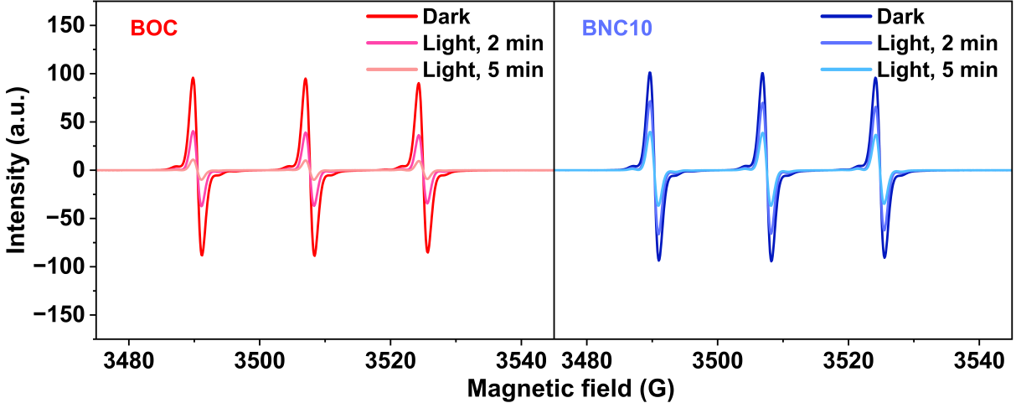

Fig. S9. EPR spectra of TEMPO-e⁻ generated by BOC and BNC10 in the dark and under visible-light irradiation.
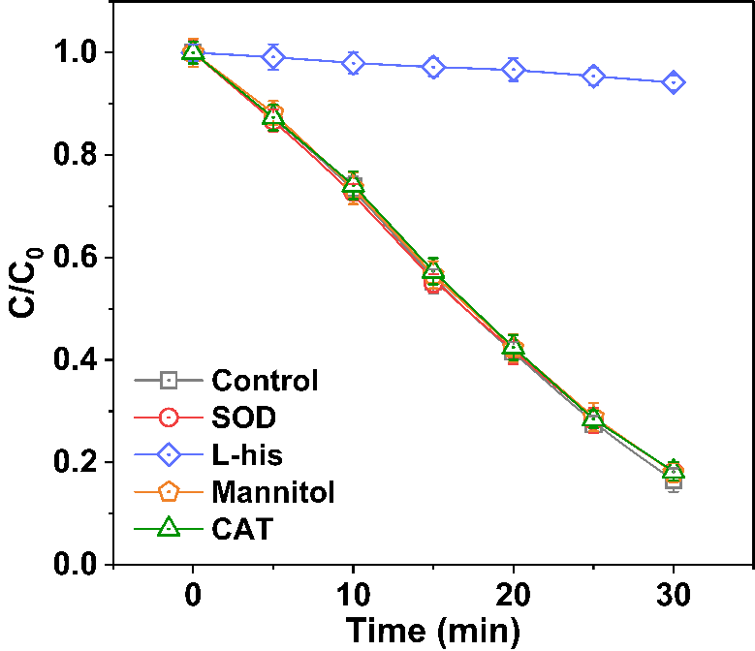

Fig. S10. FFA consumption rate in the presence of different scavengers over BNC10.
In practice, the production pathway of ¹O₂ may be not limited to ET. According to reports, ¹O₂ can also be generated via disproportionation of •OH (eq 18), the transmutation route with •O₂⁻ (eqs 19-21), and the reaction of H₂O₂ with HClO (eq 22) [20, 21].
4•OH → ¹O₂ + 2H₂O (18)
•O₂⁻ + •OH → ¹O₂ + OH⁻ (19)
•O₂⁻ + h⁺ → ¹O₂ (20)
•O₂⁻ + H₂O₂ → ¹O₂ + OH⁻ + •OH (21)
H₂O₂ + HClO→ ¹O₂ + Cl⁻ + H₂O + H⁺ (22)
FFA has been widely used as a highly soluble and efficient probe molecule for the determination of ¹O₂ in water ((k(FFA + ¹O₂) = 1.2 × 10⁸ M^{–1} sec^{–1}) [1, 2]. To verify the above discussion, the production of ¹O₂ in the BOC and BNC10 systems was further quantified through FFA probe experiments, and other possible pathway of ¹O₂ production were excluded. As shown in Fig. 3g, the steady-state concentration of ¹O₂ generated by BNC10 is calculated to be one order of magnitude higher than that of BOC. The heavily inhibited oxidation of FFA by the addition of L-his demonstrates the reliability of the reaction, while SOD, mannitol, and CAT did not show clear impact on the oxidation process, ruling out other pathways of ¹O₂ production. Accordingly, the strong excitonic effect in BNC10 can selectively generate ¹O₂ through energy transfer during photocatalytic O₂ activation.
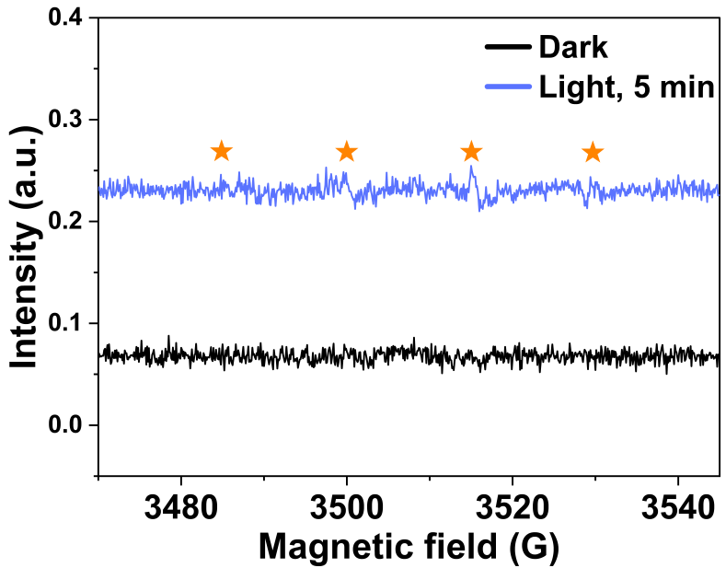

Fig. S11. EPR spectra of DMPO-•OH generated by BNC10 in the dark and under visible-light irradiation.
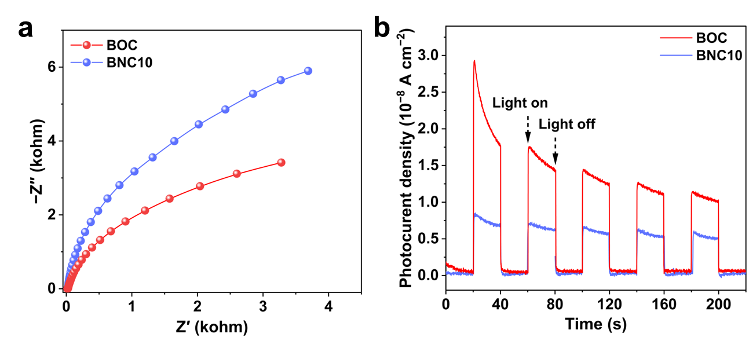

Fig. S12. (a) EIS spectra and (b) transient photocurrent of BOC and BNC10.

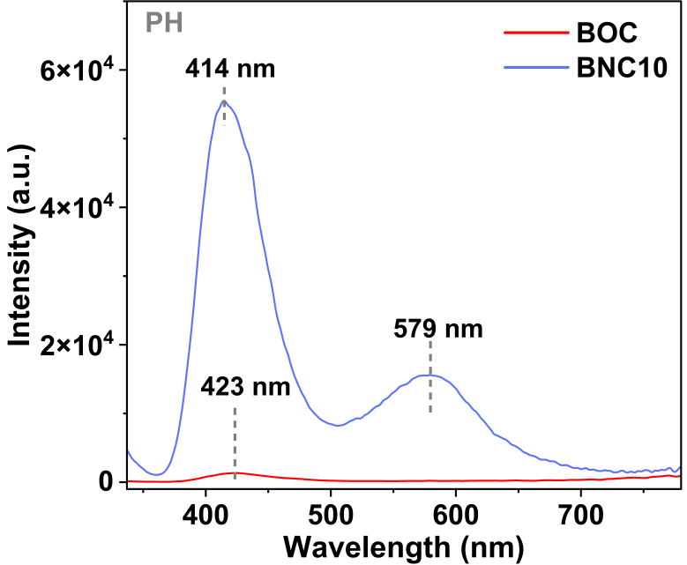

Fig. S13. PH spectra of BOC and BNC10 samples.

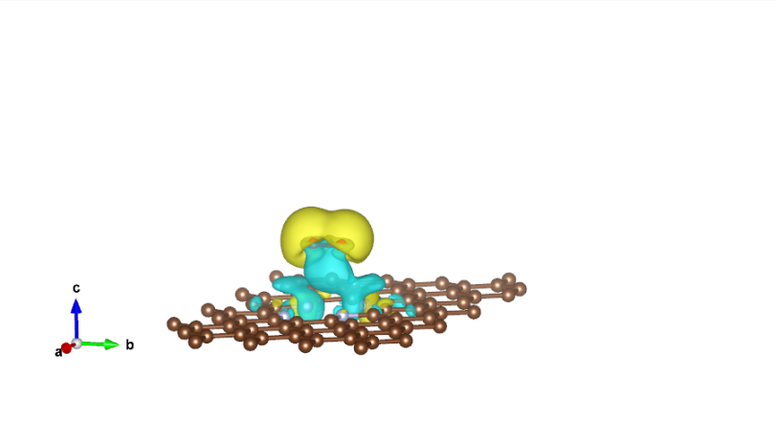
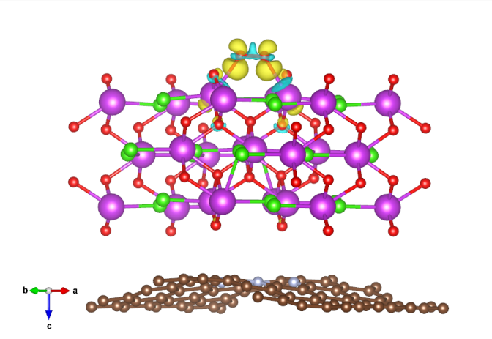
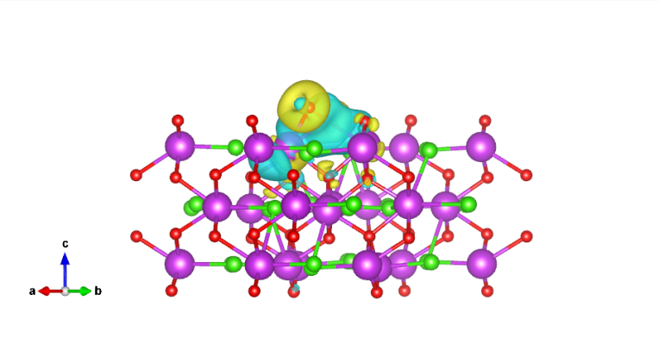
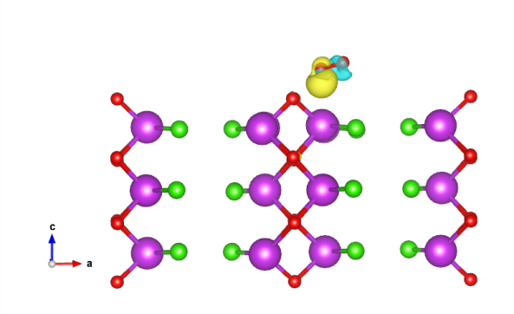
Fig. S14. Differential charge density of (a) NC, (b) BOC without OV, (c) BOC with OV, and (d) BNC without OV, with charge accumulation and depletion regions represented in yellow and cyan, respectively. The isosurface value is set to be 0.00134 e/Å³.
a
b
c
d
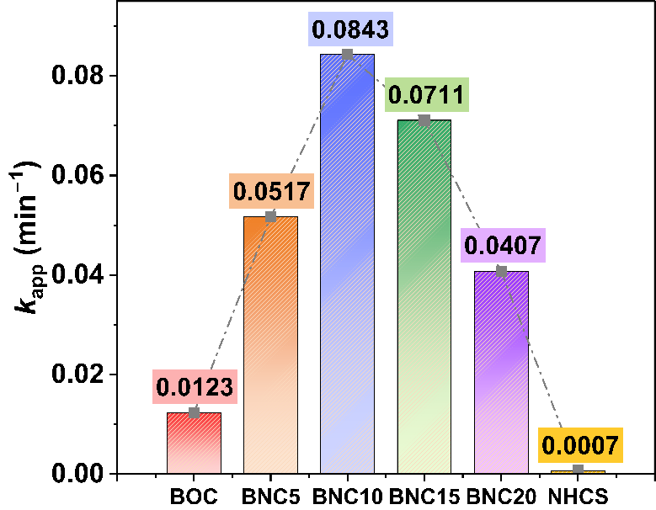

Fig. S15. Pseudo-first order rate constants for CIP degradation with prepared samples.
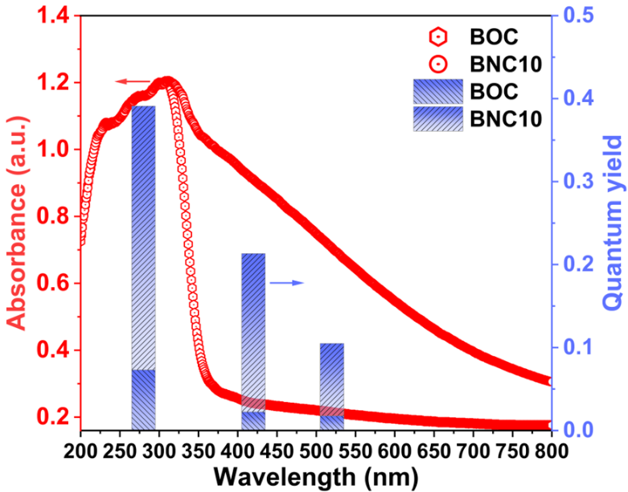

Fig. S16. Quantum yield of CIP degradation in photocatalytic system as a function of the irradiation wavelength.
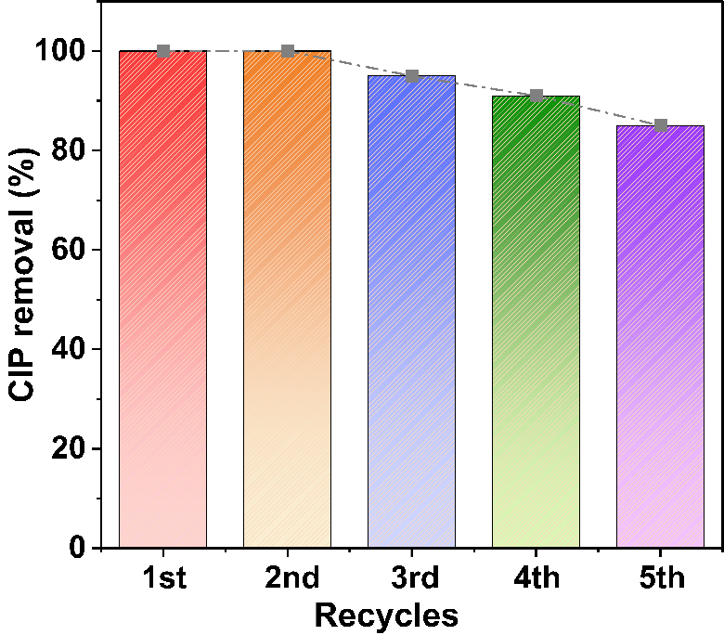

Fig. S17. Recycling tests of BNC10 for CIP degradation.
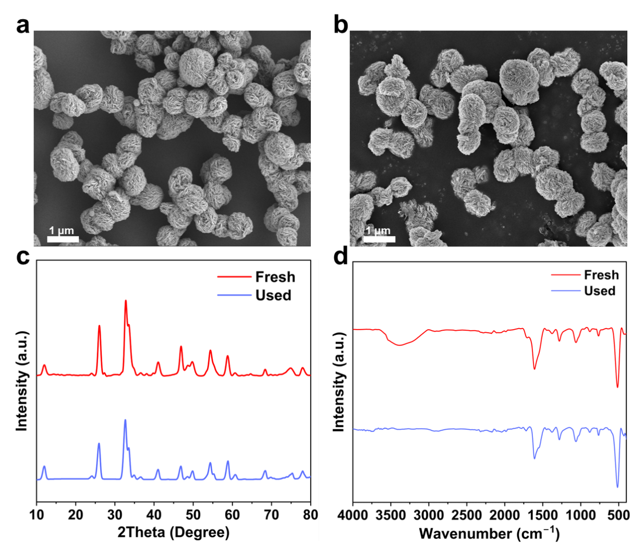

Fig. S18. SEM images of BNC10 (a) before and (b) after degradation reaction. (c) XRD patterns and (d) FTIR spectra of BNC10 before and after use.
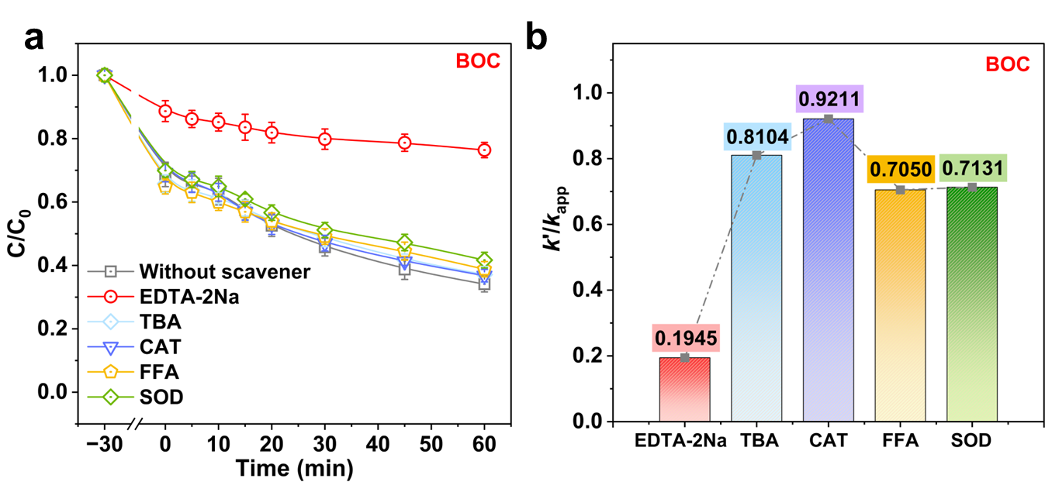

Fig. S19. (a) Degradation plots and (b) the corresponding ratio of CIP degradation rate by BOC samples after the addition of various scavengers.
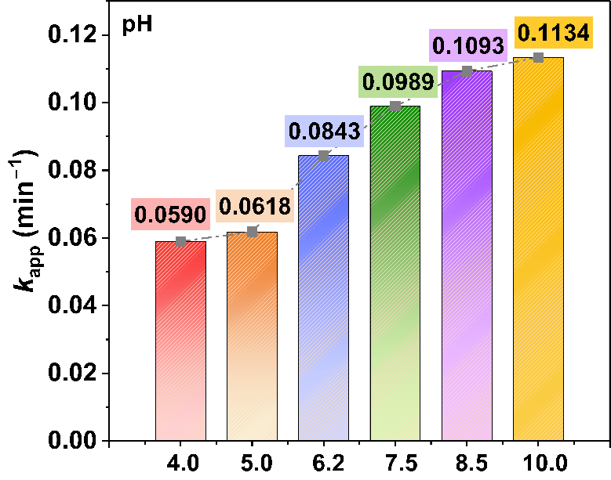

Fig. S20. Rate constant for CIP degradation over BNC10 at different pH values.
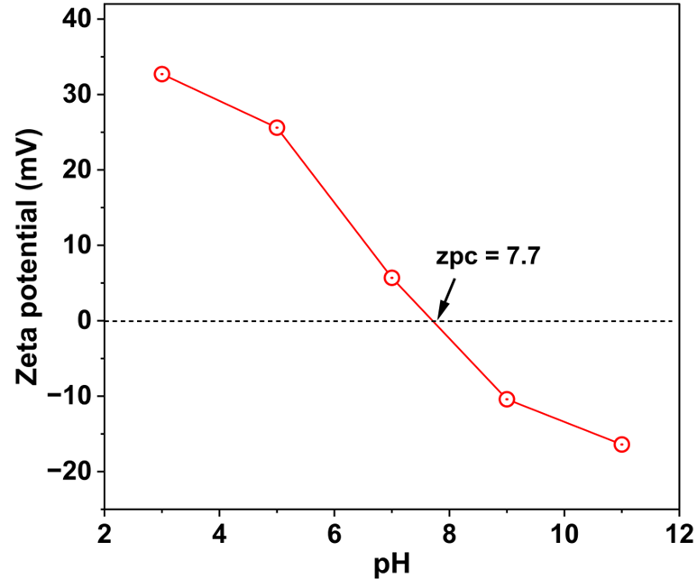

Fig. S21. Zeta potential (ζ) of BNC10 at different pH values.
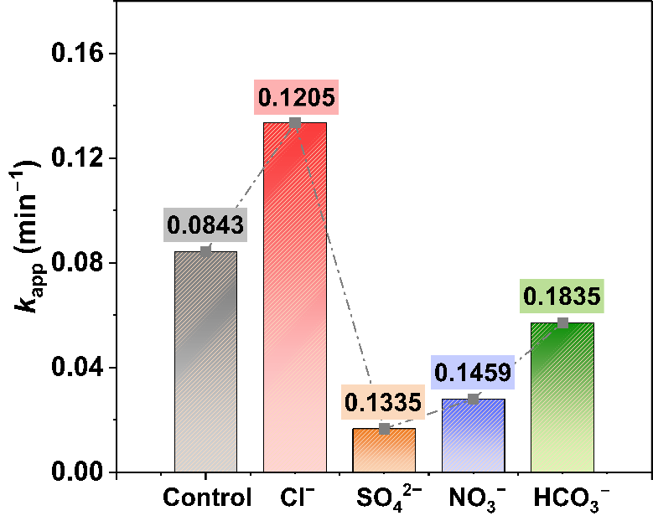

Fig. S22. Rate constant for CIP degradation over BNC10 in the presence of various anions.
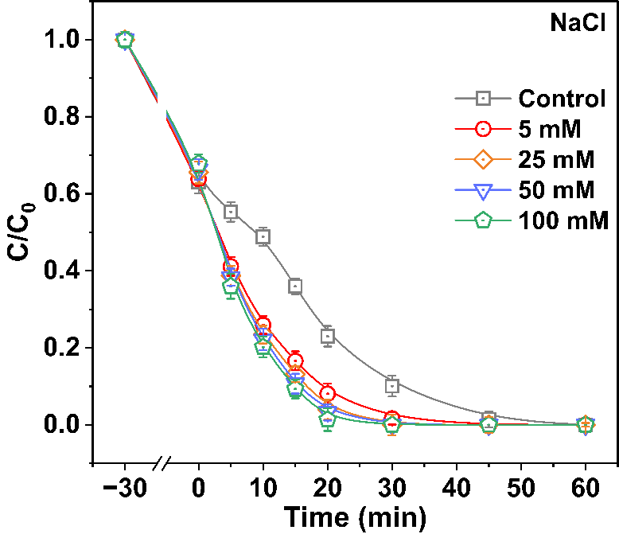

Fig. S23. Photocatalytic performance for CIP degradation by BNC10 with different concentration of Cl–.
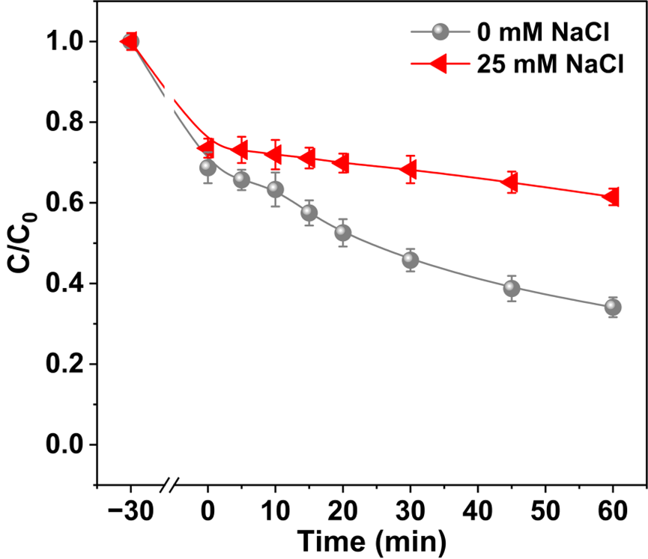

Fig. S24. Photocatalytic performance by BOC for CIP degradation with or without Cl–.
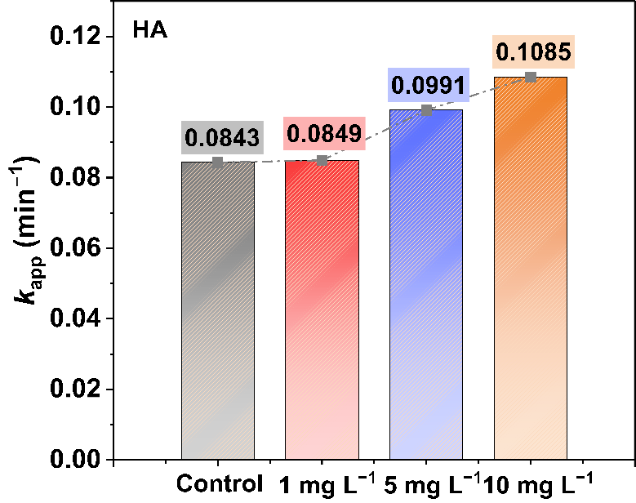

Fig. S25. Rate constant for CIP degradation over BNC10 in the presence of different HA concentration.
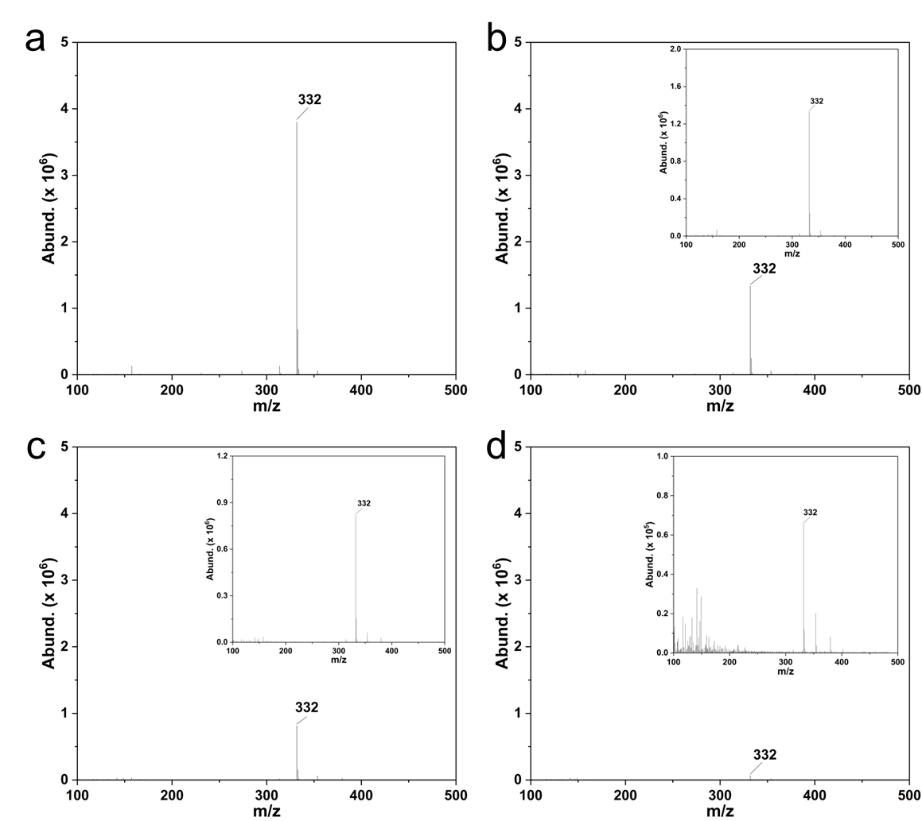

Fig. S26. Mass spectra (MS) of the CIP intermediates at different illumination time of (a) 0 min, (b) 15 min, (c) 30 min, and (d) 60 min. Insets in (b) and (c) are the corresponding image of normal vertical scale.
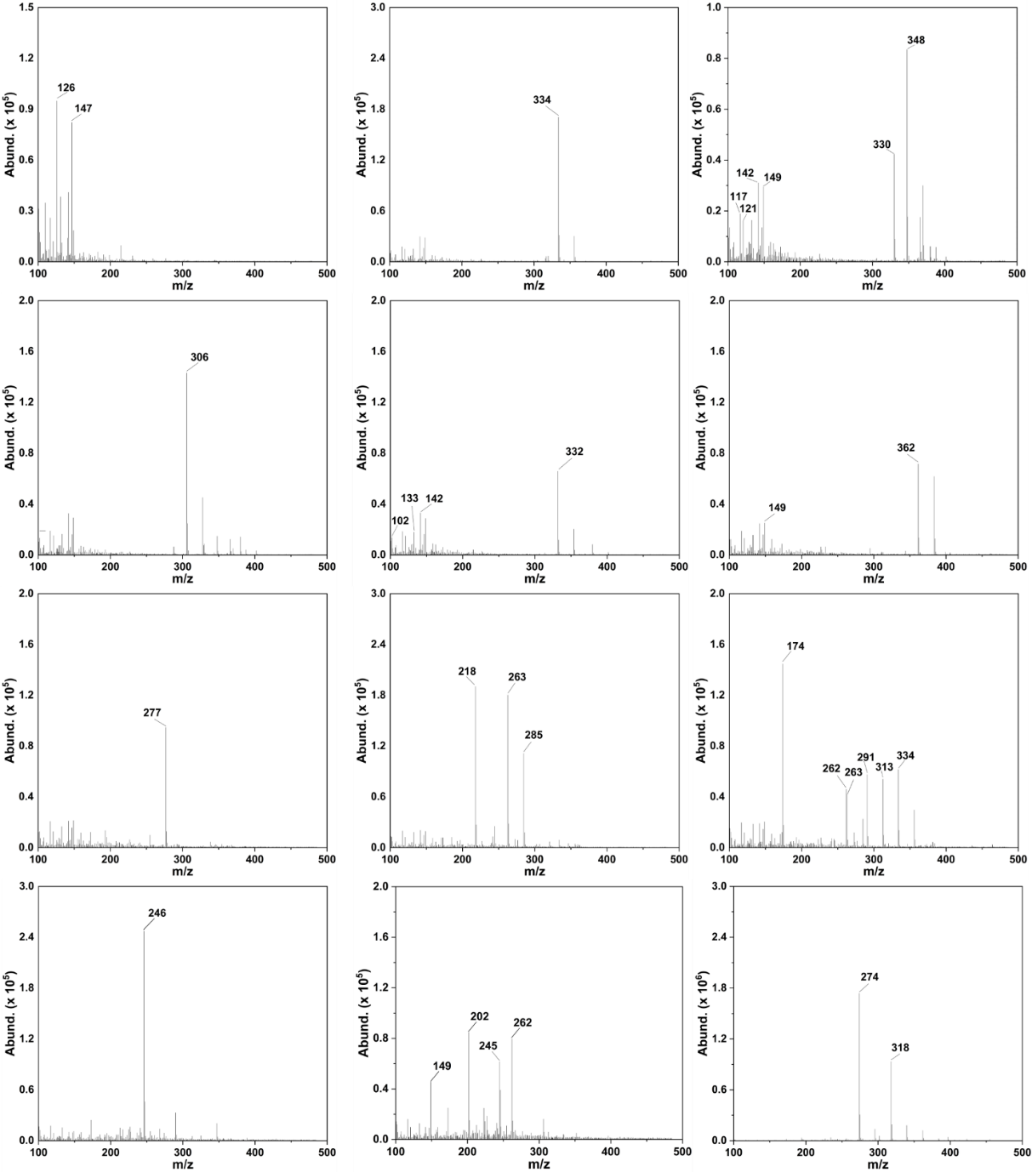

Fig. S27. MS of the possible intermediates during CIP degradation.
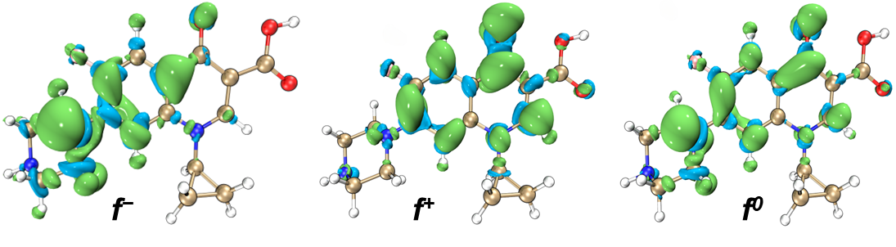

Fig. S28. NPA charge distribution and Fukui index in CIP.
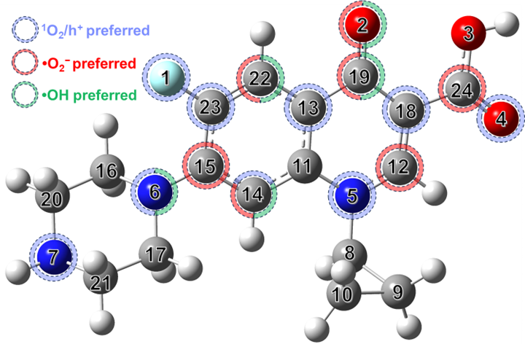

Fig. S29. CIP molecular structure with atomic sites vulnerable to attack by different active species.
As displayed in Fig. S24, the 6N of the piperazine ring, as well as the 13C, 14C, and 23C sites of the parent core, exhibit relatively high f⁻ values, indicating that they are more vulnerable to h⁺ or ¹O₂ attack and then bond breakage. The 2O, 19C, 12C atoms on the quinolone ring, as well as the 14C, 15C, and 22C atoms in the parent core, have a greater tendency to be attacked by nucleophilic •O₂⁻. These results are similar to those observed in ALIE. Moreover, the most active sites for •OH addition reactions are 2O, 6N, 14C, 19C, and 22C. Undoubtedly, the characteristics of multiple reactive attacks found at these sites are expected to lead to different degradation pathways. In this regard, the Hirshfeld charge distribution shows that 2O and 19C are actually more prone to electrophilic and nucleophilic reactions, respectively. It is also observed that 1F, 4O, 5N, 7N, and 18C sites exhibits a preference for electrophilic reactions, while 24C was more sensitive to nucleophilic reactions. The above results are further discussed by the calculated CDD values, where the more negative/positive the CDD values of the site, the more likely they are to be attacked by electrophilic/nucleophilic species. The 6N atom on the piperazine ring also has higher sensitivity to electrophilic reactions.
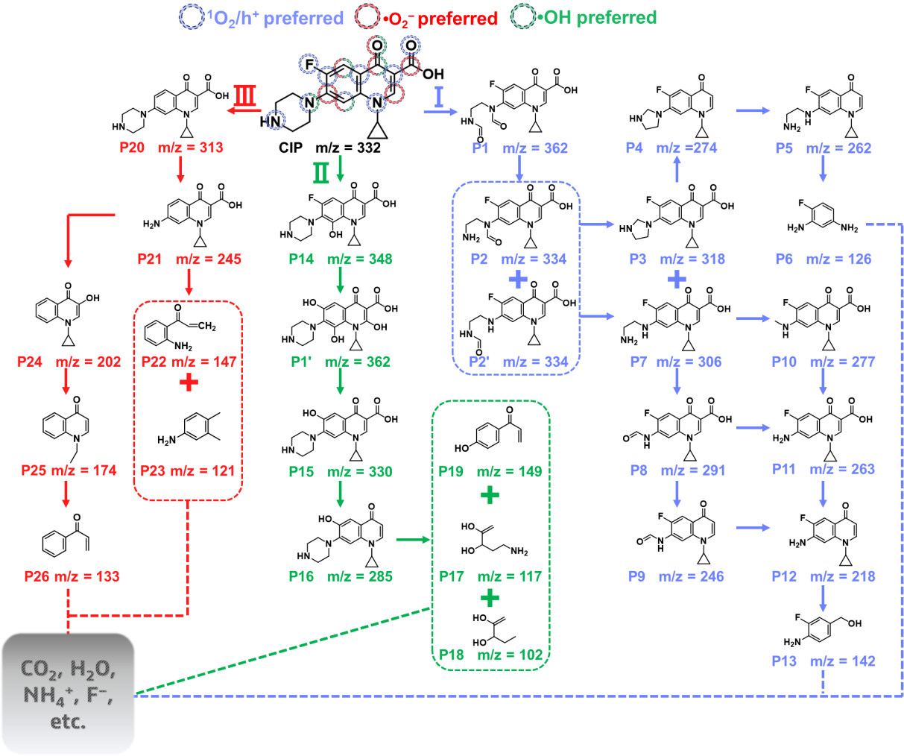

Fig. S30. Possible degradation pathways of CIP in BNC10 system. Pathway I (blue) included the cleavage and oxidation of piperazine ring and decarboxylation; Pathway II (green), dominated by OH/F substitution; Pathway III (red), with C-F bond breaking and quinolone ring cleavage.
Pathway I is initiated by the aldehyde reaction, with the formation of P1 (m/z = 362). P1 is converted to P2 and P2ʹ isomers (m/z = 334) after the attack by h⁺ and subsequent hydrolysis. The decomposition of aldehyde groups leads to the formation of P3 (m/z = 318) and P7 (m/z = 306). P4 (m/z = 274) is released after the decarboxylation of C24 site of the quinolone moiety in P3 is attacked by •O₂⁻. The five-membered ring of P4 is broken, obtaining P5 with m/z = 262, and then produce small molecular compound (P6 with m/z = 126) under continuous degradation. When N7 site in P7 is attacked by ¹O₂ and h⁺, an amine nitrogen group will lose, pointing to the formation of P8 (m/z = 291) [22]. Like the transformation of P3 to P4, the formation of P9 (m/z = 246) originates from the decarboxylation of P8. Another transformation route starting from P7 is attributed to the cleavage of secondary amine side chains, loss of formaldehyde groups, and decarboxylation, forming a series of intermediates (P10-P12). In the end, P12 (m/z = 218) undergoes cracking of the quinolone ring and shedding of the cyclopropyl group to generation P13 (m/z = 142).
Pathway II starts with the addition of the −OH group on C14, forming P14 with m/z = 348, as the C14 site is relatively reactive to •OH according to the f⁰ value. The formation of isomer P1ʹ (m/z = 362) from P14 mainly involves the addition of −OH on the quinolone ring and the substitution of F atom. The Hirshfeld charge distribution proves the higher electrophilicity of the 1F site, meaning that the C−F bond is a strong electron withdrawing group. Moreover, •OH tends to react with strong electron-donor groups, making it difficult to directly substitute F atoms. In view of this, −OH group may originate from OH in water and occupy the F site after the C−F bond is attacked and broken by ¹O₂ [23]. The production of P15 (m/z=330) is because of the dehydroxylation of P1ʹ induced by the gradual hydrolysis. Subsequently, P15 is attacked and lost its carboxyl group, resulting in P16 (m/z = 285) and further producing small molecule compounds P17-P19. In terms of pathway III, the 1F site of CIP is first attacked by ¹O₂ and undergoes defluorination, forming P20 (m/z = 313). P21 with m/z = 245 is obtained due to the opening of the piperazine ring in P20. Next, the cleavage of the quinolone moiety resulted in the generation of P22 (m/z = 147) and P23 (m/z = 121). In addition, P21 can also form P24 (m/z = 202) through the loss of −CO and −HN₂, followed by cleavage of cyclopropyl groups and dehydroxylation to produce P25 (m/z=174). P26 with m/z = 133 is obtained by eliminating the methyl, amino, and carbonyl groups of P25.
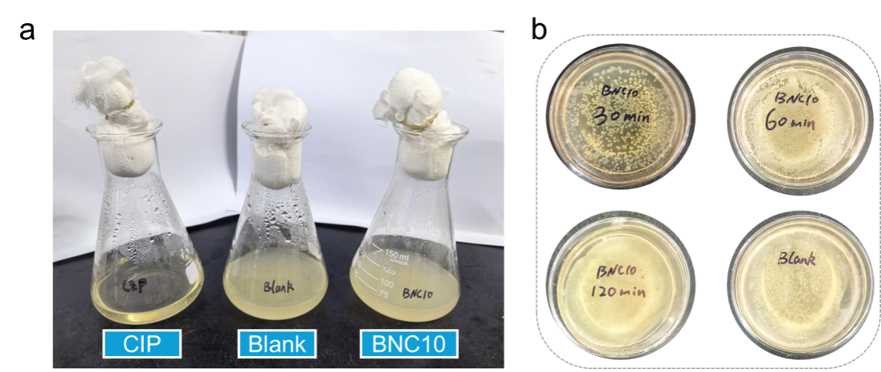

Fig. S31. (a) Growth curves (b) culture situation of E.coli in the addition of BNC10 degradation solution for 13 h. (c) Photographs of E.coli colonies cultivation on LB-agar plates with the addition of degraded CIP solutions by BNC10 system by different times (Blank represents E.coli cultivated in pure water.

Table S1. Eluent programs and detection wavelengths for HPLC analysis.
Compound | Molecular structure | Detection wavelength (nm) | Flow rate (mL/min) | Column temp (℃) | Mobile phase (v/v)
Ciprofloxacin (CIP) |  | 278 | 0.8 | 30 | H₂O-0.1% formic acid : acetonitrile = 80 : 20
Acetaminophen (ACE) |  | 245 | 0.8 | 30 | H₂O : methanol = 75 : 25
Bisphenol A (BPA) |  | 273 | 1.0 | 30 | H₂O-0.1% formic acid : acetonitrile = 50 : 50
Tetracycline Hydrochloride (TC) |  | 352 | 1.0 | 30 | 0.1% oxalic acid-H₂O : acetonitrile = 47.5 : 52.5

Table S2. Quantitative analysis of element content of BNC10 by organic element analyzer.
Sample | N(％) | C(％) | H(％) | S(％) | O(％)
BNC10 | 0.23 | 2.44 | 0.47 | 0.00 | /
BNC10-repeat | 0.23 | 2.51 | 0.49 | 0.00 | /

Table S3. Specific surface area, average pore size, pore volume, and corresponding normalized reaction rate of BOC and BNC samples.
Sample | BET surface srea (m² g⁻¹) | Pore volume (cm³ g⁻¹) | Average pore size (nm) | Reaction rate constantª k_{obs} (× 10⁻³ min⁻¹) | Normalized reaction rate constants^{b} k_{s} (× 10⁻³ min⁻¹ L m⁻²)
BOC | 19.5105 | 0.0892 | 17.3791 | 12.3 | 1.5761
BNC10 | 33.6090 | 0.0495 | 5.4961 | 84.3 | 6.2706
ªApparent reaction rate constants (k_{obs}) of CIP photodegradation on BOC and BNC were calculated based on the pseudo-first-order model. ^{b}k_{s} denoted the rate constant normalized to surface area and catalyst concentration, k_{s}=k × (catalyst concentration × surface area)⁻¹.

Table S4. Compositions of the as-prepared samples derived from XPS analyses.
Samples | Composition (at%)
Samples | Bi | O |  | Cl | C | N
Samples | Bi | Total | O_{abs}ª | Cl | C | N
NHCS | / | 21.81 | 6.00 | / | 74.38 | 3.81
BOC | 20.1 | 37.78 | 3.84 | 19.26 | 22.87 | /
BNC10 | 8.80 | 30.78 | 9.71 | 8.10 | 47.1 | 5.22
[a] O_{abs} = chemisorbed oxygen

Table S5. Summarized XPS data of different N types in NHCS and BNC10 samples.
Samples | Pyridinic N | Pyrrolic N | Graphitic N | Oxidized N
NHCS | 21.80% | 37.60% | 20.30% | 20.30%
BNC10 | 15.55% | 18.90% | 42.02% | 23.53%

Table S6. Bond length and charge transfer of oxygen adsorbed at different models.
Model | Energy (eV) | E_{ad} (eV) | O−O bond length (Å) | Charge transfer (e)
NC | -574.72 | 0.01 | 1.25 | 0.14
BOC | -1190.24 | 0.01 | 1.24 | 0.07
BOC-OV | -339.79 | -3.59 | 1.51 | 1.13
BNC | -905.01 | -0.19 | 1.28 | 0.38
BNC-OV at NC interface | -897.53 | -0.03 | 1.25 | 0.12
BNC-OV at BOC interface | -899.72 | -4.01 | 1.52 | 1.18

Table S7. Comparison of photocatalytic degradation of CIP over BiOX-based photocatalysts.
Photocatalysts | Conditions | Removal efficiency (%) | Reaction time (min) | k_{obs} (min⁻¹) | Reference
Bi₃NbO₇/BiOCl | [catalyst]=0.5 g/L; [CIP]=10 mg/L; 300 W Xe lamp (λ>400 nm) | 93 | 40 | 0.0729 | [24]
Co-BiOCl/CQDs | [catalyst]=0.5 g/L; [CIP]=20 mg/L; 300 W Xe lamp (λ>420 nm) | 80 | 100 | 0.0147 | [25]
BiOCl/Cu-doped Bi₂S₃ | [catalyst]=0.5 g/L; [CIP]=20 mg/L; 300 W Xe lamp (λ>380 nm) | 97 | 30 | 0.1119 | [26]
BiOCl prepared by different temperature | [catalyst]=0.5 g/L; [CIP]=20 mg/L; 300 W Xe lamp (λ>420 nm) | 90 | 90 | 0.0220 | [27]
CoAl-LDH/Bi₁₂O₁₇Cl₂ | [catalyst]=0.4 g/L; [CIP]=15mg/L; 300 W Xe lamp (λ>420 nm) | 96 | 120 | 0.0214 | [28]
BiOCl incorporated with N-doped carbon coated layer | [catalyst]=0.4 g/L; [CIP]=10 mg/L; 300 W Xe lamp (λ>420 nm) | 100 | 60 | 0.0843 | This work

Table S8. Characteristics of real water samples.
Index | Ultrapure water  (μg L⁻¹) | Tap water  (mg L⁻¹) | River water  (mg L⁻¹) | Lake water  (mg L⁻¹)
pH | 6.9 | 6.8 | 7.6 | 7.4
TOC | 4.2 | 1.3 | 3.9 | 5.6
NO³⁻ | ND | 2.4 | 5.3 | 1.2
SO₄²⁻ | ND | 0.16 | 52.6 | 72.1
Cl⁻ | ND | 4.8 | 34.5 | 21.3

Table S9. Structural information of CIP and its possible intermediate products.
Compound | m/z | Molecular formula | Tentative structure
Ciprofloxacin | 332 | C₁₇H₁₈FN₃O₃
P1 | 362 | C₁₇H₁₆FN₃O₅
P1ʹ | 362 | C₁₇H₁₉N₃O₆
P2 | 334 | C₁₆H₁₆FN₃O₄
P2ʹ | 334 | C₁₆H₁₆FN₃O₄
P3 | 318 | C₁₆H₁₆FN₃O₃
P4 | 274 | C₁₅H₁₆FN₃O
P5 | 262 | C₁₄H₁₆FN₃O
P6 | 126 | C₆H₇FN₂
P7 | 306 | C₁₅H₁₆FN₃O₃
P8 | 291 | C₁₄H₁₁FN₂O₄
P9 | 246 | C₁₃H₁₁FN₂O₂
P10 | 277 | C₁₄H₁₃FN₂O₃
P11 | 263 | C₁₃H₁₁FN₂O₃
P12 | 218 | C₁₂H₁₁FN₂O
P13 | 142 | C₇H₈FNO
P14 | 348 | C₁₇H₁₈FN₃O₄
P15 | 330 | C₁₇H₁₉N₃O₄
P16 | 285 | C₁₆H₁₉N₃O₂
P17 | 117 | C₅H₁₁NO₂
P18 | 102 | C₅H₁₀O₂
P19 | 149 | C₉H₈O₂
P20 | 313 | C₁₇H₁₉N₃O₃
P21 | 245 | C₁₃H₁₂N₂O₃
P22 | 147 | C₉H₉NO
P23 | 121 | C₈H₁₁N
P24 | 202 | C₁₂H₁₁NO₂
P25 | 174 | C₁₁H₁₁NO
P26 | 133 | C₉H₈O

Table S10. Hirshfeld charges and Fukui index of CIP.
Atom | q(N) | q(N+1) |  | q(N-1) |  | f⁻ |  | f⁺ |  | f⁰ |  |  | CDD
1(F) | -0.1042 |  | -0.1270 |  | -0.0741 |  | 0.0301 |  | 0.0228 |  | 0.0265 | -0.0073
2(O) | -0.3815 |  | -0.5206 |  | -0.3400 |  | 0.0415 |  | 0.1391 |  | 0.0903 | 0.0976
3(O) | -0.1873 |  | -0.1963 |  | -0.1832 |  | 0.0040 |  | 0.0091 |  | 0.0065 | 0.0050
4(O) | -0.3507 |  | -0.3762 |  | -0.3424 |  | 0.0083 |  | 0.0255 |  | 0.0169 | 0.0172
5(N) | 0.0235 |  | -0.0078 |  | 0.0283 |  | 0.0048 |  | 0.0312 |  | 0.0180 | 0.0264
6(N) | -0.0851 |  | -0.1048 |  | 0.0992 |  | 0.1843 |  | 0.0197 |  | 0.1020 | -0.1646
7(N) | -0.1795 |  | -0.1817 |  | -0.1727 |  | 0.0068 |  | 0.0021 |  | 0.0045 | -0.0047
8(C) | 0.0246 |  | 0.0185 |  | 0.0262 |  | 0.0016 |  | 0.0061 |  | 0.0039 | 0.0045
9(C) | -0.0581 |  | -0.0654 |  | -0.0540 |  | 0.0041 |  | 0.0073 |  | 0.0057 | 0.0032
10(C) | -0.0615 |  | -0.0690 |  | -0.0584 |  | 0.0031 |  | 0.0076 |  | 0.0053 | 0.0045
11(C) | 0.0479 |  | 0.0218 |  | 0.0743 |  | 0.0264 |  | 0.0261 |  | 0.0263 | -0.0003
12(C) | 0.0705 |  | 0.0000 |  | 0.0860 |  | 0.0155 |  | 0.0705 |  | 0.0430 | 0.0550
13(C) | -0.0429 |  | -0.0732 |  | 0.0255 |  | 0.0684 |  | 0.0303 |  | 0.0494 | -0.0381
14(C) | -0.0629 |  | -0.1135 |  | 0.0011 |  | 0.0640 |  | 0.0506 |  | 0.0573 | -0.0134
15(C) | 0.0416 |  | -0.0184 |  | 0.0806 |  | 0.0390 |  | 0.0601 |  | 0.0495 | 0.0211
16(C) | -0.0109 |  | -0.0204 |  | 0.0226 |  | 0.0335 |  | 0.0096 |  | 0.0215 | -0.0239
17(C) | -0.0057 |  | -0.0122 |  | 0.0247 |  | 0.0305 |  | 0.0065 |  | 0.0185 | -0.0240
18(C) | -0.0788 |  | -0.1057 |  | -0.0674 |  | 0.0114 |  | 0.0269 |  | 0.0191 | 0.0154
19(C) | 0.1050 |  | -0.0084 |  | 0.1249 |  | 0.0199 |  | 0.1133 |  | 0.0666 | 0.0934
20(C) | -0.0130 |  | -0.0173 |  | -0.0013 |  | 0.0117 |  | 0.0043 |  | 0.0080 | -0.0074
21(C) | -0.0125 |  | -0.0166 |  | 0.0009 |  | 0.0133 |  | 0.0041 |  | 0.0087 | -0.0092
22(C) | -0.0512 |  | -0.1326 |  | -0.0191 |  | 0.0321 |  | 0.0814 |  | 0.0567 | 0.0493
23(C) | 0.0810 |  | 0.0380 |  | 0.1363 |  | 0.0553 |  | 0.0430 |  | 0.0492 | -0.0123
24(C) | 0.2072 |  | 0.1915 |  | 0.2128 |  | 0.0055 |  | 0.0158 |  | 0.0106 | 0.0102
25(H) | 0.0661 |  | 0.0532 |  | 0.0699 |  | 0.0039 |  | 0.0128 |  | 0.0083 | 0.0089
26(H) | 0.0590 |  | 0.0526 |  | 0.0616 |  | 0.0025 |  | 0.0064 |  | 0.0045 | 0.0039
27(H) | 0.0599 |  | 0.0543 |  | 0.0626 |  | 0.0027 |  | 0.0055 |  | 0.0041 | 0.0028
28(H) | 0.0592 |  | 0.0533 |  | 0.0619 |  | 0.0027 |  | 0.0058 |  | 0.0043 | 0.0032
29(H) | 0.0539 |  | 0.0477 |  | 0.0565 |  | 0.0027 |  | 0.0062 |  | 0.0044 | 0.0035
30(H) | 0.0713 |  | 0.0415 |  | 0.0790 |  | 0.0077 |  | 0.0299 |  | 0.0188 | 0.0222
31(H) | 0.0526 |  | 0.0333 |  | 0.0760 |  | 0.0234 |  | 0.0194 |  | 0.0214 | -0.0040
32(H) | 0.0266 |  | 0.0175 |  | 0.0785 |  | 0.0518 |  | 0.0092 |  | 0.0305 | -0.0427
33(H) | 0.0362 |  | 0.0294 |  | 0.0594 |  | 0.0231 |  | 0.0068 |  | 0.0150 | -0.0163
34(H) | 0.0476 |  | 0.0422 |  | 0.0734 |  | 0.0257 |  | 0.0055 |  | 0.0156 | -0.0203
35(H) | 0.0311 |  | 0.0235 |  | 0.0808 |  | 0.0497 |  | 0.0076 |  | 0.0286 | -0.0420
36(H) | 0.0247 |  | 0.0224 |  | 0.0380 |  | 0.0133 |  | 0.0022 |  | 0.0078 | -0.0111
37(H) | 0.0450 |  | 0.0416 |  | 0.0597 |  | 0.0147 |  | 0.0034 |  | 0.0091 | -0.0113
38(H) | 0.0448 |  | 0.0414 |  | 0.0602 |  | 0.0154 |  | 0.0033 |  | 0.0094 | -0.0121
39(H) | 0.0246 |  | 0.0225 |  | 0.0382 |  | 0.0137 |  | 0.0021 |  | 0.0079 | -0.0116
40(H) | 0.0589 |  | 0.0153 |  | 0.0782 |  | 0.0193 |  | 0.0436 |  | 0.0315 | 0.0244
41(H) | 0.1129 |  | 0.1084 |  | 0.1226 |  | 0.0098 |  | 0.0045 |  | 0.0071 | -0.0053
42(H) | 0.2101 |  | 0.1984 |  | 0.2127 |  | 0.0026 |  | 0.0117 |  | 0.0072 | 0.0091

Table S11. Toxicity classification according to the Globally Harmonized System of Classification and Labelling of Chemicals.
Toxicity range (mg/L) | Logarithmic-transformed toxicity range | Classification
LC50ª/EC50^{b}/ChV^{c} ≤ 1 | lg (LC50ª/EC50^{b}/ChV^{c}) ≤ 0 | Very toxic
1 < LC50/EC50/ChV ≤ 10 | 0< lg (LC50/EC50/ChV) ≤ 1 | Toxic
10 < LC50/EC50/ChV ≤ 100 | 1< lg (LC50/EC50/ChV) ≤ 2 | Harmful
LC50/EC50/ChV > 100 | lg (LC50/EC50/ChV)>2 | Not harmful
ªLC50, Half lethal concentration; ^{b}EC50, Half effective concentration; ^{c}ChV, Chronic toxicity value.

Table S12. Estimated acute and chronic toxicity by ECOSAR.
Compounds | Acute toxicity  (mg/L) |  |  | Chronic toxicity  (mg/L)
Compounds | Fish  (LC₅₀-96h) | Daphnid  (LC₅₀-48h) | Green Algae  (EC₅₀-96h) |  | Fish  (ChV) | Daphnid  (ChV) | Green Algae  (ChV)
CIP | 13131 | 1240 | 1620 |  | 1550 | 81.3 | 455
P1 362 | 28200 | 19500 | 3660 |  | 330 | 2180 | 1650
P1' 362 | 1210 | 10.1 | 88.8 |  | 4.6 | 2.66 | 10.3
P2 334 | 141000 | 11100 | 20800 |  | 1540 | 609 | 2470
P2' 334 | 20000 | 25200 | 1310 |  | 124 | 2230 | 392
P3 318 | 26400 | 2360 | 3450 |  | 3720 | 146 | 930
P4 274 | 61.3 | 7.22 | 6.1 |  | 3.7 | 0.586 | 2.01
P5 262 | 109 | 12.2 | 11.4 |  | 7.6 | 0.948 | 3.61
P6 126 | 366 | 4.77 | 2.4 |  | 9.06 | 0.0678 | 0.614
P7 306 | 47300 | 4020 | 6470 |  | 7700 | 238 | 1680
P8 291 | 2920 | 1990 | 273 |  | 27.9 | 136 | 127
P9 246 | 71.7 | 70 | 8.63 |  | 0.927 | 3.98 | 5.45
P10 277 | 1550 | 1030 | 1370 |  | 342 | 60.6 | 119
P11 263 | 899 | 42.8 | 128 |  | 12.4 | 0.488 | 47.9
P12 218 | 26.5 | 2.37 | 6.28 |  | 0.276 | 0.0288 | 1.77
P13 142 | 179 | 3.86 | 13.4 |  | 3.54 | 0.0405 | 7.2
P14 348 | 30500 | 2270 | 4760 |  | 7460 | 118 | 1120
P15 330 | 874 | 29.3 | 104 |  | 5.73 | 6.68 | 15.2
P16 285 | 6.89 | 0.859 | 1.3 |  | 0.0756 | 0.171 | 0.236
P17 117 | 14.8 | 53.7 | 2.37 |  | 44.8 | 10.3 | 20.4
P18 102 | 4.82 | 14.8 | 0.511 |  | 4.25 | 1.44 | 3.9
P19 149 | 41.3 | 14.6 | 51.3 |  | 3.91 | 1.48 | 6.81
P20 313 | 16800 | 1550 | 2120 |  | 2140 | 99.4 | 586
P21 246 | 1130 | 44.9 | 139 |  | 16.9 | 0.502 | 56.4
P22 147 | 68.8 | 21 | 44 |  | 3.32 | 1.07 | 9.82
P23 121 | 10.1 | 1.14 | 2.88 |  | 0.0948 | 0.0141 | 0.731
P24 202 | 4.52 | 12.2 | 0.35 |  | 1.57 | 0.716 | 2.45
P25 174 | 49.2 | 32.4 | 61.6 |  | 27.4 | 1.62 | 4.08
P26 133 | 54.5 | 36.1 | 76.6 |  | 40.7 | 1.97 | 4.34

1. W.R. Haag, Hoigne. J (1986) Singlet oxygen in surface waters. 3. Photochemical formation and steady-state concentrations in various types of waters. Environmental science & technology 20:341-348. 10.1021/es00146a005
2. Mostafa S, Rosario-Ortiz FL (2013) Singlet Oxygen Formation from Wastewater Organic Matter. Environmental Science & Technology 47:8179-8186. 10.1021/es401814s
3. Haag WR, Hoigne´ JR, Gassman E, Braun AM (1984) Singlet oxygen in surface waters — Part I: Furfuryl alcohol as a trapping agent. Chemosphere 13:631-640. 10.1016/0045-6535(84)90199-1
4. Yu H, Huang J, Jiang L, Yuan X, Yi K, Zhang W, Zhang J, Chen H (2021) Steering photo-excitons towards active sites: Intensified substrates affinity and spatial charge separation for photocatalytic molecular oxygen activation and pollutant removal. Chemical Engineering Journal 408:127334. https://doi.org/10.1016/j.cej.2020.127334
5. Wang X, Wang X, Huang J, Li S, Meng A, Li Z (2021) Interfacial chemical bond and internal electric field modulated Z-scheme Sv-ZnIn2S4/MoSe2 photocatalyst for efficient hydrogen evolution. Nature Communications 12:4112. 10.1038/s41467-021-24511-z
6. Serpone N (1997) Relative photonic efficiencies and quantum yields in heterogeneous photocatalysis. Journal of Photochemistry and Photobiology A: Chemistry 104:1-12. https://doi.org/10.1016/S1010-6030(96)04538-8
7. Ling L, Tugaoen H, Brame J, Sinha S, Li C, Schoepf J, Hristovski K, Kim J-H, Shang C, Westerhoff P (2017) Coupling Light Emitting Diodes with Photocatalyst-Coated Optical Fibers Improves Quantum Yield of Pollutant Oxidation. Environmental Science & Technology 51:13319-13326. 10.1021/acs.est.7b03454
8. Shinohara H, Tsaryova O, Schnurpfeil G, Wöhrle D (2006) Differently substituted phthalocyanines: Comparison of calculated energy levels, singlet oxygen quantum yields, photo-oxidative stabilities, photocatalytic and catalytic activities. Journal of Photochemistry and Photobiology A: Chemistry 184:50-57. https://doi.org/10.1016/j.jphotochem.2006.03.024
9. Perdew JP, Burke K, Ernzerhof M (1996) Generalized Gradient Approximation Made Simple. Physical Review Letters 77:3865-3868. 10.1103/PhysRevLett.77.3865
10. Frisch M, Trucks G, Schlegel H, Scuseria G, Robb M, Cheeseman J, Scalmani G, Barone V, Petersson G, Nakatsuji (2016) Gaussian 16, revision A.03. Gaussian Inc.: Wallingford, CT
11. Zhao Y, Truhlar DG (2008) Density Functionals with Broad Applicability in Chemistry. Accounts of Chemical Research 41:157-167. 10.1021/ar700111a
12. Marenich AV, Cramer CJ, Truhlar DG (2009) Universal Solvation Model Based on Solute Electron Density and on a Continuum Model of the Solvent Defined by the Bulk Dielectric Constant and Atomic Surface Tensions. The Journal of Physical Chemistry B 113:6378-6396. 10.1021/jp810292n
13. Lu T, Chen F (2012) Multiwfn: A multifunctional wavefunction analyzer. Journal of Computational Chemistry 33:580-592. https://doi.org/10.1002/jcc.22885
14. Humphrey W, Dalke A, Schulten K (1996) VMD: Visual molecular dynamics. Journal of Molecular Graphics 14:33-38. https://doi.org/10.1016/0263-7855(96)00018-5
15. Sjoberg P, Murray JS, Brinck T, Politzer P (1990) Average local ionization energies on the molecular surfaces of aromatic systems as guides to chemical reactivity. Canadian Journal of Chemistry 68:1440-1443.
16. Fan L, Ma R, Zhang Q, Jia X, Lu B (2019) Graphite Anode for a Potassium-Ion Battery with Unprecedented Performance. Angewandte Chemie International Edition 58:10500-10505. https://doi.org/10.1002/anie.201904258
17. Du C, Feng W, Nie S, Su X, Liu H, Feng J, Sun J, Hu C, Dong S (2022) π-π conjugation driving degradation of aromatic compounds with in-situ hydrogen peroxide generation over Zn₂In₂S₅ grown on nitrogen-doped carbon spheres. Applied Catalysis B: Environmental 310:121298. https://doi.org/10.1016/j.apcatb.2022.121298
18. Wu Y, Gao Z, Feng Y, Cui Q, Du C, Yu C, Liang L, Zhao W, Feng J, Sun J, Yang R, Sun J (2021) Harnessing selective and durable electrosynthesis of H₂O₂ over dual-defective yolk-shell carbon nanosphere toward on-site pollutant degradation. Applied Catalysis B: Environmental 298:120572. https://doi.org/10.1016/j.apcatb.2021.120572
19. Zhang Y, Xu Z, Wang Q, Hao W, Zhai X, Fei X, Huang X, Bi Y (2021) Unveiling the activity origin of ultrathin BiOCl nanosheets for photocatalytic CO₂ reduction. Applied Catalysis B: Environmental 299:120679. https://doi.org/10.1016/j.apcatb.2021.120679
20. Zhang C, Deng Y, Wan Q, Zeng H, Wang H, Yu H, Pang H, Zhang W, Yuan X, Huang J (2024) Built-in electric field boosted exciton dissociation in sulfur doped BiOCl with abundant oxygen vacancies for transforming the pathway of molecular oxygen activation. Applied Catalysis B: Environmental 343:123557. https://doi.org/10.1016/j.apcatb.2023.123557
21. Xu H, Liu X, Li H, Zhang L (2022) O₂ activation and ¹O₂ generation over phosphate modified BiOCl for efficient photodegradation of organic pollutants. Applied Catalysis B: Environmental 314:121520. https://doi.org/10.1016/j.apcatb.2022.121520
22. Li N, Li R, Duan X, Yan B, Liu W, Cheng Z, Chen G, Hou LA, Wang S (2021) Correlation of Active Sites to Generated Reactive Species and Degradation Routes of Organics in Peroxymonosulfate Activation by Co-Loaded Carbon. Environmental Science & Technology 55:16163-16174. 10.1021/acs.est.1c06244
23. Wei X, Chen J, Xie Q, Zhang S, Ge L, Qiao X (2013) Distinct Photolytic Mechanisms and Products for Different Dissociation Species of Ciprofloxacin. Environmental Science & Technology 47:4284-4290. 10.1021/es400425b
24. Liu Y, Xu J, Chen M (2021) Synthesis of direct Z-Scheme Bi3NbO7/BiOCl photocatalysts with enhanced activity for CIP degradation and Cr(VI) reduction under visible light irradiation. Separation and Purification Technology 276:119255. https://doi.org/10.1016/j.seppur.2021.119255
25. Li W, Huang J, Fu X, Xu J, Yu X, Zhu Y, Zhang Y (2021) CQDs modified Co-BiOCl nanosheets with improved effective light absorption and charge separation for photocatalytic CIP degradation and NOX removal. Surfaces and Interfaces 27:101541. https://doi.org/10.1016/j.surfin.2021.101541
26. Du F, Lai Z, Tang H, Wang H, Zhao C (2022) Construction and application of BiOCl/Cu-doped Bi2S3 composites for highly efficient photocatalytic degradation of ciprofloxacin. Chemosphere 287:132391. https://doi.org/10.1016/j.chemosphere.2021.132391
27. Chen F, Ma N, Peng G, Xu W, Zhang Y, Meng F, Huang Q, Hu B, Wang Q, Guo X, Cheng P, Jiang L (2023) Camellia oleifera shell biochar as a robust adsorbent for aqueous mercury removal. Fermentation 910.3390/fermentation9030295
28. Guo J, Sun H, Yuan X, Jiang L, Wu Z, Yu H, Tang N, Yu M, Yan M, Liang J (2022) Photocatalytic degradation of persistent organic pollutants by Co-Cl bond reinforced CoAl-LDH/B_{i12}O₁₇Cl₂ photocatalyst: mechanism and application prospect evaluation. Water Research 219:118558. https://doi.org/10.1016/j.watres.2022.118558

