Constructing cascaded multi-heterojunction system with ultrafast electron transfer for enhanced photocatalytic CO₂ reduction
Junan Fang^{1,2}, Jiajing Zhang^{1,2}, Yaqin Han^{1,2}, Jingyin Xu³, Xuefeng He^{1,2}, Hongmei Ran⁵, Wei Chen⁵, Jia An^{*5}, Daofu Wu^{*6}, Xiaosheng Tang^{*5}, Yufei Liu^{*1,2,4}

¹ Key Laboratory of Optoelectronic Technology & Systems (Chongqing University), Ministry of Education, Chongqing 400044, China.
² Center for Intelligent Sensing Technology, College of Optoelectronic Engineering, Chongqing University, Chongqing 400044, China.
³ GBA branch of Aerospace Information Research Institute, Chinese Academy of Sciences, Guangzhou 510700, China.
⁴ Faculty of Science and Engineering, Bay Campus, Swansea University, Swansea SA1 8EN, UK.
⁵ College of Optoelectronic Engineering, Chongqing University of Posts and Telecommunications, Chongqing 400065, China.
⁶ State Key Laboratory of Catalysis, Dalian Institute of Chemical Physics, Chinese Academy of Sciences, Dalian 116023, China.
* Corresponding Author: E-mail address: (anjia@cqupt.edu.cn, wudaofu@dicp.ac.cn, xstang@cqu.edu.cn, Yufei.Liu@cqu.edu.)

Materials and Measurements
All reagents (including anhydrous reagents) and drugs (analytical purity) used for synthesis are purchased from Aladdin without further purification. Compounds 1 and 2 were purchased from Aladdin. Compound 3 was prepared according to previous literature^{[1]}. High-resolution transmission electron microscopy (HRTEM) was performed using an FEI Talos-F200S G2 transmission electron microscope (FEI, Netherlands). A scanning electron microscope (SEM) was performed using a German ZEISS sigma300 instrument. X-ray photoelectron spectroscopy (XPS) was performed with ESCALAB250Xi spectrometer (ThermoFisher Scientific). Photoluminescence (PL) and time-resolved fluorescence emission decay (TRPL) spectra were measured on a photoluminescence spectrometer (FLS1000, Edinburgh Instruments). The UV-visible absorption spectra were measured by a scanning UV-visible spectrophotometer (UV-3600) (Shimadzu, Japan). Fourier transforms infrared (FTIR) spectra were recorded on a Nicolet 380 FTIR spectrometer. Analytical size exclusion chromatography (SEC) was performed on LC20 High-Performance Liquid Chromatograph (Shimadzu, Japan) using THF as eluent at a temperature of 303 K. The samples were referenced concerning standard polystyrene (PS) calibration curves. NMR spectroscopy was performed using a Bruker AVANCE NEO 400 MHz NMR instrument The high-resolution electrospray ionization mass spectrometry (HR-ESI-MS) was performed on Bruker Daltonics flex analysis. The Raman spectra of the optimized structures were simulated at the same level. CO and CH₄ products were obtained by differentially pumped quadrupole mass spectrometer (QMS, Hiden HPR20) in isotope labeling experiments. Photocatalysis was performed using a Labsolar-6A photocatalytic system (Perfect Light Co., China), which consisted of a fully enclosed quartz reactor, a 300 W xenon lamp, and a gas chromatograph (GC).

Supplementary Scheme 1. Amide reaction mechanism.

Synthesis of compound 4
Take compound 1 (1.104 g, 3 mmol), 4-(methoxycarbonyl)phenylboronic acid pinacol ester (compound 2, 2.35 g, 9 mmol), potassium carbonate (2 M/H₂O, 30 mmol), and methyl trioctylammonium chloride (5 drops, 0.027 mmol, phase transfer catalyst) in a 250 mL round bottom flask, add 15 mL of deionized water, 15 mL of anhydrous ethanol, and 60 mL of toluene, stir and exchange air three times for a total time of about 10 minutes. Quickly add tetra (triphenylphosphine) palladium (470 mg, 0.3 mmol, catalyst) under nitrogen protection, seal, and continue stirring and extracting air three times, heat, and reflux for 24 hours. After the reaction, cool to room temperature, add 50 mL of water, and stir, then extract three times (3×30 mL) with dichloromethane and merge the organic phase. Dry with anhydrous sulfuric acid, collect and spin dry the filtrate, separate with a chromatography column, and use dichloromethane as the eluent to obtain 800 mg of white solid compound 4. ¹H NMR (CDCl₃,400 MHz) δ：3.826 (s, 4H), 3.942 (s, 6H), 7.260-7.283 (d, J=9.2Hz, 4H), 7.581-7.601 (d, J=8Hz, 4H), 7.638-7.659 (d, J=8.4Hz, 4H), 8.091-8.112 (d, J=8.4Hz, 4H). ¹³C NMR（400 MHz，CDCl₃，ppm) δ：14.371, 48.880, 52.155, 61.013, 126.939, 127.614, 128.986, 130.125, 130.147, 133.891, 138.882, 145.078, 166.986, 205.151. HRMS (ESI, positive) m/z calcd for C₃₁H₂₆O₅H⁺ 479.1853, found 479.1849.
Synthesis of compound 5
Take compound 2 (342 mg, 1.423 mmol) and compound 4 (700 mg, 1.43 mmol) into a 150 mL dried three-necked flask, add 60 mL of anhydrous n-tert butanol solution and 20 mL of anhydrous 1,4-dioxane solution, and evacuate three times under nitrogen gas. Heat to 80 ℃ under nitrogen protection, quickly add 0.367 mL of tetrabutylammonium hydroxide methanol solution (40%, 0.1 mmol) at this temperature, and continue the reaction for 30 minutes. Transfer the mixed solution to a round bottom flask under reduced pressure to remove the solvent, add 50 mL of dichloromethane solution, wash the solution with water and saturated salt water respectively, and collect the organic phase. Add anhydrous sodium sulfate for drying, filter and collect the filtrate, and remove the solvent under reduced pressure. Chromatographic column separation and purification were carried out using dichloromethane as the eluent, resulting in 700 mg of purple-black solid compound 16 with a yield of 73%. ¹H NMR (CDCl₃, 400 MHz) δ: 2.929 (s, 1H), 3.862 (s, 6H), 6.891-6.913 (t, 3H), 7.186-7.348 (m, 6H), 7.449-7.483 (m, 5H), 7.564-7.593 (m, 6H), 8.000-8.027 (m, 5H). ¹³C NMR（400 MHz，CDCl₃，ppm) δ: 13.340, 51.110, 59.969, 76.909,81.819, 121.236, 125.828, 125.858, 125.907, 125.996, 127.208, 127.294, 128.017, 128.169, 128.628, 129.089, 129.195, 129.592, 131.320, 131.576, 131.651, 152.663,153.827, 165.960, 199.014. HRMS (ESI, positive) m/z calcd for C₄₇H₃₂O₅H₃O⁺ 695.2428, found 695.2208.
Synthesis of Poly-Diester
300 mg of compound 5 was added to a 100 mL round-bottomed three-necked flask, 1 mL of diphenyl ether was added, and the gas was extracted three times under nitrogen gas for about 10 minutes. The purple color disappeared and turned pale yellow when heated under a heating hood at 260-270 ℃ nitrogen gas, indicating the completion of polymerization. The reaction lasted for 3 hours and a large amount of solid was found to be produced. After the reaction is completed and cooled to room temperature, the obtained polymer is ultrasonically dissolved in tetrahydrofuran, and filtered, the filtrate is collected, the solvent is removed under reduced pressure, and the polymer solid is collected and extracted using a Soxhlet extractor. The extraction solution is methanol/tetrahydrofuran (3:1), resulting in a yellow solid. The polymer was characterized by GPC analysis using the PS standard, with Mw=14.174 kg/mol, PDI=1.89, and a percentage of 100%.
Synthesis of compound cGNRs-Diester
In a dry 500 mL round-bottomed three-necked flask, 300 mg of Poly-Diester and 300 mL of anhydrous dichloromethane were added. Under nitrogen protection, an anhydrous diaphragm pump removed the gas three times for about 10 minutes. Then, 6.2 g of anhydrous FeCl₃ was dissolved in 15 mL of anhydrous CH₃NO₂, degassed, and dropped into the precursor solution under nitrogen atmosphere. Stirring was carried out, and nitrogen gas was continuously introduced for 3 days at room temperature. After the reaction is completed, remove a large amount of dichloromethane solution at low temperature, add 400 mL of methanol, stir for 10 minutes, let it stand for half a day, pour out the supernatant, collect the lower turbid liquid for centrifugation, collect the black solid, use methanol solution for Soxhlet extraction, and collect the final black solid as cGNRs-Diester.
Synthesis of compound cGNRs-DiCOOH
In a 100 mL round bottom flask, add 50 mg of cGNRs-Diester and 50 mL of tetrahydrofuran solvent, sonicate for 4 hours, then add 10 mL of water/methanol (1:1) mixed solution containing 0.5 g of KOH, and transfer to an oil bath for heating and reflux for 48 hours at a reflux temperature of 70 ℃. After the reaction is completed, use a rotary evaporator to remove the tetrahydrofuran solvent, then dilute the system with water, add concentrated hydrochloric acid to adjust the acidity of the system, filter, wash with water several times, and finally wash twice with ethanol. The final product cGNRs-DiCOOH was obtained by vacuum drying at room temperature.
Preparation of cGNRs-DiCOOH@TiO₂ (TCPP-Fe or CdS) heterojunction: cGNRs-DiCOOH and TiO₂ with a mass ratio of 1:1 were added to a 100 mL round-bottom flask, and then 50 mL of DMF was added and ultrasonicated for 3 hours to make it uniformly mixed. The solvent was removed to obtain cGNRs-DiCOOH@TiO₂ heterojunction.

Photo-electrochemical test
First, accurately weigh 10 mg of the sample to be tested and disperse it in 1 mL of pure ethanol. In order to enhance the stability and adhesion of the suspension, 50 μL of Nafion solution was then added. Next, the mixed solution was placed in an ultrasonic treatment device and continuously stirred for thirty minutes until a mixed suspension was formed. Subsequently, 100 μL of the mixed suspension was accurately taken out with a micropipette and evenly dropped on the pre-prepared indium tin oxide (ITO) glass substrate. At room temperature, the suspension was allowed to evaporate and dry naturally. After it was completely dried, the photoelectric properties of the prepared sample could be tested and analyzed in detail. The assembled photoelectrode ITO was used as the working electrode, the Pt mesh was used as the counter electrode, and the Ag/AgCl electrode was used as the reference electrode. (1) Photocurrent stability evaluation: Under periodic illumination conditions (each cycle includes 20 seconds of illumination and 20 seconds of no illumination, and the cycle is repeated more than 10 times), a xenon lamp is used as the light source, and 0.5 M Na₂SO₄ solution is used as the medium for the electrochemical reaction to record and analyze the photocurrent (i-t) curve. (2) Electrochemical impedance spectroscopy (EIS) analysis: Under light irradiation conditions, 0.5 M Na₂SO₄ solution is used as the electrolyte to perform electrochemical impedance spectroscopy tests on the materials. The test frequency range covers 0.1 Hz to 100 kHz to comprehensively evaluate the impedance characteristics of the materials. (3) Mott-Schottky (M-S) analysis: At a fixed frequency of 2000 Hz, 0.5 M Na₂SO₄ solution is used as the base solution to perform Mott-Schottky (M-S) tests, and the potential scan range is set to -3 to 3 V.

In situ diffuse reflectance infrared fourier transform spectroscopy tests
In situ diffuse reflectance infrared fourier transform spectroscopy (In situ DRIFTS) measurements were performed on a BRUKER TENSOR 27 FTIR instrument equipped with a custom reactor and a liquid nitrogen cooled HgCdTe (MCT) detector. Prior to the adsorption/desorption process, the loaded sample was purged with Ar (50 mL min⁻¹) at 120 °C for 1 h to remove all contaminants. Then, a background spectrum was collected after the sample chamber was cooled to room temperature. Next, a mixed reaction gas flow (25 mL min⁻¹ of Ar and 5 mL min⁻¹ of CO₂ with trace H₂O vapor) was introduced into the reactor, and the changes in the FTIR spectrum were recorded to monitor the dynamic adsorption process. After reaching absorption equilibrium (32 min), the background spectrum was collected again. Subsequently, the light radiation (300 W Xe lamp) was turned on, and the FTIR spectrum was recorded as a function of time to study the dynamic process of reactant conversion under radiation.
Gas adsorption capacity test
The samples were pretreated for 8 h at 120 °C vacuum using a standard degassing station from Micromeritics. The samples were then subjected to nitrogen (or CO₂) adsorption and desorption tests at 77k liquid nitrogen using a 4-station fully automatic surface area analyzer from Micromeritics APSP 2460 from the United States. The isothermal adsorption and desorption curves were obtained after the instrumental analysis, and the total specific surface area of the material was obtained using the BET method.

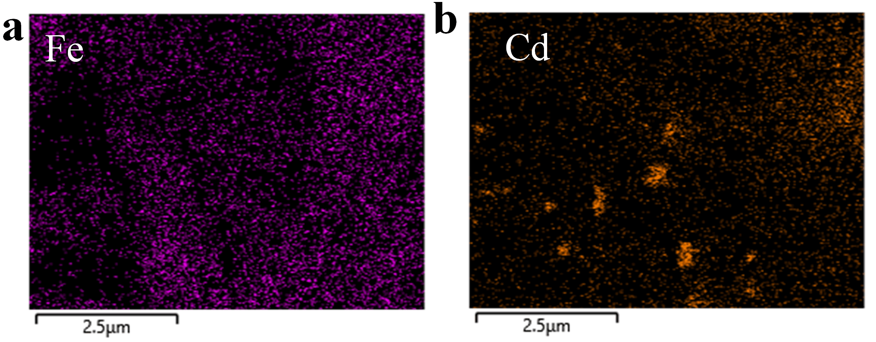
Fig. S1 (a) EDS mapping images of Fe in the Complex material, scale bar: 2.5 μm. (b) EDS mapping images of Cd in the Complex material, scale bar: 2.5 μm.

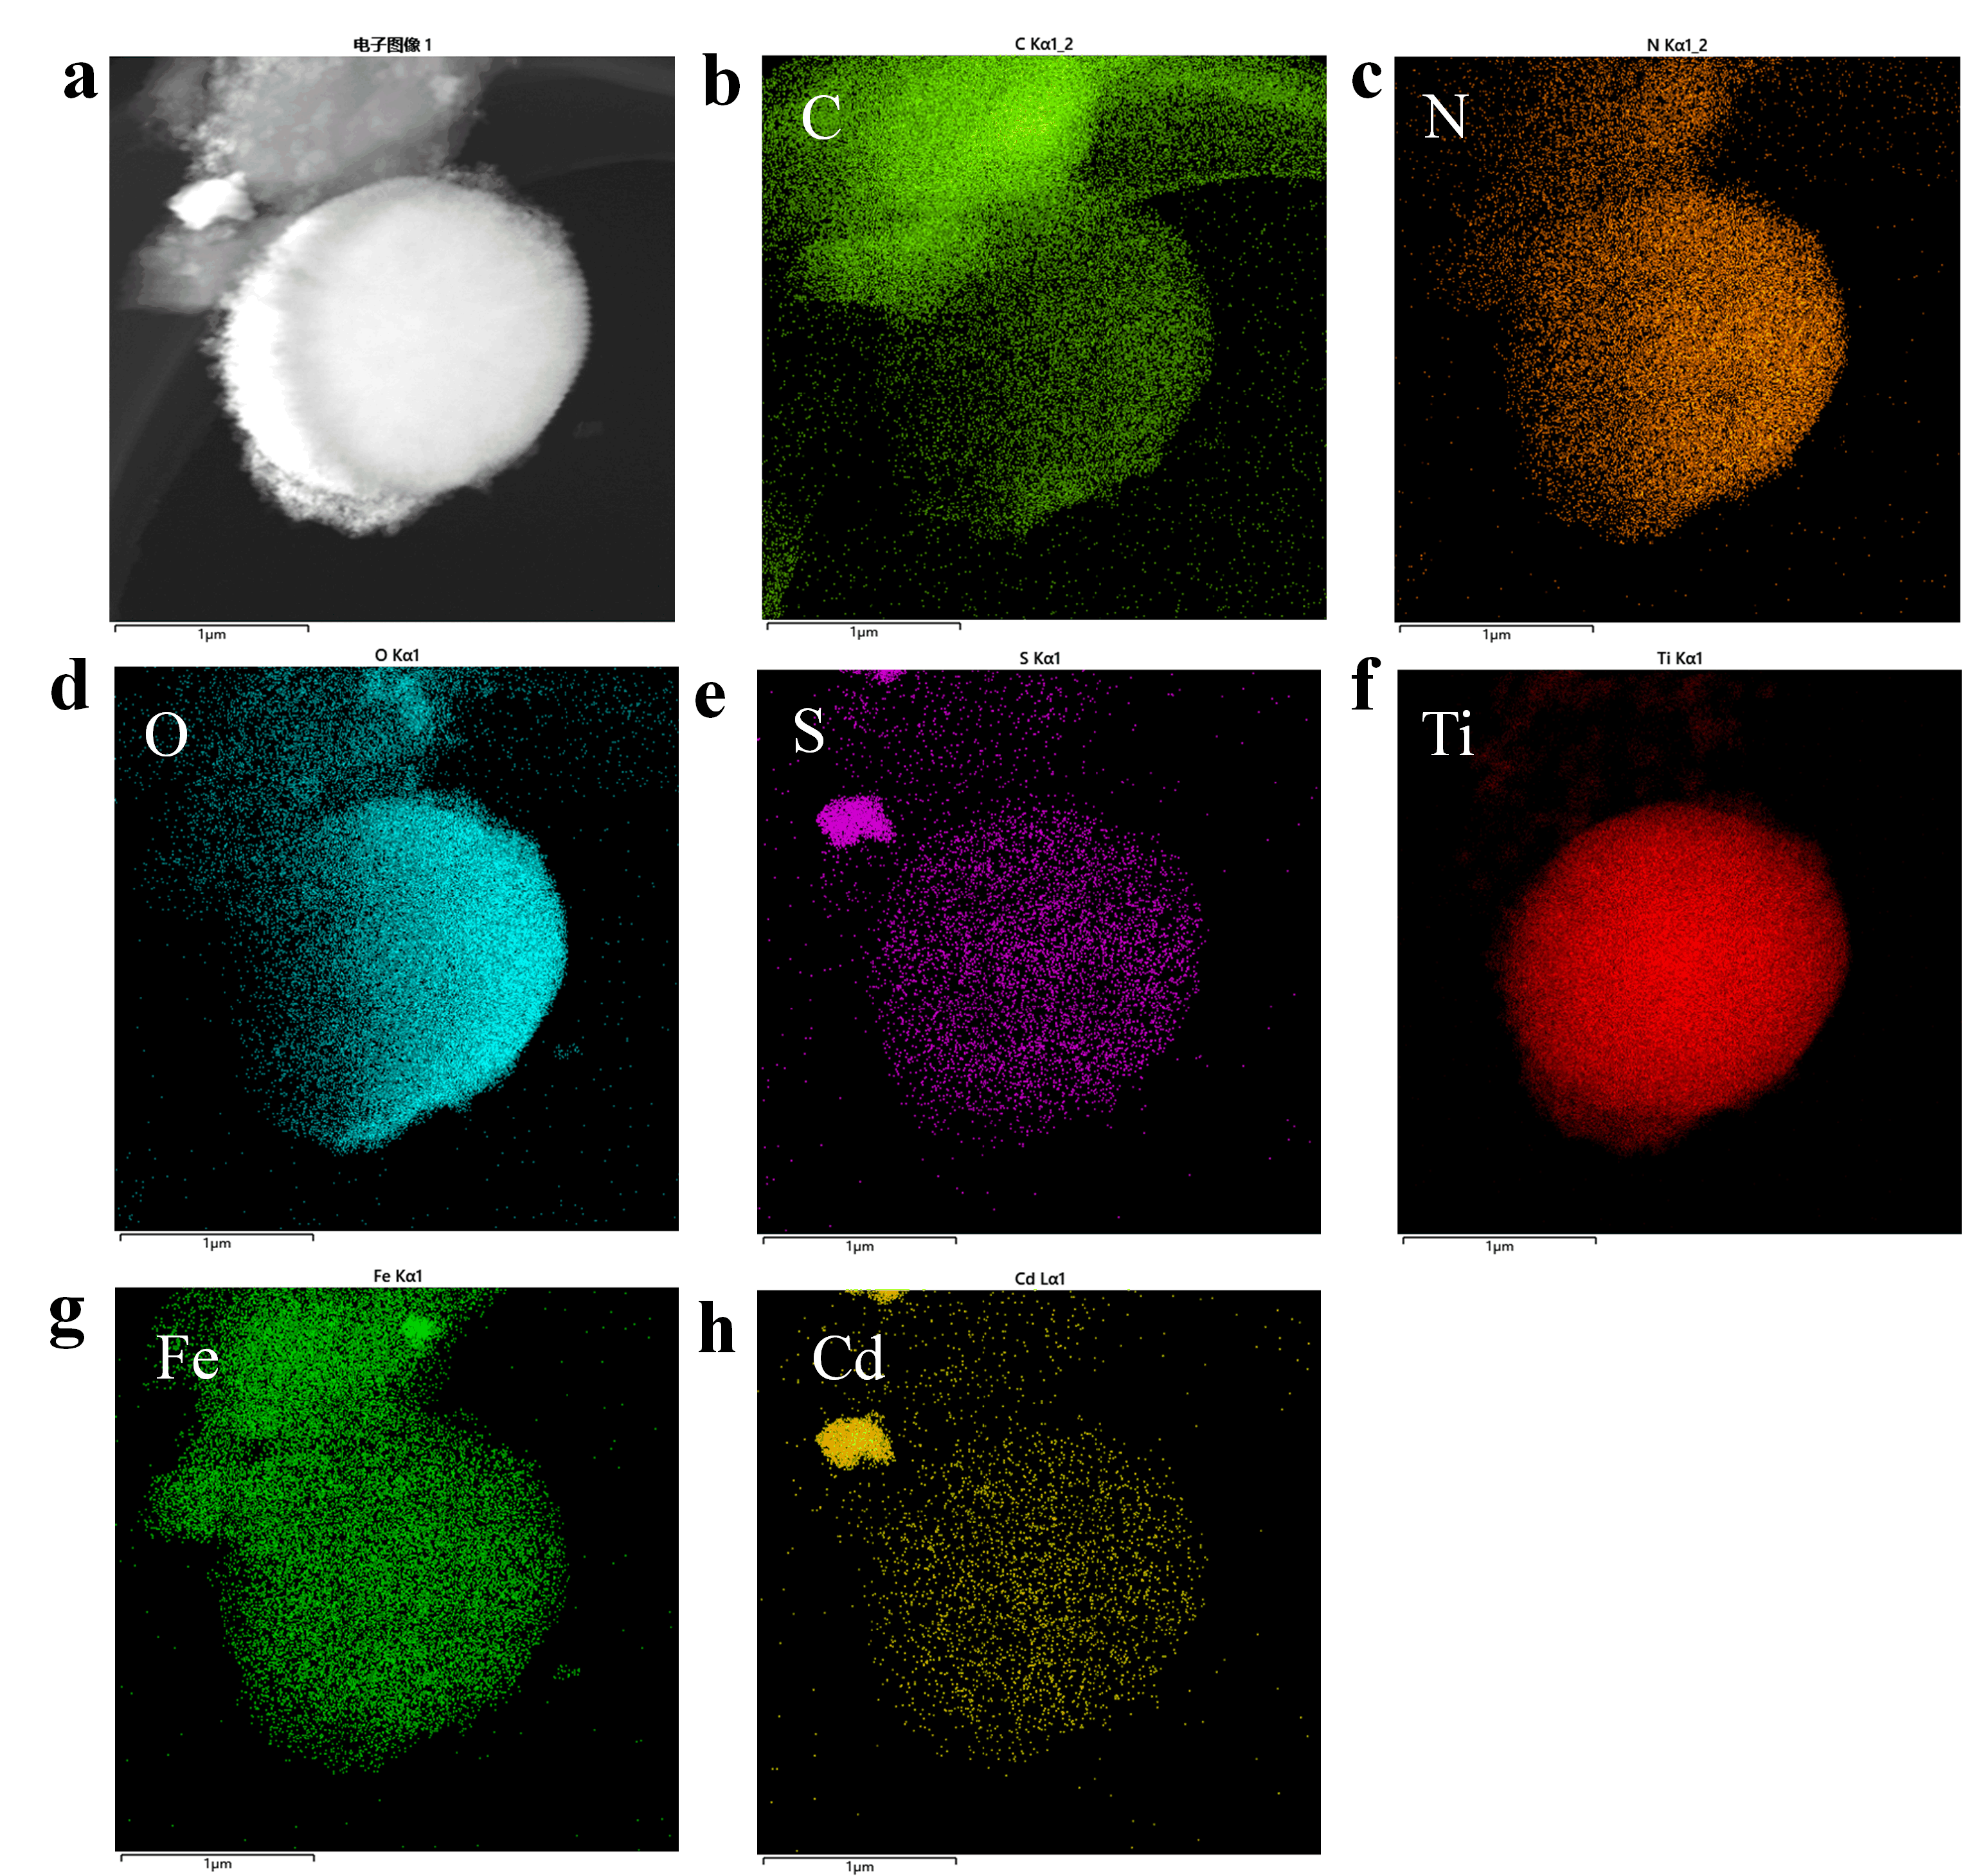
Fig. S2 (a~h) HAADF images of Complex material and corresponding C, N, O, S, Ti, Fe, and Cd element mapping images, scale bar: 1 μm.

Fig. S3 XPS full spectrum of Complex material and cGNRs-DiCOOH.

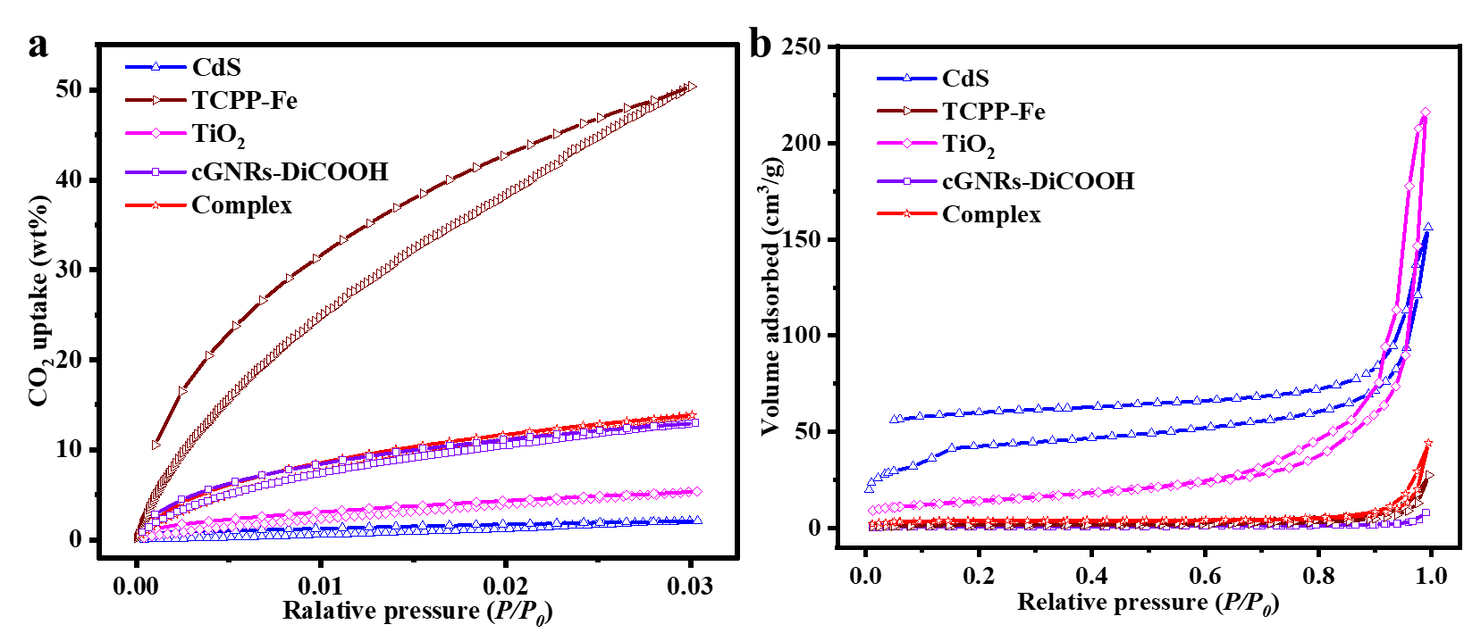
Fig. S4 (a) Nitrogen adsorption and desorption isotherms at 77.3K of the Complex material, TiO₂, CdS, TCPP-Fe, and cGNRs-DiCOOH. (b) Volumetric CO₂ adsorption isotherms and desorption isotherms up to 1.00 bar at 273.15K of the Complex material, TiO₂, CdS, TCPP-Fe, and cGNRs-DiCOOH.

Fig. S5 High-resolution XPS of S of the Complex before and after illumination and high-resolution XPS of S of CdS after illumination for 20 h.

Table S1 Comparison of catalytic performance between Complex and other carbon-based materials
Carbon-based materials | CO Production  (μmol·g⁻¹·h⁻¹) | CH₄ Production  (μmol·g⁻¹·h⁻¹) | Reference
CCNR-NPC@Pt | 1.16 | 11.79 | [29]
ICN-3 | 12.09 | / | [30]
Co-MOF/Cu₂O | 3.83 | / | [31]
Ti₃C₂Tx/p-BN | 22.53 | / | [32]
PRGO/TP-COF | 48.81 |  | [33]
3CoPc-0.6PO₄⁻-WS₂ | 28.1 | 7.3 | [34]
C/CdS@ZnIn₂S₄ | 115.4 | / | [35]

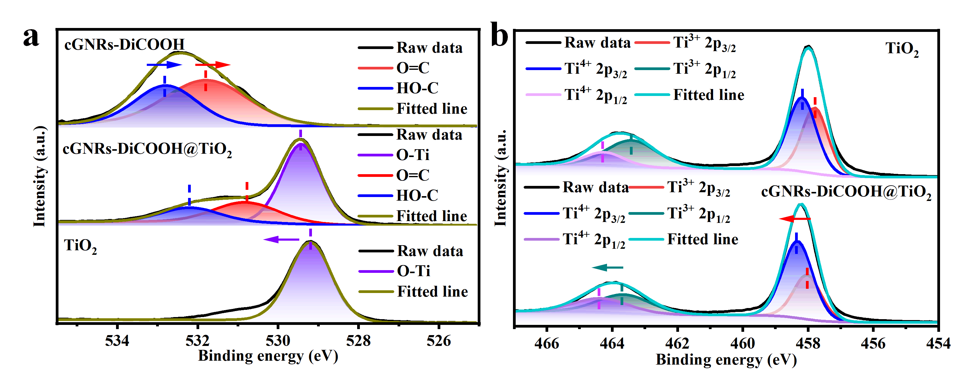
Fig. S6 (a) High-resolution XPS of C 1s of cGNRs-DiCOOH, cGNRs-DiCOOH@TiO₂ heterojunction and TiO₂. (b) High-resolution XPS of Ti 1s of cGNRs-DiCOOH, cGNRs-DiCOOH@ TiO₂ heterojunction and TiO₂.

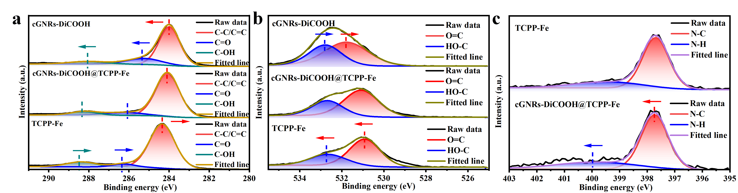
Fig. S7 (a) High-resolution XPS of C 1s of cGNRs-DiCOOH, cGNRs-DiCOOH@TCPP-Fe heterojunction and TCPP-Fe. (b) High-resolution XPS of O 1s of cGNRs-DiCOOH, cGNRs-DiCOOH@TCPP-Fe heterojunction, and TCPP-Fe. (c) High-resolution XPS of Ti 1s of cGNRs-DiCOOH, cGNRs-DiCOOH@TCPP-Fe heterojunction, and TCPP-Fe.

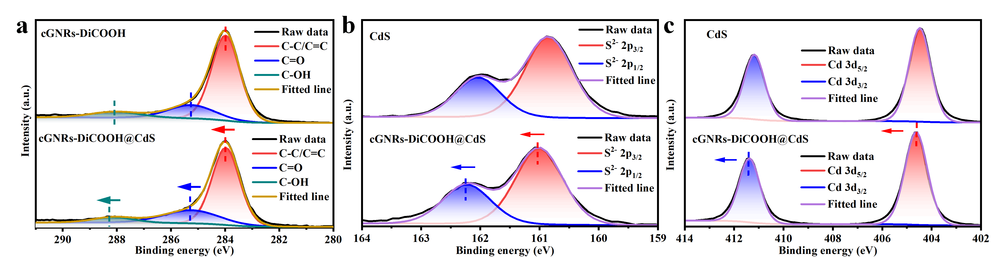
Fig. S8 (a) High-resolution XPS of C 1s of cGNRs-DiCOOH, cGNRs-DiCOOH@CdS heterojunction and CdS. (b) High-resolution XPS of S 2p of cGNRs-DiCOOH, cGNRs-DiCOOH@CdS heterojunction, and CdS. (c) High-resolution XPS of Cd 3d of cGNRs-DiCOOH, cGNRs-DiCOOH@CdS heterojunction, and CdS.

Table S2 The fitted lifetime of the fluorescence decay of cGNRs-DiCOOH, TiO₂, CdS, TCPP-Fe, and the Complex sample.
Sample | τ_{av}(ns) | τ₁(ns) | τ₂(ns) [Rel.%]
TiO₂ | 45.32 | 2.61（21.04） | 43.98（78.96）
TCPP-Fe | 4.52 | 1.56（46.49） | 7.03（53.51）
CdS | 5.10 | 1.29（43.35） | 8.01（56.65）
cGNRs-DiCOOH | 13.33 | 1.68（31.31） | 18.57（68.68）
Complex | 1.09 | 0.91（78.17） | 4.26（21.83）

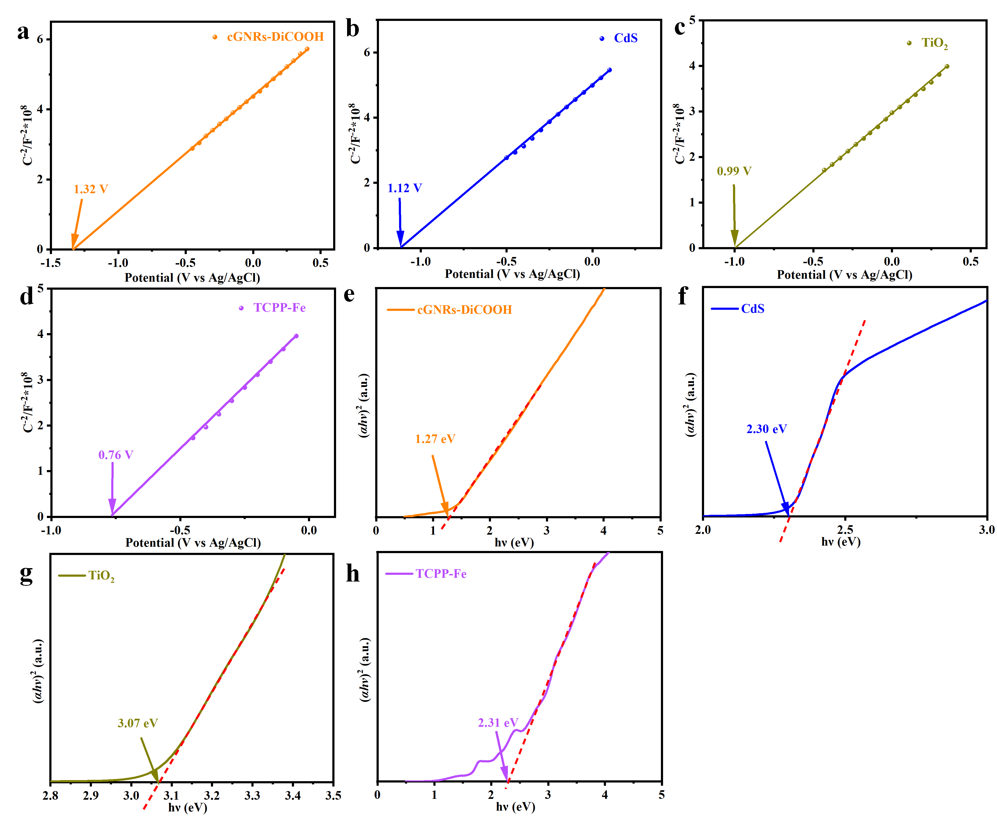
Fig. S9 (a~h) Mott-Schottcky plots of cGNRs-DiCOOH, TiO₂, CdS, and TCPP-Fe. (i~l) Tauc plots of (αhν)² versus hν of cGNRs-DiCOOH, TiO₂, CdS, and TCPP-Fe; The equation (αhν)²=A(hν - E_{g}) represents the Kubelka-Munk formula, where α, hν, A, and E_{g} correspond to the absorption index, light energy, constant value, and bandgap energy of a semiconductor, respectively.

Fig. S10 ¹H NMR of compound 4

Fig. S11 ¹³C NMR of compound 4
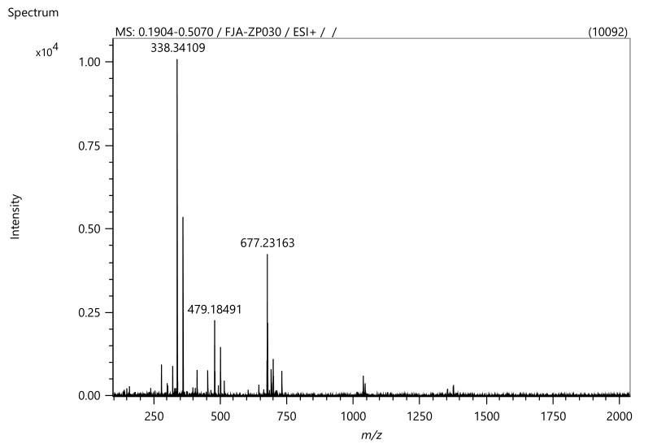
Fig. S12 HRMS spectra of compound 4
Fig. S13 ¹H NMR of compound 5
Fig. S14 ¹³C NMR of compound 5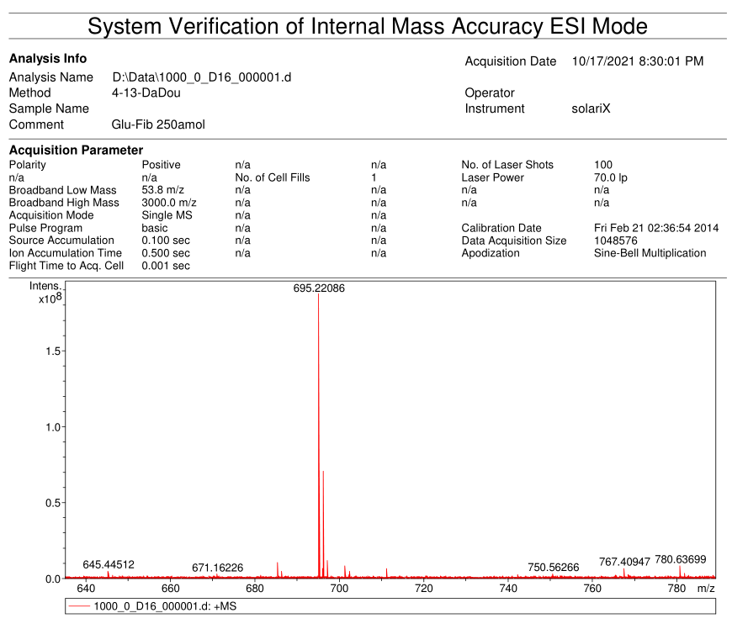
Fig. S15 HRMS spectra of compound 5
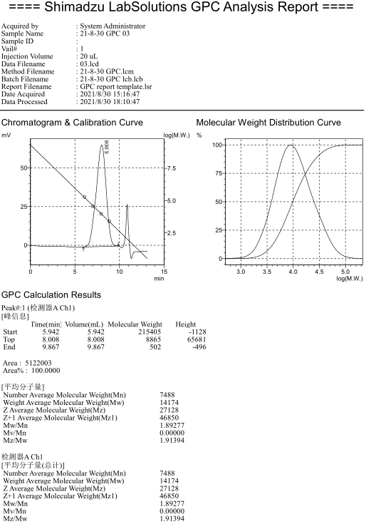
Fig. S16 GPC graph of Poly-Diester

References
[1] J. Fang, Y. Hu, Y. Han, J. Du, G. Zhang, Y. Liu, Chemical Engineering Journal 2023, 471.

