Supplementary Information for

Electrostatically engineered thermal interface materials with multiscale boron nitride-alumina-nanodiamond fillers in polyvinyl alcohol composites for tailored anisotropic thermal conductivities

Sohyung Jiong^{1,2,‡} Jiheon Kim^{1,‡} Kyungmin Kim¹, Yong Choi¹, Jeongwoo Lee¹, Jaemin Lee¹, Dowon Noh¹, Jisoo Park¹, and Wonjoon Choi^{1,}*

¹ School of Mechanical Engineering, Korea University, Seoul 02841, Republic of Korea
² SEMES.Co., Ltd, Cheonan 31040, Republic of Korea
‡ These authors contributed equally to this study.
* Correspondence should be addressed to Wonjoon Choi.
* E-mail: wojchoi@korea.ac.kr, Phone: +82 2 3290 5951, Fax: +82 2 926 9290.
Address: School of Mechanical Engineering, Korea University, 145 Anam-Ro, Seongbuk-Gu, Seoul, 02841, Republic of Korea

Keywords: thermal interface material; electrostatic interaction; thermal conductivity; boron nitride; hybrid composites

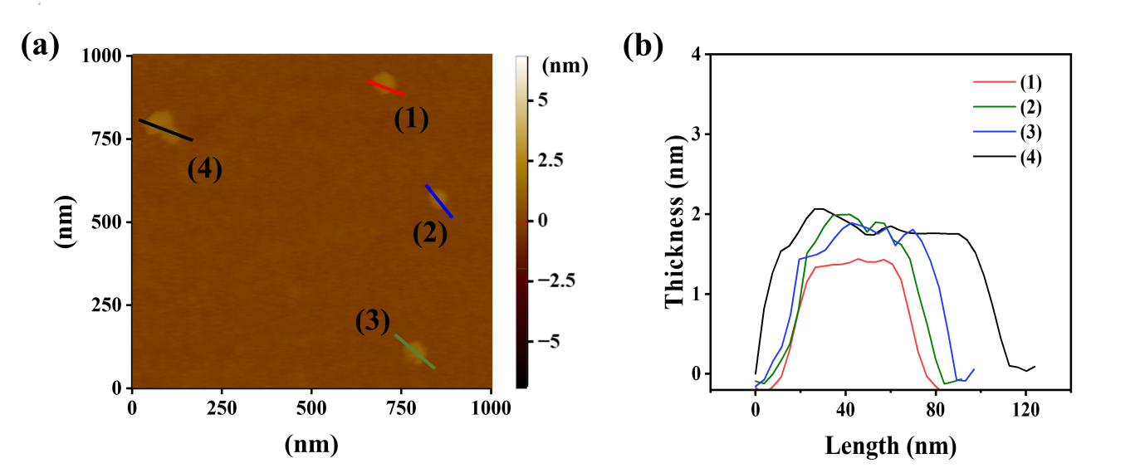
Fig. S1 Morphologies of exfoliated boron nitride (m-BN) particles. (a) Atomic force microscopy (AFM) image. (b) Corresponding height trace curves, confirming the thickness of individual m-BN nanosheets in the range of 1-2 nm, with lateral dimensions less than 100 nm.

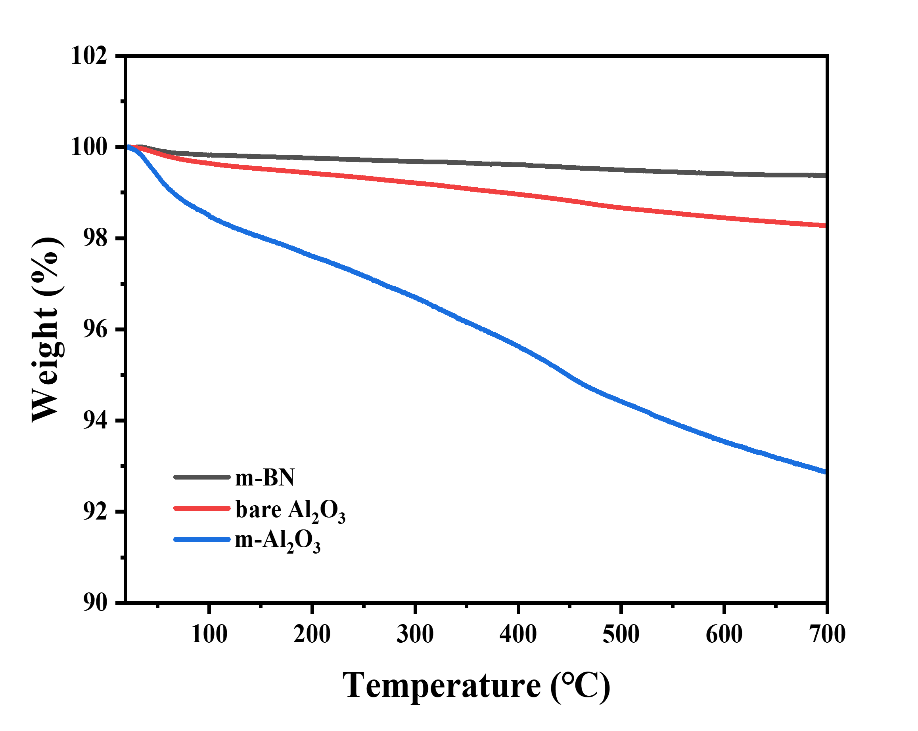
Fig. S2 TGA curves of m-BN, bare Al₂O₃, and KH550-modified Al₂O₃ (m-Al₂O₃).

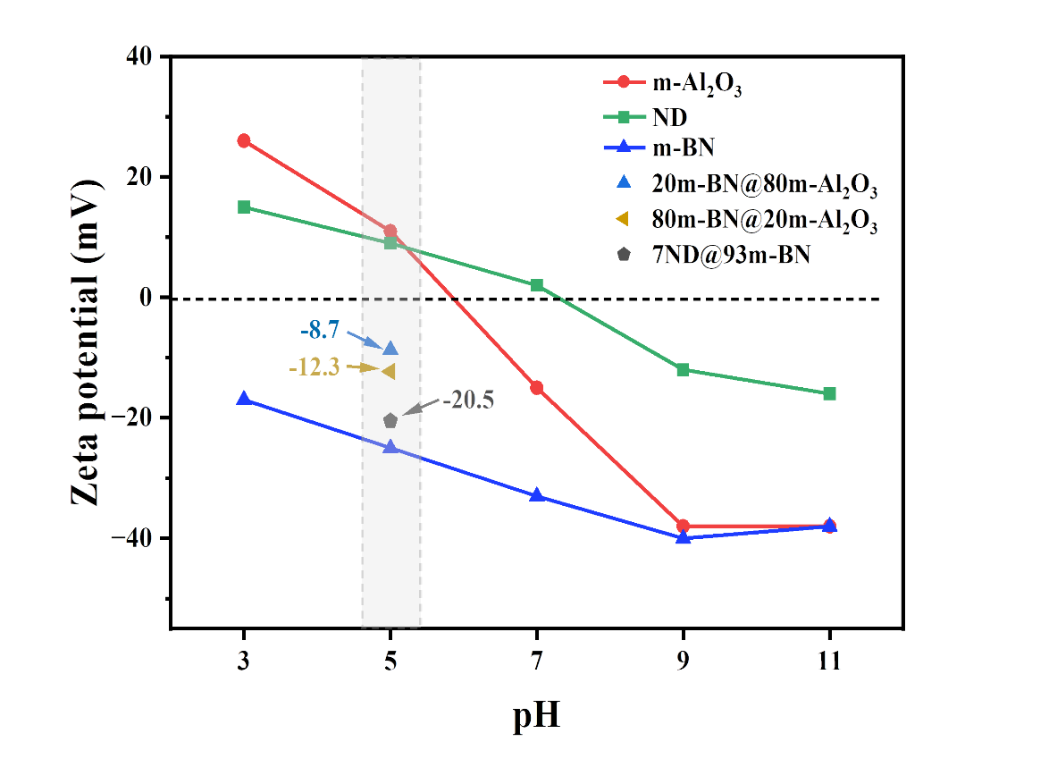
Fig. S3 Zeta potential measurements of hybrid particles, including 80m-BN@20m-Al₂O₃, 20m-BN@80m-Al₂O₃, and ND@m-BN, at pH 5.

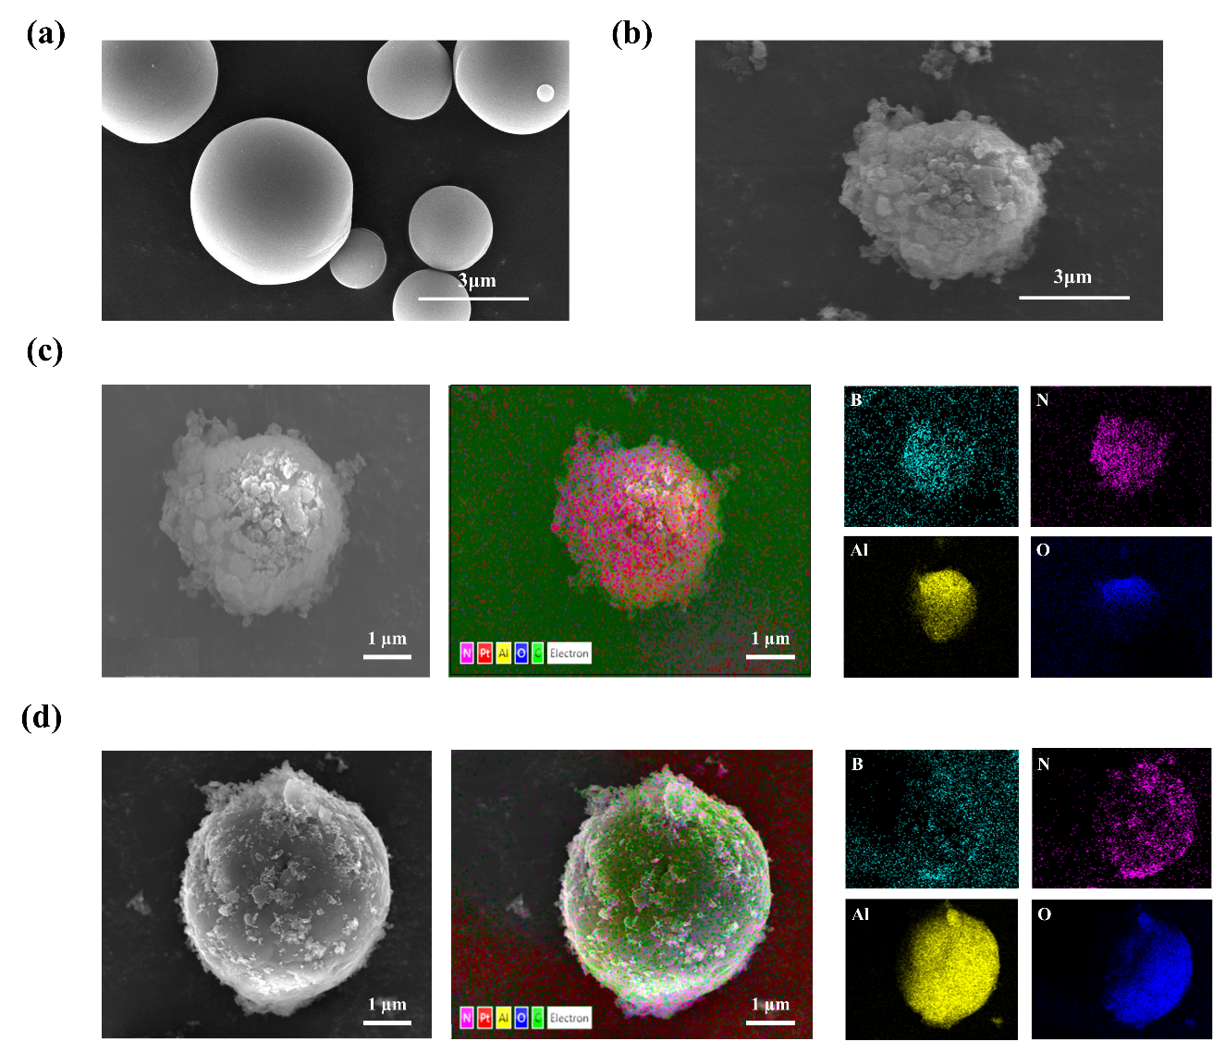
Fig. S4 Morphology and elemental analysis of hybrid fillers. (a) SEM image of untreated Al₂O₃. (b) SEM image of the 80m-BN@20m-Al₂O₃ hybrid structure formed via electrostatic interaction. (c)–(d) SEM and EDS mapping images of 80m-BN@20m-Al₂O₃ and 20m-BN@80m-Al₂O₃ hybrid fillers, respectively. The 80m-BN@20m-Al₂O₃ structure exhibits a dense coating of m-BN nanoparticles on the surface of Al₂O₃, whereas the 20m-BN@80m-Al₂O₃ structure shows a more sparse distribution. EDS mapping confirms the successful hybridization of m-BN with m-Al₂O₃ via electrostatic interaction, as indicated by the presence and relatively uniform distribution of B and N elements on the Al₂O₃ surface, suggesting a well-controlled hybridization process.
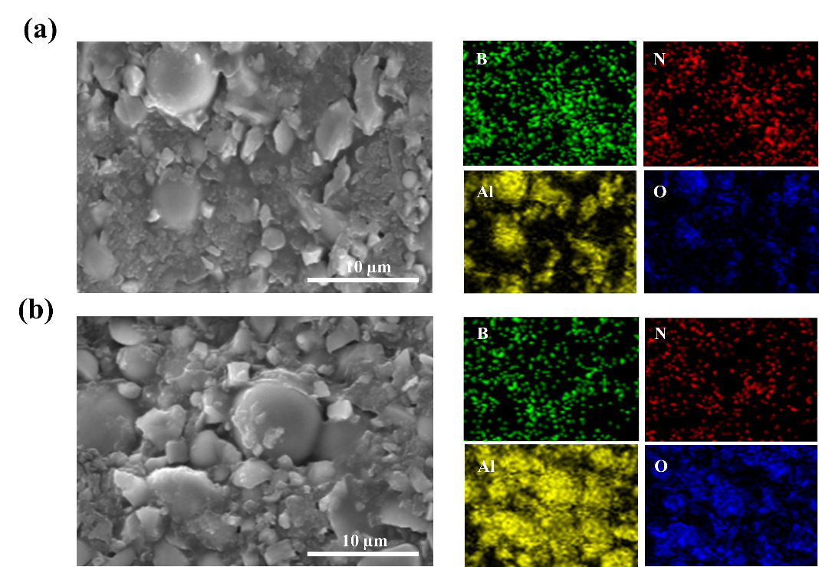
Fig. S5 EDS images of the (a) 80m-BN@20m-Al₂O₃, and (b) 20m-BN@80m-Al₂O₃ film.

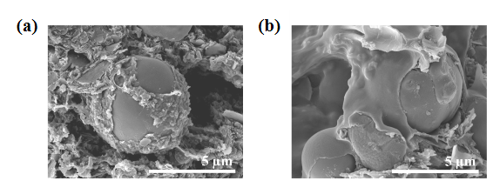

Fig. S6 Magnified SEM images of the (a) 80m-BN@20m-Al2O3, and (b) 20m-BN@80m-Al2O3 film

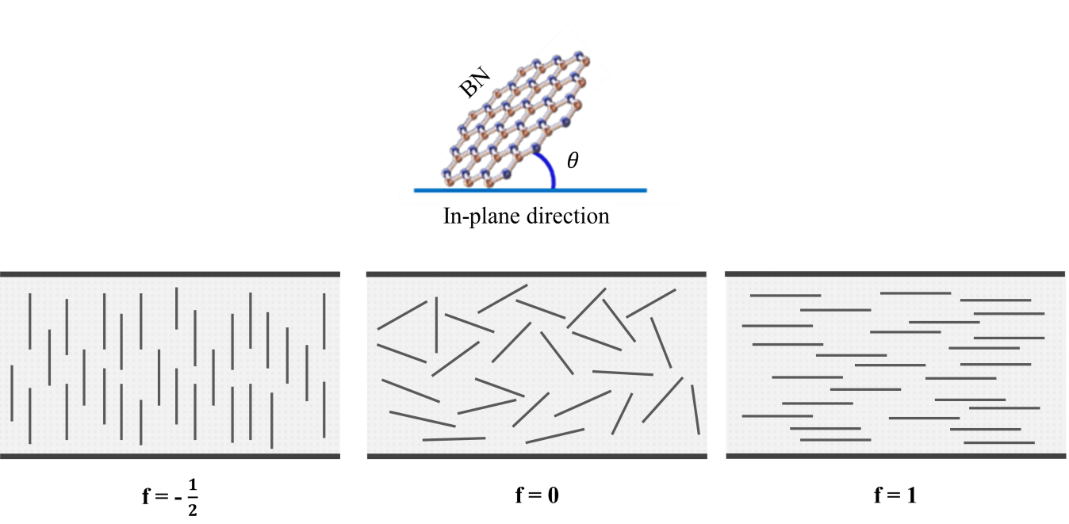

Fig. S7 Values of the f and θ for three orientations of the platelets.

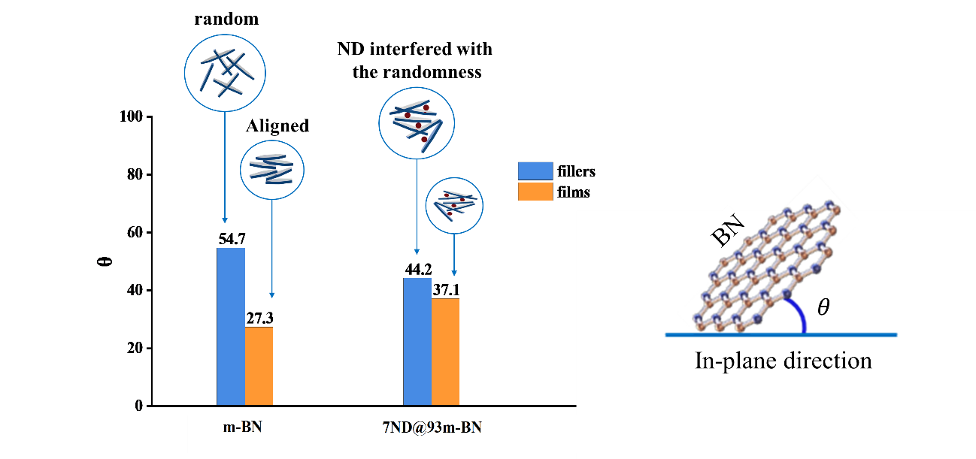
Fig. S8 Changes in the orientation angle (θ) of m-BN and its corresponding microstructure within the 7ND@93m-BN filler and film.

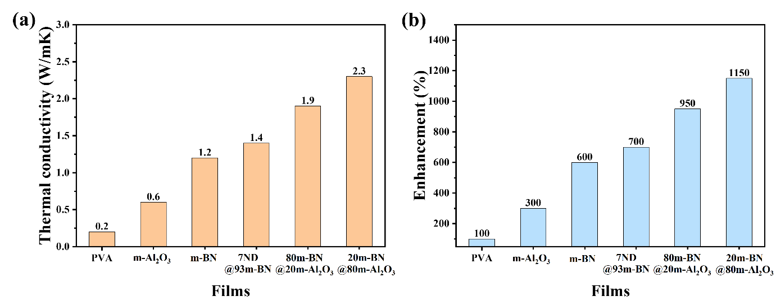
Fig. S9 Thermal conductivities of the bare PVA film, the m-Al₂O₃ film, and the hybrid filler films at various filler concentrations.

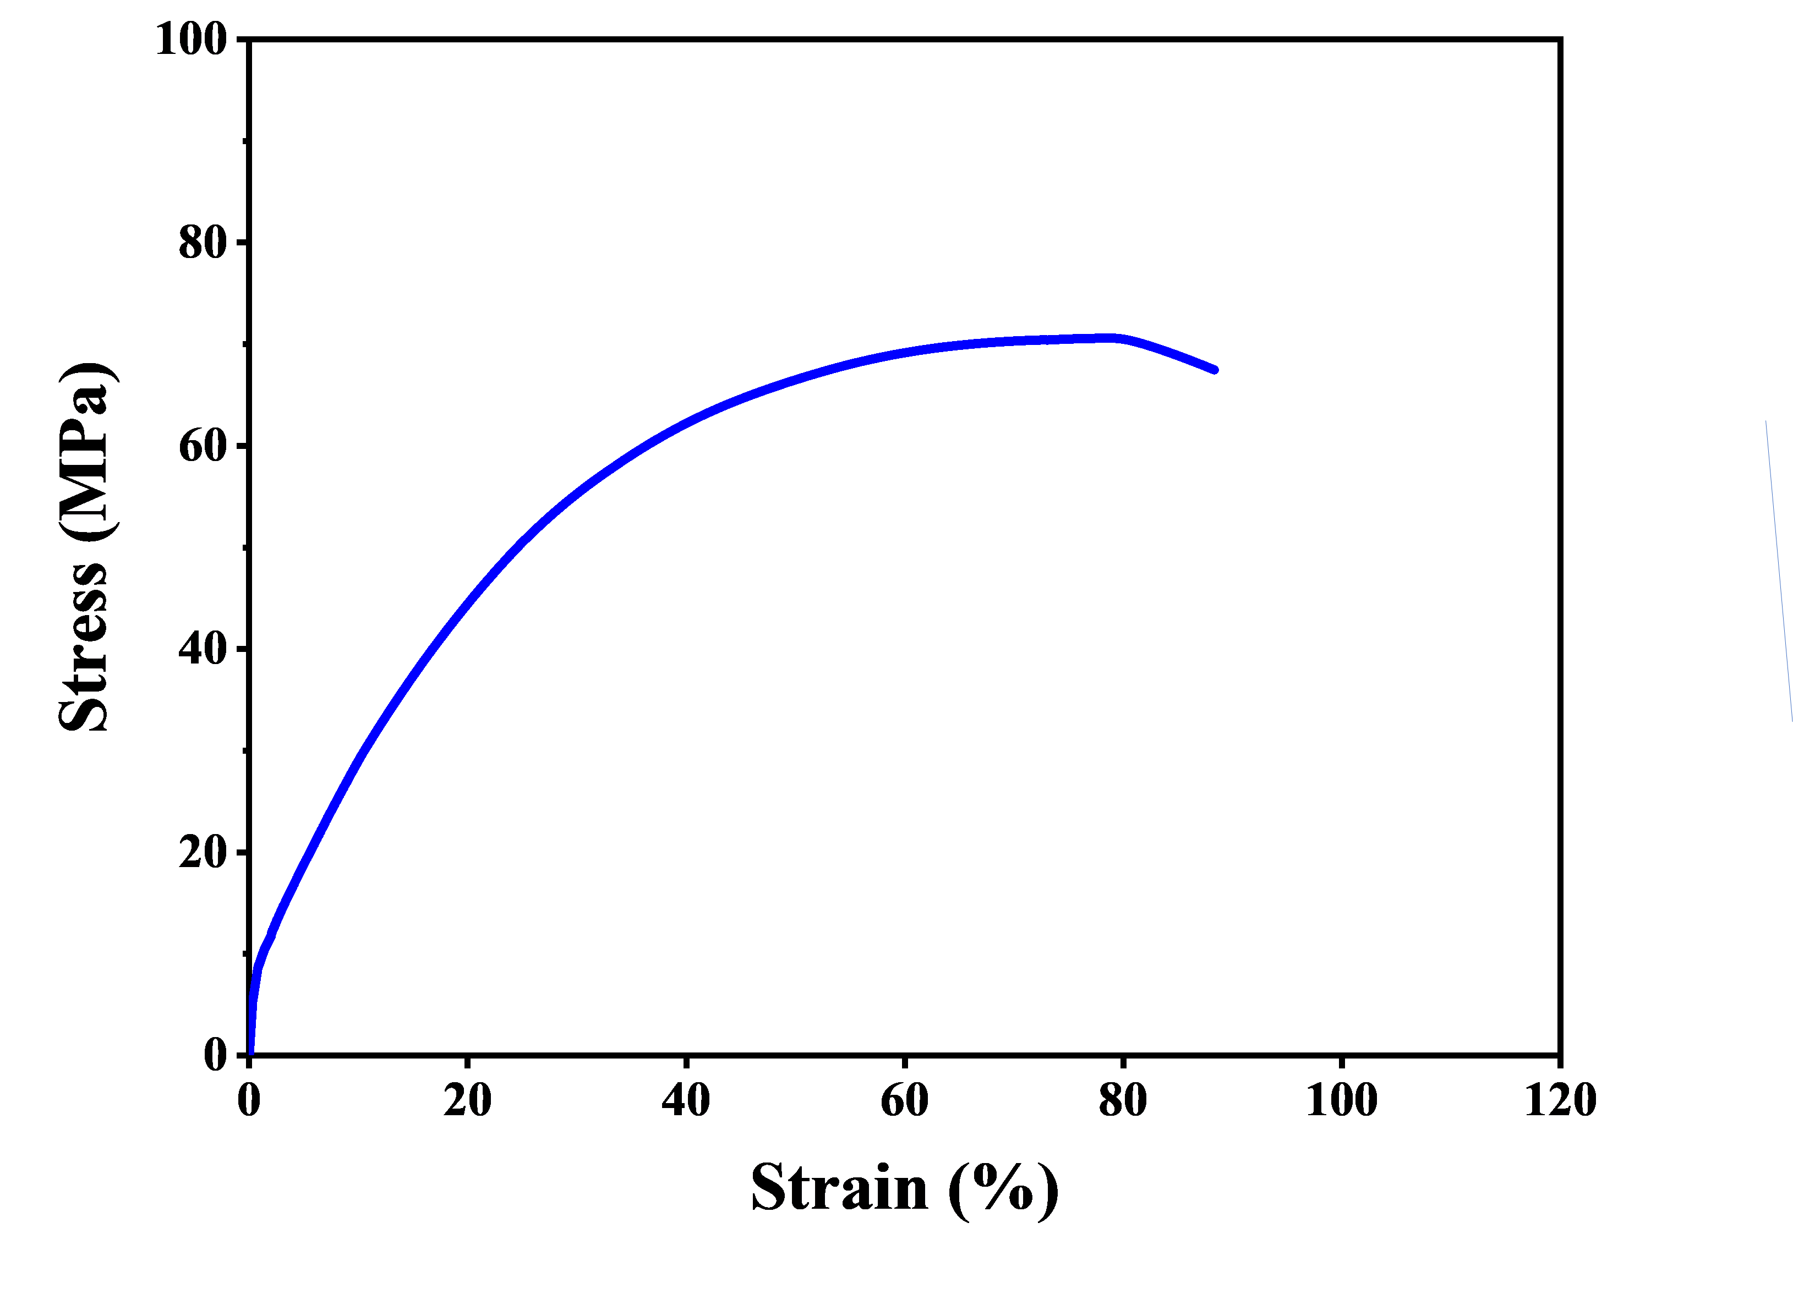
Fig. S10 Tensile stress-strain curve of PVA film.

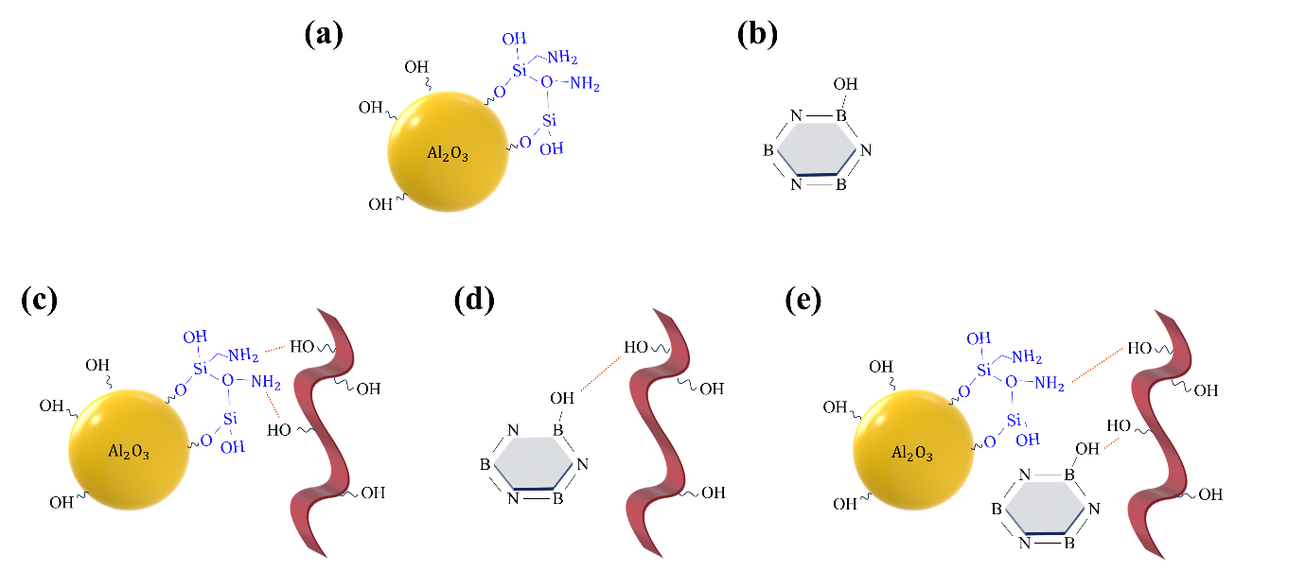

Fig. S11 Schematic representation of the interfacial interactions via hydrogen bonding between m-BN, m-Al₂O₃, and the PVA matrix. (a) KH550-modified Al₂O₃, (b) modified BN, and (c–e) hydrogen bonding between m-Al₂O₃, m-BN, and the PVA matrix, respectively.

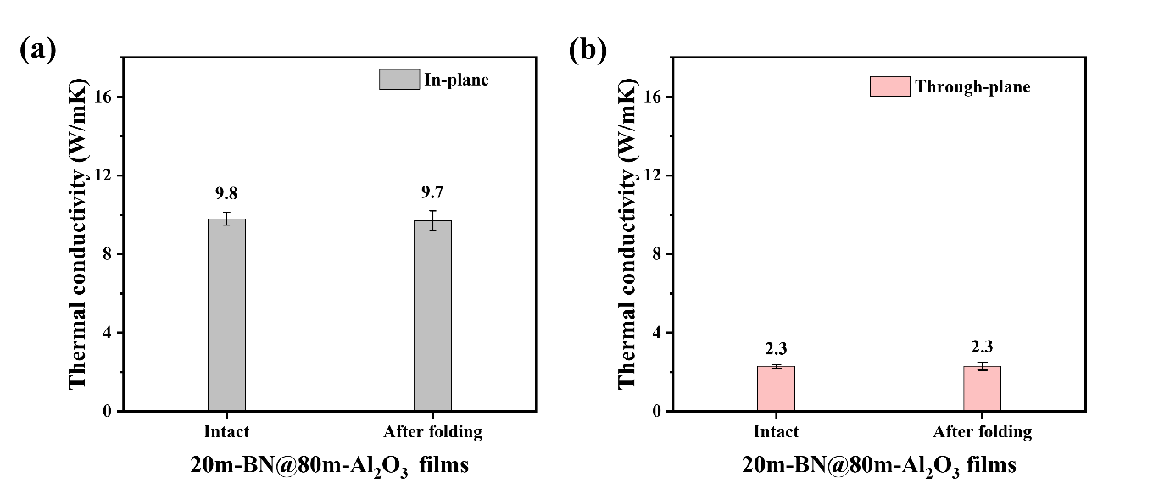
Fig. S12 Durability of composite films under the cyclic mechanical deformation. (a) In-plane thermal conductivity and (b) through-plane thermal conductivity of the intact sample and the 50-folded sample.

Table S1 Summary of the relative uncertainties (%) for thermal diffusivity (α), specific heat capacity (c_{p}​), and density (ρ) used in the calculation of thermal conductivity (k). The combined uncertainty of thermal conductivity was calculated based on the propagation of these individual uncertainties.

Parameters | Thermal diffusivity  ($\text{α}$) | Specific heat  (${\text{c}}_{\text{p}}$) | Density  ($\text{ρ}$) | Thermal conductivity  ($\text{k}$)
Uncertainty (%) | 1.5 | 4 | 0.6 | 4.31

Table S2 Comparison of this work with hybrid and non-hybrid polymer composite TIMs. Typically, a sample's thermal conductivity increases with higher loading % and thinner film thickness.
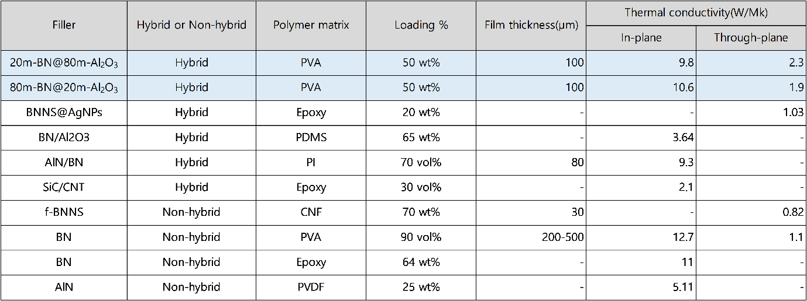

Table S3 Rationale behind Radar Plot with a detailed breakdown of the properties that were considered in the construction of the plot. (a) Detailed properties for each sample, including thermal conductivity, mechanical properties, electrical insulation, cost, and processability. (b) Normalized scores for each property, ranging from 1 to 4, to facilitate comparison across different samples. (c) Final scores for the primary properties of each sample, rated on a scale of 1 to 4, without assigning any weighting to individual properties.
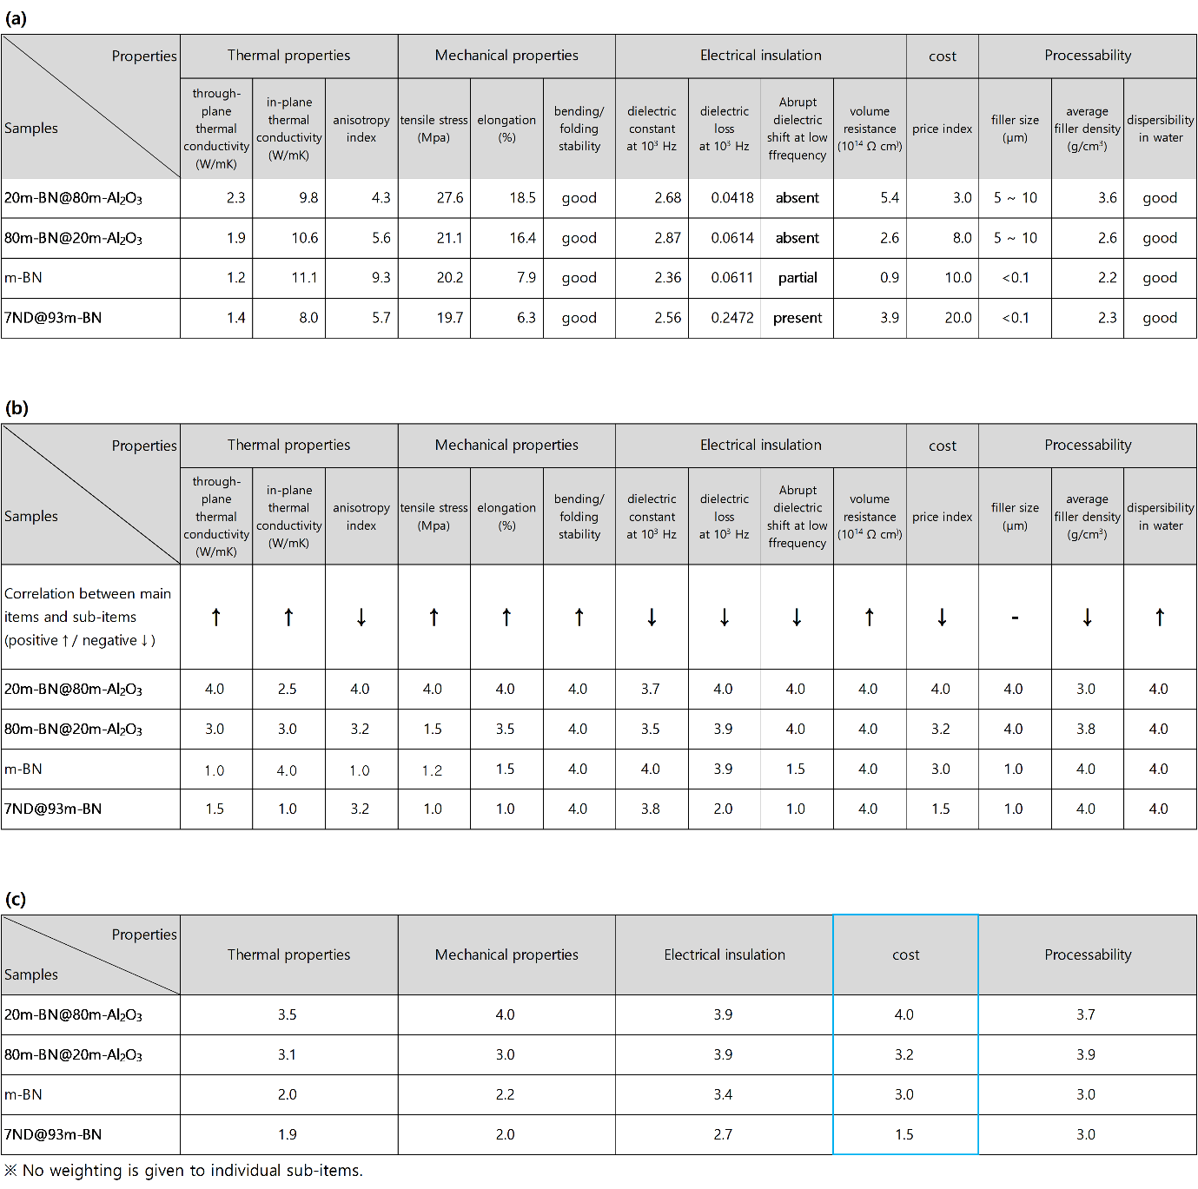

Note S1 Theoretical derivation of the equation for estimating the in-plane orientation (f) and the mean angular deviation (θ)

In systems involving molecular or crystalline orientation, such as XRD studies or polymer analysis, the orientation distribution function (ODF), P(cosθ), describes the angular distribution of entities relative to a reference direction. The ODF is commonly expressed as a series of Legendre polynomials:

$$P(\cos{θ}) = \sum_{n=0}^{∞}{a_{n}P_{n}(\cos{θ}})$$

Here, a_{n}​ represents the degree of orientation, and P_{n}​(cosθ) are the corresponding polynomials. In most cases, the second-order term, P₂​(cosθ), dominates due to its significance in symmetric systems, alignment quantification, and experimental sensitivity. This term is expressed as:

$P_{2}(\cos{θ})$ = $\frac{1}{2}(3\cos^{2}θ$ - 1)

The orientation factor f, which quantifies the degree of alignment, is defined as the average value of P₂​(cosθ):

$f = 〈P_{2}(\cos{θ)}〉$ = $\frac{1}{2}(3\cos^{2}θ$ - 1)
Key values of f:
- f = 1 : Perfect alignment (parallel to the reference axis).
- f = 0 : Random (isotropic) orientation.
- f = -0.5 : Perfect anti-alignment (perpendicular to the reference axis).
Fig. S7 illustrates these three states of alignment (f = -0.5, 0, 1).
In XRD analysis, diffraction intensities I₁₀₀ and I₀₀₂ at specific planes reflect sample orientation. The intensity ratio, K = k I₁₀₀/I₀₀₂ (with k as a calibration constant), is related to the ODF. Substituting K into f, we obtain:

$$f = \frac{1-K}{1+2K}$$
This equation connects grain orientation distribution with experimental XRD data to quantitatively describe alignment.
The two equations,

$f = \frac{1-K}{1+2K}$ and f = $\frac{1}{2}(3\cos^{2}θ$ - 1)

share the same physical meaning, both representing the degree of orientation. Their equivalence implies a relationship between K (experimentally derived) and cos²θ. Thus, cos²θ can be indirectly calculated from K, linking experimental measurements to the orientation distribution.
Note S2 Equation for calculating the combined relative uncertainty of thermal conductivity (k) by propagating the individual uncertainties of thermal diffusivity (α), specific heat capacity (c_{p} ​), and density (ρ).

$${\left(\frac{U_{k}}{k}\right)}^{2}= {\left(\frac{U_{α}}{α}\right)}^{2}+ {\left(\frac{U_{c_{p}}}{c_{p}}\right)}^{2}+ {\left(\frac{U_{ρ}}{ρ}\right)}^{2}$$

