Supporting information

Homogeneously crosslinked in situ hydrogel enclosing high-density human-cancer cells promotes vascularized in vivo tumor modeling for immune cell therapy

Ziqi Huang^{1,a}, Yip Ming Tsun^{2,a}, Chao Liang^{1,a}, Zhenzhen Wu¹, Theo Aurich^{2,3}, Lu Liu², Chloe Kan², Rio Ryohichi Sugimura^{2,4,b,*}, Sang Jin Lee^{1,b,*}

¹Biofunctional Materials, Division of Applied Oral Sciences and Community Dental Care, Faculty of Dentistry, The University of Hong Kong, 34 Hospital Road, Sai Ying Pun, Hong Kong SAR, PRC
²School of Biomedical Sciences, Li Ka Shing Faculty of Medicine, The University of Hong Kong, Pokfulam, Hong Kong SAR, PRC
³German Cancer Research Center (DKFZ), Heidelberg, Germany
⁴Centre for Translational Stem Cell Biology, Hong Kong SAR, PRC

ªThese authors contributed equally to this work
^{b}These corresponding authors contributed equally to this work
Histological analysis in vitro and
*Correspondence to Rio Ryohichi Sugimura, Ph.D. and Sang Jin Lee, Ph.D.
Contact: rios@hku.hk (Rio Ryohichi Sugimura), dentsj@hku.hk (Sang Jin Lee).
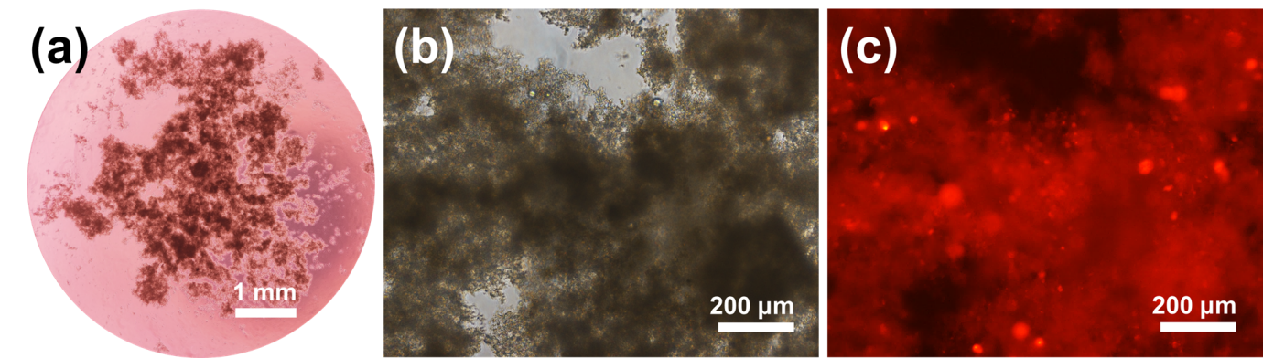
Fig. S1 Microscope images of rhodamine-labeled HepG2 cultured in CMCTS/oHA hydrogels for 7 days in vitro. High-density HepG2 cells were formed aggregated (a) and exhibited strong cell-to-cell connection (b and c).

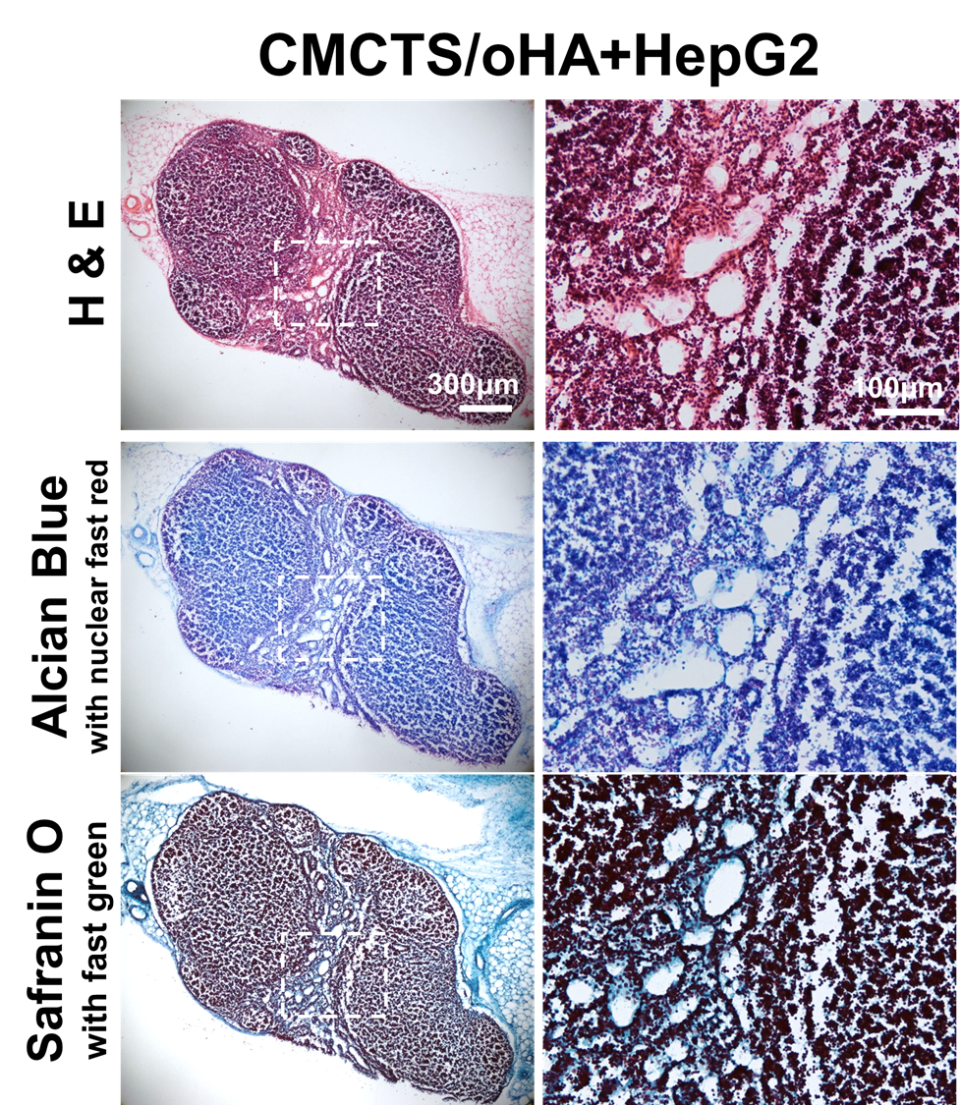
Fig. S2 H&E, Alcian Blue and Safranin O staining of injection site after subcutaneous injection of high concentration HepG2-encapsulated CMCTS/oHA hydrogel over 2 weeks. Transplants were accumulated and connected with host-mouse tissue.

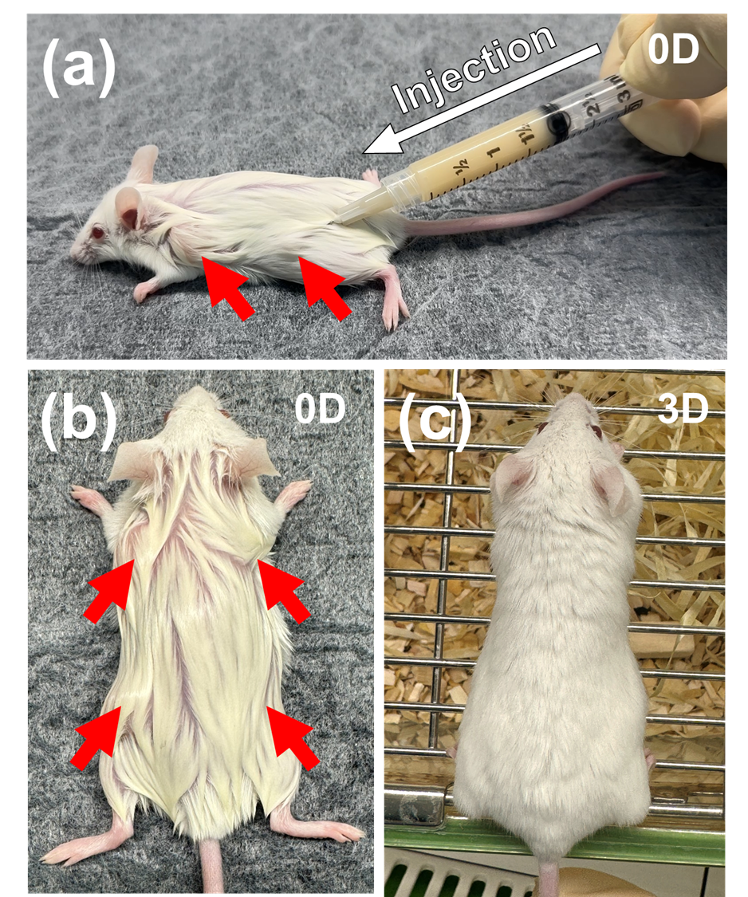
Fig. S3 Administration procedure by subcutaneous injection. Hydrogel was injected subcutaneously on the back of mice without any incision (a). The injected hydrogel maintained the integrity of its volume in the immediate postoperative period (b), and the site volume receded after 3 days (c).

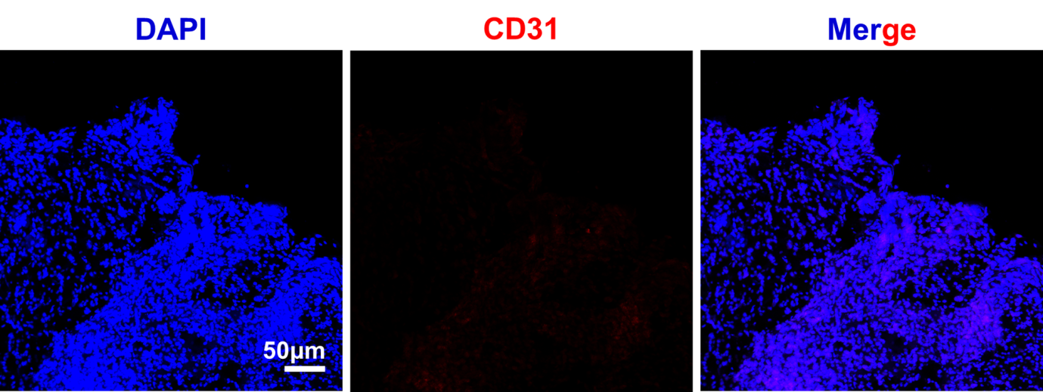
Fig. S4 Immunofluorescence staining analysis of HepG2-encapsulated CMCTS/oHA hydrogel before implantation. CD31 showed no positive staining, demonstrating that the hydrogel was not pre-vascularized before injection.

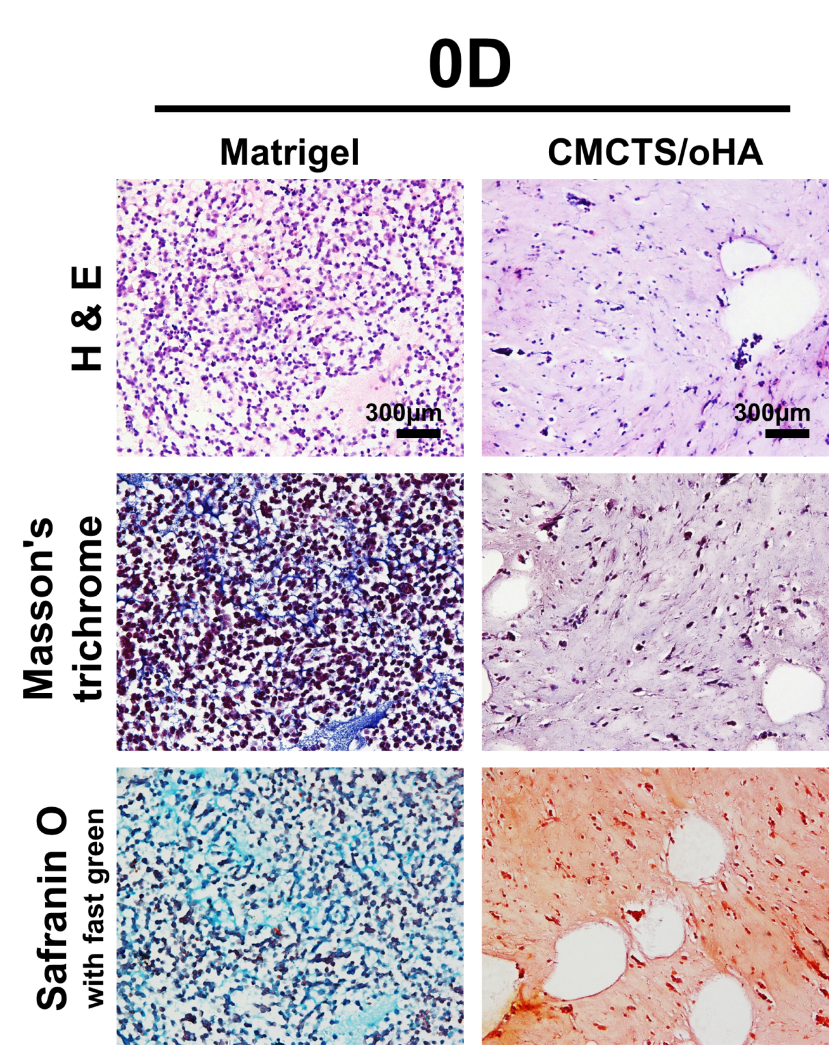
Fig. S5 Morphology of cells embedded in Matrigel or CMCTS/oHA hydrogel, stained with H&E, Masson's trichrome, and Safranin O with fast green, was observed just prior to implantation. The cells are uniformly embedded within the hydrogel matrix, and the single cells before implantation did not form aggregates due to the hydrogel matrix.

