Supplementary Materials
Nature-derived Hydrogel for Microplastic Removal

Seungoh Jungª, Jungkyu Kimª, Sangwoo Parkª, Junsik Bangª, Heecheol Yun^{b}, Sungwook Wonª, Seojin Kimª, Hyoseung Limª, Seon-Gyeong Kimª, Jong-Chan Kim^{c}, Hyoung-Joon Jin^{d,e}, In-Gyu Choi^{a,b} and Hyo Won Kwak^{a,b*}

ª Department of Agriculture, Forestry and Bioresources, College of Agriculture & Life Sciences, Seoul National University, 1 Gwanak-ro, Gwanak-gu, Seoul 08826, Korea
^{b} Research Institute of Agriculture and Life Sciences, Seoul National University, 1 Gwanak-ro, Gwanak-gu, Seoul 08826, Korea
^{c} Department of Forest Biomaterials, College of Natural Resources, North Carolina State University, Raleigh, NC 27695, USA
^{d} Program in Environmental and Polymer Engineering, Inha University, Incheon 22212, Korea
^{e} Department of Eco-Polymer Science and Engineering, Inha University, Incheon 22212, Korea

*Corresponding author.
Telephone: (+82) 2-880-4788
Fax: (+82) 2-873-2318
E-mail: bk0502@snu.ac.kr
Detailed methods
Characterization
Morphology
The morphologies of the samples were observed by FE-SEM (SUPRA 55VP, Carl Zeiss, Germany) after Pt coating using a platinum coater (Sputter coater, EM SCD005, Leica, Germany). In addition, transmission electron microscopy (TEM, Talos L120C, FEI, Czech Republic) was performed at an acceleration voltage of 120 kV. A single drop of 0.01 wt% dispersion was cast on a carbon-coated Cu grid (200 mesh). The samples were treated with uranyl acetate for 20 s or air dried before observation.

Gel permeation chromatography (GPC)
The number-average molecular weight (M_{n}), weight-average molecular weight (M_{w}), and polydispersity index (PDI) of the KL and PS nanoplastics were measured using GPC (LC-40, Shimadzu, Japan) at 313 K. Before the analysis, the samples were prepared by dissolving 10 mg of samples in 1 mL of THF and filtered through a hydrophobic PTFE syringe filter (pore size = 0.45 μm, Advantec Co, Japan). THF was used as the eluent was THF and the flow rate was 1.0 mL/min. For the GPC calibration, PS standards with molecular weights in the range of 266-25,000 Da were used.
For Q-KL, analysis was conducted using aqueous GPC (Ultimate 3000, Dionex, USA) at 313 K. Then, 1 mL of 1 wt% Q-KL solution was centrifuged at 13,000 rpm to collect the supernatant for the analysis. Sodium azide (0.1 M) was used to inhibit the growth of microorganisms at a flow rate of 1 mL/min. For the calibration of the GPC, pullulan standards with molecular weights in the range of 342-803,000 Da were used.

Chemical structure
The chemical structures of the materials were analyzed by FTIR, NMR, and XPS analyses. The FTIR analysis was performed in the range of 4,000–525 cm⁻¹ at a resolution of 4 cm⁻¹, and the number of scans was 64.
The ³¹P and ¹³C-NMR spectra of the lignin were obtained using a high-resolution NMR spectrometer (AVANCE 600 MHz, Bruker, Germany). For ³¹P NMR analysis, 40 mg of KL was dissolved in 0.5 mL of pyridine/CDCl₃ (1.6:1, v/v) containing 0.05 mL of the stabilizer (acetylacetonate chromium (III)). Cyclohexanol was used as the internal standard. Then, 0.1 mL of 2-chloro-4,4,5,5-tetramethyl-1,3,2-dioxaphospholane (TMDP) was added as a phosphorylating agent. ¹³C NMR spectroscopy of KL was performed using DMSO-d₆. KL (60 mg) was dissolved in 0.75 mL of dimethylsulfoxide-d₆ (DMSO-d₆). ¹³C NMR spectroscopy of Q-KL was performed using D₂O. Q-KL (60 mg) was dissolved in 0.75 mL of D₂O (0.03% 3-(trimethylsilyl) propionic-2,2,3,3-d₄ acid sodium salt (TMSP-d₄) was used as an internal standard).
The XPS spectra of the lignin were obtained using an XPS photoelectron spectrometer (AXIS SUPRA, Kratos, UK). XPS analysis was performed in the range of 1,200–0 eV and the degree of vacuum was approximately 5 × 10⁻⁵ Torr. Deconvolution using Gaussian functions was performed for the binding energy regions corresponding to C 1s, N 1s, and O 1s across the entire energy spectrum.

Thermal properties
The thermal properties of the lignin samples were analyzed using thermogravimetric analysis (TGA, TG 209F3, NETZSCH, Germany). The samples were heated to 800 °C at a rate of 10 °C/min under a flow of nitrogen gas at 10 mL/min, and TGA and derivative thermogravimetry (DTG) curves were obtained.
Elemental analysis
Elemental analysis of the lignin was performed using an elemental analyzer (Flash EA 1112, Thermo Electron Corporation, USA). Before the analysis, the lignin samples were freeze dried to remove any remaining water. The degree of substitution (DS) of Q-KL was calculated according to Eq. S1.
$DS=\frac{180 ×\left(N{}_{Q-KL}-N_{KL}\right)}{1400-151.5×\left(N{}_{Q-KL}-N_{KL}\right)}$ (S1)
where N_{KL} and N_{Q-KL} represent the nitrogen contents of KL and Q-KL (wt%), respectively, as determined by elemental analysis. 180 is the molecular weight of the C₉ unit of KL, and 151.5 is the molecular weight of GTMAC [1].

Zeta potential
Zeta potential measurements were performed using a Zetasizer (Litesizer 500, Anton-Paar, Malvern, Austria). The zeta potential was measured using various pH buffer solutions (1, 2, 4, 7, 10 and 12), and analysis was performed at 25 °C and 200 V of adjusted voltage, and the number of scans was 1,000. The samples were well-dispersed before measuring.

Size distribution
The size distributions of the PS nanoplastics and ChNFs were measured by dynamic light scattering (DLS) method using a Zetasizer (Litesizer 500, Anton-Paar, Malvern, Austria). A 0.01 wt% of each dispersion was prepared, and the analysis was performed at 25 °C using a 90° detection angle.

Contact angle
Contact angle measurements of lignin were performed using a contact angle analyzer (GSM, Surfacetech, Gwangju, Korea) and the ImageJ program (National Institute of Health, Bethesda, MD, USA). The lignin samples were pelletized to ensure a smooth surface. The volume of water droplet was 5 μm, and the contact angle was measured at regular time intervals up to 300 s.

Mechanical properties
The mechanical properties of the ChNFs/Q-KL composite hydrogels were analyzed using a universal testing machine (UTM; 34SC-1, Instron, USA) at a compression rate of 5 mm/min. Before the analysis, the composite hydrogel was freeze dried into an aerogel. The aerogels were cylindrical (10 mm (h)×15 mm (d)).

Specific surface area (SSA)
The SSA of the ChNFs/Q-KL composite hydrogels was measured using a porosimetry analyzer (BELSORP-max, MicrotracBEL, Osaka, Japan). Adsorption/desorption curves were obtained using nitrogen gas in the pressure range of 0.1–0.99 P/P₀. The specific surface areas and total pore volumes were calculated from the curves obtained using the BET method.

Swelling ratio
The swelling ratio of the ChNFs/Q-KL composite hydrogel was measured by Formula S2 after immersing the hydrogel in water at various pH levels.
$Swelling ratio (\%)=\frac{M_{s}-M_{d}}{M_{d}}×100$ (S2)
where M_{s} represents the mass of the swollen hydrogel (g) and M_{d} represents the mass of the dried hydrogel (g).

Antibacterial properties
The antibacterial properties of KL, Q-KL, ChNFs and CQ₁ were conducted using gram-positive and gram-negative bacteria, which are Staphylococcus aureus (MRSA) ATCC 33591 and Escherichia coli ATCC 25922, respectively. The bacterial suspensions were incubated at 35 ± 1 °C for 24 h with shaking at 120 rpm. After incubation, 10 mL of phosphate-buffered saline (PBS, pH 7.0 ± 0.2) was used as a neutralizing solution, and the viable bacterial counts (CFU/mL) were measured. The antibacterial activity was evaluated based on Eq. S3.
$Bacterial reduction rate (\%) = (B_{24}-A_{24})/B_{24} × 100$ (S3)
where B₀ is the initial bacterial count of the control, B₂₄ is the number of bacterial colony after 24 h in the control, and A₂₄ is the number of bacterial colony after 24 h in the test sample.

Water analysis
Total organic matter (TOC) of real water sample was measured using TOC analyzer (TOC-L, Shimadzu, Japan). Total nitrogen (T-N), nitrate nitrogen (NO₃⁻-N) and ammonia nitrogen (NH₄⁺-N) of water samples were measured using auto analyzer (SYNCA, BLTEC, Japan), ion chromatograph (Aquion RFIC, Thermo Fisher Scientific, USA) and UV-vis spectrophotometer (Cary 100, Agilent, USA), respectively.
Concentration of metal species (Fe, Mn, Cr, Ni, Cu, Zn, Cd, Pb, Sr, Li) in water samples were measured using Inductively Coupled Plasma-Mass Spectrometry (ICP-MS, Agilent 7900 ICP-MS, Agilent, USA). Concentration of total P (T-P) and other metal species (K, Mg, Na, Ca) were measured using Inductively Coupled Plasma-Atomic Emission Spectrometry (ICP-AES, Agilent 5800 ICP-OES, Agilent, USA). Concentration of mercury in water samples were measured mercury analyzer (QuickTrace M-7600, Teledyne Leeman Labs, USA).

Adsorption
Adsorption kinetics
Two adsorption kinetic models (pseudo-first order and pseudo-second order) were used to determine the PS nanoplastic adsorption behavior of the hydrogel. The adsorption process was conducted in a 250–2,800 mg/L polystyrene (PS) nanoplastic dispersion, and the adsorption capacity was measured at regular time intervals. The experimental data were fitted to the pseudo-first-order kinetic model (Eq. S4) and the pseudo-second-order kinetic model (Eq. S5).
$q_{t}=q_{e} (1-e^{-k_{1}t})$ (S4)
$q_{t}=\frac{k_{2}q_{e}^{ 2}t}{1+k_{2}q_{e}t}$ (S5)
where q_{e} represents the equilibrium adsorption capacity (mg/g), and k₁ and k₂ represent the rate constants for the pseudo-first-order (min⁻¹) and pseudo-second-order models (g/mg/min). The parameters of each kinetic model were obtained by non-linear regression analysis, without any pretreatment of the experimental data.
In addition, an intraparticle diffusion model (Eq. S6) was introduced to analyze the diffusion behavior of PS nanoplastics in the hydrogel.
$q_{t}=k_{id}\sqrt{t}$ (S6)
where k_{id} (mg/g/min^{0.5}) represents the rate constant of the intraparticle diffusion model.

Adsorption isotherm
The Langmuir and Freundlich adsorption isotherm models were employed to determine the PS nanoplastic adsorption behavior of the hydrogel. The prepared hydrogel was immersed in PS dispersions at varying concentrations until equilibrium was reached, and the equilibrium adsorption capacity was calculated using Eq. (1). The experimental data were fitted using the Langmuir isotherm model (Eq. S7) and Freundlich isotherm models (Eq. S8).
$q_{e}=\frac{q_{m}×k_{L}×C_{e}}{1+k_{L}×C_{e}}$ (S7)
$q_{e}=k_{F}×C_{e}^{ \frac{1}{n}}$ (S8)
where k_{L} represents the Langmuir isotherm constant (L/mg), which is related to the adsorption energy, and q_{m} represents the maximum adsorption capacity (mg/g). k_{F} represents the Freundlich isotherm constant related to the adsorption strength and capacity ((mg/g)(L/mg)^{1/n}), and 1/n represents the heterogeneity factor of the Freundlich model, which indicates the reduction rate of the binding strength caused by covering the adsorption sites. The parameters of each isotherm model were obtained by non-linear regression analysis, without any pretreatment of the experimental data.

Adsorption thermodynamics
The ChNF/Q-KL composite hydrogel was immersed in a PS dispersion at a concentration of 2,000 mg/L, and the adsorption process was conducted at four different temperatures (293, 298, 303, and 308 K) until equilibrium was reached. The heat of enthalpy (ΔH°), Gibbs free energy (ΔG°), and entropy (ΔS°), which are the three major thermodynamic parameters, were obtained using Eq. S9, S10 and S11, respectively.
$\ln\left(\frac{1000×q_{e}}{C_{e}}\right)= \frac{∆S°}{R}-\frac{∆H°}{RT}$ (S9)
$∆G°=-RT lnK_{c}$ (S10)
$∆G°=∆H°-T∆S°$ (S11)
In Eqs. 9-11, T represents the temperature in Kelvin (K), and R represents the gas constant (8.314 J/mol. K). From the plot of Ln (1000*q_{e}/C_{e}) vs. 1/T, the intercept and slope were used to determine values of ΔS° and ΔH°, respectively.

Reusability
The adsorption process was conducted in a 500 mg/L PS dispersion. The adsorption efficiency was calculated using Eq. 1 when the adsorption equilibrium was reached. Desorption was performed by squeezing the hydrogel in water and washing it with ethanol. After each desorption process, the hydrogels were quickly washed with distilled water to prepare for subsequent adsorption. The regenerated hydrogel underwent ten additional adsorption–desorption cycles. The reuse efficiency of the hydrogel was evaluated using Formula S12.
$Re_{n} (\%)=\frac{q_{n}}{q_{0}}×100$ (S12)
where n represents the number of adsorption–desorption cycles and Re_{n} (%) represents the reuse efficiency after n adsorption–desorption cycles. q_{n} represents the adsorption capacity after n adsorption–desorption cycles (mg/g), and q₀ represents the initial adsorption capacity of the hydrogel (mg/g).

Biodegradation
The biodegradability of CQ₁ was tested according to ISO 17556 standard [2]. The test soil was prepared by mixing seasand, agricultural topsoil, kaolinite clay, and compost in a dry weight ratio of 70:16:10:4, and adding water to 50-60% of the maximum water holding capacity. The CQ1 hydrogel was prepared by completely drying, grinding it finely in a grinder, and sieving it through a 250 µm sieve. 200 mg of powdered CQ₁ was added to 200 g of the test soil, mixing it evenly, and storing it at 25°C to proceed with biodegradation.
To trap CO₂ released by microbial activity, a 45-mL trap vial containing 15 mL of 0.5 N KOH was placed inside each test flask. Biodegradation was monitored by quantifying the CO₂ captured in the KOH during the incubation period, according to Reaction (S13):
$2 KOH+CO_{2}→K_{2}CO_{3}+H_{2}O$ (S13)
CO₂ produced from sample decomposition was converted to K₂CO₃ in the trap. To precipitate carbonate, an amount of 1 N BaCl₂ solution exceeding twice the KOH volume was added, yielding BaCO₃ as described in Reaction (S14):
$K_{2}CO_{3}+BaCl_{2}→BaCO_{3}(↓) + 2 KCl$ (S14)
The theoretical CO₂ from each flask (ThCO₂) was estimated using Equation S15:
$$ThCO_{2} = M_{total}× C_{total}×44.01 / 12.0107$$
where M_{total} is the total dry mass (mg) of material added to the flask, C_{total} is its carbon content (mg_{carbon} / mg_{material}), and 44.01 and 12.0107 are the molecular and atomic weights (g/mol) of CO₂ and carbon, respectively.
To determine evolved CO₂, the BaCO₃ precipitate was centrifuged, the supernatant discarded, and the precipitate dried and weighed. The biodegradation rate was then calculated using Equation S16:
$Biodegradation rate \left(\%\right)= {(\left(CO_{2}\right)}_{T}-{\left(CO_{2}\right)}_{B}) / ThCO_{2}×100$ (S16)
where (CO₂)_{T} is the CO₂ from the test sample and (CO₂)_{B} is the CO₂ from the blank (flask without test material). Biodegradability was evaluated 25 days by calculating the daily CO₂ production.

Data analysis
The experiments were conducted at least three times, and the results are presented as mean values. Error bars on the graphs depict the standard errors and standard deviations of individual observations. Origin Pro (version 8) software (Stat-Ease Inc., Minneapolis, MN, USA) was used to analyze the results.
Results
Supplementary note 1: Characterization of PS nanoplastic.
The results of the dynamic light scattering (DLS) measurements are presented in Fig. S1b, which shows an average diameter of ~166.50 nm with a polydispersity index (PDI) of 0.05, thereby indicating the synthesis of uniform-sized nanoplastics. In addition, the Tyndall effect—a phenomenon observed in colloidal dispersions—was observed.
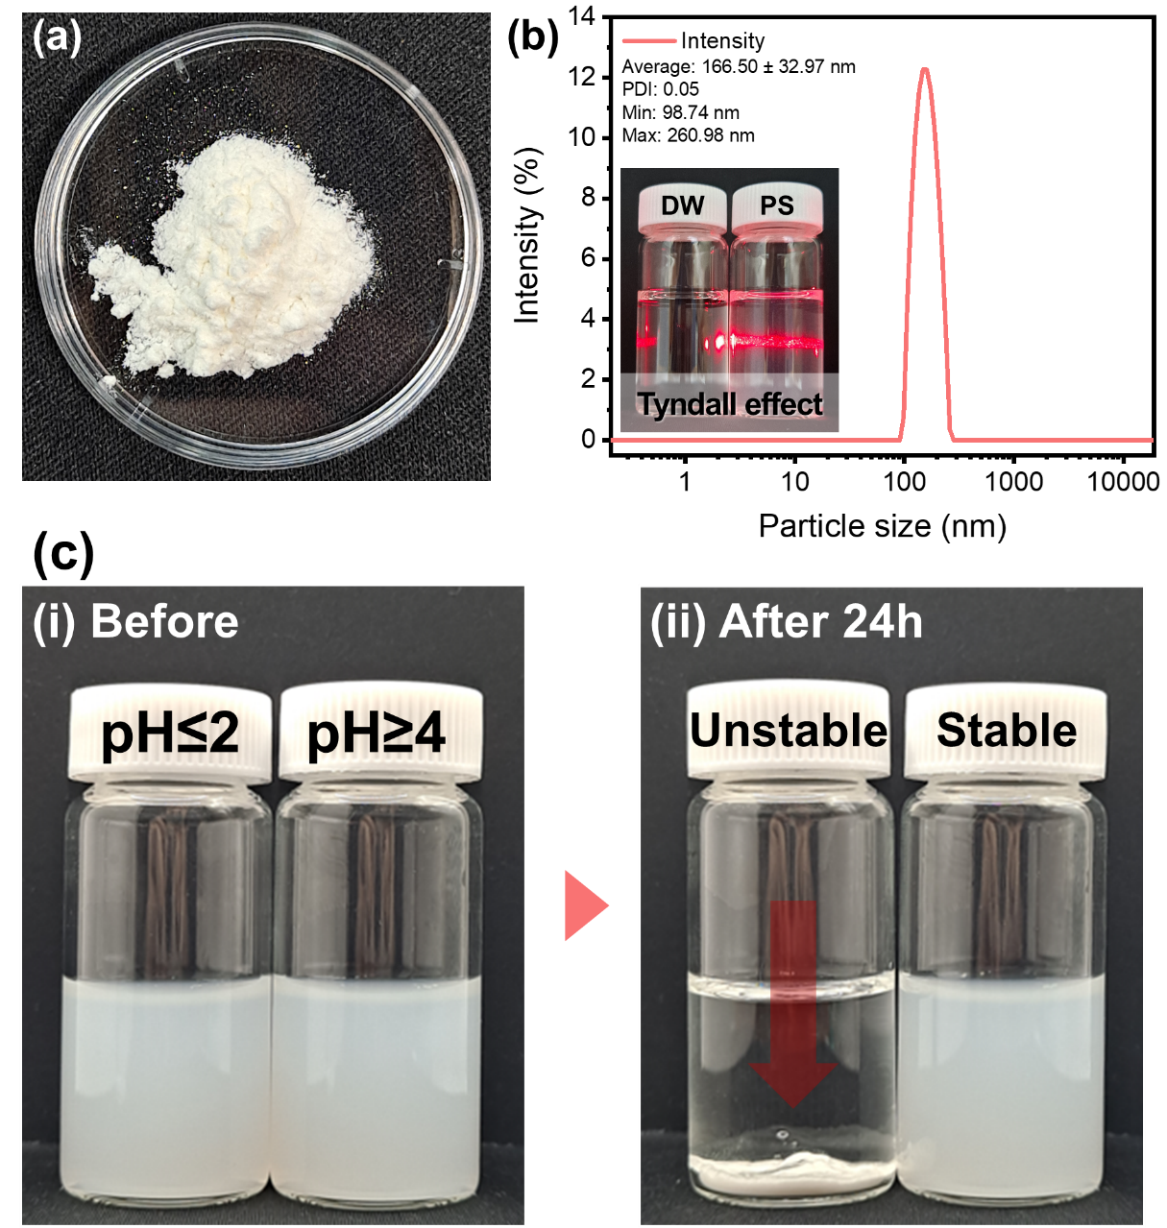
Fig. S1: Characterization of PS nanoplastic.
(a) Optical image of PS nanoplastics. (b) Particle size distribution of PS nanoplastics. (c) PS dispersion stability under different pH conditions (concentration: 1000 mg/L).
Supplementary note 2: Physicochemical properties of KL and Q-KL.
There was an increase in the carboxyl group content in Q-KL was observed, which is consistent with the XPS results [3, 4]. This phenomenon can be attributed to the sub-reaction of carboxylic acid formation under quaternization conditions using NaOH, as suggested by Wahlström et al. [4].
The change in the hydrophilicity of lignin caused by quaternization was confirmed by contact angle measurements (Fig. S2d). Both KL and Q-KL showed a decreasing trend in the contact angle over time; this was attributed to the hydrophilic hydroxyl groups within the lignin structure, which absorbed water into the lignin pellets. However, compared with KL, which had an initial contact angle of 86° and decreased to 41° after 300 s, the hydrophilicity of Q-KL significantly increased. The initial contact angle of Q-KL was 62°, which decreased steadily to 21° after 300 s.
Table S3 indicates that the quaternization increased the molecular weight of Q-KL. This increase can be attributed to the incorporation of GTMAC into the KL backbone coupled with the removal of lower-molecular-weight lignin moieties during washing with ethanol and acetone [5, 6]. Pinto et al. suggested the ring-opening oligomerization of GTMAC as a side reaction, which could have caused its higher molecular weight [5]. An increase in the molecular weight influences the thermal stability of lignin, potentially altering its structural transformation patterns, such as condensation under heating and an increase in char residue [7, 8]. Fig. S2(e and f) show that the char residue of Q-KL (42.3%) was notably higher than that of the unmodified KL (33.1%). Furthermore, the introduction of GTMAC into the structure resulted in variations in thermal degradation behavior. The decomposition of KL at 150.8 °C involves the loss of chemically bound water and dehydration of the hydroxyl groups in lignin [9]. Near 248.9 °C, the degradation of carboxylic acid and anhydride groups occurs along with the decomposition of residual hemicellulose. The principal thermal degradation of KL around 344.2 °C is attributed to the cleavage of ether and C-C bonds. Q-KL, with its lower hydroxyl group content compared to that of KL, exhibited less thermal decomposition around 150 °C. In addition, the carboxyl groups and introduced quaternary ammonium groups displayed pronounced thermal decomposition behavior at 260 °C, as noted by Kong et al. [1]. Beyond 400 °C, the quaternary ammonium salts decomposed into ammonia and alkyl halide [10, 11]. Subsequently, the thermal decomposition that occurred at ~672.2 °C is hypothesized to involve further condensation and aromatization, thereby leading to the formation of heteroaromatic structures. This transformation is caused by a continued thermal processes in which complex molecular rearrangements promote the stabilization of aromatic systems under high-temperature conditions [5]. The GPC and TGA results for KL and Q-KL indicated an effective functionalization of KL with GTMAC.
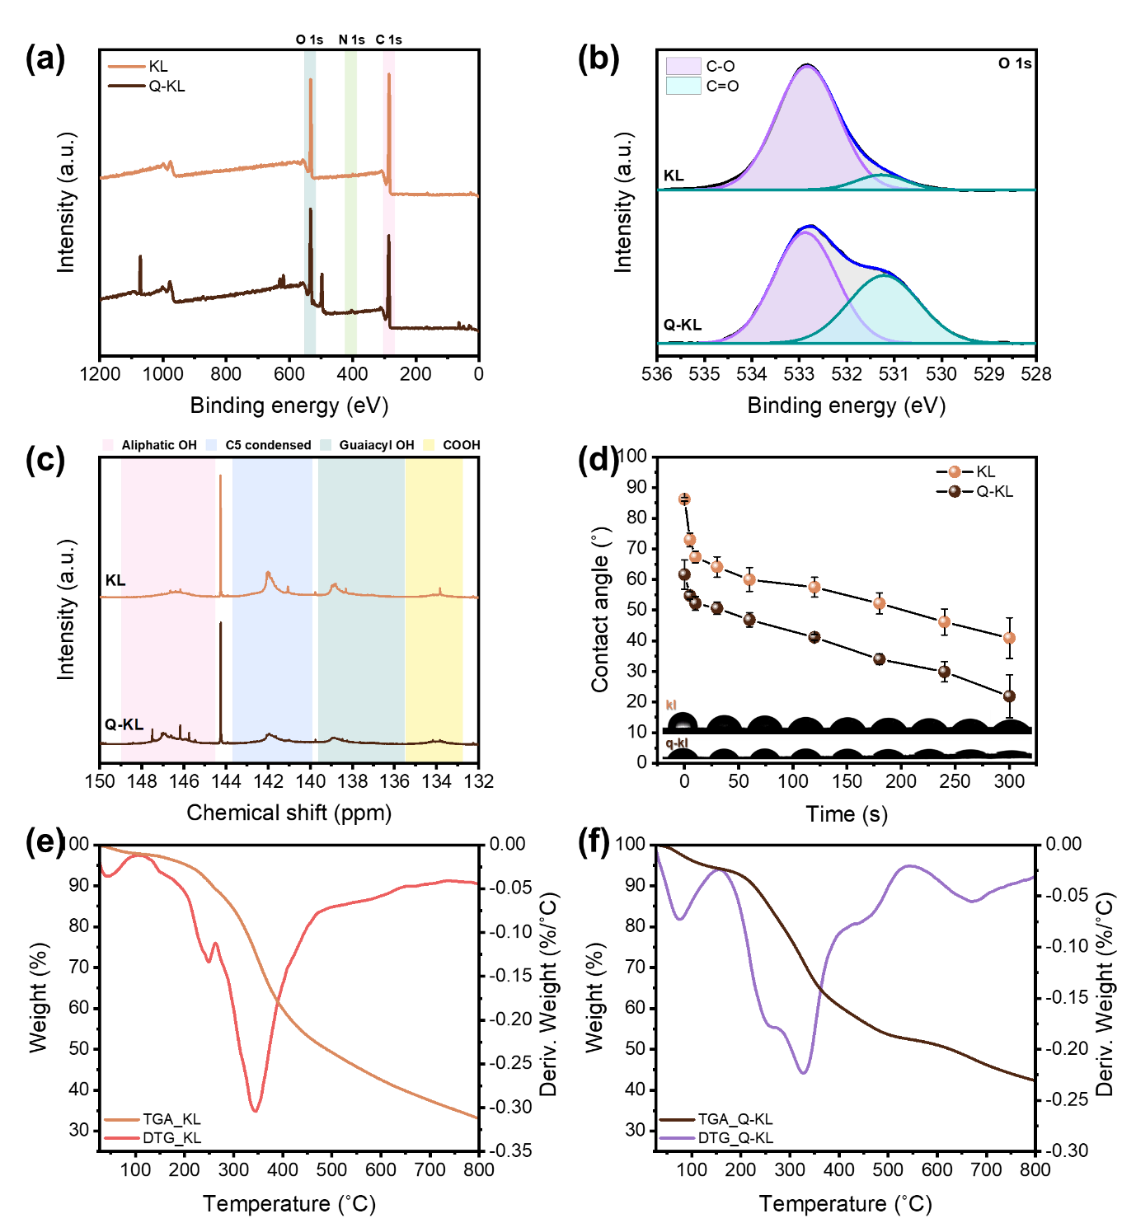
Fig. S2: Physicochemical properties of KL and Q-KL.
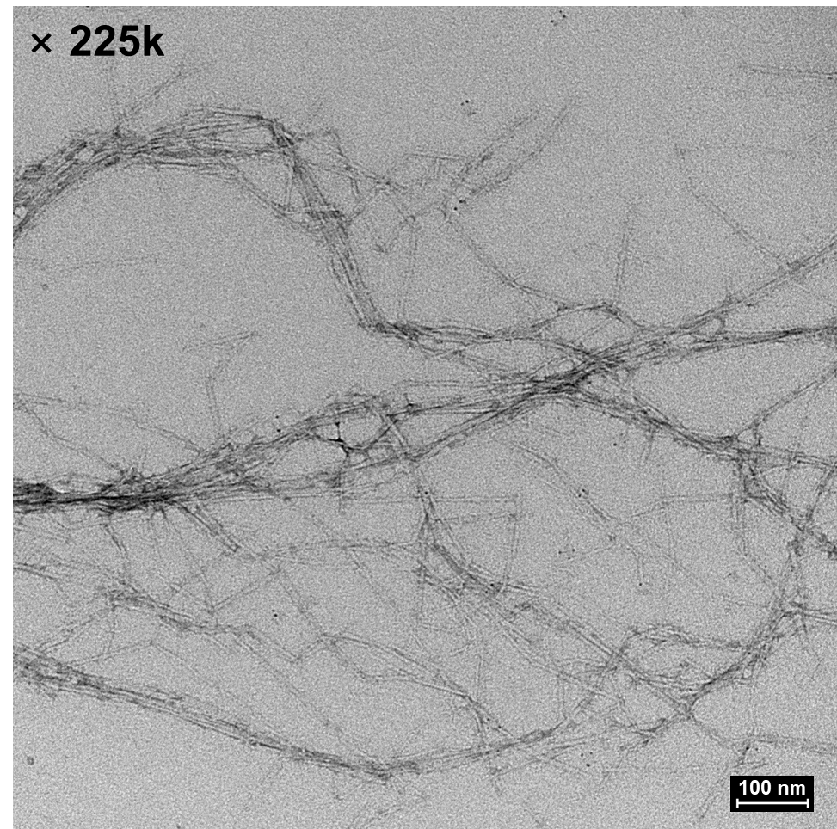
(a) XPS full spectra of KL and Q-KL. (b) O 1s binding region of KL and Q-KL. (c) ³¹P-NMR results of KL and Q-KL. (d) Contact angle of KL and Q-KL. The experiment was reproduced n=3 times. (e) TGA and DTG results of KL. (f) TGA and DTG results of Q-KL.
B
C
D
A
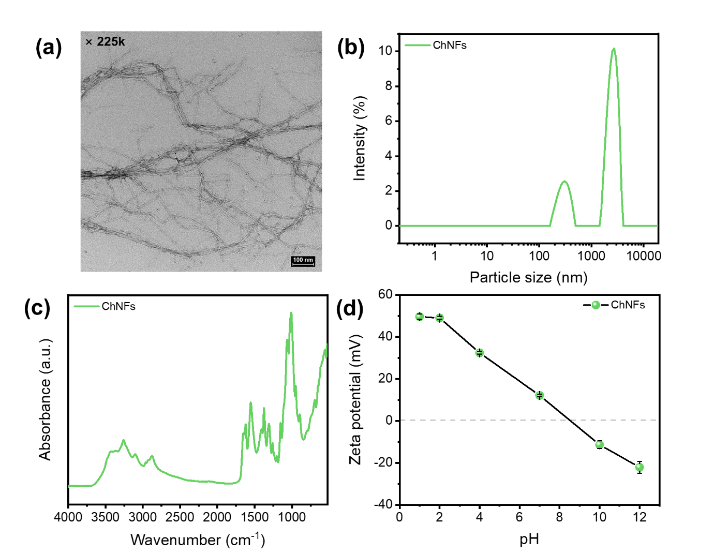
Fig. S3: Characterization of ChNFs.
(a) TEM image of ChNFs. (b) Size distribution of ChNFs. (c) FTIR spectrum of ChNFs. (d) Zeta potential of ChNFs. The experiment was reproduced n=3 times.

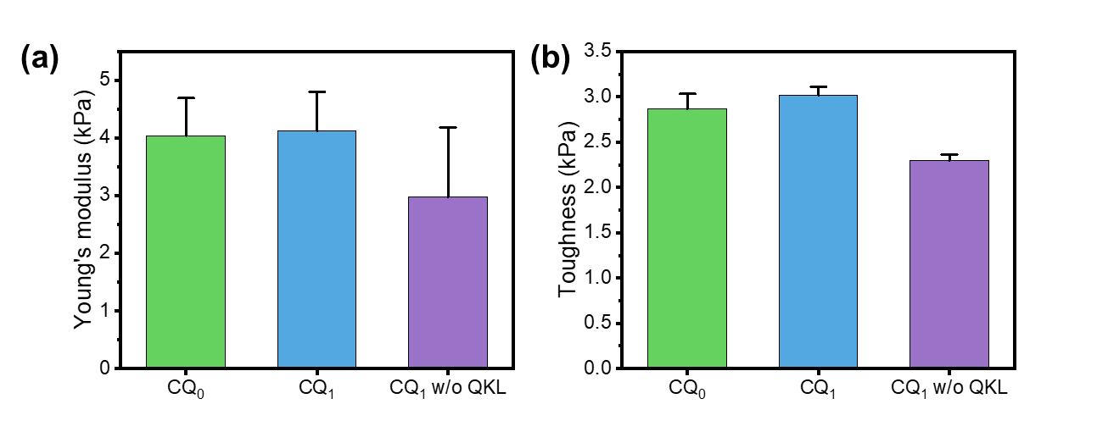
Fig. S4: Mechanical properties of CQ₀, CQ₁ and CQ₁ without Q-KL.
(a) Young’s modulus of CQ₀, CQ₁ and CQ₁ without Q-KL. The experiment was reproduced n=3 times. (b) toughness of CQ₀, CQ₁ and CQ₁ without Q-KL. The experiment was reproduced n=3 times.
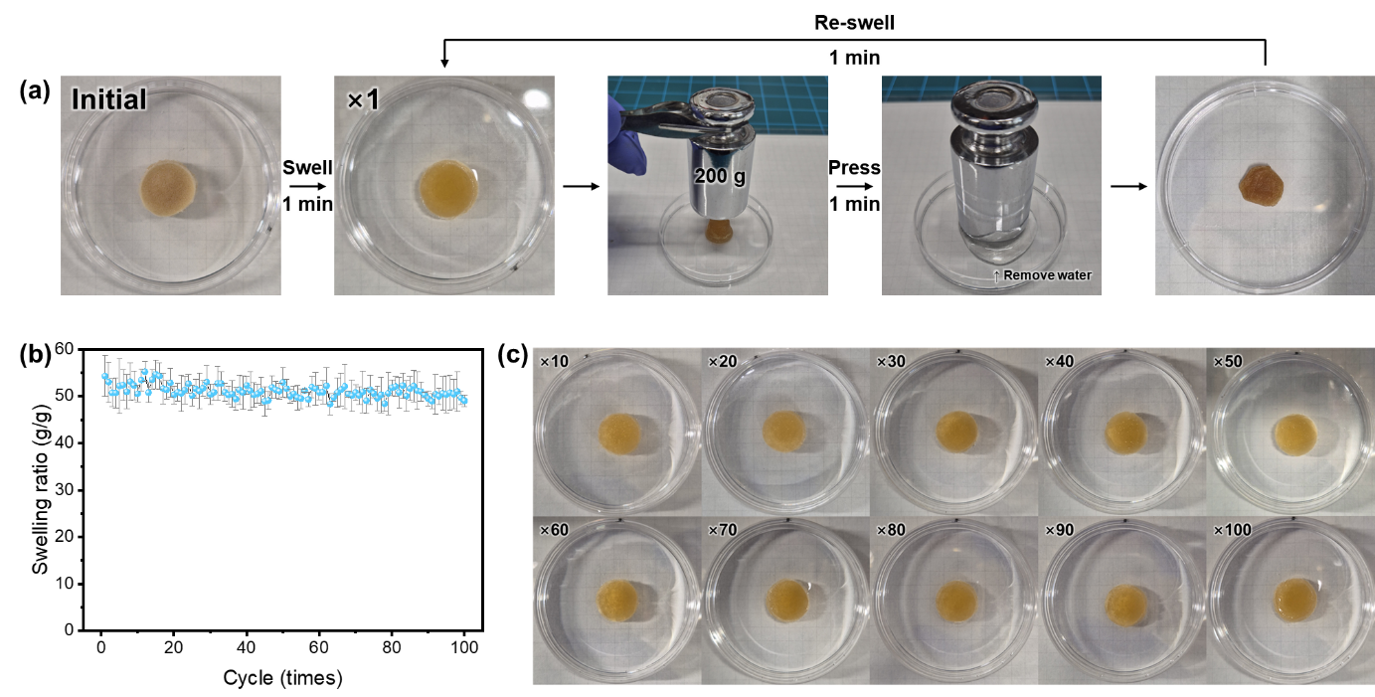
Fig. S5: Repeated swelling-deswelling experiments on CQ₁ hydrogel.
(a) Procedure of repeating swelling-deswelling cycle on CQ₁ hydrogel. (b) Swelling ratio of CQ₁ hydrogel during 100 times of cycle. The experiment was reproduced n=3 times. (c) Interval optical image of CQ₁ hydrogel during the 100 cycles.
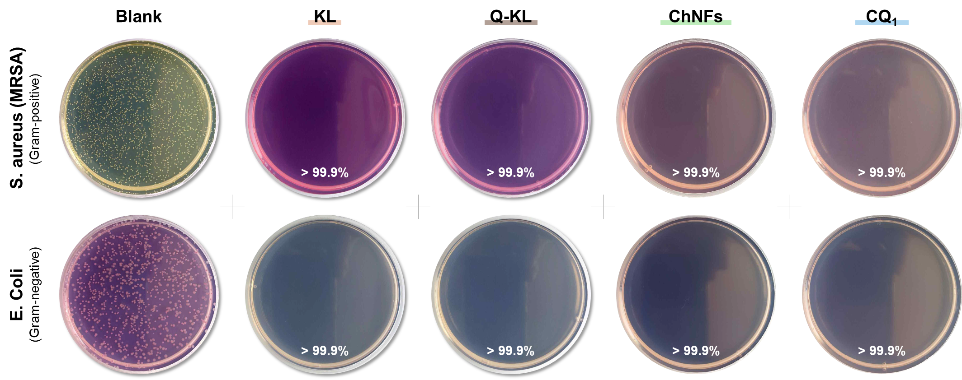
Fig. S6 : Antibacterial properties of raw materials and CQ₁ hydrogel.
Antibacterial evaluation of raw materials and CQ₁ hydrogel against gram-positive and gram-negative bacteria. Evaluation was performed by counting the number of bacterial colonies generated compared to the untreated medium (blank).
Supplementary note 3: Adsorption kinetics
Adsorption kinetics analysis is used to evaluate the adsorption behavior over time. Adsorption kinetics is essential for determining both the rate and mechanism of adsorption, providing crucial information for designing adsorption processes [12]. Pseudo-first and pseudo-second-order models are well-known models in adsorption kinetics. Physical adsorption processes occurring in porous adsorbents with microporous structures (e.g. activated carbon) predominantly follow the pseudo-first-order kinetics model. Conversely, a high correlation with the pseudo-second-order kinetics model was demonstrated when chemical forces such as electrostatic interactions, covalent bonding, coordination bonding, and ionic bonding predominantly influenced the adsorption process [13].

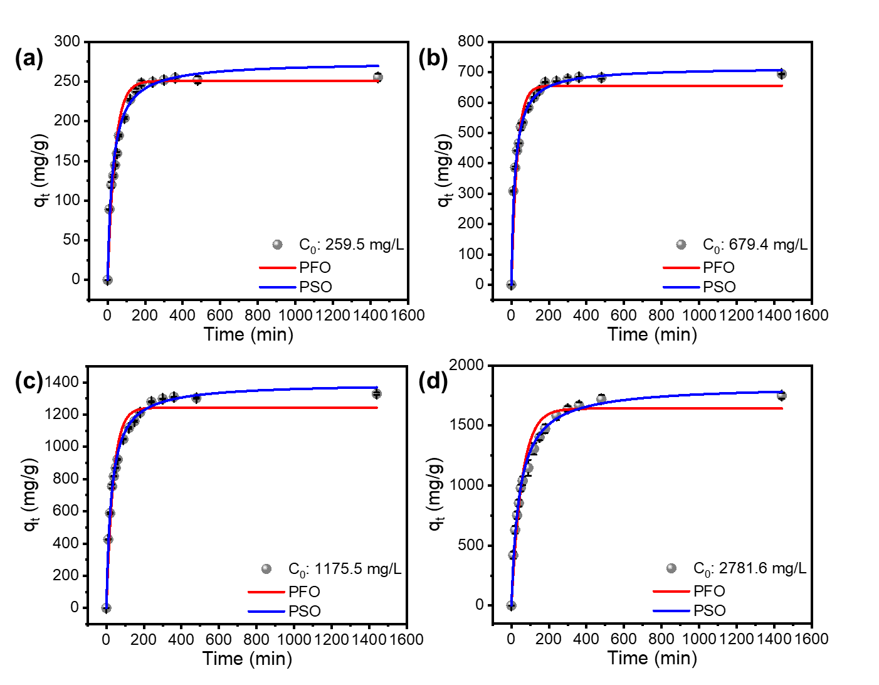
Fig. S7: Adsorption kinetics.
Adsorption kinetics of PS nanoplastic adsorption on CQ₁. (a) C₀=259.5 mg/L. (b) C₀=679.4 mg/L. (c) C₀=1,175.5 mg/L. (d) C₀=2,781.6 mg/L. In all graphs, the red line is pseudo-first-order (PFO) model fitting results and the blue line is pseudo-second-order (PSO) model fitting results. The experiment was reproduced n=3 times.
Supplementary note 4: Intraparticle diffusion
The adsorption process includes three stages: boundary-layer diffusion, intraparticle diffusion, and adsorption equilibrium. These stages occur as the adsorbate diffuses inward through the porous structure of the adsorbent, and variations in the diffusion rates over time influence the rate of adsorption. This process is described by the intraparticle diffusion model and its application to the adsorption of PS nanoplastics by CQ₁ is illustrated in Fig. 5b. At all concentrations, the first stage of boundary layer diffusion was completed within 60 min, during which rapid adsorption occurred at the adsorbent surface. Once the surface reached saturation, the process transitioned to the second stage of adsorption, which involved diffusion into the interior of the adsorbent. The rapid transition to the internal diffusion phase was attributed to the rapid saturation of the CQ₁ surface caused by its excellent adsorption capacity and rapid mass transfer within the adsorbent because of capillary forces through the pores. Most of the adsorption is completed during the second stage. After 240 min, the rate of adsorption decreased significantly, reaching adsorption equilibrium, where the system achieved a dynamic equilibrium state. The parameters representing the adsorption rates at each stage are listed in Table S6.
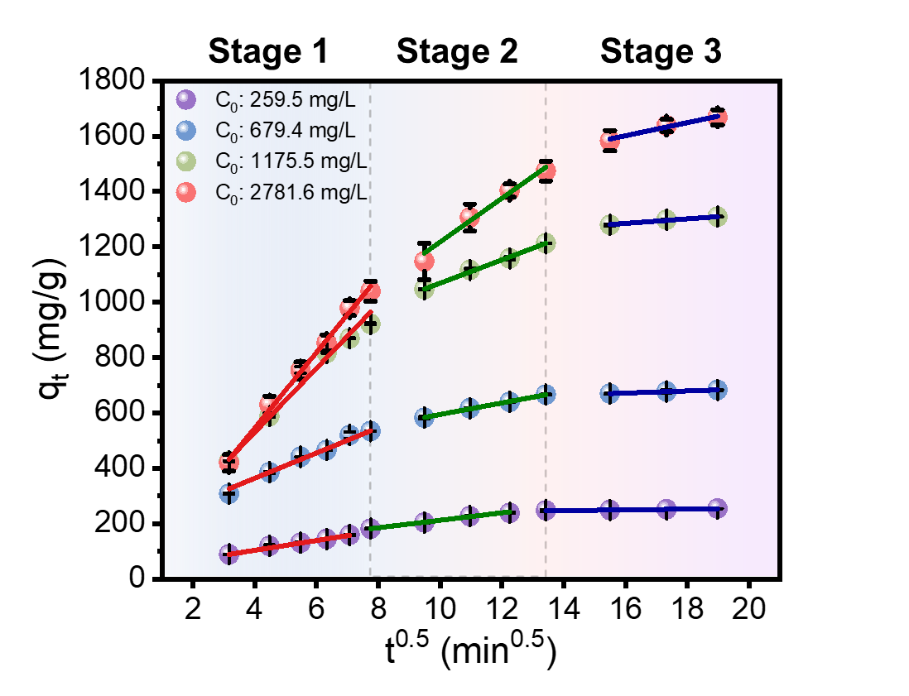
Fig. S8: Intraparticle diffusion.
The intraparticle diffusion kinetics of PS nanoplastics into CQ₁. The experiment was reproduced n=3 times.
Supplementary note 5: Adsorption isotherm
The adsorption isotherm analysis provides information on the adsorption behavior of an adsorbent at a constant temperature. The Langmuir and Freundlich models are well-known models, and they provide fundamental information on the adsorption process including the maximum adsorption capacity of the adsorbent and strength of adsorption [12].
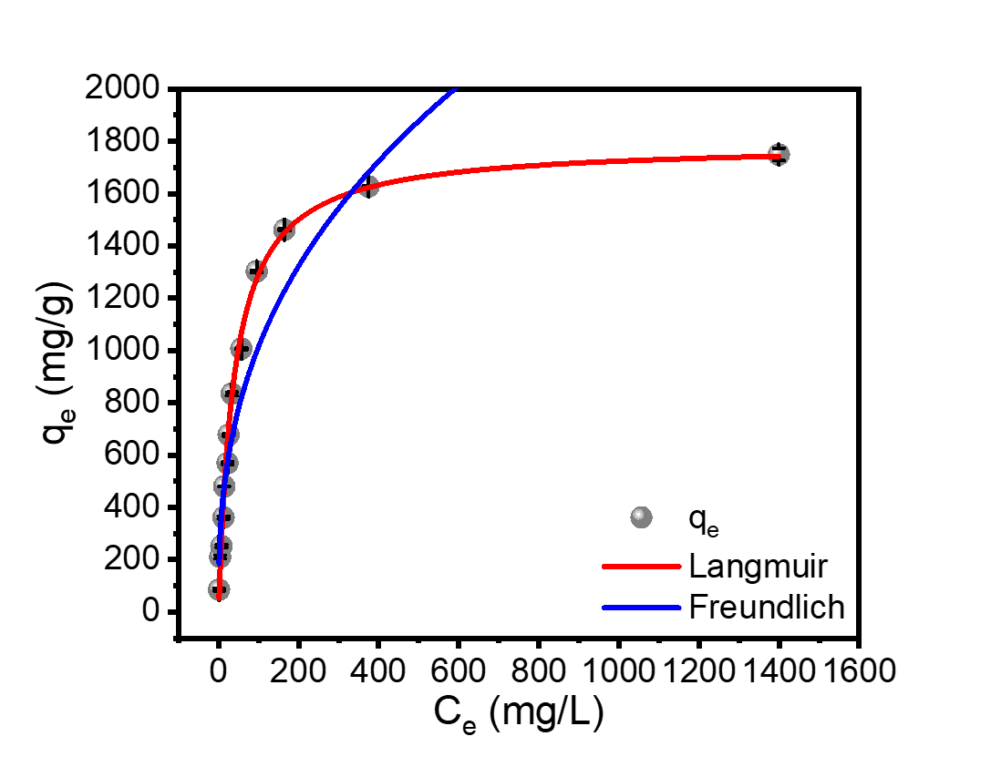

Fig. S9: Adsorption isotherm.
The PS nanoplastic adsorption isotherm of CQ₁. The experiment was reproduced n=3 times.
Supplementary note 6: Theoretical adsorption capacity calculations.
This calculation is based on the basic assumption of the Langmuir model (monolayer adsorption without interaction between adsorbates) and the assumption that size of all PS nanoplastics is same. When the spherical polystyrene nanoplastics cover the surface most densely, the actual surface occupied by each nanoplastic is a regular hexagon. This forms a virtual honeycomb structure on the surface, and the area of each regular hexagon is named A_{PS}. The theoretical maximum adsorption capacity calculation process of CQ₁ based on this assumption is described below, and it is compared with the actual adsorption capacity from the experiment and the theoretical adsorption capacity calculated from each model. This result shows that most area of the CQ₁ participate in PS adsorption, indicating the high affinity of CQ₁ towards the PS nanoplastics.

- $SSA_{CQ_{1}}=19.5620 m^{2}/g_{CQ_{1}}$$$\frac{SSA_{CQ_{1}}}{A_{PS}}=8.15×{10}^{14} particle/g_{CQ_{1}}$$
- $Weight of one PS nanoplastic= Volume of one PS nanoplastic ×density of PS nanoplastic$
$=\frac{4}{3}πr^{3}\left(nm^{3}\right)×1.05×{10}^{-18} \left({mg}/{nm^{3}}\right)$
$=2.54×{10}^{-12} mg_{PS}$
- $Theoretical maximum PS nanoplastic adsorption capacity of CQ_{1}.=8.15×{10}^{14}{{particle}/g}_{CQ_{1}}×2.54×{{10}^{-12} mg_{PS}}/{particle}=2,067.7 mg_{PS}/g_{CQ_{1}}$
- $Experimental adsorption capacity=1,801.1 mg/g$
- $Langmuir monolayer maximum adsorption capacity \left(q_{m}\right)=1,790.8 {mg}/g$
- $Calculated adsorption capacity from pseudo2nd order kinetics fitting \left(q_{e,cal}\right)=1,843.9 mg/g$
Supplementary note 7: Adsorption thermodynamics
Water resource temperature varies seasonally. Considering this, assessing the adsorption efficiency at different temperatures is essential. Adsorption thermodynamic analysis provides insights into the energy changes associated with the adsorption process, enabling the determination of the spontaneity and thermal stability of adsorption, as well as understanding how adsorption varies with temperature.
The adsorption thermodynamics results of the PS nanoplastic adsorption on CQ₁ are shown in Fig. 5d. The ΔG° values, which indicate the spontaneity of adsorption, were negative across all temperatures, suggesting that adsorption occurs spontaneously under all temperature conditions. Furthermore, ΔG° values became more negative with an increase in temperature, indicating the enhanced removal of PS nanoplastics at higher temperatures. Consequently, an increase in adsorption capacity was observed with increasing temperature. The ΔH° and ΔS° values calculated from the linear plot of ln K_{c} versus 1/T are displayed in Table S8. A positive ΔS° value indicates that randomness at the interface of the adsorbent is enhanced during the adsorption process, while a positive ΔH° value of 136.89 kJ/mol indicates that the adsorption process is endothermic and chemisorption [14, 15].
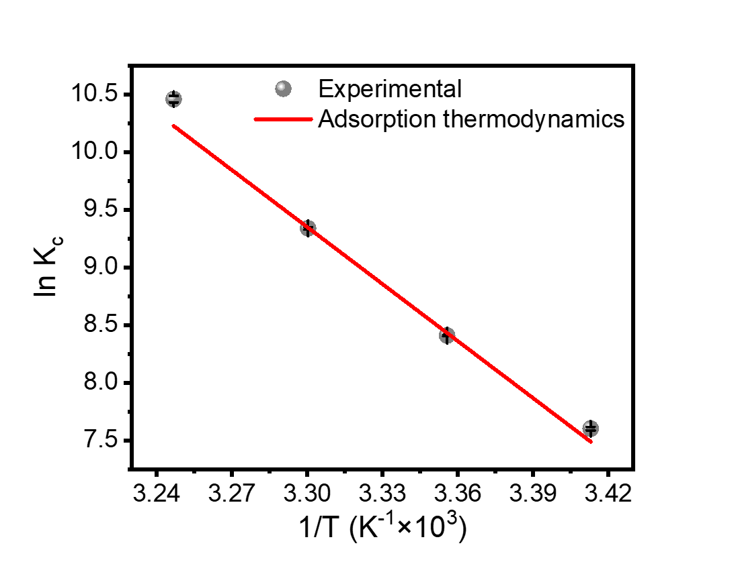
Fig. S10: Adsorption thermodynamics.
The PS nanoplastic adsorption thermodynamics of CQ₁. The experiment was reproduced n=3 times.

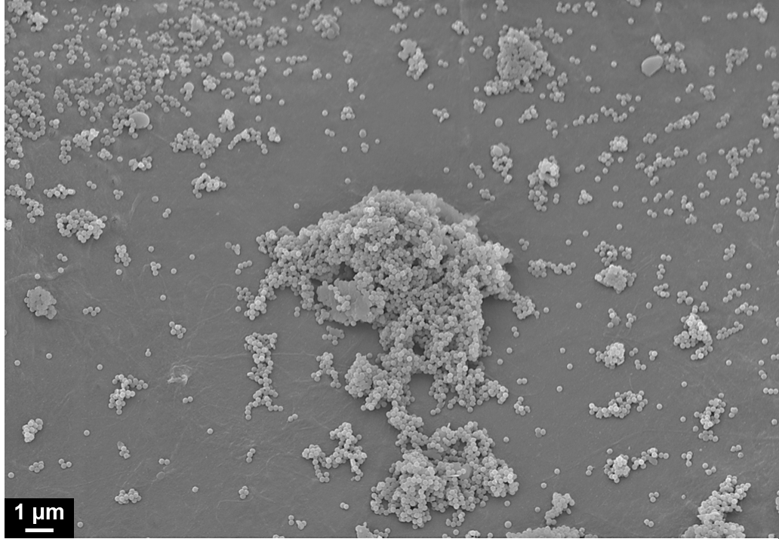
Fig. S11: SEM image of CQ₁ hydrogel after PS nanoplastic adsorption.
Around Q-KL, PS nanoplastics are adsorbed in multiple layers due to strong electrical attraction. Conversely, on the flat surface which is mainly ChNFs, they are adsorbed in a single layer. Considering that the surface of the CQ₁ hydrogel has a higher proportion of ChNFs than Q-KL, the PS nanoplastic adsorption on CQ₁ is likely to occur in a single layer (follows Langmuir isotherm model).
*Note: The SEM image in Fig. 5b also shows the same adsorption pattern, but it focuses on emphasizing the effect of Q-KL particles, which provide strong electrical attraction.

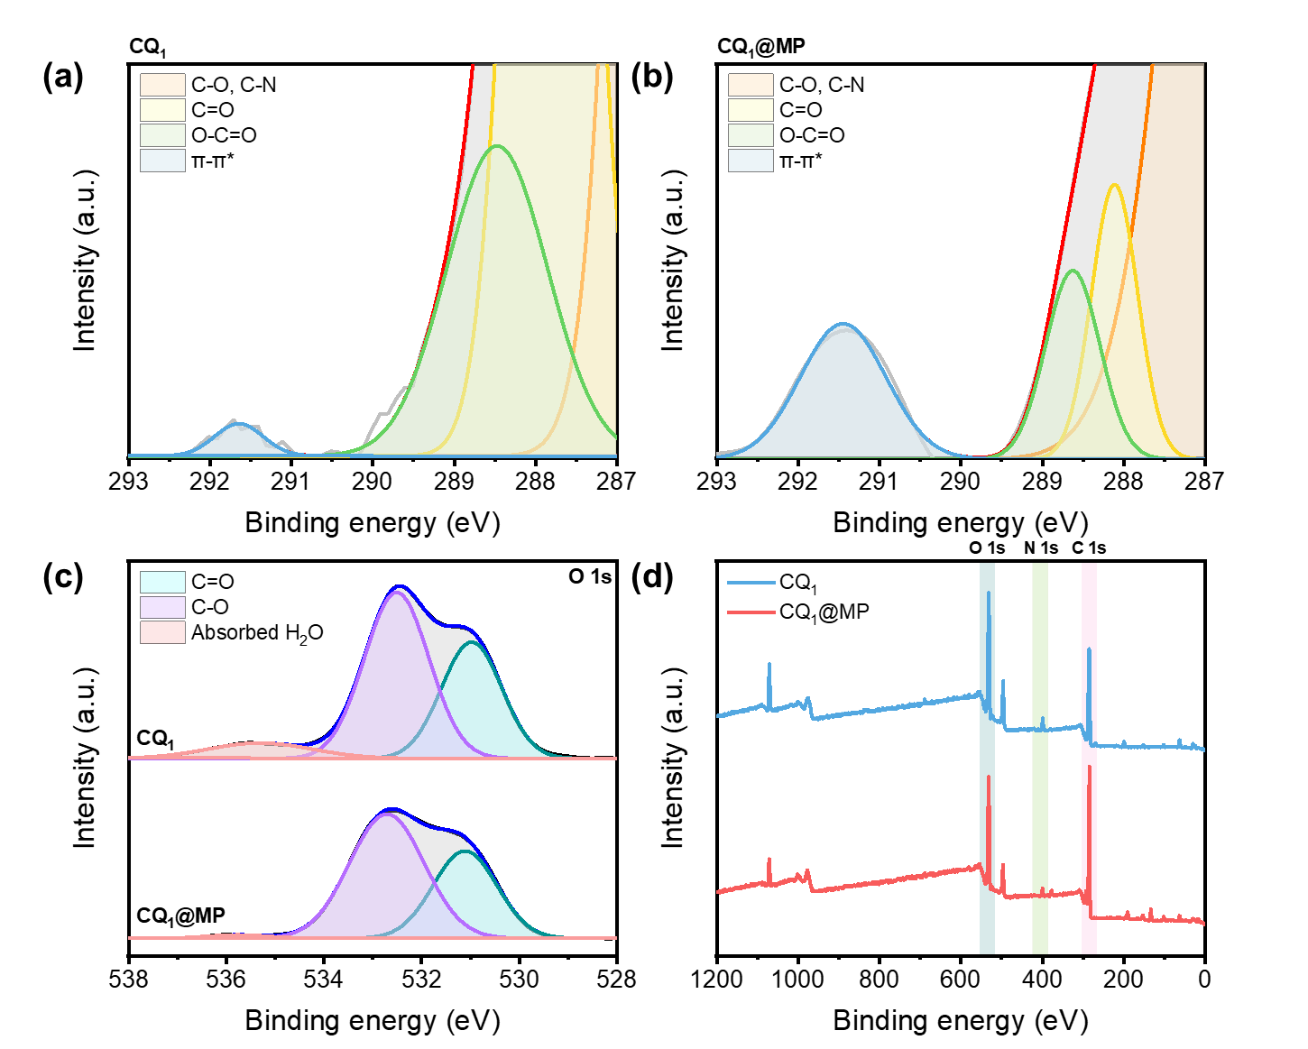
Fig. S12: Adsorption mechanism.
(a) C 1s XPS spectra of CQ₁ . (b) C 1s XPS spectra of MP-adsorbed CQ₁ (CQ₁@MP). (c) O 1s XPS spectra of CQ₁ and CQ₁@MP. (d) XPS full spectra of CQ₁ and CQ₁@MP.
* Note: (a) and (b) present magnified views of the 293–287 eV region highlighted in Fig. 5c of the main text.

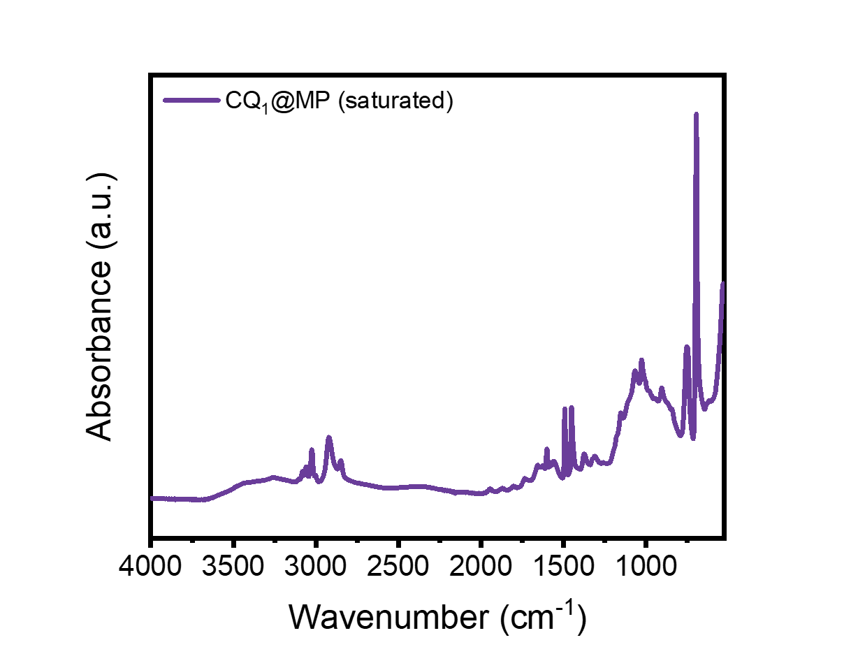
Fig. S13: FTIR spectrum of PS nanoplastic-saturated CQ₁.
FTIR spectrum of PS nanoplastic-saturated CQ₁. Due to the excessive coverage of the CQ₁ surface by PS nanoplastics, the resulting spectrum predominantly corresponds to that of PS nanoplastics.
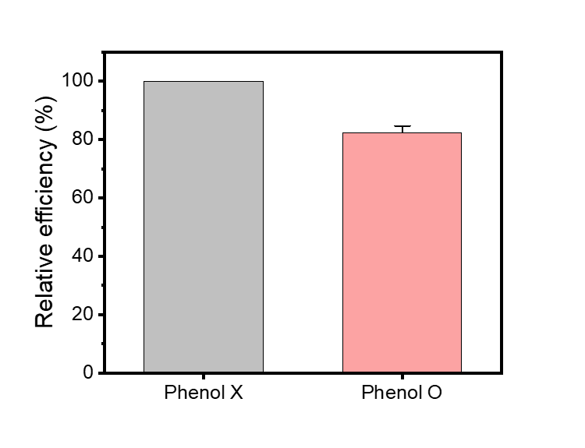
Fig. S14: Relative contribution of adsorption mechanism.
Relative adsorption efficiency of CQ₁ hydrogel after pre-immersion in a saturated phenol solution. Phenol preemptively occupies π-π bond sites on the hydrogel surface, weakening π-π stacking, a key mechanism involved in adsorption. This indirectly indicates the contribution of the two main forces involved in adsorption. After the π-π bonds were weakened, the adsorption capacity decreased to 82.3% of the original one, indicating that π-π interactions contributed 17.8% of the total adsorption amount.
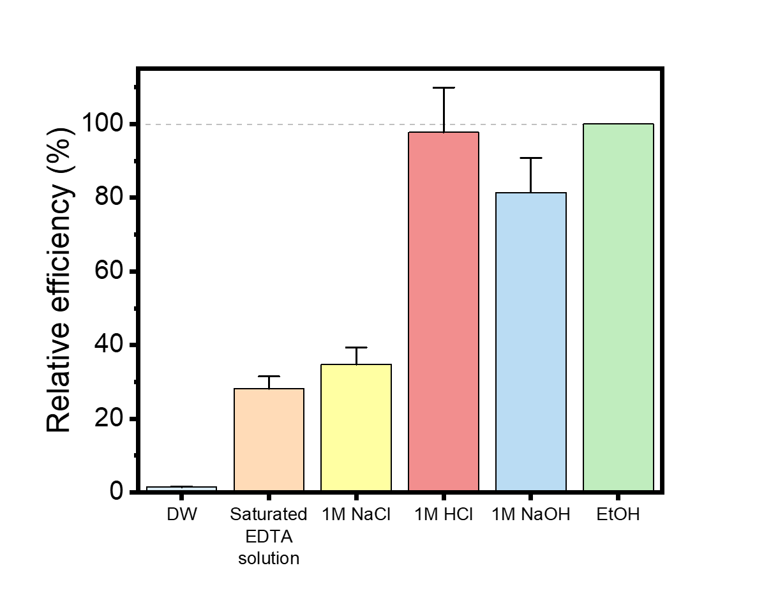
Fig. S15: Alternatives for desorption.
Relative desorption efficiency of DW, saturated EDTA solution, 1M NaCl, 1M HCl and 1M NaOH with respect to ethanol. Change in pH showed higher efficiency than salt solutions, which indicates the adsorption mechanism is based on electrostatic interaction between CQ₁ hydrogel and PS nanoplastic. These changes were particularly pronounced under acidic conditions. Using 1M HCl showed an efficiency of 97.7% compared to using ethanol.
Supplementary note 8: Comparison with other PS nanoplastic adsorbents
The cost of raw materials was calculated using the selling price of the source specified in each paper, if possible. If not, the price of chemicals was referenced from Aladdin Scientific (www.aladdinsci.com), Sigma-Aldrich (www.sigmaaldrich.com), and Alibaba (www.alibaba.com). The price of coffee ground and fly ash was referenced from Coupang (www.coupang.com) and Amazon (www.amazon.com), respectively.
The process cost was calculated by multiplying the total power value calculated by considering all variables such as power consumption, operating time, and temperature of the equipment specified in each paper by the average industrial electricity rate in the United States. However, transportation costs were not included in the total process cost, which may add to the cost calculated in this study.

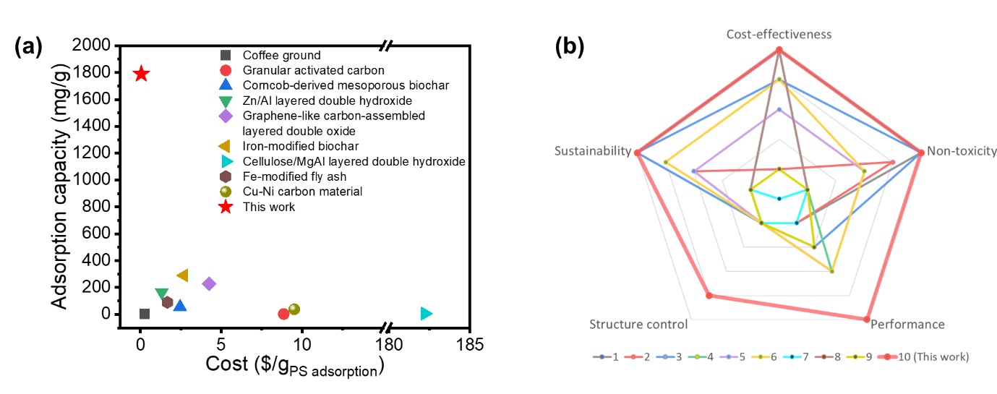
Fig. S16: Comparison with other PS nanoplastic adsorbents.
(a) Adsorption capacity of other reported PS nanoplastic adsorbents and cost for absorbing 1g of PS nanoplastics using each adsorbents. (b) Comprehensive performance comparison of CQ₁ hydrogel with other PS nanoplastic adsorbents.

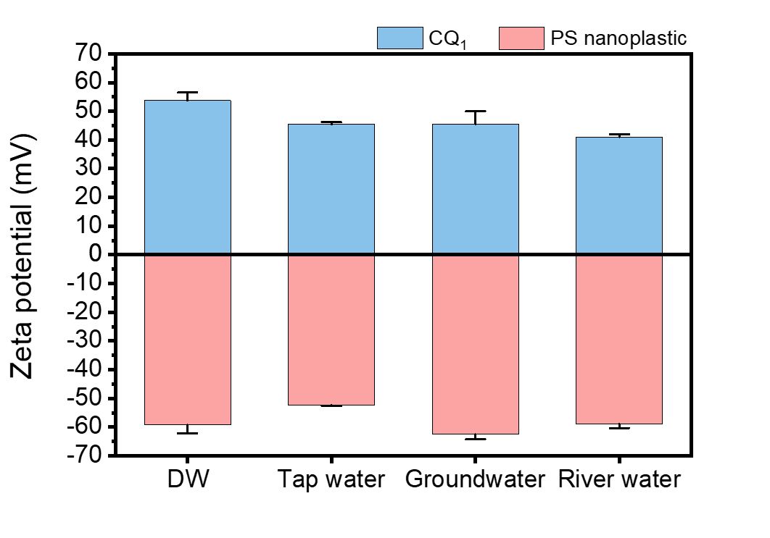
Fig. S17: Zeta potential of CQ₁ hydrogel and PS nanoplastic in various water.
Due to dissolved substances in real water samples, there was change in zeta potential of CQ₁ hydrogel and PS nanoplastic. The zeta potential of CQ₁ hydrogel became low, and that of PS nanoplastic also showed a weakening of surface charge, except for a slight increase in groundwater. This change in surface potential may affect the adsorption performance when the adsorbent is used in a real water environment.
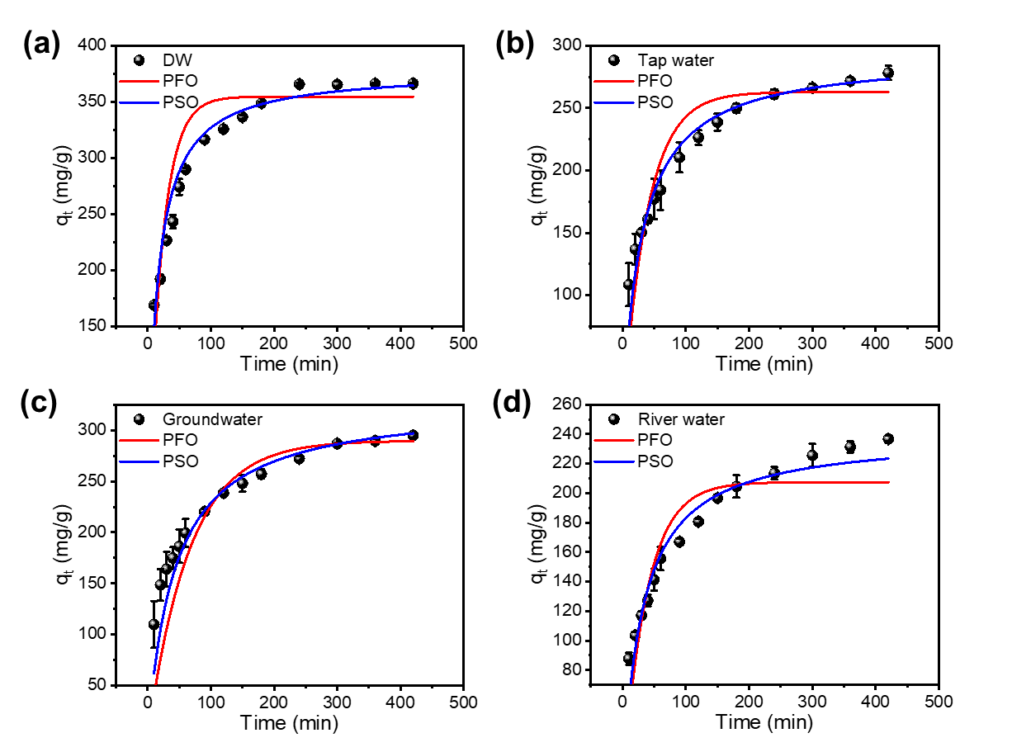
Fig. S18: Adsorption kinetics in real-water conditions.
Adsorption kinetics of PS nanoplastic adsorption on CQ₁ in real water conditions, compared to lab condtion. (a) DW, (b) tap water, (c) groundwater and (d) River water.
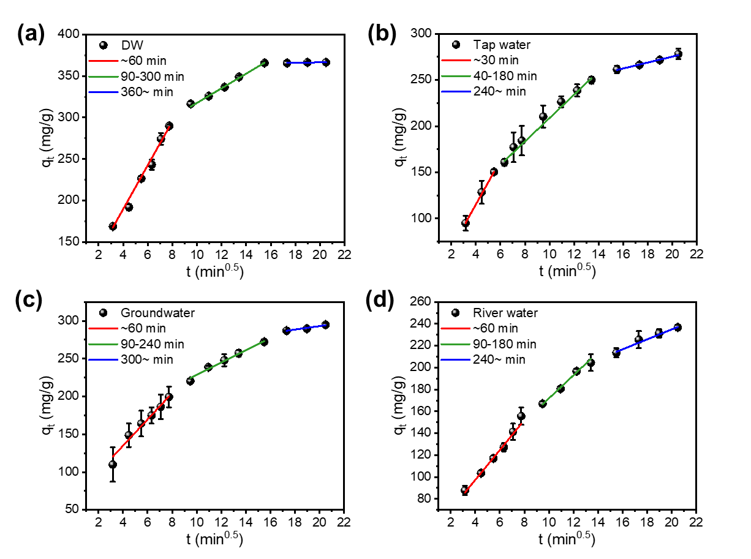
Fig. S19: Intraparticle diffusion in real-water conditions.
Intraparticle diffusion of PS nanoplastic adsorption on CQ₁ in real water conditions, compared to lab condtion. (a) DW, (b) tap water, (c) groundwater and (d) River water.

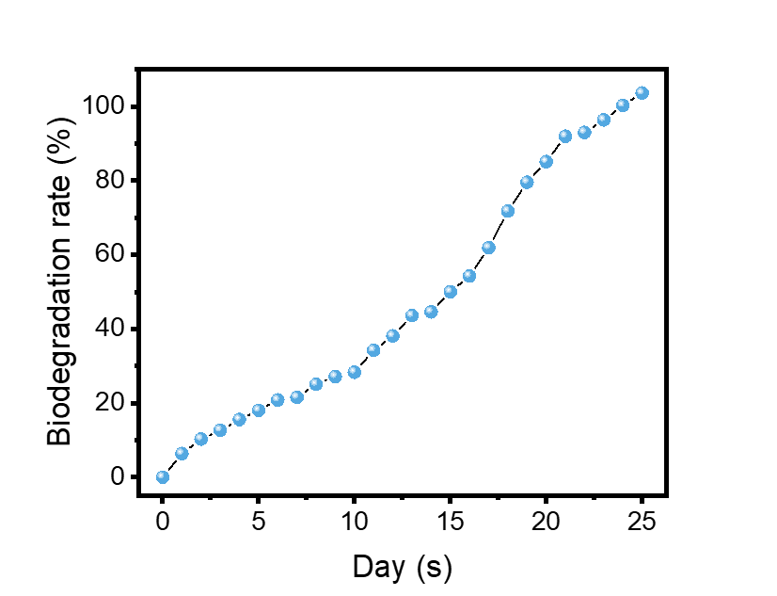
Fig. S20: Biodegradation of CQ₁ hydrogel.
Biodegradation rate of CQ₁ hydrogel according to ISO 17556 standard.

Supplementary table
Table S1. Elemental composition of KL and Q-KL.
 | C (wt%) | H (wt%) | O (wt%) | N (wt%) | S (wt%) | Formula | DS
KL | 65.52 | 6.08 | 27.43 | 0.02 | 0.95 | C₉H_{9.95}O_{2.83}N_{0.002}S_{0.05} | -
Q-KL | 54.09 | 5.60 | 38.48 | 1.64 | 0.19 | C₉H_{11.09}O_{4.81}N_{0.23}S_{0.01} | 0.25

Table S2. Quantitative ³¹P-NMR results of KL and Q-KL.
 | Aliphatic OH  (mmol/g) | Phenolic OH (mmol/g) |  |  | Carboxylic group  (mmol/g) | Total OH  (mmol/g)
 | Aliphatic OH  (mmol/g) | C5 condensed | Guaiacyl OH | Total phenolic OH | Carboxylic group  (mmol/g) | Total OH  (mmol/g)
KL | 0.652 | 2.571 | 1.376 | 3.947 | 0.151 | 4.750
Q-KL | 1.242 | 1.132 | 0.648 | 1.779 | 0.223 | 3.244

 | M_{n} (Da) | M_{w} (Da) | PDI
KL | 470 ± 4.90 | 1,753 ± 43.3 | 3.73 ± 0.12
Q-KL | 1,002 ± 9.86 | 4,389 ± 248.0 | 4.38 ± 0.21
Table S3. GPC results of KL and Q-KL.

Table S4. BET analysis results of the ChNFs/Q-KL aerogels.
 | S_{BET}  (m²/g) | V_{total}  (cm³/g)
CQ₀ | 21.10 | 0.0245
CQ₁ | 19.56 | 0.0275
CQ₂ | 5.70 | 0.0256

Table S5. Adsorption kinetics model parameters.
 | Pseudo-first order |  |  | Pseudo-second order
C₀  (mg/L) | q_{e, cal}  (mg/g) | k₁  (min⁻¹) | R² | q_{e, cal}  (mg/g) | k₂  (g/mg/min) | R²
259.5 | 250.8 | 0.026 | 0.9966 | 274.8 | 0.00013 | 0.9987
679.4 | 655.8 | 0.033 | 0.9959 | 716.1 | 0.00007 | 0.9991
1175.5 | 1242.7 | 0.027 | 0.9966 | 1395.1 | 0.00003 | 0.9995
2781.6 | 1641.9 | 0.018 | 0.9953 | 1834.9 | 0.00001 | 0.9992

Table S6. Intraparticle diffusion model parameters.
C₀  (mg/L) | k_{id1}  (mg/g/min^{0.5}) | R² | k_{id2}  (mg/g/min^{0.5}) | R² | k_{id3}  (mg/g/min^{0.5}) | R²
259.5 | 33.3 | 0.9986 | 13.5 | 0.9870 | 1.4 | 0.9912
679.4 | 45.7 | 0.9795 | 20.8 | 0.9949 | 3.9 | 0.9991
1175.5 | 116.0 | 0.9882 | 42.1 | 0.9989 | 8.2 | 0.9764
2781.6 | 136.5 | 0.9948 | 78.9 | 0.9652 | 23.6 | 0.9377

Table S7. Adsorption isotherm model parameters.
Langmuir |  |  | Freundlich
k_{L}  (L/mg) | q_{m}  (mg/g) | R² | k_{F}  (mg/g)(L/mg)^{1/n} | n | R²
0.026 | 1790.8 | 0.9974 | 174.9 | 2.62 | 0.9621

Table S8. Adsorption thermodynamics parameters.
T (K) | ΔG° (kJ/mol) | ΔH° (kJ/mol) | ΔS° (kJ/mol·K)
293 | −18.24 | 136.89 | 0.5295
298 | −20.89 | 136.89 | 0.5295
303 | −23.54 | 136.89 | 0.5295
308 | −26.18 | 136.89 | 0.5295

Table S9. Comparison of PS nanoplastic adsorption capacity of various adsorbents.
No. | Adsorbent | Particle size  (nm) | Initial concentration  (mg/L) | pH | Equilibration  time  (h) | Adsorption capacity  (mg/g) | Reference
1 | Coffee ground | 100 | 100 | 7 | 40 min | 4.0 | Yen et al. [16]
2 | Granular activated carbon | 97 | 40 | 7.4 | 4 | 2.2 | Arenas et al. [17]
3 | Corncob-derived mesoporous biochar | 100 | 50 | 6.5 | 24 | 56.0 | Zhu et al. [18]
4 | Zn/Al layered double hydroxide | 55 | 250 | 4 | 2 | 164.5 | Tiwari et al. [19]
5 | Graphene-like carbon-assembled layered double oxide | 80 | 300 | 9 | 12 | 227.3 | Peng et al. [20]
6 | Iron-modified biochar | 30 | 10 | 5.5 | < 10 min | 290.2 | Singh et al. [21]
7 | Cellulose/MgAl layered double hydroxide | 100 | 5 | 7 | 24 | 6.1 | Sun et al. [22]
8 | Fe-modified fly ash | 80 | 30 | 7 | 15 | 89.9 | Zhao et al. [23]
9 | Cu-Ni carbon material | 100 | 10 | 4 | 24 | 37.0 | Zhou et al. [24]
10 | CQ₁ | 166.5 | ~2781.6 | 7.0 | 4 | 1790.8 | This work

Table S10. Properties of different types of water media.
 | Tap water | Groundwater | River water
pH | 7.25 | 7.27 | 7.45
Conductivity (mS/cm) | 0.250 ± 0.003 | 0.225 ± 0.001 | 0.137 ± 0.001
TOC (mg/L) | 1.1 | 1.7 | 3.8
Total N (mg/L) | 2.87 | 1.88 | 3.16
NO₃⁻-N (mg/L) | 2.6 | 1.7 | 2.2
NH₄⁺-N (mg/L) | 0.05 | 0.06 | 0.32
Total P (mg/L) | 0.014 | 0.008 | 0.042
Na (mg/L) | 10.35 | 15.09 | 9.04
K (mg/L) | 2.45 | 3.32 | 3.03
Ca (mg/L) | 13.38 | 19.17 | 13.81
Mg (mg/L) | 2.56 | 3.63 | 2.61
Cr (μg/L) | 0.112 | 0.281 | 0.249
Ni (μg/L) | 0.589 | 10.046 | 1.029
Pb (μg/L) | 0.196 | 0.122 | 0.072
Zn (μg/L) | 55.161 | 306.72 | 10.751
Fe (μg/L) | 6.872 | 0.562 | 19.627
Mn (μg/L) | 0.606 | 0.611 | 25.441
Li (μg/L) | 0.663 | 2.106 | 12.533
Sr (μg/L) | 72.111 | 96.026 | 80.691
Cu (μg/L) | 423.03 | 17.508 | 3.109
Cd (μg/L) | 0.009 | 0.016 | 0.008
Hg (μg/L) | ND* | ND | ND
*TOC: Total organic carbon
**ND: Not detected.

 |  | Pseudo-1st order |  |  | Pseudo-2nd order
Water type | C₀  (mg/L) | q_{e, cal}  (mg/g) | k₁  (min⁻¹) | R² | q_{e, cal}  (mg/g) | k₂  (g/mg/min) | R²
Distilled water | 345.4 | 354.7 | 0.043 | 0.81200 | 378.1 | 0.00017 | 0.97163
Tap water | 345.4 | 262.8 | 0.026 | 0.94879 | 292.8 | 0.00011 | 0.99018
Underground water | 345.4 | 289.8 | 0.015 | 0.91817 | 327.5 | 0.00007 | 0.97490
River water | 345.4 | 207.4 | 0.027 | 0.82363 | 239.9 | 0.00013 | 0.94644
Table S11. Adsorption kinetics model parameters for the PS nanoplastic adsorption by CQ₁ under real water conditions.

Table S12. Intraparticle diffusion model parameters for the PS nanoplastic adsorption by CQ₁ under real water conditions.
Water type | C₀  (mg/L) | k_{id1}  (mg/g/min^{0.5}) | R² | k_{id2}  (mg/g/min^{0.5}) | R² | k_{id3}  (mg/g/min^{0.5}) | R²
Distilled water | 345.4 | 26.4 | 0.99638 | 8.80 | 0.99613 | 0.13 | 0.58387
Tap water | 345.4 | 23.8 | 0.99880 | 12.7 | 0.99317 | 3.21 | 0.98220
Underground water | 345.4 | 17.4 | 0.96622 | 8.12 | 0.98015 | 2.30 | 0.95042
River water | 345.4 | 13.7 | 0.98514 | 10.6 | 0.98697 | 4.54 | 0.98097

References
[1] F. Kong, K. Parhiala, S. Wang, P. Fatehi, (2015). Preparation of cationic softwood kraft lignin and its application in dye removal, European Polymer Journal 67 335-345. https://doi.org/10.1016/j.eurpolymj.2015.04.004.
[2] S. ISO17556, (2019). Plastics—Determination of the Ultimate Aerobic Biodegradability of Plastic Materials in Soil by Measuring the Oxygen Demand in a Respirometer or the Amount of Carbon Dioxide Evolved, TC 61.
[3] G.N. Riviere, A. Korpi, M.H. Sipponen, T. Zou, M.A. Kostiainen, M. Osterberg, (2020). Agglomeration of Viruses by Cationic Lignin Particles for Facilitated Water Purification, ACS Sustain Chem Eng 8 (10) 4167-4177. https://doi.org/10.1021/acssuschemeng.9b06915.
[4] R. Wahlström, A. Kalliola, J. Heikkinen, H. Kyllönen, T. Tamminen, (2017). Lignin cationization with glycidyltrimethylammonium chloride aiming at water purification applications, Industrial Crops and Products 104 188-194. https://doi.org/10.1016/j.indcrop.2017.04.026.
[5] P.I.F. Pinto, S. Magina, E. Budjav, P.C.R. Pinto, F. Liebner, D. Evtuguin, (2022). Cationization of Eucalyptus Kraft LignoBoost Lignin: Preparation, Properties, and Potential Applications, Ind Eng Chem Res 61 (10) 3503-3515. https://doi.org/10.1021/acs.iecr.1c04899.
[6] S.Y. Park, J.Y. Kim, H.J. Youn, J.W. Choi, (2018). Fractionation of lignin macromolecules by sequential organic solvents systems and their characterization for further valuable applications, Int J Biol Macromol 106 793-802. https://doi.org/10.1016/j.ijbiomac.2017.08.069.
[7] R.T. Sun, Jeremy ; Gwynn Lloyd Jones, (2000). Fractional characterization of ash-AQ lignin by successive extraction with organic solvents from oil palm EFB ®bre, Polymer Degradation and Stability 68 111-119. https://doi.org/10.1016/S0141-3910(99)00174-3.
[8] J. Sameni, S. Krigstin, D.d.S. Rosa, A. Leao, M. Sain, (2014). Thermal Characteristics of Lignin Residue from Industrial Processes, Bioresources 9 (1) 725-737. https://doi.org/10.15376/biores.9.1.725-737.
[9] Q. Yan, R. Arango, J. Li, Z. Cai, (2021). Fabrication and characterization of carbon foams using 100% Kraft lignin, Materials & Design 201 109460. https://doi.org/10.1016/j.matdes.2021.109460.
[10] S. Francis, L. Varshney, S. Sabharwal, (2007). Thermal degradation behavior of radiation synthesized polydiallyldimethylammonium chloride, European Polymer Journal 43 (6) 2525-2531. https://doi.org/10.1016/j.eurpolymj.2007.03.009.
[11] J.T. Price, W. Gao, P. Fatehi, (2018). Lignin-g-poly(acrylamide)-g-poly(diallyldimethyl- ammonium chloride): Synthesis, Characterization and Applications, ChemistryOpen 7 (8) 645-658. https://doi.org/10.1002/open.201800105.
[12] G. Nandikes, O. Banerjee, M. Mirthipati, A. Bhargavi, H. Jones, P. Pathak, Separation, Identification, and Quantification of Microplastics in Environmental Samples, Microplastic Pollutants in Biotic Systems: Environmental Impact and Remediation Techniques, ACS Publications2024, pp. 1-19.
[13] S. Jung, H. Yun, J. Kim, J. Kim, H. Yeo, I.G. Choi, H.W. Kwak, (2023). Lignin/PVA hydrogel with enhanced structural stability for cationic dye removal, Int J Biol Macromol 257 (Pt 2) 128810. https://doi.org/10.1016/j.ijbiomac.2023.128810.
[14] Y. Narita, S.C.W. Sakti, Y. Akemoto, S. Tanaka, (2019). Ultra-rapid removal of cationic organic dyes by novel single- and double-stranded DNA immobilized on quaternary ammonium magnetic chitosan, Journal of Environmental Chemical Engineering 7 (5) 103308. https://doi.org/10.1016/j.jece.2019.103308.
[15] P. Saha, S. Chowdhury, Insight into adsorption thermodynamics, 2011.
[16] P.L. Yen, C.H. Hsu, M.L. Huang, V.H. Liao, (2022). Removal of nano-sized polystyrene plastic from aqueous solutions using untreated coffee grounds, Chemosphere 286 (Pt 3) 131863. https://doi.org/10.1016/j.chemosphere.2021.131863.
[17] L. Ramirez Arenas, S. Ramseier Gentile, S. Zimmermann, S. Stoll, (2021). Nanoplastics adsorption and removal efficiency by granular activated carbon used in drinking water treatment process, Sci Total Environ 791 148175. https://doi.org/10.1016/j.scitotenv.2021.148175.
[18] N. Zhu, Q. Yan, Y. He, X. Wang, Z. Wei, D. Liang, H. Yue, Y. Yun, G. Li, N. Sang, (2022). Insights into the removal of polystyrene nanoplastics using the contaminated corncob-derived mesoporous biochar from mining area, J Hazard Mater 433 128756. https://doi.org/10.1016/j.jhazmat.2022.128756.
[19] E. Tiwari, N. Singh, N. Khandelwal, F.A. Monikh, G.K. Darbha, (2020). Application of Zn/Al layered double hydroxides for the removal of nano-scale plastic debris from aqueous systems, J Hazard Mater 397 122769. https://doi.org/10.1016/j.jhazmat.2020.122769.
[20] G. Peng, M. Xiang, W. Wang, Z. Su, H. Liu, Y. Mao, Y. Chen, P. Zhang, (2022). Engineering 3D graphene-like carbon-assembled layered double oxide for efficient microplastic removal in a wide pH range, J Hazard Mater 433 128672. https://doi.org/10.1016/j.jhazmat.2022.128672.
[21] N. Singh, N. Khandelwal, Z.A. Ganie, E. Tiwari, G.K. Darbha, (2021). Eco-friendly magnetic biochar: An effective trap for nanoplastics of varying surface functionality and size in the aqueous environment, Chemical Engineering Journal 418 129405. https://doi.org/10.1016/j.cej.2021.129405.
[22] J. Sun, Y. Wang, Y. He, J. Liu, L. Xu, Z. Zeng, Y. Song, J. Qiu, Z. Huang, L. Cui, (2022). Effective removal of nanoplastics from water by cellulose/MgAl layered double hydroxides composite beads, Carbohydr Polym 298 120059. https://doi.org/10.1016/j.carbpol.2022.120059.
[23] H. Zhao, X. Huang, L. Wang, X. Zhao, F. Yan, Y. Yang, G. Li, P. Gao, P. Ji, (2022). Removal of polystyrene nanoplastics from aqueous solutions using a novel magnetic material: Adsorbability, mechanism, and reusability, Chemical Engineering Journal 430 133122. https://doi.org/10.1016/j.cej.2021.133122.
[24] G. Zhou, X. Huang, H. Xu, Q. Wang, M. Wang, Y. Wang, Q. Li, Y. Zhang, Q. Ye, J. Zhang, (2022). Removal of polystyrene nanoplastics from water by CuNi carbon material: The role of adsorption, Sci Total Environ 820 153190. https://doi.org/10.1016/j.scitotenv.2022.153190.

