Supporting Information

Modulation of magnetodielectric equilibrium in porous biochar embedded with MOF-derived Fe₃O₄/CeO₂ for excellent electromagnetic absorption and anti-microbial properties
Youyan Zhangª, Di Lan^{b}, Zihan Wang^{c}, Guodi Xu^{d}, Zhihua Gaoª, Guixian Bu^{e}, Xiaozhong Zhong^{e,*}, Pengfei Yin^{a,*}
- College of Science, Sichuan Agricultural University, Ya’an 625014, P.R. China
- School of Materials Science and Engineering, Hubei University of Automotive Technology, Shiyan 442002, P.R. China
- College of Food Science, Sichuan Agricultural University, Ya’an 625014, P.R. China
- College of Mechanical and Electrical Engineering, Sichuan Agricultural University, Ya’an 625014, P.R. China
- College of Life Science, Sichuan Agricultural University, Ya’an 625014, P.R. China
*Corresponding authors: xiaozhong@sicau.edu.cn (Xiaozhong Zhong); yinpengfei@sicau.edu.cn (Pengfei Yin)

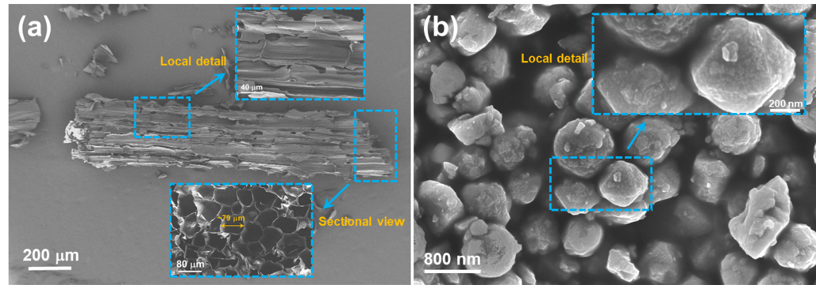
Fig.S1 SEM images of sugarcane-derived porous biochar (a) and polyhedral morphology of Ce-UIO-66.

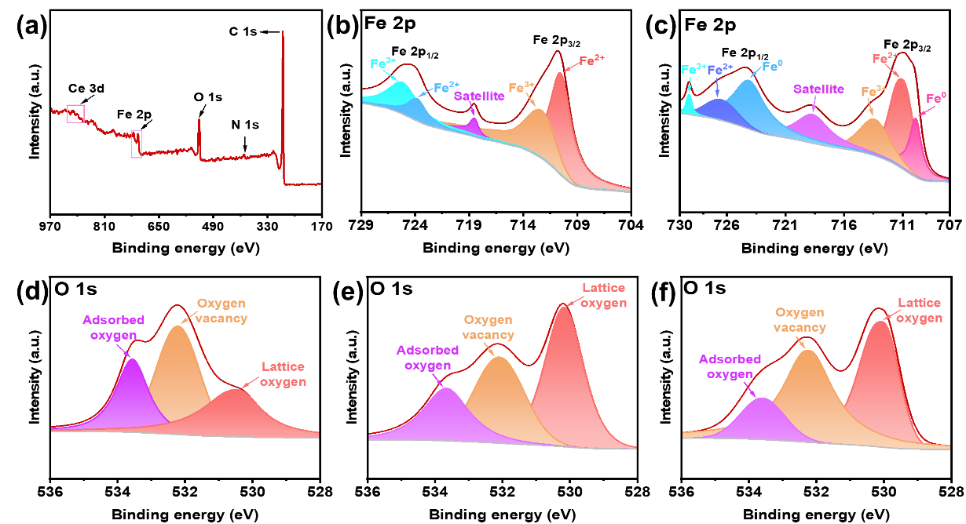
Fig.S2 Survey spectrum of XPS in CMF-3 (a), high-resolution spectrum of Fe 2p in CMF-2 (b) and CMF-4 (c), high-resolution XPS spectrum of O 1s in CMF-1 (d), CMF-2 (e), and CMF-4 (f).

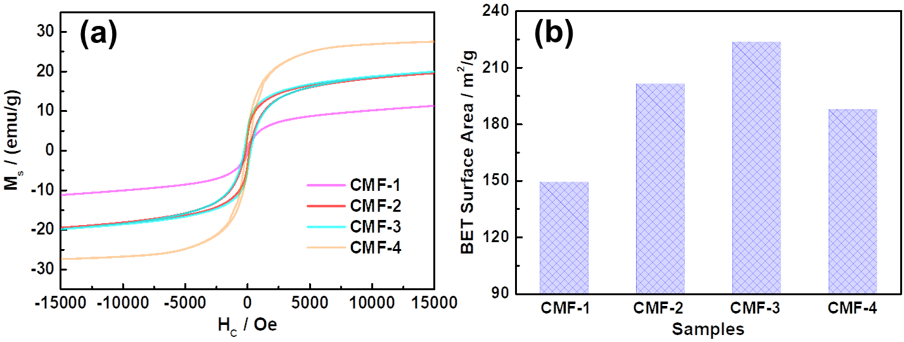
Fig.S3 Hysteresis loops (a) and BET surface area (b) of CMF-1, CMF-2, CMF-3, and CMF-4.

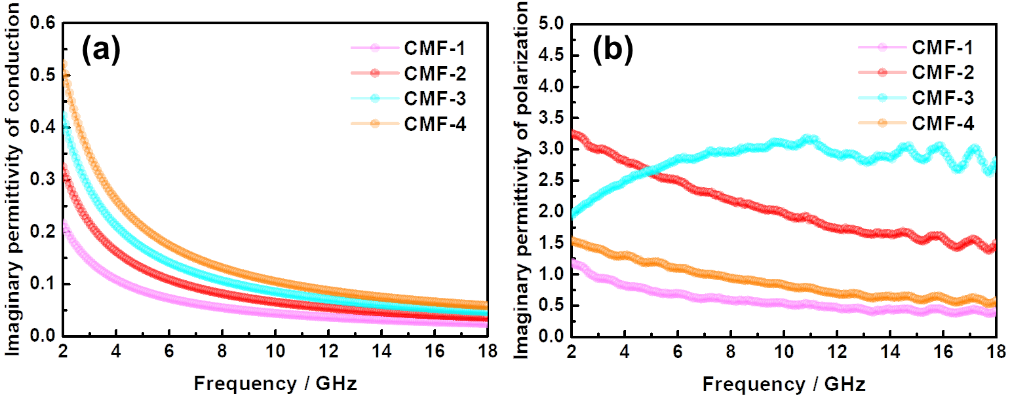
Fig.S4 Conduction part (a) and polarization part (b) of imaginary permittivity in the CMF-1, CMF-2, CMF-3, and CMF-4.

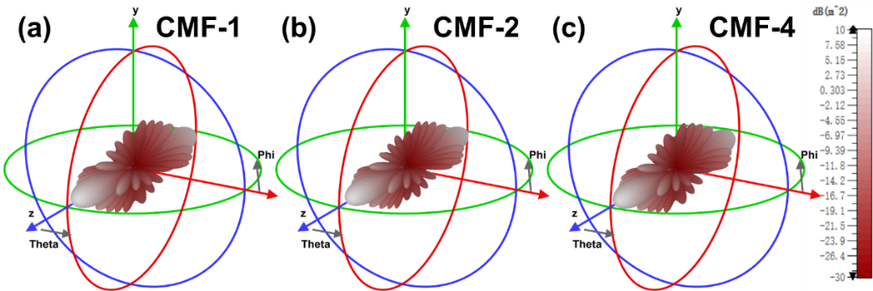
Fig.S5 RCS simulations of CMF-1 (a), CMF-2 (b), and CMF-4 (c).

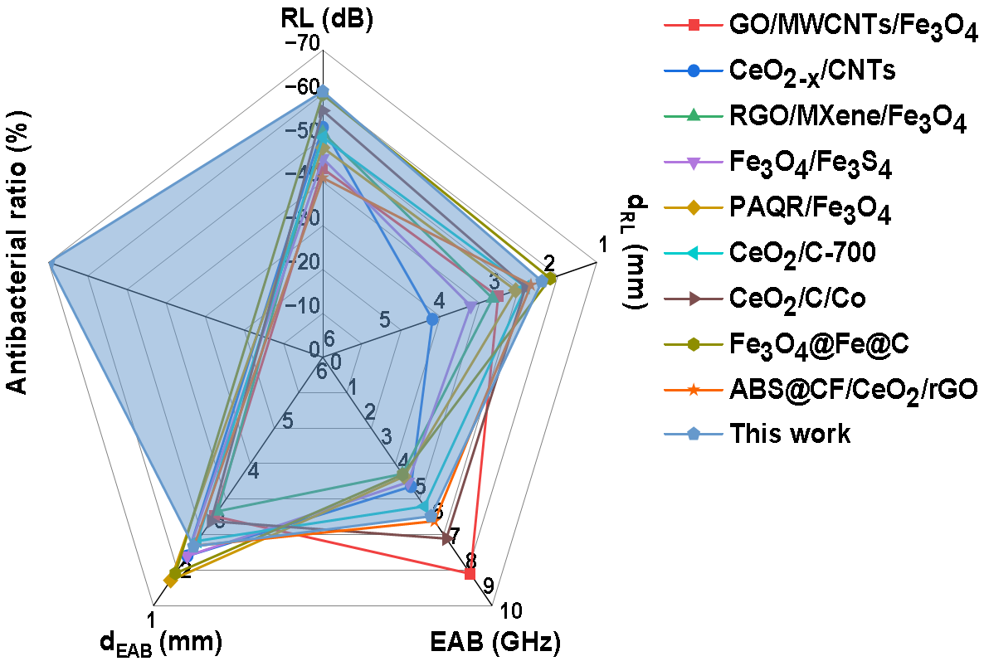
Fig.S6 Graphical contrasting of comprehensive properties between the CMF-3 and other related composites.

Tab.S1 Microwave absorbing performance and antibacterial activity of the CMF-3 and other composites reported in recent years.
Composites | RL/dB | d_{RL}/mm | EAB/GHz | d_{EAB}/mm | Anti-bacteria | Ref.
GO/MWCNTs/Fe₃O₄ | -43.00 | 2.80 | 8.72 | 2.80 | / | [77]
CeO_{2-x}/CNT_{S} | -52.40 | 4.00 | 5.21 | 2.00 | / | [78]
RGO/MXene/Fe₃O₄ | -51.20 | 2.90 | 4.70 | 2.90 | / | [79]
Fe₃O₄/Fe₃S₄ | -45.33 | 3.30 | 5.03 | 2.00 | / | [80]
PAQR/Fe₃O₄ | -47.79 | 2.48 | 4.80 | 1.51 | / | [81]
CeO₂/C-700 | -50.10 | 2.30 | 6.00 | 2.30 | / | [82]
CeO₂/C/Co | -56.20 | 2.30 | 7.30 | 2.70 | / | [83]
Fe₃O₄@Fe@C | -59.09 | 1.85 | 4.72 | 1.65 | / | [84]
ABS@CF/CeO₂/rGO | -40.90 | 2.20 | 6.60 | 2.20 | / | [85]
CMF-3 | -60.60 | 2.00 | 6.40 | 2.19 | Yes | This work

