Supplementary information
Bimetallic Pd@CeO₂-decorated 2D-g-C₃N₄/calcium alginate conductive hydrogel: A multifunctional hybrid material for wearable electrochemical sensing of serotonin
Rajesh Madhuvilakku ^{a, b, c}, Ok Chan Jeong ^{a, d}, Yonggeun Hong ^{a, b, c, e, f *}
ª Department of Digital Anti-aging Healthcare, Graduate School of Inje University, Gimhae 50834, Republic of Korea.
^{b} Biohealth Products Research Center (BPRC), Inje University, Gimhae 50834, Republic of Korea.
^{c} Research Center for Aged-life Redesign (RCAR), Inje University, Gimhae 50834, Republic of Korea.
^{d} Department of Biomedical Engineering, College of Biomedical Sciences & Health, Inje University, Gimhae 50834, Republic of Korea.
^{e} Department of Physical Therapy, College of Biomedical Sciences & Health, Inje University, Gimhae 50834, Republic of Korea.
^{f} Department of Rehabilitation Science, Graduate School of Inje University, Gimhae 50834, Republic of Korea.

*Corresponding author
Prof. Yonggeun Hong (DVM, PhD)
Email: yonghong@inje.ac.kr
Tel.: +82-55-320-3681(lab. 3806); Fax.: +82-55-329-1678

Experimental
Materials and reagents
Melamine (>99.0%, C₃H₆N₆), Cerium(III) nitrate hexahydrate (Ce(NO₃)₃·6H₂O, ≥98%), Palladium(II) chloride (Cl₂Pd, ≥99.9%), polyvinylpyrrolidone (PVP, (C₆H₉NO)_{n}, M_{w} ~55,000), L-arginine (H₂NC(=NH)NH(CH₂)₃CH(NH₂)CO₂H, ≥98%), dopamine hydrochloride (DA, (HO)₂C₆H₃CH₂CH₂NH₂·HCl, ≥98.0%), L-ascorbic acid (C₆H₈O₆, >99.0%), Uric acid (UA, C₅H₄N₄O₃, ≥99.0%), bovine serum albumin (BSA, ≥96.0%), D-(+)-glucose (C₆H₁₂O₆, ≥99.5%), potassium hexa-cyanoferrate (II) trihydrate (K₄[Fe(CN)₆]·3H₂O, ≥98.5%), potassium hexa-cyanoferrate (III) (K₃[Fe(CN)₆], ≥99.0%), levodopa (L-DOPA, (HO)₂C₆H₃CH₂CH(NH₂)CO₂H, ≥95.0%), ethanol (C₂H₆O, ≥99.9%), potassium bromide (KBr, ≥99%), sodium borohydride (NaBH₄, ≥98.0%), sodium bicarbonate (NaHCO₃, ≥99.7%), sucrose (C₁₂H₂₂O₁₁, ≥99.5%), Agarose (C₂₄H₃₈O₁₉, ≥90.0), AM580 (C₂₂H₂₅NO₃, ≥98.0%), L-(+)-Lactic acid (C₃H₆O₃, ≥98%), sodium L-lactate (C₃H₅NaO₃,≥99.9%), L-Glutamic acid (C₅H₉NO₄, ≥99%) and serotonin hydrochloride (5-HT, C₁₀H₁₂N₂O·HCl, ≥98%) were purchased from Sigma-Aldrich (Korea). Isopropanol ((CH₃)₂CHOH, ≥99.7%) and urea (CH4N2O, ≥99.0%) were obtained from Bio Basic Canada Inc. (Canada). Sodium alginate and citric acid anhydrous (C₆H₈O₇, ≥99.5%) were purchased from Daejung Chemicals & Materials Co., Ltd. (Korea). Sulfuric acid (H₂SO₄, ≥ 99.0%), sodium hydroxide (NaOH, ≥ 93.0%), sodium chloride (NaCl, ≥99.0%), hydrochloric acid (HCl, 35–37%), magnesium chloride hexahydrate (MgCl₂·6H₂O, ≥98.0%), calcium chloride anhydrous (CaCl₂, ≥ 98.0%) and sodium phosphate dibasic anhydrous (Na₂HPO₄, ≥93.0%) were supplied by Duksan Pure Chemical Co. Ltd. (Korea). Potassium chloride (KCl, ≥99.0%), potassium dihydrogen phosphate (KH₂PO₄, ≥99.0%), magnesium sulfate heptahydrate (MgSO₄·7H₂O, ≥99.0%), and disodium hydrogen phosphate dodecahydrate (Na₂HPO₄·12H₂O, ≥98.0%) were purchased from Shinyo Pure Chemical Co., Ltd. (Japan). Dimethylsufoxide (DMSO, C₂H₆OS, ≥99.0%) was obtained from Duchefa Biochemie B.V. (The Netherlands). A transparent cell culture petri dish (3 cm in diameter), fetal bovine serum (FBS), Dulbecco’s modified Eagle medium (DMEM), and trypsin-EDTA (0.25%) were purchased from Thermo Fisher Chemicals (Oregon). 5-HT ELISA kit purchased from Abcam Ltd. (The Netherlands). The SH-SY5Y neuroblastoma cell line was obtained from Seoul Hospital, Seoul, Korea. The SPGEs were obtained from Metrohm (Switzerland). No additional purification was performed on the chemicals, and all the solutions were prepared with deionized (DI) water purified by Zeneer Power (TOC) water purification systems from Human Corporation, Seoul, Korea.
Instrumentation
The microscopic morphologies (Transmission Electron Microscope (TEM) imaging, Selected area electron diffraction (SAED)) were done with TEM (Tecnai F30, USA) with an accelerating voltage of 50 kV. Spectroscopic measurements in the infrared region (IR) were performed in a Varian 640-IR spectrometer (California, USA). The Raman spectrum was obtained on a high-resolution Raman spectrometer (LabRAM HR Evolution, France). Brunauer-Emmett-Teller (BET) specific surface area and pore-size distribution were characterized by N₂ adsorption/desorption measurements obtained with Micromeritics ASAP-2020 gas adsorption analyzer (USA). The elemental analysis was carried out with an X-ray photoelectron spectroscopy (XPS) NEXSA G2 (Thermo Fisher Scientific, Korea). Electrochemical measurements were performed using a PalmSens4, equipped with PSTrace 5.9 software (PalmSens BV, Houten, The Netherlands).
Fabrication of Pd@CeO₂-g-C₃N₄/SPGE sensor probe
SPGE cleaning process
For effective immobilization of nanomaterials, it is crucial to use a clean and dust-free SPGE substrate. Prior to modification, the electrodes underwent an electrochemical pre-treatment process to ensure optimal surface conditions. This process was executed in a 0.1 M phosphate-buffered saline (PBS, pH 7.4) electrolyte solution, involving five potential cycles at a scan rate of 25 mV s⁻¹, within a voltage range of -1.0 V to 1.0 V. This electrochemical activation of the bare SPGE electrode thoroughly cleans the surface, significantly enhancing its interaction with the materials intended for modification. The resulting activated surface improves the efficiency of subsequent nanomaterial immobilization.
Sensor probe fabrication
The cleaned SPCE was employed for the fabrication of 5-HT sensors. We used a commercially available screen-printed graphite electrode containing an integrated three-electrode system: an Ag/AgCl reference electrode, a graphite counter electrode, and a nanomaterial-modified working electrode. A solution containing Pd@CeO₂/g-C₃N₄ nanocomposites was prepared by dissolving the material in a 1:1 aqueous isopropanol solvent system, with the addition of Nafion for improved adhesion and conductivity. This mixture was subjected to ultrasonication for 30 min to achieve a homogeneous dispersion of the components. Following this, 15 μL of the resultant solution was applied dropwise onto the working electrode surface. The electrode was allowed to air dry, thus finalizing the sensor fabrication process.
Electrochemical determination of 5-HT
To evaluate the electrochemical properties of the sensor, we conducted cyclic voltammetry (CV) and electrochemical impedance spectroscopy (EIS) on pristine, binary, and ternary composites. The studies utilized 5 mM [Fe(CN)₆]³⁻/⁴⁻ as a redox probe and 0.1 M KCl as the electrolyte, performed at a scan rate of 100 mV/s using a PalmSens4 system with PSTrace 5.6 software (PalmSens BV, Houten, The Netherlands). The voltammograms were recorded over a potential range of -0.2 to 0.8 V. Additionally, differential pulse voltammetry (DPV) was carried out within the potential range of -0.2 to +0.6 V in PBS (pH 7.0), with an applied potential of 50 mV/s and a sampling interval of 0.02 s, aiming to achieve enhanced specificity and sensitivity for the developed sensor.
Preparation of artificial cerebrospinal fluid (CSF) and sweat
Artificial CSF was prepared according to the reported literature [55] by mixing 108 mM NaCl, 2.5 mM KCl, 8.2 mM MgCl₂, 2 mM CaCl₂, 4 mM NaHCO₃, 1 mM Na₂HPO₄·7H₂O, and 0.126 mM NaH₂PO₄·H₂O at pH 7.4. Artificial sweat was prepared using the European standard EN1811:2012648 (33) by mixing 0.5 Wt% NaCl, 0.1 Wt% urea, and 0.1 Wt% lactic acid in DI water and adjusted to pH 7 [56]. DPV was used to evaluate samples containing 5-HT across various concentrations, employing the standard addition method for calibration. The actual 5-HT concentrations were inferred by correlating peak currents with a calibration curve.
Preparation of the skin-mimicking model
According to the following literature [33], a skin-mimicking model was prepared using an agarose gel. In brief, 210 mg of agarose was dissolved in 1 mL of PBS buffer and heated to 120 °C under stirring until a homogeneous solution was obtained. Subsequently, 200 μL of gel was poured into Petri dishes of diameter 4.5 cm and allowed to solidify. Meanwhile, about 300 μL of 5-HT solutions (50, 100, 150, and 200 μM) was added and allowed to diffuse for 60 min. The gel was made to contact with the sensor device and 5-HT. DPV was performed for the monitoring of 5-HT.
Preparation of the wearable sweat sensor
The prepared wearable sweat sensor is based on SPGE modification with hydrogels. Specifically, Pd@CeO₂-g-C₃N₄ was first dispersed in water at a concentration of 1 mg mL⁻¹. Then, 15 μL of this dispersion was drop-cast onto the SPGE surface and dried at ambient temperature. For the hydrogel formation, 10 μL of 0.1 g mL⁻¹ CaCl₂ aqueous solution was added to 1 mL of a 2 mg mL⁻¹ sodium alginate solution prepared in 4 mM KOH. Subsequently, 10 μL of the resulting mixture was quickly drop-cast onto the Pd@CeO₂-g-C₃N₄/SPGE and air-dried. The resulting electrode was termed CA/Pd@CeO₂-g-C₃N₄/SPGE.
Cell culture of SH-SY5Y
Transparent Petri dishes with a 3 cm diameter were utilized for culturing SH-SY5Y cells. By flow cytometry, we calculated the density of the cells to be 1×10⁵ cells/mL in 10 mL of DMEM supplemented with 10% FBS and 1% antibiotic (penicillin-streptomycin). We maintained the culture at 37 °C with 5 % CO₂ in a humidified incubator (Thermo Forma series II CO₂ incubator) and refreshed the medium every two days. For the cellular experiment, SH-SY5Y cells were cultured on a Pd@CeO₂/g-C₃N₄-embedded SPGE and placed in a culture dish with a fresh medium for 24 h to allow cell adhesion. Before electrochemical measurements, the electrode was gently rinsed with DMEM to remove loosely attached cells.
Drug treatment
The SH-SY5Y was treated with different concentrations of AM580 the next day after passage. As the stock AM580 solution (10 μM) is prepared with DMSO, the negative controls were the control (non-treated) group and the DMSO (treated with 1% DMSO) group. The dynamic changes of SH-SY5Y morphologies before and after AM580 treatment and recorded using an Olympus CK2 (Japan) inverted microscope.
Human serotonergic neuron media preparation
To measure 5-HT concentration in the cell culture media of human serotonergic neurons, media were collected 24 h after a medium change. The cells were cultured as mentioned above. Finally, the medium was replaced with FBS-free medium and cultured for 2 days to achieve the performance characteristics suitable for studies on SH-SY5Y cells and the relationship between 5-HT and drugs. Serotonergic neurons were treated with media containing 30 mM KCl for 30 min prior to media collection. Using a pipette, the culture medium was withdrawn from the cell culture dish, transferred into a centrifuge tube, centrifuged at 14000 rpm for 20 min at 4 °C, and the supernatant was immediately stored at -80 °C. For measurements, samples were thawed and kept on ice during the experiment, with freeze-thaw cycles limited to twice per sample to avoid 5-HT degradation.
On-body 5-HT monitoring in sweat
To enable real-time, non-invasive monitoring of 5-HT in sweat, a highly elastic and sweat-absorbent patch (commercially sourced; thickness ~2 mm) was employed as the substrate for integrating the CA/Pd@CeO₂–g-C₃N₄/SPGE, thereby constructing a wearable sensing platform. On-body potentiometric measurements were conducted on the forearm of two healthy volunteers (male, 33 years; female, 29 years) using a PalmSens4 system equipped with PSTrace 5.6 software (PalmSens BV, Houten, The Netherlands). Sweat secretion was stimulated through physical exercise, and the device functioned in a passive mode, utilizing naturally secreted sweat without the need for external pumping or flow regulation. Upon the appearance of sweat, the fabricated sensor was maintained in close contact with the skin for 30 min to allow continuous exposure. DPV responses were subsequently recorded, and the on-body potential responses were quantified by referencing the calibration curve obtained from sprayed artificial sweat samples. The concentration of 5-HT in sweat was thus determined, with each measurement repeated in triplicate for both volunteers to ensure reproducibility.

Structural characterization
The crystallographic structures of the bulk g-C₃N₄, exfoliated g-C₃N₄, Pd@CeO₂, and g-C₃N₄/Pd@CeO₂ nanocomposites were investigated using X-ray Diffraction (XRD), and the resulting patterns are presented in Fig. 1h. The XRD pattern of bulk g-C₃N₄ exhibits characteristic diffraction peaks at approximately 12.9° and 27.2°, corresponding to the (100) and (002) crystallographic planes (JCPDS No. 87-1526), indicative of the in-plane structural ordering within the continuous tri-s-triazine network and the inter-layer graphitic stacking of C₃N₄ units in g-C₃N₄ [36]. In contrast, the XRD pattern of the exfoliated g-C₃N₄ shows a significant reduction in the intensity of both the (100) and (002) peaks. This decrease confirms the effective exfoliation of the bulk g-C₃N₄ into thinner nanosheets, consistent with the TEM observations discussed earlier. The instability of the hydrogen-bonded polymeric melon units within the bulk g-C₃N₄ layers towards oxidation in air likely contributes to a gradual layer-by-layer thinning process, ultimately leading to the nanoscale dimensions observed in the exfoliated material [57].The XRD spectrum of pure CeO₂ displays intense diffraction peaks at 2θ values of 28.2°, 32.8°, 47.4°, 56.1°, 58.9°, 69.3°, 76.5°, 78.8°, and 88.4°, which are attributed to the (111), (200), (220), (311), (222), (400), (331), (420), and (422) crystallographic planes, respectively. These peaks confirm the formation of a cubic phase of CeO₂ (JCPDS file No. 89-8436). Upon the introduction of Pd, the XRD spectrum of Pd@CeO₂ does not exhibit any discernible reflections corresponding to Pd-related phases (such as Pd, PdO, or H₂PdCl₄). This absence suggests that the Pd species are highly dispersed on the CeO₂ support. A closer examination of the most intense (111) peak of Pd-doped CeO₂ reveals a significant reduction in its intensity compared to that of pure CeO₂. This observation may indicate a selective interaction between the supported palladium species and the ceria lattice [58]. The relatively small difference in ionic radii between Pd²⁺ (0.86 Å) and Ce⁴⁺ (0.97 Å) likely facilitates interstitial doping at lower Pd concentrations, potentially inhibiting the growth of ceria-based crystallites. Furthermore, a slight broadening of the XRD peaks is observed with increasing Pd²⁺ addition, further confirming the formation of a single-phase CeO₂ structure and the successful incorporation of Pd²⁺ ions into the CeO₂ lattice. Finally, the XRD pattern of the g-C₃N₄/Pd@CeO₂ composite exhibits characteristic diffraction peaks corresponding to both Pd@CeO₂ and g-C₃N₄. The presence of these distinct peak sets confirms the successful formation of the g-C₃N₄/Pd@CeO₂ ternary composite material, where the individual components retain their crystalline characteristics within the hybrid structure.
Fig. S1 Structural characterization of the Pd@CeO₂–g-C₃N₄ sensing probe. a XRD patterns for bulk-g-C₃N₄, 2D-g-C₃N₄, CeO₂, Pd@CeO₂ and Pd@CeO₂–g-C3N4. b FTIR spectra for 2D-g-C₃N₄, CeO₂, Pd@CeO₂ and Pd@CeO₂–g-C₃N₄. c Raman spectra for 2D-g-C₃N₄, CeO₂, Pd@CeO₂ and Pd@CeO₂–g-C₃N₄. d, e Nitrogen adsorption–desorption isotherms and corresponding pore size distribution plots of 2D g-C₃N₄ and Pd@CeO₂–g-C₃N₄ nanocomposite
The chemical structures of the samples were further analyzed by FTIR spectroscopy to ascertain the formation of the g-C₃N₄/Pd@CeO₂ composite from 500 - 4000 cm⁻¹, as shown in Fig. 1i. The FTIR spectra of both pure g-C₃N₄ and the g-C₃N₄/Pd@CeO₂ composite exhibit characteristic peaks at approximately ~804 cm⁻¹ and ~875 cm⁻¹, corresponding to the typical breathing mode of the tri-s-triazine units and the N–H deformation mode [40], respectively. Intense vibration bands observed at ~1223, 1310, 1396, 1548, and 1627 cm⁻¹ are attributed to the skeletal vibration modes of C=N and C–N heterocycles within the g-C₃N₄ structure [59]. Furthermore, an adsorption band at 1069 cm⁻¹, present in both g-C₃N₄ and the composite, is assigned to the deformation mode of heptazine units [40]. A band at 3668 cm⁻¹ in pure g-C₃N₄ is attributed to the N–H stretching vibrations of primary and secondary amines, indicating the presence of uncondensed amino functional groups [37]. The high intensity of this peak in pure g-C₃N₄ suggests a larger proportion of terminal amine groups, which are associated with smaller polymeric segments containing fewer heptazine units and are considered structural defects [40]. Notably, the N–H stretching bands largely disappeared in the g-C₃N₄/Pd@CeO₂ composite, implying a potential crystallization effect or defect removal in the presence of the metal oxide salt during composite formation. Additionally, a new band corresponding to C≡N triple bonds appeared at approximately 2116 cm⁻¹ in the g-C₃N₄/Pd@CeO₂ composite. This suggests that the interaction with Pd@CeO₂ may have induced partial cleavage of C=N and C–N bonds in g-C₃N₄, leading to the formation of C≡N groups [60], indicative of a strong interaction and the successful formation of the g-C₃N₄/Pd@CeO₂ heterostructure. For pure CeO₂ NPs and Pd@CeO₂, a characteristic peak at 561 cm⁻¹ was observed, corresponding to the Ce–O stretching vibration. The FTIR spectra of pure CeO₂ NPs and Pd-doped CeO₂ NPs show distinct differences, highlighting the impact of Pd doping on the material's surface chemistry and structural features. In the CeO₂ spectrum, characteristic peaks are observed at 663 cm⁻¹ (Ce–O stretching), along with peaks at 872, 907, and 1043 cm⁻¹, attributed to carbonate groups and other surface functional groups [37]. Additional peaks at 1267, 1346, and 1537 cm⁻¹ were assigned to the symmetric and asymmetric stretching of carbonate or carboxylate species. Peaks at 1629, 2981, and 3297 cm⁻¹ correspond to O–H bending and stretching vibrations, indicating the presence of adsorbed water and hydroxyl groups [40]. In contrast, the FTIR spectrum of Pd@CeO₂ exhibits new peaks and shifts in existing peaks, suggesting modifications in surface chemistry due to Pd incorporation. Peaks at 672 and 721 cm⁻¹ indicate changes in Ce–O vibrations or the formation of new metal-oxide interactions. The peak at 926 cm⁻¹ may correspond to modified carbonate or hydroxyl species. Additional peaks at 1438 and 1519 cm⁻¹ suggest alterations in carboxylate or carbonate vibrations. Distinct peaks at 1971, 2025, 2153, and 2317 cm⁻¹ indicate the presence of Pd-related surface species, possibly arising from interactions with adsorbed gas molecules. The O–H stretching peaks are shifted to 2895, 2976, and 3186 cm⁻¹, reflecting altered hydroxyl groups and possible organic interactions [37]. However, the characteristic absorption peaks of Pd@CeO₂ were less prominent in the FTIR spectrum of the g-C₃N₄/Pd@CeO₂ nanocomposite, likely due to the relatively low CeO₂ content within the composite material.
Raman spectroscopy, a non-destructive and effective technique, was employed to further characterize the synthesized g-C₃N₄ nanosheets and the g-C₃N₄/Pd@CeO₂ nanocomposite. The Raman spectra of g-C₃N₄ and the g-C₃N₄/Pd@CeO₂ nanocomposite (Fig. 1j) exhibit two prominent carbon-related bands: The D-band around 1360 cm⁻¹, which indicates the presence of defects or disorder (sp³-hybridized carbon atoms), and the G-band around 1590 cm⁻¹, which corresponds to the graphitic nature (sp²-hybridized carbon atoms) [28]. The intensity ratio of these bands (I_{D}/I_{G}) showed an increasing trend from g-C₃N₄ (0.63) to g-C₃N₄/Pd@CeO₂ (0.87), suggesting an increase in the degree of disorder upon the incorporation of Pd@CeO₂ into the g-C₃N₄ matrix. The characteristic Raman vibration peak of the CeO₂ nanostructure was observed at 450 cm⁻¹, which is primarily attributed to the symmetrical stretching vibration of oxygen atoms surrounding the cerium ions [61]. In the Pd@CeO₂ nanostructure, a shift and broadening of this peak position were observed compared to pure CeO₂, indicating a change in the oxygen atomic symmetry around the Ce ions upon Pd doping. Furthermore, the appearance of a shoulder peak at 540 cm⁻¹ provides additional evidence for the formation of Pd−O−Ce bonds [62].
The porosity of the g-C₃N₄ nanosheets and the g-C₃N₄/Pd@CeO₂ nanocomposite was investigated using N₂ physisorption experiments. The nitrogen adsorption-desorption isotherms and the Barrett−Joyner−Halenda (BJH) desorption pore size distribution plots for both samples are presented in Fig. 2a and 2b. As shown, both pristine g-C₃N₄ and the g-C₃N₄/Pd@CeO₂ hybrid nanocomposite exhibit type IV isotherms with distinct hysteresis loops [36], characteristic of mesoporous materials. The Brunauer-Emmett-Teller (BET) specific surface area was determined to be 56.43 m² g⁻¹ for pure g-C₃N₄ and significantly higher at 83.8 m² g⁻¹ for the g-C₃N₄/Pd@CeO₂ nanocomposite. The average pore diameter, estimated using the BJH model, was found to be 3.68 nm for pristine g-C₃N₄ and 3.32 nm for the g-C₃N₄/Pd@CeO₂ nanocomposite. These results demonstrate that the incorporation of Pd@CeO₂ leads to a substantial increase in the specific surface area and a slightly reduced average pore diameter compared to pure g-C₃N₄. The higher specific surface area of the g-C₃N₄/Pd@CeO₂ modified SPGE is advantageous as it enhances the contact area at the electrode-electrolyte interface, provides a greater number of catalytically active sites for efficient electrocatalytic reactions, and facilitates the transport of ions and electrons, thereby contributing to the remarkable electrocatalytic performance of the g-C₃N₄/Pd@CeO₂ ternary nanocomposite.

Table S1 Elemental analysis of Pd@CeO₂-g-C₃N₄ hybrid nanocomposite by XPS elemental analysis
_____________________________________________________________________________
Name of Elements Element in Pd@CeO₂-g-C₃N₄ (atomic%)
______________________________________________________________________________
C 1s 21.49
N 1s 30.11
O 1s 34.69
Ce 3d 11.54
Pd 3d 2.17
______________________________________________________________________________

Table S2 The comparison of electrochemical parameters of the modified electrodes
______________________________________________________________________________
Types of E_{pa} E_{pc} ΔE_{p} I_{pa} I_{pc} I_{pa}/I_{pc} Electroactive
modified (V) (V) (mV) (μA) (μA) surface area (cm²)
electrodes
______________________________________________________________________________
SPGE 0.205 0.063 142.00 81.91 -102.43 0.80 0.0195
CeO₂/SPGE 0.194 0.072 122.00 95.36 -114.03 0.84 0.0227
Pd@CeO₂/SPGE 0.182 0.054 128.00 130.87 -142.04 0.92 0.0312
g-C₃N₄/SPGE 0.224 0.0507 173.30 154.78 -169.77 0.91 0.0369
Pd@CeO₂-g-C₃N₄/SPGE 0.202 0.039 163.00 176.85 -196.09 0.90 0.0421
______________________________________________________________________________

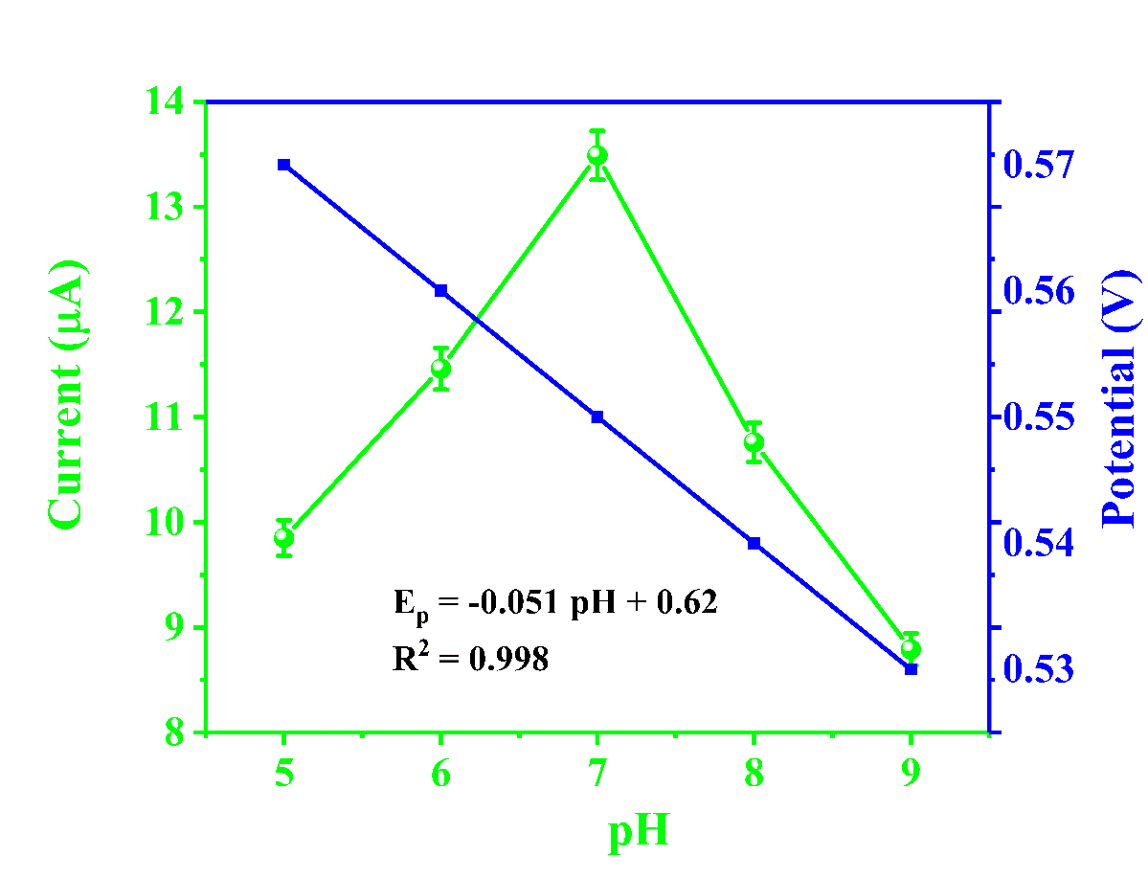
Fig. S2 Plots of anodic peak current (I_{pa}) and peak potential (E_{pa}) for 5-HT versus pH values. Error bars indicate standard deviation (n=3)

Table S3 A comparison of the analytical performance between the previously reported methods and the proposed Pd@CeO₂-g-C₃N₄/SPGE for 5-HT detection
_________________________________________________________________________________________________________________________________
Electrodes Method Electrolyte Linear range LOD Sensitivity Real samples Ref
(μM) (μM) (μA μM⁻¹ cm⁻²)
__________________________________________________________________________________________________________________________________________________________________
FVMX@SPCE DPV 0.1M PBS 0.025-0.75 0.005 3.0 Human serum [22]
FeC-AuNPs-MWCNT/SPCE SWV 1×PBS 0.05-20 0.017 - Urine [26]
DGNW/SPGE DPV 0.1M PBS 1-50 1.23 - Synthetic urine [63]
P-WO₃ NS/GCE LSV 0.1M PBS 0.01-100 0.06 0.2 Human urine, blood serum [ 64]
Nafion-CNT/EC CFMEs CV 0.1M PBS 0.1-1 0.14 0.074 Artificial urine [65]
Tf-Au NCs Fluorescence 10 mM PBS 0.2-50 0.049 - Human serum [66]
QDs@SiO2@MIPs Fluorescence 0.2M 0.28-2.8 0.00391 - Human blood [67]
SA-AuNPs Colorimetric 10 mM PBS 0.05-1.0 0.02 - Human plasma [68]
Ni(OH)₂-nanoplate-Chit/SPCE DPV 0.1M PBS 0.1-30 0.06 - Urine, saliva [69]
Pt/MWCNT/PPy/AgNPs DPV 0.2M PBS 0.50-5.0 0.15 - Plasmatic serum [70]
Pd@CeO₂-g-C₃N₄/SPGE DPV 0.1M PBS 0.035-1.2 0.000637 204 sweat [This work]
DPV PBS +Serum 0.001-0.68 0.00167 207 Serum [This work]
i-t DMEM 0.001-0.5 0.0019 263 SH-SY5Y cell line [This work]
__________________________________________________________________________________________________________________________________________________________________
FVMX = iron vanadate nanoflakes (FeVO₄ NFs) supported on Ti₃C₂ MXene hybrid nanocomposites; SPCE = screen printed carbon electrode; FeC-AuNPs-MWCNT = ferrocene covalently linked gold nanoparticles on multiwall carbon nanotubes; SWV = square wave voltammetry; DGNW = boron/nitrogen co-doped with diamond graphene nanowalls; SPGE = screen-printed graphene electrode; P-WO₃ NS = phosphorous-doped tungsten trioxide nanosheet; GCE = glassy carbon electrode; LSV = linear sweep voltammetry; Nafion-CNT/EC CFMEs = Nafion/carbon nanotubes and electrochemically modified carbon fiber microelectrodes; Tf-Au NCs = transferrin encapsulated gold nanoclusters; QDs@SiO₂@MIPs = Mn-doped ZnS quantum dots@silica nanoparticle@molecularly imprinted polymers; SA-AuNPs = sialic acid (SA) anchored gold nanoparticles; Ni(OH)₂-nanoplate-Chit= nickel hydroxide nanoplates-chitosan; Pt/MWCNT/PPy/AgNPs = Platinum/multi-walled carbon nanotubes/polypyrrole/silver nanoparticles.

Table S4 Interference (%) of various potential interferences in the presence of 5-HT for evaluating anti-interference properties in artificial CSF
_____________________________________________________________________________________________
S.No. Interference Current (μA) Current difference (μA) Interference (%)
_____________________________________________________________________________________________
0 5-HT 2.62 - -
1 Glu 2.64 +0.02 +0.76
2 UA 2.61 -0.01 -0.38
3 AA 2.62 0.00 0.00
4 DA 2.58 -0.04 -1.53
5 L-DOPA 2.57 -0.05 -1.91
6 Urea 2.49 -0.13 -4.96
7 NaCl 2.54 -0.08 -3.05
8 KCl 2.63 +0.01 +0.38
9 Lactate 2.61 -0.01 -0.38
10 Sucrose 2.59 -0.03 -1.15
11 Citric acid 2.47 -0.15 -5.73
12 Glutamic acid 2.512 -0.108 -4.12
_____________________________________________________________________________________________
Table S5 Interference (%) of various potential interferences in the presence of 5-HT for evaluating anti-interference properties in artificial sweat
_____________________________________________________________________________________________
S.No. Interference Current (μA) Current difference (μA) Interference (%)
_____________________________________________________________________________________________
0 5-HT 2.308 - -
1 Glu 2.423 +0.115 +4.98
2 UA 2.418 +0.110 +4.77
3 AA 2.265 -0.043 -1.86
4 DA 2.361 +0.053 +2.30
5 L-DOPA 2.11 -0.198 -8.58
6 Urea 2.28 -0.028 -1.21
7 NaCl 2.23 -0.078 -3.38
8 KCl 2.17 -0.138 -5.98
9 Lactate 2.34 +0.032 +1.39
10 Sucrose 2.22 -0.088 -3.81
11 Citric acid 2.29 -0.018 -0.78
12 Glutamic acid 2.21 -0.098 -4.25
_____________________________________________________________________________________________

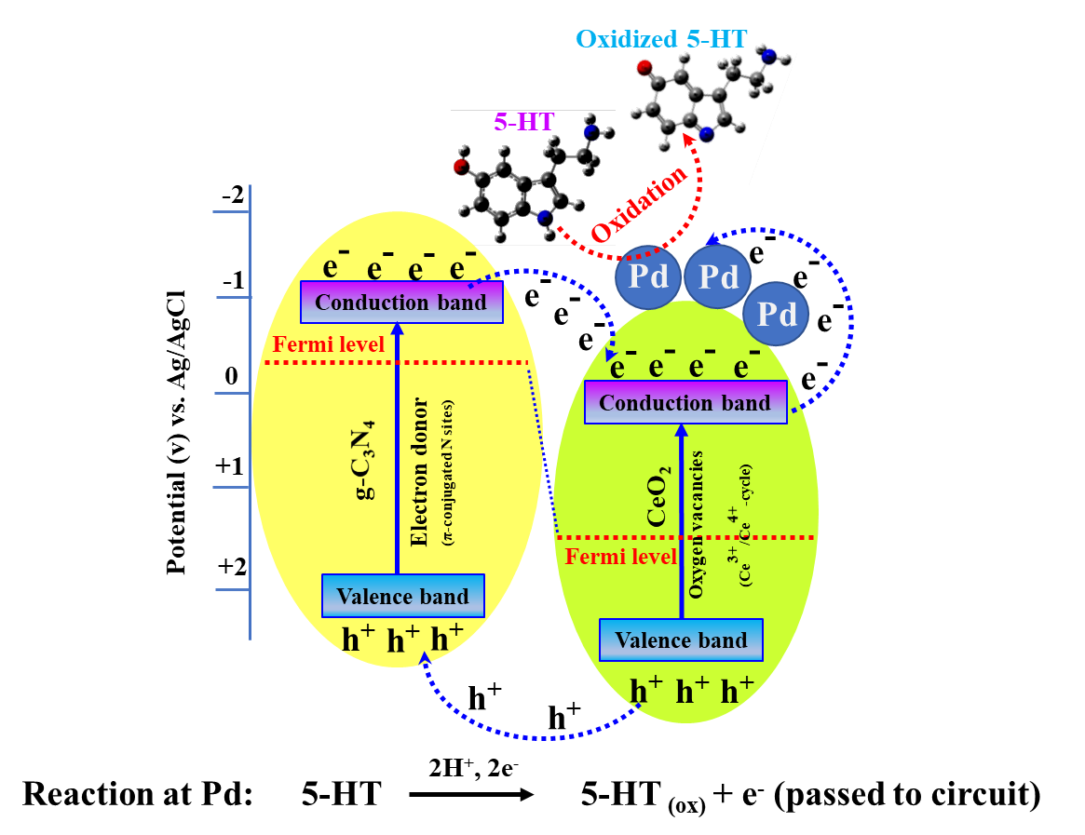
Fig. S3 Schematic illustration of the electron transfer pathway and band alignment in the Pd@CeO₂-g-C₃N₄ heterostructure for 5-HT oxidation
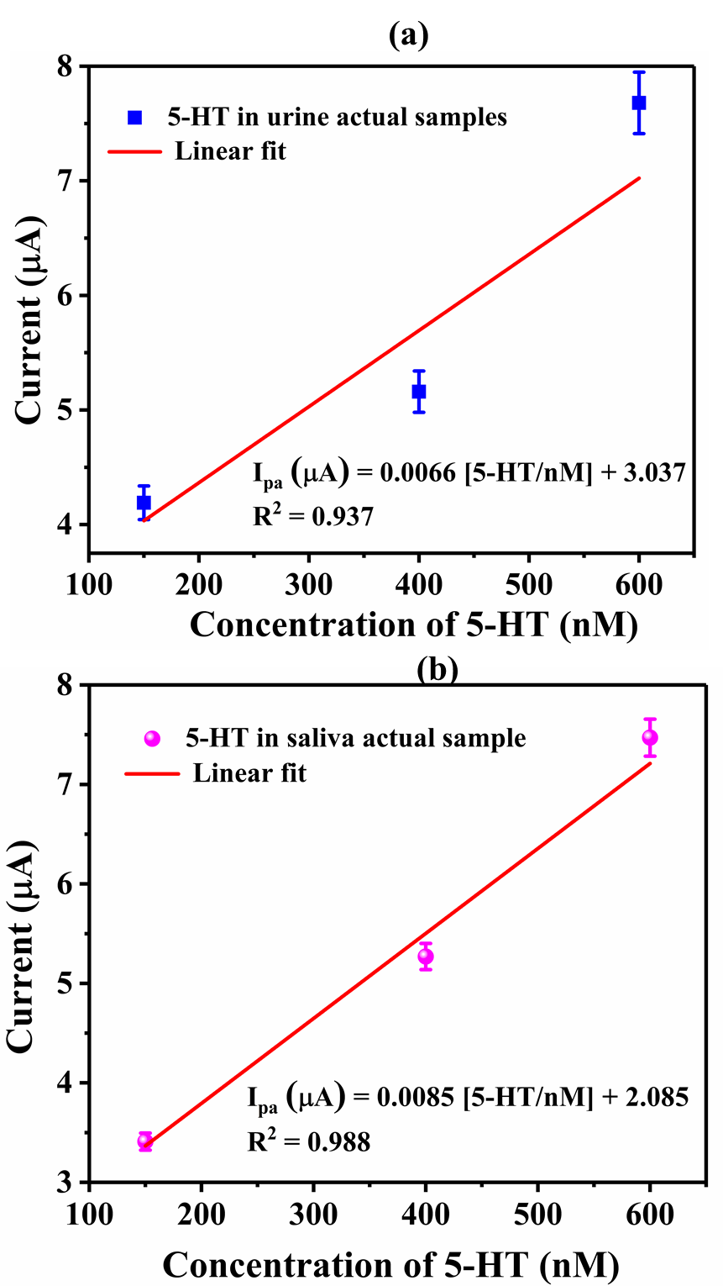
Fig. S4 Detection of 5-HT in actual human samples. Calibration plots obtained using DPV for the determination of 5-HT in a human urine and b human saliva samples spiked with varying concentrations of 5-HT

Table S6 Detection of 5-HT in spiked human urine and saliva samples with CA/Pd@CeO₂-g-C₃N₄/SPGE sensors
Sample | 5-HT added (nM) | ^{*)} 5-HT found (nM) | ^{*a)}SD | ^{b)}Recovery (%)
Urine | 150 | 186.59 | 0.043 | 124.3
 | 400 | 392.52 | 0.039 | 98.13
 | 600 | 654.1 | 0.144 | 109.0
Saliva | 150 | 200.9 | 0.408 | 133.9
 | 400 | 402.7 | 0.240 | 100.67
 | 600 | 637.1 | 0.084 | 106.18
^{*)}Average value from six independent measurements; ^{a)}Standard deviation (SD) of five measurements; ^{b)}Recovery (%) = (Measured value/Added value)×100.

Fig. S5 Real-time application in a skin-mimicking model and long-term stability. a Photograph of an array of screen-printed gel electrodes integrated with the hydrogel sensor platform during sample application. b Real-time wearable sensor setup interfaced with a potentiostat and data acquisition system, demonstrating in-lab deployment and 5-HT signal readout. c Long-term stability and d reproducibility test of the developed CA/Pd@CeO₂–g-C₃N₄/SPGE sweat sensor in the presence of 1 μM of 5-HT detection within a skin-mimicking gel model containing artificial sweat

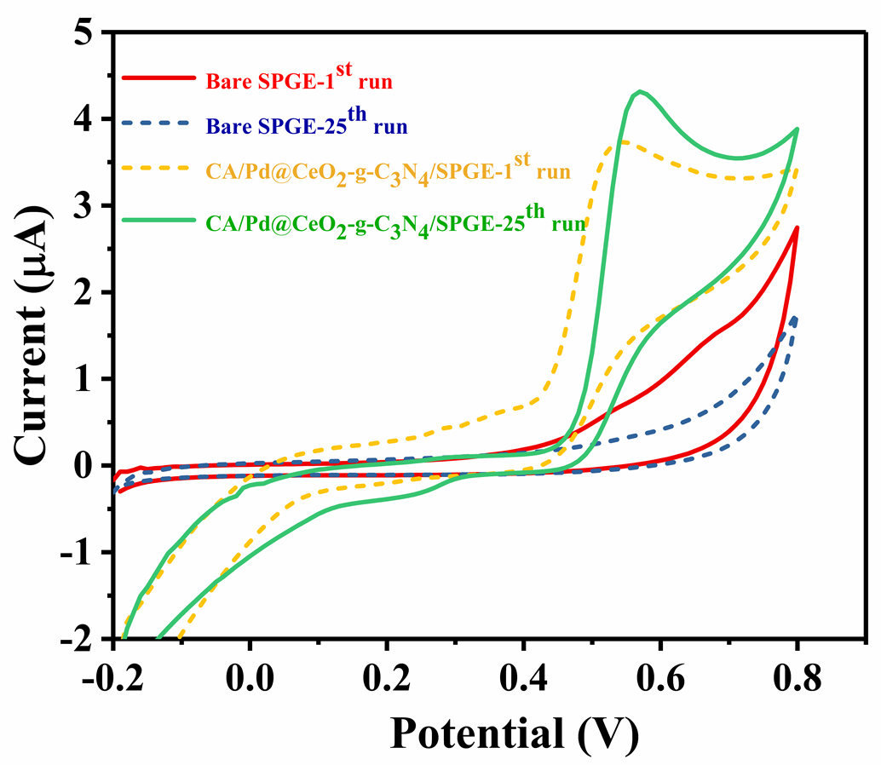
Fig. S6 Anti-fouling performance evaluation. CV of bare SPGE and CA/Pd@CeO₂-g-C₃N₄/SPGE electrodes in 0.1 M PBS (pH 7.0) containing 50 μM 5-HT for the 1st and 25th consecutive scans at a scan rate of 50 mV/s, demonstrating the enhanced resistance to fouling of the modified electrode

Fig. S7 Differentiation of SH-SY5Y cells and in vitro detection of 5-HT. a Timeline depicting the experimental protocol for SH-SY5Y cell culture, neuronal differentiation, and cell stimulation to trigger 5-HT release. b Cell viability of SH-SY5Y cells treated with different concentrations of Pd@CeO₂–g-C₃N₄. c CV curves obtained with the CA/Pd@CeO₂–g-C₃N₄/SPGE in cell culture medium before and after stimulation with butyrate
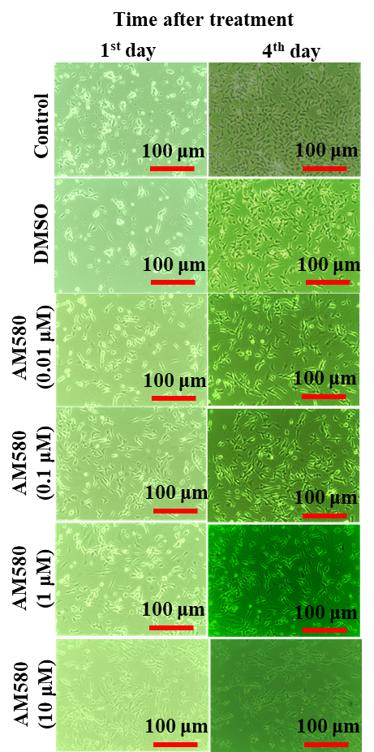
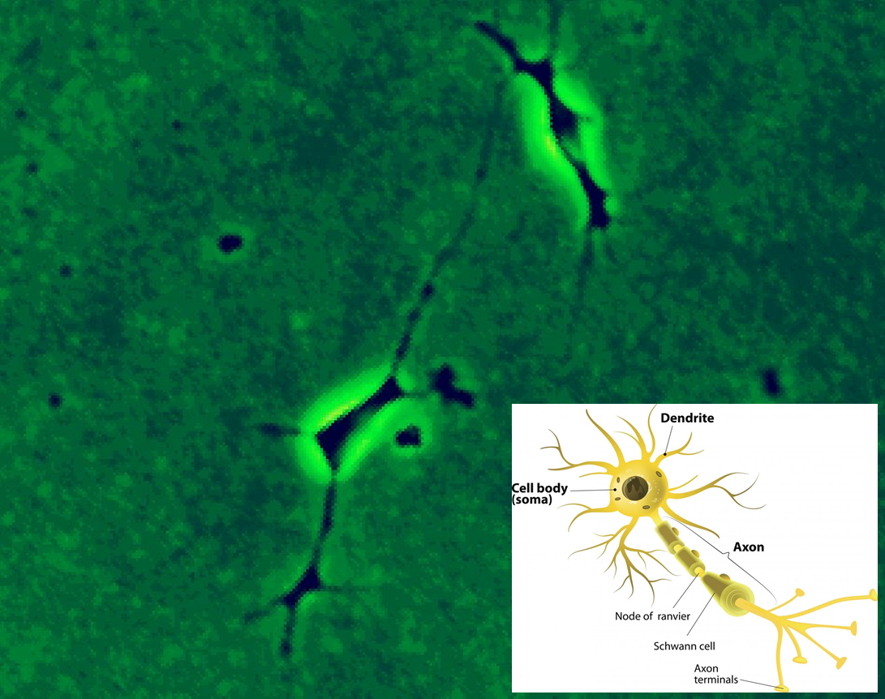
Fig. S8 Morphological changes of SH-SY5Y cells upon AM580 treatment. a microscopic observation of SH-SY5y after AM580 treatment with different concentrations. b Magnified view of single differentiated SH-SY5Y cells
(a)
100 μm
(b)

References
- Zheng WH, Yan C, Chen T, Kang DZ (2020) New scheme for the preparation and use of artificial cerebrospinal fluid. J Physiol Pharmacol 71:919−925.
https://doi.org/10.26402/jpp.2020.6.15
- Haglock-Adler CJ, Hurley A, Strathmann FG (2014) Use of synthetic urine as a matrix substitute for standard and quality control materials in the clinical assessment of iodine by inductively coupled plasma mass spectrometry. Clinic Biochem 47:80−82. https://doi.org/10.1016/j.clinbiochem.2014.07.008
- Zhang X, Xie X, Wang H, Zhang J, Pan B, Xie Y (2013) Enhanced photoresponsive ultrathin graphitic-phase C₃N₄ nanosheets for bioimaging. J Am Chem Soc 135:18−21. https://doi.org/10.1021/ja308249k
- GaoY, Hu E, Yin G, Huang Z (2021) Pd nanoparticles supported on CeO₂ nanospheres as efficient catalysts for dehydrogenation from additive-free formic acid at low temperature. Fuel 302:121142.
https://doi.org/10.1016/j.fuel.2021.121142
- Yang ZC, Li J, Cheng FX, Chen Z, Dong XP (2015) BiOBr/protonated graphitic C₃N₄ heterojunctions: intimate interfaces by electrostatic interaction and enhanced photocatalytic activity. J Alloy Compd 634:215−222.
https://doi.org/10.1016/j.jallcom.2015.02.103
- Miao H, Zhang G, Hu X, Mu J, Han T, Fan J, Zhu C, Song L, Bai J, Hou X (2017) A novel strategy to prepare 2D g-C₃N₄ nanosheets and their photoelectrochemical properties. J Alloys Compd 690:669−676.
https://doi.org/10.1016/j.jallcom.2016.08.184
- Ruan H, Zhang S, Wang H, Pei J, Zhao R, Mu X, Wang H, Zhang X (2022) Single-atom Pd/CeO₂ nanostructures for mimicking multienzyme activities. ACS Appl Nano Mater 5:6564−6574. https://doi.org/10.1021/acsanm.2c00644
- Nie L, Mei D, Xiong H, Peng B, Ren Z, Hernandez XIP, DeLaRiva A, Wang M, Engelhard MH, Kovarik L, Datye AK, Wang Y (2017) Activation of surface lattice oxygen in single-atom Pt/CeO₂ for low-temperature CO oxidation. Science 358:1419−1423. https://doi.org/10.1126/science.aao2109
- Boonkaew S, Dettlaff A, Sobaszek M, Bogdanowicz R, Jonsson-Niedziolka M (2022) Electrochemical determination of neurotransmitter serotonin using boron/nitrogen co-doped diamond-graphene nanowall-structured particles. J Electroanal Chem 926:116938. https://doi.org/10.1016/j.jelechem.2022.116938
- Babulal SM, Wu HF, Wu CC (2023) Two-dimensional phosphorus-doped tungsten trioxide nanosheets for electrochemical detection of serotonin in biological fluids. ACS Appl Nano Mater 6:14552–14562. https://doi.org/10.1021/acsanm.3c02724
- Han J, Stine JM, Chapin AA, Ghodssi R (2023) A portable electrochemical sensing platform for serotonin detection based on surface-modified carbon fiber microelectrodes. Anal Methods 15:1096–1104.
https://doi.org/10.1039/D2AY01627C
- Sha Q, Sun B, Yi C, Guan R, Fei J, Hu Z, Liu B, Liu X (2019) A fluorescence turn-on biosensor based on transferrin encapsulated gold nanoclusters for 5-hydroxytryptamine detection. Sens Actuators B Chem 294:177–184.
https://doi.org/10.1016/j.snb.2019.05.060
- Wang Z, Zhang Y, Zhang B, Lu X (2018) Mn²⁺ doped ZnS QDs modified fluorescence sensor based on molecularly imprinted polymer/sol-gel chemistry for detection of Serotonin. Talanta 190:1–8.
https://doi.org/10.1016/j.talanta.2018.07.065
- Avci B, Akpınar Y, Ertas G, Volkan M (2024) Sialic acid-functionalized gold nanoparticles for sensitive and selective colorimetric determination of serotonin. ACS Omega 9:23832–23842. https://doi.org/10.1021/acsomega.4c01859
- Moru S, Kumar VS, Kummari S, Goud KY (2023) A disposable screen printed electrodes with hexagonal Ni(OH)₂ nanoplates embedded chitosan layer for the detection of depression biomarker. Micromachines 14:146.
https://doi.org/10.3390/mi14010146
- Cesarino I, Galesco HV, Machado SAS (2014) Determination of serotonin on platinum electrode modified with carbon nanotubes/polypyrrole/silver nanoparticles nanohybrid. Mater Sci Eng C 40:49–54.
https://doi.org/10.1016/j.msec.2014.03.030

