Supplementary Information

A covalent organic framework interface with robust electron entrapment enabled improved capacitive energy storage performance for polymer nanocomposites

Qing Zhang¹, Chunran Wu¹, Lingni Yang¹, Zhuofeng Liu^{1,}*, Fenglin Wang¹, Xingyu Chen¹, Haijun Mao¹, Xueying Qiu², Weijun Zhang^{1,}*, and Wei Li^{1,}*

¹College of Aerospace Science and Engineering, National University of Defense Technology, Changsha, 410073, P. R. China
²Analyzing & Testing Center, School of Chemistry and Chemical Engineering, Changsha University of Science and Technology, Changsha, 410114, P. R. China

*Corresponding authors
E-mail: liuzhuofeng@nudt.edu.cn (Zhuofeng Liu); zhwjun@nudt.edu.cn (Weijun Zhang); liwei21e@nudt.edu.cn (Wei Li)

Supplementary Methods

Synthesis of the BT nanoparticles. BT nanoparticles were synthesized by the hydrothermal method. First, 3 mmol Ba(OH)₂∙8H₂O was added to 25 mL deionized water and dissolved at 80°C with stirring. Then, 2 mmol tetrabutyl titanate was added to 25 mL ethanol and dissolved with stirring, followed by the addition of NH₃∙H₂O to adjust the pH of the solution to 10, and a cloudy white suspension was obtained. It should be noted that the molar ratio of Ba and Ti was 1.5. After that, the transparent Ba(OH)₂ solution was slowly added to the suspension and stirred for 1 h. Lastly, the above mixture was transferred into a 100 mL PTFE-lined stainless-steel autoclave and heated in an oven at 200°C for 48 h. The products were centrifuged, washed and freeze-dried to obtain BT nanoparticles.

Characterizations. The morphology and elemental mapping images of the core-shell structured BT@COF nanofillers were characterized by a JEM-F200 (JEOL) transmission electron microscope at 200 kV equipped with X-ray energy dispersive spectrometer (EDX) and high-angle annular darkfield (HAADF) detector. The cross-section and surface morphology of the nanocomposite films were characterized using JSM-7900F (JEOL) field emission scanning electron microscopy (SEM) at 15 kV. X-ray photoelectron spectroscopy (XPS) was performed on a Thermo Fisher Scientific ESCALAB Xi+ instrument equipped with monochromatic Al Kα radiation (1486.6 eV) as the excitation source. Brunauer-Emmett-Teller (BET) surface area measurement (Micromeritics ASAP 2460) are adopted to analyze the surface area. Ultraviolet photoelectron spectroscopy (UPS) was carried out on a Shimadzu Kratos AXIS SUPRE+ with the He lamp radiation (21.2 eV) and the Fermi level was calibrated using clean Au. UV-vis spectroscopy was obtained on a Hitachi UH-4150 spectrophotometer. Fourier transform infrared (FT-IR) spectra was taken on INVENIO-S (BRUKER) spectrometer from 4000 to 400 cm⁻¹ with resolution of 4 cm⁻¹ collected over the mid-IR region using a KBr beamsplitter and a built-in diamond crystal attenuated total reflectance (ATR). In the FT-IR spectra, the characteristic absorption peaks at 841 cm⁻¹ and 761 cm⁻¹ correspond to the polar phases (T>3), and the intensity of the absorption peaks at 841 cm⁻¹ is more strong in comparison to that at 761 cm⁻¹. Therefore, the relative β phase content is calculated by the ratio of the absorption intensity at 841 cm⁻¹ (polar phase) and 750 cm⁻¹ (non-polar phase). The specific equation is as follows:
${\text{F}}_{\text{β}}\text{ = }\frac{{\text{I}}_{\text{841}}}{\frac{{\text{K}}_{\text{841}}}{{\text{K}}_{\text{750}}}\text{×}{\text{I}}_{\text{750}}\text{+}{\text{I}}_{\text{841}}}\text{×100\%}$ (1)
where F_{β} is the relative fraction of the polar phase, and I₈₄₁ and I₇₅₀ represent the absorbance intensity at 840 and 750 cm⁻¹, respectively. K₈₄₁ (7.7×10⁴ cm²/mol) and K₇₅₀ (6.1×10⁴ cm²/mol) are the absorption coefficients at the respective wavenumbers [1, 2].

Finite Element Analysis Methods. The two-phase structure of the nanocomposite system was established by randomly placing BT and BT@COF in the BBPM matrix, respectively. The 2D model was designed as a 144 × 240 grid point array, where the nanofillers were uniformly distributed. A voltage of 7200 V (electric field strength of 600 MV/m) was applied to the bottom of the above model, and the top was grounded. Based on the experimental results, the ε_{r} of BBPM was set to 7.8. The ε_{r} of BT and COF were set to 100 and 2, respectively [3, 4]. The electric field and polarization distributions around the interface between the nanofillers and the polymer matrix were simulated using the COMSOL physical electrostatic field. The growth probability of the electric tree channels can be calculated using the following equation:
$\text{P}\text{(}{\text{i}}^{\text{'}}\text{,}{\text{j}}^{\text{'}}\text{→i,j}\text{)=}\frac{{\text{(}{\text{φ}}_{{\text{i}}^{\text{'}}\text{,}{\text{j}}^{\text{'}}}\text{-}{\text{φ}}_{\text{i,j}}\text{-}\text{φ}\text{)}}^{\text{n}}}{\sum{{\text{(}{\text{φ}}_{{\text{i}}^{\text{'}}\text{,}{\text{j}}^{\text{'}}}\text{-}{\text{φ}}_{\text{i,j}}\text{-}\text{φ}\text{)}}^{\text{n}}}}\text{+}{\text{(}{\text{φ}}_{{\text{i}}^{\text{'}}\text{,}{\text{j}}^{\text{'}}}\text{-}{\text{φ}}_{{\text{i}}^{\text{''}}\text{,}{\text{j}}^{\text{''}}}\text{-}\text{φ}\text{)}}^{\text{n}}\text{-}\text{loss}$ (2)
where φ_{i,j}, φ_{iʹ,jʹ} and φ_{iʹʹ,jʹʹ} were the electrical potential of discharged point, probable point, and linked point, respectively. The φ was the threshold electrical potential of the composites. The loss and n represented the evolution loss of the tip of electric tree channels and the fractal dimension, respectively. This equation calculates the probability of electric tree growth from one site (i′, j′) to the next site (i, j).

Supplementary Figures

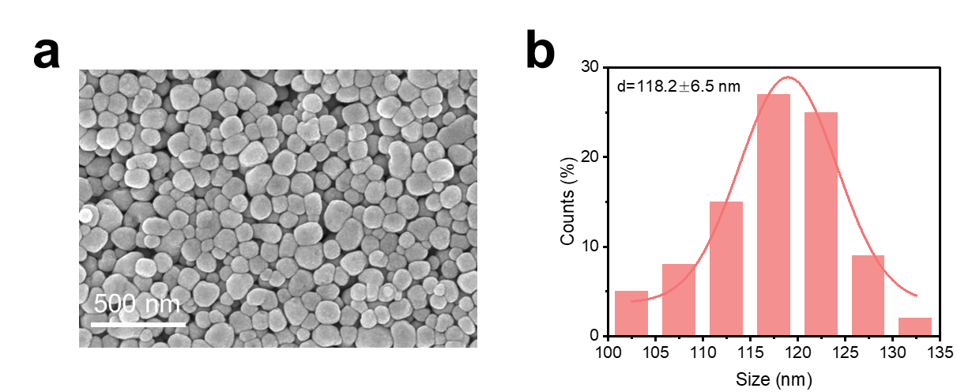
Fig. S1 SEM image of the BT nanoparticles and their size distribution. a SEM image of the BT nanoparticles synthesized by hydrothermal reaction. b The size distribution of the above BT nanoparticles obtained by manually measuring the data using nano measurer software

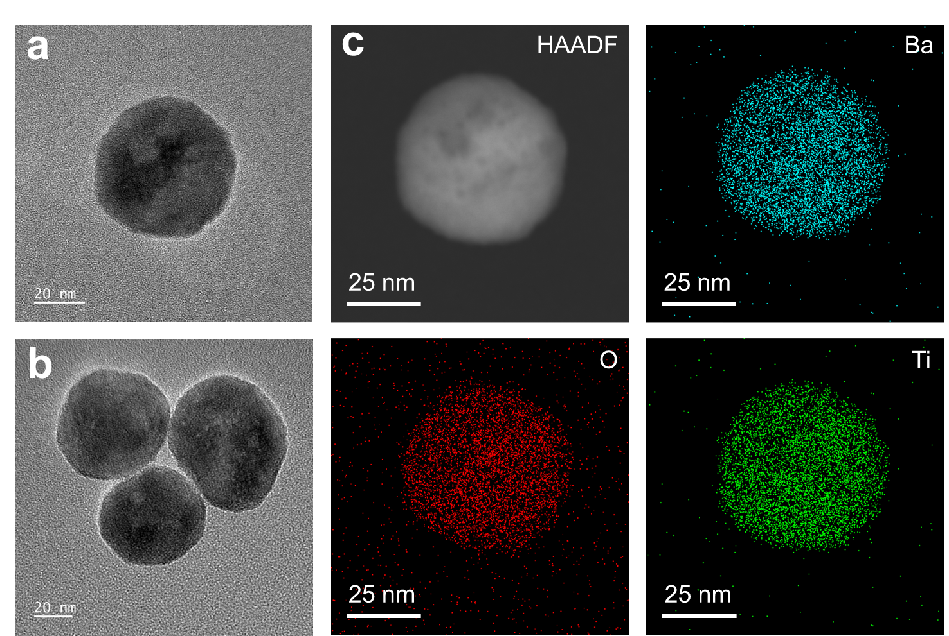
Fig. S2 TEM and corresponding EDX-mapping images of the BT nanoparticles. a-b TEM images of the BT nanoparticles. c The high-angle annular darkfield (HAADF) image of the BT nanoparticle and the corresponding EDX-mapping images

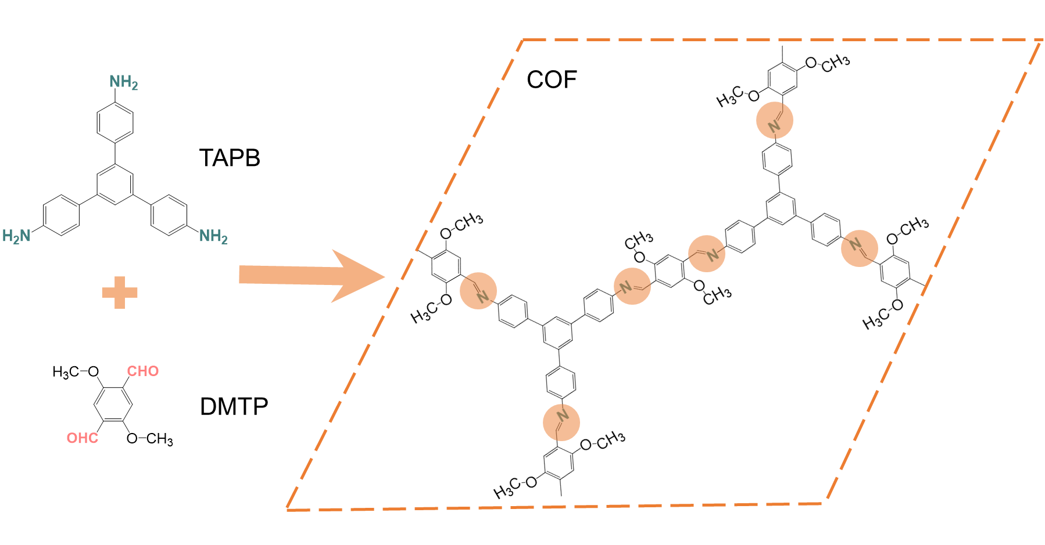
Fig. S3 Schematic diagram of the condensation reaction process

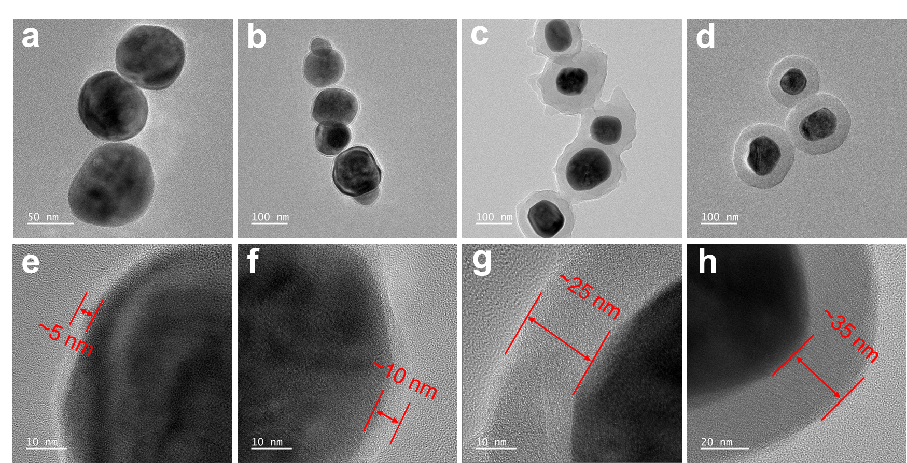
Fig. S4 TEM images of the core-shell structured BT@COF nanoparticles with different COF shell thickness. a, e ~5 nm. b, f ~10 nm. c, g ~25 mg. d, h ~35 mg

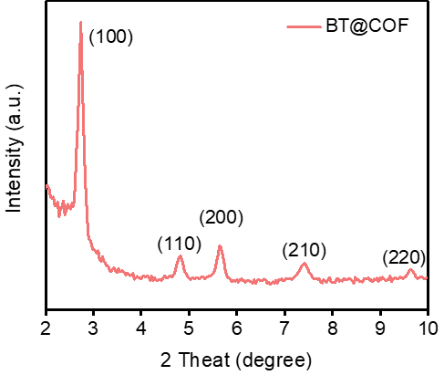
Fig. S5 Low-angle XRD pattern of the BT@COF nanoparticles

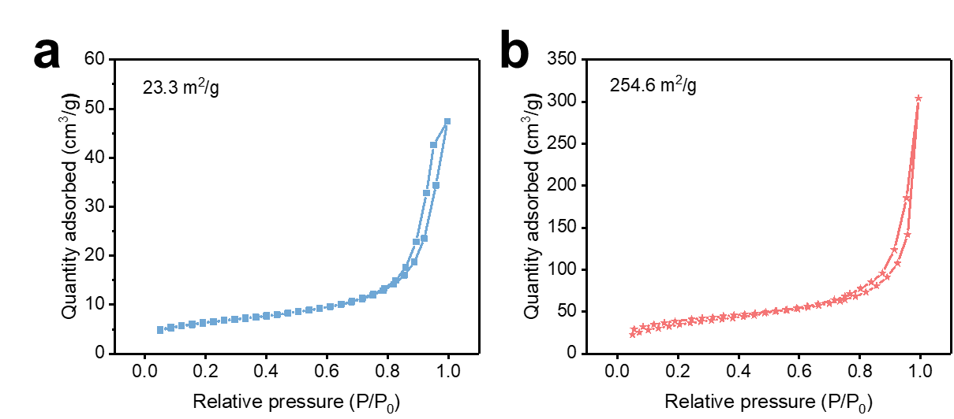
Fig. S6 Specific surface area measurement. a-b N₂ adsorption-desorption isotherms curves of the BT and BT@COF nanoparticles respectively

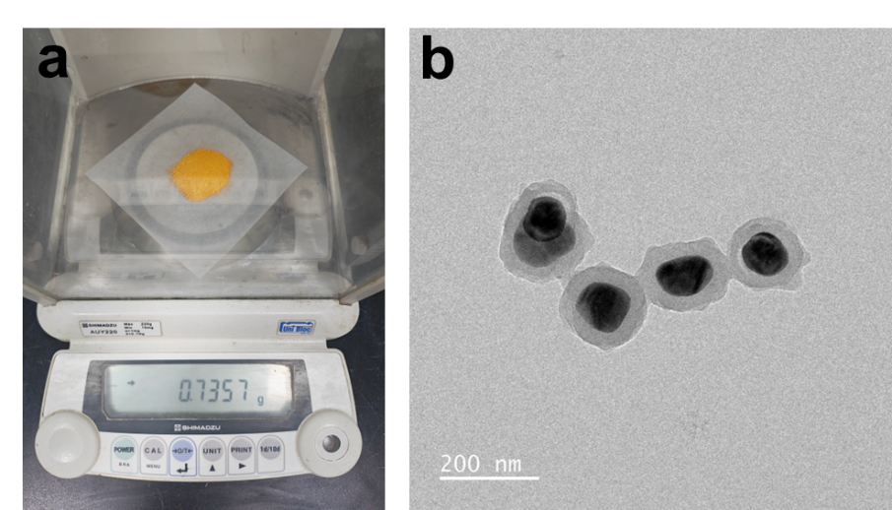
Fig. S7 The BT@COF nanoparticles prepared in the magnification experiment. a Display of samples prepared exceeding several hundred milligrams suggesting scalability potential. b TEM image of the BT@COF nanoparticles prepared in the magnification experiment

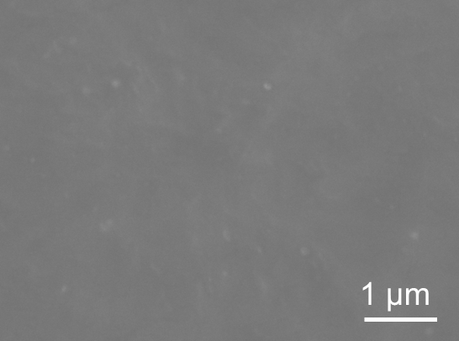
Fig. S8 The surface SEM image of the BT@COF-0.5% nanocomposite film

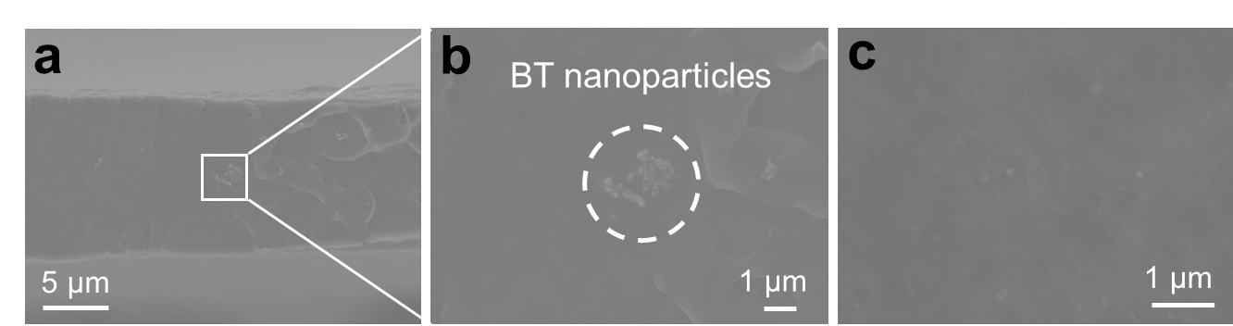
Fig. S9 SEM images of the BT/BBPM nanocomposite film. a-b The cross-sectional and c surface SEM images of the nanocomposite film with 0.5 wt% BT nanofiller respectively

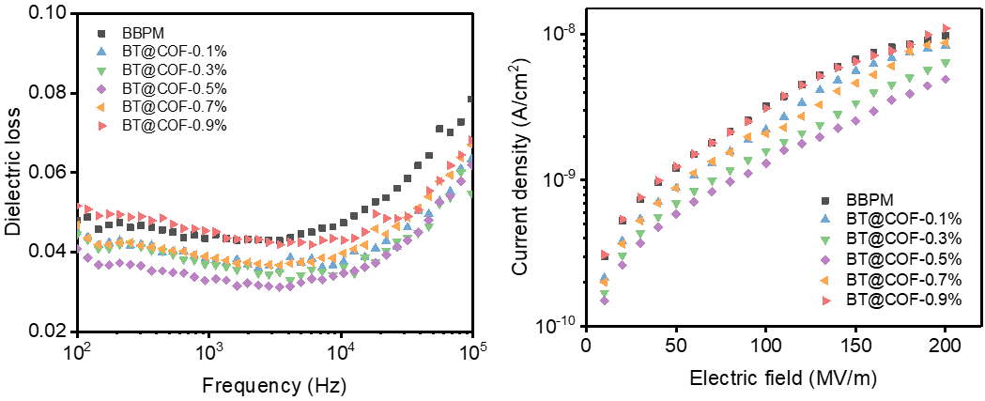
Fig. S10 Frequency-dependent dielectric loss of BT@COF/BBPM nanocomposite films with different nanofiller contents

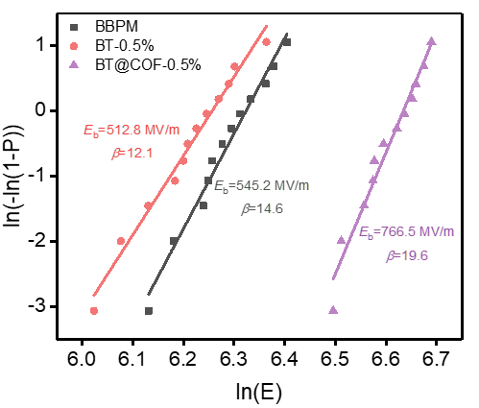
Fig. S11 Two-parameter Weibull breakdown strength of pure BBPM, BT-0.5% and BT@COF-0.5% nanocomposite films

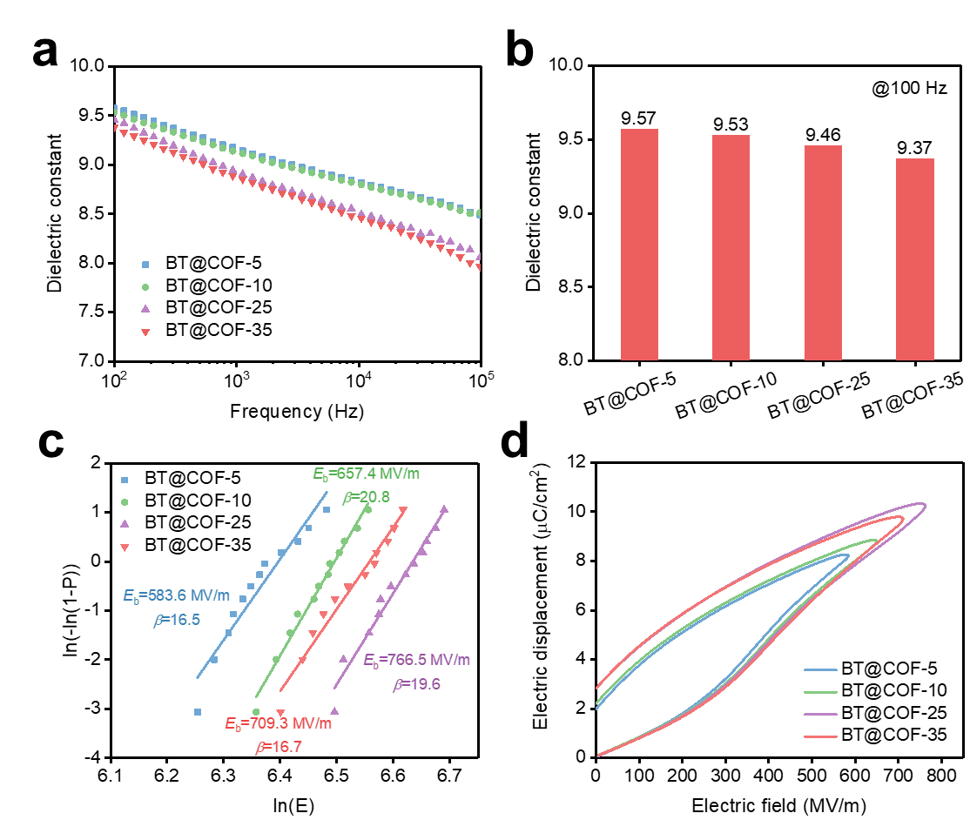
Fig. S12 The dielectric properties and energy storage performance of the BT@COF/BBPM nanocomposite films with different COF shell thicknesses. a Frequency-dependent dielectric constant of the BT@COF/BBPM films with different COF shell thicknesses at 0.5 wt% nanofiller content. b Dielectric constant of nanocomposite films as a function of the COF shell thickness at 100 Hz. c Two-parameter Weibull breakdown strength of BT@COF/BBPM films with different COF shell thicknesses at 0.5 wt% nanofiller content. d The unipolar D-E loops of the BT@COF/BBPM films with different COF shell thicknesses at 0.5 wt% nanofiller content

To explore the optimal dielectric energy storage performance of BT@COF/BBPM nanocomposite film with different COF shell thicknesses, the highest polar phase content of 0.5 wt% nanofiller is selected. Each nanocomposite film with different COF shell thicknesses is uniquely labeled as BT@COF-Y (Y denoted as the COF shell layer thickness). The frequency-dependent ε_{r} of the BT@COF/BBPM films with different COF shell thicknesses are shown in Fig. S12a-b. Apparently, with thickening the COF shell layer, the ε_{r} of the nanocomposite films decrease monotonically, which is mainly attributed to the low ε_{r} of COF. The dielectric breakdown tests are conducted on nanocomposite films with different COF shell thicknesses using a two-parameter Weibull distribution function:
ln[−ln(1−P)] = βlnE−βlnE_{b} (3)
where E_{b} is the Weibull breakdown strength at 63.2% of cumulative failure probability, and β is the shape parameter reflecting the data dispersion. The largest β indicates the higher reliability of the values. As shown in Fig. S12c, it is worth noting that there are differences of E_{b} for nanocomposite films with different COF shell thicknesses. The nanocomposite film with moderate COF shell thickness (~25 nm) reaches a maximum E_{b} of 766.5 MV/m, which is improved by nearly 40.6 % compared to that of the pure BBPM film (545.2 MV/m). Lower thicknesses of COF shell may not confine charge migration, while higher thicknesses inevitably induce structural defects that deteriorate the E_{b} of the composites [5]. In particular, the E_{b} of the pristine BT nanofiller composite film is only 512.8 MV/m, indicating that there is a unique advantage and intrinsic mechanism for the COF shell to enhance the breakdown field strength of the composites, which is crucial for improving the energy storage performance of the nanocomposite films. In addition, the energy storage densities of the BT@COF/BBPM nanocomposite films with different COF shell thicknesses are evaluated using the unipolar D-E loops (Fig. S12d). As a result, the energy density of the nanocomposite films first increases and then decreases upon increasing the thickness of the COF shell layer. Notably, the nanocomposite film with moderate COF shell thickness (~ 25 nm) achieves a maximum U_{d} of 26.1 J/cm³ at 760 MV/m.

Fig. S13 Leakage current densities of BT@COF/BBPM composite films with different nanofiller contents

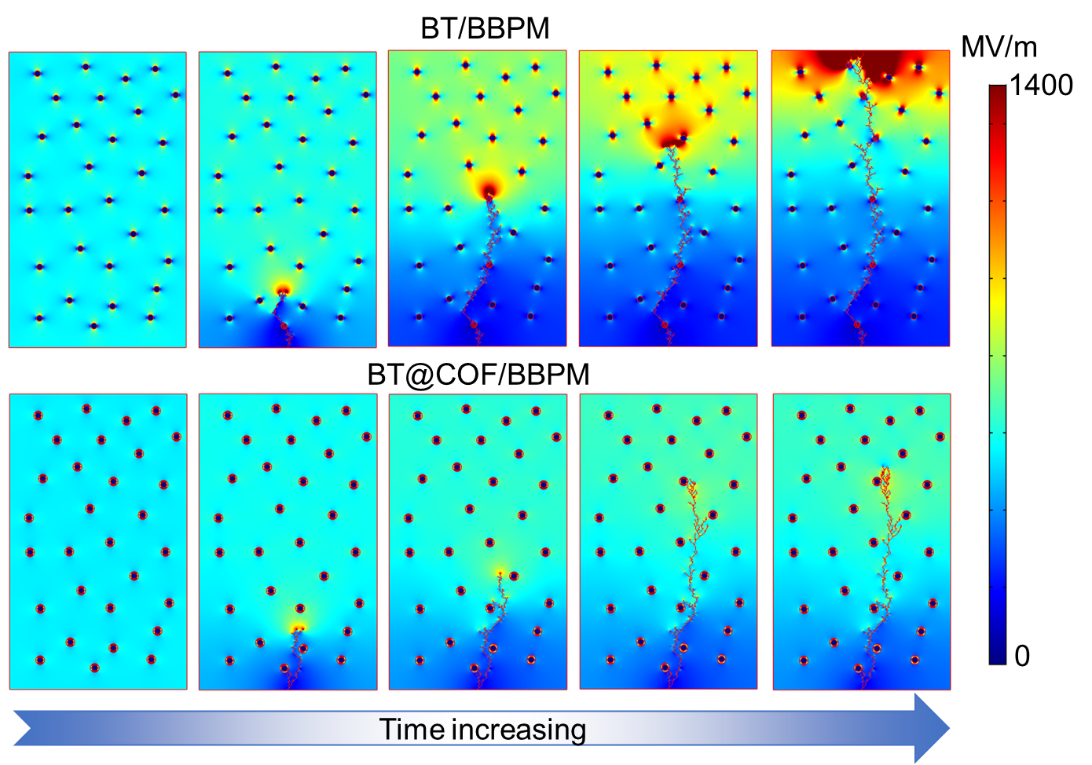
Fig. S14 The evolution of breakdown paths in BT/BBPM and BT@COF/BBPM nanocomposites

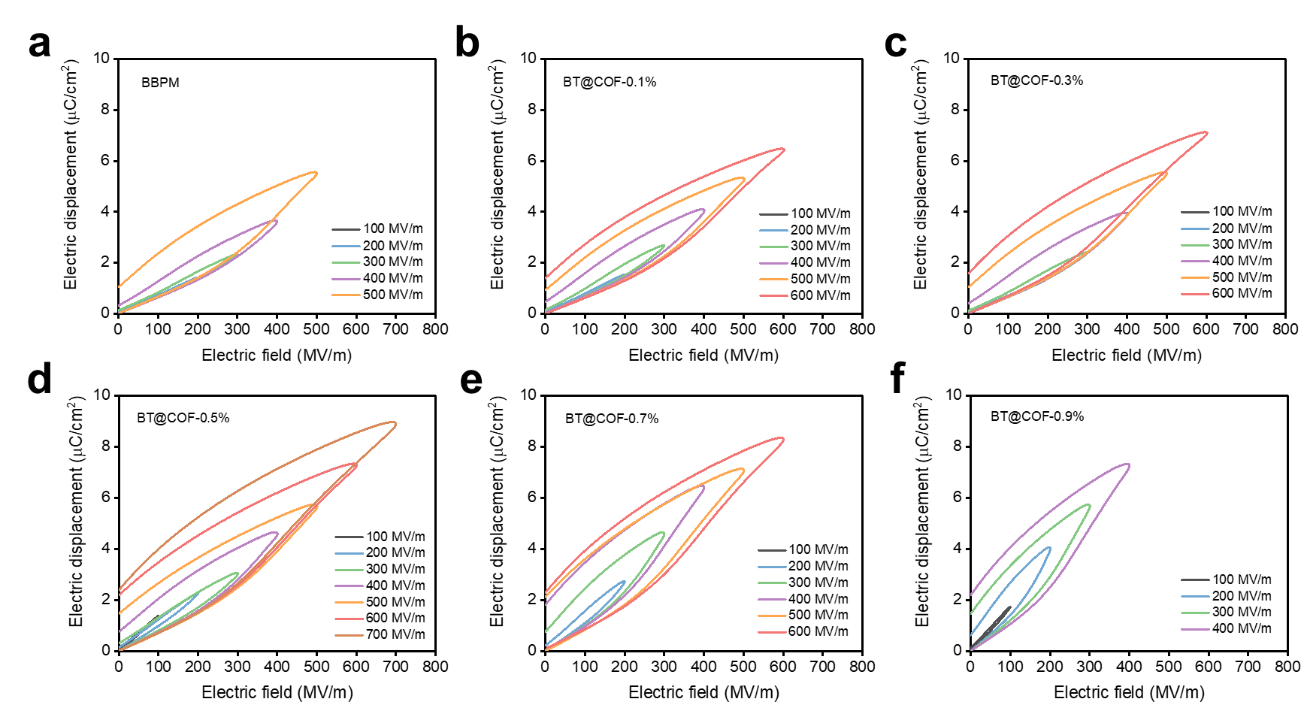
Fig. S15 D-E loops of pure BBPM and BT@COF/BBPM nanocomposites under different external electric fields. a pure BBPM. b BT@COF-0.1%. c BT@COF-0.3%. d BT@COF-0.5%. e BT@COF-0.7%. f BT@COF-0.9%

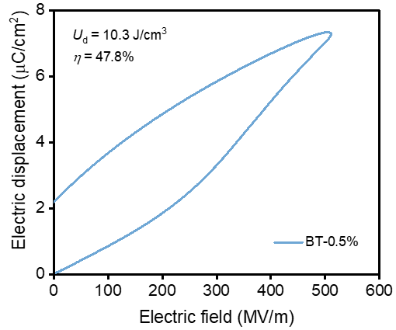
Fig. S16 D-E loops of BT/BBPM nanocomposites with 0.5 wt% nanofillers content

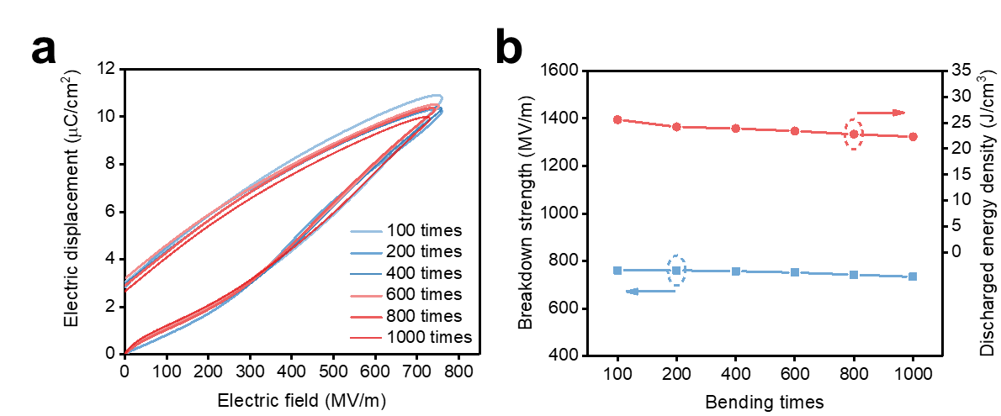
Fig. S17 The energy storage performance of the BT@COF-0.5% nanocomposite film after different times of bending. a The unipolar D-E loops of the BT@COF-0.5% nanocomposite film after different times of bending. b Fluctuations of E_{b} and U_{d} of the BT@COF-0.5% nanocomposite film after different times of bending

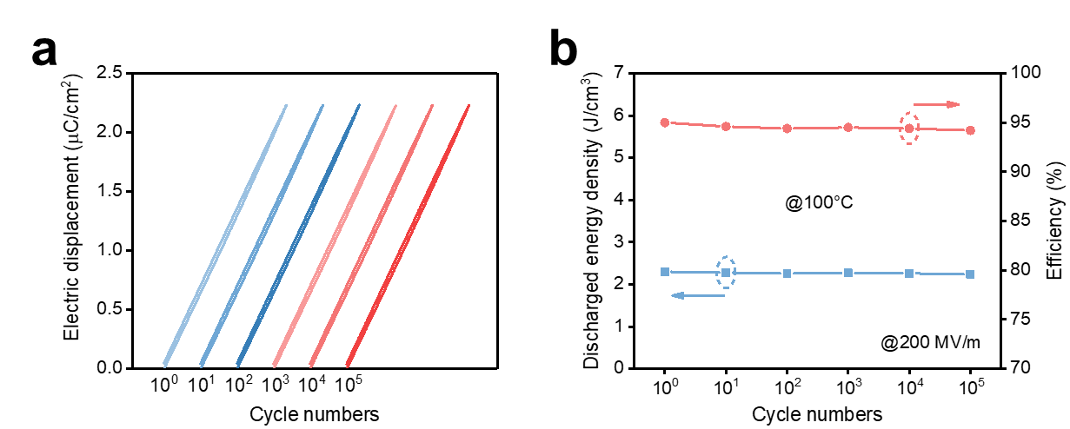
Fig. S18 The cycling reliability of BT@COF-0.5% nanocomposite film at elevated temperature. a The unipolar D-E loops of the BT@COF-0.5% nanocomposite film at 100°C under 200 MV/m at various cycle numbers. b Fluctuations of U_{d} and η of the BT@COF-0.5% nanocomposite film at 100°C under 200 MV/m at various cycle numbers

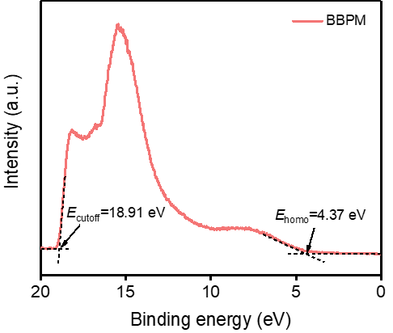
Fig. S19 The UPS measurement of the pure BBPM

The energy of secondary electron cutoff (E_{cutoff}) is 18.91 eV. The position of E_{cutoff} can be extracted from the intersection of the baseline and the tangents of the curve in the secondary electron cutoff region. The work function (ϕ_{d}), calculated by the difference between the incident photoelectron energy (21.2 eV) and E_{cutoff}, is 2.29 eV for pure BBPM. The E_{homo} value of pure BBPM is 4.37 eV. The position of E_{homo} can be extracted from the intersection of the baseline and the tangents of the curve in HOMO (the highest occupied molecular orbital) region. The ionization potential (IP) value (ϕ_{IP}), calculated by the summation of ϕ_{d} and E_{homo}, is 6.66 eV for pure BBPM [6, 7].

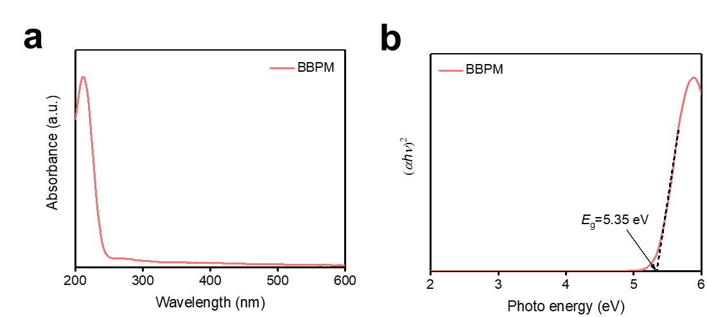
Fig. S20 UV-vis absorption measurement of the pure BBPM. a UV-vis absorption spectra. b (αhν)²-photo energy plot of the pure BBPM

The curve of (αhν)² versus photo energy is converted from the UV-vis spectrum by Tauc plot, in which α, h, and ν are the absorption coefficient, Planck constant, and light frequency, respectively. The band gap (E_{g}) determined from the absorption onset of the linear region is 5.35 eV for the pure BBPM.

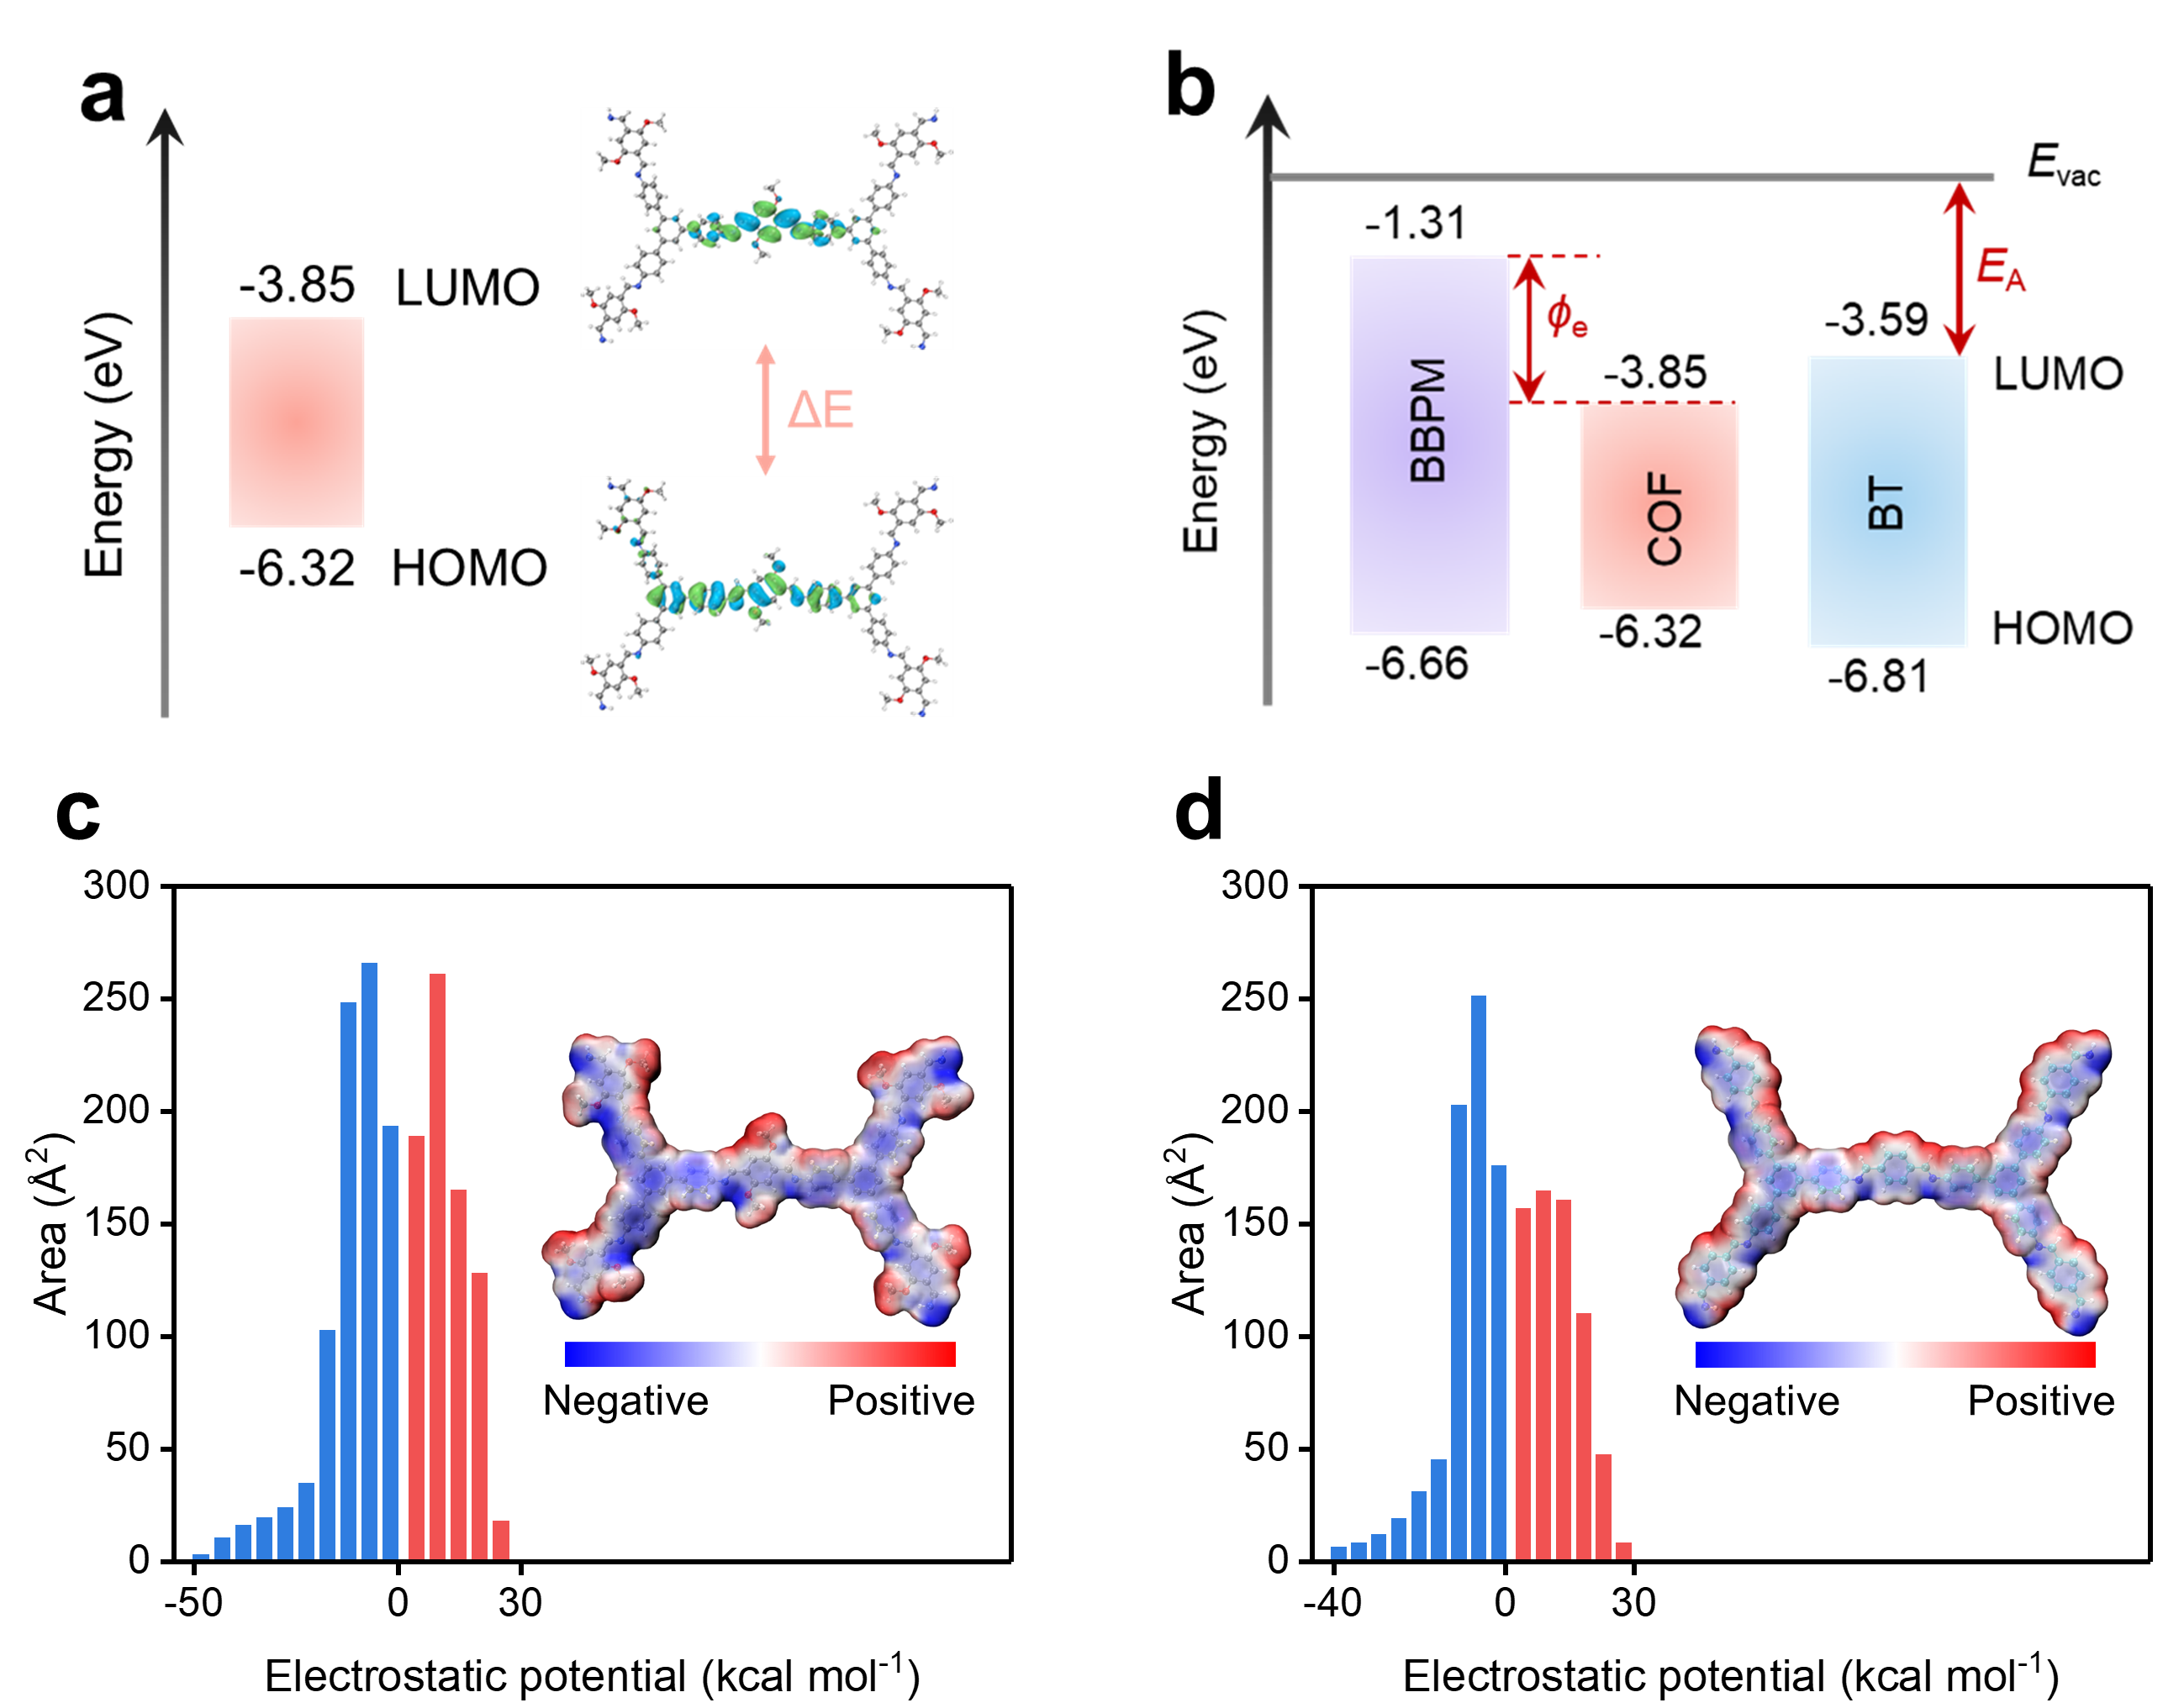
Fig. S21 DFT calculations. a Electronic structures of LUMO-HOMO orbital and relative energy level of COF. b Energy band diagram of BBPM, COF and BT. Electrostatic potential distribution and area percentage of the repetitive units in c COF and d COF without -OCH₃ groups

The above energy band diagram suggests the electron trap in BT@COF/BBPM composites. E_{A}, electron affinity; E_{vac}, vacuum level. The ϕ_{IP} is obtained by the UPS measurement in Supplementary Fig. S19. With the obtained ϕ_{IP}, the position of the HOMO level for pure BBPM can be determined. The E_{g} is obtained by the UV-vis measurement in Supplementary Fig. S20. Thus, the position of LUMO (the lowest unoccupied molecular orbital) level for pure BBPM, calculated by the difference between the HOMO level and the band gap, is 1.31 eV for pure BBPM, which is also its electron affinity. Energy value is an absolute value relative to the vacuum. The E_{g} and E_{A} of BT refer to the relevant reported literature [8, 9]. In addition, the energy band structure and electrostatic potential of the TAPB-DMTP-COF molecules are calculated based on DFT results.
Supplementary References
1. Guan Y, Tu L, Ren K et al (2023) Soft, super-elastic, all-polymer piezoelectric elastomer for artificial electronic skin. ACS Appl Mater Interfaces 15:1736-1747.
2. Xu F, Li Y, Zou Q et al (2022) The electric field cavity array effect of 2D nano-sieves. Nat Commun 13:7887.
3. Li Q, Ju TX, Li RP et al (2023) Investigation into the crystal structure-dielectric property correlation in barium titanate nanocrystals of different sizes. Nanoscale 15:7829-7844.
4. Chen DL, Sha JC, Mei XD et al (2024) Ultralow k covalent organic frameworks enabling high fidelity signal transmission and high temperature electromechanical sensing. Nat Commun 15: 10864.
5. Bi K, Bi MH, Hao YN et al (2018) Ultrafine core-shell BaTiO₃@SiO₂ structures for nanocomposite capacitors with high energy density. Nano Energy 51:513-523.
6. Yuan C, Zhou Y, Zhu Y et al (2020) Polymer/molecular semiconductor all-organic composites for high-temperature dielectric energy storage. Nat Commun 11:3919.
7. Chen J, Pei ZT, Liu YJ et al (2023) Aromatic-free polymers based all-organic dielectrics with breakdown self-healing for high-temperature capacitive energy storage. Adv Mater 35:2306562.
8. Wan LC, Han J, Tian WR et al (2023) Barium titanate@covalent organic framework core-shell nanoparticles for adsorption-enhanced piezo-photocatalysis. Chem Eng J 462:142324.
9. Xie ZL, Le K, Li H et al (2024) Interfacial engineering using covalent organic frameworks in polymer composites for high-temperature electrostatic energy storage. Adv Funct Mater 34:2314910.

