Supplementary Information

Polymer Dispersed Liquid Crystals-impregnated Switchable Thermochromic Transparent Woods with Excellent Ultraviolet Blocking Performance for Smart Windows

Cheng Ai Li¹ · Jae Gyu Ahn¹ · Hyeon Ji Jeong¹ · Jang Hee Kim¹ · Taeyoung Park¹ · Do Kyoung Han² · Jin Kim³ · Dong Ju Lee⁴ · Sung Ho Song¹

Cheng Ai Li and Jae Gyu Ahn contributed equally to this work.

Jin Kim
jinnie.kim@hanbat.ac.kr

Dong Ju Lee
dongjulee@chungbuk.ac.kr

Sung Ho Song
shsong805@kongju.ac.kr

¹ Division of Advanced Materials Engineering, Center for Advanced Materials and Parts of Powders, Kongju National University, Cheonan-si 31080, Republic of Korea

² Division of Materials Analysis and Research, Korea Basic Science Institute, 169–148, Gwahak-ro, Yuseong-Gu, Daejeon 34133, Republic of Korea
Department of Chemistry, Chung-Ang University, Seoul 06974, Republic of Korea

³ Department of Materials Science and Engineering, Hanbat National University, Daejeon 34158, Republic of Korea
⁴ Department of Urban, Energy, and Environmental Engineering, Chungbuk National University, Cheongju 28644, Republic of Korea

Figure S1. Weight loss after lignin modification and bleaching. (a) balsa, (b) bass, and (c) pine woods.

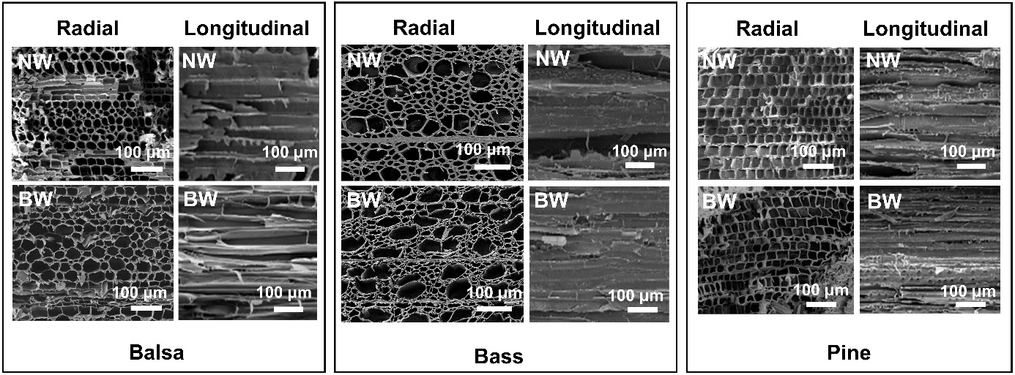

Figure S2. SEM images of balsa, bass, and pine NWs and BWs.

Figure S3. (a-c) SEM image and the corresponding elemental mapping of balsa NOA 63/TW.

Figure S4. (a-c) SEM image and the corresponding elemental mapping of balsa Epoxy/TW.

Figure S5. Experimental stress-strain curves of epoxy, NWs, and Epoxy/TWs using (a) balsa, (b) bass, and (c) pine woods.

Figure S6. Images of PDLC/TWs below 25 ºC and above 40 ºC and SEM images of PDLC/TWs. (a) balsa, (b) bass, and (c) pine PDLC/TWs.

Figure S7. Haze as function of wavelength for balsa, bass, and pine PDLC/TWs.

Figure S8. Optical transmittance spectra of balsa PDLC/TW with 1 mm thickness at room temperature and 40 °C.

Figure S9. (a) Enlarged view of the FTIR curves between 1450 and 1650 cm⁻¹ in Figure 4d. (b) FTIR and (c) Raman spectra of balsa, bass, and pine PDLC/TWs.

Figure S10. Cyclic change of transmittance of the balsa PDLC/TW during the heating and cooling cycle of 100 times.

Figure S11. DSC spectra of PDLC film and PDLC/TW.

Figure S12. Transmittance of the color-changing sunglasses measured inside the PDLC/TW RT, PDLC/TW 40 °C and glass showcases after 1 min of UV illumination, respectively.

Figure S13. Comparison of the thermal conductivities of glass and PDLC/TW.

