Supporting information:

Tailoring the Topography, Crystalline Structure, and Piezoelectric Response of Electrospun Biodegradable Poly(3-hydroxybutyrate) Scaffolds by Glycine Loading
Lada E. Shlapakova^{1,&}, Vladimir V. Shvartsman^{2,&}, Boris N. Slautin², Doru C. Lupascu², Irina Grubova^{1,3}, Yi-Yang Sun³, Vladimir V. Botvin⁴, Sanjay Mathur⁵, Maria A. Surmeneva^{1,*,@}, and Roman A. Surmenev^{1,*,@}
¹ Physical Materials Science and Composite Materials Center, Research School of Chemistry & Applied Biomedical Sciences, National Research Tomsk Polytechnic University, 634050, Tomsk, Russia
² Institute for Materials Science and Center for Nanointegration Duisburg-Essen (CENIDE), University of Duisburg-Essen, 45141 Essen, Germany
³ Integrated Computational Materials Research Centre, Shanghai Institute of Ceramics, Chinese Academy of Sciences, Shanghai 201899, China
⁴ National Research Tomsk State University, 634050, Tomsk, Russia
⁵ Institute of Inorganic Chemistry, University of Cologne, Greinstr. 6, 50939, Cologne, Germany
*corresponding authors: rsurmenev@mail.ru (Roman A. Surmenev); surmenevamaria@mail.ru (Maria A. Surmeneva), sanjay.mathur@uni-koeln.de (Sanjay Mathur); vladimir.shvartsman@uni-due.de (Vladimir Shvartsman)
& the authors contributed equally and share the first authorship
@ the authors contributed equally and share the last authorship
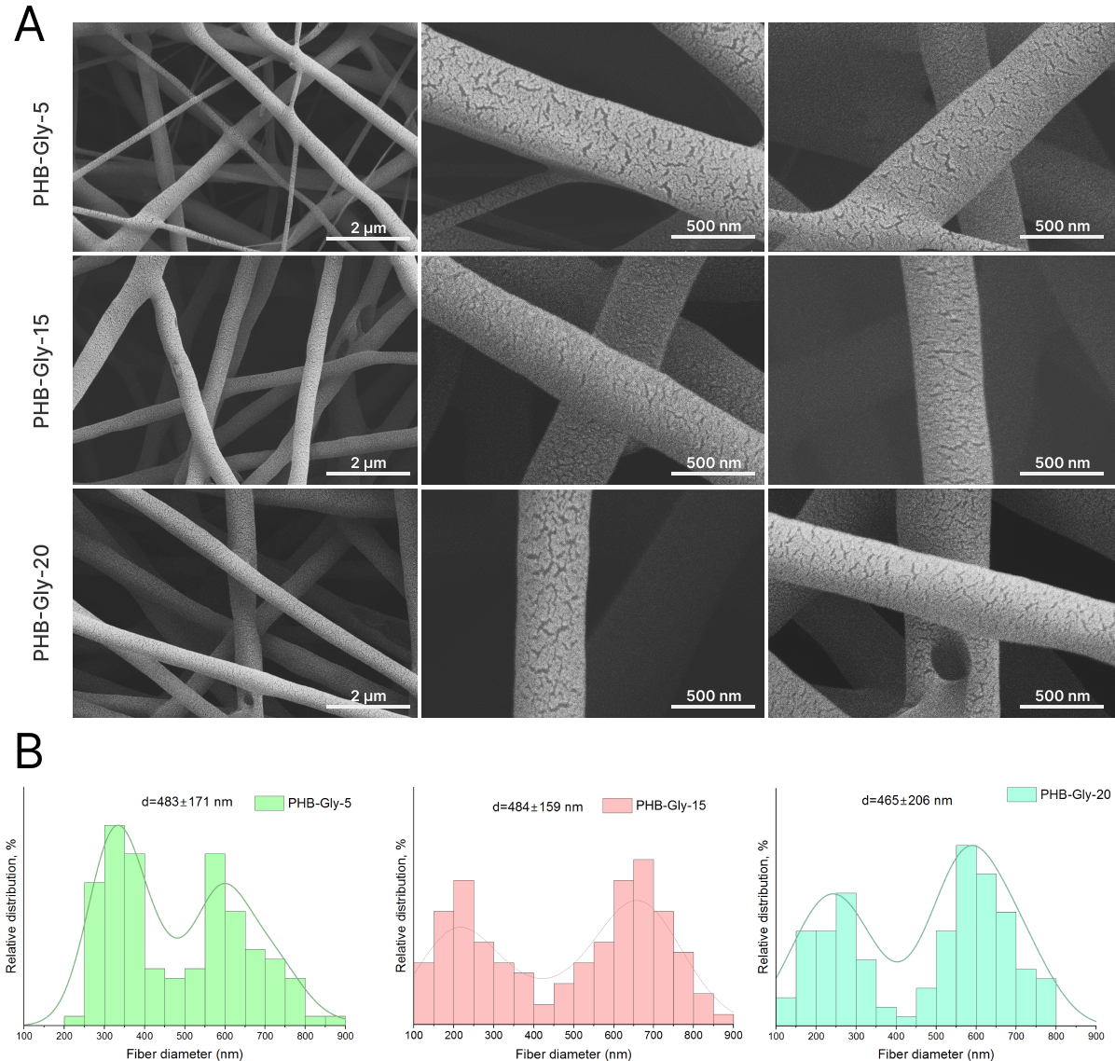
Figure S1. SEM images (A) and fiber diameter distributions (B) of the studied scaffolds. One hundred fibers have been analyzed (n=100)
Table S1. Raman shifts and their assignments observed in the Raman spectra of the pure PHB and PHB-Gly scaffolds and of the pristine Gly (1, 2).
Raman shift, cm⁻¹ | Assignment
Raman shift, cm⁻¹ | PHB | α-Gly | β-Gly
1725 | C=O stretching vibrations (crystalline phase)
1671 |  | NH₃ asymmetric deformation
1569 |  | CO₂ asymmetric stretching
1565 |  |  | CO₂ asymmetric stretching
1524 |  |  | NH₃ symmetric deformation
1503 |  | NH₃ symmetric deformation
1460 | CH₃ asymmetric bending vibrations
1443 | CH₂ bending vibrations
1440 |  | CH₂ bending
1412 |  | CO₂ symmetric stretching
1402 | CH₃ symmetric bending vibrations
1365 | CH bending vibrations and CH₃ symmetric bending vibrations
1326 |  | CH₂ torsion/wagging
1322 |  |  | CH₂ torsion/wagging
1295 | СН bending vibrations
1261 | C–O–C stretching vibrations and CH bending vibrations
1220 | C–O–C asymmetric stretching vibrations
1109 |  |  | NH₃ rocking
1101 | C–O–C symmetric stretching vibrations
1058 | C–O stretching vibrations
1041 |  |  | C–N stretching
953 | C–C stretching vibrations and CH₃ rocking bending vibrations
893 |  |  | C–C stretching
841 | C–COO stretching vibrations
704 |  |  | CO₂ bending
698 |  | CO₂ bending
691 | C=O bending vibrations (in plane)
680 | C=O bending vibrations (out of plane)
598 | C–CH₃ and CCO bending vibrations
510 | C–CH₃ and CCO bending vibrations
497 |  | CO₂ torsion/wagging
488 |  |  | CO₂ torsion/wagging
367 | C–CH₃ and CCO bending vibrations
359 |  | CCN rocking
351 | C–CH₃ and CCO bending vibrations
350 |  |  | CCN rocking
222 | CH₃ torsion bending vibrations

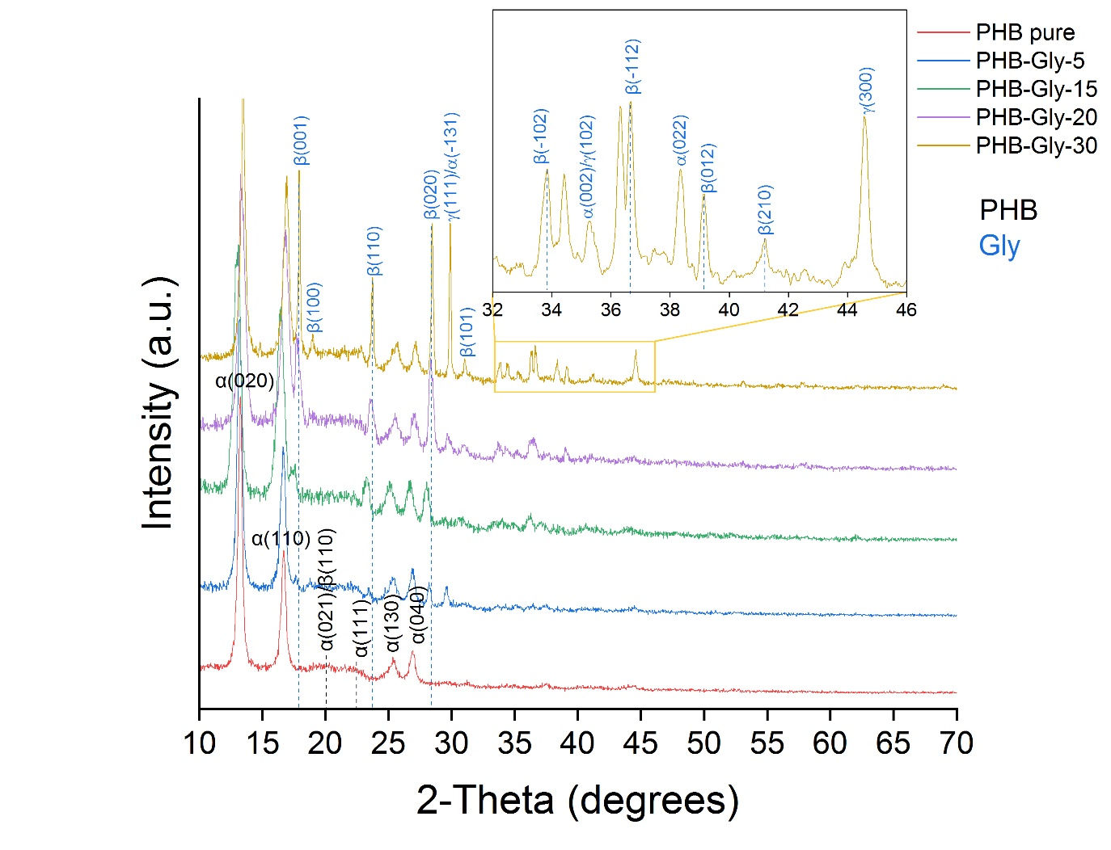
Figure S2. XRD patterns of Gly-loaded PHB scaffolds
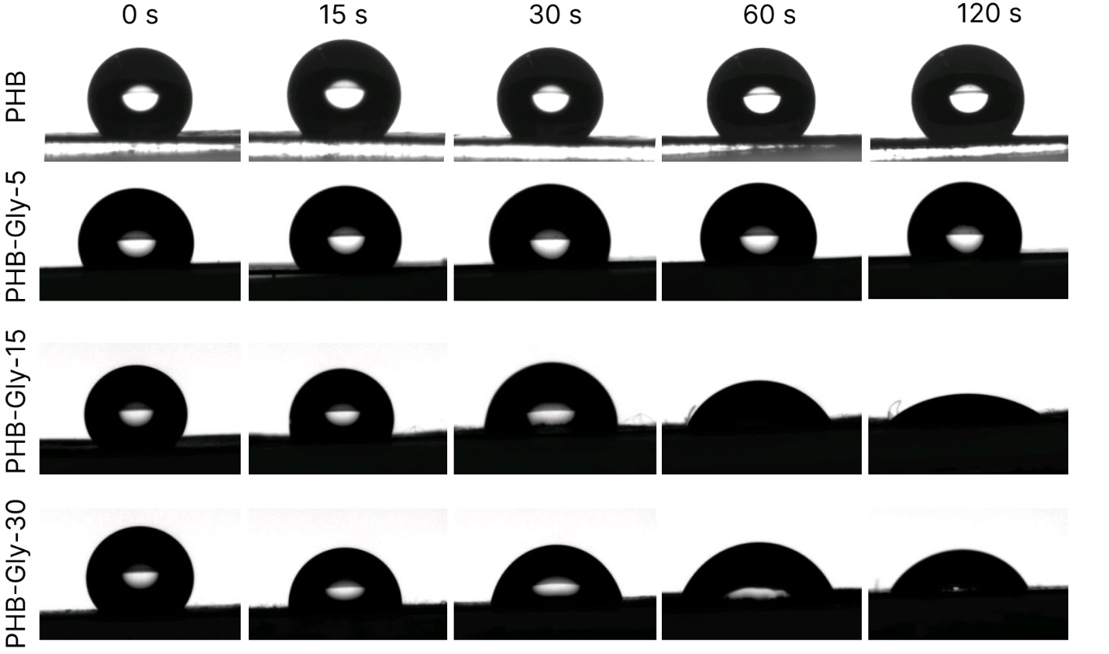
Figure S3. Changes in surface wettability of Gly-loaded PHB scaffolds during two-minute observation

Table S2. Adsorption energies (in eV) of different Gly forms on PHB (010) surface
Gly Form | Site | Orientation | E_{ads}
Amino Acid | Bridge | 1-NH₂ | -0.2205
 |  | 2-COOH | -0.1215
 |  | 3-Gly parallel to surface | -0.2082
 | Atop | 1-NH₂ | -0.1046
 |  | 2-COOH | -0.0909
 |  | 3-Glycine parallel to surface | -0.0928
 | Hollow | 1-NH₂ | -0.2823
 |  | 2-COO | -0.5502
 |  | 3-Glycine parallel to surface | -0.3678
Zwitterion | Bridge | 1-NH₃ | -0.1203
 |  | 2-COO | -0.0864
 |  | 3-Glycine parallel to surface | -0.2614
 | Atop | 1-NH₃ | -0.0957
 |  | 2-COO | -0.1133
 |  | 3-Glycine parallel to surface | -0.1413
 | Hollow | 1-NH₃ | -0.2767
 |  | 2-COO | -0.1130
 |  | 3-Glycine parallel to surface | -0.1109
Deprotonated Zwitterion (–H) | Bridge | 1-NH₂ | -0.0930
 |  | 2-COO | -0.0580
 |  | 3-Glycine parallel to surface | -0.3274
 | Atop | 1-NH₂ | -0.0656
 |  | 2-COO | -0.1010
 |  | 3-Glycine parallel to surface | -0.1014
 | Hollow | 1-NH₂ | -0.3017
 |  | 2-COO | -0.1053
 |  | 3-Glycine parallel to surface | -0.1059

Gly is a component of many proteins in the human body playing a crucial role in the synthesis of many biomolecules, including glutathione, heme, creatine, nucleic acids, RNA, DNA, and uric acid (3). It is well-known for its anti-inflammatory, anti-oxidative, and immunomodulatory effects in several cell types. In addition, Gly acts as a neurotransmitter, modulates neuronal activity, and controls motor functions; it confers protection against neuronal death in in vitro and in vivo experimental conditions (3). Other beneficial activities involving Gly are the modulation of growing; facilitating muscle tone, collagen synthesis, tissue restore, and delaying muscular degeneration (4).
In humans, the normal serum level of glycine is approximately 300 μM; however, elevating its intake can lead to blood levels of more than 900 μM that increase its benefic actions without having harmful side effects (5). Researchers have utilized Gly to (1) prevent tissue injury; (2) enhance anti-oxidative capacity; (3) promote protein synthesis and wound healing; (4) improve immunity; (5) treat metabolic disorders (6). A number of in vitro, in vivo, and clinical studies report positive effects of Gly in varied concentrations on different cell cultures, organs, and conditions. For instance, 0.3 mM Gly protects against chemical energy depletion in endothelial cells of human umbilical vein, kidney endothelial cells, and PC-12 cells (5). In rat cortical neuron cultures Gly in concentrations of 1000-2000 μM decreases neuronal hypoxic injury (7). Finally, Gly (3 mM) increases viability of cardiac myocytes by blocking injury induced by re-energization and pH normalization following induced ischemia (8).
Thus, Gly can be considered a perspective therapeutic agent in tissue-engineering scaffolds that can facilitate restoration of various tissues due to its unique biochemical activities. When subjected to cell culture medium or body fluids, the scaffolds release Gly (9) that acts as biochemical agent modulating the cell and tissue growth. In order to ensure that the scaffolds provide Gly concentration covering the therapeutic, but not harmful, range, the Gly release was monitored by a ninhydrin assay during 20 minutes (Figure S4). Gly was rapidly released from the scaffolds into the PBS medium during 10 minutes for the PHB-Gly-5 and PHB-Gly-15 samples and during 8 minutes for PHB-Gly-30, after which the Gly concentration maintained statistically unaltered, which is in line with literature data (9). The ultimate Gly concentrations in the medium are 2.1±0.1, 4.0±0.1, and 6.9±0.2 mM for the PHB-Gly-5, PHB-Gly-15, and PHB-Gly-30, respectively, which correspond to the therapeutic concentrations reported in a number of papers. For instance, 2–10 mM Gly protects hepatocytes and non-specifically blocks influx of sodium, cobalt, nickel ions (10). In isolated perfused or stored organ models Gly in concentrations from 3 to 12 mM was demonstrated to improve functions and viability and ameliorate injury of multiple organs, including liver, heart, kidney, and intestine (5).

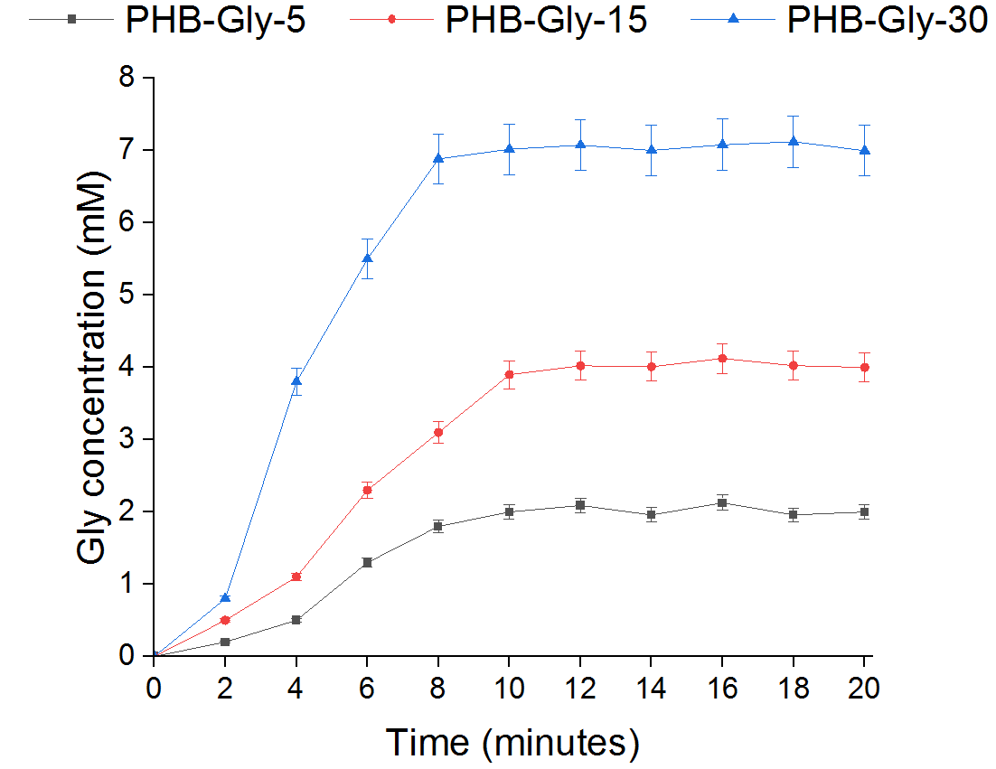
Figure S4. Gly release from the studied scaffolds

Of note, on the early stage of the experiment (i.e., 0–4 minutes for the PHB-Gly-5 and PHB-Gly-15 and 0–2 minutes for the PHB-Gly-30) Gly releases at a lower rate, after which severe release occurs up to the minute 10 (Figure S4). This early stage may correspond to the water adsorption on the fiber surface and the dissolution of the surface Gly, which opens channels for further water penetration and action in the fiber bulk leading to the rapid Gly release.
Although future studies are anticipated to assess cellular and tissue responses to the developed scaffolds, this material is perspective for a wide range of tissue-engineering applications for a rapid and straightforward delivery of Gly at therapeutic levels to intended tissues and organs, as well as for alternative applications such as wearable piezoelectronics. Beker et al. (11) introduced a piezoelectric PLLA/Gly wearable sensor for non-invasive monitoring of dynamic human motions (e.g., slight movement of the muscle, including the trachea, esophagus, and movements of joints) and physiological signals (e.g., artery pulse). However, for applications, where a long-term Gly persistence is required, solutions to postpone its release should be explored, e.g., surface modifications with adhesive coatings, such as polydopamine (12-14).

References:
1. T. Furukawa et al., Raman microspectroscopy study of structure, dispersibility, and crystallinity of poly(hydroxybutyrate)/poly(l-lactic acid) blends. Polymer 47, 3132-3140 (2006).
2. N. V. Surovtsev et al., Glycine phases formed from frozen aqueous solutions: Revisited. The Journal of chemical physics 137, (2012).
3. K. A. Aguayo-Cerón et al., Glycine: the smallest anti-inflammatory micronutrient. International Journal of Molecular Sciences 24, 11236 (2023).
4. M. A. Razak, P. S. Begum, B. Viswanath, S. Rajagopal, Multifarious beneficial effect of nonessential amino acid, glycine: a review. Oxidative medicine and cellular longevity 2017, 1716701 (2017).
5. I. Pérez-Torres, A. María Zuniga-Munoz, V. Guarner-Lans, Beneficial effects of the amino acid glycine. Mini reviews in medicinal chemistry 17, 15-32 (2017).
6. W. Wang et al., Glycine metabolism in animals and humans: implications for nutrition and health. Amino acids 45, 463-477 (2013).
7. P. Zhao, H. Qian, Y. Xia, GABA and glycine are protective to mature but toxic to immature rat cortical neurons under hypoxia. European Journal of Neuroscience 22, 289-300 (2005).
8. M. Ruiz‐Meana et al., Glycine protects cardiomyocytes against lethal reoxygenation injury by inhibiting mitochondrial permeability transition. The Journal of Physiology 558, 873-882 (2004).
9. P. V. Mayuri, A. Bhatt, P. Ramesh, Glycine integrated zwitterionic hemocompatible electrospun poly (ethylene-co-vinyl alcohol) membranes for leukodepletion. Biomedical Physics & Engineering Express 6, 055019 (2020).
10. A. Frank, U. Rauen, H. de Groot, Protection by glycine against hypoxic injury of rat hepatocytes: inhibition of ion fluxes through nonspecific leaks. Journal of hepatology 32, 58-66 (2000).
11. M. Ali et al., A Flexible and Biodegradable Piezoelectric‐Based Wearable Sensor for Non‐Invasive Monitoring of Dynamic Human Motions and Physiological Signals. Advanced Materials Technologies 8, 2300347 (2023).
12. R. Schönlein et al., Enhanced Piezoelectric Properties of Poly(L-lactide) Nanocomposite Microfiber Scaffolds Due to Polydopamine-Coating of Barium Titanate Nanoparticles. Advanced Materials Interfaces 12, 2400546 (2025).
13. C.-W. Lou et al., Electroactive HA/PDA/PPy stents applied for bone tissue engineering by layer-by-layer strategy. Progress in Organic Coatings 183, 107820 (2023).
14. P. Bai et al., A Novel Method to Improve the Physical Property and Biocompatibility of Decellularized Heart Valve Scaffold with Sericin and Polydopamine. Journal of Bionic Engineering 19, 1109-1123 (2022).

