Supporting Information for

Microbiota-Responsive Oral Nano-Amifostine Enables Colorectal-Specific Radioprotection and Tumor Immunity via Gut Microenvironment Reprogramming
Kaichao Song^{1, #}, Ling Ren^{1, #}, Xiuping Guo^{1, #}, Gang Ren^{1, #}, Yanan Sun¹, XiaoLian Tian¹, Chujuan Hu¹, Mingyu Pan², Quanyong Yu³, Zhigang Luo⁵, Yumei Hao⁵, Peng Lei⁵, Haoyang Yu¹, Sitong Yang¹, Qingbo Chen¹, Yuanbin Li¹, Shan Wang¹, Yingying He¹, Zhouguang Hui^{4, *}, Wensheng Zheng^{5, *}, Jiandong Jiang^{1, *}, Lulu Wang^{1, *}

1. State Key Laboratory of Bioactive Substance and Function of Natural Medicines, Institute of Medicinal Biotechnology, Chinese Academy of Medical Sciences & Peking Union Medical College, Beijing 100050, China
2. University of California, Riverside, Riverside, CA 92521, USA
3. China Pharmaceutical University, Nanjing 211112, China
4. Department of VIP Medical Services, National Cancer Center/National Clinical Research Center for Cancer/Cancer Hospital, Chinese Academy of Medical Sciences & Peking Union Medical College, Beijing 100021, China
5. Institute of Materia Medica, Chinese Academy of Medical Sciences & Peking Union Medical College, Beijing 100050, China.
*Correspondence:
Lulu Wang, E-mail: wanglulu@imb.cams.cn.
Jiandong Jiang, E-mail: jiang.jdong@163.com.
Wensheng Zheng, E-mail: zhengwensheng@imm.ac.cn.
Zhouguang Hui, E-mail: drhuizg@163.com.

1 Materials
Pectin (PEC) with galacturonic acid ≥74.0% (dried basis) and molecular weight 20,000-40,000 was purchased from Puxitang (Tianjin) Biotechnology Co., LTD. Chitosan (CS) with deacetlylation ≥75.0% and viscosity 20-300 mPas was purchased from Golden-Shell Pharmaceutical Co., Ltd (Zhejiang, China). Amifostine was obtained from Shanghai YaXing Biomedical Technology Co., Ltd (Shanghai, China). Sulfo-cyanine 5 amine was purchased from Wuhan duofluorBioengineering Technology Co., LTD (China). 1-(3-Dimethylaminopropyl)-3-ethylcarbodiimide hydrochloride (EDC·HCl) were purchased from Aladdin. Triethylamine was supplied by Beijing InnoChem Science & Technology Co., Ltd (Beijing, China).

2 Methods
Table Sup 1 List of antibodies used for immunofluorescence of cell samples
Antibody | Manufacturer | Species source | Catalog no. | Dilution
γH2AX | Servicebio | Rabbit polyclonal | GB111841 | 1:250
TNF-α | Abcam | Mouse monoclonal | Ab1793 | 5μg/mL
IL-1β | Abcam | Rabbit monoclonal | Ab216995 | 1:50

Table Sup 2 List of primers used for RNA analyses
 | Primers | Sequence
TNF-α | Forward Primer | GAACACGTCGTGGGATAATG
TNF-α | Reverse Primer | GGCAGACTTTGGATGCTTCTT
IL-1β | Forward Primer | AAATGCCACCTTTTGACAGTG
IL-1β | Reverse Primer | TGGATGCTCTCATCAGGACAG
IL-6 | Forward Primer | TTCCTCTGGTCTTCTGGAGT
IL-6 | Reverse Primer | TCTGTGACTCCAGCTTATCTCTTG
α-SMA | Forward Primer | TGCCGAGCGTGAGATTGTC
α-SMA | Reverse Primer | CGTTCGTTTCCAATGGTGATC
Collegan I | Forward Primer | TGACTGGAAGAGCGGAGAGTACT
Collegan I | Reverse Primer | TTCGGGCTGATGTACCAGTTC
ZO-1 | Forward Primer | GCCGCTAAGAGCACAGCAA
ZO-1 | Reverse Primer | TCCCCACTCTGAAAATGAGGA
Occludin | Forward Primer | TTGAAAGTCCACCTCCTTACAGA
Occludin | Reverse Primer | CCGGATAAAAAGAGTACGCTGG
GAPDH | Forward Primer | GTCAAGGCCGAGAATGGGAA
GAPDH | Reverse Primer | CTCGTGGTTCACACCCATCA

Table Sup 3 List of antibodies used for Western Blot
Antibody | Manufacturer | Species source | Catalog no. | Dilution
TNF-α | Proteintech® | Rabbit | 17590-1-AP | 1:1000
IL-1β | Proteintech® | Rabbit | 26048-1-AP | 1:1000
IL-6 | Proteintech® | Rabbit | 21865-1-AP | 1:1000
α-SMA | CST® | Rabbit | 19245 | 1:1000
Collegan I | Proteintech® | Rabbit | 14695-1-AP | 1:1000
ZO-1 | Proteintech® | Rabbit | 21773-1-AP | 1:5000
Occludin | Proteintech® | Rabbit | 13409-1-AP | 1:2000
GAPDH | Proteintech® | Mouse | 60004-1-Ig | 1:50000
Hsp-90 | Beyotime® | Mouse | AF0192 | 1:1000

Table Sup 4 List of antibodies used for immunofluorescence in tissue samples
Antibody | Manufacturer | Species source | Catalog no. | Dilution
Lysozyme | Abcam | Rabbit | Ab108508 | 1:250
Lgr5 | Thermofisher | Rabbit | PA5-87974 | 1:100
Mucin-2 | Abcam | Rabbit | Ab272692 | 1:250
Ki67 | Abcam | Rabbit | Ab15580 | 1:250
γH2AX | Servicebio | rabbit | GB111841 | 1:250
ZO-1 | Abcam | Rabbit | ab221547 | 1:250
Occludin | Abcam | Rabbit | ab216327 | 1:250
CD206 | Abcam | Rabbit | Ab64693 | 1:250
CD68 | Abcam | Rabbit | Ab283654 | 1:250
TNF-α | Thermofisher | Rabbit | PA1-40281 | 1:100
IL-1β | Abcam | Rabbit | Ab315084 | 1:250
IL-6 | Abcam | Rabbit | Ab290735 | 1:250
α-SMA | Abcam | Rabbit | ab5694 | 1:250
Collegan I | Abcam | Rabbit | Ab270993 | 1:250
CD11c | Abcam | Rabbit | Ab219799 | 1:250
Ly6G | Abcam | Rabbit | Ab238132 | 1:250
Goat anti rabbit IgG | Servicebio | HRP-conjugated | GB23303 | 1:1000
Fitc-TSA | Servicebio | N.A. | G1222 | 1:100
CY3-TSA | Servicebio | N.A. | G1223 | 1:100
647-TSA | Servicebio | N.A. | G1224 | 1:100

Table Sup 5 List of antibodies used for cytometric analysis
Antibody | Manufacturer | Species source | Catalog no. | Dilution
γ-H2A.X | Thermofisher | Rabbit | MA5-33062 | 1ug/mL
ZO-1 | Thermofisher | Mouse | 33-9100 | 1:100
Occludin | Abcam | Rabbit | ab216327 | 1:250
Alexa Fluor 488 labelled Goat Anti-Rabbit | Abcam | Rabbit | ab150077 | 1:1000
Alexa Fluor 488 labelled Goat Anti-mouse | Abcam | Goat | ab150113 | 1:1000
Alexa Fluor 488 conjugated Ki67 | Abcam | Goat | ab281847 | 1:50
Lgr5 | Abcam | Rabbit | PA5-87974 | 1:250

3 Results
Table Sup 6 The zeta potential of pectin and chitosan solutions at different pH
pH | PEC solution potential (mV) | CS solution potential (mV)
3.5 | 0.0800 | 6.64
4.0 | -17.7 | 4.21
4.5 | -18.9 | 3.40
5.0 | -23.8 | 2.51
6.0 | -25.5 | 0.336
7.0 | -18.6 | 1.36
8.0 | -22.5 | -0.323
9.0 | -20.2 | -2.47

Table Sup 7 The size, zeta potential and PDI of CS/PEC-AMF NPs at different pectin concentrations
Pectin concentrations (mg/mL) | Size (nm) | PDI | Potential (mV)
2.5 | 75.73 | 1.00 | -16.8
1.0 | 832.4 | 0.439 | -10.3
0.50 | 362.2 | 0.153 | -9.50
0.25 | 322.4 | 0.112 | -1.63
0.10 | 278.3 | 0.0791 | 1.26

Table Sup 8 The size, zeta potential and PDI of CS/PEC-AMF NPs at different pectin/chitosan mass Ratios
PEC/CS (m/m) | Size (nm) | PDI | Potential (mV)
10:1 | 91.22 | 1 | -15.7
5:1 | 678.4 | 0.464 | -12.2
2:1 | 381.1 | 0.172 | -8.24
1:1 | 304.8 | 0.131 | -0.184
1:2 | 288.1 | 0.110 | 2.75
1:5 | 273.5 | 0.0847 | 6.60
1:10 | 277.9 | 0.0964 | 12.7

Figure Sup 1 (A) Amifostine exerts its selective action by utilizing the metabolic differences between normal cells and cancer cells, (B) Tumor cells, normal cells, intestinal immune cells and gut microbiota differences in alkaline phosphatase content, and (C) statistical analysis.
Figure Sup 2 (A) Effect of amifostine on cell viability of SW620, HCT 116, Caco 2, MCEC, and FHC cells at different radiation intensities, (B) quantitative analysis.
Figure Sup 3 Effect of AMF on the survival of (A) aerobic, anaerobic bacteria and (B) Intestinal immune cells at different radiation intensities (Staining with PI).
Figure Sup 4 Construction and evaluation of PEC-AMF conjugate and CS/PEC-AMF NPs. (A) The reaction pathway for the formation of the PEC-AMF conjugate from AMF and PEC; (B) ¹H NMR spectrogram, (C) The infrared spectrogram, and (D) differential scanning calorimeter spectrogram of AMF, PEC and PEC-AMF conjugate. FT-IR spectra further supported the synthesis, revealing absorption bands corresponding to N-H bond stretching, amido II, and amido III bands. DSC thermogram showed distinct thermodynamic properties for PEC-AMF.
Figure Sup 5 (A) The degree of substitution of PEC-AMF conjugate, (a) H-PEC, (b) AMF and (c) PEC-H-AMF; (B) Transmission electron microscopy images of PEC-AMF conjugate.
Figure Sup 6 Prescription screening and optimization process. (A) Effect of pH on Potential, (B) Effect of mass ratio of AMF and PEC on grafting efficiency, (C) Effect of pectin concentration on Size and PDI, (D) Effect of pectin concentrations on Potential, (E) Effect of mass ratio of PEC-AMF and CS on size and PDI, (F) Effect of mass ratio of PEC-AMF and CS on potential.
Figure Sup 7 (A-B) The schematic diagram of the construction of PEC-Cy5 conjugate and CS/PEC-Cy5 NPs; (C) Particle size distribution and (D) the potential of CS/PEC-Cy5 NPs.
Figure Sup 8 (A) Time-dependent uptake of CS/PEC-Cy5 NPs by FHC cells, and (B) quantitative analysis. The fluorescence intensity in FHC cells gradually increased over time, reaching its peak at 2 hours of incubation. Thus, in following in vitro analysis, we incubated cells with AFM formulations for 2 h before radiation.
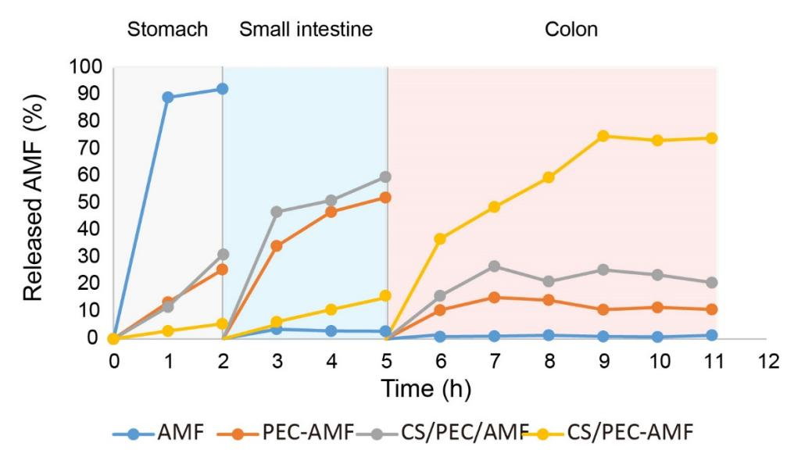
Figure Sup 9 Dissolution of AMF formulations in simulated gastrointestinal environments. AMF formulations were loaded into dialysis tubes, which were then immersed in artificial gastric fluid for 2 hours, followed by artificial intestinal fluid for 3 hours, and artificial colon fluid with 4.5% w/v mouse caecal contents for 6 hours.
Figure Sup 10 (A) In vitro toxicity assessment of AMF, PEC-AMF and CS/PEC-AMF NPs, In vitro toxicity assessment revealed no significant cytotoxicity for AMF, PEC-AMF or CS/PEC-AMF NPs up to 250 μg/mL, (B) ROS generation in FHC cells post X-ray exposure.
Figure Sup 11 (A) Percentage of cell survival, early apoptosis, late apoptosis and apoptosis in different administration groups after radiation stimulation, (B) analysis of cell death using Calcein-AM/PI staining post CS/PEC-AMF NPs treatment, (C) The assessment of intracellular ROS in different treatment groups.
Figure Sup 12 Percentage of immune cell survival, early apoptosis, late apoptosis, apoptosis and dead in different administration groups after radiation stimulation.
Figure Sup 13 The fluorescence imaging of excised gastrointestinal tract after administration with Cy5, PEC-Cy5 and CS/PEC-Cy5 NPs at different times. Fluorescence intensity of Cy5 in (A) Small intestine and (B) Caecum.
Figure Sup 14 Diagram of CS/PEC-AMF NPs administration and radiation treatment in mice.

Figure Sup 15 CS/PEC-AMF NPs alleviate acute bowel injury induced by radiation. CS/PEC-AMF NPs reduce radiation-induced ROS levels, as measured by (A) flow cytometry and (B) microplate fluorometric assay, (C-D) apoptosis in colon tissue, and (E) DNA double-strand breaks.
Figure Sup 16 CS/PEC-AMF NPs protection of (A) reduced expression of tight junction protein and (B) quantitative analysis in radiation-induced acute intestinal injury.
Figure Sup 17 (A) Comparison of Ace Index between NPs and X-Ray Groups and between X-Ray and Control Groups, (B) β diversity of the gut microbiota after treatment with CS/PEC-AMF NPs.
Figure Sup 18 (A) Barplot of microbial abundance at the Family and Genus levels across different treatment groups, (B) Heatmap showing microbial abundance at the Family and Genus levels across different treatment groups.
Figure Sup 19 (A) LDA bar plot showing microbial taxa with significant differences between CS/PEC-AMF NPs and X-Ray groups based on LEfSe analysis, (B) Bar plot showing the mean proportion of microbial communities at the Class level and Order level across different treatment groups, and boxplot showing the proportion of Bacteroidia at the Class level and Bacteroidales at the Order level across different treatment groups.
Figure Sup 20 (A) Immunofluorescence, (B-C) flow cytometry, and (D) quantitative analysis demonstrate that CS/PEC-AMF NPs promote the polarization of macrophages from the activated M1 to M2 phenotype, thereby enhancing anti-inflammatory effects and tissue repair.
Figure Sup 21 (A) Immunofluorescence, (B-C) flow cytometry of DCs and monocytes, and (D) quantitative analysis. It demonstrate that CS/PEC-AMF NPs significantly reduce the infiltration of monocytes and neutrophils, while increasing the number of DCs.

Figure Sup 22 CS/PEC-AMF NPs attenuates apoptosis of intestinal tissue in radiation-induced chronic intestinal injury.
Figure Sup 23 (A) WB evaluated CS/PEC-AMF NPs to reduce the expression of inflammatory factors, fibrosis and tight junction protein in intestinal tissue in radiation-induced chronic intestinal injury; (B) immunofluorescence also showed that CS/PEC-AMF NPs reduced radiation-induced inflammation.
Figure Sup 24 Diagram of orthotopic colon cancer construction.
Figure Sup 25 (A) Lung morphology, (B) Lung morphology (reverse side), and (C-D) histopathological analysis demonstrate that the use of CS/PEC-AMF NPs alleviates tumor lung metastasis, (E) Lung tumor nodules per mouse.
Figure Sup 26 Diagram of Orthotopic Rectal Cancer Construction.
Figure Sup 27 (A) Bar plot showing differentially regulated genes between X-Ray and Control groups, and (B) volcano plot illustrating gene expression changes between X-Ray and Control groups, (C) Volcano plot showing gene expression changes between CS/PEC-AMF NPs and Control groups.
Figure Sup 28 Cluster analysis of upregulated genes in the CS/PEC-AMF NPs group compared to the X-Ray group.
Figure Sup 29 Luminex analysis showing the levels of inflammatory cytokines across different treatment groups.
Figure Sup 30 CS/PEC-AMF NPs exhibit excellent biocompatibility, (A) causing no inflammatory infiltration in major organs and (B) inducing no significant changes in key serum markers.

