Supporting Information
Efficient visible light-driven photocatalytic CO₂ reduction by self-assembled CsPbBr₃ perovskite quantum dots on two-dimensional Bi₂O₂CO₃ petals
Won Seok Cho, Jin Hyuk Cho, Jae Yong Park, Wan Jae Dong*, Soo Yong Kim*, Jong-Lam Lee*

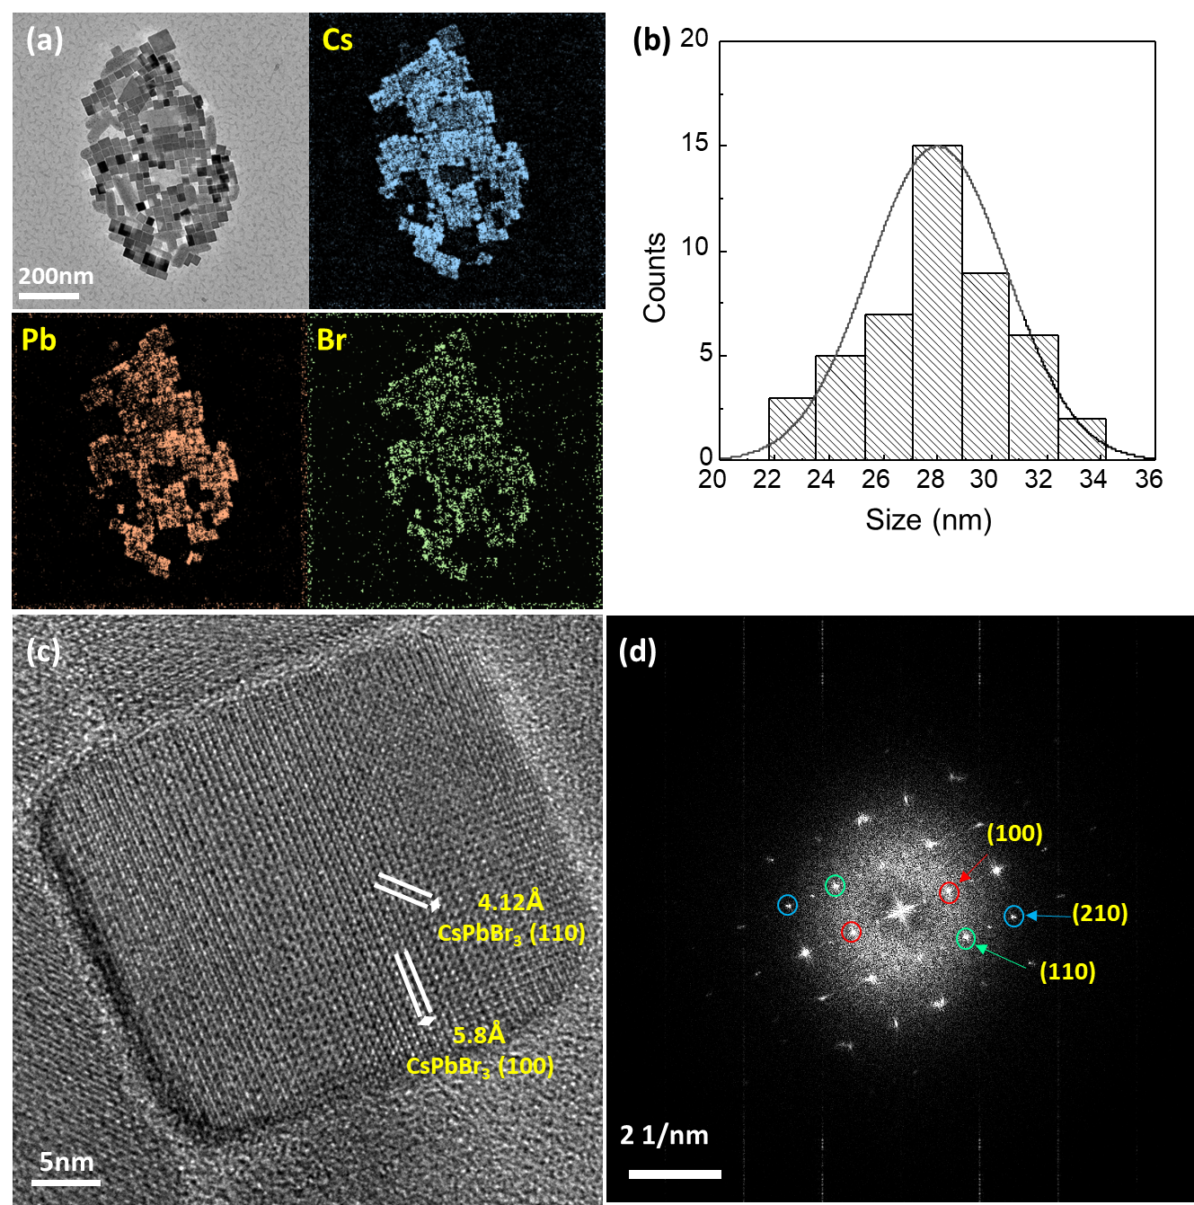
Fig. S1 (a) Transmission electron microscope (TEM) image and electron energy loss spectroscopy (EELS) elemental map of CPB QD. (b, c) High-resolution TEM images and (d, e) electron diffraction patterns of CPB QD.

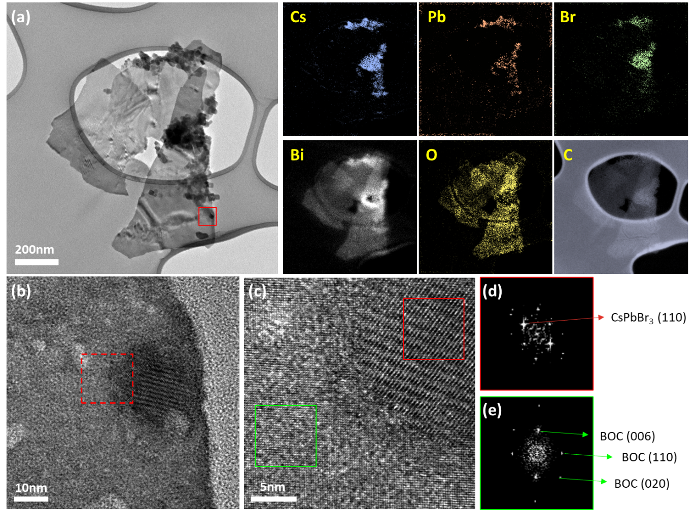
Fig. S2 (a) Transmission electron microscope (TEM) image and electron energy loss spectroscopy (EELS) elemental map of CPB QD/BOC. (b, c) High-resolution TEM images and (d, e) electron diffraction patterns of CPB QD/BOC.

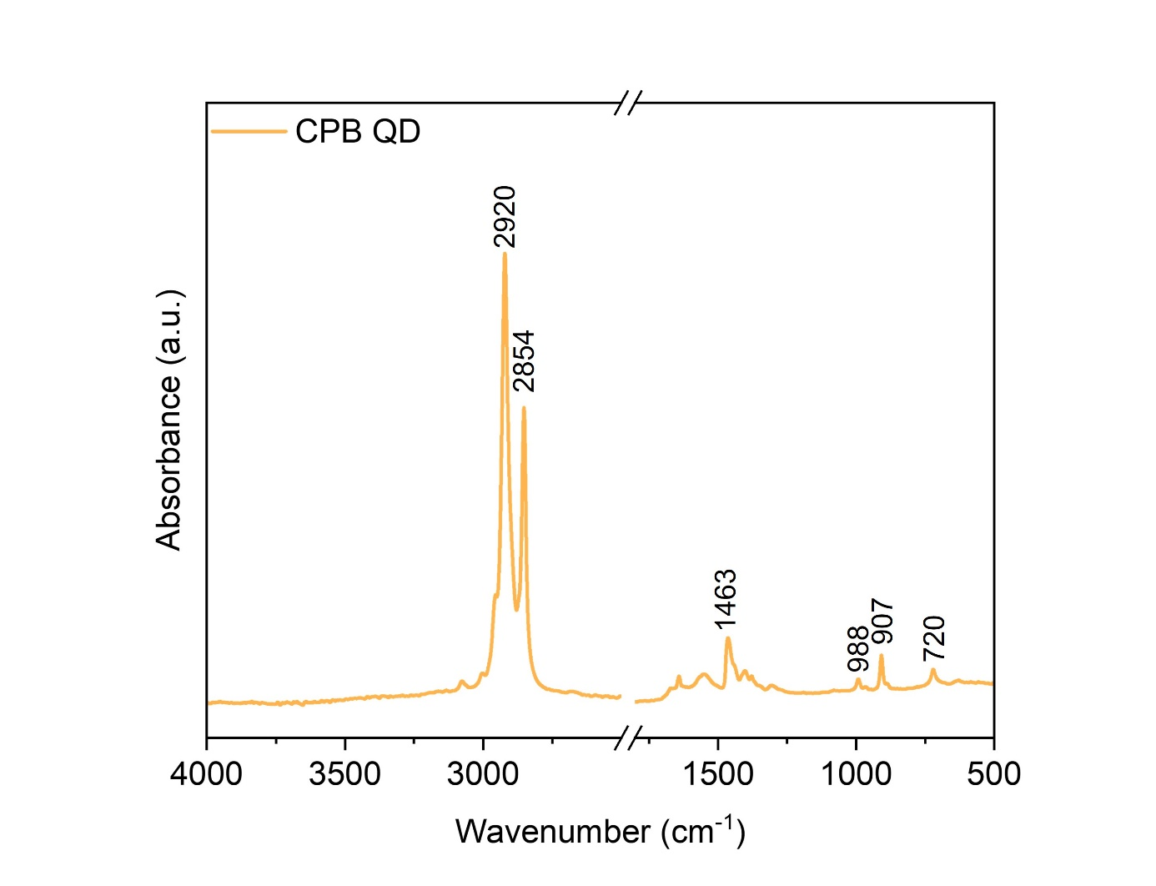
Fig. S3 FTIR spectra of CPB QDs.
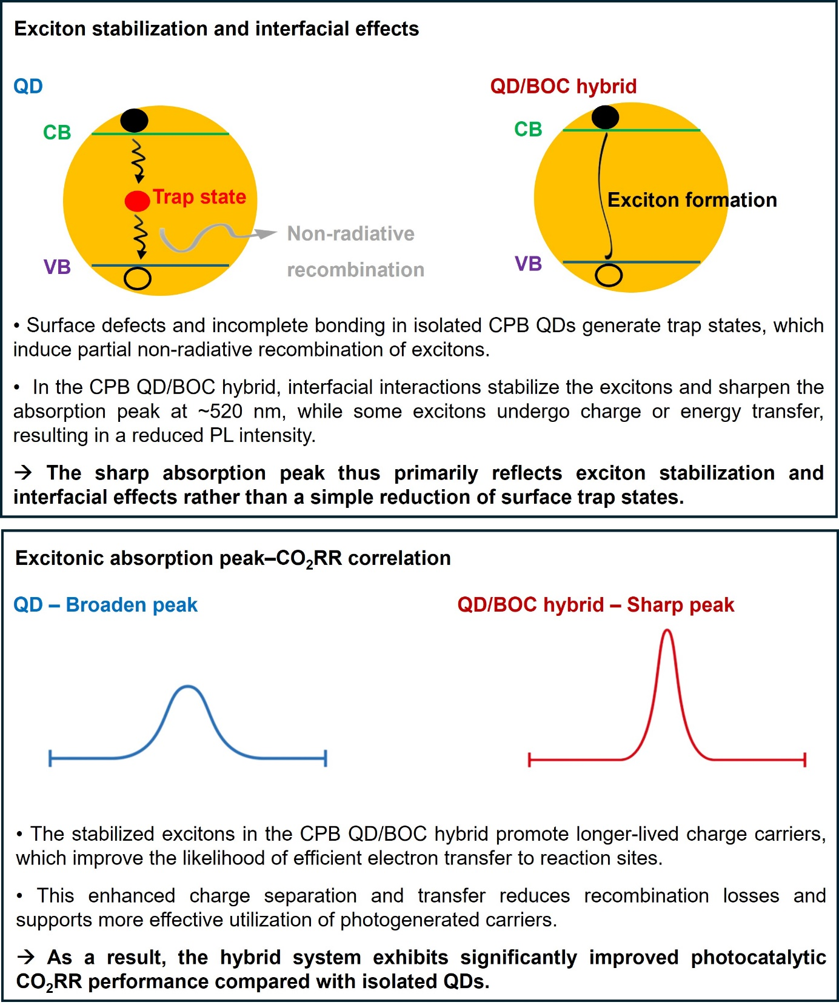
Fig. S4 Mechanism for the enhanced excitonic peak in CPB QD/BOC hybrids compared to isolated CPB QDs.

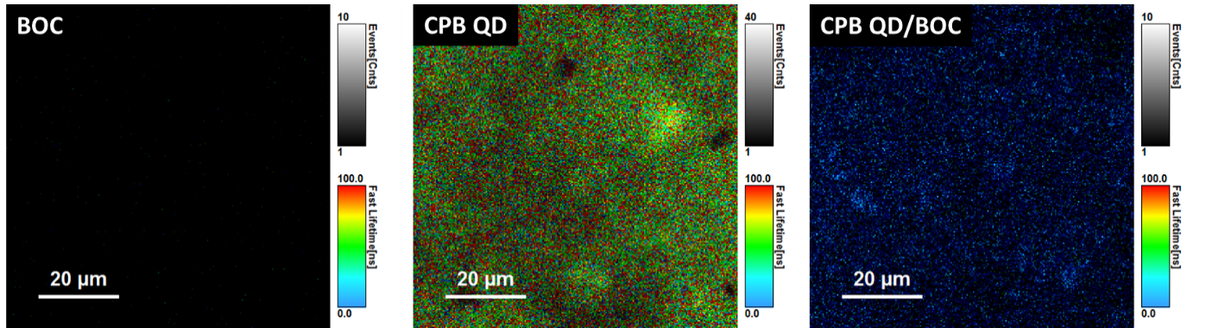
Fig. S5 Photoluminescence mapping images of BOC, CPB QD, and CPB QD/BOC at an excitation wavelength of 375 nm.

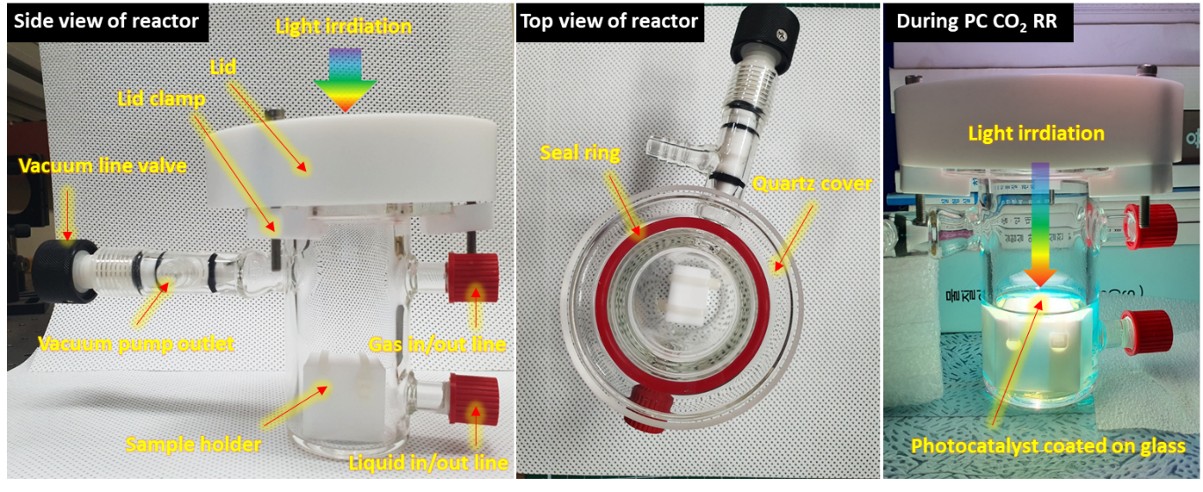
Fig. S6 Photograph images of PC CO₂ RR reactor and its components.

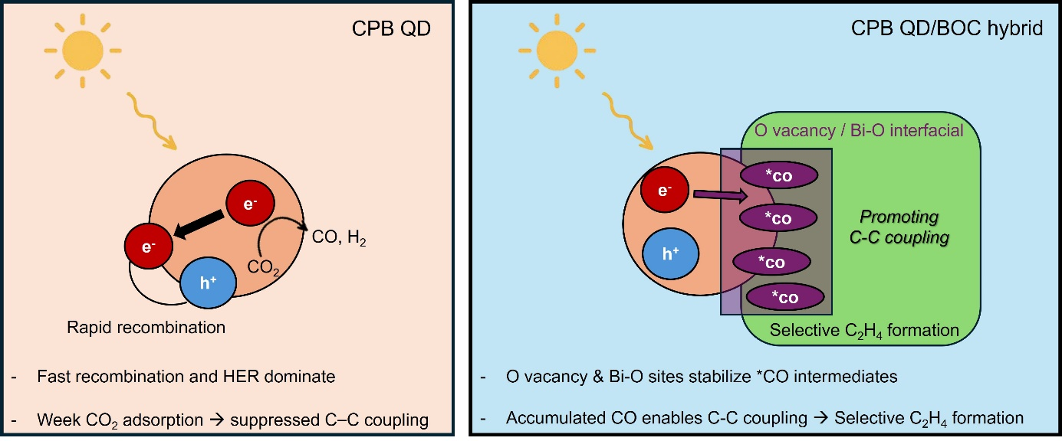
Fig. S7 Proposed mechanism for C₂H₄ formation in the CPB QD/BOC hybrid photocatalyst.

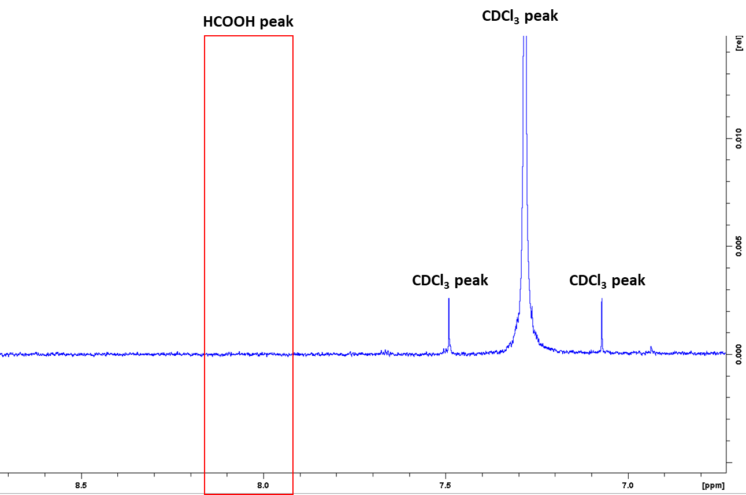
Fig. S8 500 MHz 1H 1D liquid nuclear magnetic resonance spectra of CPB/QD BOC.

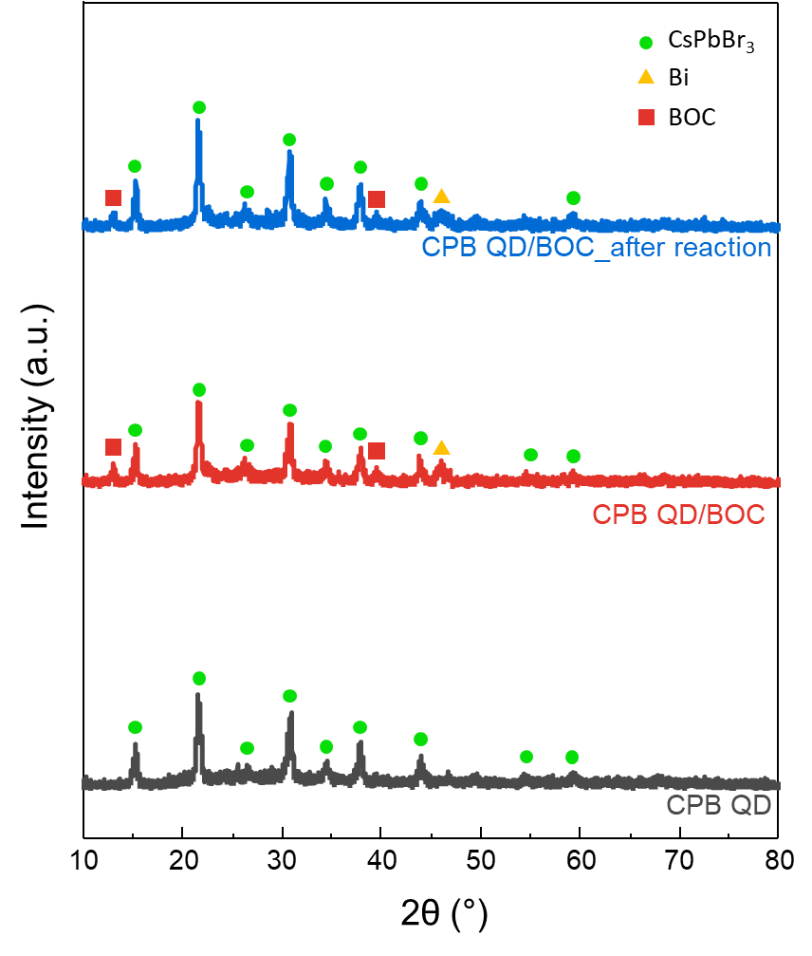
Fig. S9 XRD patterns of CPB QD, CPB QD/BOC, and CPB QD/BOC after PC CO₂ RR.

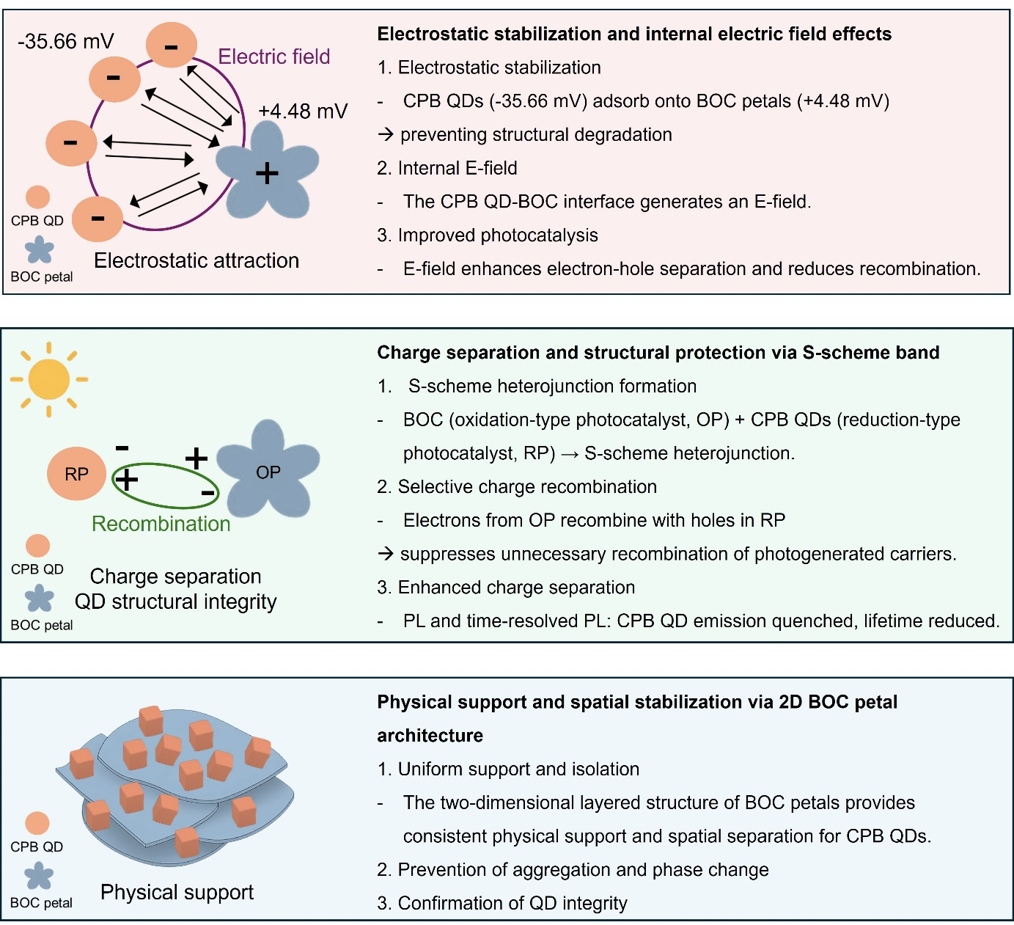
Fig. S10 Electrostatic attraction, S-scheme charge separation, and 2D structural support in CPB QD/BOC hybrid for enhanced cycling stability.

Table S1 Calculated time constants of CPB QD and CPB QD/BOC photocatalyst based on time-resolved photoluminescence spectra.
Photocatalyst | τ_{amp} (ns) | τ₁ (ns) | τ₂ (ns)
CPB QD | 1.7 | 1.06 | 4.9
CPB QD/BOC | 0.09 | 0.28 | 0.04

Table S2 Performance comparison of PC CO₂ RR based on CPB QD material from recent literature.
Photocatalyst | Conditions | Light source | Products  (μmol g^{–1} h^{–1}) | Ref
CsPbBr₃ QD/BOC | Ethyl acetate/DI | 150W Xe lamp  200 mW cm⁻² | CO 80.5  CH₄ 12.2  C₂H₄ 10.7 | This work
CsPbBr₃ | Ethyl acetate | 100W Xe lamp | CO 4.3  CH₄ 1.5  H₂ 0.1 | R1
CsPbBr₃/GO | Ethyl acetate | 100W Xe lamp  150 mW cm⁻² | CO 4.9  CH₄ 2.5  H₂ 0.13 | R2
CsPbBr₃/ZIF-8 | Gas (CO₂ + H₂O) | 100W Xe lamp  150 mW cm⁻² | CO 0.5  CH₄ 1.8 | R3
CsPbBr₃ QDs/PCN | Acetonitrile/water | 300W Xe lamp | CO 148.9 | R4
CsPbBr₃ NC/a-TiO₂ | Ethyl acetate/IPA | 150W Xe lamp  150 mW cm⁻² | CO 3.9  CH₄ 6.7  H₂ 1.5 | R5
CsPbBr₃/USGO  /α-Fe₂O₃ | Acetonitrile/water | 300W Xe lamp  100 mW cm⁻² | CO 73.8 | R6
CsPbBr₃/P3HT | Acetonitrile/DI | 300W Xe lamp | CO 145.45  CH₄ 23.05 | R7

References
[R1] J. Hou, S. Cao, Y. Wu, Z. Gao, F. Liang, Y. Sun, Z. Lin, L. Sun, Chem. Eur. J. 23 (2017), 9481-9485.
[R2] Y.-F. Xu, M.-Z. Yang, B.-X. Chen, X.-D. Wang, H.-Y. Chen, D.-B. Kuang, C.-Y. Su, J. Am. Chem. Soc. 139 (2017), 5660-5663.
[R3] Z.-C. Kong, J.-F. Liao, Y.-J. Dong, Y.-F. Xu, H.-Y. Chen, D.-B. Kuang, C.-Y. Su, ACS Energy Lett. 3 (2018), 2656-2662.
[R4] M. Ou, W. Tu, S. Yin, W. Xing, S. Wu, H. Wang, S. Wan, Q. Zhong, R. Xu, Angew. Chem. 130 (2018), 13758-13762.
[R5] Y. F. Xu, X. D. Wang, J. F. Liao, B. X. Chen, H. Y. Chen, D. B. Kuang, Adv. Mater. interfaces 5 (2018), 1801015.
[R6] Y. F. Mu, W. Zhang, G. X. Dong, K. Su, M. Zhang, T. B. Lu, Small 16 (2020), 2002140.
[R7] L. Li, Z. Zhang, C. Ding, J. Xu, Chem. Eng. J. 419 (2021), 129543.

