Supplementary Materials for
A Senolysis-Targeting Bioenergetic Nanoplatform for Diabetic Wound healing
Zijun Zheng¹, Xuerong Wei¹, Ziwei Jiang¹, Daping Xie², Pengwei Shi³, Jun Ma¹, Qiuyi Yu¹, Yufang He¹, Yanbin Gao¹*, Chunming Wang²*, Lei Yang¹*

¹ Department of Burns, Nanfang Hospital, Southern Medical University; Jingxi Street, Baiyun District, Guangzhou, 510515, P.R. China.
² State Key Laboratory of Quality Research in Chinese Medicine, Institute of Chinese Medical Sciences, University of Macau, Taipa, Macau SAR, China.
³ Emergency Department, Nanfang Hospital, Southern Medical University; Jingxi Street, Baiyun District, Guangzhou, 510515, P.R. China.

This PDF file includes:
Experimental Section
Supplementary Figures

- Experimental Section
Cell Culture in Conditioned Medium: Fibroblasts were cultured in DMEM medium (Gibco, C11995500BT) supplemented with 10% fetal bovine serum (FBS; Gibco, A5256701) and 1% antibiotic-antimycotic mixture (Biosharp, BL142A) at 37 ℃ and 5% CO₂. For the senescent fibroblasts, we initially prepared an HG medium by diluting a D-glucose solution (200 g L⁻¹) (Procell, PB180418) with a DMEM medium to achieve a glucose concentration of 35 mM. ASCs were cultured in DMEM -F12 (Gibco, C11330500BT) with 10% FBS and 1% antibiotic-antimycotic mixture. All Primary cells were cultured through P2 to P5 for subsequent experiments. The co-culture system was established by seeding normal fibroblasts on the bottom of 6-well plates and placing senescent fibroblasts along with the materials in Transwell inserts (Corning, 3412).

Stem cell differentiation staining: ASCs were cultured to 70-80% confluence and treated with adipogenic or osteogenic induction medium. The cells were induced by adipogenic induction medium for 14 days and by osteogenic induction medium for 21 days. After being washed with PBS and fixed with paraformaldehyde, adipogenic differentiation staining was conducted using Oil Red O solution (Biosharp, BL987B) for 30 min to check for the formation of lipid droplets; and osteogenic differentiation staining (Procell, PD-007) was performed using a 1% Alizarin Red solution for 20 min to observe the calcified nodules.

Particle size and zeta potential analysis: To analyze the particle size and zeta potential of extracellular vesicles, 1 mL of a 0.5 mg/mL solution was placed in a sample cup and measured using a dynamic light scattering instrument (Microtrac Camsizer X2) and nanoparticle tracking analysis (ZetaView x30), with each sample tested in triplicate.

Western blotting: After lysing the cells in RIPA lysis buffer (EpiZyme,PC102) containing protease and phosphatase inhibitor, the resulting mixture was centrifuged to collect the proteins. The concentration of the proteins was then determined using the BCA protein assay kit (EpiZyme, ZJ101L). After separation by SDS-PAGE (EpiZyme, PG212 & WJ103), protein samples were transferred to a PVDF membrane (0.2 μm, Merck millipore). The membrane was blocked with a quick-blocking solution (EpiZyme, PS108P) for 15 min at RT. Next, the trimmed membrane was separately placed into diluted primary antibody and incubated overnight on a rocking platform at 4 ℃. The membrane was incubated with appropriately diluted secondary antibodies for 1 h. After washing with TBST, bands were visualized using ECL reagent, and images were quantified using ImageJ.

Antibodies used for immunoblotting were shown as following: rabbit polyclonal anti- p16INK4a (Thermo Fisher, PA5-20379), rabbit monoclonal anti-p21 (abcam, ab188224), rabbit monoclonal anti-AMPK alpha-1 (Proteintech, MA5-53542), rabbit monoclonal anti-AMPK alpha 1 (T183) + AMPK alpha 2 (T172) (abcam, ab133448), rabbit polyclonal anti- SIRT1 (Proteintech, 13161-1-AP), rabbit polyclonal anti-LC3B (Proteintech, 18725-1-AP), mouse monoclonal anti- Beta actin (Proteintech, 66009-1-Ig), HRP-conjugated anti-rabbit IgG (Proteintech, SA00001-2), HRP-conjugated anti-mouse IgG (Proteintech, SA00001-1).

Characterization of drug release concentration: AICAR was dissolved in PBS at concentration gradients of 5, 10, 20, 30, 40, and 50 mM mL⁻¹, respectively. The wavelength-absorbance relationship curves were then plotted using a Nanodrop UV-Vis spectrophotometer (SPT-NanoF). Standard curves were constructed based on the absorbance values corresponding to the peak wavelengths. Then, the absorbance of AICAR at different concentration gradients of 0.25, 0.5, 0.75, 1, 1.25, and 1.5 mM mL⁻¹ was measured, and the encapsulation efficiency (EE) and drug loading capacity (DLC) of the composite EVs were calculated based on the standard curve, with the following formulas:

$$\text{EE (\%)= ∆M / M}\text{t}\text{ ×100\%}$$$$\text{DLC (\%) = ∆M / M}\text{e}\text{ ×100\%}$$

where M_{t} (g) is the total amount of AICAR added, ∆M (g) is M_{t} minus the amount of AICAR not encapsulated in EVs, and M_{e} (g) is the total mass of the EVs plus AICAR.

Cell cytotoxicity assay：Suitable amounts of SF and NF were evenly seeded in a 96 well plate, with a blank control (cell - free medium). Each group was triplicated with ~1 × 10⁴ cells per well. 100 µL of culture medium with vesicles (Ctrl, EVs, GEVs, GEAs) were added to each well and incubated for 12 h, followed by CCK-8 assay (Glpbio, GK10001) for 2 h to assess the cytotoxicity of engineered EVs. On the other hand, NFs were cultured for 12 h with medium soaked with Gel or different concentrations of NGel for 12 h, and then the CCK-8 assay was performed for 2 h to evaluate hydrogel cytotoxicity.

SA-𝛽-gal staining: According to the manufacturer’s instructions, the fibroblasts was fixed with 4% paraformaldehyde, and a β-galactosidase kit (Beyotime, C0602) was used to stain in a 37 ℃ incubator for 8 h. Then, the samples were observed and photographed under an optical microscope.

Cellular ROS Determination: For detecting the intracellular ROS levels, each group of EVs or Gel in transwell was co-incubated with fibroblasts for 3 days. Subsequently, cells were incubated with the 2’,7’-dichlorodihydrofluorescein diacetate (DCFH-DA) probe (Beyotime, S0033S) for 30 min, washed with PBS. Hoechst was used to stain the nuclei of fibroblasts. The image was observed in fluorescence microscope and analyzed in image J software.

Swelling properties test: NGel and Gel samples were selected with uniform diameter, height and mass, and repeat three times. The samples were frozen and dried to remove water, and recorded the dry mass as W₀. Then, the dried materials were completely soaked in saline in a 37 ℃ water bath, taken out at 1, 2, 4, 6, 8, 12 and 24 hours, and weighed immediately after removing the surface liquid to record the mass as W_{n}. The swelling ratio was calculated using the following formula:

$$S_{r}=(W_{n}−W_{0}) / W_{0} × 100\%$$

Degradation properties test: Similarly, NGel and Gel hydrogels of uniform mass were selected, and their initial masses (W₀) were recorded. 3 mL of simulated body fluid was added to 5 mL centrifuge tubes, and the NGel and Gel hydrogels were placed into the corresponding tubes, which were incubated in a thermostatic shaker at a shaking speed of 120 rpm for 28 days. Samples were removed on days 7, 14, 21, and 28, and the masses of the samples (W_{n}) were measured after surface moisture blotting. The in vitro degradation rate of the hydrogels was calculated using the following formula:

$$D_{r}=(W_{0}−W_{n}) / W_{0} × 100\%$$

Immunofluorescence Staining: Cells were fixed with 4% paraformaldehyde for 10 minutes, permeabilized with 0.1% Triton X-100 for 15 min, and finally blocked in 10% bovine serum albumin (BSA) for 1 h. The hydrated tissue sections underwent antigen retrieval in boiled 0.01 M sodium citrate buffer (pH 6.0) for 20 minutes. After naturally cooling to RT, the sections were incubated with 3% hydrogen peroxide (H₂O₂) for 15 min and then blocked with 5% normal goat serum for 1 h. Subsequently, the cells and tissue sections were separately incubated overnight in diluted corresponding primary antibodies at 4 ℃，and then combined with corresponding secondary antibodies for 1 h. DAPI (1:1000) was employed to stain nuclear for 10 minutes, followed by the addition of an anti-fade mounting medium. Finally, the samples were visualized under a fluorescence microscope.

Antibodies used for immunoblotting were exhibited as following: rabbit monoclonal anti-p21 (abcam, ab188224), rabbit polyclonal anti-ki67 (Proteintech, MA5-14520), rabbit polyclonal anti-fibronectin (Proteintech, PA5-29578), rabbit polyclonal anti- p16INK4a (Thermo Fisher, PA5-20379), rabbit polyclonal anti-CD86 (Affinity, DF6365 DF4149), rabbit polyclonal anti-CD206 (Affinity, DF4149), rabbit polyclonal anti-α-SMA (Affinity, AF1032), CoraLite488-conjugated anti-rabbit IgG (Proteintech, SA00013-2), CoraLite594-conjugated anti-rabbit IgG (Proteintech, SA00013-4).

NAD+/NADH ratio and ATP levels: Approximately 1×10⁶ cells from each group (NGel@GEAs, NGel, GEAs, and control) were harvested. Following the protocols of the NAD+/NADH assay kit (UElandy, N6035S) and ATP assay kit (Beyotime, S0026), cells were lysed, heated, and centrifuged. The samples were then placed in a 96-well plate, and corresponding working solution and color-developing solution were added. Absorbance was measured using a multifunctional microplate reader.

q-PCR：Total RNA was extracted from cells using RNAiso (BGI, 9109), after which the extracted RNA was reverse-transcribed into complementary DNA (cDNA) using a reverse transcription kit (TaKaRa, RR047A). Real-time quantitative PCR was performed on Light Cycler 480II (Roche) using iTaq™ Universal SYBR® Green Supermix (BIO-RAD, 1725121). The gene primer sequences used in this study, which were derived from mouse fibroblasts, are listed as follows:

Table S1. List of Gene primer sequences
ID | Sequences
TNF-α F | 5' CCTGTAGCCCACGTCGTAG 3'
TNF-α R | 5' GGGAGTAGACAAGGTACAACCC 3'
IL-6 F | 5' CTGCAAGAGACTTCCATCCAG 3'
IL-6 R | 5' AGTGGTATAGACAGGTCTGTTGG 3'
IL-1A F | 5' TCTATGATGCAAGCTATGGCTCA 3'
IL-1A R | 5' CGGCTCTCCTTGAAGGTGA 3'
IL-8 F | 5' TCGAGACCATTTACTGCAACAG 3'
IL-8 R | 5' CATTGCCGGTGGAAATTCCTT 3'
MMP2 F | 5' ACCTGAACACTTTCTATGGCTG 3'
MMP2 R | 5' CTTCCGCATGGTCTCGATG 3'
MMP3 F | 5' GGCCTGGAACAGTCTTGGC 3'
MMP3 R | 5' TGTCCATCGTTCATCATCGTCA 3'
MMP9 F | 5' GCAGAGGCATACTTGTACCG 3'
MMP9 R | 5' TGATGTTATGATGGTCCCACTTG 3'
MMP14 F | 5' ACCCACACACAACGCTCAC 3'
MMP14 R | 5' GCCTGTCACTTGTAAACCATAGA 3'
CXCL-1 F | 5' ACTGCACCCAAACCGAAGTC 3'
CXCL-1 R | 5' TGGGGACACCTTTTAGCATCTT 3'
CXCL-2 F | 5' CCAACCACCAGGCTACAGG 3'
CXCL-2 R | 5' GCGTCACACTCAAGCTCTG 3'
CXCL-9 F | 5' GGAGTTCGAGGAACCCTAGTG 3'
CXCL-9 R | 5' GGGATTTGTAGTGGATCGTGC 3'
CXCL-10 F | 5' CCAAGTGCTGCCGTCATTTTC 3'
CXCL-10 R | 5' GGCTCGCAGGGATGATTTCAA 3'
CXCL-16 F | 5' CCTTGTCTCTTGCGTTCTTCC 3'
CXCL-16 R | 5' TCCAAAGTACCCTGCGGTATC 3'
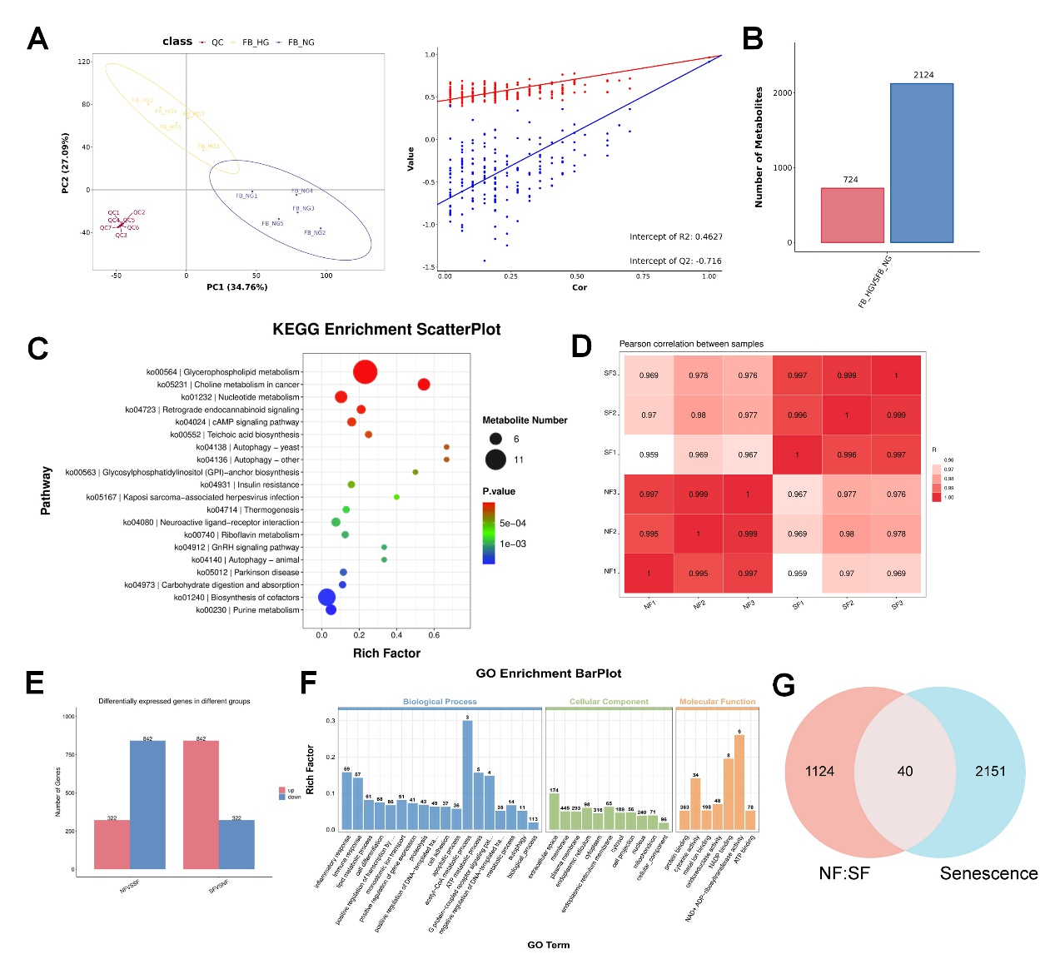
Supplementary Figures

Fig. S1. Transcriptomics and metabolomics analysis of SF-HG and NF-NG groups. A. PLS-DA test. B. Expression of differential metabolites. C. KEGG enrichment analysis bubble plot. D. Transcriptomic Pearson correlation coefficient plot. E. Expression of differential genes. F. GO analysis. G. Venn diagram of the correlation between high glucose-induced fibroblasts and senescence.

Fig. S2. Engineered bio-targeted extracellular vesicles function assessment. A. Morphological and functional assessment of ASCs. a. Morphology of P3 ASCs under light microscopy. b. Stem cell adipogenic differentiation c. Stem cell osteogenic differentiation (Scale bar: 400 µm). B. Zeta potential analysis of a. EVs, b, GEVs and c. GEAs. C. Uptake of EVs and GEVs by NF and SF cells (Scale bar: 20 µm). D. Drug release experiment. a. Absorbance-Wavelength curves of AICAR at different concentrations. b. Standard curve for AICAR release. c. CCK8 for cells intervened by EVs loaded with different concentrations of AICAR (n=3 per group). The data were presented as mean ± SD. Statistical significance was assessed by one-way ANOVA (*P ＜0.05, **P ＜0.01).

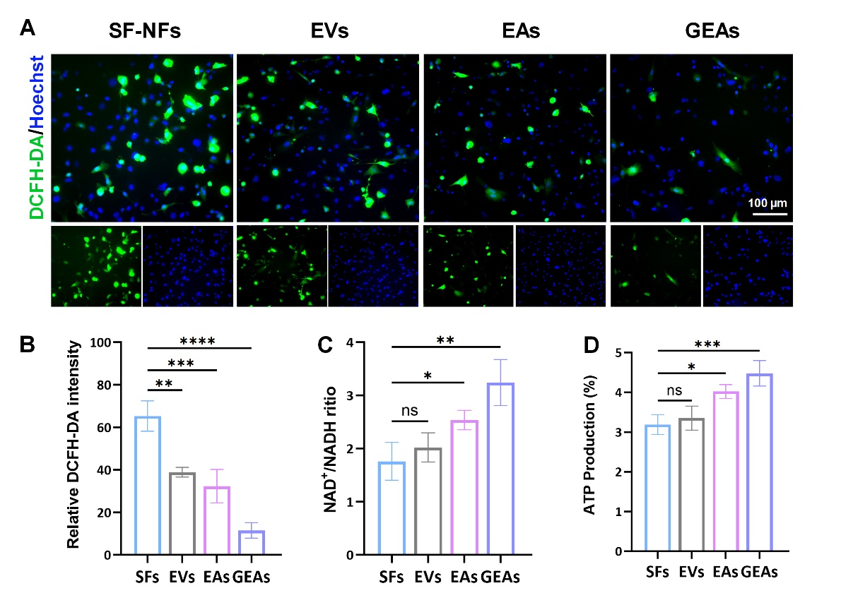

Fig. S3. The principal component analysis for SF-HG and NF-NG groups. A. Cellular ROS detection in DCFH-DA fluorescence (Scale bar: 100 µm). B. Quantification of ROS. C. NAD+/NADH ratio. D. ATP production. The data were presented as mean ± SD. Statistical significance was assessed by one-way ANOVA (n=3 per group) (*P ＜0.05, **P ＜0.01, ***P ＜0.001, ****P ＜0.0001).

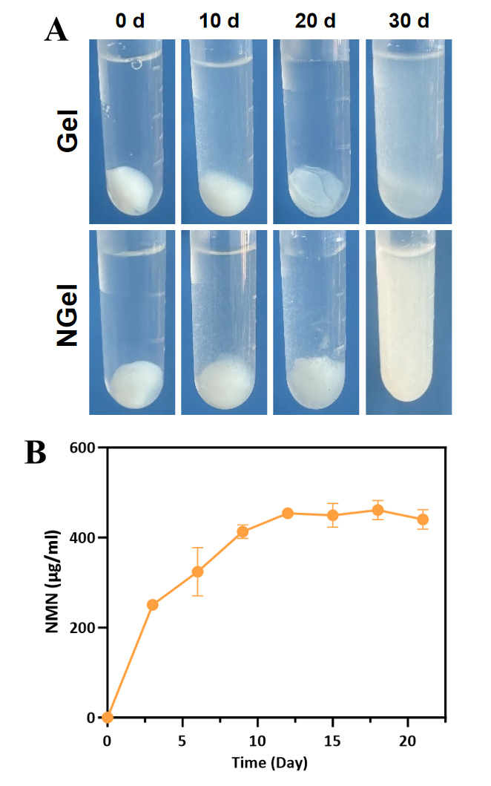
Fig. S4. Hydrogel Degradation and Drug Release Efficiency. A. Hydrogel degradation macroscopic images. B. NMN release experiment of hydrogel.

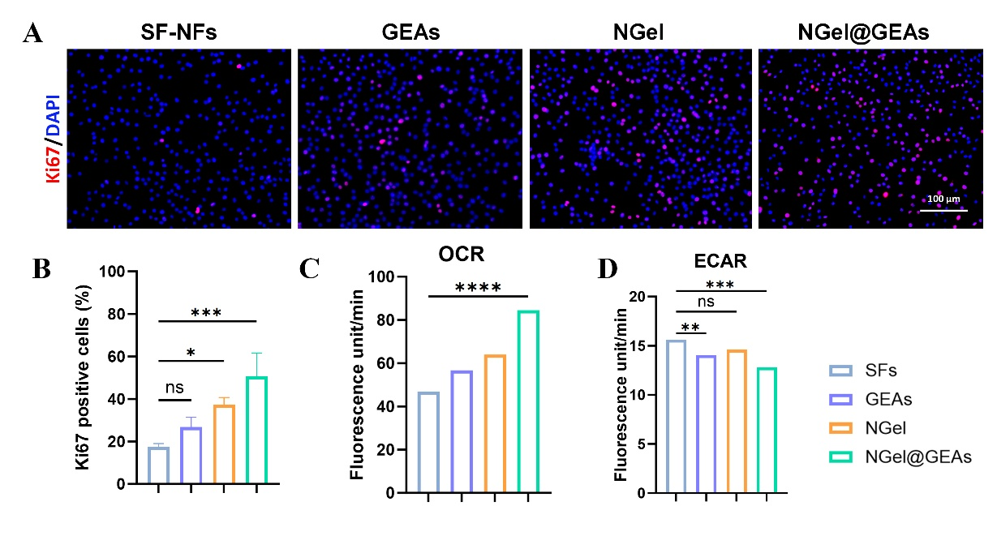

Fig. S5. Adjacent cells and senescent microenvironment function assessment. A. Immunofluorescence staining of Ki67 for surrounding cells (Scale bar: 100 µm). B. Quantitative analysis of Ki67. C. Quantification of OCR slopes. D. Quantification of ECAR slopes. The data were presented as mean ± SD. Statistical significance was assessed by one-way ANOVA (n=3 per group, *P ＜0.05, **P ＜0.01, ***P ＜0.001, ****P ＜0.0001).

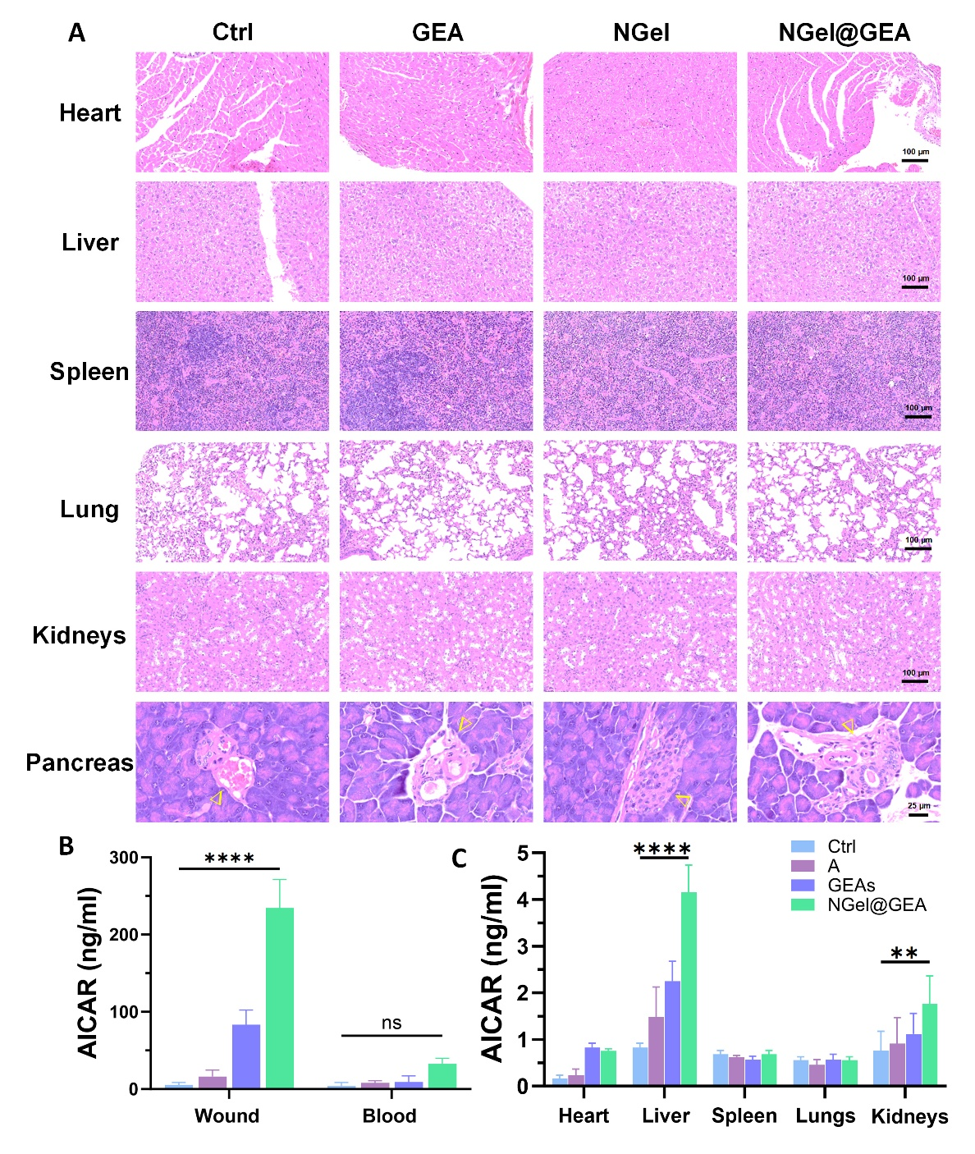

Fig. S6. Organ toxicity test. A. The HE staining of vital organs in vivo. Scale bar: 100 µm. B. AICAR concentrations in blood and local tissues (n=3 per group). C. AICAR concentrations in vital organs (n=3 per group). The data were presented as mean ± SD. Statistical significance was assessed by one-way ANOVA (B and C, **P ＜0.01, ****P ＜0.0001).

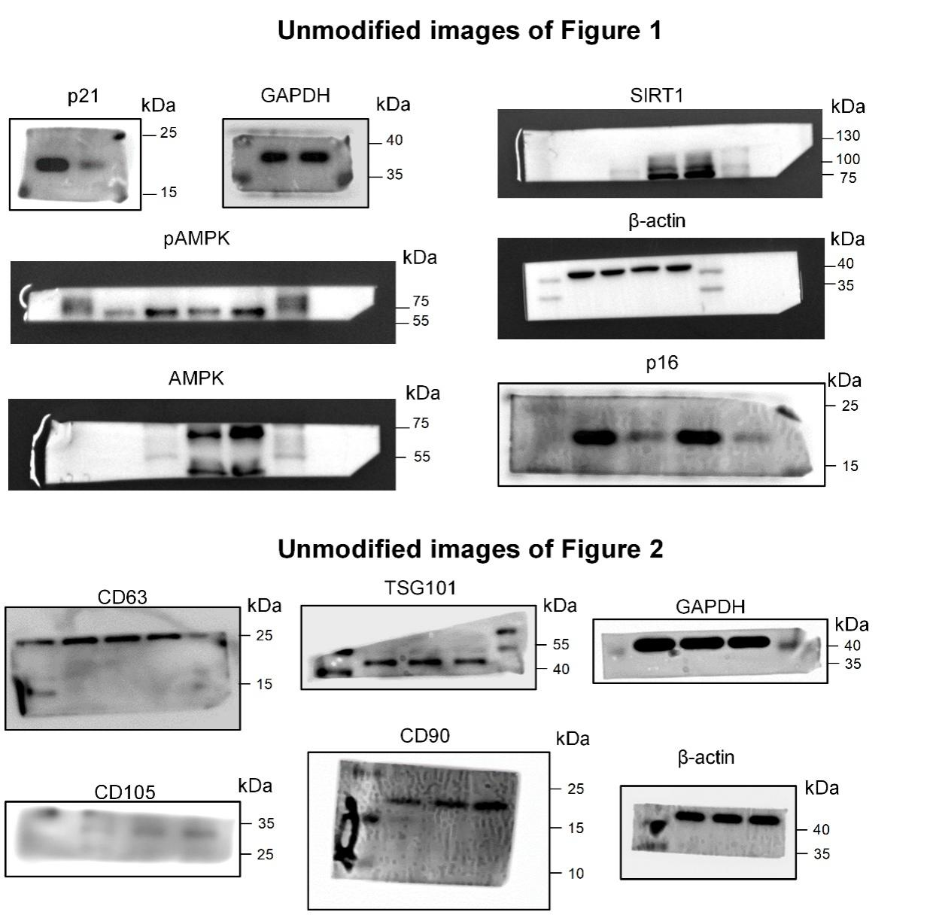
Fig. S7. Original scans of the blots in Figure 1 & 2.

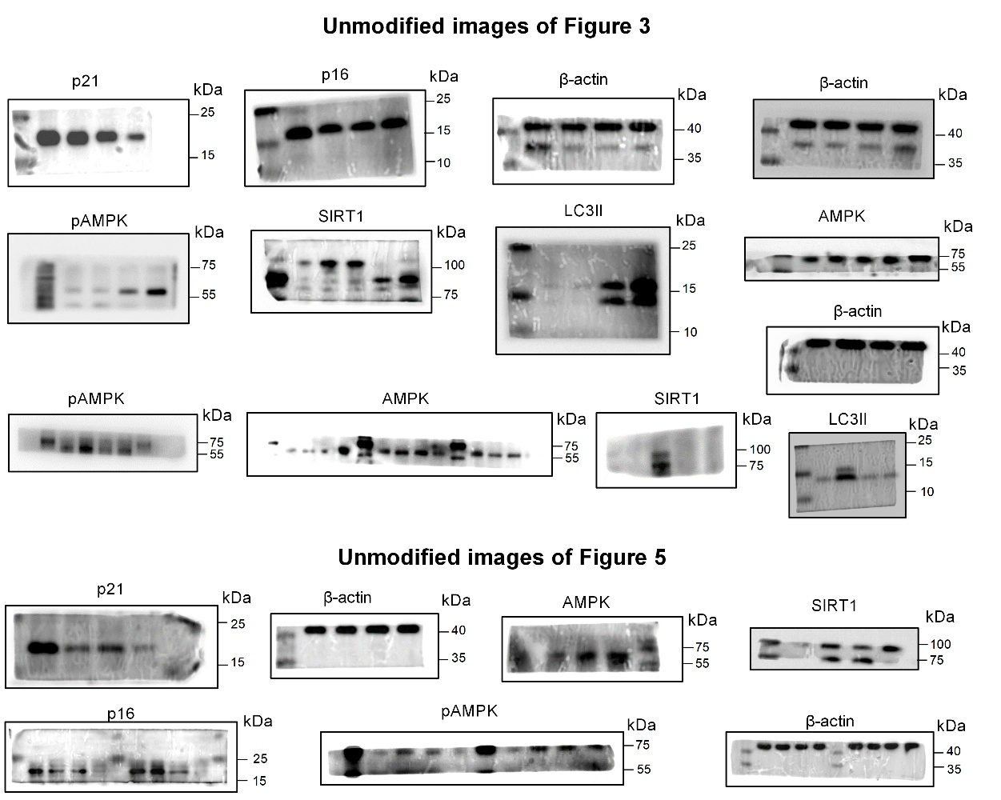

Fig. S8. Original scans of the blots in Figure 3 & 5.

