Reprogramming Endothelial Tip Cell Fate via PI3K-VEGF Signaling Cascade: A Multifunctional Adhesive Hydrogel for Enhanced Angiogenesis and Infected Wound Healing

Tanjun Deng ^{a,1}, Ao Zheng ^{b,c,1}, Yumeng Zheng ^{a,1}, Xiaoxian Zhao ^{d}, Zengguang Wang ^{e}, Haoyu Wang ^{f}, Yun Wang ª, Lingli Hou ^{g}, Jinling Liu ^{b,c}, Sirui Tan ^{h}, Zhengyu Shen ^{a,}* , Lingyan Cao ^{b,c,}*

ª Department of Dermatology, Shanghai Ninth People’s Hospital, Shanghai Jiao Tong University School of Medicine, Shanghai, 200011, China
^{b} Department of Prosthodontics, Shanghai Ninth People’s Hospital, Shanghai Jiao Tong University School of Medicine; College of Stomatology, Shanghai Jiao Tong University, Shanghai, 200011, China
^{c} National Center for Stomatology; National Clinical Research Center for Oral Diseases; Shanghai Key Laboratory of Stomatology; Shanghai Engineering Research Center of Advanced Dental Technology and Materials, Shanghai, 200011, China
^{d} Department of Oral Mucosal Diseases, Shanghai Ninth People’s Hospital, Shanghai Jiao Tong University School of Medicine; College of Stomatology, Shanghai Jiao Tong University, Shanghai, 200011, China
^{e} Department of Orthopaedic Surgery, Shanghai Ninth People's Hospital, Shanghai Jiao Tong University School of Medicine, Shanghai, China
^{f} Department of Dermatology, Huashan Hospital Affiliated to Fudan University, Shanghai, China, Shanghai, 200040, China
^{g} Shanghai Institute of Precision Medicine, Shanghai, 200011, China
^{h} Shanghai Jiao Tong University School of Medicine, Shanghai, 200011, China
¹ These authors contributed equally to this work
* Corresponding authors: cly_linya@163.com (L. Cao); neuronszy@sina.com (Z. Shen)
Abstract:
Infected skin wounds represent a significant healthcare challenge, affecting millions of patients worldwide and imposing substantial economic burden on healthcare systems. Traditional wound dressings and systemic antibiotics face critical limitations including lack of tissue adhesion in wet environments, increasing antibiotic resistance, and inability to promote tissue regeneration, resulting in suboptimal healing outcomes. In this research, we formulated an injectable composite hydrogel comprising dopamine-modified sodium alginate, chondroitin sulfate, and silk fibroin as the primary matrix, with magnesium oxide (MgO) nanoparticles and human umbilical mesenchymal stem cells (hUMSCs)-derived exosomes (Exo) as functional components. The resultant ACS/MgO/Exo hydrogel exhibits effective tissue adhesion, superior hemostatic capability, mild-photothermal therapy (M-PTT)-mediated antibacterial activity, and enhanced angiogenesis. in vitro studies demonstrated that the hydrogel effectively reduced bleeding time, eliminated bacteria through M-PTT, and significantly enhanced endothelial tip cell activation, proliferation, motility, and vascularization through activation of the PI3K-AKT-NF-κB-VEGF signaling cascade. in vivo experiments with infected full-thickness defect model confirmed the composite hydrogel's ability to accelerate wound closure, eliminate bacterial infection, enhance collagen deposition, and promote vascularization while simultaneously modulating the inflammatory response. This multifunctional hydrogel represents a promising therapeutic platform for complex infected wound management, addressing the critical clinical need for integrated solutions that simultaneously achieve adhesion, hemostasis, infection control, and tissue regeneration
Keywords:
Adhesive hydrogel, Hemostasis, Exosomes, Photothermal therapy, Wound healing

1. Introduction
Infected skin wounds represent a significant healthcare challenge, affecting millions of patients worldwide and imposing substantial economic burden on healthcare systems[1, 2]. The complexity of infected wound healing involves multiple intricate biological processes, including hemostasis, inflammation regulation, angiogenesis, and tissue regeneration. Particularly, bacterial infection can severely impair these healing processes by disrupting the normal wound healing cascade, triggering excessive inflammatory responses, and compromising tissue regeneration, ultimately resulting in chronic wounds resistant to conventional treatments[3, 4]. Therefore, developing an effective therapeutic strategy that can simultaneously address infection control and tissue regeneration remains an urgent clinical need.
Currently available treatments for infected skin wounds, including traditional dressings and systemic antibiotics, face significant limitations in clinical practice[5]. Traditional dressings often fail to maintain appropriate moisture levels and lack the ability to actively combat bacterial infection[6]. While systemic antibiotics have been widely used, their effectiveness is increasingly compromised by the emergence of antibiotic-resistant strains and potential systemic side effects[7]. Furthermore, these conventional approaches typically cannot promote tissue regeneration or angiogenesis, leading to suboptimal healing outcomes in complex wound environments. Hydrogel-based dressings have emerged as promising alternatives because of their unique advantages: high water content that mimics extracellular matrix, excellent biocompatibility, and capability to establish a hydrated microenvironment conducive to wound healing[8-10]. Additionally, hydrogels can serve as versatile platforms for incorporating various therapeutic agents to achieve multiple functions[11-15]. However, most existing hydrogels still face challenges in terms of adhesion to wet tissue surfaces, controlled degradation, and limited multifunctional integration[16-18]. Therefore, there is an urgent need to develop an advanced adhesive hydrogel that can simultaneously achieve hemostasis, resist bacterial infection, and promote angiogenesis for effective infected wound management.
Mussel-inspired materials, particularly those utilizing L-3,4-dihydroxyphenylalanine (DOPA) from mussel foot proteins, have emerged as promising candidates for wet adhesives due to their unique catechol-mediated underwater adhesion properties[19-21]. Dopamine, a DOPA analogue derived from tyrosine, when conjugated with sodium alginate (AD), not only provides adhesive functionality through its catechol groups but also enables photothermal therapy (PTT) for potential antibacterial applications[22, 23]. Chondroitin sulfate (CS), an extracellular matrix-derived sulfated glycosaminoglycan, exhibits intrinsic antibacterial properties and modulates inflammatory responses during wound healing[15, 24]. Its tissue adhesion capability can be enhanced through N-hydroxysuccinimide-mediated formation of covalent amide bonds with tissue surface –NH₂ groups, representing one of three primary types of dynamic covalent bonds in biological adhesion alongside Schiff base and isocyanate bonds[25, 26]. Silk fibroin (SF), derived from Bombyx mori silk, offers excellent biodegradability, biocompatibility and presents mechanical properties by forming β-sheet structures[27-29]. It is reported that MgO particles can interact electrostatically with negatively charged SF, accelerating gelation kinetics and enhancing the structural stability of the hydrogel network[30]. MgO exhibits distinctive antibacterial properties through multiple mechanisms and demonstrates excellent biological safety. Upon hydrolytic ionization, MgO generates magnesium ions (Mg²⁺), which not only demonstrate intrinsic antibacterial activity but also play a vital role in the coagulation cascade by occupying specific binding sites in the Gla domain of coagulation factors, enabling optimal activation kinetics for factors IX, X, thus promoting platelet aggregation and subsequent hemostasis[31, 32]. The combination of dopamine-modified sodium alginate, chondroitin sulfate, silk fibroin, and MgO constructs a multifunctional therapeutic hydrogel platform that synergistically provides tissue adhesion, bacterial inhibition, and hemostasis for infected wound management.
Human umbilical mesenchymal stem cells (hUMSCs) represent a promising therapeutic avenue for tissue restoration due to their multipotent differentiation abilities and secretion of regenerative bioactive factors that facilitate healing processes[33, 34]. However, the clinical use of hUMSCs faces challenges including immune rejection, reduced post-transplantation viability, and inconsistent therapeutic efficacy [35, 36]. As an alternative, hUMSC-derived exosomes (Exo) have shown great potential in skin wound healing[37]. These exosomes are small extracellular vesicles capable of transferring proteins, lipids, and RNA, thus facilitating intercellular communication and promoting regenerative processes[38]. Although exosomes from hUMSCs have demonstrated benefits in enhancing skin regeneration and wound healing, an effective strategy for their localized and sustained release to accelerate tissue repair or angiogenesis remains an essential area of development. To address this challenge, hydrogel-based delivery systems have emerged as a promising solution for controlled exosome release in tissue regeneration[39-43].
In this study, we developed an injectable hydrogel composed of dopamine-modified sodium alginate, chondroitin sulfate, silk fibroin, MgO, and hUMSC-derived exosomes (ACS/MgO/Exo hydrogel) for infected wound management. The composite hydrogel incorporates tissue adhesion for wound site retention, hemostatic capability through its interconnected network, and photothermal antibacterial activity mediated by dopamine components. MgO nanoparticles serve as porogens with pH sensitivity while releasing magnesium ions that contribute to antibacterial efficacy and hemostasis. Additionally, the synergistic effects of exosomes and magnesium ions enhance angiogenesis promotion. The engineered porous structure facilitates controlled release of therapeutic components, maintaining sustained biological activities during wound healing. We conducted systematic evaluations of the hydrogel's physicochemical properties, antibacterial efficacy, and wound healing performance through in vitro and in vivo studies. These findings highlight the therapeutic potential of the developed composite hydrogel for managing infected wounds in clinical settings. (Scheme 1).
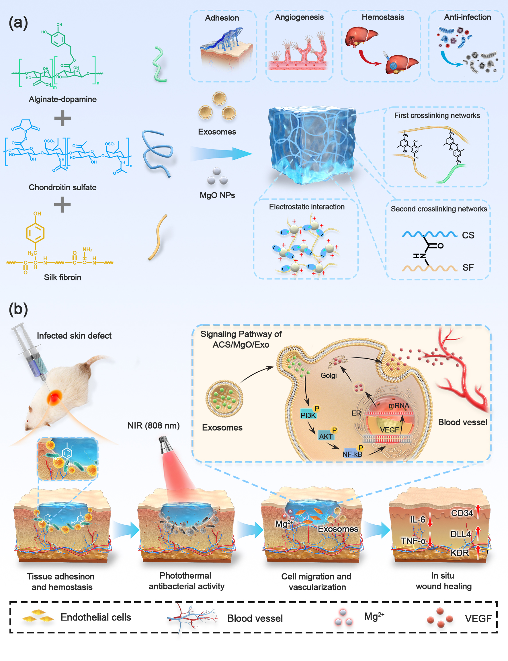
Scheme 1. Schematic illustration of the ACS/MgO/Exo hydrogel as a multifunctional wound dressing for infected skin wound healing. (a) The synthesis and fabrication process of ACS/MgO/Exo hydrogels. (b) The mechanism for infected skin wound healing by injecting hydrogels.
2. Materials and methods
2.1. Materials
Chondroitin sulfate (CS, 95%), Sodium alginate (SA), N-(3-dimethylaminopropyl)-N'-ethylcarbodiimide hydrochloride (EDC), dopamine hydrochloride (DA·HCl, 98%), sodium carbonate (Na₂CO₃, 99.99%), N-hydroxysuccinimide (NHS), calcium chloride (CaCl₂, 99.99%) and horseradish peroxidase (HRP, >300 U/mg) were obtained from Aladdin (China). Magnesium oxide nanoparticles (MgO) were obtained from HAOMING Tech Co., Ltd. (China). Silkworm cocoons from Bombyx mori were sourced from Jiangsu Province, China. All animal studies adhered to the ethical protocols established by the institution (Approval No. SH9H-2023-A820-1, Shanghai Jiao Tong University School of Medicine). Six-week-old male Kunming (KM) mice were supplied by the JieSiJie Laboratory Animal Co., Ltd.
2.2. Preparation of SF
SF extraction from Bombyx mori cocoons followed established protocols. In brief, cocoon fragments (5 g) underwent triple boiling cycles in 0.02 M Na₂CO₃ solution (1 L) for 30 min each to remove sericin. Following overnight desiccation at 60 °C, the purified silk fibers were solubilized using a ternary solvent system (molar ratio of CaCl₂: H₂O: ethanol=1: 8: 2) at 100 °C. The prepared silk fibroin (SF) solution underwent 3 days of dialysis in deionized water using a 3500 Da MWCO cellulose membrane, followed by freeze-drying for storage.
2.3. Preparation of dopamine-modified sodium alginate
Dopamine-modified sodium alginate was synthesized via EDC/NHS coupling chemistry. Briefly, 2 g of sodium alginate was initially dissolved in the MES buffer (200 mL). To activate the carboxyl groups, EDC (1.15 g) and NHS (0.69 g) were introduced and allowed to react for 30 minutes at ambient temperature. Subsequently, dopamine hydrochloride (1.14 g) was incorporated into the mixture, followed by 24 h of agitation in a dark environment at ambient temperature. The resulting solution underwent thorough dialysis using deionized water containing 0.1% ascorbic acid (to prevent dopamine oxidation) for 48 h, followed by dialysis against pure deionized water for another 24 h. The resulting product was freeze-dried and maintained at −20 °C until further experiments.
2.4. Isolation and characterization of hUMSCs-derived exosomes
hUMSCs were purchased from Guangzhou Cellcook Biotech Co., Ltd. (China). Cells at passages 3-5 were used for exosome isolation. To isolate exosomes, hUMSCs were maintained in serum-free α-MEM for 48 h. The conditioned medium was collected and subjected to gradient centrifugation: 10 min at 300 g, followed by 20 min at 2000 g and 30 min at 10,000 g, to remove cellular components and residual debris. The clear supernatant underwent subsequent centrifugal separation at 100,000 g (70 min, 4 °C) for exosome precipitation. The pellet was rinsed with PBS and ultracentrifuged again under the same conditions. The purified exosomes were dispersed in PBS, aliquoted, and stored at −80 °C. The morphology of both the initially purified exosomes and those collected after subsequent experimental treatments (e.g., hydrogel encapsulation, photothermal therapy) was examined by transmission electron microscopy (TEM). Size distribution of particles was then determined by nanoparticle tracking analysis (NTA).
2.5. Fabrication of ACS/MgO/Exo hydrogels
NHS-activated chondroitin sulfate (NCS) was prepared by reacting CS (2 g) with NHS (0.69 g) and EDC (1.15 g) in the MES buffer (200 mL) at ambient temperature over 24 hours. The product was dialyzed in H₂O for 48 h and lyophilized. For hydrogel preparation, lyophilized SF was dissolved in PBS to obtain solution at a concentration of 10 wt%. NCS and AD powder was then dissolved in PBS to obtain a 10 wt% solution, MgO nanoparticles were then added to the solution at a concentration of 5 mg/mL. SF solution was combined with H₂O₂ (0.1% v/v final concentration) with concentrations of hUMSC-derived exosomes at 100 μg/ml. NCS and AD solution were combined with HRP solution to reach 200 U/mL final concentration. The composite hydrogel (ACS/MgO/Exo) was prepared by mixing the SF-H₂O₂ solution with the NCS-AD-HRP solution at a 1:1 ratio, followed by incubation at ambient temperature for gelation.
2.6. Physiochemical properties of ACS/MgO/Exo hydrogels
2.6.1. Structure analysis of the hydrogel
Hydrogels were freeze-dried using a lyophilizer. Their chemical composition and structural characteristics were assessed using Fourier Transform Infrared Spectroscopy (FTIR, Bruker, USA) within the spectral range of 4000 to 400 cm⁻¹. Energy Dispersive X-ray Spectroscopy (EDS) mapping was utilized to determine elemental composition (X-MaxN, Oxford Instruments, UK).
2.6.2. Gelation time and rheology properties of the hydrogel
The vial-tilting approach was employed to assess gelation time. Briefly, precursor solutions were combined and maintained at 37 °C. A lack of fluidity within 15 seconds after vial inversion was considered indicative of gelation. Rheological characterization was conducted at 37 °C on a DHR-3 rheometer (DE, USA) using a 35 mm parallel plate geometry with a 1 mm sample gap. To evaluate the viscoelastic properties of the hydrogel, an oscillatory frequency sweep was performed from 0.1 to 10 Hz at a constant strain of 0.1%, and the storage (G') and loss (G'') moduli were recorded. Additionally, the hydrogel's self-healing behavior was investigated via a continuous strain recovery test, where samples were subjected to alternating cycles of low (1%) and high (1000%) strain to monitor the rapid recovery of their mechanical properties. The injectability was quantified by measuring the extrusion force required to pass the hydrogel through a needle from a 1 mL syringe at a constant speed of 10 mm/min using a universal testing machine.
2.6.3. Morphology observation of the hydrogel
Samples were maintained at −20 °C for one day and then freeze-dried for 48 hours to preserve their microstructure. Subsequently, sample morphology was examined by scanning electron microscopy (SEM, S4800, Hitachi, Japan). The pore sizes were measured using Image J software (NIH, USA).
2.6.4. Swelling and degradation capacities of the hydrogel
To evaluate swelling behavior of composite hydrogels, samples were first weighed (W₀) and submerged in PBS to reach equilibrium. At specific intervals, hydrogels were withdrawn, surface moisture was removed using filter paper, and wet weights (Wₜ) were recorded. Swelling ratios were determined as follow:
Swelling ratio (%) = (Wₜ-W₀)/W₀ × 100%
For degradation studies, hydrogel samples were immersed in phosphate buffer saline with pH values of 6.5, 7.4, and 8.5. To evaluate enzymatic degradation, a parallel set of samples was incubated in PBS (pH 7.4) supplemented with either alginate lyase, proteinase K, or chondroitinase ABC (all at 0.1 U/mL). At pre-set time points (days 1, 3, 7, 14, and 21), specimens were extracted, excess fluid was eliminated, and weights (Wₜ) were obtained. The degradation percentage was determined according to the equation below:
Degradation ratio (%) = (W₀-Wₜ)/W₀ × 100%
2.6.5. Magnesium ion and exosome release profile
To determine the Mg²⁺ and exosome release profile, hydrogel samples were incubated in PBS. At pre-set time points, the Mg²⁺ and exosome concentrations in the supernatant was determined by using an inductively coupled plasma optical emission spectrometer (ICP-OES, PlasmaQuant 9100, Germany) and nanoparticle tracking analysis (NTA), respectively.
2.6.6. Adhesive capacity of the hydrogel
The tissue adhesion performance of the hydrogel was assessed using a lap shear test. Briefly, fresh porcine skin was cut into strips (1 cm × 3 cm), and hydrogel precursor (100 μL) was applied between two overlapping skin pieces (overlap area: 1 cm²). After gelation for 10 min at 37°C, the tensile strength was tested with the universal testing machine (Shimadzu, Japan). Commercial fibrin glue was used as a control. To evaluate its durability, the adhesive strength was also measured over five consecutive attachment-detachment cycles under both standard room humidity (RH = 40%) and high-humidity (RH = 90%) conditions. Additionally, the adhesion of the hydrogel to various tissues (heart, kidney, lung, spleen, and liver) was visually assessed under both dry and water-rinsing conditions.
2.7. Photothermal capacity evaluation of the hydrogel
The photothermal properties were explored using a near-infrared (NIR) laser (808 nm, initial spot diameter 3.0 mm at the aperture, working distance 3.0 mm). Hydrogel samples (100 μL) were placed in Eppendorf tubes and irradiated with a NIR laser at power density of 2.0 W/cm² for 300 s, corresponding to an effective energy density (fluence) of 600 J/cm². H₂O served as the control. The temperature was recorded using the thermal imaging camera (Fotric 280, China) at preset times. To investigate the impact of laser power density, ACS/MgO/Exo hydrogel was treated with NIR laser irradiation at power densities of 0.6, 1.3, 2.0, and 2.7 W/cm² for 300 s. To evaluate photostability, the hydrogel was subjected to five cycles of heating (2.0 W/cm², 300 s) and cooling (natural cooling).
2.8. Antibacterial activity assessment
The antibacterial efficacy against Escherichia coli (E. coli, BNCC 336902) and Staphylococcus aureus (S. aureus, BNCC 186335) was evaluated using the plate spreading technique. Initially, bacteria were cultivated in LB medium at 37°C for 12 h. Hydrogel (200 μL) samples were then placed into the 48-well plate until gelation for 5 min. 200 μL bacterial suspension (1 × 10⁴ CFU/mL) was added onto the hydrogel surface, followed by incubation at 37 °C for 6 h in the presence or absence of NIR irradiation (2.0 W/cm², 300 s). After co-culture, 100 μL bacterial suspension was diluted and plated onto agar medium. After 37°C incubation for 12 h, CFUs were determined. The bacterial samples treated with PBS served as the control.
2.9. Biocompatibility of the hydrogel
2.9.1. Cytotoxicity evaluation
The adipose-derived stem cells (ADSCs) and L929 fibroblasts were utilized to assess cell cytotoxicity. Cells were co-cultured with hydrogel samples using a Transwell system, in which 5 × 10⁴ cells/well were seeded in the 24-well plates (bottom chamber), while hydrogels were positioned in the upper inserts. After incubating at 37 °C in a humidified 5% CO₂ environment for 1, 3, or 5 days, cells were incubated with Calcein-AM and propidium iodide for 20 minutes to assess viability using a fluorescence microscope. For quantification, cells (5 × 10³/well) were co-incubated with hydrogels in a 96-well Transwell format. On the indicated days, CCK-8 reagent was added, followed by incubation at 37 °C for 1 h, after which absorbance (450 nm) was recorded with a microplate analyzer (Safire, TECAN, Switzerland). To assess exosome bioactivity, HUVECs were treated with low (L-Exo, 10 μg/ml) or high (H-Exo, 100 μg/ml) concentrations of exosomes for 1 and 3 days, after which cell proliferation was quantified as described above.
2.9.2. Cell attachment evaluation
L929 cells and ADSCs (5 × 10⁴ cells/well) were cultured on hydrogel substrates for one day. Following incubation, specimens were subjected to 15-minute fixation in 4% paraformaldehyde. To visualize the cytoskeleton, FITC-conjugated phalloidin (Beyotime, China) was incubated for 1 h, followed by DAPI nuclear staining for 10 min. Confocal laser scanning microscope (CLSM, TCS SP8, Leica, Germany) was utilized to visualize the morphology. The average spreading area of cells was quantified by Image J.
2.9.3. Blood compatibility evaluation
Hemolytic performance was assessed through a hemolysis test. In short, anticoagulated whole blood samples were obtained from mice, and erythrocyte samples were isolated following centrifugal separation at 1000 rpm for 10 min. The red blood cells were subsequently diluted to achieve 5% (v/v) concentration in PBS. Hydrogel specimens (500 μL) were added in 48-well plates, with subsequent equal volume addition of the erythrocyte suspension and incubation for 1 h. Triton X-100 (0.1%) and PBS were used as the positive control and the negative control. Following incubation, the absorbance (540 nm) of the supernatant was recorded after concentration. The hemolysis rate was calculated as belows:
Hemolysis ratio (%) = (A_{S}-A_{NC})/(A_{PC}-A_{NC}) × 100%
AS, APC, and ANC denote absorbance measurements for sample, positive control, and negative control supernatants, respectively.
2.10. Hemostatic capability assessment
The hemostatic ability of the ACS/MgO/Exo hydrogel was assessed in vitro by measuring the coagulation time of whole blood. Hydrogel samples were placed in a clean centrifuge tube containing 1 mL of anticoagulated whole blood and maintained at 37°C. Subsequently, 100 μL of 0.2 M CaCl₂ solution was introduced, and timing commenced immediately. The clotting process was monitored every 15 seconds by tilting the tube at a 30° angle. The coagulation time was recorded when blood flow ceased. The hemostatic capability was evaluated by whole blood clotting test. The blood clotting index (BCI) assay was carried out with a previously described method[44]. Fresh anticoagulated blood samples from mice were placed into pre-warmed tubes with hydrogel samples. After 15 min, 1 mL of DD water was introduced into the tubes to lyse red blood cells that had not clotted. The absorbance (540 nm) of the resulting supernatant was recorded. The blood clotting index (BCI%) was computed with the formula below:
BCI% = (As/Ac) × 100%
As and Ac represent the absorbance of the samples and the control group, respectively.
For tail vein bleeding assay, a 3-mm segment was excised from the terminal portion of each mouse tail and immediately treated with hydrogel samples. Bleeding time and blood loss were documented. For liver hemorrhage model, a standardized liver incision was made in anesthetized rats, and hydrogel samples were immediately applied. Bleeding time and blood loss were measured.
2.11. Angiogenesis assessment of the hydrogel
2.11.1. Transwell assay
HUVECs motility was determined with the Transwell inserts (8 μm pore size). HUVECs suspension (100 μL, 1 × 10⁴ cells/well) was seeded in the upper chamber. 200 μL hydrogels were placed in the lower chamber. 12 h later, cells that did not migrate were discarded, while those that traversed the membrane were stained with 1% crystal violet after fixation with 4% paraformaldehyde. Migratory cells were then visualized and quantified under a microscope.
2.11.2. Scratch assay
HUVECs (5 × 10⁴ cells/well) were plated in 24-well plates and grown to approximately 90% confluency. A linear wound was created across the cell monolayer with a pipette tip (200 μL), and ells in suspension were removed through PBS washing. Cells were then co-cultured with hydrogels using a Transwell system. At 0, 12, and 24 h, The cells underwent Calcein-AM labeling and were subsequently visualized using microscopy. The wound closure rate was obtained with Image J.
2.11.3. Tube formation assay
Matrigel (BD Biosciences, USA) was prepared at 4°C for 12 h and added to 24-well plates (200 μL for each well). After gelation for 30 min, HUVECs were plated on the Matrigel surface at a concentration of 1 × 10⁵ cells/well. Hydrogel extracts were used as the conditioned medium. After 6 h, HUVECs were observed under a fluorescence microscope following Calcein-AM staining. The tube formation parameters (total tube length and junction numbers) were analyzed using Angiogenesis Analyzer for ImageJ.
2.12. Quantification of gene expression via quantitative real-time polymerase chain reaction (qRT-PCR)
Total RNA was extracted from HUVECs after 48 hours of co-culture with hydrogel constructs using TRIzol reagent (Takara, Japan). cDNA was subsequently generated employing the PrimeScript RT kit (Takara, Japan). Gene expression levels were quantified via real-time PCR (StepOnePlus, Applied Biosystems) with TB Green chemistry (Takara, Japan). The expression levels of Delta-like ligand 4 (DLL4), CD34, and vascular endothelial growth factor receptor II (KDR) were analyzed. GAPDH served as the internal control. Detailed sequences of the primer are showed in Table S2.
2.13. Transcriptomic profiling
Total RNA samples were isolated from cells (HUVECs) exposed to either ACS/MgO/Exo hydrogel (designated as the gel group) or left untreated (control group). RNA-Seq was performed on the Illumina NovaSeq 6000 system (LC-Bio Technology) for transcriptome profiling. Differential gene expression analysis between the gel-treated and control HUVECs was performed to identify significantly altered transcripts, with criteria set at p < 0.05 and fold change ≥ 2. Functional enrichment of the identified differentially expressed genes (DEGs) was carried out through the OmicStudio analysis suite.
2.14. Protein expression analysis via western blot (WB)
Following 48 h hydrogel incubation, HUVECs were lysed in RIPA buffer supplemented with protease/phosphatase inhibitors. Protein quantification was performed via BCA assay, with equal aliquots resolved by SDS-PAGE and electroblotted onto PVDF membranes. After 5% BSA blocking, membranes were probed with primary antibodies (PI3K, AKT, NF-κB, their phosphorylated forms, VEGF, and β-actin) at 4°C for 12 h. Target proteins were visualized using ECL detection (Bio-Rad, USA) after secondary antibody incubation. To validate the signaling pathway, HUVECs were treated with PI3K inhibitor (LY294002, 10 μM, MedChemExpress) or VEGF inhibitor (Bevacizumab, 0.1 mg/mL, MedChemExpress) before co-culture with hydrogel samples.
2.15. Wound healing performance in vivo
2.15.1. Procedure for establishing infected full-thickness skin defects
Circular full-thickness skin wounds (diameter = 8 mm) were surgically created on the back of anesthetized mice. To induce infection, S. aureus suspension (100 μL, 1 × 10⁸ CFU/mL) was administered into each wound. After 24 h, animals were randomly assigned to four groups and treated with PBS (control), ACS, ACS/MgO/Exo, or ACS/MgO/Exo combined with NIR exposure (2.0 W/cm², 5 min) on days 1 and 3. Wound sites were photographed on days 0, 1, 3, 7, and 14. The wound healing percentage was determined as follows:
Wound closure rate (%) = (A₀-Aₜ)/A₀ × 100%
A₀ denotes baseline wound size and Aₜ indicates residual wound area at measurement timepoint t.
The in vivo antibacterial assessment was performed on day 3, tissues collected from infected wound areas were homogenized in sterile saline solution. Gradient dilutions were conducted and the bacterial suspensions were seeded on agar plates. After 24-hour incubation (37°C), viable bacterial colonies were quantified.
2.15.2. Histopathological evaluation
Skin samples were fixed in 4% paraformaldehyde, processed into paraffin blocks, and sliced into 5 μm sections. Tissue architecture was examined via H&E staining, while collagen deposition was visualized using Masson’s trichrome. Wound gap, epidermal layer thickness, and collagen content were measured with ImageJ software. For immunohistochemistry, tissue slices were treated with primary antibodies targeting IL-6 and TNF-α. After primary antibody incubation, sections were treated with HRP-labeled secondary antibodies and developed with DAB substrate for target protein visualization. Immunofluorescence involved incubation with antibodies against CD31 and α-SMA, with secondary antibodies conjugated to fluorophores. DAPI was used to stain nuclei. CLSM was employed for fluorescence imaging, and signal intensities were quantified using ImageJ software.
2.15.3. in vivo biosafety
Blood specimens were obtained for standard hematological and biochemical tests after 14 days post-treatment. Principal organs (including heart, spleen, lungs, liver, and kidneys) were collected, sectioned, and stained with H&E to evaluate potential systemic toxicity. Additionally, to specifically assess the local biosafety of the photothermal therapy, wound tissues were collected on days 1 and 3 post-treatment. The sectioned tissues were then subjected to immunofluorescence staining for the heat shock protein HSP70 and an apoptosis detection assay (TUNEL) to evaluate cellular stress and damage.
2.16. Statistical analysis
Three biological replicates were analyzed for all experiments, with data presented as mean ± SD. Differential analysis was performed via Student’s t-test (two groups) or ANOVA (multiple groups) via GraphPad Prism 9.0 software.

3. Results and discussion
3.1. Preparation and characterization of the ACS/MgO/Exo hydrogels
Exosomes were successfully isolated from hUMSCs using differential ultracentrifugation (Fig. S1). TEM results displayed distinctive cup-shaped morphology of the isolated exosomes with intact membrane structures (Fig. S2A). Nano-Flow cytometry analysis demonstrated that the isolated vesicles had an average diameter of 65.65 ± 14.99 nm (Fig. S2B), which falls within the typical size range of exosomes (30-150 nm), confirming the purity and quality of our isolation procedure. Previous reports have documented the angiogenic capacity of mesenchymal stem cell-derived exosomes. To evaluate this property in our hUMSC-derived exosomes, we co-cultured HUVECs with either low-concentration exosomes (L-Exo, 10 μg/ml) or high-concentration exosomes (H-Exo, 100 μg/ml) for periods of 1 and 3 days. CCK-8 assay and the live/dead staining were utilized to explore the cell proliferation (Fig. S2C-D). The results demonstrated that H-Exo enhanced HUVEC proliferation compared with the control and L-Exo groups. This dose-dependent effect was particularly evident in the live/dead staining images at day 3, where the H-Exo group exhibited a markedly higher cell density with predominantly viable cells.
The ACS composite hydrogel was successfully fabricated through a facile preparation process involving the integration of dopamine-modified sodium alginate (AD), chondroitin sulfate (CS), and silk fibroin (SF). Building upon our previous research on SF-CS hydrogel crosslinked via horseradish peroxidase (HRP)-catalyzed reactions[45], we modified the chondroitin sulfate component with NHS activation to enhance its adhesion properties in wet environments. In addition, dopamine-modified AD was introduced into the hydrogel network to enhance its functional versatility. The incorporation of AD not only improved the injectability and degradability of the composite hydrogel but also provided catechol groups that enable photothermal responsiveness and covalent interactions with SF, thereby reinforcing the mechanical integrity of the matrix. Based on this ACS platform, the complete ACS/MgO/Exo composite hydrogel was subsequently developed by incorporating magnesium oxide (MgO) nanoparticles (approximately 50 nm, shown in Fig. S3) and hUMSCs-derived exosomes (Exo). The hydrogel network formation involves three distinct crosslinking mechanisms: (1) interactions between catechol groups of alginate-dopamine and tyrosine residues within SF molecules; (2) covalent crosslinking through NHS-activated CS groups with the amine groups of SF; and (3) electrostatic attraction between protonated amino groups in SF (e.g., -NH₃⁺ from lysine residues) and the negatively charged surface of MgO nanoparticles. Gelation time analysis revealed rapid solidification across all formulations, with the base ACS hydrogel achieving gelation within 220±9 seconds (Table S1). Notably, the incorporation of MgO nanoparticles significantly accelerated the gelation process, reducing the gelation time to 160±17 seconds for the ACS/MgO formulation. The addition of exosomes maintained this rapid gelation property, with the complete ACS/MgO/Exo composite hydrogel exhibiting a gelation time of 165±15 seconds. This accelerated gelation in the presence of MgO might be attributed to the electrostatic interactions between negatively charged components of the hydrogel matrix and positively charged MgO nanoparticles, facilitating faster network formation and enhanced structural stability. To evaluate the impact of the hydrogel fabrication process on hUMSCs-derived exosomes, the integrity and biological activity of the exosomes were assessed before and after gelation. TEM imaging revealed that exosomes collected from the hydrogel after gelation maintained their typical cup-shaped morphology and intact membrane structure (Fig. S4A), similar to native exosomes presented in Fig. S2A. We then evaluated their pro-angiogenic capabilities. Both pre- and post-gelation exosomes significantly promoted the proliferation of HUVECs, with no significant difference observed between the two groups, as determined by CCK-8 and live/dead staining assays (Fig. S4B-C). Furthermore, functional assays including transwell, scratch wound healing, and tube formation assays demonstrated that the pro-migratory and pro-angiogenic abilities of exosomes were well-preserved after the gelation process, with no statistical difference compared to the pre-encapsulation group (Fig. S4D-J). These results indicate that our fabrication method is mild and effectively preserves the structural integrity and biological functions of the exosomes.
The successful fabrication of the injectable ACS/MgO/Exo hydrogel was first confirmed through visual and rheological analyses. As shown in Fig. 1A, the individual components (AD, CS, and SF) exhibited fluid characteristics, while the composite hydrogel ACS/MgO/Exo demonstrated typical hydrogel properties with maintained shape upon tube inversion, indicating successful gelation. To quantitatively verify this and further explore its properties, a full suite of rheological measurements was conducted. Both frequency sweeps (Fig. S5A) and amplitude sweeps (Fig. S5C) unequivocally demonstrated that the storage modulus (G') was consistently and significantly higher than the loss modulus (G''), a definitive hallmark of a stable, predominantly elastic, and robustly cross-linked gel network. A key feature of this hydrogel is its suitability for minimally invasive administration, as demonstrated by its smooth passage through a syringe and needle (Fig. 1B). This excellent injectability is attributed to the hydrogel's distinct shear-thinning behavior, where its viscosity decreases dramatically under increasing shear rates (Fig. S5B). In addition, the hydrogel exhibited self-healing properties (Fig. S5D). A cyclic strain test showed that the hydrogel could rapidly recover its solid-like state (G' > G'') after shear-induced disruption, ensuring that it can reform into a stable, functional depot immediately upon delivery to the target site. The quantitative syringe extrusion force test further confirmed a extrusion force of only 7.39 N (Fig. S6), which is well within the range for easy clinical administration[46]. SEM results showed the internal morphology of lyophilized hydrogel samples across different formulations (Fig. 1C). The incorporation of MgO nanoparticles significantly altered the scaffold architecture, with both ACS/MgO and ACS/MgO/Exo hydrogels displaying notably higher porosity compared to the ACS control. Quantitative analysis of the pore diameter distribution and porosity confirmed this observation, showing a reduction in average pore size with increased porosity in ACS/MgO and ACS/MgO/Exo groups (Fig. 1D-E). The addition of exosomes did not significantly impact the pore structure, suggesting that the architectural changes were primarily mediated by MgO incorporation rather than the exosomes.
The chemical composition and crosslinking mechanism of the composite hydrogel were investigated using Fourier Transform Infrared spectroscopy (Fig. 1F). Characteristic peaks at ~3400 cm⁻¹ and ~1100 cm⁻¹ showed the O-H and C-O stretching vibrations in AD and SF, while the peak at ~1640 cm⁻¹ indicated the presence of amide I in SF. Notably, the preservation of this peak in the final ACS/MgO/Exo hydrogel suggested minimal structural transformation of SF during enzymatic crosslinking, confirming good structural stability. The strong absorption at 1245 cm⁻¹ verified the presence of O-SO₃ groups from CS, while the band at 1572 cm⁻¹ indicated successful NHS-mediated modification of CS. EDS mapping revealed distribution of key elements, particularly Mg, throughout the hydrogel matrix (Fig. 1G and Fig. S7), confirming successful integration of all components within the composite system. The structural characterization collectively demonstrates the successful development of an injectable, well-integrated composite hydrogel with controlled internal architecture. The uniform distribution of functional components and stable chemical structure provide a solid foundation for subsequent biological applications.
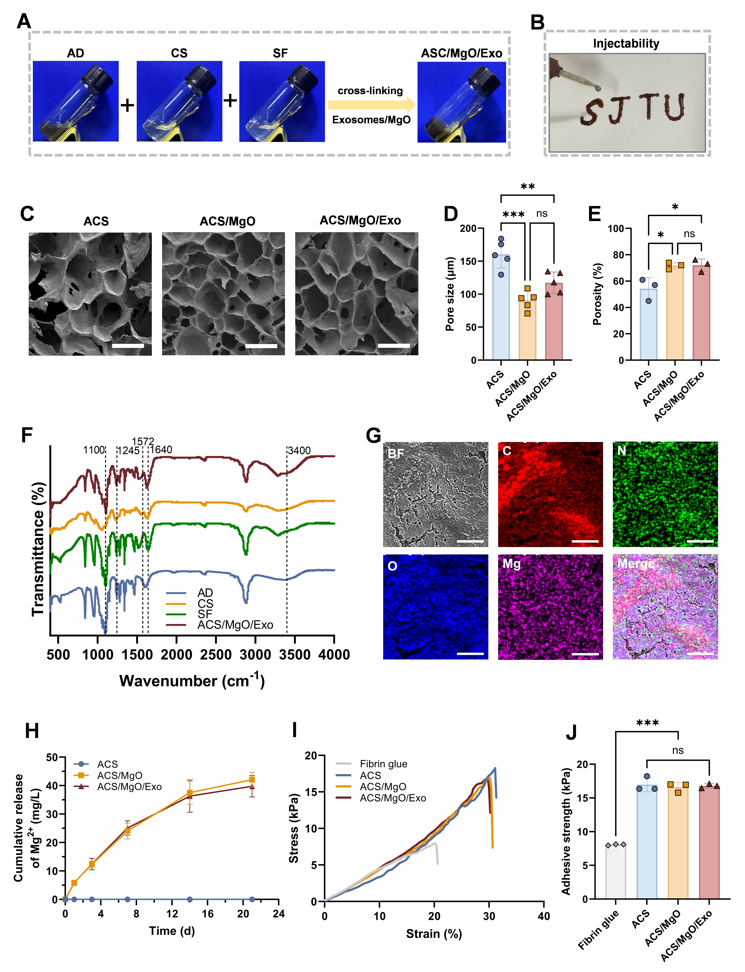
Fig. 1. Preparation and characterization of the ACS/MgO/Exo hydrogel. A) Gelation process of the composite hydrogel. B) Injectability of the composite hydrogel. C) SEM images of lyophilized ACS, ACS/MgO, and ACS/MgO/Exo hydrogels (scale bars = 100 μm). D) Pore size analysis and E) porosity analysis of the composite hydrogel. F) FTIR spectra of AD, SC, SF, and the ACS/MgO/Exo hydrogel. G) Elemental mapping images of the ACS/MgO/Exo hydrogel (scale bars = 50 μm). H) Magnesium ion release profiles from the ACS, ACS/MgO, and ACS/MgO/Exo hydrogels over 21 days (days 1, 3, 7, 14, 21). I) Adhesion tensile test curves and J) adhesion strength analysis of fibrin glue, the ACS, ACS/MgO, and ACS/MgO/Exo hydrogels. Data are presented as mean ± SD (n = 3), ns = not significant, *p < 0.05, **p < 0.01, ***p < 0.001.
3.2. Physical properties of the ACS/MgO/Exo hydrogels
The swelling performance and the degradation characteristics of the ACS/MgO/Exo hydrogels were systematically investigated to evaluate their potential for controlled therapeutic delivery. The swelling ratios of ACS/MgO and ACS/MgO/Exo hydrogels reached approximately 145% in PBS (Fig. S8A), significantly higher than that of the ACS hydrogel (~135%). This enhanced swelling capacity can be attributed to the increased porosity introduced by MgO nanoparticles, while the incorporation of exosomes showed negligible impact on the hydrogel's water absorption capability.
The degradation profiles of these hydrogels were examined under physiologically relevant pH conditions (pH 6.5, 7.4, and 8.5) to simulate various wound microenvironments (Fig. S8B-D). At physiological pH (7.4), all formulations exhibited controlled degradation kinetics, with approximately 50% mass loss over 21 days. The MgO-containing hydrogels (ACS/MgO and ACS/MgO/Exo) demonstrated slightly accelerated degradation rates compared to the ACS hydrogel, likely due to their enhanced porosity. Under alkaline conditions (pH 8.5), all formulations showed expedited degradation, retaining only ~40% mass at day 14 and further decreasing to ~10% by day 21, suggesting structural destabilization in the alkaline environment. At pH 6.5, while the ACS hydrogel maintained relatively steady degradation, both MgO-containing formulations exhibited rapid degradation kinetics, with ~90% mass loss within 7 days and near-complete degradation by day 14. This acid-responsive degradation can be attributed to the enhanced solubility of MgO under acidic conditions. This pH-dependent degradation profile aligns well with the dynamic wound healing process: rapid therapeutic release in the initial alkaline wound environment for inflammation control, sustained release during the neutral pH phase of wound progression, and accelerated degradation in the slightly acidic environment of the late healing stage, ultimately facilitating complete wound resolution. In addition to this pH-responsiveness, we confirmed the hydrogel’s excellent biodegradability in a simulated biological environment. As detailed in Fig. S9, the hydrogel underwent significantly accelerated degradation in the presence of relevant enzymes such as alginate lyase, chondroitinase ABC, and proteinase K. This rapid enzymatic decomposition is crucial as it demonstrates that the hydrogel can be effectively resorbed and cleared by endogenous enzymes in vivo, ensuring its excellent biosafety and preventing long-term retention. Magnesium ion release kinetics from the hydrogels was monitored in PBS (Fig. 1H). While the ACS hydrogel showed no detectable Mg²⁺ release, both ACS/MgO and ACS/MgO/Exo hydrogel displayed a biphasic release pattern with an early burst release within the first 7 days, succeeded by a prolonged and steady release phase. The incorporation of exosomes did not significantly alter the Mg²⁺ release kinetics, suggesting that the release behavior is primarily governed by the hydrogel degradation process and MgO dissolution dynamics. Similarly, the release of exosomes from the composite hydrogel was characterized (Fig. S10). A comparable front-loaded release pattern was observed, featuring an initial burst over the first 3 days that resulted in a cumulative release of approximately 80% by day 7. After this period, the release rate slowed significantly and leveled off. The burst release profile ensured the delivery of the bioactive exosomes during the critical initial phase of wound healing.
The tissue adhesion capabilities of the hydrogels were systematically evaluated through mechanical testing and compared with commercial fibrin glue (Fig. 1I-J). Quantitative analysis revealed that all three formulations (ACS, ACS/MgO, and ACS/MgO/Exo) demonstrated significantly enhanced adhesion strength compared to fibrin glue. Notably, the incorporation of MgO nanoparticles and exosomes did not compromise the inherent adhesive properties of the base hydrogel, maintaining consistent adhesion performance across all modified formulations. To further validate the practical applicability of the hydrogel, the adhesion performance of ACS/MgO/Exo was assessed on various biological tissues under both dry and aqueous conditions (Fig. S11, Video S1). The hydrogel demonstrated robust adhesion to multiple organs including lung, heart, spleen, liver, and kidney, maintaining its adhesive properties even under water rinsing conditions. To further evaluate the durability and reliability of this adhesion for practical applications, cyclic attachment/detachment tests were conducted in both standard and high-humidity environments (Fig. S12). Even after five repeated cycles, the hydrogel maintained a strong adhesive strength of over 10 kPa. Importantly, this robust adhesive performance was also observed in a high-humidity environment (RH = 90%) designed to mimic a moist wound bed, where the adhesion strength also remained consistently above the 10 kPa threshold. In summary, while the adhesive strength may not match that of high-performance bioadhesives designed specifically for adhesion[47, 48], our hydrogel nonetheless demonstrates a versatile and durable adhesion across diverse tissues and environments that is highly suitable for complex wound applications.
3.3. in vitro biocompatibility of the ACS/MgO/Exo hydrogels
The biological safety and cellular interactions of the hydrogel formulations were comprehensively assessed using multiple cell types and compatibility assays. Cell viability studies using the CCK-8 assay with L929 fibroblasts revealed that the ACS/MgO/Exo hydrogel significantly promoted cell proliferation compared with the control by day 3, with more significant effects observed at day 5 (Fig. 2A). Similar proliferation enhancement patterns were observed with adipose-derived stem cells (ADSCs), with the ACS/MgO/Exo group demonstrating superior proliferation rates at both day 3 and day 5 timepoints (Fig. 2B). These quantitative viability findings were further validated by live/dead cell staining analysis (Fig. 2C-D). All hydrogel formulations supported cell survival with negligible cytotoxicity, as evidenced by the predominance of viable cells and absence of dead cells across all groups. Notably, by day 5, both L929 and ADSC cultures in the ACS/MgO/Exo group exhibited markedly higher cell densities compared to other formulations, confirming its superior capacity to promote cellular proliferation.
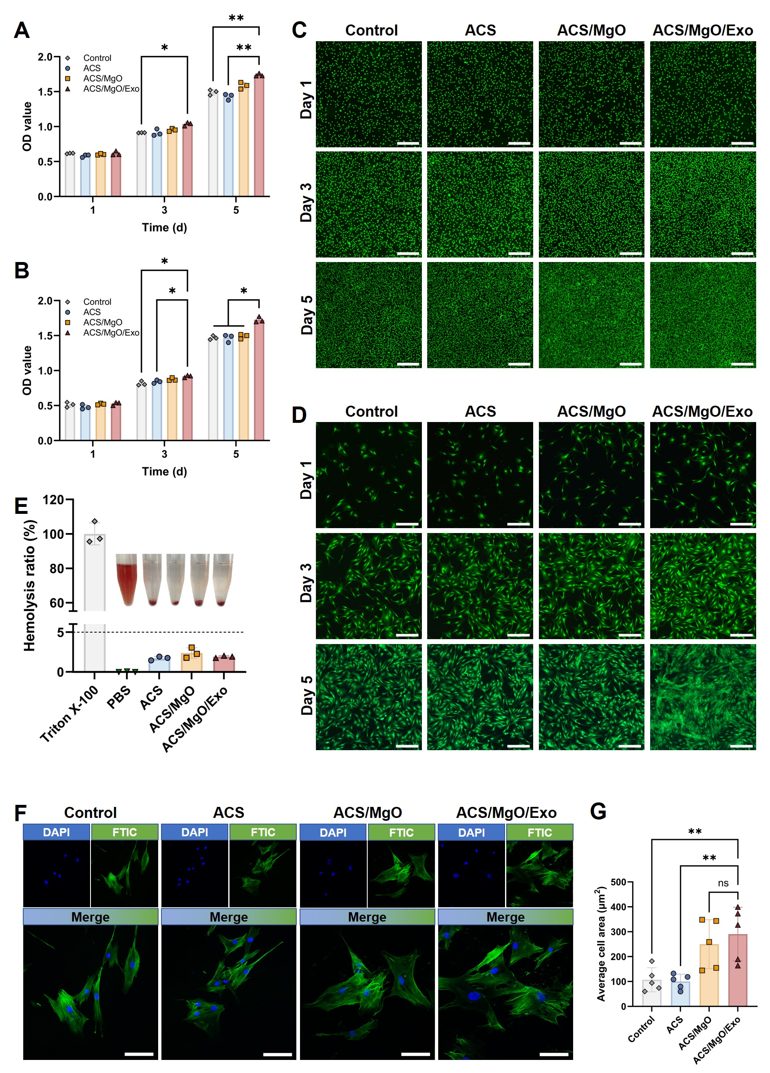
Fig. 2. in vitro biocompatibility evaluation of the ACS/MgO/Exo hydrogel. A-B) Cell proliferation of L929 and ADSC cells cultured in the extract of different hydrogels for 1, 3, and 5 days. C-D) Live/dead staining of L929 and ADSC cells cultured in the extract of different hydrogels for 1, 3, and 5 days. E) Hemocompatibility evaluation of different hydrogels. F) Attachment of ADSCs cultured on the surface of different hydrogels for 24 h and G) corresponding quantification of the average cell areas. Data are presented as mean ± SD (n = 3), ns = not significant, *p < 0.05, **p < 0.01, ***p < 0.001.

Blood compatibility of hydrogels was quantified through hemolysis assays (Fig. 2E). All hydrogel formulations demonstrated excellent blood compatibility, with hemolysis ratios below 5%, comparable to the PBS-treated group (negative control) and significantly lower than the Triton X-100-treated group (positive control). The absence of visible hemolysis in the digital photographs further validates the exceptional hemocompatibility of these hydrogels, a critical prerequisite for wound healing applications where direct blood contact is inevitable.
Cell attachment analysis through cytoskeletal staining revealed enhanced cellular interactions with MgO-containing hydrogels (Fig. 2F-G, Fig. S13). ADSCs cultured on ACS/MgO and ACS/MgO/Exo hydrogels exhibited more extensive cytoskeletal spreading and superior morphological characteristics significantly larger spreading areas in the ACS/MgO/Exo group compared to control and ACS groups, compared to those on control and ACS substrates. Quantitative analysis of average cell area confirmed though the difference between ACS/MgO and ACS/MgO/Exo was not statistically significant. Similar enhanced spreading patterns were observed with L929 fibroblasts, where the ACS/MgO/Exo formulation demonstrated a significant advantage over all other groups in promoting cell adhesion and spreading. These results collectively indicate that the incorporation of hUMSCs-derived exosomes significantly enhances the cell-material interactions, promoting cellular attachment, spreading, and subsequent proliferation (especially for fibroblasts), which are essential processes for effective wound healing.
3.4. Hemostatic capability of the ACS/MgO/Exo hydrogels
The hemostatic capability of the ACS/MgO/Exo hydrogel was explored in vitro and in vivo. The whole blood clotting test showed significant differences in coagulation kinetics in the four experimental groups. Results in Fig. 3A showed that the control and ACS groups exhibited prolonged clotting times of approximately 600s, indicating limited hemostatic activity. In contrast, the ACS/MgO group demonstrated enhanced coagulation with a reduced clotting time of about 400s. Notably, the ACS/MgO/Exo group achieved the most rapid hemostasis, with a clotting time of merely 200s, representing a 66.7% reduction compared with the control. This substantial improvement in hemostatic efficiency can likely due to the synergistic effects of Mg²⁺, which regulate multiple coagulation factors (IX, VIII, and VII) and promote platelet aggregation, coupled with bioactive components within the exosomes that further accelerate the coagulation cascade. The blood clotting index (BCI%) results (Fig. 3B) corroborated these findings, with significantly lower BCI values observed in the MgO-containing groups. The ACS/MgO/Exo group exhibited the lowest BCI%, indicating superior hemostatic performance. The enhanced hemostatic capability of the composite hydrogel is likely due to the combined effects of its physical network structure that facilitates platelet adhesion and aggregation, along with the biochemical stimulation provided by the Mg²⁺ and exosome-derived factors.
in vivo hemostatic efficacy was assessed via the tail vein bleeding and liver hemorrhage models in rats (Fig. 3C). The tail vein bleeding test (Fig. 3D) visually demonstrated the superior hemostatic performance of the experimental groups, particularly the ACS/MgO/Exo group, which showed minimal bleeding at both 60s and 120s timepoints compared to the evident hemorrhage in the control and fibrin glue groups. Quantitative analyses confirmed these observations, with the ACS/MgO/Exo group exhibiting significantly reduced hemostasis time (Fig. 3E) and blood loss (Fig. 3F) compared to all other groups, including a marked improvement over the ACS/MgO group. This suggests that the exosomes contribute additional hemostatic factors beyond those provided by the Mg²⁺ alone. The liver hemorrhage model (Fig. 3G) further validated the exceptional hemostatic properties of the composite hydrogel under more challenging conditions involving parenchymal organ bleeding. Consistent with the tail vein results, the ACS/MgO/Exo group demonstrated minimal blood loss, with quantitative analyses of hemostasis time (Fig. 3H) and blood loss volume (Fig. 3I) revealing statistically significant enhancements relative to the control group. The robust hemostatic performance across different bleeding models highlights the versatility of the ACS/MgO/Exo hydrogel in diverse hemorrhagic conditions.
The superior hemostatic efficacy of the ACS/MgO/Exo hydrogels can be attributed to a multifaceted mechanism: (1) the physical barrier formed by the adhesive hydrogel matrix that occludes the bleeding site; (2) the acceleration of the coagulation cascade by Mg²⁺ through modulation of clotting factors; and (3) the contribution of exosome-derived bioactive components that enhance platelet function and fibrin formation. These combined effects result in a hemostatic system that significantly outperforms conventional approaches, addressing a critical need in the management of infected wounds with acute hemorrhage.

Fig. 3. Hemostasis activity of the ACS/MgO/Exo hydrogel. A) The clotting time of whole blood and B) blood clotting index (BCI) of different hydrogels. C) Schematic diagram of the hemostatic experiments on two mouse models (tail amputation and liver hemorrhage). D) Photograph of the hemostasis process in the tail amputation model (Scale bar = 5 cm), E) hemostasis time and F) blood loss in various groups. G) Photograph of the hemostasis process in the liver hemorrhage model (Scale bar = 3 cm), H) hemostasis time and I) blood loss in various groups. Data are presented as mean ± SD (n = 3), ns = not significant, *p < 0.05, **p < 0.01, ***p < 0.001.

3.5. in vitro photothermal antibacterial activity of the ACS/MgO/Exo hydrogels
The photothermal ability of the ACS/MgO/Exo hydrogel was assessed under NIR laser irradiation for 300 seconds (power density of 2.0 W/cm²). The thermal imaging revealed significant temperature increases in ACS, ACS/MgO, and ACS/MgO/Exo groups, while the control group (H₂O) exhibited negligible temperature elevation (Fig. 4A). The photothermal conversion mechanism lies in the presence of dopamine moieties within the hydrogel structure, which effectively absorb NIR laser and convert it to thermal energy. Quantitative temperature-time profiles (Fig. 4B) demonstrated that ACS, ACS/MgO, and ACS/MgO/Exo rapidly reached approximately 40°C within 120 seconds of irradiation and stabilized at around 49°C after 5 minutes. Notably, no significant differences in temperature elevation were observed among these three groups, indicating that the incorporation of MgO and exosomes did not compromise the intrinsic photothermal properties of the dopamine-modified alginate. The achieved temperature range (45-50°C) is particularly advantageous for antibacterial applications, as it is sufficient to inhibit bacterial growth while minimizing potential thermal damage to surrounding healthy tissues.
To optimize the irradiation parameters for subsequent experiments, we explored the impact of laser power density on thermal response of the ACS/MgO/Exo hydrogel (Fig. 4C). Four different power densities including 0.6, 1.3, 2.0, and 2.7 W/cm² were tested, resulting in steady-state temperatures of 36.4, 44.2, 48.8, and 60.2°C, respectively, after 5 minutes of irradiation. Based on these results, we selected 2.0 W/cm² as the optimal power density for further studies, as it provides sufficient thermal energy for antibacterial effects (>45°C) while remaining below the threshold for potential tissue damage (<50°C), meeting the basic biosafety requirements of mild-photothermal therapy (M-PTT) biomaterials. The photostability of the composite hydrogel was assessed through repeated heating-cooling cycles (Fig. 4D). The ACS/MgO/Exo hydrogel maintained consistent photothermal performance throughout five consecutive cycles of NIR irradiation (2.0 W/cm²), with no observable degradation in heating capacity. This excellent photostability suggests that the hydrogel could provide sustained photothermal therapy during extended wound treatment periods without compromising its therapeutic efficacy.

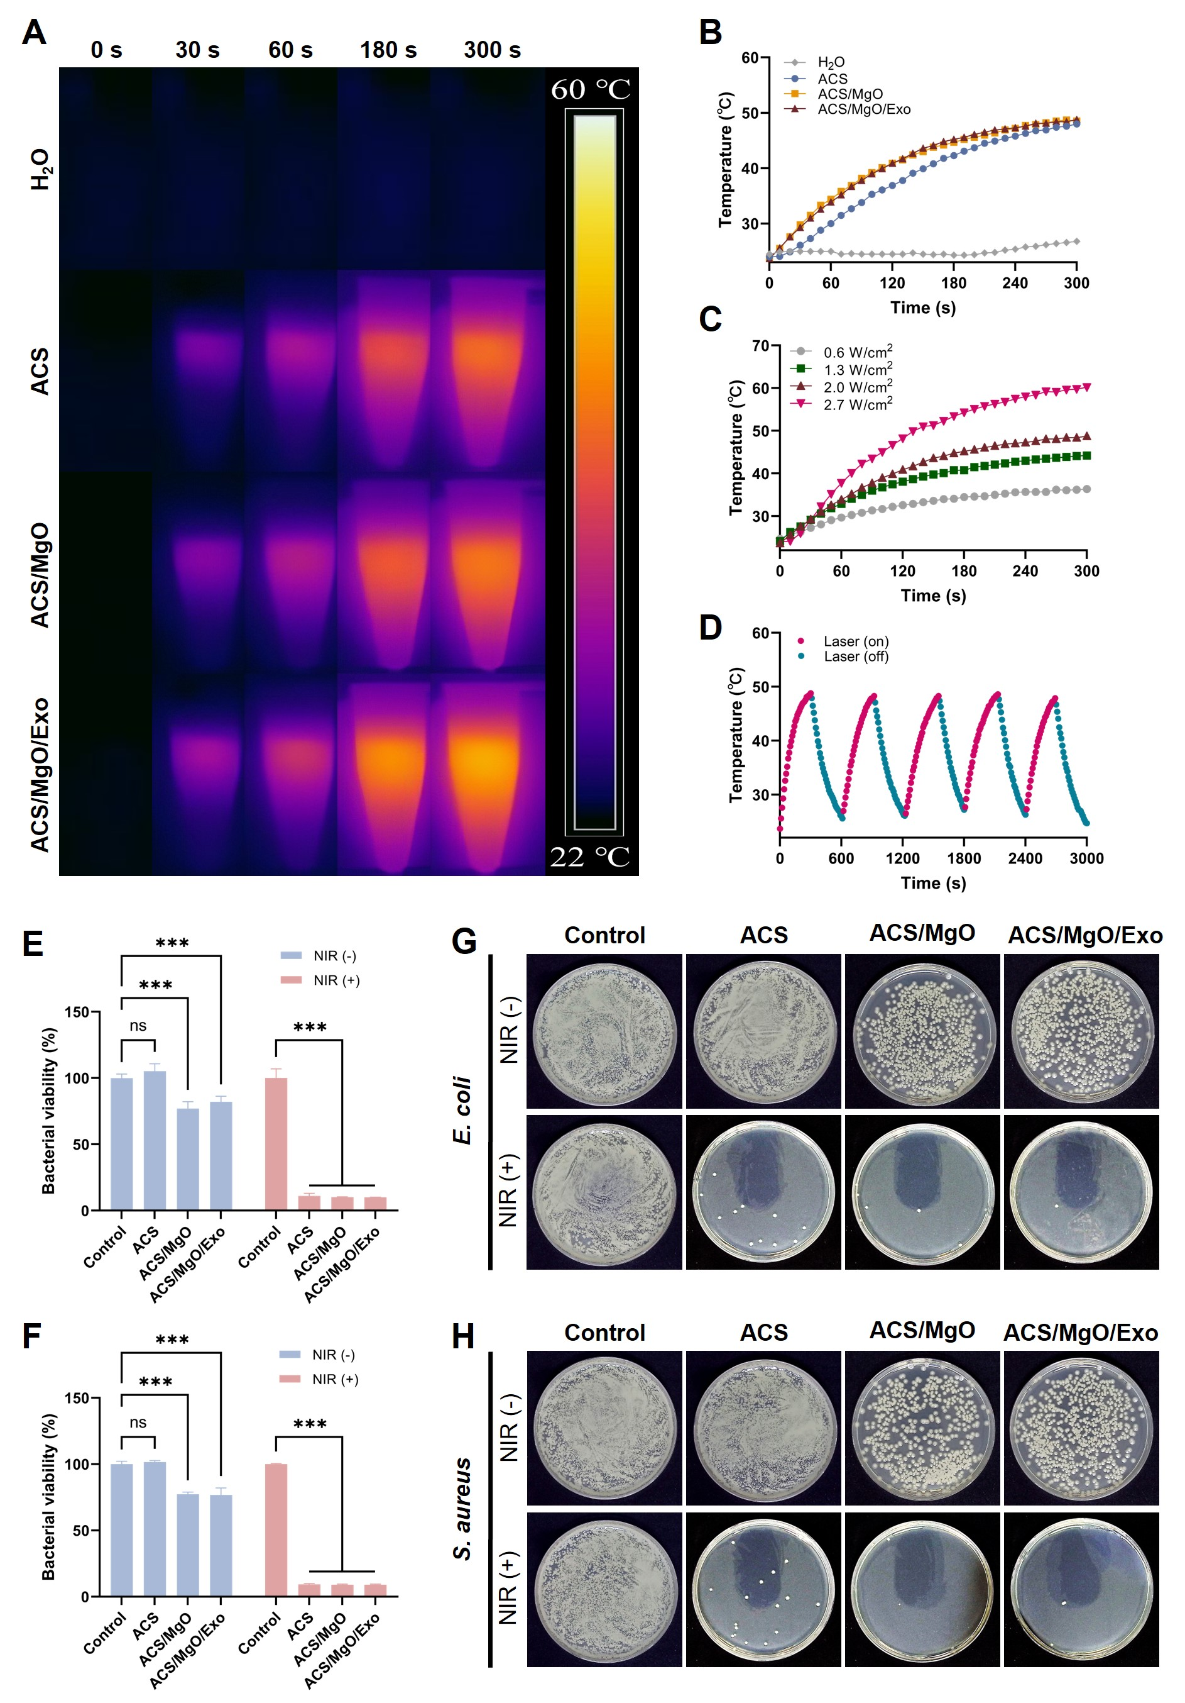
Fig. 4. in vitro photothermal antibacterial capability of the ACS/MgO/Exo hydrogel. A) Thermal images and B) temperature-time curves of different hydrogels under 808 nm NIR irradiation (2.0 W cm⁻ ², 300 s). C) Temperature-time curves of the ACS/MgO/Exo hydrogel with various power densities (0.6, 1.3, 2.0 and 2.7 W cm⁻ ²) under 808 nm NIR irradiation. D) Photothermal stability of the ACS/MgO/Exo hydrogel under repeated on-off NIR irradiation (808 nm, 2.0 W cm⁻ ²). E-F) Bacterial viability of E. coli and S. aureus after treatments of different hydrogels with or without NIR irradiation (808 nm, 2.0 W cm⁻², 300 s). G-H) Optical images of E. coli and S. aureus bacterial colonies after treatments of different hydrogels with or without NIR irradiation (808 nm, 2.0 W cm⁻², 300 s). Data are presented as mean ± SD (n=3), *p < 0.05, **p < 0.01, ***p < 0.001.
The antibacterial efficacy of the composite hydrogel against both gram-positive (G⁺) and gram-negative (G⁻) bacteria was determined under various conditions. In the absence of NIR irradiation, control and ACS groups showed minimal antibacterial activity, while ACS/MgO and ACS/MgO/Exo exhibited significant bacterial growth inhibition, reducing bacterial survival by approximately 80% (Fig. 4E-F). This baseline antibacterial effect can be attributed to the intrinsic antimicrobial properties of Mg²⁺ released from MgO nanoparticles, which disrupt bacterial cell membranes and interfere with essential cellular processes. Upon NIR irradiation, all hydrogel groups (ACS, ACS/MgO, and ACS/MgO/Exo) demonstrated dramatically enhanced antibacterial activity for both E. coli and S. aureus, reducing bacterial survival to less than 10%. Colony-forming unit (CFU) assays (Fig. 4G-H) corroborated these findings, showing minimal bacterial colonies in the NIR-irradiated hydrogel groups, with ACS/MgO and ACS/MgO/Exo exhibiting superior inhibition compared to ACS. The enhanced antibacterial performance of the MgO-containing hydrogels under photothermal conditions suggests a synergistic effect between the thermal damage induced by the photothermal conversion and the antibacterial property of Mg²⁺. The potent, broad-spectrum antibacterial efficacy of the ACS/MgO/Exo hydrogel is predominantly attributed to the dopamine-mediated photothermal effect. Upon NIR irradiation, the hydrogel generates localized hyperthermia that effectively eradicates both gram-positive and gram-negative bacteria through non-specific physical mechanisms, including irreversible protein denaturation and cell membrane disruption[49-51]. Complementing this powerful, acute bactericidal action, the sustained release of Mg²⁺ provides a secondary, milder bacteriostatic environment, which is understood to further interfere with bacterial membrane integrity and metabolism[52, 53]. This combined approach provides a robust strategy for managing infected wounds, potentially reducing the reliance on conventional antibiotics and addressing issues associated with antibiotic resistance.
3.6. in vitro promotion of vascularization
The biological effects of the ACS/MgO/Exo hydrogel on endothelial cells were further investigated in vitro. The proliferation of HUVECs was tested using CCK-8 assay over 5 days (Fig. 5A). While minimal differences were monitored among different groups at day 1, by day 3, both ACS/MgO and ACS/MgO/Exo groups exhibited significantly higher proliferation rates compared with the control. Notably, by day 5, the ACS/MgO/Exo group demonstrated the highest proliferation rate, significantly surpassing even the ACS/MgO group. These results indicate that the composite hydrogel, particularly with exosome incorporation, effectively promotes endothelial cell proliferation.
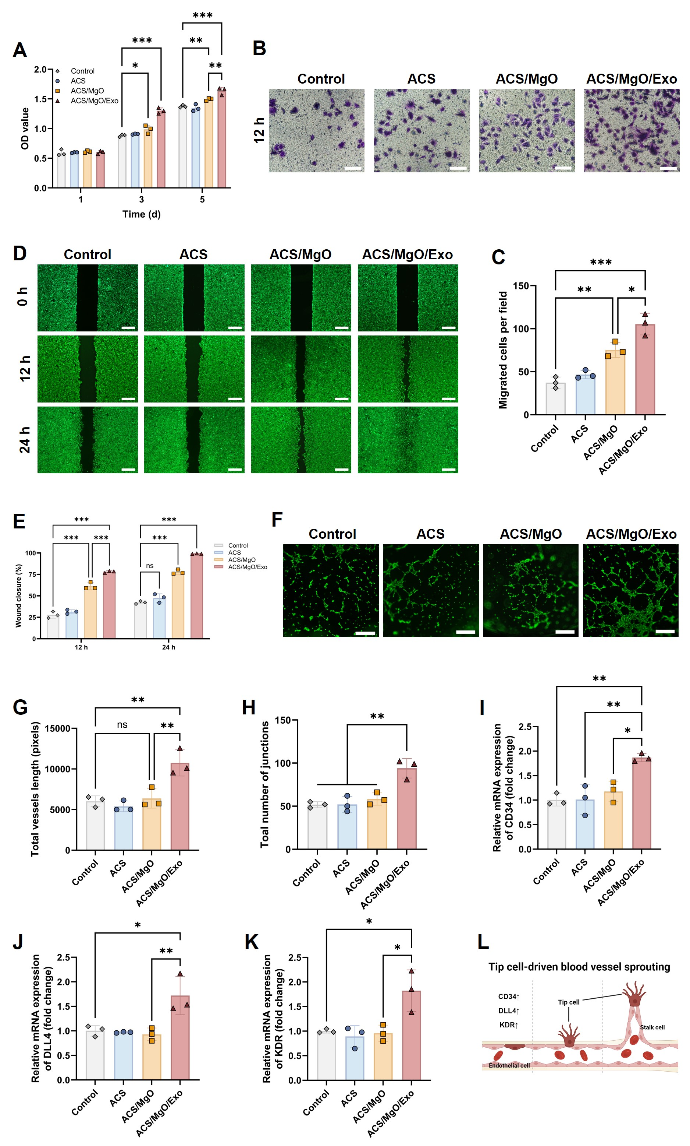
Fig. 5. in vitro promotion of angiogenesis and tip cell differentiation by ACS/MgO/Exo hydrogel. A) Cell viability of HUVECs after treatment with different hydrogels for 1, 3, and 5 days. B) Transwell assay of HUVECs after treatment with different hydrogels for 12 h (scale bars = 200 μm) and C) the corresponding quantification of migrated cells. D) Scratch assay of HUVECs after treatments with different hydrogels (scale bars = 200 μm) and E) the corresponding percentage of wound closure after incubation for 12 and 24 h. F) Tube formation assay of HUVECs after treatments with different hydrogels for 6 h (scale bars = 200 μm), and the corresponding G) number of junctions and H) total vessel length of tube formation assay. I-K) Relative mRNA expression of tip cell markers including I) CD34, J) DLL4, and K) KDR in HUVECs after treatment with different hydrogels for 48 h. L) Schematic illustration of tip cell-driven blood vessel sprouting. Data are presented as mean ± SD (n = 3), *p < 0.05, **p < 0.01, ***p < 0.001.

The migratory capacity of HUVECs was assessed through Transwell migration assay (Fig. 5B-C). Crystal violet staining revealed substantially more migrated cells in the ACS/MgO/Exo group compared to other experimental groups (Fig. 5B). Quantitative analysis confirmed that the ACS/MgO/Exo hydrogel significantly enhanced cell migration compared to both control and ACS/MgO groups (Fig. 5C). The enhanced migratory potential is likely attributable to bioactive factors released from the exosomes, which activate cellular signaling pathways involved in directional movement. The wound healing scratch assay further validated the pro-migratory effects of the composite hydrogel (Fig. 5D-E). The ACS/MgO/Exo group demonstrated near-complete wound closure by 12 hours and complete closure by 24 hours, whereas other groups showed varying degrees of incomplete closure (Fig. 5D). Quantification of wound closure rates at 12 and 24 hours confirmed that both ACS/MgO and ACS/MgO/Exo groups significantly outperformed the control group, with ACS/MgO/Exo exhibiting superior performance (Fig. 5E). This accelerated wound closure reflects the hydrogel's ability to stimulate coordinated cell migration, a critical aspect of angiogenesis during wound healing.
To further characterize the angiogenic potential of our composite hydrogel, we evaluated its effect on endothelial tube formation, which simulates the organization of endothelial cells into vessel-like structures (Fig. 5F-H). Microscopic images revealed more extensive tubular networks in the ACS/MgO/Exo group compared to all other groups (Fig. 5F). Quantitative measurements of total vessel length (Fig. 5G) and junction numbers (Fig. 5H) confirmed that the ACS/MgO/Exo group exhibited significantly enhanced angiogenesis compared to both control and ACS/MgO groups. These findings demonstrate the superior ability of the exosome-containing composite hydrogel to promote endothelial cell organization into functional vascular structures.
During wound healing, endothelial tip cells move toward the injury site and establish connections with adjacent tip cells from nearby sprouts, thereby initiating vascular lumen development. We next examined whether our composite hydrogel could influence the differentiation of these critical endothelial tip cells. CD34 serves as a recognized marker of endothelial tip cells with strong migratory potential, whereas Delta-like ligand 4 (DLL4) is highly expressed during KDR-mediated filopodial extension in these tip cells. PCR analysis revealed that the ACS/MgO/Exo group demonstrated significantly upregulated expression of these critical tip cell markers: CD34 (Fig. 5I), DLL4 (Fig. 5J), and KDR (Fig. 5K) compared to all other groups. This distinctive gene expression profile strongly indicates that the composite hydrogel, particularly with exosome incorporation, promotes the differentiation of endothelial cells into specialized tip cells, which guide sprouting angiogenesis as illustrated in Fig. 5L. Notably, the dynamic nature of endothelial plasticity during angiogenesis involves DLL4-Notch signaling under conditions of close intercellular contact, which induces tip-stalk switching and may influence the cellular response to our hydrogel over time. Collectively, these in vitro findings demonstrate that the ACS/MgO/Exo hydrogel possesses potent pro-angiogenic properties, promoting endothelial tip cell proliferation, migration, and vascularization.
To determine the underlying mechanisms by which ACS/MgO/Exo hydrogel enhances angiogenesis, transcriptome sequencing was performed on HUVECs exposed to the composite hydrogel compared to untreated controls. The Principal Component Analysis (PCA) plot (Fig. S14) revealed a distinct separation in gene expression profiles between the ACS/MgO/Exo group and the control. Gene expression heatmap revealed distinct patterns between the two groups, demonstrating widespread transcriptional changes in response to hydrogel treatment (Fig. 6A). Volcano plot analysis identified 178 differentially expressed genes (DEGs), with 169 upregulated and only 9 downregulated genes in the hydrogel-treated group (Fig. 6B), indicating a predominantly activating effect on endothelial cell gene expression. Gene Ontology (GO) analysis results revealed that the DEGs were markedly enriched in biological processes critical for vascular development, including extracellular exosome activity, positive regulation of cell migration, angiogenesis, and vascular endothelial growth factor production (Fig. 6C). These enriched categories correspond directly with the observed phenotypic changes in endothelial cell behavior, particularly enhanced migration and tube formation. KEGG analysis results further indicated that these DEGs were mainly associated with enrichment in the PI3K-AKT signaling pathway and NF-κB signaling pathway (Fig. 6D), both of which are well-established regulators of angiogenesis. Gene Set Enrichment Analysis (GSEA) further confirmed the presence of the activation of specific angiogenic pathways. Significant enrichment was observed in the PI3K-AKT signaling pathway (Fig. 6E), NF-κB signaling pathway (Fig. 6F), positive regulation of vascular endothelial growth factor production (Fig. 6G), and positive regulation of angiogenesis (Fig. 6H). The consistent appearance of these pathways across multiple analytical approaches strongly suggests their involvement in mediating the pro-angiogenic effects of the composite hydrogel.
The PI3K-AKT signaling pathway was widely reported to serve as vital regulators of angiogenesis process, controlling multiple aspects of endothelial cell function including proliferation, motility, and tube formation. It has been reported in prior studies that exosomes can activate the PI3K-AKT pathway in various cell types, including endothelial cells. Moreover, NF-κB signaling, which functions downstream of PI3K-AKT, has been implicated in regulating VEGF expression and subsequent angiogenic responses. Based on our transcriptomic findings, we hypothesized that the ACS/MgO/Exo hydrogel enhances angiogenesis by activating the PI3K-AKT pathway, and then activates NF-κB pathway, leading to increased VEGF transcription, production, and release. To validate this proposed signaling cascade, we performed RT-PCR analysis of key components in this pathway. Consistent with our hypothesis, hydrogel-treated HUVECs exhibited significantly upregulated expression of PI3K, AKT, NF-κB, and VEGF compared to untreated controls (Fig. 6I). Western blot analysis provided further verification of these observations at the protein level (Fig. 6J), revealing enhanced phosphorylation of PI3K, AKT, and NF-κB, along with enhanced VEGF expression in hydrogel-treated cells.
To further validate the relationship among these signaling components, we employed specific inhibitors targeting different points in the pathway. Treatment with a PI3K inhibitor (LY294002) significantly reduced the phosphorylation of all downstream components (AKT and NF-κB) and suppressed VEGF expression, confirming the upstream regulatory role of PI3K. In contrast, VEGF inhibition (Bevacizumab) reduced VEGF expression without affecting the phosphorylation status of upstream components, thereby validating the integrity and directionality of the proposed signaling cascade. Our findings demonstrate that the ACS/MgO/Exo hydrogel promotes angiogenesis primarily through activation of the PI3K-AKT-NF-κB-VEGF signaling cascade as illustrated in the schematic diagram (Fig. 6K), resulting in coordinated enhancement of endothelial cell proliferation, migration, and tube formation.
In addition to this pathway, it is worth noting that angiogenesis is a multifactorial process regulated by a network of interconnected signaling cascades. Previous studies have shown that other pathways, including MAPK/ERK, JAK/STAT, and Notch signaling, also play crucial roles in neovascularization[54-59]. These alternative pathways may act in concert with, or independently of, the PI3K-AKT axis to fine-tune the angiogenic response. Although our transcriptomic analysis revealed the PI3K-AKT-NF-κB-VEGF pathway as the most significantly enriched and thus was selected for detailed validation in this study, the potential involvement of MAPK/ERK and JAK/STAT signaling cannot be excluded. Further investigations will be carried out in future studies to elucidate whether these additional signaling routes also contribute to the hydrogel-induced angiogenic effects.

Fig. 6. ACS/MgO/Exo hydrogel promotes angiogenesis via the PI3K/AKT/NF-κB/VEGF signaling axis. A) Heatmap of the differentially expressed genes between control and ACS/MgO/Exo hydrogel-treated HUVECs. B) Volcano plot of the differentially expressed genes (DEGs). C) Gene Ontology (GO) enrichment analysis of DEGs in biological process. D) Kyoto Encyclopedia of Genes and Genomes (KEGG) pathway enrichment analysis of DEGs. I) RT-PCR results of PI3K, AKT, NF-κB and VEGF expression in HUVECs after treatments with control or ACS/MgO/Exo hydrogel. J) Western blot results of PI3K, p-PI3K, AKT, p-AKT, NF-κB, p-NF-κB and VEGF in HUVECs after treatments with control, ACS/MgO/Exo hydrogel, ACS/MgO/Exo hydrogel with PI3K inhibitor (LY294002), and ACS/MgO/Exo hydrogel with VEGF inhibitor (Bevacizumab). K) Schematic illustration of ACS/MgO/Exo hydrogel promoting angiogenesis via PI3K/AKT/NF-κB/VEGF signaling axis.

3.7. in vivo infected wound healing evaluation
To evaluate the therapeutic efficacy of our multifunctional hydrogel in vivo, we established a mouse model of infected full-thickness skin defects (Fig. 7A). Different formulations were administered ​to​ the wound sites: control (untreated), ACS, ACS/MgO/Exo, and ACS/MgO/Exo with NIR irradiation (2.0 W/cm², 5 min). Given the combination of photothermal therapy and bioactive exosomes, we first validated in vitro that the NIR-induced hyperthermia did not compromise the stability or function of the exosomes. First, TEM imaging confirmed that exosomes subjected to the irradiation protocol retained their structural integrity and characteristic cup-shaped morphology (Fig. S15). Complementing this structural validation, functional assays detailed in Fig. S16 further demonstrated that their key bioactivities—including the promotion of endothelial cell proliferation, migration, and angiogenesis—were also fully preserved after the NIR irradiation. Together, these results confirmed the compatibility of our dual-therapeutic approach. Digital photographs were captured to document the wound healing progression over 14 days. The macroscopic wound appearance demonstrated clear differences in healing rates between treatment groups. By day 3, wounds treated with ACS/MgO/Exo and ACS/MgO/Exo+NIR exhibited significantly reduced wound areas compared to control and ACS groups. This accelerated healing became even more evident by day 7, when wounds in the ACS/MgO/Exo+NIR group were almost completely closed, while the other groups still displayed obvious scabbing and incomplete closure. At day 14, although wounds in all groups had substantially healed, the ACS/MgO/Exo+NIR treatment resulted in notably smaller scar formation. Quantitative wound closure analysis (Fig. 7C-D) and wound area calculation (Fig. S17) confirmed further these observations. By day 3, the wound closure rates reached 63.9%, 62.7%, 75.3%, and 78.2% for control, ACS, ACS/MgO/Exo, and ACS/MgO/Exo+NIR groups, respectively. This trend continued through day 7, with closure rates of 80.7%, 77.7%, 84.2%, and 95.3%. By day 14, the final wound closure rates were 91.9%, 87.0%, 93.4%, and 97.6%. Statistical analysis revealed that wounds treated with ACS/MgO/Exo+NIR exhibited significantly faster closure rates at all time points compared to other groups. Body weight monitoring of all experimental animals throughout the study period showed no significant differences between treatment groups and controls (Fig. S18), suggesting good biocompatibility of our composite hydrogel.

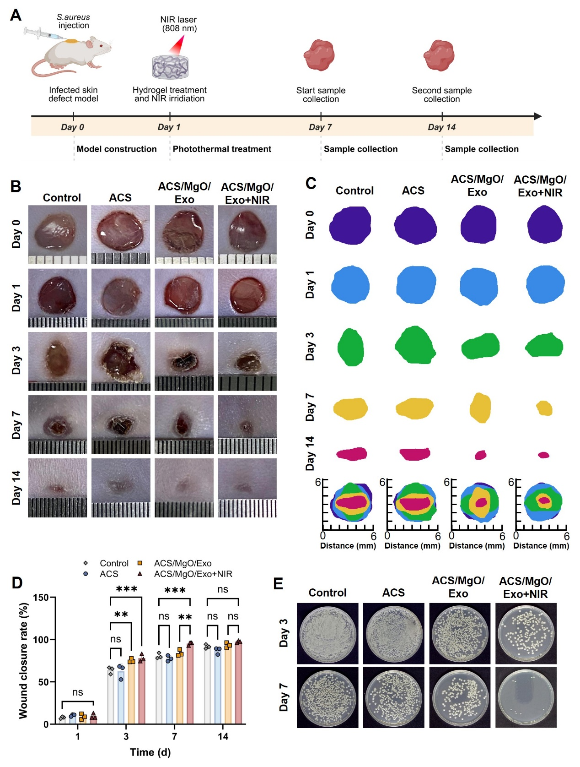
Fig. 7. in vivo evaluation of the ACS/MgO/Exo hydrogel in infected wound healing. A) Schematic illustration of the infected skin wound model. B) Representative photographs of infected full-thickness skin wounds treated with control, ACS, ACS/MgO/Exo, and ACS/MgO/Exo+NIR on days 0, 1, 3, 7, and 14 post-wounding. C) Traces of wound closure on day 0, 1, 3, 7 and 14. D) Quantitative analysis of wound closure rate (%) in different treatment groups. E) Representative images of bacterial colonies cultured from wound tissues harvested on days 3 and 7. Data are presented as mean ± SD (n=3), *p < 0.05, **p < 0.01, ***p < 0.001.

Bacterial infection is a critical factor affecting wound healing processes. As shown in Fig. S19, thermal imaging revealed that the ACS/MgO/Exo hydrogel exhibited significant temperature elevation under NIR irradiation, while the control group showed minimal temperature change. Temperature-time curves (Fig. S20) demonstrated that the ACS/MgO/Exo+NIR group reached temperatures above 45°C within 180 seconds and maintained between 45-50°C thereafter, representing an ideal temperature range for M-PTT. To assess the antibacterial efficacy of treatments in vivo, bacterial culture analysis was performed on wound tissues harvested at days 3 and 7 (Fig. 7E). The ACS/MgO/Exo+NIR group displayed markedly fewer bacterial colonies compared to all other groups at both time points. Quantitative analysis of bacterial viability (Fig. S21) further confirmed that the ACS/MgO/Exo+NIR treatment significantly reduced bacterial burden in the wounds. This enhanced antibacterial effect can be attributed to the photothermal properties of dopamine under NIR irradiation, which generated localized hyperthermia sufficient to effectively eliminate bacteria while maintaining the health of adjacent tissues.
The histopathological evaluation of wound tissues was performed to determine the wound healing efficacy of the ACS/MgO/Exo hydrogel. Fig. 8A presents the H&E staining of tissue sections on day 7 and 14 post-treatment across all experimental groups. At day 7, the control and ACS groups exhibited prominent scab formation with discontinuous epidermal and dermal layers. In contrast, the ACS/MgO/Exo+NIR group demonstrated significant wound filling with granulation tissue and a continuous epidermal layer overlying the dermis, although minimal scab formation and incomplete epithelial restoration were still observable. By day 14, while all groups showed substantial wound closure, the ACS/MgO/Exo+NIR group displayed remarkably reduced wound width compared to other groups, with more hair follicle development in certain regions, consistent with the digital photography findings. Moreover, the epithelial tissue in this group closely resembled normal tissue morphology, indicating superior wound resolution. Quantitative analysis confirmed these observations, with the ACS/MgO/Exo+NIR group exhibiting significantly reduced wound width at both day 7 and day 14 compared to all other experimental groups (Fig. 8C and 8D). Masson's trichrome staining at day 14 (Fig. 8B) revealed enhanced collagen deposition in both ACS/MgO/Exo and ACS/MgO/Exo+NIR groups compared wih the control and ACS groups. Quantification of collagen content (Fig. 8F) showed that ACS/MgO/Exo and ACS/MgO/Exo+NIR groups achieved approximately 80% collagen deposition, whereas the control and ACS groups displayed merely 20% and 50%, respectively.

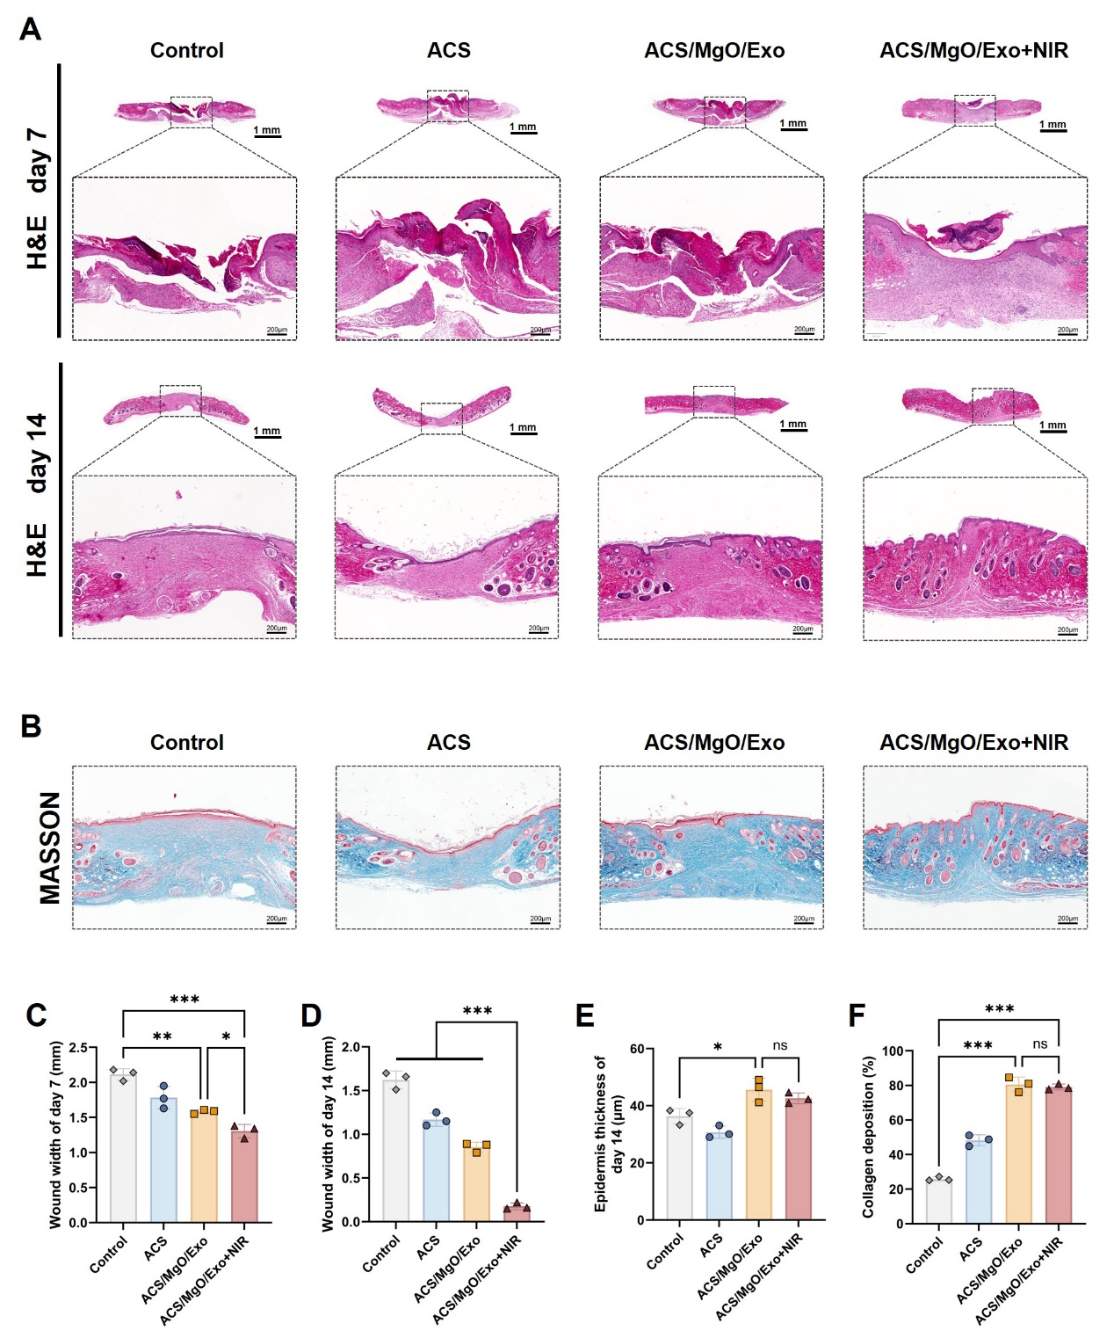
Fig. 8. Histological evaluation of wound healing process after treatment with different hydrogel formulations. A) H&E staining of wound tissues on day 7 and 14. B) Masson's trichrome staining of wound tissues on day 14. C-D) Quantitative analysis of wound width on day 7 and day 14, respectively. E) Quantitative analysis of epidermis thickness on day 14. F) Quantitative analysis of collagen deposition (%) on day 14. Data are presented as mean ± SD (n=3), *p < 0.05, **p < 0.01, ***p < 0.001.

This substantial enhancement in collagen synthesis demonstrates the composite hydrogel's efficacy in promoting the maturation phase of wound healing. The epidermal thickness measurement at day 14 (Fig. 8E) further demonstrated that both ACS/MgO/Exo and ACS/MgO/Exo+NIR groups achieved greater epithelial regeneration compared with the control and ACS groups, although statistically significant difference was not observed between these two composite hydrogel formulations.
The immunofluorescence staining results for vascular markers (α-SMA and CD31) at day 7 post-treatment are shown in Fig. 9A. The control and ACS groups exhibited minimal fluorescence signals, with the control group showing particularly negligible CD31 red fluorescence. In contrast, both ACS/MgO/Exo and ACS/MgO/Exo+NIR groups demonstrated significant expression of α-SMA (green fluorescence) and CD31 (red fluorescence) at the wound site, indicating substantial vascular formation. Quantitative analysis of relative fluorescence intensity for α-SMA and CD31 (Fig. 9C-D) revealed significantly higher expression levels in the ACS/MgO/Exo+NIR group compared with all other groups. Notably, the CD31 fluorescence level in the ACS/MgO/Exo+NIR group surpassed that of the ACS/MgO/Exo group, suggesting an additional angiogenic benefit conferred by the photothermal effect under NIR irradiation. This enhanced angiogenic response is likely due to the improved oxygen and nutrient delivery to the regenerating tissue caused by temperature change. The inflammatory reaction levels were assessed through immunohistochemical staining of pro-inflammatory markers IL-6 and TNF-α at day 7 (Fig. 9B). The control group exhibited markedly intense staining for both inflammatory indicators, while the ACS/MgO/Exo and ACS/MgO/Exo+NIR groups demonstrated substantially reduced expression of these markers. The corresponding quantitative analysis of relative area coverage (Fig. 9E-F) confirmed significantly lower IL-6 and TNF-α expression in both hydrogel treatment groups compared to the control and ACS groups. This pronounced anti-inflammatory effect of the ACS/MgO/Exo hydrogel, particularly when combined with NIR irradiation, corresponds with the enhanced tissue regeneration observed in these treatment groups. These findings demonstrate that the developed ACS/MgO/Exo hydrogel effectively addresses two critical aspects of wound healing: promoting vascular network formation and modulating the inflammatory microenvironment.
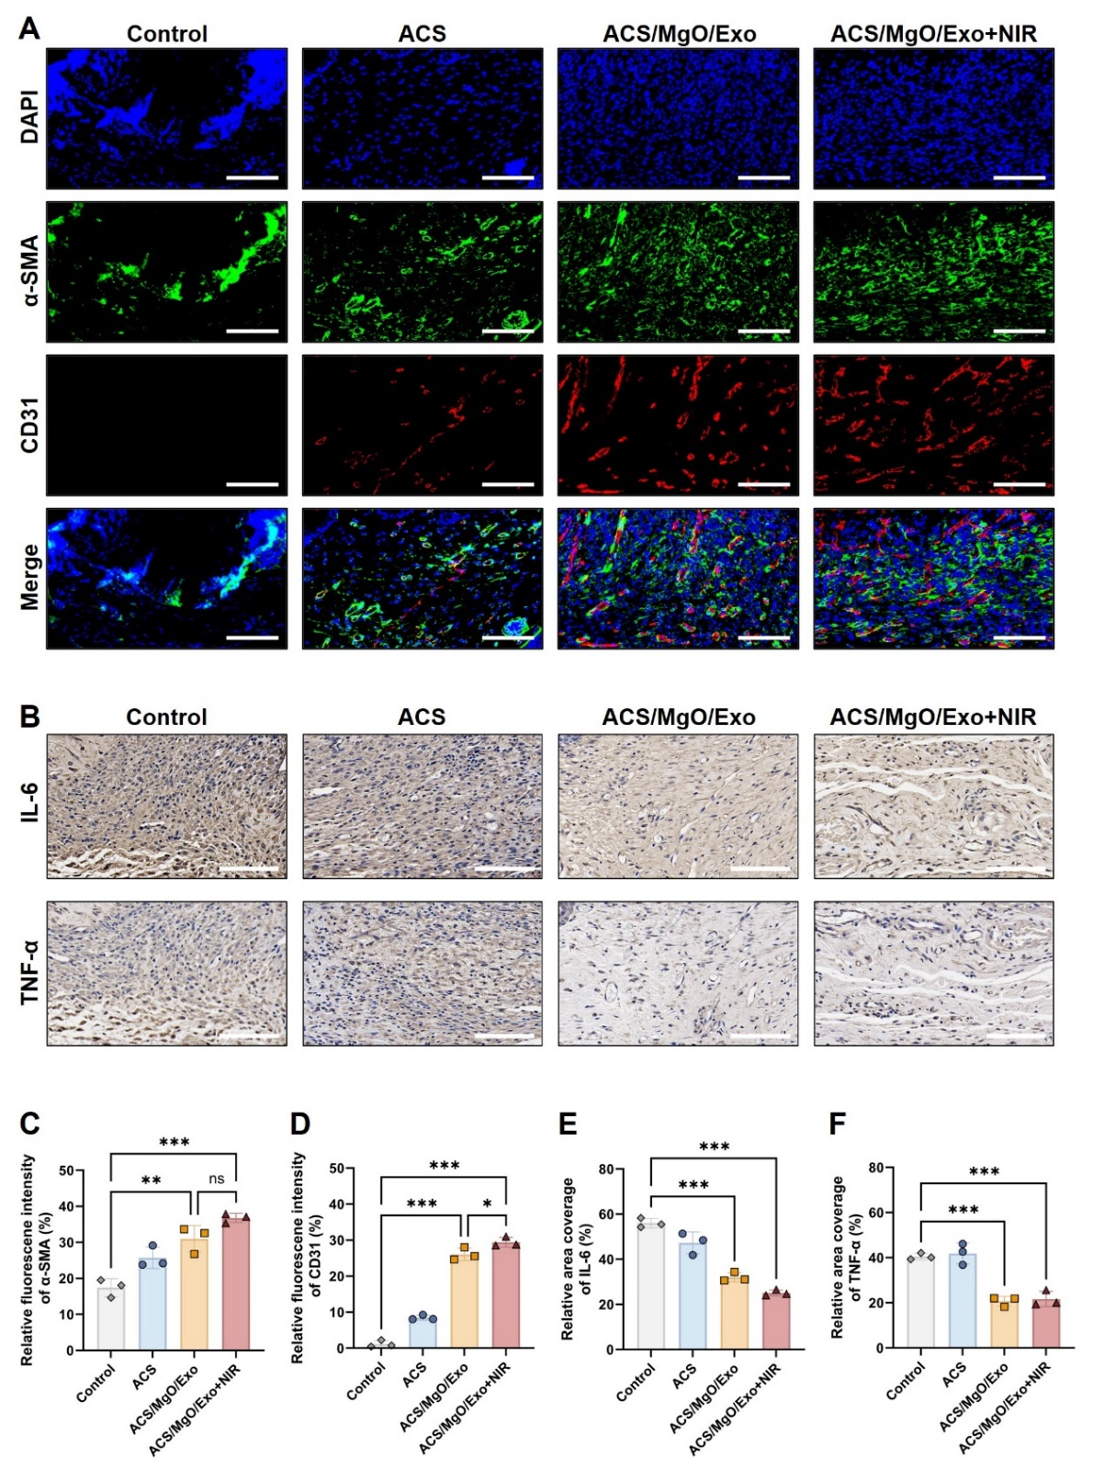
Fig. 9. Assessment of vascular formation and inflammatory response in wound healing. A) Immunofluorescence staining of α-SMA (green) and CD31 (red) at the wound site on day 7 (scale bars = 100 μm). B) Immunohistochemical staining of inflammatory markers IL-6 and TNF-α on day 7 (scale bars = 100 μm). C-D) Quantitative analysis of relative fluorescence intensity of α-SMA and CD31, respectively. E-F) Quantitative analysis of relative area coverage of IL-6 and TNF-α, respectively. Data are presented as mean ± SD (n = 3), *p < 0.05, **p < 0.01, ***p < 0.001.

The biocompatibility of the composite hydrogel was comprehensively evaluated at both the local and systemic levels. First, to confirm the biosafety of the photothermal treatment at the application site, immunofluorescence staining for heat shock protein 70 (HSP70) and apoptosis (TUNEL) was performed on wound tissues from day 1 and day 3. The quantitative analysis revealed no significant differences between the ACS/MgO/Exo+NIR and control groups, indicating that the therapy did not cause detectable local tissue damage (Fig. S22). In addition to this localized safety, long-term systemic biocompatibility was assessed via histopathological examination of key organs on day 14. The H&E staining revealed no observable pathological alterations or inflammatory lesions in any experimental group (Fig. S23), demonstrating excellent tissue compatibility of the composite hydrogel. Furthermore, hematological parameters and blood biochemistry showed no significant differences in groups with different treatments (Fig. S24-25), indicating that the ACS/MgO/Exo hydrogel did not trigger systemic hematological or biochemical adverse effects. Collectively, these findings demonstrate the excellent local and systemic biocompatibility of the ACS/MgO/Exo hydrogel and its associated photothermal treatment.
Despite the promising results, this study has certain limitations. First, while the ACS/MgO/Exo hydrogel combined with mild photothermal therapy (NIR) demonstrated potent antibacterial activity, the precise molecular pathways and physiological processes underlying bacterial eradication remain to be fully elucidated. Second, the observation that CD31 expression in the ACS/MgO/Exo+NIR group was higher than that in the ACS/MgO/Exo group suggests additional biological mechanisms may be involved; however, the exact pathways mediating this enhanced angiogenic response require further investigation in future studies.

4. Conclusions
In this study, we successfully developed an injectable multifunctional ACS/MgO/Exo composite hydrogel with effective tissue adhesion, antibacterial efficacy, and pro-angiogenic properties for infected wound management. The hydrogel's unique composition creates a synergistic platform that effectively addresses multiple challenges in infected wound healing. The incorporation of MgO significantly increased the porosity and antibacterial property of the hydrogel, and enhanced the hydrogel's hemostatic capability in various hemorrhagic models. The mild-photothermal therapy (M-PTT) enabled by dopamine components provided effective antibacterial ability against gram-positive and gram-negative bacteria, offering a non-antibiotic approach to infection control. Notably, the inclusion of hUMSC-derived exosomes significantly promoted angiogenesis through activation of the PI3K-AKT-NF-κB-VEGF signaling cascade, enhancing endothelial cell proliferation, motility, angiogenesis. in vivo studies confirmed the hydrogel's effectiveness in accelerating infected wound closure, reducing bacterial burden, promoting collagen deposition, and enhancing vascularization while modulating the inflammatory response. Collectively, this multifunctional hydrogel represents a promising therapeutic platform for complex infected wound management, addressing the critical clinical need for effective alternatives to traditional treatments.

Supplementary information
Supplementary data to this article can be found online.

Author contribution
Tanjun Deng: Investigation, Methodology, Data curation, Formal analysis, Writing original draft, Writing review & editing. Ao Zheng: Investigation, Formal analysis, Writing original draft. Yumeng Zheng: Investigation, Formal analysis. Xiaoxian Zhao: Data curation, Investigation. Haoyu Wang: Data curation, Formal analysis. Zengguang Wang: Data curation, Investigation. Yun Wang: Data curation, Investigation. Lingli Hou: Data curation. Jinling Liu: Data curation. Sirui Tan: Data curation. Zhengyu Shen: Supervision, Conceptualization, Methodology, Funding acquisition, Writing review & editing, Project administration. Lingyan Cao: Conceptualization, Data curation, Methodology, Writing review & editing.

Funding
This research was funded by the National Natural Science Foundation of China (Nos. 82270953), Shanghai Rising-Star Program (21QA1405400), Natural Science Foundation of Shanghai (22ZR1436400) and Original Exploration Project of Shanghai Ninth People's Hospital, Shanghai Jiao Tong University School of Medicine (JYYC005).

Data availability
No datasets were generated or analyzed during the current study.

Declarations
Competing interests The authors declare no competing interests.

References
[1] Duane TM, Huston JM, Collom M, Beyer A, Parli S, Buckman S, Shapiro M, Mcdonald A, Diaz J, Tessier JM, Sanders J. Surgical Infection Society 2020 Updated Guidelines on the Management of Complicated Skin and Soft Tissue Infections [J]. Surg Infect (Larchmt), 2021, 22(4): 383-99. http://dx.doi.org/10.1089/sur.2020.436
[2] Burillo A, Pulido-Pérez A, Bouza E. Current challenges in acute bacterial skin infection management [J]. Curr Opin Infect Dis, 2024, 37(2): 71-9. http://dx.doi.org/10.1097/qco.0000000000000989
[3] Martin P, Nunan R. Cellular and molecular mechanisms of repair in acute and chronic wound healing [J]. Br J Dermatol, 2015, 173(2): 370-8. http://dx.doi.org/10.1111/bjd.13954
[4] Uberoi A, Mccready-Vangi A, Grice EA. The wound microbiota: microbial mechanisms of impaired wound healing and infection [J]. Nat Rev Microbiol, 2024, 22(8): 507-21. http://dx.doi.org/10.1038/s41579-024-01035-z
[5] Markiewicz-Gospodarek A, Kozioł M, Tobiasz M, Baj J, Radzikowska-Büchner E, Przekora A. Burn Wound Healing: Clinical Complications, Medical Care, Treatment, and Dressing Types: The Current State of Knowledge for Clinical Practice [J]. Int J Environ Res Public Health, 2022, 19(3). http://dx.doi.org/10.3390/ijerph19031338
[6] Goh M, Du M, Peng WR, Saw PE, Chen Z. Advancing burn wound treatment: exploring hydrogel as a transdermal drug delivery system [J]. Drug Deliv, 2024, 31(1): 2300945. http://dx.doi.org/10.1080/10717544.2023.2300945
[7] Guo Y, Song G, Sun M, Wang J, Wang Y. Prevalence and Therapies of Antibiotic-Resistance in Staphylococcus aureus [J]. Front Cell Infect Microbiol, 2020, 10: 107. http://dx.doi.org/10.3389/fcimb.2020.00107
[8] Kuo CY, Lin TY, Yeh YC. Hydrogel-Based Strategies for the Management of Osteomyelitis [J]. ACS Biomater Sci Eng, 2023, 9(4): 1843-61. http://dx.doi.org/10.1021/acsbiomaterials.2c01057
[9] Chen Y, Wang X, Tao S, Wang Q, Ma PQ, Li ZB, Wu YL, Li DW. Research advances in smart responsive-hydrogel dressings with potential clinical diabetic wound healing properties [J]. Mil Med Res, 2023, 10(1): 37. http://dx.doi.org/10.1186/s40779-023-00473-9
[10] Yuan N, Shao K, Huang S, Chen C. Chitosan, alginate, hyaluronic acid and other novel multifunctional hydrogel dressings for wound healing: A review [J]. Int J Biol Macromol, 2023, 240: 124321. http://dx.doi.org/10.1016/j.ijbiomac.2023.124321
[11] Vivcharenko V, Trzaskowska M, Przekora A. Wound Dressing Modifications for Accelerated Healing of Infected Wounds [J]. Int J Mol Sci, 2023, 24(8). http://dx.doi.org/10.3390/ijms24087193
[12] Arabpour Z, Abedi F, Salehi M, Baharnoori SM, Soleimani M, Djalilian AR. Hydrogel-Based Skin Regeneration [J]. Int J Mol Sci, 2024, 25(4). http://dx.doi.org/10.3390/ijms25041982
[13] Shan BH, Wu FG. Hydrogel-Based Growth Factor Delivery Platforms: Strategies and Recent Advances [J]. Adv Mater, 2024, 36(5): e2210707. http://dx.doi.org/10.1002/adma.202210707
[14] Zheng A, Wang X, Xin X, Peng L, Su T, Cao L, Jiang X. Promoting lacunar bone regeneration with an injectable hydrogel adaptive to the microenvironment [J]. Bioact Mater, 2023, 21: 403-21. http://dx.doi.org/10.1016/j.bioactmat.2022.08.031
[15] Liao W, Duan X, Xie F, Zheng D, Yang P, Wang X, Hu Z. 3D-bioprinted double-crosslinked angiogenic alginate/chondroitin sulfate patch for diabetic wound healing [J]. Int J Biol Macromol, 2023, 236: 123952. http://dx.doi.org/10.1016/j.ijbiomac.2023.123952
[16] Zhang FX, Liu P, Ding W, Meng QB, Su DH, Zhang QC, Lian RX, Yu BQ, Zhao MD, Dong J, Li YL, Jiang LB. Injectable Mussel-Inspired highly adhesive hydrogel with exosomes for endogenous cell recruitment and cartilage defect regeneration [J]. Biomaterials, 2021, 278: 121169. http://dx.doi.org/10.1016/j.biomaterials.2021.121169
[17] Zhu T, Cai G, Zhao W, Yao X, Zhang Y. Effects of Silk Fibroin Hydrogel Degradation on the Proliferation and Chondrogenesis of Encapsulated Stem Cells [J]. Biomacromolecules, 2025, 26(2): 1305-19. http://dx.doi.org/10.1021/acs.biomac.4c01676
[18] Zong Q, Peng X, Ding Y, Wu H, Lu C, Ye J, Sun W, Zhang J, Zhai Y. Multifunctional hydrogel wound dressing with rapid on-demand degradation property based on aliphatic polycarbonate and chitosan [J]. Int J Biol Macromol, 2023, 244: 125138. http://dx.doi.org/10.1016/j.ijbiomac.2023.125138
[19] Xiao L, Xie P, Ma J, Shi K, Dai Y, Pang M, Luo J, Tan Z, Ma Y, Wang X, Rong L, He L. A Bioinspired Injectable, Adhesive, and Self-Healing Hydrogel with Dual Hybrid Network for Neural Regeneration after Spinal Cord Injury [J]. Adv Mater, 2023, 35(41): e2304896. http://dx.doi.org/10.1002/adma.202304896
[20] Liu Z, Ding Y, Ding Y, Wang W, Mao Z, Yu L. Gelatin-DOPA-knob/fibrinogen hydrogel inspired by fibrin polymerization and mussel adhesion for rapid and robust hemostatic sealing [J]. Biomaterials, 2025, 317: 123038. http://dx.doi.org/10.1016/j.biomaterials.2024.123038
[21] Chen X, Zhang H, Liang Y, Lu Y, Xie X, Tu J, Ba L, Zhang X, Liu H. Inflammation-modulating antibacterial hydrogel sustained release asiaticoside for infection wound healing [J]. Biomater Adv, 2023, 147: 213302. http://dx.doi.org/10.1016/j.bioadv.2023.213302
[22] Deepankumar K, Guo Q, Mohanram H, Lim J, Mu Y, Pervushin K, Yu J, Miserez A. Liquid-Liquid Phase Separation of the Green Mussel Adhesive Protein Pvfp-5 is Regulated by the Post-Translated Dopa Amino Acid [J]. Adv Mater, 2022, 34(25): e2103828. http://dx.doi.org/10.1002/adma.202103828
[23] Kang S, Baskaran R, Ozlu B, Davaa E, Kim JJ, Shim BS, Yang SG. T(1)-Positive Mn(2+)-Doped Multi-Stimuli Responsive poly(L-DOPA) Nanoparticles for Photothermal and Photodynamic Combination Cancer Therapy [J]. Biomedicines, 2020, 8(10). http://dx.doi.org/10.3390/biomedicines8100417
[24] Mantry S, Behera A, Pradhan S, Mohanty L, Kumari R, Singh A, Yadav MK. Polysaccharide-based chondroitin sulfate macromolecule loaded hydrogel/scaffolds in wound healing- A comprehensive review on possibilities, research gaps, and safety assessment [J]. Int J Biol Macromol, 2024, 279(Pt 3): 135410. http://dx.doi.org/10.1016/j.ijbiomac.2024.135410
[25] Federle W, Labonte D. Dynamic biological adhesion: mechanisms for controlling attachment during locomotion [J]. Philos Trans R Soc Lond B Biol Sci, 2019, 374(1784): 20190199. http://dx.doi.org/10.1098/rstb.2019.0199
[26] Dompé M, Cedano-Serrano FJ, Heckert O, Van Den Heuvel N, Van Der Gucht J, Tran Y, Hourdet D, Creton C, Kamperman M. Thermoresponsive Complex Coacervate-Based Underwater Adhesive [J]. Adv Mater, 2019, 31(21): e1808179. http://dx.doi.org/10.1002/adma.201808179
[27] Mazurek Ł, Szudzik M, Rybka M, Konop M. Silk Fibroin Biomaterials and Their Beneficial Role in Skin Wound Healing [J]. Biomolecules, 2022, 12(12). http://dx.doi.org/10.3390/biom12121852
[28] Sun W, Gregory DA, Tomeh MA, Zhao X. Silk Fibroin as a Functional Biomaterial for Tissue Engineering [J]. Int J Mol Sci, 2021, 22(3). http://dx.doi.org/10.3390/ijms22031499
[29] Pan X, Li R, Li W, Sun W, Yan Y, Xiang X, Fang J, Liao Y, Xie C, Wang X, Cai Y, Yao X, Ouyang H. Silk fibroin hydrogel adhesive enables sealed-tight reconstruction of meniscus tears [J]. Nat Commun, 2024, 15(1): 2651. http://dx.doi.org/10.1038/s41467-024-47029-6
[30] Mao Z, Bi X, Yu C, Chen L, Shen J, Huang Y, Wu Z, Qi H, Guan J, Shu X, Yu B, Zheng Y. Mechanically robust and personalized silk fibroin-magnesium composite scaffolds with water-responsive shape-memory for irregular bone regeneration [J]. Nat Commun, 2024, 15(1): 4160. http://dx.doi.org/10.1038/s41467-024-48417-8
[31] Chen M, Qiao Y, Yu L, Wang W, Wang W, Sun H, Xu Y, Bai J, Zhou J, Geng D. A microenvironment responsive polyetheretherketone implant with antibacterial and osteoimmunomodulatory properties facilitates osseointegration [J]. Bioact Mater, 2025, 43: 273-91. http://dx.doi.org/10.1016/j.bioactmat.2024.09.017
[32] Agah S, Sutton A, Velander WH, Bajaj SP. Role of Mg2+ in Extrinsic and Intrinsic Coagulation Under Physiologic Conditions [J]. Blood, 2008, 112(11): 2024-. http://dx.doi.org/10.1182/blood.V112.11.2024.2024
[33] Yaghoubi Y, Movassaghpour A, Zamani M, Talebi M, Mehdizadeh A, Yousefi M. Human umbilical cord mesenchymal stem cells derived-exosomes in diseases treatment [J]. Life Sci, 2019, 233: 116733. http://dx.doi.org/10.1016/j.lfs.2019.116733
[34] Jo H, Brito S, Kwak BM, Park S, Lee MG, Bin BH. Applications of Mesenchymal Stem Cells in Skin Regeneration and Rejuvenation [J]. Int J Mol Sci, 2021, 22(5). http://dx.doi.org/10.3390/ijms22052410
[35] Yang S, Huang S, Feng C, Fu X. Umbilical cord-derived mesenchymal stem cells: strategies, challenges, and potential for cutaneous regeneration [J]. Front Med, 2012, 6(1): 41-7. http://dx.doi.org/10.1007/s11684-012-0175-9
[36] Li L, Li J, Guan H, Oishi H, Takahashi S, Zhang C. Human umbilical cord mesenchymal stem cells in diabetes mellitus and its complications: applications and research advances [J]. Int J Med Sci, 2023, 20(11): 1492-507. http://dx.doi.org/10.7150/ijms.87472
[37] Yang R, Zhou S, Huang J, Kang D, Chen Y, Wang X, Shi Y, Wang Z. The role of Q10 engineering mesenchymal stem cell-derived exosomes in inhibiting ferroptosis for diabetic wound healing [J]. Burns Trauma, 2024, 12: tkae054. http://dx.doi.org/10.1093/burnst/tkae054
[38] Hu WJ, Wei H, Cai LL, Xu YH, Du R, Zhou Q, Zhu XL, Li YF. Magnetic targeting enhances the neuroprotective function of human mesenchymal stem cell-derived iron oxide exosomes by delivering miR-1228-5p [J]. J Nanobiotechnology, 2024, 22(1): 665. http://dx.doi.org/10.1186/s12951-024-02941-3
[39] Han X, Saengow C, Ju L, Ren W, Ewoldt RH, Irudayaraj J. Exosome-coated oxygen nanobubble-laden hydrogel augments intracellular delivery of exosomes for enhanced wound healing [J]. Nat Commun, 2024, 15(1): 3435. http://dx.doi.org/10.1038/s41467-024-47696-5
[40] Liu X, Wu C, Zhang Y, Chen S, Ding J, Chen Z, Wu K, Wu X, Zhou T, Zeng M, Wei D, Sun J, Fan H, Zhou L. Hyaluronan-based hydrogel integrating exosomes for traumatic brain injury repair by promoting angiogenesis and neurogenesis [J]. Carbohydr Polym, 2023, 306: 120578. http://dx.doi.org/10.1016/j.carbpol.2023.120578
[41] Song Y, You Y, Xu X, Lu J, Huang X, Zhang J, Zhu L, Hu J, Wu X, Xu X, Tan W, Du Y. Adipose-Derived Mesenchymal Stem Cell-Derived Exosomes Biopotentiated Extracellular Matrix Hydrogels Accelerate Diabetic Wound Healing and Skin Regeneration [J]. Adv Sci (Weinh), 2023, 10(30): e2304023. http://dx.doi.org/10.1002/advs.202304023
[42] Li W, Wu S, Ren L, Feng B, Chen Z, Li Z, Cheng B, Xia J. Development of an Antiswelling Hydrogel System Incorporating M2-Exosomes and Photothermal Effect for Diabetic Wound Healing [J]. ACS Nano, 2023, 17(21): 22106-20. http://dx.doi.org/10.1021/acsnano.3c09220
[43] Pan S, Yin Z, Shi C, Xiu H, Wu G, Heng Y, Zhu Z, Zhang J, Gui J, Yu Z, Liang B. Multifunctional Injectable Hydrogel Microparticles Loaded with miR-29a Abundant BMSCs Derived Exosomes Enhanced Bone Regeneration by Regulating Osteogenesis and Angiogenesis [J]. Small, 2024, 20(16): e2306721. http://dx.doi.org/10.1002/smll.202306721
[44] Zou CY, Lei XX, Hu JJ, Jiang YL, Li QJ, Song YT, Zhang QY, Li-Ling J, Xie HQ. Multi-crosslinking hydrogels with robust bio-adhesion and pro-coagulant activity for first-aid hemostasis and infected wound healing [J]. Bioact Mater, 2022, 16: 388-402. http://dx.doi.org/10.1016/j.bioactmat.2022.02.034
[45] Deng T, Lu W, Zhao X, Wang H, Zheng Y, Zheng A, Shen Z. Chondroitin sulfate/silk fibroin hydrogel incorporating graphene oxide quantum dots with photothermal-effect promotes type H vessel-related wound healing [J]. Carbohydr Polym, 2024, 334: 121972. http://dx.doi.org/10.1016/j.carbpol.2024.121972
[46] Guo J, Fang W, Wang F. Injectable fillers: current status, physicochemical properties, function mechanism, and perspectives [J]. RSC Adv, 2023, 13(34): 23841-58. http://dx.doi.org/10.1039/d3ra04321e
[47] Mehdizadeh M, Weng H, Gyawali D, Tang L, Yang J. Injectable citrate-based mussel-inspired tissue bioadhesives with high wet strength for sutureless wound closure [J]. Biomaterials, 2012, 33(32): 7972-83. http://dx.doi.org/10.1016/j.biomaterials.2012.07.055
[48] Zhou Y, Nie W, Zhao J, Yuan X. Rapidly in situ forming adhesive hydrogel based on a PEG-maleimide modified polypeptide through Michael addition [J]. J Mater Sci Mater Med, 2013, 24(10): 2277-86. http://dx.doi.org/10.1007/s10856-013-4987-1
[49] Fan S, Lin W, Huang Y, Xia J, Xu JF, Zhang J, Pi J. Advances and Potentials of Polydopamine Nanosystem in Photothermal-Based Antibacterial Infection Therapies [J]. Front Pharmacol, 2022, 13: 829712. http://dx.doi.org/10.3389/fphar.2022.829712
[50] Chen Y, Gao Y, Chen Y, Liu L, Mo A, Peng Q. Nanomaterials-based photothermal therapy and its potentials in antibacterial treatment [J]. J Control Release, 2020, 328: 251-62. http://dx.doi.org/10.1016/j.jconrel.2020.08.055
[51] He L, Di D, Chu X, Liu X, Wang Z, Lu J, Wang S, Zhao Q. Photothermal antibacterial materials to promote wound healing [J]. J Control Release, 2023, 363: 180-200. http://dx.doi.org/10.1016/j.jconrel.2023.09.035
[52] Bhattacharya P, Dey A, Neogi S. An insight into the mechanism of antibacterial activity by magnesium oxide nanoparticles [J]. J Mater Chem B, 2021, 9(26): 5329-39. http://dx.doi.org/10.1039/d1tb00875g
[53] Nguyen NT, Grelling N, Wetteland CL, Rosario R, Liu H. Antimicrobial Activities and Mechanisms of Magnesium Oxide Nanoparticles (nMgO) against Pathogenic Bacteria, Yeasts, and Biofilms [J]. Sci Rep, 2018, 8(1): 16260. http://dx.doi.org/10.1038/s41598-018-34567-5
[54] Curry JM, Eubank TD, Roberts RD, Wang Y, Pore N, Maity A, Marsh CB. M-CSF signals through the MAPK/ERK pathway via Sp1 to induce VEGF production and induces angiogenesis in vivo [J]. PLoS One, 2008, 3(10): e3405. http://dx.doi.org/10.1371/journal.pone.0003405
[55] Mavria G, Vercoulen Y, Yeo M, Paterson H, Karasarides M, Marais R, Bird D, Marshall CJ. ERK-MAPK signaling opposes Rho-kinase to promote endothelial cell survival and sprouting during angiogenesis [J]. Cancer Cell, 2006, 9(1): 33-44. http://dx.doi.org/10.1016/j.ccr.2005.12.021
[56] Xue C, Xie J, Zhao D, Lin S, Zhou T, Shi S, Shao X, Lin Y, Zhu B, Cai X. The JAK/STAT3 signalling pathway regulated angiogenesis in an endothelial cell/adipose-derived stromal cell co-culture, 3D gel model [J]. Cell Prolif, 2017, 50(1). http://dx.doi.org/10.1111/cpr.12307
[57] Zhang L, Li R, Wu BH, Liang TT, Liu Z, Ju W, Wang Y, Wen YT, Liu MC, Du JH. Leptin activates the JAK/STAT pathway to promote angiogenesis in RF/6A cells in vitro [J]. Int J Ophthalmol, 2022, 15(4): 554-9. http://dx.doi.org/10.18240/ijo.2022.04.05
[58] Siekmann AF, Lawson ND. Notch signalling and the regulation of angiogenesis [J]. Cell Adh Migr, 2007, 1(2): 104-6. http://dx.doi.org/10.4161/cam.1.2.4488
[59] Ramasamy SK, Kusumbe AP, Wang L, Adams RH. Endothelial Notch activity promotes angiogenesis and osteogenesis in bone [J]. Nature, 2014, 507(7492): 376-80. http://dx.doi.org/10.1038/nature13146

