Supporting Information

Engineered resveratrol nanoantioxidants: intestinal targeted oral delivery system of mesalazine for inflammatory bowel disease via spatiotemporal-ecological regulation

Jun Yan ¹, Tianyu Yu ^{1, 2}, Xiaoping Zhao ³, Zhicheng Liu ³, Heng Sun ³, Xiaojiang Zhang ¹, Yichen Liu ¹, Wen Wang ⁴, Lingjie Meng ^{1, 3, 5} *, Junjun She ¹ *, and Xunan Jing ^{1, 3} *
¹ Department of General Surgery; Department of Talent Highland; Center for Gut Microbiome Research, Med-X Institute, The First Affiliated Hospital of Xi’an Jiaotong University, Xi’an 710061, P. R. China
² Department of Otorhinolaryngol Head & Neck Surgery, The First Affiliated Hospital of Xi’an Jiaotong University, Xi’an 710061, P. R. China
³ School of Chemistry, Xi’an Key Laboratory of Sustainable Energy Material Chemistry,
Xi’an Jiaotong University, Xi’an 710049, P. R. China.
⁴ Tendering and Procurement Office, The First Affiliated Hospital of Xi’an Jiaotong University, Xi’an 710061, P. R. China.
⁵ Instrumental Analysis Center of Xi’an Jiaotong University, Xi’an 710049, P. R. China.

Figure S1. SEM images of (A) PHRv and (B) PHRv@Mz@HA, respectively.

Figure S2. XPS spectrum of PHRv@Mz@HA: (a) C, (b) O, (c) P, (d) N, (e) CI elements.

Figure S3. FT-IR spectra of PHRv and PHRv@Mz.

Figure S4. TGA curves of PHRv@Mz and PHRv@Mz@HA.
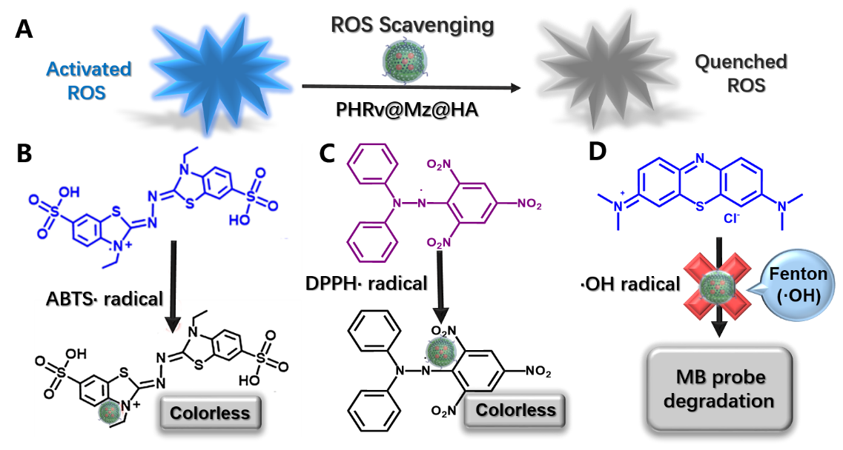
Figure S5. (A) Schematic illustration of the ROS scavenging mechanism by PHRv@Mz@HA: (B) ABTS·, (C) DPPH·, and (D) ·OH, respectively.

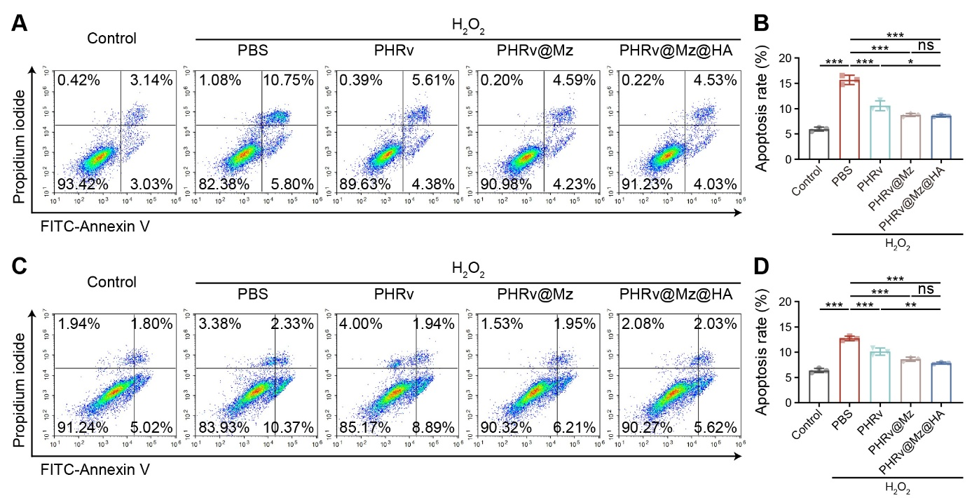
Figure S6. Flow cytometry profiles of the apoptosis for H₂O₂ (100 μM) -induced (A, B) NCM460 and (C, D) HT29 cells after treatment with various formulations (10 μg/mL) for 72 h, respectively.

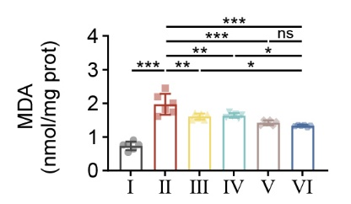
Figure S7. The level of MDA in DSS-induced colitis after different treatments.

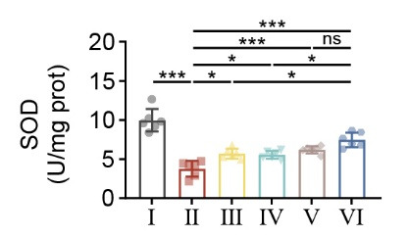
Figure S8. The level of SOD in DSS-induced colitis after different treatments.

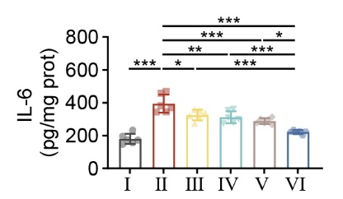
Figure S9. Concentration of IL-6 in the colon tissues of mice were measured by ELISA.

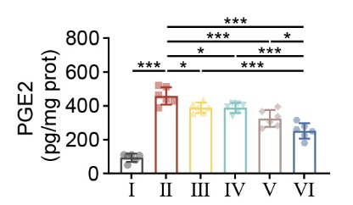
Figure S10. Concentration of PGE2 in the colon tissues of mice were measured by ELISA.

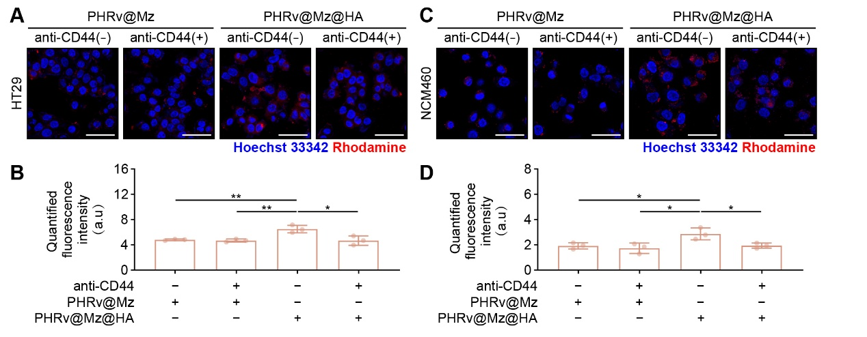
Figure S11. Fluorescence images and Corresponding quantification of cellular uptake profiles of the activated /non-activated HT29 cells (A, B) and NCM460 cells (C, D) with the treatment of Rhodamine 800-labeled PHRv@Mz@HA and the addition of anti-CD44 for 4 h. Scale bar: 50 μm.

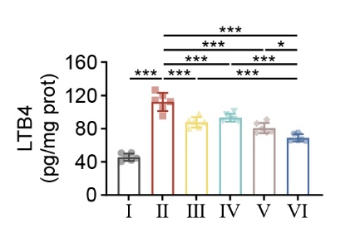
Figure S12. The levels of LTB4 in DSS-induced colitis after different treatments. (n = 6; *p < 0.05, **p < 0.01, and ***p< 0.001; ns, non-significant).

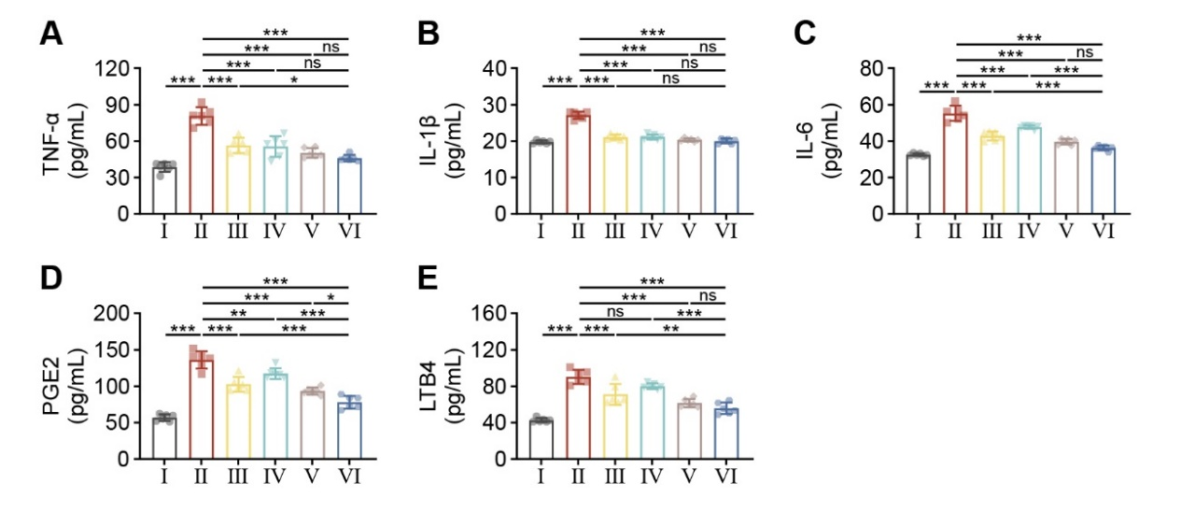
Figure S13. The Serum levels of (A) TNF-α, (B) IL-1β, (C) IL-6, (D) PGE2 and (E) LTB4 in DSS-induced colitis after different treatments. (n = 6; *p < 0.05, **p < 0.01, and ***p< 0.001; ns, non-significant).

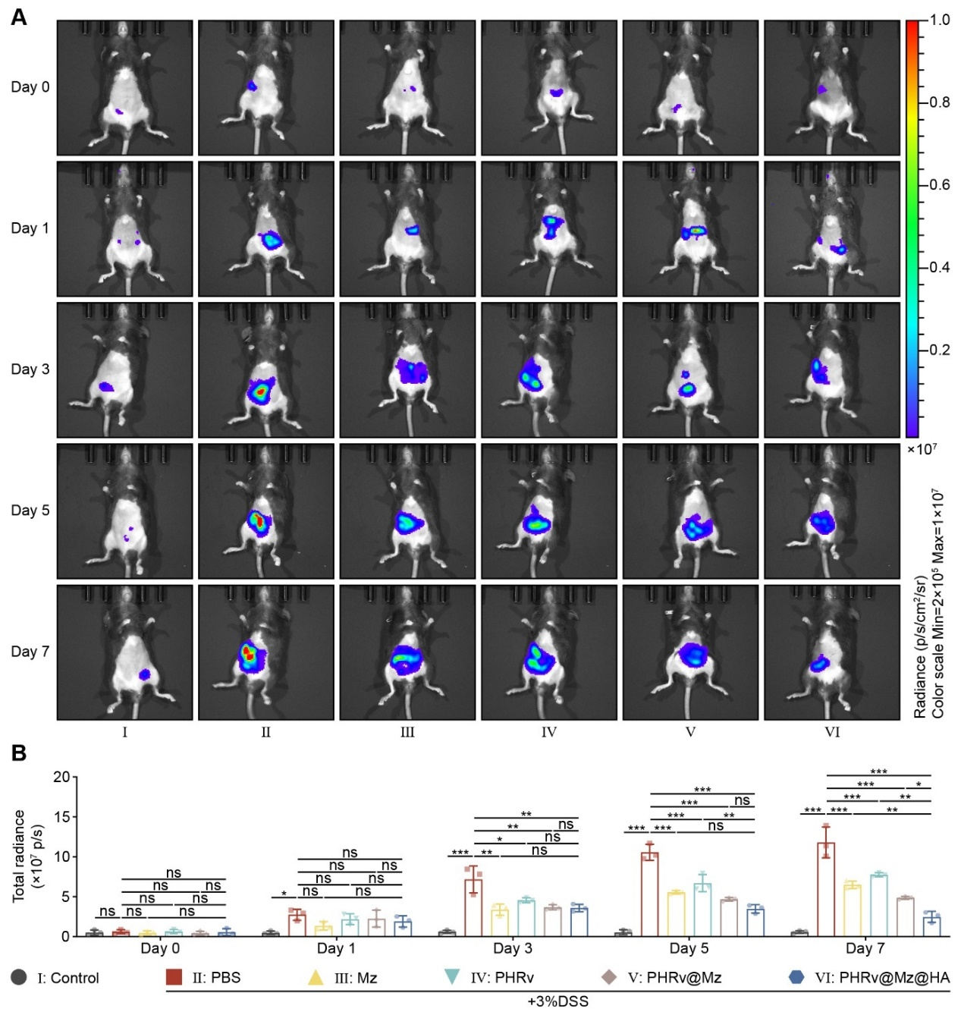
Figure S14. (A) L-012 in vivo imaging abdominal signals at multiple time points and (B) Corresponding quantitative analysis in DSS model (n = 3; *p < 0.05, **p < 0.01, and ***p< 0.001; ns, non-significant).

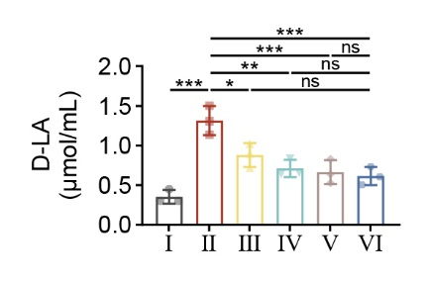
Figure S15. The Serum level of D-La in DSS-induced colitis after different treatments. (n = 3; *p < 0.05, **p < 0.01, and ***p< 0.001; ns, non-significant).

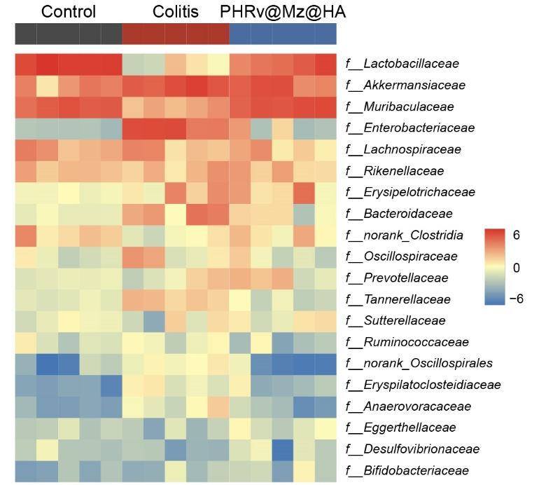

Figure S16. Heatmap of relative abundance of the top 20 gut microbiotic organisms classified by family-level taxonomy.

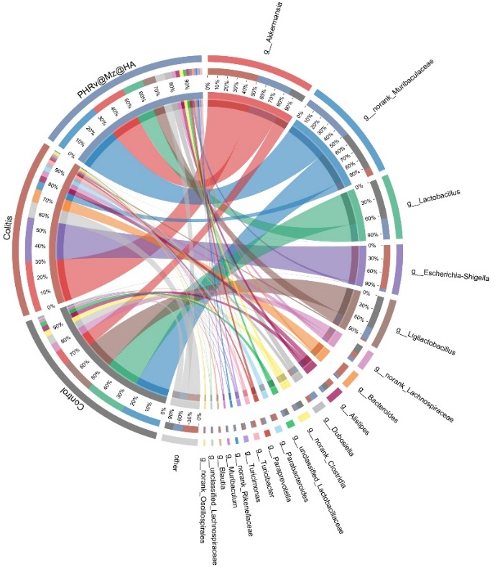

Figure S17. Circular plot showing interactions between the gut microbiota and different groups.

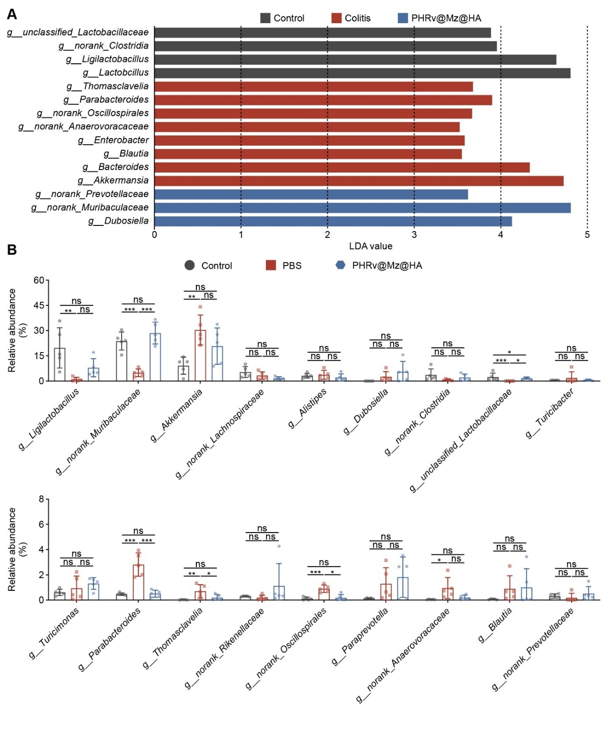
Figure S18. (A) The LDA scores showing the differentially abundant taxa with the three groups at genus level (LDA score>3.0).(B) Relative abundance of other top 20 bacteria and those showing significant changes at genus level. (n = 5; *p < 0.05, **p < 0.01, and ***p< 0.001; ns, non-significant).

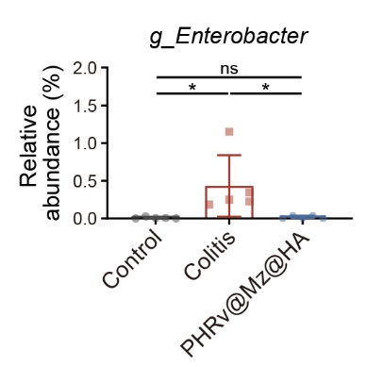
Figure S19. Relative abundance of Enterobacter in the gut microbiota at the genus level. (n = 5; *p < 0.05, **p < 0.01, and ***p< 0.001; ns, non-significant).

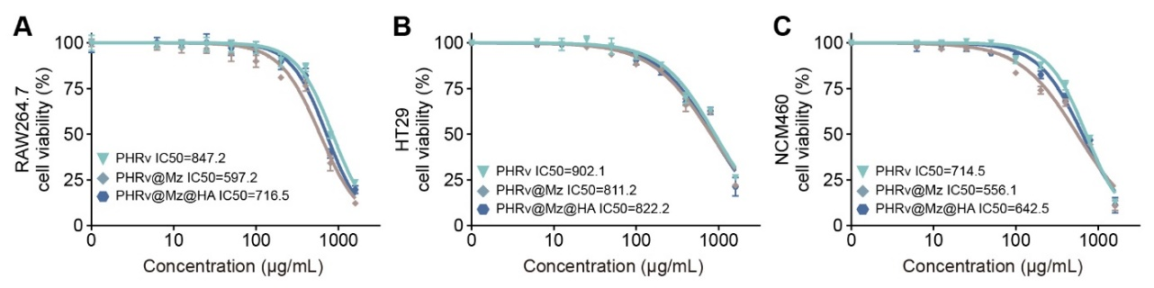
Figure S20. (A) Raw 264.7, (B) HT29, and (C) NCM460 cells viability after incubation with various formulations for 72 h, respectively.

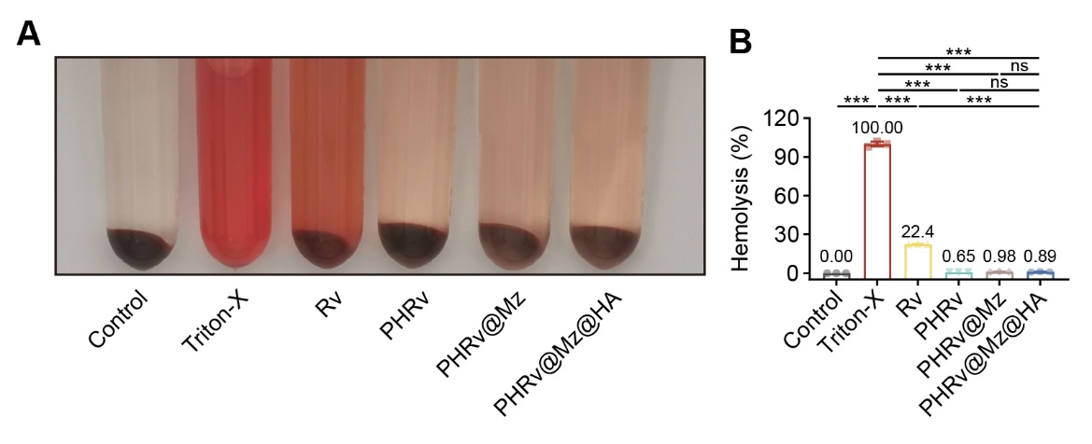
Figure S21. (A) Hemolytic behaviors and (B) Percentage of hemolysis of RBCs treated with various formulations at concentrations of 5 mg/mL.

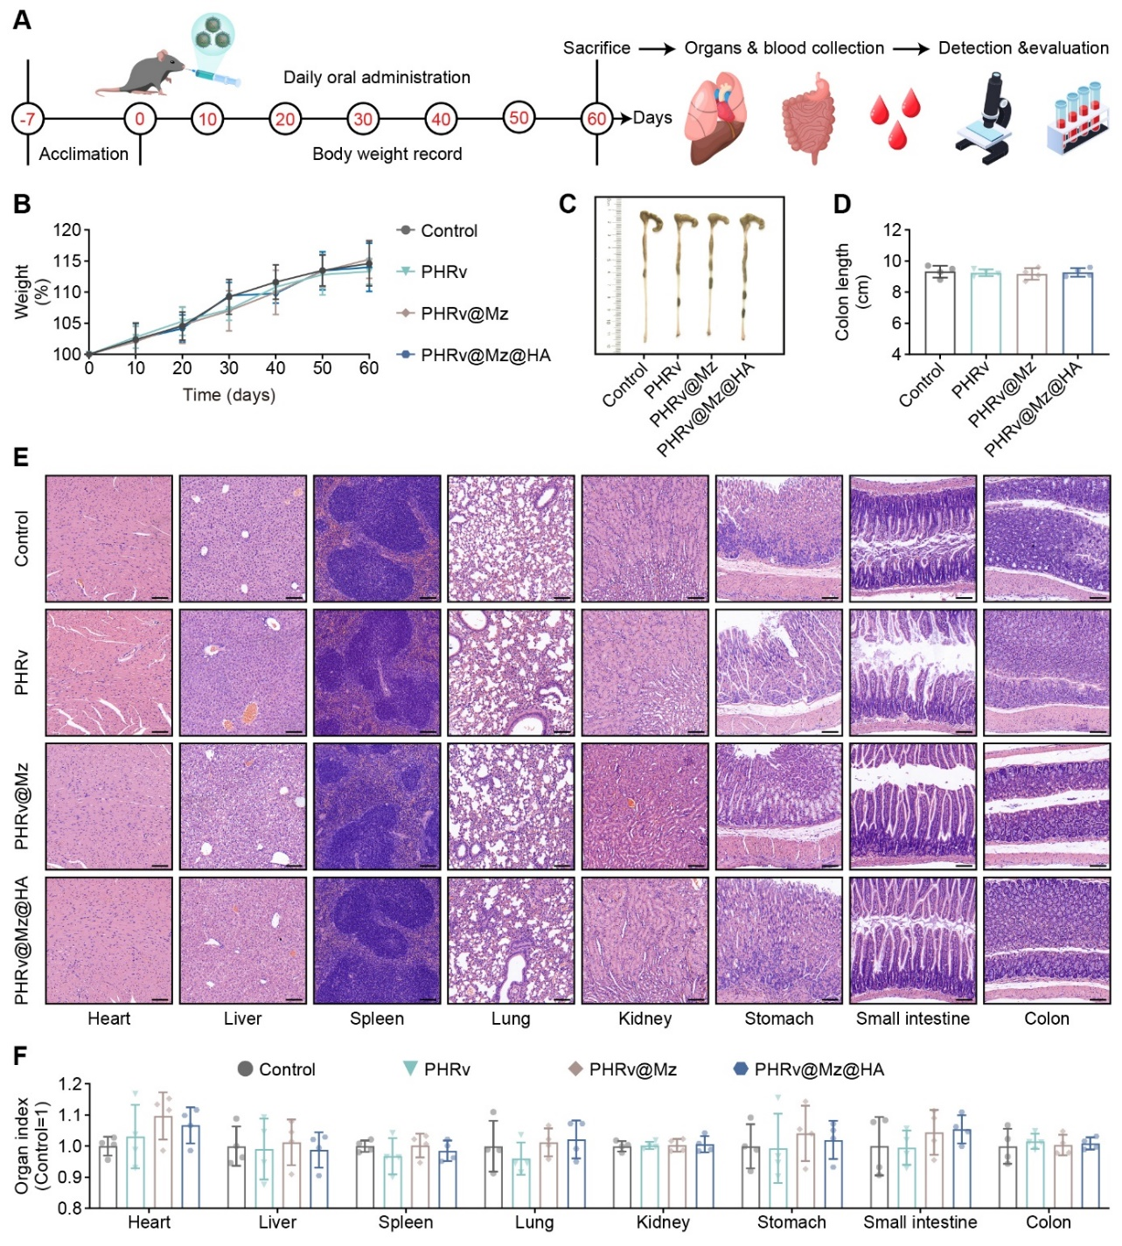
Figure S22. Biocompatibility of PHRv@Mz@HA. (A) Schematic diagram of the experimental schedule; (B) Body weights, (C) Representative images of colon and (D) corresponding colon length of normal mice receiving different administration; (E) H&E staining images of major organ tissues and (F) corresponding organ index. Scale bar =100 μm. (n = 4).

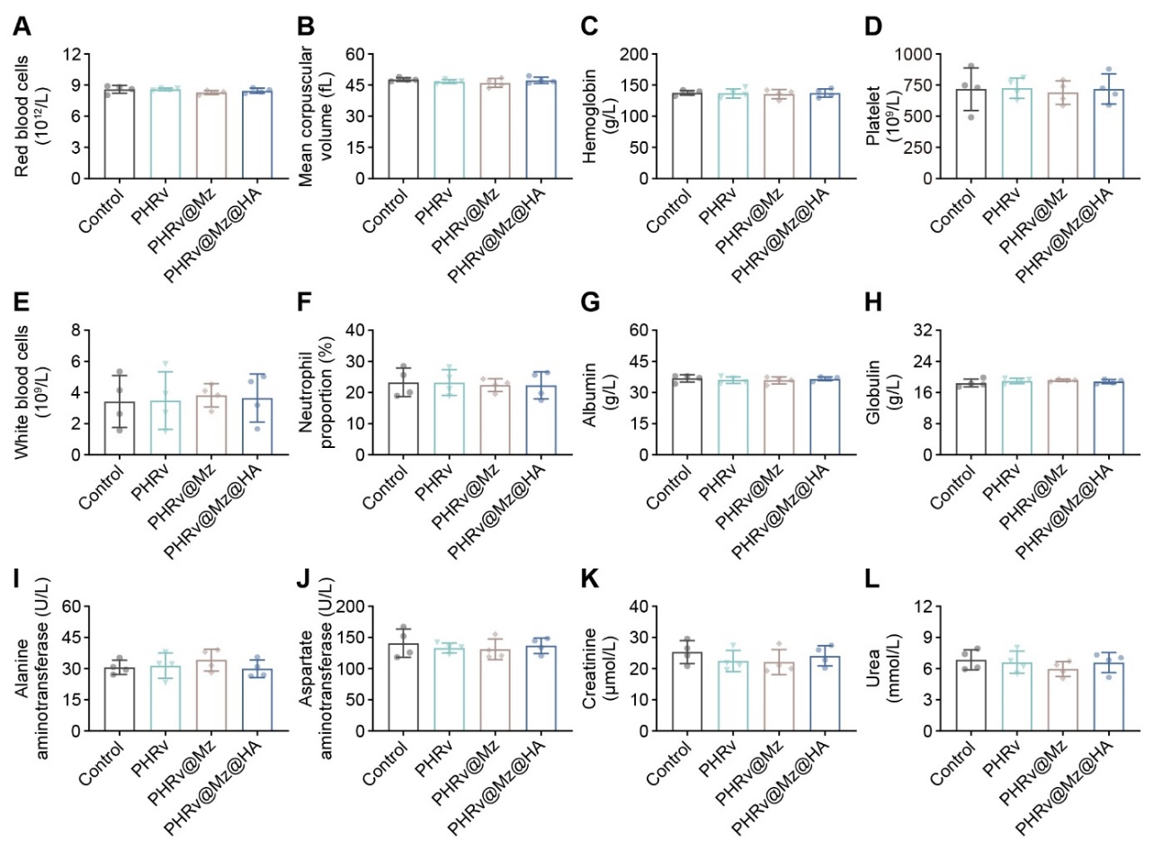
Figure S23. Hematology and serology of PHRv@Mz@HA. (A) Red bood cells; (B) Mean corpuscular volume; (C) Hemoglobin; (D) Platelet; (E) White blood cells ; (F) Neutrophil proportion; (G) Albumin; (H) Globulin; (I) Alanine aminotransferase; (J) Aspartate aminotransferase; (K) Creatinine; (L) Urea.

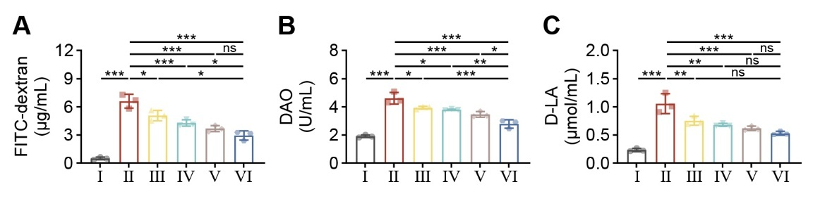
Figure S24. The levels of (A) FITC-dextran, (B) DAO, and (C) D-La in TNBS-induced colitis after different treatments. (n = 3; *p < 0.05, **p < 0.01, and ***p< 0.001; ns, non-significant).

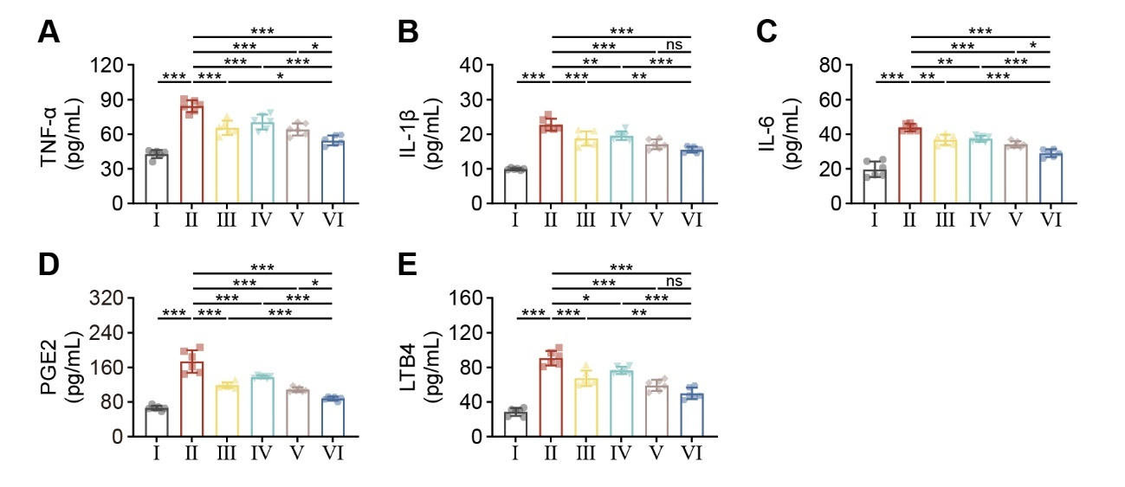
Figure S25. The levels of (A) TNF-α, (B) IL-1β, (C) IL-6, (D) PGE2 and (E) LTB4 in TNBS-induced colitis after different treatments. (n = 3; *p < 0.05, **p < 0.01, and ***p< 0.001; ns, non-significant).

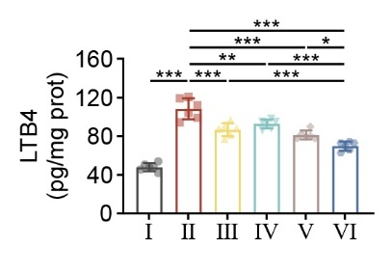
Figure S26. The levels of LTB4 in TNBS-induced colitis after different treatments. (n = 3; *p < 0.05, **p < 0.01, and ***p< 0.001; ns, non-significant).

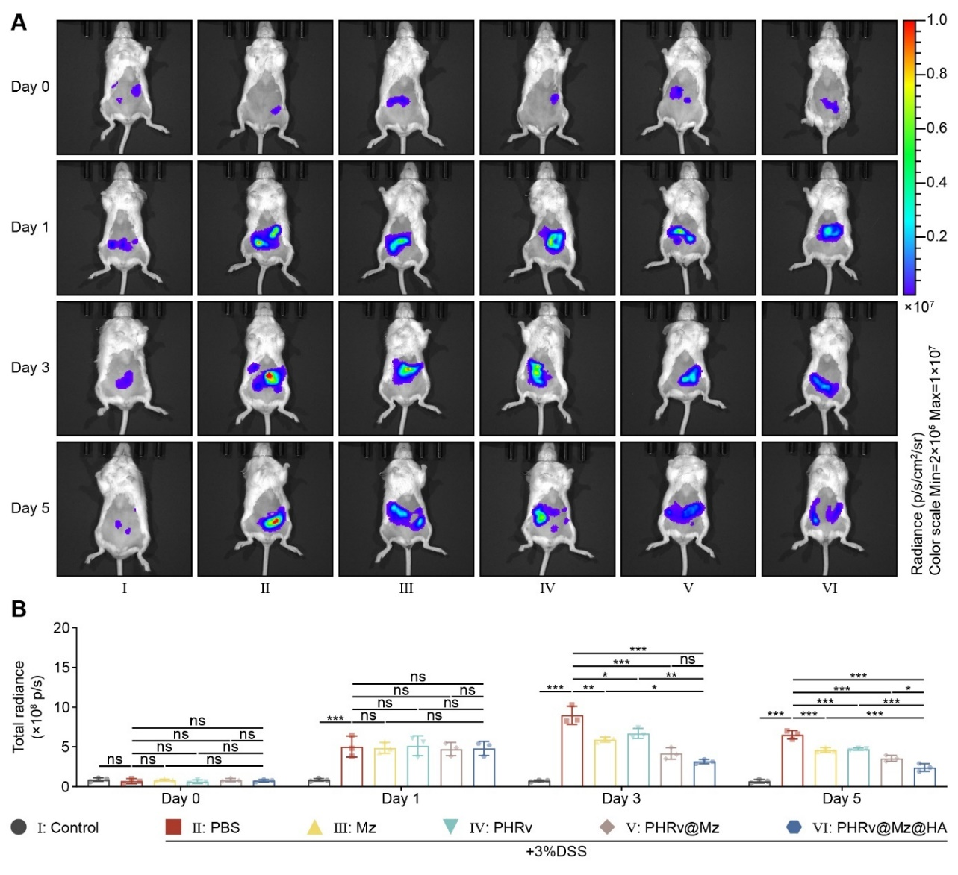
Figure S27. (A) L-012 in vivo imaging abdominal signals at multiple time points and (B) Corresponding quantitative analysis in TNBS model (n = 3; *p < 0.05, **p < 0.01, and ***p< 0.001; ns, non-significant).

Table S1. Encapsulation efficiency (%) and drug loading efficiency (%) of PHRv loaded Mz under different Mz/Rv ratios. Data are presented as the means ± SD (n=3).
Mz/Rv  ratios | Encapsulation efficiency (%) | Drug loading content (%)
1:1 | 34.2 ± 1.72 | 25.2 ± 0.33
1:2 | 57.3 ± 4.46 | 21.1 ± 0.67
1:4 | 89.8 ± 0.61 | 18.5 ± 1.54

Table S2. DAI scoring system for colitis
Score | Weight loss | Stool consistency | Blood
0 | None | Normal | Negative hemoccult
1 | 1-5% | Soft but still formed | Negative hemoccult
2 | 6-10% | Soft | Positive hemoccult
3 | 11-18% | Very soft; wet | Blood traces in stool visible
4 | >18% | Watery diarrhea | Gross rectal bleeding

Table S3. Scoring system for inflammation-associated histological changes in DSS-induced colitis.
Score | Tissue damage | Lamina propria inflammatory cell infiltration
0 | None | Infrequent
1 | Isolated focal epithelial damage | Increased, some neutrophils
2 | Mucosal erosions and ulcerations | Submucosal presence of inflammatory cell clusters
3 | Extensive damage deep into the bowel wall | Transmural cell infiltrations

Table S4. Scoring system for inflammation-associated histological changes in TNBS-induced colitis.
Score | Histologic changes in TNBS colitis
0 | No evidence of inflammation
1 | Low level of inflammation, with scattered infiltrating mononuclear cells (1–2 foci)
2 | Moderate inflammation, with multiple foci
3 | High level of inflammation, with increased vascular density and marked wall thickening
4 | Maximal severity of inflammation, with transmural leukocyte infiltration and loss of goblet cells

Table S5. Primer sequences.
Gene | Forward primer | Reverse primer
Gapdh | AGGTCGGTGTGAACGGATTTG | TGTAGACCATGTAGTTGAGGTCA
ZO-1 | CCAGAAATACCTGACGGTGCT | AGGATGGAGTTACCCACAGC
Occludin | CTTACAGACCTGATGAATTCAAACC | TGCATCTCTCCGCCATACAT
iNOS | GGAGTGACGGCAAACATGACT | TCGATGCACAACTGGGTGAAC
TNF-α | CAGGCGGTGCCTATGTCTC | CGATCACCCCGAAGTTCAGTAG
IL-1β | GAAATGCCACCTTTTGACAGTG | TGGATGCTCTCATCAGGACAG
Arg1 | TGTCCCTAATGACAGCTCCTT | GCATCCACCCAAATGACACAT
IL-10 | CTTACTGACTGGCATGAGGATCA | GCAGCTCTAGGAGCATGTGG
TGF-β | CCACCTGCAAGACCATCGAC | CTGGCGAGCCTTAGTTTGGAC

Table S6. Antibodies used for western blotting.
Antibody | Manufacturer | Catalog | Dilution
ZO-1 | Abcam | ab276131 | 1:1000
Occludin | Abcam | ab216327 | 1:1000
Nrf2 | Cell Signaling Technology | 12721 | 1:1000
HO-1 | Abcam | ab68477 | 1:1000
NF-κB p65 | Cell Signaling Technology | 3033 | 1:1000
Phospho-NF-κB p65 | Cell Signaling Technology | 6956 | 1:1000
TLR4 | Servicebio | GB11519 | 1:500

Appendix
