Supplemental Information for
Harnessing oxygen-driven phase engineering for a strong and ductile duplex titanium alloy
Aihua Yu ¹, Yu Pan ^{1,}, Yanjun Liu ¹, Tengfei Zheng ², Yi Wen ³, Yuan Wu ², Xin Lu ^{1,2,**}
¹ Institute of Engineering Technology, National Engineering Research Center for Advanced Rolling and Intelligent Manufacturing, University of Science and Technology Beijing, Beijing, P.R. China.
² Beijing Advanced Innovation Center for Materials Genome Engineering, State Key Laboratory for Advanced Metals and Materials, University of Science and Technology Beijing, Beijing, P.R. China.
³ School of Materials Science and Engineering, Beihang University, Beijing, P.R. China.

This file includes:
Supplementary Figs. S1-S9
Supplementary Tables S1-S4
Supplementary Notes 1-2
References

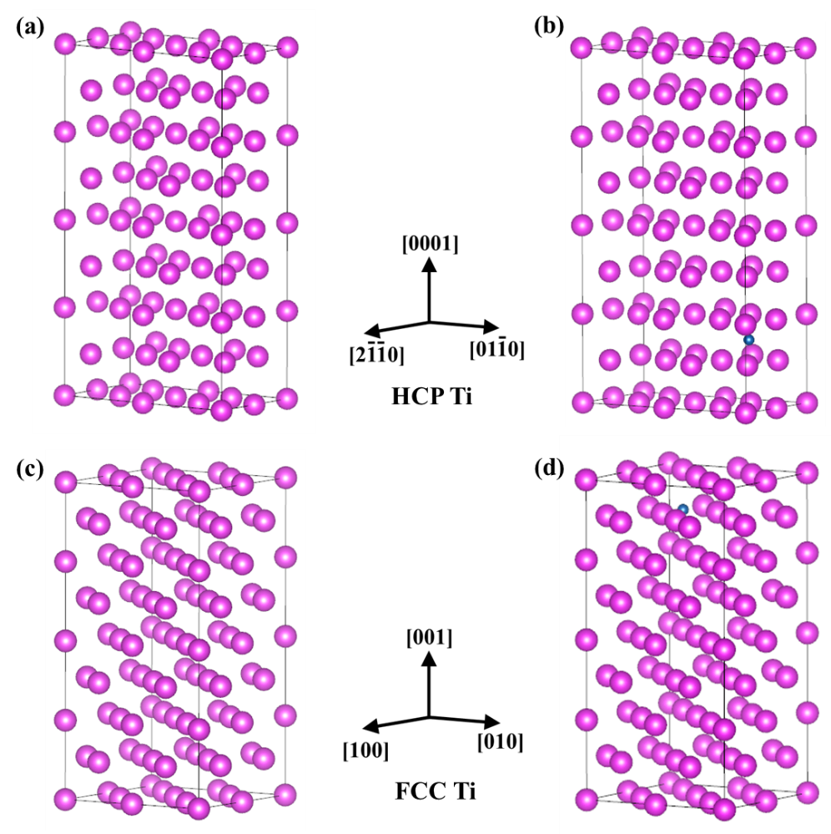
Fig. S1. The calculation of formation energies based on DFT. a) Initial configuration of the HCP Ti phase and b) the HCP Ti doped with an O atom. c) Initial configuration of the FCC Ti and d) the FCC Ti doped with an O atom.

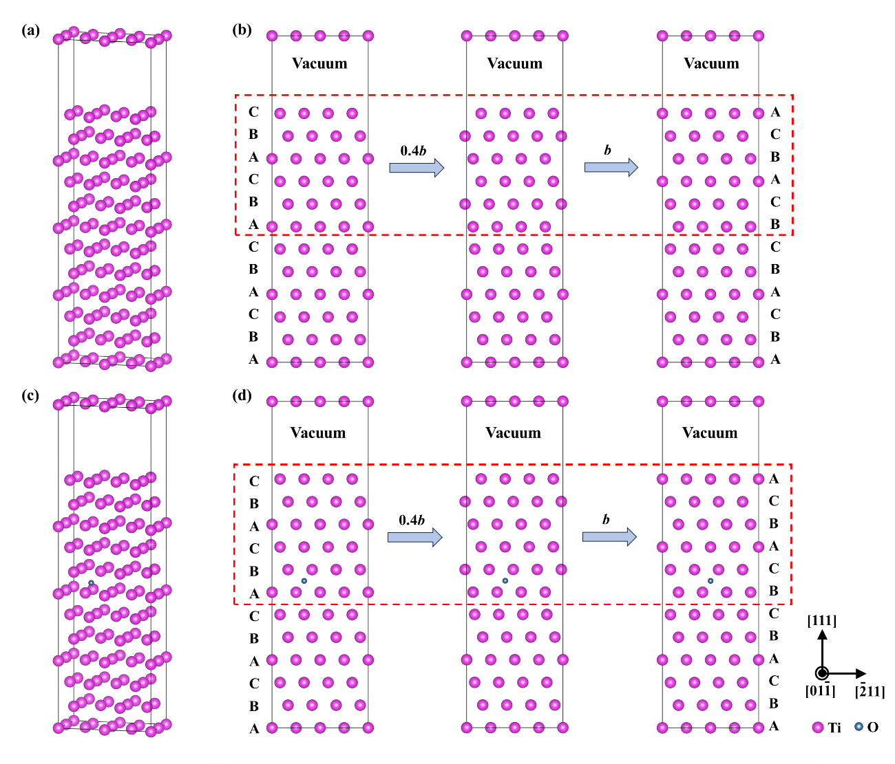
Fig. S2. The calculation of GSFE based on DFT. a) Initial configuration of the pure FCC Ti and b) its process diagram. c) Initial configuration of the 1O-doped FCC Ti and d) its process diagram.

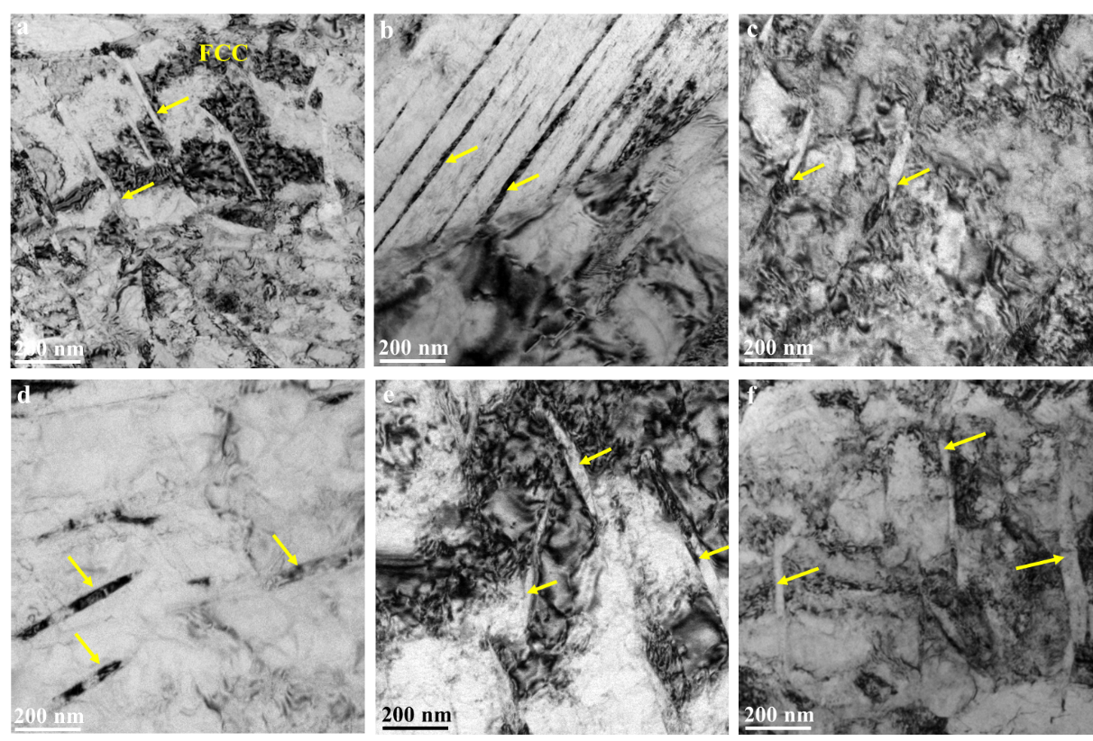
Fig. S3. TEM images randomly collected from the top, middle and bottom regions of the as-printed Ti-0.615O alloy. a)-b) BF-TEM image of a two-phase region collected from the top regions, c)-d) the middle regions and e)-f) the bottom regions of the as-printed parts.

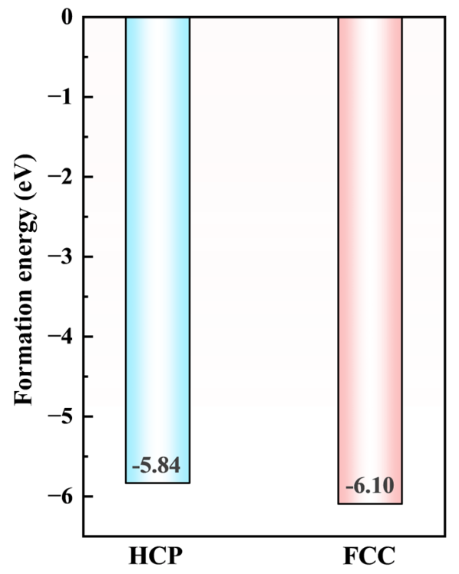
Fig. S4. The calculation of formation energy for an O atom in both HCP and FCC Ti based on DFT.

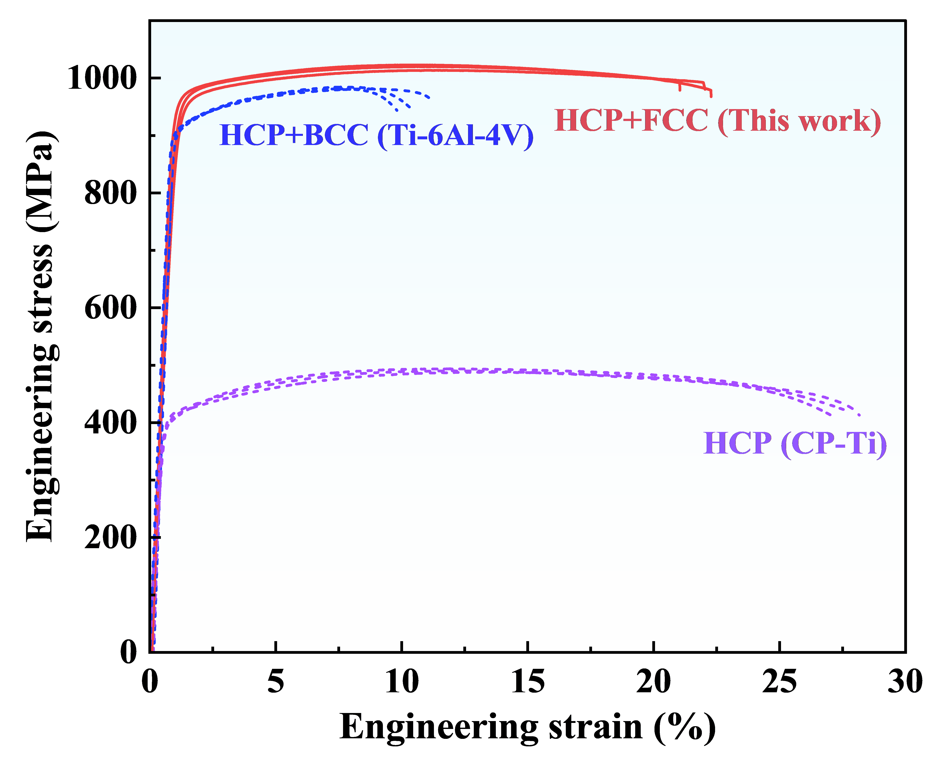
Fig. S5. Engineering stress-strain curves of the duplex Ti-0.615O alloy together with the reference Ti-6Al-4V alloy and CP-Ti.

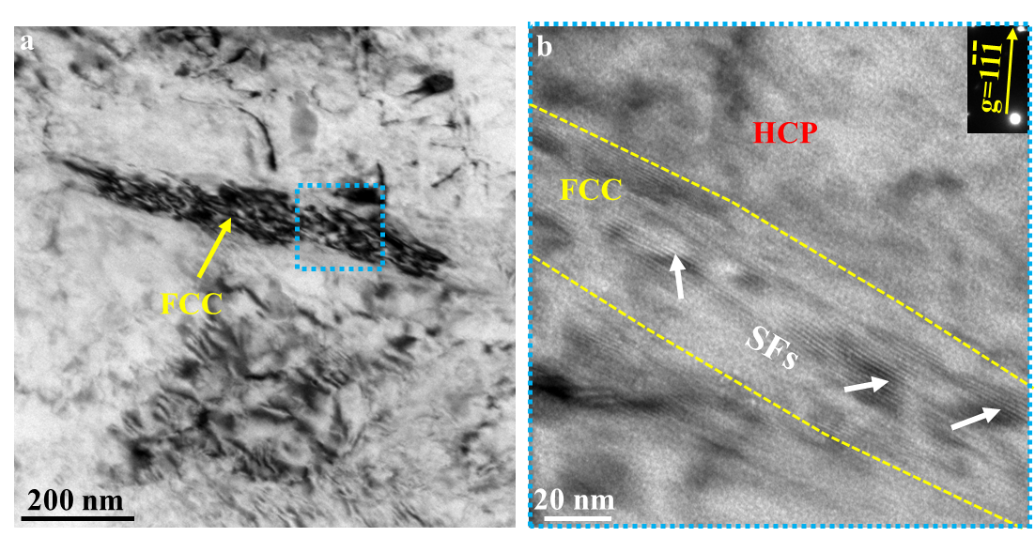
Fig. S6. The deformation substructures of the FCC phase in the duplex Ti-0.615O alloy after tensile deformation. a) BF-TEM image of the FCC phase. b) The magnified views of the blue box in (a) observed along g=111 diffraction vector, showing SFs (indicated by the white arrows) in the {111} planes.

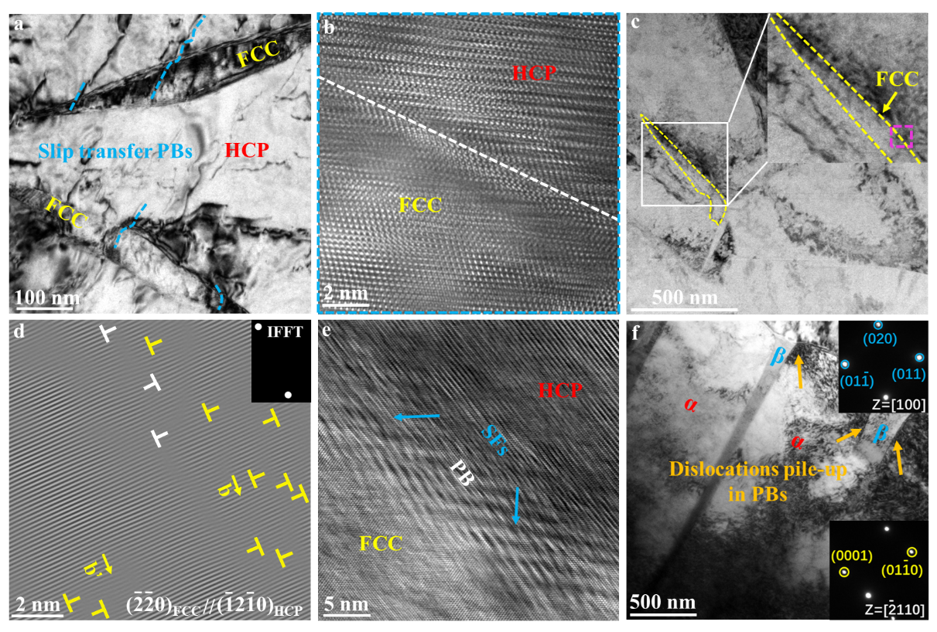
Fig. S7. The deformation substructures of the HCP/FCC PBs in the duplex Ti-0.615O alloy and α/β (HCP/BCC) interfaces in commercial Ti-6Al-4V after tensile deformation. a) BF-TEM image of a two-phase region shows the dislocation transmission across HCP/FCC PBs, highlighted by blue dotted lines. b) HRTEM image corresponding to the blue box in Fig. 4b. c) BF-TEM image of a two-phase region. d) IFFT image (related to the pink box in (c)) selected by the condition on the basis of the criteria that the planes between HCP and FCC are parallel. One possible dislocation transmission across HCP/FCC PBs is shown. e) HRTEM image of the HCP/FCC PBs shows massive SFs, indicating SFs serve as a deformation mode for stress relaxation. f) BF-TEM image in the commercial Ti-6Al-4V alloy clearly shows dislocations pile-up in α/β interfaces.

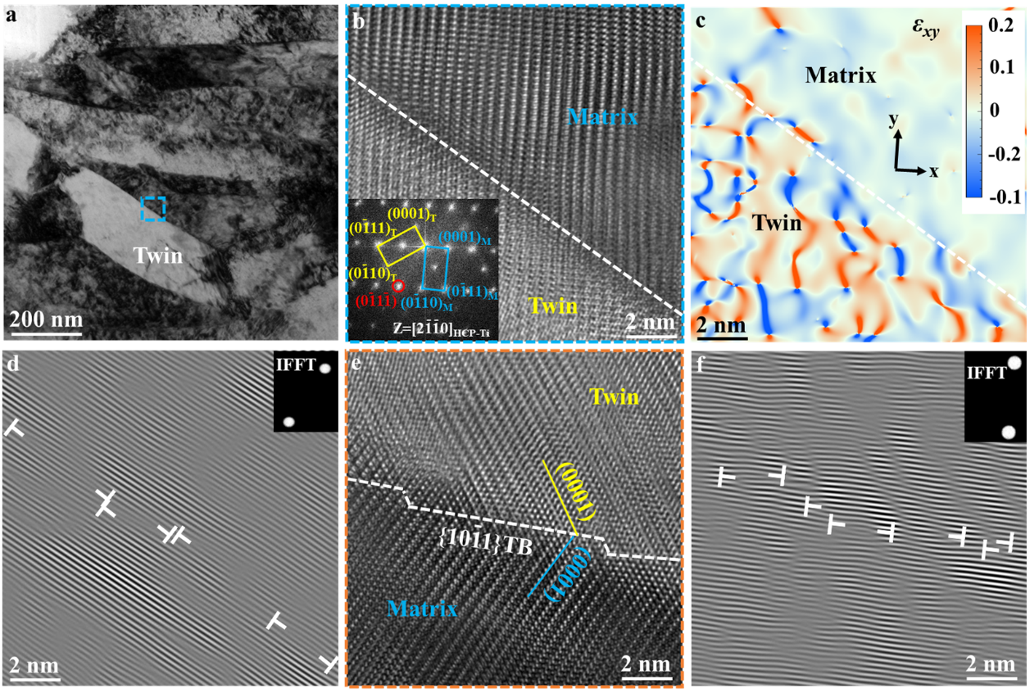
Fig. S8. The deformation substructures of the HCP matrix phase in the duplex Ti-0.615O alloy after tensile deformation. a-b) BF-TEM, the corresponding HRTEM and FFT images of the twin in the HCP matrix, showing the typical {1011} twin. c) GPA pattern of the region in (b) shows significantly larger lattice distortions inside the twin compared to the matrix. d) IFFT image of (b) shows several dislocations in the twin boundary. e) HRTEM image of the orange box in Fig. 4f. f) IFFT image of (e) shows several dislocations in the twin boundary.

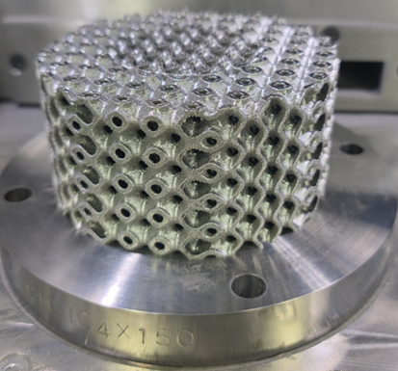
Fig. S9. As-printed Ti-0.615O alloy product with the complex Gyroid structure.

Table S1. Chemical compositions of the raw powders and as-printed duplex alloy.
Elements (wt.%) | Raw powders | As-printed specimens
Oxygen | 0.610 ± 0.020 | 0.615 ± 0.010
Carbon | 0.012 ± 0.002 | 0.012 ± 0.002
Nitrogen | 0.017 ± 0.001 | 0.018 ± 0.001
Hydrogen | 0.014 ± 0.002 | 0.014 ± 0.002
Iron | 0.021 ± 0.002 | 0.022 ± 0.002
Titanium | Bal. | Bal.

Table S2. Tensile properties of as-printed Ti-0.615O alloy, and as-forged CP-Ti and Ti-6Al-4V alloy.
Alloy | UTS (MPa) | EL (%) | SUTS × EL (GPa·%·cm³·g⁻¹)
Ti-0.615O | 1020 ± 4 | 21.8 ± 0.5 | 4.93
Ti-6Al-4V | 983 ± 3 | 10.4 ± 0.6 | 2.30
CP-Ti | 492 ± 5 | 27.4 ± 0.5 | 2.99
The values of UTS and EL are shown as mean ± s.d. (n=3).

Table S3. The GSFE calculated by DFT. A {111}<211> GSFE of pure and 1O-doped FCC Ti.
Displacement ($a/\sqrt{6}$) | γ_{GSF} of pure FCC Ti (mJ/m²) | γ_{GSF} of 1O-doped FCC Ti (mJ/m²)
0 | 0 | 0
0.1 | 16.892 | 16.230
0.2 | 49.580 | 52.046
0.3 | 74.073 | 85.794
0.4 | 86.759 | 100.793
0.5 | 44.592 | 82.181
0.6 | -21.658 | 36.192
0.7 | -92.317 | -23.045
0.8 | -140.228 | -80.739
0.9 | -175.545 | -124.436
1 | -198.288 | -141.611

Supplementary Note 1: Tensile properties data of various materials (Table S4)
Table S4 presents the data details corresponding to the points in Figure 3c, and ρ and SUTS represent the density and specific UTS (UTS/ρ), respectively. For literature that did not directly provide specific data, we utilized Plot Digitizer program to extract UTS and EL values from the engineering stress-strain curves.
Table S4. Tensile properties of Ti alloys, steel, aluminum and nickel-based superalloys fabricated by AM and forging.
Alloy | Processing | UTS (MPa) | EL (%) | SUTS (GPa·cm³·g⁻¹) | ρ (g·cm³) | Ref.
Ti | AM | 641 | 18.0 | 142.13 | 4.51 | [1]
Ti | AM | 732 | 20.3 | 162.31 | 4.51 | [2]
Ti | AM | 876 | 14.7 | 194.24 | 4.51 | [3]
Ti | Forging | 240 | 24.0 | 53.22 | 4.51 | [4]
Ti | Forging | 345 | 20.0 | 76.50 | 4.51 | [4]
Ti | Forging | 450 | 18.0 | 99.78 | 4.51 | [4]
Ti | Forging | 550 | 15.0 | 121.95 | 4.51 | [4]
Ti-(6-25)Ta | AM | 697 | 17.4 | 147.98 | 4.71 | [1]
Ti-(6-25)Ta | AM | 783 | 14.5 | 158.50 | 4.94 | [1]
Ti-(6-25)Ta | AM | 1186 | 5.8 | 215.25 | 5.51 | [1]
Ti-(3.5-8.5)Cu | AM | 867 | 14.9 | 188.89 | 4.59 | [5]
Ti-(3.5-8.5)Cu | AM | 1073 | 5.5 | 230.26 | 4.66 | [5]
Ti-(3.5-8.5)Cu | AM | 1180 | 2.1 | 250.53 | 4.71 | [5]
Ti-(0.14~0.67)O-(0.062~3.36)Fe | AM | 886 | 14.3 | 193.87 | 4.57 | [6]
Ti-(0.14~0.67)O-(0.062~3.36)Fe | AM | 1194 | 9.0 | 261.27 | 4.57 | [6]
Ti-(0.14~0.67)O-(0.062~3.36)Fe | AM | 1271 | 3.0 | 278.12 | 4.57 | [6]
Ti-(0.14~0.67)O-(0.062~3.36)Fe | AM | 1268 | 3.2 | 277.46 | 4.57 | [6]
Ti-(0.14~0.67)O-(0.062~3.36)Fe | AM | 1303 | 2.2 | 285.12 | 4.57 | [6]
Ti-4Al-4V | AM | 936 | 13.3 | 210.34 | 4.45 | [7]
Ti-6Al-4V | Forging | 884 | 16.4 | 198.65 | 4.45 | [8]
Ti-6Al-4V | Forging | 1115 | 7.1 | 250.56 | 4.45 | [9]
Ti-6Al-4V | Forging | 1066 | 11.0 | 239.55 | 4.45 | [9]
Ti-6Al-4V | AM | 989 | 7.9 | 222.25 | 4.45 | [10]
Ti-6Al-4V | AM | 1040 | 7.5 | 233.71 | 4.45 | [10]
Ti-6Al-4V | Forging | 980 | 13.5 | 220.22 | 4.45 | [10]
Ti-6Al-4V | Forging | 995 | 14 | 223.60 | 4.45 | [10]
Ti-6Al-4V | AM | 980 | 13.5 | 220.22 | 4.45 | [11]
Ti-6Al-4V | AM | 1114 | 3.0 | 250.34 | 4.45 | [12]
Ti-6Al-4V | AM | 1040 | 5.0 | 233.71 | 4.45 | [13]
Ti-6Al-4V | AM | 945 | 11.6 | 212.36 | 4.45 | [13]
Ti-6Al-4V | AM | 1005 | 8.3 | 225.84 | 4.45 | [13]
Ti-6Al-4V | AM | 998 | 6.0 | 224.27 | 4.45 | [14]
Ti-6Al-4V | AM | 1042 | 13.0 | 234.16 | 4.45 | [15]
Ti-6Al-4V | AM | 920 | 17.5 | 206.74 | 4.45 | [16]
Ti-6Al-4V | AM | 989 | 10.2 | 222.25 | 4.45 | [16]
Ti-6Al-4V | AM | 948 | 13.6 | 213.03 | 4.45 | [17]
Ti-6Al-4V | Forging | 985 | 15.5 | 221.35 | 4.45 | [18]
Ti-6Al-4V | Forging | 950 | 16.0 | 213.48 | 4.45 | [18]
Ti-6Al-4V | AM | 1149 | 11.3 | 258.20 | 4.45 | [19]
Ti-6Al-4V | AM | 1090 | 12.7 | 244.94 | 4.45 | [19]
Ti-6Al-4V | AM | 1115 | 12.3 | 250.56 | 4.45 | [20]
Ti-6Al-4V | AM | 1095 | 8.1 | 246.07 | 4.45 | [21]
Ti-6Al-4V | AM | 1250 | 10.3 | 280.90 | 4.45 | [22]
Ti-6Al-4V | AM | 1134 | 13.0 | 254.83 | 4.45 | [22]
Ti-6Al-4V | AM | 1202 | 10.1 | 270.11 | 4.45 | [23]
Ti-6Al-4V | AM | 1267 | 7.3 | 284.72 | 4.45 | [24]
Ti-6Al-4V | AM | 1199 | 7.6 | 269.44 | 4.45 | [25]
Ti-6Al-4V | AM | 1065 | 7.0 | 239.33 | 4.45 | [25]
Ti-6Al-4V | AM | 1269 | 5.0 | 285.17 | 4.45 | [26]
Ti-6Al-4V | AM | 898 | 13.6 | 201.80 | 4.45 | [27]
Ti-6Al-4V | AM | 1077 | 14.1 | 242.02 | 4.45 | [27]
Ti-6Al-4V | AM | 1134 | 13 | 254.83 | 4.45 | [27]
Ti-6Al-4V | AM | 1207 | 9.5 | 271.24 | 4.45 | [27]
Ti-6Al-4V | AM | 1175 | 6.9 | 264.04 | 4.45 | [28]
Ti-6Al-4V | AM | 988 | 9.5 | 222.02 | 4.45 | [20]
Ti-6Al-4V | AM | 963 | 13.9 | 216.40 | 4.45 | [29]
Ti-6Al-4V | AM | 975 | 15.8 | 219.10 | 4.45 | [29]
Ti-6Al-4V | AM | 947 | 11.8 | 212.81 | 4.45 | [29]
Ti-6Al-4V | AM | 1016 | 12.5 | 228.31 | 4.45 | [29]
Ti-6Al-4V | AM | 996 | 3.0 | 223.82 | 4.45 | [14]
Ti-6Al-4V-10Mo | AM | 919 | 20.1 | 182.70 | 5.03 | [30]
Ti-4Al-4V-(0~0.2)Y₂O₃ | AM | 983 | 11.3 | 220.90 | 4.45 | [28]
Ti-4Al-4V-(0~0.2)Y₂O₃ | AM | 1045 | 14.4 | 234.83 | 4.45 | [28]
Ti-4Al-4V-(0~0.2)Y₂O₃ | AM | 1050 | 11.4 | 235.96 | 4.45 | [28]
Ti-6.5Al-2Zr-1Mo-1V | AM | 949 | 10.0 | 213.26 | 4.45 | [31]
Ti-6.5Al-2Zr-1Mo-1V | AM | 731 | 16.1 | 164.27 | 4.45 | [31]
Ti-6.5Al-2Zr-1Mo-1V | AM | 770 | 17.5 | 173.03 | 4.45 | [31]
Ti-5Al-5Mo-5V-3Cr-1Zr | AM | 819 | 16.5 | 174.26 | 4.7 | [32]
Ti-5Al-5Mo-5V-3Cr-1Zr | AM | 806 | 19.2 | 171.49 | 4.7 | [32]
Ti-5Al-5Mo-5V-3Cr-1Zr | AM | 1329 | 4.5 | 282.77 | 4.7 | [32]
Ti-5Al-5Mo-5V-3Cr-1Zr | AM | 1338 | 4.1 | 284.68 | 4.7 | [32]
Ti-5Al-5Mo-5V-3Cr-1Zr | AM | 1234 | 10.5 | 262.55 | 4.7 | [32]
Ti-5Al-5Mo-5V-3Cr-1Zr | AM | 1274 | 8.2 | 271.06 | 4.7 | [32]
Ti-5Al-5Mo-5V-3Cr-1Zr | AM | 1200 | 10.5 | 255.32 | 4.7 | [33]
Ti-5Al-5Mo-5V-3Cr-1Zr | AM | 1287 | 8.5 | 273.83 | 4.7 | [33]
IN718 | Forging | 1446 | 14.3 | 177.21 | 8.16 | [34]
IN718 | Forging | 1427 | 13.7 | 174.88 | 8.16 | [34]
IN718 | Forging | 1425 | 13.0 | 174.63 | 8.16 | [34]
IN718 | Forging | 1311 | 12.0 | 160.66 | 8.16 | [35]
IN718 | Forging | 1287 | 13.0 | 157.72 | 8.16 | [35]
IN718 | AM | 1268 | 11.0 | 155.39 | 8.16 | [36]
IN718 | AM | 1300 | 10.0 | 159.31 | 8.16 | [36]
IN718 | AM | 1355 | 9.5 | 166.05 | 8.16 | [36]
IN718 | AM | 1385 | 7.6 | 169.73 | 8.16 | [36]
IN718 | AM | 1423 | 6.2 | 174.39 | 8.16 | [36]
IN718 | AM | 954 | 15.1 | 116.91 | 8.16 | [36]
IN718 | AM | 903 | 16.2 | 110.66 | 8.16 | [36]
IN718 | AM | 852 | 18.3 | 104.41 | 8.16 | [36]
IN718 | AM | 1400 | 8.7 | 171.57 | 8.16 | [36]
IN718 | AM | 1333 | 8.4 | 163.36 | 8.16 | [37]
IN718 | AM | 1341 | 8.5 | 164.34 | 8.16 | [37]
IN718 | AM | 1216 | 16.4 | 149.02 | 8.16 | [37]
IN718 | AM | 960 | 17.5 | 117.65 | 8.16 | [38]
IN718 | AM | 1000 | 18.0 | 122.55 | 8.16 | [38]
IN718 | AM | 961 | 20.0 | 117.77 | 8.16 | [38]
IN718 | AM | 943 | 21.0 | 115.56 | 8.16 | [38]
IN718 | AM | 1368 | 10.7 | 167.65 | 8.16 | [39]
IN718 | AM | 1187 | 20.0 | 145.47 | 8.16 | [39]
IN718 | AM | 1372 | 12.3 | 168.14 | 8.16 | [40]
IN718 | AM | 1370 | 13.7 | 167.89 | 8.16 | [41]
IN718 | AM | 1268 | 21.4 | 155.39 | 8.16 | [41]
IN718 | AM | 1563 | 13.9 | 191.54 | 8.16 | [42]
IN718 | AM | 1398 | 16.1 | 171.20 | 8.16 | [43]
IN718 | AM | 1397 | 17.8 | 171.20 | 8.16 | [44]
IN939 | AM | 1187 | 7.5 | 145.47 | 8.16 | [45]
EP741NP | AM | 1357 | 12.4 | 169.63 | 8 | [46]
EP741NP | AM | 1357 | 13.5 | 169.63 | 8 | [46]
EP741NP | AM | 1406 | 14.3 | 175.75 | 8 | [46]
EP741NP | AM | 1358 | 11.4 | 169.75 | 8 | [46]
EP741NP | AM | 1349 | 11.9 | 168.63 | 8 | [46]
7xxx Al alloy | AM | 373 | 8.3 | 133.21 | 2.8 | [47]
7xxx Al alloy | AM | 451 | 4.3 | 161.07 | 2.8 | [47]
7xxx Al alloy | AM | 441 | 5.0 | 157.50 | 2.8 | [47]
7xxx Al alloy | AM | 440 | 3.0 | 157.14 | 2.8 | [47]
AlSi10Mg | AM | 431 | 7 | 160.82 | 2.68 | [48]
AlSi10Mg | AM | 403 | 6.1 | 150.37 | 2.68 | [48]
AlSi10Mg | AM | 280 | 4.2 | 104.48 | 2.68 | [48]
AlSi10Mg | AM | 316 | 6.0 | 117.91 | 2.68 | [48]
AA7075 | AM | 541 | 8.2 | 193.21 | 2.8 | [49]
AlSi10Mg | AM | 315 | 7.3 | 112.50 | 2.8 | [50]
Al7075+Zr | AM | 383 | 3.8 | 136.79 | 2.8 | [50]
Al7075+Zr | AM | 410 | 5.3 | 146.43 | 2.8 | [50]
Al7075+Zr | AM | 417 | 5.4 | 148.93 | 2.8 | [50]
AerMet100 | AM | 1538 | 12.3 | 194.68 | 7.9 | [51]
AerMet100 | AM | 1997 | 11.0 | 252.78 | 7.9 | [51]
AerMet100 | AM | 2060 | 10.9 | 260.76 | 7.9 | [51]
AerMet100 | AM | 2009 | 12.5 | 254.30 | 7.9 | [51]
AerMet100 | AM | 2025 | 12.5 | 256.33 | 7.9 | [51]
AF9628 | AM | 1400 | 10.2 | 178.34 | 7.85 | [52]
AF9628 | AM | 1310 | 9.0 | 166.88 | 7.85 | [52]
AF9628 | AM | 1410 | 8.4 | 179.62 | 7.85 | [52]
AF9628 | AM | 1340 | 7.4 | 170.70 | 7.85 | [52]
AF9628 | AM | 1430 | 9.8 | 182.17 | 7.85 | [52]
AF9628 | AM | 1320 | 10.9 | 168.15 | 7.85 | [52]
AF9628 | AM | 1420 | 7.7 | 180.89 | 7.85 | [52]
AF9628 | AM | 1380 | 9.5 | 175.80 | 7.85 | [52]
X15CrMnNiN15-3-3-0.15 | AM | 1310 | 5.6 | 165.82 | 7.9 | [53]
X15CrMnNiN15-3-3-0.15 | AM | 1450 | 9.5 | 183.54 | 7.9 | [53]
X15CrMnNiN15-3-3-0.15 | AM | 1380 | 4.2 | 174.68 | 7.9 | [53]
X15CrMnNiN15-3-3-0.15 | AM | 1350 | 6.1 | 170.89 | 7.9 | [53]
X15CrMnNiN15-3-3-0.15 | AM | 1340 | 3.3 | 169.62 | 7.9 | [53]
X15CrMnNiN15-3-3-0.15 | AM | 1330 | 3.5 | 168.35 | 7.9 | [53]
X15CrMnNiN15-3-3-0.15 | AM | 1360 | 3.7 | 172.15 | 7.9 | [53]
X15CrMnNiN15-3-3-0.15 | AM | 1370 | 8.4 | 173.42 | 7.9 | [53]
Fe19Ni5Ti | AM | 1300 | 10.0 | 165.18 | 7.87 | [54]

Supplementary Note 2: The influence of O on the GSFE of FCC Ti (Table S2)
Table S2 presents the GSFE (γ_{GSF}) results of the pure and O-doped FCC Ti. The unstable stacking fault energy (γ_{usf}) represents the energy barrier of SF formation, corresponding to the γ_{GSF} at the displacement of 0.4($\frac{a}{\sqrt{6}}$) in this study. It can be found that the γ_{usf} of the pure FCC Ti (86.759 mJ/m²) is significantly lower compared to that of the traditional HCP Ti (240 mJ/m²),⁵⁵ indicating that SF is more likely to act as an alternative deformation behavior for FCC Ti.⁵⁶ For the O-doped FCC Ti, the γ_{usf} slightly increases by 14.034 mJ/m² to 100.793 mJ/m² with respect to that of the pure FCC Ti. This demonstrates that interstitial O atoms minimally affect the SF barrier, that is, SF remains an effective strain accommodation mechanism in the O-rich FCC Ti. Additionally, the γ_{GSF} corresponding to the intrinsic stacking fault structure (i.e., at the displacement of $\frac{a}{\sqrt{6}}$ Å) is the intrinsic stacking fault energy (γ_{isf}), which can reflect the stability of the crystal structure. It is worth noting that the γ_{isf} of O-doped FCC Ti significantly increased by 56.677 mJ/m² relative to the pure FCC Ti, from -198.288 to -141.61 mJ/m². This indicates that interstitial O atoms could suppress HCP Ti nucleation from FCC Ti, thereby stabilizing FCC Ti. These findings highlight that the O-rich FCC Ti is stable and effectively accommodates deformation via the formation of SFs, verifying our experimental observations.

References:
- D. L. Zhao, C. J. Han, Y. Li, J. J. Li, K. Zhou, Q. S. Wei, J. Liu, Y. S. Shi, J. Alloy. Compd. 2019, 804, 288.
- Q. Y. Tao, Z. W. Wang, G. Chen, W. Cai, P. Cao, C. Zhang, W. W. Ding, X. Lu, T. Luo, X. H. Qu, M. L. Qin, Addit. Manuf. 2020, 34, 101198.
- W. Xu, S. Q. Xiao, X. Lu, G. Chen, C. C. Liu, X. H. Qu, J. Mater. Sci. Technol. 2019, 35, 322.
- B381-13 Standard specification for titanium and titanium alloy forgings, ASTM International, West Conshohocken, PA, 2017.
- D. Y. Zhang, D. Qiu, M. A. Gibson, Y. F. Zheng, H. L. Fraser, D. H. StJohn, M. A. Easton, Nature 2019, 576, 91.
- T. T. Song, Z. B. Chen, X. Y. Cui, S. L. Lu, H. S. Chen, H. Wang, T. Dong, B. L. Qin, K. C. Chan, M. Brandt, X. Z. Liao, S. P. Ringer, M. Qian, Nature 2023, 618, 63.
- L. Y. Wang, Z. Song, X. Zhang, J. S. Park, J. Almer, G. M. Zhu, Y. W. Chen, Q. Li, X. Q. Zeng, Y. J. Li, Addit. Manuf. 2022, 52, 102656.
- W. T. Ou-yang, L. Zhang, H. C. Wu, D. Wu, S. W. Zhang, X. Qin, S. L. Jiang, S. J. Li, W. W. Zhang, L. Y. Sheng, Int. J. Mach. Tool. Manu. 2024, 201, 104192.
- J. H. Luan, Z. B. Jiao, G. Chen, C. T. Liu, J. Alloy. Compd. 2015, 624, 170.
- T. Vilaro, C. Colin, J. D. Bartout, Metall. Mater. Trans. A 2011, 42, 3190.
- M. Shunmugavel, A. Polishetty, G. Littlefair, Procedia. Technol. 2015, 20, 231-236.
- Z. Song, Y. H. Liu, G. M. Zhu, J. Wang, L. Y. Wang, X. Q. Zeng, Mater. Lett. 2024, 375, 137245.
- S. Leuders, M. Thöne, A. Riemer, T. Niendorf, T. Tröster, H. A. Richard, H. J. Maier, Int. J. Fatigue 2013, 48, 300.
- V. Cain, L. Thijs, J. Van Humbeeck, B. Van Hooreweder, R. Knutsen, Addit. Manuf. 2015, 5, 68.
- D. A. Hollander, V. W. Matthias, W. Tobias, S. Richard, S. R. Bernhard, P. Othmar, E. Hans-Josef, Biomaterials 2006, 27, 955.
- H. J. Bai, H. Deng, L. Q. Chen, X. B. Liu, X. R. Qin, D. G. Zhang, T. Liu, X. D. Cui, Metals 2021, 11, 534.
- B. Vrancken, L. Thijs, J. P. Kruth, J. V. Humbeeck, J. Alloy. Compd. 2012, 542, 177.
- W. X. Yu, M. Q. Li, J. Luo, S. B. Su, C. Q. Li, Mater. Design 2010, 31, 3282.
- W. Xu, E. W. Lui, A. Pateras, M. Qian, M. Brandt, Acta Mater. 2017, 125, 390.
- G. Kasperovich, J. Hausmann, J. Mater. Process. Tech. 2015, 220, 202.
- L. Facchini, E. Magalini, P. Robotti, A. Molinari, S. Höges, K. Wissenbach, Rapid Prototyping J. 2010, 16, 1355.
- D. C. Zhang, L. Y. Wang, H. Zhang, A. Maldar, G. M. Zhu, W. Chen, J. S. Park, J. Wang, X. Q. Zeng, Acta Mater. 2020, 189, 93.
- P. Kumar, O. Prakash, U. Ramamurty, Acta Mater. 2018, 154, 246.
- B. Vrancken, L. Thijs, J. P. Kruth, J. V. Humbeeck, Acta Mater. 2014, 68, 150.
- M. Simonelli, Y. Y. Tse, C. Tuck, Mater. Sci. Eng. A 2014, 616, 1.
- H. K. Rafi, N. V. Karthik, H. J. Gong, T. L. Starr, B. E. Stucker, J. Mater. Eng. Perform. 2013, 22, 3872.
- H. F. Nurly, D. C. Ren, Y. S. Cai, H. B. Ji, H. Wang, A. J. Huang, R. Yang, Mater. Sci. Eng. A 2024, 894, 146170.
- Y. H. Liu, Z. Song, Y. Guo, G. M. Zhu, Y. H. Fan, H. M. Wang, W. T. Yan, X. Q. Zeng, L. Y. Wang, J. Mater. Sci. Technol. 2024, 191, 146.
- P. Kumar, U. Ramamurty, Acta Mater. 2019, 169, 45.
- B. Vrancken, L. Thijs, J. P. Kruth, J. Van Humbeeck, Acta Mater. 2014, 68, 150.
- J. W. Liu, Y. X. Li, Y. M. Zhu, Y. Yang, R. F. Zhang, Z. B. Zhang, A. J. Huang, K. Zhang, Mater. Sci. Eng. A 2022, 859, 144201.
- H. Deng, W. B. Qiu, S. Cao, L. Q. Chen, Z. D. Hu, Y. Q. Wei, Z. X. Xia, L. J. Zhou, X. D. Cui, J. Tang, J. Alloy. Compd. 2021, 858, 158351.
- C. W. Huang, Y. Q. Zhao, S. W. Xin, W. Zhou, Q. Li, W. D. Zeng, J. Alloy. Compd. 2017, 693, 582.
- K. S. Li, R. S. Lu, X. F. Gong, Y. B. Pei, X. Zhang, J. P. Tan, X. C. Zhang, S. T. Tu, R. Z. Wang, Mater. Sci. Eng. A 2024, 899, 146465.
- E. Hosseini, V. A. A. Popovich, Addit. Manuf. 2019, 30, 100877.
- J. L. Yang, C. W. Li, N. Shu, H. Zhang, X. F. Zhang, Z. S. Liu, X. Y. Zhang, J. F. Gu, Mater. Sci. Eng. A 2024, 913, 147067.
- H. Qi, M. Azer, A. Ritter, Metall. Mater. Trans. A 2009, 40, 2410.
- J. H. Yi, J. W. Kang, T. J. Wang, X. Wang, Y. Y. Hu, T. Feng, Y. L. Feng, P. Y. Wu, J. Alloy. Compd. 2019, 786, 481.
- D. Y. Zhang, W. Niu, X. Y. Cao, Z. Liu, Mater. Sci. Eng. A 2015, 644, 32.
- Q. S. Song, Y. Zhang, Y. F. Wei, X. Y. Zhou, Y. F. Shen, Y. M. Zhou, X. M. Feng, Opt. Laser Technol. 2021, 144, 107423.
- M. M. Kirka, F. Medina, R. Dehoff, A. Okello, Mater. Sci. Eng. A 2017, 680, 338.
- X. L. Yao, S. K. Moon, B. Y. Lee, G. J. Bi, Inter. J. Precis. Eng. Man. 2017, 18, 1693.
- E. Tekoğlu, A. D. O’Brien, J. Liu, B. M. Wang, S. Kavak, Y. Zhang, S. Y. Kim, S. T. Wang, D. Ağaoğulları, W. Chen, A. J. Hart, J. Li, Addit. Manuf. 2023, 67, 103478.
- I. Šulák, T. Babinský, A. Chlupová, A. Milovanović, L. Náhlík, J. Mech. Sci. Technol. 2023, 37, 1071.
- B. Zhang, H. Ding, A. C. Meng, S. Nemati, S. M. Guo, W. J. Meng, Addit. Manuf. 2023, 72, 103623.
- Z. A. Sentyurina, F. A. Baskov, P. A. Loginov, Y. Y. Kaplanskii, A. V. Mishukov, I. A. Logachev, M. Y. Bychkova, E. A. Levashov, A. I. Logacheva, Addit. Manuf. 2021, 37, 101629.
- E. Beevers, N. J. Mena, L. Thijs, N. Nutal, A. Norman, B. V. Hooreweder, Mater. Sci. Eng. A 2024, 916, 147334.
- M. N. Liu, K. W. Wei, X. Y. Zeng, Mater. Sci. Eng. A 2022, 842, 143107.
- J. K. Yoder, R. J. Griffiths, H. Z. Yu, Mater. Design 2021, 198, 109288.
- J. H. Martin, B. D. Yahata, J. M. Hundley, J. A. Mayer, T. A. Schaedler, T. M. Pollock, Nature 2017, 549, 365.
- X. Z. Ran, D. Liu, J. Li, X. Liu, H. M. Wang, X. Cheng, B. He, H. B. Tang, Mater. Sci. Eng. A 2018, 723, 8.
- R. Seede, D. Shoukr, B. Zhang, A. Whitt, S. Gibbons, P. Flater, A. Elwany, R. Arroyave, I. Karaman, Acta Mater. 2020, 186, 199.
- R. Lehnert, O. Volkova, R. Wagner, C. Burkhardt, H. Biermann, Mater. Sci. Eng. A 2020, 794, 139684.
- P. Kürnsteiner, M. B. Wilms, A. Weisheit, B. Gault, E. A. Jägle, D. Raabe, Nature 2020, 582, 515.
- P. Kwasniak, H. Garbacz, K. J. Kurzydlowski, Acta Mater. 2016, 102, 304.
- Z. J. Wu, X. Y. Zhu, Y. Z. Shen, X. B. Zong, Y. Wu, Q. X. Wang, J. G. Tang, Z. Q. Wang, H. H. Zhu, X. Y. Yuan, Z. L. Zhou, X. J. Liu, X. B. Zhang, H. Wang, S. H. Jiang, M. J. Kim, Z. P. Lu, Mater. Today 2024, 80, 61.

Corresponding author. ** Corresponding author. E-mail addresses: panyu@ustb.edu.cn; luxin@ustb.edu.cn.

