High-Power Temperature Resilient Ionic Liquid-Driven Graphene Supercapacitor for an Effective Solar-Powered Energy Backup System
Vignesh Krishnanª, Noor Ul Haq Liyakath Aliª, Muthukumar Perumalsamyª, Mohamed Sadiq Mohamed Saleemª, Sang-Jae Kim^{a,b,c,d*}
ªNanomaterials & System Laboratory, Major of Mechatronics Engineering, Faculty of Applied Energy System, Jeju National University, Jeju 63243, Republic of Korea
^{b}Research Institute of New Energy Industry (RINEI), Jeju National University, Jeju 63243,
Republic of Korea
^{c}Green Hydrogen Glocal Leading Research Center (gH₂-RC), Jeju National University, Jeju 63243,
Republic of Korea
^{d}Nanomaterials & System Lab, Major of Mechanical System Engineering, College of Engineering,
Jeju National University, Jeju 63243, Republic of Korea

Mailing address:
Prof. Sang-Jae Kim,
Nanomaterials & System Lab, Department of Mechatronics Engineering,
Engineering Building No. 4, D-130, Jeju National University,
Ara-1-Dong, Jeju-Si, Jeju-Do, Jeju-63243, South Korea
Email ID: kimsangj@jejunu.ac.kr
S1. Materials and methods
S1.1 Chemicals
Polyvinylidene fluoride (PVDF) powders were obtained from Alfa Aesar, South Korea. The chemicals, such as absolute ethanol and N-methyl pyrrolidone (NMP), were purchased from Dae Jung Chemicals Co., Ltd, South Korea. Deionized water (DI) with a resistivity of 18.2 MΩ was prepared using a Millipore system. All the chemicals used in this work are of research grade and were used without further purification.
S1.2 Physicochemical characterization
The morphology of as-prepared GO, rGO, and F-Gr was examined using field emission scanning electron microscopy (FE-SEM, TESCAN MIRA3). High-resolution transmission electron microscopy (HR-TEM: Talos F200X G2) attached to the EDS Analyser was used to study the morphological and quantitative elemental analysis of GO, rGO, and F-Gr powders. To analyze the planar structure and lattice characteristics, X-ray diffraction (XRD) was performed with a Malvern Panalytical diffractometer (UK). Raman spectroscopy (DXR3xi, 532 nm excitation laser) was used to assess the graphitic nature of as-prepared materials. The chemical states of the surface elements were investigated using X-ray photoelectron spectroscopy (XPS) (ESCA-2000, VG Microtech Ltd.) at the Korea Basic Science Institute (Busan center). Atomic force microscopy (AFM) was performed using a Multimode 8-HR atomic force microscope to assess the surface topology.
S1.3 Electrochemical Characterisation
Electrochemical measurements were conducted using an AUTOLAB PGSTAT302N electrochemical workstation for cyclic voltammetry (CV), galvanostatic charge-discharge (GCD), and electrochemical impedance spectroscopy (EIS) in coin cell configuration. Further details on device fabrication and additional experimental procedures can be found in the corresponding experimental sections. The temperature tolerance behaviour of the F-Gr IL-SSC device was recorded by using a temperature control chamber, as shown in Figure S10. The CV and EIS analysis was measured at various temperatures ranging from -10 to 80 °C, and its resilience is discussed by calculating the capacitive response.
S2. Electrochemical characterization
S2.1 Supercapacitor device fabrication
The as-prepared electrode materials F-Gr are mixed with PVDF binder at a ratio of 95:5 in an agate mortar to form a homogenous slurry. The slurry was coated on a stainless-steel substrate, and a coin-cell device was fabricated using a Celgard separator, and its performance was investigated in a TEABF₄ electrolyte. The electroactive mass of the coated electrodes is calculated from the difference in mass between the substrate before and after the coating of the active materials (F-Gr), which is approximately ~1.2 mg.
S2.2 Determination of specific capacitance from CV and GCD profiles
The specific capacitance for the electrode and the F-Gr IL-SSC device was calculated using the relation [1]:
C_{s} = [ʃ IdV / (s ×∆V× M)] .......................... (1)
C_{s} = (I × t_{d}) / (M × ΔV) ………………. (2)
Here, “C_{s}” is the specific capacitance (F g⁻¹), “I” is the current (A), “s” is the scan rate (mV s⁻¹), “∆V” is the potential window (V), “t_{d}” is the discharge time, and “M” is the mass of the electrode (g).
The coulombic and energy efficiency were calculated by using the following equations;
$Coulombic efficiency (\%)=\frac{Dicharge time ×100}{Charge time}$ .................... (3)
$Energy efficiency (\%)=\frac{dicharge specific energy ×100}{charge specific energy }$ ....................(4)
S2.3 Determination of energy and power density
The energy and power density for the F-Gr IL-SSC device were obtained using the relations:
E = (C_{s} × ΔV²)/2 ……………….…… (5)
P = E/t_{d} ………….………………..… (6)
Here, “C_{s}” is the specific capacitance, “E” is the energy density, “P” is the power density, “t_{d}” is the discharge time, and “∆V” is the potential window.
S3. Computational analysis details
The density functional theory calculations are performed by using the Vienna ab-initio simulation package (VASP) with the projector augmented wave (PAW) method [2]. The generalized gradient approximation (GGA) with Perdew-Burke-Ernzerhof (PBE) exchange-correlation functional was employed [3].GO and F-Gr structures are analyzed in detail during the optimization process; no constraints were applied to bonds, angles, or dihedral angles. For all the electronic structure calculations, the VASP code was used. The energies of the HOMO (Highest Occupied Molecular Orbitasl) and LUMO (Lowest Unoccupied Molecular Orbital) orbitals go a long way towards describing the physical and chemical properties. The difference in energy between these two orbitals is called the energy gap, and its energy value is given by
-ΔEg = E_{LUMO} − E_{HOMO}…………… (7)

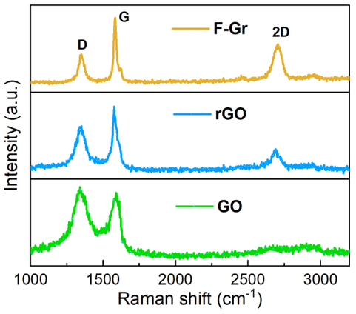
Fig. S1 Raman analysis of Go, rGO and F-Gr.

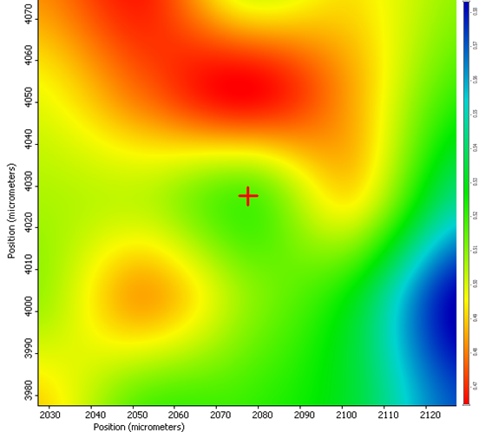
Fig. S2 Overall FT-IR mapping for rGO.

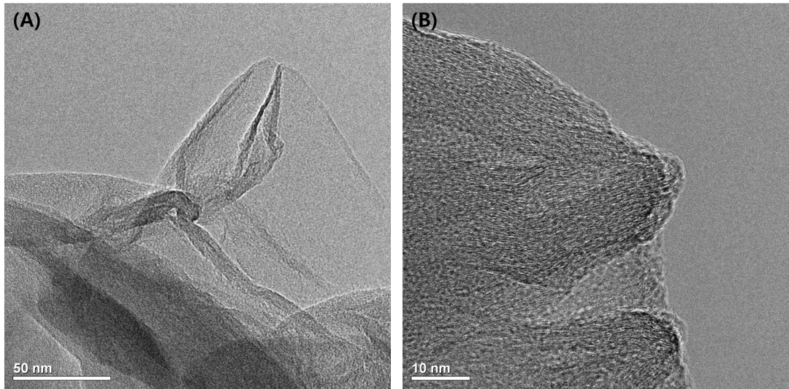
Fig. S3 (A-B) HR-TEM images of GO measured at various magnifications.

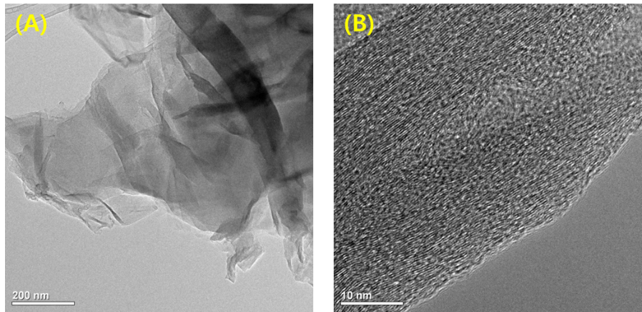
Fig. S4 (A-B) HR-TEM images of rGO measured at various magnifications

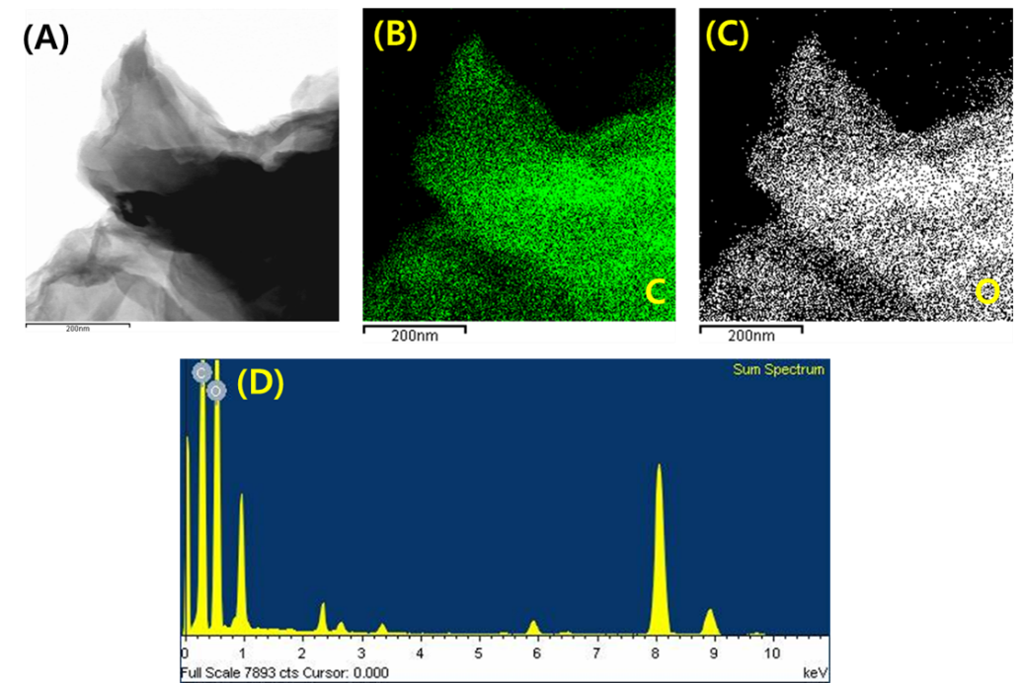
Fig. S5 (A) Overlay micrograph and (B) elemental mapping of carbon, (C) oxygen, and (D) elemental spectra for GO obtained from HR-TEM analysis.

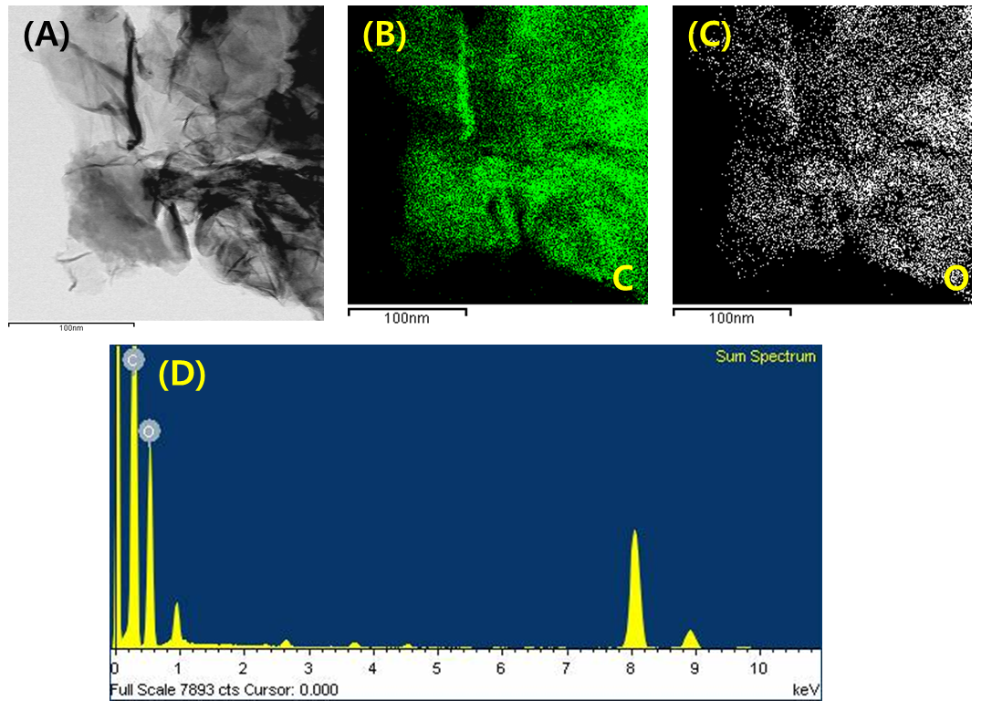
Fig. S6 (A) Overlay micrograph, (B) Elemental mapping of carbon, (C) oxygen, and (D) Elemental spectra for rGO obtained from HR-TEM analysis.

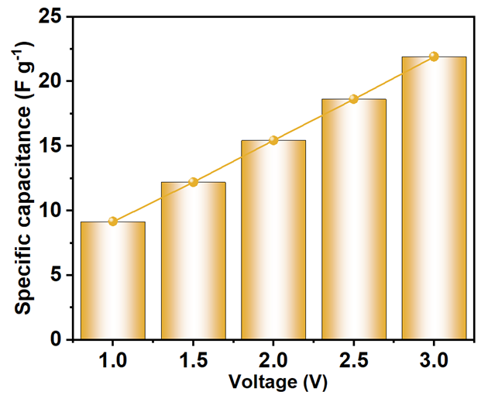
Fig. S7 Specific capacitance vs. extended voltage from 1.0 V to 3.0 V of F-Gr IL-SSC device calculated from the CV analysis.

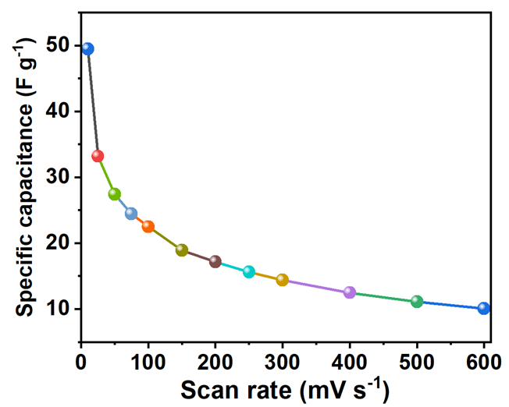
Fig. S8 Specific capacitance vs. scan rate plot in F-Gr IL-SSC device.

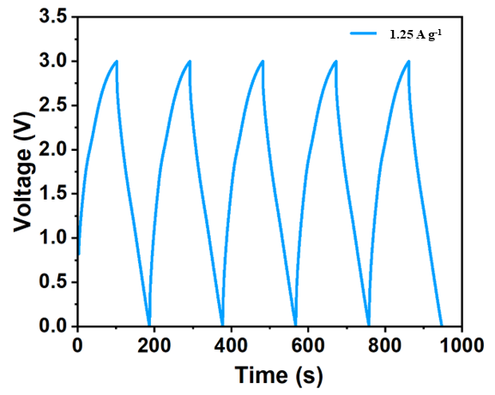
Fig. S9 Continuous charging and discharging profile of F-Gr IL-SSC device measured at 1.25 A g⁻¹.

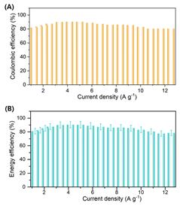
Fig. S10 Coulombic and energy efficiency plot at different current densities from GCD analysis of F-Gr IL-SSC device.

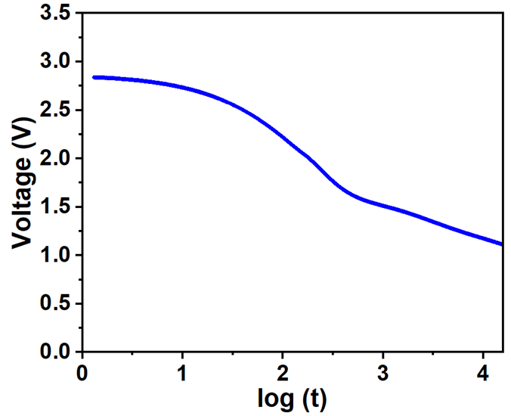
Fig. S11 Analyzing the mechanism of self-discharge via voltage vs. t^{1/2} profile.

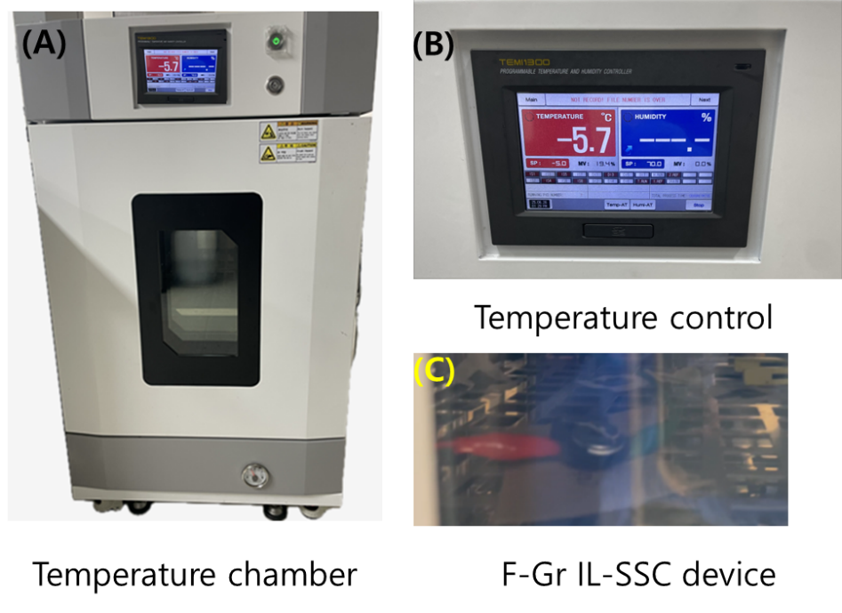
Fig. S12 (A) Temperature chamber, (B) control unit, and (C) F-Gr IL-SSC device in temperature control chamber.

Table S1: Comparison of specific capacitance with F-Gr IL-SSC device and state-of-the-art SSC devices in ionic/organic electrolyte.
S. No | Electrode  materials | Electrolyte | Potential window (V) | Specific capacitance (F g⁻¹) | Ref
R1 | Activated carbon (AC) | BMPY-  TFSI | 3.0 | 16.3 | [4]
R2 | Graphene / V₂O₅ | LiClO₄ | 2.5 | 31.2 | [5]
R3 | BDA/rGO | TEABF₄ | 2.5 | 33.5 | [6]
R4 | Tris-rGO | TEABF₄ | 3.5 | 29.75 | [6]
R5 | rGO | [SET₃] [TFSI] / GO | 2.5 | 25.9 | [7]
R6 | MoSe₂ | TEABF₄ | 3.0 | 25.31 | [8]
R7 | MoS₃ | TEABF₄ | 3.0 | 6.3 | [9]
R8 | ReS₂ | TEABF₄ | 2.0 | 51.4 | [10]
R9 | MoS₂ | TEABF₄ | 3.0 | 24.98 | [9]
R_{T} | F-Gr | TEABF₄ | 3.0 | 50.1 | This work

Table S2: Comparison of energy density and power density of F-Gr IL-SSC device with reported SSC devices in ionic/organic electrolyte.
S. No | Electrode  materials | Electrolyte | Potential window (V) | Energy density (Wh g⁻¹) | Power density  (W Kg⁻¹) | Ref
R1 | Activated carbon (AC) | BMPY-  TFSI | 3.0 | 25 | 5000 | [4]
R2 | Graphene / V₂O₅ | LiClO₄ | 2.5 | 10.92 | 1034 | [5]
R3 | BDA/rGO | TEABF₄ | 2.5 | 34 | 10000 | [6]
R4 | Tris-rGO | TEABF₄ | 3.5 | 32 | 1000 | [6]
R5 | rGO | [SET₃] [TFSI] / GO | 2.5 | 17.7 | 875 | [7]
R6 | Graphene | BMIMBF₄ | 4.0 | 16.5 | 1600 | [11]
R7 | Silicon oxy carbide | TEABF₄ | 3.0 | 20.89 | 750 | [12]
R8 | Siloxene | TEABF₄ | 3.0 | 20.89 | 8000 | [13]
R9 | NiHCC-rGO | H₂SO₄ | 1.55 | 38.03 | 20666 | [14]
R10 | MnO₂ | ZnSO₄ | 1.2 | 40.42 | 385 | [15]
R11 | Gr | ZnSO₄ | 2.0 | 203 | 4900 | [16]
R12 | rGO | TEABF₄ | 3.0 | 38.07 | 15000 | [17]
R_{T} | F-Gr | TEABF₄ | 3.0 | 50.73 | 18750 | This work

References
[1] P. Pazhamalai, K. Krishnamoorthy, V.K. Mariappan, A. Sathyaseelan, S.J. Kim, Solar driven renewable energy storage using rhenium disulfide nanostructure based rechargeable supercapacitors, Mater. Chem. Front. 4 (2020) 3290–3301. https://doi.org/10.1039/d0qm00421a.
[2] P.E. Blöchl, Projector augmented-wave method, Phys. Rev. B 50 (1994) 17953–17979. https://doi.org/10.1103/PhysRevB.50.17953.
[3] J.P. Perdew, K. Burke, M. Ernzerhof, Generalized Gradient Approximation Made Simple, Phys. Rev. Lett. 77 (1996) 3865–3868. https://doi.org/10.1103/PhysRevLett.77.3865.
[4] Z. Li, J. Liu, K. Jiang, T. Thundat, Carbonized nanocellulose sustainably boosts the performance of activated carbon in ionic liquid supercapacitors, Nano Energy 25 (2016) 161–169. https://doi.org/10.1016/j.nanoen.2016.04.036.
[5] R. Narayanan, A. Dewan, D. Chakraborty, Complimentary effects of annealing temperature on optimal tuning of functionalized carbon–V 2 O 5 hybrid nanobelts for targeted dual applications in electrochromic and supercapacitor devices, RSC Adv. 8 (2018) 8596–8606. https://doi.org/10.1039/C7RA13357J.
[6] B. Song, J. Zhao, M. Wang, J. Mullavey, Y. Zhu, Z. Geng, D. Chen, Y. Ding, K. Moon, M. Liu, C.-P. Wong, Systematic study on structural and electronic properties of diamine/triamine functionalized graphene networks for supercapacitor application, Nano Energy 31 (2017) 183–193. https://doi.org/10.1016/j.nanoen.2016.10.057.
[7] N. das M. Pereira, J.P.C. Trigueiro, I. de F. Monteiro, L.A. Montoro, G.G. Silva, Graphene oxide – Ionic liquid composite electrolytes for safe and high-performance supercapacitors, Electrochim. Acta 259 (2018) 783–792. https://doi.org/10.1016/j.electacta.2017.10.124.
[8] P. Pazhamalai, K. Krishnamoorthy, S. Sahoo, S.-J. Kim, Two-dimensional molybdenum diselenide nanosheets as a novel electrode material for symmetric supercapacitors using organic electrolyte, Electrochim. Acta 295 (2019) 591–598. https://doi.org/10.1016/j.electacta.2018.10.191.
[9] P. Pazhamalai, K. Krishnamoorthy, S. Sahoo, V.K. Mariappan, S.-J. Kim, Supercapacitive properties of amorphous MoS 3 and crystalline MoS 2 nanosheets in an organic electrolyte, Inorg. Chem. Front. 6 (2019) 2387–2395. https://doi.org/10.1039/C9QI00623K.
[10] P. Pazhamalai, K. Krishnamoorthy, V.K. Mariappan, A. Sathyaseelan, S.-J. Kim, Solar driven renewable energy storage using rhenium disulfide nanostructure based rechargeable supercapacitors, Mater. Chem. Front. 4 (2020) 3290–3301. https://doi.org/10.1039/D0QM00421A.
[11] Y. Chen, X. Zhang, D. Zhang, Y. Ma, High power density of graphene-based supercapacitors in ionic liquid electrolytes, Mater. Lett. 68 (2012) 475–477. https://doi.org/10.1016/j.matlet.2011.11.008.
[12] P. Pazhamalai, K. Krishnamoorthy, S. Sahoo, V.K. Mariappan, S.-J. Kim, Carbothermal conversion of siloxene sheets into silicon-oxy-carbide lamellae for high-performance supercapacitors, Chem. Eng. J. 387 (2020) 123886. https://doi.org/10.1016/j.cej.2019.123886.
[13] K. Krishnamoorthy, P. Pazhamalai, S.-J. Kim, Two-dimensional siloxene nanosheets: novel high-performance supercapacitor electrode materials, Energy Environ. Sci. 11 (2018) 1595–1602. https://doi.org/10.1039/C8EE00160J.
[14] R. Stephanie, C.Y. Park, M.S. Hyun, A. Al Ghaferi, H. Han, E. Alhajri, N.R. Chodankar, T.J. Park, Longevous Protic Hybrid Supercapacitors Using Bimetallic Prussian Blue Analogue/rGO‐Based Nanocomposite Against MXene Anode, Small 21 (2025). https://doi.org/10.1002/smll.202406369.
[15] H.B. Tyagaraj, V. Mahamiya, S.J. Marje, G.S. Kumar, S.R. Burse, S.R. Patil, E. Al Hajri, N.R. Chodankar, Y.S. Huh, Y.K. Han, One‐Step Tunable MoS 2 with Enhanced Zn 2+ Diffusion for High‐Energy Zinc‐Ion Hybrid Capacitors, Adv. Sci. (2025). https://doi.org/10.1002/advs.202506467.
[16] N.R. Chodankar, S.J. Patil, S. Lee, J. Lee, S. Hwang, P.A. Shinde, I. V. Bagal, S. V. Karekar, G. Seeta Rama Raju, K. Shanmugam Ranjith, D.P. Dubal, Y. Huh, Y. Han, High energy superstable hybrid capacitor with a <scp>self‐regulated</scp> Zn/electrolyte interface and <scp>3D</scp> graphene‐like carbon cathode, InfoMat 4 (2022). https://doi.org/10.1002/inf2.12344.
[17] K. Krishnamoorthy, P. Pazhamalai, V.K. Mariappan, S. Manoharan, D. Kesavan, S. Kim, Two‐Dimensional Siloxene–Graphene Heterostructure‐Based High‐Performance Supercapacitor for Capturing Regenerative Braking Energy in Electric Vehicles, Adv. Funct. Mater. 31 (2021). https://doi.org/10.1002/adfm.202008422.

