Supporting Information

Thermo-Reversible Transparent Wood with Tunable Optics and Mechanics
for Energy-Efficient Windows

Linhan He ª, Yafei Fan ª,Yao Chen ^{a,}*, Yuxiang Huang ^{b,}*

ª Beijing Key Laboratory of Wood Science and Engineering, Beijing Forestry University, Beijing 100083, China
^{b} Research Institute of Wood Industry, Chinese Academy of Forestry, Haidian 100091, Beijing, China.
*Correspondence: ychen@bjfu.edu.cn; yxhuang@caf.ac.cn
1. Materials and Methods
1.1 Preparation of TRTW
Firstly, the natural balsa wood (NW) was immersed in deionized water overnight to achieve water saturation. Subsequently, the water-saturated balsa wood was treated in a 10 wt.% sodium chlorite solution with a pH of 4.6 and a temperature of 80 °C for 5 hours to remove lignin. Following this treatment, the delignified balsa wood (DW) was rinsed three times with deionized water to eliminate any residual chemical substances. Finally, the DW was soaked in an ethanol solution and boiled at 70 °C until it became translucent. PEG was added into a three-necked flask and heated to 50 °C until completely dissolved. Following this, PEGDA was gradually introduced into the three-necked flask and stirred for 30 minutes. PEG was mixed with PEGDA at weight ratios of 50%, 60%, 70%, 80%, and 90% to form the PEG/PEGDA mixtures. Next, the photoinitiator, comprising 1% of the weight of PEGDA, was added to the three-necked flask and stirred in the dark for an additional 30 minutes to achieve various proportions of PEG/PEGDA mixtures. The DW samples were taken from the ethanol solution and immersed in the PEG/PEGDA mixtures with different proportions at 50 °C under a pressure of -0.08 MPa to facilitate infiltration. After 1 hour, the mixtures were replaced, and this process was repeated three times to ensure complete penetration. Following infiltration, the samples were sandwiched between two glass slides and transferred to a heating stage at 50 °C, where they were cured under an ultraviolet curing lamp for 5 minutes. Once the ultraviolet curing was completed, the materials were carefully peeled away from the glass slides.
1.2 Characterization
The main components in wood were tested in accordance to the NREL/TP-510-42,618 analytical method, issued by the National Renewable Energy Laboratory (NREL). Briefly, the acid insoluble lignin content was confirmed by sulfuric acid (72 wt%) hydrolysis. The hemicellulose and cellulose content were calculated based on sugar analyses using highperformance anion exchange chromatography (Dionex 3000). The nitrogen adsorption/desorption isotherms and pore size distributions of the samples were measured using a fully automatic specific surface area and porosity analyzer (BET, Micromeritics ASAP 2460, USA), with a degassing temperature of 120 °C and a degassing time of 8 h. The anti-leakage performance of the samples was assessed by observing the leakage situation of the samples when placed on filter paper at 50 °C, along with evaluating the materials’ efficiency through 200 heating-cooling cycles. Thermal conductivity of the materials was measured with a thermal conductivity tester (DRL-Ⅲ, China). The light transmittance and haze of the materials at 10 °C and 35 °C were measured by a haze meter (TH-100, China). Mechanical properties were carried out on the samples using a universal mechanical testing machine (SHIMADZU AGS-X, Japan). The photothermal conversion efficiency was characterized using a solar simulator light source (power 350 W) in conjunction with an infrared thermal imager (HIKVISION P20, China). The samples were placed on a heating stage at 50 °C and then transferred to room temperature while the surface temperature was recorded with the infrared thermal imager to assess thermal conductivity. The refractive index of the material was measured using an ellipsometer (Eoptics Technology ME-L, China). The testing wavelength range was set to 400~1000 nm with a fixed incident angle of 65°, and measurements were conducted under environmental conditions of relative humidity ≤40%.
Statistical analysis: Data with error bars are presented as mean and standard deviation based on at least three replicates. All data were processed using Origin2021 and Excel.
2. Supporting Notes
2.1 Methodology for finite element simulations
Finite element simulations (Figure S14) simplified the model to 1/8 size (AEGD-BFCH) for symmetry, with 8 mm thickness. Assumptions included symmetric material distribution, no macro-flow during melting, uniform surface thermal conductivity, and no chemical reactions. Heat diffusion occurred via conduction (FEGH) and convection (AEGD, BFAE), with symmetric boundaries (BFHC, ABCD, CHGD). The 3D unsteady model (Figure 4f) initialized at 0 °C with 50 °C external temperature, recording temperatures at 0, 60, 120, 180, 240 s.
2.2 The molecular dynamic simulations for TRTW
The molecular dynamics calculations were performed in the GROMACS software package, utilizing the GAFF 2 force field for simulation. Energy minimization was conducted prior to molecular dynamics simulations. The simulations were carried out under the NPT ensemble, with the Berendsen thermostat employed to maintain constant pressure and temperature throughout the process. Van der Waals interactions were managed using the Ewald technique with a cutoff radius of 1.2 nm. Coulombic interactions were controlled via the PME method, featuring a grid spacing of 0.10 nm and Fourier transform precision of 1e-5. The corresponding simulation results for Broussonetia papyrifera are shown in Figure S20.
2.3 Energy consumption simulation
The EnergyPlus energy consumption simulation software was employed to conduct energy consumption simulations for buildings equipped with TRTW and conventional glazing (model dimensions: 20×9.5×3m; window dimensions: 3×1.5m; as shown in Figure S26) in order to evaluate the energy-saving performance of TRTW. Modifications were made to the lighting power density and internal loads based on the U.S. Department of Energy Commercial Reference Building model. Six cities—Beijing, Shanghai, Shenzhen, Kunming, Haikou, and Urumqi—were selected as analysis locations, and the annual energy consumption of the building models was calculated using weather data obtained from the website.
2.4 Methodology for life cycle analysis (LCA)
A cradle-to-gate LCA was carried out to evaluate the environmental repercussions associated with TRTW, juxtaposing it with glass and conventional plastics like polyethylene (PE), and polyvinyl chloride (PVC), which are widely used across sectors such as agriculture, packaging, and construction. The LCA focus on 1 kg of TRTW, PE, and PVC as the first functional unit. The life cycle inventory (LCI) data incorporated primary data from TRTW production experiments and secondary data sourced from the Ecoinvent 3.5 database. The life cycle impact assessment (LCIA) utilized the "CML 2001" methodology for its analysis. Table S4 showed the simulation result.

Tab. S1 Composition and impregnation rate of PP and TRTW.
Samples | PEG proportion in PP (%) | PEGDA proportion in PP (%) | PP impregnation rate (%)
PP₅₀ | 50 | 50
PP₆₀ | 60 | 40
PP₇₀ | 70 | 30
PP₈₀ | 80 | 20
PP₉₀ | 90 | 10
TRTW₅₀ | 50 | 50 | 81.2
TRTW₆₀ | 60 | 40 | 80.7
TRTW₇₀ | 70 | 30 | 79.3
TRTW₈₀ | 80 | 20 | 80.3
TRTW₉₀ | 90 | 10 | 80.1
TRTW₀ | 0 | 100 | 81.9

Tab. S2 Thermal characteristics of PEG, PP and TRTW.
Samples | Melting process |  | Solidification process
Samples | T_{m} (°C) | ΔH_{m} (J·g⁻¹) | T_{s} (°C) | ΔH_{s} (J·g⁻¹)
PEG | 31.51 | 133.6 | 20.4 | 129.4
PP₅₀ | 30.80 | 64.5 | 12.03 | 64.3
PP₆₀ | 30.71 | 76.9 | 14.22 | 77.8
PP₇₀ | 30.48 | 92.8 | 15.12 | 92.7
PP₈₀ | 29.56 | 105.9 | 16.62 | 105.7
PP₉₀ | 29.86 | 117.1 | 17.11 | 116.2
TRTW₅₀ | 29.62 | 47.9 | 12.96 | 48.1
TRTW₆₀ | 29.61 | 60.1 | 15.47 | 60.6
TRTW₇₀ | 29.72 | 72.9 | 16.38 | 72.3
TRTW₈₀ | 29.51 | 84.2 | 18.35 | 84.0
TRTW₉₀ | 29.74 | 96.3 | 18.85 | 95.8

Tab. S3 Comparison of thermal storage performance between TRTW and various composite phase change materials.
Types of composite PCMs | Latent heat (J/g) | Ref.
Photosensitive resin/PEG | 11.3 | [1]
Wood/myristic acid | 26.1 | [2]
Al₂O₃–SiO₂ aerogels/paraffin | 28.91 | [3]
Epoxy resin/N-tetradecane | 50.75 | [4]
Sepiolite/paraffin | 62.08 | [5]
Diatomite /fatty acids | 65.84 | [6]
Cenosphere/capric acid | 69.07 | [7]
Sepiolite/Stearic acid | 74.66 | [8]
Bentonite/stearic acid | 79.13 | [9]

Tab. S4 The environmental impacts of TRTW, Glass, PE, PVC based on mass (per kg).
Impact category | Unit | TRTW | PVC | PE | Glass
Abiotic depletion | kg Sb eq | 0.0000035304 | 0.0000246621 | 0.000005042 | 0.00001307
Abiotic depletion (fossil fuels) | MJ | 7.9601782 | 57.630697 | 16.455181 | 14.68932
Global warming (GWP100a) | kg CO₂ eq | 0.57605596 | 3.1343982 | 1.5416997 | 1.4071432
Human toxicity | kg 1,4-DB eq | 0.237913110 | 1.4599384 | 0.66295239 | 0.47230332
Fresh water aquatic ecotox. | kg 1,4-DB eq | 0.004139699 | 0.034060148 | 0.068417249 | 0.01061345
Marine aquatic ecotoxicity | kg 1,4-DB eq | 381.63157 | 1409.6403 | 986.57176 | 1261.5145
Terrestrial ecotoxicity | kg 1,4-DB eq | 0.0035916472 | 0.026932166 | 0.055098029 | 0.00901685
Photochemical oxidation | kg C₂H₄ eq | 0.0001156835 | 0.0006559706 | 0.000355758 | 0.00039359
Acidification | kg SO₂ eq | 0.0023661954 | 0.012004945 | 0.005882161 | 0.01073009
Eutrophication | kg PO₄ eq | 0.0002653096 | 0.0014332418 | 0.000807375 | 0.00090488

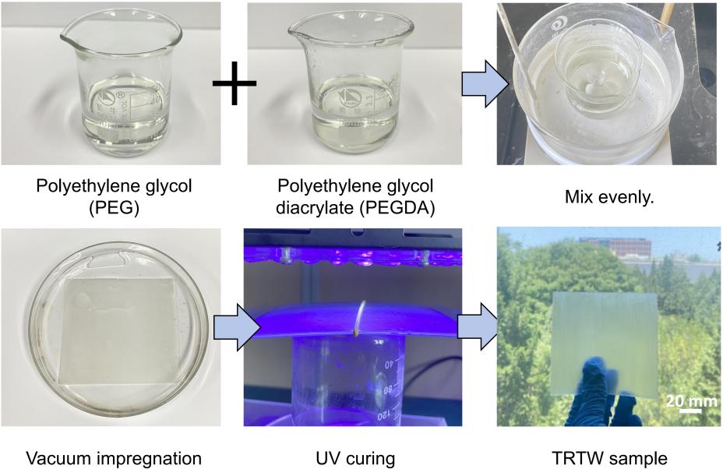
Figure S1 The specific process for TRTW preparation.

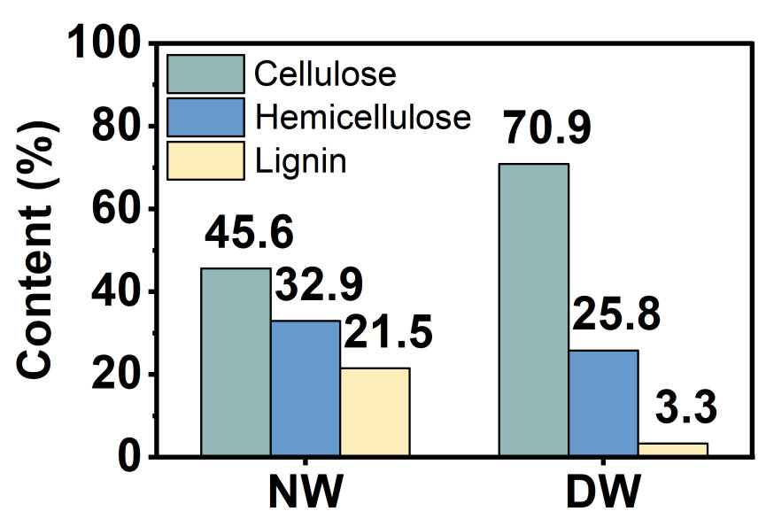
Figure S2 The major element content of NW and DW.

Figure S3 The infrared spectra of NW and DW.

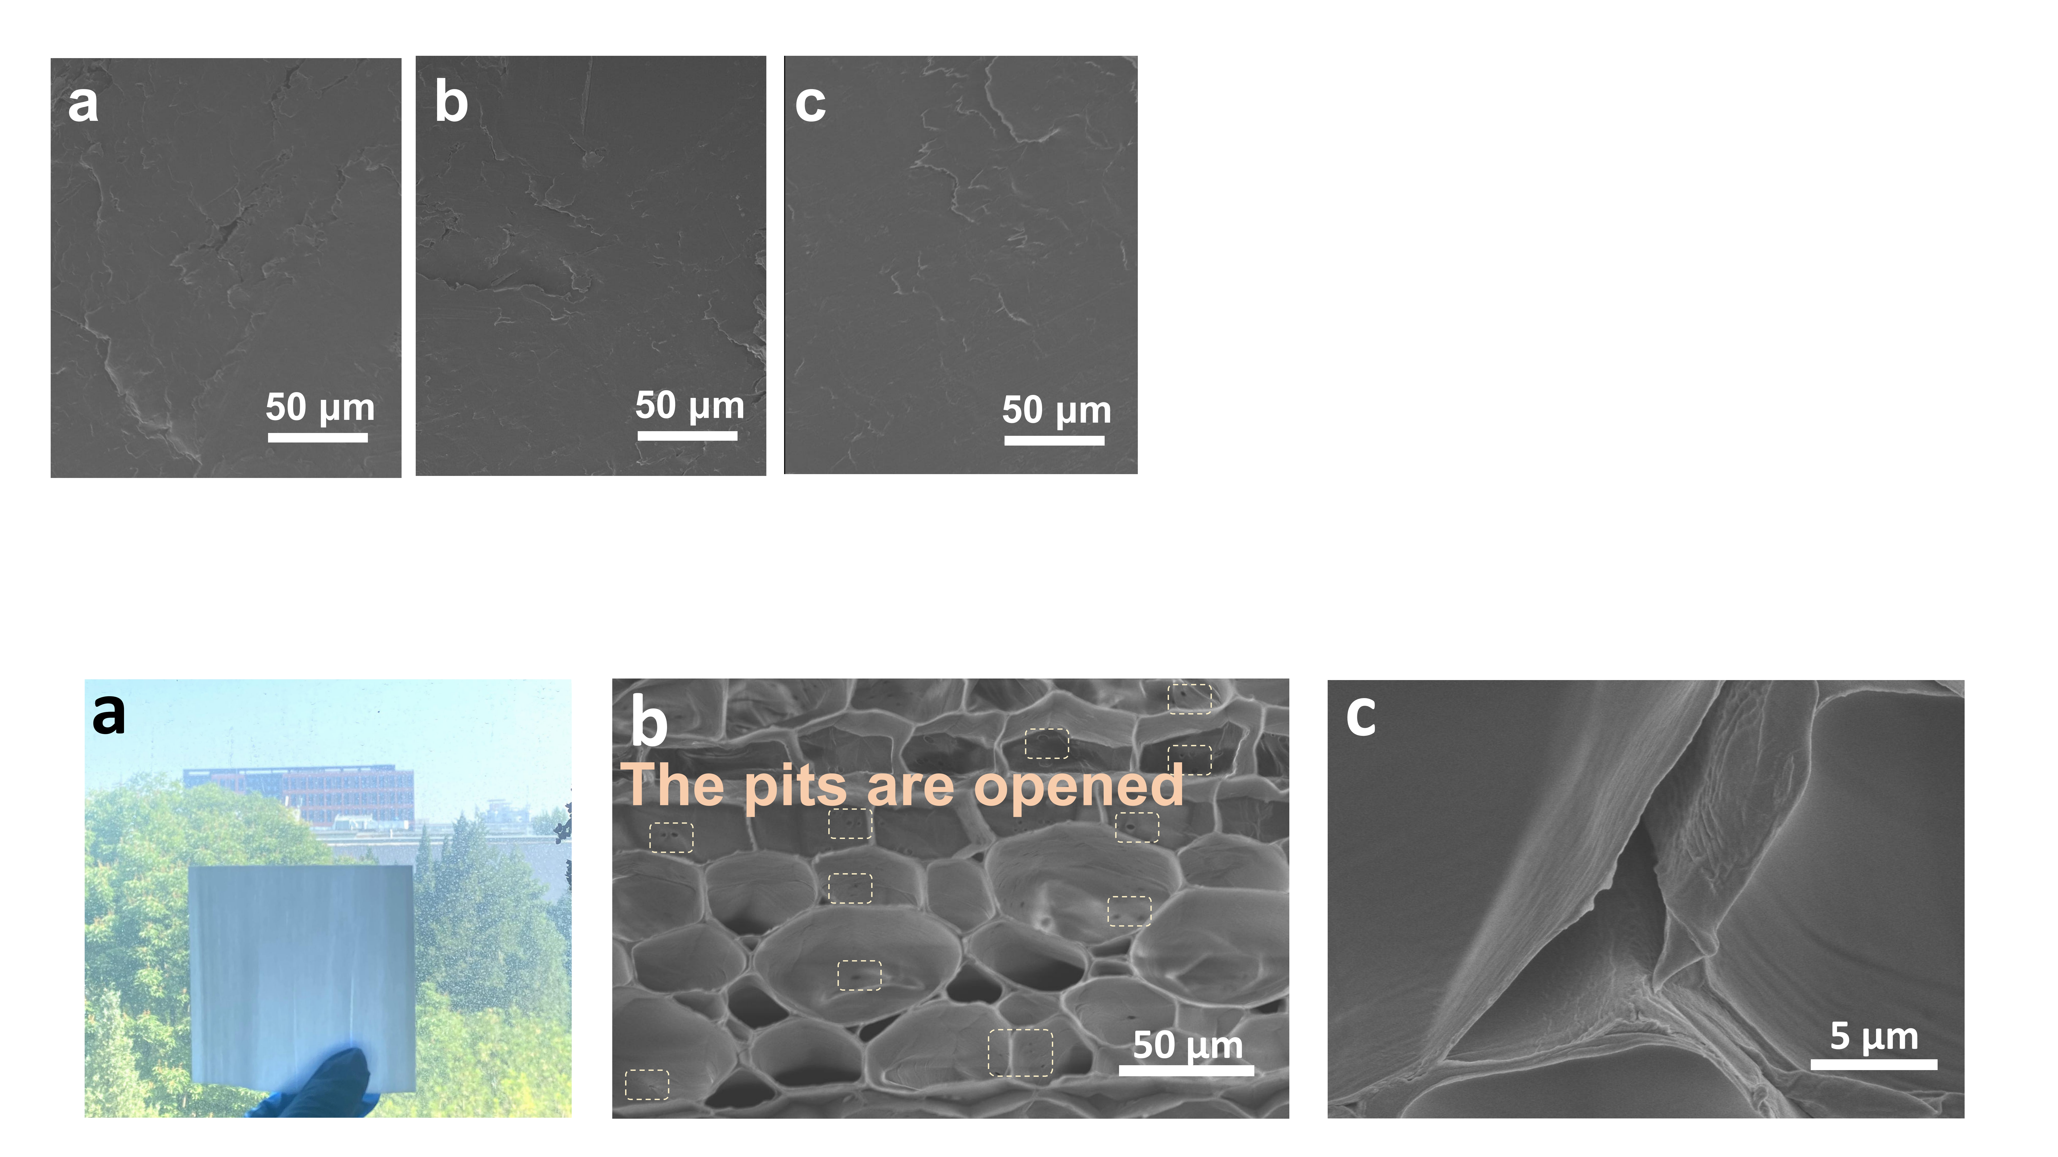
Figure S4 Appearance and microstructures of DW.

Figure S5 The XRD patterns of NW and DW.

Figure S6 SEM images of (a) TRTW₆₀, (b) TRTW₇₀, and (c) TRTW₈₀.

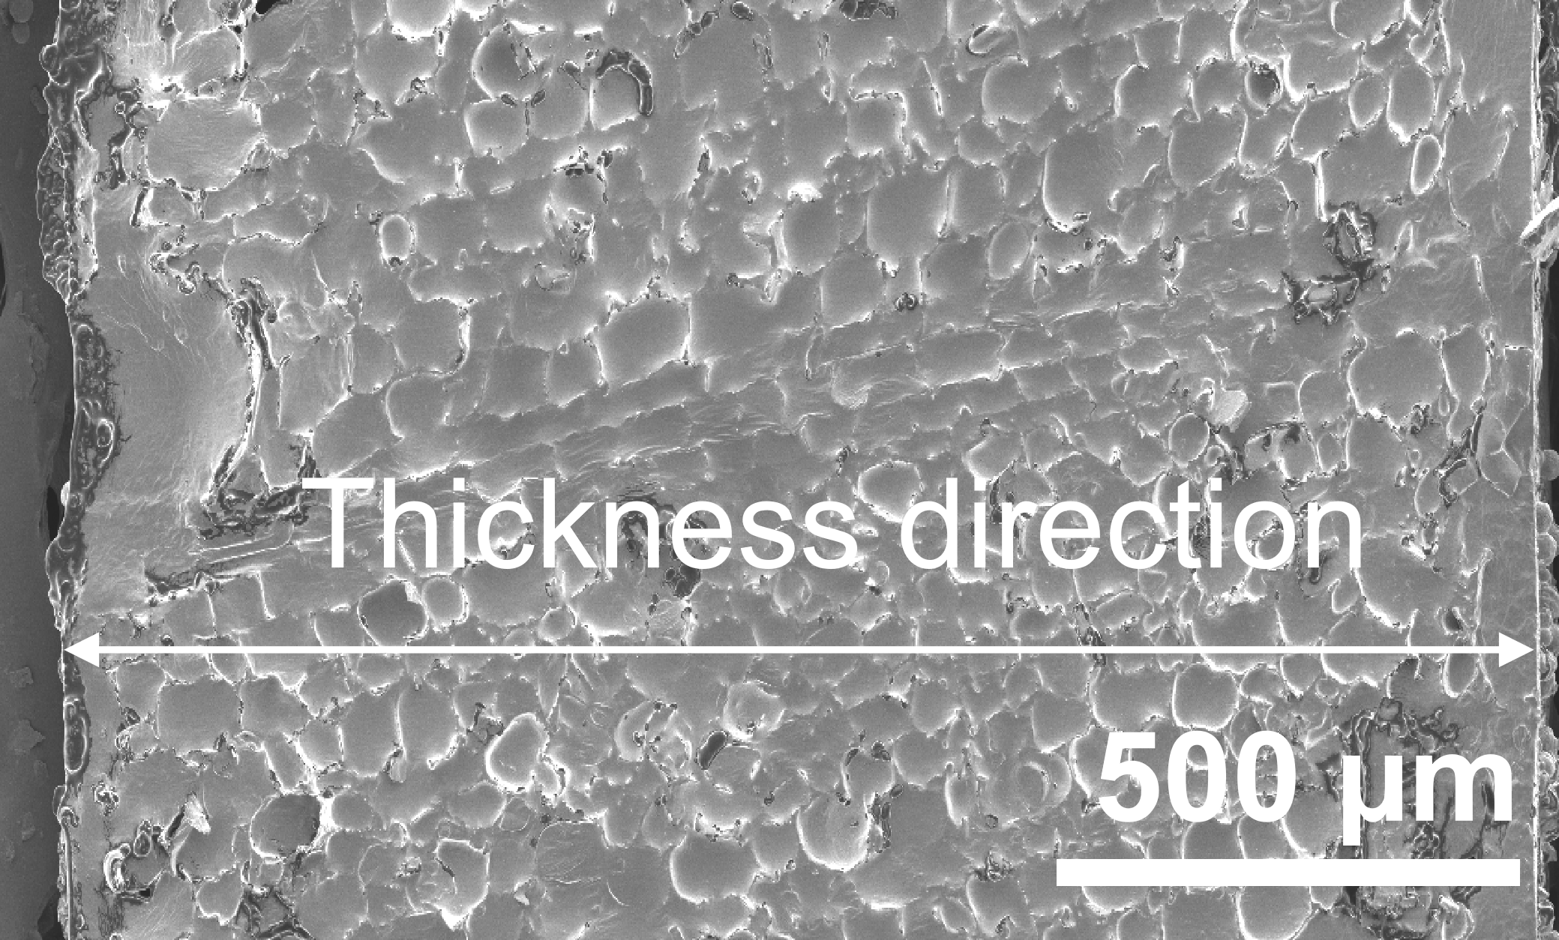
Figure S7 SEM image of the cross-section of TRTW₇₀.

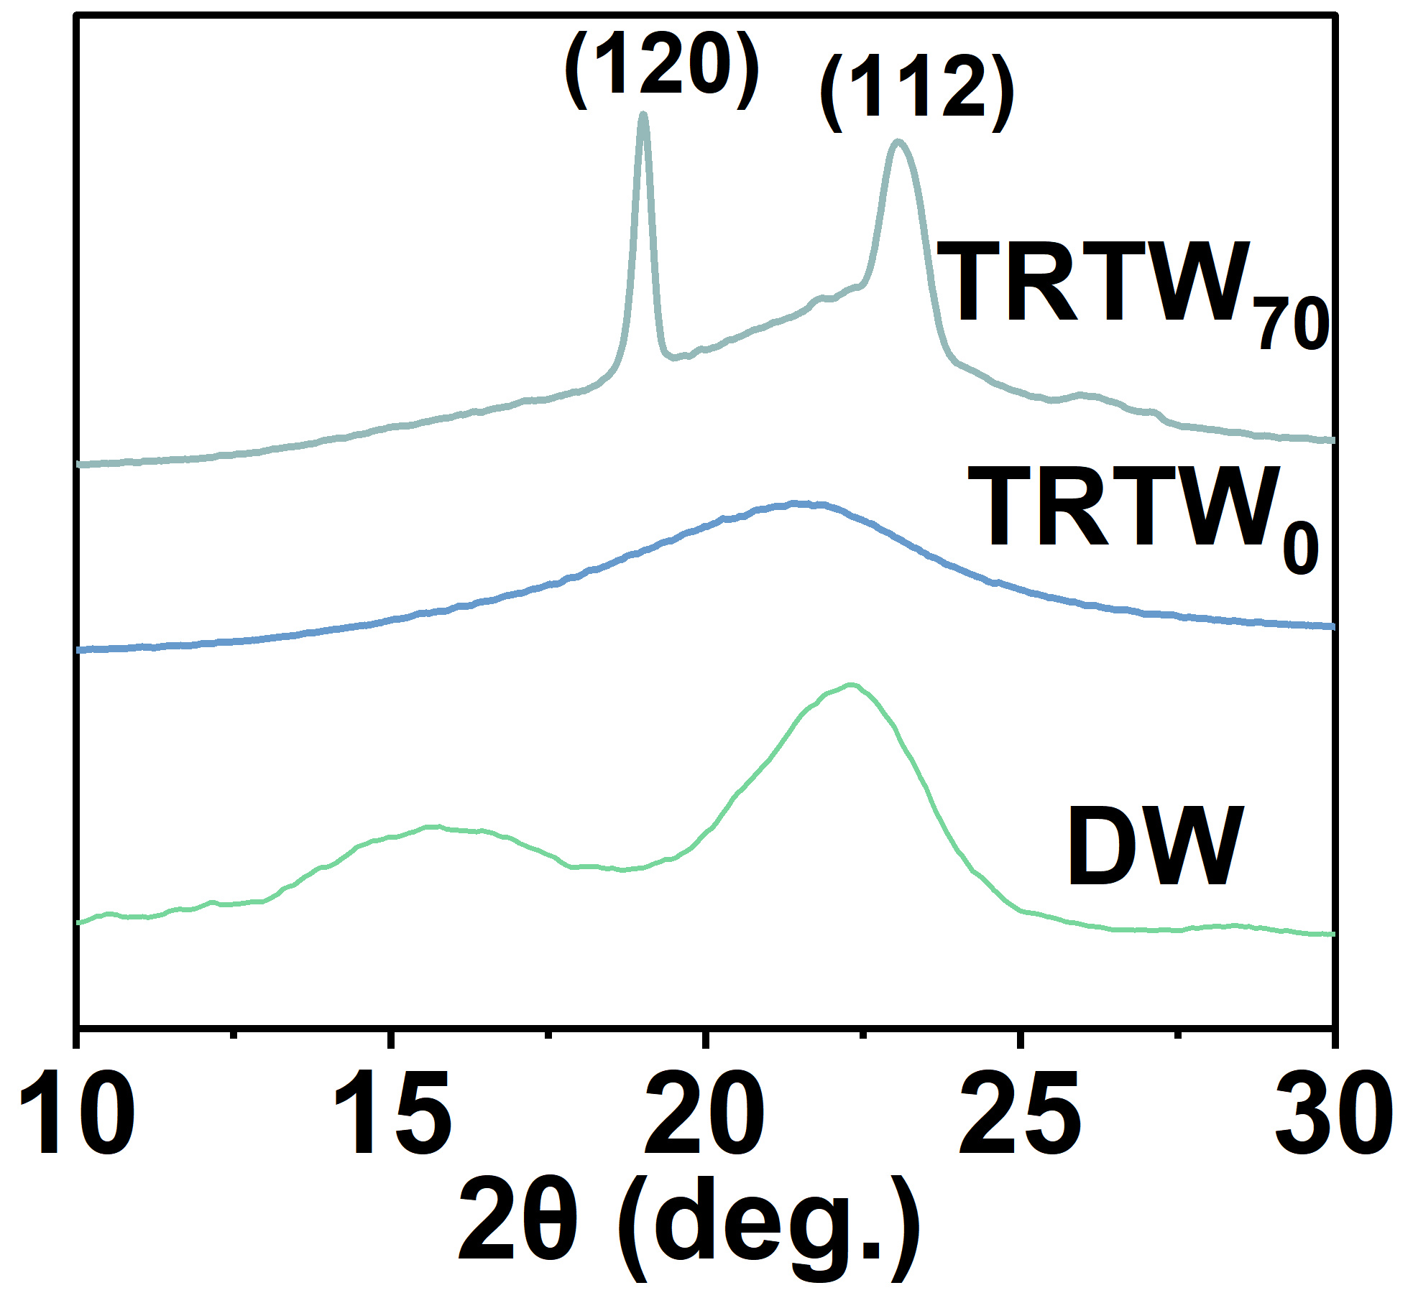
Figure S8 XRD patterns of DW, TRTW₀, and TRTW₇₀.

Figure S9 Nitrogen adsorption-desorption curves of NW, DW, and TRTW.

Figure S10 Porosity of NW, DW, and TRTW.

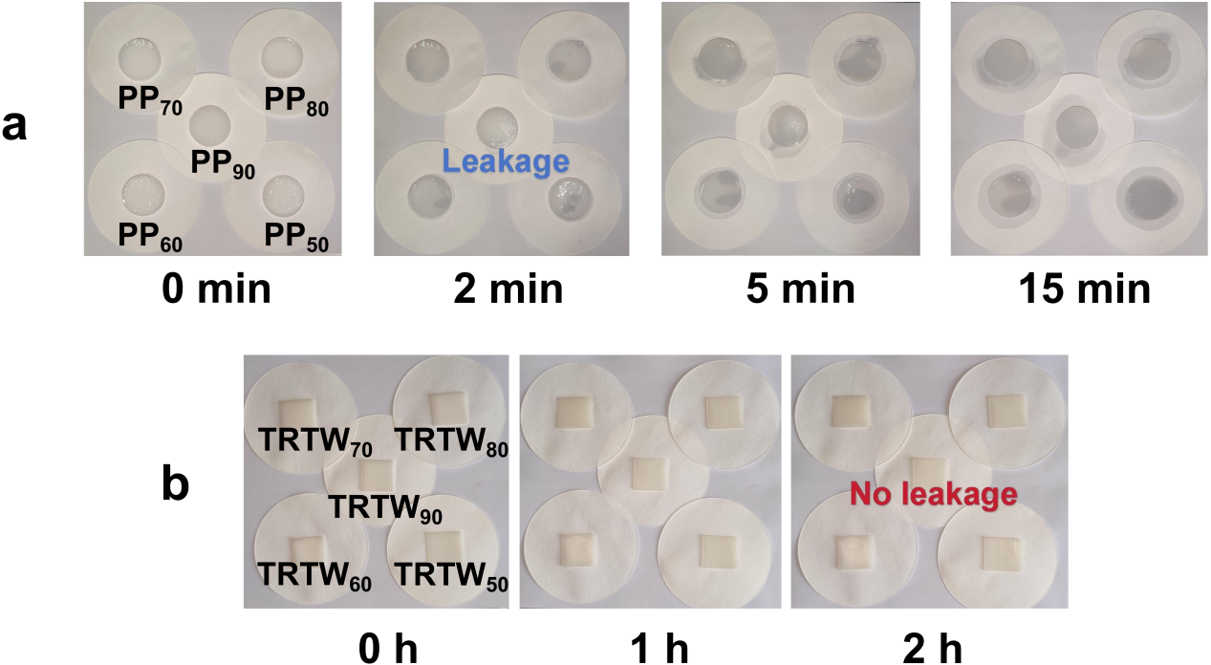
Figure S11 leak-proof testing of (a) PP and (b) TRTW.

Figure S12 Leakage rate of TRTW after 200 cycles of cold-hot tests.

Figure S13 Infrared spectrum of TRTW₇₀ after 200 cycles of cold-hot tests.

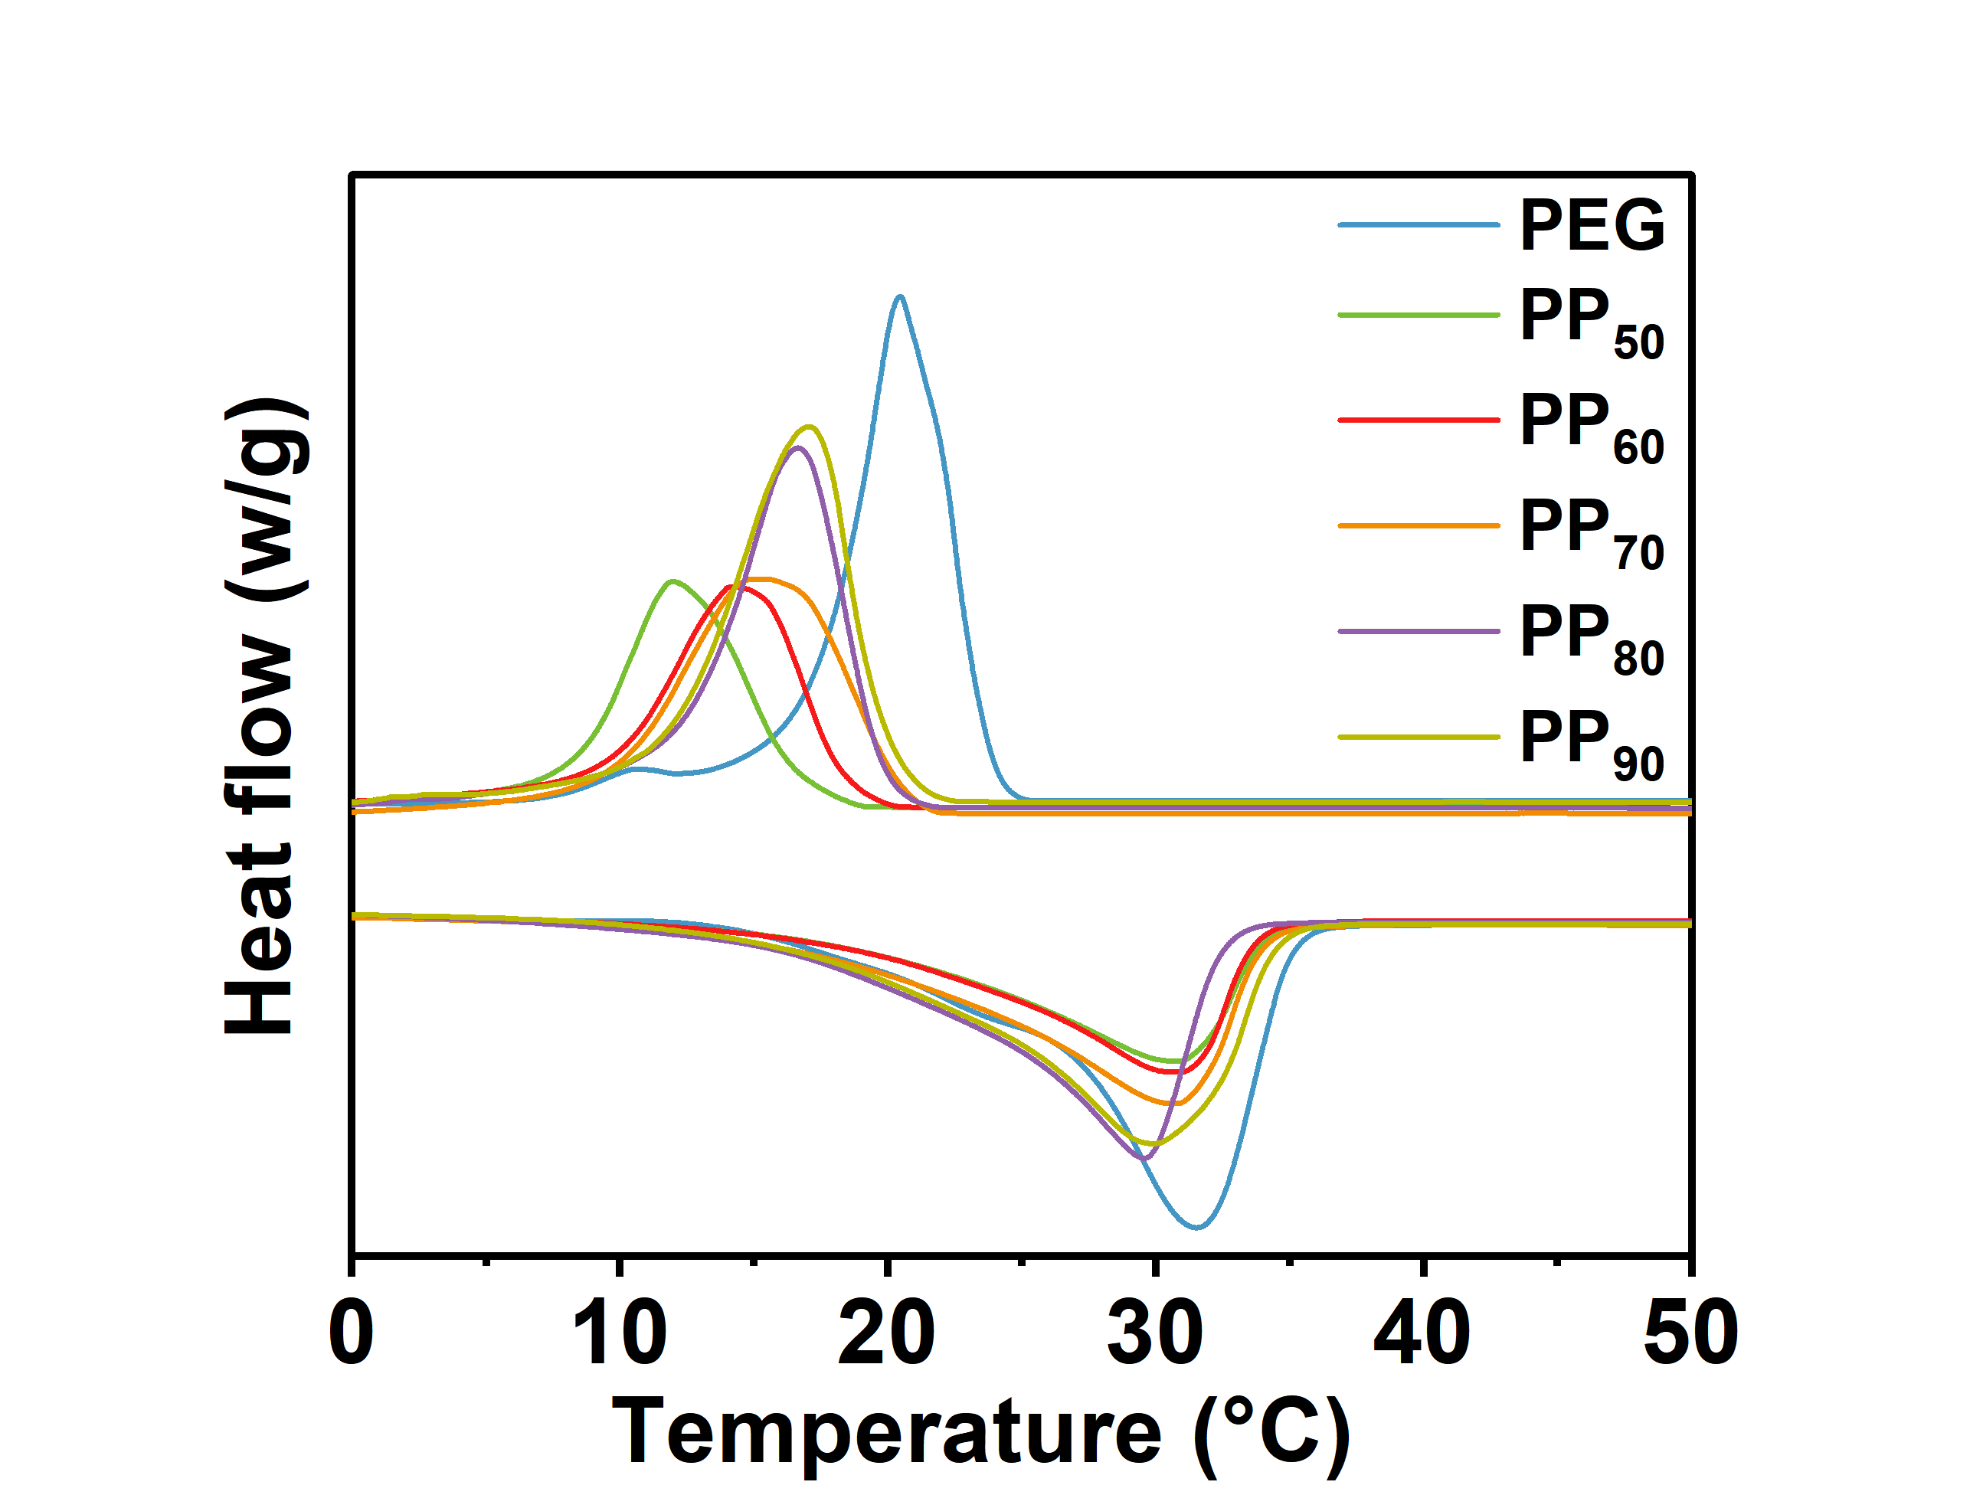
Figure S14 The DSC curves of PEG and PP.

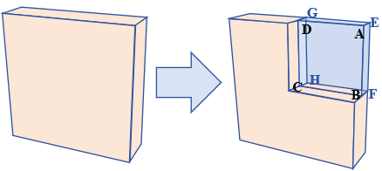
Figure S15 Overall structure of the TRTW.
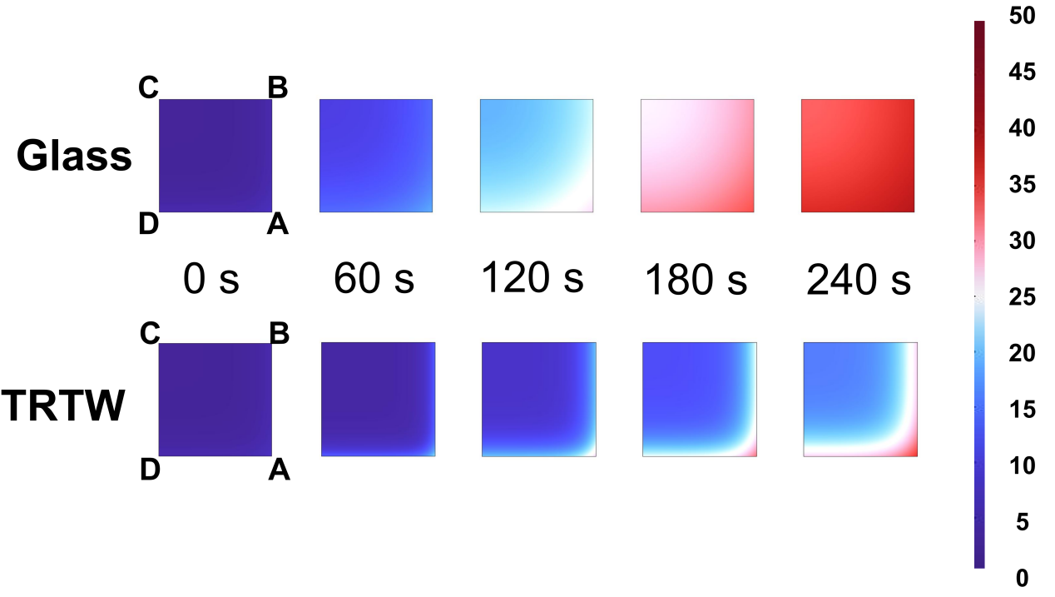
Figure S16 The 3D unsteady heat conduction model for the glass and TRTW.

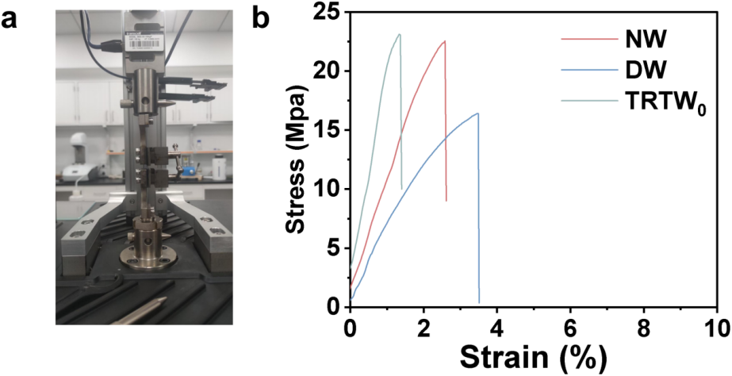
Figure S17 (a) Schematic diagram of tensile strength test. (b) Stress-strain curves for NW, DW, and TRTW₀.

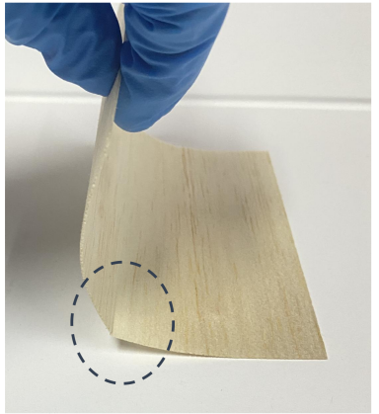
Figure S18 Folding experiment results of NW.

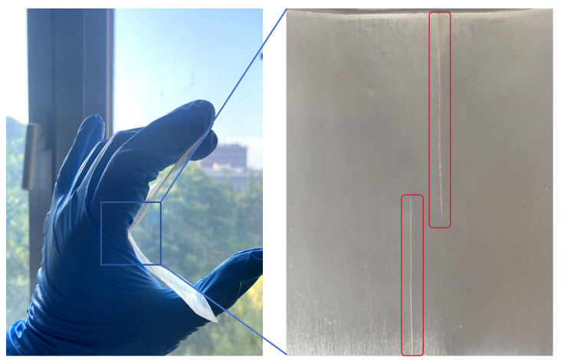
Figure S19 Folding experiment results of TRTW_{0.}

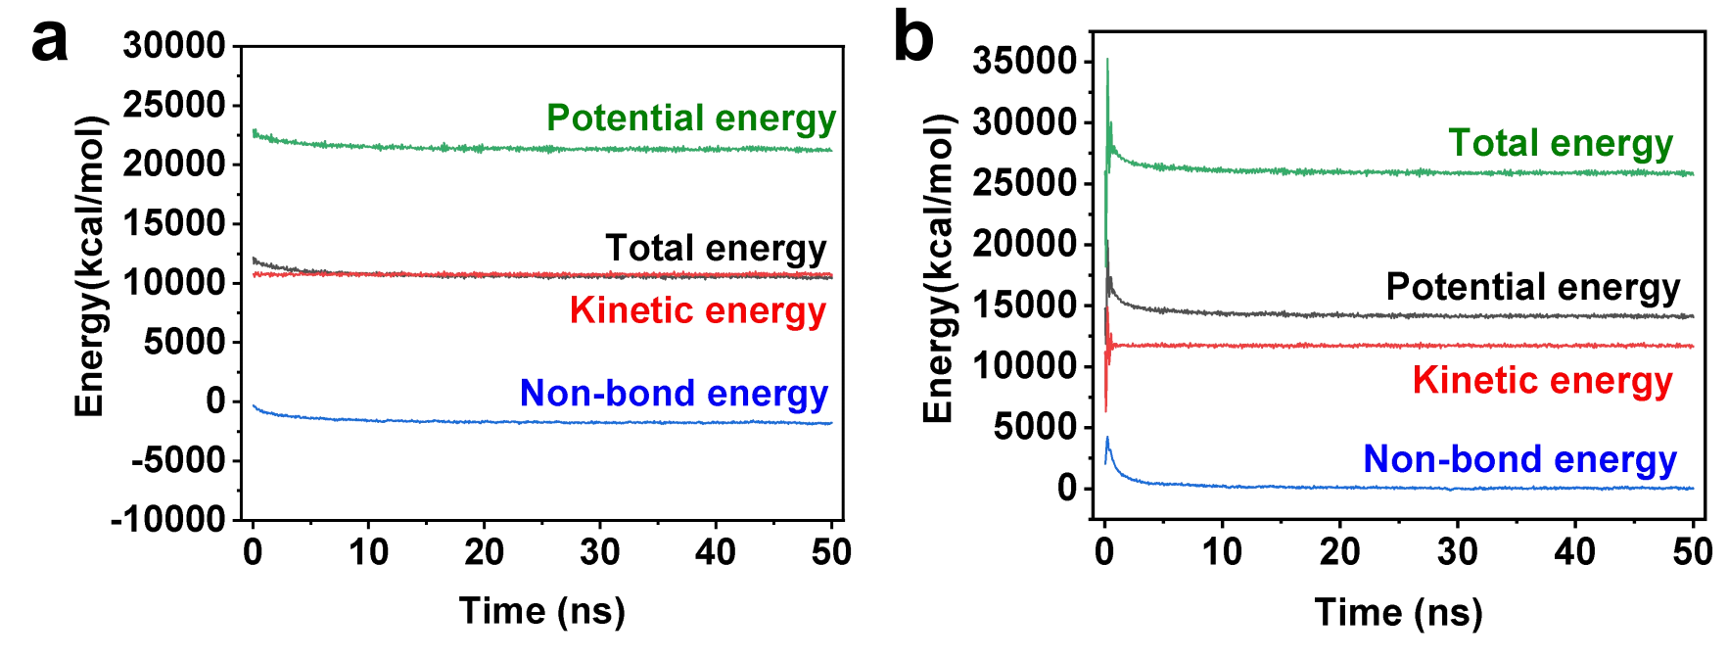
Figure S20 Energy variation during (a) molten state simulation and (b) solidification state simulation.
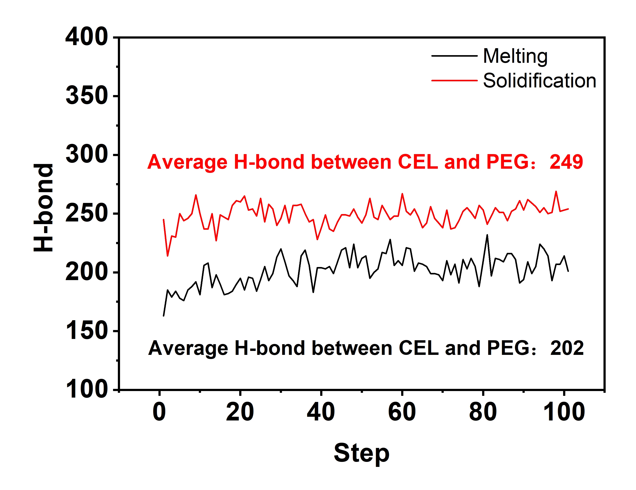
Figure S21 Number of hydrogen bonds in the molten and solid states.

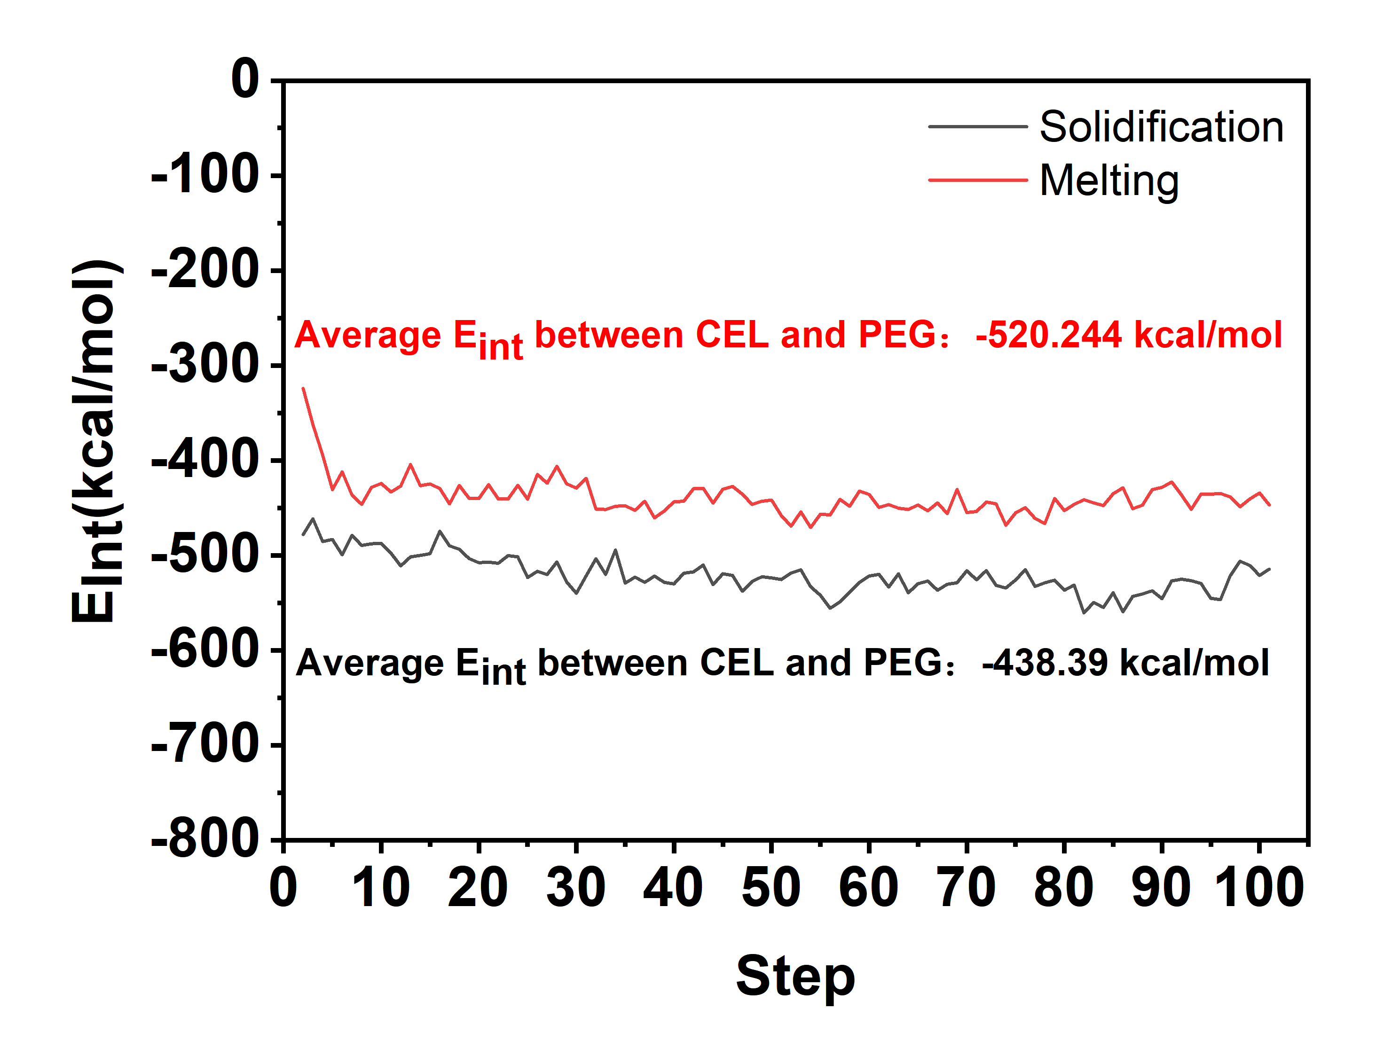
Figure S22 Interaction energy in the molten and solid states.

Figure S23 Surface roughness of NW, DW, and TRTW.

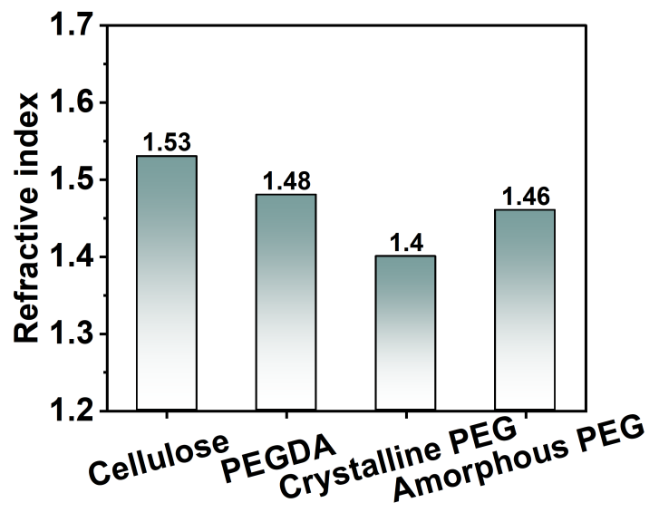
Figure S24 Refractive indices of cellulose, PEGDA, crystalline PEG, and amorphous PEG.

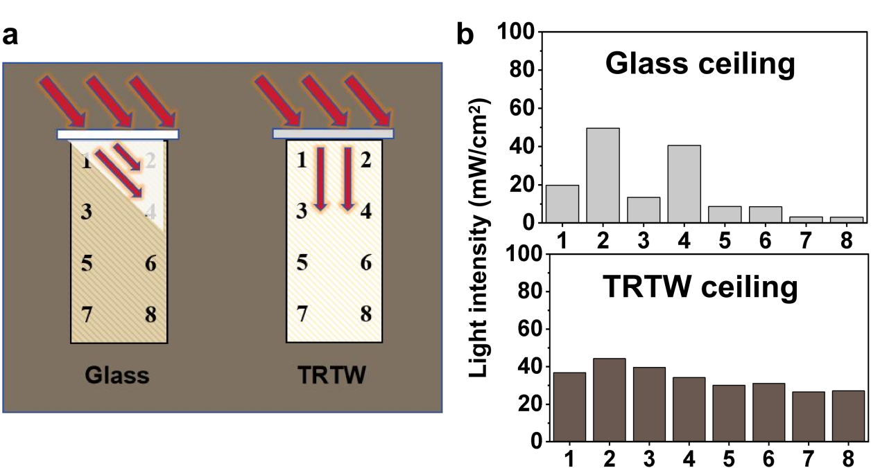
Figure S25 (a) Schematic diagram of uniform light distribution inside a house model with glass and TRTW as transparent ceilings. (b) Light distribution at corresponding points in the ceiling of a house with TRTW ceiling and a glass ceiling.

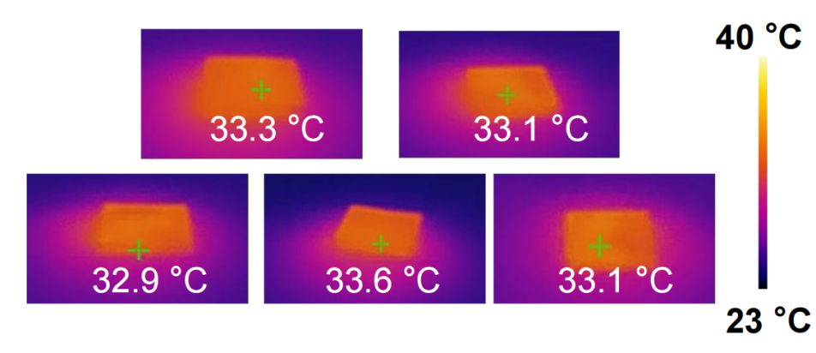
Figure S26 Temperature distribution of TRTW under simulated illumination.

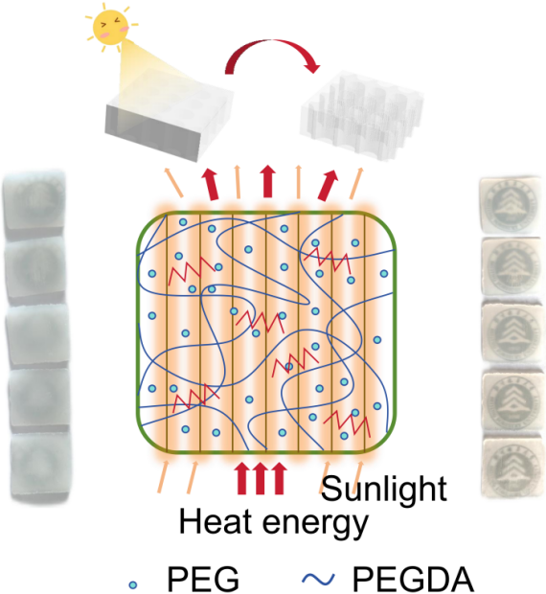
Figure S27 Photothermal conversion mechanism of TRTW.

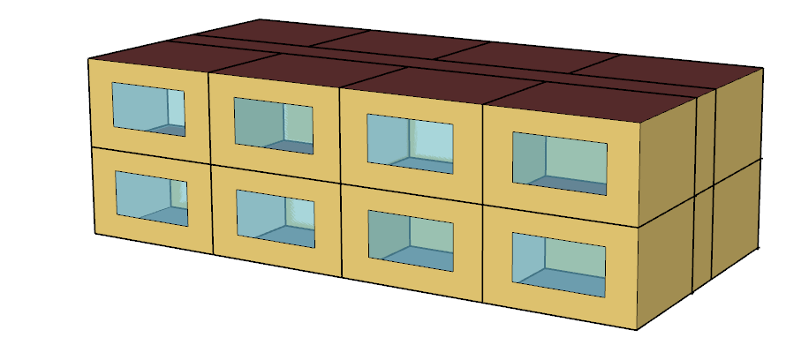
Figure S28 Schematic diagram of buildings.

References
1. Wang C, Liu C, Li C (2023) Additive manufacturing of shape-stabilized composite phase change materials via ultraviolet curing. Addit Manuf 61: 103341. https://doi.org/10.1016/j.addma.2022.103341
2. Can A, Özlüsoylu İ, Sözen E, Ergün ME (2024) Properties of Pinus nigra Arn. wood impregnated with phase change materials for potential energy-saving building material. Journal of Energy Storage 83: 110687. https://doi.org/10.1016/j.est.2024.110687
3. Zhang Y, Li J, Liu H, Li Y, Rui J, Da H, et al. (2020) Microencapsulated phase change materials composited Al₂O₃–SiO₂ aerogel and the thermal regulation properties. J Sol-Gel Sci Technol 96(3): 627-635. https://doi.org/10.1007/s10971-020-05363-3
4. Cheng P, Wei K, Shi W, Shi J, Wang S, Ma B (2022) Preparation and performance analysis of phase change microcapsule/epoxy resin composite phase change material. Journal of Energy Storage 47: 103581. https://doi.org/10.1016/j.est.2021.103581
5. Konuklu Y, Ersoy O (2016) Preparation and characterization of sepiolite-based phase change material nanocomposites for thermal energy storage. Appl Therm Eng 107: 575-582. https://doi.org/10.1016/j.applthermaleng.2016.07.012
6. Ren M, Zhao H, Gao X (2022) Effect of modified diatomite based shape-stabilized phase change materials on multiphysics characteristics of thermal storage mortar. Energy 241: 122823. https://doi.org/10.1016/j.energy.2021.122823
7. Perumal Arulselvan S, Vellalapalayam Gurusamy S (2022) Characterization of Fly Ash Cenosphere – Capric acid composite as phase change material for thermal energy storage in buildings. Energy Sources Part A 44(1): 2088-2102. https://doi.org/10.1080/15567036.2022.2055234
8. Yan W-T, Ye W-B, Du J, Hong Y (2021) Improvement of acid modification and its effect on the adsorption of stearic acid into sepiolite. J Therm Anal Calorim 147(4): 3025-3032. https://doi.org/10.1007/s10973-021-10633-5
9. Li C, Xie B, Chen J, He Z, Chen Z, Long Y (2019) Emerging mineral-coupled composite phase change materials for thermal energy storage. Energy Convers Manage 183: 633-644. https://doi.org/10.1016/j.enconman.2019.01.021

