Supplementary data

Graphene-Perovskite Composite Structure Facilitates High-Performance X-ray Detectors with Low Detection Limits
Ciyu Liu, Yi Luo, Runhao Chen, Wenyi Wu and Hai Zhou*
International School of Microelectronics, Dongguan University of Technology, Dongguan, Guangdong, 523808, P.R. China

*Corresponding authors
Hai Zhou: hizhou@dgut.edu.cn

1. Supplementary experimental data
Materials:
CsBr (≥99.5%) 、 PbBr (≥99.5%) 、MACl (99.5%) and PbCl₂ (99.5%)was purchased from Macklin. Diethyl carbonate (DEC,99%), N,N-Dimethylformamide (DMF, 98%) ， Dimethyl sulfoxide（DMSO，99.8%） and graphene prepared by mechanical stripping method were purchased from Aladdin. All materials are used as received without any further purification. Silicon wafers were obtained from Tianjin Institute of Semiconductor Technology.
Treatment of Growth Substrate:
The n-Si wafers were cut into 1 cm × 1 cm square samples using a tungsten carbide pen, and then sequentially cleaned by ultrasonic treatment with deionized water, isopropanol, and anhydrous ethanol (15 minutes each). After drying, they were stored in a dry environment for later use. The pretreated n-Si wafers were then treated in a UV-ozone environment for 20 minutes, followed by immediate spin-coating at 4000 rpm to apply 10 μL of 0.2 M MAPbCl₃ solution (DMF as solvent) for 30 seconds. The samples were then annealed on a hot plate at 80°C for 10 minutes and set aside for further use.
Device fabrication：
734 mg of PbBr₂ and 425 mg of CsBr were dissolved in 10 mL of DMF to prepare a 0.2 M CsPbBr₃ precursor solution. The solution was stirred at 40°C until fully dissolved and then filtered. The precursor solution was transferred to a beaker and heated to 100°C under stirring. Diethyl carbonate was then added slowly, and the mixture was stirred for 20 minutes. The CsPbBr₃ microcrystalline powder was obtained by separating the precipitate. The powder was dried in a vacuum oven for 48 hours. The perovskite microcrystalline powder was mixed with graphene powder in a ball milling jar and milled at 4000 rpm for 2 hours to ensure thorough mixing. The control group was prepared by ball milling only the perovskite microcrystalline powder for 2 hours under the same conditions. Next, 30 mg of the powder was evenly spread on the substrate using a 1000-mesh sieve. A quartz glass plate was placed on top, and the mixture was hot-pressed at 40 MPa and 120°C for 80 minutes to form a CsPbBr₃ microcrystalline thick film. Finally, conductive carbon paste was screen-printed onto the device to prepare a 2 mm × 2 mm electrode, with a channel width of 0.2 mm between the two electrodes, completing the fabrication of the device.

Measurements:
The SEM images of the CsPbBr₃ Microcrystal Films were obtained from scanning electron microscopy (VeriosG4UC). The XPS of the CsPbBr₃ Microcrystal Films were obtained from X-ray photoelectron spectroscopy (ESCALAB XI). The ultraviolet-visible-near infrared (UV-VIS-NIR) absorption spectra of the CsPbBr₃ Microcrystal Films were measured by using a UV-VIS-NIR spectrophotometer (CARY5000). Steady-state photoluminescence (PL) spectra were collected on Edinburgh Instruments Ltd (FLS-1000). The X-ray diffraction (XRD) patterns of the CsPbBr₃ Microcrystal Films were characterized by D8ADVACE Multifunctional X-ray Diffractometer with Cu Kα radiation at 40 kV and 40 mA.
Device characterizations:
The current-voltage (I-V) and current-time (I-t) curves were measured by a Keysight B2450A Precision Sources/Measure Unit. An X-ray tube with a tungsten anode (Newton Scientific. Inc, Mini X2) was used as the source. A Keithley 2450 provided the bias voltage and recorded the response current. Silver is used as a target in the X-ray tube, the average energy of X-ray photons irradiating the detector is approximately 22 keV. The X-ray source was under a constant 40 KeV voltage. The current was changed from 10 to 200 μA. Al foil (2–16 mm thick) was used as the attenuator between the X-ray tube and perovskite wafer. The radiation dose rate was assessed utilizing a Radcal ionization chamber (model: 10 × 6-6), as the dosimetric instrument. During the calibration process, it was essential to ensure that the dosimeter probe was fully covered by X-rays and positioned 15 cm from the X-ray tube. Calibration was performed within the ionization chamber (non-vacuum). The instrument provides a real-time display of the current dose rate, averaging the dose rate over 60 s to minimize error. The measurement was conducted in darkness and within a vacuum environment to mitigate interference from ambient light and air ionization effects. For acquiring X-ray imaging, the object was adhered to a x-y scanning stage (Zolix PSA20011-X), and the object’s movement was directed along the x and y axes for precise manipulation.
Calculations:
The μτ product is determined by fitting the photoconductivity using a simplified Hecht equation:
$I=\frac{I_{0}μτV}{L^{2}}(1-exp(-{\frac{L^{2}}{μτV}}$)

The defect density can be calculated using Equation:
$$n_{trap}=2εV_{TFL}/qL^{2}$$
where V_{TFL} denotes the threshold voltage, L signifies the thickness of the crystal, whereas 𝜀 and 𝜀₀ correspond to the relative dielectric constant and the dielectric constant of vacuum, respectively.

The X-ray sensitivity (S) of the detectors can be calculated by the following equation:
$$S=\frac{I_{p}-I_{dark}}{A.D}$$

Here, the signal current (I_{signal}) is calculated by subtracting the average photocurrent (I_{photo}) by the average dark current. D is the dose rate of incident X-ray radiation, and A is the top electrode area of the detector.

The SNR can be calculated by the following equation:
$$SNR=\frac{I_{photo}-I_{dark}}{\sqrt{\frac{1}{N}\sum_{l}^{n}{{\left(I_{t}-I_{photo}\right)}^{2}}}}$$

Here, the signal current (I_{signal})is calculated by subtracting the average photocurrent (I_{photo}) by the average dark current. The denominator of this equation is the standard deviation of the photocurrent.

2. Supplementary figures
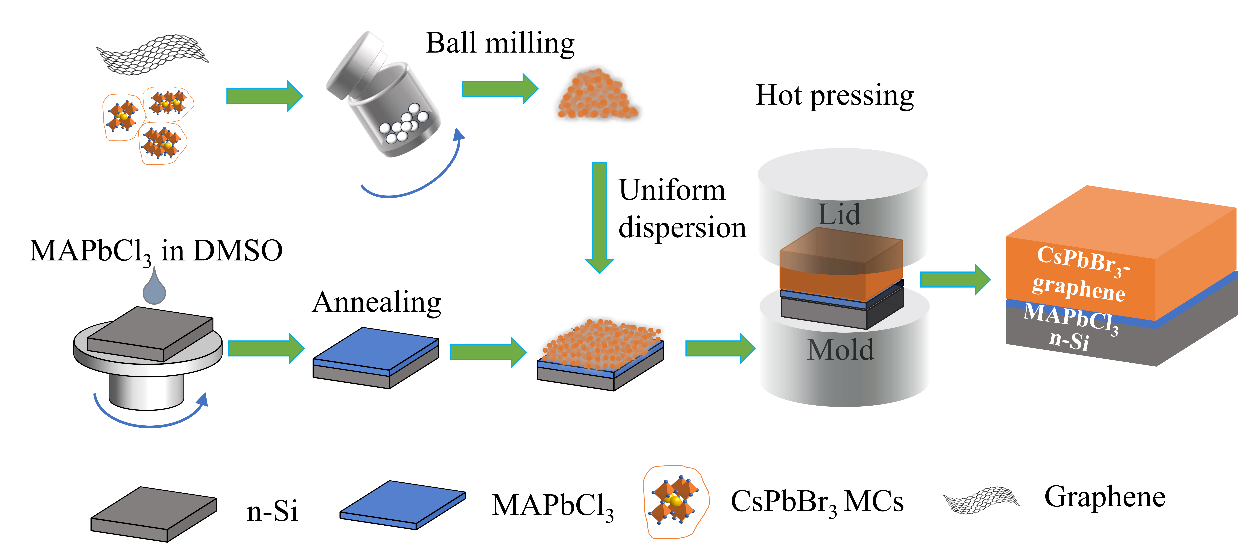
Figure S1. Schematic diagram of the preparation process for CsPbBr₃ PTF.
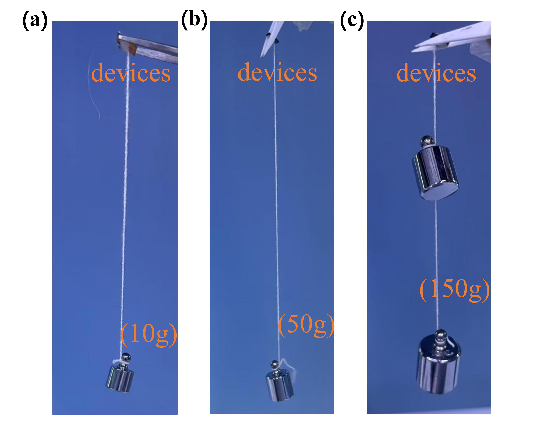
Figure S2. (a) Photograph of Si/ CsPbBr₃ microcrystalline films with a 10 g weight attached to the perovskite. (b) Photograph of Si/ CsPbBr₃-graphene microcrystalline films with a 50 g weight attached to the perovskite. (c) Photograph of Si/ MAPbCl₃/CsPbBr₃-graphene microcrystalline films with a 150 g weight attached to the perovskite.

Table S1 Calculation process for the bonding strength of different devices.
device structure |  |  | Si/ CsPbBr₃ | Si/CsPbBr₃-graphene |  |  | Si/MAPbCl₃/CsPbBr₃-graphene
A (mm²) | 9 |  |  |  | 9 | 9
F_{max} (N) |  | 0.98 |  |  | 4.7 | 14.6
σ（N/m²） |  |  | 1.08×10⁵ |  | 5.44×10⁵ | 1.63×10⁶

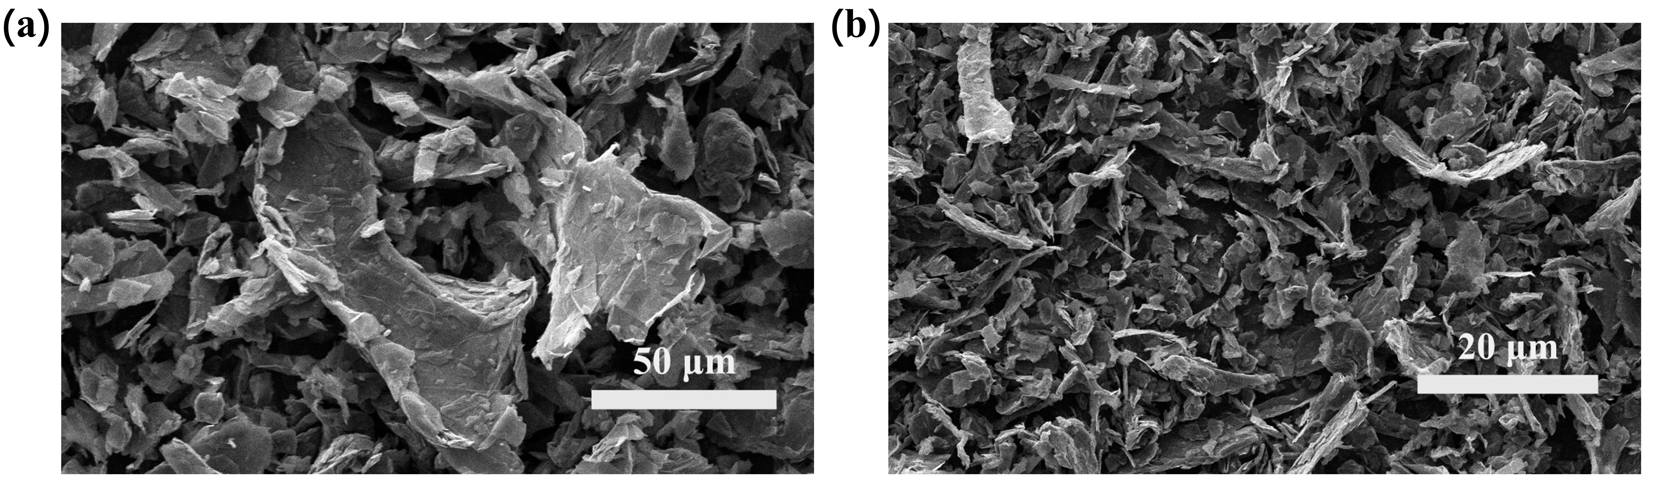
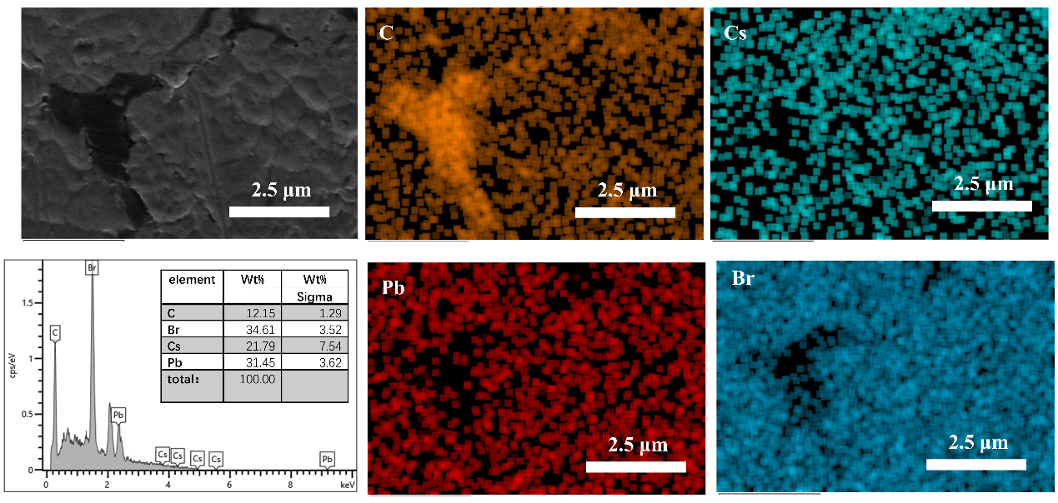
Figure S3. SEM images of graphene ultra-fine powder.
Figure S4. The EDS mapping of CsPbBr3-graphene composite structure thick-film.
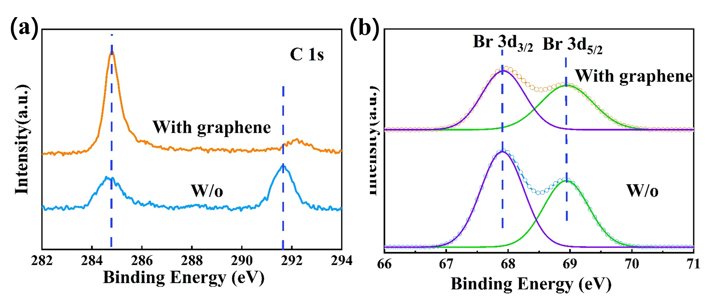
Figure S5. The XPS of CsPbBr3 and CsPbBr3-graphene thick films. (a) C 1s; (b) Br 3d.
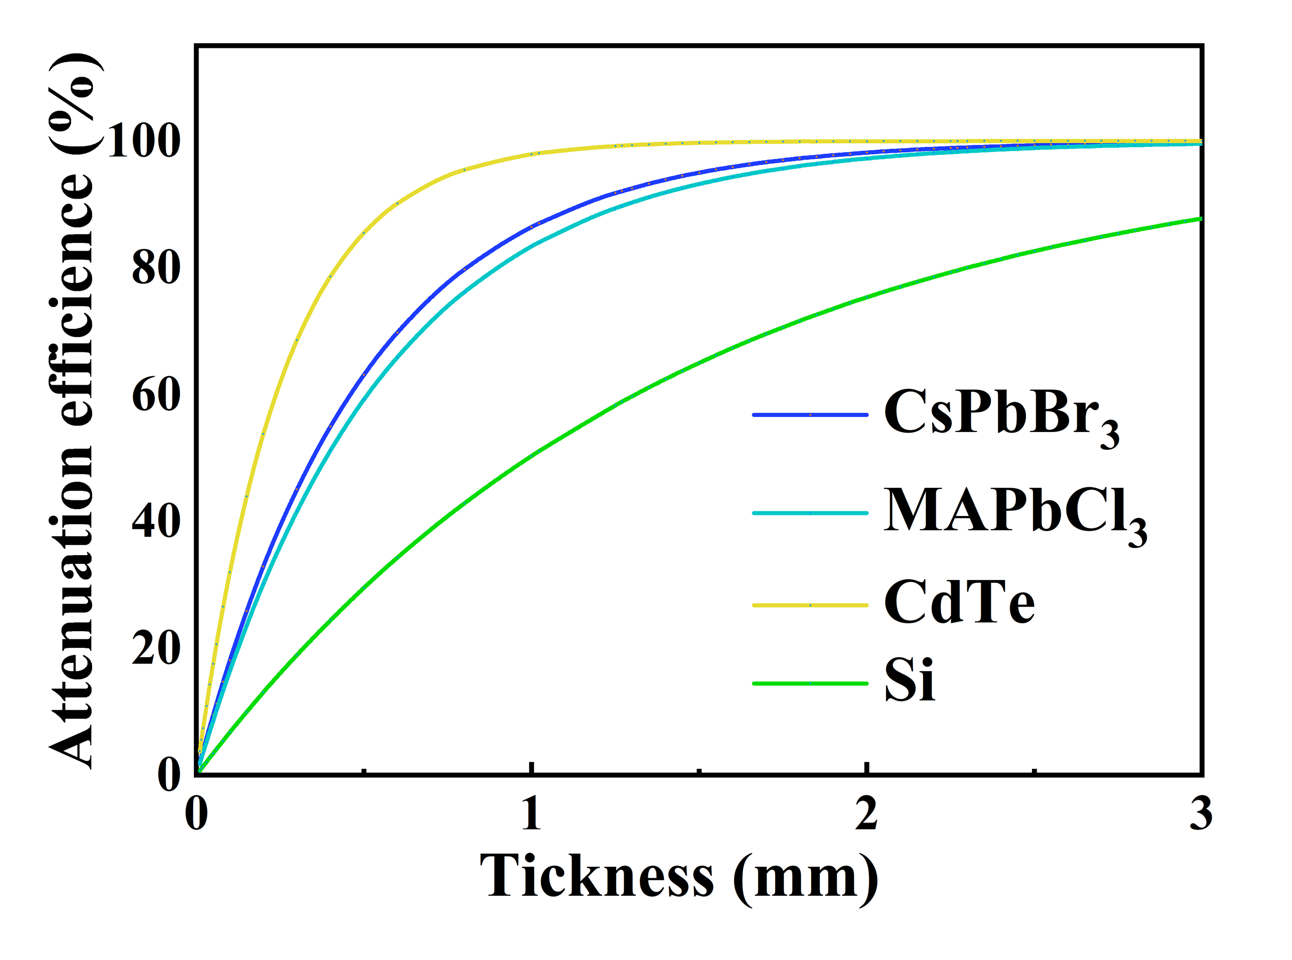
Figure S6. Thickness-dependent X-ray attenuation efficiency of typical X-ray detection materials to 40 KeV X-ray photons.
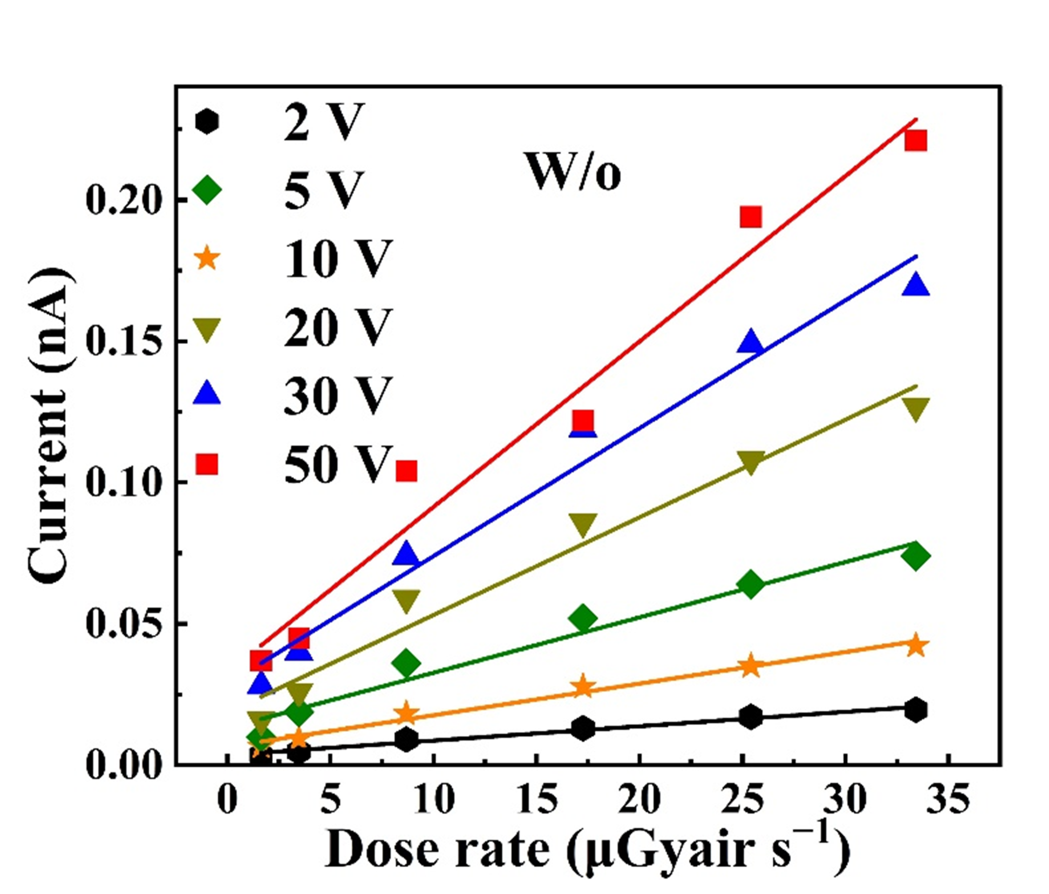
Figure S7. The photocurrent density of the CsPbBr₃ microncrystal thick films detectors under different X-ray irradiation dose rates.
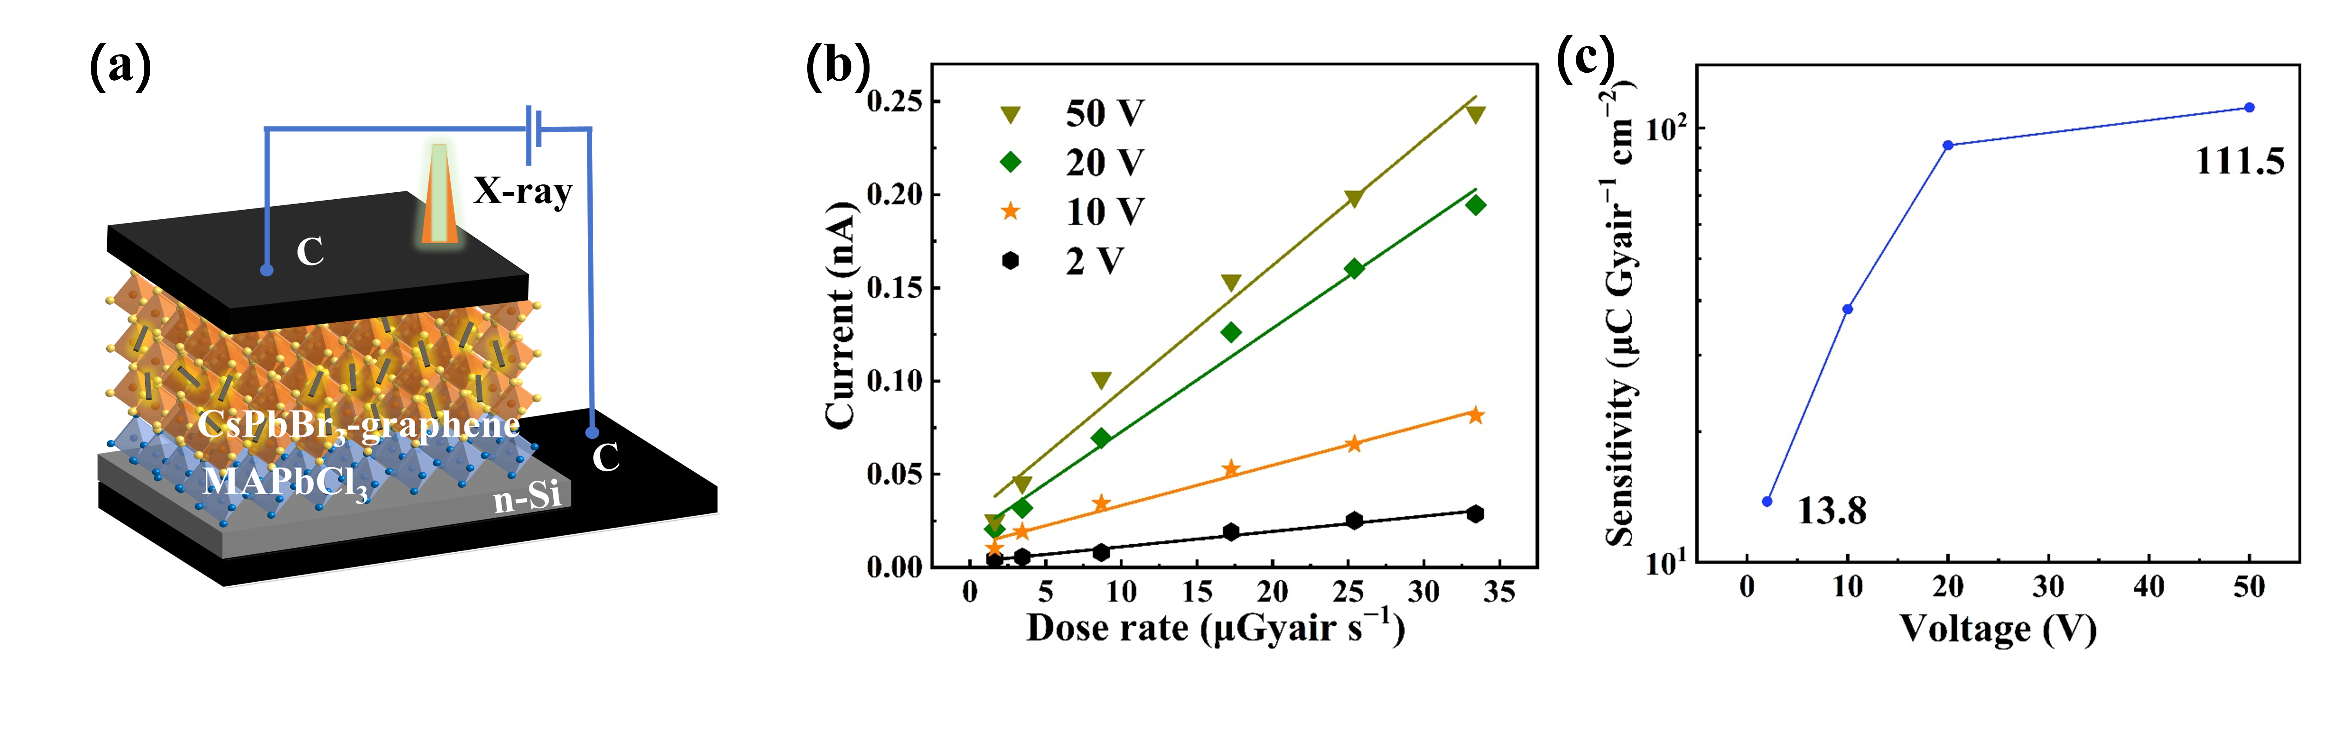
Figure S8. (a) The schematic diagram of the C/n-Si/CsPbBr₃-graphene/C device structure; (b) X-ray induced current density of the devices with dose rate at different biases; (c) Sensitivity of the X-ray detectors under different biases;
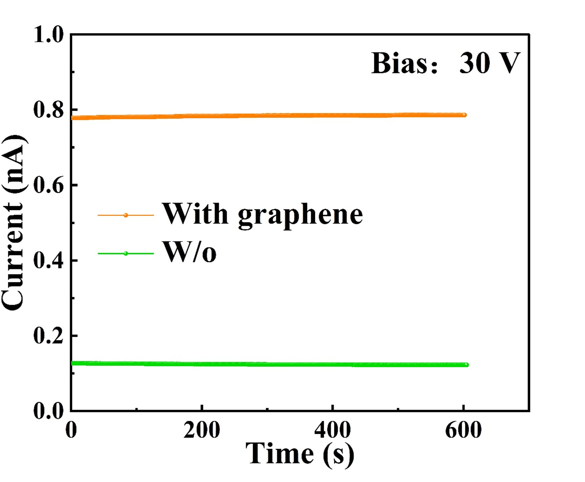
Figure S9. CsPbBr₃ and graphene-CsPbBr₃ composite structure micronthick films devices at 30 V for 600 s of dark current.
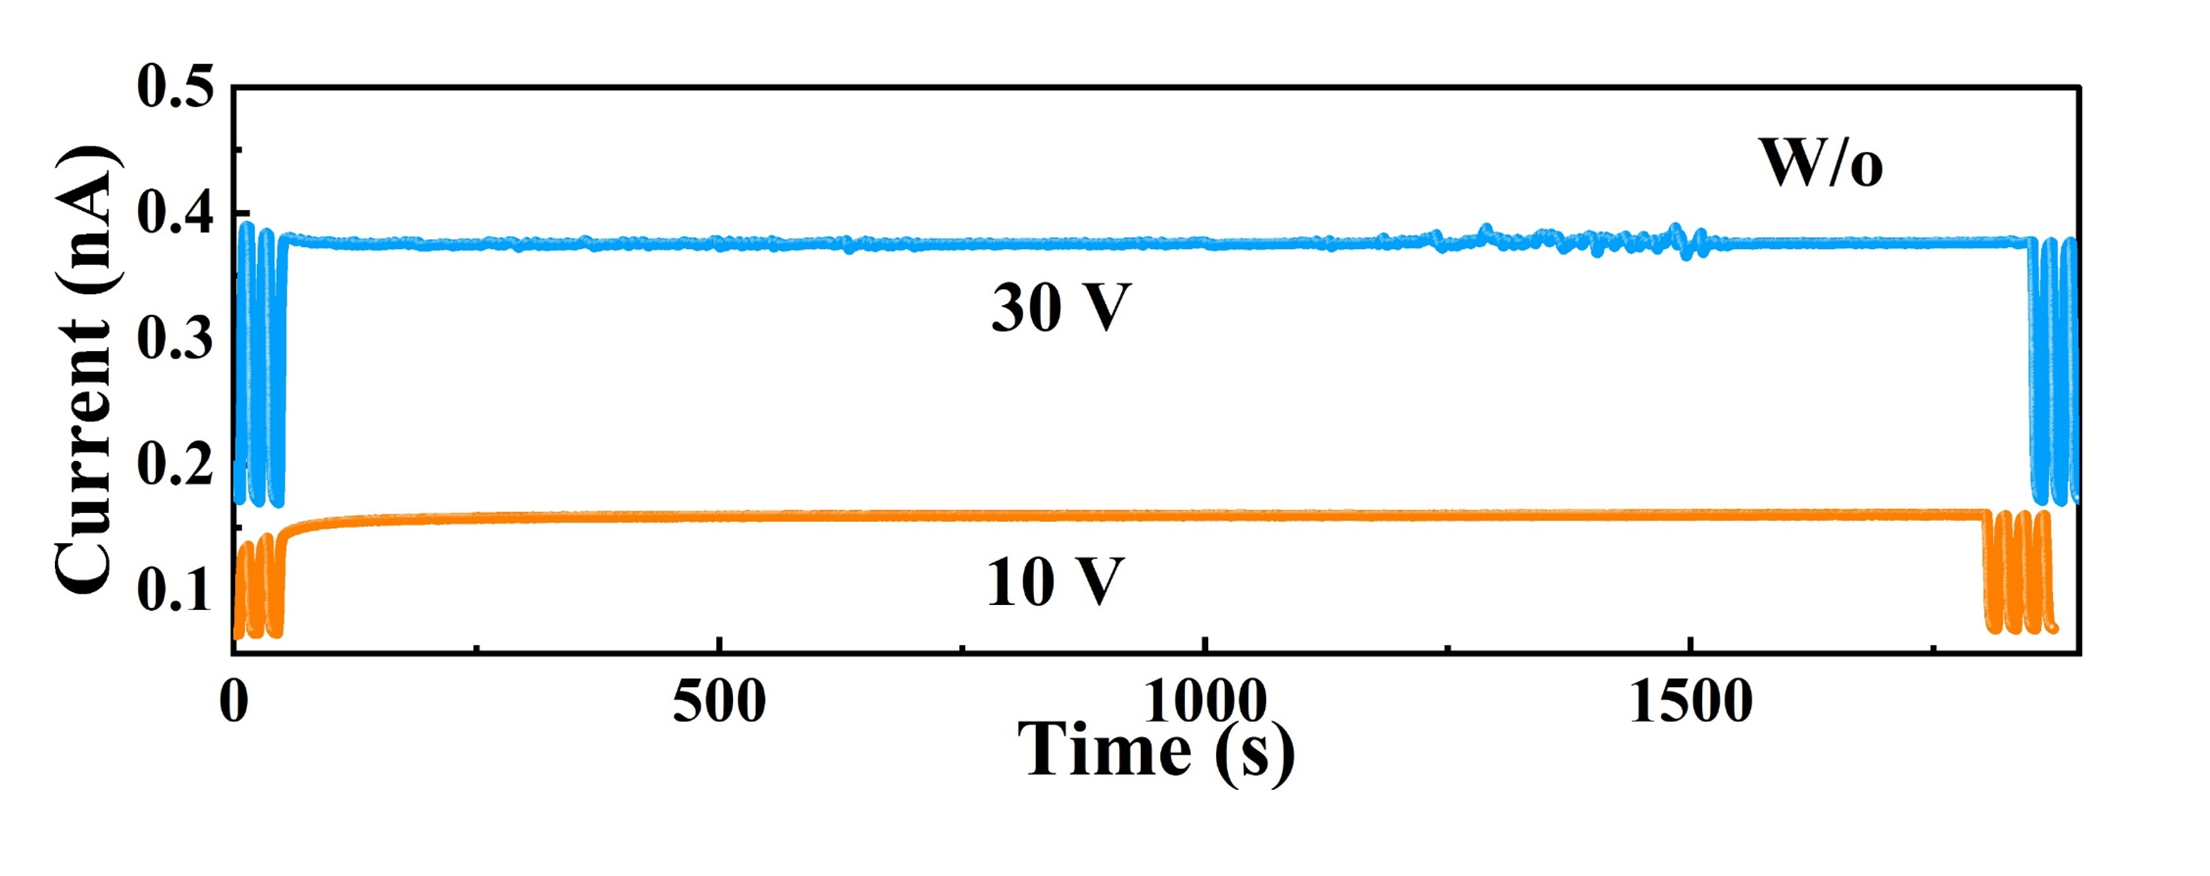
Figure S10. Long-term irradiation stability test of unencapsulated devices at a dose rate of 8.69 μGy_{air} s⁻¹ and biases of 10V and 30V.
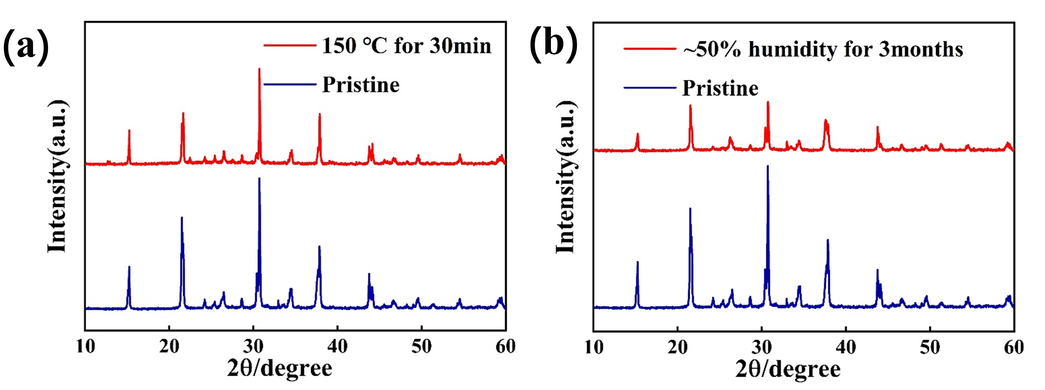
Figure S11. (a) XRD spectra of the device after annealing at 150℃for 30 min; (b) XRD spectra of the device before and after 3 months of storage at ≈50% humidity.

