Supporting Information

Harnessing LDHs@GO Hierarchical Nanocomposites for Robust and Efficient Corrosion Protection in Sustainable Marine Concrete Infrastructure
Liangsheng Qiu ^{1,2,3}, Siqi Ding ^{2,3*}, Zhiheng Ding ¹, Hanyao Qin ¹, Xinyue Wang ⁴, Yangyang Zhang ⁵, Chao Yang ^{2,3}, Kai Zhou ², Yi-Qing Ni ^{2,3,6*}, Baoguo Han ^{1*}
¹ School of Civil Engineering, Dalian University of Technology, Dalian 116024, China
² Department of Civil and Environmental Engineering, The Hong Kong Polytechnic University, Hung Hom, Kowloon, Hong Kong S.A.R.
³ National Rail Transit Electrification and Automation Engineering Technology Research Center (Hong Kong Branch), Hung Hom, Kowloon, Hong Kong S.A.R.
⁴ School of Civil Engineering, Tianjin University, Tianjin 300072, China
⁵ State Key Laboratory of Metastable Materials Science and Technology, Yanshan University, Qinhuangdao 066004, China
⁶ Hangzhou Technology and Innovation Research Institute, The Hong Kong Polytechnic University, Hangzhou 310000, China
Corresponding author: s.q.ding@connect.polyu.hk; yiqing.ni@polyu.edu.hk; hanbaoguo@dlut.edu.cn

This supplementary information includes supplementary methods, supplementary figures 1-20, and supplementary tables 1-18.

Supplementary Methods

Synthesis process optimization of LDHs and LDHs@GO using orthogonal design
To determine the optimal synthesis parameters for NiAl-LDHs (hereafter referred to as LDHs), a three-factor orthogonal experiment was designed, considering hydrothermal temperature, the molar ratio of urea to Ni(NO₃)₂·6H₂O and Al(NO₃)₃·9H₂O (U/(Ni+Al)), and reaction time (three levels for each factor, Supplementary Table 1,2). Range analysis in Supplementary Table 3 indicated that the order of influence on chloride adsorption capacity of LDHs is temperature> U/(Ni+Al) > time. The optimal solution refers to the combination of the better levels of each factor within the experimental range, and the better level of each factor corresponds to the level with the largest value of K. Specifically, for the temperature, the Level 1 is the best; for the U/(Ni+Al), the Level 1 is the best; and for the reaction time, the Level 3 is the best. Therefore, the optimized synthesis parameters of LDHs were: temperature of 100℃, reaction time of 24 h, U/(Ni+Al) of 5, corresponding to the process parameters of the L1. Chloride adsorption capacity (Supplementary Fig. 1a), XRD (Supplementary Fig. 1b-d) and specific surface area (SSA, Supplementary Table 4) were characterized to confirm the optimized results.
As shown in Supplementary Figure 1b-d, all the hydrothermally synthesized samples exhibited typical LDHs structures, with strong intensity at 2θ = 11.8° and 23.7° corresponding to the (003) and (006) crystal planes of LDHs, respectively. In addition to the LDH phase, a small amount of Ni(OH)₂ phase was also detected, with the diffraction peak located at 2θ = 19.2° (ICDD#01-073-6992), corresponding to the (001) crystal plane of Ni(OH)₂. Remarkably, it should be noted that in the samples with high urea content and high temperature, such as L9, Al(OH)₃ phase was also detected, with diffraction peak located at 2θ = 14.6° (ICDD#01-074-2895), corresponding to the (020) crystal plane of Al(OH)₃. As evidenced in Supplementary Fig. 2, a large number of needle- and rod-like Ni(OH)₂ and Al(OH)₃ phases were found in L9, consistent with the XRD results. Moreover, samples L1 and L3, synthesized at 100°C, exhibited a homogeneous lamellar hexagonal morphology with transverse dimensions of 100–200 nm. Increasing the reaction time resulted in larger transverse dimensions.
These results demonstrate that the chloride binding capacity of NiAl-LDHs can be enhanced by using a lower reaction temperature (90–100°C) and a urea concentration of 5% during hydrothermal synthesis. Because urea is a weak Brønsted base (pK_{b} = 13.8), which can accept protons (H⁺) in aqueous solution but does not completely dissociate or release a large number of hydroxide ions (OH⁻) in the process, thus exhibiting a weak alkalinity^{[1]}. The relatively low degree of urea dissociation prevents a significant increase in OH⁻ concentration. At low temperatures, urea solution is neutral and forms a homogeneous solution with metal ions. As the reaction temperature exceeds 90°C, urea decomposes into ammonia, gradually increasing the system pH and precipitating Ni²⁺ and Al³⁺, resulting in well-crystallized LDHs. However, at very high urea content and reaction temperature, extensive urea decomposition leads to a very high pH. The different pH requirements for Ni(OH)₂ (pH ~8–10) and Al(OH)₃ (pH > 10) precipitation result in different precipitation rates and, consequently, different crystal structures and morphologies, including the formation of Al(OH)₃ heterogeneous phases.
The chloride adsorption capacity of LDHs increased with the addition of GO, and the adsorption process was thermodynamically spontaneous. As seen in Supplementary Fig. 3a, the chloride adsorption capacity of LDHs increased by 1.48% (2.5GL), 12.5% (5GL), 12.2% (7.5GL) and 16.5% (10GL) with increasing GO content. This indicates that the larger the content of GO, the better the effect of improving the chloride adsorption capacity of LDHs. Based on these results, the optimum GO loading for LDHs@GO synthesis was determined to be 10 vol.%, which was also supported by XRD (Supplementary Fig.3b) and pore structure (Supplementary Table 6) analysis.

Chloride adsorption isothermal equilibria calculation
Langmuir and Freundlich models are the commonly used models for fitting the data from the chloride adsorption isotherm experiments, and they can be expressed by Supplementary Eqs. S1, S2, respectively:
(S1)
(S2)
where Q_{e} (mg/g) represents the amount of chloride absorbed at equilibrium; Q_{m} (mg/g) and C_{e} (M) represents the maximum chloride adsorption capacity per unit mass of the adsorbent and the chloride concentration at equilibrium, respectively; K_{L} (L/mol) is constant of Langmuir model, corresponding to the adsorption rate; K_{F} and n are the Freundlich isotherm constants related to the adsorption capacity and the heterogeneity factor, respectively.

Chloride adsorption kinetics calculation
Kinetics models including pseudo-first-order (Supplementary Eq. S3) and pseudo-second-order (Supplementary Eq. S4) were employed to characterize the chloride adsorption kinetics experiment in simulated concrete pore solutions (SCPs) and seawater (SW), see follows:
(S3)
(S4)
where Q_{e} and Q_{t} (mg/g) are the chloride adsorption capacities at equilibrium and time t (h), respectively. k₁ and k₂ are the adsorption rate constant of pseudo-first-order and pseudo-second-order model, respectively.

Modified Bingham model fitting
The modified Bingham model (Supplementary Eq. S5) was used to characterize the rheological behavior of cementitious composites:
(S5)
where and means shear stress and yield stress, respectively (Pa); is the imposed shear rate (s⁻¹); is plastic viscosity (Pa·s) ; c is consistency.

Chemical reactions of cementitious composites after SCPs immersion
The reaction mechanisms behind the formation of Friedel’s salt (Supplementary Eq. S6) and reduced CH amount (Supplementary Eq. S7) of cementitious composites after immersion in SCPs:
(S6)
(S7)

Equivalent circuit model fitting
As for the R_{c} and Q_{c} represent the resistance and capacitance of pore solution and cementitious composites matrix, respectively. R_{f} and Q_{f} are related to the dielectric properties of the corrosion product/passive film layers. R_{ct} is the charge transfer resistance. Q_{dl} is the double layer capacitance of the steel-paste interface^{[2]}. W is Warburg impedance to characterize the diffusion behavior occurred on the steel bar surface^{[3]}. It is attributed to the slow ionic diffusion effects at the steel-paste interface at low frequency range. Q_{c}, Q_{f}, and Q_{dl} were substituted by a constant phase element (CPE) whose impedance can be represented by Supplementary Eq. S8:
(S8)
where Y₀ is the magnitude of the CPE, j is the imaginary unit (j²=-1), ω is the angular frequency (in radians).

Corrosion inhibition efficiency calculation
The corrosion inhibition efficiency (η) of LDHs@GO and LDHs on steel bars embedded in cementitious composites can be calculated by Supplementary Eq. S9:
(S9)
here, R_{ct} and R_{ct,Ref} are the charge transfer resistances for reinforced cementitious composites samples with and without fillers.

Supplementary Figures

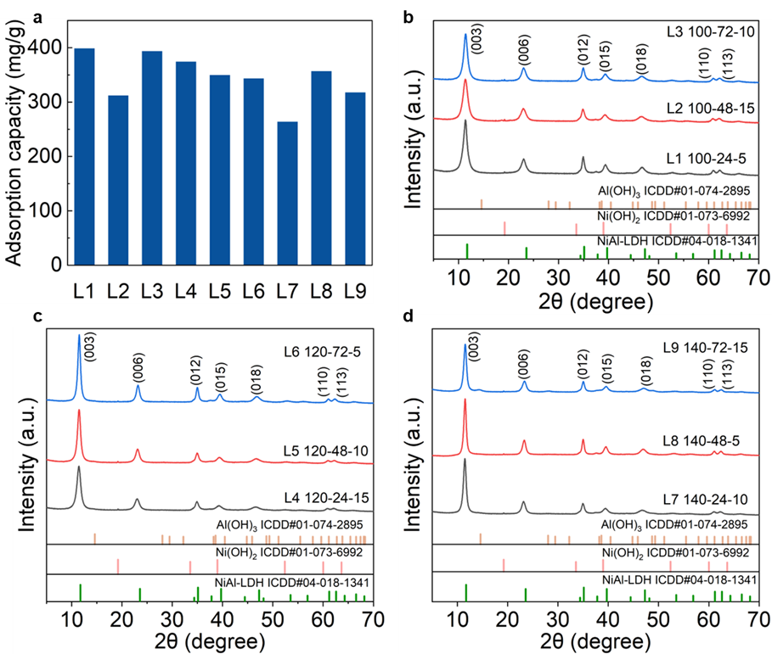
Figure S1. (a) Chloride adsorption capacity of NiAl-LDHs designed by orthogonal test. XRD patterns of (b) L1-L3; (c) L4-L6; (d) L7-L9.

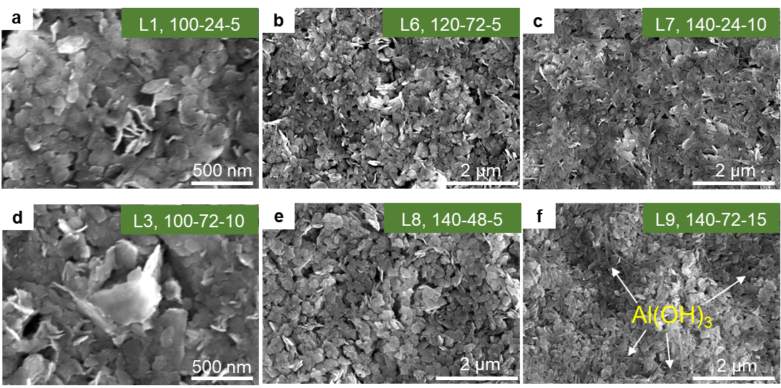
Figure S2. SEM images of (a) L1, (b) L6, (c) L7, (d) L3, (e) L8 and (a) L9 after sonication in isopropanol for 30 min.

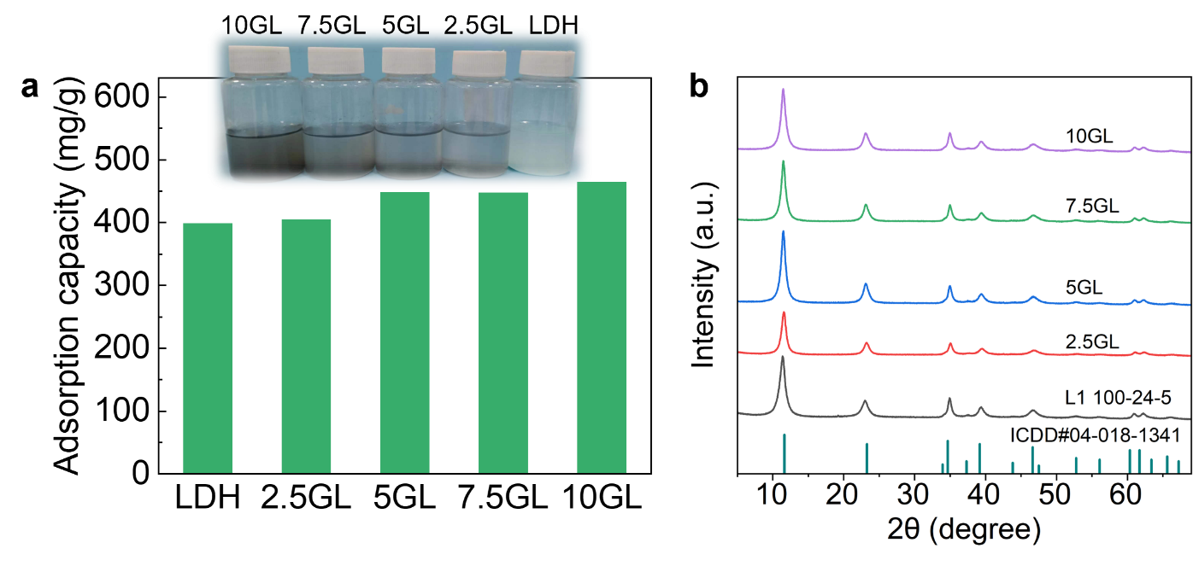
Figure S3. (a) Chloride adsorption capacity and (b) XRD patterns of LDHs and LDHs@GO loaded with different volumes of GO.

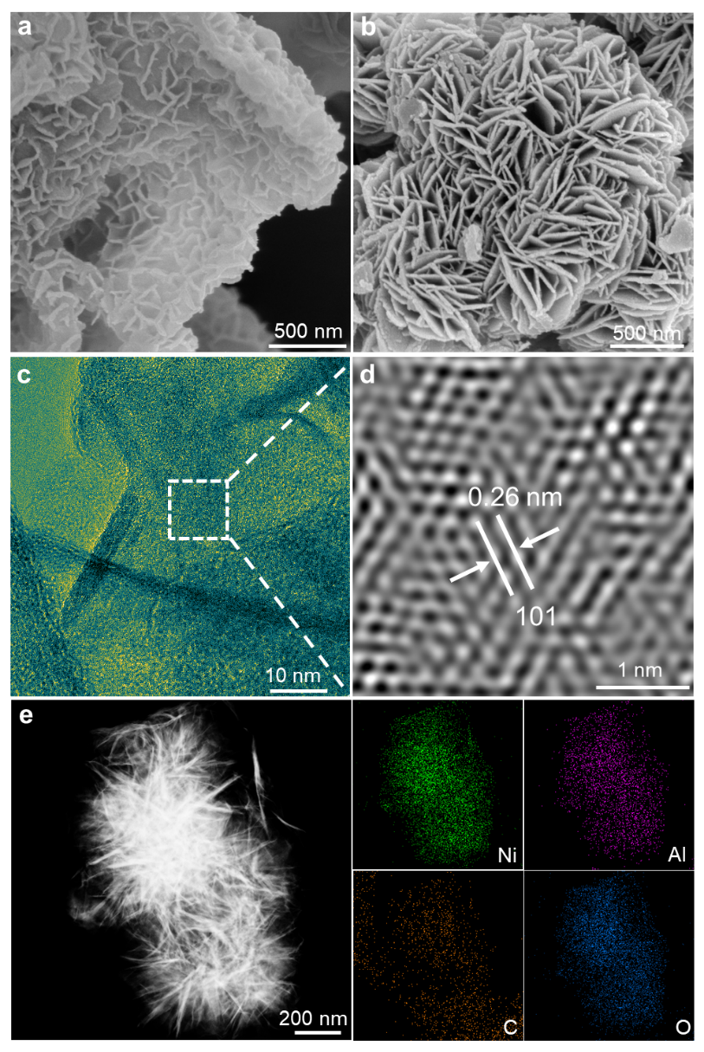
Figure S4. SEM images of (a) LDHs@GO and (b) LDHs. (c) HRTEM image of LDHs and (d) corresponding interplanar spacing of LDHs based on fast Fourier transformation. (e) Mapping images of LDHs.

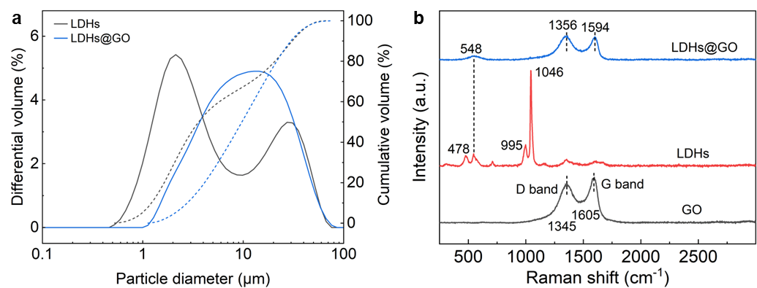
Figure S5. (a) Particle size distribution and (b) Raman spectra of LDHs@GO and LDHs.

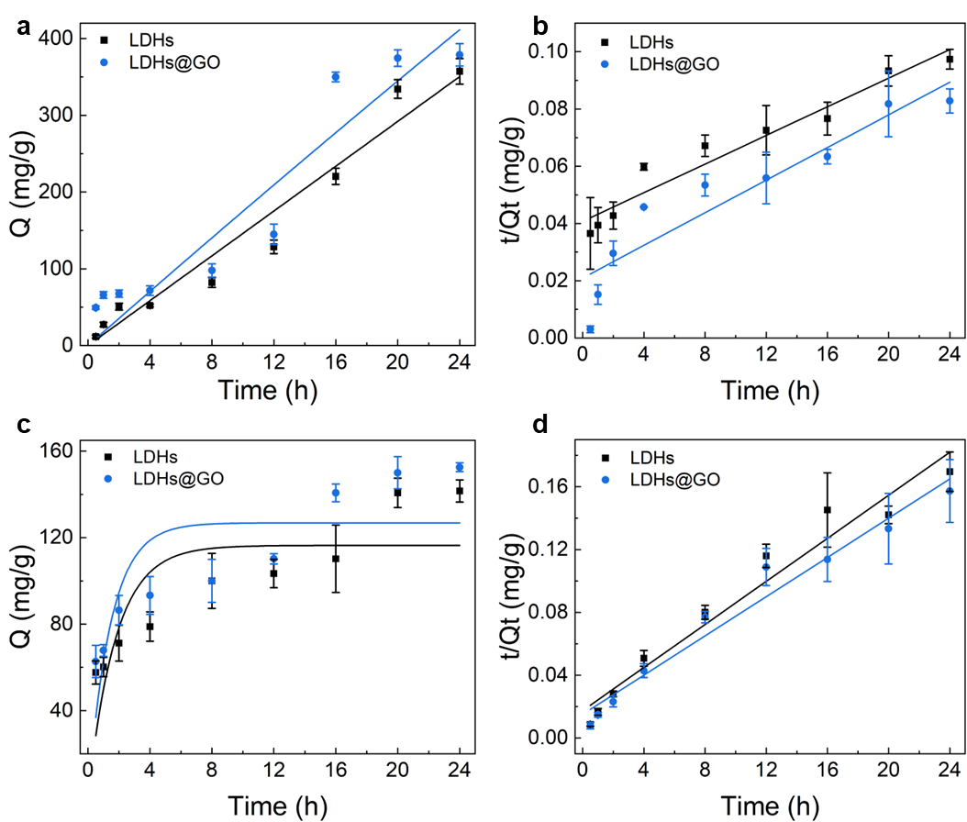
Figure S6. Chloride adsorption kinetics of LDHs and LDHs@GO adsorption in chloride-contaminated SCPs fitted to (a) pseudo-first-order model, (b) pseudo-second-order model and LDHs and LDHs@GO adsorption in SW fitted to (c) pseudo-first-order model, (d) pseudo-second-order model.

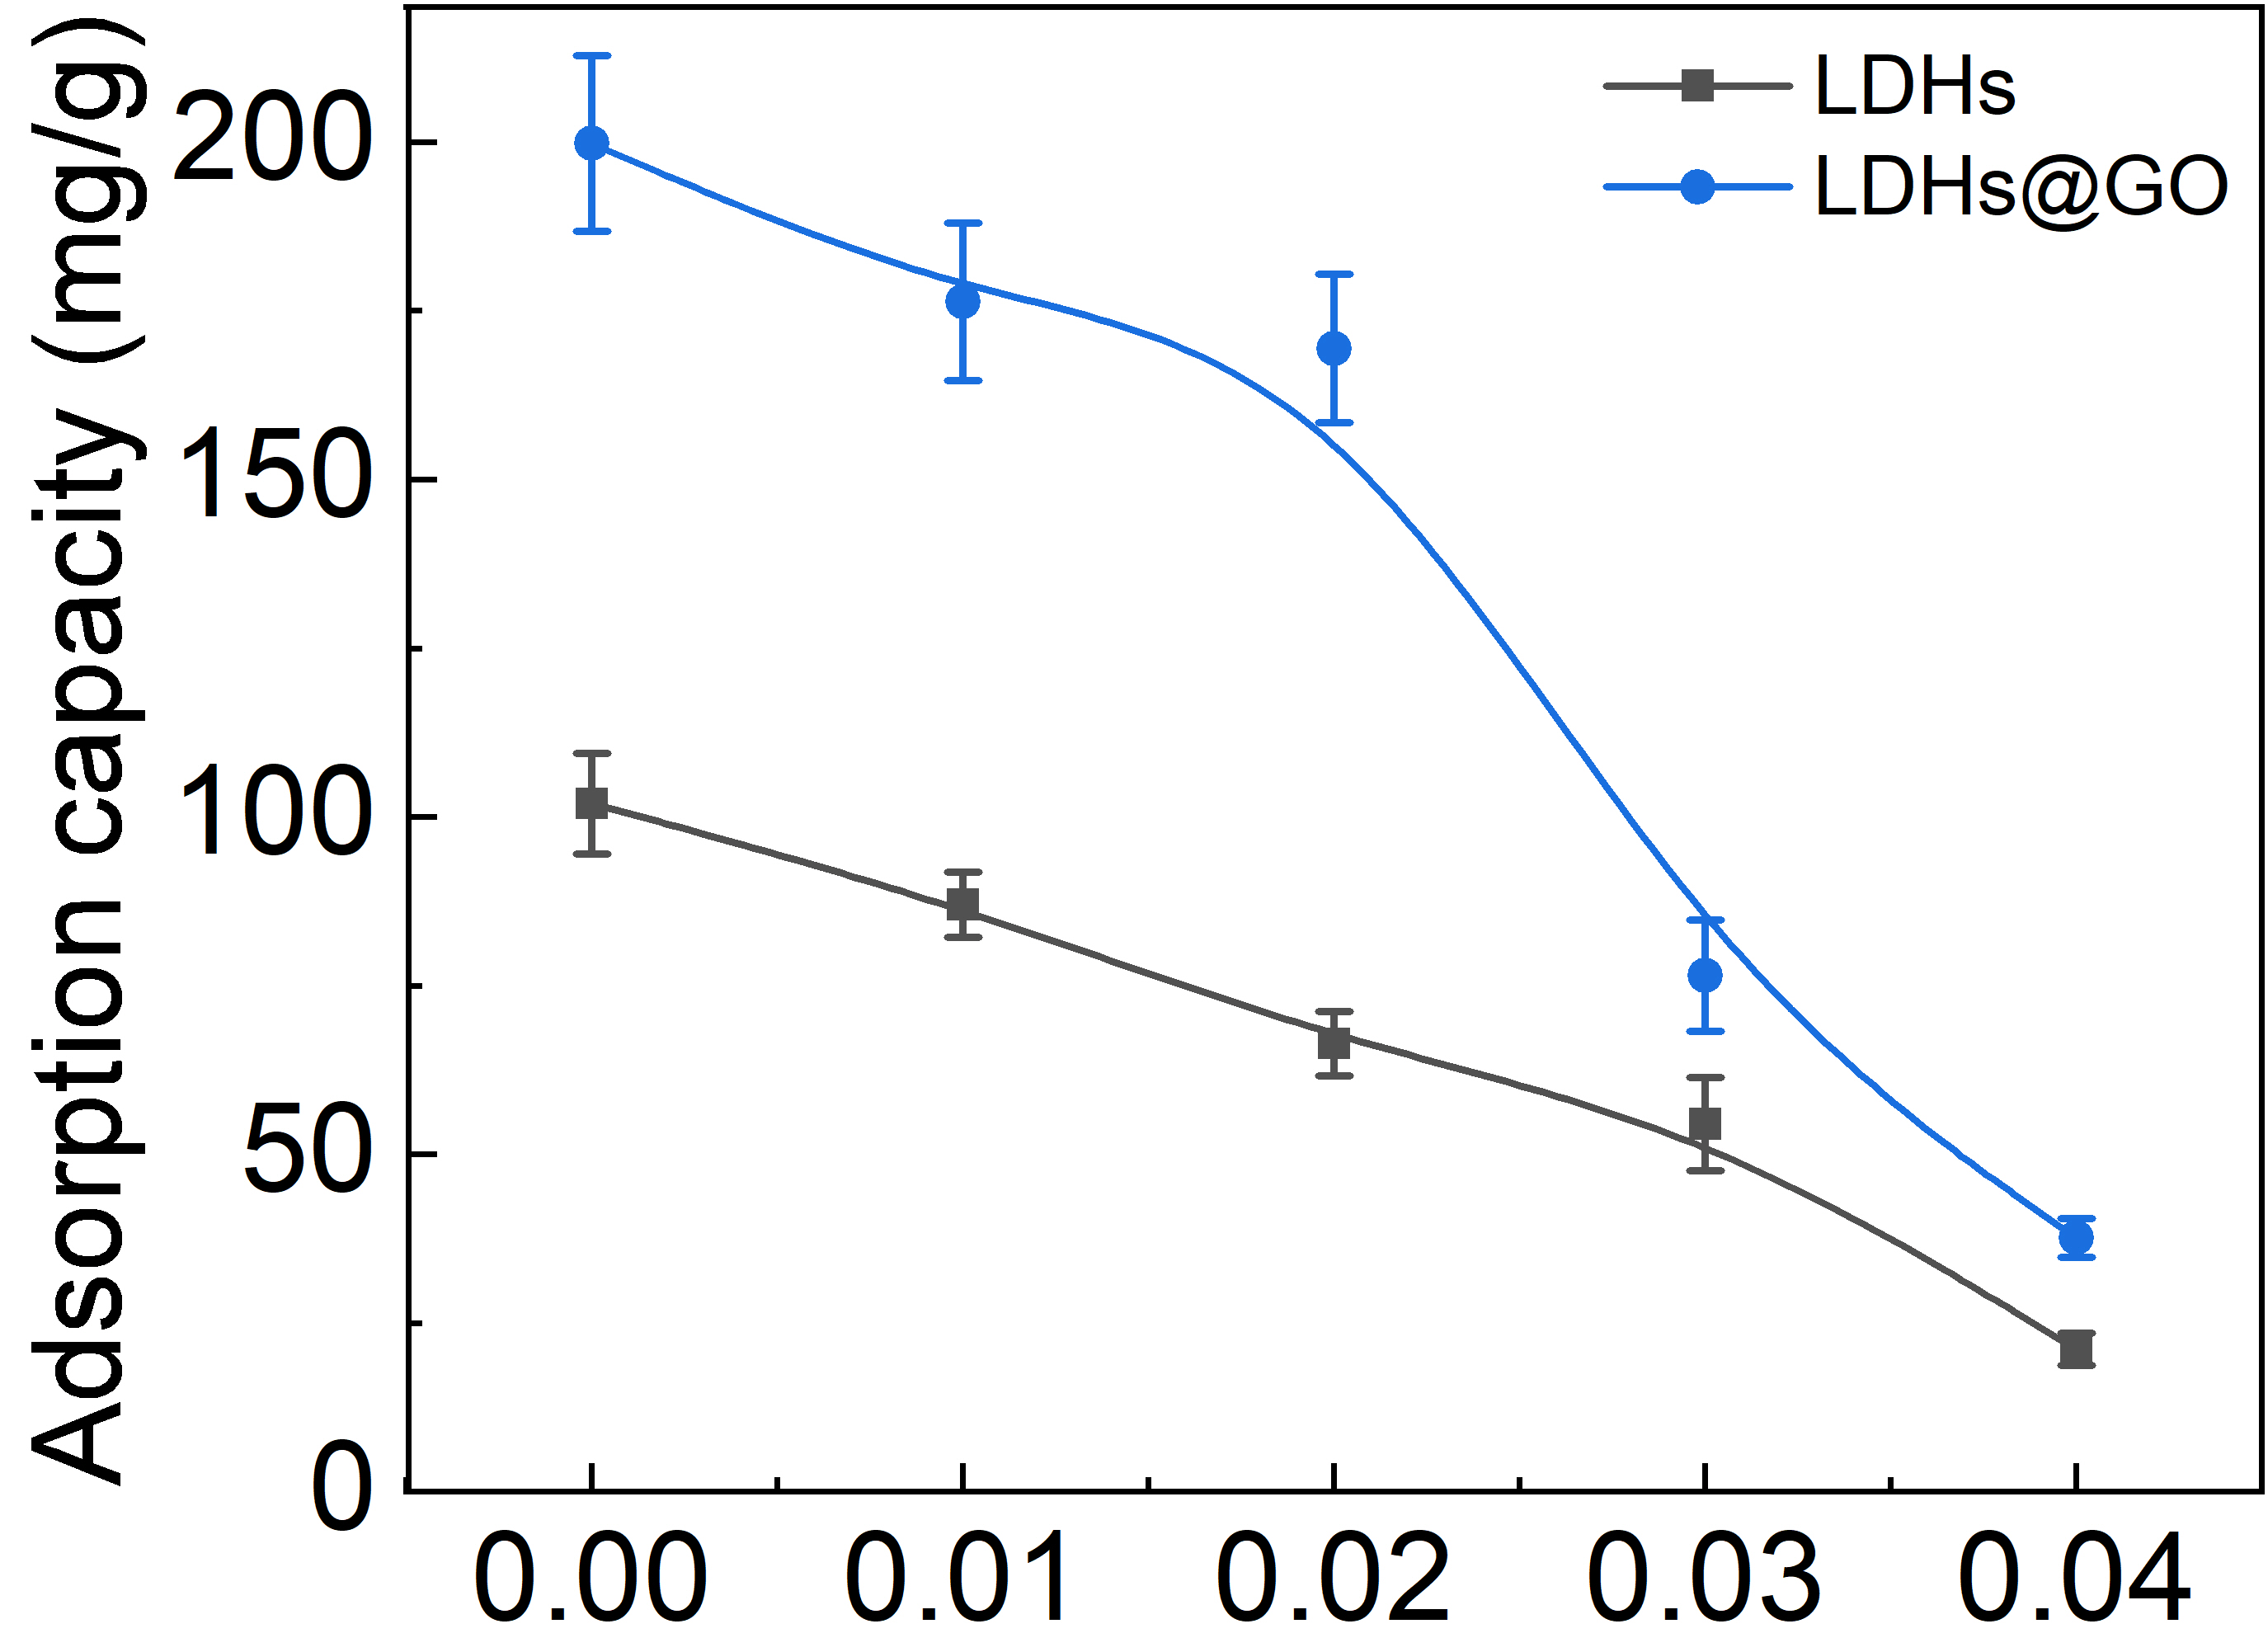
Figure S7. Chloride adsorption capacity of LDHs@GO and LDHs at varying sulfate concentrations.

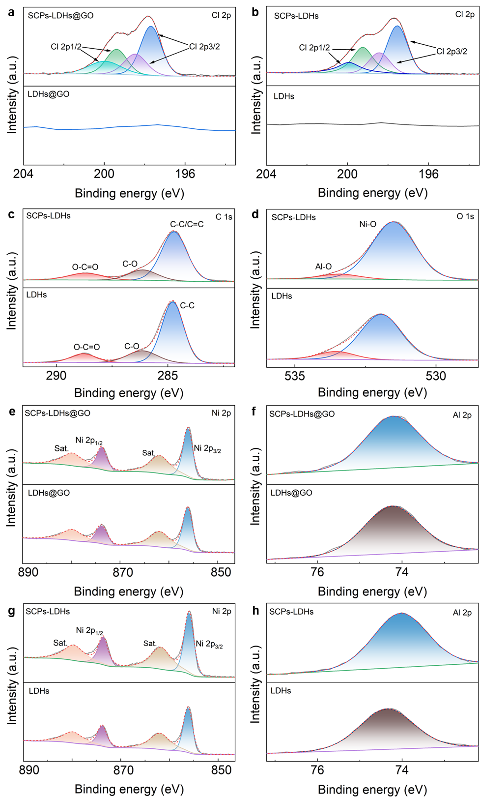
Figure S8. High-resolution XPS survey scan of Cl 2p of (a) LDHs@GO and (b) LDHs before and after adsorption in SCPs. (c) C 1s and (d) O 1s of LDHs before and after adsorption in SCPs. Ni 2p of (e) LDHs@GO and (f) LDHs before and after adsorption in SCPs. Al 2p of (g) LDHs@GO and (h) LDHs before and after adsorption in SCPs.
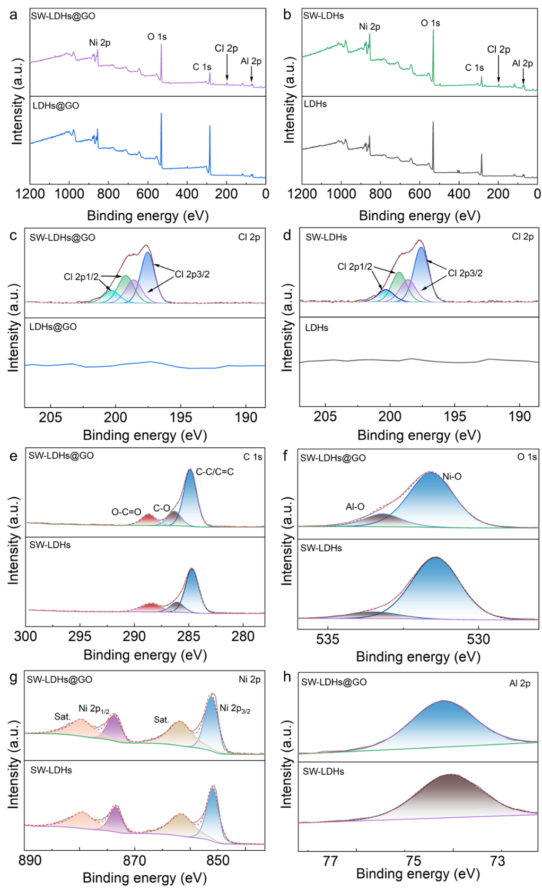
Figure S9. XPS survey spectra of (a) LDHs@GO and (b) LDHs before and after adsorption in SW. High-resolution XPS survey scan of Cl 2p of (c) LDHs@GO and (d) LDHs before and after adsorption in SW. High resolution XPS spectra of (e) C 1s, (f) O 1s, (g) Ni 2p and (h) Al 2p of LDHs@GO and LDHs after absorption in SW.

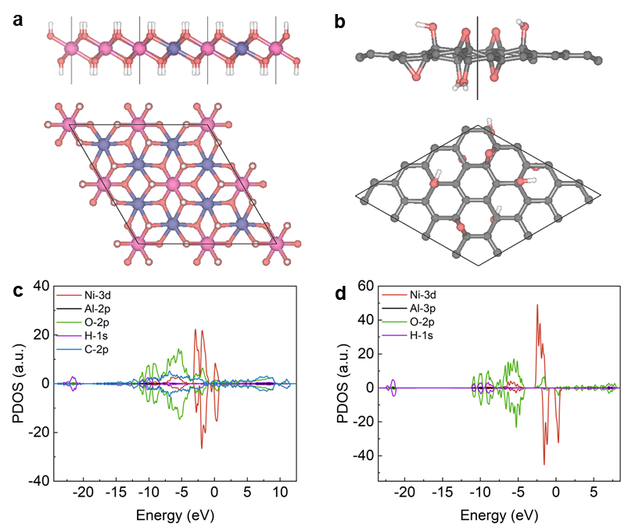
Figure S10. (a) The monolayer structure of NiAl-LDH. (b) GO model.
PDOS of (c) LDHs@GO and (d) NiAl-LDH.

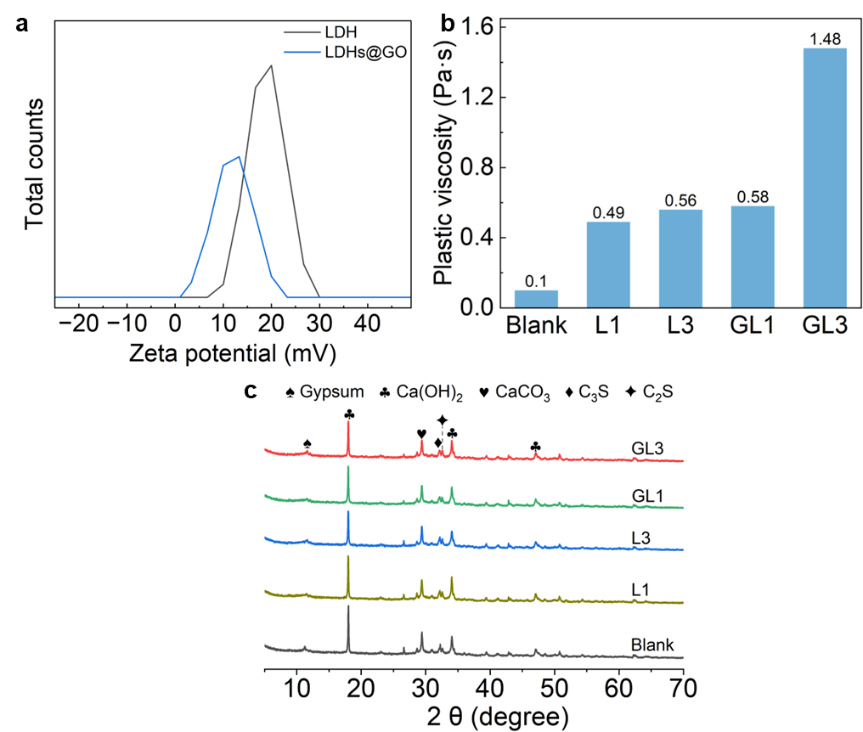
Figure S11. (a) Zeta potential of LDHs@GO and LDHs. (b) Plastic viscosity of various cementitious composites. (c) XRD patterns of cementitious composites at 28 days.

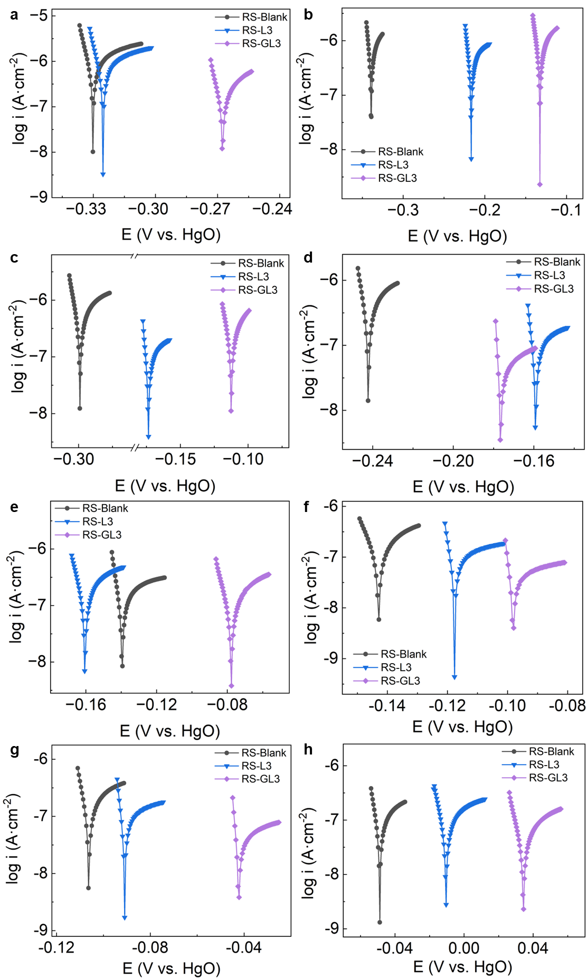
Figure S12. Polarization curves of SW-mixed reinforced cementitious composites at the age of (a) 1 d, (b) 14 d, (c) 56 d, (d) 90 d, (e) 180 d, (f) 300d, (g) 360 d and (h) 500 d.

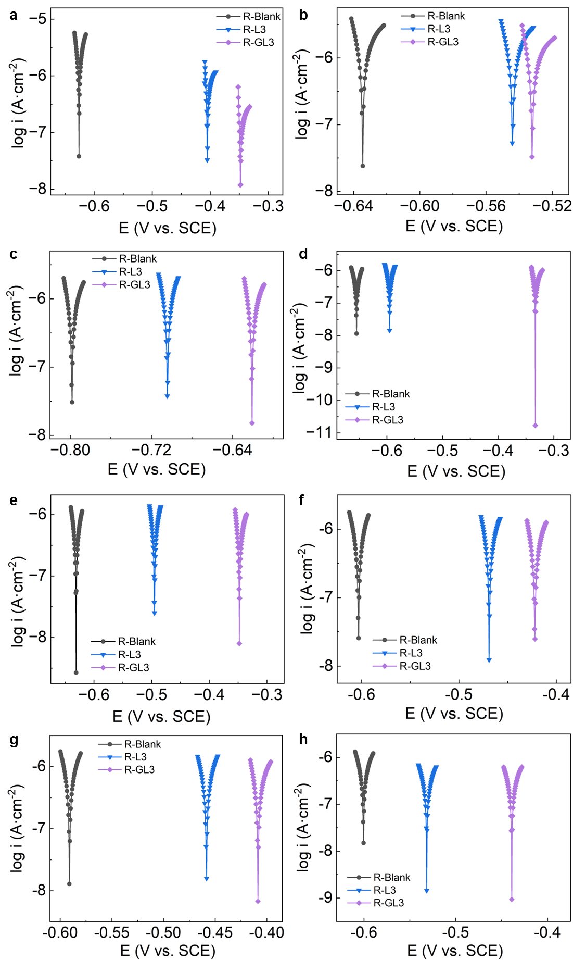
Figure S13. Polarization curves of NaCl-immersed reinforced cementitious composites at the age of (a) 1 d, (b) 14 d, (c) 56 d, (d) 90 d, (e) 180 d, (f) 300d, (g) 350 d and (h) 500 d.

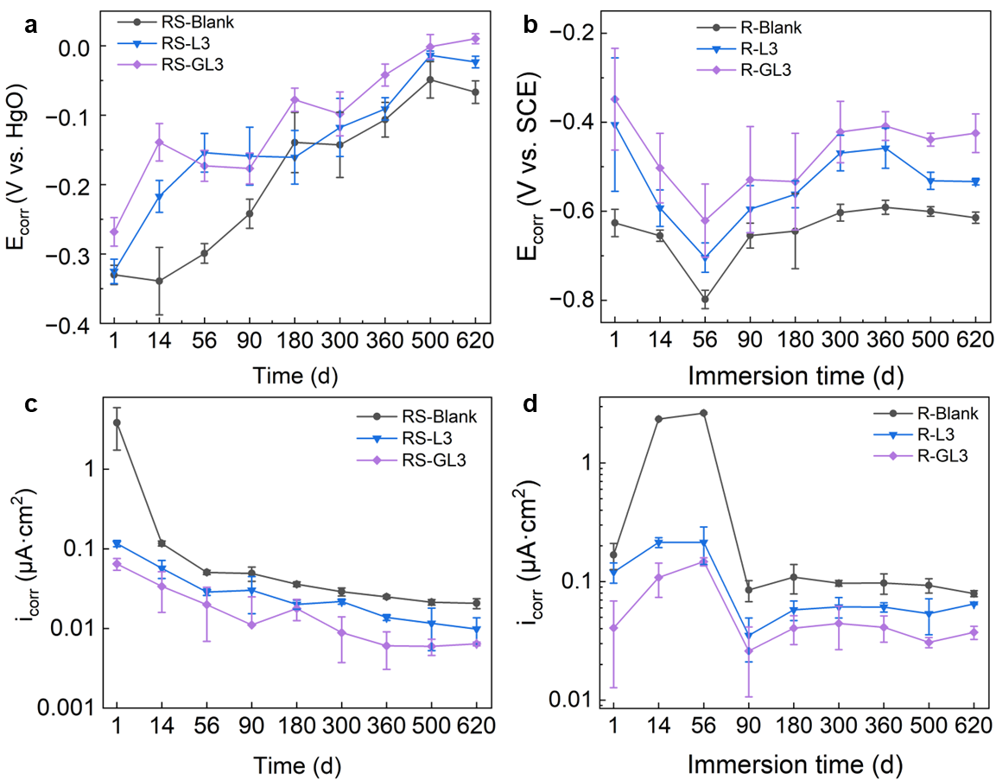
Figure S14. Evolution of E_{corr} of (a) SW-mixed reinforced cementitious composites and (b) NaCl-immersed reinforced cementitious composites. Evolution of i_{corr} of (c) SW-mixed reinforced cementitious composites and (d) NaCl-immersed reinforced cementitious composites.

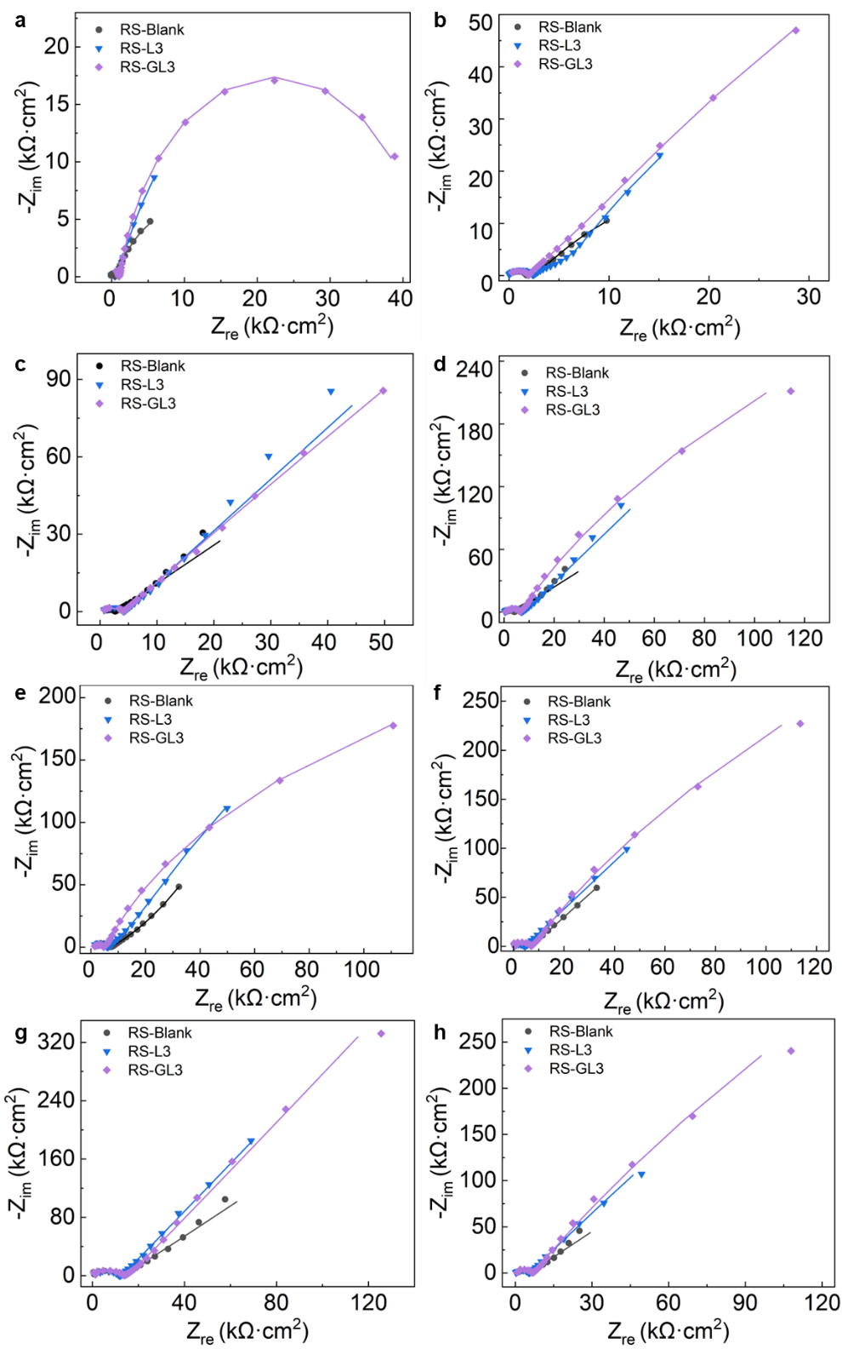
Figure S15. Nyquist plots of SW-mixed reinforced cementitious composites at the age of (a) 1 d, (b) 14 d, (c) 56 d, (d) 90 d, (e) 180 d, (f) 300d, (g) 360 d and (h) 500 d (The solid line represents the fitting results).

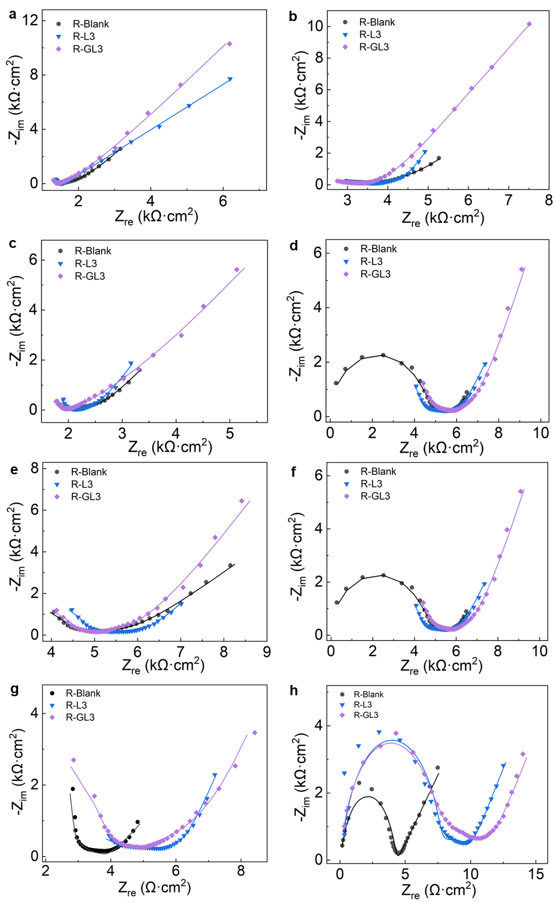
Figure S16. Nyquist plots of NaCl-immersed reinforced cementitious composites at the age of (a) 1 d, (b) 14 d, (c) 56 d, (d) 90 d, (e) 180 d (f) 300d, (g) 360 d and (h) 500 d (The solid line represents the fitting results).

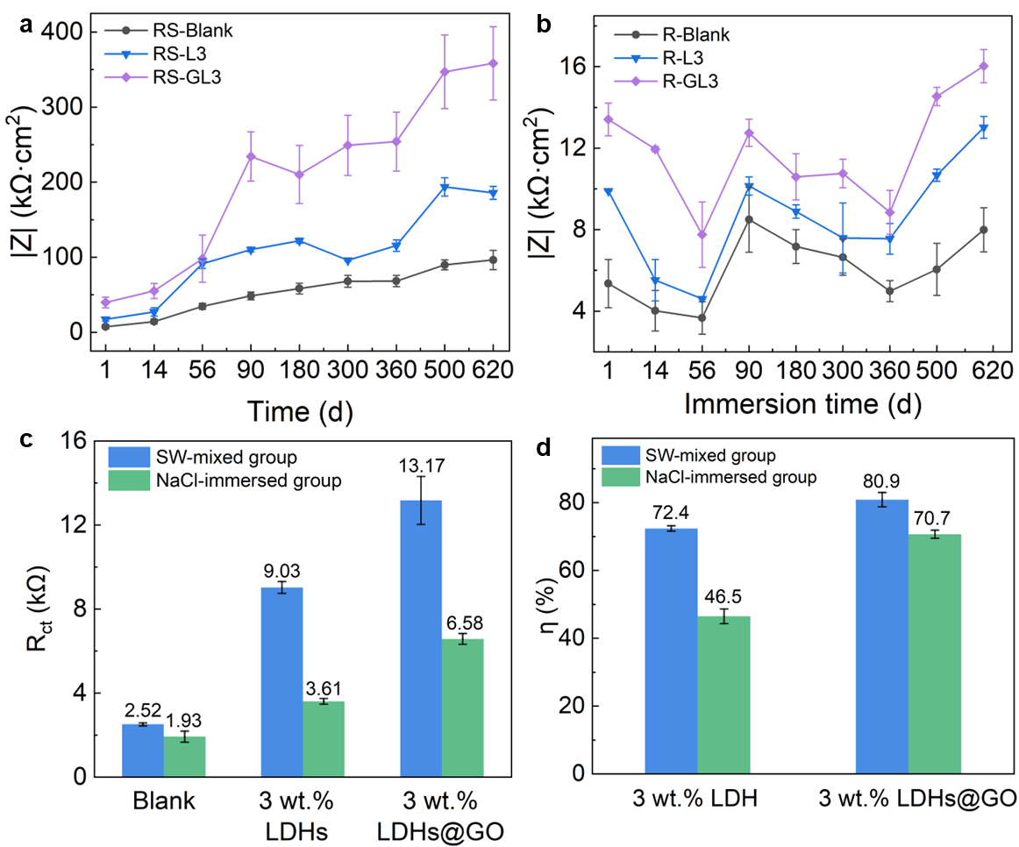
Figure S17. The evolution of fitted impedance modulus (|Z|) of (a) SW-mixed reinforced cementitious composites and (b) NaCl-immersed reinforced cementitious composites. (c) The fitted R_{ct} and (d) calculated η of SW-mixed reinforced cementitious composites and NaCl-immersed reinforced cementitious composites at 620 d.

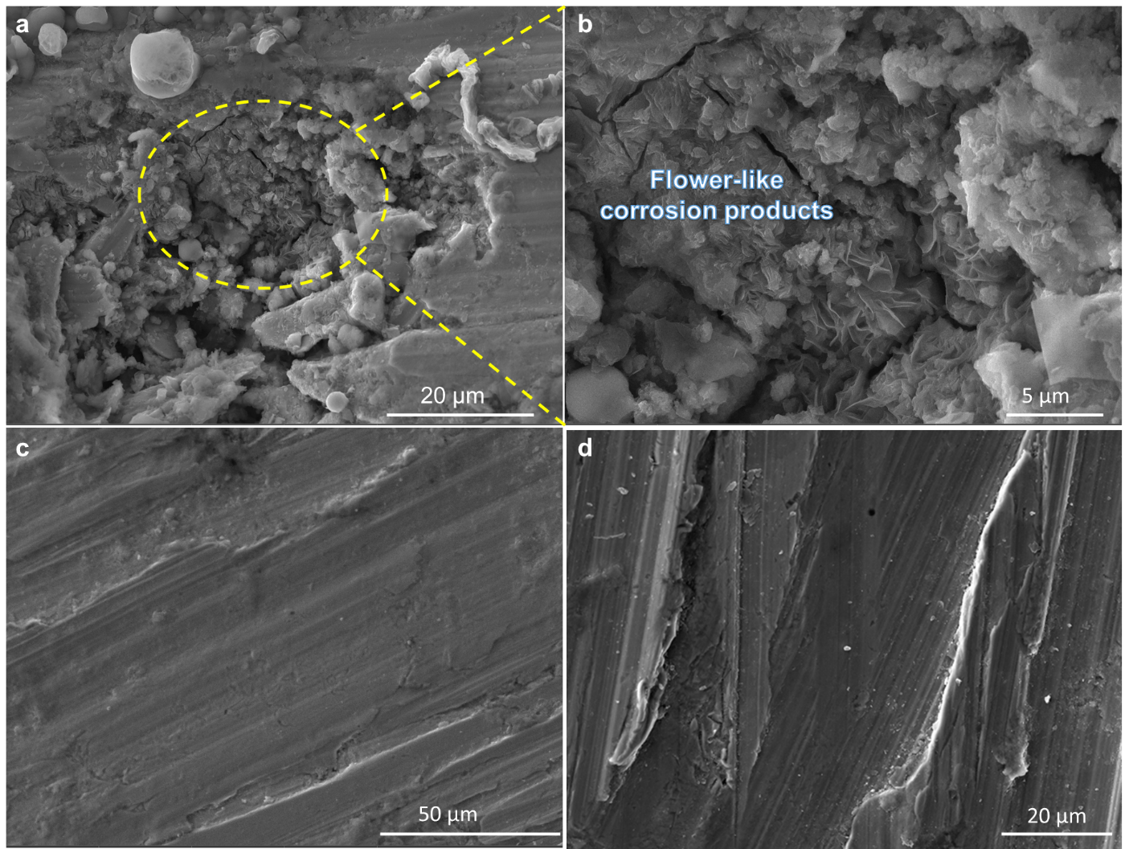
Figure S18. Surface microscopic morphology of steel bar in (a, b) R-Blank and (c, d) R-GL3.

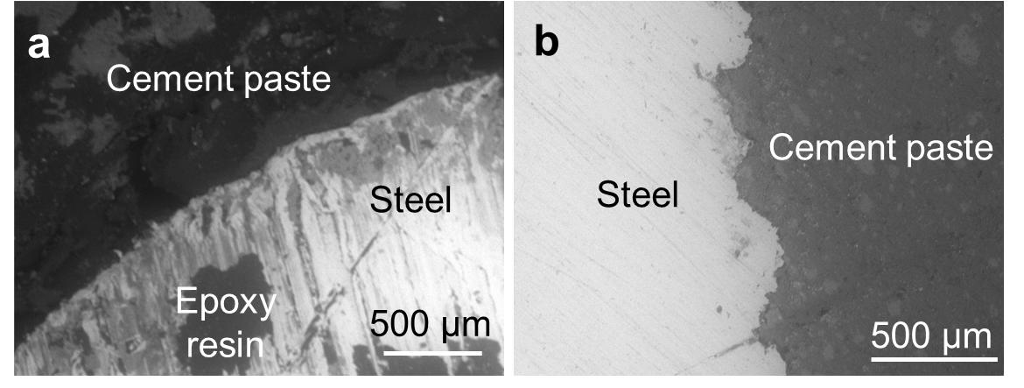
Figure S19. Cross-sectional corrosion morphology of (a) R-Blank and (b) R-GL3.

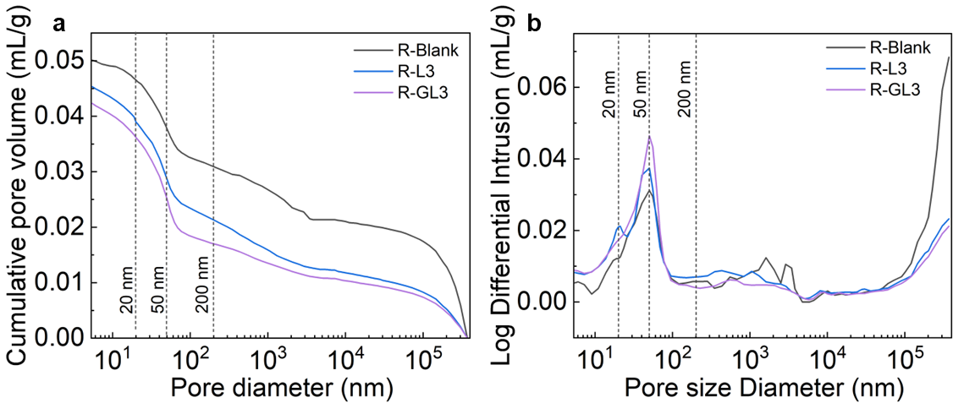
Figure S20. (a) Cumulative pore volume curves and (b) pore size distribution curves of NaCl-immersed reinforced cementitious composites.

Supplementary Tables

Table S1 Factors and levels of orthogonal experiment
Levels | Factor 1 | Factor 2 | Factor 3
Levels | Temperature (℃) | Time (h) | U/(Ni+Al) *
Level 1 | 100 | 24 | 5
Level 2 | 100 | 48 | 10
Level 3 | 100 | 72 | 15
* Molar ratio of urea to Ni(NO₃)₂· 6H₂O and Al(NO₃)₃·9H₂O.

Table S2 Orthogonal experiment for NiAl-LDHs
Label | Temperature (℃) | Time (h) | U/(Ni+Al)
L1 | 100 | 24 | 5
L2 | 100 | 48 | 15
L3 | 100 | 72 | 10
L4 | 120 | 24 | 15
L5 | 120 | 48 | 10
L6 | 120 | 72 | 5
L7 | 140 | 24 | 10
L8 | 140 | 48 | 5
L9 | 140 | 72 | 15

Table S3 Range analysis based on chloride adsorption capacity for orthogonal experiment
Factor  Level | Temperature (℃) | Time (h) | U/(Ni+Al)
k_{1j} | 1104.65 | 1036.83 | 1099.00
k_{2j} | 1067.60 | 1018.62 | 1004.17
k_{3j} | 938.23 | 1055.04 | 1007.31
K_{1j}= k_{1j}/3 | 368.22 | 345.61 | 366.33
K_{2j}= k_{2j}/3 | 355.87 | 339.54 | 334.72
K_{3j}= k_{3j}/3 | 312.74 | 351.68 | 335.77
R_{j} | 55.47 | 12.14 | 31.61
k_{1j} represents the sum of factor j (j=1, 2, 3) at level 1. K_{1j} is average of k_{1j}. R_{j} is the corresponding range value for factor j, which is the largest K_{ij} minus the smallest K_{ij}.

Table S4 SSA, pore volume and crystal structural parameters, for NiAl-LDHs achieved from orthogonal experiment
Label | SSA (m²/g) | Pore volume (cm³/g) | Crystallinity (%) | Average crystallite size (nm)
L1 | 67.50 | 0.1022 | 74.4 | 11.2
L2 | 57.70 | 0.0849 | 82.1 | 13.7
L3 | 59.35 | 0.0877 | 74.5 | 12.8
L4 | 46.19 | 0.0783 | 83.4 | 14.7
L5 | 49.53 | 0.0812 | 84.5 | 13.2
L6 | 48.72 | 0.0824 | 77.3 | 15.2
L7 | 44.49 | 0.0713 | 85.5 | 13.4
L8 | 39.42 | 0.0577 | 72.1 | 15.9
L9 | 54.69 | 0.0865 | 78.0 | 13.3

Table S5 Rietveld refinement results of LDHs and LDHs@GO
 | d₀₀₃ (Å) | a (Å) | b (Å) | c (Å)
LDHs | 7.63 | 3.03 | 3.03 | 22.89
LDHs@GO | 7.80 | 3.04 | 3.04 | 23.11

Table S6 SSA, pore volume and pore size of LDHs (L1) and LDHs@GO
Sample | GO content (vol.%) | SSA  (m²/g) | Pore volume (cm³/g) | Average pore size (nm)
L1 | 0 | 67.50 | 0.1022 | 6.68
2.5GL | 2.5 | 75.51 | 0.0937 | 6.02
5GL | 5 | 82.93 | 0.1143 | 5.87
7.5GL | 7.5 | 86.06 | 0.1156 | 5.81
10GL | 10 | 92.65 | 0.1478 | 5.68

Table S7 Particle size of LDHs and LDHs@GO
Sample | D₁₀ (μm) | D₅₀ (μm) | D₉₀ (μm) | D₉₉ (μm)
LDHs | 1.38 | 4.08 | 34.93 | 57.86
LDHs@GO | 3.15 | 11.02 | 33.84 | 58.68

Table S8 Langmuir and Freundlich parameters for the chloride adsorption isotherm of LDHs@GO and LDHs in SCPs
Model | Langmuir |  |  | Freundlich
Filler type | Q (mg/g) | K_{L} (L/mg) | R² | K_{F} | n | R²
LDHs | 267.9 | 1.66 | 0.971 | 171.6 | 0.58 | 0.991
LDHs@GO | 517.9 | 1.46 | 0.943 | 313.0 | 0.59 | 0.977

Table S9 Kinetic parameters for the pseudo-first-order and pseudo-second-order models for chloride adsorption of LDHs@GO and LDHs
Model |  | Pseudo-first-order |  | Pseudo-second-order
Solution type | Filler type | K₁ (h⁻¹) | R² | K₂ (g·mg⁻¹·h⁻¹) | R²
SCPs | LDHs | 0.000041 | 0.939 | 0.0181 | 0.950
SCPs | LDHs@GO | 0.0028 | 0.877 | 0.0357 | 0.881
SW | LDHs | 0.559 | 0.529 | 0.0028 | 0.954
SW | LDHs@GO | 0.686 | 0.533 | 0.0026 | 0.960

Table S10 Binding energy and content of LDHs@GO and LDHs before and after immersion in SCPs
 | LDHs |  | LDHs@GO |  | SCP-LDHs |  | SCP-LDHs@GO
 | Binding energy (eV) | Content (%) | Binding energy (eV) | Content  (%) | Binding energy  (eV) | Content  (%) | Binding energy (eV) | Content (%)
C-C/C=C | 284.78 | 69.7 | 284.74 | 71.9 | 284.84 | 70.0 | 284.76 | 72.4
C-O | 286.15 | 18.7 | 286.24 | 17.9 | 286.41 | 13.4 | 286.17 | 15.8
O-C=O | 288.79 | 11.6 | 288.74 | 10.2 | 288.70 | 16.6 | 288.78 | 11.8
Ni-O | 531.94 | 87.1 | 531.84 | 85.3 | 531.51 | 93.1 | 531.64 | 85.4
Al-O | 533.54 | 12.9 | 533.54 | 14.7 | 533.41 | 6.9 | 533.35 | 14.6

Table S11 Binding energy and content of LDHs@GO and LDHs after immersion in SW
 | SW-LDHs |  | SW-LDHs@GO
 | Binding energy  (eV) | Content  (%) | Binding energy (eV) | Content  (%)
C-C/C=C | 284.70 | 64.8 | 284.87 | 71.1
C-O | 286.08 | 14.9 | 286.32 | 15.7
O-C=O | 288.45 | 20.3 | 288.69 | 13.2
Ni-O | 531.42 | 90.2 | 531.57 | 83.4
Al-O | 533.46 | 9.8 | 533.18 | 16.6

Table S12 The optimized lattice parameters of NiAl-LDH, GO, and monolayer LDHs@GO structures
Type | α (°) | β (°) | γ (°) | a (Å) | b (Å) | Interlayer spacing (Å)
Monolayer LDH | 90.00 | 90.00 | 120.00 | 10.75 | 10.75 | /
Double-layered LDH (003) surface | 90.00 | 90.00 | 120.00 | 10.84 | 10.83 | 7.72
GO | 90.00 | 90.00 | 120.00 | 9.98 | 9.98 | /
GO/double-layered LDH (003) surface | 90.00 | 90.00 | 120.00 | 10.23 | 10.25 | 8.05
GO/monolayer LDH | 90.00 | 90.00 | 120.00 | 10.15 | 10.19 | /

Table S13 Langmuir parameters for the chloride adsorption isotherm of cementitious composites in SCPs
Label | Q (mg/g) | K_{L} (L/mg) | R²
Blank | 45.3 | 0.97 | 0.994
L1 | 45.4 | 1.11 | 0.992
L3 | 64.9 | 0.71 | 0.984
GL1 | 69.7 | 0.69 | 0.994
GL3 | 76.1 | 0.59 | 0.988

Table S14 Comparison of EIS parameters in this paper and reported results
Matrix | Filler | Solution | Time | ECM | R_{f} (Ω) | R_{ct} (Ω) | Ref
Paste | LDHs@GO | 3.5 wt.% NaCl solution | 620 d | (QR)(QR)(Q(RW)) | 3.48E3 | 6.58E3 | This work
Paste | LDHs@GO | Seawater | 620 d | (QR)(QR)(QR) | 5.63E3 | 1.32E4 | This work
Mortar | MgAl-pAB LDH | 3.5 wt.% NaCl solution | 60 W/D*¹ | R(QR)(QR)(QR) | 4.54E3 | 5.32E4 | Jiang et al.[25]
Mortar | LDHs-PVP | Simulated Seawater | 70 d | R(QR)(QR)(QR) | - | 3.85E5 | Yang et al.[4]
Mortar | VB3-LDH | Deionized water | 60 d | R(QR)(QR) | 0.62E3 | 2.52E4 | Yang et al.[5]
Mortar | MgAl-NO₂ LDH | 3.5 wt.% NaCl solution | 12 W/D*² | (CR(CR))(QR)(QR) | 1.27E3 | 2.65E6 | Cao et al.[19]
Mortar | ZnAl-NO₃ LDH | 3.5 wt.% NaCl solution | 72 d | R(Q(R(QR))) | 1.54E4 | 1.12E6 | Gomes et al.[6]
Mortar | ZnAl-NO₂ LDH | 3.5 wt.% NaCl solution | 64 d | R(Q(R(QR))) | 1.52E4 | 1.79E5 | Gomes et al.[6]
Note that R_{f} represents interfacial film (such as the passive film, corrosion products or the mixture of them) resistance between cementitious matrix and steel surface, while R_{ct} means transfer charge resistance. pAB and PVP denote p-aminobenzoic acid and polyvinylpyrrolidone, respectively; W/D means wet-dry cycles, 1-immersion for 16 h and dry for 8 h, 2- immersion for 5 d and dry for 5 d.

Table S15 MIP results for NaCl-immersed reinforced cementitious composites
Label | Porosity  (%) | Total pore volume  (mL/g) | Average pore diameter (nm) | Median pore diameter of volume (nm) | Median pore diameter of area (nm)
R-Blank | 10.659 | 0.0504 | 72.39 | 156.30 | 22.28
R-L3 | 9.983 | 0.0453 | 45.50 | 127.39 | 17.56
R-GL3 | 9.321 | 0.0423 | 41.09 | 61.24 | 17.52

Table S16 Chemical compositions of SW determined by IC (in g/L)
Ion | Cl⁻ | SO₄²⁻ | Br⁻ | NO₃⁻ | NO₂⁻ | PO₄³⁻ | Na⁺ | Mg²⁺ | K⁺ | Ca²⁺
Concentration | 17.7812 | 1.7438 | 0.0617 | 0.0285 | 0.0000 | 0.0000 | 11.0738 | 1.2913 | 0.4329 | 0.4609

Table S17 Mix proportion of SW-mixed (reinforced) cementitious composites with LDHs@GO or LDHs.
Filler | Label 1 | Label 2 | Filler content* | Cement | SW* | Superplasticizer*
- | S-Blank | RS-Blank | 0 | 1 | 0.35 | 0.2%
LDHs | S-L1 |  | 1% | 1 | 0.35 | 0.2%
LDHs | S-L3 | RS-L3 | 3% | 1 | 0.35 | 0.2%
LDHs@GO | S-GL1 |  | 1% | 1 | 0.35 | 0.2%
LDHs@GO | S-GL3 | RS-GL3 | 3% | 1 | 0.35 | 0.2%
Label 1 represents SW-mixed cementitious composites, Label 2 represents SW-mixed reinforced cementitious composites. * by mass of cement.

Table S18 Mix proportions of (reinforced) cementitious composites with LDHs@GO or LDHs
Filler | Label 1 | Label 2 | Filler content* | Cement | Deionized water* | Superplasticizer*
- | Blank | R-Blank | 0 | 1 | 0.35 | 0.2%
LDHs | L1 |  | 1% | 1 | 0.35 | 0.2%
LDHs | L3 | R-L3 | 3% | 1 | 0.35 | 0.2%
LDHs@GO | GL1 |  | 1% | 1 | 0.35 | 0.2%
LDHs@GO | GL3 | R-GL3 | 3% | 1 | 0.35 | 0.2%
Label 1 represents cementitious composites without reinforced steel, Label 2 represents NaCl-immersed reinforced cementitious composites. * by mass of cement.

Supplementary References
[1] J. Liu, J. Song, H. Xiao, L. Zhang, Y. Qin, D. Liu, W. Hou, N. Du, Powder Technol. 2014, 253, 41.
[2] J. Zuo, B. Wu, B. Dong, C. Luo, J. Ma, G. Wei, Cem. Concr. Compos. 2023, 105306.
[3] H. Tang, J. Qian, J. Qin, Z. Li, X. Jia, Y. Yue, F. Dai, Cem. Concr. Res. 2023, 169, 107167.
[4] L. Yang, M. Chen, C. Liang, L. Lu, P. Zhao, F. Wu, J. Xu, Y. Huang, Appl. Clay Sci. 2022, 216,106385.
[5] H. Yang, C. Xiong, X. Liu, T. Li, Y. Zhang, S.P. Shah, W. Li, Int. J. Electrochem. Sci. 2021, 16(3), 210362.
[6] C. Gomes, Z. Mir, R. Sampaio, A. Bastos, J. Tedim, F. Maia, C. Rocha, M. Ferreira, Materials, 2020, 13(7), 1769.

