Supporting Information

Janus graphene-Al₂O₃: aramid hybrid fabric for multifunctional passive cooling and flame retardancy
Gang Huang¹, Shenghui Li¹, Xiaohua Li¹, Zhenhong Zhao¹, Zhengrong Li^{1,}*, Yangling Li¹, Jing Zhao^{1,}*
¹College of Textile Science and Engineering, Wuyi University, Jiangmen 529020, China.

*Correspoinding authors. E-mails: lizhengrongwu@163.com; jingzhaoedu@126.com.

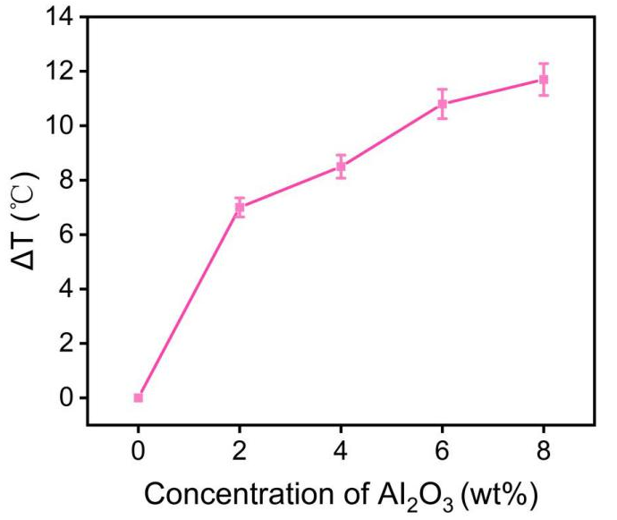
Fig. S1 Relationship between the Al₂O₃ concentration and the resulting temperature difference (ΔT) measured under steady-state lighting conditions, comparing the treated fabrics with the untreated (pristine) fabric.

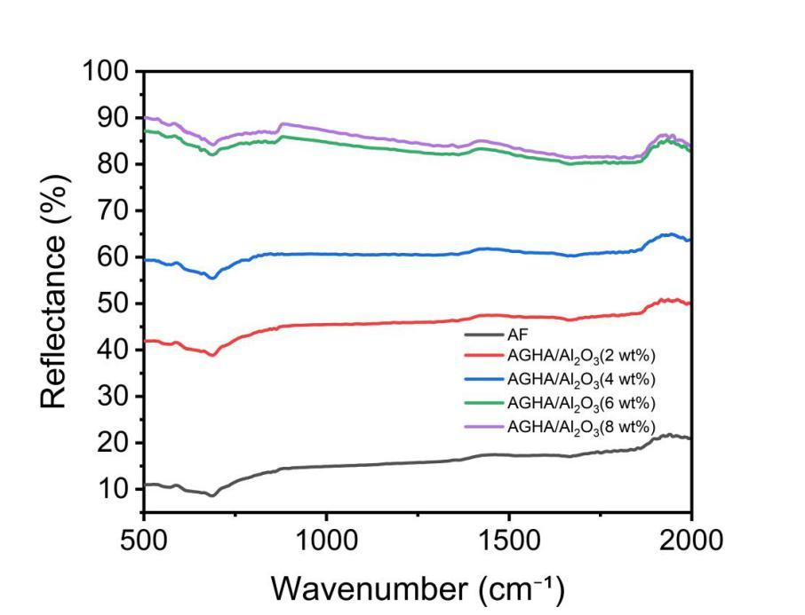

Fig. S2 Solar reflectance performance of AGHA/Al₂O₃ at various Al₂O₃ concentrations.

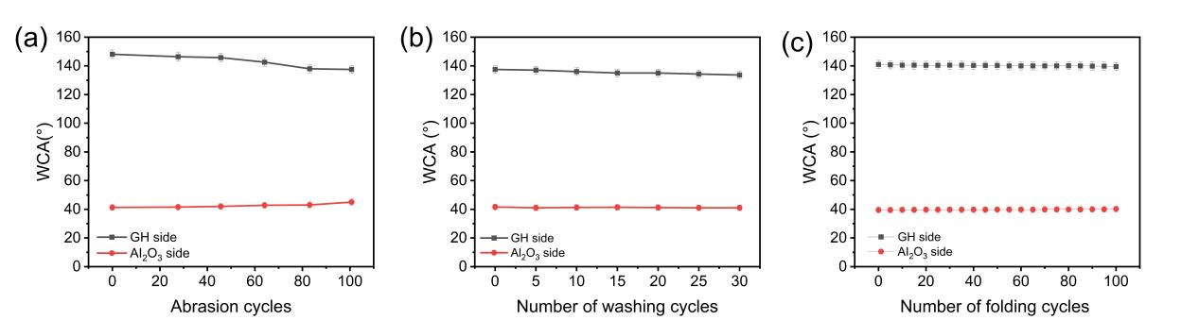
Fig. S3 (a) Water contact angles (WCAs) of the GH and Al₂O₃ sides after up to 100 abrasion cycles; (b) WCAs of the GH and Al₂O₃ sides after up to 30 washing cycles; and (c) WCAs of the GH and Al₂O₃ sides after up to 100 folding cycles.

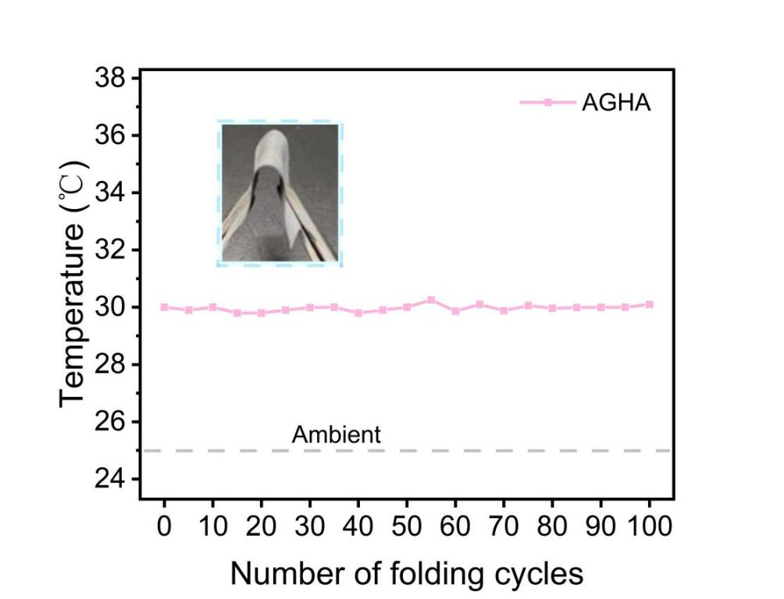
Fig. S4 Temperature changes of the AGHA after 100 folding cycles.

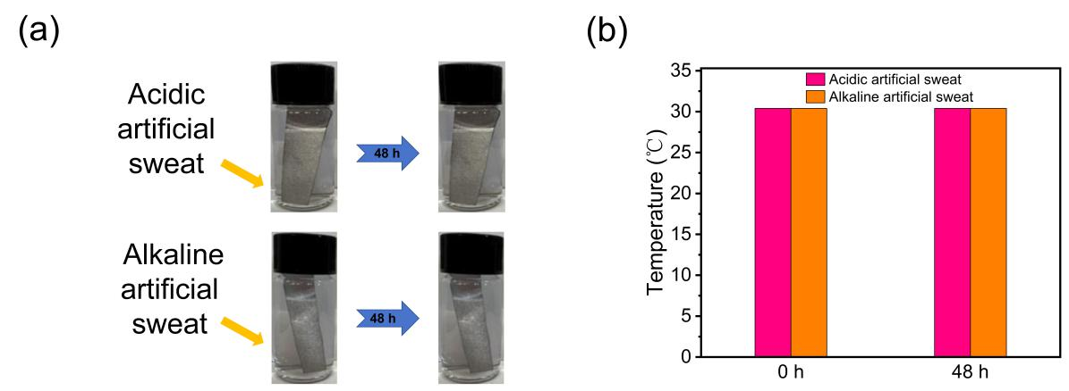
Fig. S5 (a) Static immersion tests of AGHA in acidic and alkaline artificial sweat at room temperature. (b) Temperature changes of the AGHA after soaking in acidic and alkaline artificial sweat for 48 h.

Table S1. Comparison of comprehensive properties of AGHA fabric and other materials reported in the literature.
Material or structure | Substrate | Cooling performance (ΔT, °C) | directional water transport capacities (R,%) | Flame retardancy
AGHA fabric  (This work) | aramid | 10.6 | 1090.20 | Yes
SF [1] | silk | 5.6 | 809.43 | No
G/P-C fabric [2] | cotton | 3.2 | 1270.11 | No
PAN/TP [3] | PAN | 3.7 | 696.63 | No
Janus RSF [4] | SF | 9.0 | 1028.93 | No
PLA-JFM [5] | membrane | 5.8 | 708 | No
SEBS-SEBS/F127/  Al₂O₃ [6] | spandex | 6.5 | 920 | No
RCUM-Textile [7] | membrane | 8.7 | 985 | No
BAWCM textile [8] | TPU | 9.3 | 523 | No
CAHNN/cotton/WFP textile [9] | PU/PAN | 4.2 | 1140 | No
NPs/NADES@PAAm/  PVA [10] | PAAm/PVA | 7.2 | 458 | No
TiO₂-PLA [11] | PLA | 3.4 | 572 | No

Table S2. Weight parameters of the pristine and coated fabrics.
Sample | W(g) | W−W₀(g) | (W−W₀)/W₀(%)
AF | 4.74±0.03 | 0 | 0
GHA | 5.25±0.01 | 0.51±0.01 | 10.8±1.1
AGHA | 5.45±0.02 | 0.71±0.02 | 14.9±0.7

References
- Li Z, Wu L, Jian C, Liu Y (2025) Durable asymmetric silk fabric with rapid heat conduction, spectral selectivity and sweat transfer capabilities for effective personal thermal-moisture management. J Colloid Interface Sci 689:137203. https://doi.org/10.1016/j.jcis.2025.02.211
- Yuan S, Wang J, Mei J (2023) Fabric comprised of cotton impregnated with graphene oxide and coated with polystyrene for personal moisture and thermal management. ACS Appl Nano Mater 6(6):4499-4510. https://doi.org/10.1021/acsanm.2c05582
- Li Z, Yuan Y, Wu L (2025) Hierarchically engineered silk fibroin nanotextiles with spectral selectivity and asymmetric nanostructure for sustainable personal thermal-wet regulation. Adv Fiber Mater 7(5):1475-1494. https://doi.org/10.1007/s42765-025-00563-4
- Zheng R, Wang M, Jiang M (2024) Dynamic spectral metafabric with unidirectional moisture transport property for personal thermal management. ACS Appl Mater Interfaces 16(28):36973-36982. https://doi.org/10.1021/acsami.4c06170
- Yang P, Ju Y, He J, Xia Z, Chen L, Tang S (2024) Advanced Janus membrane with directional sweat transport and integrated passive cooling for personal thermal and moisture management. Adv Fiber Mater 1-12. https://doi.org/10.1007/s42765-024-00444-2
- Fan C, Zhang Y, Long Z, Mensah A, Wang Q, Lv P, Wei Q (2023) Dynamically tunable subambient daytime radiative cooling metafabric with Janus wettability. Adv Funct Mater 33(29), 2300794. https://doi.org/10.1002/adfm.202300794
- Yang X, Qu W, Tong W, Zhang B (2025) Multifunctional cooling textiles with enhanced radiative and moisture management by one-step phase separation. ACS Appl Mater Interfaces 17(21), 31442-31453. https://doi.org/10.1021/acsami.5c04369
- Gu B, Fan F, Xu Q, Shou D, Zhao D (2023) A nano-structured bilayer asymmetric wettability textile for efficient personal thermal and moisture management in high-temperature environments. Chem Eng J 461, 141919. https://doi.org/10.1016/j.cej.2023.141919
- Miao D, Cheng N, Wang X, Yu J, Ding B (2022) Sandwich-structured textiles with hierarchically nanofibrous network and Janus wettability for outdoor personal thermal and moisture management. Chem Eng J 450, 138012. https://doi.org/10.1016/j.cej.2022.138012
- Xu L, Sun D-W, Tian Y, Sun L, Fan T, Zhu Z (2022) Combined effects of radiative and evaporative cooling on fruit preservation under solar radiation: sunburn resistance and temperature stabilization. ACS Appl Mater Interfaces 14(40), 45788-45799. https://doi.org/10.1021/acsami.2c11349
- Xue S, Huang G, Chen Q, Wang X, Fan J, Shou D (2024) Personal thermal management by radiative cooling and heating. Nano-Micro Lett 16(1), 153. https://doi.org/10.1007/s40820-024-01360-1

