Supporting Information

In Situ Grown Polypyrrole and PDMS Coatings Enable Superhydrophobic Silk Fabrics with Photothermal Antimicrobial Activity and High-Efficiency Electromagnetic Shielding
Tiancheng Wei,^{1,#} Li Xu,^{1,#}, Qichao Cheng,^{1, #} Jiangfeng Cai,¹ Jing Yu,¹ Qi Wu,¹ Quan Wan,¹ Jie Wang,¹ Zongpu Xu,¹ Yajun Shuai,¹ and Mingying Yang^{1,∗}

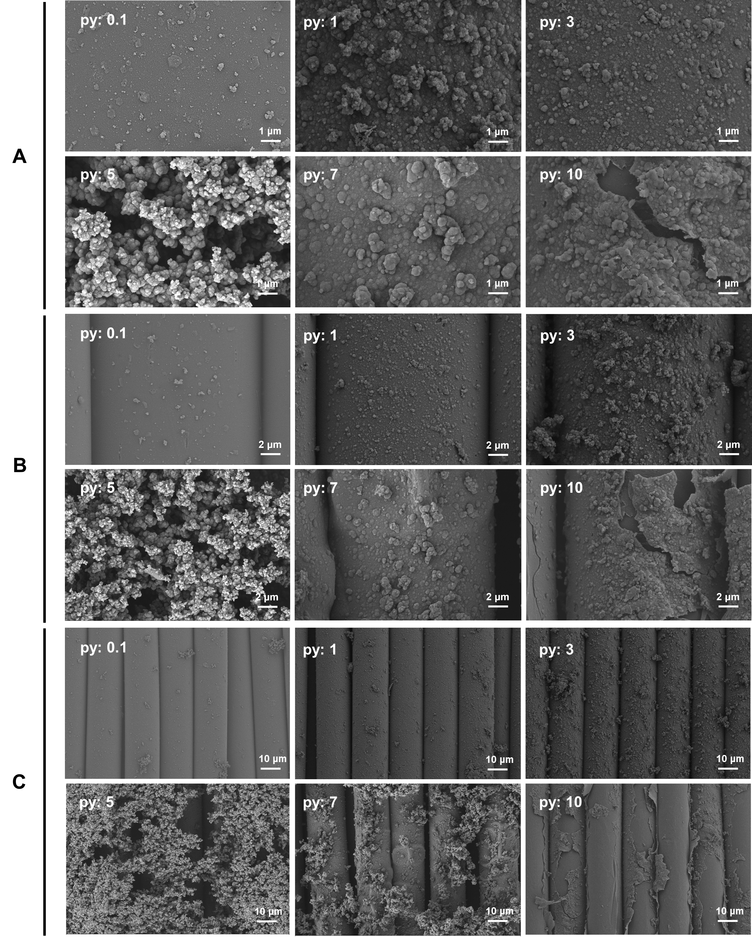
Figure S1. SEM images of Silk-PPy(0.1-10) with different Py addition ratios (0.1, 1, 3, 5, 7, 10 mmol per 50 mL system). (A) shows a two-fold magnification of (B), while (B) displays a five-fold magnification of (C). Ppy begins to delaminate when the Py amount increases to 7 mmol per 50 mL.

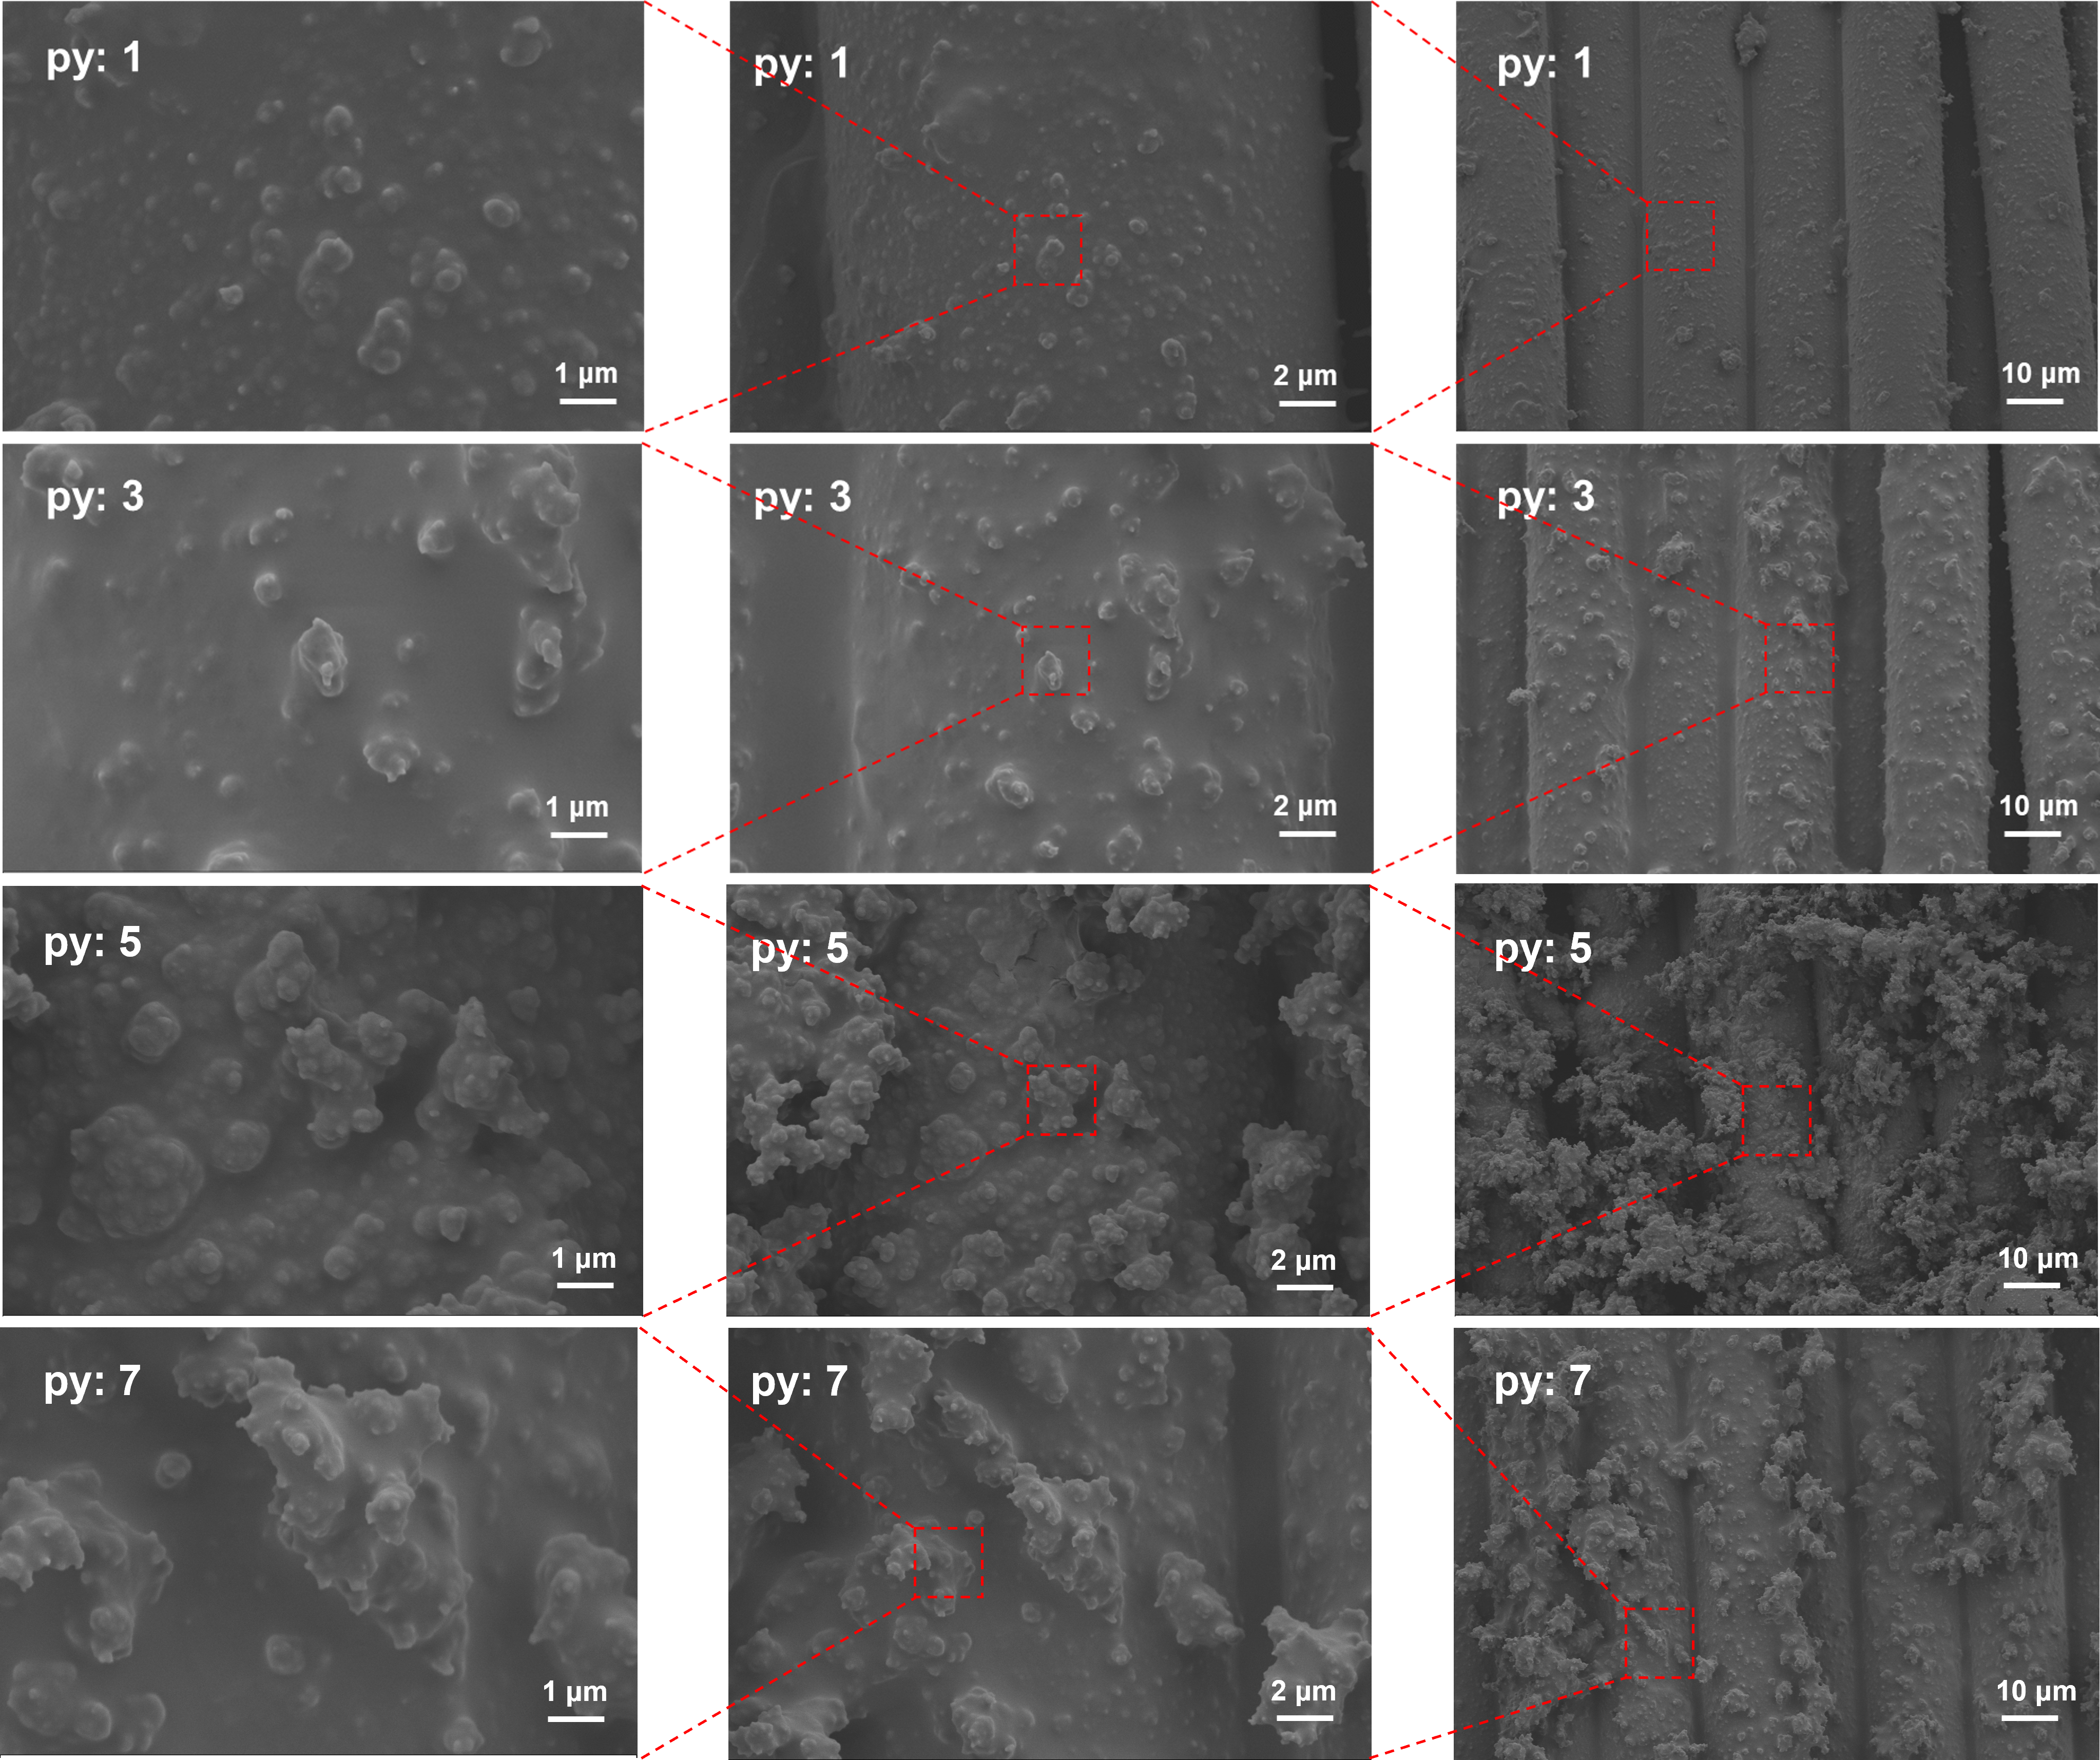
Figure S2. SEM images of Silk-P(1-7)-P with different pyrrole addition ratios (0.1, 1, 3, 5, and 7 mmol per 50 mL system).

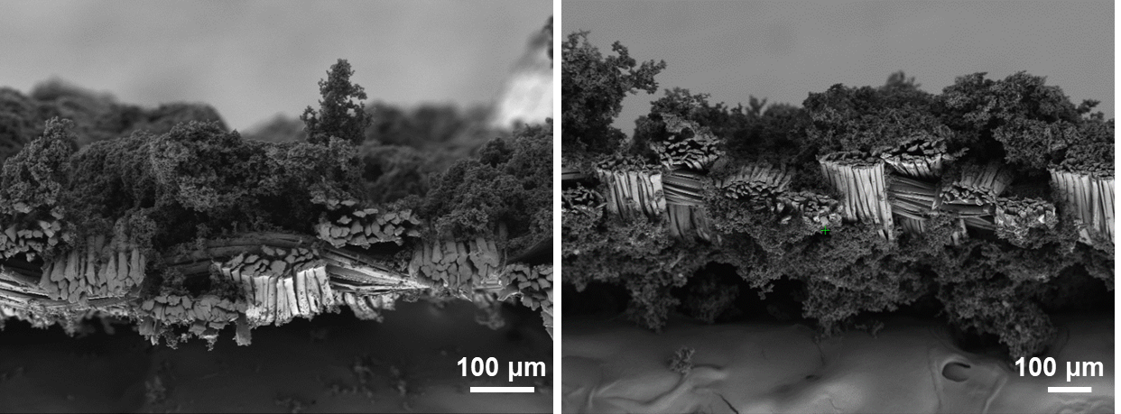
Figure S3. SEM image of the cross-section of Silk-P5.

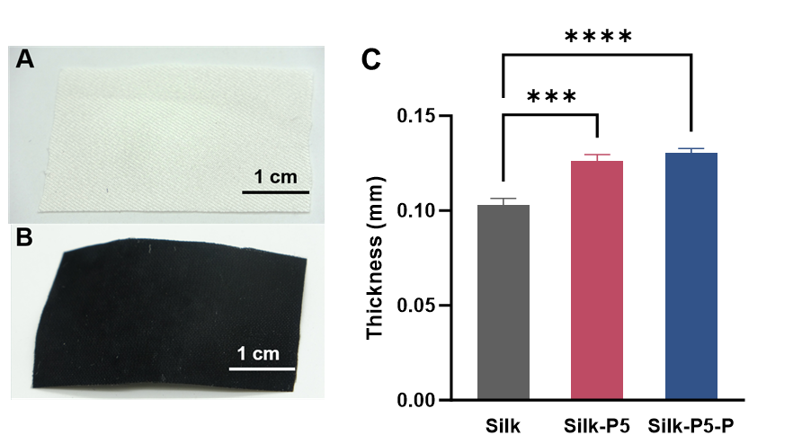
Figure S4. Photographs of the real products. (A) Silk fabric, (B) Silk-P5-P. (C) The thickness of the samples.

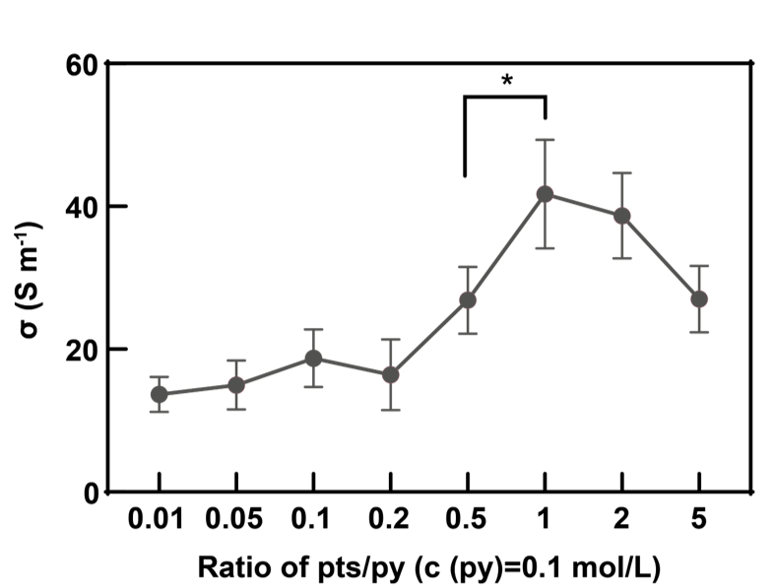
Figure S5. Effect of doping of different concentrations of PTS on the electrical conductivity of EMI fabrics

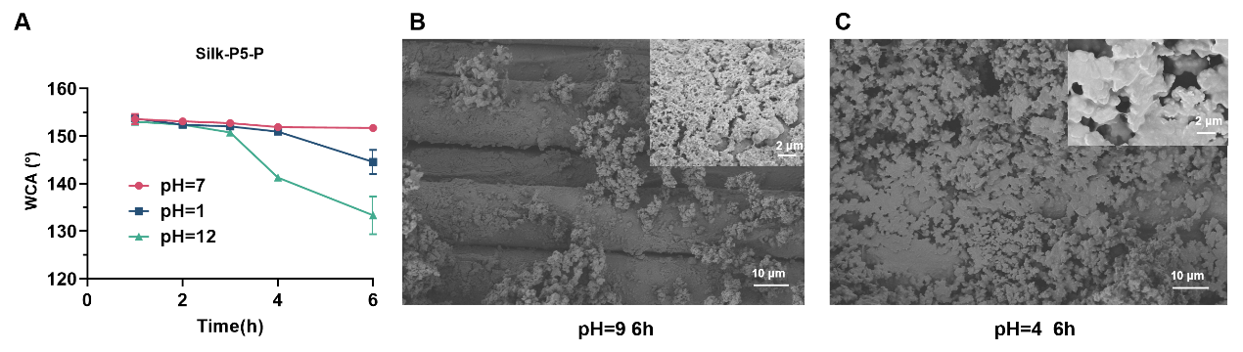
Figure S6. Chemical stability of Silk-P5-P. (A) Changes in WCA of Silk-P5-P in neutral (pH=7), strong acid (pH=1), and strong alkaline (pH=12) environments after continuous immersion for 6h. (B) SEM image of Silk-P5-P after continuous immersion for 6h in a weak alkaline (pH=9) environment, the inset is a magnified image. (C) SEM image of Silk-P5-P after continuous immersion for 6h in a weak acid (pH=4) environment, the inset is a magnified image.

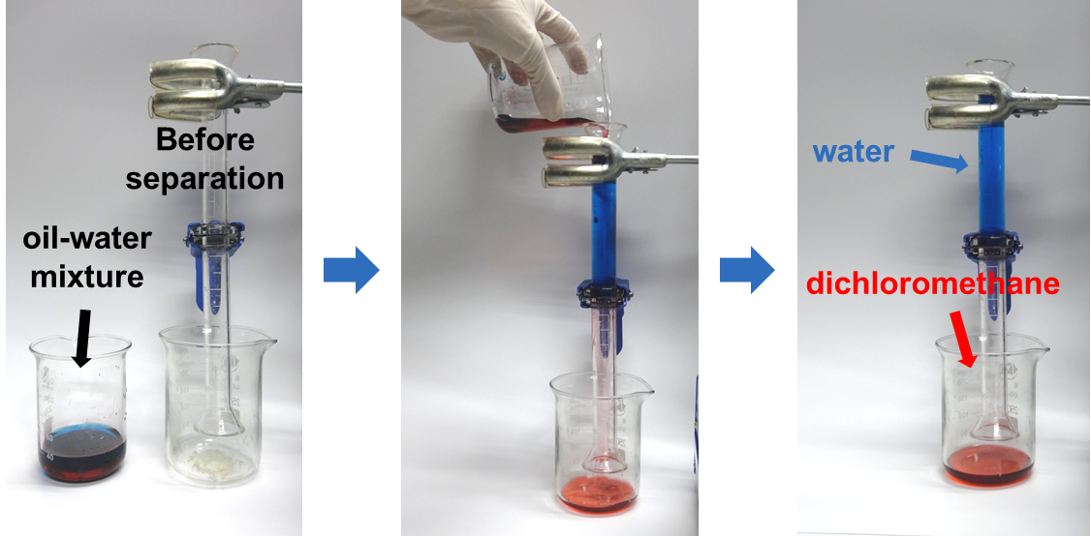
Figure S7. Photographs of Silk-P5-P used for oil-water separation. Water and methylene chloride were stained with methylene blue and Sudan III, respectively.

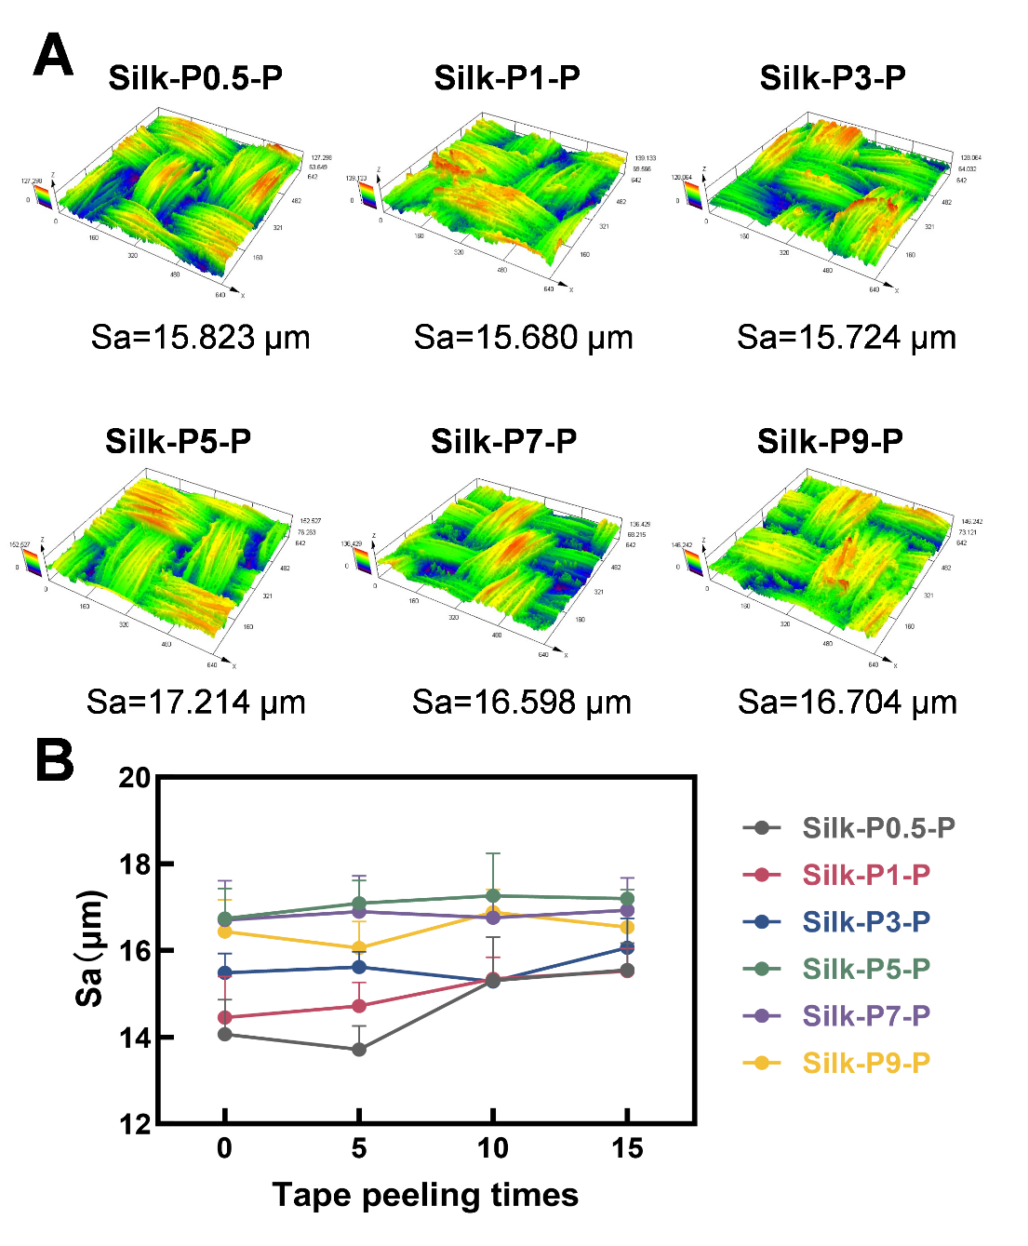
Figure S8. (A) Surface roughness changes in Silk-P(0.5-9)-P after15 times of tape peeling. (B) Sa changes in Silk-P(0.5-9)-P after 5, 10, 15 times of tape peeling.

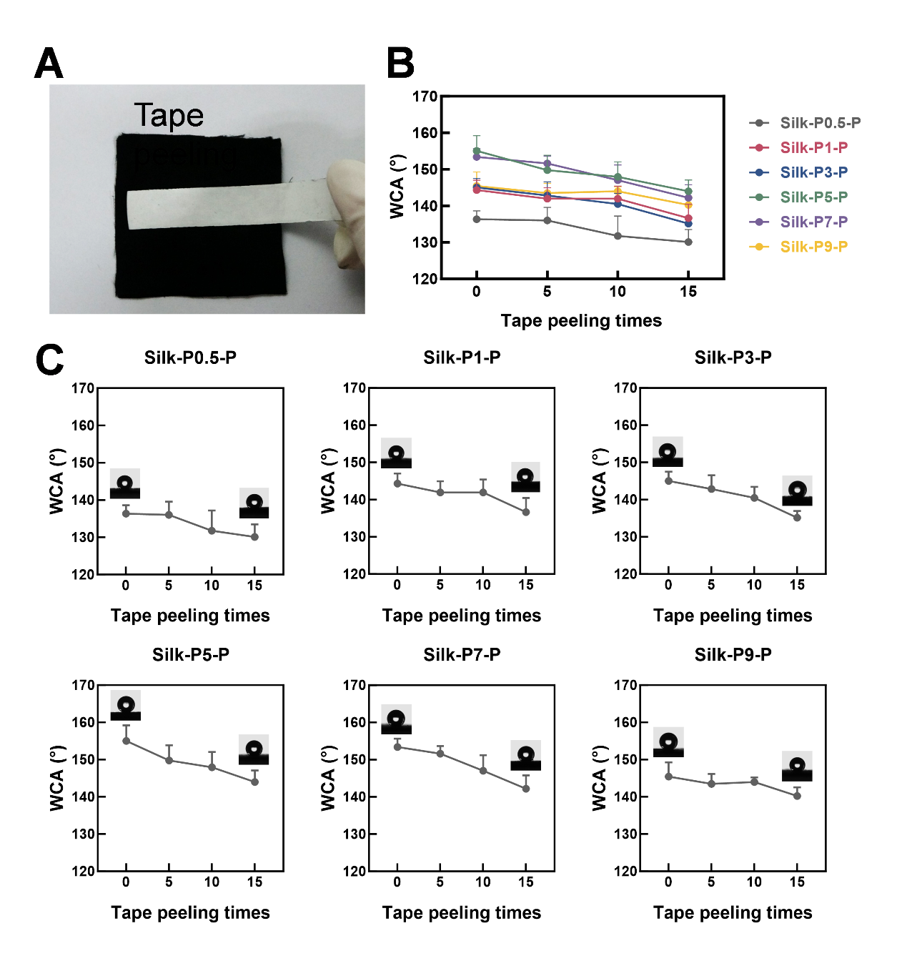
Figure S9. (A) Mechanical durability testing (tape-peeling) of Silk-P(0.5-9)-P. (B, C) WCA changes in Silk-P(0.5-9)-P after 5, 10, 15 times of tape peeling.

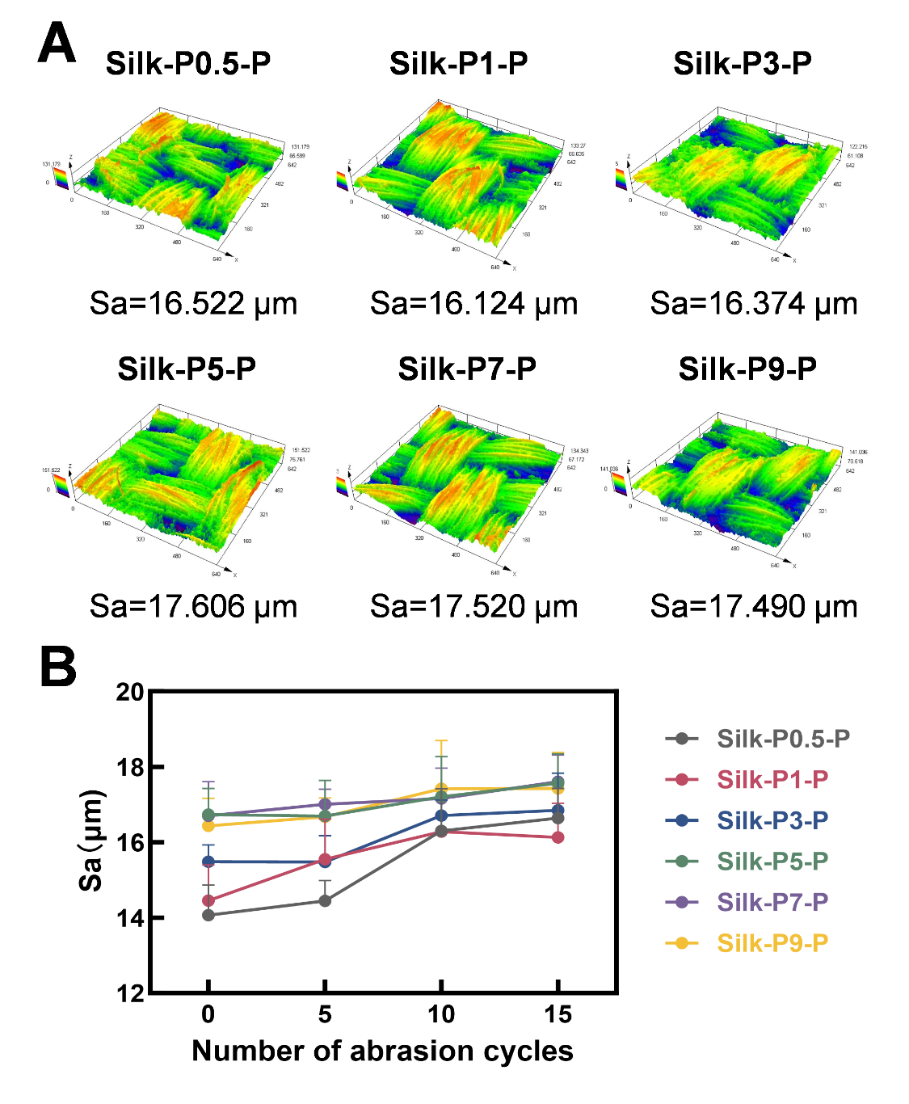
Figure S10. (A) Surface roughness changes in Silk-P(0.5-9)-P after 15 cycles of sandpaper abrasion. (B) Sa changes in Silk-P(0.5-9)-P after 5, 10, 15 cycles of sandpaper abrasion.

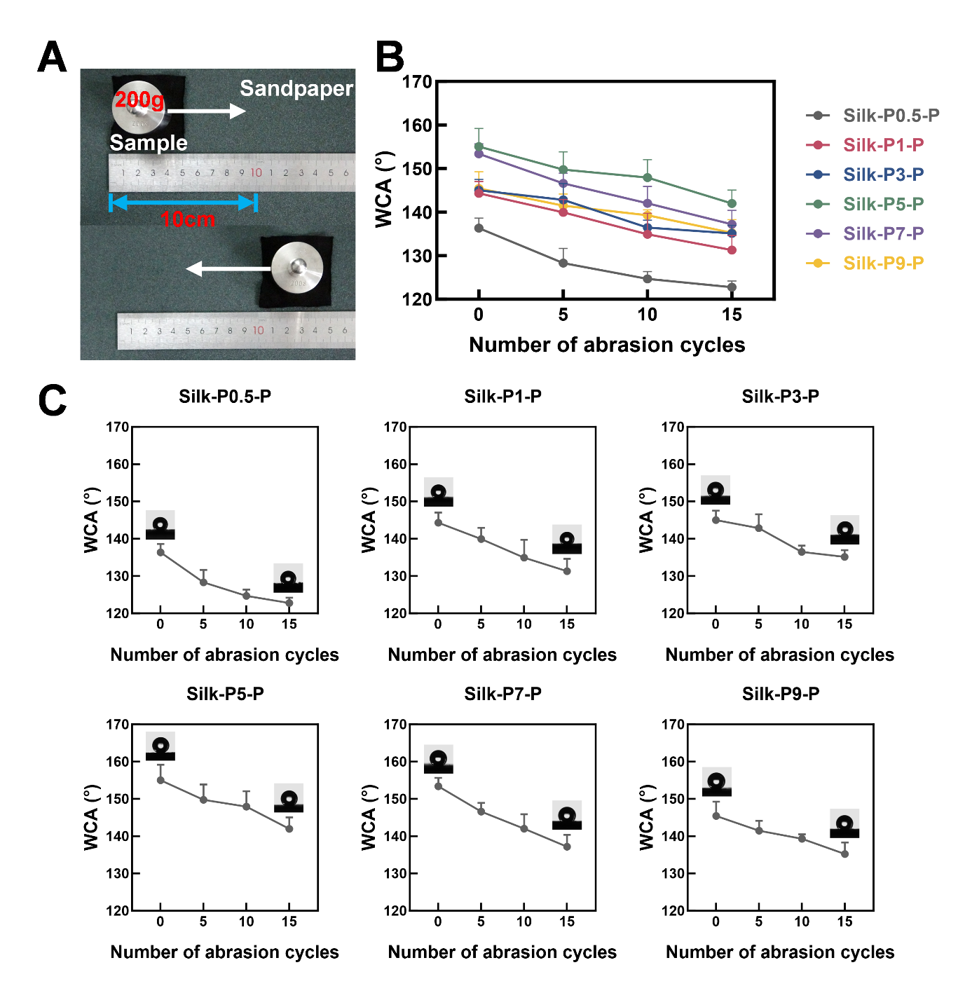
Figure S11. (A) Cycle photographs of Silk-P(0.5-9)-P sandpaper wear. (B, C) WCA changes in Silk-P(0.5-9)-P after 5, 10, 15 cycles of sandpaper abrasion.

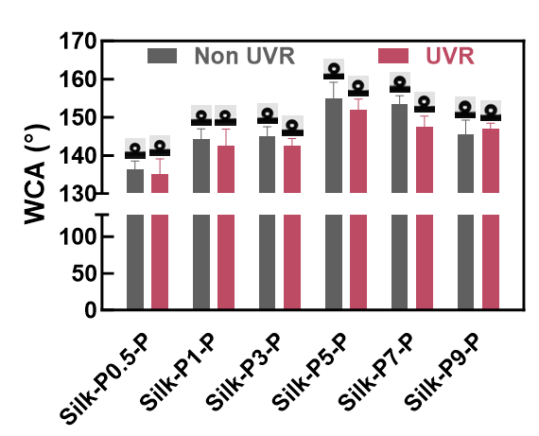
Figure S12. WCA changes in Silk-P(0.5-9)-P after 7 d ultraviolet irradiation.

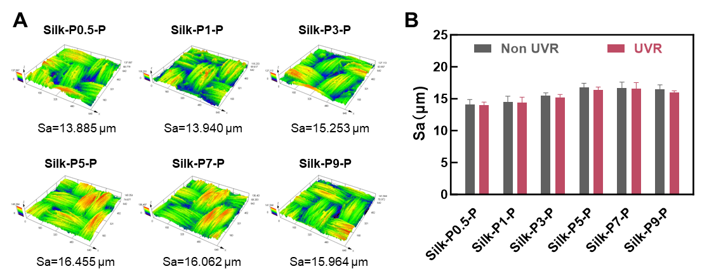
Figure S13. (A) Surface roughness changes in Silk-P(0.5-9)-P after 24 h ultraviolet irradiation. (B) Sa changes in Silk-P(0.5-9)-P after 24 h ultraviolet irradiation.

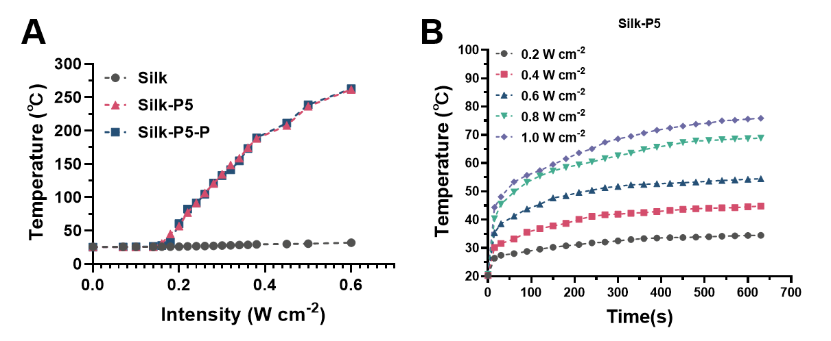
Figure S14. Temperature rise of Silk-P5-P in dry and moist environments at different intensities of 808 nm laser irradiation for 10 min. (A) Photothermal temperature rise of Silk, Silk-P5, and Silk-P5-P in dry and moist environments at different intensities of light intensity (0.22-0.6 W cm⁻²). (B) Photothermal temperature rise of wet environments of Silk-P5 at different intensities of light intensity (0.2-1.0 W cm⁻²).

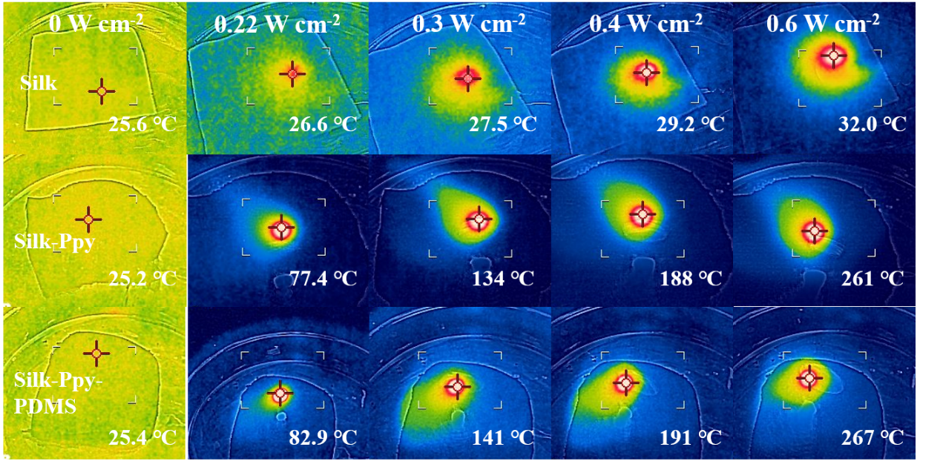
Figure S15. Infrared camera photographs of dry ambient photothermal temperatures of Silk, Silk-P5, and Silk-P5-P at different intensities of light intensity (0.22-0.6 W cm⁻²).

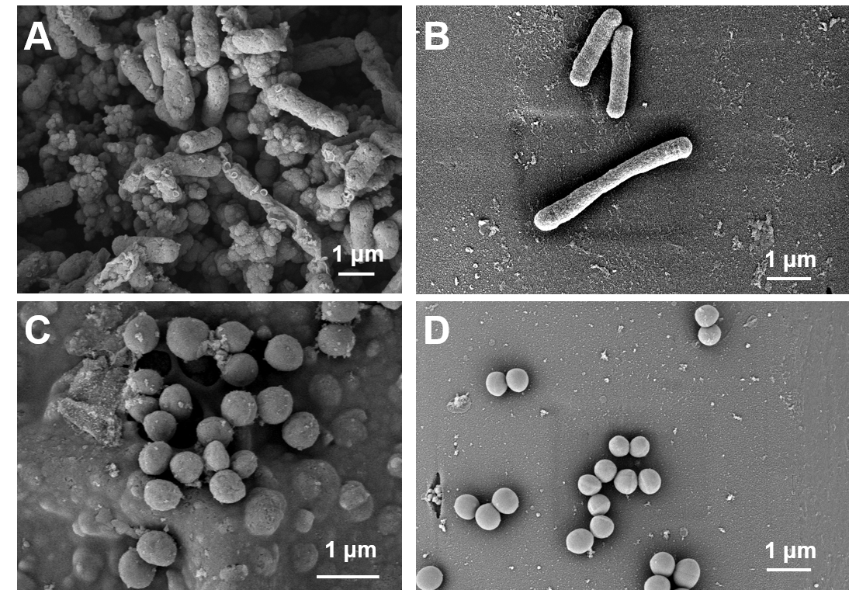
Figure S16. SEM image of bacteria after Silk-P5-P sustained 10min photothermal antibacterial. (A) SEM image of E. coli after photothermal antimicrobial treatment. (B) SEM image of S. aureus after photothermal antimicrobial treatment. (C) SEM image of E. coli before photothermal antimicrobial. (D) SEM image of S. aureus before photothermal antimicrobial.
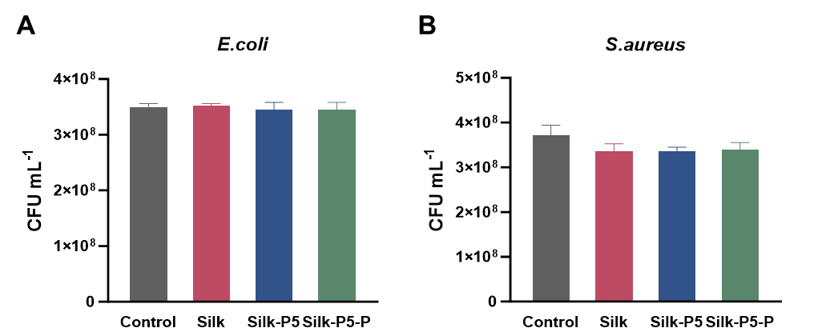
Figure S17. Colony counts of E. coli (A) and S. aureus (B) for control, silk, Silk-P5, and Silk-P5-P groups without NIR irradiation.

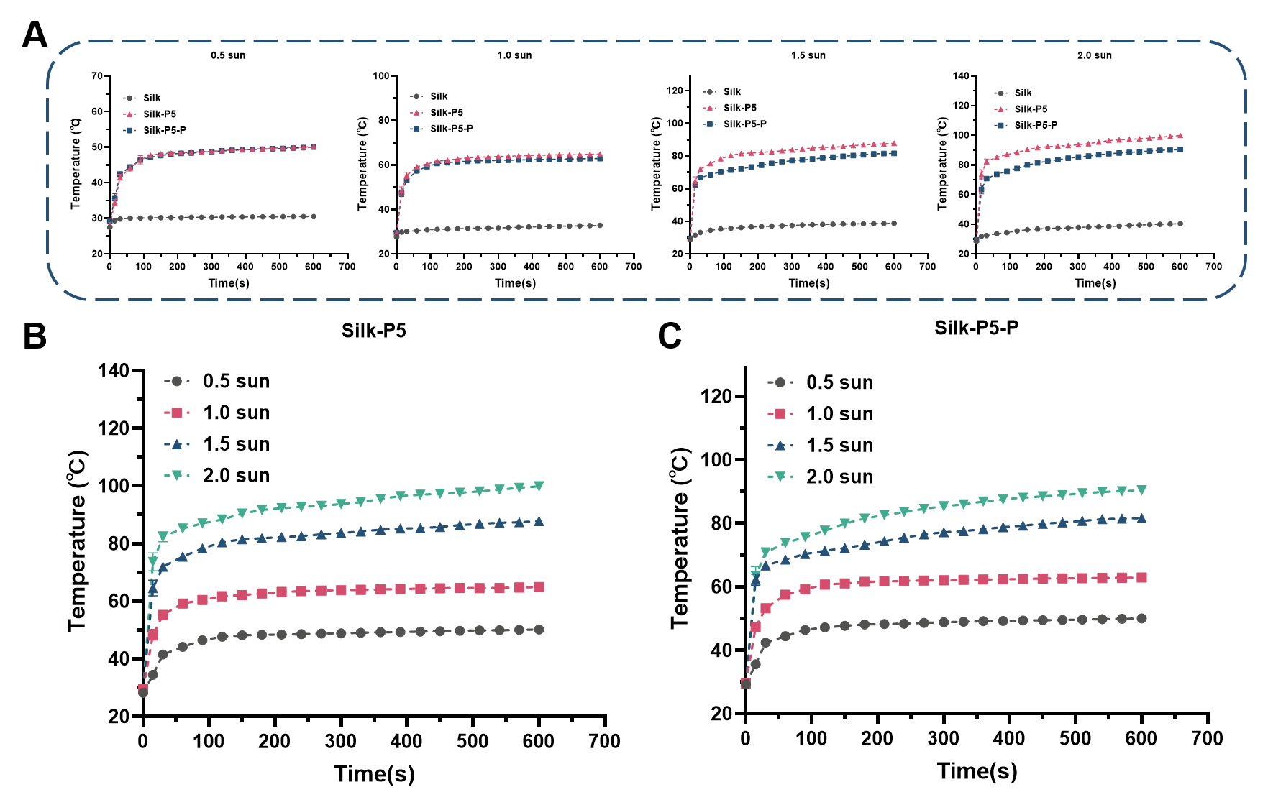
Figure S18. Temperature of Silk, Silk-P5, Silk-P5-P under different daylight (0.5-2.0 sun). (A) Comparison of the temperatures of Silk, Silk-P5, and Silk-P5-P under the same daylight. (B) Temperature of Silk-P5 under different daylight. (C) Temperature of Silk-P5-P under different daylight.

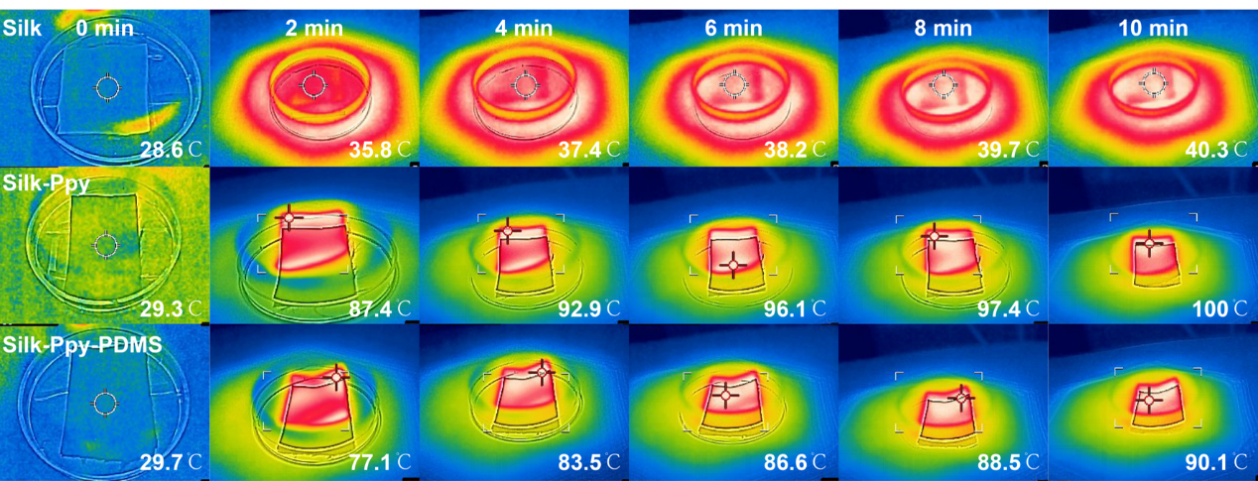
Figure S19.Temperature changes of Silk, Silk-Ppy, and Silk-Ppy-PDMS irradiated at 2sun for 10min.

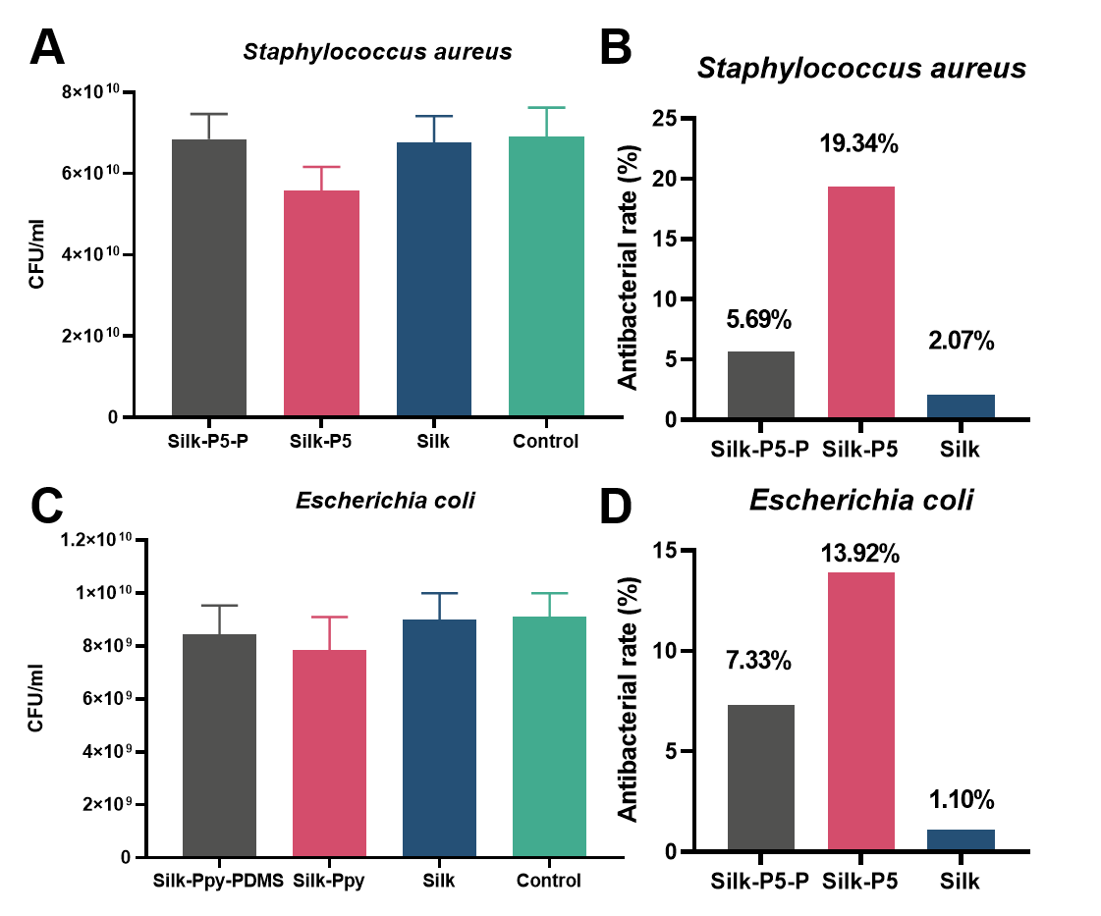
Figure S20. Colony counts and antimicrobial rates of Silk, Silk-P5, and Silk-P5-P irradiated for 10 min in a humid environment at 1sun. (A) Colony number of S. aureus. (B) Antibacterial rate of S. aureus. (C) Colony number of E. coli. (D) Antibacterial rate of E. coli.

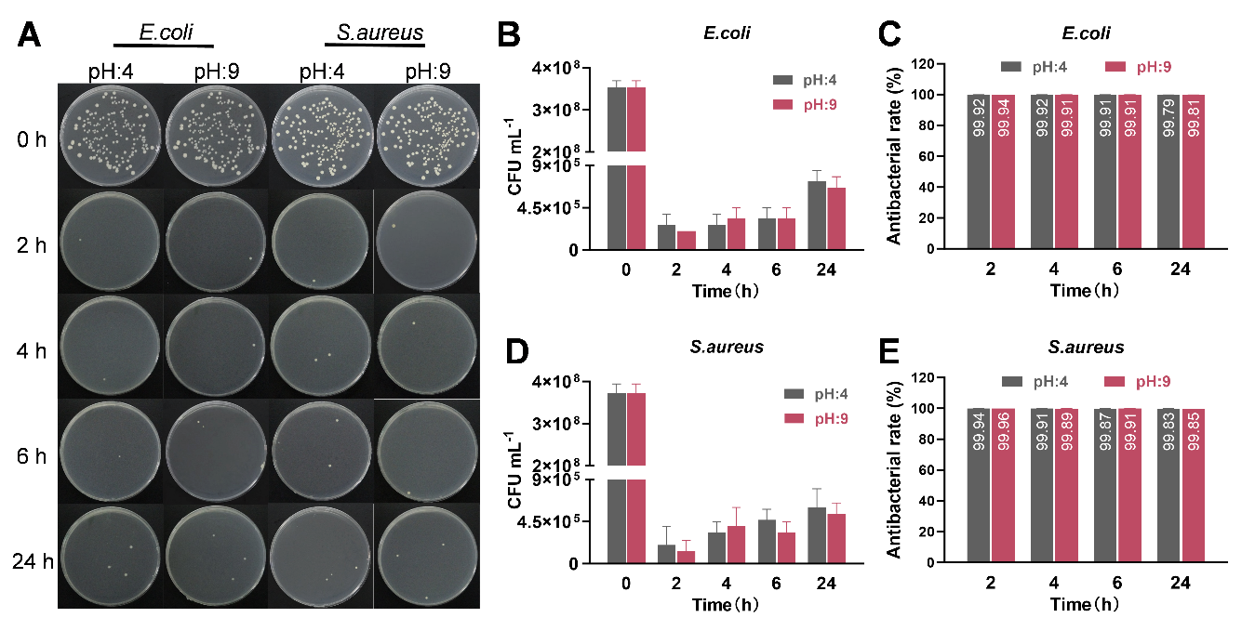
Figure S21. (A) Photographs of bacterial colonies of Silk-P5-P during continuous immersion for 2, 4, 6, 24h in different chemical environments (pH=4, 9) and control after 10 min of continuous irradiation with infrared light (E. coli and S. aureus). (B-E) Colony counts and antimicrobial rates of Silk-P5-P during continuous immersion for 2, 4, 6, 24h in different chemical environments (pH=4, 9) and control after 10 min of continuous irradiation with infrared light ( E. coli (B, C) and S. aureus (D, E)).

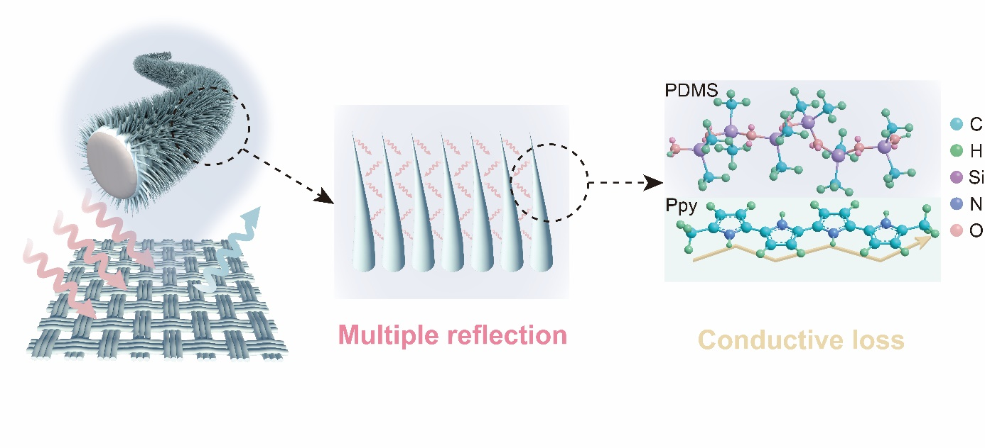
Figure S22. Schematic illustration of the EMI shielding mechanism. The conjugated Ppy backbone facilitates charge transport, causing conductive and dielectric losses, while the needle-like morphology extends the EM wave propagation path through repeated reflection and scattering within the hierarchical structure.

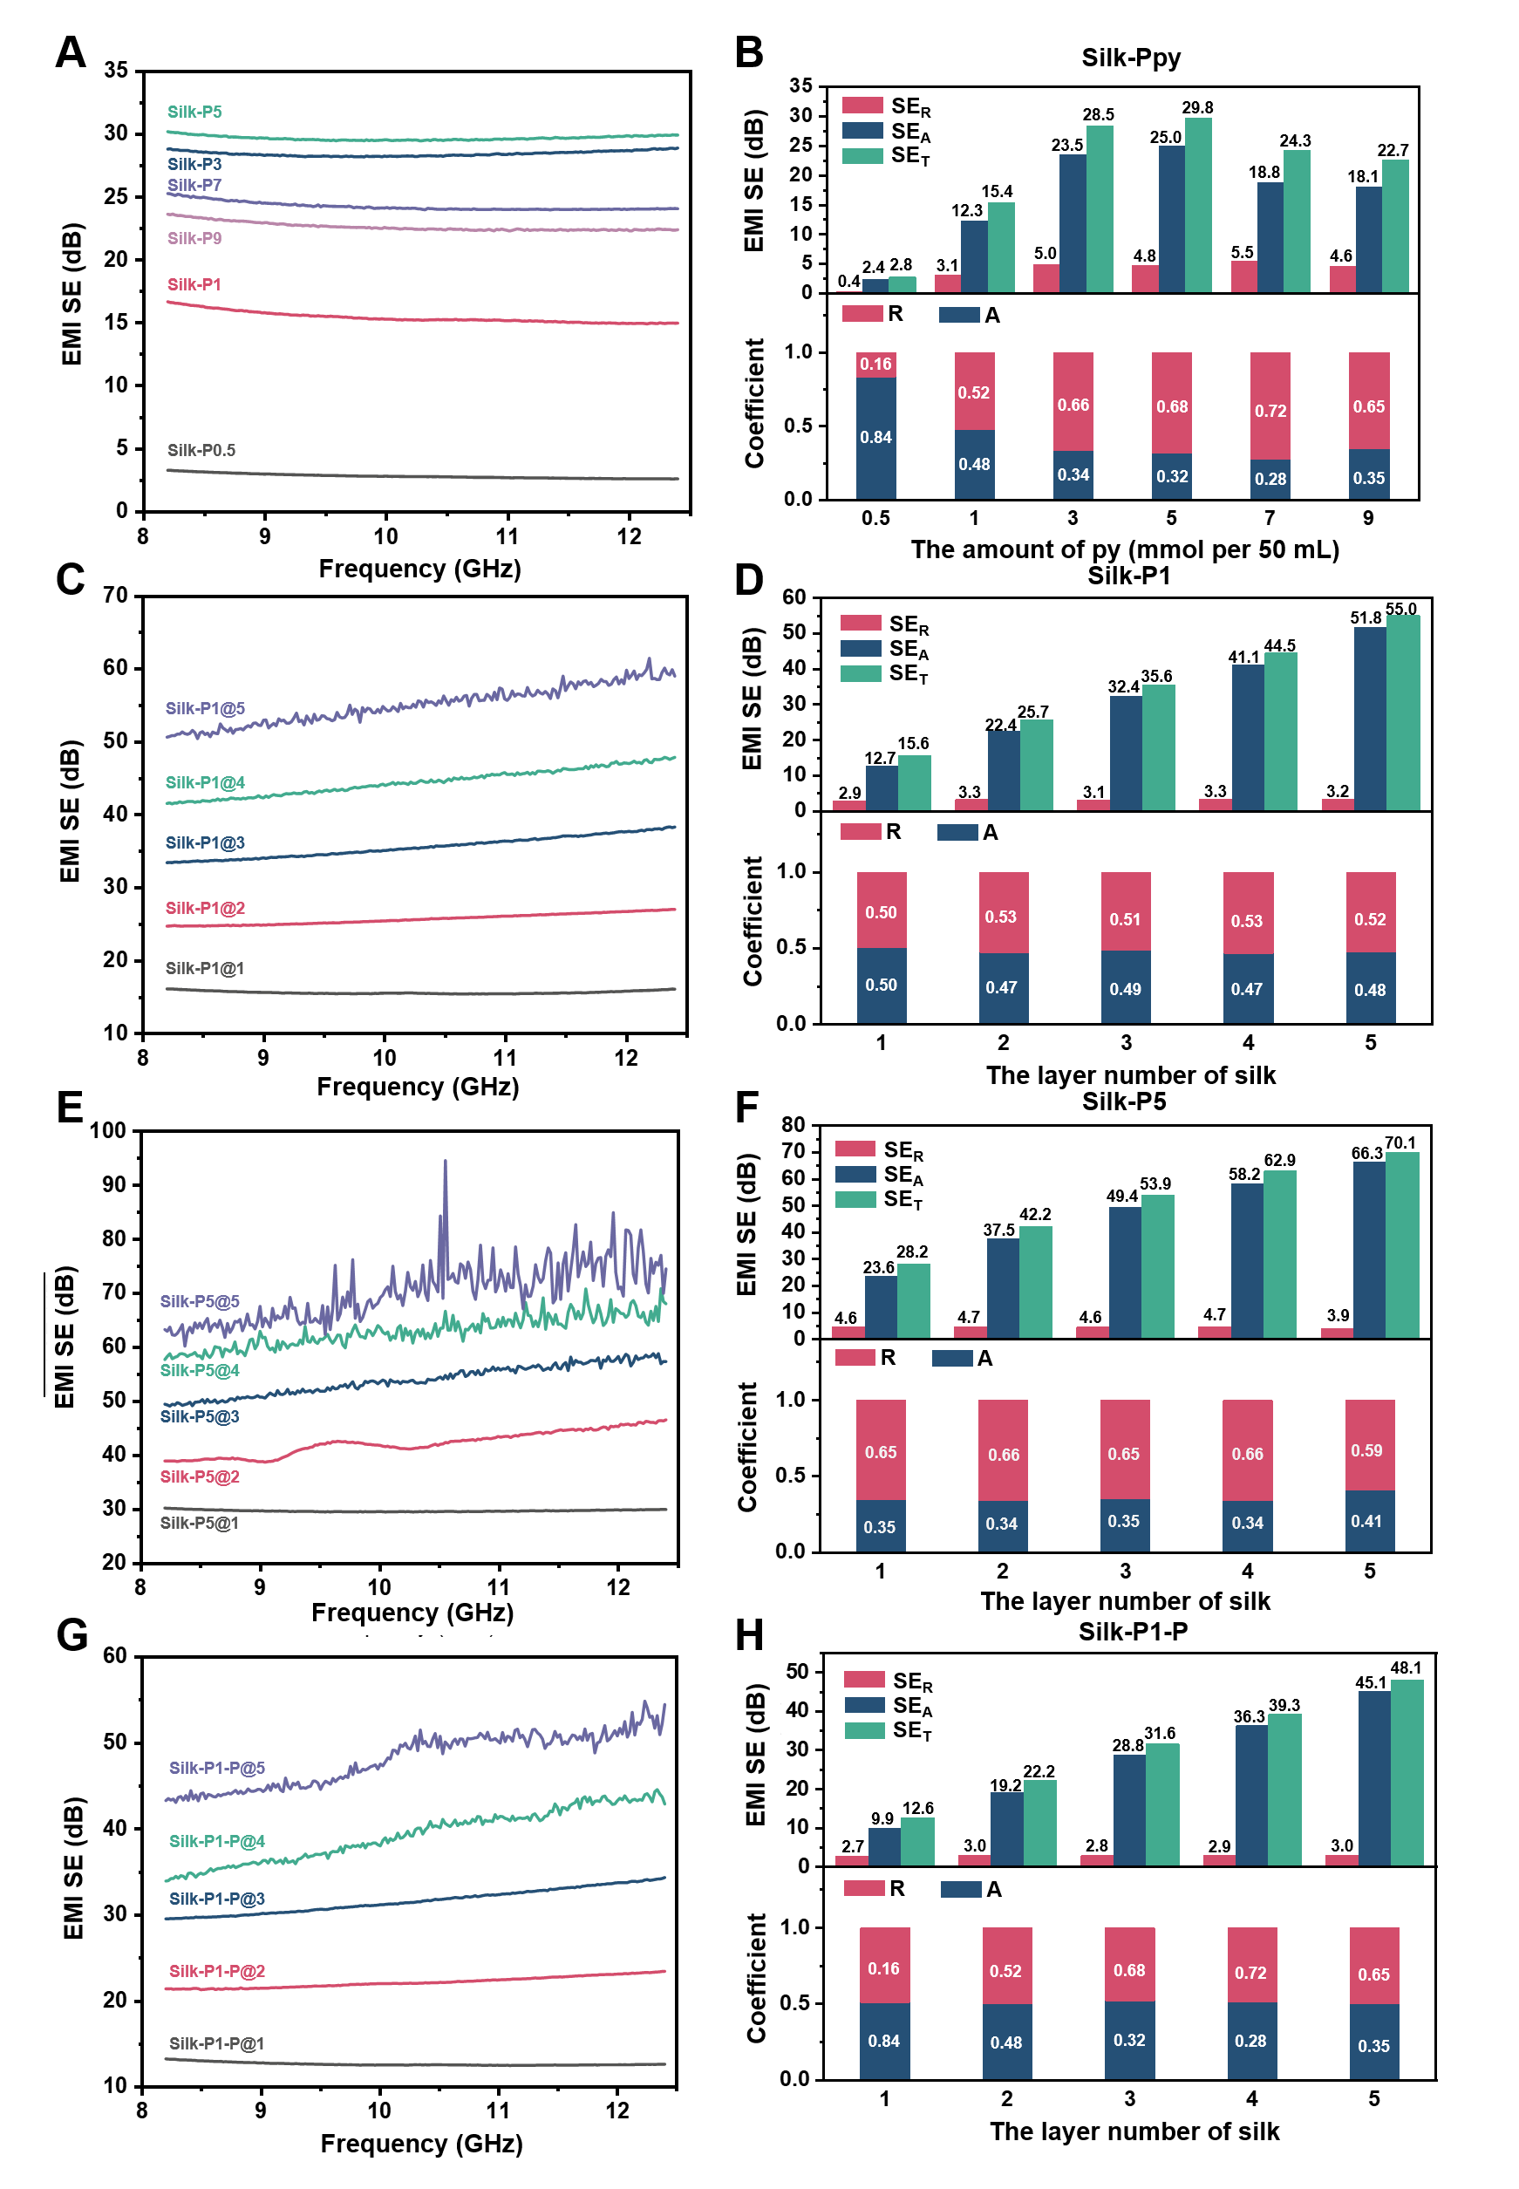
Figure S23. Electromagnetic shielding effectiveness of electromagnetic shielding fabrics with different py additions and number of fabric layers, corresponding to the normalized calculation of absorption coefficient (A) and reflection coefficient (R). (A) Electromagnetic shielding effectiveness, (B) absorption and reflection coefficients of electromagnetic shielding fabric Silk-P (0.5-9) with different py additions (0.5, 1, 3, 5, 7, 9 mmol per 50 mL solution), (C) Electromagnetic shielding effectiveness, (D) absorption and reflection coefficients of electromagnetic shielding fabric Silk-P1 @ (1-5) with different number of layers and py additions (1 mmol per 50 mL) (E) electromagnetic shielding effectiveness, (F) absorption and reflection coefficients of electromagnetic shielding fabrics Silk-P5 @ (1-5) with different number of layers of 5 mmol per 50 mL of py. (G) electromagnetic shielding effectiveness, (H) absorption and reflection coefficients of electromagnetic shielding fabrics Silk-P1-P @ (1-5) with different number of layers of 1 mmol per 50 mL of py.

Table S1. Summary of Key Fabrication Parameters for the Silk-Ppy-PDMS Composites.

Fabrication Step | Parameter | Value / Condition | Notes
Silk Pre-treatment | Fabric Size | 40 mm × 40 mm
 | Washing Solvent | Ethanol, Deionized Water | Repeated 3 times
 | Drying | 50 °C, Oven, 1 h
Ppy Polymerization | Monomer (Pyrrole) | 0.1 - 10 mmol (in 50 mL) | 0.002 - 0.2 M
 | Dopant (PTS) | 1:1 Molar Ratio to Py
 | Oxidant (FeCl₃) | 1:1 Molar Ratio to Py | In 10 mL water
 | Catalyst / Acid | 1 mL H₃PO₄ (85 wt%)
 | Premixing & Adsorption | ~300 rpm, 25 min total | Room Temperature
 | Polymerization | ~300 rpm, 6 h | Room Temperature (25 ± 2 °C)
 | Washing | Ethanol & Deionized Water | Until supernatant clear
 | Drying | 50 °C, 2 h
PDMS Coating | PDMS Precursor : Curing Agent | 10 : 1 (0.40 g : 0.04 g) | Sylgard 184
 | Solvent | n-Hexane, 60 mL
 | Total PDMS Concentration | ~7.3 mg/mL | In n-Hexane
 | Sonication (Dispersion) | 10 min | Room Temperature
 | Sonication (Coating) | 30 min | Ice-water Bath
 | Curing | 60 °C, 20 min | Oven
 | Coating Cycles | 3

Table S2. Comparison of Silk-P5-P and recent electromagnetic shielding fabric studies in terms of electromagnetic shielding effectiveness (dB), thickness (mm), and electromagnetic shielding effectiveness per unit thickness (dB/mm).
Num | Materials | SE (dB) | Thickness (mm) | SE/T (dB/mm) | Ref
1 | Silk-P5-P | 26.3 | 0.13 | 202.31 | This work
 | Silk-P5-P@5 | 62.9 | 0.67 | 96.77 | This work
2 | CNs-P@M-PG-N/P | 38.6 | 0.32 | 117 | [1]
3 | CF/MXene/NiCo-LDH | 52.34 | 2.12 | 24.689 | [2]
4 | PDMS@CuS@PSF | 46 | 0.35 | 131.43 | [3]
5 | MoSe₂@MXene/CFs | 37 | 0.3 | 123.33 | [4]
6 | MXene@PDA-cotton fabric | 45 | 0.358 | 125.70 | [5]
7 | MXene/magnetic LM/polycomposite fibers | 63.45 | 0.8 | 79.313 | [6]
8 | MXene/CNTs/TPU fabric | 25.7 | 0.15 | 171.3 | [7]
9 | rGO@CNTs-PF fabrics | 40.1 | 0.6 | 66.83 | [8]
10 | Ni-SS@CNTs Acetate fabrics | 37 | 0.8 | 46.25 | [9]
11 | MXene- cellulose fabric | 35.2 | 0.62 | 56.8 | [10]
12 | MXene/aramid nonwoven fabrics | 35.7 | 1.04 | 34.3 | [11]
13 | CNT/graphene/WPU/textile | 35 | 0.35 | 100 | [12]
14 | MXene/AgNWs-decorated nonwoven fabrics | 66.4 | 0.6 | 110.67 | [13]
15 | SWNTs/GA-chitosan polyamide nonwoven fabrics | 29 | 2.8 | 10.36 | [14]
16 | Ag/Ti-TiO2 Cotton fabrics | 40 | 1.8 | 22.22 | [15]
17 | TPU/MXene TPU fabrics | 31 | 0.3 | 103.33 | [16]
18 | MXene/SPF PET textile | 30 | 0.2 | 150 | [17]
19 | Al-waste cotton-carbon felt fabric | 82.63 | 6 | 13.771 | [18]
20 | Ni-PIC fabrics | 44 | 0.8 | 55 | [19]
21 | Ferromagnetic graphene quartz fabrics | 107 | 1 | 107 | [20]
22 | MXene/Ppy PET fabric | 90 | 1.3 | 69.2 | [21]

References
[1] Yu Z, Deng C, Seidi F, Yong Q, Lou Z, Meng L, Liu J, Huang C, Liu Y, Wu W.(2022) Air-permeable and flexible multifunctional cellulose-based textiles for bio-protection, thermal heating conversion, and electromagnetic interference shielding. J. Mater. Chem. A. 10: 17452
[2] Lian Y, Lan D, Jiang X, Wang L, Yan S, Dong Q, Jiang Y, Gu J, Gao Z, Wu G.(2024) Multifunctional electromagnetic wave absorbing carbon fiber/Ti3C2TX MXene fabric with superior near-infrared laser dependent photothermal antibacterial behaviors. Journal of Colloid and Interface Science. 676: 217
[3] Yu F, Jia P, Song L, Hu Y, Wang B, Wu R.(2023) Multifunctional fabrics based on copper sulfide with excellent electromagnetic interference shielding performance for medical electronics and physical therapy. Chem. Eng. J., 472: 145091
[4] Xie J, Zhang Y, Dai J, Xie Z, Xue J, Dai K, Zhang F, Liu D, Cheng J, Kang F.(2023) Multifunctional MoSe2@ MXene Heterostructure‐Decorated Cellulose Fabric for Wearable Thermal Therapy. Small. 19: 2205853
[5] Yan B, Zhou M, Yu Y, Xu B, Cui L, Wang Q, Wang P.(2022) Orderly Self-Stacking a High-Stability coating of MXene@ Polydopamine hybrid onto textiles for multifunctional personal thermal management. Compos. Part A: Appl. S., 160: 107038
[6] Yi P, Zou H, Yu Y, Li X, Li Z, Deng G, Chen C, Fang M, He J, Sun X.(2022) MXene-reinforced liquid metal/polymer fibers via interface engineering for wearable multifunctional textiles. ACS nano. 16: 14490
[7] Zhang D, Yin R, Zheng Y, Li Q, Liu H, Liu C, Shen C.(2022) Multifunctional MXene/CNTs based flexible electronic textile with excellent strain sensing, electromagnetic interference shielding and Joule heating performances. Chem. Eng. J., 438: 135587
[8] Lee J-H, Kim Y-S, Ru H-J, Lee S-Y, Park S-J.(2022) Highly flexible fabrics/epoxy composites with hybrid carbon nanofillers for absorption-dominated electromagnetic interference shielding. Nano-Micro Lett., 14: 188
[9] Duan Q, Lu Y.(2021) Silk sericin as a green adhesive to fabricate a textile strain sensor with excellent electromagnetic shielding performance. ACS Appl. Mater. Inter., 13: 28832
[10] Zheng X, Wang P, Zhang X, Hu Q, Wang Z, Nie W, Zou L, Li C, Han X.(2022) Breathable, durable and bark-shaped MXene/textiles for high-performance wearable pressure sensors, EMI shielding and heat physiotherapy. Compos. Part A: Appl. S., 152: 106700
[11] Wang X, Lei Z, Ma X, He G, Xu T, Tan J, Wang L, Zhang X, Qu L, Zhang X.(2022) A lightweight MXene-coated nonwoven fabric with excellent flame retardancy, EMI shielding, and electrothermal/photothermal conversion for wearable heater. Chem. Eng. J., 430: 132605
[12] Dai M, Zhai Y, Zhang Y.(2021) A green approach to preparing hydrophobic, electrically conductive textiles based on waterborne polyurethane for electromagnetic interference shielding with low reflectivity. Chem. Eng. J., 421: 127749
[13] Zheng X, Cao W, Hong X, Zou L, Liu Z, Wang P, Li C.(2023) Versatile electronic textile enabled by a mixed‐dimensional assembly strategy. Small. 19: 2208134
[14] Zhu S, Wang M, Qiang Z, Song J, Wang Y, Fan Y, You Z, Liao Y, Zhu M, Ye C.(2021) Multi-functional and highly conductive textiles with ultra-high durability through ‘green’fabrication process. Chem. Eng. J., 406: 127140
[15] Wang C, Zhang W, Xu X, Su J, Shi J, Amin MA, Zhang J, Yamauchi Y.(2022) Multifunctional wearable thermal management textile fabricated by one-step sputtering. Nano Today. 45: 101526
[16] Dong J, Luo S, Ning S, Yang G, Pan D, Ji Y, Feng Y, Su F, Liu C.(2021) MXene-coated wrinkled fabrics for stretchable and multifunctional electromagnetic interference shielding and electro/photo-thermal conversion applications. ACS Appl. Mater. Inter., 13: 60478
[17] Li E, Pan Y, Wang C, Liu C, Shen C, Pan C, Liu X.(2021) Asymmetric superhydrophobic textiles for electromagnetic interference shielding, photothermal conversion, and solar water evaporation. ACS Appl. Mater. Inter., 13: 28996
[18] Zhang Y, Shen G, Lam SS, Ansar S, Jung S-C, Ge S, Hou L, Fan Z, Wang F, Fan W.(2023) A waste textiles-based multilayer composite fabric with superior electromagnetic shielding, infrared stealth and flame retardance for military applications. Chem. Eng. J., 471: 144679
[19] Zhou S, Dong J, Li X, Zhao X, Zhang Q.(2023) Continuous surface metallization of polyimide fibers for textile-substrate electromagnetic shielding applications. Adv. Fiber Mater., 5: 1892
[20] Xie Y, Liu S, Huang K, Chen B, Shi P, Chen Z, Liu B, Liu K, Wu Z, Chen K.(2022) Ultra‐broadband strong electromagnetic interference shielding with ferromagnetic graphene quartz fabric. Advanced Materials. 34: 2202982
[21] Wang QW, Zhang HB, Liu J, Zhao S, Xie X, Liu L, Yang R, Koratkar N, Yu ZZ.(2019) Multifunctional and water‐resistant MXene‐decorated polyester textiles with outstanding electromagnetic interference shielding and joule heating performances. Adv. Funct. Mater., 29: 1806819

#Tiancheng Wei, Li Xu and Qichao Cheng have contributed equally to the work. *Corresponding authors: Mingying Yang: yangm@zju.edu.cn ¹Key Laboratory of Silkworm and Bee Resource Utilization and Innovation of Zhejiang Province, Institute of Applied Bioresource Research, College of Animal Science, Zhejiang University, Hangzhou, Zhejiang 310058, P. R. China

