Supporting Information
Low-temperature hydrothermal synthesis of ultra-high-strength phenolic aerogel composites based on a physicochemical double-crosslinked network

Xiangyu Jin ^{a#}, Shuai Yuan^{a#}, Can Wu^{b#}, Wei Wangª , Jiaxin Zhengª, Yu Fengª, Min Liu ª , Yiwu Pan^{c}, Changqing Hongª*, & Xinghong Zhangª*.
a National Key Laboratory of Science and Technology on Advanced Composites in Special Environments, Harbin Institute of Technology, Harbin, 150001, P. R. China
b AVIC Composite Corporation Ltd, Beijing, 101300, PR China
c Shaanxi Key Laboratory of Fiber Reinforced Light Composite Materials, Science and Technology on Thermostructural Composite Materials Laboratory, Northwestern Polytechnical University, Xi’an 710072, PR China
#These authors contributed equally to this work and should be considered co-first authors.
*Corresponding author: hongcq@hit.edu.cn (C.Q Hong*)
*Corresponding author: zhangxh@hit.edu.cn (X.H Zhang*)

Results and Discussion
Figure S1 Multi-stage energy dissipation strategy of PR aerogels
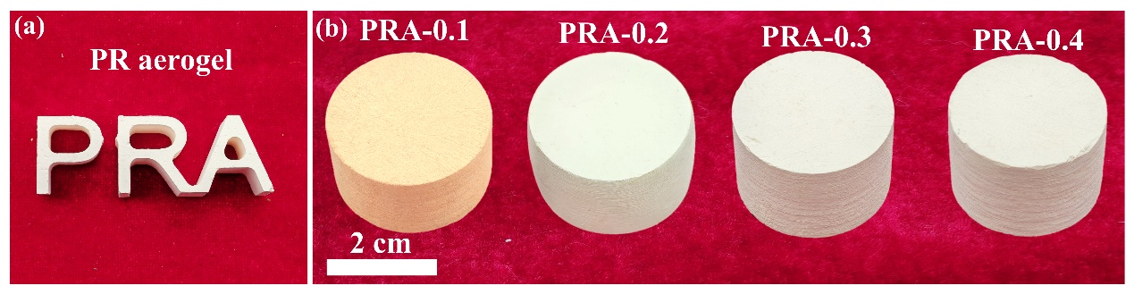
Figure S2 Macroscopic image of phenolic aerogel
Figure S3 Chemica structure of PR aerogel. (a) FT-IR curves of PR aerogel. (b) XPS survey spectrum of PR aerogel. (c) O 1s XPS spectrum of the PR aerogel. (d) C 1s XPS spectrum of the PR aerogel.
Figure S4 Temperature-dependent FT-IR spectra of PR aerogel between 30 °C -190 °C
Figure S5 Pore and particle size distribution of NCF/PRA-2
Figure S6 Thermal insulation performance of the PRA. (a)Surface and bottom temperature curves of 20 mm after 30 min on 200 ℃ plate. (b) Thermal conductivity. (c) The thermal conductivity of LPRA-2 at RT, 100 ℃ and 200 ℃.
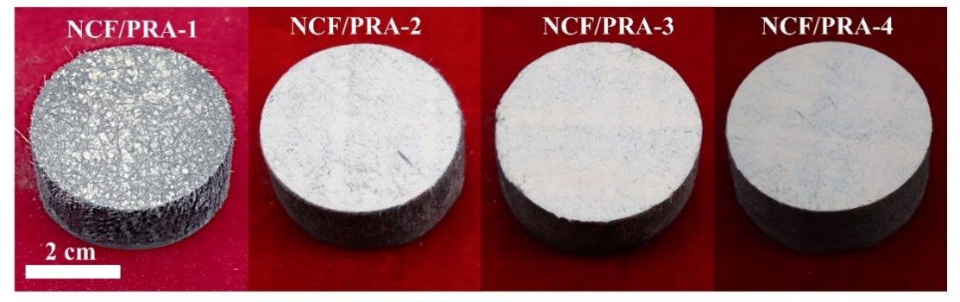
Figure S7 Macroscopic image of NCF/PRA composites
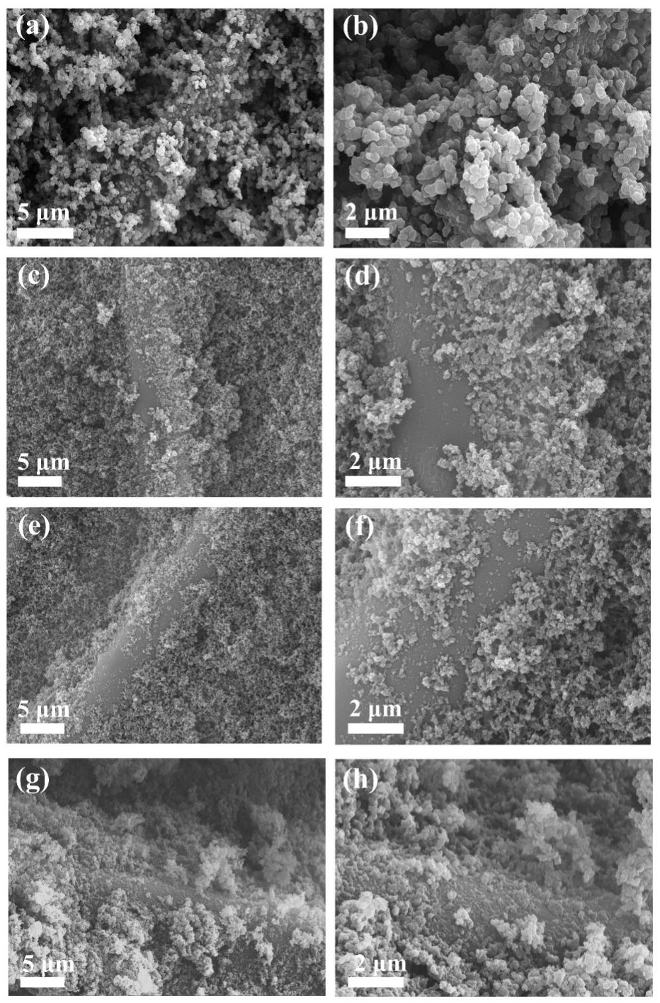
Figure S8 Nano-structure micrograph of NCF/PRA composites. (a)(b)NCF/PRA-1. (c)(d) NCF/PRA-2. (e)(f) NCF/PRA-3. (g)(h) NCF/PRA-4.
Figure S9 (a)The stress-strain curve in the XY direction of compression(b) The compressive strength and modulus of NGF/PRA composites.
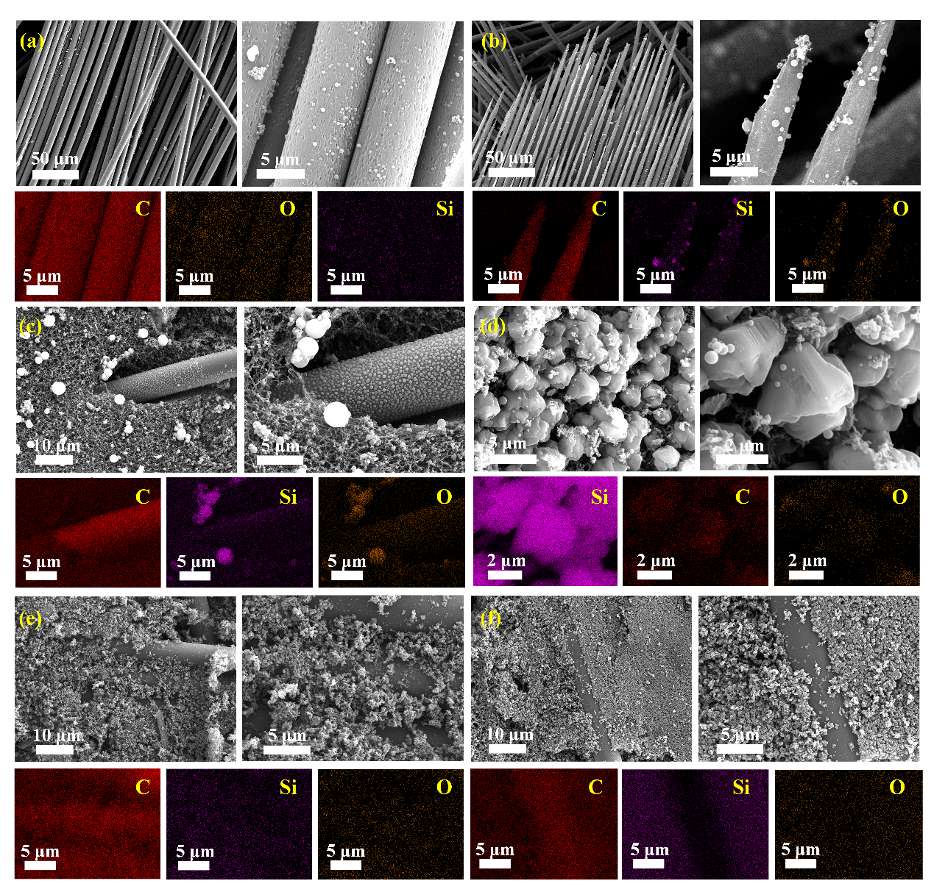
Figure S10 Microstructural images of each layer of NCF/PRA-2 composites after ablation. (a)(b) Ablative surface. (c)(d) Ablative subsurface .(e) Carbonized layer. (f) Pyrolysis layer.

