Supporting Information

Nanocellulose Hydrogels with Tunable Porosity, High elongation, and Autonomous Healing for Promote Wound Repair

Lifang Wangª, Weidong Yu^{b}, Shan Yiª, Amjad Farooq^{c}, Hong Qiuª, Li Chenª, Yika Tangª, Hongguo Gao^{d}, Meiying Wang^{d}, Lifang Liu^{a,d,*}
ª College of Textiles, Donghua University, Shanghai 201620, China
^{b} College of Textile and Fashion, Hunan Institute of Engineering, Xiangtan, Hunan 411104, China
^{c} College of Textile and Clothing, Nantong University, Nantong 22601, China
^{d} Yuyue Home Textile Co., Ltd, Binzhou, Shandong 256623, China
*Corresponding Authors: E-mail: lifangliu@dhu.edu.cn (Lifang Liu).

Supplementary Information
The PDF file includes:
Synthesis of CG solution, PG solution, PB hydrogel, CP solution, CPG solution, respectively
FTIR spectra characterization
Tables S1 to S2
Figures S1 to S10

Synthesis of CG solution
Disperse CNF in deionized water and magnetically stir for 20 minutes at room temperature. The mass fraction of CNF suspension was 1.00%. Introduce 6% gelatin(w/v) into the aforementioned nanocellulose suspensions. Heat and stir at 70°C for 60 minutes, maintaining a stirring speed of 500 rpm until complete dissolution, and then continue stirring while cooling to approximately 37°C. Subsequently, centrifuge at 5000 rpm for 15 min, named CG solution.
Synthesis of PG solution
PVA powder was dissolved in deionized water with a mass fraction of 5%. Heat and stir at 90°C for 180 minutes, maintaining a stirring speed of 800 rpm until complete dissolution. Gradually cool the resulting solution while stirring to 70°C. Add gelatin to the mixture, getting a 6% (w/v) solution. After 60 minutes, the solution was gradually cooled to about 37°C. Subsequently, the hydrogel was centrifuged at 5000 rpm for 15 min, named PG solution.
Synthesis of PB hydrogel
PVA was dissolved in deionized water with a mass fraction of 5%. Heat and stir at 90°C for 180 minutes, maintaining a stirring speed of 800 rpm until complete dissolution. Then, dissolve borax powder in deionized water to get a 0.1 M Borax solution. The solution was gradually cooled to about 37°C, and slowly added with 0.1 M Borax solution to cross-link. The ratio of the amount of addition to the total volume was 1:5. Subsequently, the hydrogel was centrifuged at 5000 r/min for 15 min to make it fully cross-linked, named PB hydrogel.
Synthesis of CP solution
Disperse CNF in deionized water and magnetically stir for 20 minutes at room temperature. The mass fraction of CNF suspension was 1.00%. PVA powder was added to the CNF suspension to reach a final volume fraction of 5%. The mixture was heated to 90°C and stirred at 800 rpm for 180 min until fully dissolved. and then continue stirring while cooling to approximately 37°C. Subsequently, centrifuge at 5000 rpm for 15 min, named CP solution.
Synthesis of CPG solution
Disperse CNF in deionized water and magnetically stir for 20 minutes at room temperature. The mass fraction of CNF suspension was 1.00%. PVA powder was added to the CNF suspension to reach a final volume fraction of 5%. The mixture was heated to 90°C and stirred at 800 rpm for 180 min until fully dissolved. The solution was allowed to cool to 70°C, followed by the addition of 6% gelatin (w/v). Stirring was continued at 800 rpm until complete dissolution, then cooled to 37°C. Subsequently, centrifuge at 5000 rpm for 15 min, named CPG solution.
FTIR spectra characterization
CNF, PVA, Gel, and freeze-dried CG, PG, PB, CP, and CPG samples were ground and compressed with potassium bromide, respectively. Fourier Transform Infrared Spectroscopy (FTIR) was conducted using a NicoletTM iS50 spectrometer (Thermo Scientific, USA) in the 500-4000 cm⁻¹ range, with 32 scans per sample at a resolution of 4 cm⁻¹.

Supplementary Table 1: Compositions of all hydrogels
Sample | H₂O (ml) | Cellulose Nanofibers (ml) | PVA(g) | Gelatin(g) | Borax(ml)
PB | 40 | / | 2.0 | / | 8
PG | 40 | / | 2.0 | 2.4 | 0
CG | 20 | 20 | / | 2.4 | /
CP | 20 | 20 | 2.0 | / | /
CPG | 20 | 20 | 2.0 | 2.4 | /
C_{0.0}PGB | 40 | / | 2.0 | 2.4 | 8
C_{0.5}PGB | 30 | 10 | 2.0 | 2.4 | 8
C_{1.0}PGB | 20 | 20 | 2.0 | 2.4 | 8
C_{1.5}PGB | 10 | 30 | 2.0 | 2.4 | 8
C_{2.0}PGB | 0 | 40 | 2.0 | 2.4 | 8
Note: The cellulose nanofiber suspension is 2.0 wt%. The concentration of borax is 0.1 M. “/”: not added.

Supplementary Table 2: Specific data of radar chart
Reference | Elongation (%) | Healing time (s) | Antibacterial rate (%)
Zhang Shu | 869 | / | 80
Ge Sijia | 1400 | / | /
Zhang jie | 926 | 43200 | /
Zhang Sufeng | 1489 | 540 | /
Xiong Yangkai | 380.57 | 90 | /
Linn berglund | 45 | / | /
An Heng | 300 | 2400 | /
Wang Fang | / | 1200 | 84.1
Li Dangwei | 50 | / | 99.96
Luo Huitong | / | 600 | /
Ding Fuyuan | / | 7200 | /
This work | 1016 | 8 | 84.3
Note: “/” indicates that this performance is not given in the literature. For better comparison, the performance that is not given is marked as 0 in the radar chart, and the self-healing time greater than 43200 seconds is marked as 48000 seconds.

Supplementary Figure 1. FTIR spectra of CNF, PVA, Gel, Borax, CG, PG, PB, CP, CPG
Supplementary Figure 2. Photography of C_{1.0}PGB hydrogel in different shapes

Supplementary Figure 3 SEM images of C_{x}PGB hydrogels: cross sectional views of (a) C_{0.5}PGB, (b) C_{1.5}PGB, and (c) C_{2.0}PGB; (a₁)~(c₁) corresponding longitudinal section; (a₂)~(c₂) cross-sectional pore size distribution; and (a₃)~(c₃) longitudinal pore size distribution of the respective hydrogels
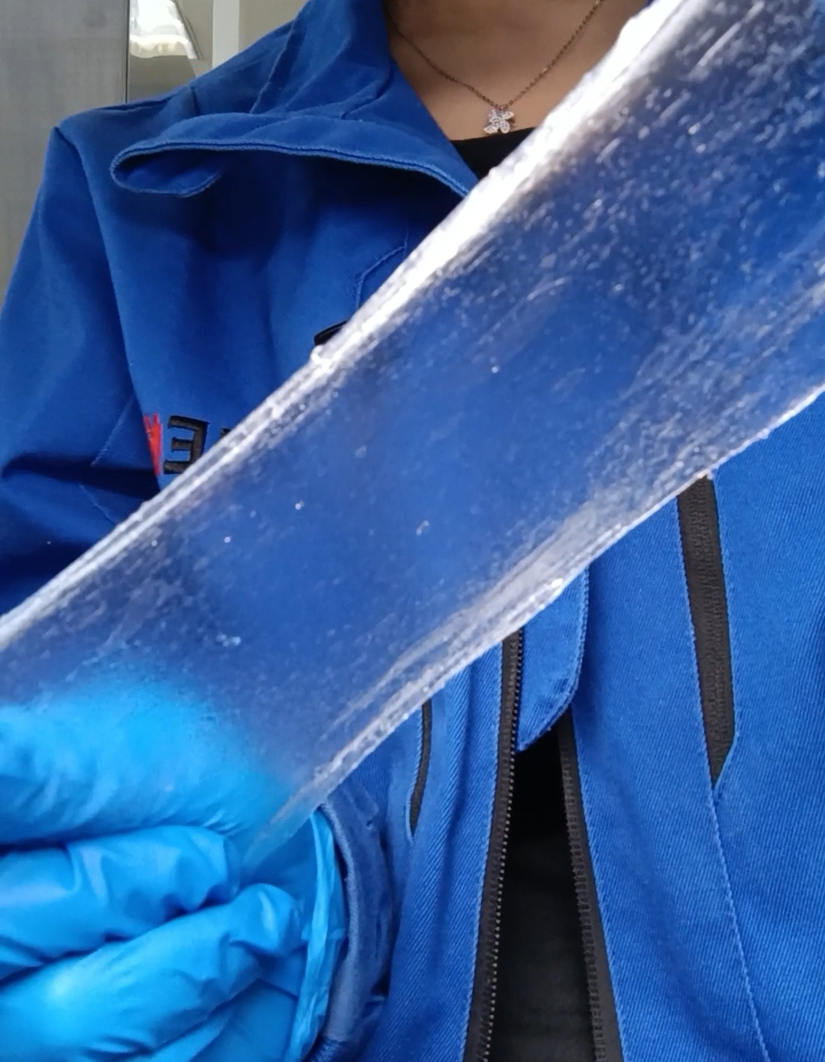
Supplementary Figure 4. C_{1.0}PGB hydrogel stretch film

Supplementary Figure 5. Actual picture of finger compression hydrogel

Supplementary Figure 6. Actual picture of the morphological changes of the hydrogel after being placed for different periods

Supplementary Figure 7. Actual picture of the changes in adhesion and fluidity of hydrogel after being placed for different periods
Supplementary Figure 8. Stress-strain curves before and after hydrogel healing

Supplementary Figure 9. Time scanning in hydrogel rheological characterization

Supplementary Figure 10. Photographs of inhibition zones (a) and antibacterial activity (b) of C_{1.0}PG and C_{1.0}PGB against S.aureus and E.coli, (c) bacterial survival rate

