ENHANCING REPROCESSABILITY OF DYNAMIC POLYMER COMPOSITES WITH THERMALLY SENSITIVE PARTICLES AND CONTROLLED PARTICLE-MATRIX INTERFACES
Hoogmartens Anthony1, Schlögl Sandra2, Leterrier Yves1, Michaud Véronique1
1Laboratory for Processing of Advanced Composites (LPAC), Ecole Polytechnique Fédérale de Lausanne (EPFL), Station 12, Lausanne, 1015, Vaud, Switzerland.
2Chemistry of Functional Polymers, Polymer Competence Center
Leoben GmbH (PCCL), Sauraugasse, Leoben, 8700, Styria, Austria.
Advanced Composites and Hybrid Materials

Corresponding author: Véronique Michaud (veronique.michaud@epfl.ch)

Contributing authors: anthony.hoogmartens@epfl.ch; sandra.schloegl@pccl.at; yves.leterrier@epfl.ch; veronique.michaud@epfl.ch;

Structural characterization of cystamine

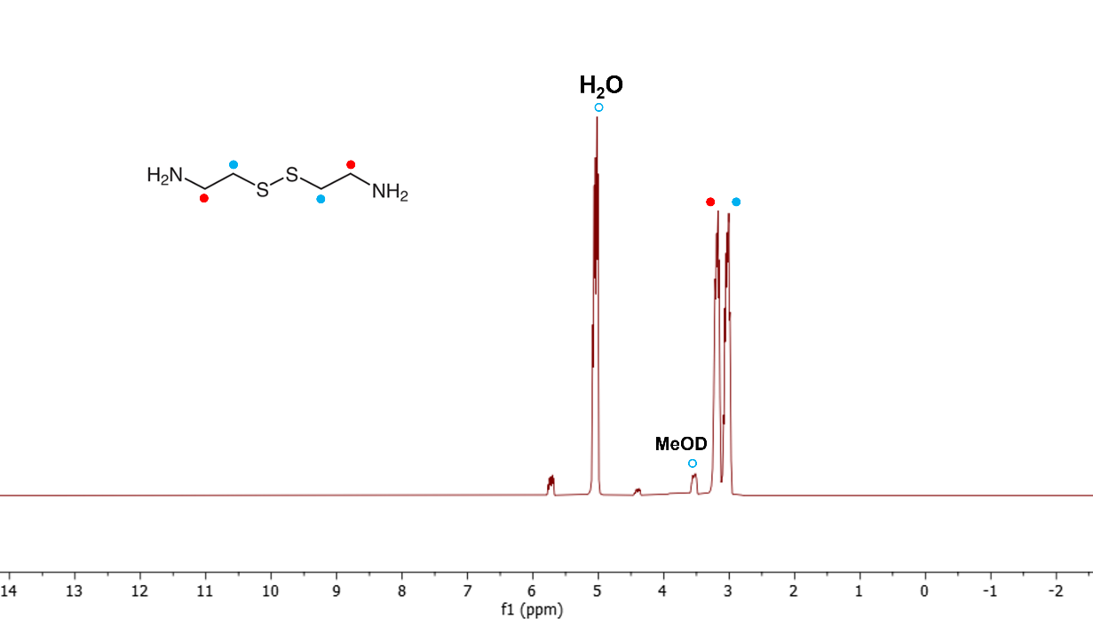
Fig. S1 ¹H NMR cystamine: ¹H NMR (400 MHz, d-methanol, δ ppm): 3.20 (t, 4H), 3.03 (t, 4H)

Characterization of the polyester particles

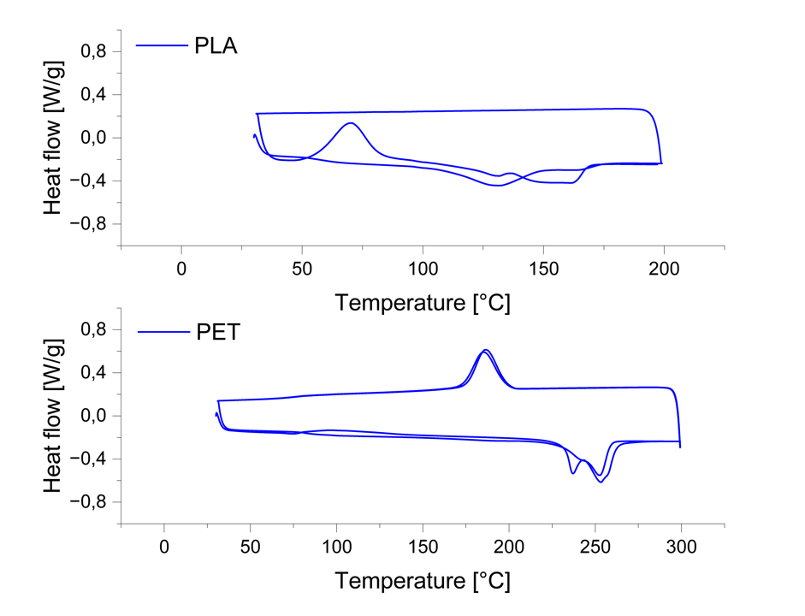
Fig.S2 DSC measurement of the polyester particles

Table 1: Additional information for the polyester particles
 | PLA | PET
T_{g} [°C] | 55.68 | 80
Melting point T_{m} [°C] | 150-160 | 240-250
Enthalpy of  melting [J/g] | 38.49 | 55.1
Degree of  crystallinity  X_{c} [%] | 41.4 [1] | 39.3 [2]

TGA, amplitude sweep, glass transition temperature and viscosity measurements – main and control formulations

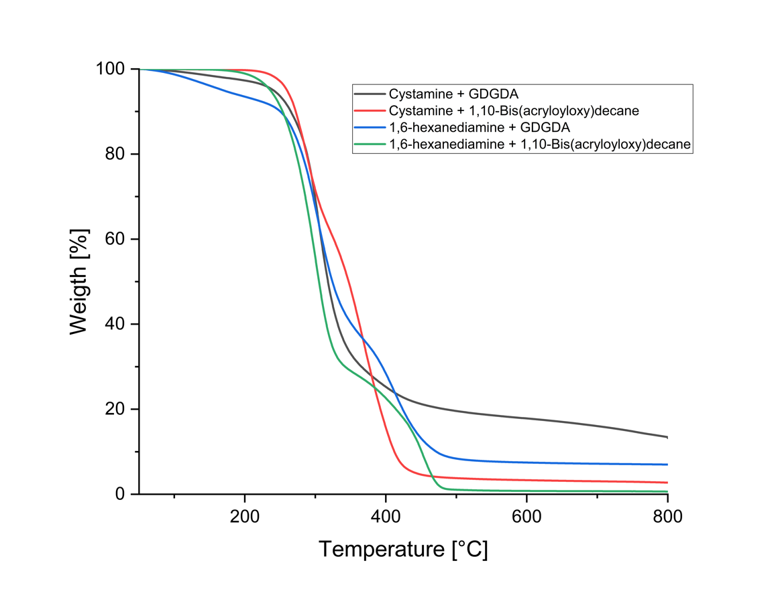
Fig.S3 TGA measurements for the main formulation and the control formulations

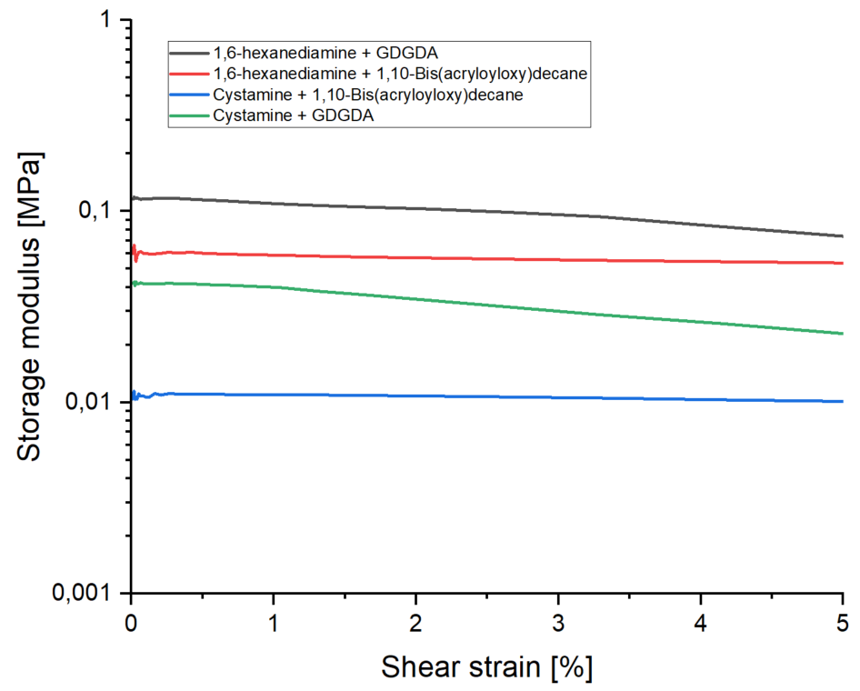
Fig.S4 Amplitude sweep of the main formulation and the control formulations

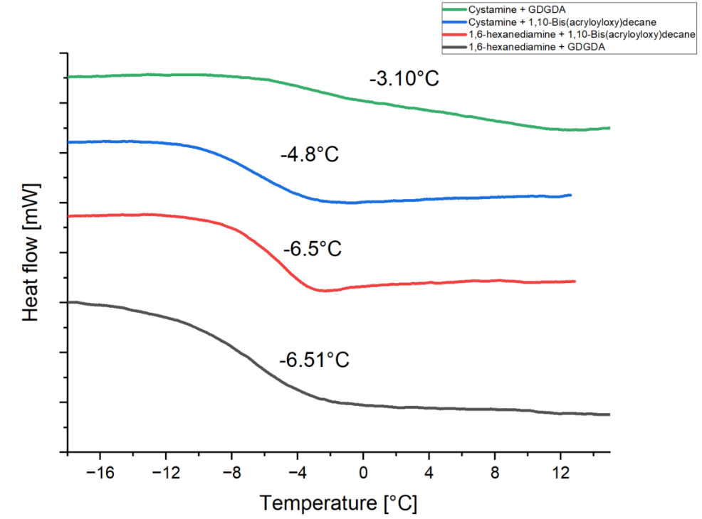
Fig. S5 Glass transition temperature measurements of the main formulation and the control formulations

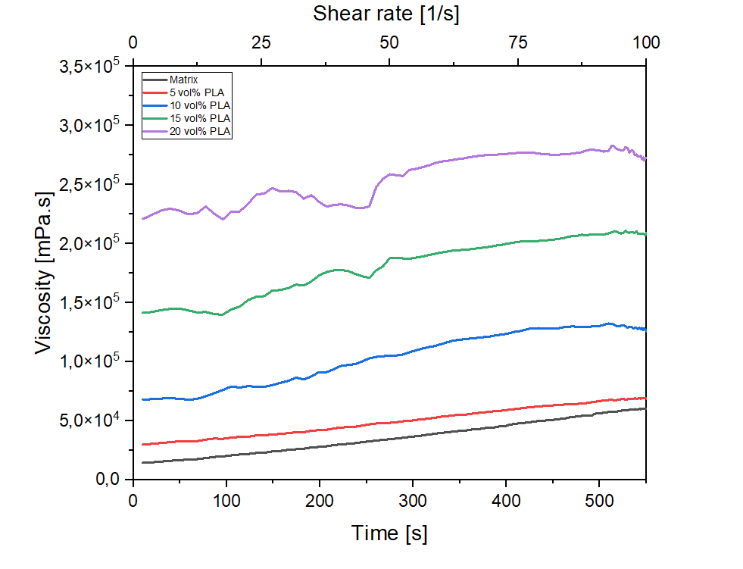
Fig.S6 Flow curves of the matrix and composites

Stress relaxation measurements of the matrix
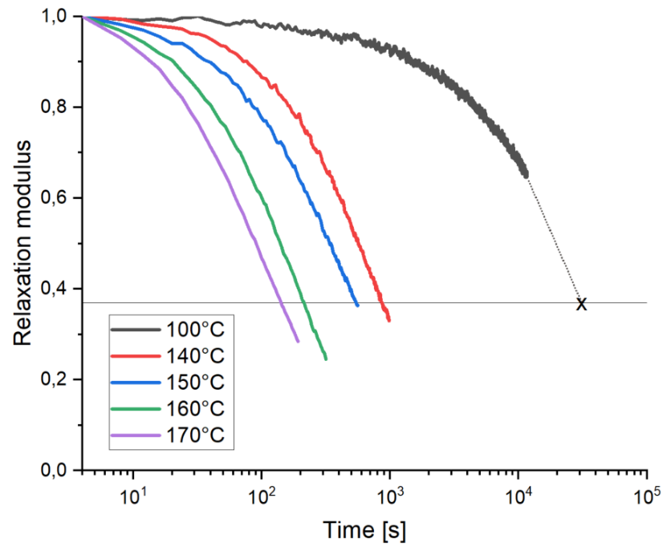
Fig.S7 Normalised relaxation modulus versus time for different temperatures of the main formulation. The relaxation time for the test at 100°C is 32194 seconds which is extrapolated from the given data

Topology freezing temperature measurements

The topology freezing temperature (T_{V}) is the temperature at which a vitrimer network stops flowing on practical timescales. It is defined as the temperature where the stress relaxation time 𝜏* becomes very long (typically 10⁷ seconds), meaning the network behaves like a solid.

The T_{v} can be extrapolated from the Arrhenius fitted line (blue curve in Fig. 8) to a relaxation time of 10⁷ s (τ(T_{v}) = 10⁷).

$$τ\left(T\right)= τ_{0}e^{\frac{E_{a}}{RT}} or\ln\left(τ\right)=\ln\left(τ_{0}\right)+ \frac{E_{a}}{R} . \frac{1}{T} ≈\ln\left(τ\right)=m\left(\frac{1000}{T}\right)+b$$

where E_{a} is the activation energy of the bond-exchange process, R is the gas constant, τ₀ is the pre-exponential factor, m the slope and b the intercept.

In this case, E_{a} = 105.1 kJ/mol⁻¹ and τ₀ = e^{b} = e^{-23.8} = 4x10⁻¹¹s

$$T_{v}= \frac{E_{a}}{R(\ln{τ_{v}}-\ln{τ_{0})}}=315.6 K or 42.5°C$$

This value is comparable to that of other systems having dynamic ester bonds and exhibiting a rather low T_{g} (for example T_{g} = 8°C and T_{v} = 48.7°C [1]).

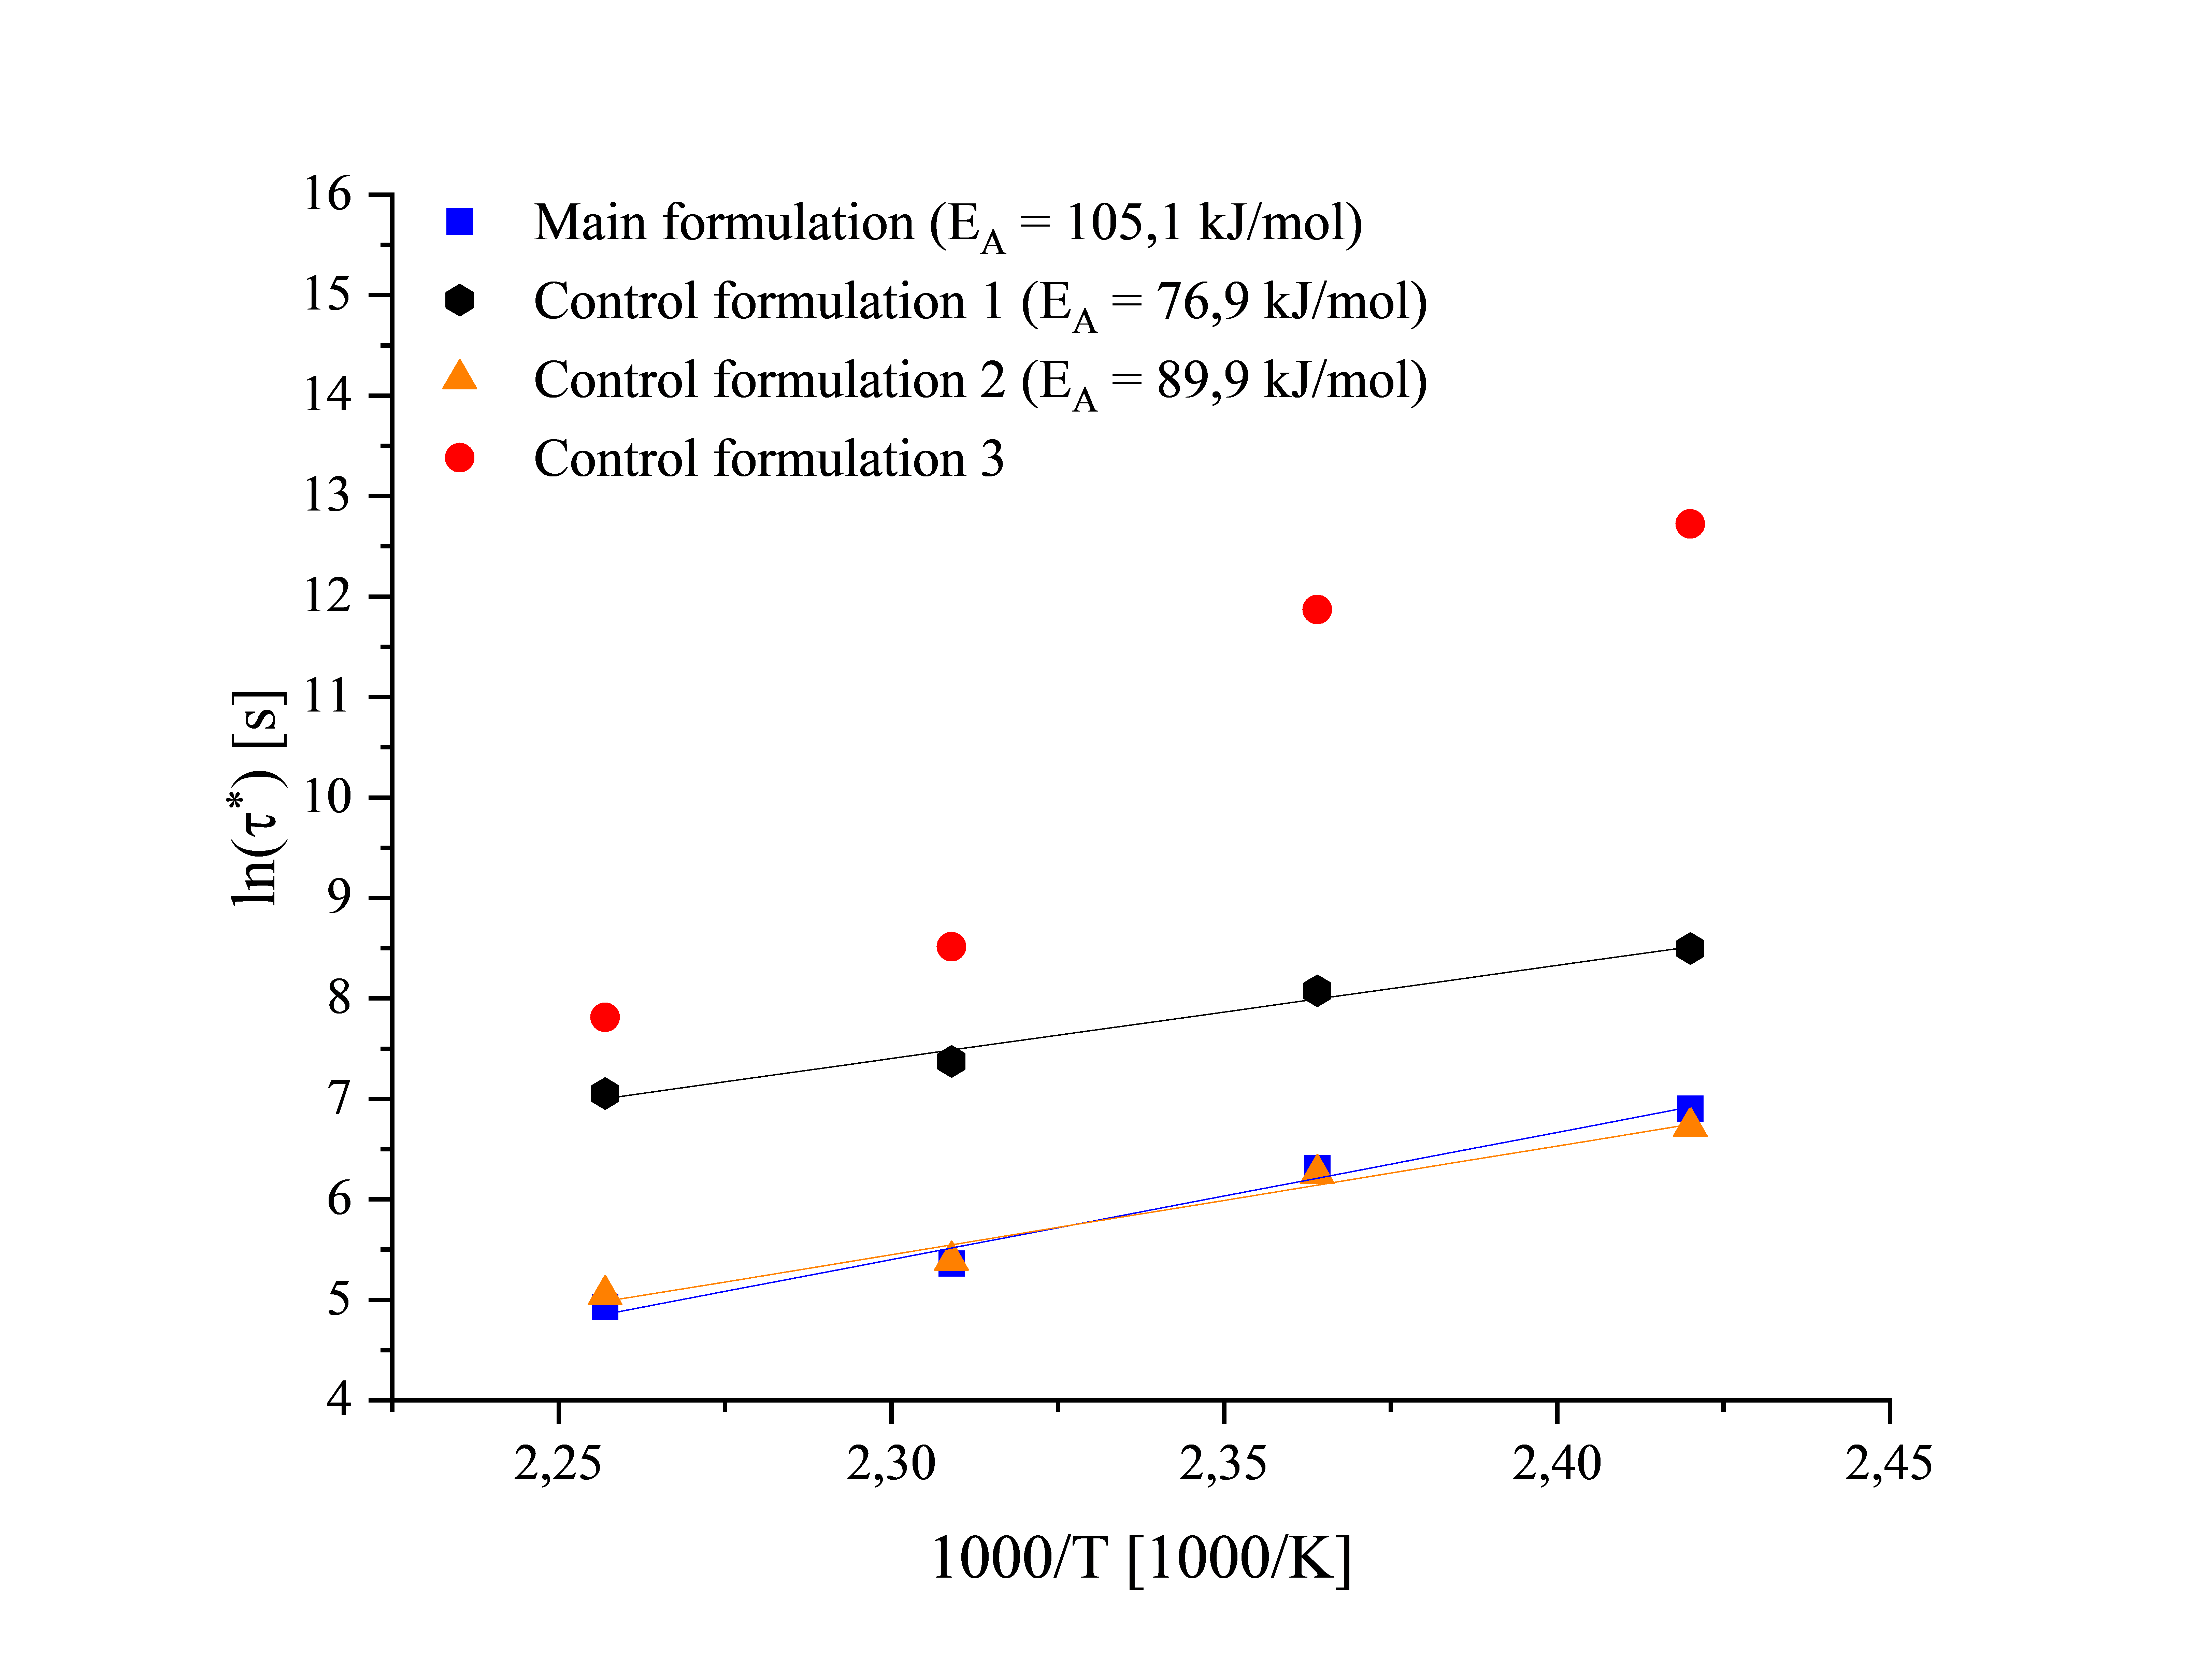
Fig.S8 Stress relaxation times (Arrhenius diagram) of the main and control formulations

The influence of the PLA particles on the curing behaviour

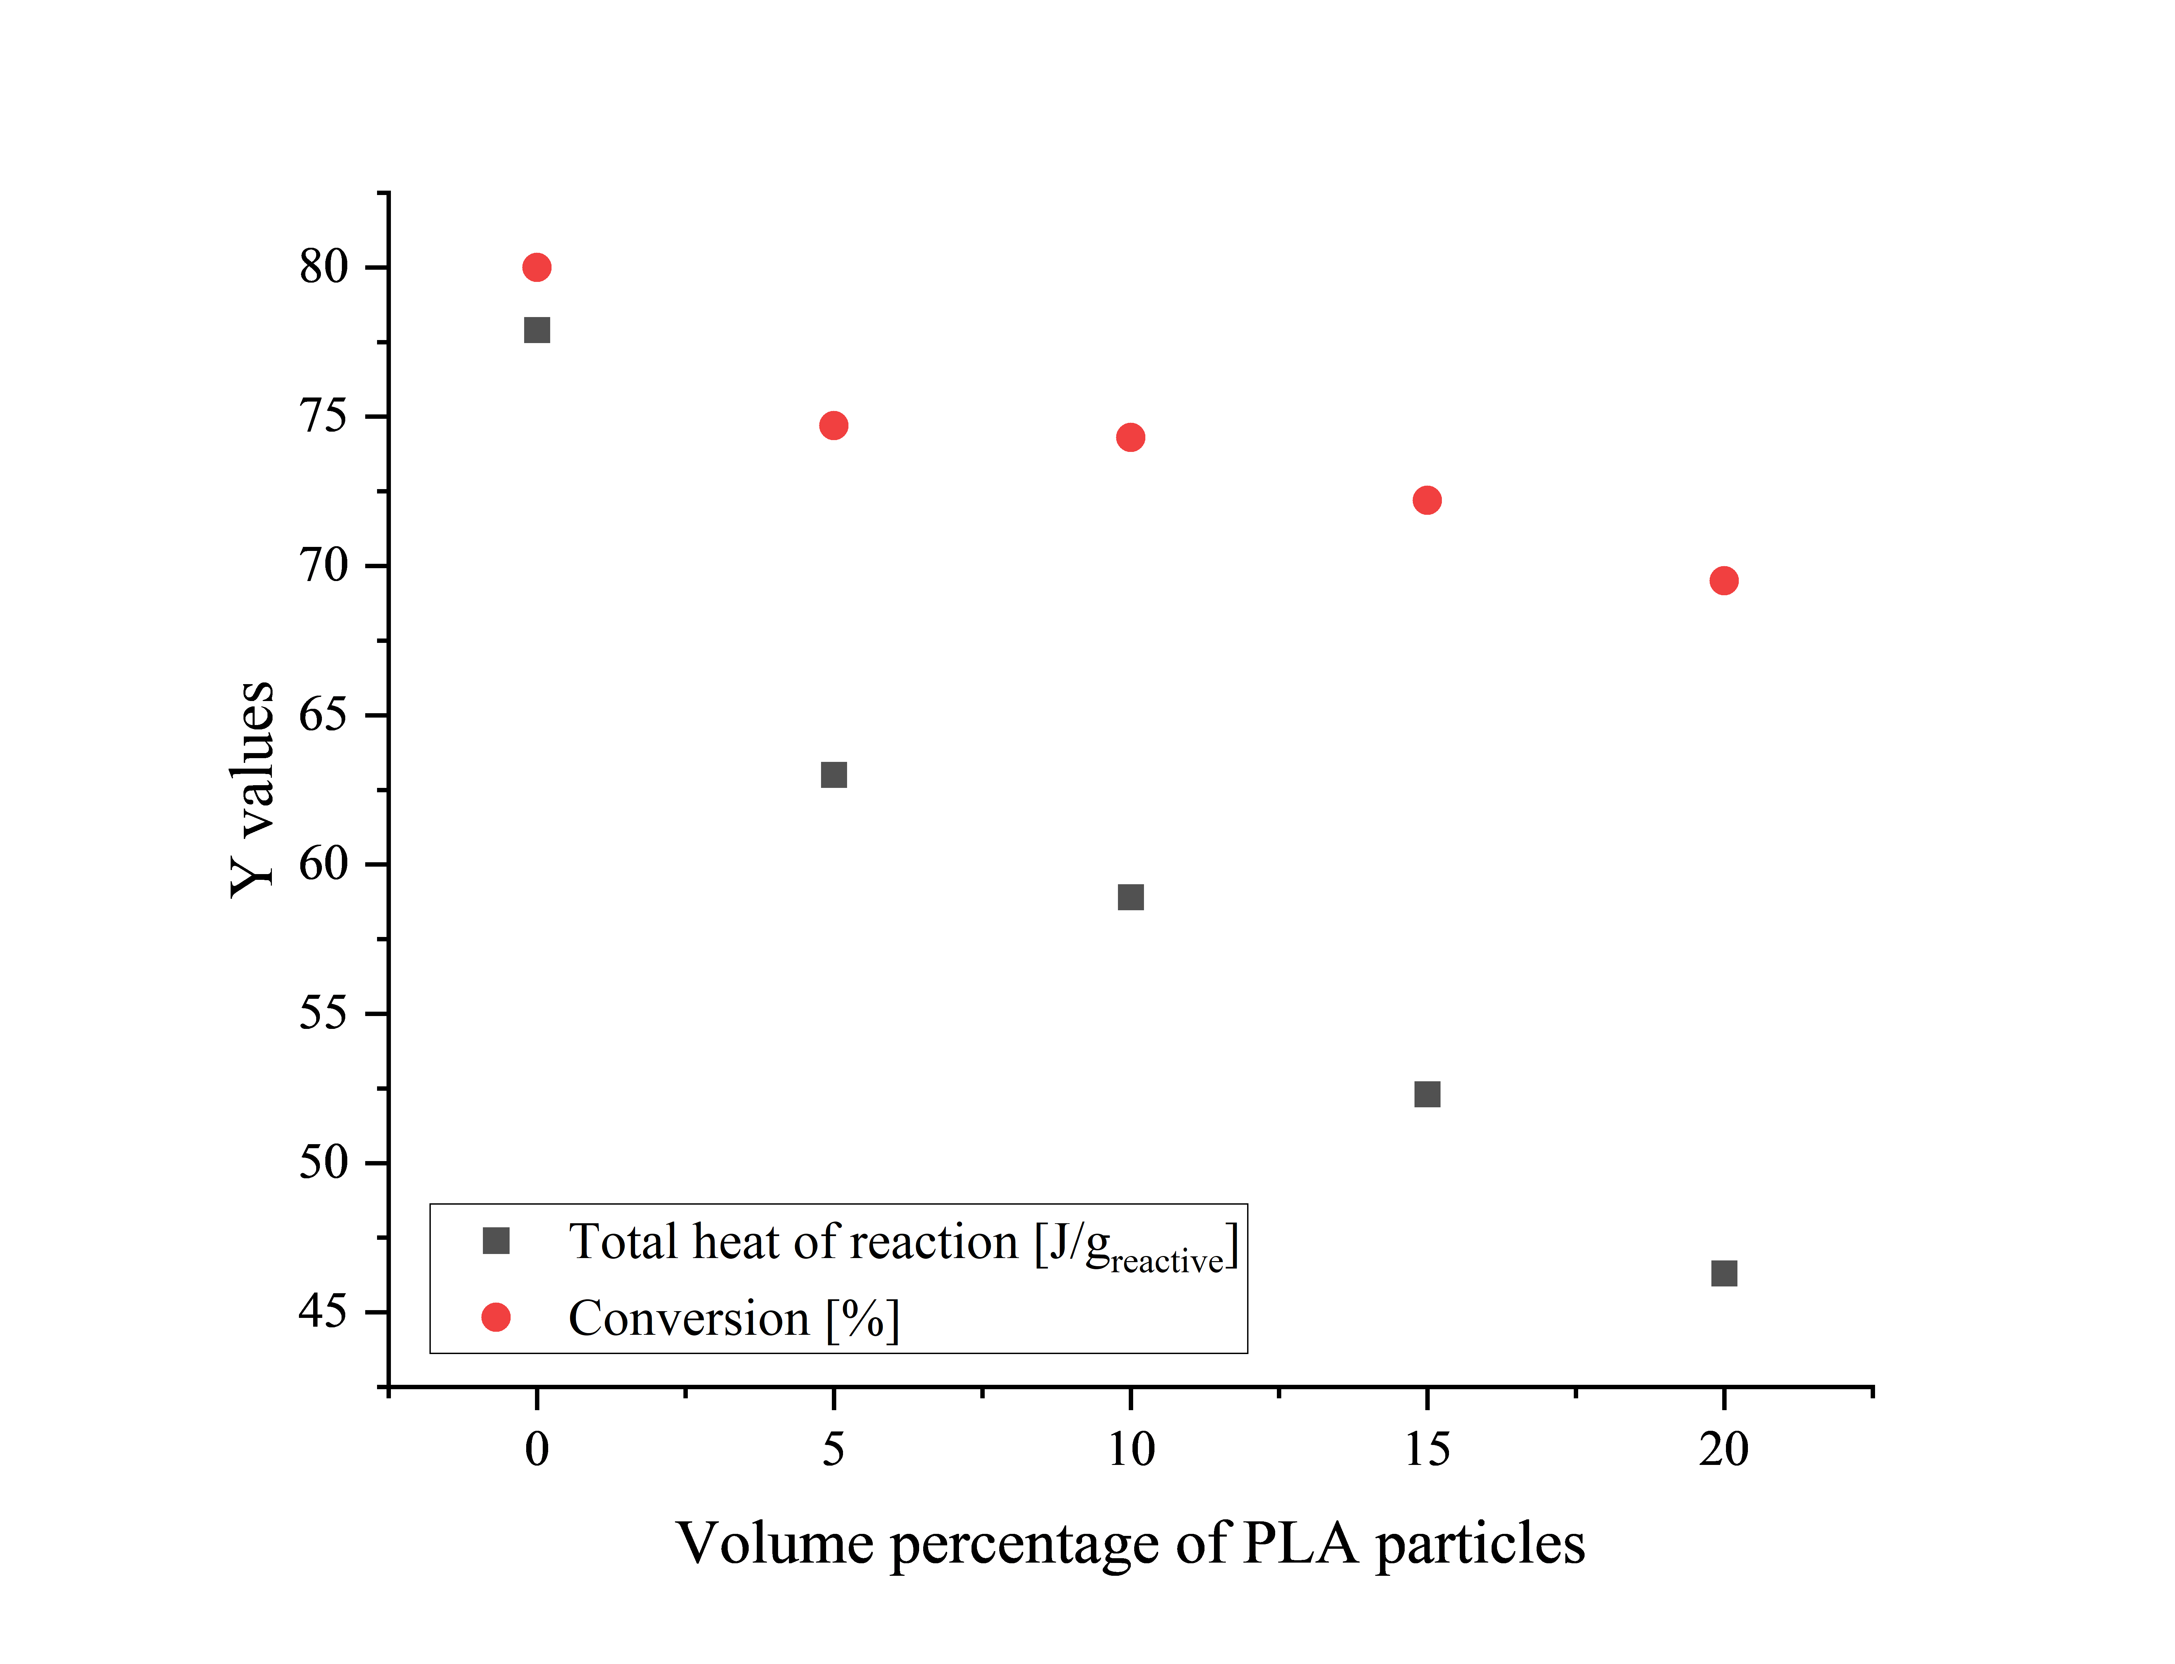
Fig.S9 Total heat of reaction and conversion in function of volume percentage of PLA particles

References

1. Zhang C, Lan Q, Zhai T, et al (2018) Melt Crystallization Behavior and Crystalline Morphology of Polylactide/Poly(ε-caprolactone) Blends Compatibilized by Lactide-Caprolactone Copolymer. Polymers 10:1181. https://doi.org/10.3390/polym10111181
2. Ronkay F, Molnár B, Nagy D, et al (2020) Melting temperature versus crystallinity: new way for identification and analysis of multiple endotherms of poly(ethylene terephthalate). J Polym Res 27:372. https://doi.org/10.1007/s10965-020-02327-7

