[Supplemental Information]

A Cure-Kinetics-Based Framework Linking Residual Stress Evolution to Strength Degradation in Carbon/Cyanate Ester Laminates.
In Jun Leeª, Sieun Je ^{b}, Jong Heon Choi ª, Hyemi Lee ^{b}, Jaejun Lee ^{b *} and Sang Yup Kim^{a*}
ªDepartment of Mechanical Engineering, Sogang University, Seoul 04107, Republic of Korea
^{b}Department of Polymer Science and Engineering, Pusan National University, Busan 46241, Republic of Korea
*Corresponding authors
Email address: jlee-pse@pusan.ac.kr (J. Lee), sangyupkim@sogang.ac.kr (S. Y. Kim)

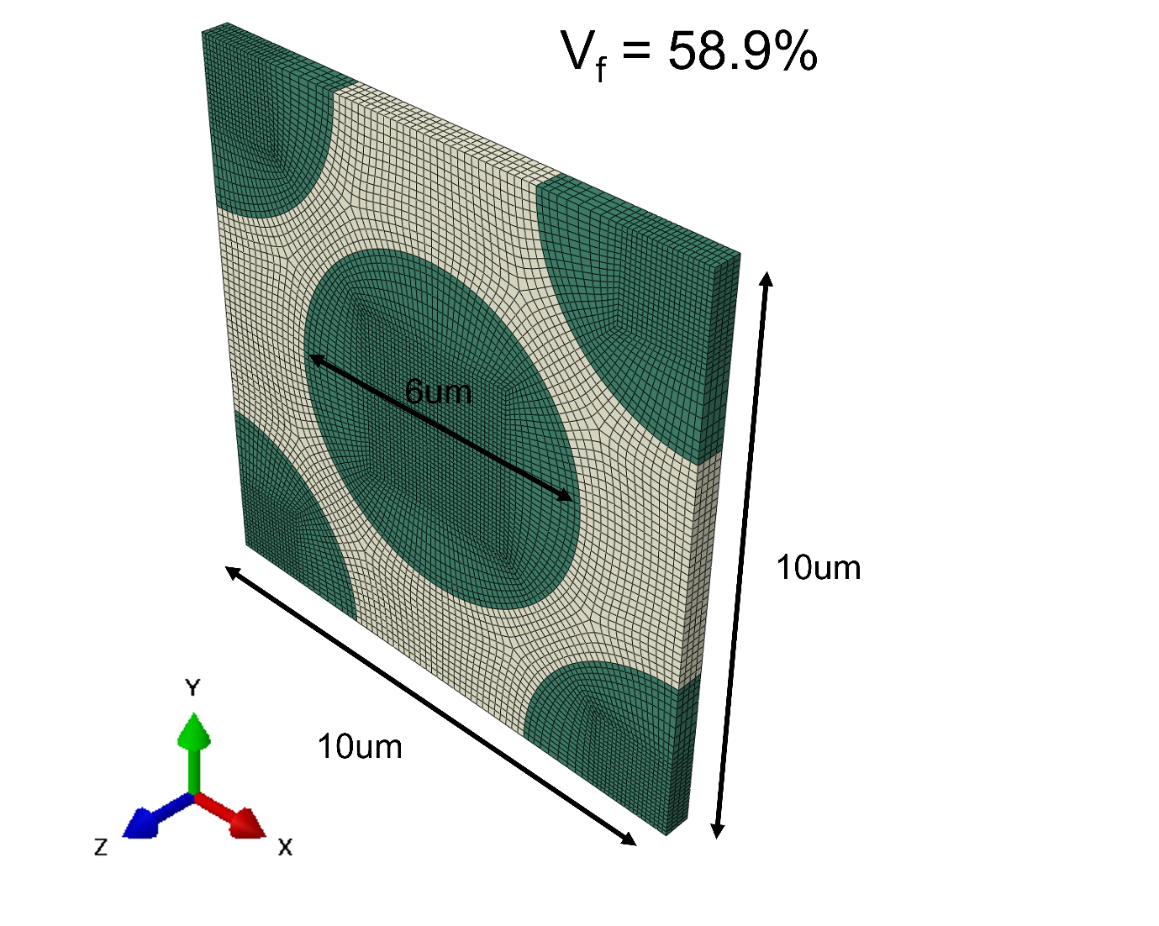
Supplemental Figure 1. RVE model geometry (fiber volume fraction = 58.9%) and mesh configuration using C3D8 elements for fiber–matrix interface analysis. The fiber volume fraction of 58.9% corresponds to the exact geometric value imposed by the idealized hexagonal packing used for periodic boundary condition implementation, while the experimentally measured fiber volume fraction is 60%.

