Supplementary Information

Fast and Energy-Efficient Resistive Switching in ZrOₓ/TaOₓ Bilayer Structures under Ultra-Low Voltage Operation for Next-Generation Memory Applications

Min Kyung Lee, Jae-Seung Jeong, Jaeho Jung, Hyun Kyu Seo, Changhwan Shin*, Gun Hwan Kim* and Min Kyu Yang*

Supporting Information 1 | Wafer-to-wafer reproducibility of ZrOₓ/TaOₓ-based device

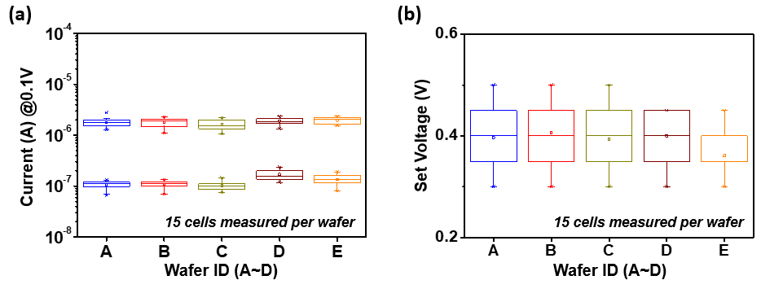
a Statistical distributions of the LRS and HRS currents measured at a read voltage of 𝑉_{read} = 0.1 V for five different wafers (A–E). b Corresponding distributions of SET voltages extracted from the same devices. For each wafer, 15 randomly selected cells were characterized, and the box plots represent the median, interquartile range, and full distribution, highlighting the wafer-to-wafer and device-to-device variability.

Supporting Information 2 | Pulse amplitude and pulse width induced device-to-device variability in LTP/LTD performance

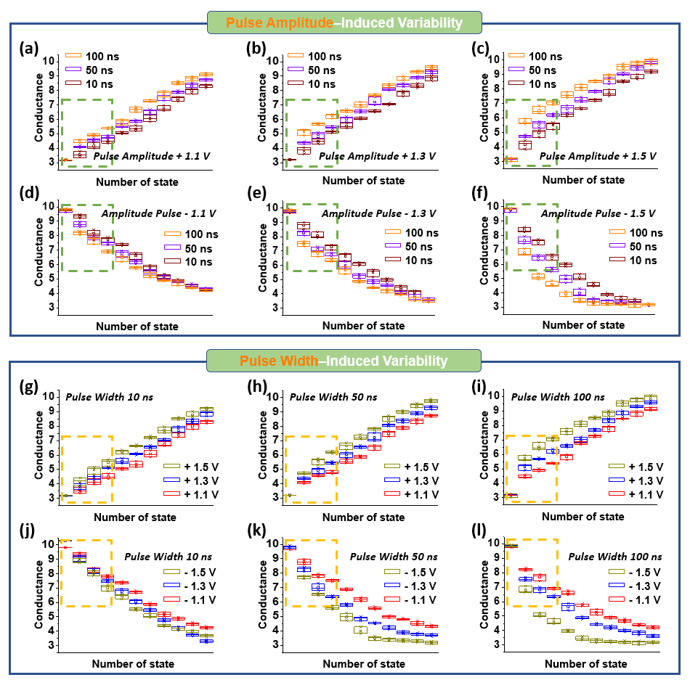
a–f State-resolved conductance evolution during LTP and LTD under pulse amplitudes of ±1.1 V, ±1.3 V, and ±1.5 V, measured at pulse widths of 10 ns, 50 ns, and 100 ns. g–l State-resolved conductance evolution during LTP and LTD under pulse widths of 10 ns, 50 ns, and 100 ns, measured at pulse amplitudes of ±1.1 V, ±1.3 V, and ±1.5 V. All data are obtained from three independent devices (N = 3). Dashed boxes indicate the initial switching regime, where device-to-device variability is most sensitive.

Supporting Information 3 | Quantitative evaluation of hardware-aware robustness and resolution scaling

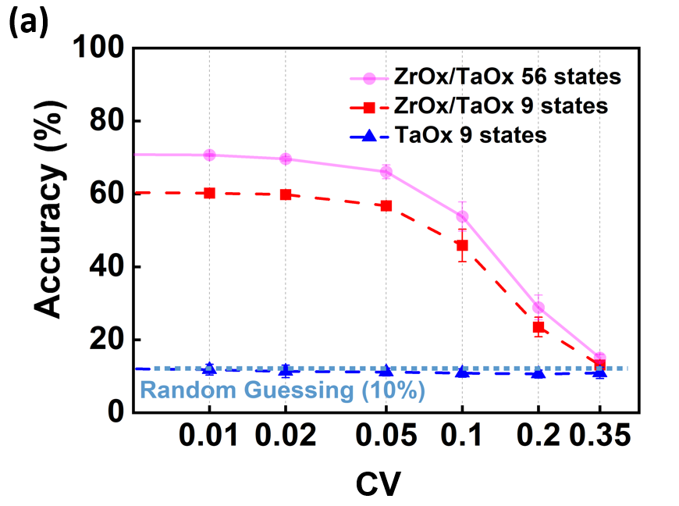
a Accuracy degradation curves for CIFAR-10 inference as a function of device-to-device (D2D) variability (CV). Comparison of inference performance between 9-measured and 56-interpolated states. The ZrOₓ/TaOₓ-based device, preserves high recognition intelligence even under substantial variation levels, demonstrating the importance of analog linearity and resolution for robust neuromorphic computing.

Table S1 | Fitting quality (R²) of Poole–Frenkel conduction at different temperatures
Device State | Temperature (°C) | R² (Adjusted R²)
HRS Positive | 25 | 0.99996
HRS Positive | 45 | 0.9946
HRS Positive | 65 | 0.99874
HRS Positive | 85 | 0.99971
HRS Positive | 25 | 0.99996
HRS Positive | 45 | 0.9946
HRS Positive | 65 | 0.99874
HRS Positive | 85 | 0.99971
HRS Negative | 25 | 0.99678
HRS Negative | 45 | 0.99375
HRS Negative | 65 | 0.99861
HRS Negative | 85 | 0.99761
LRS Negative | 25 | 0.99863
LRS Negative | 45 | 0.99434
LRS Negative | 65 | 0.99617
LRS Negative | 85 | 0.99664

The PF fitting was performed in the high-field region of the I–V characteristics using the ln(I/E) versus $\sqrt{E}$ representation for various device states and bias polarities. The reported values correspond to the coefficient of determination (R²) and the adjusted R², demonstrating the reliability of PF conduction analysis across the measured temperature range.

Table S2 | Fitting quality (R²) of Arrhenius plots at different read voltages
Device State | Read Voltage (V) | Temperature (°C) | R² (Adjusted R²)
HRS Positive | 0.10 | 25-85 | 0.99834
HRS Positive | 0.15 | 25-85 | 0.99789
HRS Positive | 0.2 | 25-85 | 0.99399
HRS Positive | 0.25 | 25-85 | 0.99966
HRS Positive | 0.3 | 25-85 | 0.99099
HRS Positive | 0.10 | 25-85 | 0.99708
HRS Positive | 0.15 | 25-85 | 0.99198
HRS Positive | 0.2 | 25-85 | 0.99752
HRS Negative | 0.25 | 25-85 | 0.9914
HRS Negative | 0.3 | 25-85 | 0.99751
HRS Negative | 0.10 | 25-85 | 0.99481
HRS Negative | 0.15 | 25-85 | 0.99789
LRS Negative | 0.2 | 25-85 | 0.99699
LRS Negative | 0.25 | 25-85 | 0.99914
LRS Negative | 0.3 | 25-85 | 0.99866
LRS Negative | 0.10 | 25-85 | 0.99956

Arrhenius fitting was conducted over the temperature range of 25–85 °C using temperature-dependent I–V measurements for both HRS and LRS states under positive and negative bias conditions. The reported R² and adjusted R² values indicate consistent and reliable thermally activated conduction behavior across different read voltages.

Table S3 | Benchmarking of Neuromorphic ReRAM Devices: Device Structure, Operating Conditions, and Reliability
Structure | V_{Form} (V) | V_{SET} (V) | V_{RESET} (V) | Speed (s) | Endurance | Retention  (s @ °C)
ZrO_{x/}TaO_{x}  (This work) | +1.35 | +0.4 | -1 | 10 ns | 10⁹ | 10⁴ s @ 85 °C
[63] Pt/HfO₂/Ag | +0.7 | +0.5 | -0.3 | 50 µs | 10⁸ | 10⁸ s @ 70 °C
[64] TiN/HfO₂/Ti/Cu | +2 | +0.6 | -0.5 | 50 µs | 10³ | 10⁸ s @ 200 °C
[65] ITO/WO_{X}/ITO | - | +2 | −1.5 | 10 µs | 300 | 10⁴
[66] Ti/HfO₂/Pt | +3.25 | +0.7 | -0.8 | 1 µs | - | 2×10³

The table compares the forming, SET, and RESET voltages, switching speed, endurance, and retention characteristics of representative ReRAM devices reported in the literature. The performance of the ZrOₓ/TaOₓ-based device developed in this work is highlighted for direct comparison.

References
63. Banerjee, W., Kim, S., Lee, S., Lee, D., & Hwang, H. (2021). An Efficient Approach Based on Tuned Nanoionics to Maximize Memory Characteristics in Ag‐Based Devices. Advanced Electronic Materials, 7. https://doi.org/10.1002/aelm.202100022
64. Banerjee, W., & Hwang, H. (2019). Quantized Conduction Device with 6-Bit Storage Based on Electrically Controllable Break Junctions. Advanced Electronic Materials, 5(12):1900744. https://doi.org/10.1002/aelm.201900744
65. Kim, J., Park, J., & Kim, S. (2022). Bipolar Switching Characteristics of Transparent WOX-Based RRAM for Synaptic Application and Neuromorphic Engineering. Materials, 15(20). https://doi.org/10.3390/ma15207185
66. Ku, B., Abbas, Y., Kim, S., Sokolov, A. S., Jeon, Y.-R., & Choi, C. (2019). Improved resistive switching and synaptic characteristics using Ar plasma irradiation on the Ti/HfO2 interface. Journal of Alloys and Compounds, 797:277–283. https://doi.org/10.1016/j.jallcom.2019.05.114

