Hypoxia Nanoalleviator with Dual Disruption of Iron and Redox Metabolism for Efficient Ferroptosis-Mediated Cancer Immunotherapy
Weimin Yin^{1 2 #}, Yang Li^{1 #}, Shiyu Chen¹, Hui Zhi¹, Jiao Chang¹, Nana Chen¹, Zichen Yang¹, Yaping Xiao⁴, Yan Li¹, Yongyong Li¹, Bin Ma^{3*}, Haiqing Dong^{1 *}

- Key Laboratory of Spine and Spinal Cord Injury Repair and Regeneration, Ministry of Education, Tongji Hospital, Department of Pharmacy, School of Medicine, Tongji University, 389 Xincun Road, Shanghai 200065, China
- Key Laboratory of Prevention and Treatment of Cardiovascular and Cerebrovascular Diseases (Ministry of Education), School of Basic Medicine, Gannan Medical University, Ganzhou 341000, China
- Division of Spine Surgery, Department of Orthopaedics, Tongji Hospital, School of Medicine, Tongji University, 389 Xincun Road, Shanghai 200065, China
- School of Life and Health Technology, Dongguan University of Technology, Dongguan 523808, China
# Equal contribution
The correspondence author:
Haiqing Dong, Ph.D Professor
Email: inano_donghq@tongji.edu.cn
Bin Ma, M.D Professor
Mabin1995@tongji.edu.cn

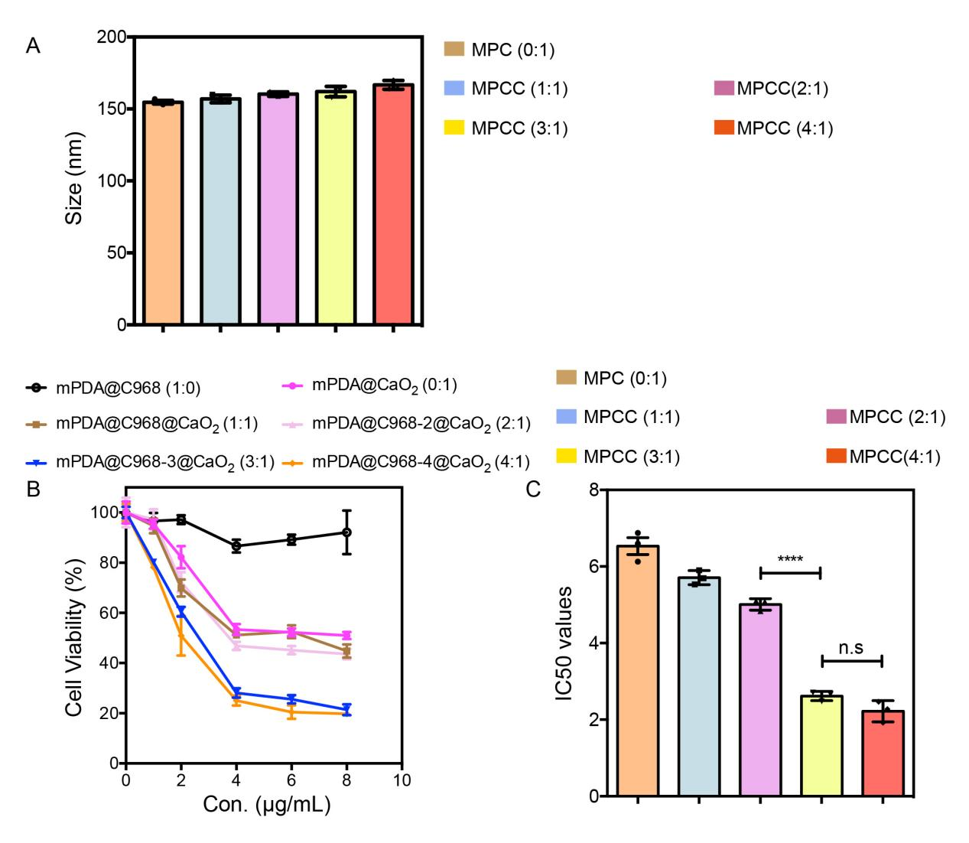
Figure S1. (A) Hydrodynamic size (determined by dynamic light scattering, DLS) of MPCC at different mass ratios of C968:CaO₂(w/w: 0:1, 1:1, 2:1, 3:1, 4:1). (B) Cell viability of 4T1 tumor cells after treatment with MPCC prepared at different mass ratios of C968:CaO₂(w/w: 1:0, 0:1, 1:1, 2:1, 3:1, 4:1) under hypoxic conditions. (C) Statistical analysis of IC₅₀ values derived from the cell viability curves in 4T1 tumor cells.

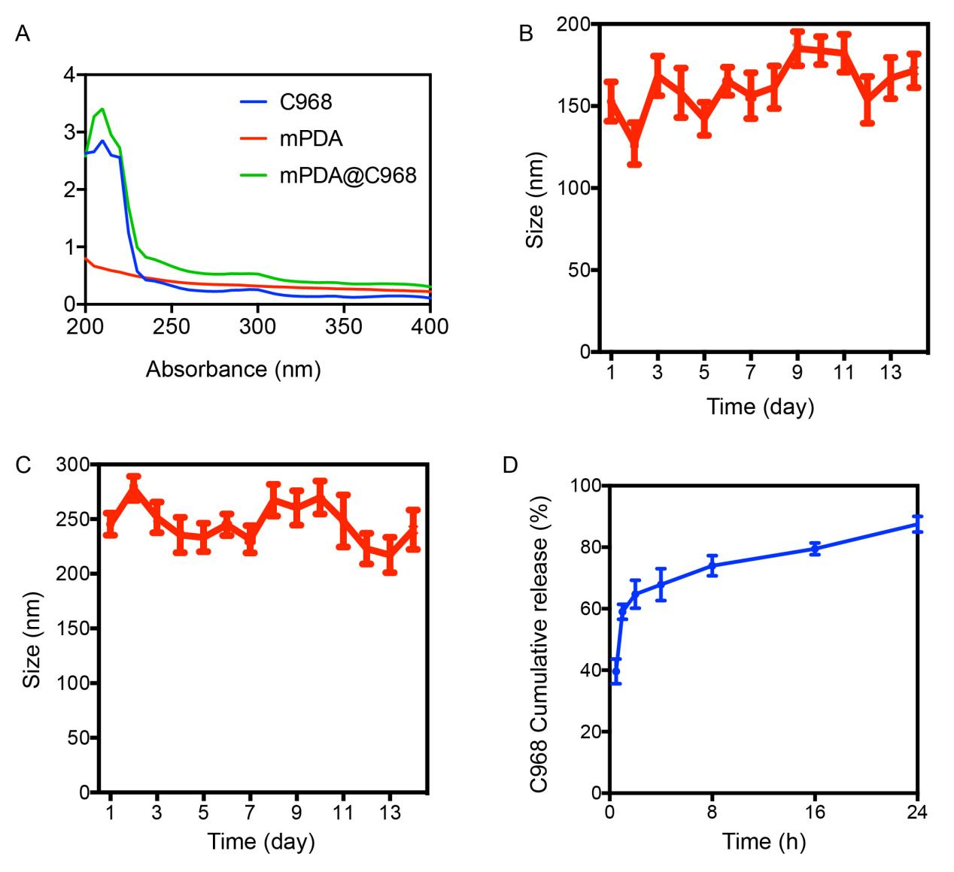
Figure S2. (A) The UV-Vis absorption spectra of free C968, mPDA, and mPDA@C968. (B-C) Hydrodynamic size changes of MPCC over 14 days in PBS (B) and PBS supplemented with 2% FBS (C) at 37 °C. (D) Cumulative release profile of C968 from MPCC in DMSO at 37°C.
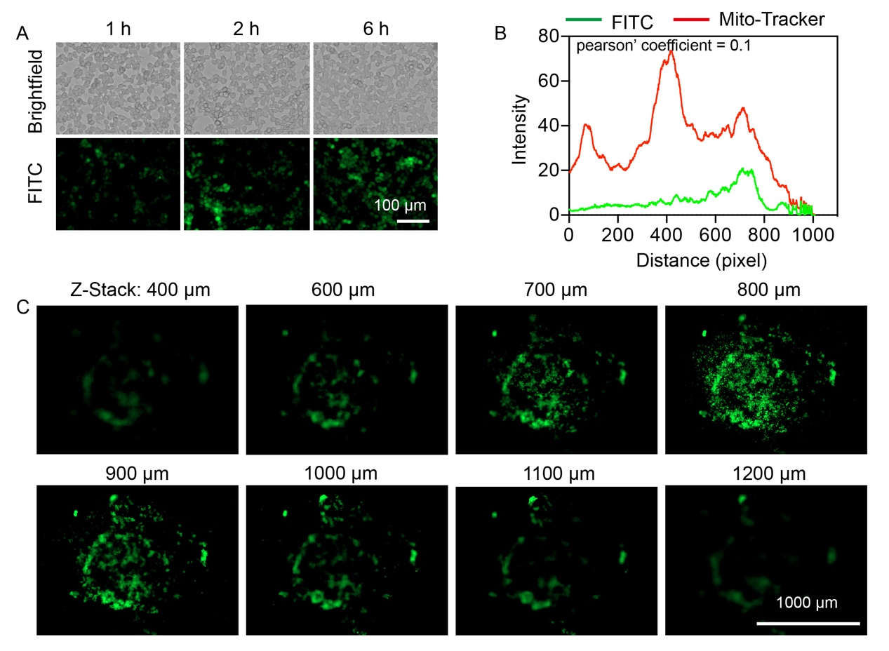
Figure S3. (A) Representative fluorescence images showing time-dependent intracellular uptake of MPCC@FITC (green) in 4T1 tumor cells at indicated time points. Nuclei were counterstained with DAPI (blue). Scale bar: 100 μm. (B) Pearson’s correlation coefficient quantifying colocalization between MPCC@FITC (green) and mitochondria (MitoTracker Red) in 4T1 cells. (C) Representative confocal z-stack images of 3D tumor spheroid penetration assay demonstrating penetration of MPCC@FITC (green) into 4T1 tumor spheroids at different depths (0-1200 μm). Scale bar: 1000 μm.

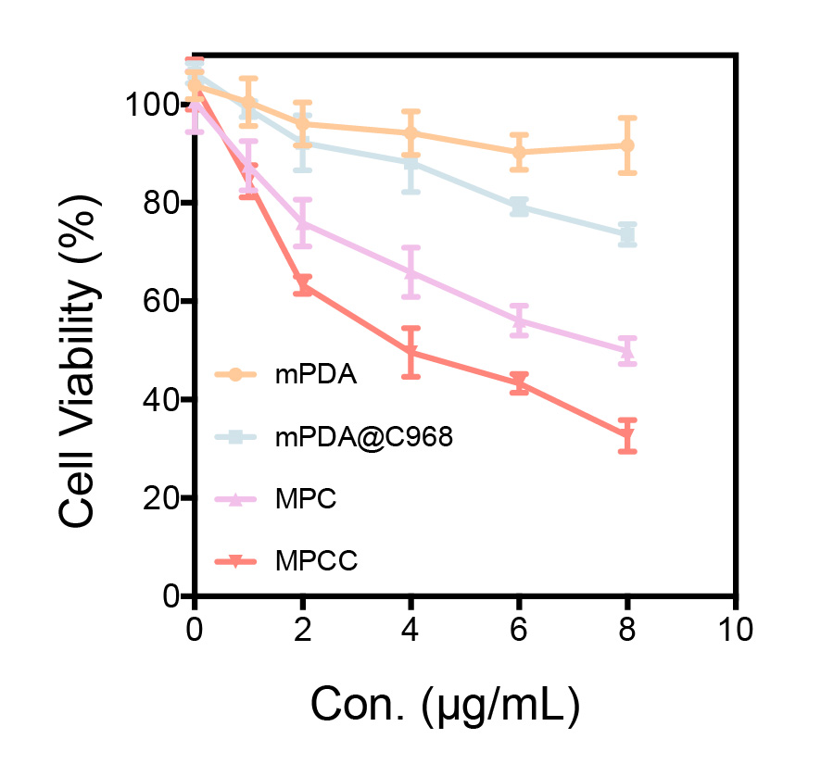
Figure S4. Cell viability of MB231 tumor cells after treatment with increasing concentrations of mPDA, mPDA@C968, MPC, and MPCC in a hypoxic chamber (37℃, 5% O₂, 5%CO₂, 90%N₂ balance).

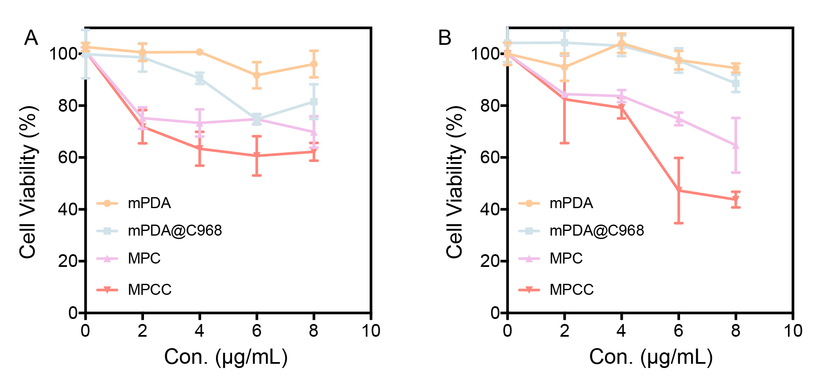
Figure S5. (A-B) Viabilities of 3T3 (A) and HUVECs (B) after treatment with different concentrations of mPDA, mPDA@C968, MPC, and MPCC.

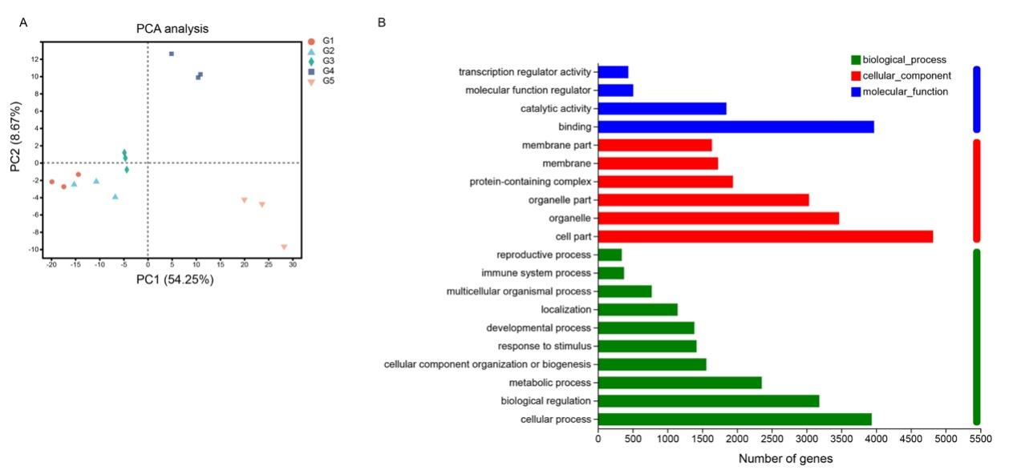
Figure S6. (A) PCA of RNA-seq data from 4T1 tumor cells after different treatments (G1: PBS, G2: mPDA, G3: mPDA@C968, G4: MPC, G5: MPCC) (B) GO functional classification and enrichment analysis of differentially expressed genes between PBS control and MPCC treatment groups.

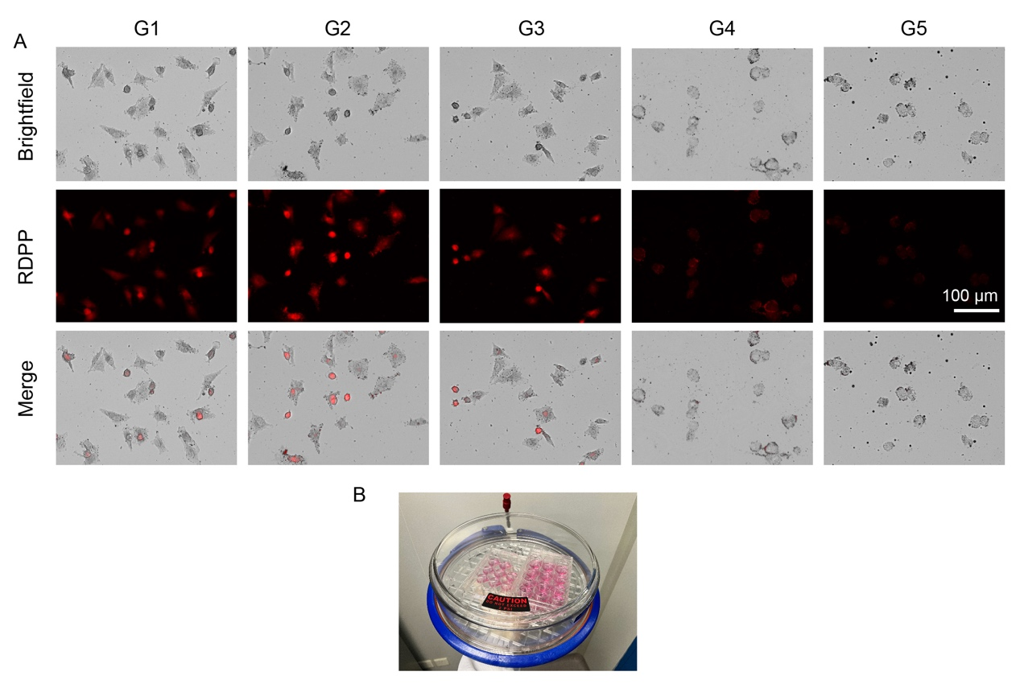
Figure S7. (A) Representative fluorescence images of 4T1 tumor cells dyed with the oxygen-sensitive probe Ru(dpp)₃(PF₆)₂ after treatment with PBS (G1), mPDA (G2), mPDA@C968 (G3), MPC (G4), or MPCC (G5) in a hypoxic chamber. Scale bar: 100 μm. (B) Schematic illustration of the hypoxic chamber setup used to simulate a tumor microenvironment (37 °C, 5% O₂, 5% CO₂, 90% N₂ balance).
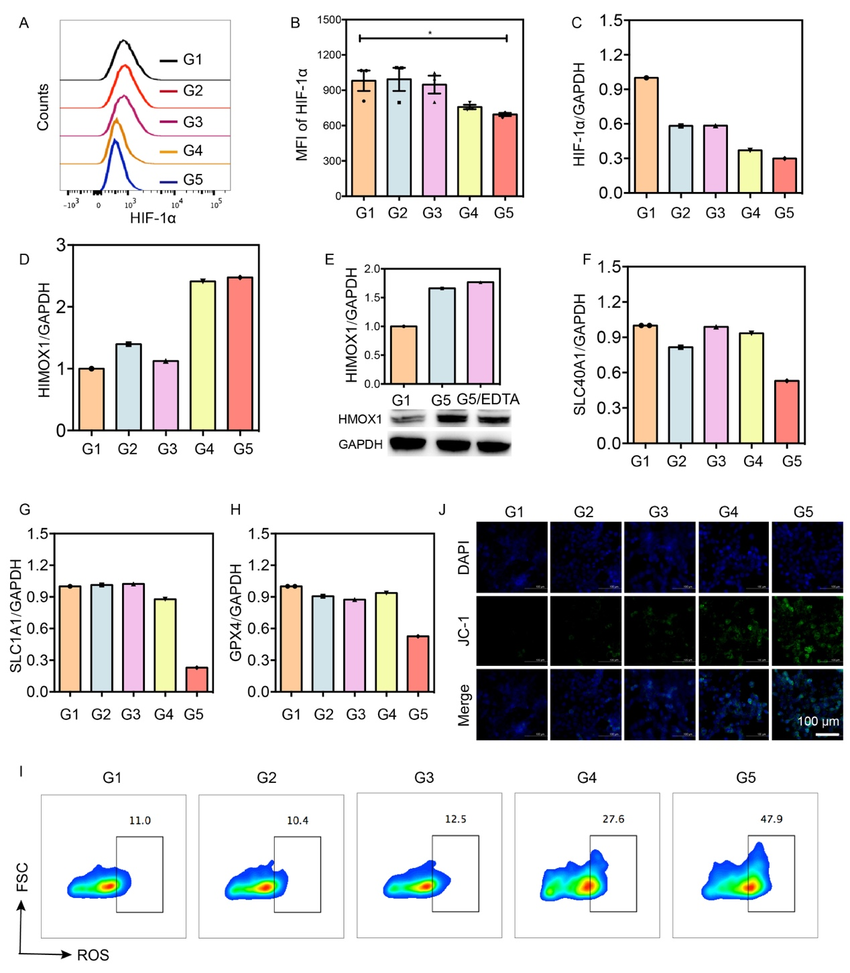

Figure S8. (A-B) Representative flow cytometry analysis of HIF-1α expression (A) and corresponding quantification of MFI (B) in 4T1 tumor cells. (C–D) Quantitative analysis of relative expression levels of HIF-1α (C), HMOX1 (D) in 4T1 cells after the indicated treatment. (E) Representative western blot and corresponding densitometric quantification of HMOX1 protein expression in 4T1 cells after treated with EDTA. (F-H) Quantitative analysis of relative expression levels of SLC40A1 (F), SLC1A1 (G), and GPX4 (H) in 4T1 cells after the indicated treatments. (I) Representative FACS of intracellular ROS levels in 4T1 tumor cells after different treatments. (J) Representative CLSM images demonstrating changes in mitochondrial membrane potential in 4T1 tumor cells stained with JC-1 after different treatments. Scale bar: 100 μm. (G1: PBS, G2: mPDA, G3: mPDA@C968, G4: MPC, G5: MPCC)

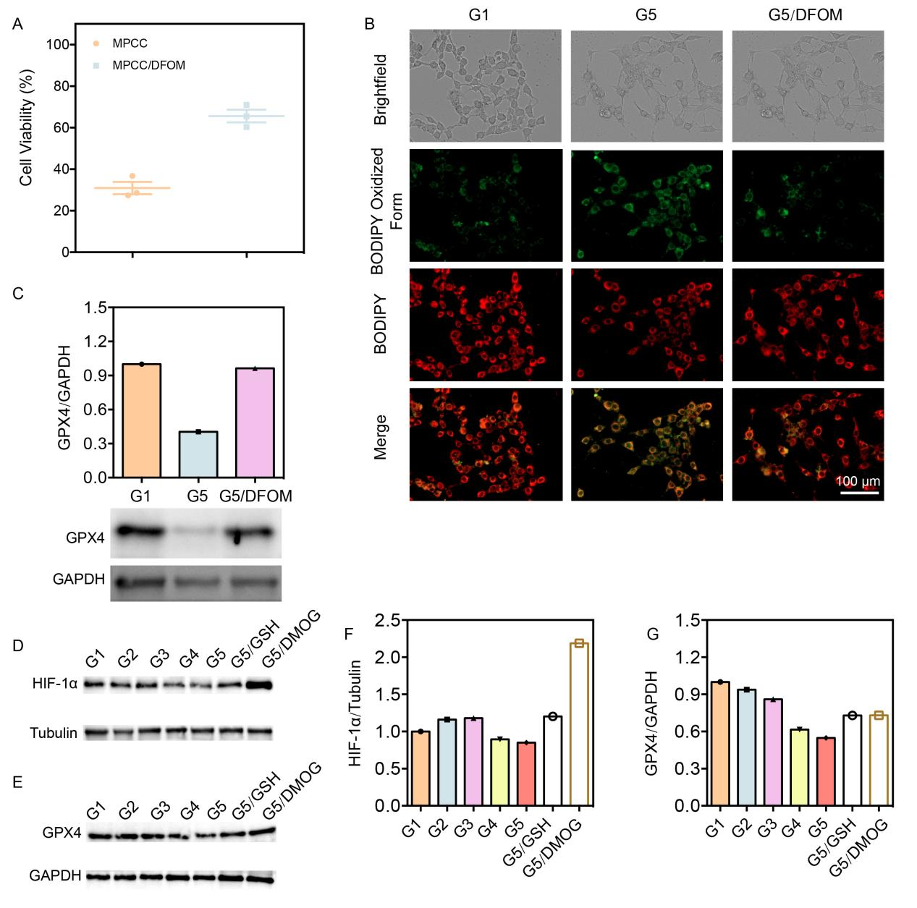
Figure S9. (A) Viabilities of 4T1 tumor cells treated with MPCC or MPCC combined with DFOM. (B) Fluorescence images of 4T1 tumor cells stained with C11-BODIPY level after treatments (G1, G5 and G5/DFOM, scale bar: 100 μm). (C) Representative western blot and corresponding densitometric quantification of GPX4 protein expression in 4T1 tumor cells after treatment with MPCC alone (G5) or MPCC combined with DFOM (G5/DFOM). (D–G) Representative western blot and corresponding densitometric quantification of HIF-1α (D, F) and GPX4 (E, G) protein expression across different treatment groups in 4T1 tumor cells under hypoxic conditions. (G1: PBS, G2: mPDA, G3: mPDA@C968, G4: MPC, G5: MPCC)

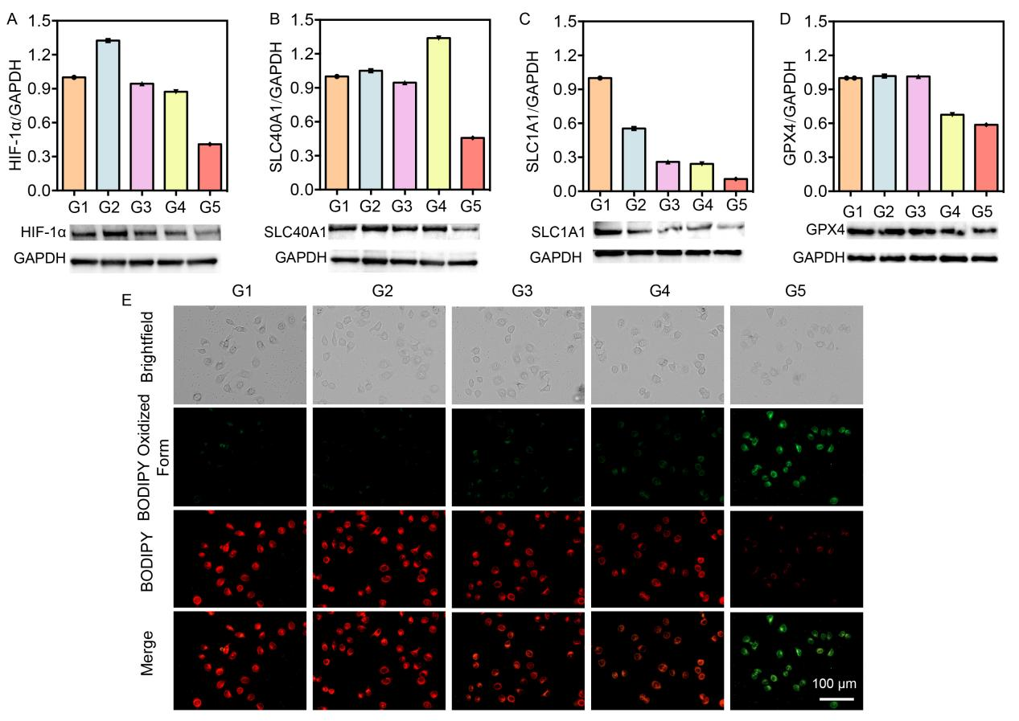Figure S10. (A-D) Representative western blots (upper panels) and corresponding quantification of HIF-1α (A), SLC40A1 (B), SLC1A1 (C), and GPX4 (D) in MB231 cells after the indicated treatments. (E) Representative fluorescence images of MB231 cells stained with C11-BODIPY after different treatments. Scale bar: 100 μm. (G1: PBS, G2: mPDA, G3: mPDA@C968, G4: MPC, G5: MPCC)

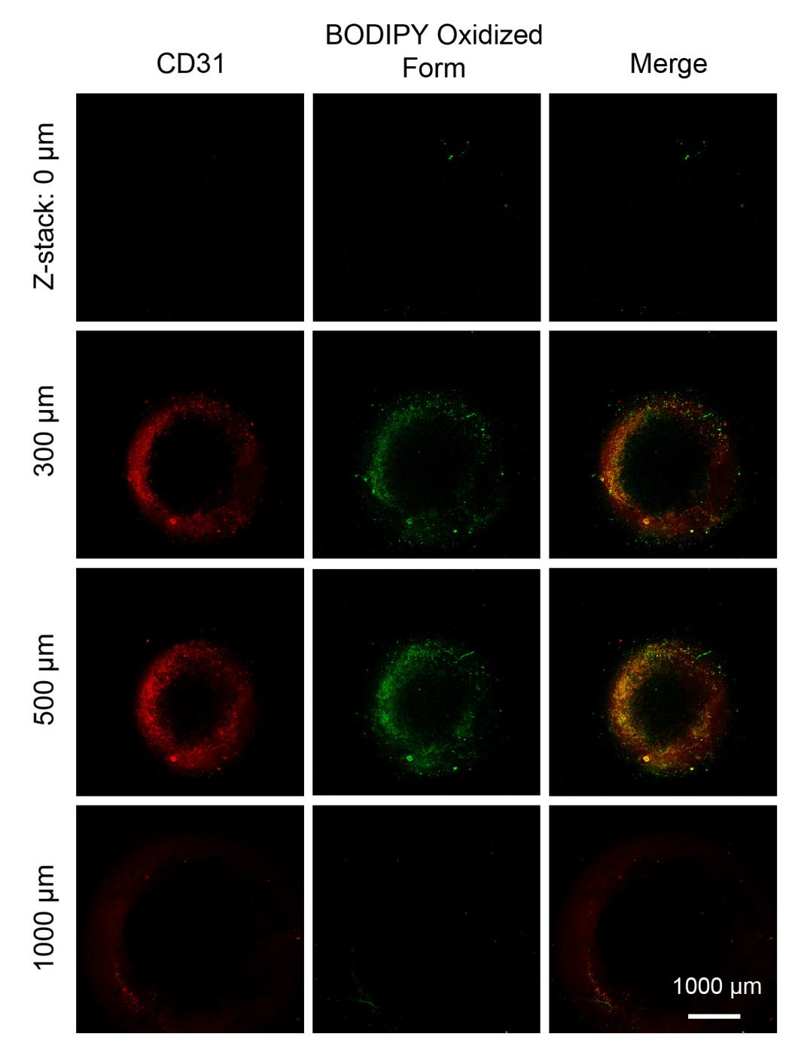
Figure S11. Representative CLSM Z-stack images showing the relationship between CD31 (vascular endothelium) and lipid peroxidation in 3D tumor model. Scale bar: 1000 μm.

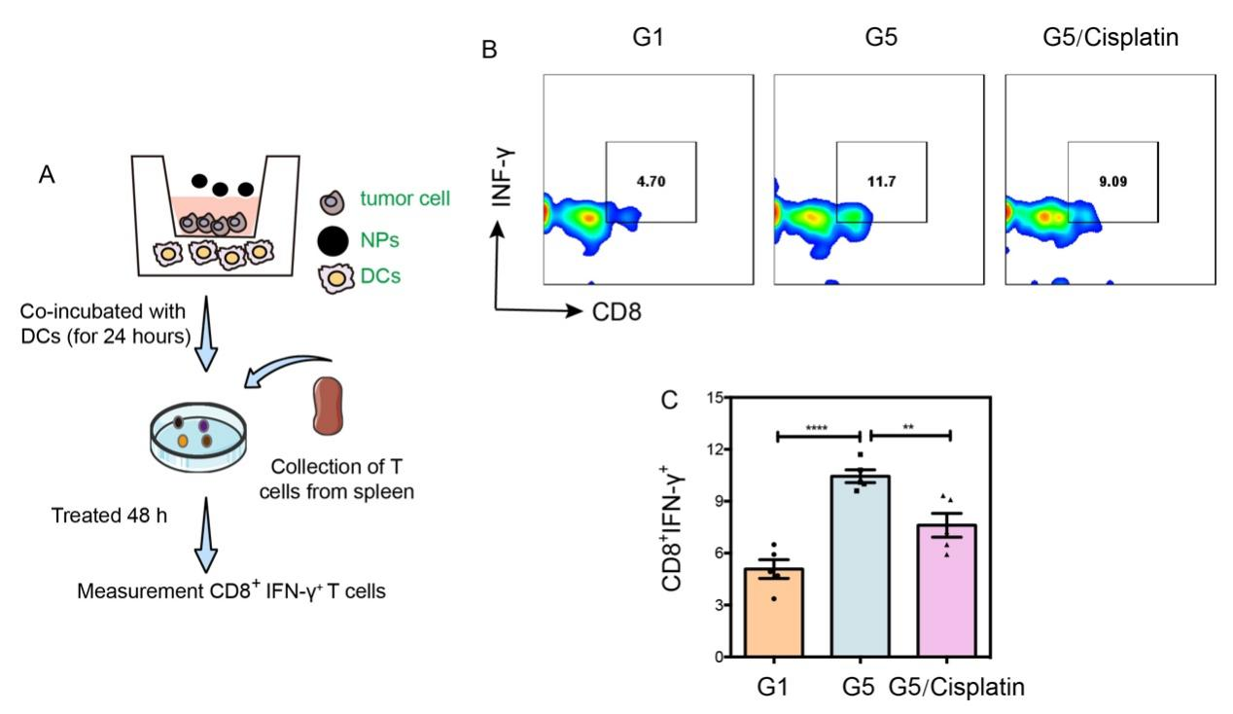
Figure S12. (A) Schematic illustration of the co-culture model used to evaluate T cell activation. (B-C) Representative FACS of CD8⁺IFN-γ⁺ T cells (B) and corresponding quantitative statistical analysis (C) following different treatments in the co-culture system. (G1: PBS, G2: mPDA, G3: mPDA@C968, G4: MPC, G5: MPCC)

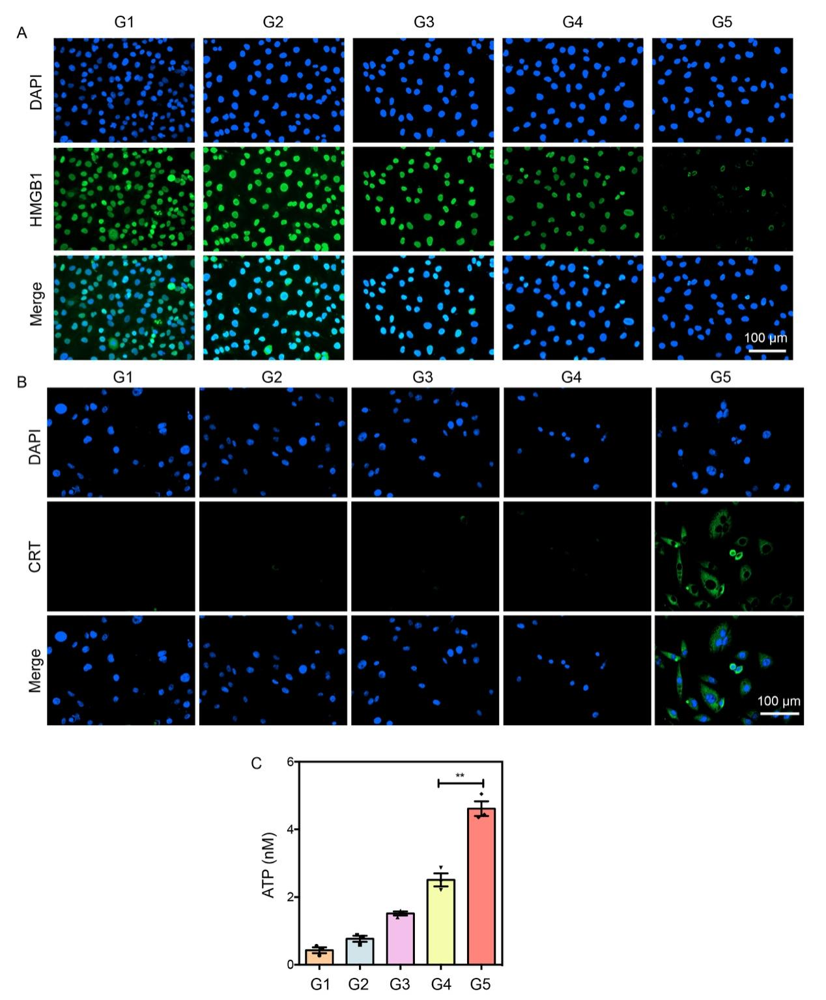
Figure S13. (A) Representative fluorescence images showing HMGB1 leakage from MB231 tumor cells after different treatments. Scale bar: 100 μm. (B) Representative fluorescence images of calreticulin (CRT) exposure on the surface of MB231 tumor cells after the indicated treatments. Scale bar: 100 μm. (C) Quantitative analysis of extracellular ATP release from MB231 tumor cells following different treatments. (G1: PBS, G2: mPDA, G3: mPDA@C968, G4: MPC, G5: MPCC)

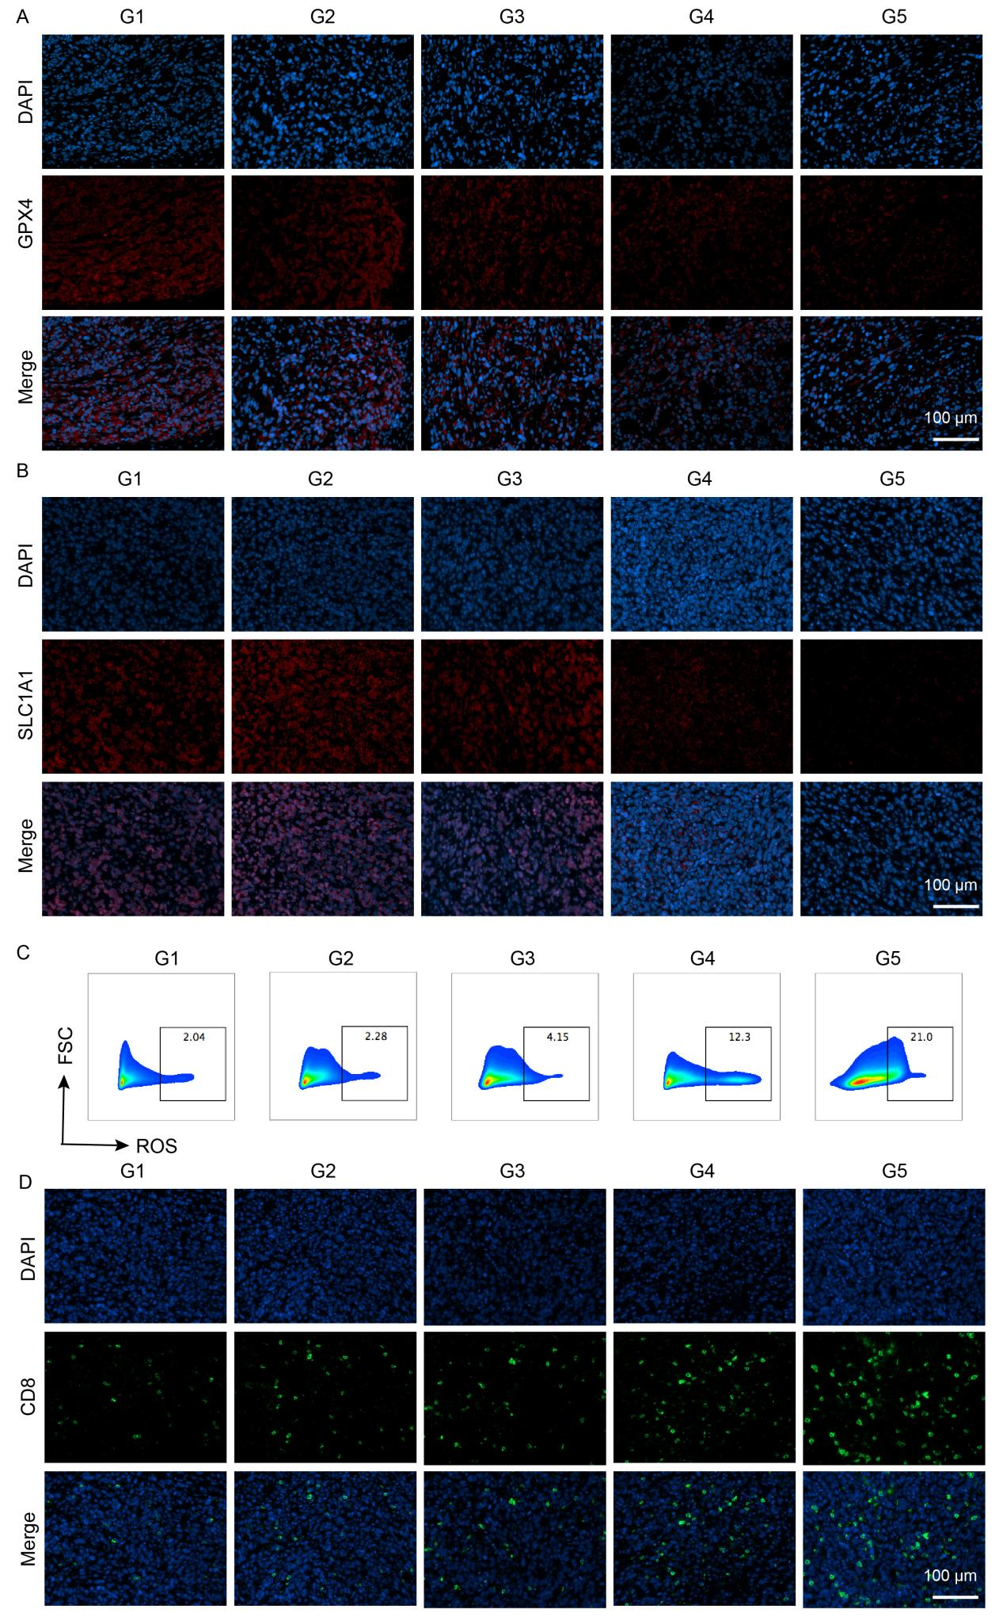
Figure S14. (A-B) Representative immunofluorescence staining of GPX4 (A) and SLC1A1 (B) in tumor tissues from mice after different treatments. Scale bar: 100 μm.
(C) Representative FACS intracellular ROS levels in dissociated tumor tissues after the indicated treatments. (D) Representative immunofluorescence staining of CD8⁺ T cells infiltration in tumor tissues after different treatments. Scale bar: 100 μm. (G1: PBS, G2: mPDA, G3: mPDA@C968, G4: MPC, G5: MPCC)
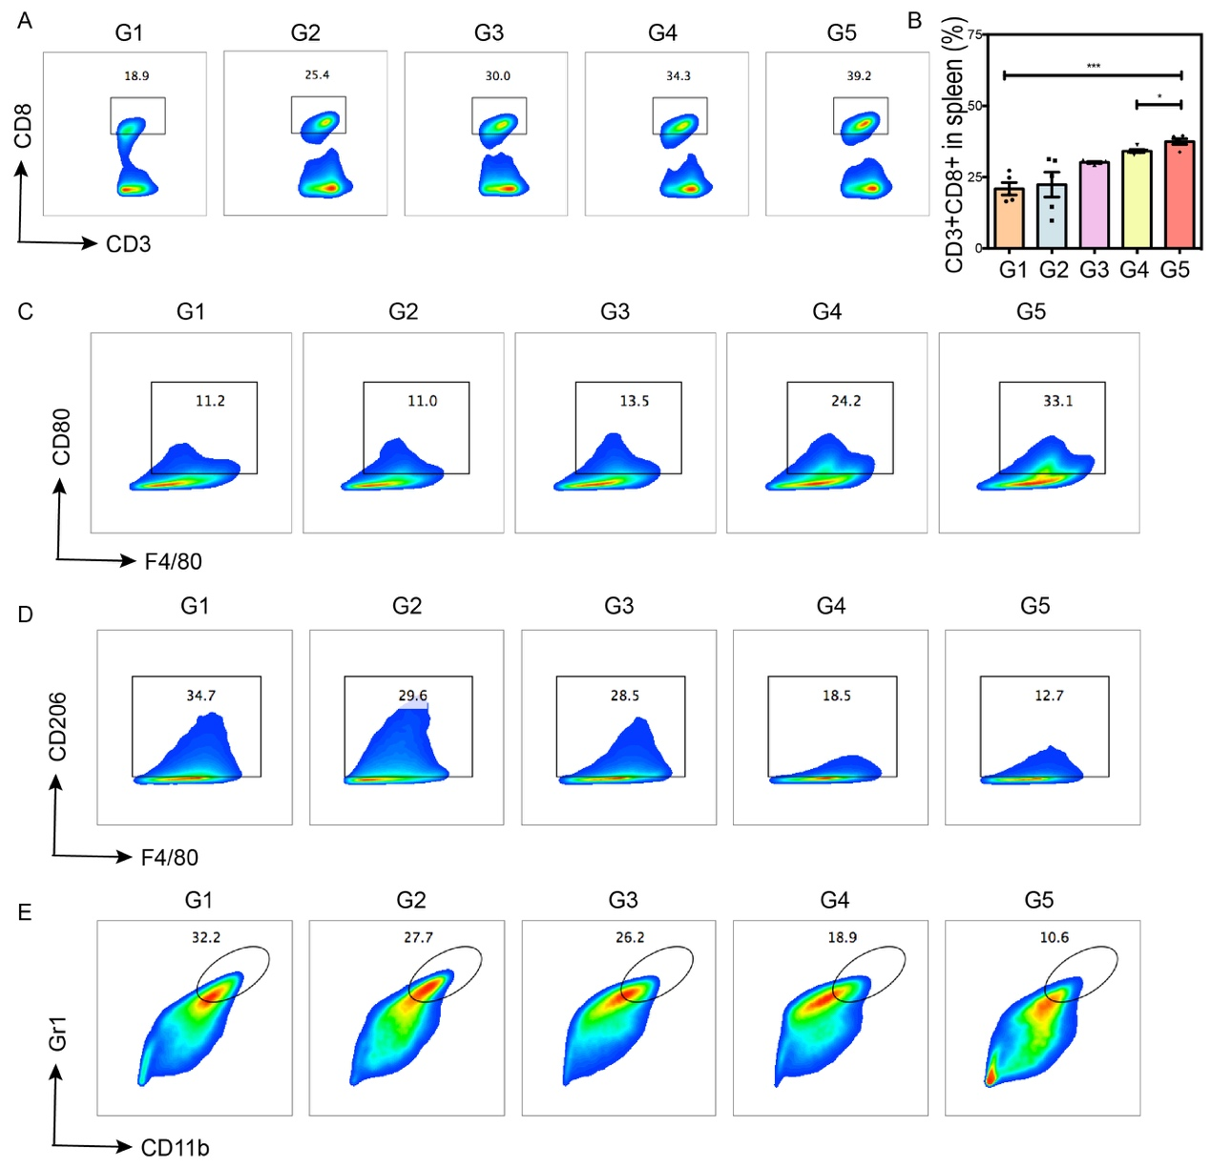
Figure S15. (A-B) Representative FACS analysis of CD3⁺CD8⁺ T cells in spleen tissues and corresponding quantitative statistical analysis after different treatments.
(C-D) Representative FACS analysis of M1-like macrophages (F4/80⁺CD80⁺) (C) and M2-like macrophages (F4/80⁺CD206⁺) (D) in spleen or tumor tissues after the indicated treatments. (E) Representative FACS analysis of MDSCs in tumor tissues after different treatments. (G1: PBS, G2: mPDA, G3: mPDA@C968, G4: MPC, G5: MPCC)
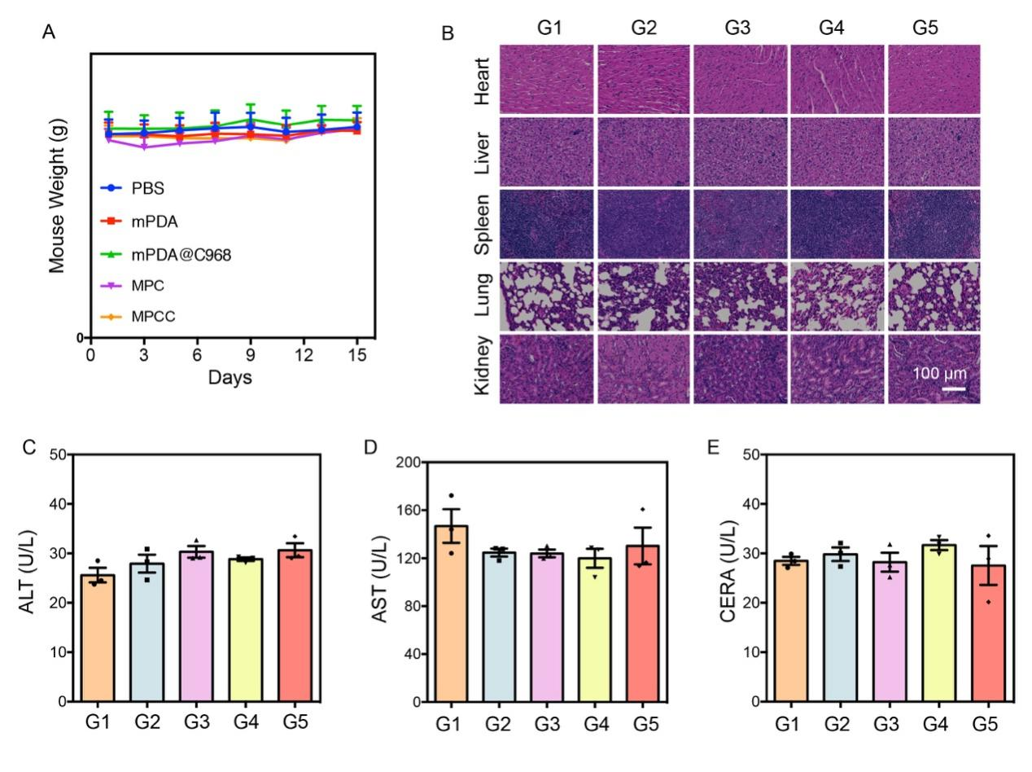
Figure S16. (A) Body weight monitoring of mice over the treatment period following administration of different formulations. (B) Representative H&E staining of major organs (heart, liver, spleen, lung, and kidney) harvested from mice after the indicated treatments. Scale bar: 100 μm. (C–E) Serum biochemistry analysis of liver and kidney function markers in mice after different treatments: ALT (C), AST (D), and CREA (E). (G1: PBS, G2: mPDA, G3: mPDA@C968, G4: MPC, G5: MPCC)

