Supporting Information

Host-Induced Mn²⁺ Coordination for Multicolor Emission and High-Resolution X-Ray Detection in Metal Halide Perovskites
Tongtong Kou^{1,2}, Qilin Wei^{1,3}, Xinxin Han⁴, Tong Chang^{1,2,}*, Shiguo Han^{1,5*}, Liang Wang^{3,5,}*, William W. Yu^{1,2,}*

¹ School of Chemistry and Chemical Engineering, Ministry of Education Key Laboratory of Special Functional Aggregated Materials, Shandong University, Jinan 250100, China
² Shandong Provincial Key Laboratory for Science of Material Creation and Energy Conversion, Science Center for Material Creation and Energy Conversion, Qingdao 266237, China.
³ School of Integrated Circuits, Shandong University, Jinan 250101, China.
⁴ State Key Laboratory of Featured Metal Materials and Life-cycle Safety for Composite Structures, School of Physical Science and Technology, Guangxi University, Nanning 530004, China.
⁵ Shenzhen Research Institute of Shandong University, Shenzhen 518000, China.

*To whom correspondence should be addressed: chtoon@sdu.edu.cn; sghan@sdu.edu.cn; liangwang2023@sdu.edu.cn; wyu6000@gmail.com.

Experimental Section
Materials
Cesium carbonate (Cs₂CO₃, Aladdin, 99%), cadmium acetate dihydrate (Cd(CH₃COO)₂·2H₂O, Macklin, 99.99%), manganese(II) bromide tetrahydrate (MnBr₂·4H₂O, Aladdin, 98%), hydrobromic acid (HBr, 40 wt% in water), ethanol (CH₃CH₂OH, Tianjin Fuyu Chemical Co., LTD, 99.9%), toluene (Aladdin, 99.5 %), polydimethylsiloxane (PDMS) (Sylgard 184, Dow Corning). All these chemical agents were used without further purification.

Syntheses of CsCdBr₃:Mn, Cs₇Cd₃Br₁₃:Mn and Cs₃CdBr₅:Mn
1. Preparation of CsCdBr₃:x%Mn (x = 0, 1, 5 10, 20, 30 and 50)
The solvothermal method was used to synthesize Cs₃CdBr₅:x% Mn (x = 0, 1, 5 10, 20, 30 and 50) metal halide perovskites. 0.5 mmol Cs₂CO₃, 1 mmol Cd(CH₃COO)₂·2H₂O, x mmol MnBr₂·4H₂O and 4 mL HBr were added to a Teflon liner autoclave. The autoclave was then placed in an oven and heated at 160 °C for 4 h. After the reaction, it was slowly cooled to room temperature. Then, the contents were washed three times with ethanol, and dried in a drying oven at 70 °C for 4 h to obtain a solid powder.

2. Preparation of Cs₇Cd₃Br₁₃:x%Mn (x = 0, 1, 5 10, 20, 30 and 50)
The solvothermal method was used to synthesize Cs₃CdBr₅:x% Mn (x = 0, 1, 5 10, 20, 30 and 50) metal halide perovskites. 1.17 mmol Cs₂CO₃, 1 mmol Cd(CH₃COO)₂·2H₂O, x mmol MnBr₂·4H₂O and 4 mL HBr were added to a Teflon liner autoclave. The autoclave was then placed in an oven and heated at 160 °C for 4 h. After the reaction, it was slowly cooled to room temperature. Then, the contents were washed three times with ethanol, and dried in a drying oven at 70 °C for 4 h to obtain a solid powder.

3. Preparation of Cs₃CdBr₅:x%Mn (x = 0, 1, 5 10, 20, 30 and 50)
The solvothermal method was used to synthesize Cs₃CdBr₅:x% Mn (x = 0, 1, 5 10, 20, 30 and 50) metal halide perovskites. 3 mmol Cs₂CO₃, 1 mmol Cd(CH₃COO)₂·2H₂O, x mmol MnBr₂·4H₂O and 4 mL HBr were added to a Teflon liner autoclave. The autoclave was then placed in an oven and heated at 160 °C for 4 h. After the reaction, it was slowly cooled to room temperature. Then, the contents were washed three times with ethanol, and dried in a drying oven at 70 °C for 4 h to obtain a solid powder.

Fabrication of LED Devices
The LED device was fabricated using 370 nm UV-LED chips. The powders of CsCdBr₃:Mn, Cs₇Cd₃Br₁₃:Mn, and Cs₃CdBr₅:Mn with red, yellow, and green emissions were thoroughly mixed and then blended with a UV-curable resin. The mass ratio of the total phosphor powders to the resin was 1:1.3. The resulting mixture was uniformly applied to the surface of the LED chip, followed by UV curing. After curing, the performance of the LED device was tested.

Preparation of flexible scintillation films
The CsCdBr₃:20%Mn, Cs₇Cd₃Br₁₃:20%Mn and Cs₃CdBr₅:20%Mn powders were first finely ground and sieved through a 200-mesh screen. A portion of each sieved powder was thoroughly mixed with PDMS in toluene at a mass ratio of 1:5. The resulting mixtures were then slowly poured into polytetrafluoroethylene (PTFE) molds and allowed to evaporate at room temperature for approximately 12 hours to form flexible composite films. The final dimensions of the films were determined by the size of the plastic substrate.

Characterization
The phase structure of the synthesized materials was identified through single-crystal X-ray diffraction (SCXRD), with data collected using an Oxford Gemini S Ultra system equipped with graphite monochromated Mo Kα radiation (λ = 0.71073 Å). Powder X-ray diffraction (XRD) analysis was conducted using a Rigaku SmartLab diffractometer. The morphology, elemental composition, and element distribution were examined via scanning electron microscopy (SEM, Zeiss Sigma 500) coupled with energy-dispersive X-ray spectroscopy (EDS, Oxford X-Max 20). X-ray photoelectron spectroscopy (XPS, Thermo Fisher Scientific ESCALAB 250Xi) was employed to analyze elemental composition and chemical states. Steady-state photoluminescence spectra, photoluminescence quantum yield (PLQY), and photoluminescence decay curves were recorded using a Horiba Jobin Yvon Fluorolog-3 spectrometer and an Edinburgh FLS 1000 fluorescence spectrometer. The optical absorption properties were assessed with a UV-VIS-NIR spectrophotometer (Shimadzu, UV-3600i Plus). The performance of the WLED was tested using an OHSP-350M LED Fast-Scan Spectrophotometer. The RL spectral characterization and X-ray imaging of the materials were performed using an X-ray light source (TUB00154-9I-W06), an X-ray-induced luminescence spectrometer (X-XILS-P70V-5), and an X-ray image performance evaluation system (A-ICXS-DRPE-SSD-1) designed for small scintillator devices. Measurements were conducted at 50 kV and 25 μA (dose rate: 1.39 mGy s⁻¹) with an exposure time of 2 ms, corresponding to a total dose of 0.00118 mGy. The detector pixel size was 5.86 μm × 5.86 μm.

Modulation Transfer Function (MTF) Measurement: using the slanted-edge method, the MTF is obtained by capturing an X-ray image of a tungsten plate with a sharp edge. From the edge profile of the X-ray image, the Line Spread Function (LSF) is derived from the Edge Spread Function (ESF).
where 𝑥 represents the position of the pixel. The MTF curve can be derived from the Fourier transform of the LSF, as shown below:

Computational details
Density functional theory (DFT) computations were conducted using the Vienna Ab initio Simulation Package (VASP)¹. The exchange–correlation interactions were treated with the Perdew–Burke–Ernzerhof (PBE) functional under the framework of the generalized gradient approximation (GGA), and the projector augmented-wave (PAW) approach was applied²⁻³. Ultra-soft pseudopotentials were employed for all constituent atoms, namely Cs, Cd, Br, and Mn. The plane-wave basis set was truncated at a kinetic energy cutoff of 400 eV. A Monkhorst–Pack grid of 4×4×4 was adopted for Brillouin zone sampling. The structural optimization proceeded until the total energy converged within 1.0×10⁻⁴ eV.

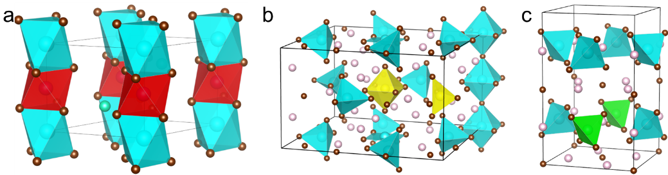
Figure S1. Standard orientation of the optimized (a) Cs₂CdMnBr₆, (b) Cs₂₈Cd₁₀Mn₂Br₅₂, and (c) Cs₁₁₂Cd₃MnBr₂₀ crystal shapes. Pink represents Cs, cyan represents Cd, and brown represents Br, while red, yellow, and green represent Mn.

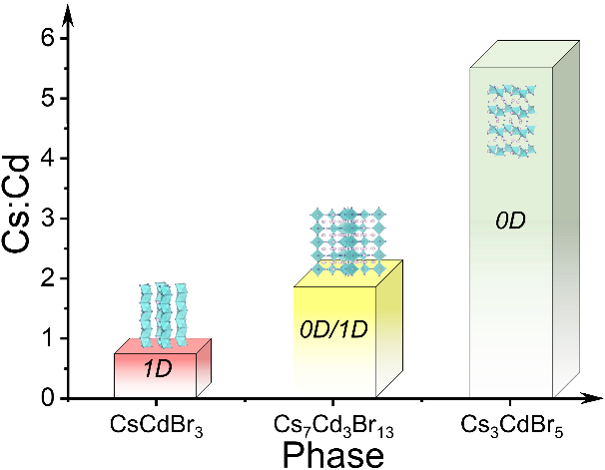
Figure S2. Schematic diagram of the formation of different phases at various Cs:Cd ratios.

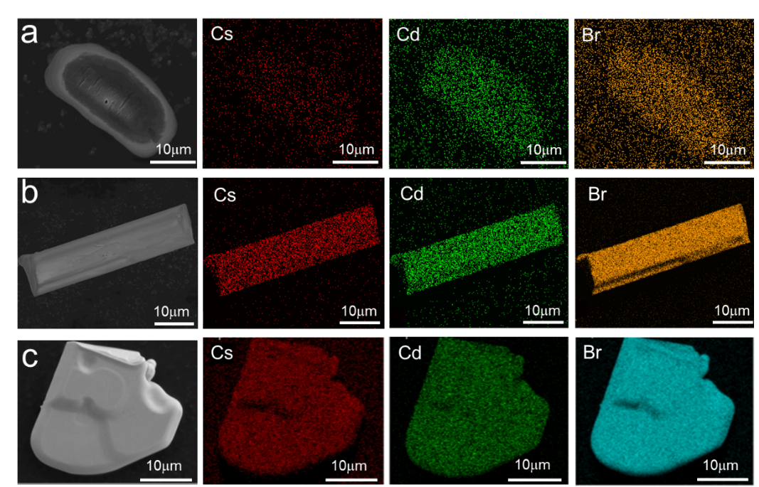
Fgure S3. SEM and EDS-mapping images of (a) CsCdBr₃, (b) Cs₇Cd₃Br₁₃ and (c) Cs₃CdBr₅.

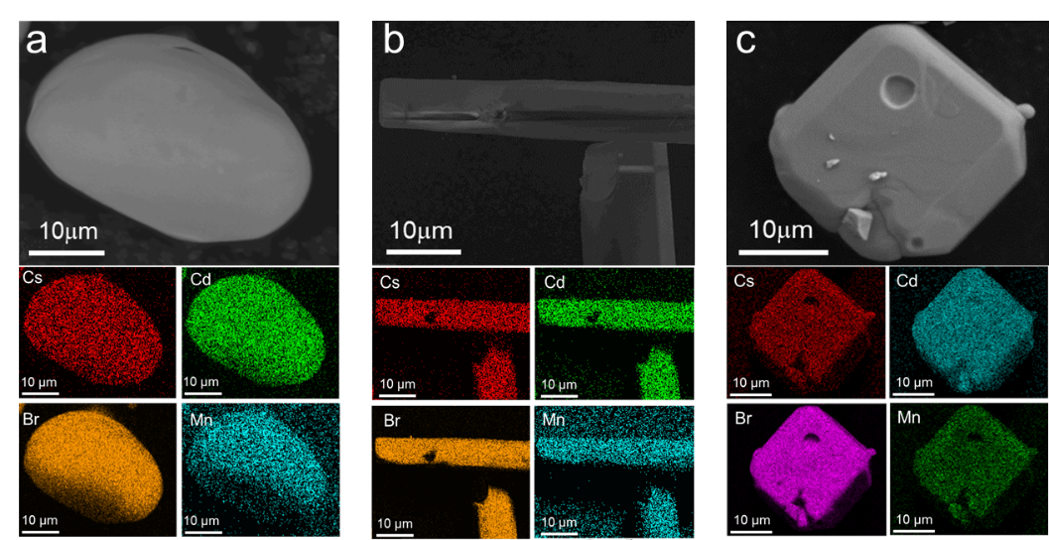
Figure S4. SEM and EDS-mapping images of (a) CsCdBr₃:30%Mn, (b) Cs₇Cd₃Br₁₃:20%Mn and (c) Cs₃CdBr₅:20%Mn.

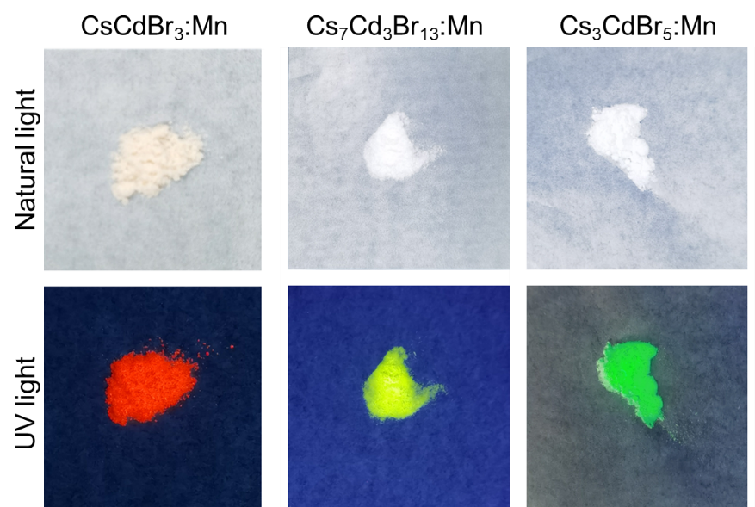
Figure S5. Photos of CsCdBr₃:Mn, Cs₇Cd₃Br₁₃:Mn and Cs₃CdBr₅:Mn under natural and ultraviolet light.

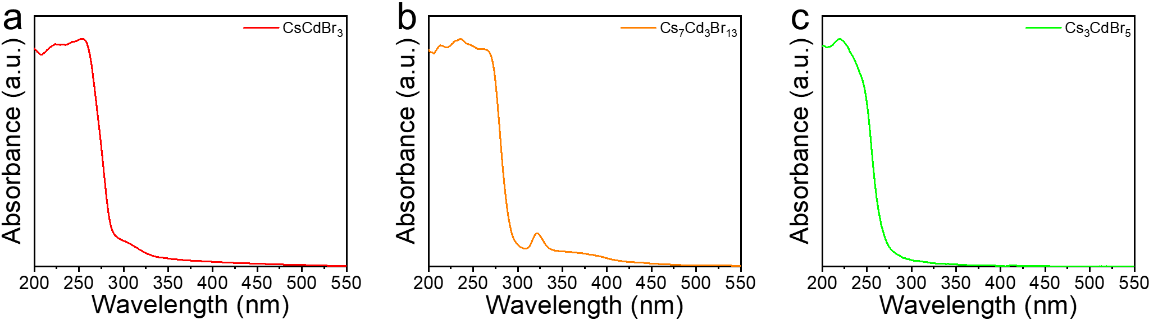
Figure S6. Absorption spectra of (a) CsCdBr₃, (b) Cs₇Cd₃Br₁₃ and (c) Cs₃CdBr₅.

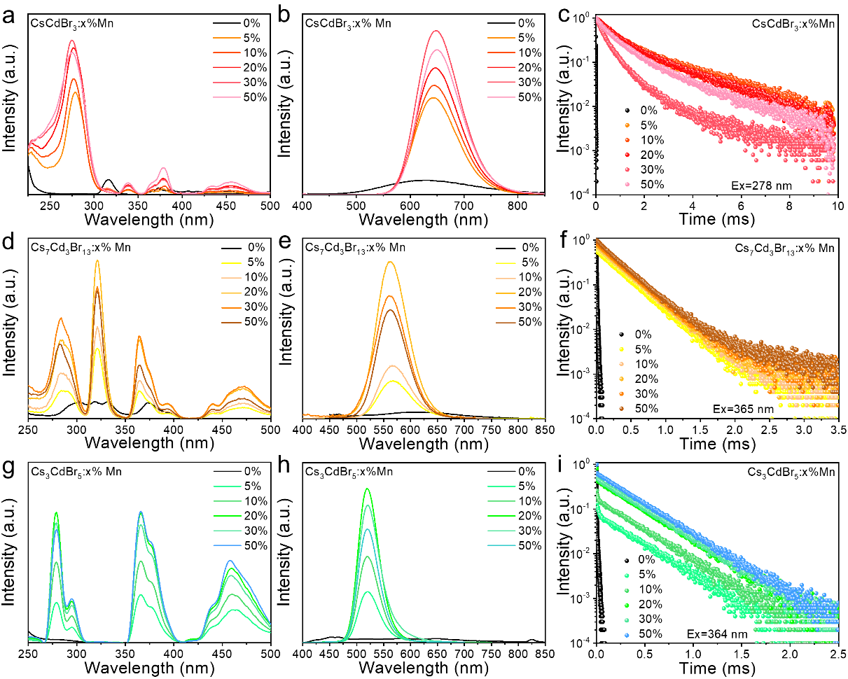
Figure S7. (a) PLE spectra, (b) PL spectra and (c) PL decay curves of CsCdBr₃:x%Mn. (d) PLE spectra, (e) PL spectra and (f) PL decay curves of Cs₇Cd₃Br₁₃: x%Mn. (g) PLE spectra, (h) PL spectra and (i) PL decay curves of Cs₃CdBr₅: x%Mn (x = 0-50).

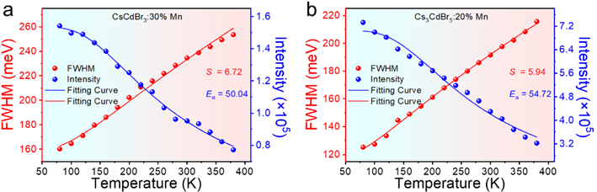
Figure S8. Huang-Rhys factor S and exciton activation energy (E_{a}) of (a) CsCdBr₃:30%Mn and (b) Cs₃CdBr₅:20%Mn.

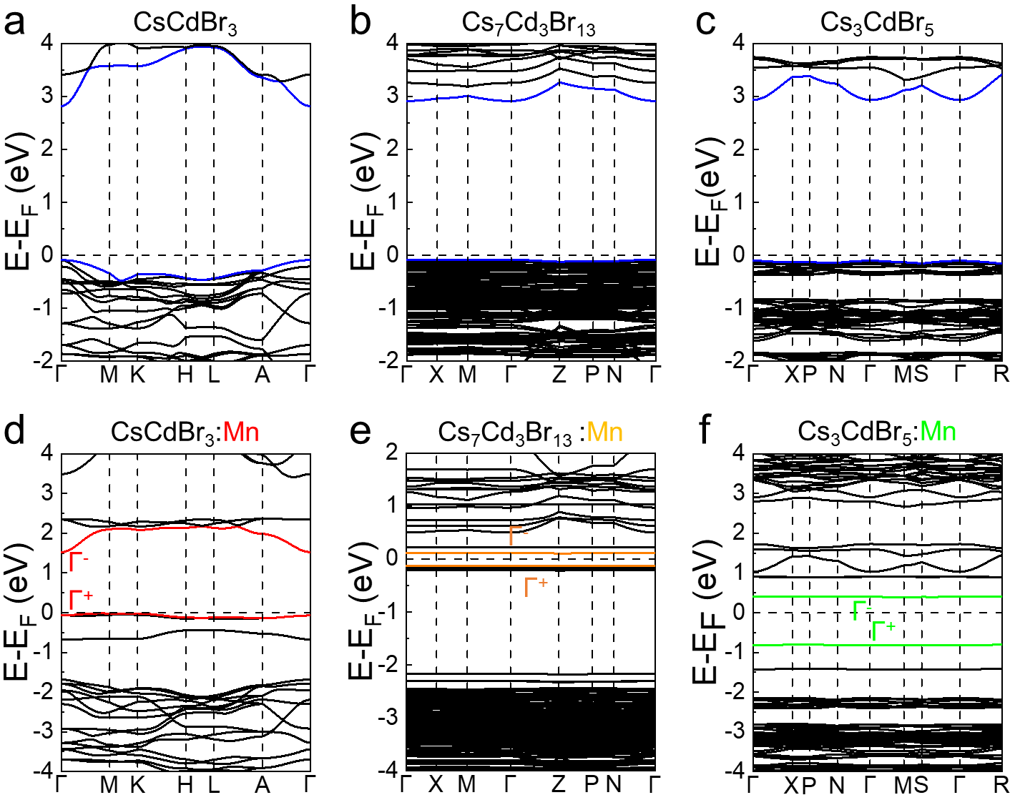
Figure S9. Band structures of (a) CsCdBr₃, (b) Cs₇Cd₃Br₁₃ and (c) Cs₃CdBr₅. Band structures of (d) CsCdBr₃:30%Mn, (e) Cs₇Cd₃Br₁₃:20%Mn and (f) Cs₃CdBr₅:20%Mn.

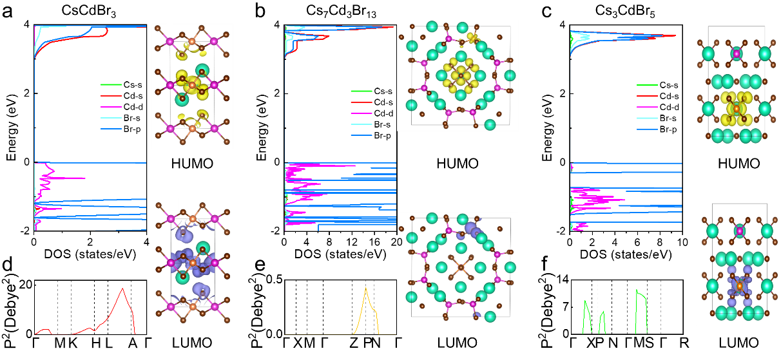
Figure S10. Density of states (DOS) and electron densities of (a) CsCdBr₃, (b) Cs₇Cd₃Br₁₃ and (c) Cs₃CdBr₅. Square of the electric dipole transition dipole moment (TDM) of (d) CsCdBr₃, (e) Cs₇Cd₃Br₁₃ and (f) Cs₃CdBr₅. Green represents Cs, purple represents Cd, orange represents Mn and brown represents Br.

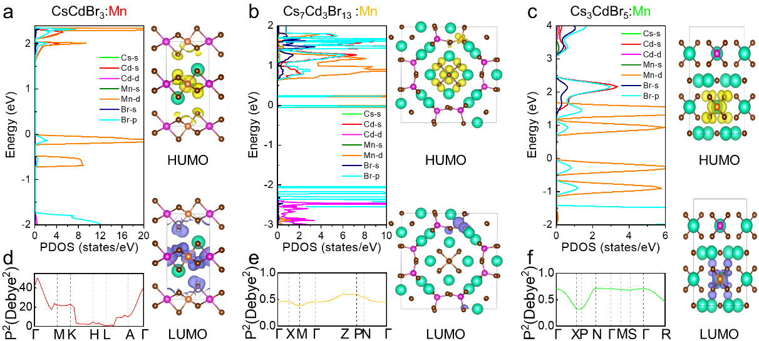
Figure 11. Density of states (DOS) and electron densities of (a) CsCdBr₃:Mn, (b) Cs₇Cd₃Br₁₃:Mn and (c) Cs₃CdBr₅:Mn. Square of the electric dipole transition dipole moment (TDM) of (d) CsCdBr₃:Mn, (e) Cs₇Cd₃Br₁₃:Mn and (f) Cs₃CdBr₅:Mn. Green represents Cs, purple represents Cd, orange represents Mn and brown represents Br.

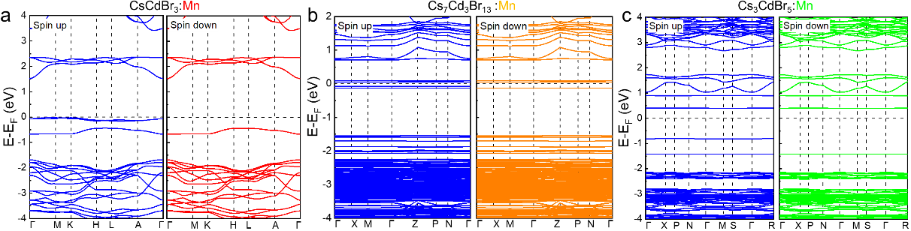
Figure S12. Spin-polarized band structure of (a) CsCdBr₃:Mn, (b) Cs₇Cd₃Br₁₃:Mn and (c) Cs₃CdBr₅:Mn.

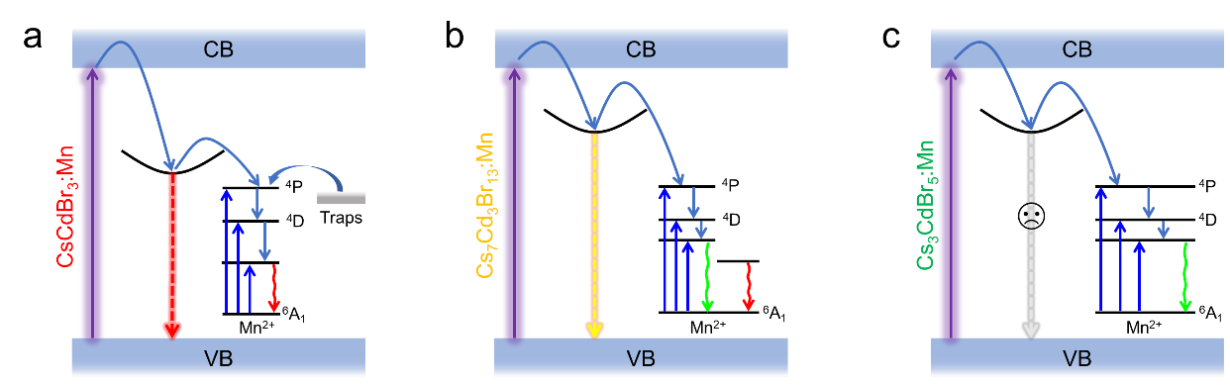
Figure S13. The charge-carrier dynamics models for (a) CsCdBr₃:Mn, (b)Cs₇Cd₃Br₁₃:Mn and (c) Cs₃CdBr₅:Mn.

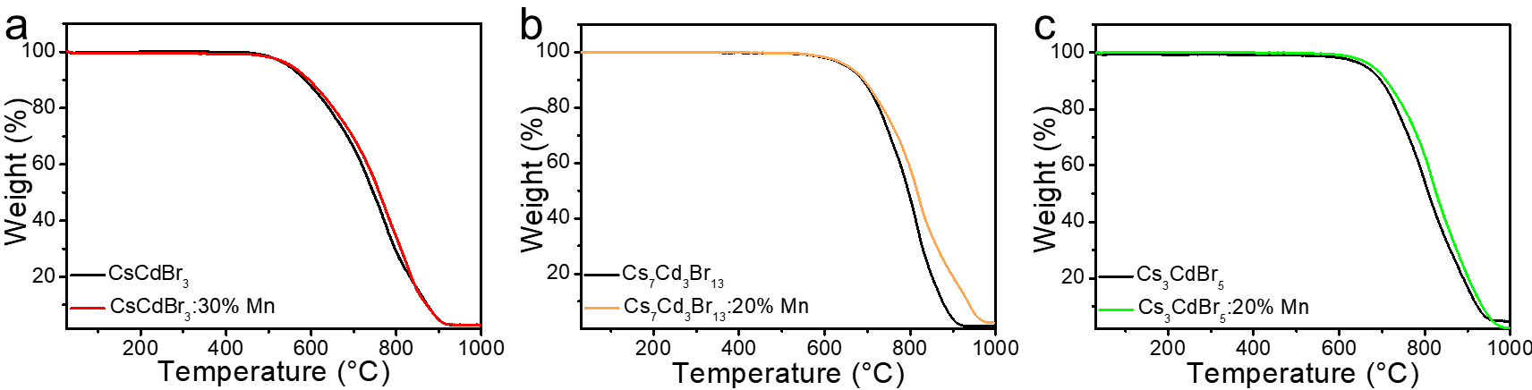
Figure S14. Thermogravimetric Analysis curves of (a) CsCdBr₃ and CsCdBr₃:30%Mn, (b) Cs₇Cd₃Br₁₃ and Cs₇Cd₃Br₁₃:20%Mn, (c) Cs₃CdBr₅ and Cs₃CdBr₅:20%Mn.

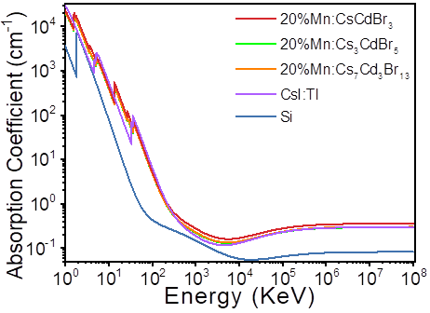
Figure S15. X-ray absorption coefficients CsCdBr₃:20%Mn, Cs₇Cd₃Br₁₃:20%Mn, Cs₃CdBr₅:20%Mn, CsI:Tl and Si.

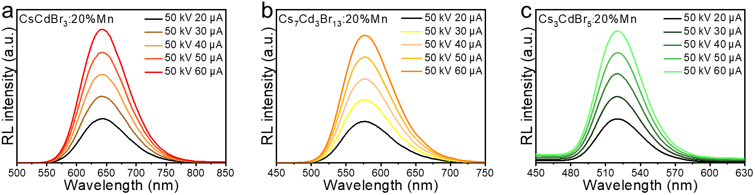
Figure 16. (a) RL spectra of CsCdBr₃:20%Mn, Cs₇Cd₃Br₁₃:20%Mn and Cs₃CdBr₅:20%Mn.

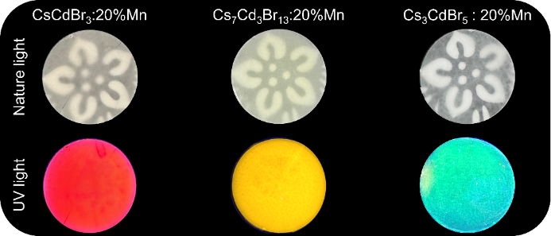
Figure S17. Photos of CsCdBr₃:20%Mn, Cs₇Cd₃Br₁₃:20%Mn, Cs₃CdBr₅:20%Mn with PDMS-based films under natural and UV light.

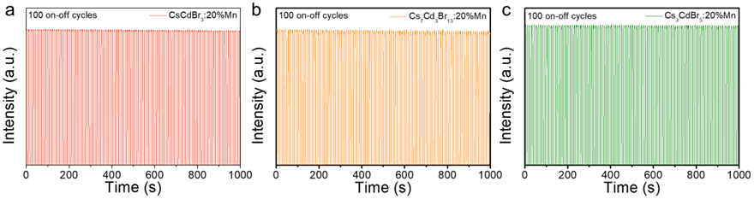
Figure S18. RL emission photostability of (a) CsCdBr₃:20%Mn, (b) Cs₇Cd₃Br₁₃:20%Mn, and (c) Cs₃CdBr₅:20%Mn under repeated on–off X-ray irradiation cycles at a dose rate of 1.39 mGy air·s⁻¹.

Table S1. Relevant parameters for the crystal structure.
Sample | Atom volume (Å³) | Molr mass (g/mol) | Cell volume (Å³) | APF  (%) | Density (g/cm³)
Cs2CdMnBr6 | 239.32 | 912.57 | 349.17 | 68.54 | 4.34
Cs28Cd10Mn2Br52 | 2298.48 | 9110.38 | 3859.50 | 59.55 | 3.92
Cs12Cd3Mn1Br20 | 908.72 | 18366.62 | 1552.18 | 58.55 | 3.84

Table S2. Fitting data for PL decay curves.
Sample | A₁ | τ₁ (ms) | A₂ | τ₂ (ms) | τ_{ave}
CsCdBr₃:30%Mn | 0.67 | 0.26 | 0.34 | 0.81 | 0.64
Cs₇Cd₃Br₁₃:20%Mn | 0.20 | 0.32 | 0.80 | 0.002 | 0.32
Cs₃CdBr₅:20%Mn | 0.60 | 0.005 | 0.43 | 0.32 | 0.31

References
1. Kresse, G.; Furthmüller, J., Efficient iterative schemes for ab initio total-energy calculations using a plane-wave basis set. Phys. Rev. B 1996, 54 (16), 11169-11186.
2. Perdew, J. P.; Burke, K.; Ernzerhof, M., Generalized gradient approximation made simple. Phys. Rev. Lett. 1996, 77 (18), 3865-3868.
3. Blöchl, P. E., Projector augmented-wave method. Phys. Rev. B 1994, 50 (24), 17953-17979.

