Supporting Information

Bio-Inspired Smart Glass-Like Hydrogels with Strong and Switchable Underwater Adhesion
Yi Liu,^{a,b} Yuanmao Fu,^{b} Xian Zhang,^{b} Xiaoyu Guo,^{b} Xiaolin Wang,^{a,*} and Hui Guo ^{a,b*}
- State Key Laboratory of Quality Research in Chinese Medicine and School of Pharmacy, Macau University of Science and Technology, Taipa, 999078, Macao.
- School of Chemical Engineering and Technology, Sun Yat-sen University, Zhuhai, 519082, China.
Corresponding Authors
Xiaolin Wang: xilwang@must.edu.mo
Hui Guo: guohui@must.edu.mo

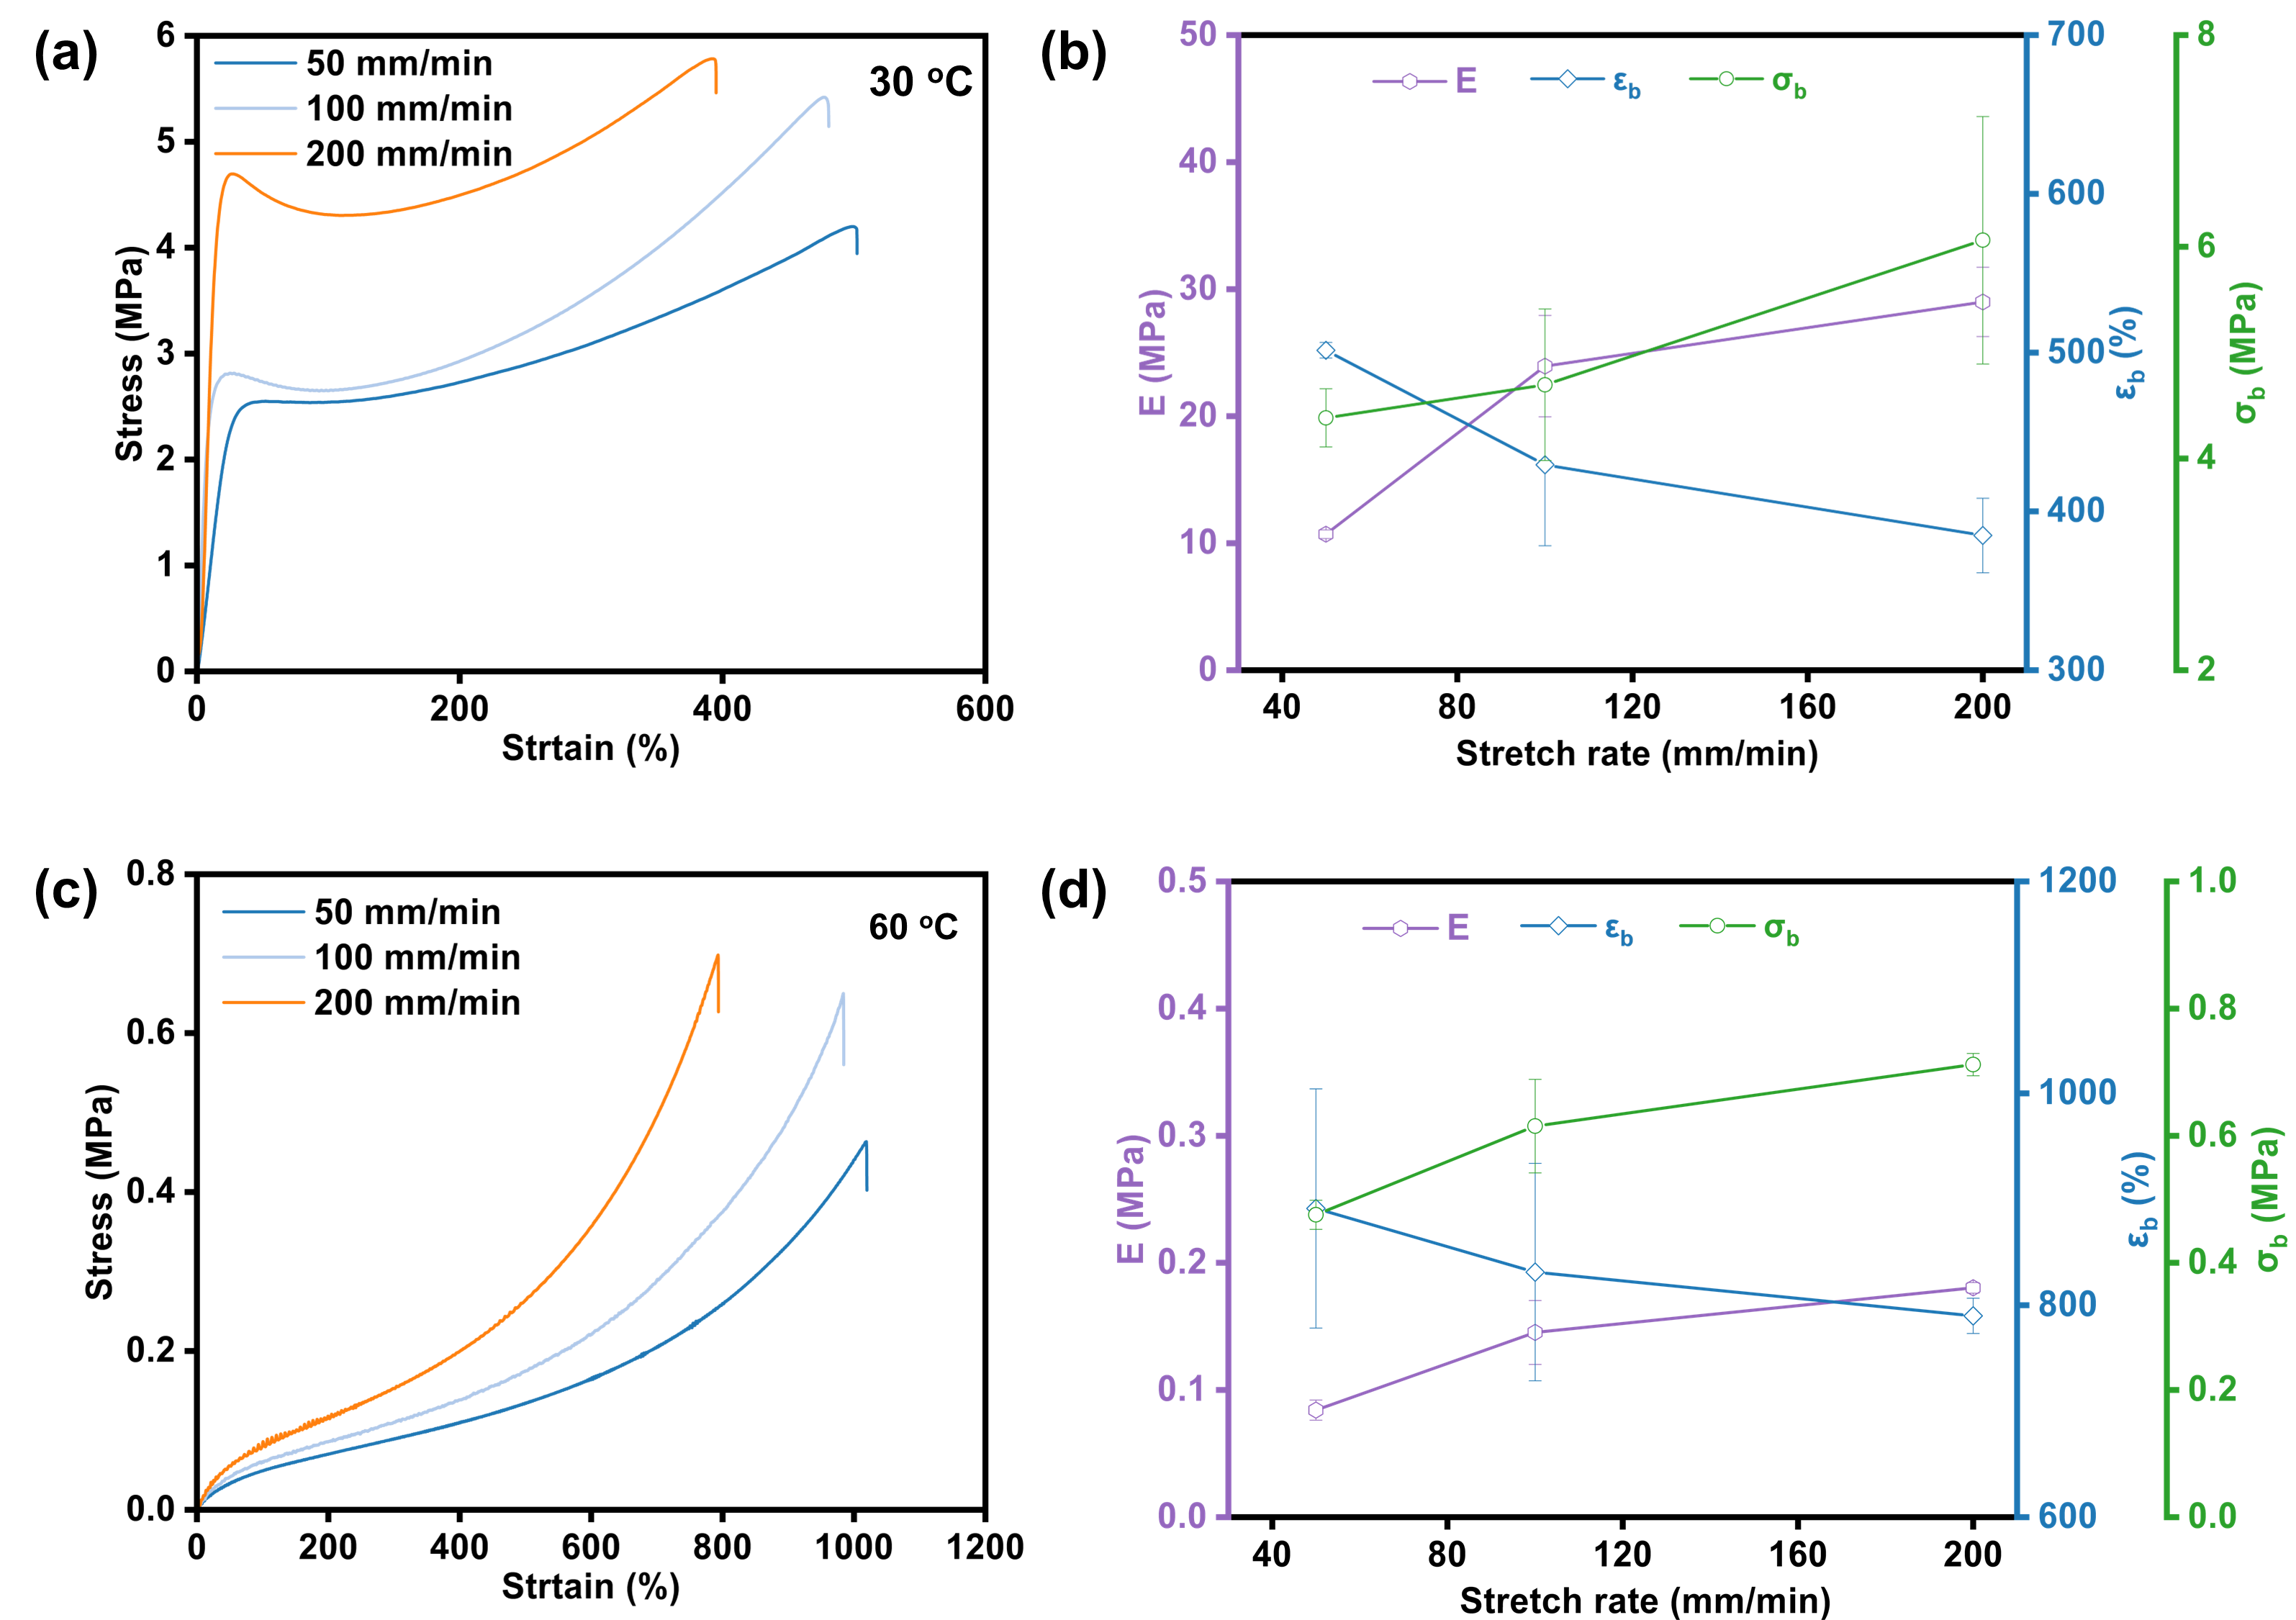
Figure S1. Strain rate dependent tensile behavior of PP₃D₁-3M at 30 and 60 °C. (a,c) Stress-strain curves measured at 50, 100, and 200 mm/min. (b,d) Young’s modulus (E), fracture stress (σ_{b}), and fracture strain (ε_{b}) as a function of stretch rate.

Figure S2. Cyclic loading-unloading tensile curves of PP₃D₁-3M under 30 °C.

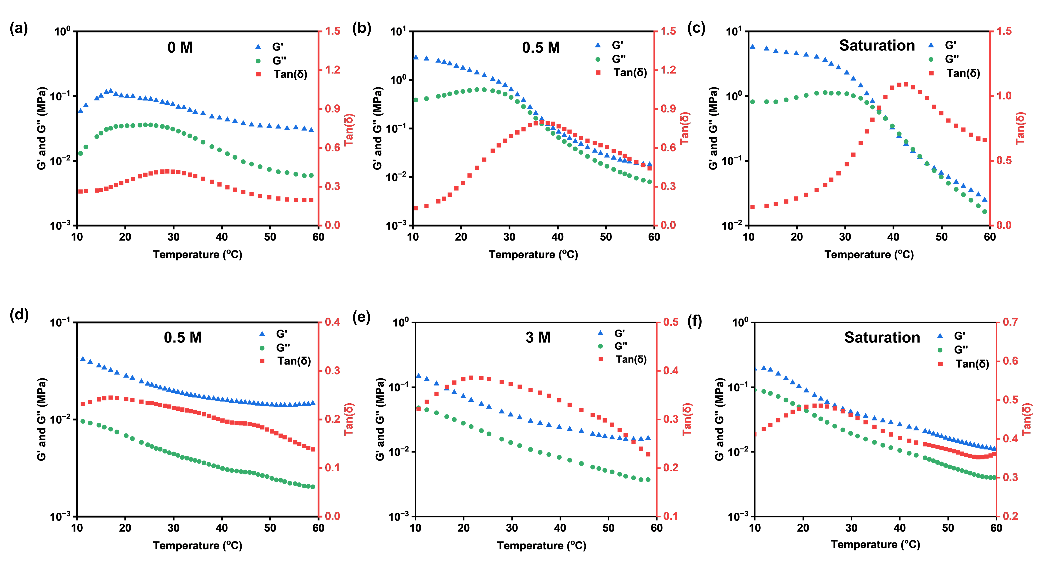
Figure S3. Storage modulus G’, loss modulus G”, and loss factor tanδ were measured during a temperature ramp from 10 to 60 ºC for (a) PP₃D₁-0M, (b) PP₃D₁-0.5M, (c) PP₃D₁-saturation, (d) PP₃D₂-0.5M, (e) PP₃D₂-3M and (f) PP₃D₁-saturation hydrogels.

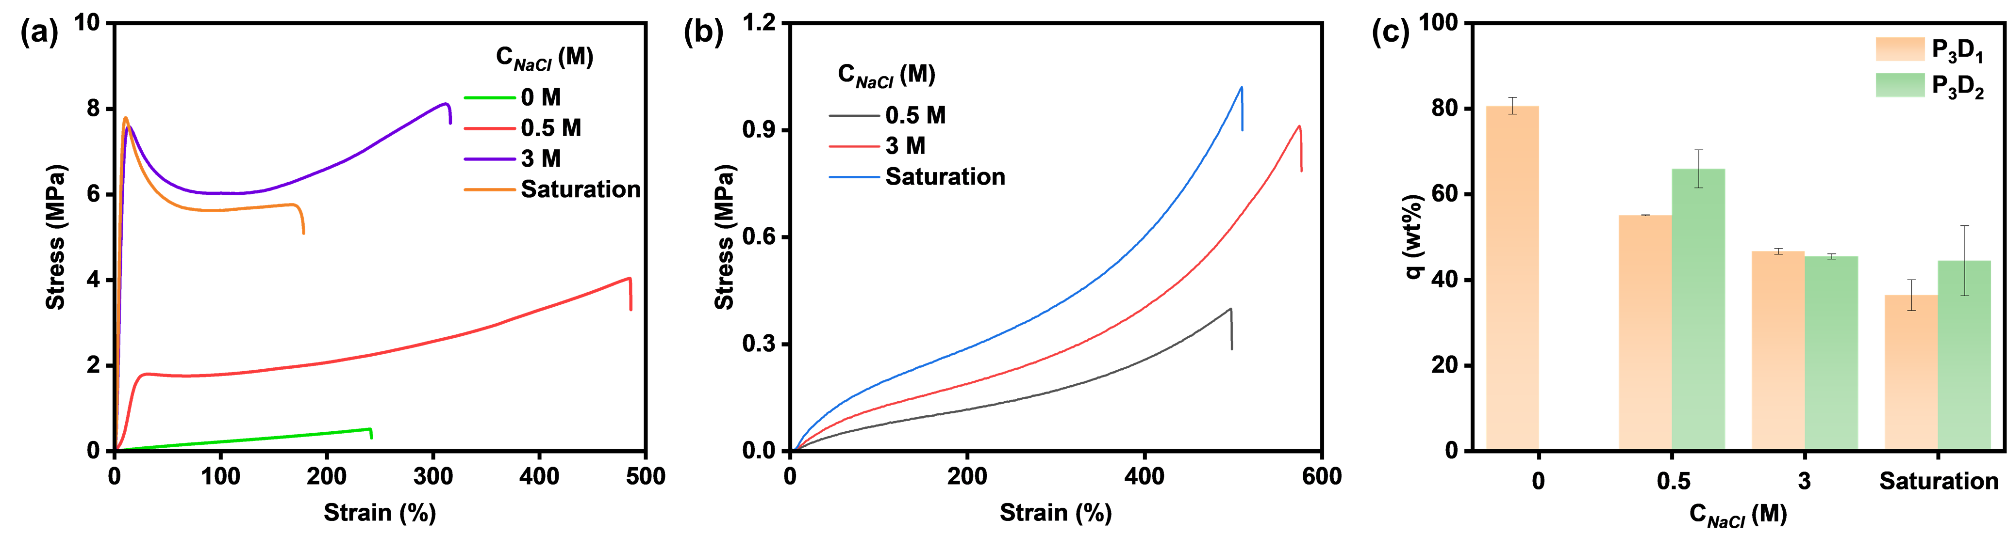
Figure S4. The stress-strain curves of (a) PP₃D₁ and (b) PP₃D₂ hydrogels at room temperature. (c) Water content of SGH.

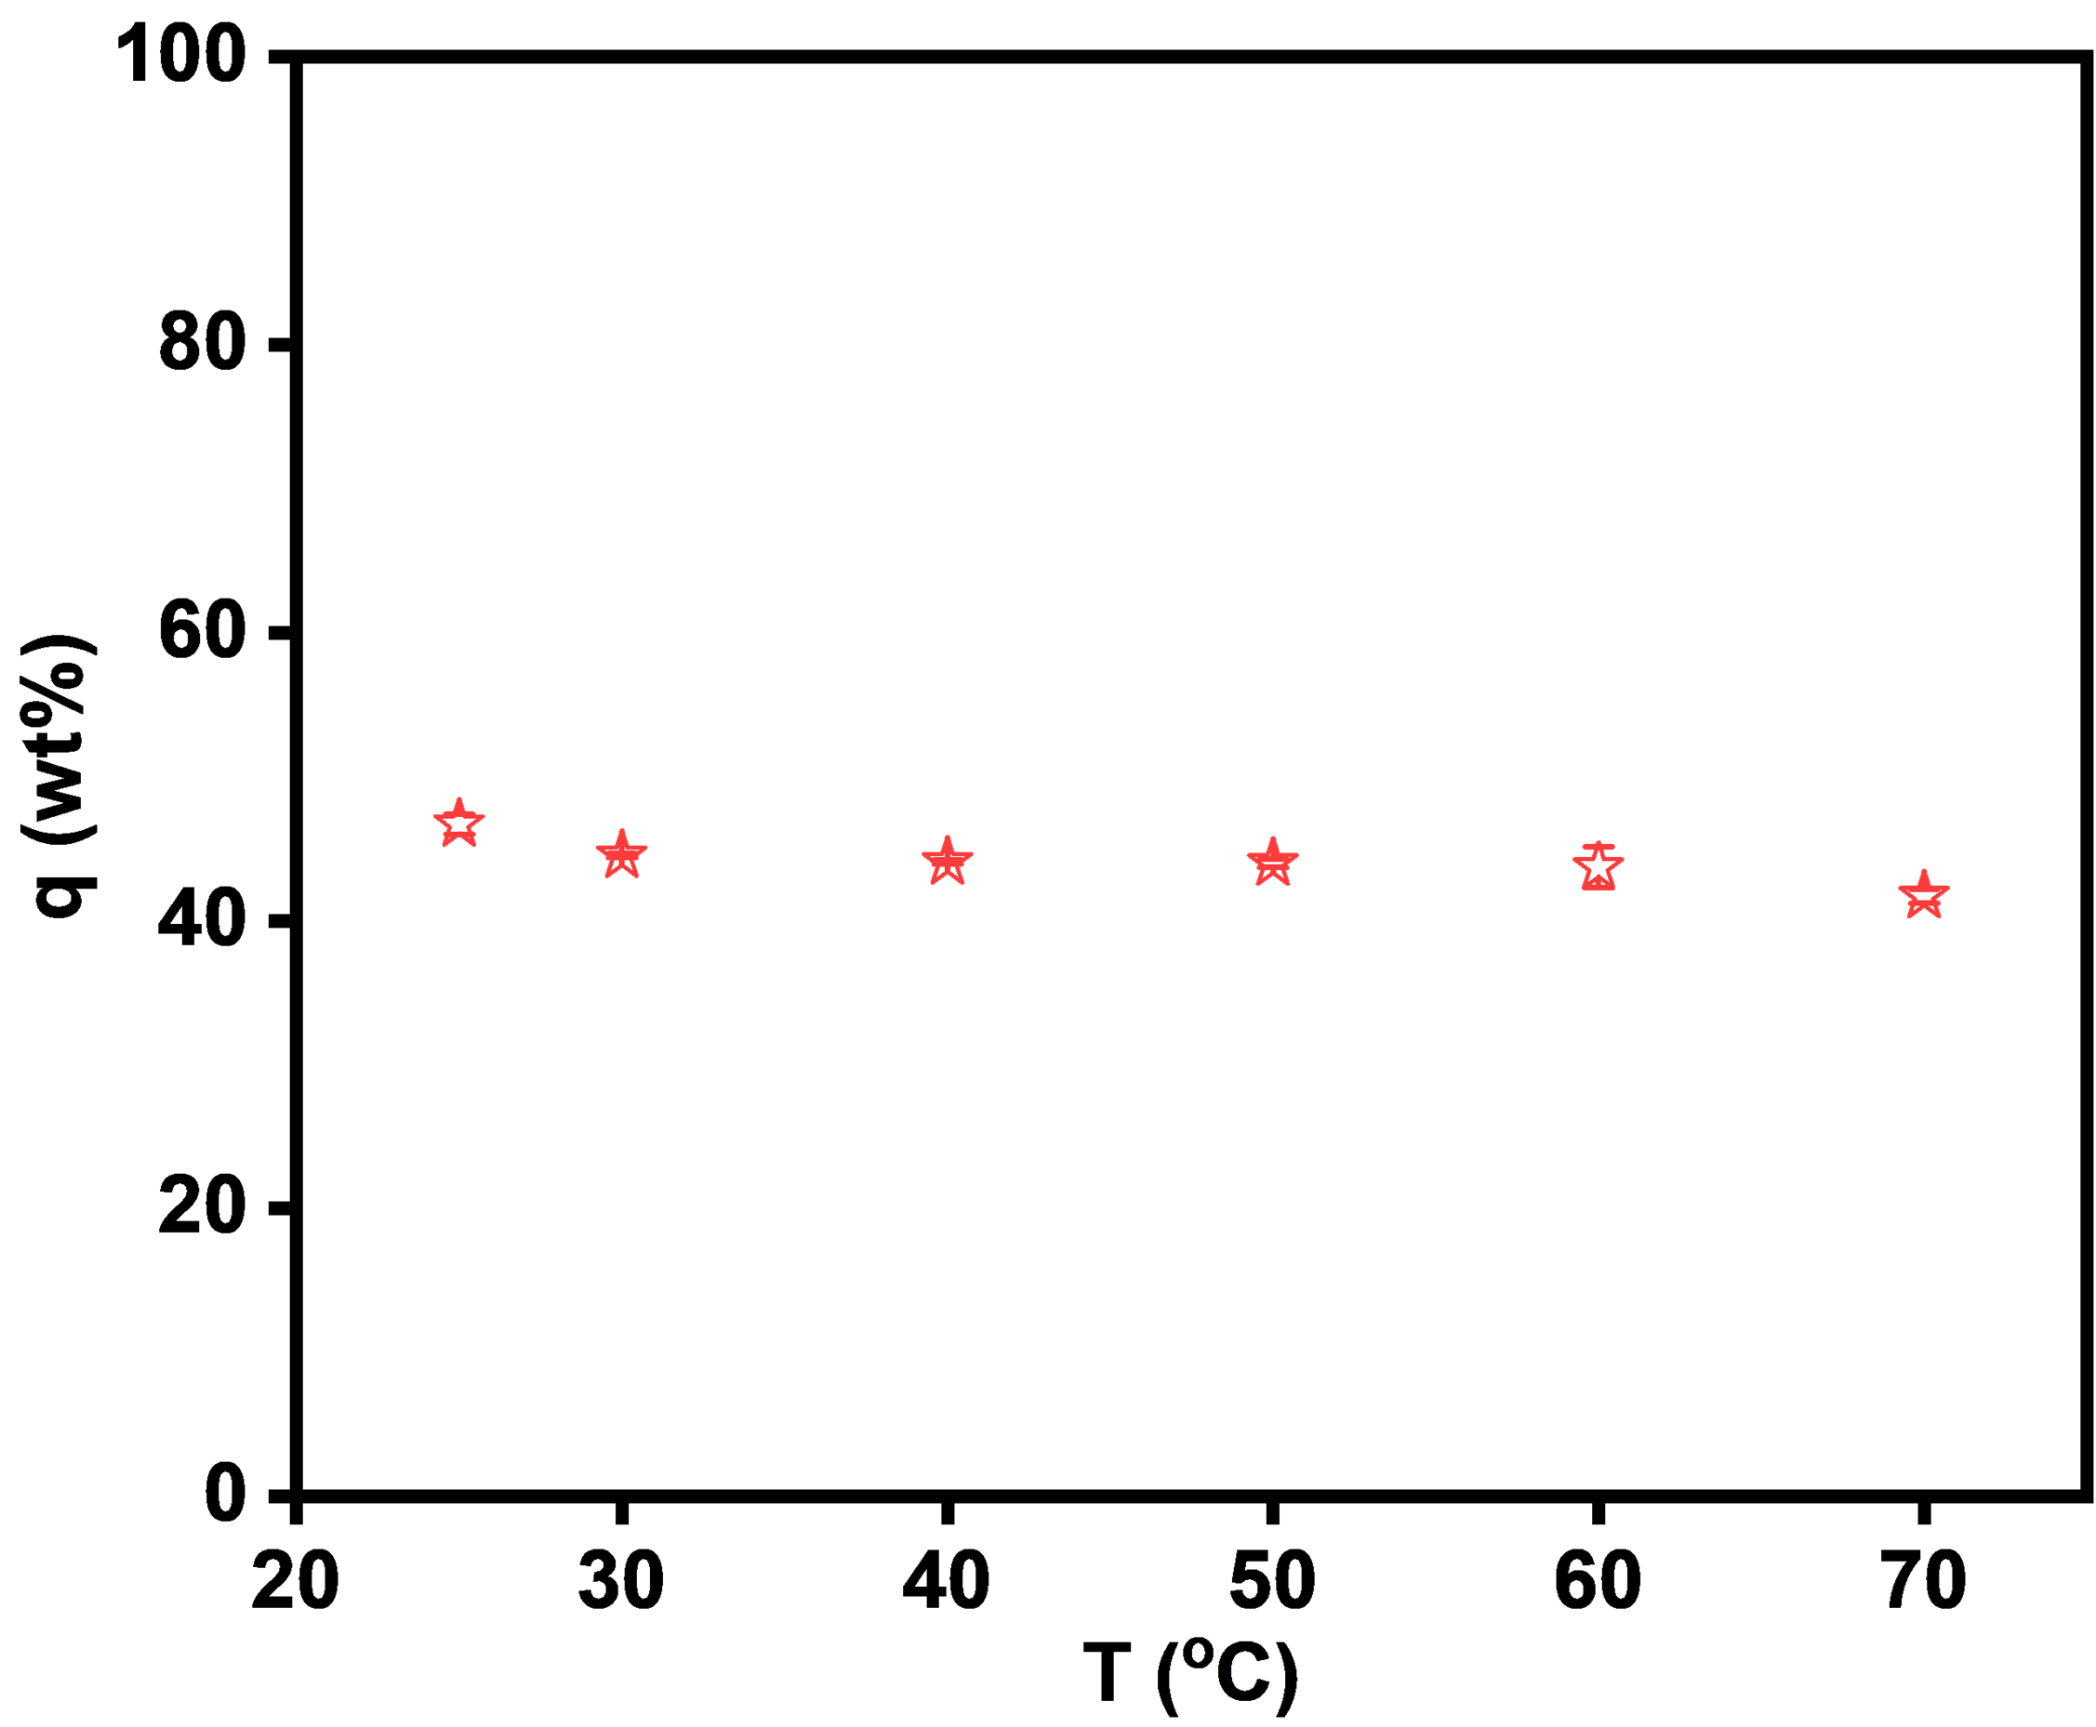
Figure S5. The water content of PP₃D₁-3M in different temperature.
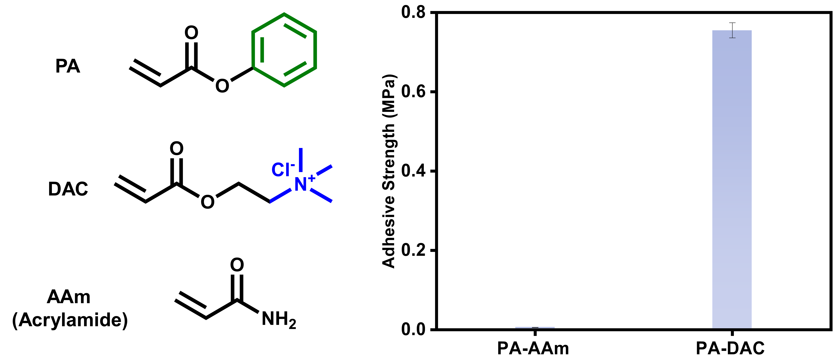
Figure S6. Chemical structures of PA, DAC, and AAm, and adhesive strength of PA-DAC and PA-AAm hydrogels measured under identical conditions.

Figure S7. Loading-rate-dependent lap-shear adhesive strength of SGH on flat and rough (180 μm) glass substrates.
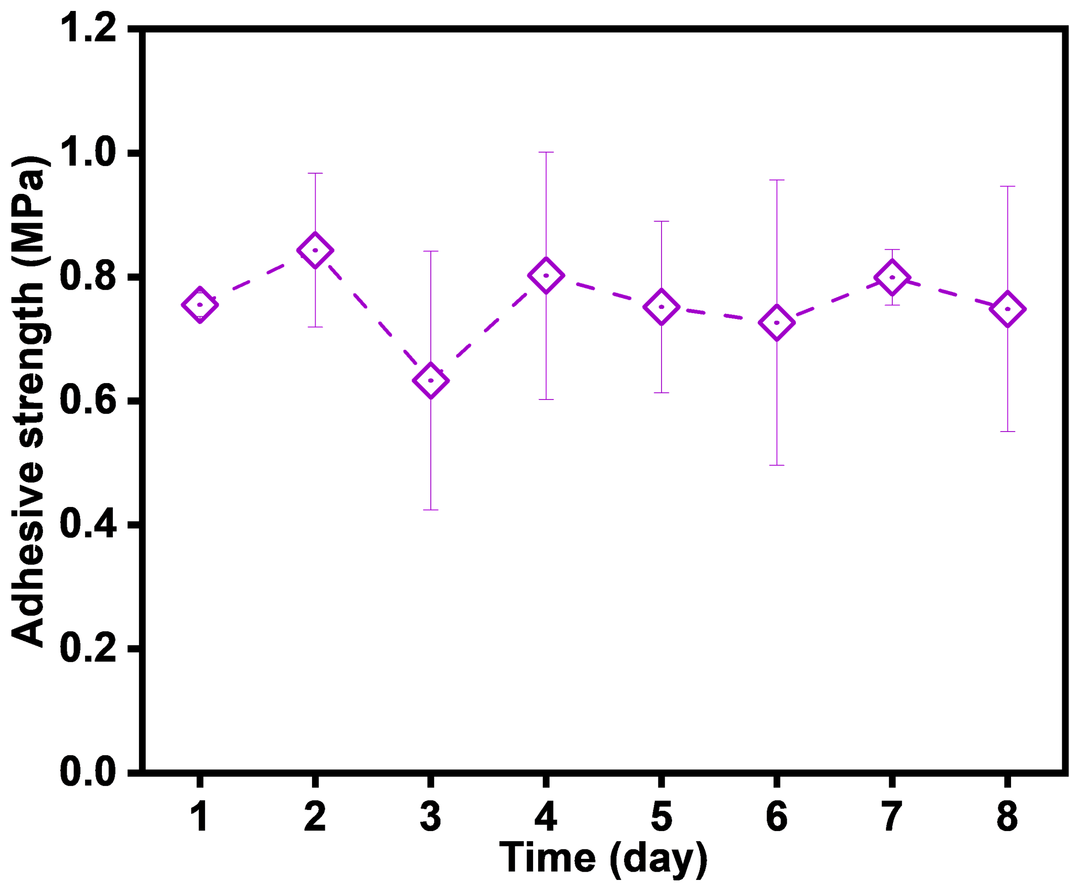
Figure S8. Long-term adhesion stability of PP₃D₁-3M (25 ºC and 90% humidity). Error bars represent the standard deviation from at least three replicates. Data in this figure are presented as mean values ± SD.
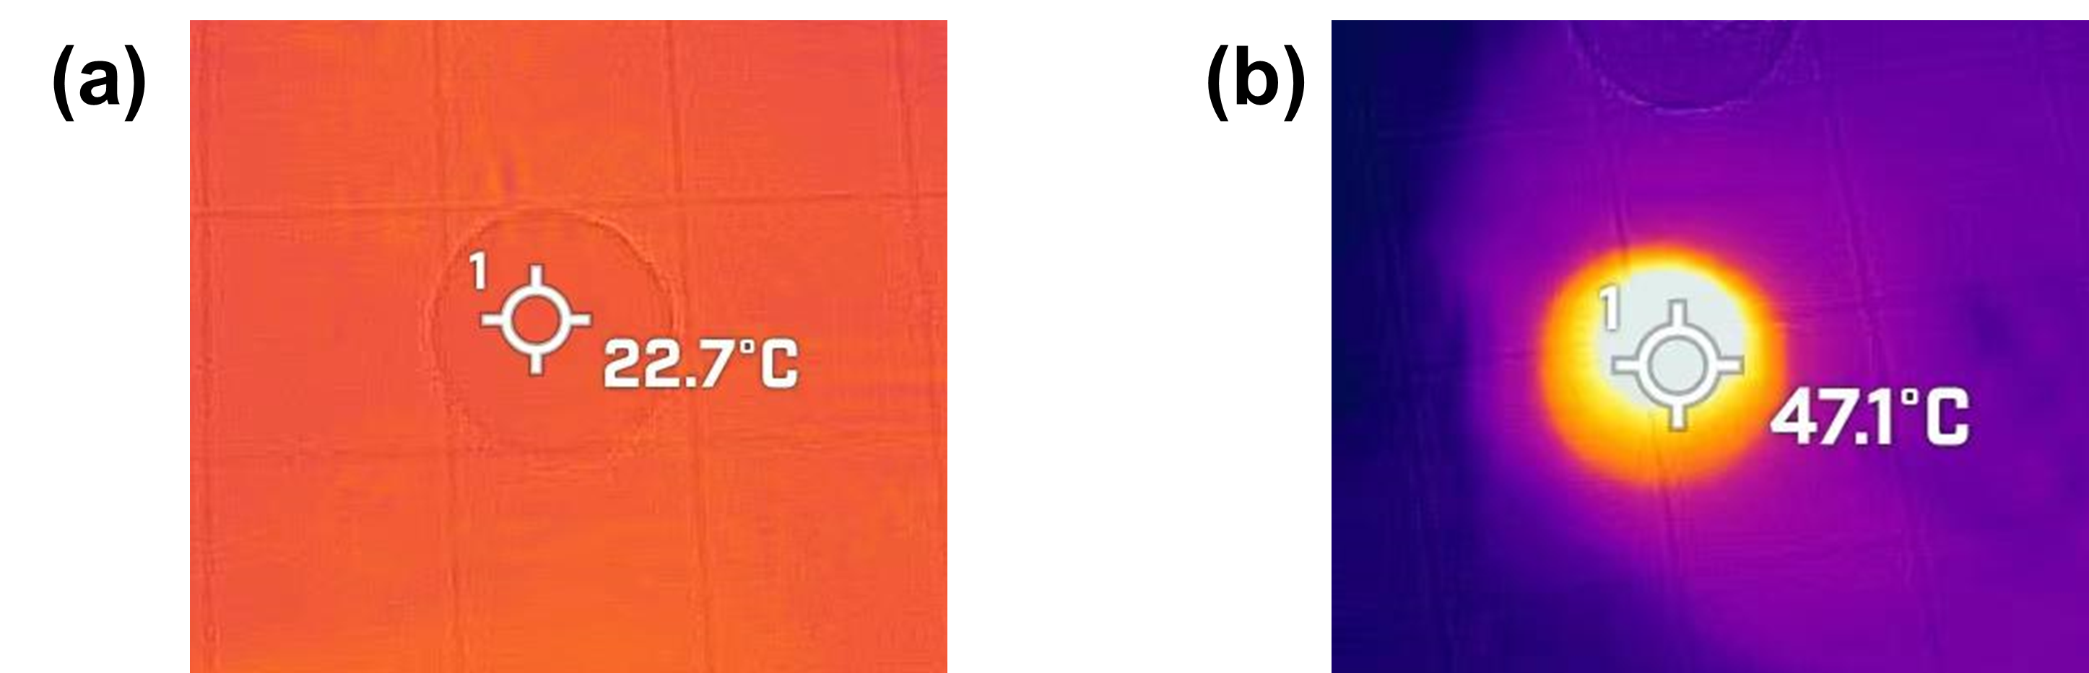
Figure S9. The photothermal effect of SGH (with 0.1 wt% carbon nanoparticles). The temperature of hydrogels (a) before and (b) after light irradiation.

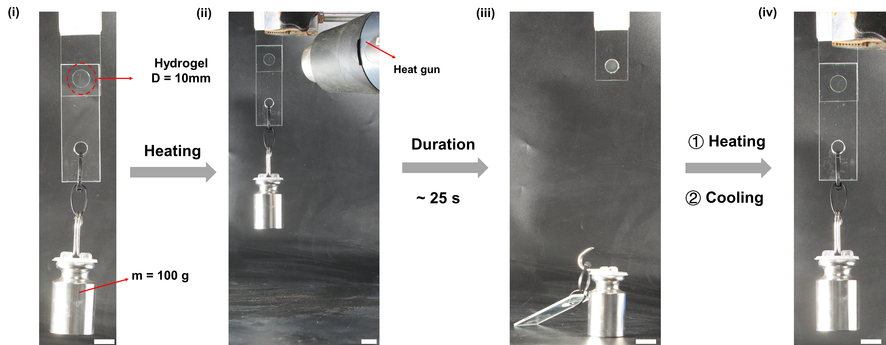
Figure S10. Photographic demonstration of the temperature-responsive switching ability in hydrogels, showcasing their adhesive strength modulation. Scale bar: 2 cm.

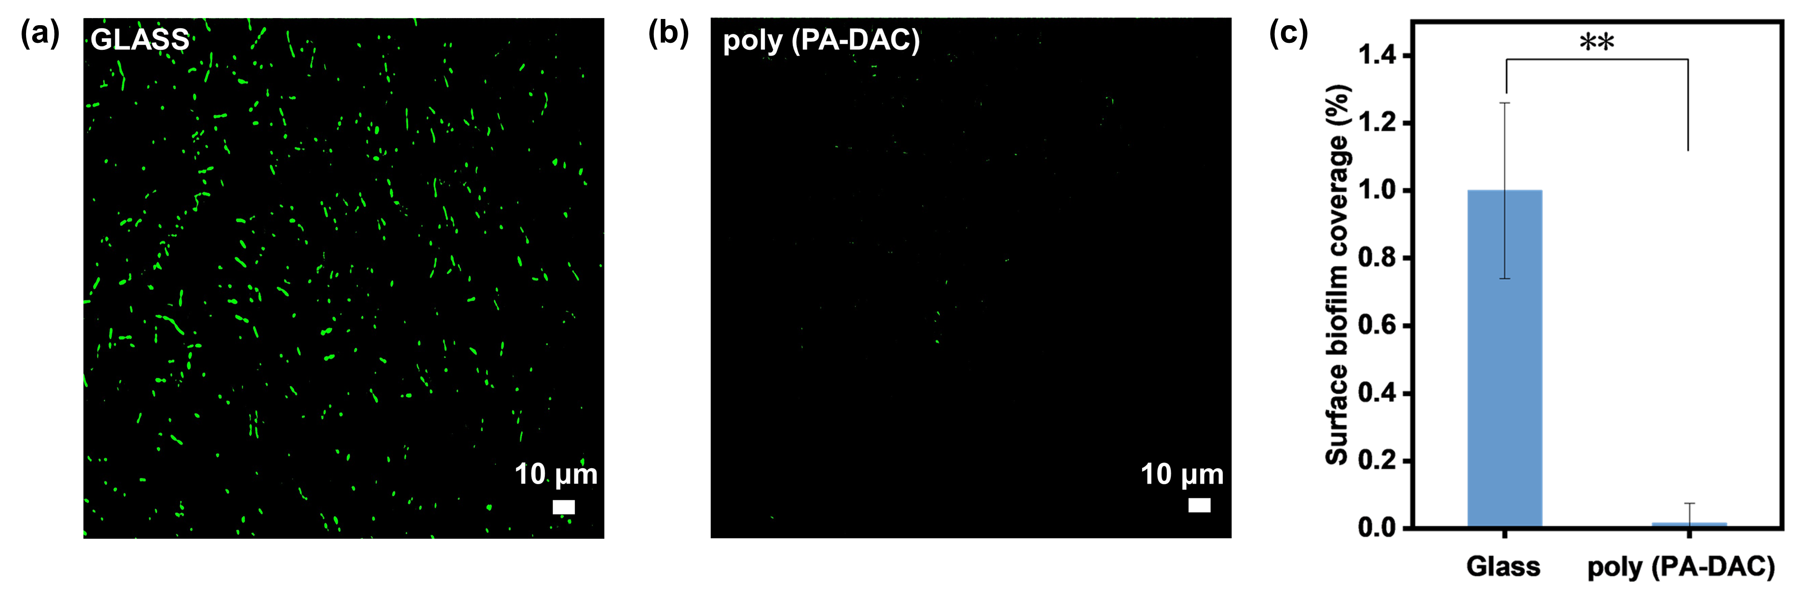
Figure S11. (a) and (b) Microscopic picture of a glass sample and PP₃D₁ hydrogel sample after 48 h of cultivation with the Escherichia coli bacteria. (c) Surface biofilm coverage of hydrogels after 48 h of cultivation with E. coli bacteria. (**p < 0.01.)

Table S1. Comparison of SGH with other switchable adhesive gels on glass substrates.
Entry | Materials | High adhesion | Low adhesion | Stimulus | Versatility | Underwater adhesion
This work | Hydrogel | 0.885 MPa | 0.061 MPa | Temperature | Glass, Rubber, PP, Al, Fe, Cu, Wood, PMMA | Yes
1¹ | Hydrogel | 20.554 kPa | 0.480 kPa | Temperature | Wood, Ti, Fe, Al, Glass, Si, PET | No
2² | Hydrogel | 226.122 kPa | 5.138 kPa | Temperature | Wood, Steel, Glass, PMMA, PET | No
3³ | Hydrogel | 70.8 kPa | 4 kPa | Temperature | Skin, Paper, Glass, PA, Al, PET, PP, PTFE, Hydrogel | No
4⁴ | Ionogel | 24.111 kPa | 3.072 kPa | Temperature | Glass, PTFE, PU, Rubber, Steel | Yes
5⁵ | Hydrogel | 2.06 kPa | 0.34 kPa | Temperature | Petal, Chicken meat, Metal, Eggshell, PTFE | Yes
6⁶ | Hydrogel | 272.4 kPa | 50 kPa | Temperature | Metal, Glass, Teflon, Rock, Snail, Leaf | Yes
7⁷ | Hydrogel | 166.68 kPa | 19.35 kPa | UV light | Skin, Glass, PDMS, Al, PET, PTFE, PA, Hydrogel | No
8⁸ | Eutecogel | 0.627 MPa | 0.045 MPa | Temperature | Glass, Steel, Cu, PMMA, PTFE, PP | No
9⁹ | Hydrogel | 204.84 kPa | 5.12 kPa | Temperature | Metal, Glass, Ceramic, Teflon, PP, Rubber, Wood, Paper | No
10¹⁰ | Hydrogel | 465.56 kPa | 12.71 kPa | Temperature | Metal, Glass, Ceramic, Teflon, PC, Rubber, Cork, Paper | No
11¹¹ | Hydrogel | 50.4 kPa | 28.05 kPa | Temperature | Glass, SS, PP, Silica | Yes
12¹² | Hydrogel | 9.5 kPa | ~0 kPa | Temperature | Glass, Silicone, Plastic, Paper, Al, Cu | No
13¹³ | Hydrogel | 27.74 kPa | ~0 kPa | Temperature | Steel, Glass, Si rubber, Plastic, Sheep leather, Paper, Skin | No
14¹⁴ | Hydrogel | 9.5 kPa | 0.248 kPa | Electrical stimulation | Cu, ITO, Glass, Al, Carbon paper, Steel | No
15¹⁵ | Hydrogel | 40 kPa | 5 kPa | Temperature | Glass, PVC, PC, Ni, Si, Skin | No
16¹⁶ | Hydrogel | 18 kPa | 5 kPa | pH | SiO₂ | No
17¹⁷ | Hydrogel | 3.18 kPa | 0.63 kPa | Temperature | Glass, Pork tissue, PVA hydrogel, Pork skin | Yes

References:
(1) Zhang, Z.; Qin, C.; Feng, H.; Xiang, Y.; Yu, B.; Pei, X.; Ma, Y.; Zhou, F. Design of large-span stick-slip freely switchable hydrogels via dynamic multiscale contact synergy. Nat. Commun. 2022, 13 (1), 6964.
(2) Fang, Y.; Xiong, X.; Yang, L.; Yang, W.; Wang, H.; Wu, Q.; Liu, Q.; Cui, J. Phase change hydrogels for bio‐inspired adhesion and energy exchange applications. Adv. Funct. Mater. 2023, 33 (27), 2301505.
(3) Zhang, L.; Wang, S.; Wang, Z.; Liu, Z.; Xu, X.; Liu, H.; Wang, D.; Tian, Z. Temperature-mediated phase separation enables strong yet reversible mechanical and adhesive hydrogels. ACS Nano 2023, 17 (14), 13948-13960.
(4) Zhao, C.; Chen, L.; Ru, Y.; Zhang, L.; Liu, M. Thermoresponsive ionogels with switchable adhesion in air and aqueous environments induced by LCST phase behavior. Soft Matter 2022, 18 (32), 5934-5938.
(5) Eklund, A.; Ikkala, O.; Zhang, H. Highly efficient switchable underwater adhesion in channeled hydrogel networks. Adv. Funct. Mater. 2023, 34 (35), 2214091.
(6) Tan, D.; Meng, F.; Ni, Y.; Sun, W.; Liu, Q.; Wang, X.; Shi, Z.; Zhao, Q.; Lei, Y.; Luan, S.; et al. Robust and smart underwater adhesion of hydrophobic hydrogel by phase change. Chem. Eng. J. 2023, 471, 144625.
(7) Zhang, L.; Chen, L.; Wang, S.; Wang, S.; Wang, D.; Yu, L.; Xu, X.; Liu, H.; Chen, C. Cellulose nanofiber-mediated manifold dynamic synergy enabling adhesive and photo-detachable hydrogel for self-powered E-skin. Nat. Commun. 2024, 15 (1), 3859.
(8) Xu, H.; Li, H.; Zhang, Y.; Guan, Y.; Zhang, Y. Strong and thermo-switchable gel adhesion based on UCST-type phase transition in deep eutectic solvent. Adv. Sci. 2024, 11 (31), 2400938.
(9) Shi, Z.; Wang, Z.; Xiao, K.; Zhu, B.; Wang, Y.; Zhang, X.; Lin, Z.; Tan, D.; Xue, L. Bioinspired touch-responsive hydrogels for on-demand adhesion on rough surfaces. ACS Appl. Mater. Interfaces 2024, 16 (15), 19819-19827.
(10) Shi, Z.; Tan, D.; Xiao, K.; Zhang, X.; Zhu, B.; Lin, Z.; Liu, Q.; Chen, D.; Zhang, Q.; Xue, L. Touch initiated on-demand adhesion on rough surfaces. Mater. Horiz. 2024, 11 (15), 3539-3547.
(11) Li, S.; Zhi, L.; Chen, Q.; Zhao, W.; Zhao, C. Reversibly adhesive, anti-swelling, and antibacterial hydrogels for tooth-extraction wound healing. Adv. Healthc. Mater. 2024, 13 (14), 2400089.
(12) Di, X.; Hang, C.; Xu, Y.; Ma, Q.; Li, F.; Sun, P.; Wu, G. Bioinspired tough, conductive hydrogels with thermally reversible adhesiveness based on nanoclay confined NIPAM polymerization and a dopamine modified polypeptide. Mater. Chem. Front. 2020, 4 (1), 189-196.
(13) Bai, L.; Jin, Y.; Shang, X.; Jin, H.; Shi, L.; Li, Y.; Zhou, Y. Temperature-triggered smart milk-derived hydrogel with programmable adhesion for versatile skin-attached iontronics. Nano Energy 2022, 104, 107962.
(14) Huang, J.; Liu, Y.; Yang, Y.; Zhou, Z.; Mao, J.; Wu, T.; Liu, J.; Cai, Q.; Peng, C.; Xu, Y.; et al. Electrically programmable adhesive hydrogels for climbing robots. Sci. Robot. 2021, 6 (53), eabe1858.
(15) Zhang, B.; Jia, L.; Jiang, J.; Wu, S.; Xiang, T.; Zhou, S. Biomimetic microstructured hydrogels with thermal-triggered switchable underwater adhesion and stable antiswelling property. ACS Appl. Mater. Interfaces 2021, 13 (30), 36574-36586.
(16) Narkar, A. R.; Kendrick, C.; Bellur, K.; Leftwich, T.; Zhang, Z.; Lee, B. P. Rapidly responsive smart adhesive-coated micropillars utilizing catechol-boronate complexation chemistry. Soft Matter 2019, 15 (27), 5474-5482.
(17) Xu, R.; Ma, S.; Wu, Y.; Lee, H.; Zhou, F.; Liu, W. Adaptive control in lubrication, adhesion, and hemostasis by Chitosan-Catechol-pNIPAM. Biomater. Sci. 2019, 7 (9), 3599-3608.

