Metal-Polyphenol Networks Facilitate the Construction of Recyclable Fiberboard
Xia Yu ^{1,2}, Zongying Fu ², Kai Wang ², Xiaoxuan Guo ², Yun Lu ²*, Lihong Yao¹*
1 College of Material Science and Art Design, Inner Mongolia Agricultural University, Hohhot, 010018, China.
2 Research Institute of Wood Industry, Chinese Academy of Forestry, Beijing 100091, China
* Corresponding author: Email: y.lu@caf.ac.cn (Y. Lu) ; yaolihong@imau.edu.cn (L. Yao)

Abstract：
The global annual fiberboard production is approximately 53 million tons, yet its current recycling rate is less than 20%. The fundamental cause lies in the synthetic adhesives used in production, such as urea-formaldehyde and phenolic resins, which form chemical bonds that are difficult to cleave during bonding, hindering the recycling and reuse of fiberboard. Therefore, a dynamically reversible bonding strategy is desirable to facilitate fiberboard recycling while maintaining adequate strength and environmental safety. Metal–polyphenol networks (MPNs) exhibit several advantages, including rapid bonding, moderate binding energy, environmentally friendly synthesis, and reversible responsiveness. This study demonstrates that coordination interactions between metal ions and polyphenolic compounds form a dynamic supramolecular network, whereby board bonding is achieved through in situ self-assembly of MPNs within the fiber network, enabling the fabrication of recyclable fiberboards with integrated bonding functionality without the addition of conventional synthetic adhesives. The internal bonding strength of the resulting recyclable fiberboard reaches 2.6 MPa, static bending strength is 46 MPa, and 24-hour thickness swelling upon water absorption is 11%, showing mechanical performance comparable to or exceeding that of most biomass adhesives. After four cycles of reuse, the bonding strength retains 76%. The formaldehyde release of recyclable fiberboard is far below the ENF (European Norm for Formaldehyde) standard, and concentrations of total volatile organic compounds (TVOCs), benzene, toluene, and xylene are all below the detection limit, demonstrating both recyclability and carbon reduction potential, thus contributing to a circular economy.

Keywords: Metal-polyphenol networks, Recyclability, Synthetic-resin-free fiberboard, Circular economy

1 Introduction
The circular economy, as an important model for promoting sustainable development, is gradually transitioning from a conceptual framework to systematic practice [1-4]. Within this context, the development of sustainable and recyclable materials has become a prominent topic in scientific research [5, 6]. Fiberboard is a key material in the construction and furniture manufacturing sectors, with a large production scale [7]. According to the FAO Forest Products Yearbook, in recent years, global fiberboard production has remained stable at around 53 million tons annually [8], but the current recycling rate is less than 20% [9]. Life cycle assessment (LCA) studies suggest that increasing fiberboard recycling to 30% could reduce emissions by roughly 20 million tons of CO₂ equivalents, significantly mitigating its environmental impact [10]. Currently, fiberboard production relies primarily on synthetic adhesives such as urea-formaldehyde and phenolic resins, which form stable methylene and ether bonds [11-15]. These bonds are difficult to cleave during recycling, and residual adhesive materials weaken the strength of recycled boards. The addition of new adhesives further increases cost, representing a major bottleneck for circular fiberboard production. Therefore, exploring reversible bonding mechanisms between fibers is critical for developing recyclable fiberboard technology.
In recent years, MPNs have attracted considerable attention in the field of materials science due to their unique dynamic and reversible chemical properties [16]. Specifically, they are a type of supramolecular material self-assembled through coordination bonds between natural polyphenol molecules (such as tannic acid, gallic acid) and metal ions (e.g., Fe³⁺, Al³⁺, Cu²⁺) [17, 18]. For instance, nearly 20 types of polyvalent metal ions can bind with plant polyphenols, which is reflected in the preparation processes of capsules [19-23], hydrogels [24-26], films [27-29], coatings [30-33], and modular metamaterials [34-36]. Polyphenols contain functional groups that enable hydrogen bonding, π–π interactions, and hydrophobic interactions with various substrates [37-39]. They are abundant, biodegradable, and plant-derived (e.g., from bark or tea leaves) [40]. It is possible to tune the material properties by selecting different metal ions [41, 42]. Metal-phenolic hydroxyl coordination bonds have high bond energies (typically 150–400 kJ/mol) and exhibit dynamic reversibility [43]. They can rapidly form bonds in aqueous solutions at room temperature and undergo controllable dissociation under specific stimuli, such as pH changes or the presence of stronger chelating ligands (competitive ligands) [44, 45]. In addition, the catechol groups in polyphenols confer MPNs with universal adhesive properties, showing strong affinity for interfaces such as wood, bamboo, and polymers through hydrogen bonding and other noncovalent interactions [46-48]. These properties make MPNs an ideal candidate material for addressing the challenges of fiberboard recycling [49].
This study aims to self-assemble coordination bonds between metal ions and polyphenolic compounds into a dynamic and reversible supramolecular network structure (Figure 1a), and construct a high-performance, recyclable fiberboard. By optimizing the types of polyphenols, metal ions, and their ratios, the study explores their effects on the mechanical properties, water resistance, and recyclability of the fiberboard, and provides an in-depth analysis of the molecular mechanisms. The process includes steps such as chemical pretreatment, formation of the metal-polyphenol network, shaping, and hot pressing (Figure 1b). The hydrogen bonds and van der Waals forces at the wood interface during pretreatment, along with the coordination bonds formed between carboxyl groups, metal ions, and tea polyphenols, work together to promote the glue-free bonding of the fiberboard. The metal-polyphenol network interaction enables recyclable fiberboard to achieve a cohesive strength of 2.6 MPa and a bending strength of 46 MPa, surpassing the performance of some traditional bio-based composites that use synthetic resins, bio-based adhesives, or inorganic adhesives [50]. The core advantage of this method lies in the elimination of synthetic resins, greatly simplifying the recycling process of wood-based solid waste. By flexibly adjusting the ratio of metal ions (such as Ca²⁺, Fe³⁺, Cu²⁺, Zn²⁺, Al³⁺) to polyphenolic substances (such as tea polyphenols, tannic acid, gallic acid), the performance requirements of various application scenarios can be met, opening up new pathways for the closed-loop recycling of wood-based products.
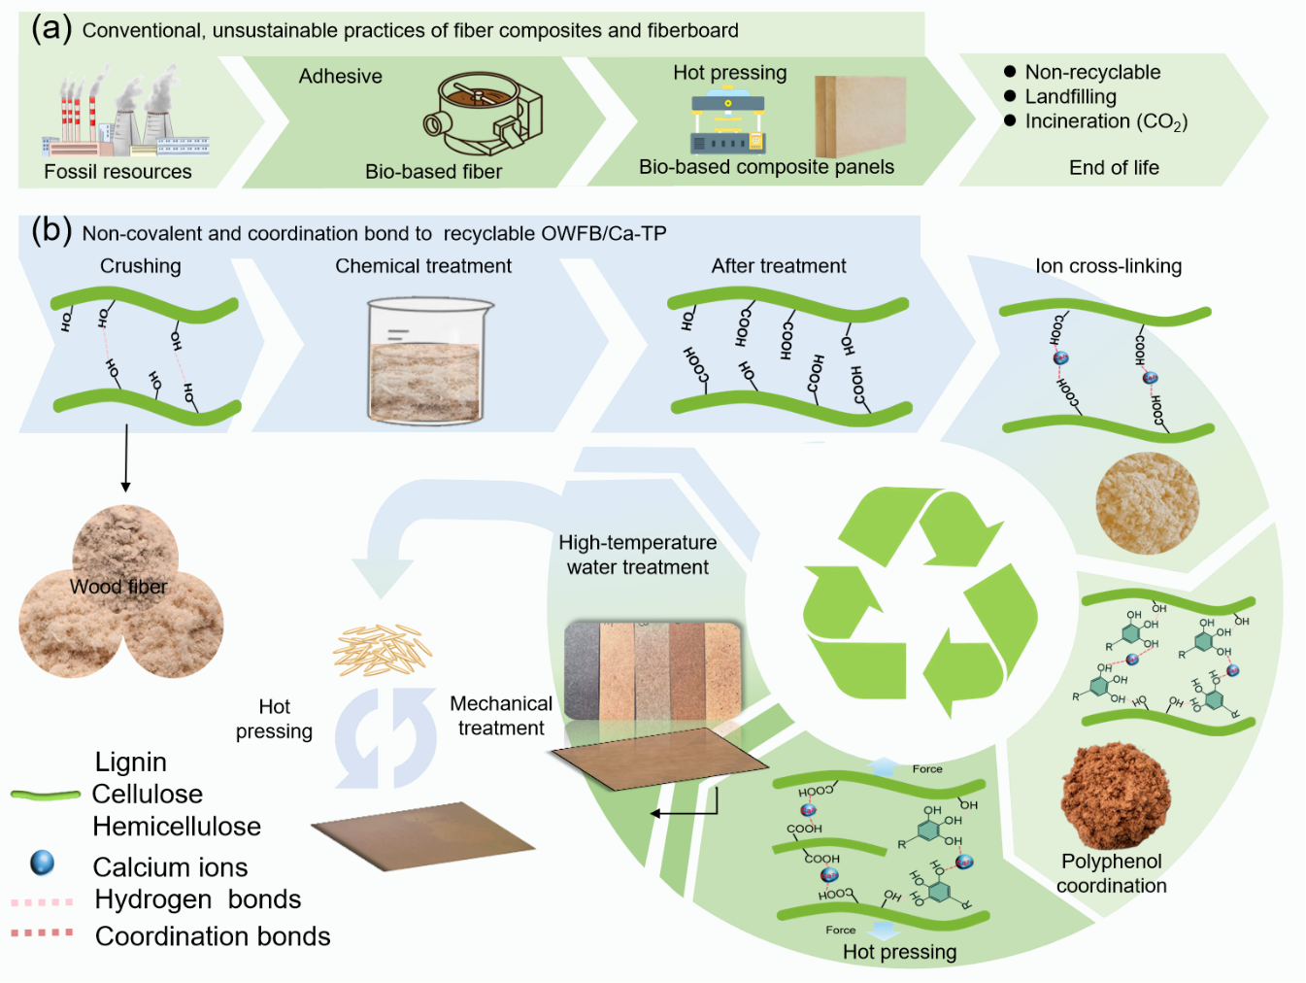
Figure 1. Synergistic Interaction between Tea Polyphenols and Wood Fibers: Constructing Multifunctional Metal-Polyphenol Network Fiberboards. (a) Traditional unsustainable production processes of wood-based fiberboards. (b) Schematic diagram illustrating the recycling mechanism of synergistic effects in OWFB/Ca-TP via metal–polyphenol networks.

2 Experimental
Materials: Poplar wood fiber was provided by Lingshou County Yigao Mineral Products Processing Plant Co., Ltd. (Hebei, China). Phosphate buffer (pH = 6.86) was ordered from Sinopharm Chemical Reagent Co., Ltd. (Shanghai, China). Potassium hydroxide (KOH, 95%), sodium chlorite (NaClO₂, 80%), 2,2,6,6-tetramethylpiperidin-1-oxyl (TEMPO, 98%), sodium hypochlorite (NaClO, active chlorine 13–16%), anhydrous ethanol (C₂H₅OH, 99.5%), tea polyphenol (C₂₂H₁₈O₁₁, 97%), tannic acid (C₇₆H₅₂O₄₆, 98%), gallic acid (C₇H₆O₅, 98%), dopamine hydrochloride (C₈H₁₁NO₂·HCl, 98%), calcium chloride dihydrate (CaCl₂·2H₂O), iron chloride hexahydrate (FeCl₃·6H₂O), copper chloride dihydrate (CuCl₂·2H₂O), zinc chloride (ZnCl₂), and aluminum chloride hexahydrate (AlCl₃·6H₂O) were all purchased from Shanghai Macklin Biochemical Co., Ltd. (Shanghai, China).
Pretreatment of Oxidized Wood Fibers: First, suspend 40 g of dry wood fibers in 1000 mL of deionized water. Poplar wood fibers were immersed in a 2 wt% KOH aqueous solution at 90℃ for 12 hours. After hemicellulose removal, the samples were immersed in deionized water several times to remove residual chemicals. Subsequently, the hemicellulose-removed poplar wood fibers were immersed in a phosphate buffer solution (220 mL, pH 6.8) containing 2,2,6,6-tetramethylpiperidine-1-oxide (TEMPO) (0.128 g), sodium chlorite (11.3 g), and sodium hypochlorite (2.56 mL) in a beaker. The reaction was then carried out at 60℃ for 24 hours, followed by cleaning with ethanol and deionized water.
Preparation of Oxidized Wood Fiberboard/Metal Ion–Polyphenol (OWFB/X-X): The dry fibers (initial moisture content 9–11%) were mixed with the solution at a ratio of 3 g of fiber to 1 mL of solution. The moisture content of the dry fibers was measured using a Lichen Rapid Moisture Analyzer (model: LC-DHS-16, Shanghai, China). Aqueous solutions of the metal ion and polyphenol compounds were prepared at concentrations of 0.5, 1, 1.5, 2, 2.5, 3 and 3.5 wt%, respectively. The prepared solutions were sequentially sprayed onto the oxidized wood fibers under mechanical stirring, while stirring was maintained continuously to ensure uniform distribution. The treated fibers were then transferred into molds (150 × 150 mm or 500 × 500 mm). The board density was controlled at 0.9 ± 0.05 g/cm³ by adjusting the amount of fiber used, and the thickness was regulated by placing steel spacers of different thicknesses between the upper and lower plates of the press. A 400 t laboratory hot press (Qingdao Guosen, model BY60×60/40, Shandong, China) was used, and the hot-pressing procedures are presented in Table S1 and S2.
Recycling test: Recycling tests were conducted by reprocessing the recovered OWFB/Ca-TP boards. The recycled boards were first subjected to hot-water treatment in a water bath at 80–100 °C, followed by mechanical crushing to redisperse them into fibers. The excess water was removed, and the fibers were subsequently dried. Two recycling strategies were investigated. In the first approach, the recovered fibers were hot-pressed again under identical conditions without the addition of metal ions or polyphenols. In the second approach, the recycling process was repeated for four cycles, and in each cycle the same amounts of metal ions and polyphenols were reintroduced prior to hot pressing under identical conditions. The recyclability of OWFB/Ca-TP was finally evaluated by comparing the flexural strength of the boards prepared using these two recycling methods.
Microstructure and Chemical characterization: Scanning electron microscope (SEM) (GeminiSEM300, ZEISS, Germany) and energy-dispersive X-ray (EDX) analysis were utilized to characterize the microstructure and elemental distribution of the samples. The samples were cut into small pieces (5×5 mm) using a mini table saw, and the testing surfaces were polished with a sliding microtome. The images of the sample morphology and elemental distribution were captured under a vacuum operation mode at 3.0 kV. Prior to SEM scanning, it is necessary to perform pre-spraying with gold/palladium (Au/Pd) on the surface of the sample. Fourier-transform infrared (FTIR) spectroscopy was performed on a Thermo Scientific Nicolet iS20 spectrometer (Thermo-Fisher Scientific, US) to determine the functional groups of wood samples. Then, the infrared spectrum of the sample was collected with a resolution of 4 cm⁻¹ , scanned 32 times, and tested over a wavenumber range of 400−4000 cm⁻¹ . The relative contents and chemical valency of elements were determined by Thermo Scientific K-Alpha-type X-ray photoelectron spectroscopy (XPS). The XPS spectra were collected at 0−1200 eV and calibrated based on surface contamination C 1s (284.8 eV) as the standard.
UV–Vis: The UV–vis absorbance of the CNF, tannins, iron nitrate solutions, and their combinations was recorded in a Shimadzu UV-2550 spectrophotometer (Shimadzu Corporation, Kyoto, Japan) in the wavelength range of 200–800 nm. All measurements were carried out at room temperature.
Mechanical Property Test: Internal bonding strength and bending strength were tested using a KXWW-01C mechanics testing machine (Chengde Kebiao Testing Instrument Manufacturing Co., Ltd). According to GB/T 17657-2022 "Test Methods for Physical and Chemical Properties of Artificial Boards and Surface Decorated Artificial Boards", the bending strength of the sample was tested using the three-point bending method. The sample size was 150×50 mm (length × width), with a gauge length of 50 mm and a loading speed of 2 mm/min. Each group was tested with 5 samples, and the average value was taken. The sample size for testing internal bonding (IB) strength was 50×50 mm, with a loading speed of 2 mm/min. Five samples were tested in each group, and the average value was taken. The hardness of the samples was tested using an SLX-D type Shore durometer (Shanghai Siwei Instrument Manufacturing Co., Ltd). Ten points on the flat surface of the sample were tested, and the average value of the results was taken. All experiments were performed with a minimum of five independent replicates (n = 5), and data are reported as mean ± standard deviation (mean ± SD).
Water Absorption Thickness Expansion Rate and Water Absorption Rate Test: The 24-hour water absorption thickness expansion rate and water absorption rate were tested according to GB/T 17657-2022 "Test Method for Physical and Chemical Properties of Artificial Boards and Decorative Artificial Boards". The samples were prepared with dimensions of 50 × 50 mm, and five replicates were tested for each group. Water absorption and thickness swelling were measured before and after 24 h immersion in water at room temperature. The samples were fully immersed without sealing the edges, and thickness was measured at the central region using a micrometer caliper. The results were expressed as the average of five samples. According to GB/T 11718-2021, the reference grade for humid environments is High-Density Fiberboard for Moist Conditions (HDF-GPMR), with a maximum allowed thickness swelling of 16%. Reference can be made to Figure 4b and Figure S4a.
Detection of Formaldehyde and Total Volatile Organic Compounds (TVOC) Concentrations: Formaldehyde and TVOC concentrations were detected using a 723P spectrophotometer, TD-30 thermal analyzer, and GCMS-QP 2020 GC-MS system. According to the national environmental protection standard "HJ 571-2010 Technical Requirements for Environmental Labeling Products of Wood-based Panels and Products", the concentrations of formaldehyde and TVOC in poplar fiberboard were measured.
Life-cycle assessment (LCA): The analysis follows the ISO 14040 and 14044 standard series. We evaluated the environmental impact of producing 1 m³ of OWFB/Ca-TP and compared it with conventional engineered wood panels. The system boundaries include the acquisition of raw materials, transportation, and the production process of OWFB/Ca-TP.

3 Results and discussion
3.1 Microstructural and Mechanistic Characterization
Figure 2 shows the microstructure and chemical characterization during the preparation process. In natural wood fiberboard (NWFB), the fibers are noticeably separated and loosely arranged (Figure 2a). After hemicellulose removal and TEMPO oxidation treatment, Ca²⁺ was added to coordinate with the carboxyl groups to prepare Oxidized wood fiberboard/calcium ion (OWFB/Ca), where the fibers of the wood fibers noticeably filled some gaps (Figure 2b). After adding tea polyphenols to form the MPN network and subsequent hot pressing treatment, the gaps in the wood fibers disappeared and were completely filled, resulting in a dense structure (Figure 2c). Compared to NWFB, the hydroxyl groups on the cellulose chains can bond with the phenolic hydroxyl groups rich on the surface of tea polyphenols, thereby increasing the hydrogen bond density per unit area and enhancing the vibrational absorption intensity of hydroxyl groups (Figure 2d). In summary, the removal of hemicellulose and oxidation treatment increase the contact area and interaction force between fibers, constructing a synergistic metal-polyphenol network structure between ions, tea polyphenols, and wood fibers, which further improves the interfacial bonding strength of wood fibers. As shown in Figure 2e, cellulose accounts for approximately 44% of natural wood fibers, providing primary structural support to the cell wall. Removal of hemicellulose slightly reduces cellulose content, likely due to co-removal or loosening of the cellulose structure. Oxidation treatment restores cellulose content, possibly by selectively degrading lignin and releasing cellulose or filling pores with oxidation products. Hemicellulose constitutes about 18.4% of natural wood fibers and connects cellulose with lignin. Its content decreases after hemicellulose removal but partially recovers following oxidation, likely due to the breakdown of lignin–carbohydrate complexes (LCCs) that release hemicellulose. Lignin makes up approximately 31.3% of natural wood fibers, providing rigidity. Its relative content increases after hemicellulose removal but decreases significantly after oxidation, indicating effective disruption of lignin and its crosslinking with polysaccharides. Overall, hemicellulose removal exposes lignin for targeted oxidative degradation, while oxidation selectively reduces lignin and indirectly enhances cellulose accessibility [51], providing a foundation for the preparation of high-performance fiberboards. The results from the automatic potentiometric titration indicated that the carboxyl content of the raw wood increased by 175% after oxidation (Figure 2f). By comparing the UV-vis spectra of NWFB and OWFB (Figure 2g), it can be seen that after chemical treatment, the peak for NWFB exhibits a significant blue shift (from 358 nm to 286 nm). For OWFB, after adding TP and metal ions, the position of the ultraviolet-visible absorption peak remains stable (Figure S1a and S1b). However, a stronger change in the TP peak observed in the OWFB/TP system indicates stronger binding ability to metal ions, which may be due to the coordination interaction between Ca²⁺ and phenolic hydroxyl groups (Figure S1c).
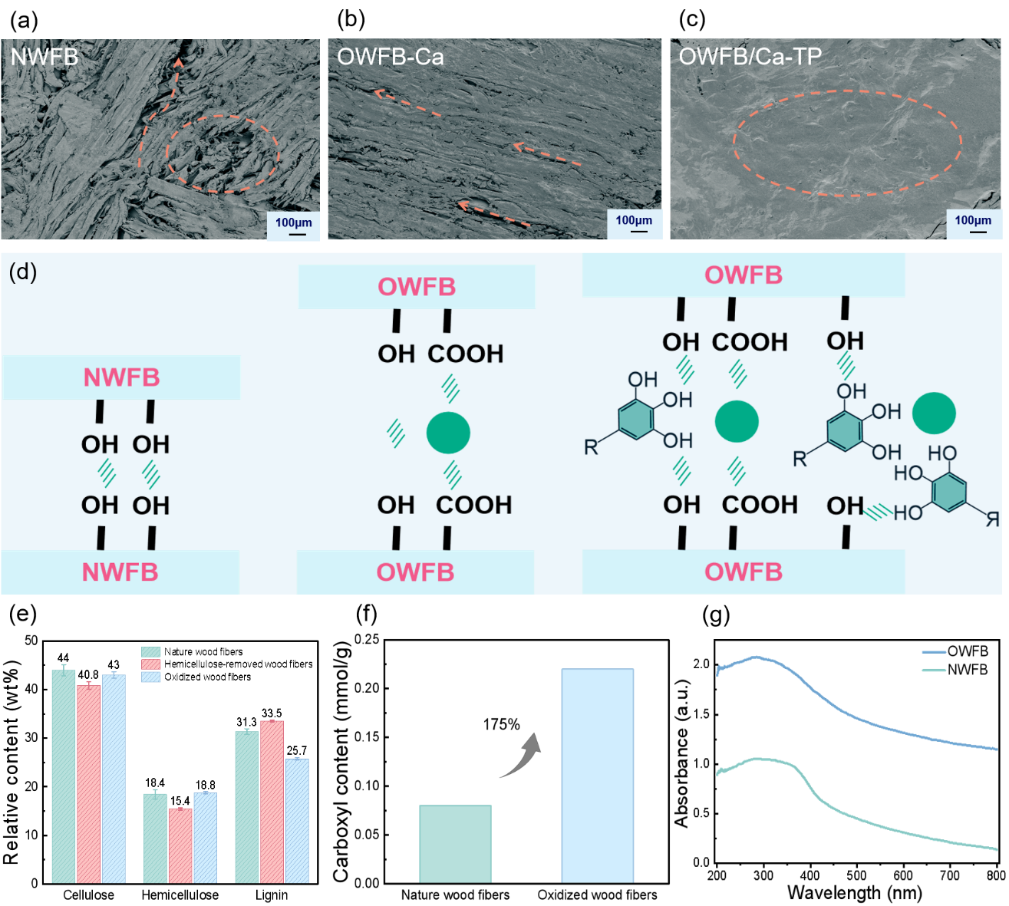
Figure 2. Changes in Microstructure and Chemical Structure During OWFB/Ca-TP Preparation. (a) Natural wood fibers, (b) oxidized wood fibers, and (c) scanning electron microscopy (SEM) images of OWFB/Ca-TP surfaces. (d) Schematic illustration of hydrogen bonding, coordination between calcium ions and carboxyl groups, and coordination between phenolic hydroxyl groups and hydroxyl groups. (e) Chemical composition analysis showing relative contents of cellulose, hemicellulose, and lignin. (f) Carboxyl content of Natural wood fibers and oxidized wood fibers. (g) UV–Vis.

By comparing the Fourier transform infrared (FTIR) spectra of NWFB, OWFB, and OWFB/Ca-TP (Figure 3a), it can be observed that the characteristic absorption band at 1740 cm⁻¹ disappears after chemical treatment. This band is commonly attributed to the C=O stretching vibration of hemicellulose, indicating that hemicellulose was effectively removed during the treatment process. Figure 3b demonstrates that the binding energy of C=O increases from 530.5 eV to 531.1 eV, while the binding energy of -OH remains unchanged, confirming that calcium ions primarily crosslink with carboxyl groups. Energy dispersive X-ray spectroscopy (EDX) results confirm the presence of calcium ions and their uniform distribution (Figure S2). The carboxyl groups are crucial for the entry of metal ions and the formation of coordination bonds. The introduction of carboxyl groups enhances the negative charge on the cellulose molecular chains, which increases the electrostatic repulsion between cellulose microfibrils. This, in turn, enlarges the spacing between cellulose microfibrils, facilitating the penetration of metal ions. Small-angle X-ray scattering (SAXS) analysis confirmed the change in the spacing between cellulose microfibrils. The results showed that after oxidation treatment, the spacing increased from 66.28 nm to 73.01 nm (Figure 3c-f).
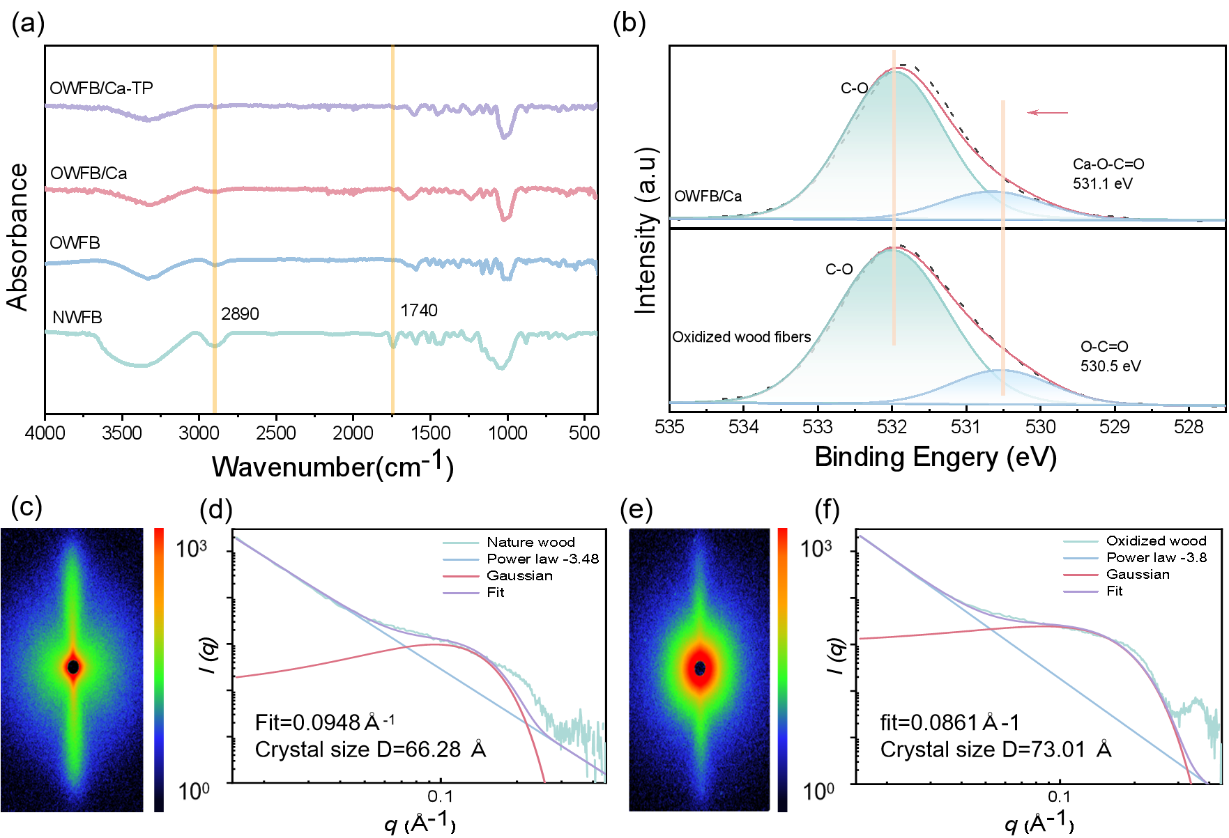
Figure 3. Changes in Microstructure and Chemical Structure During OWFB/Ca-TP Preparation. (a) FTIR. (b)XPS. Small-angle X-ray scattering (SAXS) images (c, e) and fitted curves of fiber spacing for NWFB (d) and OWFB (f).

3.2 Processability and Mechanical Properties
Figure 4a shows a large-sized board of 240×150 cm, demonstrating excellent machinability suitable for large-scale applications. Additionally, OWFB/Ca-TP in varying thicknesses can be used for different settings. For example, thin boards can be used for decorative panels, while thick boards serve as substrates for flooring or furniture. By adjusting the concentrations of the metal ion and polyphenol solutions, it was observed that the mechanical performance gradually improved with increasing concentration, reaching the highest bending strength at a solution concentration of 2.5 wt% (Figure S3). Based on these results, all metal ions and polyphenols were tested at a concentration of 2.5 wt%. The thickness swelling and water absorption of OWFB/Ca-TP decreased to 11% and 17%, respectively, and the thickness change measured with a spiral gauge before and after testing indicated only an 11% expansion (Figure 4b), meeting the requirements of China’s National Standard "GB/T 11718-2021" for fiberboards used in high-humidity environments. Figure 3f shows that OWFB/Ca-TP has a low water absorption rate after 24-hour immersion. While OPFB's water absorption is higher than NWFB (thickness swelling rate of 41%, water absorption rate of 31%), the addition of Ca ions in OWFB/Ca did not significantly increase it, mainly because the coordination with the carboxyl group was insufficient without the phenolic hydroxyl groups for strong binding (Figure S4b). Furthermore, Performance tests indicated a significant optimization of key properties in OWFB/MPN compared to NWFB. The synergistic effect between Ca²⁺ and phenolic hydroxyl groups after chemical treatment effectively regulated interfacial bonding and microstructure, leading to a 7.6-fold and 2.3-fold increase in internal bond strength and flexural strength, respectively (Figures 4d and 4e), while the Shore hardness also improved from 74 to 86 (Figure 4f). These findings support its application in construction and decoration (e.g., ceilings, floors) as well as furniture manufacturing. The outstanding strength and water resistance of OWFB/Ca-TP primarily result from two factors: Oxidation increases the contact area and hydrogen bonding interactions between wood fibers, greatly enhancing internal bond strength. The binding energy of coordination bonds is higher than that of hydrogen bonds [52], and the interactions between Ca²⁺-carboxyl and Ca²⁺-phenolic hydroxyl groups form a stable MPN structure, strengthening interfacial adhesion. The inclusion of metal ions and polyphenols also closes the hydrophilic groups (such as carboxyl and hydroxyl) on the fiber surface. The hydrophobic benzene rings in polyphenols further enhance water resistance. To evaluate the potential for applications in high-temperature environments, the thermal insulation performance of OWFB/Ca-TP was preliminarily tested using infrared thermography. When thermal imaging was applied to NWFB, the temperature rapidly increased upon exposure to heat, with the color transitioning from cool tones (blue) to warm tones (red and yellow) over time (Figure S5). This color change indicates significant heat absorption and rapid thermal propagation, which can lead to material degradation and reduced durability. Specifically, within the first 20 seconds, NWFB exhibited considerable heat buildup and rapid heat transfer, making it unsuitable for high-temperature environments. On the other hand, OWFB/Ca-TP exhibited a significantly slower thermal response. Although the temperature increased, the overall thermal change was much more gradual. Thermal imaging showed a more controlled color shift, with less pronounced changes compared to NWFB. This suggests that OWFB/Ca-TP has a better ability to resist heat propagation, preventing thermal degradation and enhancing its stability at high temperatures. The slower thermal response may be due to stronger interactions and bonding between calcium ions, polyphenols, and wood fibers, which could act as a thermal barrier, preventing the rapid transfer of heat.
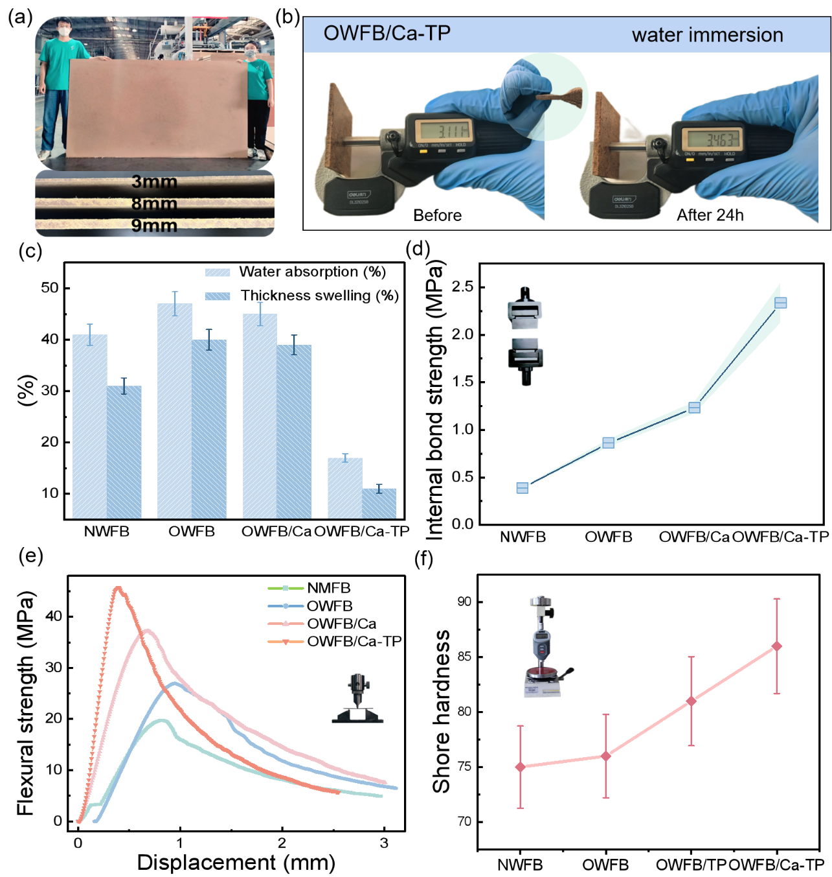
Figure 4. Physical and mechanical properties of OWFB/Ca-TP. (a) Large-size (240×150 cm) OWFB/Ca-TP with various thicknesses. (b) Comparison photographs of water absorption swelling rate between OWFB/Ca-TP and NWFB. (c) 24h water absorption rate and thickness swelling rate of different preparation methods. (d) Internal bond strength of different preparation methods. (e) Flexural strength of different preparation methods. (f) Shore hardness different preparation methods.

Similarly, at the optimal ratio of 60:1, different metal ions (e.g., Fe³⁺, Cu²⁺, Zn²⁺, and Al³⁺) (Figure 5a) and polyphenols (e.g., TA, GA, and PDA) (Figure 3c) were employed to prepare OWFB/MPN with varied properties, accompanied by noticeable differences in surface color. Figure 5b shows the flexural strength and elastic modulus of fiberboards with different ions. It can be observed that these strengths are all lower than that of OWFB/Ca-TP, with Fe³⁺ showing the highest relative strength, as well as relatively higher internal bond strength. However, the strength of Al³⁺ did not meet the standard (Figure 5c). This may be attributed to the poor performance of Al³⁺ in binding with polyphenols, mainly due to the lack of strong chelation interactions and its reliance on electrostatic attraction and π–π stacking. The composite bonds have longer bond lengths and lower bond orders, resulting in weaker bonding stability compared with ions such as Fe³⁺, Cu²⁺ and Zn²⁺, which can form chelate bonds. These characteristics lead to relatively lower interaction strength and stability between Al³⁺ and polyphenols [53]. Subsequently, OWFB/Ca-TP was compared with three other polyphenols, demonstrating the best performance in static bending strength and water absorption. All polyphenols, except for GA, met the required standards (Figures 5d and 5e). This demonstrates the interchangeability and versatility of polyphenols, due to the formation of a dense interface by chemical treatment and the enhanced interfacial interactions provided by the MPN network. After the coordination effect was strengthened, the MPN network increased the energy dissipation of interfacial damage. When OWFB/Ca-TP is subjected to bending stress, the bonding interface has sufficient strength and is not easily damaged, with the fracture section showing relatively neat fiber breakage (Figure S6).
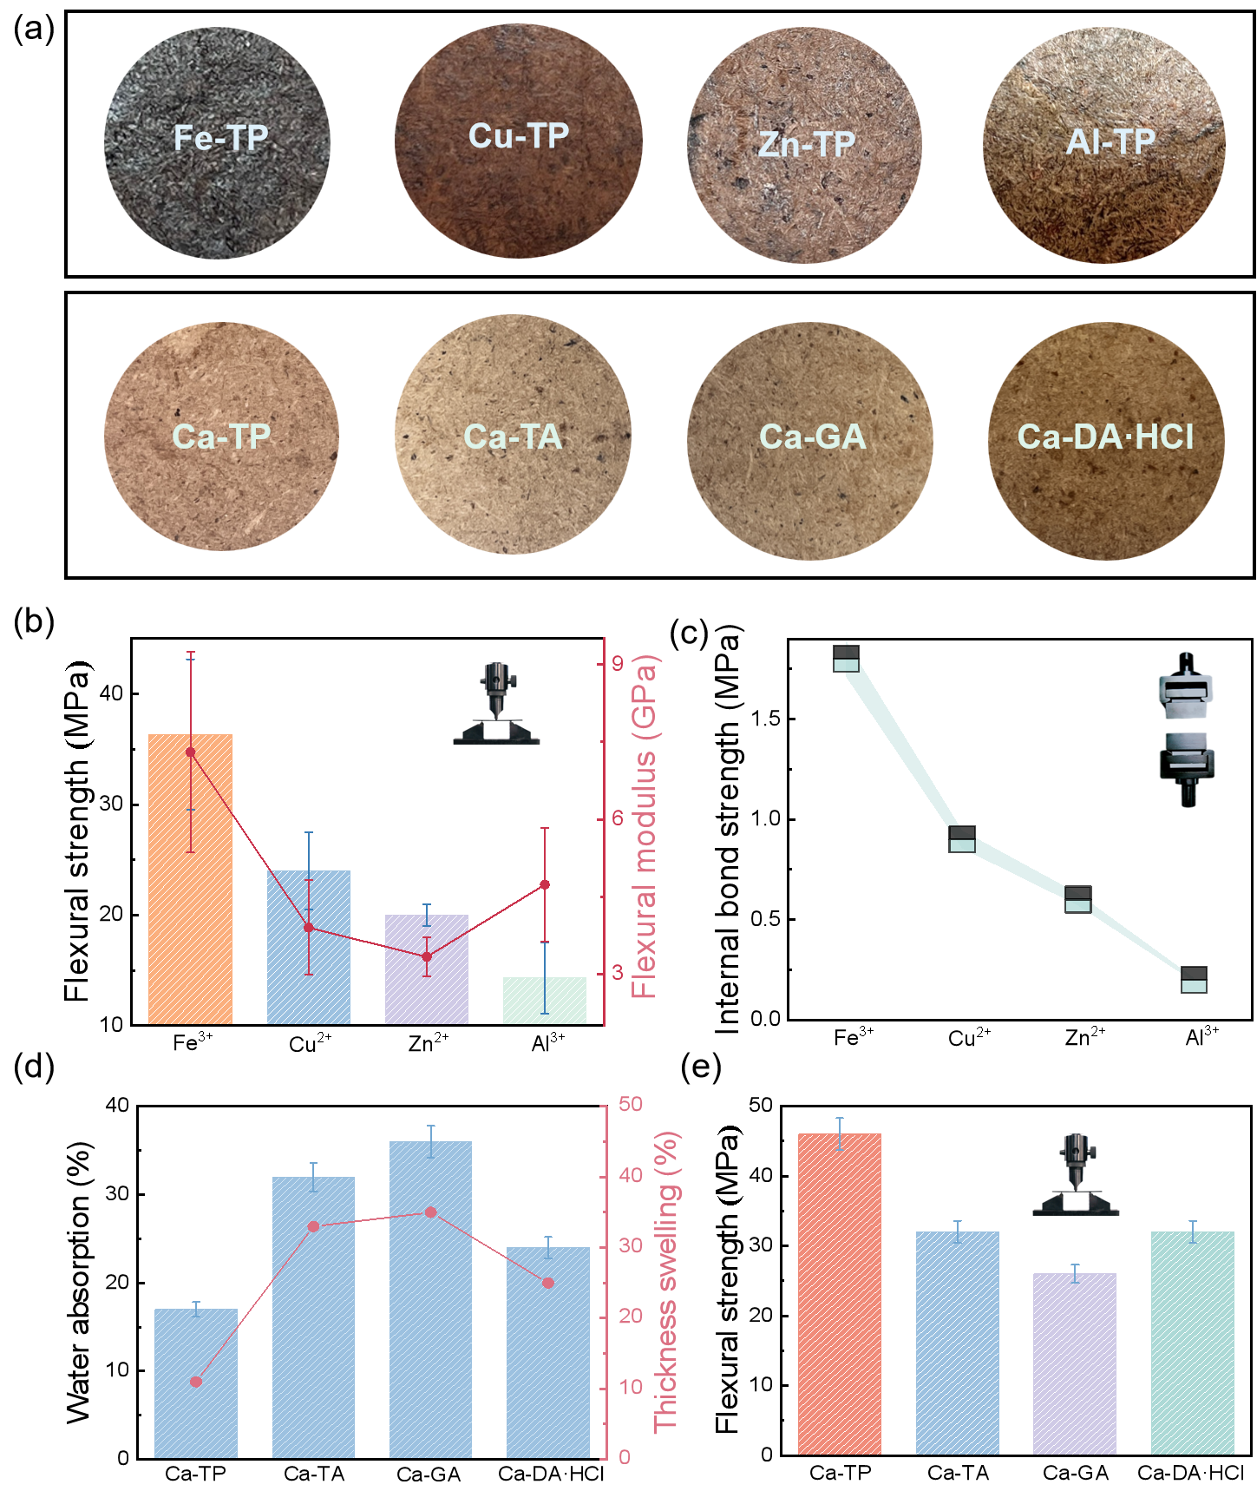
Figure 5. Physical and mechanical properties of fiberboards prepared with different metal ions and polyphenols. (a) Surface photographs of OWFB/X-TP with different ions; Surface photographs of OWFB/Ca-X with different polyphenols. (b) Flexural strength and flexural modulus of OWFB/X-TP with different ions. (c) Internal bond strength of OWFB/X-TP with different ions. (d) Flexural strength of OWFB/Ca-X with different polyphenols. (e) 24h water absorption rate and thickness swelling rate of OWFB/Ca-X with different polyphenols.

3.3 Application and Cycle Performance
OWFB/Ca-TP materials demonstrate exceptional multifunctionality and recyclability across multiple dimensions, making them ideal materials with broad application potential. Whether in building structures, interior decoration, or other high-demand application scenarios, OWFB/Ca-TP provides excellent performance, particularly excelling in environmental protection and sustainable development (Figure 6a). More importantly, this material possesses outstanding recyclability, maintaining a significant proportion of its bending strength even after undergoing multiple recycling and reprocessing cycles, indicating its long-term reliability and stability. We performed secondary processing on recycled OWFB/Ca-TP and compared its bending strength before and after recycling. Figure 6b shows the bending strength of recycled OWFB/Ca-TP, which was directly hot-pressed after high-temperature water treatment, with a retention rate of only 70%. This decline can be attributed to the loss of metal ions during the high-temperature water treatment process, which reduces the number of coordination bonds present in the recycled OWFB/Ca-TP. In contrast, after adding calcium ions and tea polyphenols post high-temperature water treatment, the bonding performance of the recycled BBM was improved, with the retention rate reaching 76% after four recycling cycles (Figure 6c). This indicates that although coordination bonds are broken during the recycling process, they are reformed when the material is reintroduced to an ion solution and subsequently hot-pressed.
Through the recycling performance tests, OWFB/Ca-TP demonstrated its remarkable cyclic performance, showcasing high recycling and reuse value. This not only solves the long-standing issue of traditional wood materials being "permanently discarded after one-time molding" but also provides strong support for promoting the application of sustainable furniture materials. With these innovative properties, OWFB/Ca-TP demonstrates its significant potential value in the fields of sustainable materials and environmental protection.
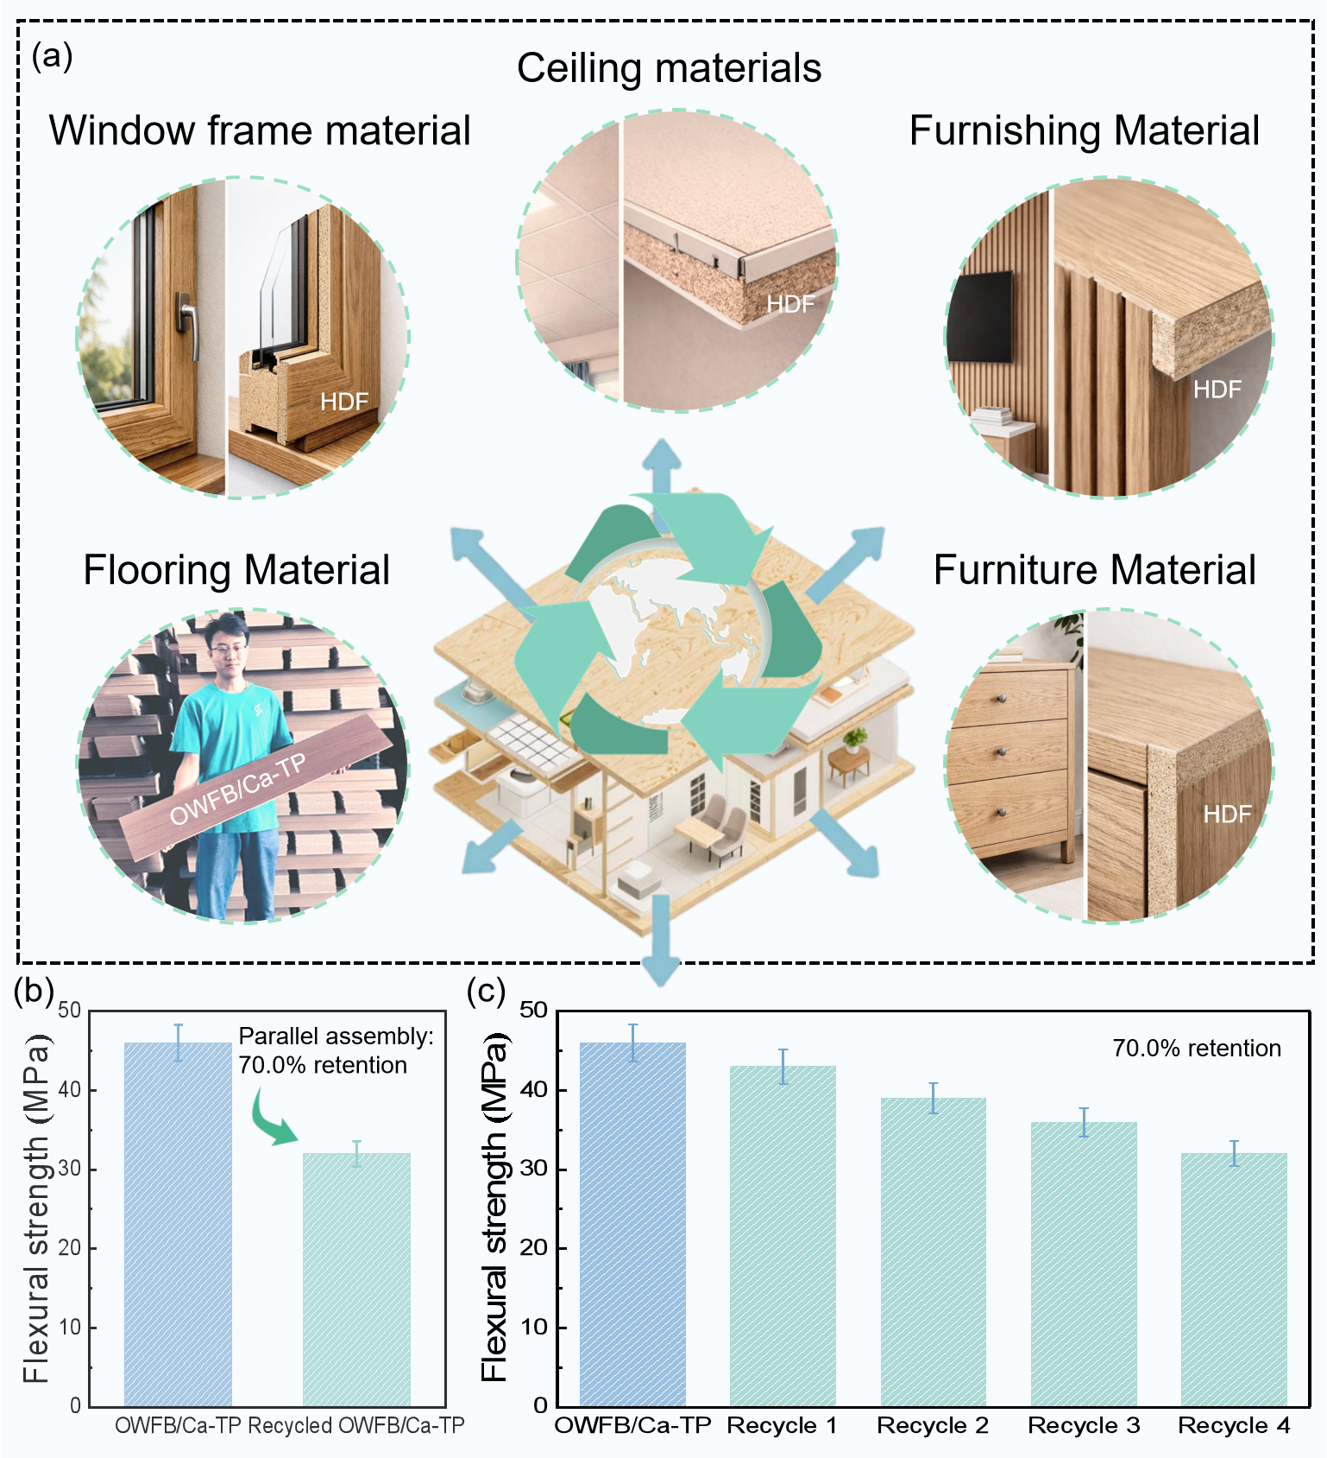
Figure 6. Cycling Performance. (a) OWFB/Ca-TP for various indoor applications including interior decoration, furniture, flooring, door and window frames, and roofing. (OWFB/Ca-TP fiberboard used for flooring (left) was produced in this study; the other images were newly generated by the authors for illustrative purposes only and do not depict actual experimental samples.) (b) Flexural strength comparison between OWFB/Ca-TP and recycled OWFB/Ca-TP. (c) Flexural strength of recycled OWFB/Ca-TP over four cycles with Ca-TP supplementation.

3.4 Performance comparison and environmental friendliness
Comparison with the national standard performance and market prices of conventional fiberboards highlights the superior performance and market competitiveness of OWFB/Ca-TP. OWFB/Ca-TP exhibits significant advantages in terms of recyclability, bonding strength, hardness, bending strength, water absorption swelling rate, and cost (Figure 7a). In terms of environmental safety, OWFB/Ca-TP strictly follows the "GB/T 39600-2021 Formaldehyde Emission Limits for Wood-based Panels and Products" standard, achieving an ENF-level formaldehyde emission (≤0.025 mg/m³). The concentrations of pollutants such as TVOCs and benzene compounds are all below the detection limits of gas chromatography-mass spectrometry (<0.001 mg/m³, Chinese National Standards, 2021) (Figure 7b). The environmental and energy impacts of producing 1 m³ of OWFB-Ca-TP were assessed and compared with conventional fiberboards. The results show that OWFB-Ca-TP exhibits the lowest energy consumption (EC), approximately 50,499.58 MJ, compared to 9,850,000 MJ for conventional fiberboards. Key environmental indicators, including global warming potential (GWP) and respiratory inorganics (RI), were also evaluated. The GWP of OWFB-Ca-TP is approximately 856.94 kg CO₂ eq., which is about 21.9 times lower than that of conventional fiberboards (18,800 kg CO₂ eq.) (Figure 7c). Although potassium hydroxide and sodium chlorite, commonly used in the de-hemicellulose and oxidation processes, may pose certain environmental risks, the overall environmental impact of OWFB-Ca-TP remains low across the assessed categories.
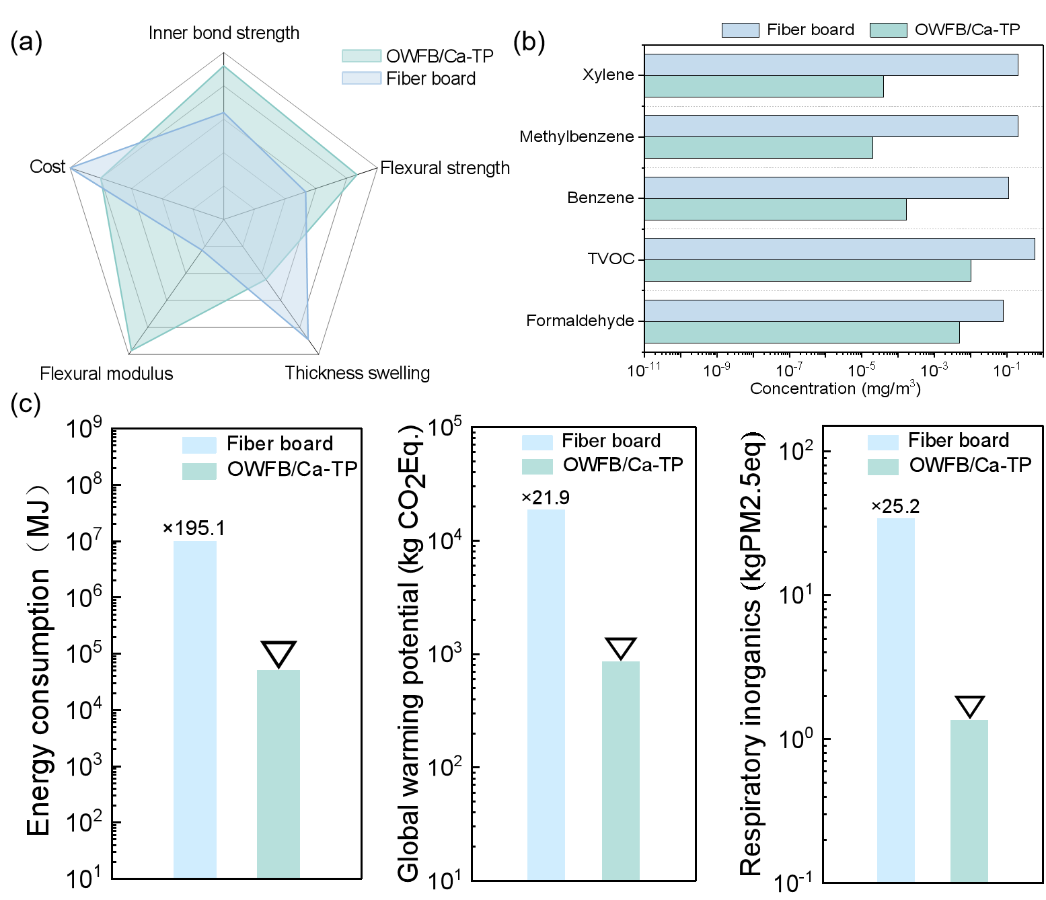
Figure 7. (a) Radar chart comparing the performance of OWFB/Ca-TP with traditional fiberboards. (b) Comparison of hazardous gas content between OWFB/Ca-TP and other formaldehyde-free fiberboards. (c) LCA.

4 Conclusion
This study employs dynamic coordination self-assembly of metal–polyphenol networks (MPNs) to successfully develop a recyclable fiberboard with integrated bonding functionality, eliminating the need for conventional synthetic resin adhesives and providing new insights into the green manufacturing of wood-based materials. The material exhibits an internal bonding strength of 2.6 MPa and a static bending strength of 46 MPa, representing increases of 7.6-fold and 2.3-fold compared with natural fiberboard, respectively. Its 24-hour water absorption thickness swelling is as low as 11%, with overall performance surpassing most bio-based adhesive boards. After four cycles of hot-pressing and dissociation, the bonding strength retains 76% of its initial value, effectively addressing the issue of traditional fiberboards being “single-use and non-recyclable,” thereby enabling repeated recycling of wood-based waste. Regarding environmental performance, the material’s formaldehyde emission meets the ENF standard (≤0.025 mg/m³), and concentrations of total volatile organic compounds (TVOCs) and benzene derivatives are below the detection limits, contributing to improved indoor air quality. The preparation process offers advantages such as a wide range of raw materials and simple operation, and performance can be tailored by selecting different metal ions (e.g., Ca²⁺, Fe³⁺, Cu²⁺, Zn²⁺, Al³⁺) and polyphenolic compounds (e.g., tea polyphenols, tannic acid, gallic acid) to suit various applications. During the pretreatment stage, hemicellulose is removed and TEMPO-mediated oxidation introduces carboxyl groups, enhancing the fiber surface reactivity. The coordination bonds in the MPN, together with hydrogen bonds, synergistically strengthen the interfacial bonding. This green bonding technology demonstrates broad application potential in areas such as building decoration, furniture manufacturing, and door/window frames, promoting the large-scale production of sustainable wood-based materials and offering a novel paradigm for the development of a circular economy in the wood industry.

CRediT authorship contribution statement
X.Y.: Conceptualization, Material preparation, Test and data analysis,Writing-original draft. Z.F.: Conceptualization, Methodology, Formal analysis, Investigation. K.W.: Formal analysis, Software. X.G.: Formal analysis, Discussion. Y.L.: Conceptualization, Methodology, Formal analysis, Resources, Supervision, Funding acquisition. L.Y.: Method ology, Formal analysis, Discussion, Investigation, Supervision, Funding acquisition.

Declaration of Competing Interest
The authors declare that there is no conflict of interests regarding the publication of this paper.

Funding
This work was supported by the National Natural Science Foundation of China (Grant No. 32371797; 32122058) , the Natural Science Foundation of Inner Mongolia Autonomous Region (Grant No. 2025MS03077), the Major Science and Technology Special Project of Inner Mongolia Autonomous Region (Grant No. 2024JBGS0013-02), and the Bayannur Municipal Science and Technology Program Project (Grant No. K2024085).

References
[1] Foundation E M (2019) Completing The Picture-How The Circular Economy Tackles Climate Change.
[2] Kirchherr J, Urbinati A, Hartley K (2023) Circular economy: A new research field? Journal of Industrial Ecology, 27 (5), 1239-1251, https://doi.org/10.1111/jiec.13426.
[3] Ncube A, Mtetwa S, Bukhari M, Fiorentino G, Passaro R (2023) Circular Economy and Green Chemistry: The Need for Radical Innovative Approaches in the Design for New Products. Energies, 16 (4), https://doi.org/10.3390/en16041752.
[4] S.Sehnem A A F S L d Q, S. C. F.Pereira, G.dos Santos Correia, & E.Kuzma (2022) Circular economy and innovation: A look from the perspective of organizational capabilities. Business Strategy and the Environment, 31 (1), 236-250.
[5] C E C D, 9. Food, Bioeconomy, Natural Resources, Agriculture and Environment In Horizon Europe-Work Programme 2021-2022
2022; pp 789-798.
[6] Fu Z, Wang K, Yu X, Liu W, Lao W, Hong W, Zhang Y, Yu W, Lu Y (2025) Synergistic interaction of non-covalent and coordination bond to fabricate recyclable bamboo-based material. The Innovation Materials, 3 (2), https://doi.org/10.59717/j.xinn-mater.2024.100132.
[7] UNECE/FAO (2022) Forest Products Annual Market Review, 2021-2022,
[8] the United Nations (UNECE) F (2024) Global forest products facts and figures 2023, UNITED NATIONS PUBLICATION,
[9] Zbieć M, Franc-Dąbrowska J, Drejerska N (2022) Wood Waste Management in Europe through the Lens of the Circular Bioeconomy. Energies, 15 (12), https://doi.org/10.3390/en15124352.
[10] Colangelo F, Farina I, Travaglioni M, Salzano C, Cioffi R, Petrillo A (2021) Eco-efficient industrial waste recycling for the manufacturing of fibre reinforced innovative geopolymer mortars: Integrated waste management and green product development through LCA. Journal of Cleaner Production, 312, https://doi.org/10.1016/j.jclepro.2021.127777.
[11] Li T, Zhang B, Jiang S, Zhou X, Du G, Wu Z, Cao M, Yang L (2020) Novel Highly Branched Polymer Wood Adhesive Resin. ACS Sustainable Chemistry & Engineering, 8 (13), 5209-5216, https://doi.org/10.1021/acssuschemeng.9b07732.
[12] Liu M, Wang Y, Wu Y, He Z, Wan H (2018) “Greener” adhesives composed of urea-formaldehyde resin and cottonseed meal for wood-based composites. Journal of Cleaner Production, 187, 361-371, https://doi.org/10.1016/j.jclepro.2018.03.239.
[13] O. G. Treusch A P (2012) A COMBINATION OF POLYETHYLENIMINE AND PHENOLIC RESIN AS AN ADHESIVE FOR WOOD-BASED PANELS. BioResources, 7 (1), 789-798.
[14] Wibowo E S, Park B-D, Causin V (2021) Recent Advances in Urea–Formaldehyde Resins: Converting Crystalline Thermosetting Polymers Back to Amorphous Ones. Polymer Reviews, 62 (4), 722-756, https://doi.org/10.1080/15583724.2021.2014520.
[15] Yang H, Tan X, Du G, Ni K, Wu Y, Li Z, Ran X, Gao W, Li J, Yang L (2023) Development of biomass adhesives based on aminated cellulose and oxidized sucrose reinforced with epoxy functionalized wood interface. Composites Part B: Engineering, 263, https://doi.org/10.1016/j.compositesb.2023.110872.
[16] Lin Z, Liu H, Richardson J J, Xu W, Chen J, Zhou J, Caruso F (2024) Metal-phenolic network composites: from fundamentals to applications. Chem Soc Rev, 53 (22), 10800-10826, https://doi.org/10.1039/d3cs00273j.
[17] Lin G, Zhao L, Jin H, Wang S, Wang N, Dai M, Lin X (2025) Designing metal–phenolic networks in biomedicine. Applied Materials Today, 45, https://doi.org/10.1016/j.apmt.2025.102822.
[18] Yao S, Han J, Zhang W, Guo D, Han S, Lu Y, Li J (2025) ZIF-67-Confined Pd Single-Atom Catalysts Implanted Into Polydopamine-Modified Bamboo Microchannels for Robust Continuous-Flow Hydrogenation. Adv Sci (Weinh), e13960, https://doi.org/10.1002/advs.202513960.
[19] Guo J, Ping Y, Ejima H, Alt K, Meissner M, Richardson J J, Yan Y, Peter K, von Elverfeldt D, Hagemeyer C E, Caruso F (2014) Engineering multifunctional capsules through the assembly of metal-phenolic networks. Angew Chem Int Ed Engl, 53 (22), 5546-5551, https://doi.org/10.1002/anie.201311136.
[20] Kim C-J, Ercole F, Ju Y, Pan S, Chen J, Qu Y, Quinn J F, Caruso F (2021) Synthesis of Customizable Macromolecular Conjugates as Building Blocks for Engineering Metal–Phenolic Network Capsules with Tailorable Properties. Chemistry of Materials, 33 (21), 8477-8488, https://doi.org/10.1021/acs.chemmater.1c02912.
[21] Kim C J, Ercole F, Chen J, Pan S, Ju Y, Quinn J F, Caruso F (2022) Macromolecular Engineering of Thermoresponsive Metal-Phenolic Networks. J Am Chem Soc, 144 (1), 503-514, https://doi.org/10.1021/jacs.1c10979.
[22] Li M, Luo S, Cheng C, Liang X, Xu J, Guo Z, Wang Z, Wang L, Huang Z, Jiang L (2025) Metal-polyphenol network-hardened coconut protein-carboxymethyl cellulose complex coacervates: Fabrication, characterization, environmental stability, and release kinetics. Carbohydr Polym, 366, 123880, https://doi.org/10.1016/j.carbpol.2025.123880.
[23] Tan X, Sheng R, Liu Z, Li W, Yuan R, Tao Y, Yang N, Ge L (2024) Assembly of Metal-Phenolic Networks onto Microbubbles for One-Step Generation of Functional Microcapsules. Small, 20 (1), e2305325, https://doi.org/10.1002/smll.202305325.
[24] Luo B, Liang B, Wang J, Yang Z, Zhang X, Xiong S, Yang L, Xu Y, Li Y (2025) Robust Hierarchically Porous Hydrogel Solar Evaporators Based on Metal‐Phenolic Networks‐Coated Carbon Nanotubes. Advanced Functional Materials, https://doi.org/10.1002/adfm.202504823.
[25] Ullah S, Hussain Z, Mehmood S, Samadikuchaksaraei A, Ullah I, Khattak S, Liu Y, Ullah I, Pei R (2025) Metal-Phenolic Network (MPN) Modified Janus Fibrous Hydrogel Scaffold for Infected Diabetic Wound Healing. ACS Appl Mater Interfaces, 17 (7), 10470-10484, https://doi.org/10.1021/acsami.4c20592.
[26] Zou M, Chen C, Wang M, Lei C, Wang Y, Luo F, Huang D, Wang M, Zheng H, Wang B, Lin Z, Weng Z (2025) Facile Fabrication of Injectable Multifunctional Hydrogels Based on Gallium-Polyphenol Networks with Superior Antibacterial Activity for Promoting Infected Wound Healing. Adv Healthc Mater, 14 (9), e2404283, https://doi.org/10.1002/adhm.202404283.
[27] Duan S, Sun W, Huang P, Sun T, Zhao X, Li Y, Yan M (2024) Tilapia gelatin films by incorporating metal-polyphenol network formed by procyanidin and zinc ion for pork preservation. Food Packaging and Shelf Life, 45, https://doi.org/10.1016/j.fpsl.2024.101345.
[28] Liu M, Wang Y, Su S, Long F, Zhong L, Hu J (2024) Multifunctional bio-nanocomposite films integrated with essential oils@metal-phenolic network nanocapsules for durable fruit preservation. Int J Biol Macromol, 278 (Pt 4), 134916, https://doi.org/10.1016/j.ijbiomac.2024.134916.
[29] Yun G, Richardson J J, Capelli M, Hu Y, Besford Q A, Weiss A C G, Lee H, Choi I S, Gibson B C, Reineck P, Caruso F (2019) The Biomolecular Corona in 2D and Reverse: Patterning Metal–Phenolic Networks on Proteins, Lipids, Nucleic Acids, Polysaccharides, and Fingerprints. Advanced Functional Materials, 30 (1), https://doi.org/10.1002/adfm.201905805.
[30] Shen X, Han S, Xiang Z, Lu Y, Qian H, Tang L, Wang H, Lu Y (2023) Universal strategy for constructing antibioadhesive and robust coatings for wood. Industrial Crops and Products, 202, https://doi.org/10.1016/j.indcrop.2023.117068.
[31] Wang Z, Hu M, Zhu L, Zhou J, He F, Liu Y, Li Y, Li Y, Lin Z, Caruso F (2025) Cracked Metal-Phenolic Networks with Durable Confinement Capillarity for Enhanced Solar Desalination. Adv Mater, e2503896, https://doi.org/10.1002/adma.202503896.
[32] Yu Z, Li X, Wang Z, Fan Y, Zhao W, Li D, Xu D, Gu T, Wang F (2024) Robust Chiral Metal-Organic Framework Coatings for Self-Activating and Sustainable Biofouling Mitigation. Adv Mater, 36 (45), e2407409, https://doi.org/10.1002/adma.202407409.
[33] Zheng Y, Zhou X, Li R, Wang X, Niu Y, Chen L, Feng X (2025) The CG MPNs@UFB composite coatings integrating antibacterial with interface anchoring for sustained protection on inanimate surfaces. Chemical Engineering Journal, 515, https://doi.org/10.1016/j.cej.2025.163304.
[34] Chen J, Pan S, Zhou J, Seidel R, Beyer S, Lin Z, Richardson J J, Caruso F (2021) Metal–Phenolic Networks as Tunable Buffering Systems. Chemistry of Materials, 33 (7), 2557-2566, https://doi.org/10.1021/acs.chemmater.1c00015.
[35] Kim J, Hong J, Park M J, Lee H S (2023) Tailoring Enantiomeric Chiral Channels in Metal-Peptide Networks: A Novel Foldamer-Based Approach for Host-Guest Interactions. Adv Mater, 35 (52), e2305753, https://doi.org/10.1002/adma.202305753.
[36] Wang Z, Gao J, Zhou J, Gong J, Shang L, Ye H, He F, Peng S, Lin Z, Li Y, Caruso F (2023) Engineering Metal-Phenolic Networks for Solar Desalination with Directional Salt Crystallization. Adv Mater, 35 (1), e2209015, https://doi.org/10.1002/adma.202209015.
[37] Wang H, Wang C, Zou Y, Hu J, Li Y, Cheng Y (2020) Natural polyphenols in drug delivery systems: Current status and future challenges. Giant, 3, https://doi.org/10.1016/j.giant.2020.100022.
[38] Wang M, Zhang S, Liu S, Nian L, Wang S, Cao C (2025) Inulin and metal-phenolic network single-cell encapsulation: Boosting the tolerance and intestinal colonization capability of Bifidobacterium lactis. Food Hydrocolloids, 169, https://doi.org/10.1016/j.foodhyd.2025.111619.
[39] Wang X, Huang H, Xu R, Fang Y, Weng Y, Wang Z, Xiong X, Liu H (2023) Robust but On-Demand Detachable Wet Tissue Adhesive Hydrogel Enhanced with Modified Tannic Acid. ACS Appl Mater Interfaces, 15 (39), 45676-45688, https://doi.org/10.1021/acsami.3c10140.
[40] Xu W, Lin Z, Cortez-Jugo C, Qiao G G, Caruso F (2025) Antimicrobial Phenolic Materials: From Assembly to Function. Angew Chem Int Ed Engl, 64 (13), e202423654, https://doi.org/10.1002/anie.202423654.
[41] Li K, Xiao G, Richardson J J, Tardy B L, Ejima H, Huang W, Guo J, Liao X, Shi B (2019) Targeted Therapy against Metastatic Melanoma Based on Self-Assembled Metal-Phenolic Nanocomplexes Comprised of Green Tea Catechin. Adv Sci (Weinh), 6 (5), 1801688, https://doi.org/10.1002/advs.201801688.
[42] Wang S X, Waite J H (2025) Catechol redox maintenance in mussel adhesion. Nat Rev Chem, 9 (3), 159-172, https://doi.org/10.1038/s41570-024-00673-4.
[43] Chen K, Kang Q K, Li Y, Wu W Q, Zhu H, Shi H (2022) Catalytic Amination of Phenols with Amines. J Am Chem Soc, 144 (3), 1144-1151, https://doi.org/10.1021/jacs.1c12622.
[44] Xia Q, Liang Y, Cao A, Cao Y, Cai L (2024) Preparation and characterization of pH-responsive metal-polyphenol structure coated nanoparticles. Food Science and Human Wellness, 13 (3), 1303-1310, https://doi.org/10.26599/fshw.2022.9250109.
[45] Zhao K, Zhao X, Guo X, Zhao Y, Tong M, Chen L, Zhuang S, Gu X (2025) Switchable, Recyclable, and Time‐Programmable Hydrogels via Counterion‐Engineered Differential Metal‐Ion Coordination. Advanced Functional Materials, https://doi.org/10.1002/adfm.202514481.
[46] Jeong Y J, Chathuranga K, Lee J-S, Kim M H, Park W H (2024) Sustainable Starch-Extracted Amylose-Rich/Tannic Acid Adhesives with Robust Adhesion Properties on Wood Substrates. ACS Sustainable Chemistry & Engineering, 12 (38), 14331-14341, https://doi.org/10.1021/acssuschemeng.4c05829.
[47] Wang K, Xiong Z, Fu Z, Yu X, Guo X, Deng S, Lu Y (2025) Fabrication of Moldable Self-Bonding Bamboo Fiberboard Using a Dual-Coordination Network Enhancement Strategy. ACS Sustainable Chemistry & Engineering, 13 (1), 700-708, https://doi.org/10.1021/acssuschemeng.4c09825.
[48] Zhao D, Tian Y, Jing X, Lu Y, Zhu G (2019) PAF-1@cellulose nanofibril composite aerogel for highly-efficient removal of bisphenol A. Journal of Materials Chemistry A, 7 (1), 157-164, https://doi.org/10.1039/c8ta09644a.
[49] Yu X, Fu Z, Liu B, Guo X, Lu Y, Yao L (2026) Low-Odor High-Density Fiberboard Enabled by Supramolecular Interactions in Wood Fibers. Polymers (Basel), 18 (2), https://doi.org/10.3390/polym18020297.
[50] Wu Y, Chen X, Liao Q, Xiao N, Li Y, Huang Z, Xie S (2024) Development of binderless fiberboard from poplar wood residue with Trametes hirsuta. Chemosphere, 362, 142638, https://doi.org/10.1016/j.chemosphere.2024.142638.
[51] Han J, Li J, Zhang W, Yao S, Yu X, Yu X, Guo X, He S, Guo D, Lu Y (2025) Nature-inspired tooth-mimetic bamboo hierarchical composites with superhard, waterproof, and stain-resistant protective structures. Advanced Composites and Hybrid Materials, 8 (5), https://doi.org/10.1007/s42114-025-01428-5.
[52] Tajima R, Nakagawa S, Yoshie N (2025) Multiple hydrogen bonds as tools to enhance the mechanical and mechanoresponsive properties of polymers. Polymer Journal, 58 (1), 1-13, https://doi.org/10.1038/s41428-025-01098-6.
[53] Liu Z-G, Chen T, Hu C-H, Wang D-H, Wang Z-M, Li G-Y (2021) Calculation and analysis of interaction between characteristic functional group of persimmon tannin and metal ions. Acta Physica Sinica, 70 (12), https://doi.org/10.7498/aps.70.20201947.

