Supporting Information

Metal-Polyphenol Networks Facilitate the Construction of Recyclable Fiberboard
Xia Yu ^{1,2}, Zongying Fu ², Kai Wang ², Xiaoxuan Guo ², Yun Lu ²*, Lihong Yao¹*

Table S1. Hot-Pressing Process of 3 mm OWFB/Ca-TP
Table S2. Hot-Pressing Process of 9 mm OWFB/Ca-TP
Figure S1. UV-Vis spectrum.
Figure S2. EDX of OWFB/Ca-TP.
Figure S3. The static bending strength of different concentrations of Ca ions and tea polyphenols.
Figure S4. Digital images of samples prepared by different methods, fully immersed in water and placed for 24 hours before and after.
Figure S5. Comparison of thermal insulation performance between NWFB and OWFB/Ca-TP within 30 minutes.
Figure S6. SEM images of cross-sections.

Table S1. Hot-Pressing Process of 3 mm OWFB/Ca-TP
Serial  Number | Control Type | Set Time (second) | Set Pressure (Mpa) | Temperature Control Type | Upper and Lower Plate Temperatures (℃)
1 | Pressurization | 25 | 6.0-8.0 | Heating | 160
2 | Pressure Holding | 450 | 4.0-6.0 | Heating | 160
3 | Depressurization | 545 | 0.8-1.5 | Heating | 160
4 | Depressurization | 600 | 0.0 | Heating | 160

Table S2. Hot-Pressing Process of 9 mm OWFB/Ca-TP
Serial  Number | Control Type | Set Time (second) | Set Pressure (Mpa) | Temperature Control Type | Upper and Lower Plate Temperatures (℃)
1 | Pressurization | 30 | 8.0-10.0 | Heating | 160
2 | Pressure Holding | 460 | 6.0-8.0 | Heating | 160
3 | Depressurization | 645 | 1.0-2.0 | Heating | 160
4 | Pressure Holding | 705 | 1.0-2.0 | Heating | 160
5 | Pressurization | 720 | 2.0-4.0 | Heating | 160
6 | Pressure Holding | 840 | 2.0-4.0 | Heating | 160
7 | Depressurization | 870 | 1.0-2.0 | Heating | 160
8 | Depressurization | 900 | 0.0 | Heating | 160

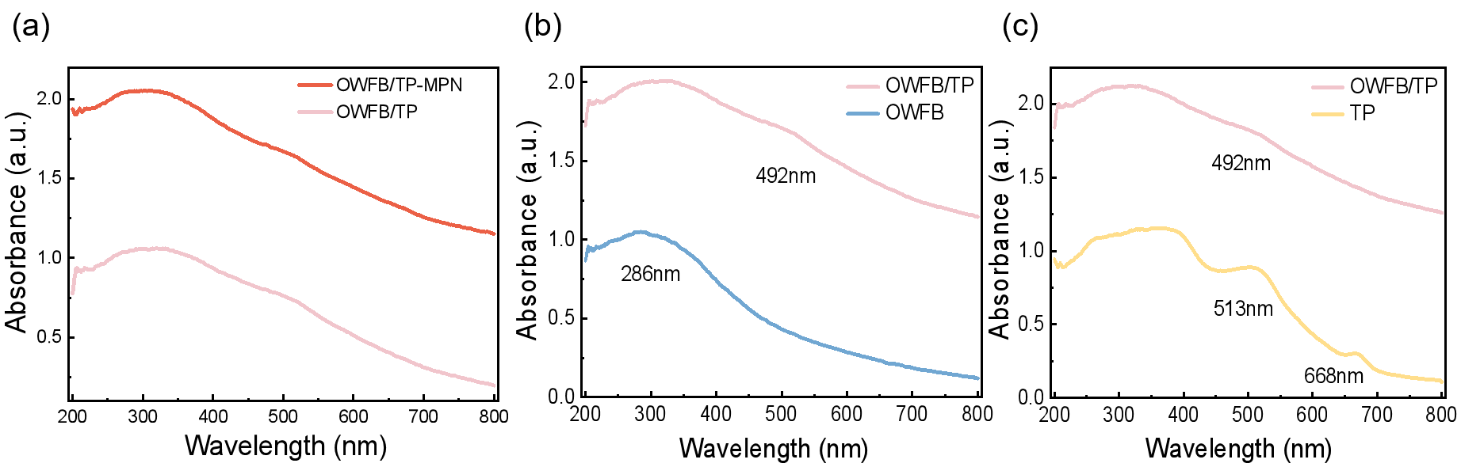
Figure S1. UV-vis spectrum.

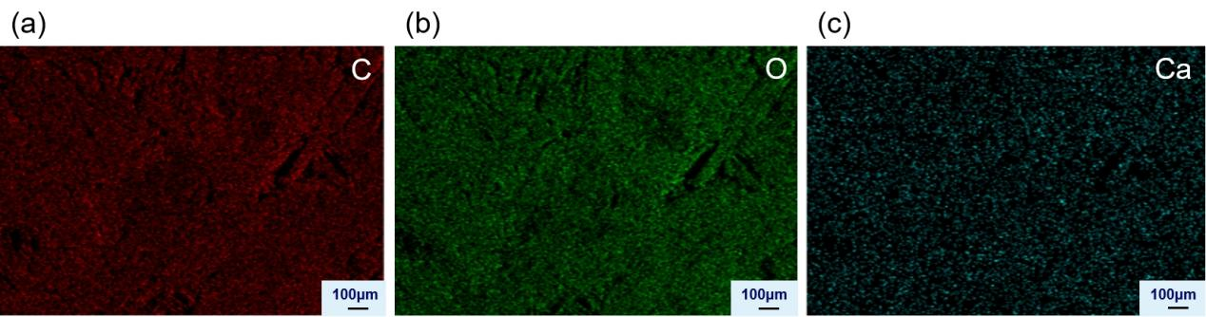
Figure S2. EDX of OWFB/Ca-TP. (a) C. (b) O. (c) Ca.

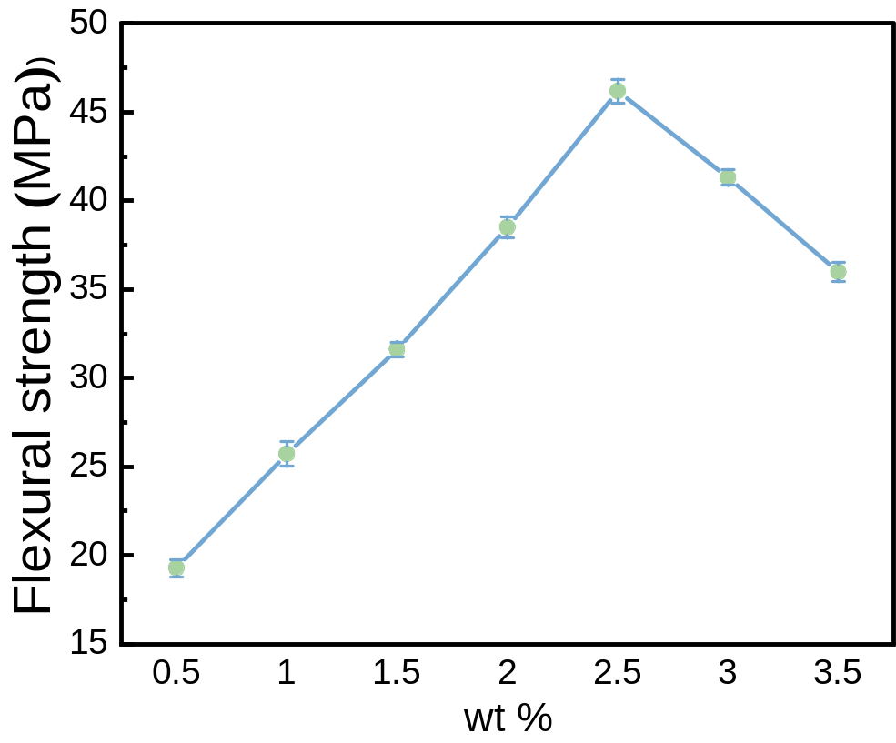
Figure S3. The static bending strength of different concentrations of Ca ions and tea polyphenols.

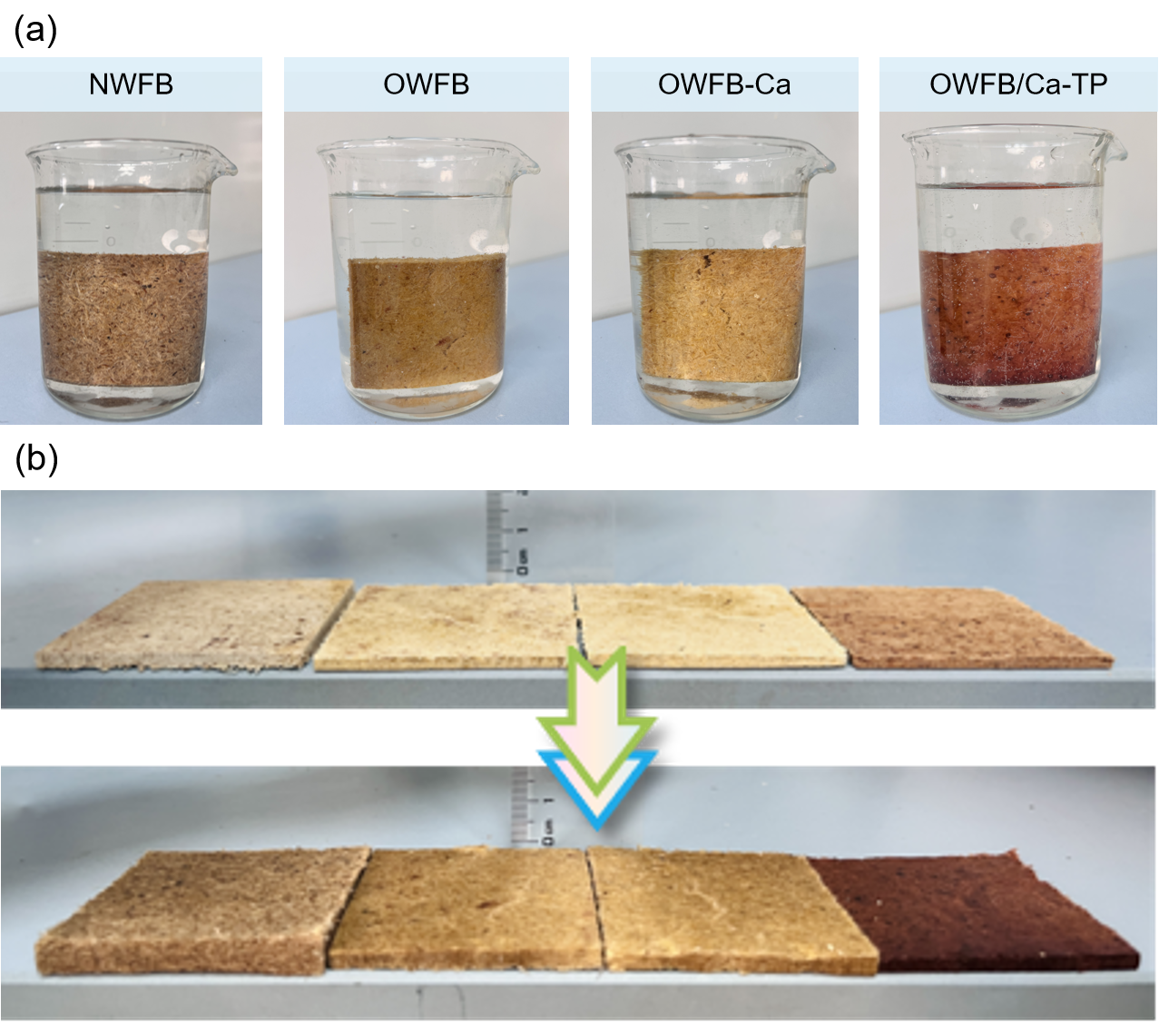
Figure S4. Digital images of samples prepared by different methods, fully immersed in water and placed for 24 hours before and after.

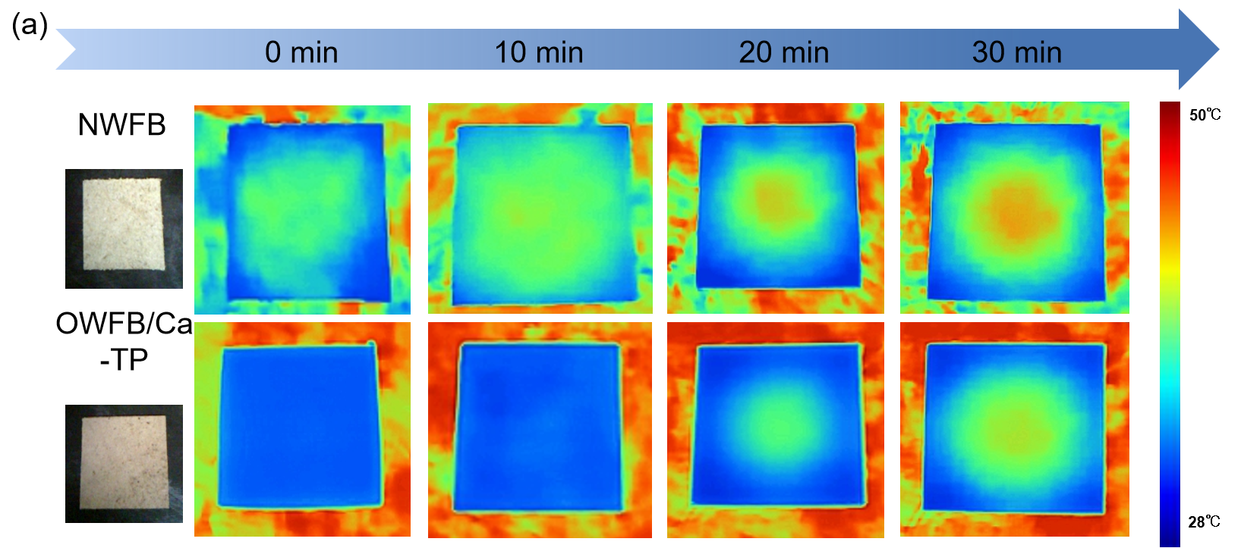
Figure S5. Comparison of thermal insulation performance between NWFB and OWFB/Ca-TP within 30 minutes.

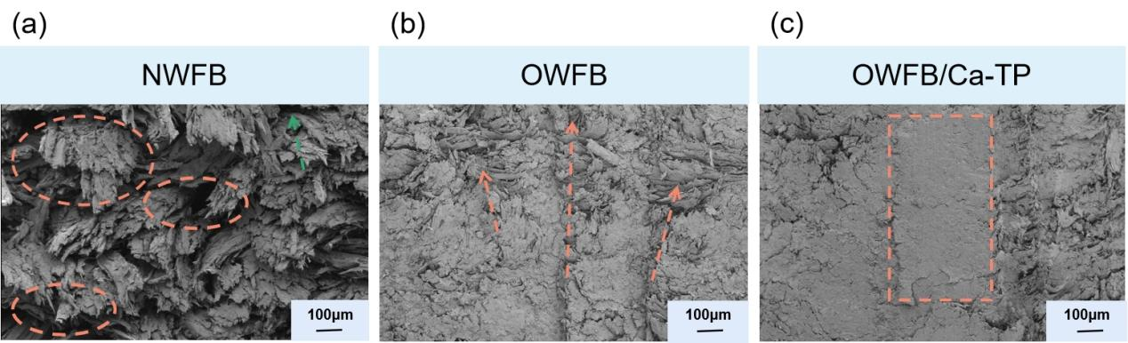
Figure S6. SEM images of (a) natural wood fiberboard, (b) oxidized wood fiberboard, and (b) OWFB/Ca-TP cross-sections.

