Interface-Optimized Hollow Metal–Phenolic PDA@ZIF-8 Nanocarriers for Stimuli-Responsive Zn²⁺/Salicylate Co-Delivery and Efficient Control of Tobacco Bacterial Wilt
Ze Lv^{1, 2}, Yu Fang^{1, 2}, Yang Gao^{1, 2}, Hongwei Li^{1, 2}, Pengkun Yan^{1, 2}, Zheng Zhang^{1, 2}, Lei Wang^{1, 2}, Fengyu Li^{1, 2}, Yingjian Ma^{1, 2}, Rui Zhao^{1, 2}, Xinyu Guo^{1, 2}, Xuemin Wu*^{1, 2}, and Yong Xu*^{1, 2}
1 Innovation Center of Pesticide Research
Department of Applied Chemistry
College of Science
China Agricultural University
Beijing 100193, P. R. China
E-mail: cauxy@cau.edu.cn; wuxuemin@cau.edu.cn
2 Key Laboratory of National Forestry and Grassland Administration on Pest Chemical Control
China Agricultural University
Beijing 100193, P. R. China.

Material and Method
ROS Detection
Intracellular reactive oxygen species (ROS) levels in R. solanacearum were evaluated using the fluorescent probe 2′,7′-dichlorodihydrofluorescein diacetate (DCFH-DA). Briefly, bacterial cells were cultured in nutrient broth at 28 °C to the logarithmic growth phase, collected by centrifugation (5000 rpm, 5 min), washed twice with sterile phosphate-buffered saline (PBS, pH 7.4), and resuspended to an optical density of OD600 ≈ 0.5. The bacterial suspensions were treated with ZIF-8 or NaSA@PDA@ZIF-8 at final concentrations of 100, 200, and 500 mg L⁻¹, respectively, and incubated at 30 °C for 4 h under gentle shaking. Untreated bacterial suspensions served as the control group. After treatment, cells were collected by centrifugation, washed twice with PBS to remove residual materials, and incubated with DCFH-DA (final concentration: 10 μM) in the dark at 30 °C for 30 min. Perform a semi-quantitative analysis of the laser confocal imaging results to obtain the average fluorescence signal intensity under different treatments.
Following incubation, the cells were washed again with PBS to eliminate excess probe and resuspended in PBS for fluorescence analysis. Intracellular ROS-associated fluorescence was observed using a confocal laser scanning microscope with an excitation wavelength of 488 nm and emission collected at 500–550 nm. All experiments were performed in triplicate.

Table S1 Seventeen sets of experiments conducted with different experimental factorial designs for response surface model.
Run | Response time (h) | Reaction temperature (℃) | Dopamine addition（g） | Loading contact（%）
1 | 6 | 55 | 1 | 21.5
2 | 6 | 35 | 1.5 | 6.6
3 | 5 | 55 | 0.5 | 4.5
4 | 6 | 35 | 0.5 | 5.8
5 | 7 | 75 | 1 | 13.8
6 | 7 | 55 | 0.5 | 17.2
7 | 7 | 35 | 1 | 14.2
8 | 5 | 35 | 1 | 7.4
9 | 6 | 75 | 1.5 | 6.1
10 | 6 | 55 | 1 | 22.4
11 | 6 | 55 | 1 | 23.1
12 | 6 | 75 | 0.5 | 6.1
13 | 5 | 75 | 1 | 5.4
14 | 6 | 55 | 1 | 20.7
15 | 6 | 55 | 1 | 23.3
16 | 7 | 55 | 1.5 | 20.7
17 | 5 | 55 | 1.5 | 7.8

Table S2 ANOVA for response surface quadratic regression equation.
Source | df | Mean Square | F-value | p-value
Model | 9 | 95.35 | 28.49 | 0.0001 | significant
A-Response time | 1 | 208.08 | 62.18 | < 0.0001
B-Reaction temperature | 1 | 0.8450 | 0.2525 | 0.6307
C-Dopamine addition | 1 | 7.22 | 2.16 | 0.1853
AB | 1 | 0.6400 | 0.1912 | 0.6751
AC | 1 | 0.0100 | 0.0030 | 0.9579
BC | 1 | 0.1600 | 0.0478 | 0.8332
A² | 1 | 33.01 | 9.86 | 0.0164
B² | 1 | 356.38 | 106.50 | < 0.0001
C² | 1 | 197.57 | 59.04 | 0.0001
Residual | 7 | 3.35
Lack of Fit | 3 | 6.21 | 5.17 | 0.0731 | not significant
Pure Error | 4 | 1.20
Cor Total | 16

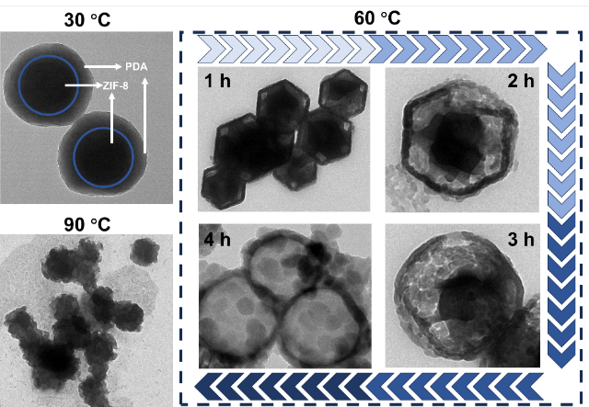
Figure S1 TEM images of PDA@ZIF-8 at different temperatures and reaction times.

Figure S2 Normal Plot of Residuals (A) and Predicted vs Actual (B) values.

Table S3 Surface Element Composition in XPS Analysis
element | Atomic (%)
element | ZIF-8 | PDA@ZIF-8
Zn | 3.96 | 5.68
C | 69.29 | 60.58
N | 14.27 | 9.23
O | 7379 | 18.36

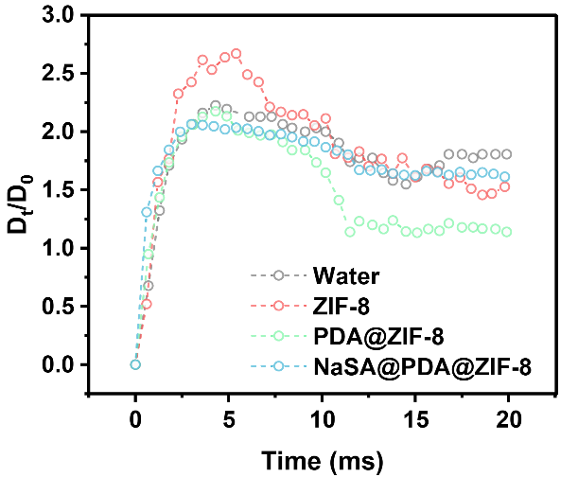
Figure S3 Normalized diameter profiles of droplets in different suspensions over 20 ms.

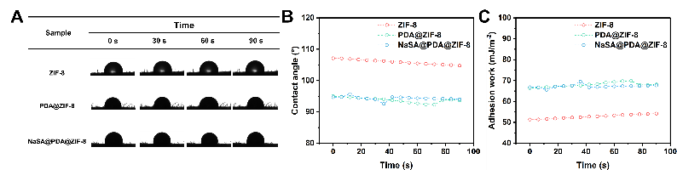
Figure S4 Dynamic contact angle images (A), data (B) and adhesion work (C) of ZIF-8, PDA@ZIF-8, and NaSA@PDA@ZIF-8 on tobacco seedlings.

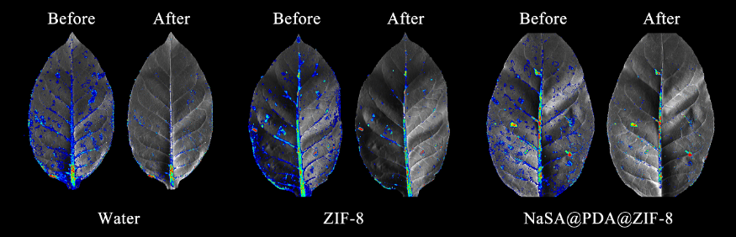
Figure S5 Changes in fluorescence of FITC-labeled water, ZIF-8, PDA@ZIF-8-treated leaves before and after rainfall washout.

Table S4 Release fitting parameters for NaSA's Zero order, First order, Higuchi and Ritger-peppas models.

Response condition | Fitting model | Kinetic  equation | a | b | R²
35 ℃ | Zero-order | y=a*x+b | 0.6515 | 46.8791 | 0.9050
35 ℃ | First-order | y=a*(1−e^(−b*x)) | 72.3599 | 2.9582 | 0.7894
35 ℃ | Higuchi | y=a*(x^(1/2))+b | 5.4166 | 42.8002 | 0.9811
35 ℃ | Ritger-peppas | y=a*(x^b) | 51.1378 | 0.1154 | 0.9938
25 ℃ | Zero-order | y=a*x+b | 0.4232 | 38.1992 | 0.6224
25 ℃ | First-order | y=a*(1−e^(−b*x)) | 60.7215 | 0.5475 | 0.5758
25 ℃ | Higuchi | y=a*(x^(1/2))+b | 4.9768 | 30.3945 | 0.8707
25 ℃ | Ritger-peppas | y=a*(x^b) | 34.5299 | 0.1649 | 0.9532
15 ℃ | Zero-order | y=a*x+b | 0.1366 | 44.5877 | 0.4460
15 ℃ | First-order | y=a*(1−e^(−b*x)) | 48.5965 | 15.4047 | 0.3306
15 ℃ | Higuchi | y=a*(x^(1/2))+b | 1.8998 | 41.4574 | 0.7034
15 ℃ | Ritger-peppas | y=a*(x^b) | 43.2994 | 0.0667 | 0.9555
pH=5 | Zero-order | y=a*x+b | 0.1349 | 70.1988 | 0.3567
pH=5 | First-order | y=a*(1−e^(−b*x)) | 73.9753 | 1.1505 | 0.4538
pH=5 | Higuchi | y=a*(x^(1/2))+b | 2.4458 | 61.3655 | 0.6815
pH=5 | Ritger-peppas | y=a*(x^b) | 56.8687 | 0.0809 | 0.9609
pH=9 | Zero-order | y=a*x+b | 0.1411 | 30.7464 | 0.4918
pH=9 | First-order | y=a*(1−e^(−b*x)) | 35.2822 | 4.6523 | 0.3292
pH=9 | Higuchi | y=a*(x^(1/2))+b | 1.6587 | 27.4723 | 0.6925
pH=9 | Ritger-peppas | y=a*(x^b) | 29.8638 | 0.0790 | 0.8898

Response condition | Fitting model | Kinetic  equation | a | b | R²
35 ℃ | Zero-order | y=a*x+b | 0.0993 | 7.7257 | 0.8440
35 ℃ | First-order | y=a*(1−e^(−b*x)) | 16.9937 | 0.1163 | 0.9319
35 ℃ | Higuchi | y=a*(x^(1/2))+b | 1.3309 | 5.0511 | 0.9453
35 ℃ | Ritger-peppas | y=a*(x^b) | 5.1230 | 0.2757 | 0.9837
25 ℃ | Zero-order | y=a*x+b | 0.1677 | 1.6572 | 0.6692
25 ℃ | First-order | y=a*(1−e^(−b*x)) | 11.8165 | 0.1547 | 0.8839
25 ℃ | Higuchi | y=a*(x^(1/2))+b | 1.7962 | 0.3874 | 0.9506
25 ℃ | Ritger-peppas | y=a*(x^b) | 2.4094 | 0.4265 | 0.9704
15 ℃ | Zero-order | y=a*x+b | 0.1730 | 4.0916 | 0.7559
15 ℃ | First-order | y=a*(1−e^(−b*x)) | 11.8785 | 0.1164 | 0.9025
15 ℃ | Higuchi | y=a*(x^(1/2))+b | 1.6749 | 1.4454 | 0.9516
15 ℃ | Ritger-peppas | y=a*(x^b) | 3.0622 | 0.3671 | 0.9803
pH=5 | Zero-order | y=a*x+b | 0.2376 | 0.6945 | 0.8842
pH=5 | First-order | y=a*(1−e^(−b*x)) | 19.9361 | 0.0537 | 0.9822
pH=5 | Higuchi | y=a*(x^(1/2))+b | 2.3378 | -0.3745 | 0.9849
pH=5 | Ritger-peppas | y=a*(x^b) | 2.4319 | 0.4845 | 0.9823
pH=9 | Zero-order | y=a*x+b | 0.0463 | 5.6488 | 0.6692
pH=9 | First-order | y=a*(1−e^(−b*x)) | 9.8238 | 0.1020 | 0.9809
pH=9 | Higuchi | y=a*(x^(1/2))+b | 0.6827 | 3.6769 | 0.9031
pH=9 | Ritger-peppas | y=a*(x^b) | 3.4257 | 0.2431 | 0.9667
Table S5 Release fitting parameters for Zn²⁺'s Zero order, First order, Higuchi and Ritger-peppas models.
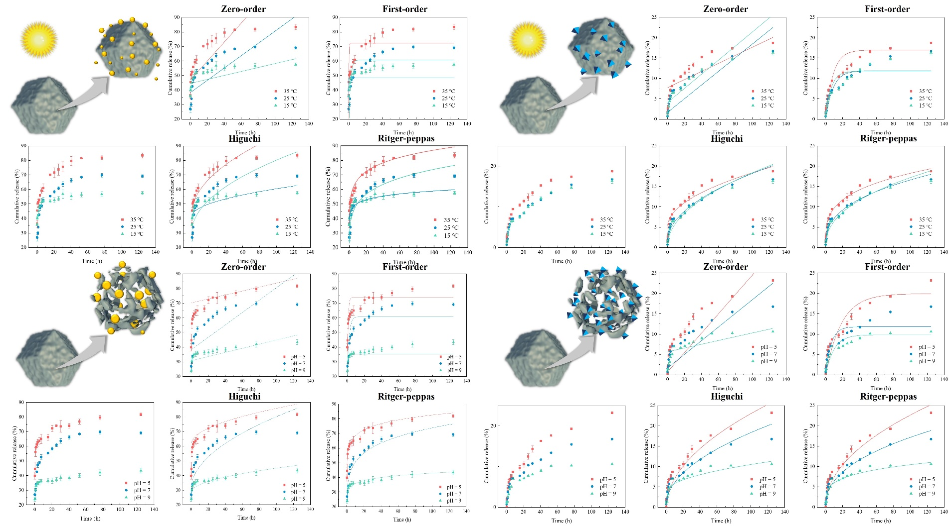
Figure S6 Cumulative release of NaSA and Zn²⁺ at different pH and temperatures were fitted with zero-order, first-order, Higuchi, and Ritger-peppas models.

The release profiles were fitted using the empirical power-law equation:
y=a*(x^b)
which is mathematically consistent with the Ritger–Peppas model^{1,2}. In this equation, y is the cumulative release, x is time, a is the apparent release rate constant, and b is the release exponent associated with the transport mechanism. For approximately spherical carriers, b≤0.43 generally indicates Fickian diffusion, whereas 0.43<b<0.85 suggests anomalous (non-Fickian) transport involving both diffusion and structural relaxation/reorganization^{3,4}.
To further clarify the release mechanism, the release profiles of NaSA and Zn²⁺ were analyzed using the Ritger–Peppas model. During the release of NaSA, b = 0.0809 at pH 5 and b = 0.0790 at pH 9, both of which are significantly lower than 0.43, indicating that the process is primarily governed by Fickian diffusion under both conditions. This result suggests that, as an encapsulated small-molecule active ingredient, NaSA is primarily released from the hollow carrier via diffusion driven by a concentration gradient⁵. The a value at pH 5 (56.8687) is higher than that at pH 9 (29.8638), indicating that acidic conditions accelerate the release of NaSA. This acceleration can reasonably be attributed to the weakening of the coordination bond between Zn²⁺ and phenolic groups under acidic conditions, as well as the increased permeability of the hollow PDA-Zn framework^{6,7}. These changes reduce diffusion resistance but do not fundamentally alter the primary transport mechanism. Furthermore, this hollow structure shortens the diffusion path, which is consistent with the strongly diffusion-controlled behavior reflected by the low b-value.
The fitted b values for NaSA release at 35°C, 25°C, and 15°C were 0.1154, 0.1649, and 0.0667, respectively. All these values are significantly lower than 0.43, indicating that the NaSA release process is consistently governed by Fickian diffusion, a behavior consistent with the structural characteristics of the carrier⁸. Specifically, NaSA acts as a guest molecule within the hollow PDA-Zn framework, and the hollow structure shortens the diffusion path, thereby facilitating concentration-gradient-driven outward diffusion^{9,10}. The temperature-dependent variation in parameter a reflects changes in the apparent release kinetics, but the low b values indicate that temperature does not fundamentally alter the primary release mechanism.
Regarding the release of Zn²⁺, the fitted value of b was 0.2431 at pH 9, indicating Fickian diffusion; whereas at pH 5, the value of b increased to 0.4845, corresponding to non-Fickian transport. Unlike NaSA, Zn²⁺ is structurally associated with the reconstructed PDA-Zn coordination framework. Consequently, its release process is more sensitive to changes in network stability induced by pH variations. Under basic conditions, the release of Zn²⁺ is primarily governed by diffusion processes. However, under acidic conditions, the release process likely involves not only the outward diffusion of Zn²⁺ but also the weakening/reorganization of the metal-phenolic coordination network, which contributes to the shift toward non-Fickian behavior. Since a and b are interrelated parameters in the Ritger-Peppas model, the a values for Zn²⁺ under different pH conditions should not be interpreted in isolation but should be considered in conjunction with the corresponding changes in b. Overall, the results indicate that the release of NaSA is primarily diffusion-controlled, whereas the release of Zn²⁺ is more closely linked to the pH-responsive structural dynamics of the hollow PDA-Zn framework^{11,12}.
The b values obtained from the Zn²⁺ fit were 0.2757, 0.4265, and 0.3671, corresponding to temperatures of 35°C, 25°C, and 15°C, respectively. These values fall within or are very close to the Fickian diffusion range, indicating that the release behavior of Zn²⁺ remains primarily diffusion-controlled across the tested temperature range. However, the b-value at 25°C is close to the empirical threshold between Fickian and anomalous transport, suggesting that, compared to NaSA, the release of Zn²⁺ may be more sensitive to subtle structural dynamics within the PDA-Zn coordination network. This difference can be reasonably explained by the fact that Zn²⁺ is structurally closely associated with the reconstructed metal-phenolic framework, whereas NaSA acts primarily as a active ingredient stored within the hollow carrier. Overall, the results of the temperature-dependent fitting indicate that both the release of NaSA and Zn²⁺ are largely dominated by diffusion processes; at the same time, the release of Zn²⁺ is more significantly influenced by the dynamic coordination properties of the hollow PDA-Zn framework.

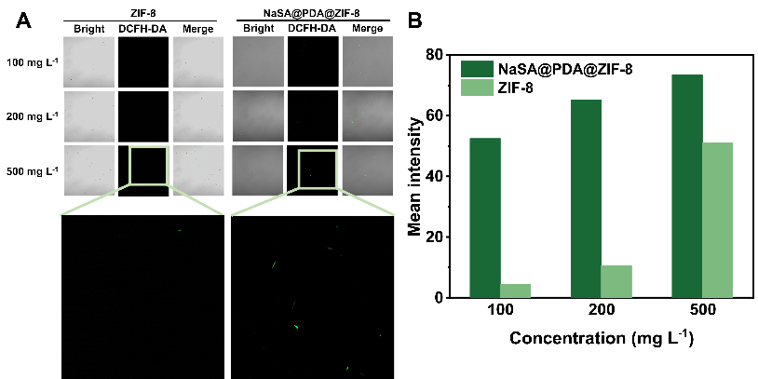
Figure S7Differences in ROS levels (A) and mean signal intensity (B) in R. solanacearum after treatment with ZIF-8 at different concentrations and NaSA@PDA@ZIF-8.

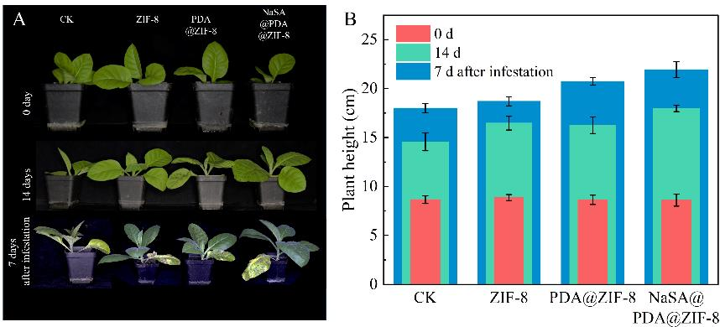
Figure S8 Effect of protective applications on plants and protection against tobacco green blight (A). Effect of treatments of different materials on the growth of tobacco plants and the protective therapeutic effect on tobacco (B).

Figure S9Heatmap representation of bacterial community composition across different subgroups.

Figure S10 Alpha diversity indices (A–G) of soil microorganisms after different material treatments, Wayne plots of ASV/OTU (H), graphs of taxonomic unit presentation of differences between groups (I), species loading plots of PCA analyses (J), and two-dimensional ordination plots of samples (K).

Reference
1. Ritger, P. L. & Peppas, N. A. A simple equation for description of solute release I. Fickian and non-fickian release from non-swellable devices in the form of slabs, spheres, cylinders or discs. J. Controlled Release 5, 23–36 (1987).
2. Ritger, P. L. & Peppas, N. A. A simple equation for description of solute release II. Fickian and anomalous release from swellable devices. J. Controlled Release 5, 37–42 (1987).
3. Siepmann, J. & Siepmann, F. Mathematical modeling of drug dissolution. Int. J. Pharm. 453, 12–24 (2013).
4. Siepmann, J. & Peppas, N. A. Modeling of drug release from delivery systems based on hydroxypropyl methylcellulose (HPMC). Adv. Drug Delivery Rev. 64, 163–174 (2012).
5. Li, Y. et al. Hollow mesoporous silica nanoparticles with tunable structures for controlled drug delivery. ACS Appl. Mater. Interfaces 9, 2123–2129 (2017).
6. Lynge, M. E., Westen, R. van der, Postma, A. & Städler, B. Polydopamine—a nature-inspired polymer coating for biomedical science. Nanoscale 3, 4916–4928 (2011).
7. Liu, Y., Ai, K. & Lu, L. Polydopamine and its derivative materials: synthesis and promising applications in energy, environmental, and biomedical fields. Chem. Rev. 114, 5057–5115 (2014).
8. Cauda, V. & Canavese, G. Mesoporous materials for drug delivery and theranostics. Pharmaceutics 12, 1108 (2020).
9. Ejima, H. et al. One-step assembly of coordination complexes for versatile film and particle engineering. Science 341, 154–157 (2013).
10. Han, Y. et al. Polyphenol-mediated assembly of proteins for engineering functional materials. Angew. Chem., Int. Ed. 59, 15618–15625 (2020).
11. Faure, E. et al. Catechols as versatile platforms in polymer chemistry. Prog. Polym. Sci. 38, 236–270 (2013).
12. Rahim, Md. A., Kristufek, S. L., Pan, S., Richardson, J. J. & Caruso, F. Phenolic building blocks for the assembly of functional materials. Angew. Chem. Int. Ed. 58, 1904–1927 (2019).

