Supplementary Information
Dual-Action Selenium Nanodrugs Confer Synergistic Protection against Parkinson's Disease via Mitochondrial-Targeted Antioxidant Therapy and Selenoprotein P-Mediated Selenium Mobilization

Li Lei^{1, 4, a, *}, Lingli Song^{1, a}, Qihang Ao^{1, a}, Qian Zheng³, Qiuxia Tu¹, Wen Zheng¹, Jiaojiao Wang¹, Xincheng Long¹, Yongsheng Huang¹, Shengkai Li¹, Haijun Yu^{4, *}, Lei Tang^{2, *}, Chunlin Zhang^{1, *}

¹ Engineering Research Center for Molecular Medicine, Key Laboratory of Medical Molecular Biology of Guizhou Province, School of Basic Medical Science, Guizhou Medical University, Guiyang 561113, P.R. China.
² State Key Laboratory of Discovery and Utilization of Functional Components in Traditional ChineseMedicine, Guizhou Medical University, Guiyang 561113, P.R. China.
³ Department of Neurology & Department of Neurosurgery, Affiliated Hospital of Guizhou Medical University, Guiyang 561113, P.R. China.
⁴ Center of Pharmaceutics, Shanghai Institute of Materia Medica, Chinese Academy of Sciences, Shanghai 201203, China.

ª Li Lei, Lingli Song and Qihang Ao contributed equally to this study.
*Correspondence:
Prof. Chunlin Zhang 362326474@qq.com
Prof. Lei Tang tlei1974@163.com
Prof. Haijun Yu hjyu@simm.ac.cn
Dr. Li Lei 1002087851@qq.com
Table of Contents
1. Experimental section
1.1 Characterization of G-Se NPs
1.2 Antioxidant activity of G-Se NPs
1.3 Cell Culture
1.3.1 Cellular Uptake
1.3.2 ROS Detection In Vitro
1.3.3 Assay of Neuronal Mitochondrial Targeting Capability In Vitro
1.3.4 Cellular Uptake of Ce6 labelled-G-Se NPs by Flow Cytometry
1.3.5 Cell Immunofluorescence Assay
1.4 Nematode and Culture Conditions
1.4.1 Uptake of G-Se NPs by Nematodes
1.4.2 Behavioral Changes in C. elegans and Lifespan Analysis
1.5 C57BL/6 Mice Rearing and Treatment
1.5.1 In Vivo Fluorescence Imaging and Biodistribution
1.5.2 Behavioral Evaluations
1.5.3 In Vivo Biosafety
1.5.4 RNA Sequencing
1.5.5 Immunohistochemical
2. Supplementary Tables
3. Supplementary Fig.s
1. Experimental section
1.1 Characterization of G-Se NPs
Transmission electron microscopy (TEM) images were collected on a JEOL-2100F transmission electron microscope (JEOL-2100F, JEOL, Japan). Zeta potential analysis at the zeta potential meter (Zetasizer Nano ZS90, Malvern, UK.). Scanning electron microscopy (SEM, SU8010, Hitachi, Japan) and high-resolution transmission electron microscopy (HRTEM, JEOL-2100F, JEOL, Japan) were employed to examine the nanoparticle morphology, with TEM samples prepared by depositing dilute dispersions onto carbon-coated copper grids. Three-dimensional topography and height distribution were analyzed by atomic force microscopy (AFM, Dimension Icon, Bruker, USA) in tapping mode with 5 × 5 μm² scan areas. Surface chemical composition and elemental oxidation states were determined using X-ray photoelectron spectroscopy (XPS, ESCALAB 250Xi, Thermo Fisher Scientific, USA) with monochromatic Al Kα radiation (1486.6 eV), where binding energies were referenced to the C 1s peak at 284.8 eV. Functional group identification was performed by Fourier transform infrared spectroscopy (FTIR, Nicolet iS50, Thermo Fisher Scientific, USA) in the 400-4000 cm⁻¹ range using KBr pellets. Colloidal properties including hydrodynamic diameter was measured at 25°C using dynamic light scattering (DLS, NanoBrook 90Plus PALS, Brookhaven, UK), with all measurements performed in triplicate to ensure reproducibility. The UV–vis spectra were collected by using a UV–Vis absorption spectra (UV, UV–2600i, Shimadzu). After 1 mg of the Ge-Se NPs and 2 mL of water were added to a 5 mL centrifuge tube, ultrasonic dispersion was performed for 5 min. After that, 1 mL of the supernatant was collected and slowly added to the sample chamber. The zeta potential of the Ge-Se NPs was measured using a Particle Sizer and Zeta Potential Analyzer (NanoBrook 90Plus PALS). DMPO was used as a spin trap to identify the O₂⁻· signals of samples with different concentrations dissolved in methanol, as well as the hydroxyl radical (·OH) electron paramagnetic resonance (EPR) spectra in deionized aqueous solution, under xenon lamp irradiation (100 mW/cm), (EPR, JES X320 JEOL, Japan).The digested sample is made up to volume in a 50ml centrifuge tube with ultrapure water for 3 times. Vortex and mix thoroughly for 1 minute, then filter the sample through a 0.22 μm pore size filter membrane to remove impurities. Dilute the sample according to its concentration, and then load it onto the instrument for analysis. Detect the relevant metal ions using an inductively coupled plasma mass spectrometer (ICP-MS, PE NexION 300D, USA).
1.2 Antioxidant Activity of G-Se NPs
The O₂⁻· scavenging activity was determined by assessing the inhibition ratio of the photoreduction of NBT. Initially, a mixture of 3.1 mM methionine, 5 μM riboflavin, 19 μM NBT and different liposomes was prepared. The mixture was then irradiated under UV light for 5 minutes, and the absorbance of the supernatant at 560 nm in each group was measured. The inhibition ratio was calculated using equation:
O₂⁻· scavenging ratio (%) = (A1-A2)/(A3-A2)×100%
where the A1, A2, and A3 represent the absorbance values of the sample group, negative control and positive control, respectively.
The ·OH scavenging efficiency of the samples was characterized by measuring the fluorescence intensity of 2-hydroxyterephthalic acid generated by the capture of ·OH by 2-hydroxyterephthalic acid (TA). Different liposomes were added to PBS containing TA (0.5 mM) and H₂O₂ (1 mM) and incubated at 37°C for 12 h. Finally, the fluorescence intensity of the supernatant in each group was measured (λ_{ex}=315 nm). The inhibition ratio was calculated using equation:
·OH scavenging ratio (%) = (B2-B1)/B2×100%
where the B₁ and B₂ represent the absorbance values of the sample group and positive control, respectively.
To measure the H₂O₂ scavenging activity of liposome samples using the titanium sulfate colorimetric method, different liposomes were first added to 1 mM H₂O₂ and incubated in the dark for 4 hours. Afterward, 1 mL of the supernatant from each group were taken and mixed with 2 mL of Ti(SO₄)₂ solution. The mixture was then incubated for 0.5 h, and the absorbance at 405 nm was measured. The inhibition ratio was calculated using equation:
H₂O₂ scavenging ratio (%) = (C2-C1)/C2×100%
where the C1 and C2 represent the absorbance values of the sample group and positive control, respectively.
1, 1-diphenyl-2-picrylhydrazyl hydrate (DPPH radical scavenging capacity) was used to measure the antioxidant strength of the G-Se NPs. The assay mixture was formed by adding 3 mL of DPPH ethanol solution (0.1 M) to 1 mL of different concentrations (5, 10, 20 μg/mL) of sample in separate test tubes and incubated at 37 °C for a period of 30 min. The reaction mixture's absorbance has been determined at 517 nm, and the percentage of damaging free radicals that the sample scavenged was estimated by using the formulas given below:
Radical Scavenging activity (%) = (D1 – D2) / D1×100% .
Where the D1 and D2 represent the absorbance values of control group and sample group.
1.3 Cell Culture
PC12 cells were purchased from the Cell Bank of the Chinese Academy of Science (Shanghai, China). The PC12 cells were maintained in DMEM (22.5 mM glucose) containing 10% FBS, 30 μg/mL penicillin, and 100 μg/mL streptomycin at 37℃ under 5% CO₂ atmosphere. The medium was exchanged every 36 h. For all experiments, cells were grown on 100 mm × 20 mm plates at a density of 1×10⁶ cells per well in 3 mL growth medium, or on 96-well plates at a density of 5×10³ cells per well in 0.2 mL growth medium. Three days after plating, cells typically reached 50-70% confluence (Day 0). Differentiation was then induced by switching to DMEM (22.5 mM glucose) supplemented with 100 ng/mL NGF, 30 μg/mL penicillin, and 100 μg/mL streptomycin.

1.3.1 Cellular Uptake
To assess the cellular uptake behavior of G-Se NPs, the G-Se NPs were labeled with Chlorin e6 (Ce6) for visualization. Briefly, 1 mL of G-Se NPs solution (0.3 mg/mL) was added to 1 mL of Ce6 aqueous solution (0.2 mg/mL). The mixture was stirred at room temperature overnight. The final Ce6 labeled G-Se NPs were washed with PBS three times, collected by centrifugation, and stored at －20 ℃. Then PC12 cells (1×10⁵ /mL) were seeded in 1000 μL of medium in a confocal dish. Another 2 mL medium was added to the dish after cell adhesion and cultured overnight. Ce6-labeled G-Se NPs (10 μg/mL) were added to the confocal dishes. 24 h after incubation, the cells were washed with PBS three times to remove the G-Se NPs that were not taken up by cells. Then the cells were fixed with 4% paraformaldehyde for 15 min and incubated with DAPI (0.5 μg/mL) for 5 min. Cellular uptake of Ce6 labeled G-Se NPs was evaluated by observing the characteristic red fluorescence of Ce6 using CLSM (FV1200, Olympus, Japan).
1.3.2 ROS Detection In Vitro
ROS assay kit was used to identify ROS levels through detecting the fluorescence intensity of DCF produced by the oxidation of intracellular DCFH-DA in the presence of ROS. PC12 cells were seeded into confocal dishes and treated with 6-OHDA (300 μM) with/without G-Se NPs, then incubated with 2 μL of DCFH-DA (10 μm) for 30 min at 37 ℃. Last, the change of ROS was examined by the Ti-U-DS-RI2 Inverted fluorescence microscope.
1.3.3 Assay of Neuronal Mitochondrial Targeting Capability In Vitro
PC12 cells (1 × 10⁶ cells per well) were seeded in con focal dishes and cultured for 24 h, respectively. After being incubated with G-Se NPs for 1, 2, 3, 6 h, cells were incubated with 100 μL MitoTracker Red CMXRos working solution (Cat. no. C1049B, Beyotime) for 30 min at 37 °C. After washing three times with fresh medium, the fluorescence of cells were observed with a CLSM (FV1200, Olympus, Japan, excitation: 549 nm, 488 nm, emission: 599 nm and 516 nm, respectively).
1.3.4 Cellular Uptake of Ce6 labelled-G-Se NPs by Flow Cytometry
Following the same treatment protocol as the mitochondrial targeting assay, PC12 cells (1 × 10⁶ cells/well) were incubated with Ce6 labelled-G-Se NPs for 0, 1, 2, 3, and 6 h. Cells were then trypsinized, washed twice with ice-cold PBS, and resuspended in 300 μL of PBS containing 1% FBS. The Ce6 fluorescence intensity was immediately analyzed using a flow cytometer with 488 nm excitation and 670±15 nm emission filters. A minimum of 10,000 events were acquired per sample, and data were processed with FlowJo software (version 10.8, BD Life Sciences). Untreated cells served as autofluorescence controls.
1.3.5 Cell Immunofluorescence Assay
PC12 cells were fixed in 4% paraformaldehyde (PFA) at ambient temperature for 20 min and washed 3 times with PBS for 5 min each time. The PC12 cells were then permeabilized in PBS containing 1% Triton X-100 at ambient temperature for 20 min and washed 3 times with PBS for 5 min each time. Cells were blocked with 3% BSA for 30 min at ambient temperature, immunostained with primary antibodies overnight at 4 °C, and then washed 3 times with PBS for 5 min each time. Then, the cells were incubated with Alexa Fluor 488- or 555-conjugated secondary antibodies (1:100; YEASEN Biotech, China) and DAPI (1:1000) at 37 °C for 1 h; again, the cells were washed 3 times with PBS for 5 min each time. Cells were examined and photographed using a Nikon DS-Ri2 digital fluorescence microscope or an Olympus FV1000 confocal laser scanning microscope.
All primary antibodies used for immunofluorescence staining are as follows: TH Rabbit Polyclonal Antibody, α-Synuclein Rabbit Polyclonal Antibody, 8-OHDG Rabbit Polyclonal Antibody.
1.4 Nematode and Culture Conditions
C. elegans wild-type Bristol (N2) strains were acquired from the Caenorhabditis Genetics Center (University of Minnesota, Saint Paul, MN, USA). The nematode transgenic BZ555 strain [Pdat-1::GFP] was acquired from the Caenorhabditis Genetics Center (University of Minnesota).The transgenic nematode PD4251 [myo-3p::mitochondrial GFP] was acquired from the Caenorhabditis Genetics Center (University of Minnesota). All nematodes were cultured on nematode growth medium (NGM) agar plates seeded with the uracil auxotroph Escherichia coli OP50 (serving as a food source) at 20 ℃.
1.4.1 Uptake of G-Se NPs by Nematodes
The assessment of nematode uptake of G-Se NPs was performed on N2 strains. Newly hatched larvae, up to the L1 stage, were placed onto NGM plates coated with a bacterial solution containing varied concentrations (0, 1, 5, 10 and 20 μg/mL) of Ce6-labeled G-Se NPs for 0, 1, 2, 3 and 6 h. The ingestion of G-Se NPs by the nematodes was meticulously observed using an inverted microscope once they had reached the L4 stage.
1.4.2 Behavioral Changes in C. elegans and Lifespan Analysis
Synchronized L1 larvae of the N2 strain were cultured on nematode growth medium (NGM) plates pre-seeded with E. coli OP50 and maintained at 20°C for 1 day to facilitate transition to the L2 developmental stage. Following cultivation, nematodes were collected by centrifugation at 3000 rpm for 1 min and randomly assigned to either the 6-OHDA lesion or control groups. The experimental groups were treated with 300 μM 6-OHDA, with or without G-Se NPs, in a light-protected environment, while the control group received 20 mM ascorbic acid. After 1 h of incubation, nematodes were thoroughly washed by replacing the M9 buffer three times. They were then transferred to Petri dishes containing the respective treatment substances and standard agar plates, where they were maintained for 48 h prior to behavioral assessments.
For lifespan analysis, after 24 h of 6-OHDA exposure, L4-stage nematodes (n = 100) from the control, model, and G-Se NPs treatment groups (1, 5, and 10 μg/mL) were randomly selected. The numbers of surviving, dead, and lost nematodes were recorded daily for each group. Surviving nematodes were transferred to fresh plates each day, and the effects of G-Se NPs (1, 5, and 10 μg/mL) on normal lifespan were evaluated. Specifically, nematodes from each group were maintained on NGM plates and transferred daily to fresh plates during the reproductive phase to prevent interference from newly hatched progeny. Survival monitoring continued daily until all nematodes had died. Nematodes unresponsive to mechanical stimulation were classified as dead.
To evaluate abnormal reversal and steering (ARS) behavior, adult nematodes at day 1 of adulthood were used following 24 h of 6-OHDA exposure. A total of 100 nematodes from each experimental group were transferred onto fresh 60 mm NGM assay plates. Video recordings were performed, capturing 1-min behavioral segments at 5 and 30 min after placement. Individual nematode trajectories were analyzed, and turns exceeding 90° from the original path were recorded. The ARS ratio was calculated by dividing the number of turns per nematode at the 5-min interval by the corresponding number at 30 min. Each experiment was repeated at least three times for every strain.
To evaluate ethanol avoidance behavior, day 1 adult nematodes (n = 100) from each experimental group were collected following 24 h of 6-OHDA exposure and placed onto assay plates divided into four quadrants. Two quadrants served as controls, while the other two were supplemented with 50 μL of ethanol. Nematodes were positioned at the center of each plate and allowed to move freely for 30 min. Plates were then imaged, and the distribution of nematodes across the quadrants was recorded. Ethanol avoidance was quantified using the preference index (PI), calculated as: PI = (number of nematodes in the control quadrants) - (number of nematodes in the ethanol quadrants))/total number of nematodes.
To assess basal slowing, adult nematodes (n = 100) from each group were exposed to 6-OHDA for 24 h. After exposure, nematodes were thoroughly washed with M9 buffer to remove residual bacteria. They were then placed onto two types of NGM plates: unseeded plates (OP50–) and plates seeded with OP50 bacteria (OP50+). After a 5 min acclimation period, nematodes were evaluated in a randomized manner by counting the number of sinusoidal body bends within a 30 s observation interval. Each nematode was assessed over three consecutive 30 s periods, and the average value was recorded as a single data point. Crawling speed was compared across groups under both bacterial and sterile conditions. Basal slowing was quantified using the following formula: (movement rate without food - movement rate with food) / movement rate with food.
1.5 C57BL/6 Mice Rearing and Treatment
All animal procedures were carried out under the guidelines approved by the Institutional Animal Care and Use Committee of Guizhou Medical University (No 2200002). The study utilized male C57BL/6 mice (weighing approximately 22 g) were sourced from the Laboratory Animal Center of Guizhou Medical University in Guiyang, China. The mice were kept under controlled environmental conditions, with cages maintained at a temperature of 21 ± 2°C. A well-controlled light/dark cycle of 12 h was followed, along with controlled humidity levels. The mice were also provided with ad libitum access to both food and water. A period of 3 days was allotted to ensure proper acclimatization of all mice prior to the commencement of the experiment. Among the mice, those that exhibited similar duration on the rotating rod during pre-training were chosen for subsequent investigations. To establish the in vivo model of PD, mice were subjected to intraperitoneal injections of MPTP five times at a dosage of 30 mg/kg per injection per day. G-Se NPs (10 mg/kg) were administered intravenously every other day for a total of 12 days starting on the day of MPTP induction. To ensure the precise dosage of each nanosheet batch, the G-Se NPs concentration was determined using the established methodology. The animals underwent behavioral testing 48 h after the final injection and then euthanized. Subsequently, blood samples, along with organs and brains, were collected from the mice for further analysis and subsequent investigations.

1.5.1 In Vivo Fluorescence Imaging and Biodistribution
C57BL/6 mice (male, 8 weeks old) were intranasally administrated with Ce6-labeled G-Se NPs (2.5 mg/kg) and observed under an in vivo imaging system at indicated time points (30 min, 1 h, 3 h, 6 h, 12 h,24 h,36 h) after administration. Brain, heart, liver, spleen, lung, and kidney were collected for in vitro fluorescence imaging at 3 and 36 h after administration. At 3 h postadministration, brain tissues were collected to prepare frozen brain slices, which were stained with TH antibody and MitoTracker® Green at 4 °C overnight and stained with DAPI for CLSM observation. The fluorescence intensities were quantified with Kuant Plant software.
1.5.2 Behavioral Evaluations
Rotarod Test: Mice from each experimental group were subjected to a rotarod test to evaluate motor coordination and balance. Each mouse was placed on a rotating rod, and the time they were able to maintain balance was recorded. Three trials were performed per mouse, with a 20 min intertrial interval. The final performance score was calculated as the average time across the three trials. The apparatus (Shandong Medical Academy of Sciences, China) featured a rod with a diameter of 3 cm rotating at a constant speed of 40 rpm.
Pole-Climbing Test: In the pole-climbing test, mice were placed on a vertical pole with a rough surface (50 cm in height, 1 cm in diameter). Two parameters were recorded: the time required for each mouse to perform a downward head turn (T-turn) and the total time taken to descend to the base of the pole (T-total).
Open Field Test: The open field test (OFT) was employed to assess spontaneous activity and anxiety-related behavior in mice when exposed to a novel environment. The experimental system comprised an open field reaction chamber and a data acquisition and processing unit. Prior to testing, mice were acclimatized in a quiet, well-lit environment for 15 min. The experiment was conducted under artificial illumination in a square white chamber (40 cm × 40 cm × 30 cm, with white walls and floor). Mouse behavior was recorded for 15 min using an infrared camera positioned above the chamber. Analysis software automatically divided the field into nine equal squares and tracked locomotor activity in real time.
Water Maze Test: The water maze test (WMT), a classic paradigm for evaluating hippocampal-dependent spatial learning and memory, was used to assess cognitive function in mice. The test was conducted over six consecutive days. Mice were introduced into the water facing the wall of the circular pool from four different entry points, and the latency to locate the hidden platform was recorded using an invisible infrared grid system. Each mouse underwent four trials per day, with a 20 min intertrial interval. On the sixth day, the hidden platform was removed, and memory retention was assessed by recording the number of times each mouse crossed the original platform location. All tests were performed at a fixed time each day. The water was rendered opaque using non-toxic white children’s paint and maintained at 20°C. The escape platform, positioned in the center of the first quadrant, was submerged 1 cm below the water surface.
Y-Maze Test: The Y-maze test was conducted in a Y-shaped apparatus with identical arms (45 cm long × 14 cm wide × 16 cm high), positioned at 120° angles from each other. The three arms were clearly labeled as "I," "II," and "III." Before testing, mice were dark-adapted for 20 min, and the experiment was carried out under quiet, dark conditions. Each mouse was placed in one arm of the maze, and the number of arm entries and alternations (triads) was recorded over a 10 min session. An entry was defined as the placement of all four limbs into an arm. Alternation was defined as entry into a new arm that differed from the two previously visited arms, while a return to either of the last two arms was recorded as an error. The percent relative alternation was calculated from the ratio of the number of alternations divided by the number of total entries and multiplying this value by 100.
Elevated Pulse-Maze Test: The elevated plus-maze (EPM) test was used to assess anxiety-related behavior in mice, based on the conflict between their natural aversion to open, elevated spaces and their drive to explore novel environments. The apparatus consisted of two open arms and two closed arms, each 65 cm in length, arranged in a plus configuration. Each mouse was placed in the central zone facing a closed arm, and its movements were recorded for 5 min using the SuperMaze Morris Video Analysis System. The number of entries into the open arms and the duration of time spent in the open arms were quantified and analyzed as measures of anxiety.
1.5.3 In Vivo Biosafety
After all the treatments, blood samples of mice were collected to analyze routine blood parameters, including aspartate transaminase (AST), aminotransferase (ALT), total bilirubin (T-Bil), creatinine (CR), blood urea nitrogen (BUN), and albumin (ALB), and serum enzyme levels, including white blood cells (WBCs), lymphocytes (Lymph), monocytes (Mons), granulocytes (Grans), red blood cells (RBCs), hemoglobin (HGB), hematocrit (HCT), mean corpuscular volume (MCV), mean corpuscular hemoglobin (MCH), mean corpuscular hemoglobin concentration (MCHC), red blood cell distribution width (RDW), platelets (PLTs), and mean platelet volume (MPV).Then, major organs (heart, liver, spleen, lungs, and kidneys) and brain tissues (substantia nigra, striatum, and cortex) were collected and fixed with 4% paraformaldehyde to prepare paraffin-embedded tissue sections. For brain sections, Nissl staining was performed using 0.1% cresyl violet to evaluate neuronal morphology and density in PD-relevant regions. After staining with H&E (for organs) or Nissl (for brain), the images were observed under a Pannoramic digital scanner (Olympus SLIDEVIEW VS200, Günthersleben).
1.5.4 RNA Sequencing
Midbrain tissue samples were obtained from mice. Sequencing and analyses were performed by Majorbio Bio-Pharm Technology Co., Ltd. (Shanghai, China). Briefly, RNA was extracted from the midbrain sample and tested for RNA quality using NanoDrop2000, and an example library was constructed for the samples that passed the test. Eukaryotic mRNA was enriched with magnetic beads with Oligo (dT). mRNA was subsequently randomly interrupted by adding a fragmentation buffer.The first strand of cDNA was synthesized using random hexamers as atemplate, followed by the second strand of cDNA with the addition ofbuffers, dNTPs, and DNA polymerase I. The purified double-stranded cDNA was then end-repaired, a-tailed, and ligated with sequencing junctions, followed by fragment size selection using AM Pure XP beads. PCR enrichment was performed to obtain the final cDNA library. After the library construction was completed, the quality of the library was checked, and sequencing was carried out only after the results met the requirements.
1.5.5 Immunohistochemical
Brain tissue samples were fixed in 4% paraformaldehyde, embedded in paraffin, and sectioned at 4-5 μm thickness. After deparaffinization and rehydration, endogenous peroxidase activity was blocked with 3% H₂O₂ for 10 min at room temperature. Antigen retrieval was performed in citrate buffer (pH 6.0) at 95°C for 15 min. Sections were then blocked with 5% BSA for 30 min at room temperature and incubated overnight at 4°C with primary anti-TH,GFAPantibody (1:500; specify company/catalog number). Following PBS washes, sections were incubated with HRP-conjugated secondary antibody (1:200) for 1 h at room temperature. The immunoreactivity was visualized using DAB substrate, followed by hematoxylin counter staining and mounting with neutral balsam. Images were acquired using a Pannoramic digital scanner (Olympus SLIDEVIEW VS200, Günthersleben), and quantitative analysis was performed using Image-Pro Plus software.

2. Supplementary Tables
Table S1. Hemolysis assay of G-Se NPs.
Concentration (μg/mL) | Mean value of hemolysis (%)
0.9% NaCl solution | 17
H₂O | 100
0.3 | 17
0.5 | 18
0.8 | 17
1 | 18
5 | 16
10 | 18
20 | 19

Table S2. Number of dopaminergic neurons in the head of 6-OHDA with or without G-Se NPs, and G-Se NPs treated BZ555 nematode (n=10).
PBS | 6-OHDA | G-Se NPs +PD | G-Se NPs | NAC
6 | 6 | 6 | 5 | 4
6 | 2 | 6 | 6 | 4
6 | 3 | 6 | 6 | 4
6 | 3 | 6 | 5 | 5
6 | 3 | 5 | 5 | 5
6 | 3 | 6 | 6 | 5
6 | 2 | 5 | 6 | 4
6 | 3 | 6 | 6 | 4
6 | 5 | 6 | 5 | 3
6 | 2 | 5 | 6 | 5
Table S3. Biochemistry test of serum in normal C57BL/6 black mice were treated with PBS, MPTP and G-Se NPs.
 | ALT  (U/L) | AST  (U/L) | TBIL  (μmol/L) | TP  (g/L) | ALB  (g/L) | UREA  (mmol/L) | BUN  (mg/dL)
Reference | 10.06–96.47 | 36.31–235.48 | 0.45–33.89 | 38.02–75.06 | 21.22–39.15 | 3.9–12.4 | 10.81–34.74
PBS | 43.207 | 292.344 | 17.729 | 54.762 | 28.981 | 12.194 | 34.143
MPTP | 42.259 | 165.792 | 9.928 | 48.939 | 30.938 | 10.853 | 30.388
G-Se NPs | 54.9 | 217.169 | 17.667 | 55.729 | 26.68 | 10.306 | 28.857
G-Se NPs + PD | 39.553 | 159.306 | 9.712 | 50.253 | 30.055 | 9.716 | 27.205

Table S3. Hematology assay of the whole blood in normal C57BL/6 black mice were treated with PBS, MPTP, and G-Se NPs.
 | WBC  (10⁹/L) | RBC(1012/L) | HGB  (g/L) | HCT  (%) | MCV  (FL) | MCH  (pg) | MCHC  (G/L) | PLT(10⁹/L)
Reference | 0.80-10.60 | 6.50-11.50 | 110-165 | 35.0-55.0 | 41.0-55.0 | 13.0-18.0 | 300-360 | 400-1600
PBS | 4.44 | 8.74 | 137 | 43.8 | 50.2 | 15.7 | 314 | 1155
MPTP | 3.68 | 9.13 | 147 | 48.1 | 52.7 | 16.1 | 306 | 1146
G-Se NPs | 3.78 | 8.35 | 130 | 40.6 | 48.7 | 15.6 | 319 | 1048
G-Se NPs + PD | 4.79 | 7.8 | 127 | 38.6 | 49.5 | 16.2 | 328 | 569

3. Supplementary Fig.s

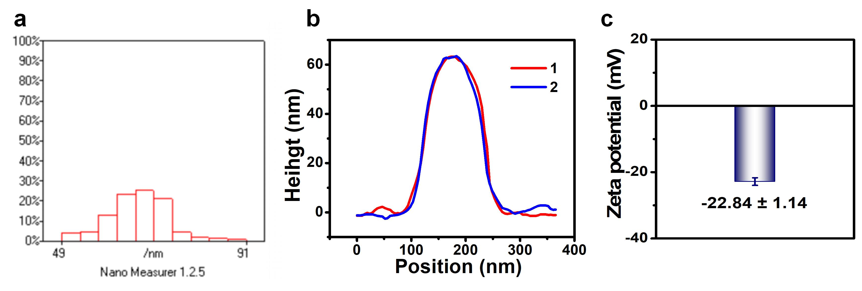
Fig. S1 (a) Statistical size distribution of G-Se NPs from TEM image. (b) Thickness measurement of G-Se NPs by AFM. (f) Zeta potential curve of G-Se NPs, all data are presented as mean ± SD (n=3).

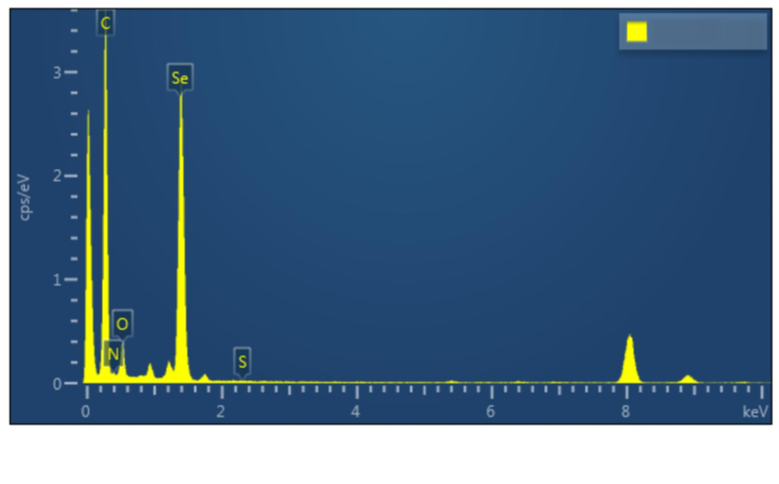
Fig. S2 Analysis of surface element content of G-Se NPs: (C, N, O, Se, S).
Fig. S3 XPS spectrum of G-Se NPs (a), C1s (b), N1s (C), O1s (D) in G-Se NPs.

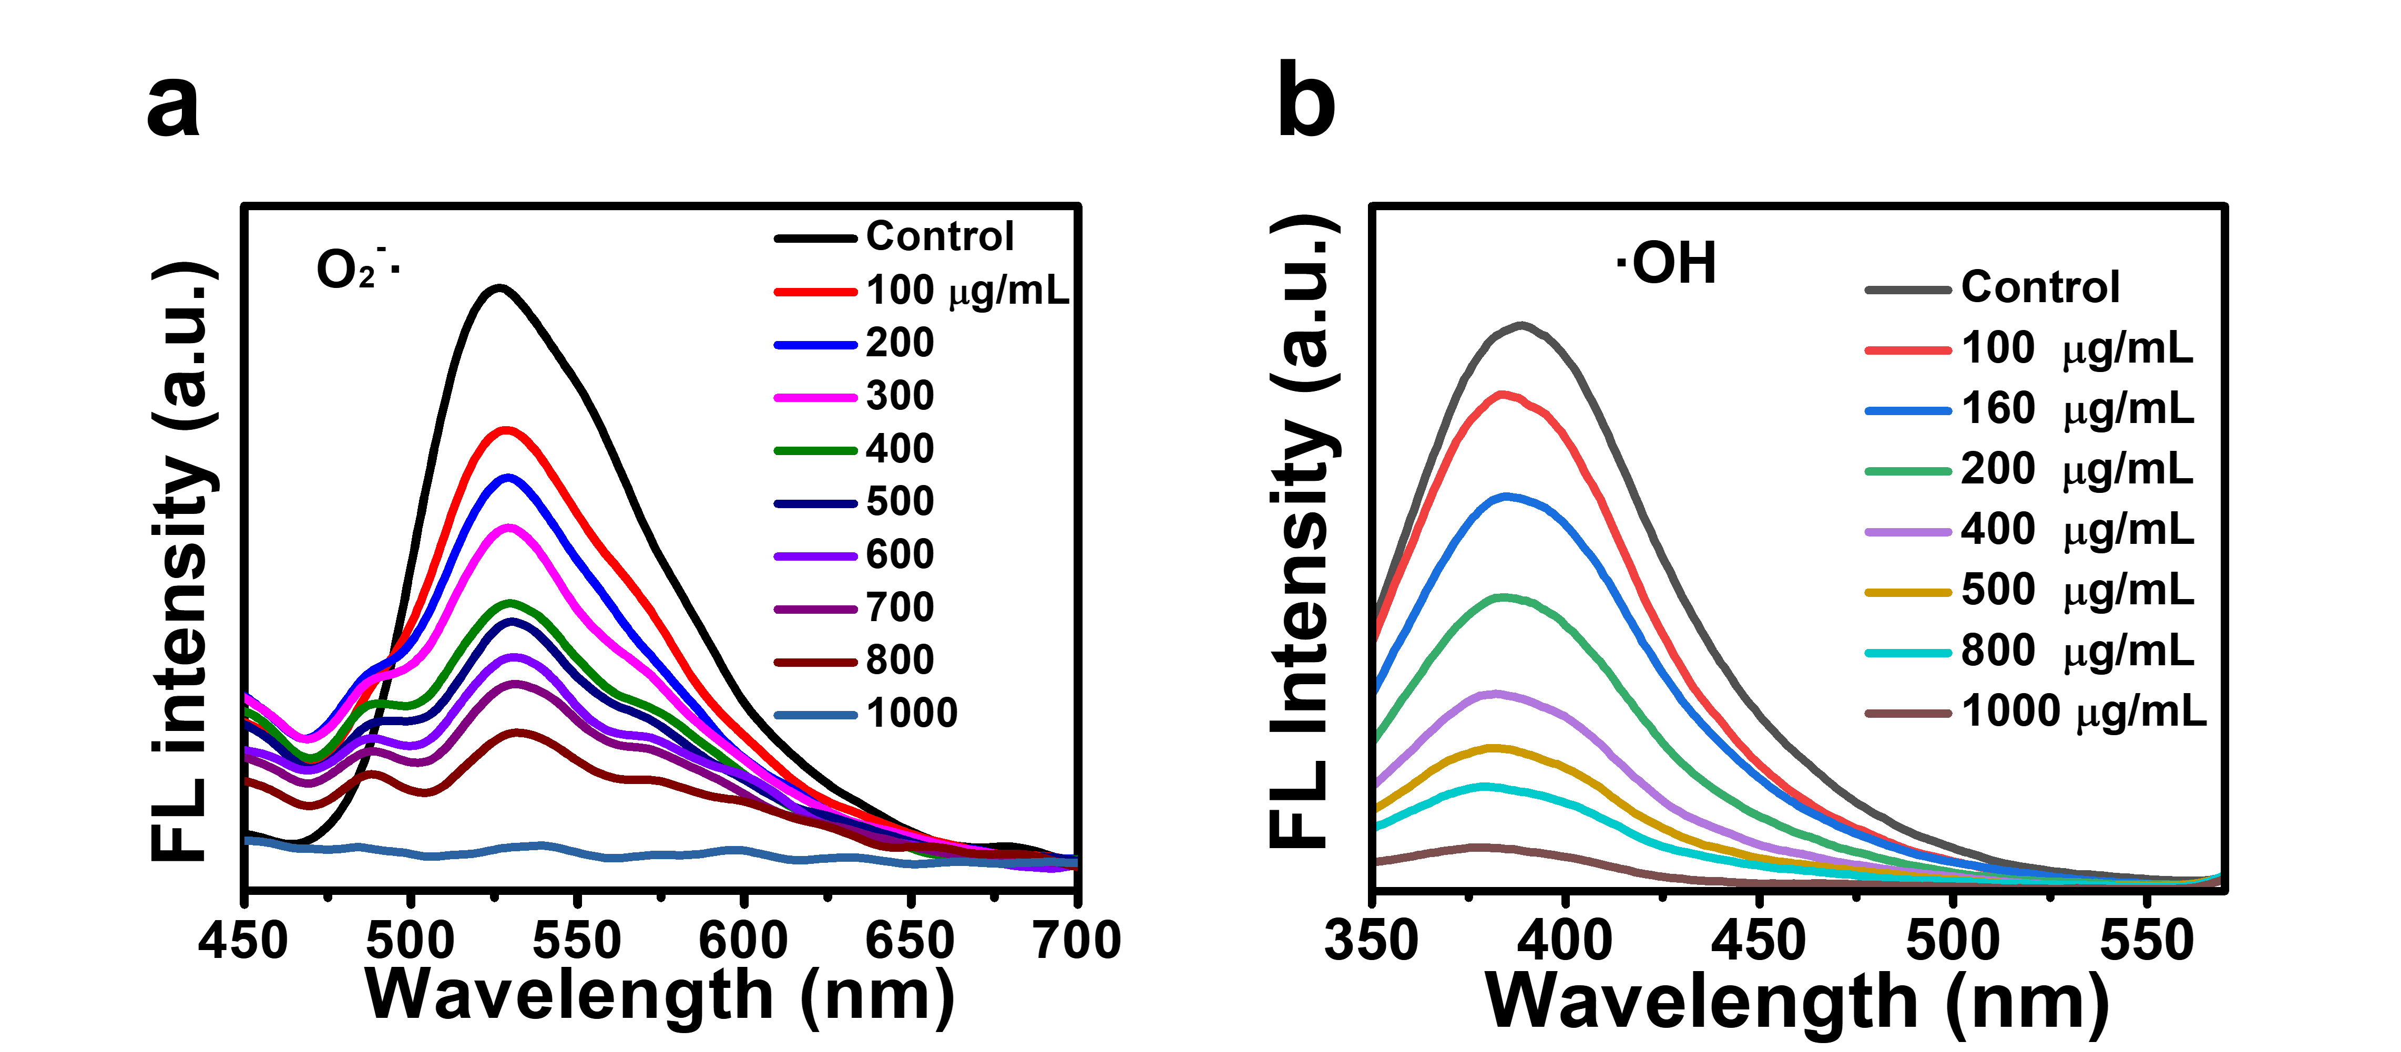
Fig. S4 (a, b) Fluorescence spectra of (a) O₂⁻· and (b) ·OH were eliminated by different concentrations of G-Se NPs.
Fig. S5. ROS generation characterization. (a) ESR spectra of ·O₂⁻ (black) and after scavenging with 1 mM p-benzoquinone (orange). (b) ESR spectra of ·OH (red) and after scavenging with 1.31 M IPA (blue). (c) UV-Vis absorption of H₂O₂ without (blue) and with (green) 200 U/mL catalase.

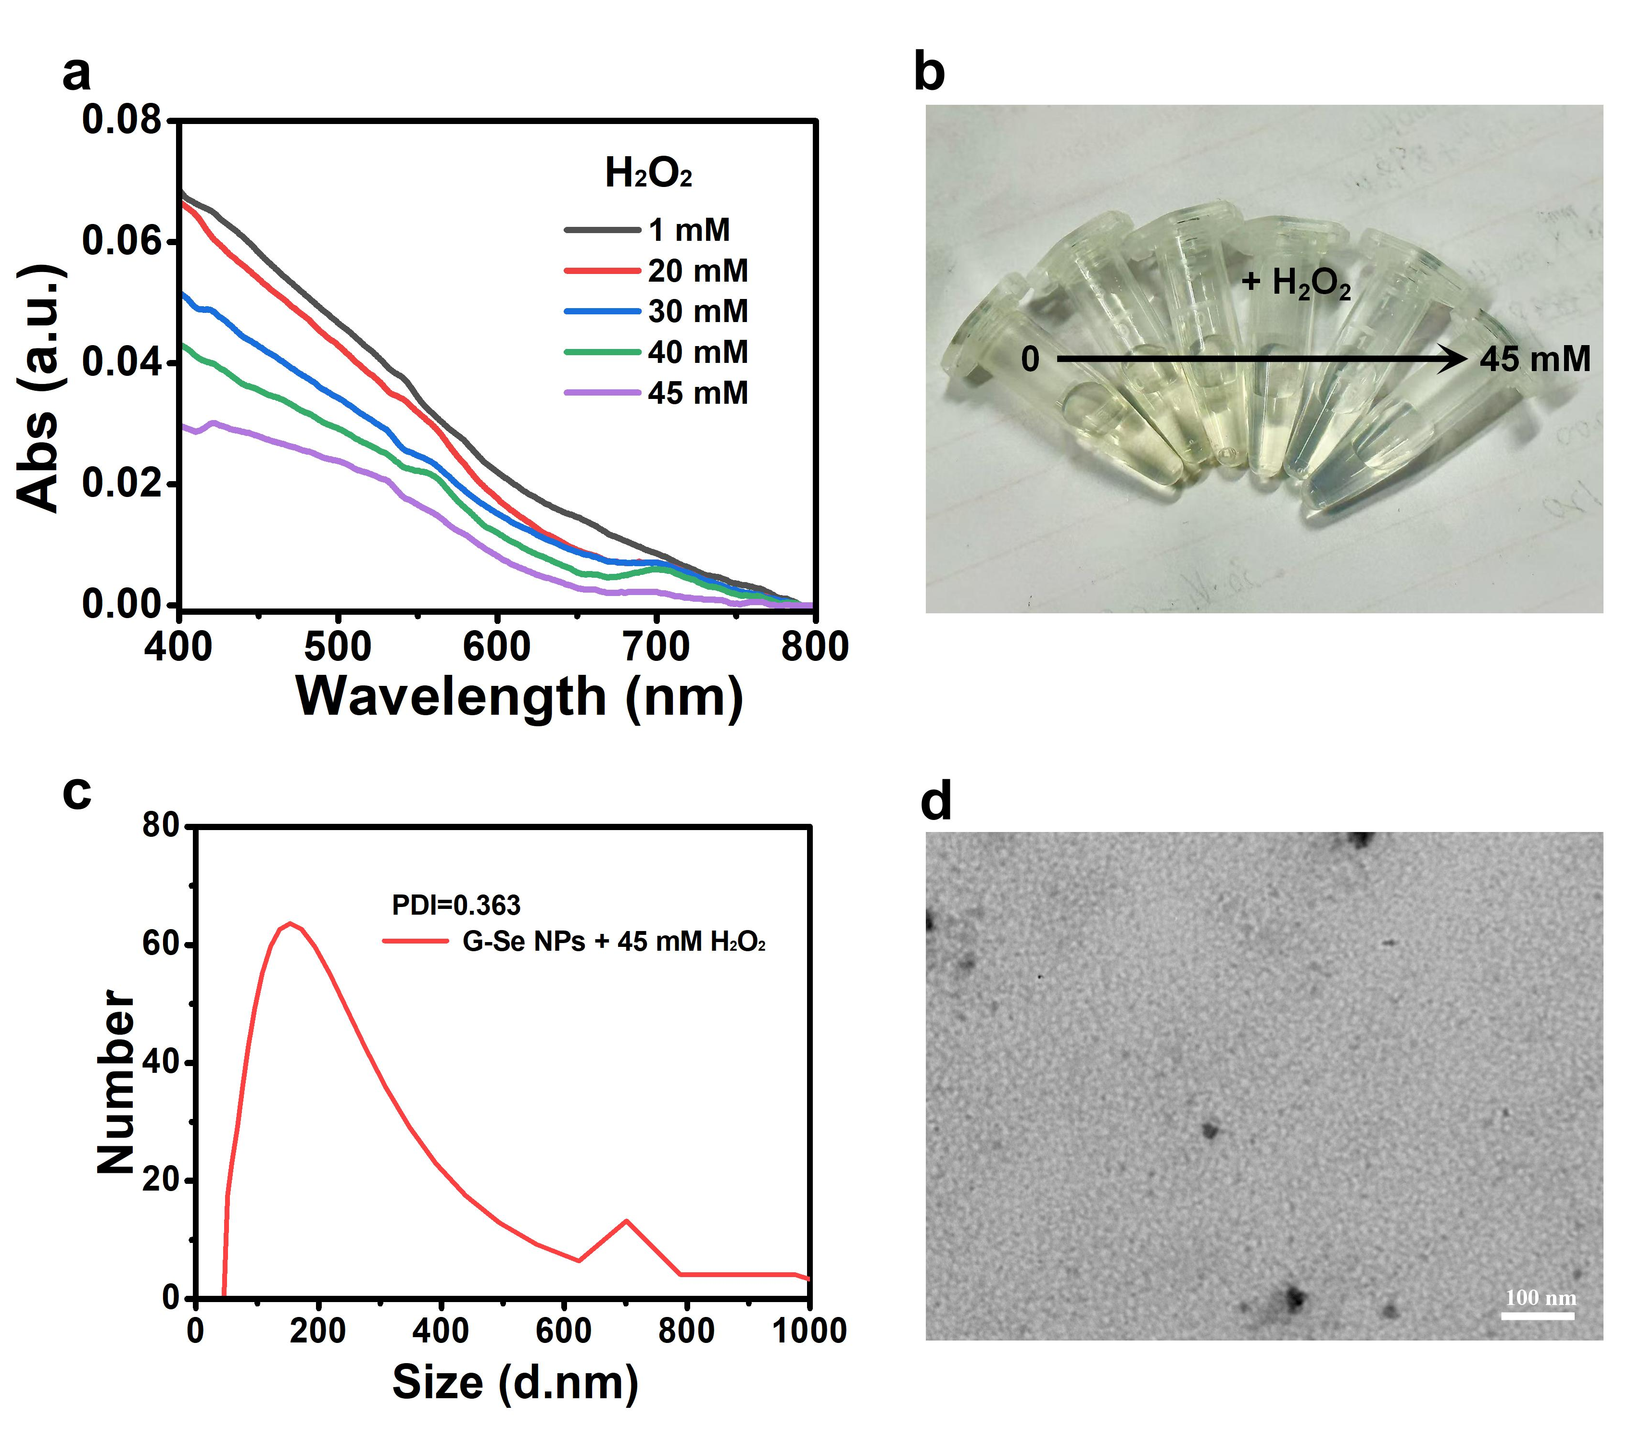

Fig. S6 (a, b) Uv-vis spectra (a) and photographs (b) of G-Se NPs reacting with different concentrations of H₂O₂. (c, d) DLS analysis and TEM imaging of G-Se NPs reacting with 45 mM of H₂O₂.
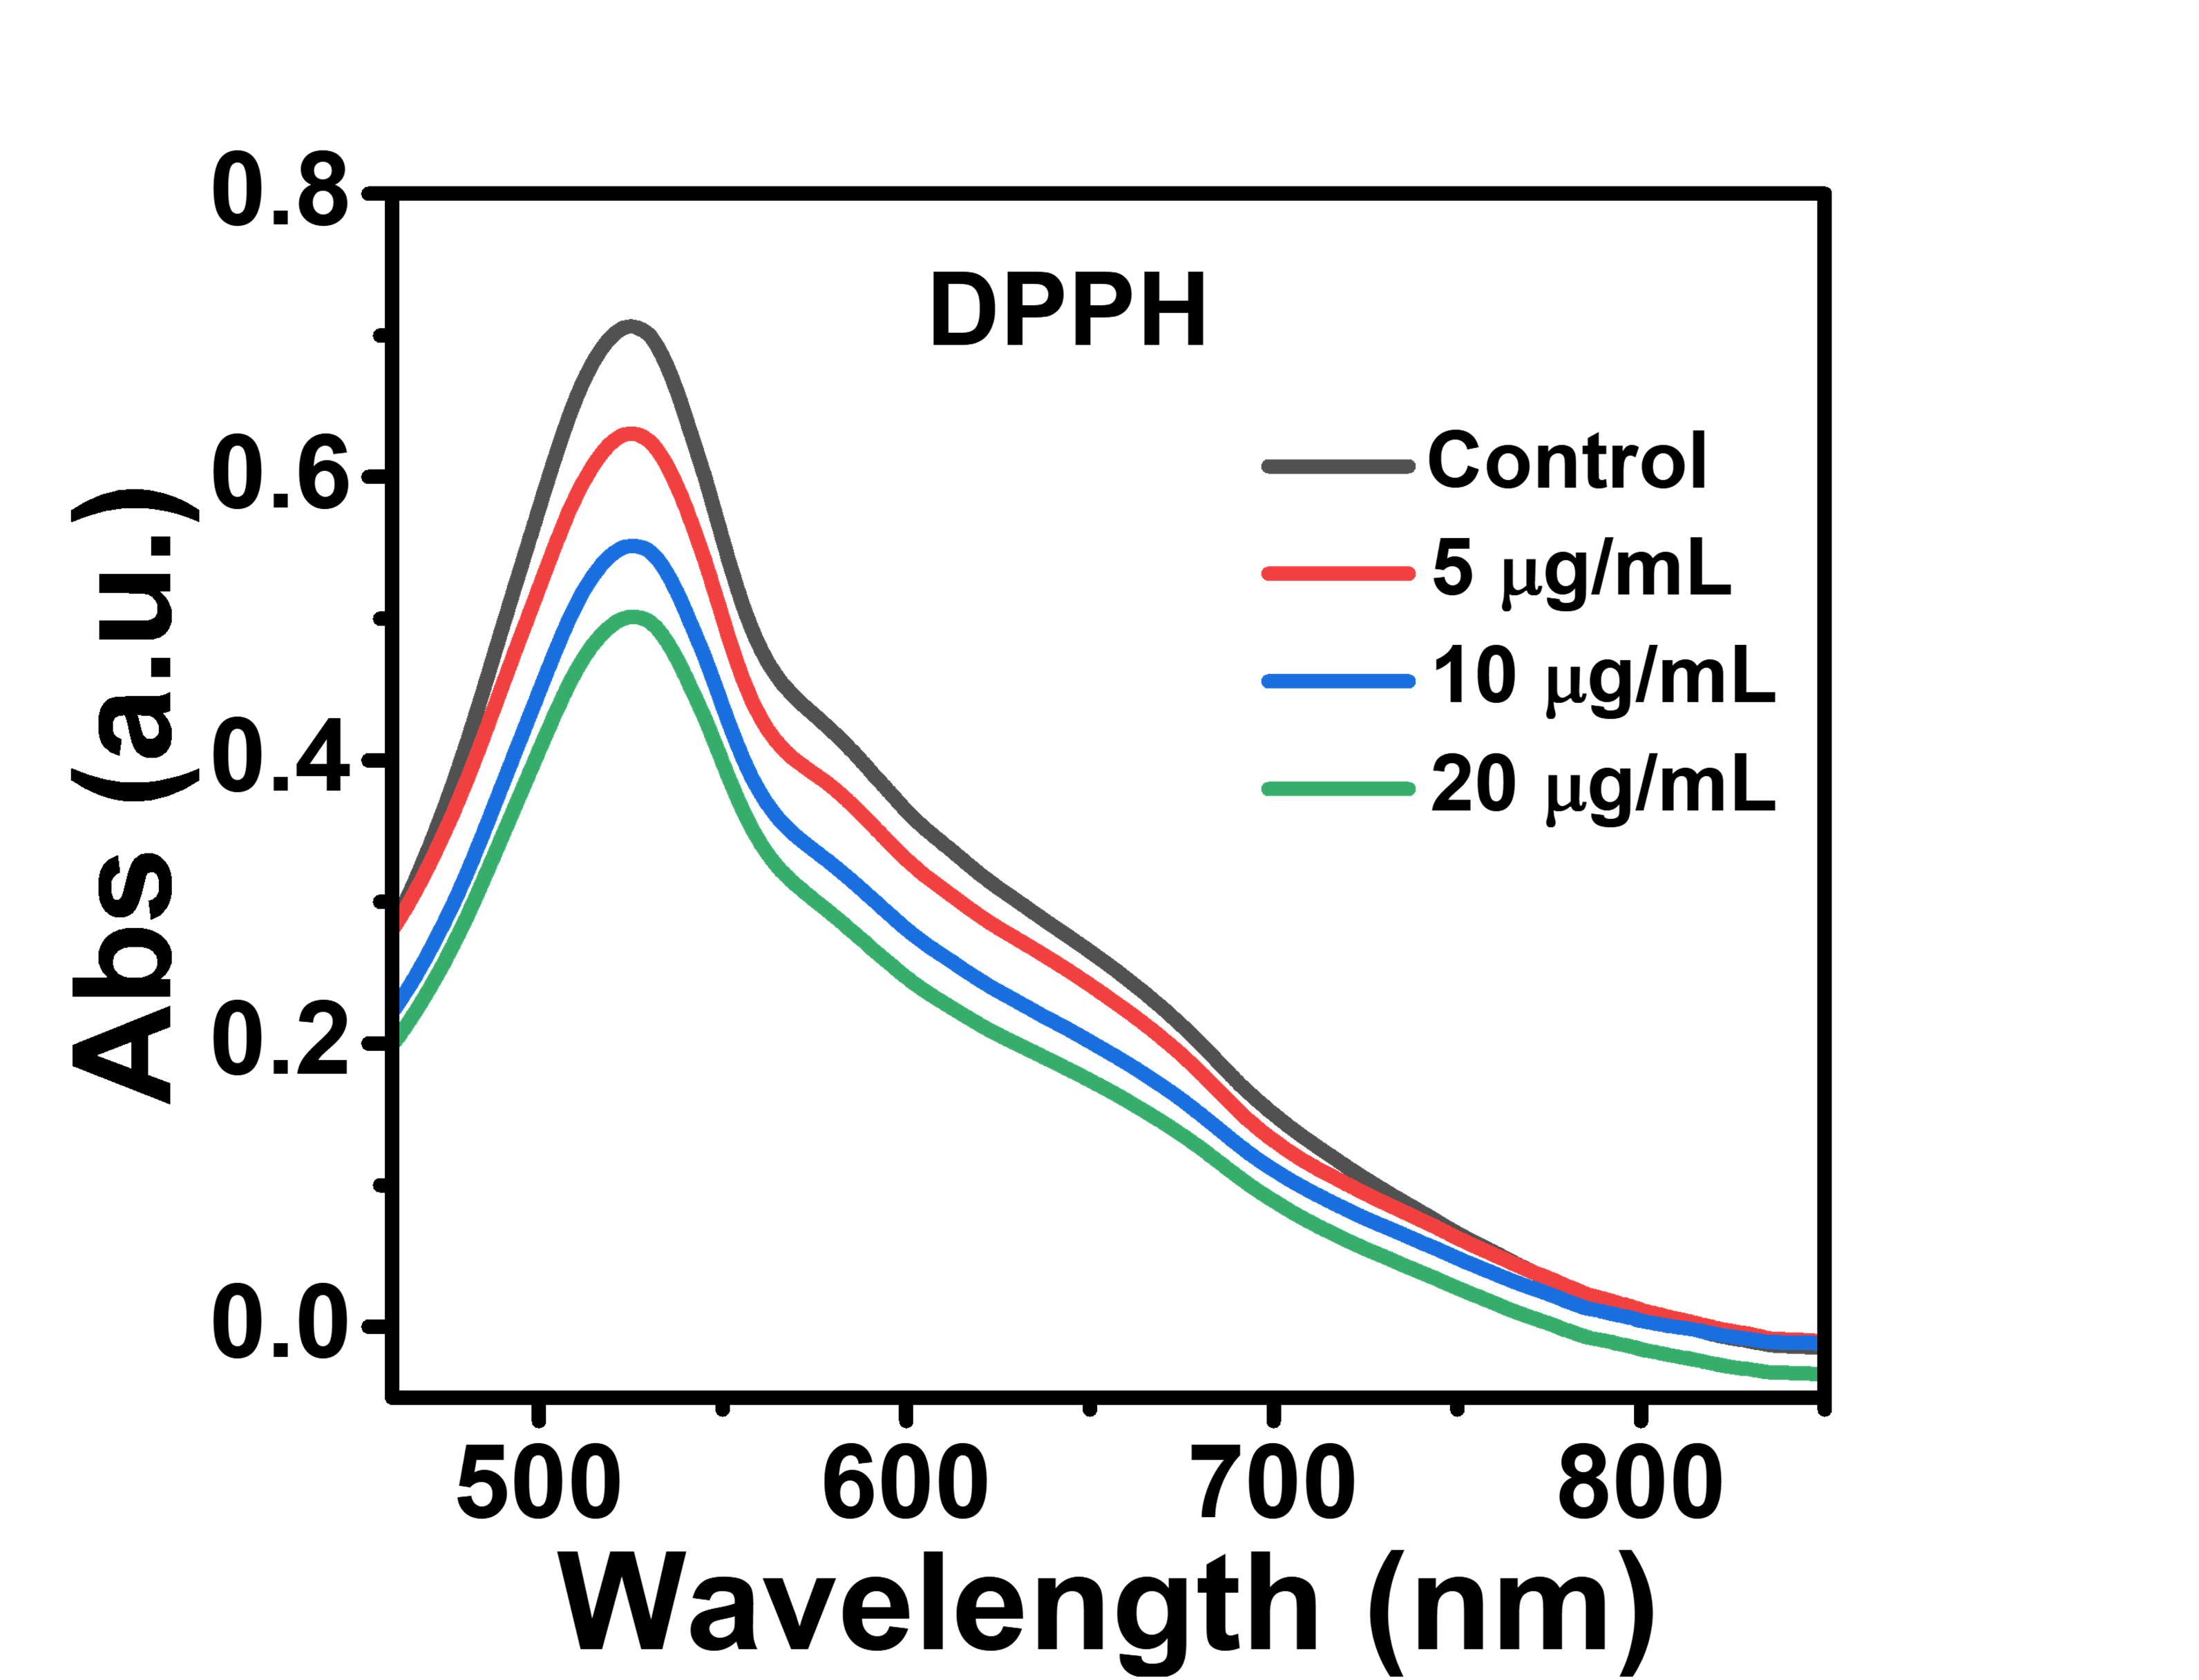

Fig. S7 Antioxidant capacity measured by the DPPH methods.

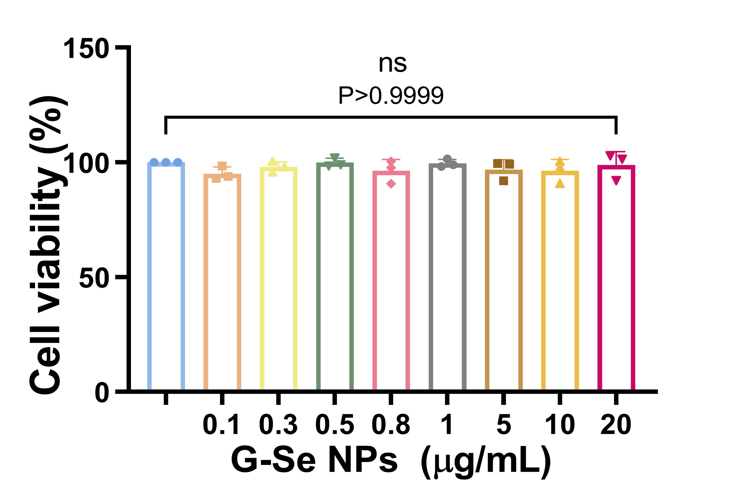
Fig. S8 Cell viability was estimated using the CCK-8 assay. SH-SY5Y cells were exposed to different concentration G-Se NPs 24 h. All data are presented as mean ± SD (n=3).

Fig. S9 Cell viability of PC12 treated with G-Se NPs at different concentrations.

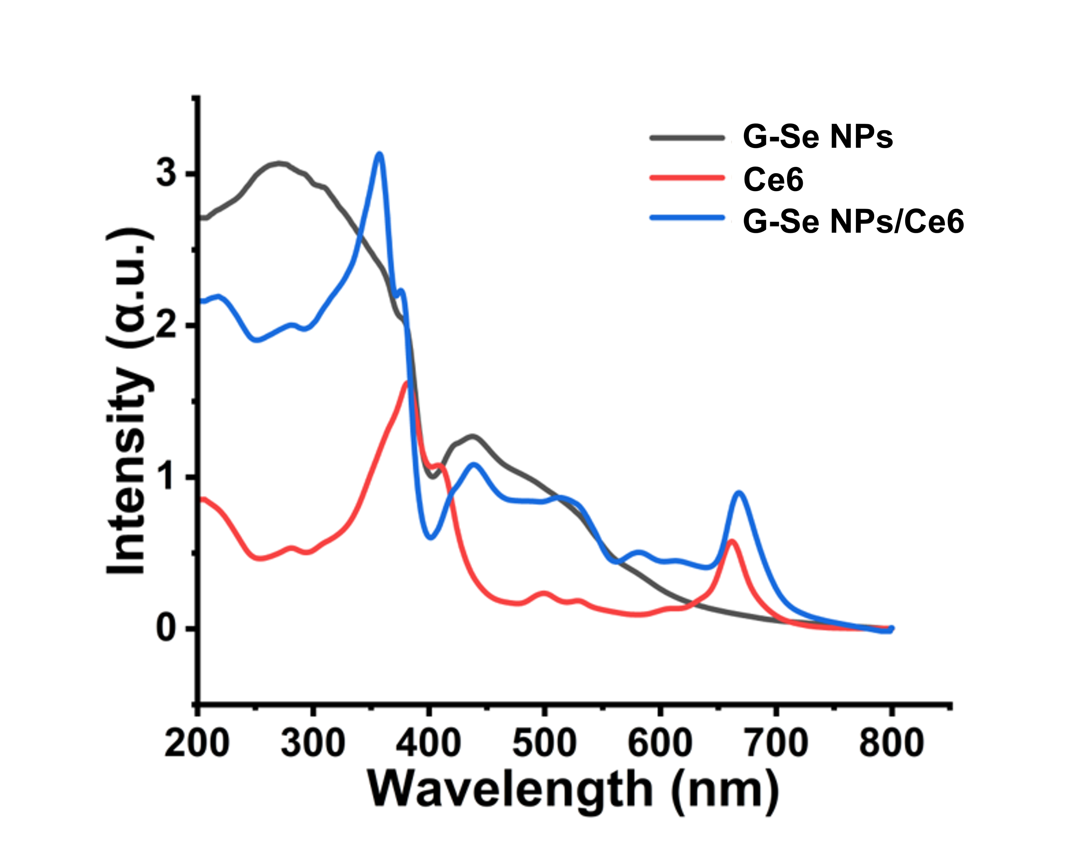
Fig. S10 UV-Vis spectral characterization of G-Se NPs/Ce6.

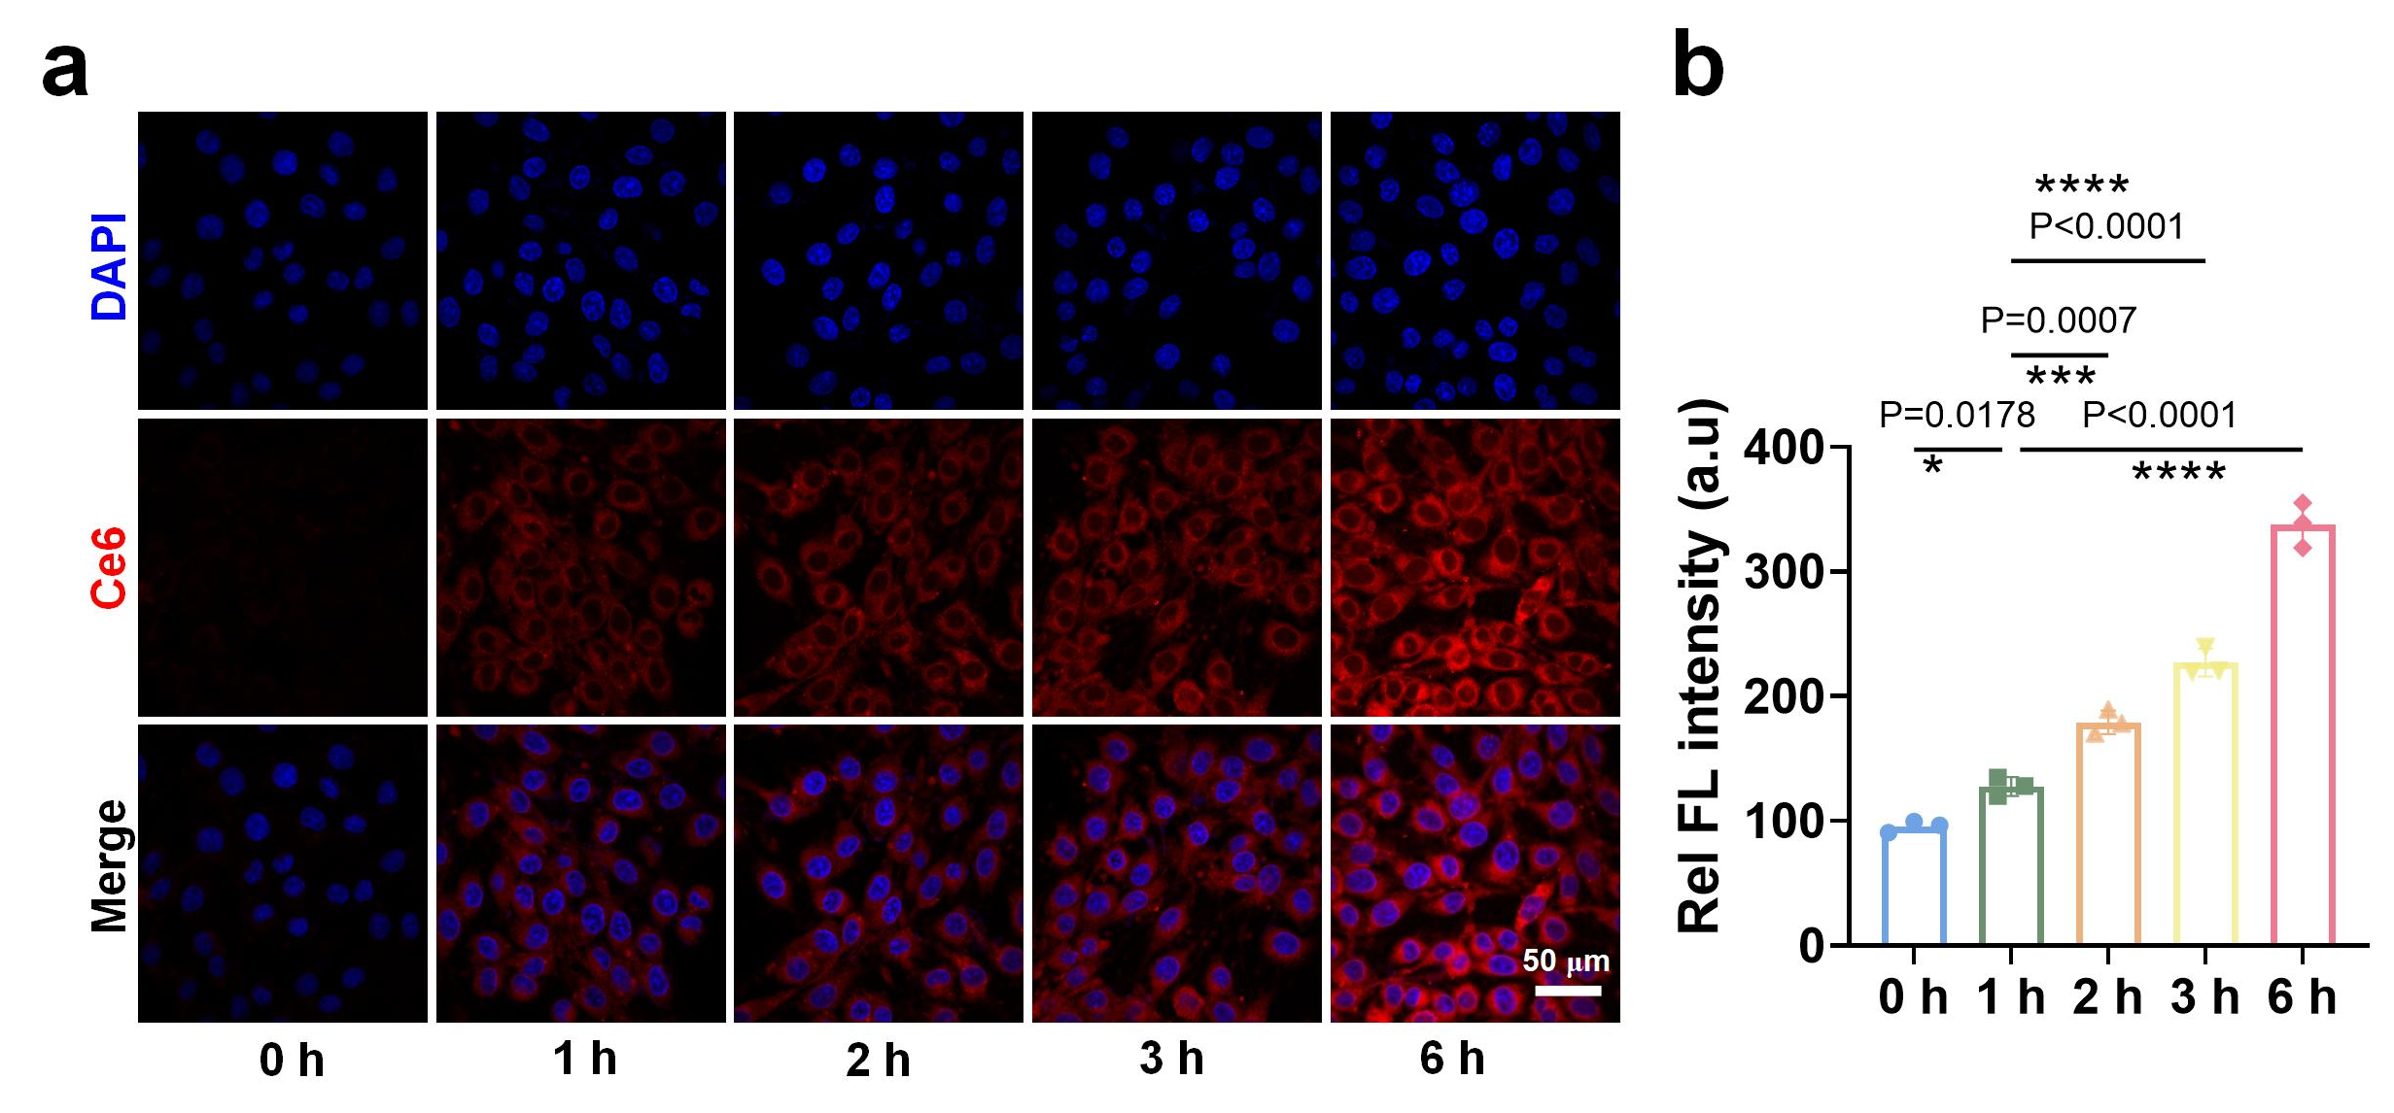
Fig. S11 (a, b) CLSM after different time exposure to G-Se NPs. All data are presented as mean ± SD (n=3).

Fig. S12 Endocytosis pathway analysis of nanoparticles. (a) CLSM of cellular uptake under various inhibition conditions (red: G-Se NPs/Ce6, blue: DAPI-stained nuclei). (b) Quantification of relative fluorescence intensity of internalized G-Se NPs/Ce6. All data are presented as mean ± SD (n=3).

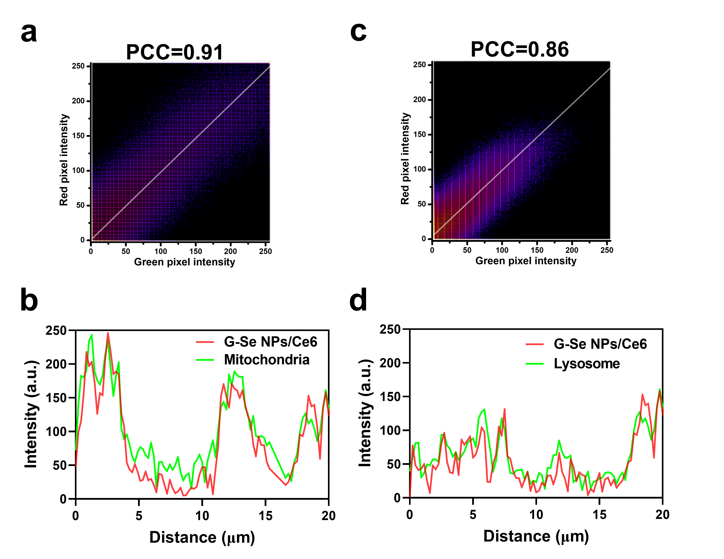
Fig. S13 (a-d) Linescan analysis and the Pearson’s correlation coefficient calculation performed by ImageJ software along the randomly selected lines in panel. All data are presented as mean ± SD (n=3).
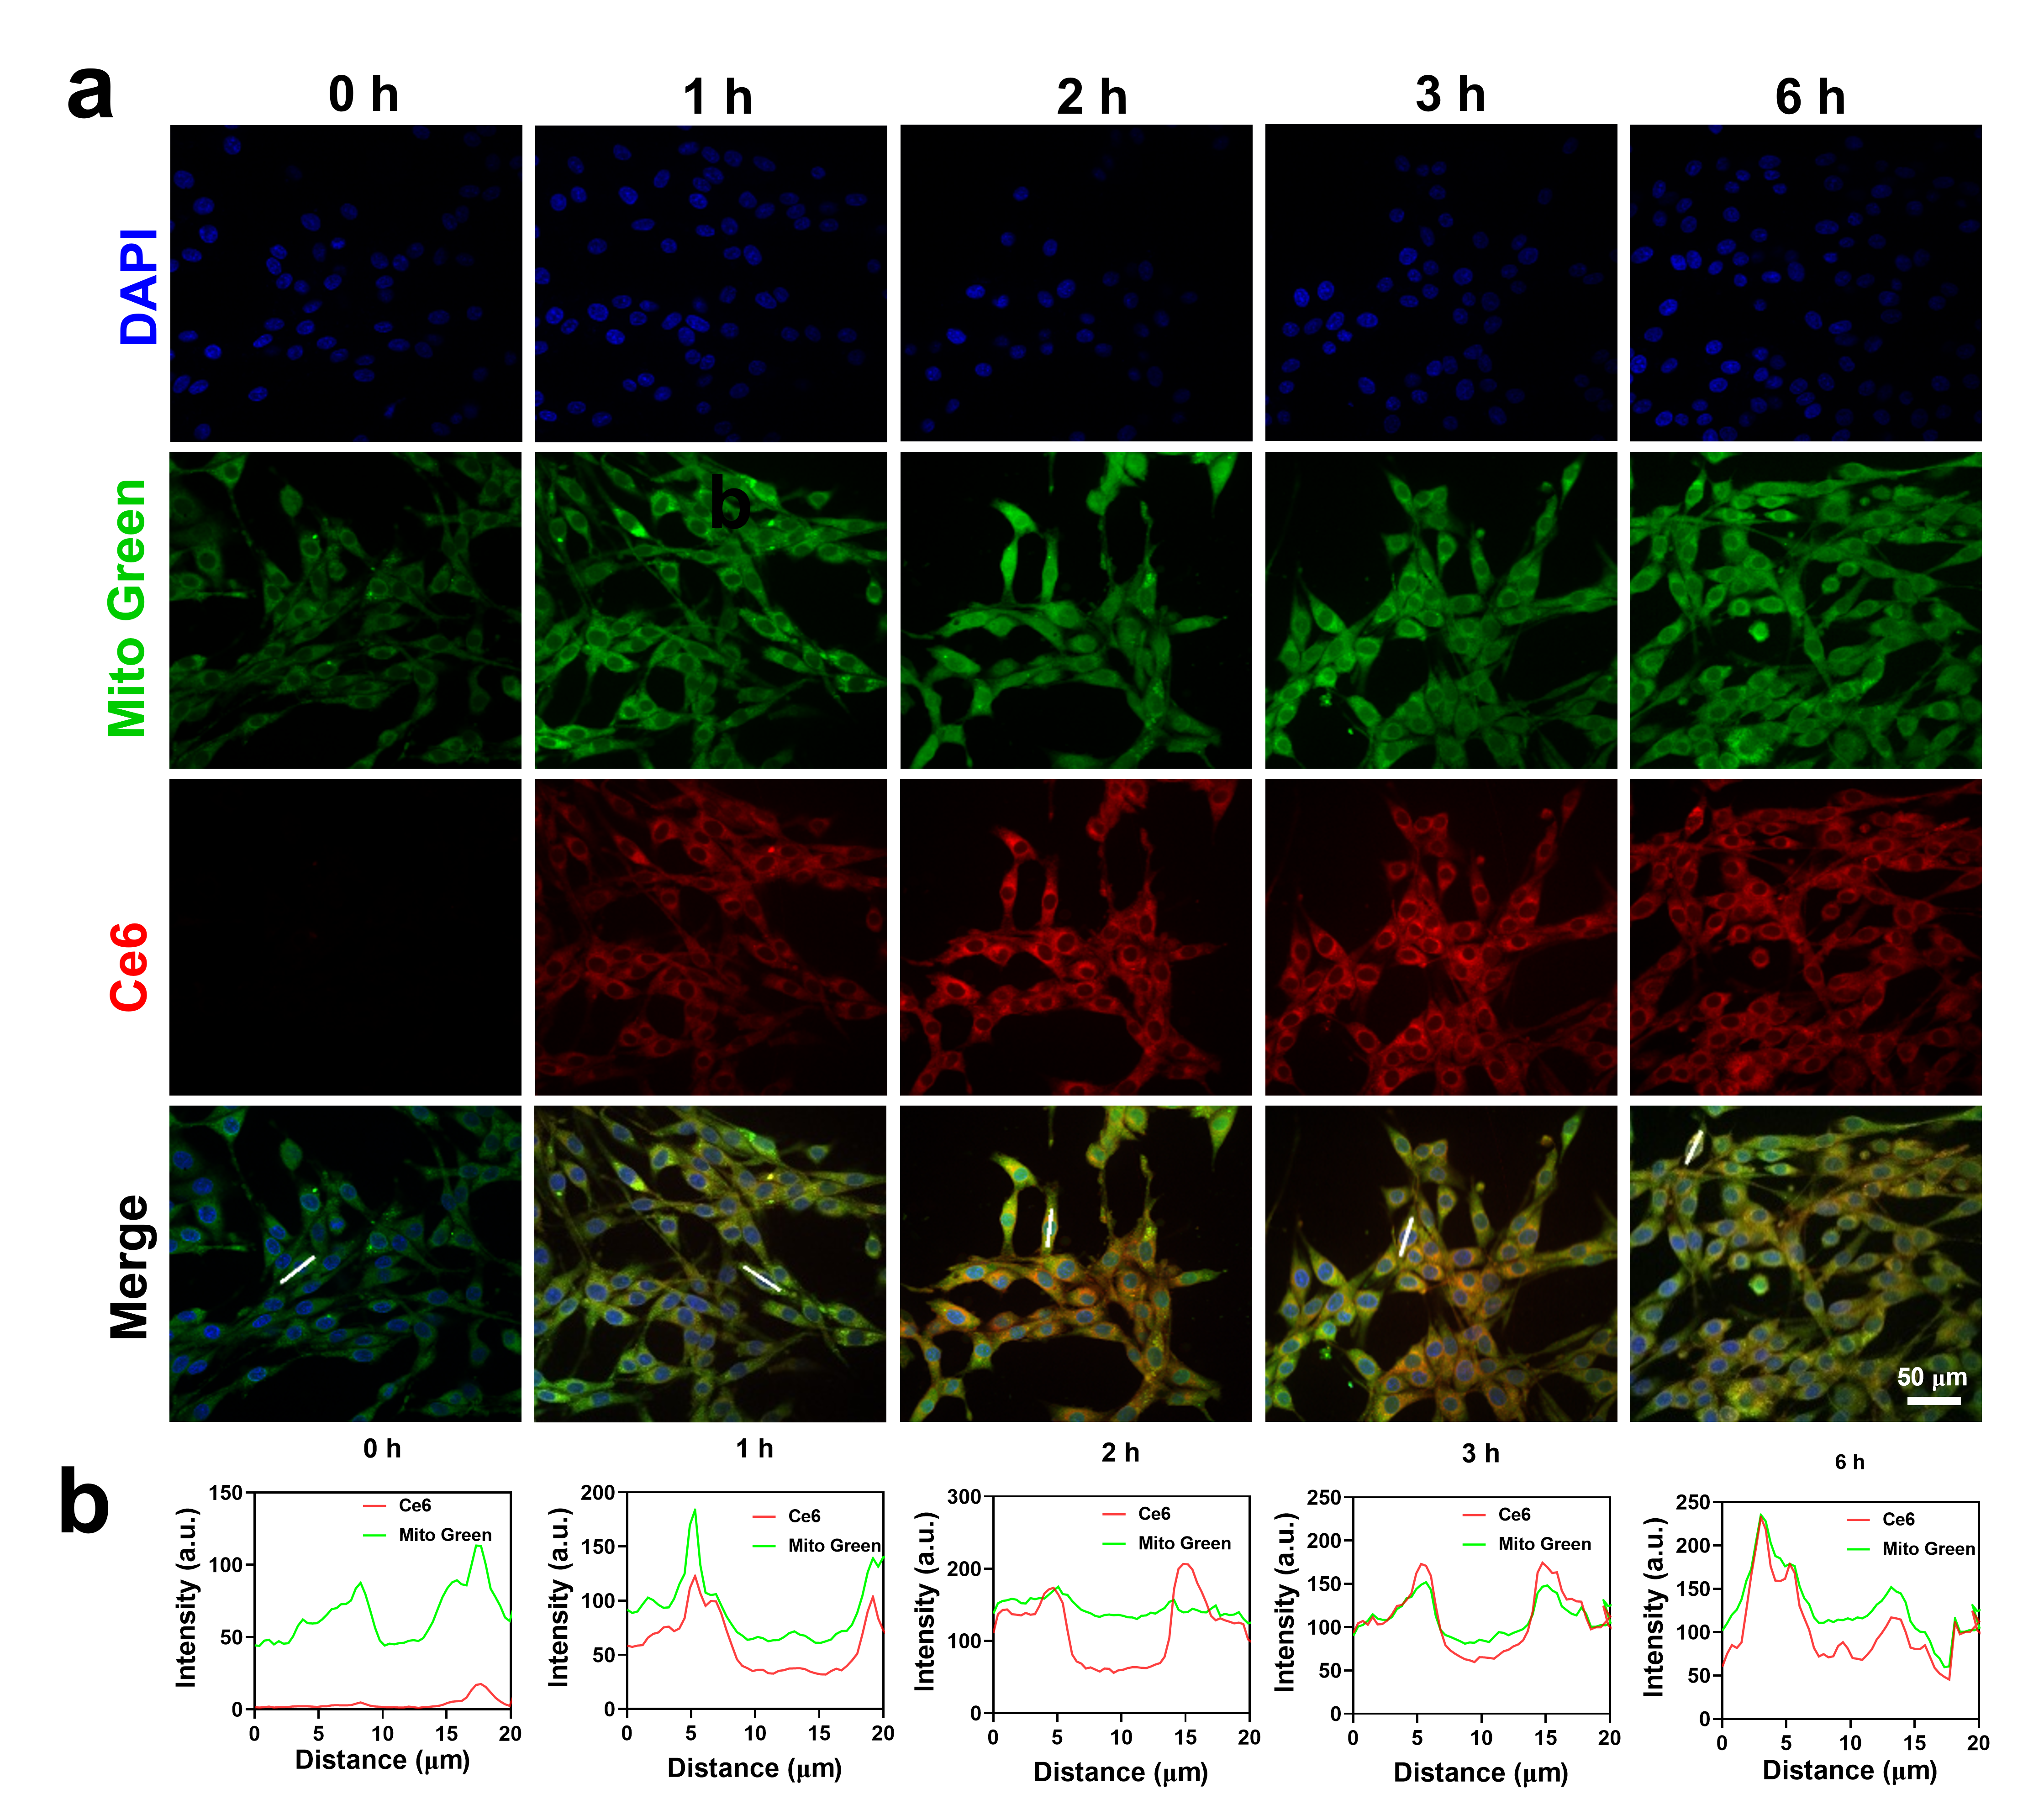
Fig. S14 Fluorescence images and line scan profiles of G-Se NPs localization in mitochondria at different time points (0 h, 1 h, 2 h, 3 h, 6 h). All data are presented as mean ± SD (n=3).

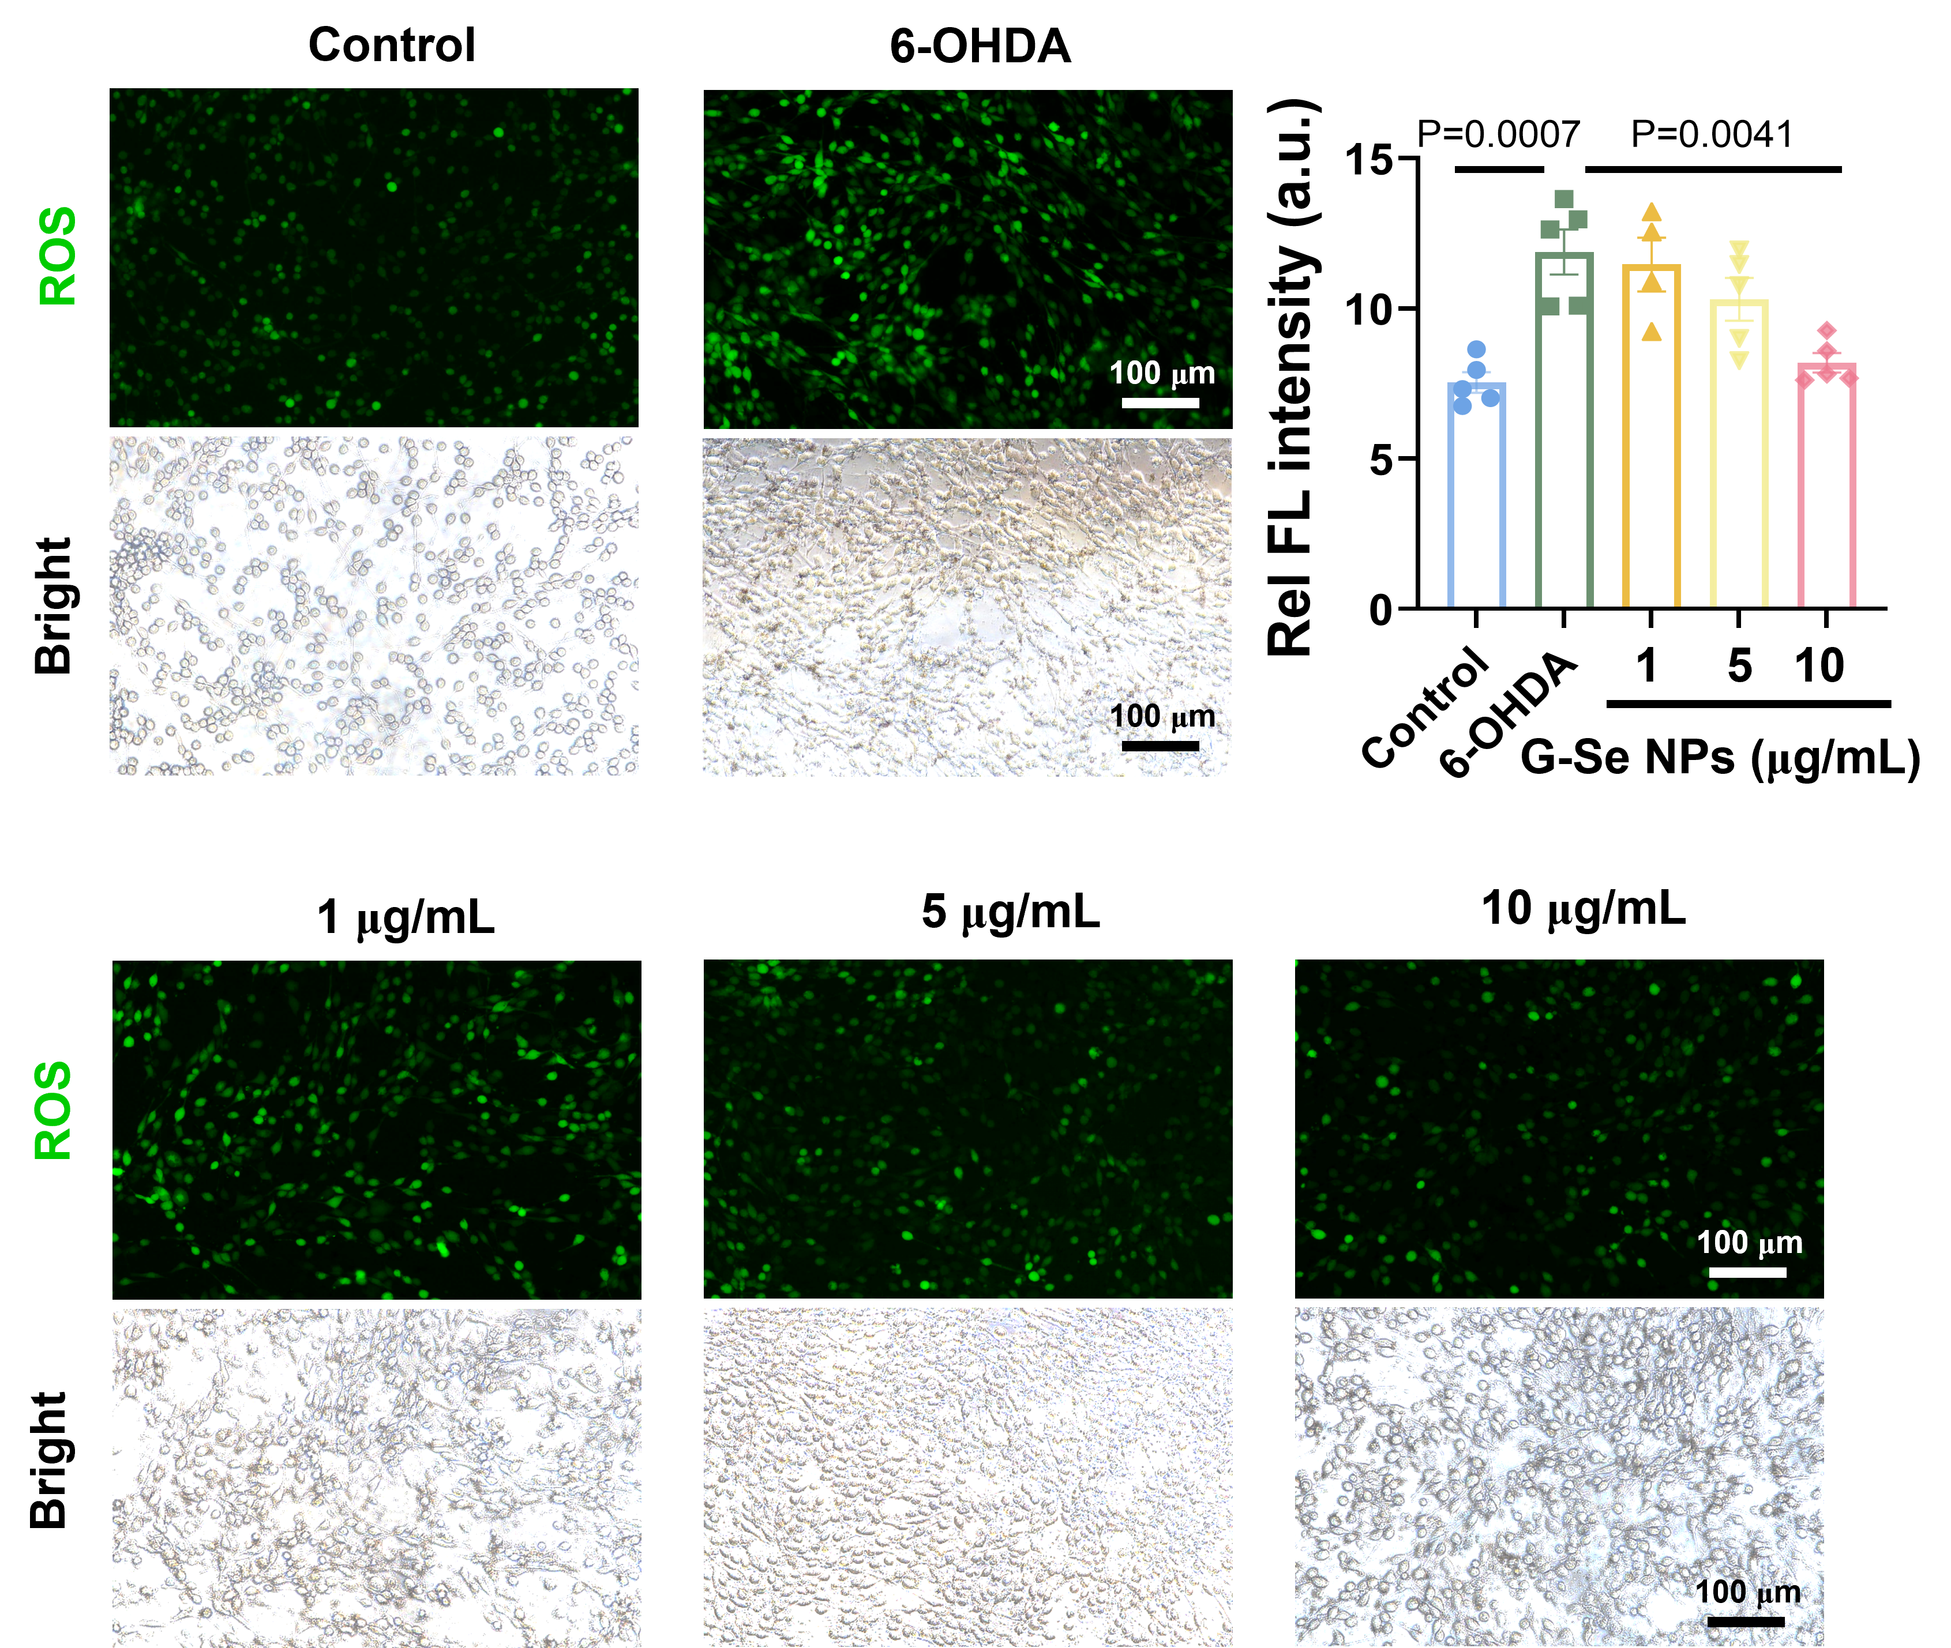
Fig. S15 Changes in ROS level in the 6-OHDA-induced PC12 cells after different concentration of G-Se NPs treatment. All data are presented as mean ± SD (n=5).
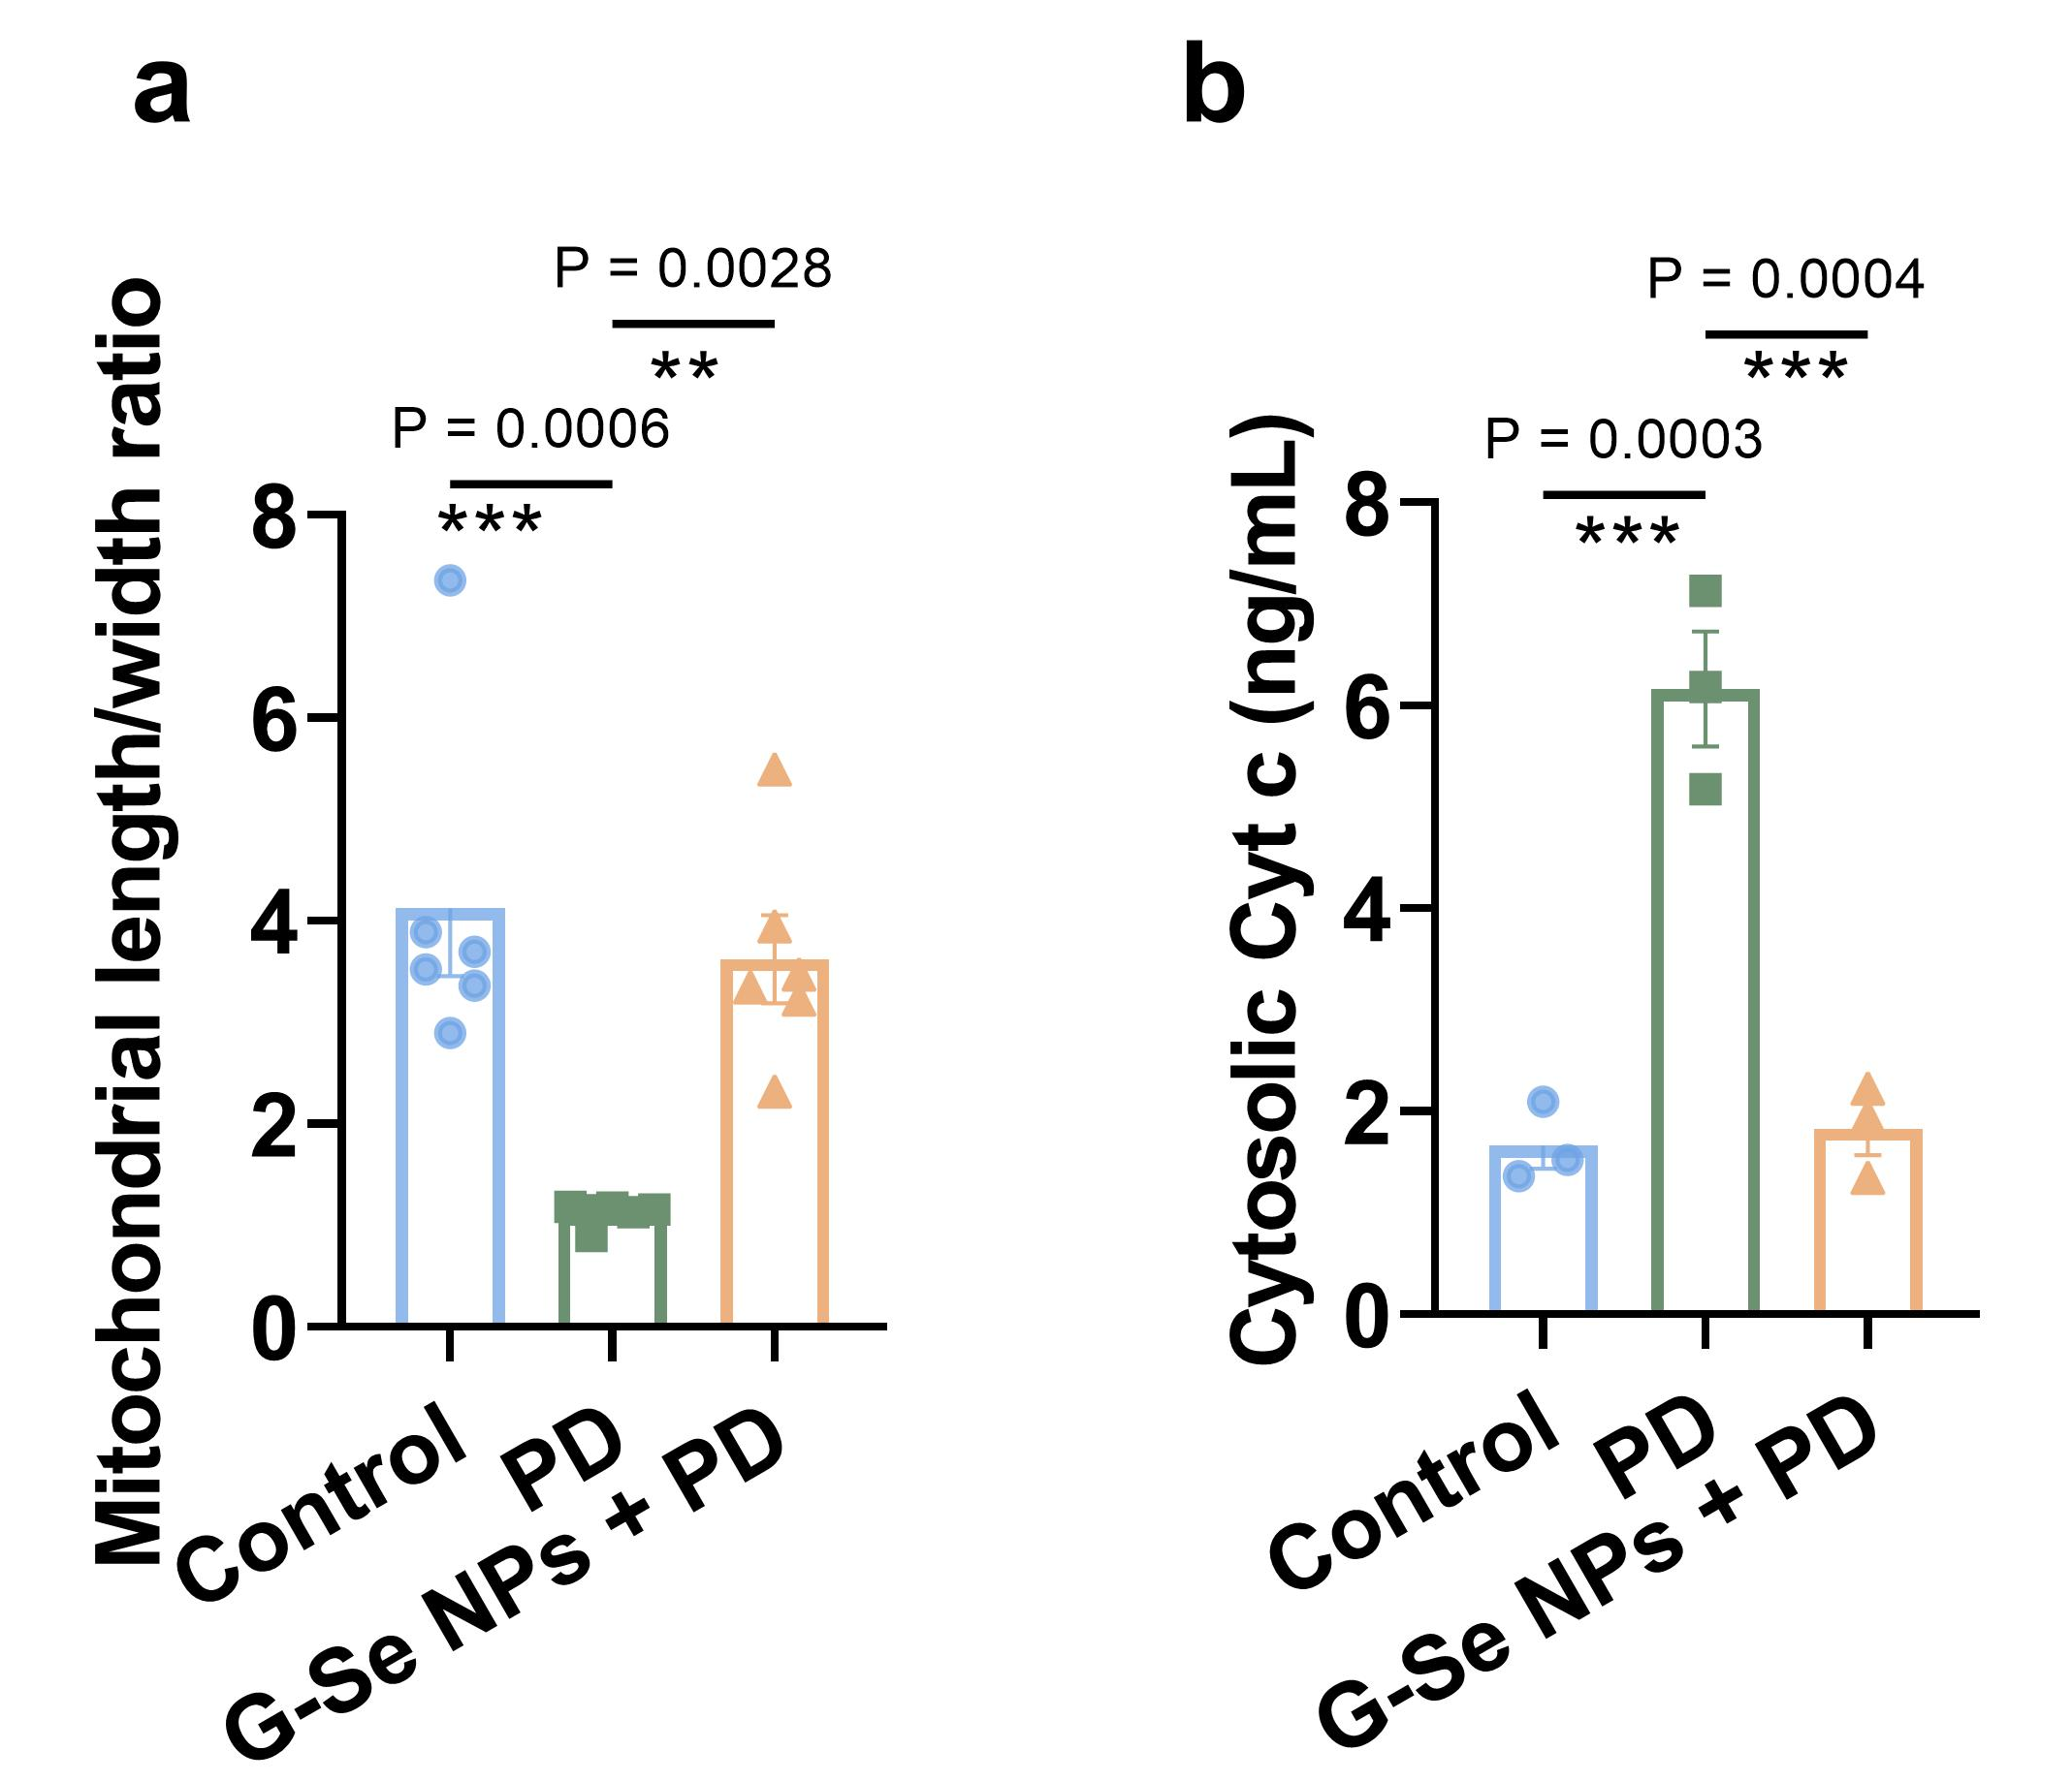
Fig. S16 (a) Statistical analysis of the mitochondrial width and length in each group of cells from TEM imaging. (b) ELISA Kit analysis of Cytosolic Cyt c expression. All data are presented as mean ± SD (n=6).

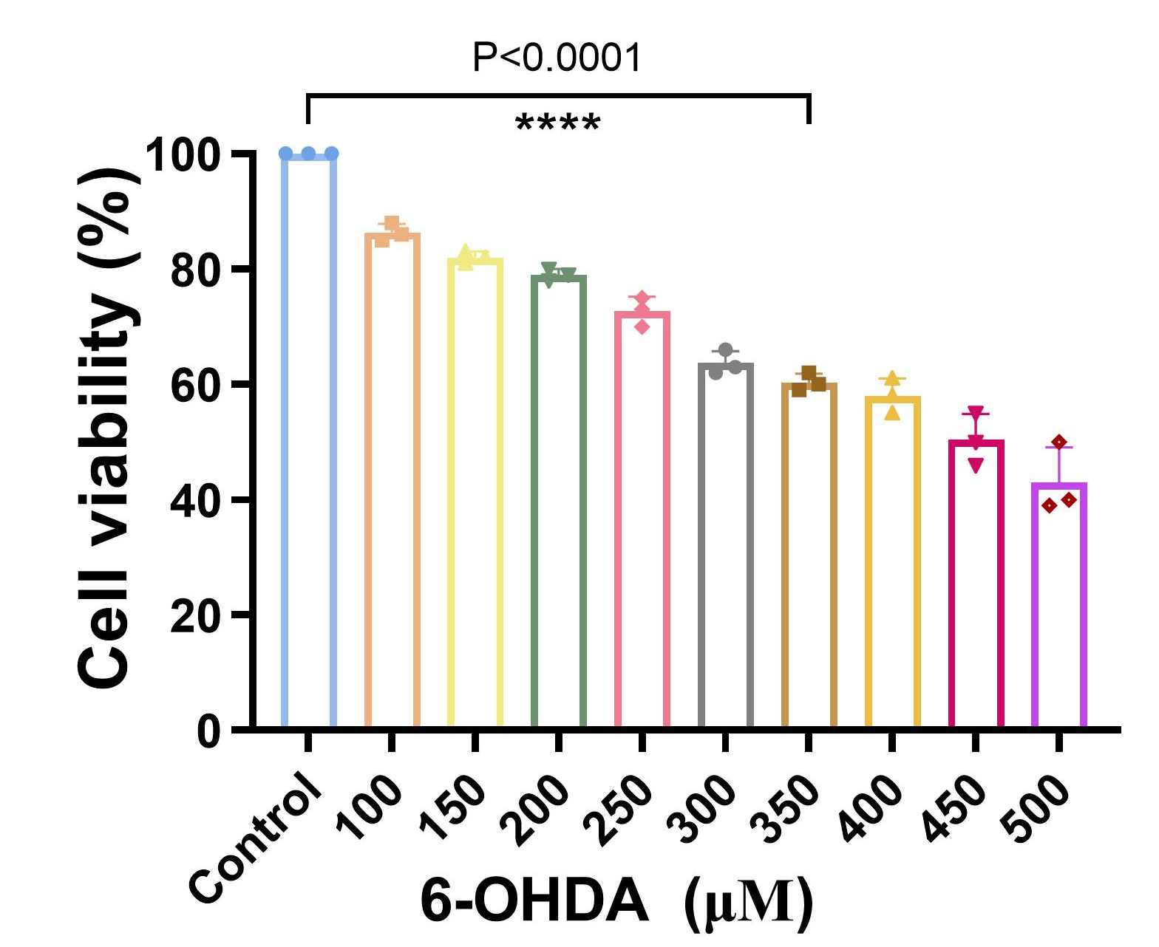
Fig. S17 Cell viability of PC12 cells with different concentrations of 6-OHDA using the CCK-8 assay. All data are presented as mean ± SD (n=3).

Fig. S18 Viabilities of 6-OHDA-induced PC12 cells treated with 0-20 μM of L-DOPA.

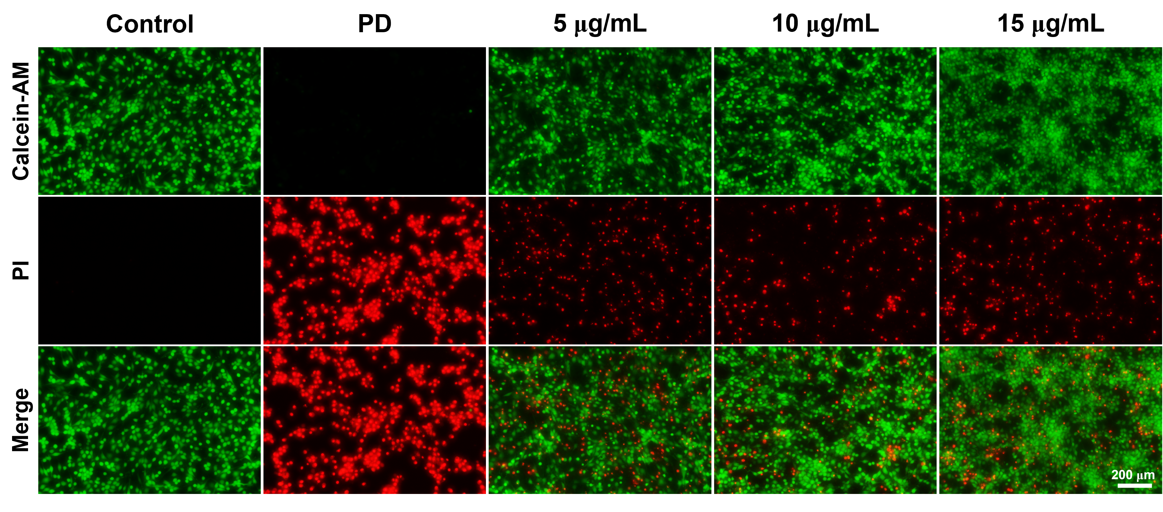
Fig. S19 Calcein-AM/PI staining in PC12 cells stimulated with 6-OHDA with or without different concentrations of G-Se NPs. All data are presented as mean ± SD (n=3).

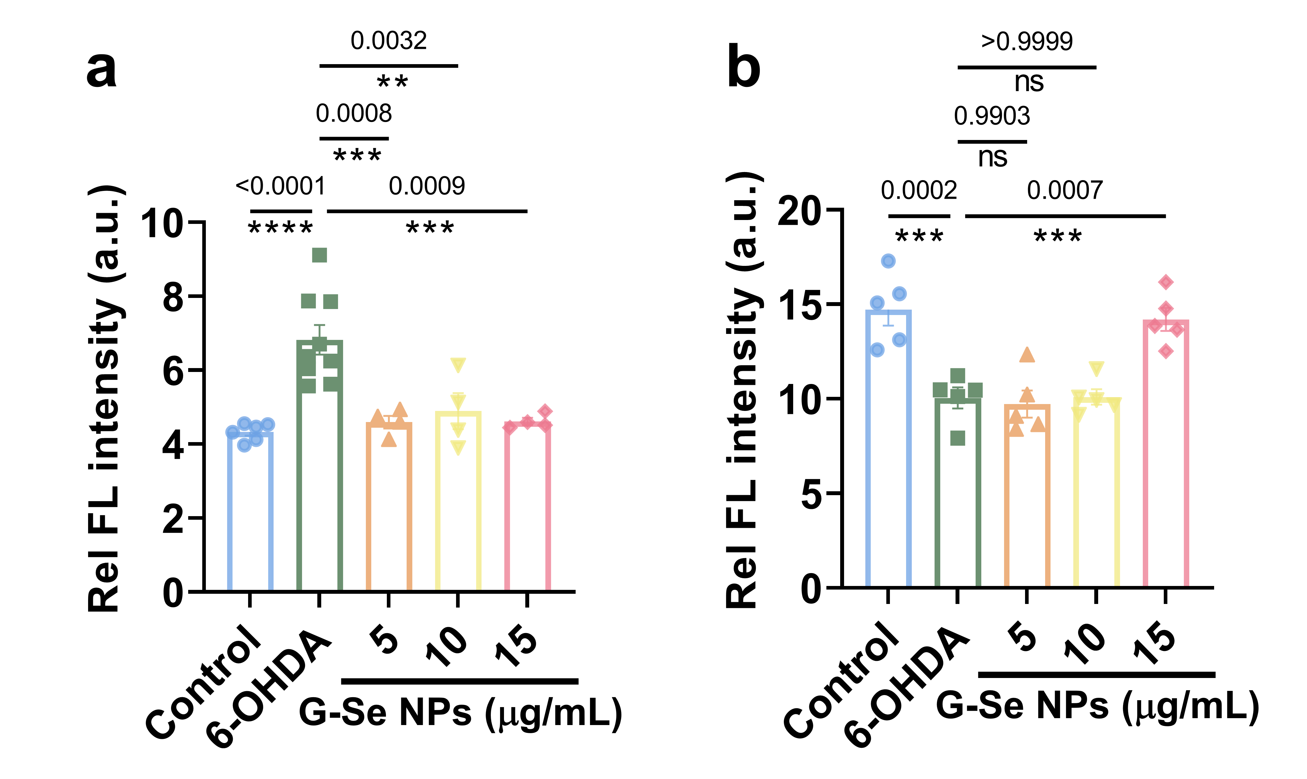

Fig. S20 Quantitative statistical analysis of α-syn and TH immunofluorescence imaging. All data are presented as mean ± SD (n≥3).

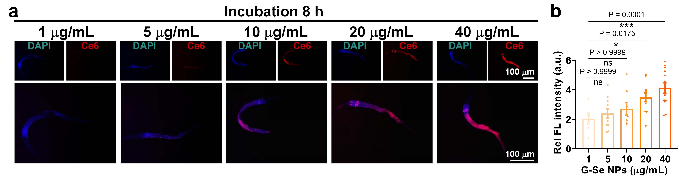
Fig. S21 (a, b) Fluorescence images (a) and quantitative analysis (b) of Bristol N2 strains of cultivated with varying G-Se NPs concentrations at 6 h. All data are presented as mean ± SD (n=10).

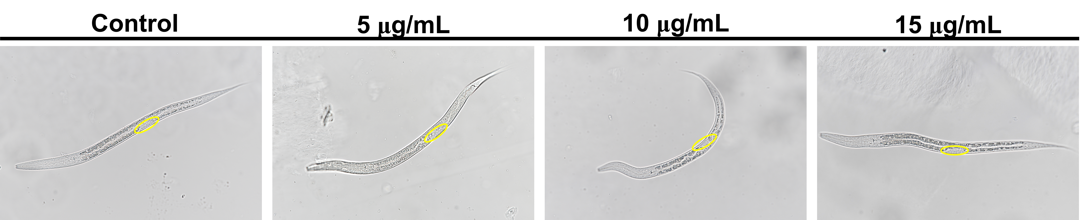
Fig. S22 The body length of nematodes for the L4 period when exposed to various concentrations of G-Se NPs. All data are presented as mean ± SD (n=50).

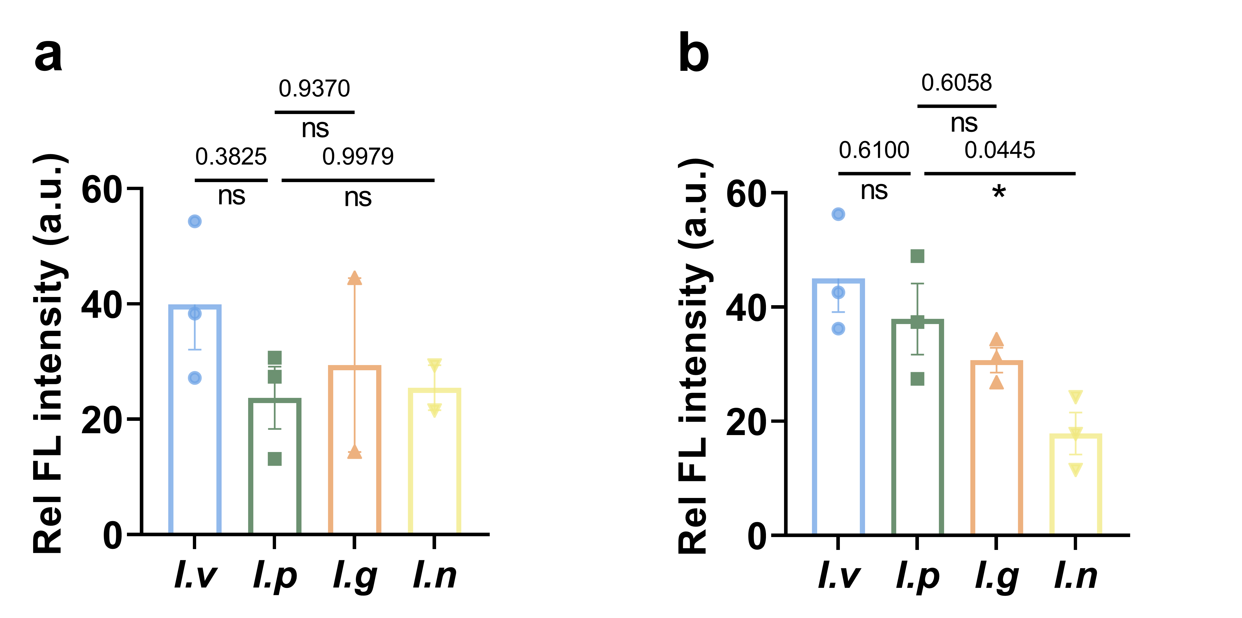

Fig. S23 Balb/c mice were administered G-Se NPs through four delivery routes：tail vein intravenous injection (i.v.), intraperitoneal injection (i.p.), intragastric administration (i.g.), and intranasal instillation (i.n.). (a, b) quantitative analysis of tissue slices in (a) brain and (b) liver. All data are presented as mean ± SD (n=3).

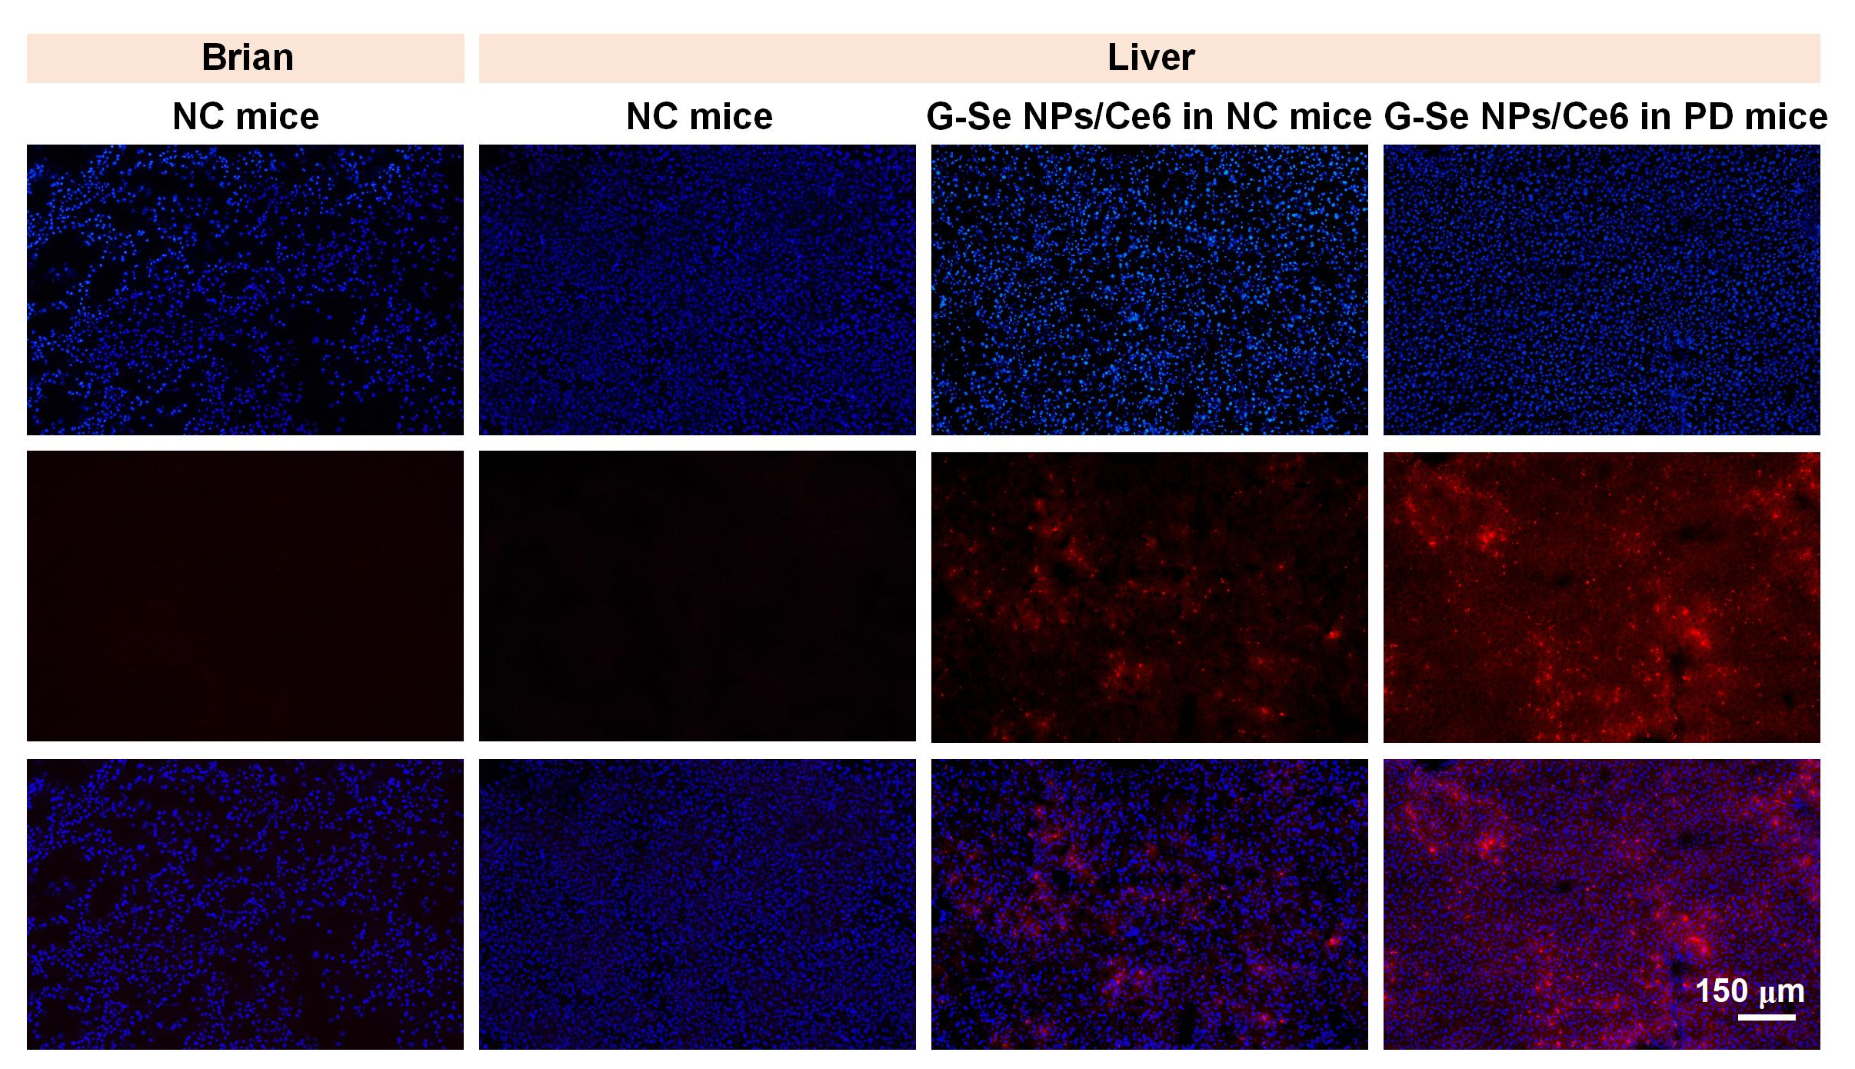
Fig. S24 Fluorescence imaging of Ce6-labeled G-Se NPs distribution in brian and liver tissue of healthy (NC) and PD mice. All data are presented as mean ± SD (n=3).

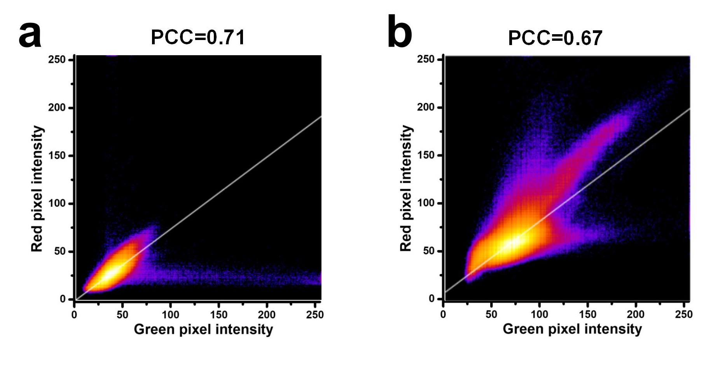
Fig. S25 (a, b) The Pearson’s correlation coefficient calculation of Ce6-labeled G-Se NPs with (a) mitochondria and (b) TH performed by ImageJ software along the randomly selected lines in panel.

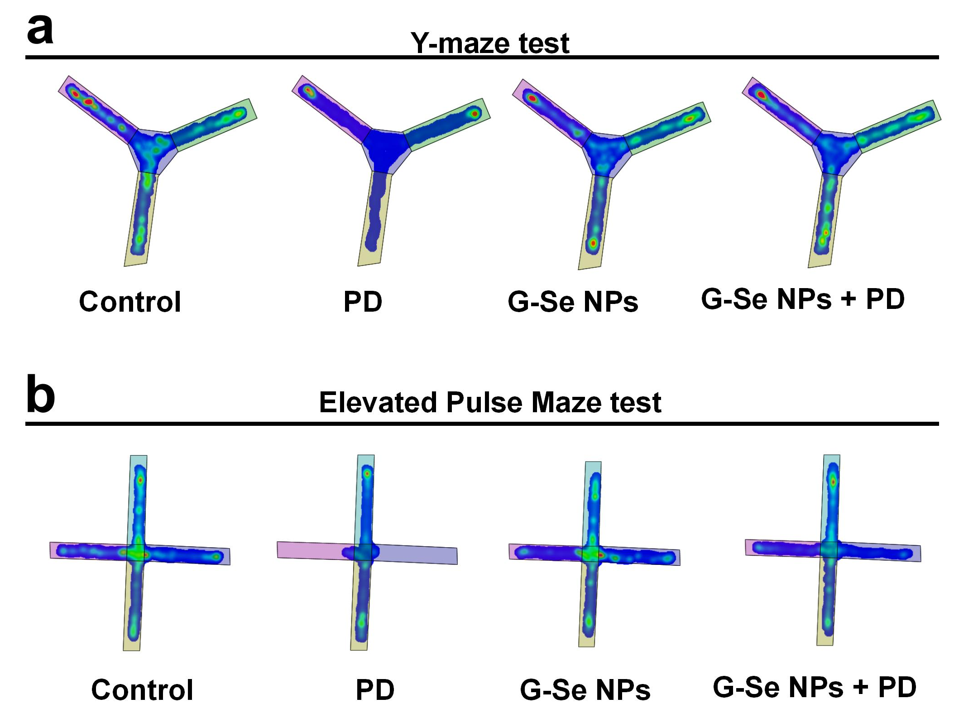
Fig. S26 (a) Heat map of tracking path of mice from different groups of mice in Y-maze test. (b) Heat map of tracking path of mice from different groups of mice in the elevated plus-maze test. All data are presented as mean ± SD (n=6).

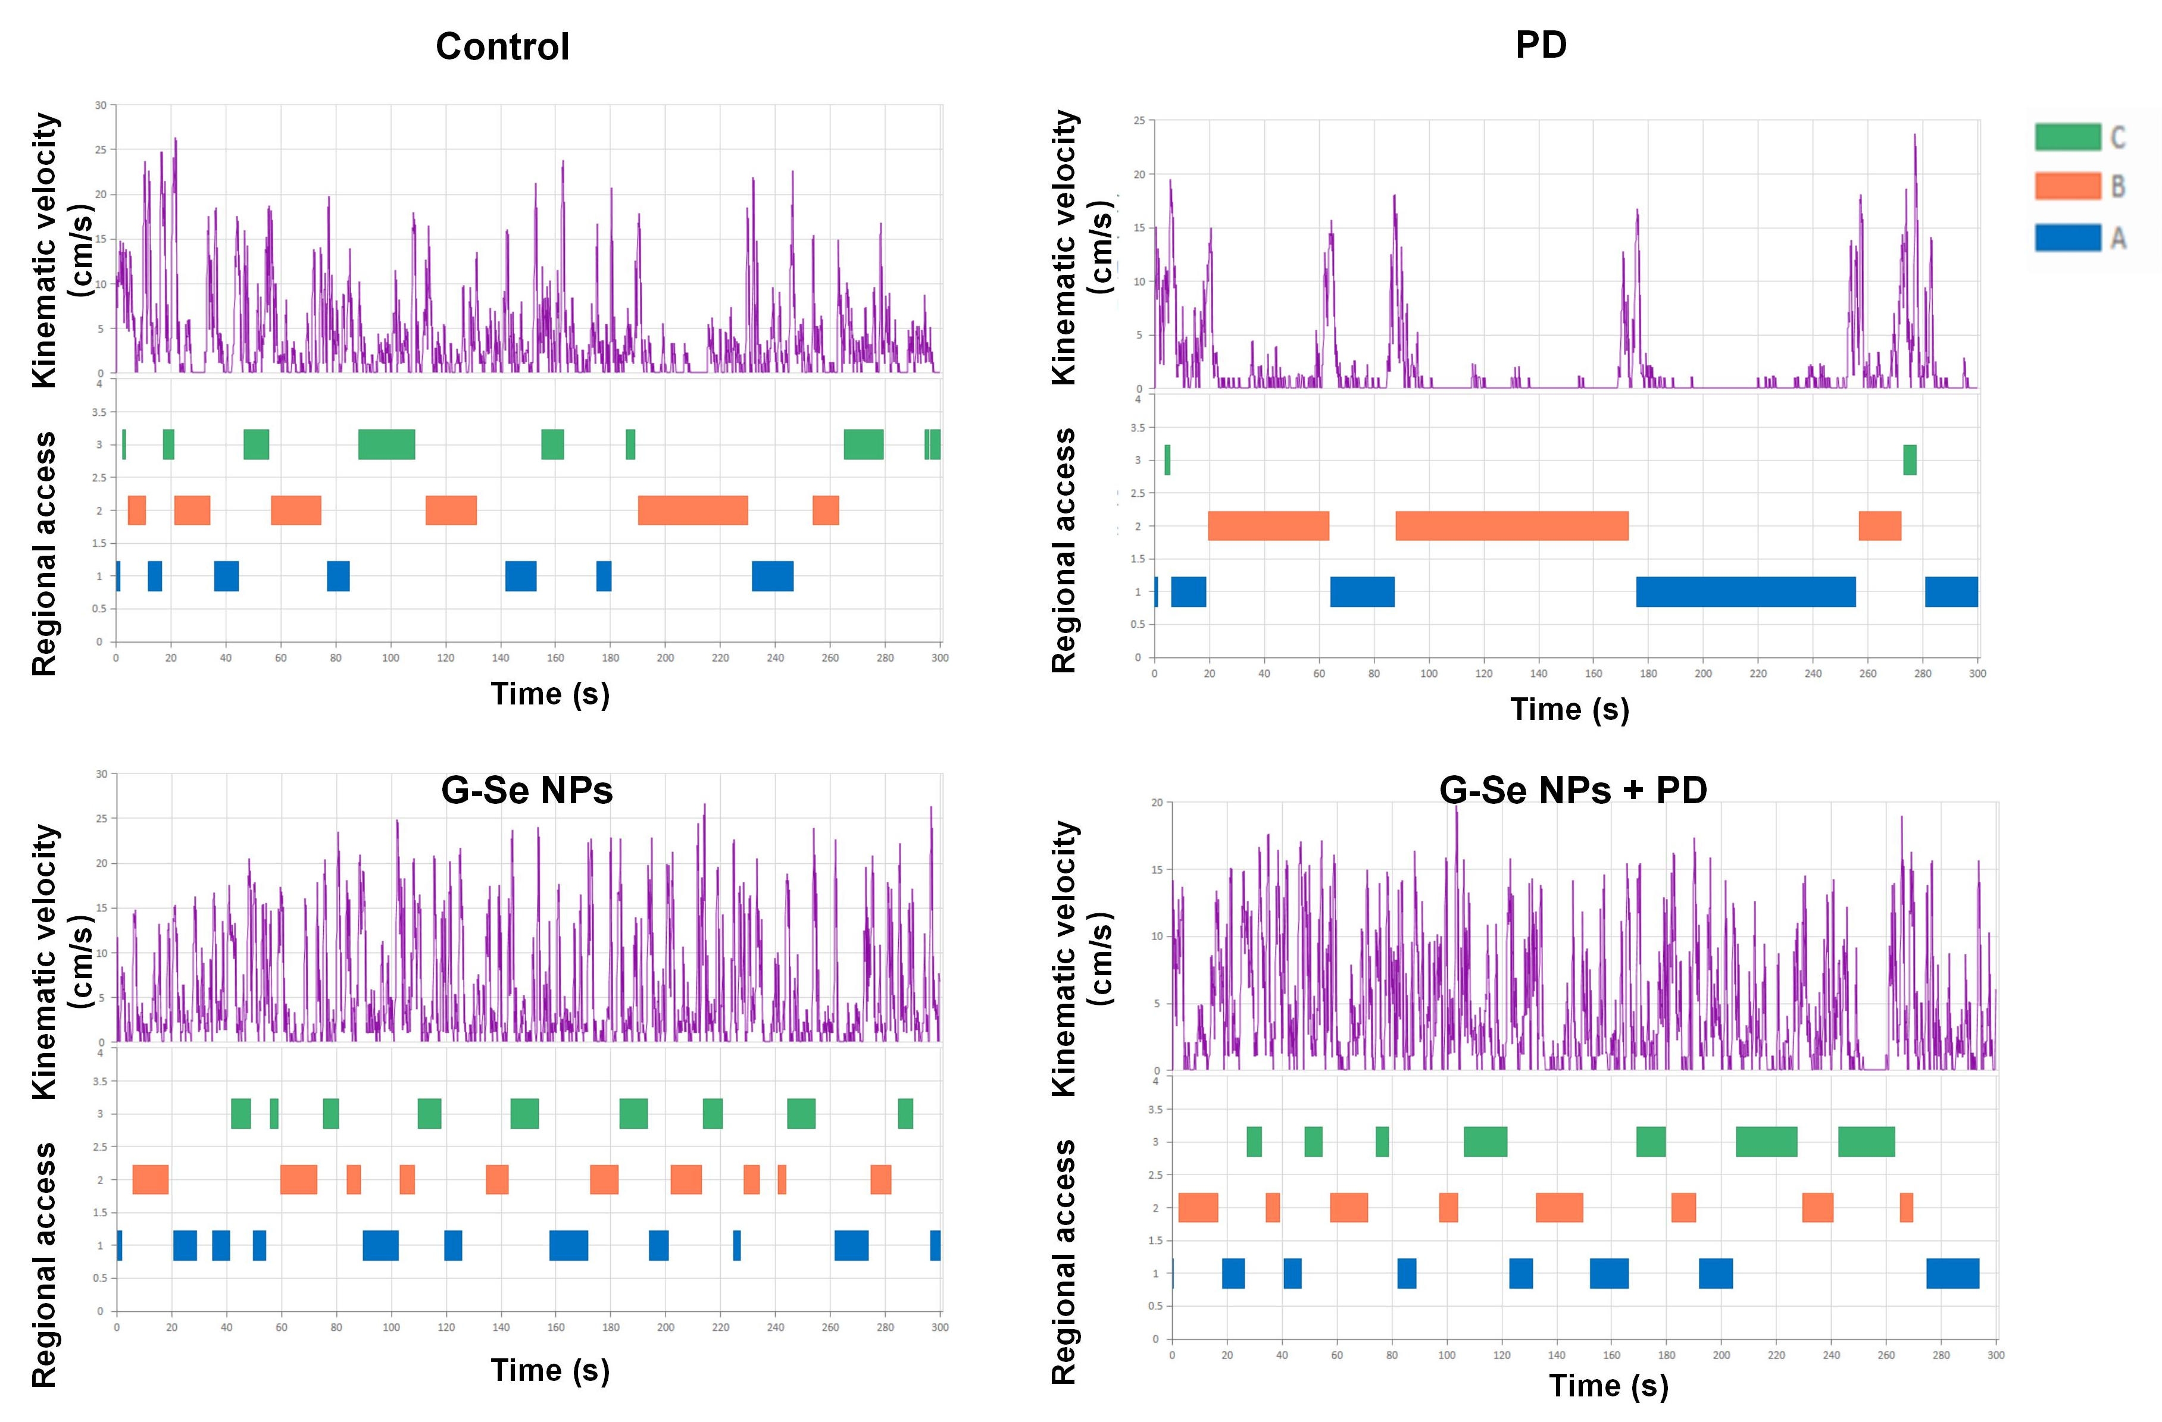
Fig. S27 The classic movement trajectory diagrams of each group of mice in Y-maze test. All data are presented as mean ± SD (n=6).

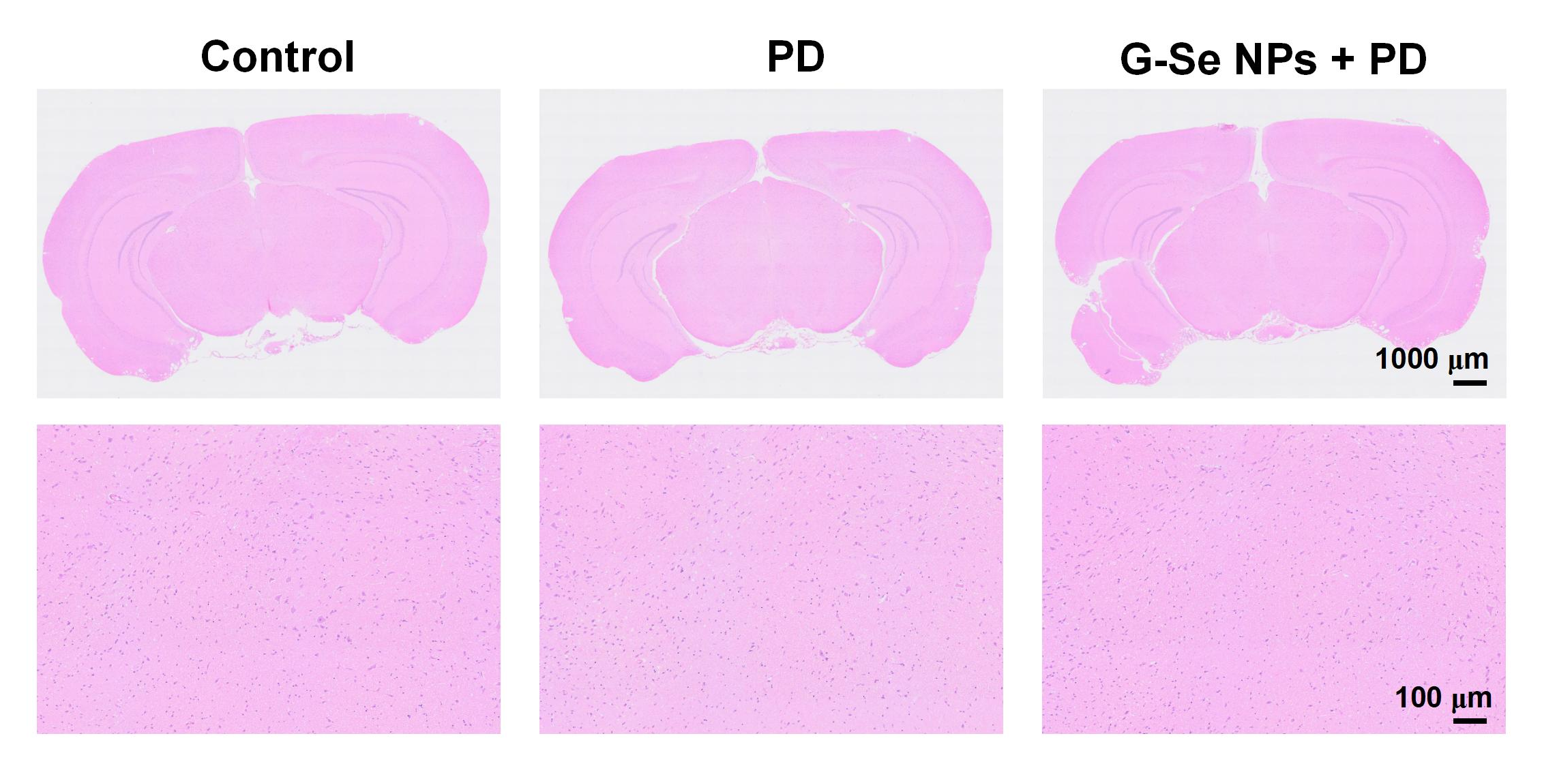
Fig. S28 H&E staining of brain after different treatments. All data are presented as mean ± SD (n=3).

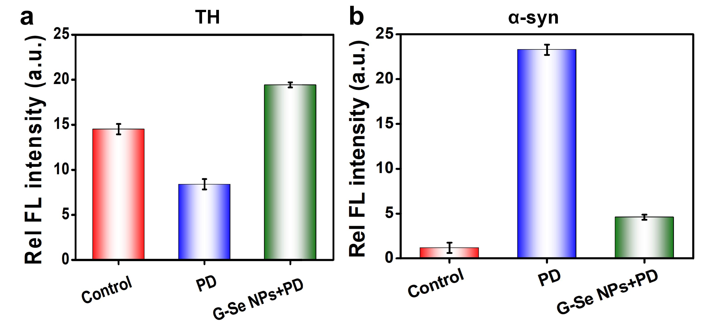
Fig. S29 Semi-quantitative analysis of (a) TH and (b) α-syn expression in the SN of PD mice ex-vivo. All data are presented as mean ± SD (n=3).

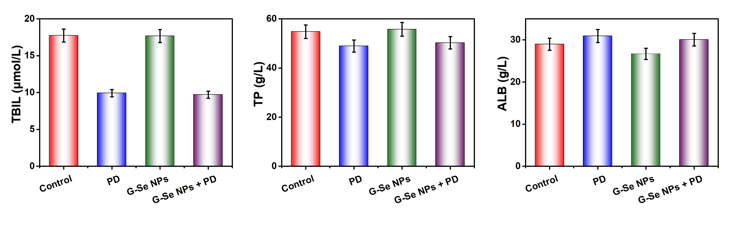
Fig. S30 Serum biochemical analysis of the mice in each group. All data are presented as mean ± SD, (n=3).

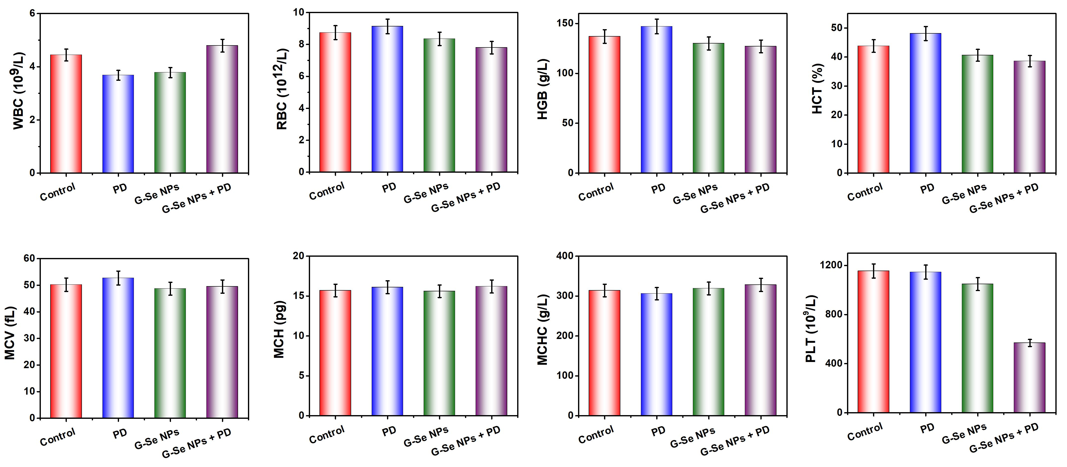
Fig. S31 (a) Routine blood analysis of the mice in each group. All data are presented as mean ± SD (n=3).
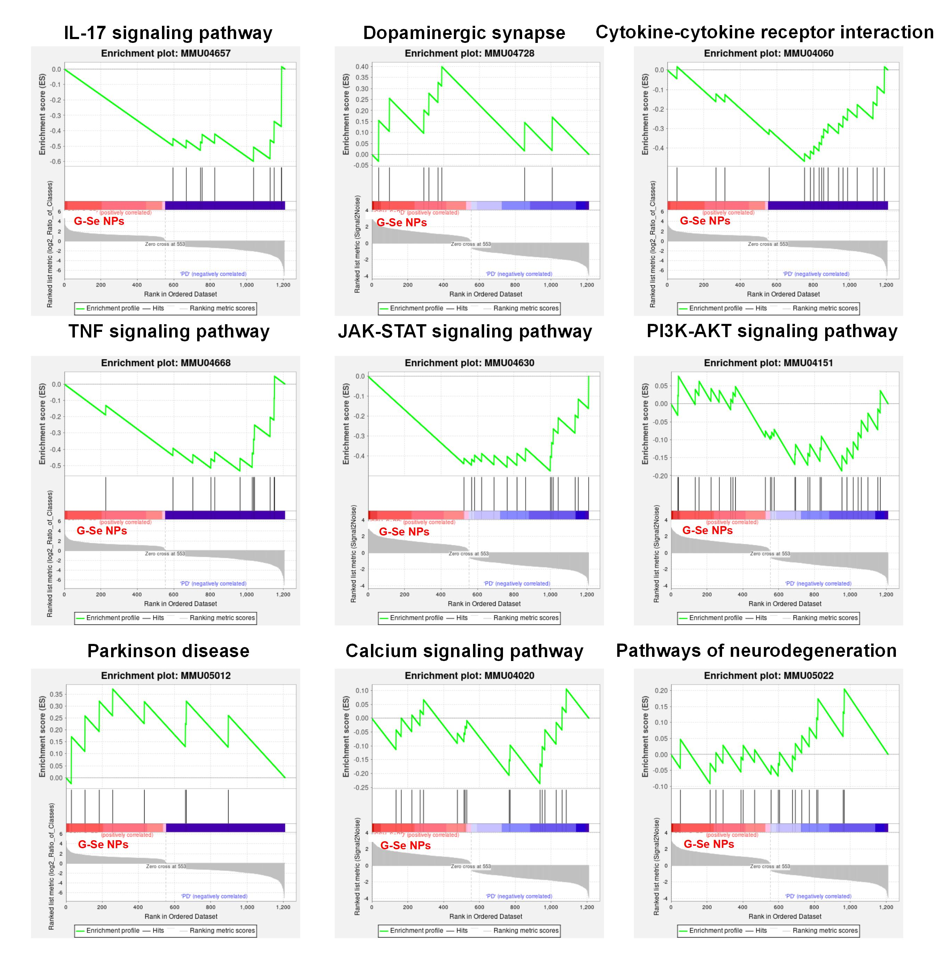
Fig. S32 Gene set enrichment analysis performed on RNA-seq data related to signaling pathway.

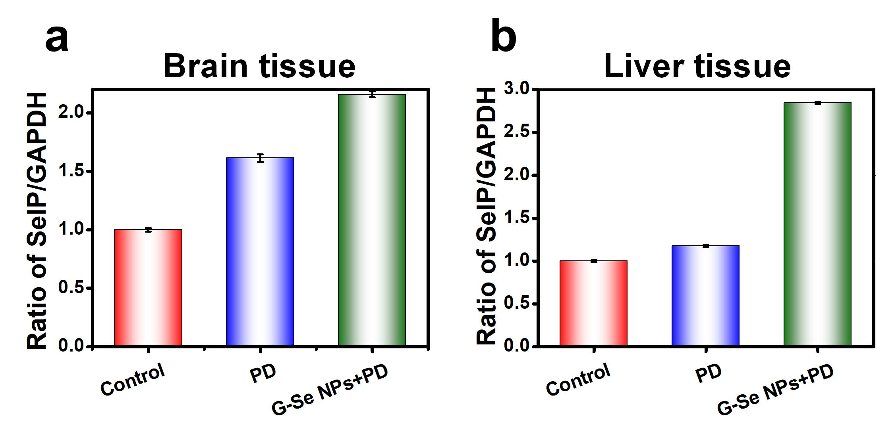
Fig. S33 Quantitative analysis was conducted to determine the expression levels of SelP in the (a) brain and (b) liver tissues of each group of mice. All data are presented as mean ± SD (n=3).
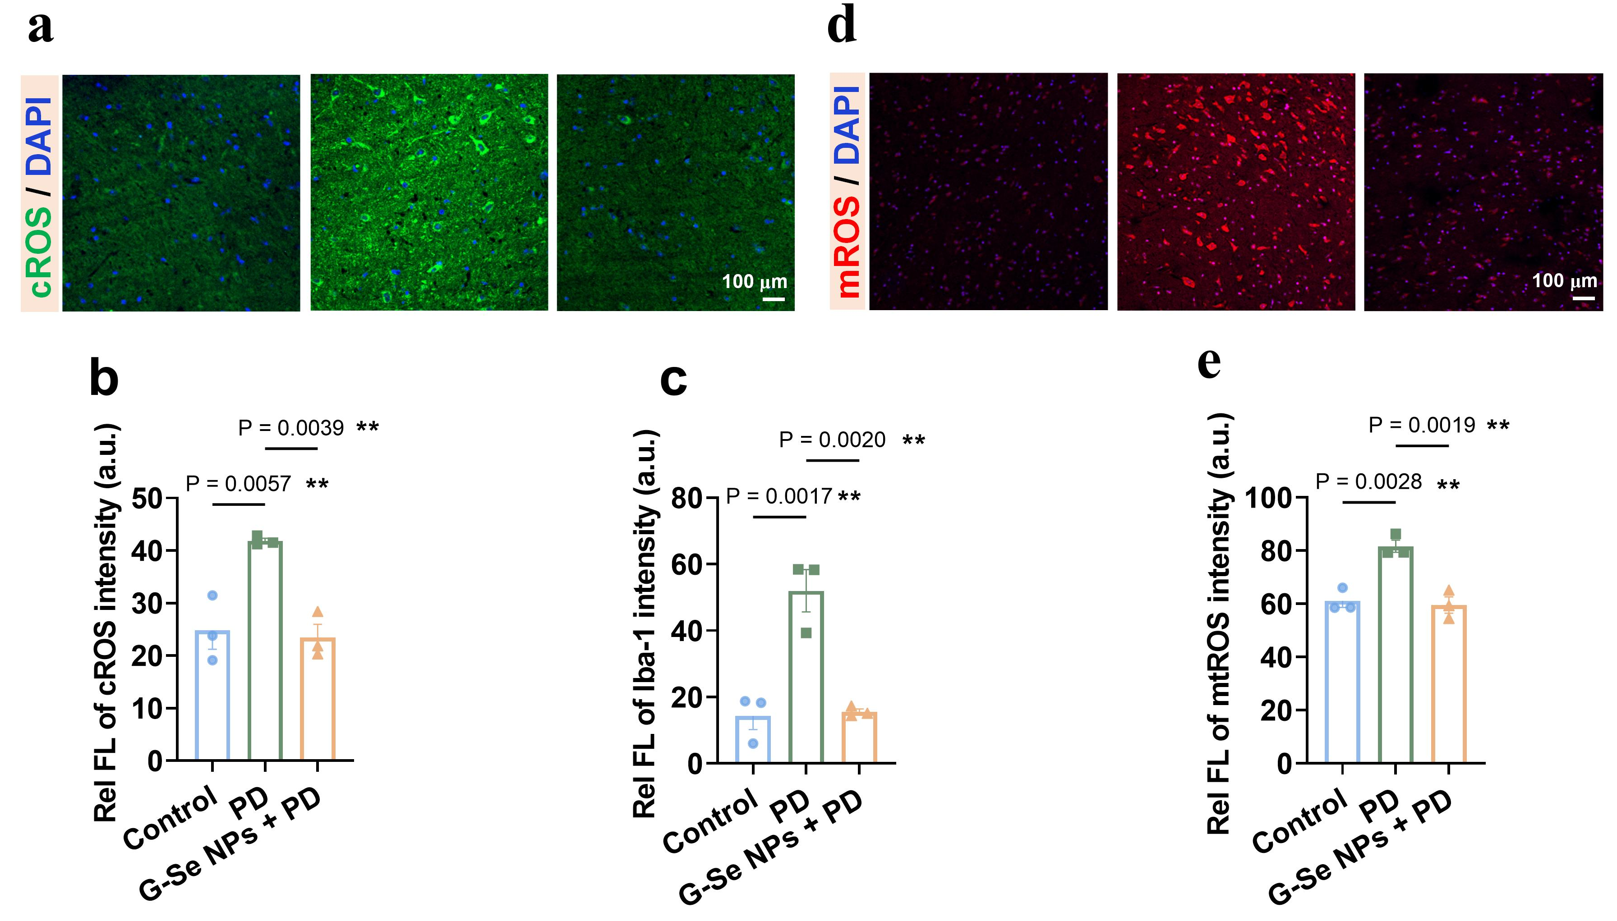
Fig. S34 (a) Representative images of ROS in the brain of PD mice after G-Se NPs treatment as indicated by DCFH-DA. (b, c) Quantitative analysis of images (b) in DCFH-DA analysis of ROS in PD mice stimulated with G-Se NPs and (c) in Iba-1 immunofluorescence staining. (d, e) Representative images (d) and quantitative analysis (e) of mtROS in the brain of PD mice after G-Se NPs treatment as indicated by MitoSOX. All data are presented as mean ± SD (n=3).
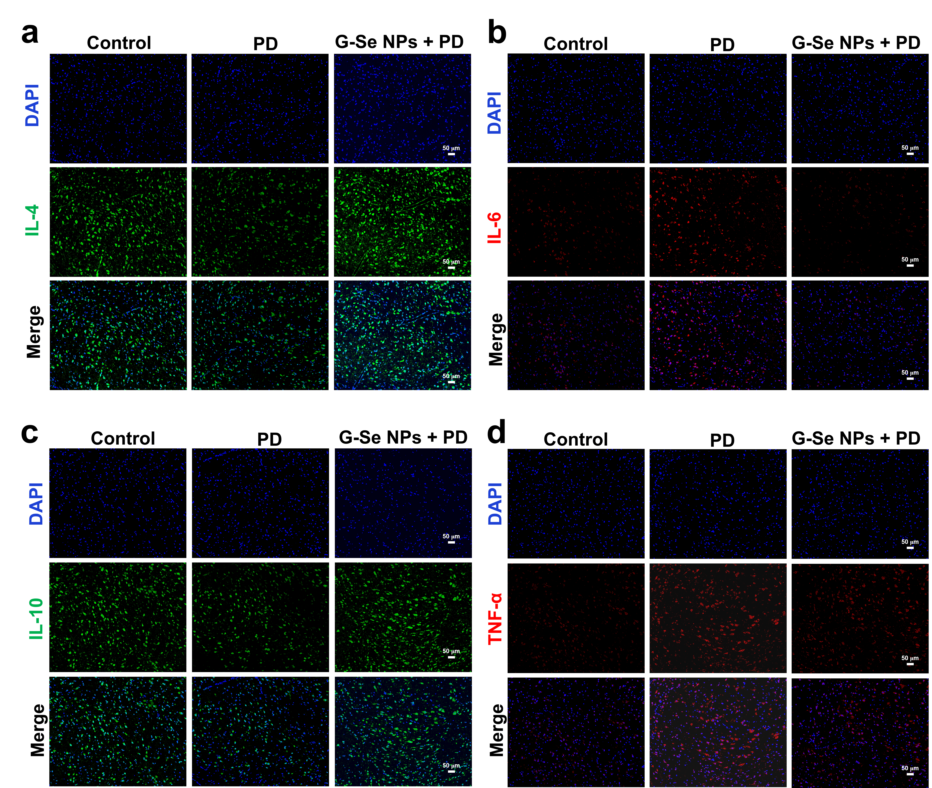
Fig. S35 (a, c) Immunofluorescence staining imaging of anti-inflammatory cytokines IL-4 and IL-10 in mouse brain tissue (b, d) Immunofluorescence staining imaging of pro-inflammatory cytokines IL-6 and TNF-α in mouse brain tissue. All data are presented as mean ± SD (n=3).

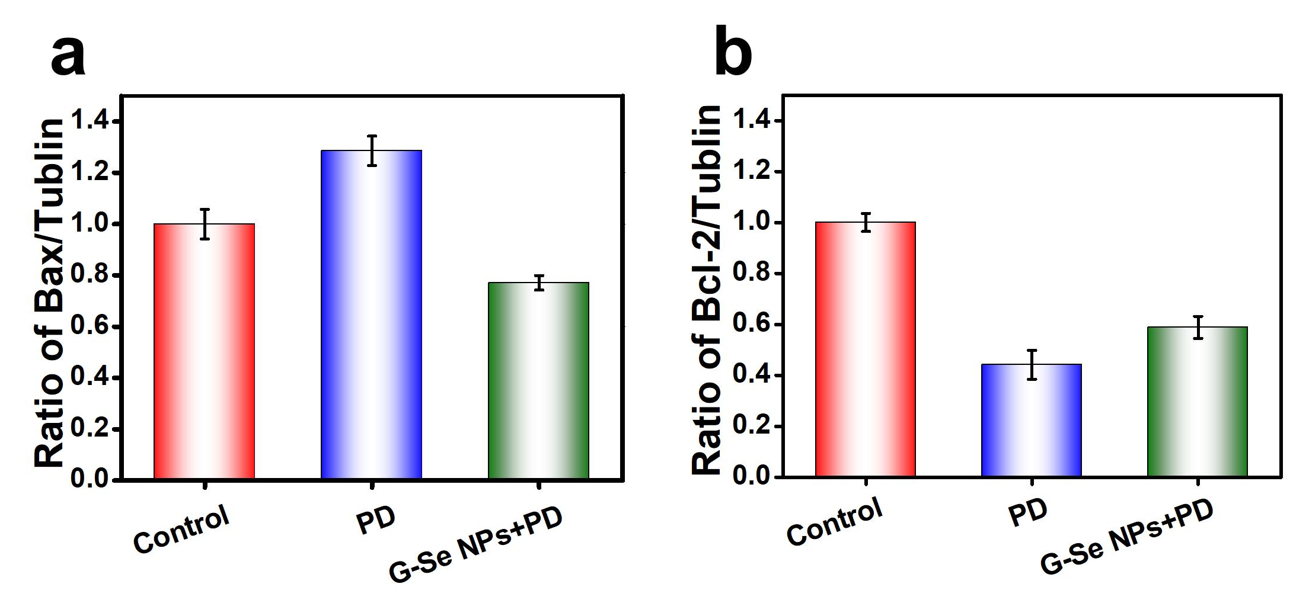
Fig. S36 Quantitative analysis was conducted to determine the expression levels of (a) Bax and (b) Bcl-2 in the brain tissues of each group of mice. All data are presented as mean ± SD (n=3).

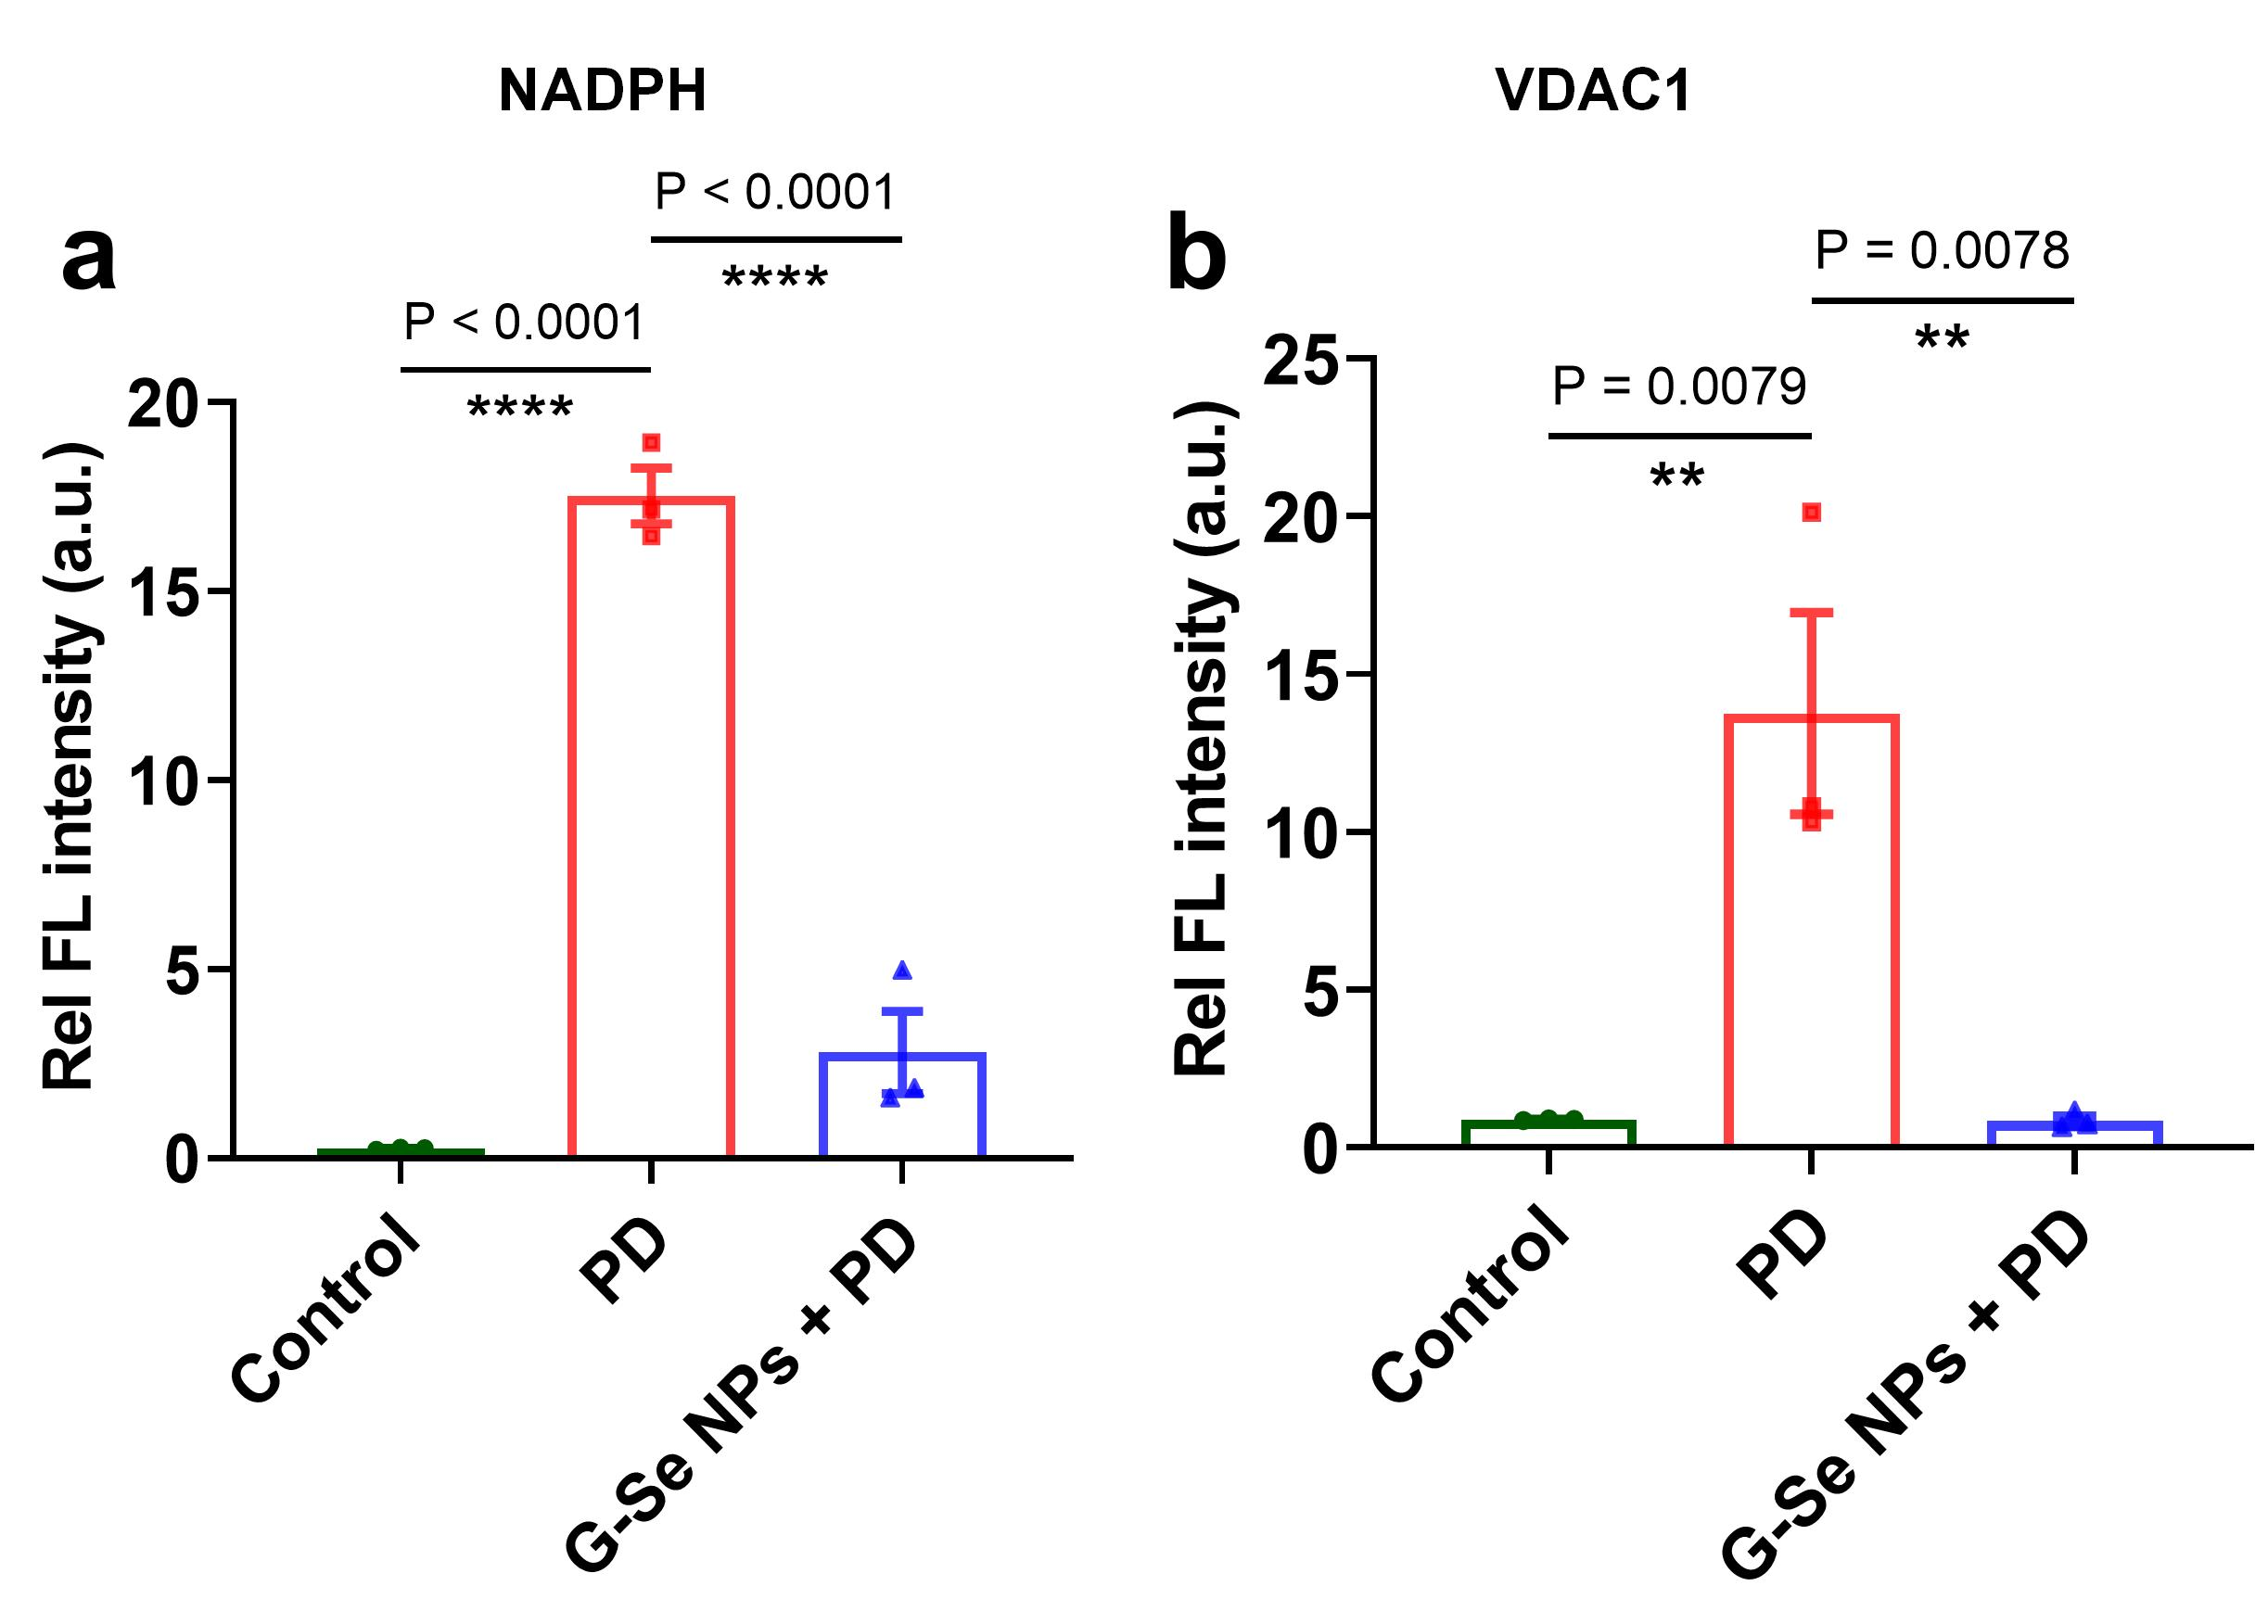
Fig. S37 Quantitative analysis was conducted to determine the levels of (a) NAPDH and (b) VDAC1 in the brain tissues of each group of mice. All data are presented as mean ± SD (n=3).

