Supplementary Materials

Self-Rectifying Memristor Crossbar Arrays Enabling Energy-Efficient Multiply–Accumulate for On/Off-Chip Neuromorphic Computing

Supplementary Material 1 | Comparison of key performance metrics of representative SRRAM devices and this work.
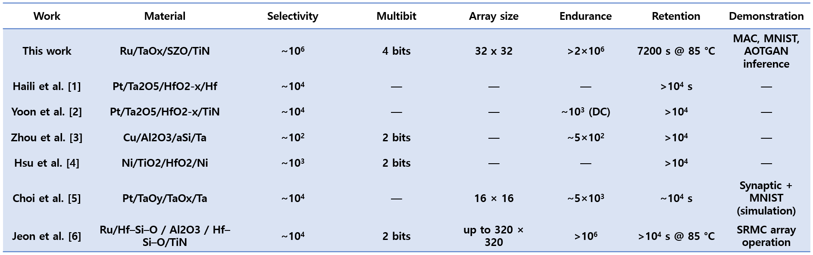
Table. S1. Comparison of representative self-rectifying RRAM devices and this work in terms of selectivity, multilevel operation, array size, endurance, retention, and demonstrated functionality.
Supplementary Material 2 | Temperature-Accelerated Retention and Arrhenius Analysis
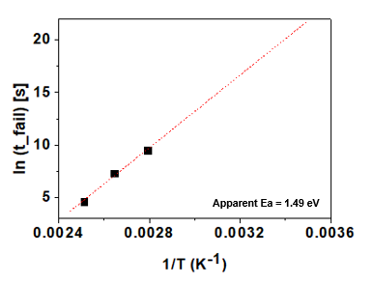
Fig. S1. Arrhenius-type plot of retention failure time (𝑡_fail) as a function of inverse temperature (1/T) extracted from temperature-accelerated retention measurements at 85 °C, 105 °C, and 125 °C. The failure time was defined as the time required to reach a 10% conductance drift from the initial state. The linear fitting yields an apparent activation energy of approximately 1.49 eV. The extrapolated retention at room temperature suggests multi-year stability.

Supplementary Material 3 | Multilevel Retention Characteristics
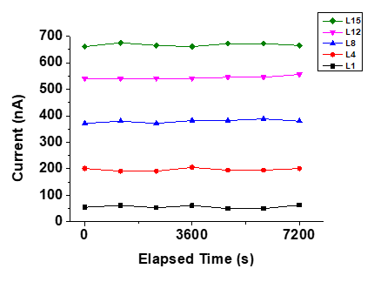
Fig. S2. Retention characteristics of representative multilevel states (L1, L4, L8, L12, and L15) measured at 85 °C. The current levels corresponding to each conductance state remain stable over 7,200 s with negligible drift, and the separation between adjacent states is well preserved throughout the measurement duration.

References
1. Haili M, Jie F, Hangbing L, et al (2017) Self-Rectifying Resistive Switching Memory with Ultralow Switching Current in Pt/Ta2O5/HfO2-x/Hf Stack. Nanoscale Research Letters 12:118 https://doi.org/10.1186/s11671-017-1905-3
2. Yoon J, Yoo S, Song S, et al (2016) Uniform Self-rectifying Resistive Switching Behavior via Preformed Conducting Paths in a Vertical-type Ta2O5/HfO2-x Structure with a Sub-μm2 Cell Area. ACS Applied Materials & Interfaces 8:18215-18221 https://doi.org/10.1021/acsami.6b05657
3. J Zhou, F Cai, Q Wang, et al (2016) Very Low-Programming-Current RRAM with Self-Rectifying Characteristics. IEEE Electron Device Letters. 37:404-407 https://doi.org/10.1109/LED.2016.2530942
4. CW Hsu, T-H Hou, M Chen, et al (2013) Bipolar Ni/TiO2/HfO2/Ni RRAM with multilevel states and self-rectifying characteristics. IEEE Electron Device Letters. 34:885-887. https://doi.org/10.1109/LED.2013.2264823
5. Choi S, Jang S, Moon J-H, et al (2018) A self-rectifying TaOy/nanoporous TaOx memristor synaptic array for learning and energy-efficient neuromorphic systems. NPG Asia Mater 10:1097–1106. https://doi.org/10.1038/s41427-018-0101-y
6. Jeon K, Kim J, Ryu JJ, et al (2021) Self-rectifying resistive memory in passive crossbar arrays. Nat Commun 12:2968. https://doi.org/10.1038/s41467-021-23180-2

