Supplementary Information

Multi-Channel Ion Transport in COF/CRO sandwich Films for Flexible Micro-Supercapacitors
Zihao Zhangª, Shaobo Zhaoª, Xianghao Mengª, Kaiwei Yangª, Xiaoyang Xu^{a, b*}, Shanlin Qiao^{a, c*}

ª College of Chemistry and Pharmaceutical Engineering, Hebei University of Science and Technology, Shijiazhuang 050018, China.
^{b} Hebei Research Center of Pharmaceutical and Chemical Engineering, Shijiazhuang, 050018 China
^{c} Hebei Engineering Research Center of Organic Solid Photoelectric Materials for electronic information, Shijiazhuang 050018, China

*E-mail: Prof. Dr. X. Xu: hebustxuxy@126.com;
Prof. Dr. S. Qiao: ccpeslqiao@hebust.edu.cn.

Section S1 Materials and Methods
1.1. Materials
The used monomers were as follows: sodium dodecylbenzene sulfonate (SDBS, 98%), dimethyl sulfoxide (DMSO, 99%) from Tianjin Damao Chemical Reagent Factory, triformylphloroglucinol (Tp, 99%) and 2,3,6,7,10,11-hexaamino triphenyl hexahydro chloride (HATP, 95%) from Jilin Academy of Sciences-Yanshen Technology Co., Ltd., tris-benzothiazole triamine (Ttz, 95%) and terephthalenaldehyde (PDA, 99%) from Shanghai Maclean's Biochemical Co., Ltd. Other reagents including CHCl₃ (99%), acetic acid (99%), poly(vinyl alcohol) (PVA, 97%), H₃PO₄ (85%), ethanol (99%), sodium dodecyl sulfate (SDS, 99%), hexadecyltrimethylammonium bromide (CTAB, 99%) and hydrochloric acid, were obtained from Aladdin Industrial Corporation (Shanghai, China). All chemicals were used without further purification.
1.2 Materials preparation
Synthesis of COF nanofilms: 20 μL of SDBS (1 mg/mL in chloroform) was injected into a crystallizing dish containing 50 mL of deionized water to form a static air-water interface. After solvent evaporating for ~40 min, 540 μL of HATP monomer (1 mg/mL in 0.12 M HCl solution) was added to the water phase and disperse for 1 h, followed by adding 400 μL of PDA monomer (1 mg/mL in 0.12 M HCl solution). Subsequently, 2 mL of 0.01 M acetic acid was introduced to catalyze the above Schiff base reaction of HATP and PDA monomers. The reaction proceeded for 7 days to yield the COF_{HP} nanofilm. Similarly, the COF_{TT} nanofilm was prepared by using 900 μL of Ttz (1 mg/mL in 0.12 M HCl solution) and 630 μL of Tp (1 mg/mL in 0.12 M HCl solution).
Synthesis of CRO: Tp (0.024 mmol, 5 mg) and Ttz (0.024 mmol, 7 mg) were dissolved into 0.8 mL of DMSO, respectively. The Tp solution was added dropwise to a CTAB (0.10 M, 55 mL) aqueous under ultrasonication, followed by adding SDS solution (0.10 M, 1.70 mL). Meanwhile, the Ttz solution was added dropwise to a separate CTAB solution (0.10 M, 50 mL) under ultrasonication, with subsequent addition of SDS solution (0.10 M, 1.70 mL). These two resulting solutions were mixed, after that adding 5 mL of acetic acid. The reaction proceed at 30°C for 3 days to yield CRO_{TT} stock solution. The CRO_{HP} stock solution was synthesized using a similar procedure to CRO_{TT}, with Hp (0.01 mmol, 5.37 mg) and PDA (0.03 mmol, 4.00 mg).
Fabrication of four COF@CRO heterojunctions: CRO layer was spontaneously assembled onto the substrate from the CRO colloidal solution through Brownian motion. Afterwards, residual CTAB and SDS were removed by ethanol rinsing for three cycles and drying at 60°C. Sandwich-type COF@CRO heterojunctions were fabricated by layer-by-layer assembly of alternately stacked COF nanofilms and CRO layers. After thermal annealing at 60°C for 2 h, four distinct COF@CRO heterojunctions were prepared such as COF_{HP}-CRO_{TT}-COF_{HP}, COF_{TT}-CRO_{HP}-COF_{TT}, CRO_{HP}-COF_{TT}-CRO_{HP}, and CRO_{TT}-COF_{HP}-CRO_{TT}.
1.3 Non-electrochemical Characterization
Chemical structure of COF, CRO and COF@CRO heterojunctions were characterized by Fourier transform infrared spectroscopy (FT-IR, Thermo Scientific Nicolet iS10), Raman spectroscopy (Horiba JY, LabRAM ARAMIS) and X-ray photoelectron spectroscopy (XPS, Thermo Scientific K-Alpha).
Morphology characterizations were analyzed by optical microscopy (OM, Leica ICC50 W), atomic force microscopy (AFM, Bruker Dimension Icon), scanning electron microscopy (SEM, JEOL) and transmission electron microscopy (TEM, JEOL/JEM-2100). Element mapping was performed using energy-dispersive spectroscopy (EDS). Surface wettability was quantified via contact angle measurements using H₃PO₄ droplets at room temperature (Data Physics OCA20).
Surface states of COF nanofilms, CRO layers and COF@CRO heterojunctions were examined by scanning electrochemical microscopy (SECM, VersaSCAN, AMETEK, USA) with a three-electrode system comprising materials-coated Si wafers as the working electrode, an Ag/AgCl reference electrode, and a platinum probe. The SECM measurements were performed in a K₃Fe(CN)₆/K₄Fe(CN)₆ (0.1 mmol/L) electrolyte solution.
1.4 Electrochemical characterization
Electrochemical properties of COF@CRO heterojunctions: Electrochemical performances of COF@CRO heterojunctions were evaluated in 1 M H₃PO₄ electrolyte by using a three-electrode system of active material-coated working electrode, platinum mesh counter electrode, and Ag/AgCl reference electrode. CV measurements were performed at 10~100 mV/s within a potential window of 0~0.6 V, while electrochemical impedance spectroscopy (EIS) over a frequency range from 10 mHz to 100 kHz on a VersaSTAT 3 workstation.
Electrochemical properties of MSC-COF_{HP}-CRO_{TT}-COF_{HP} heterojunctions: The optimized COF_{HP}-CRO_{TT}-COF_{HP} heterojunction-based interdigitated electrode was fabricated via a mask-assisted method onto a PTFE substrate (Fig. S1). Meanwhile, the PVA/H₃PO₄ gel electrolyte was prepared by dissolving 6 g of H₃PO₄ and 6 g of PVA in 60 mL of deionized water under vigorous stirring at 90°C for 1 h. After that, the MSC-COF_{HP}-CRO_{TT}-COF_{HP} heterojunction devices were assembled by using above interdigital electrodes with the interval area of filling in a PVA/H₃PO₄ gel electrolyte.
Areal (C_{A}, mF/cm²) and volumetric capacitances (C_{V}, F/cm³) were calculated based on CV curves by using Eqs. (1) and (2). Volumetric energy (E, Wh/cm³) and power density (P, W/cm³) were calculated using Eqs. (3) and (4) [1]:
$C_{A}=\frac{\int_{V_{i}}^{V_{f}}{I\left(V\right)dV}}{2v×A×(V_{f}-V_{i})}$ (1)
$C_{V}=\frac{\int_{V_{i}}^{V_{f}}{I\left(V\right)dV}}{2v×V×(V_{f}-V_{i})}$ (2)
$E=\frac{1}{2}×C_{V}×\frac{{(∆V)}^{2}}{3600}$ (3)
$P=\frac{E}{∆t}×3600$ (4)
Where ν is the scan rate (V/s), V_{f} and V_{i} are the upper and lower voltage limits of CV curves, I(V) is the voltametric current (A), A and V are the area (cm²) and volume (cm³) of active electrodes.
Mechanism research: Contributions of surface (k₁v) and diffusion-controlled (k₂v^{1/2}) capacitance were quantified by using Eq. (5) [2]:
$I\left(V\right)=k_{1}v+k_{2}v^{1/2}$ (5)
Electrochemical active area (ΔJ, μA/cm²) was calculated based on CV curves using Eq. (6) [3]:
$∆J=J_{a}-J_{c}$ (6)
where J_{a} and J_{c} represent the anodic and cathodic currents, respectively.
EIS measurements were performed to determine the H⁺ diffusion coefficient (D’ H⁺, cm²/s) from Nyquist plots, calculated by Eq. (7) [4]:
$D_{H^{+}}^{'}=\frac{R^{2}T^{2}}{2A^{2}n^{4}F^{4}C^{2}σ_{ω}^{2}}$ (7)
Where n is the number of electrons transferred in the reaction, σ_{ω} is the slope of Z’~ω^{1/2} plots, C(mol/cm³) is the H⁺ concentration within the lattice (roughly estimated as electrolyte concentration).
1.5 Density functional theory (DFT) calculations
The H⁺ diffusion energy barriers, Mulliken bond beam number, and electrostatic potential distribution map were obtained through DMol3 calculations. Geometry and frequency optimizations were performed using the GGA or LDA functional with the DND basis set.
1.6 Finite element simulations
In this study, finite element simulation was used to analyze the fluid flow of the phosphoric acid within COF nanofilms, CRO layer and COF_{HP}-CRO_{TT}-COF_{HP} heterojunction. The COF nanofilm models featured pore gaps of 1.4 nm. The diameter of the CRO sphere is 5 nm, and the pore gap is 1.2 nm.
Section S2 Supplementary Figures
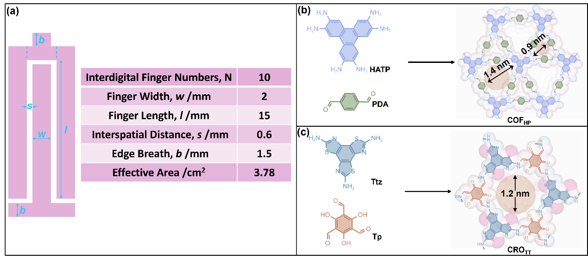
Fig. S1. (a) The parameters of the prepared interdigitated electrodes with a custom-made interdigital mask; Synthesis and simulated aperture structures of (b) COF_{HP} and (c) COF_{TT}.
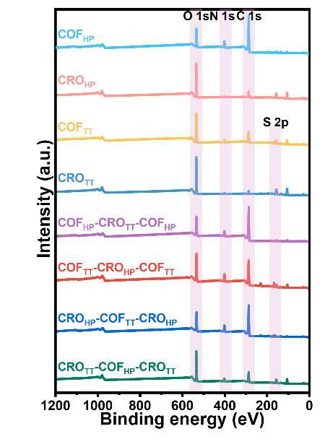
Fig. S2. XPS spectra of COF, CRO and COF@CRO heterostructures.
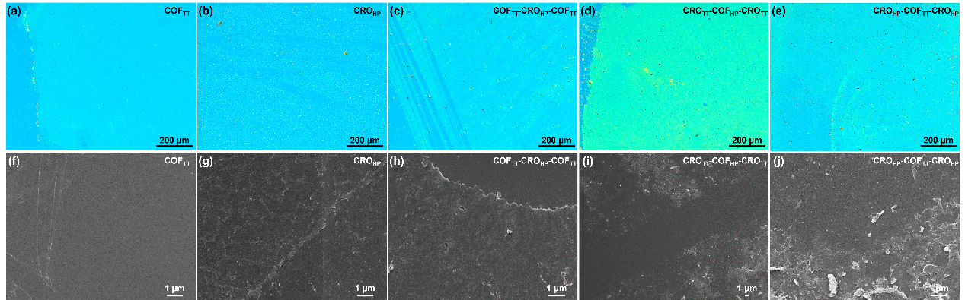
Fig. S3. (a-e) OM, (f-j) SEM of COF_{TT}, CRO_{HP}, COF_{TT}-CRO_{HP}-COF_{TT}, CRO_{TT}-COF_{HP}-CRO_{TT} and CRO_{HP}-COF_{TT}-CRO_{HP}.
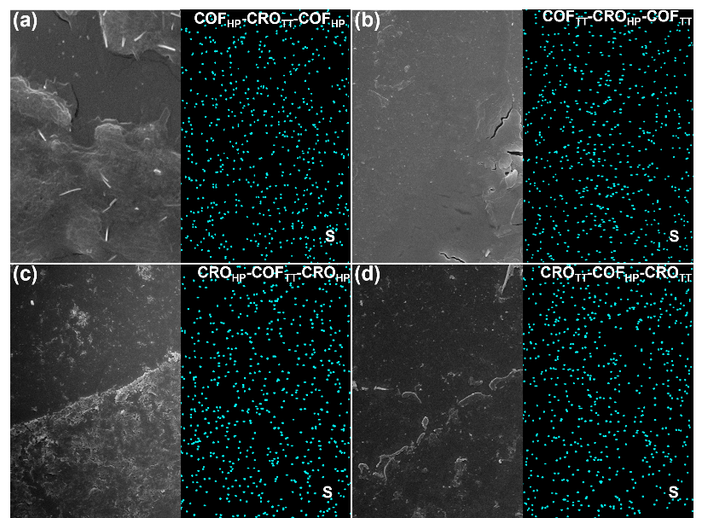
Fig. S4. EDS element mapping images of COF@CRO heterostructures.
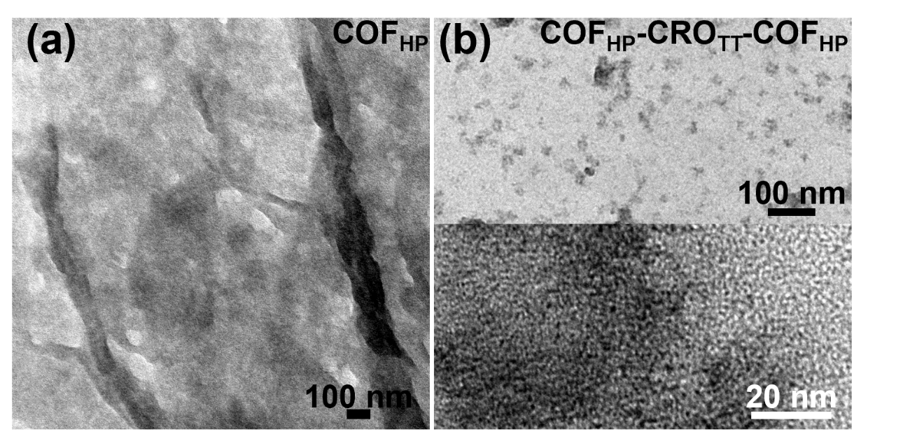
Fig. S5. TEM images of (a) COF_{HP}, (b) COF_{HP}-CRO_{TT}- COF_{HP}.
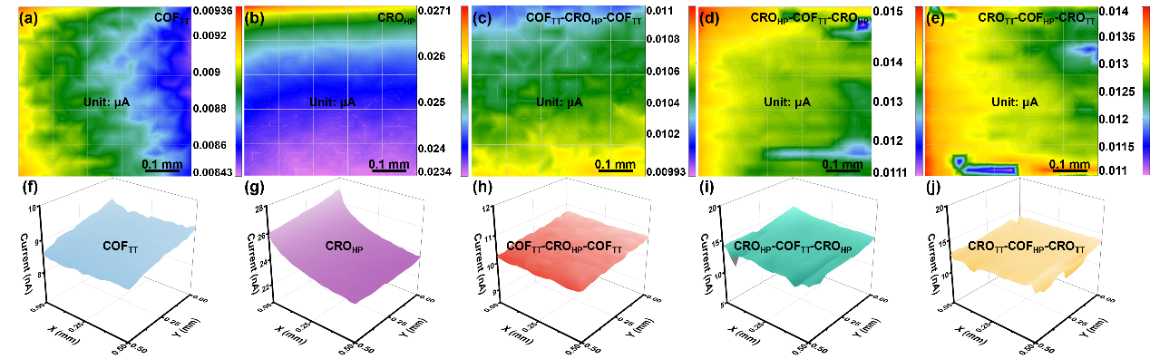
Fig. S6. (a-e) 2D, (f-j) 3D SECM images of COF_{TT}, CRO_{HP}, COF_{TT}-CRO_{HP}-COF_{TT}, CRO_{HP}-COF_{TT}-CRO_{HP} and CRO_{TT}-COF_{HP}-CRO_{TT}.
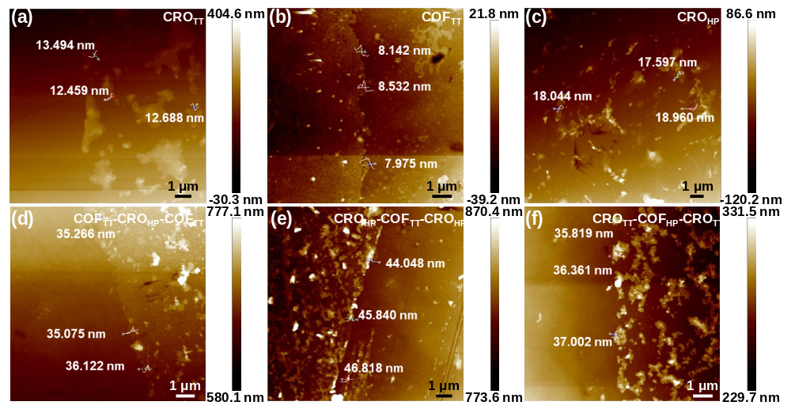
Fig. S7. AFM images of (a) CRO_{TT}, (b) COF_{TT}, (c) CRO_{HP}, (d) COF_{TT}-CRO_{HP}-COF_{TT}, (e) CRO_{HP}-COF_{TT}-CRO_{HP} and (f) CRO_{TT}-COF_{HP}-CRO_{TT}.
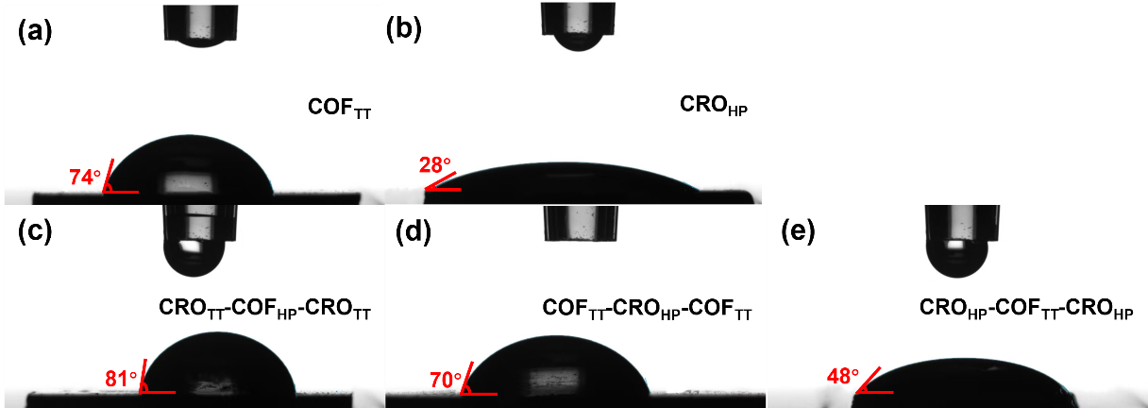
Fig. S8. Contact angle of (a) COF_{TT}, (b) CRO_{HP}, (c) CRO_{TT}-COF_{HP}-CRO_{TT}, (d) COF_{TT}-CRO_{HP}-COF_{TT} and (e) CRO_{HP}-COF_{TT}-CRO_{HP}.
Table S1. Contact angle of COF nanofilm and CRO layer
Material | Contact angle | Material | Contact angle
COF_{TT} | 74° | CRO_{TT} | 56°
COF_{HP} | 66° | CRO_{HP} | 28°
Table S2. Contact angle of COF@CRO heterostructures
Material | Contact angle | Outer contact angle | Inner contact angle
COF_{HP}-CRO_{TT}-COF_{HP} | 62° | 66° | 56°
CRO_{HP}-COF_{TT}-CRO_{HP} | 48° | 28° | 74°
COF_{TT}-CRO_{HP}-COF_{TT} | 70° | 74° | 28°
CRO_{TT}-COF_{HP}-CRO_{TT} | 81° | 56° | 66°
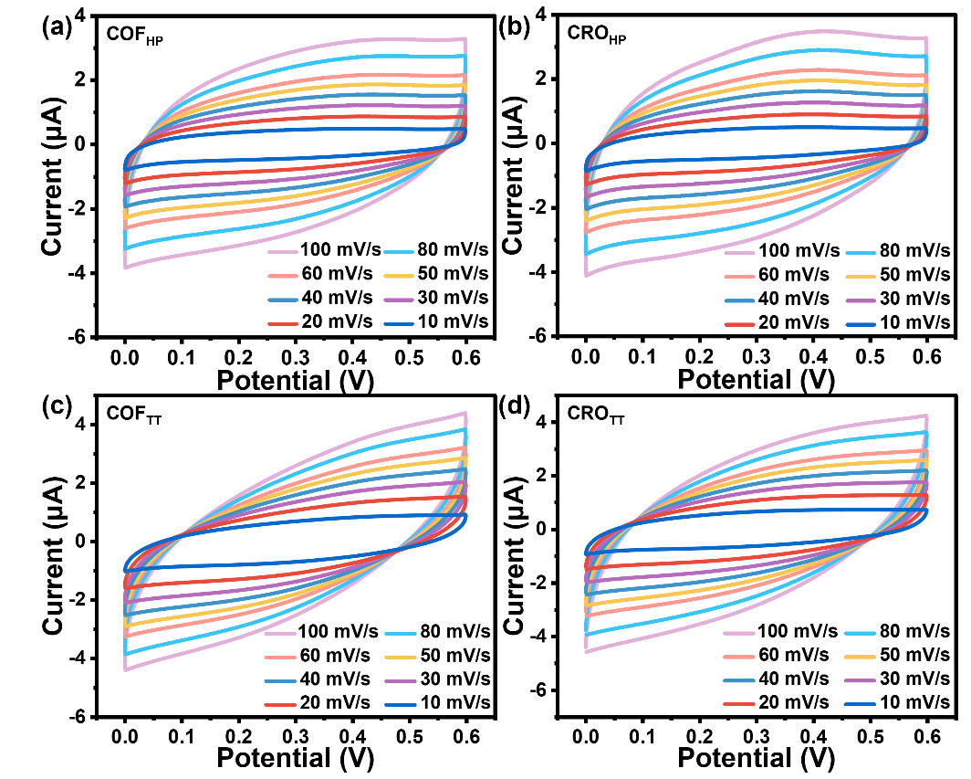
Fig. S9. CV curves of (a) COF_{HP}, (b) CRO_{HP}, (c) COF_{TT}, and (d) CRO_{TT}.
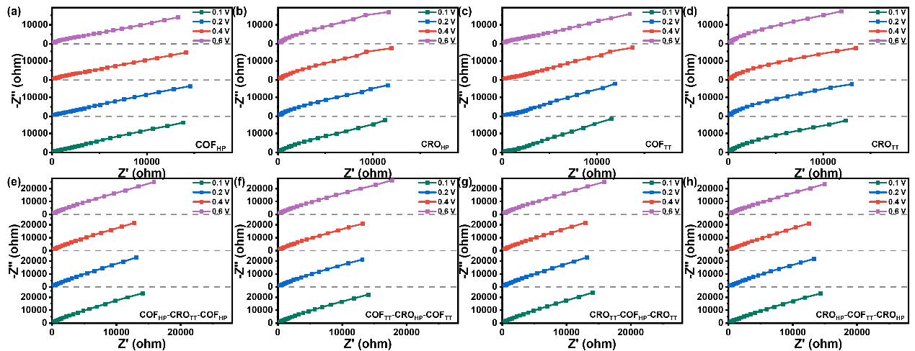
Fig. S10. EIS of (a) COF_{HP}, (b) CRO_{HP}, (c) COF_{TT}, (d) CRO_{TT}, (e)COF_{HP}-CRO_{TT}-COF_{HP}, (f) COF_{TT}-CRO_{HP}-COF_{TT}, (g) CRO_{TT}-COF_{HP}-CRO_{TT} and (h) CRO_{HP}-COF_{TT}-CRO_{HP}.
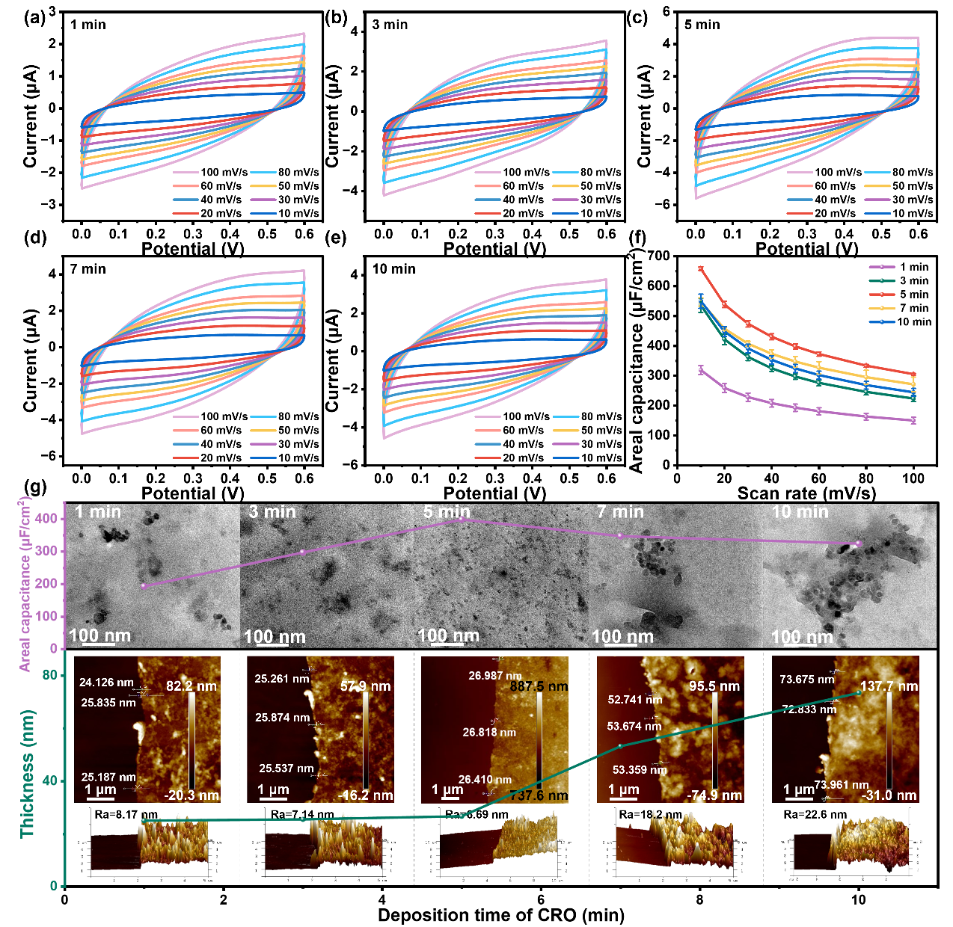
Fig. S11. (a-e) CV curves, (f) corresponding areal capacitance, (g) effect of the CRO deposition time on the thickness and areal capacitance (inset TEM images and AFM images) for COF_{HP}-CRO_{TT}-COF_{HP} heterostructures with different CRO deposition time.
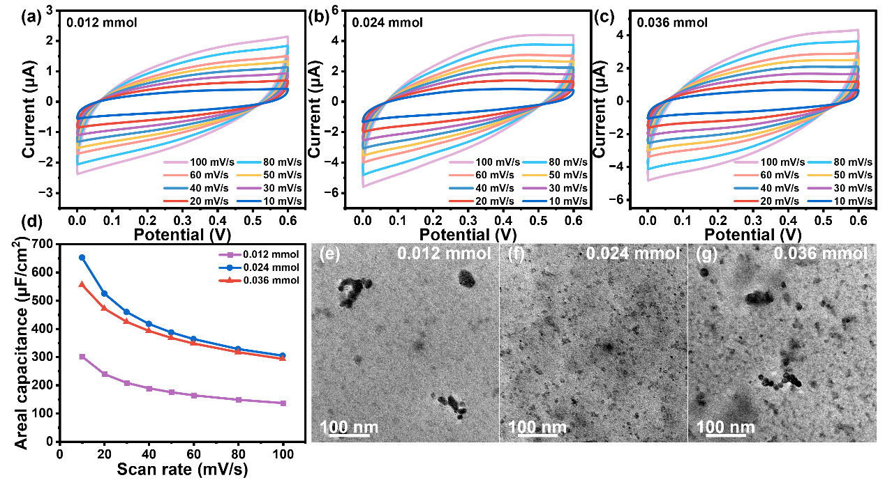
Fig. S12. (a-c) CV curves, (d) corresponding areal capacitance, (e-g) TEM images for COF_{HP}-CRO_{TT}-COF_{HP} heterostructures with different CRO monomer amounts (Tp or Ttz dissolved in 0.8 mL DMSO).
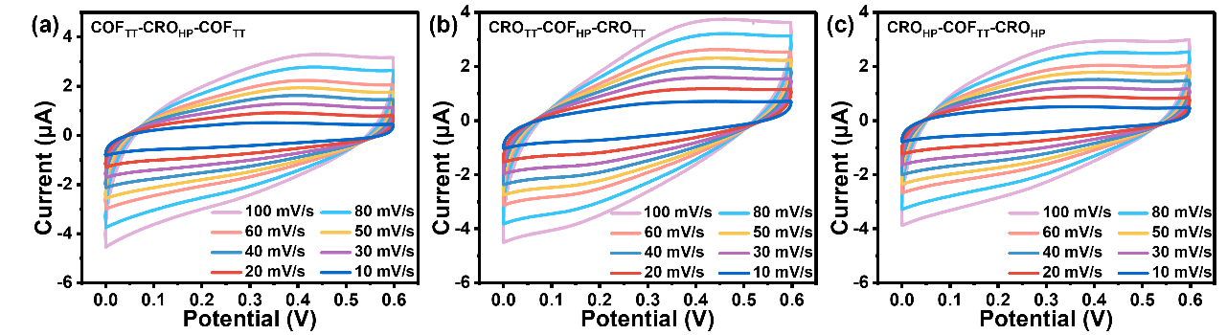
Fig. S13. CV curves of (a) COF_{TT}-CRO_{HP}-COF_{TT}, (b) CRO_{TT}-COF_{HP}-CRO_{TT}, and (c) CRO_{HP}-COF_{TT}-CRO_{HP}.
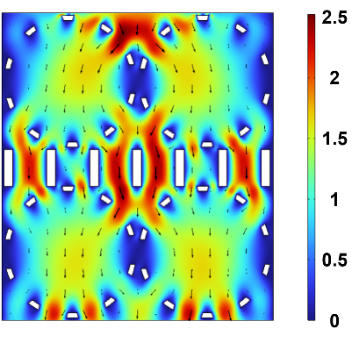
Fig. S14. Simulated fluid flow and ion transport pathways in the CRO-COF-CRO heterostructure.

References
[1] Jiang K, Baburin IA, Han P, Yang CQ, Fu XB, Yao YF, Li JT, Cánovas E, Seifert G, Chen JS, Bonn M, Feng XL, Zhuang XD (2020) Interfacial approach toward benzene-bridged polypyrrole film-based micro-supercapacitors with ultrahigh volumetric power density. Adv Funct Mater 30:1908243. http://dx.doi.org/10.1002/adfm.201908243
[2] Zhou HJ, Sun YY, Yang H, Tang YJ, Lu YY, Zhou Z, Cao S, Zhang ST, Chen SQ, Zhang YZ, Pang H (2023) Co₃O₄ quantum dots intercalation liquid-crystal ordered-layered-structure optimizing the performance of 3D-printing micro-supercapacitors. Adv Sci 10:2303636. http://dx.doi.org/10.1002/advs.202303636
[3] Qiao SL, Zhang BY, Li Q, Li Z, Wang WB, Zhao J, Zhang XJ, Hu YQ (2019) Pore surface engineering of covalent triazine frameworks@MoS₂ electrocatalyst for the hydrogen evolution reaction. ChemSusChem 12:5032−5040. http://dx.doi.org/10.1002/cssc.201902582
[4] Yang Y, Zhao X, Wang HE, Li Ml, Hao C, Ji M, Ren SZ, Cao GZ (2018) Phosphorized SnO₂/graphene heterostructures for highly reversible lithium-ion storage with enhanced pseudocapacitance. J Mater Chem A 6:3479−3487. http://dx.doi.org/10.1039/C7TA10435A

