Supplementary Information

Interfacial Engineering of Flower-like Fe₃O₄@C/FRGO Multiscale Heterostructures for Broadband and Efficient Microwave Absorption

1. Supplementary Equations
(1) The relative absorption efficiency (AE%) could be calculated from Equation S1:
AE (%) = ($\text{1-}{\text{10}}^{\text{RL}\text{/10}}$) × 100% (S1)
(2)The matching thickness d of $λ/4$ could be calculated from Equation S2:
$d=\frac{nλ}{4}=\frac{nc}{4f\sqrt{\left|ε_{r}\right|\left|μ_{r}\right|}}$ (n=1,3,5,...) (S2)
(3)$\text{S}{\text{R}\text{L}}_{\text{min}}$ is calculated based on ${\text{R}\text{L}}_{\text{min}}$ value Equation S3, considering the filler loading amount and the layer thickness:
$\text{S}{\text{R}\text{L}}_{\text{min}}\text{=}\frac{{\text{R}\text{L}}_{\text{min}}\text{(dB)}}{\text{filler loading}\text{(wt\%)}\text{×}\text{thickness(mm)}}$ (S3)
(4)$\text{S}{\text{EAB}}_{\text{max}}$ is calculated based on ${\text{EAB}}_{\text{max}}$ value Equation S4, considering the filler loading amount and the layer thickness:
$\text{S}{\text{EAB}}_{\text{max}}\text{=}\frac{{\text{EAB}}_{\text{max}}\text{(GHz)}}{\text{filler loading}\text{(wt\%)}\text{×}\text{thickness(mm)}}$ (S4)

- Text S1. Raman Peak Fitting and I_{D}/I_{G} Calculation
In our study, the displayed I_{D}/I_{G} values were calculated based on the ratio of their peak intensities (peak heights). Prior to calculation, the raw Raman spectra underwent rigorous baseline correction. The peaks were then deconvoluted and fitted using Lorentzian functions to precisely determine the maximum intensity of the D band (~1340-1350 cm⁻¹) and the G band (~1580-1590 cm⁻¹). This established method guarantees the reliability of the calculated graphitization degree and defect density.

3. Text S2. Verification of EMW Penetration via Skin Depth Calculation
To confirm that the EMW absorption originates from bulk attenuation, the skin depth δ) was calculated as: δ = $\frac{\text{1}}{\sqrt{\text{π}\text{f}\text{μσ}}}$
All calculated δ values remain above the matching thicknesses used in this study, ensuring effective wave penetration.

4. Simulation of RCS
In order to evaluate the EM dissipation capacity of MCFs series materials under real circumstances, electromagnetic simulations of the actual far-field response of the materials were performed using CST Studio Suite 2022. The simulation model consists of an absorbing layer (90 × 90 × 3 mm) and a perfect electric conductor (PEC, 90 × 90 × 1 mm). The model is placed in the X-O-Y plane, and the linearly polarized planar electromagnetic wave is incident from the Z-axis in the forward direction. The far-field detection frequency is chosen to be 9.80 GHz under open boundary conditions. The RCS value was calculated by the following Equation S5:
$σ(dB m^{2})=10\log\left[\frac{4πS}{λ^{2}}{\left|\frac{E_{S}}{E_{i}}\right|}^{2}\right]$ (S5)
where S is the area of the simulation model, $λ$ is the wavelength of microwave, ${\text{E}}_{\text{S}}$ is the electric field intensity of scattered wave, and $E_{i}$ is the electric field intensity of incident wave.

5. Supplementary Figures
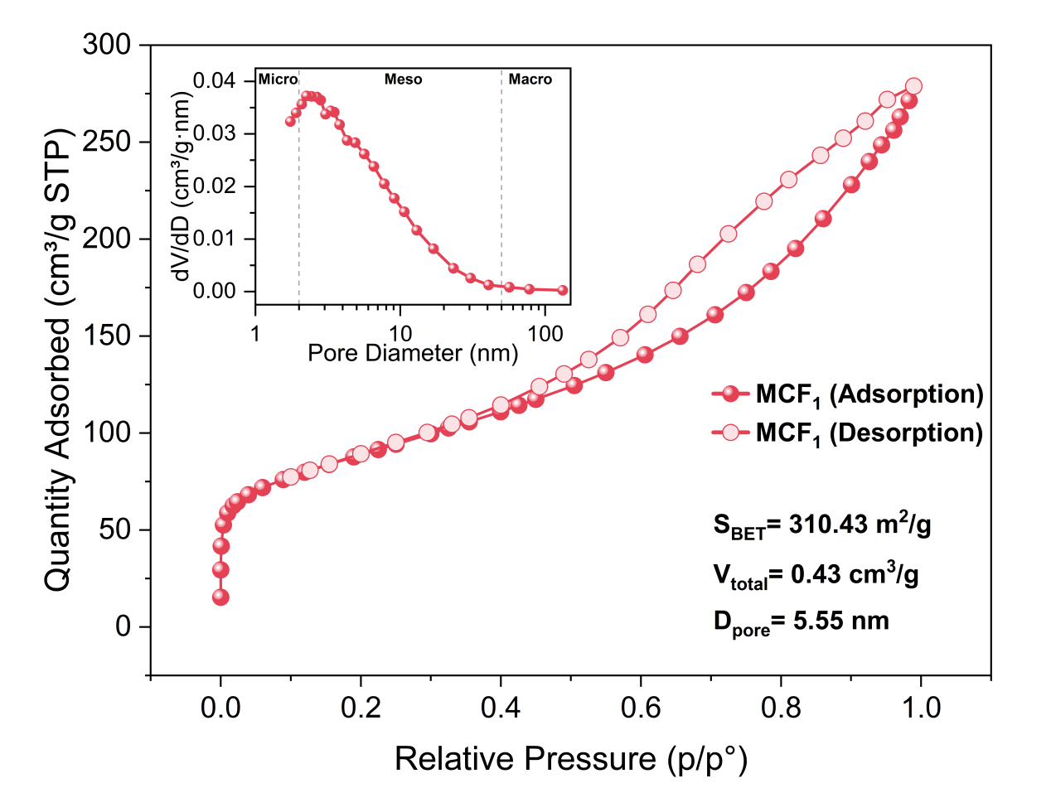
Fig. S1 N₂ adsorption-desorption isotherms of the MCF₁ composite. The inset shows the corresponding BJH pore size distribution curve.

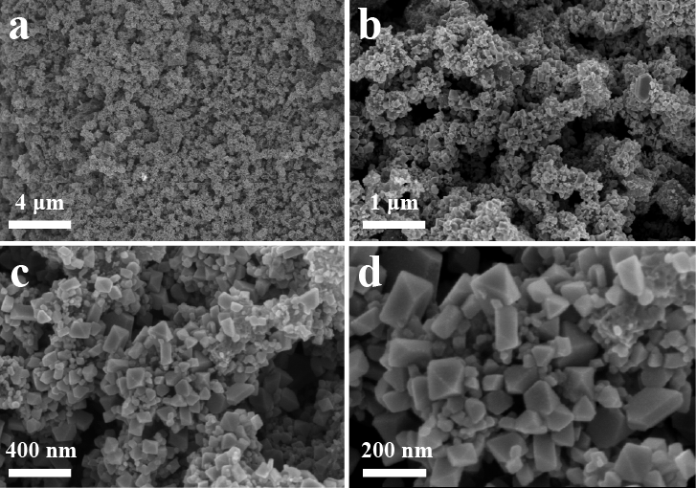
Fig. S2 SEM and EDS images of MCF₀.

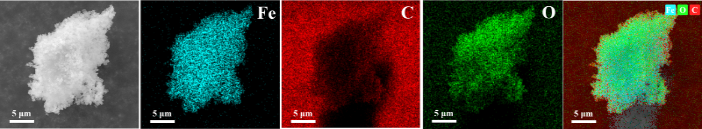
Fig. S3 SEM and EDS images of MCF₀.
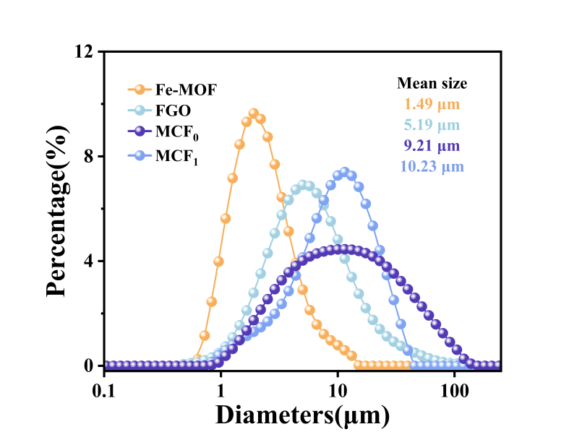
Fig. S4 Particle size statistics of Fe-MOF, FGO, MCF₀ and MCF₁.
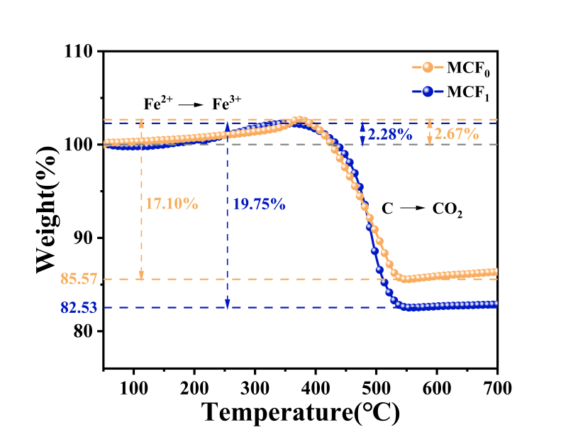
Fig. S5 TG curves of MCF₀ and MCF₁.

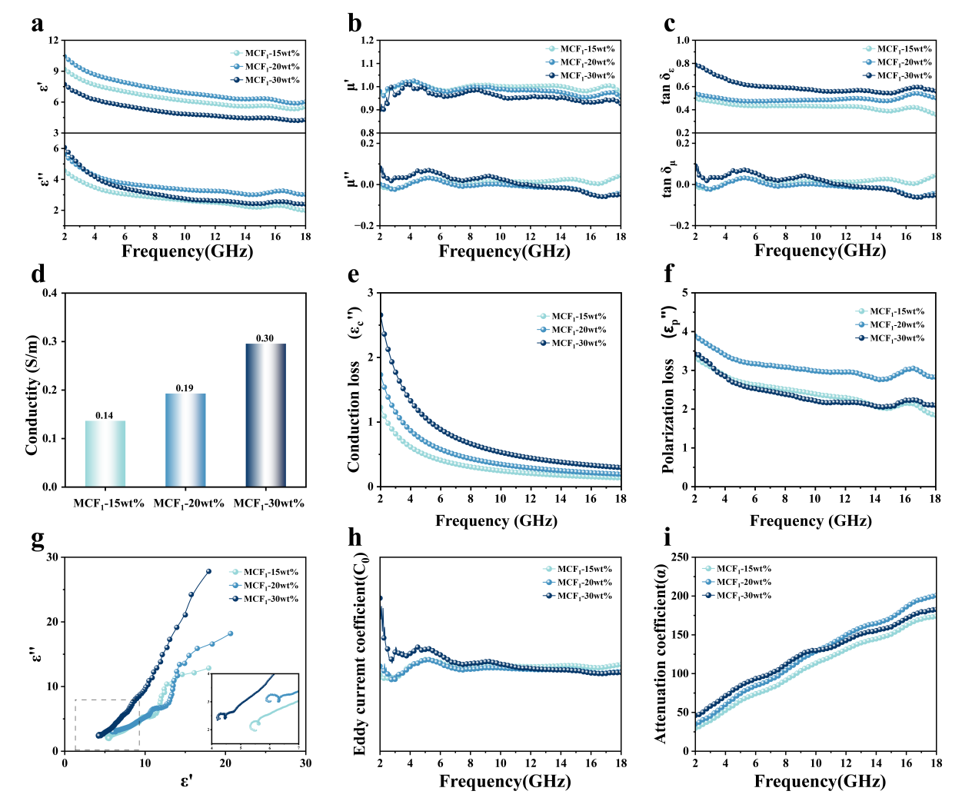
Fig. S6 (a) Real and imaginary permittivity, (b) real and imaginary permeability, (c) dielectric loss tangent and magnetic loss tangent, (d) conductivity, (e) conduction loss, (f) polarization loss, (g) Cole-Cole curves, (h) eddy current coefficient, and (i) attenuation coefficient of MCF₁-15wt%, MCF₁-20wt%, and MCF₁-30wt%.

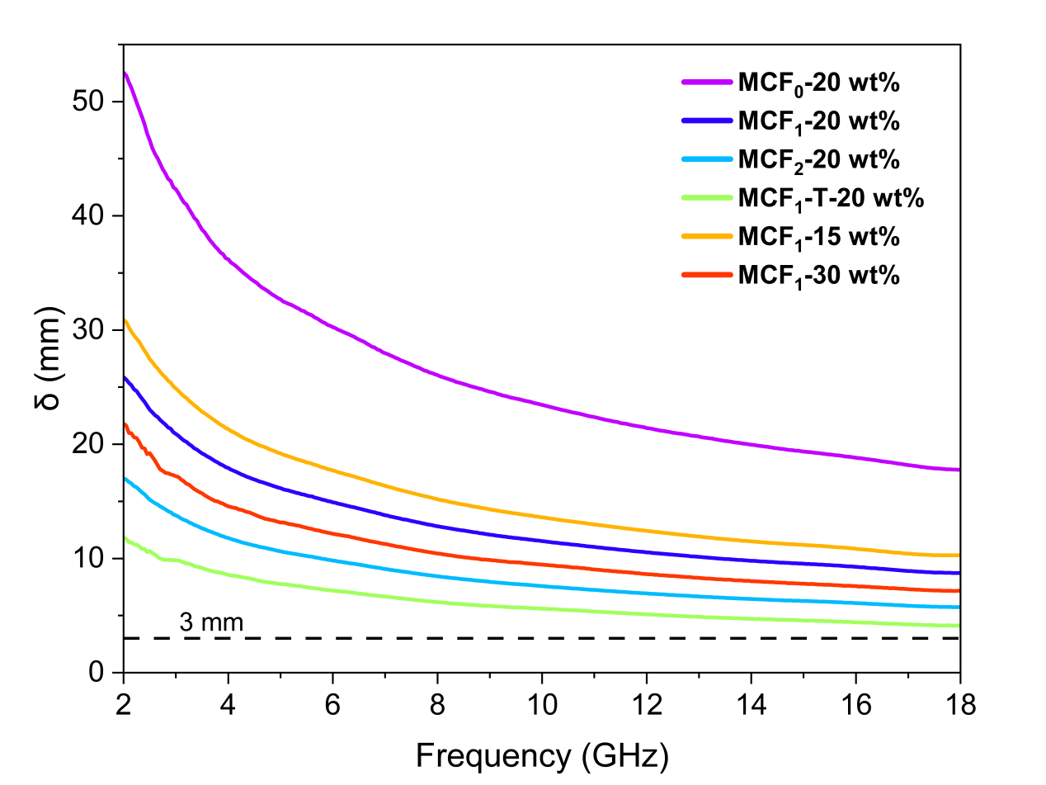
Fig. S7 Frequency-dependent skin depth (δ) of various MCF composites in the frequency range of 2-18 GHz.

6. Supplementary Tables
Table S1 Element content in MCF₀ and MCF₁
 | Fe²⁺/wt% | Fe³⁺/wt% | C/wt% |  | O/wt%
MCF₀ | 18.69 | 41.209 | 17.1(amorphous carbon) |  | 23.001
MCF₁ | 15.96 | 41.811 | 19.75 | 3.26(graphene) | 22.479
 |  |  |  | 16.49(amorphous carbon) | 22.479

Table S2 Comparison of the EMWA properties with various state-of-the-art absorbers
Samples | RL_{min}  (dB) | d_{RLmin}  (mm) | EAB_{max}  (GHz) | d_{EABmax}  (mm) | Filling content  (wt%) | SRL_{min}  (dB mg⁻¹ mm⁻¹) | SEAB_{max}  (GHz mg⁻¹ mm⁻¹) | Ref.
Mo₂C/C | -70.20 | 2.10 | 6.20 | 1.70 | 40.00 | -83.57 | 9.12 | [3]
Fe/Fe₃O₄@SiO₂@Fe | -60.62 | 2.20 | 9.00 | 1.80 | 80.00 | -34.44 | 6.25 | [9]
RGO@Fe₃GeTe₂/FeTe₂/Fe₃Ge | -61.00 | 2.50 | 5.80 | 2.50 | 20.24 | -120.55 | 11.46 | [18]
Fe/Fe₃Co₇/Co/C | -64.70 | 2.50 | 5.80 | 2.50 | 40.00 | -64.70 | 5.80 | [20]
Fe₂O₃@RGO | -48.10 | 4.00 | 5.28 | 2.50 | 30.00 | -40.08 | 7.04 | [28]
Ni/C/Graphene | -45.50 | 2.50 | 5.60 | 2.50 | 15.00 | -121.33 | 14.93 | [29]
ZrO₂/C | -57.20 | 3.30 | 6.90 | 3.30 | 50.00 | -34.67 | 4.18 | [33]
ZnO-Ni@CNT | -58.60 | 2.30 | 4.80 | 2.00 | 50.00 | -50.96 | 4.80 | [34]
Fe₃O₄@NPC | -65.50 | 3.00 | 4.50 | 3.00 | 40.00 | -54.58 | 3.75 | [35]
ferrite/Co/porous carbon | -47.31 | 2.50 | 4.80 | 1.50 | 70.00 | -27.03 | 4.57 | [36]
Co/C | -54.55 | 2.60 | 7.12 | 2.38 | 40.00 | -52.45 | 7.48 | [37]
Fe₃O₄-C/RGO | -60.50 | 3.60 | 5.50 | 1.50 | 25.00 | -67.22 | 14.67 | [38]
Fe₃O₄@N-doped carbon nanochains | -63.09 | 3.10 | 5.34 | 3.10 | 20.00 | -101.76 | 8.61 | [43]
ZnFe₂O₄-ZnO-Fe@C | -66.50 | 2.00 | 4.30 | 2.00 | 30.00 | -110.83 | 7.17 | [45]
RGO/CNT/ZnIn₂S₄ | -67.40 | 3.50 | 6.00 | 2.80 | 30.00 | -64.19 | 7.14 | [46]
MoC/NC | -47.56 | 2.50 | 4.40 | 2.50 | 15.00 | -126.83 | 11.73 | [49]
CoNi-LDH | -60.10 | 1.65 | 6.24 | 2.60 | 30.00 | -121.41 | 8.00 | [51]
Fe/C | -29.50 | 2.50 | 4.30 | 3.00 | 15.00 | -78.67 | 9.56 | [63]
Fe₃O₄-NG | -53.60 | 4.10 | 5.00 | 1.80 | 70.00 | -18.68 | 3.97 | [64]
MS-Ti₃C₂T_{x} | -47.56 | 2.50 | 4.80 | 3.00 | 30 | -63.41 | 5.33 | [66]
Nitrogen-doped graphene | -11.30 | 3.00 | 2.10 | 3.00 | 30 | -12.56 | 2.33 | [67]
Ti₃C₂T_{x}@BNNB | -32.24 | 1.60 | 5.20 | 2.21 | 40 | -50.38 | 5.88 | [68]
PANI/Ti₃C₂T_{x} | -65.21 | 2.33 | 2.61 | 2.33 | 25 | -111.95 | 4.48 | [69]
SiC/graphene | -63.94 | 4.50 | 4.05 | 4.50 | 70 | -20.30 | 1.29 | [70]
SiC@C Core−Shell  Nanowires | -50.00 | 2.80 | 8.00 | 2.80 | 50 | -35.71 | 2.71 | [71]
Hollow SiC/C nanospheres | -41.34 | 1.70 | 4.00 | 1.70 | 30 | -81.06 | 7.84 | [72]
MCF₁ | -66.29 | 1.94 | 5.80 | 2.17 | 20.00 | -170.85 | 13.36 | This work

