Supplementary Material
Reactive Oxygen Species-Responsive Hydrogel Accelerates Diabetic Wound Repair by Modulating Endoplasmic Reticulum Stress
Songjie Li^{1†}, Han Chen^{1†}, Xin Dan¹, Yikun Ju², Pu Yang¹, Yang Li¹*, Lanjie Lei³*, Xing Fan¹*

¹ Department of Plastic and Reconstructive Surgery, Xijing Hospital, Fourth Military Medical University, Xi’an, 710032, China.

² Department of Plastic and Aesthetic (Burn) Surgery, The Second Xiangya Hospital, Central South University, Changsha, 410011, China.

³ Key Laboratory of Artificial Organs and Computational Medicine in Zhejiang Province, Shulan International Medical College, Institute of Translational Medicine, Zhejiang Shuren University, Hangzhou, Zhejiang 310015, China.

*Corresponding author:
Xing Fan: fanxing.612@163.com; Lanjie Lei: leilanjie1988@163.com
Yang Li: liyangzx@fmmu.edu.cn

†These authors contributed equally to this work.

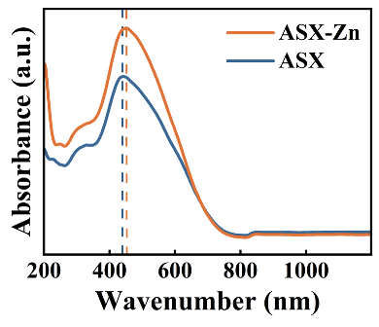
Fig. S1. UV-Vis diffuse reflectance spectroscopy analysis of ASX-Zn complexes.

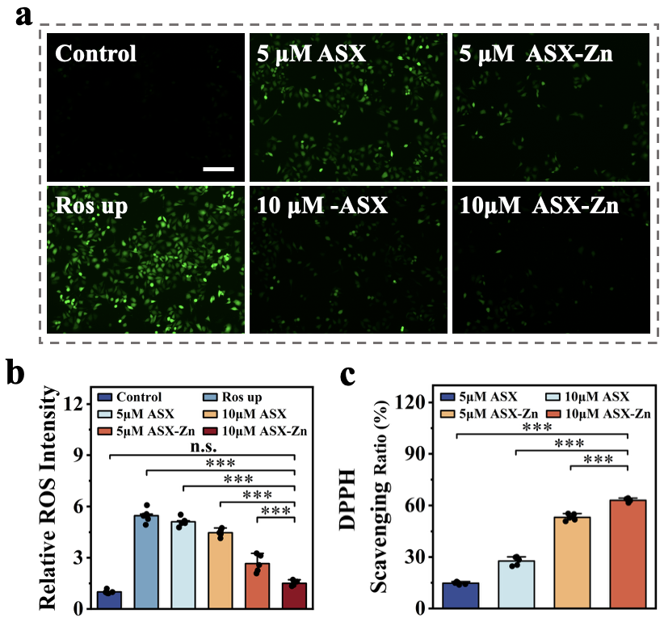
Fig. S2. Biofunctional characterisation of ASX-Zn complexes. (a, b) ROS staining with different concentrations of ASX and ASX-Zn (scalebar: 200 μm). (c) Experimental analysis of DPPH scavenging by different concentrations of ASX and ASX-Zn. (n = 5, Statistical diﬀerences: *p<0.05, **p<0.01, ***p<0.001, and ns, not significant).

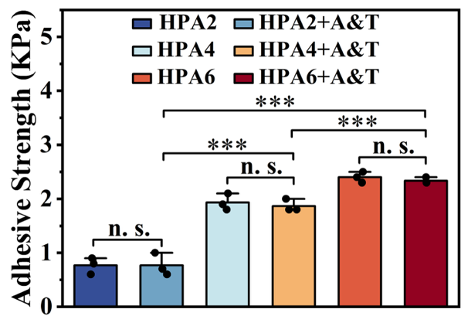
Fig. S3. Quantitative analysis of lap shear tests for different hydrogels. (n = 3, Statistical diﬀerences: *p<0.05, **p<0.01, ***p<0.001, and ns, not significant).

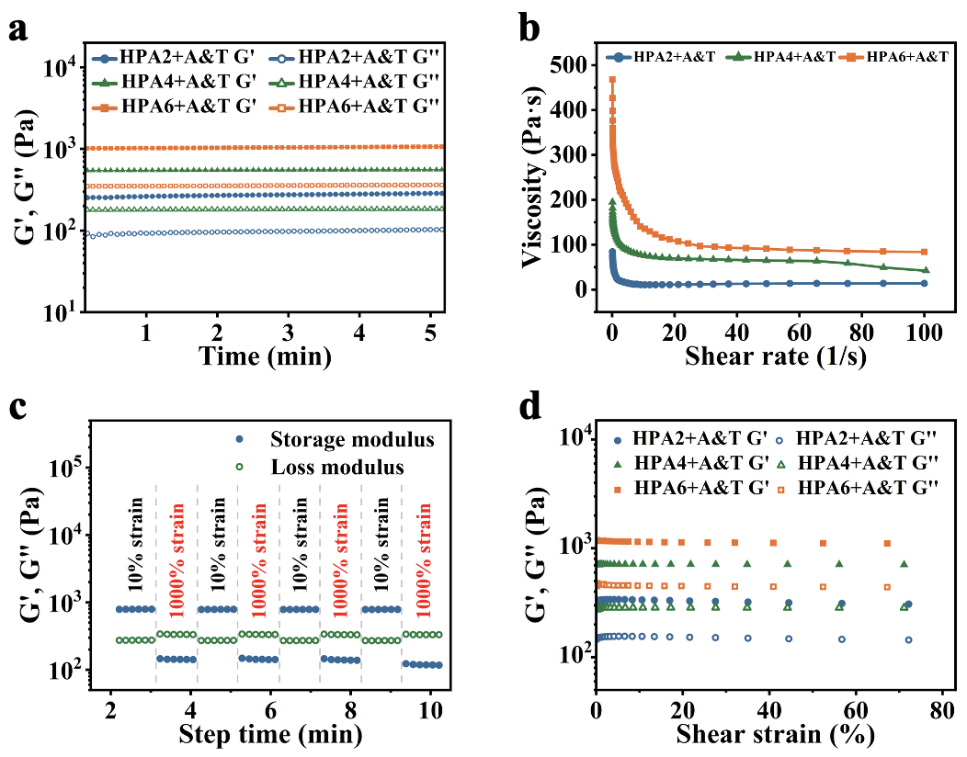
Fig. S4. Rheological characterisation of HPA@A&T hydrogels containing ASX-Zn and TUDCA. (a) Rheological behavior of hydrogels under time scanning. (b) Shear thinning properties of hydrogels. (c) The rheological properties were observed when the alternate step strain was switched from 10% to 1000%. (d) Rheological properties under amplitude scanning.

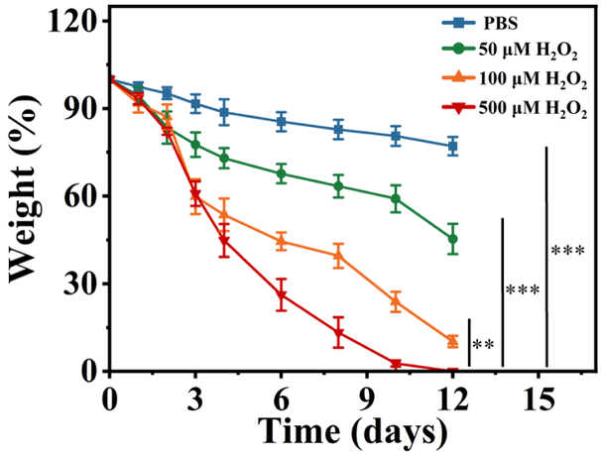
Fig. S5. Degradation curves of hydrogels in PBS and at different concentrations of H₂O₂. (n = 3, Statistical diﬀerences: *p<0.05, **p<0.01, ***p<0.001, and ns, not significant).

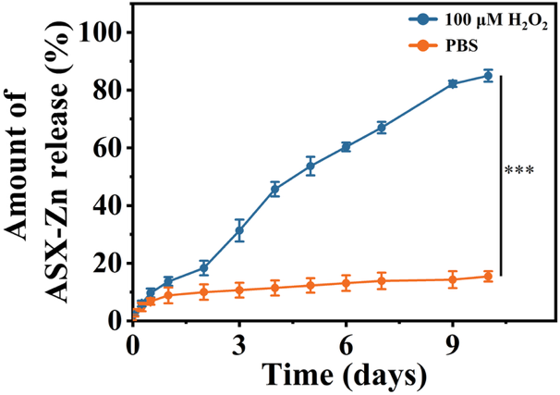
Fig. S6. Cumulative release of ASX-Zn from hydrogels in PBS and 100 μM H₂O₂. (n = 3, Statistical diﬀerences: *p<0.05, **p<0.01, ***p<0.001, and ns, not significant).

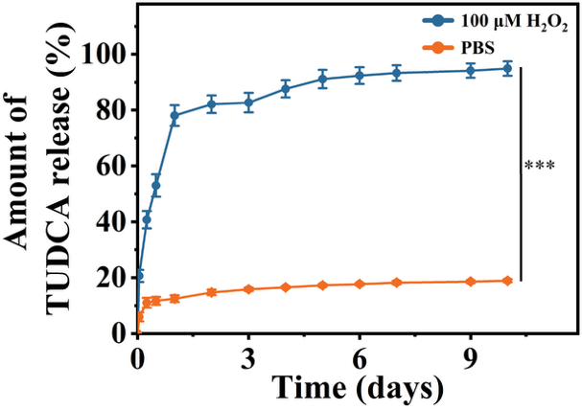
Fig. S7. Cumulative release of TUDCA from hydrogels in PBS and 100 μM H₂O₂. (n = 3, Statistical diﬀerences: *p<0.05, **p<0.01, ***p<0.001, and ns, not significant).

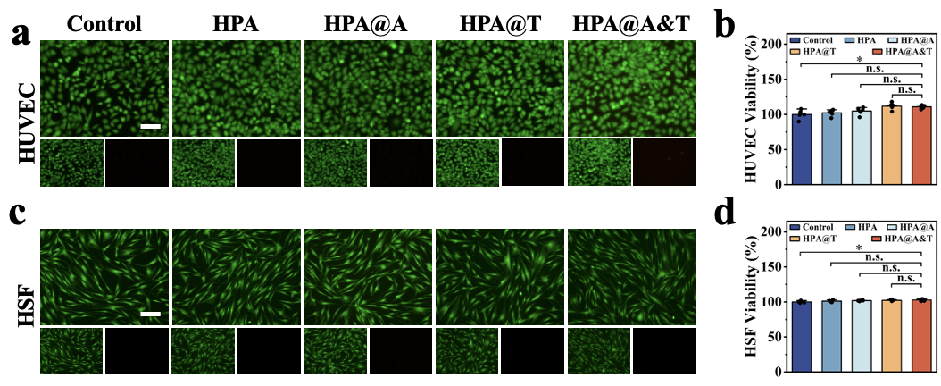
Fig. S8. Cytocompatibility of composite hydrogels. (a, c) Cytotoxicity of hydrogels against HUVEC and HSF (scalebar: 100 μm). (b, d) CCK8 experiments on HUVEC and HSF under hydrogel treatment. (n = 5, Statistical diﬀerences: *p<0.05, **p<0.01, ***p<0.001, and ns, not significant).

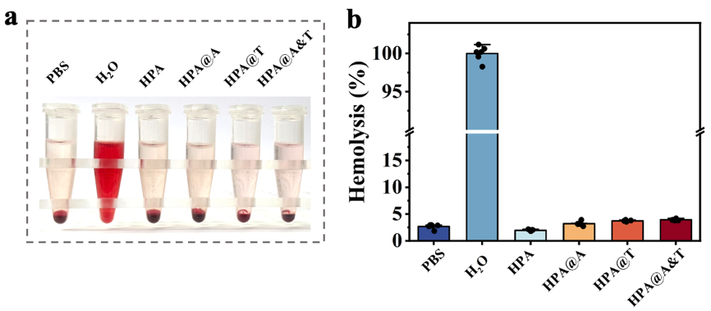
Fig. S9. Blood compatibility testing of hydrogels. Blood compatibility of hydrogels (a) and statistical analysis of the rate of haemolysis (b). (n = 6, Statistical diﬀerences: *p<0.05, **p<0.01, ***p<0.001, and ns, not significant).

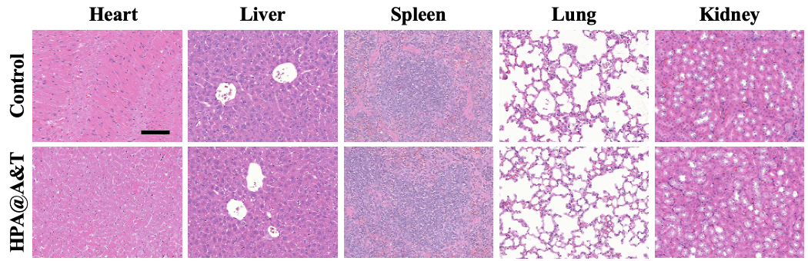
Fig. S10. Organ compatibility of hydrogels (scalebar: 100 μm).

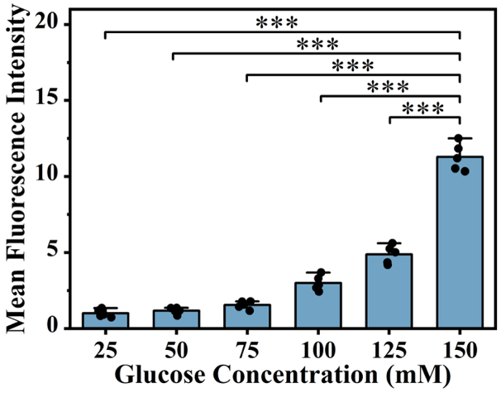
Fig. S11. Cellular ROS fluorescence experiments at different glucose concentrations. (n = 5, Statistical diﬀerences: *p<0.05, **p<0.01, ***p<0.001, and ns, not significant).

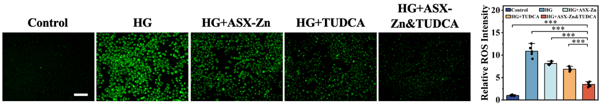
Fig. S12. Molecular-level validation of the ROS scavenging capacity of ASX-Zn and TUDCA under hyperglycaemic conditions (scalebar: 200 μm). (n = 5, Statistical diﬀerences: *p<0.05, **p<0.01, ***p<0.001, and ns, not significant).

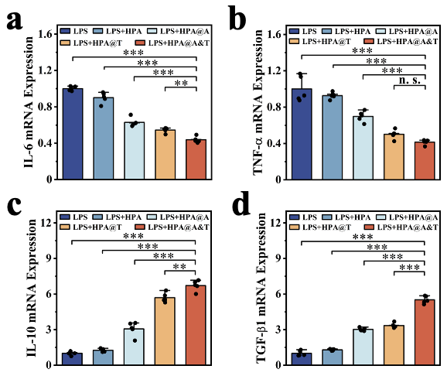
Fig. S13. Quantitative analysis of inflammatory cytokines by qPCR. (a-d) Quantitative analysis of qPCR of pro-inflammatory and anti-inflammatory factors in RAW264.7 cells treated with different hydrogels. (n = 5, Statistical diﬀerences: *p<0.05, **p<0.01, ***p<0.001, and ns, not significant).

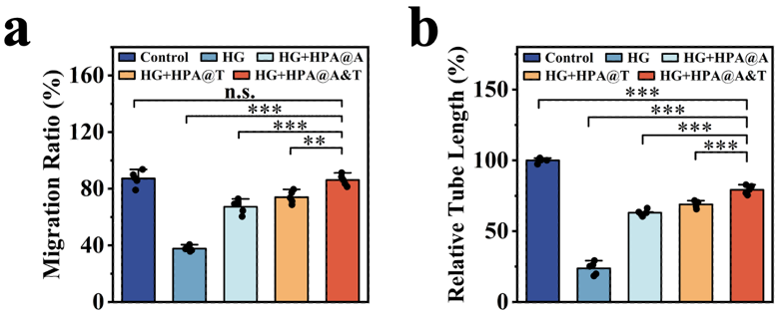
Fig. S14. Quantitative analysis of cellular functional assays. (a) Quantitative analysis of the cell scratch assay. (b) Quantitative analysis of tube-forming length in HUVEC cells during tube formation experiments. (n = 5, Statistical diﬀerences: *p<0.05, **p<0.01, ***p<0.001, and ns, not significant).

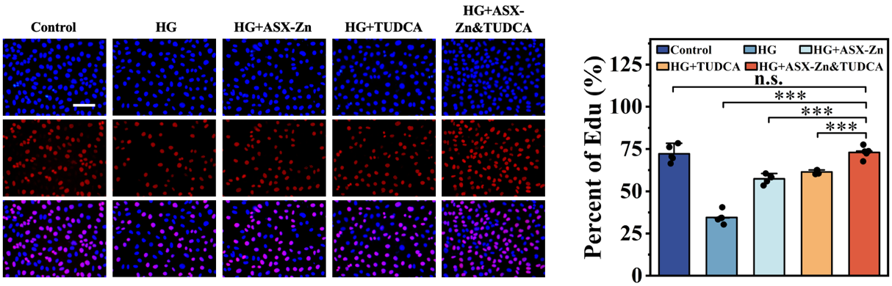
Fig. S15. Edu proliferation experiments with ASX-Zn and TUDCA molecules in the HG environment (scalebar: 200 μm). (n = 5, Statistical diﬀerences: *p<0.05, **p<0.01, ***p<0.001, and ns, not significant).

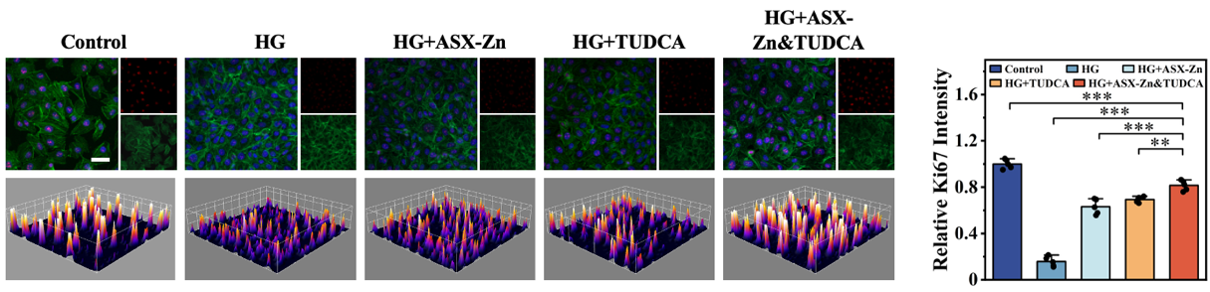
Fig. S16. Ki67 immunofluorescence staining and quantitative analysis of ASX-Zn and TUDCA molecules in the HG environment (scalebar: 50 μm). (n = 5, Statistical diﬀerences: *p<0.05, **p<0.01, ***p<0.001, and ns, not significant).

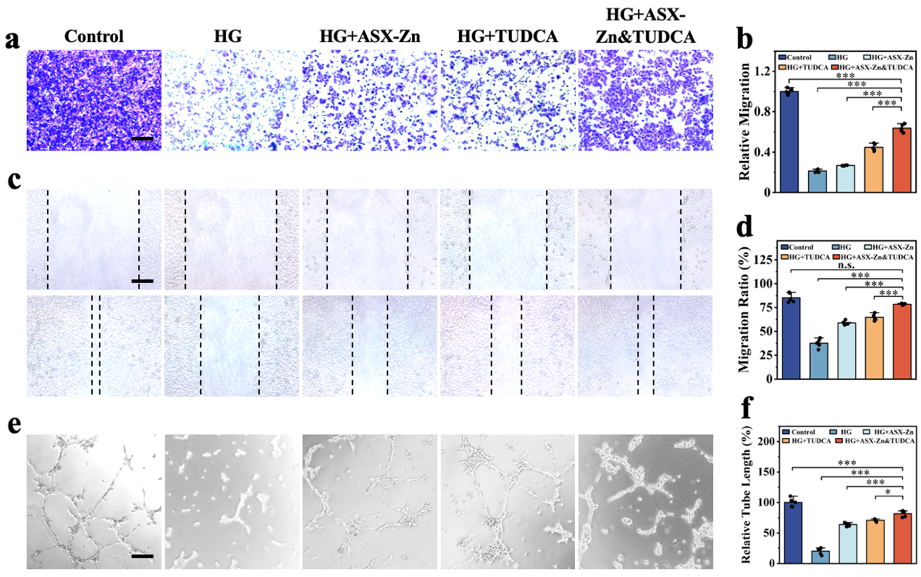
Fig. S17. Cellular functional experiments at the molecular level. (a, b) Transwell experiments and quantitative analysis of ASX-Zn and TUDCA molecules in the HG environment. (c, d) Cell scratch assays and quantitative analysis of ASX-Zn and TUDCA molecules in the HG environment. (e, f) Tube formation experiments and quantitative analysis of ASX-Zn and TUDCA molecules in the HG environment. (scalebar: 200 μm). (n = 5, Statistical diﬀerences: *p<0.05, **p<0.01, ***p<0.001, and ns, not significant).

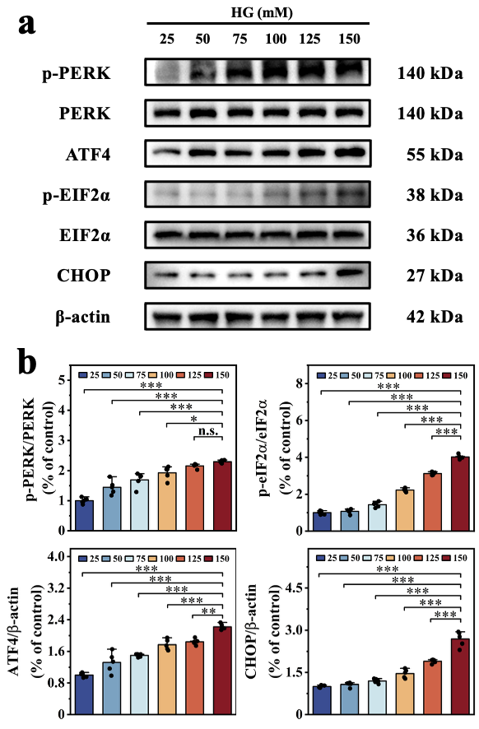
Fig. S18. High-glucose environments induce cellular endoplasmic reticulum stress. (a) WB experiments demonstrated a positive correlation between glucose concentration and the level of glucose-induced endoplasmic reticulum stress (ERS) within cells. (b) Quantitative analysis results of the WB experiment. (n = 5, Statistical diﬀerences: *p<0.05, **p<0.01, ***p<0.001, and ns, not significant).

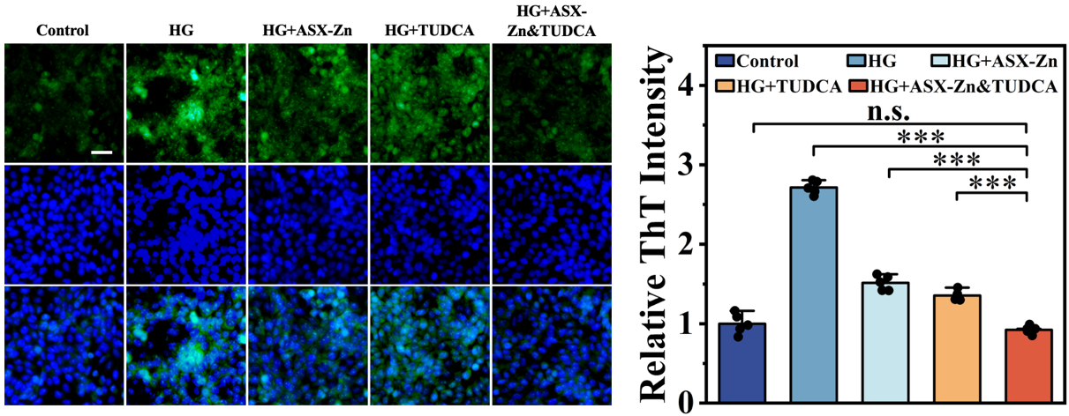
Fig. S19. ThT staining and quantitative analysis of ASX-Zn and TUDCA molecules in the HG environment (scalebar: 50 μm). (n = 5, Statistical diﬀerences: *p<0.05, **p<0.01, ***p<0.001, and ns, not significant).

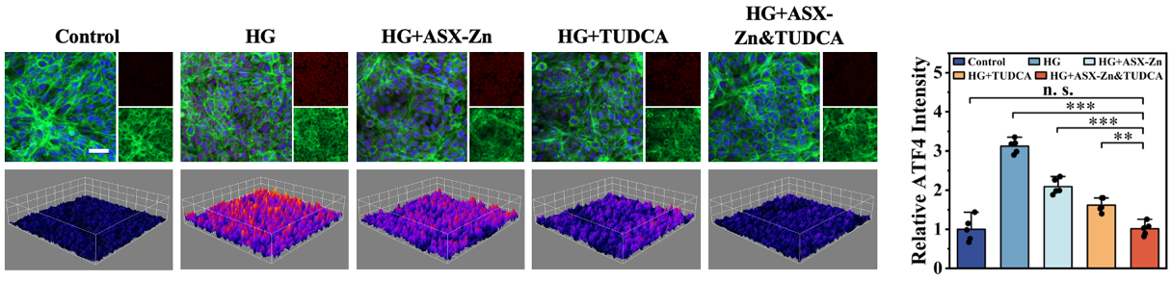
Fig. S20. ATF4 immunofluorescence staining and quantitative analysis of ASX-Zn and TUDCA molecules in the HG environment (scalebar: 50 μm). (n = 5, Statistical diﬀerences: *p<0.05, **p<0.01, ***p<0.001, and ns, not significant).

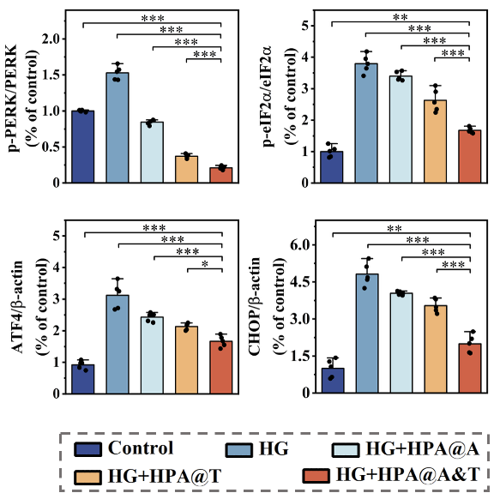
Fig. S21. Quantitative analysis of ERS-related protein expression in Western blot experiments. (n = 5, Statistical diﬀerences: *p<0.05, **p<0.01, ***p<0.001, and ns, not significant).

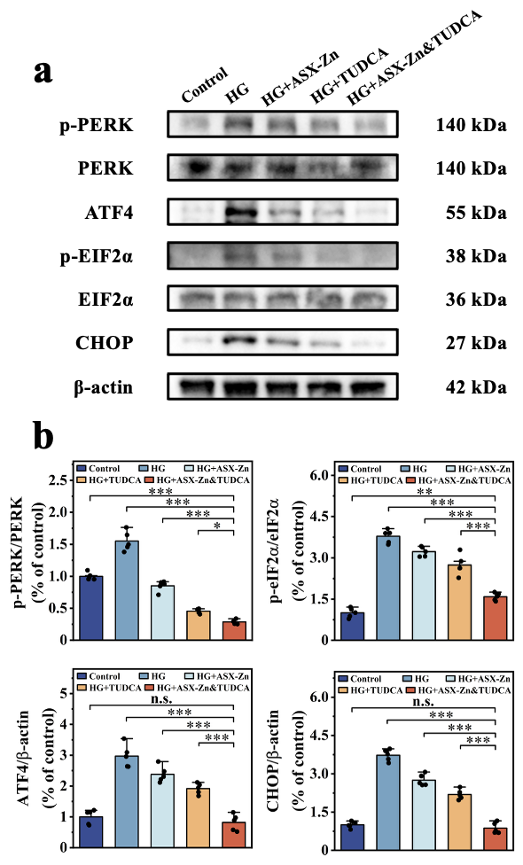
Fig. S22. The effects of ASX-Zn and TUDCA on cellular protein expression in the HG environment. (a) Western blot results for ERS-associated proteins. (b) Quantitative analysis of the Western blot experimental results. (n = 5, Statistical diﬀerences: *p<0.05, **p<0.01, ***p<0.001, and ns, not significant).

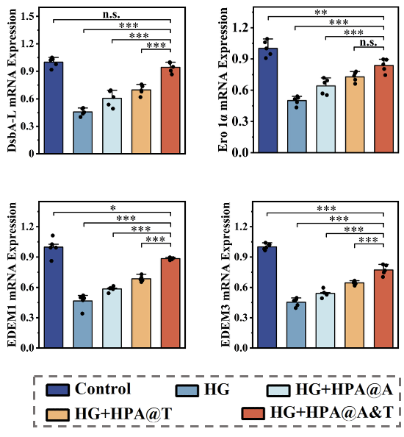
Fig. S23. qPCR analysis of ERS-related genes in the HG environment. (n = 5, Statistical diﬀerences: *p<0.05, **p<0.01, ***p<0.001, and ns, not significant).

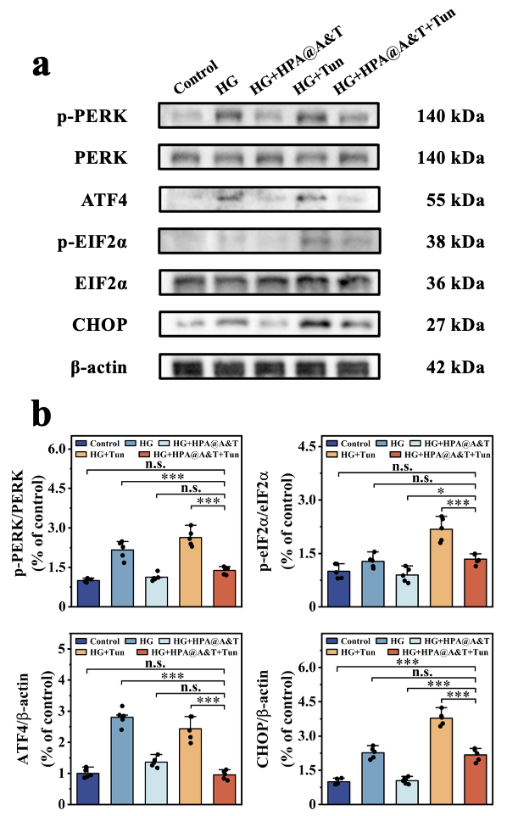
Fig. S24. The effect of HPA@A&T hydrogels on the expression of intracellular ERS-related proteins before and after the addition of the Tun agonist. (a) Western blot results for ERS-associated proteins. (b) Quantitative analysis of the Western blot experimental results. (n = 5, Statistical diﬀerences: *p<0.05, **p<0.01, ***p<0.001, and ns, not significant).

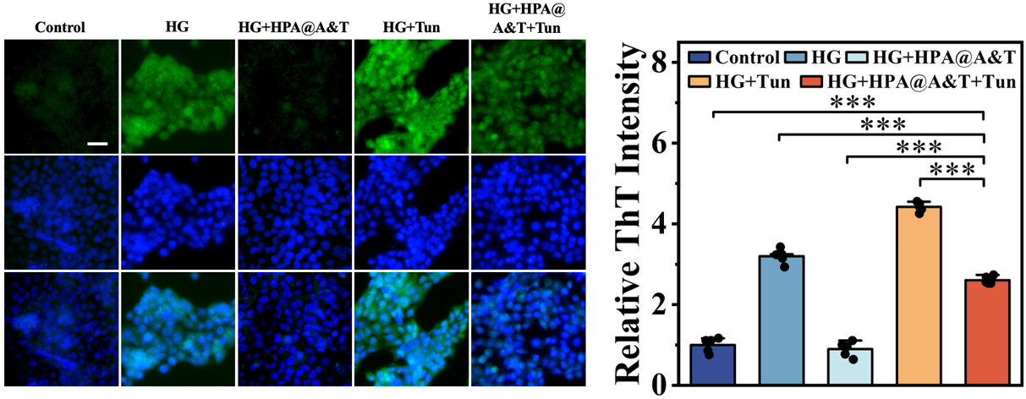
Fig. S25. ThT staining and quantitative analysis before and after the addition of the Tun agonist (scalebar: 50 μm). (n = 5, Statistical diﬀerences: *p<0.05, **p<0.01, ***p<0.001, and ns, not significant).

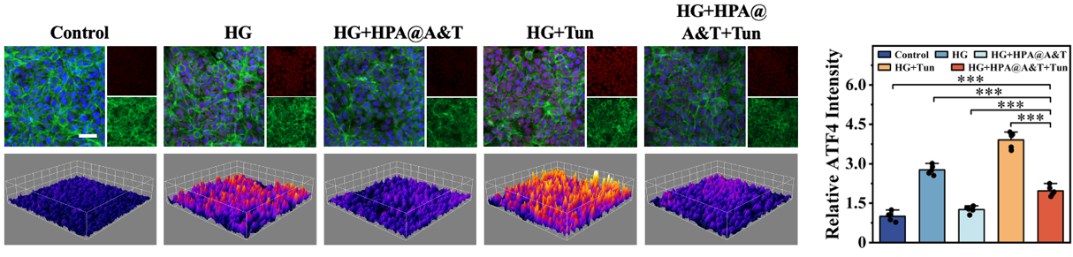
Fig. S26. ATF4 immunofluorescence staining and quantitative analysis before and after the addition of the Tun agonist (scalebar: 50 μm). (n = 5, Statistical diﬀerences: *p<0.05, **p<0.01, ***p<0.001, and ns, not significant).

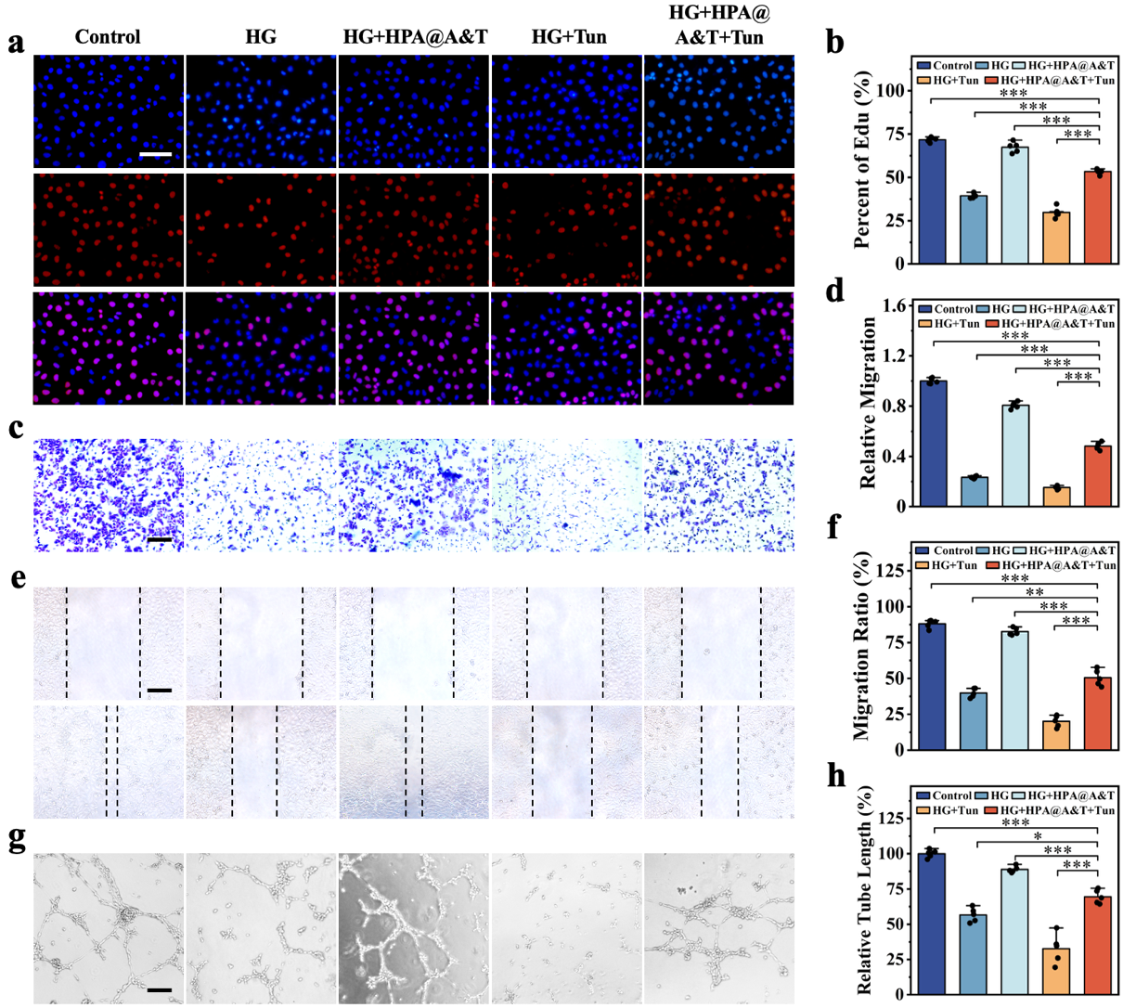
Fig. S27. Cellular functional assays before and after the addition of the Tun agonist. (a, b) Edu proliferation assay and quantitative analysis before and after the addition of the Tun agonists. (c, d) Transwell assay and quantitative analysis before and after the addition of the Tun agonist. (e, f) Cell scratch assay and quantitative analysis before and after the addition of the Tun agonist. (g, h) Tube formation assays and quantitative analysis before and after the addition of the Tun agonists. (scalebar: 200 μm). (n = 5, Statistical diﬀerences: *p<0.05, **p<0.01, ***p<0.001, and ns, not significant).

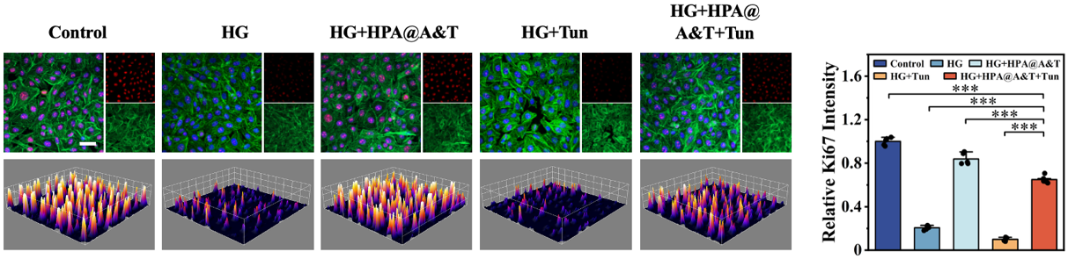
Fig. S28. Ki-67 immunofluorescence staining and quantitative analysis before and after the addition of the Tun agonist (scalebar: 50 μm). (n = 5, Statistical diﬀerences: *p<0.05, **p<0.01, ***p<0.001, and ns, not significant).

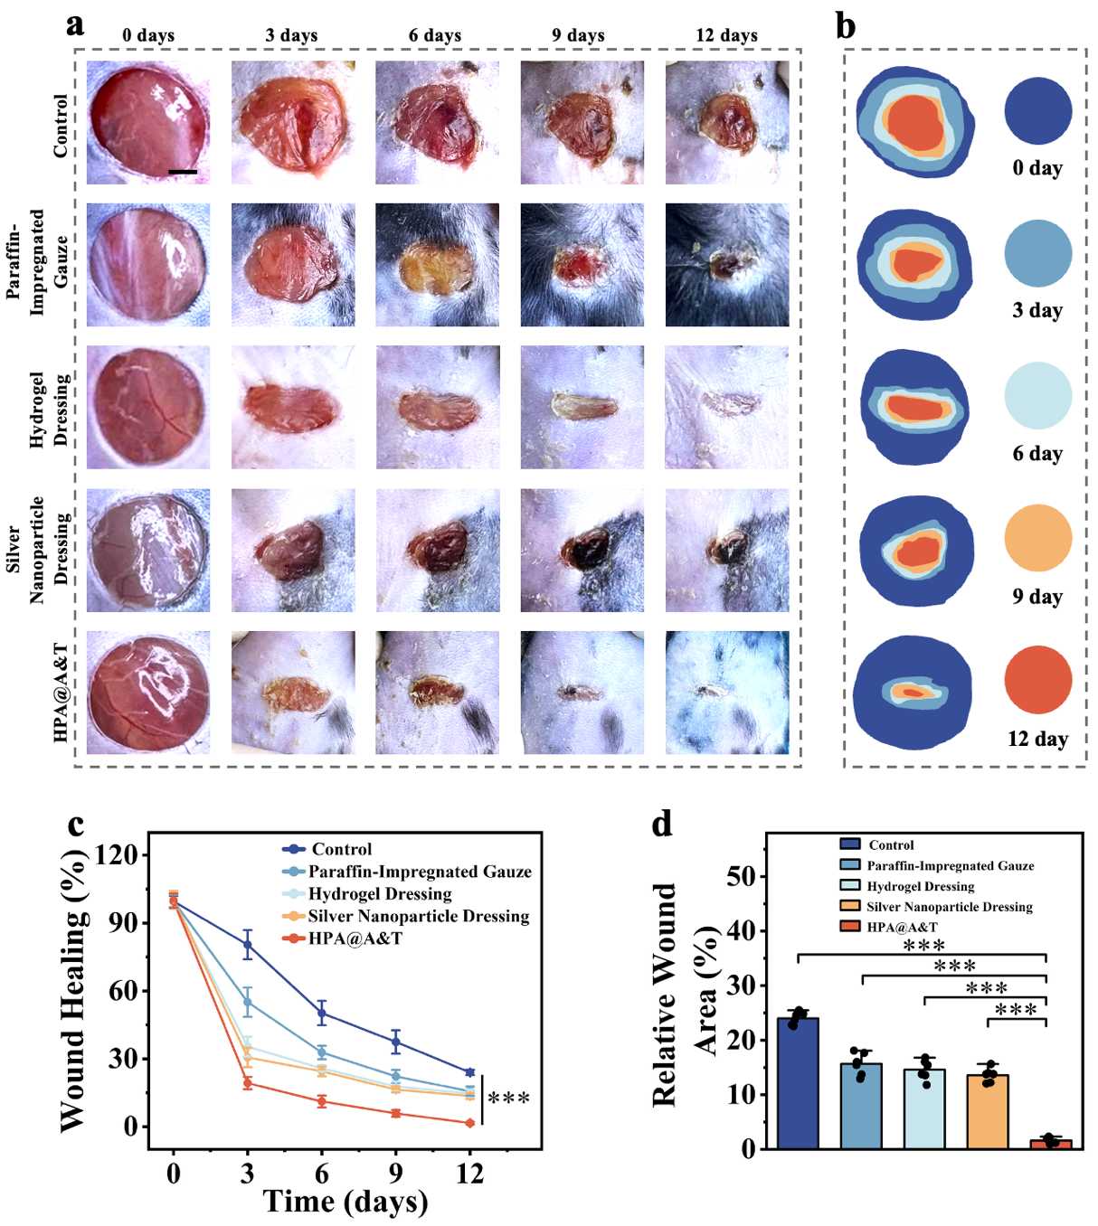
Fig. S29. In vivo experimental study of HPA@A&T hydrogels and clinically commonly used diabetic wound dressings. (a, b) Continuous healing process of diabetic wounds under different hydrogel treatments (scale bar: 2 mm). (c) Quantitative analysis of daily wound healing. (d) Quantitative analysis of the area of unhealed wounds on day 12. (n = 6, Statistical diﬀerences: *p<0.05, **p<0.01, ***p<0.001, and ns, not significant).

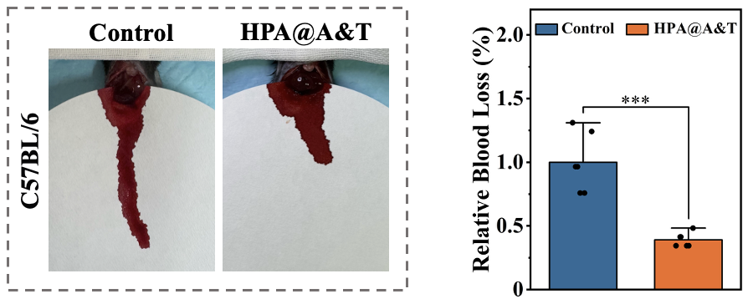
Fig. S30. Experimental and statistical analysis of hepatic haemostasis by hydrogel. (n = 6, Statistical diﬀerences: *p<0.05, **p<0.01, ***p<0.001, and ns, not significant).

Table S1. Primer sequences for real-time qRT-PCR analysis of the mRNA expression.
Gene | Primers (5′-3′)
ATF 6 | F: AGCAGCACCCAAGACTCAAAC | R: GCATAAGCGTTGGTACTGTCTGA
PERK | F: ACGATGAGACAGAGTTGCGAC | R: ATCCAAGGCAGCAATTCTCCC
ATF 4 | F: ATGACCGAAATGAGCTTCCTG | R: GCTGGAGAACCCATGAGGT
CHOP | F: GGAAACAGAGTGGTCATTCCC | R: CTGCTTGAGCCGTTCATTCTC
DsbA-L | F: GGAAACAGAGTGGTCATTCCC | R: CTGCTTGAGCCGTTCATTCTC
Ero 1α | F: GGCTGGGGATTCTTGTTTGG | R: AGTAACCACTAACCTGGCAGA
EDEM 1 | F: CGGACGAGTACGAGAAGCG | R: CGTAGCCAAAGACGAACATGC
EDEM 3 | F: CGAGCCCATGAGTAGGGAG | R: AAAGGCATGAGTTCATCAGCA
H-β-actin | F: AGAGCTACGAGCTGCCTGAC | R: AGCACTGTGTTGGCGTACAG
IL-6 | F: TAGTCCTTCCTACCCCAATTTCC | R: TTGGTCCTTAGCCACTCCTTC
TNF-α | F: CCCTCACACTCAGATCATCTTCT | R: GCTACGACGTGGGCTACAG
IL-10 | F: GCTCTTACTACTGGCATGAG | R: CGCAGCTCTAGGAGCATGTG
TGF-β1 | F: CTCCCGTGGCTTCTAGTGC | R: GCCTTAGTTTGGACAGGATCTG
Mus- GAPDH | F: GGTGAAGGTCGGTGTGAACG | R: CTCGCTCCTGGAAGATGGTG
F: forward; R: reverse.

