Supporting Information

A “Sticky Missile”-like Bioactive Polyphenol-Armored Probiotic for Targeted Immunomodulation and Microbiome Remodeling in Inflammatory Bowel Disease and Its Complication
Ning Zhang,¹ Chunxiu Cai,¹ Gen Li,² Xiangyu Zhang,¹ Meng Cui,³ Chuangxin Zhao,¹ Hailiang Zhu^{4,} * Shenzhen Ren^{1,} * Hailong An,^{1, 2,} *

¹ Key Laboratory of Molecular Biophysics of Hebei Province, Institute of Biophysics, Innovation and Research Institute of Hebei University of Technology in Shijiazhuang, School of Health Sciences and Biomedical Engineering, Hebei University of Technology, Tianjin 300401, P. R. China
² State Key Laboratory of Reliability and Intelligence of Electrical Equipment, School of Electrical Engineering, Hebei University of Technology, Tianjin 300401, P. R. China
³ Institute of Chemical Engineering, Hebei University of Technology, Tianjin 300130, P. R. China
⁴ State Key Laboratory of Pharmaceutical Biotechnology, School of Life Sciences, Nanjing University, Nanjing 210023, P. R. China
*Corresponding authors. Shenzhen Ren, E-mail: rensz@hebut.edu.cn; Hailong An, E-mail: hailong_an@hebut.edu.cn; Hailiang Zhu, E-mail: zhuhl@nju.edu.cn

Fig. S1. GO enrichment analysis of the biological process (BP), cellular component (CC), and molecular function (MF) of DEGs.

Fig. S2. (A) Structure of LSA. (B) Representative immunofluorescence images and Weatern Blot analysis of P2X7 protein levels in control and transient transfected HEK-293T cells.
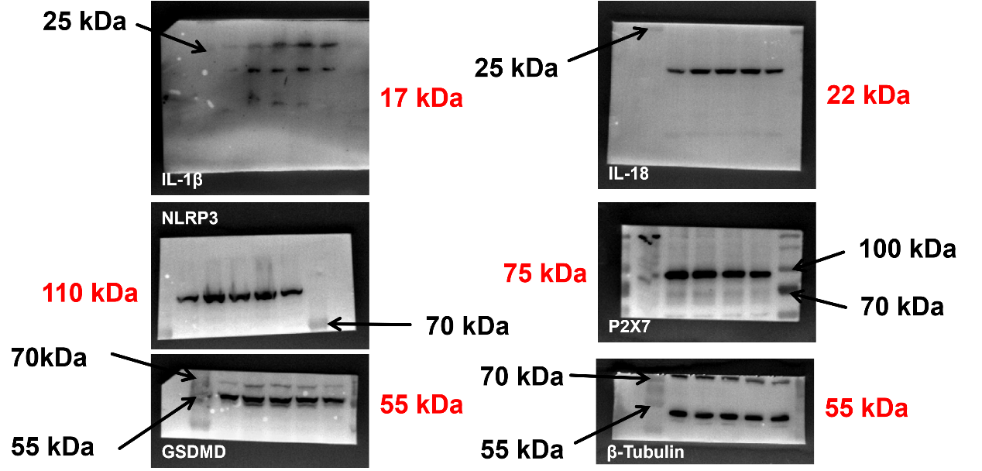
Fig. S3. Raw images for western blots included in Fig. 1M.

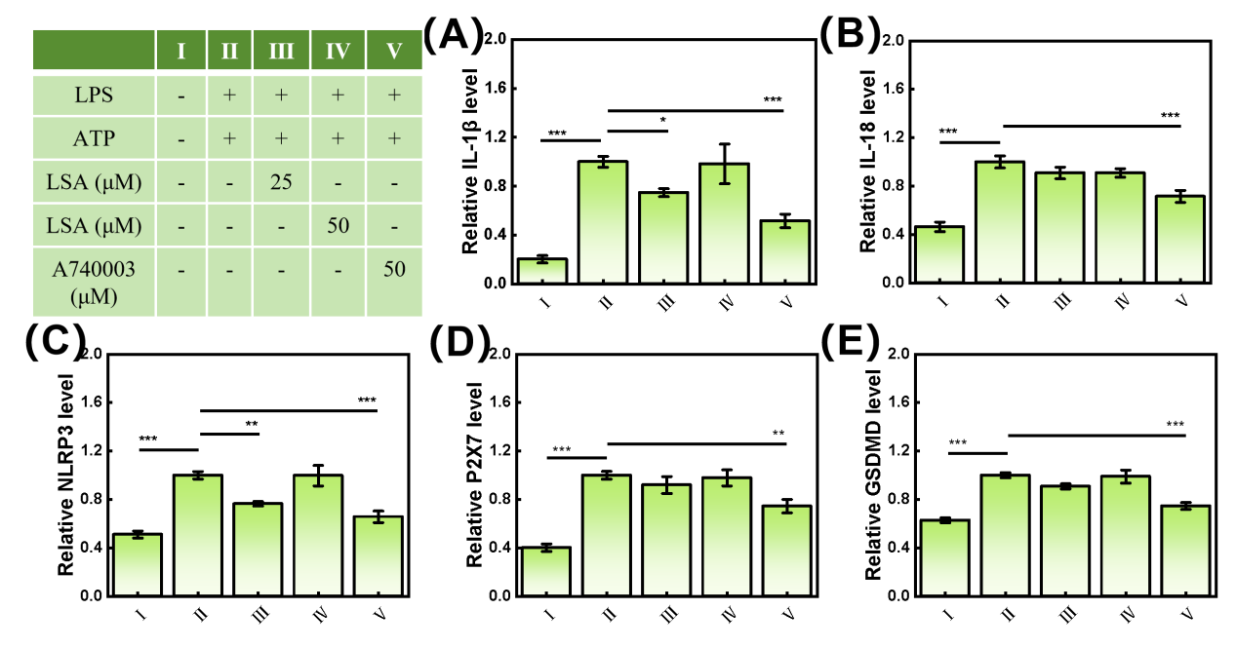
Fig. S4. Western blotting corresponding quantification analyses of (A) IL-1β, (B) IL-18, (C) NLRP3, (D) P2X7 and (E) GSDMD protein levels in RAW 264.7 after various treatments. Data are presented as mean ± S.D (n=3). P values were analyzed by one-way ANOVA analysis followed by Tukey’s post-test (*P < 0.05, **P < 0.01, ***P < 0.001).

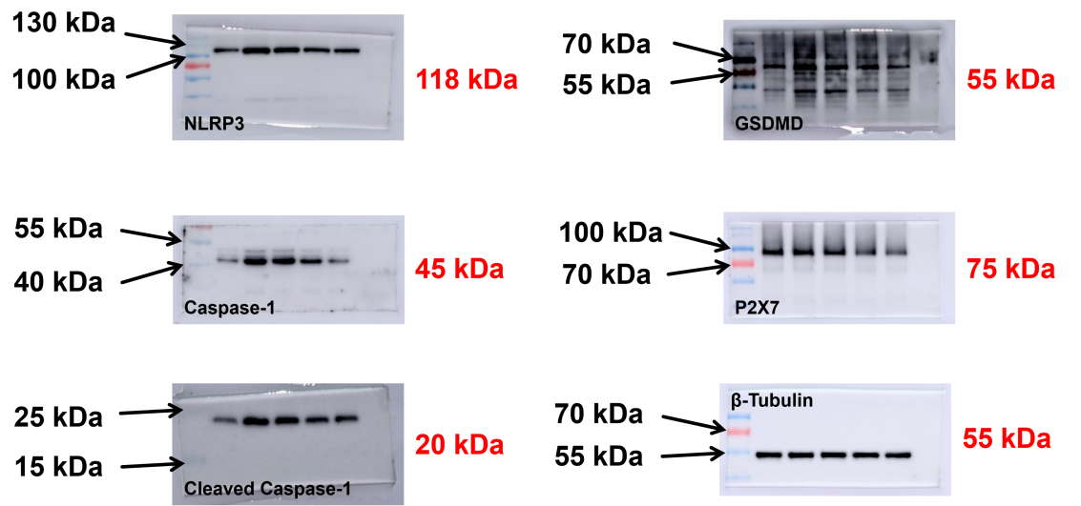
Fig. S5. Raw images for western blots included in Fig. 2I.

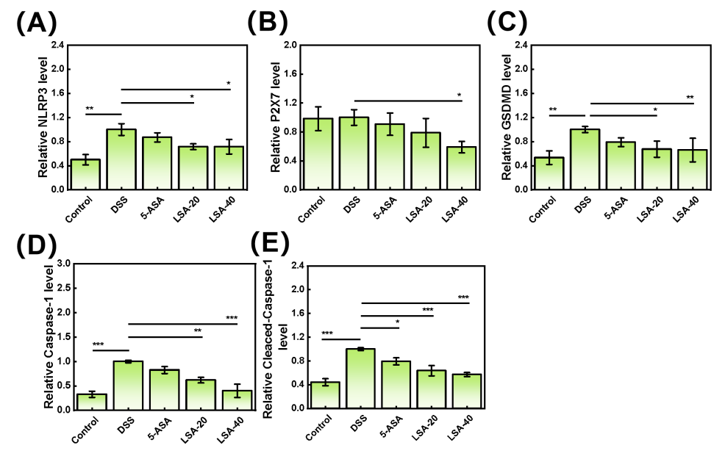
Fig. S6. Western blotting corresponding quantification analyses of (A) NLRP3, (B) P2X7, (C) GSDMD, (D) Caspase-1 and (E) Cleaved Caspase-1 protein levels in colon tissue after various treatments. Data are presented as mean ± S.D (n=3). P values were analyzed by one-way ANOVA analysis followed by Tukey’s post-test (*P < 0.05, **P < 0.01, ***P < 0.001).

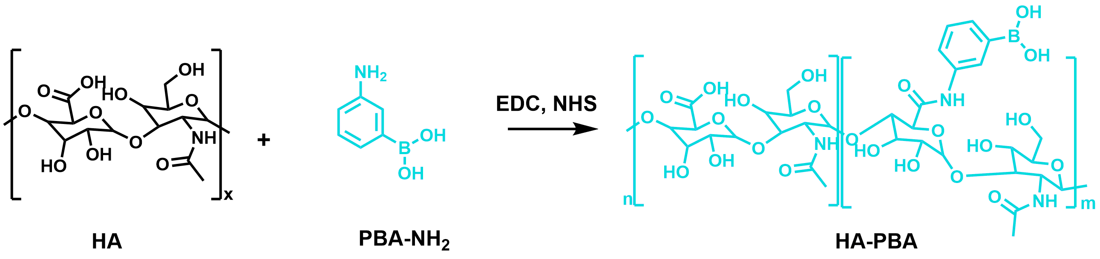
Fig. S7. Synthesis process of HA-PBA.

Fig. S8. ¹H-NMR spectrum of HA-PBA in D₂O.

Fig. S9. (A) UV−vis spectroscopy and (B) standard curve of LSA in water with different concentrations.
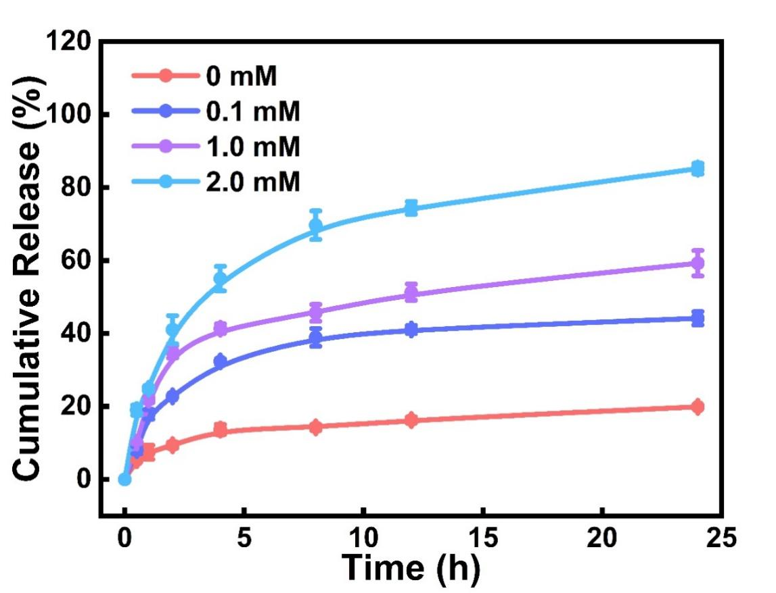
Fig. S10. Release profiles of LSA from EcN@LHP under different concentrations of H₂O₂ (n=3).

Fig. S11. CLSM images of EcN and EcN@LHP were labeled with Cy5.
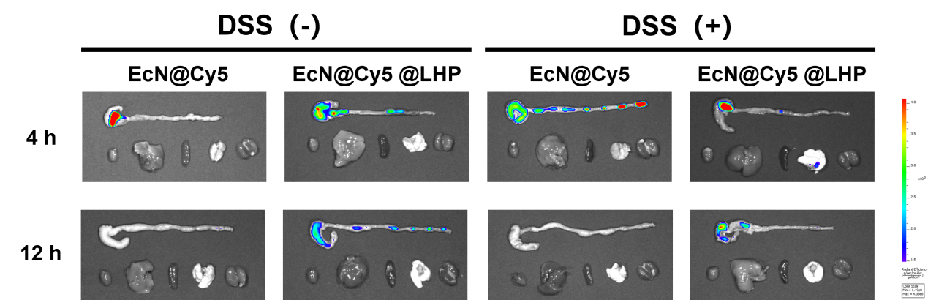
Fig. S12. Fluorescence images of ex vivo intestines at 4 h and 12h.

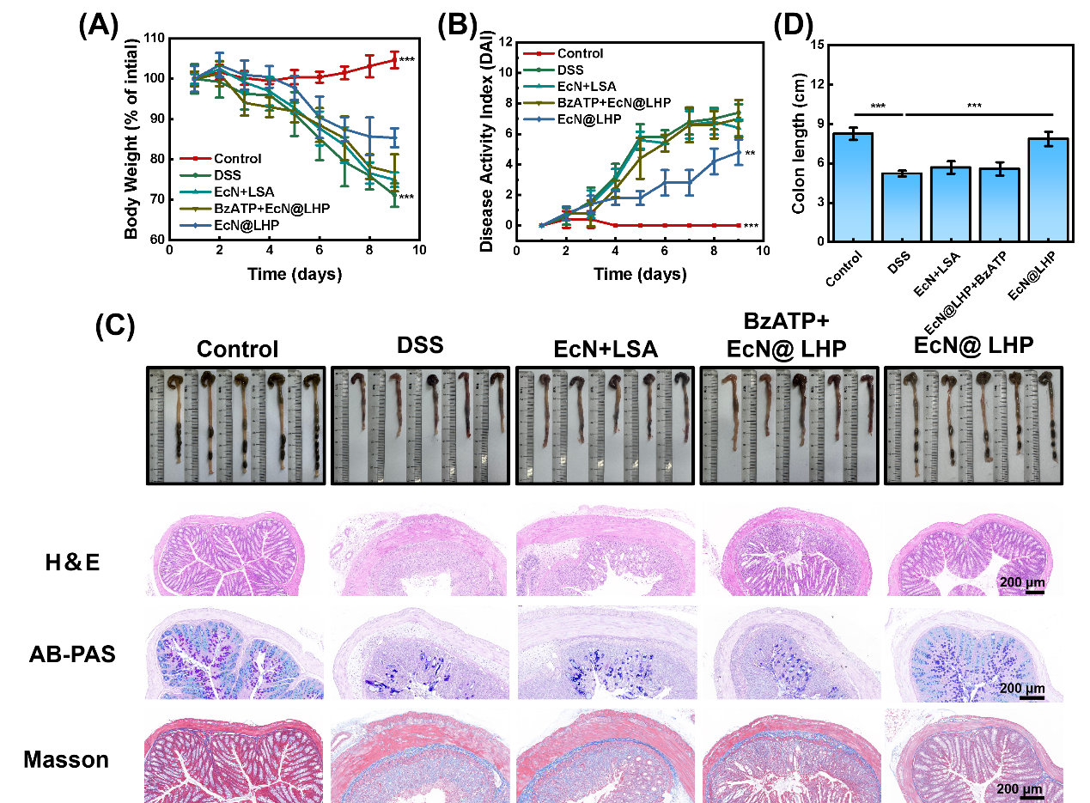
Fig. S13. (A) The body weight and (B) DAI of the experimental mice. (C) Photographs and (D) quantitative lengths of mouse colons subjected to various treatment regimens. Representative images of H&E, AB-PAS and Masson staining of colon. Data in A, B and D are presented as mean ± S.D (n=5). Statistical significance was determined using two-way ANOVA with (A, B) with Tukey’s post-test (*P < 0.05, **P < 0.01, ***P < 0.001). Statistical significance was determined using one-way ANOVA with (D) with Tukey’s post-test (*P < 0.05, **P < 0.01, ***P < 0.001).

Fig. S14. Semiquantitative analysis of ZO-1 and Occludin positive areas/tissue regions in the acute colitis. Data are presented as mean ± S.D (n=5). P values were analyzed by one-way ANOVA analysis followed by Tukey’s post-test (*P < 0.05, **P < 0.01, ***P < 0.001).
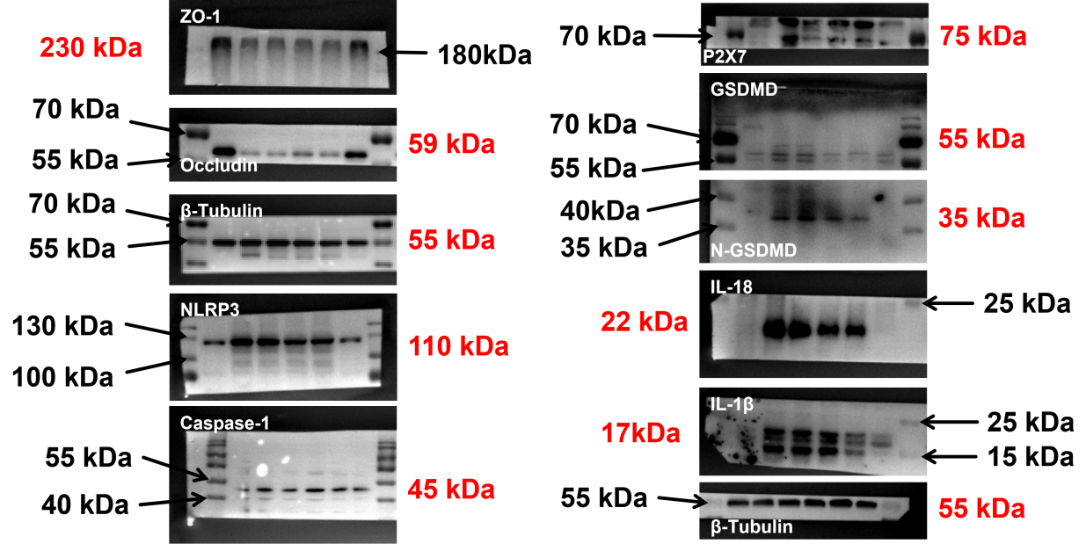
Fig. S15. Raw images for western blots included in Fig. 5G.

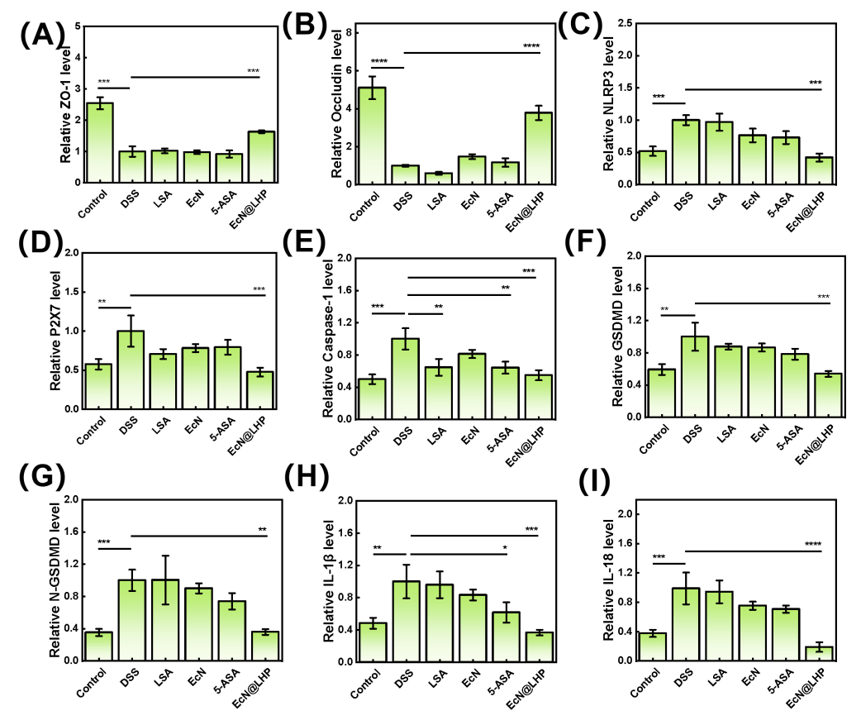
Fig. S16. Western blotting corresponding quantification analyses of (A) ZO-1, (B) Occludin, (C) NLRP3, (D) P2X7, (E) Caspase-1, (F) GSDMD, (G) N-GSDMD, (H) IL-1β and (I) IL-18 protein levels in colon tissue after various treatments. Data are presented as mean ± S.D (n=3). P values were analyzed by one-way ANOVA analysis followed by Tukey’s post-test (*P < 0.05, **P < 0.01, ***P < 0.001).

Fig. S17. The levels of IL-6 and IL-10 in colonic tissues were isolated from various treatment with acute colitis. Data are presented as mean ± S.D (n=5). P values were analyzed by one-way ANOVA analysis followed by Tukey’s post-test (*P < 0.05, **P < 0.01, ***P < 0.001).

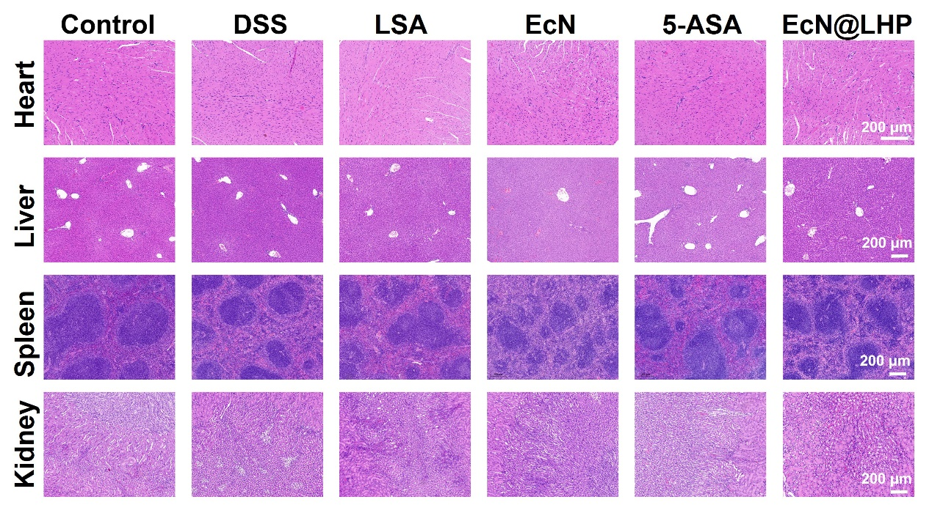
Fig. S18. H&E images of liver, spleen, kidney and heart after treatment with acute colitis.

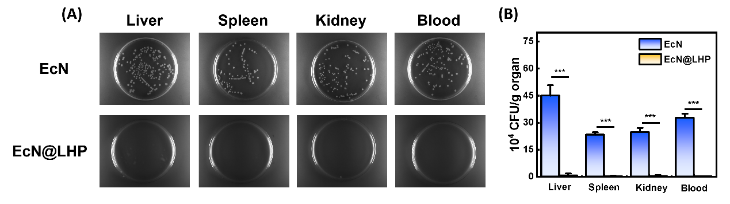
Fig. S19. (A) Photographs of agar plates and (B) Survivals of the EcN in mouse liver, spleen, kidney, and blood after treatment with EcN and EcN@LHP. P values were analyzed by one-way ANOVA analysis followed by Tukey’s post-test (*P < 0.05, **P < 0.01, ***P < 0.001).

Fig. S20. (A) RDW, (B) RBC, (C) PLT, (D)HCT, (E) WBC, (F) MCV, (G) MCHC (H) HGB (I) MCH (J) PDW (K) MPV and (L) PCT levels of mice in acute colitis (n=3).

Fig. S21. (A) alkaline phosphatase (ALP), (C) alanine aminotransferase (ALT), (E) aspartate aminotransferase (AST) and (F) lactate dehydrogenase (LDH) levels reflect the liver function of the mice, while the (B) Urea (UR) and (D) creatinine (CR) levels reflect the kidney function of the mice (n=3).

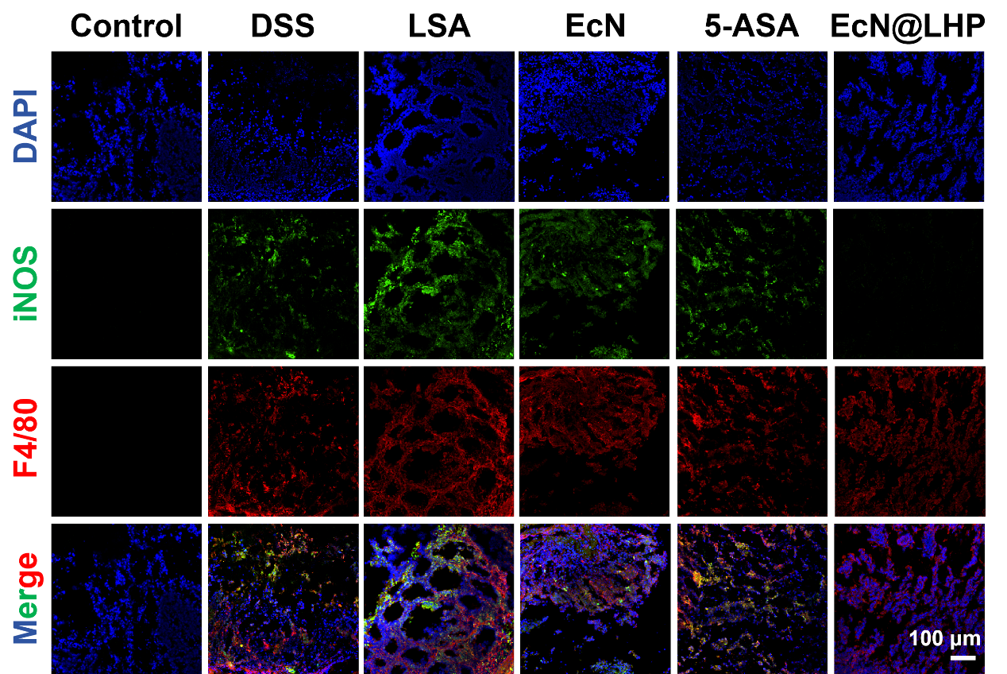
Fig. S22. Immunofluorescence analysis images of iNOS (M1 marker) and F4/80 (macrophages marker) in the acute colitis.
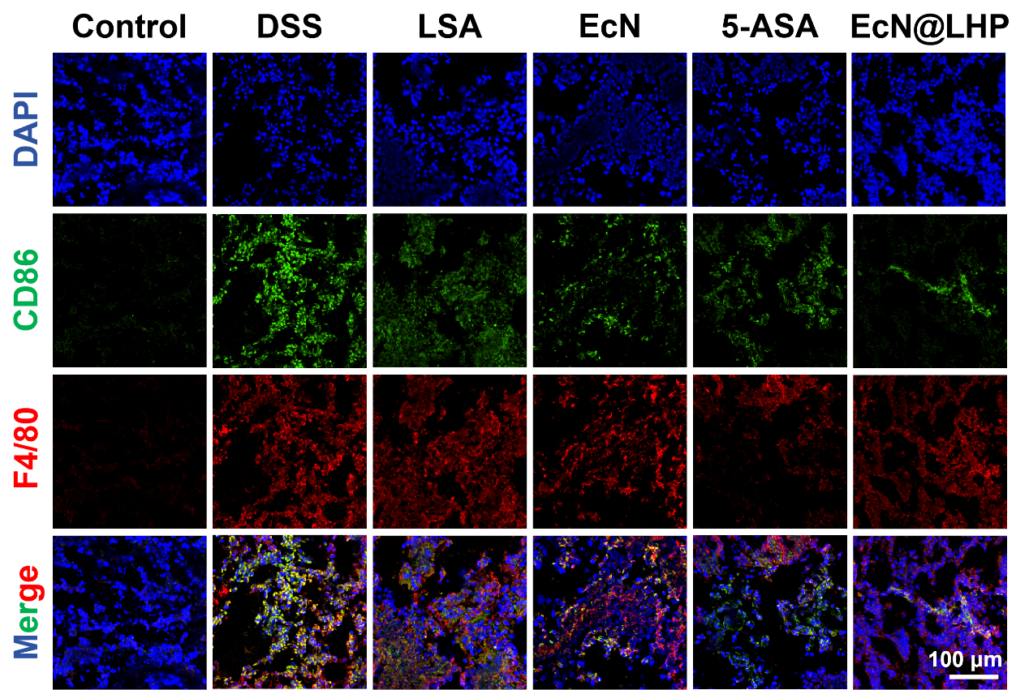
Fig. S23. Immunofluorescence analysis images of CD86 (M1 marker) and F4/80 (macrophages marker) in the acute colitis.

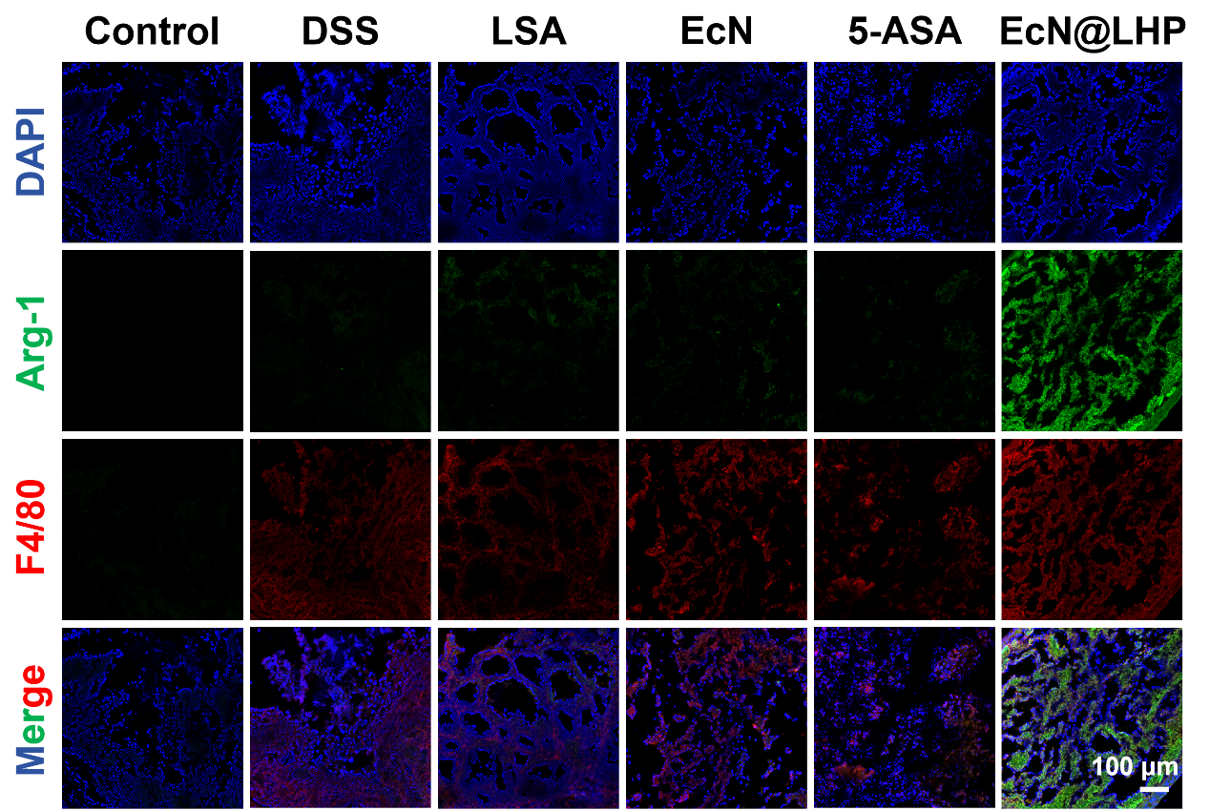
Fig. S24. Immunofluorescence analysis images of Arg-1 (M2 marker) and F4/80 (macrophages marker) in the acute colitis.

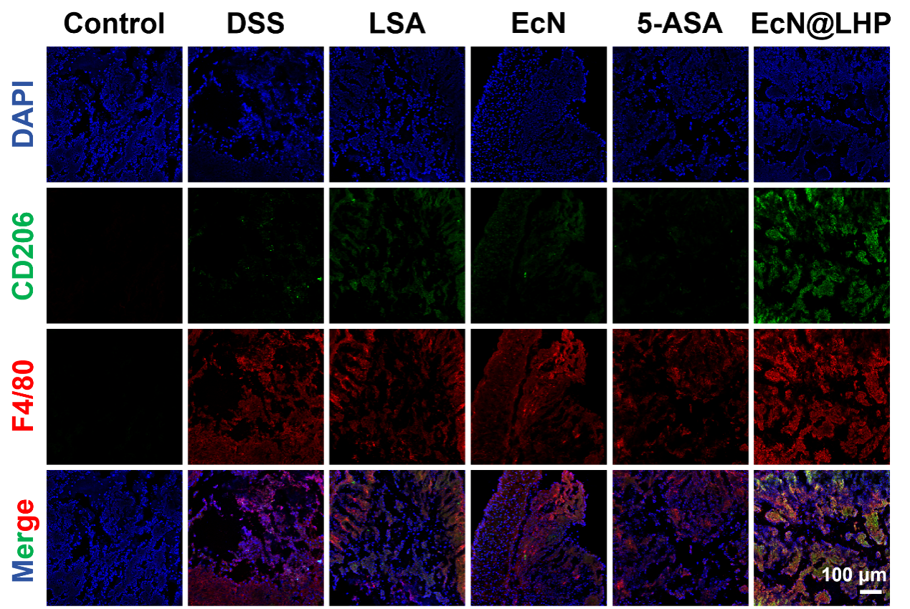
Fig. S25. Immunofluorescence analysis images of CD206 (M2 marker) and F4/80 (macrophages marker) in the acute colitis.

Fig. S26. (A) Quantitative analysis of the M1 cells and M2 cells in the acute colitis. (B) Quantitative analysis of the Th17 cells and Treg cells in the acute colitis. Data are presented as mean ± S.D (n=3). P values were analyzed by one-way ANOVA analysis followed by Tukey’s post-test (*P < 0.05, **P < 0.01, ***P < 0.001).

Fig. S27. (A) GO enrichment analysis of the DEGs between Control and DSS group in the acute colitis. (B) KEGG pathway enrichment map between Control and DSS group in the acute colitis.

Fig. S28. Semiquantitative analysis of ZO-1 (A) and Occludin (B) positive areas/tissue regions in the chronic colitis. Data are presented as mean ± S.D (n=5). P values were analyzed by one-way ANOVA analysis followed by Tukey’s post-test (*P < 0.05, **P < 0.01, ***P < 0.001).

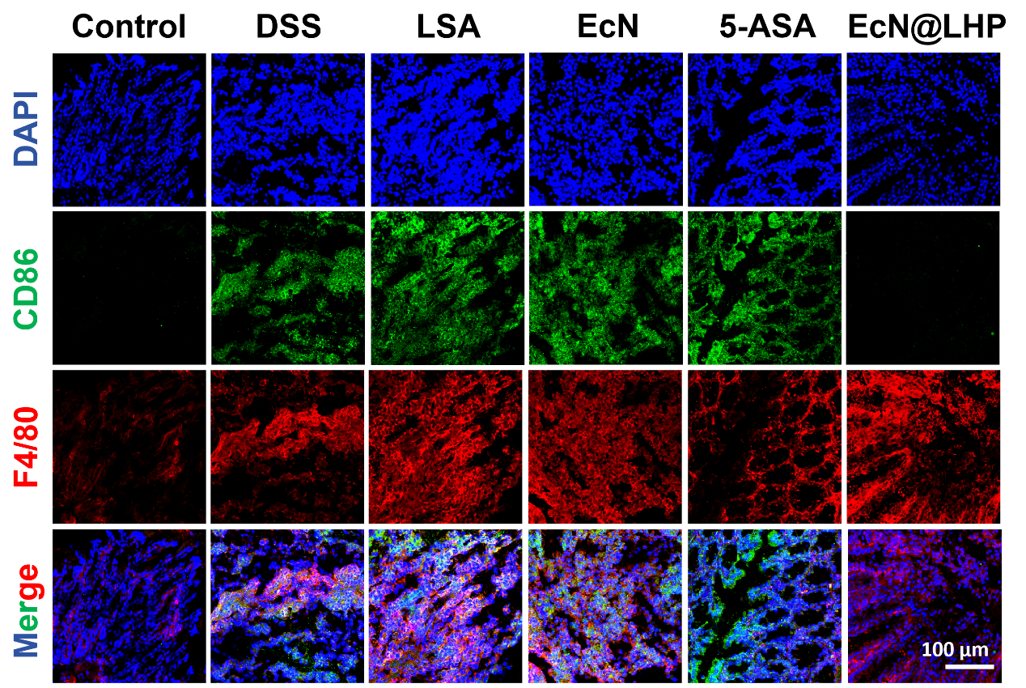
Fig. S29. Immunofluorescence analysis images of CD86 (M1 marker) and F4/80 (macrophages marker) in the chronic colitis.

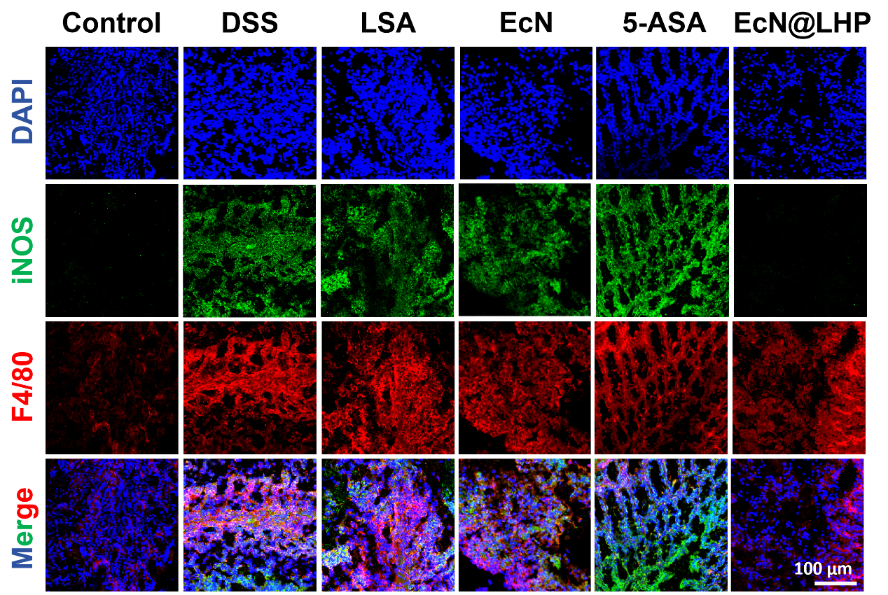
Fig. S30. Immunofluorescence analysis images of iNOS (M1 marker) and F4/80 (macrophages marker) in the chronic colitis.
Fig. S31. Immunofluorescence analysis images of Arg-1 (M2 marker) and F4/80 (macrophages marker) in the chronic colitis.

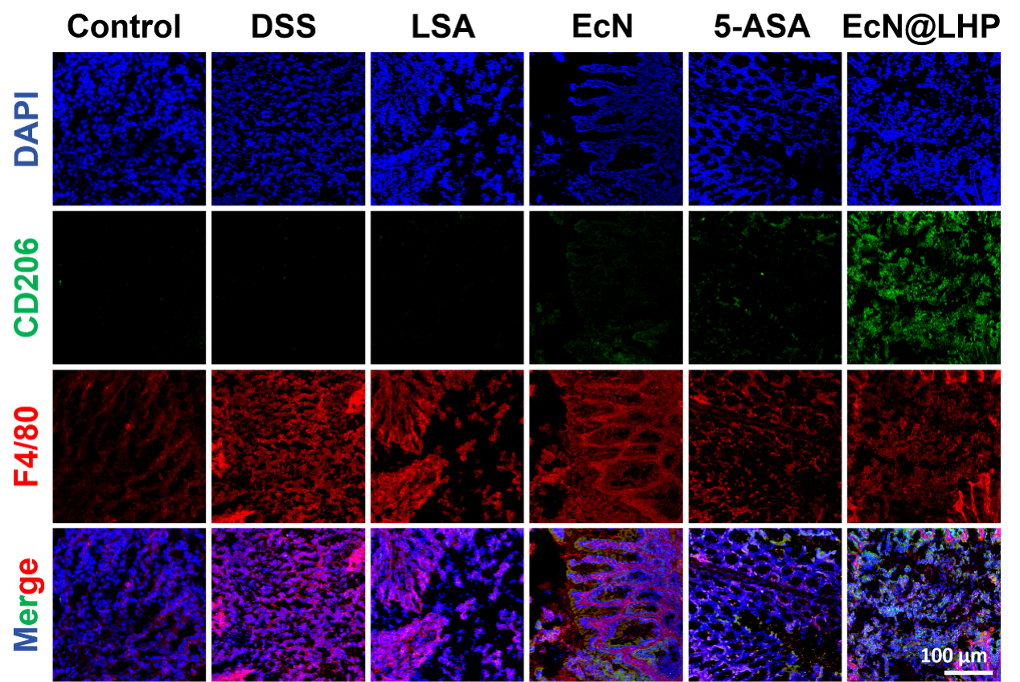
Fig. S32. Immunofluorescence analysis images of CD206 (M2 marker) and F4/80 (macrophages marker) in the chronic colitis.
Fig. S33. Semiquantitative analysis of CD86 and iNOS (A), CD206 and Arg-1 (B) positive areas/tissue regions in the chronic colitis. Data are presented as mean ± S.D (n=5). P values were analyzed by one-way ANOVA analysis followed by Tukey’s post-test (*P < 0.05, **P < 0.01, ***P < 0.001).

Fig. S34. Semiquantitative analysis of Treg (A) and Th17 (B) positive areas/tissue regions in the chronic colitis. Data are presented as mean ± S.D (n=5). P values were analyzed by one-way ANOVA analysis followed by Tukey’s post-test (*P < 0.05, **P < 0.01, ***P < 0.001).

Fig. S35. The levels of IL-6 (A) and IL-10 (B) in colonic tissues were isolated from various treatment with chronic colitis. Data are presented as mean ± S.D (n=5). P values were analyzed by one-way ANOVA analysis followed by Tukey’s post-test (*P < 0.05, **P < 0.01, ***P < 0.001).

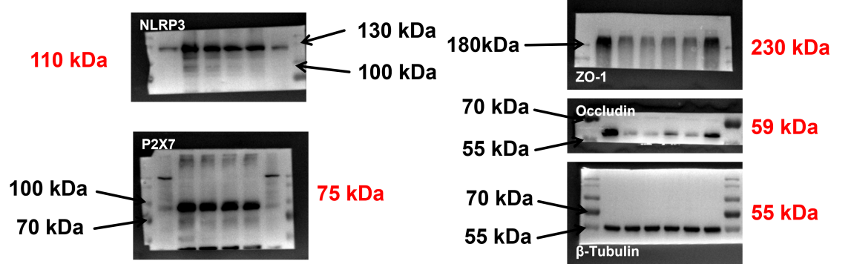
Fig. S36. Raw images for western blots included in Fig. 9G.
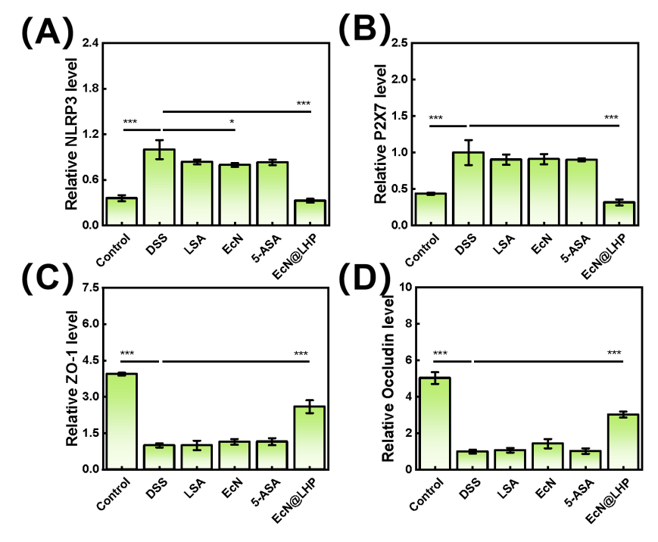
Fig. S37. Western blotting corresponding quantification analyses of (A) NLRP3, (B) P2X7, (C) ZO-1 and (D) Occludin protein levels in colon tissue after various treatments. Data are presented as mean ± S.D (n=3). P values were analyzed by one-way ANOVA analysis followed by Tukey’s post-test (*P < 0.05, **P < 0.01, ***P < 0.001).

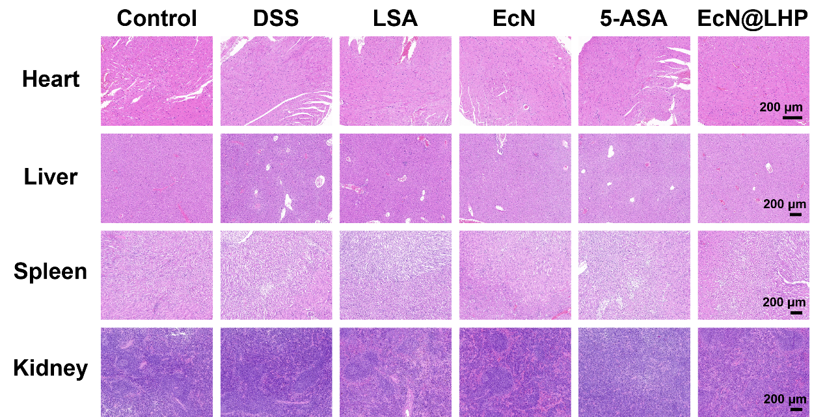
Fig. S38. H&E images of liver, spleen, kindey and heart after treatment with chronic colitis.
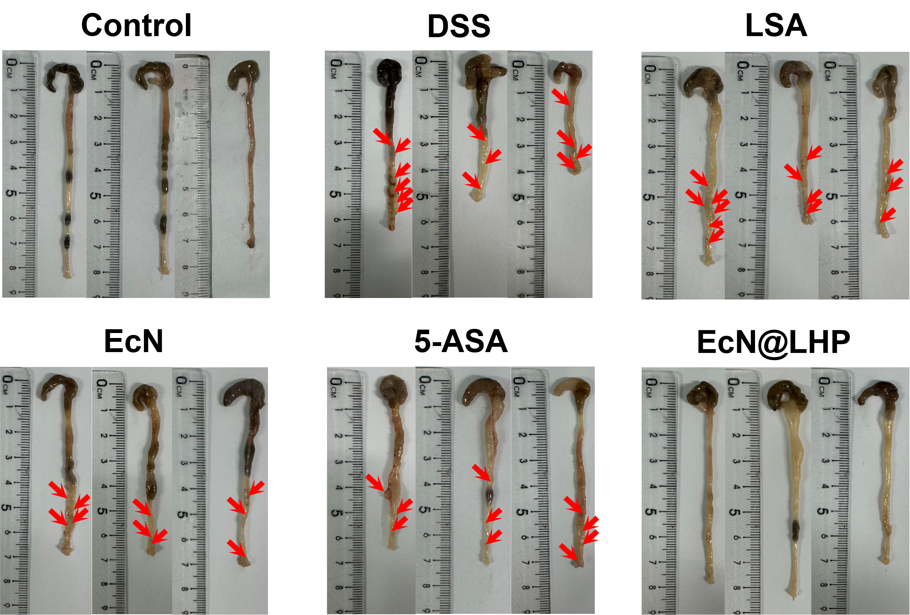
Fig. S39. Photographs of mouse colons after different treatments with CAC.

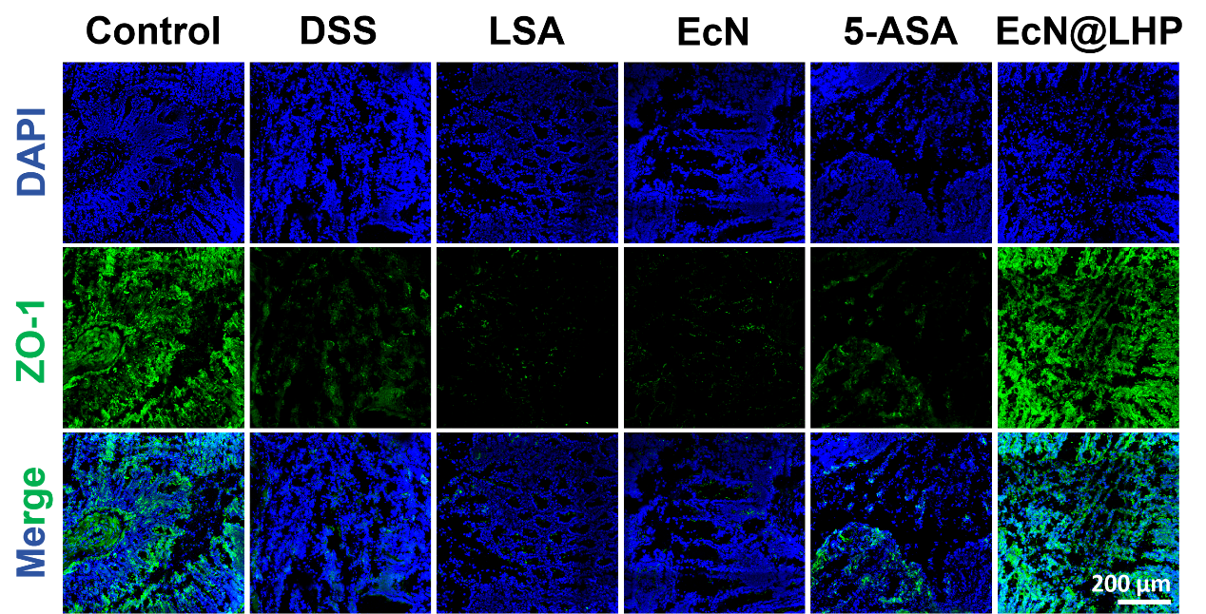
Fig. S40. Immunofluorescence staining of colon sections to visualize the expression patterns of ZO-1 in the CAC.

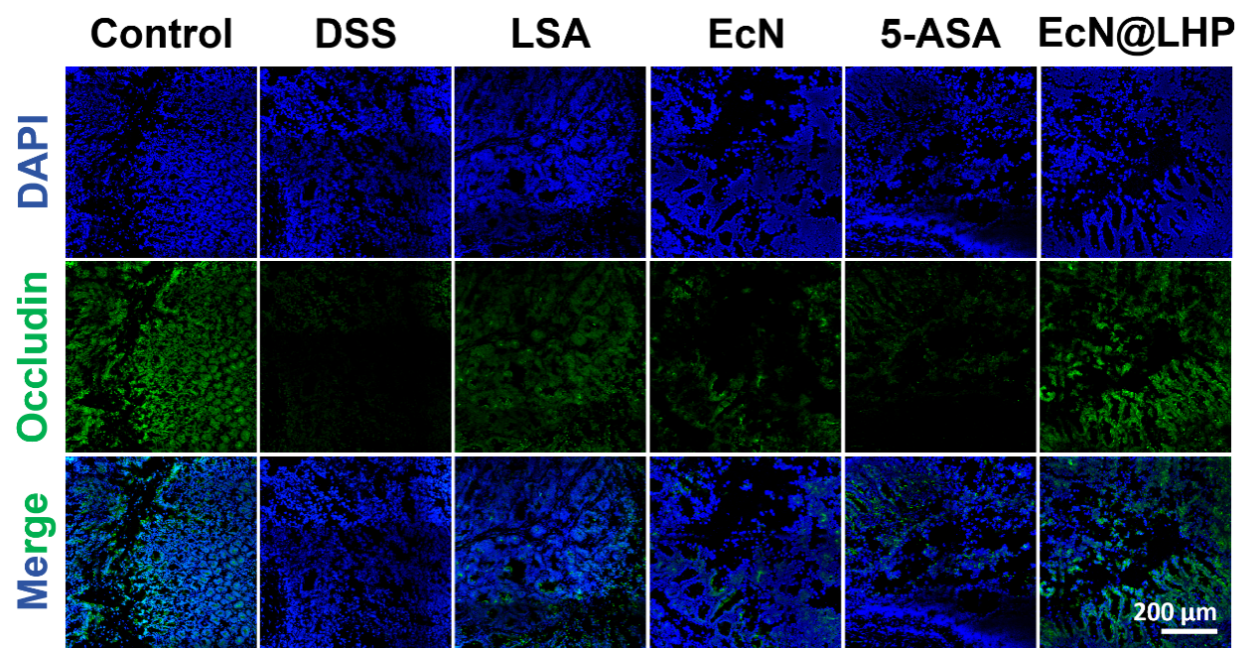
Fig. S41. Immunofluorescence staining of colon sections to visualize the expression patterns of Occludin in the CAC.

Fig. S42. Semiquantitative analysis of ZO-1 (A) and Occludin (B) positive areas/tissue regions in CAC. Data are presented as mean ± S.D (n=5). P values were analyzed by one-way ANOVA analysis followed by Tukey’s post-test (*P < 0.05, **P < 0.01, ***P < 0.001).

Fig. S43. The levels of TNF-α (A), IL-6 (B) and IL-10 (C) in colonic tissues were isolated from various treatment with CAC. Data are presented as mean ± S.D (n=5). P values were analyzed by one-way ANOVA analysis followed by Tukey’s post-test (*P < 0.05, **P < 0.01, ***P < 0.001).

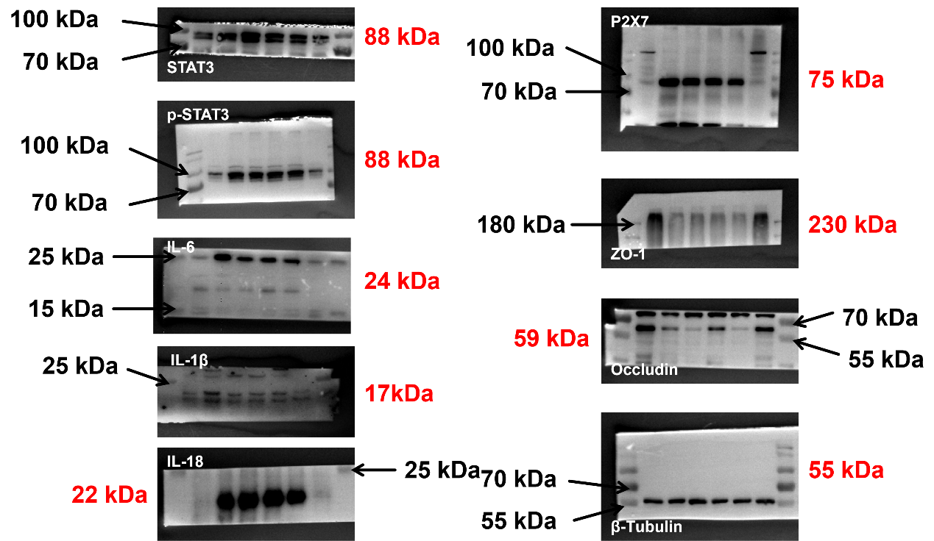
Fig. S44. Raw images for western blots included in Fig. 10I.
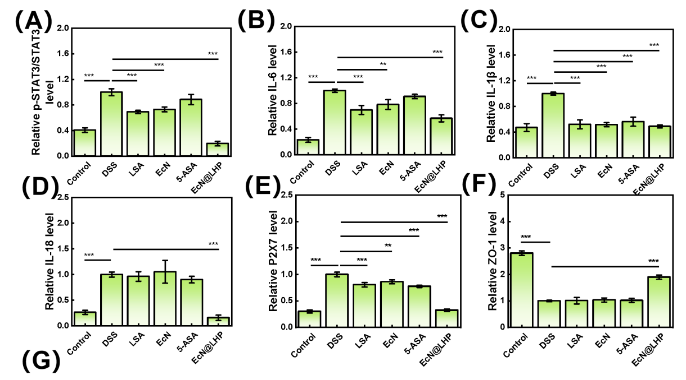
Fig. S45. Western blotting corresponding quantification analyses of (A) p-STAT3/STAT3, (B) IL-6, (C) IL-1β, (D) IL-18, (E) P2X7, (F) ZO-1 and (G) Occludin protein levels in colon tissue after various treatments. Data are presented as mean ± S.D (n=3). P values were analyzed by one-way ANOVA analysis followed by Tukey’s post-test (*P < 0.05, **P < 0.01, ***P < 0.001).

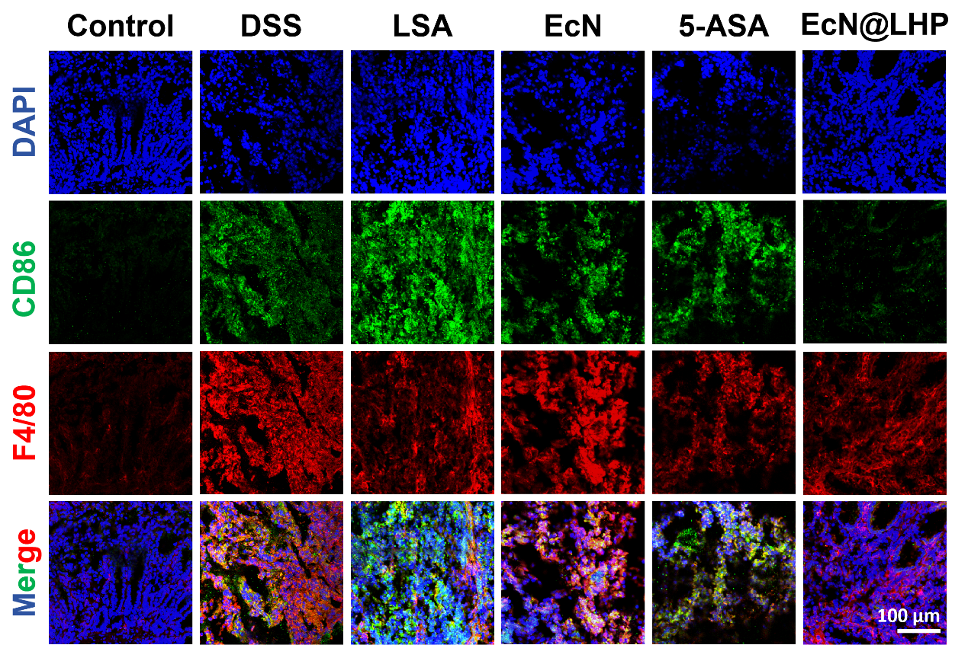
Fig. S46. Immunofluorescence analysis images of CD86 (M1 marker) and F4/80 (macrophages marker) in CAC.

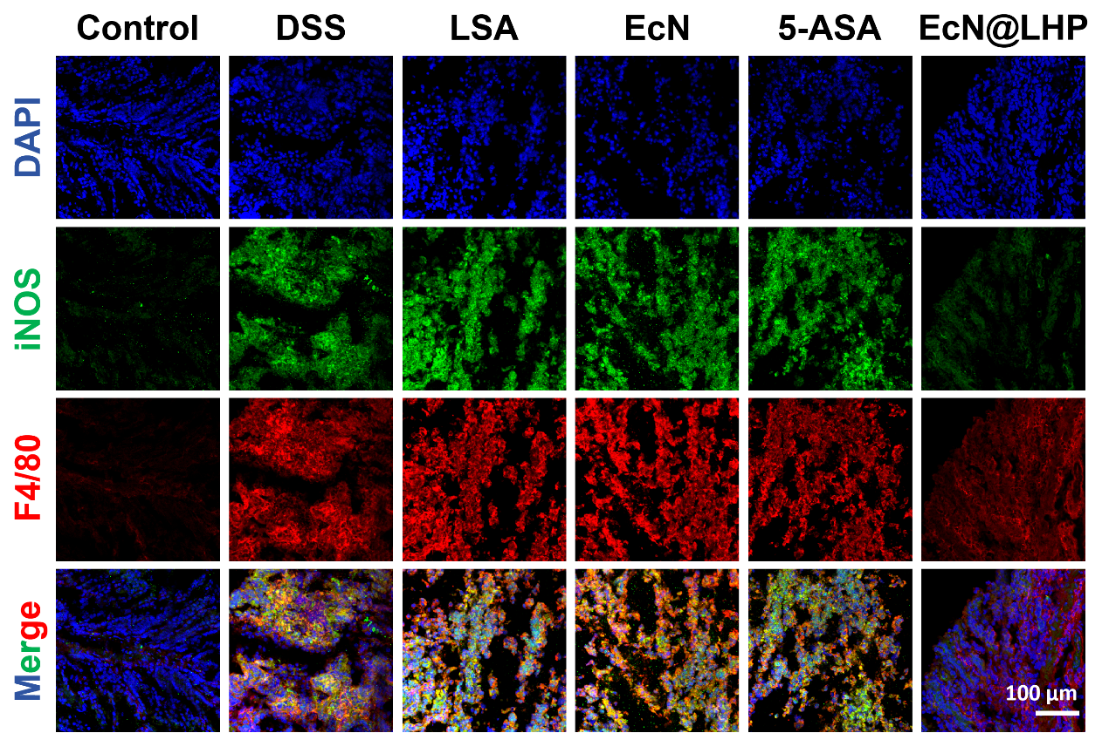
Fig. S47. Immunofluorescence analysis images of iNOS (M1 marker) and F4/80 (macrophages marker) in CAC.

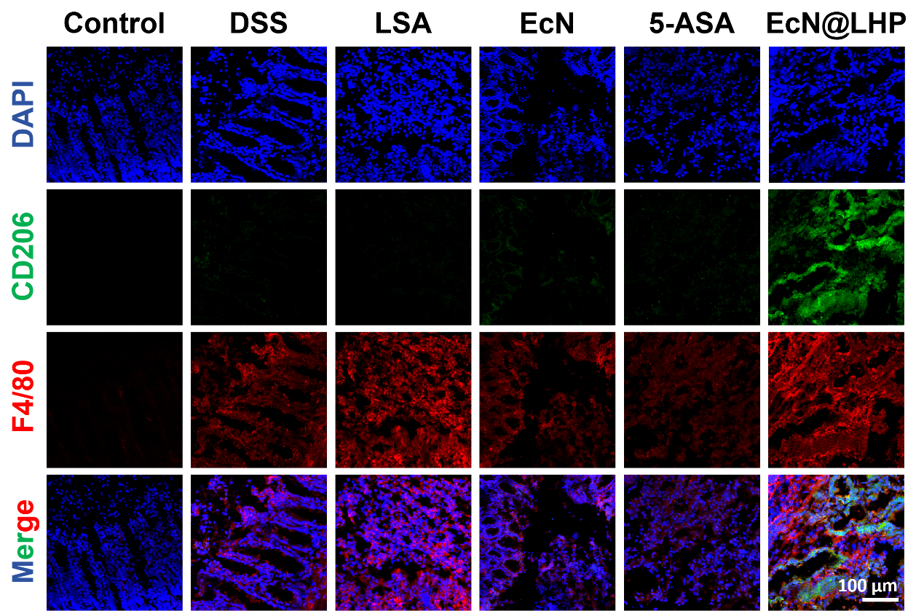
Fig. S48. Immunofluorescence analysis images of CD206 (M2 marker) and F4/80 (macrophages marker) in CAC.

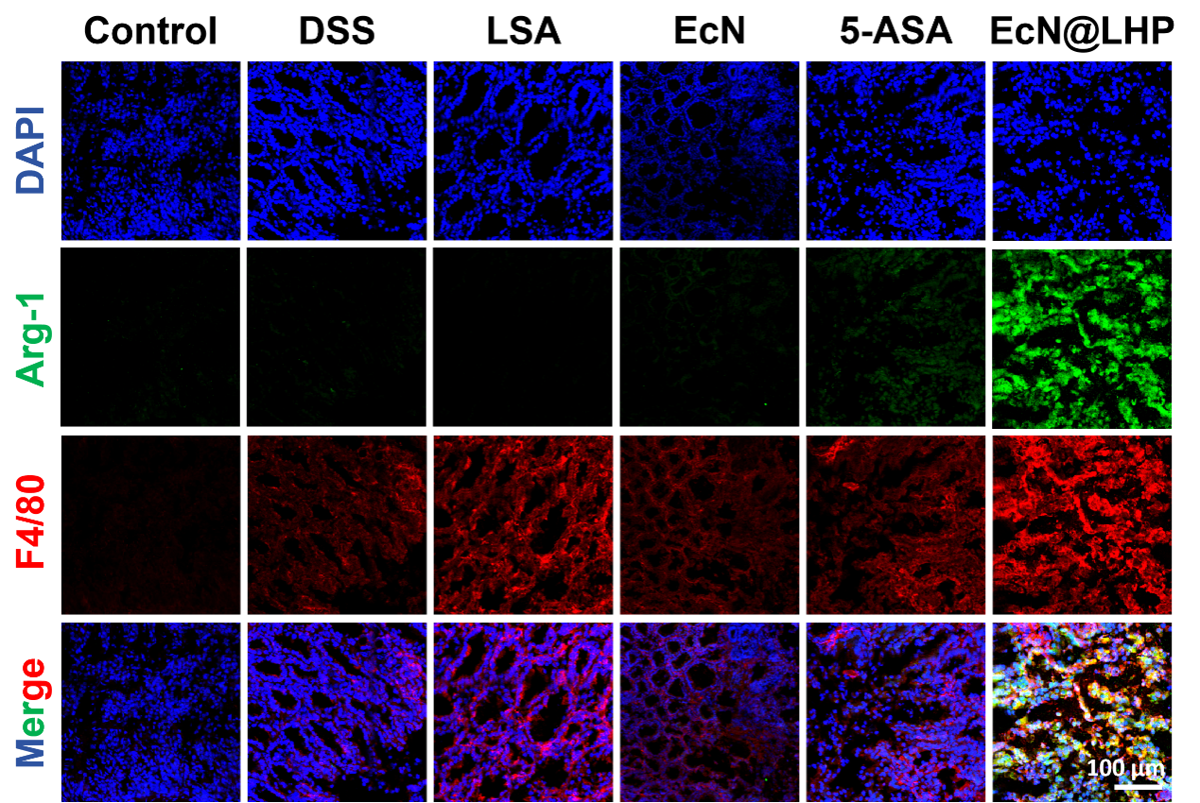
Fig. S49. Immunofluorescence analysis images of Arg-1 (M2 marker) and F4/80 (macrophages marker) in CAC.

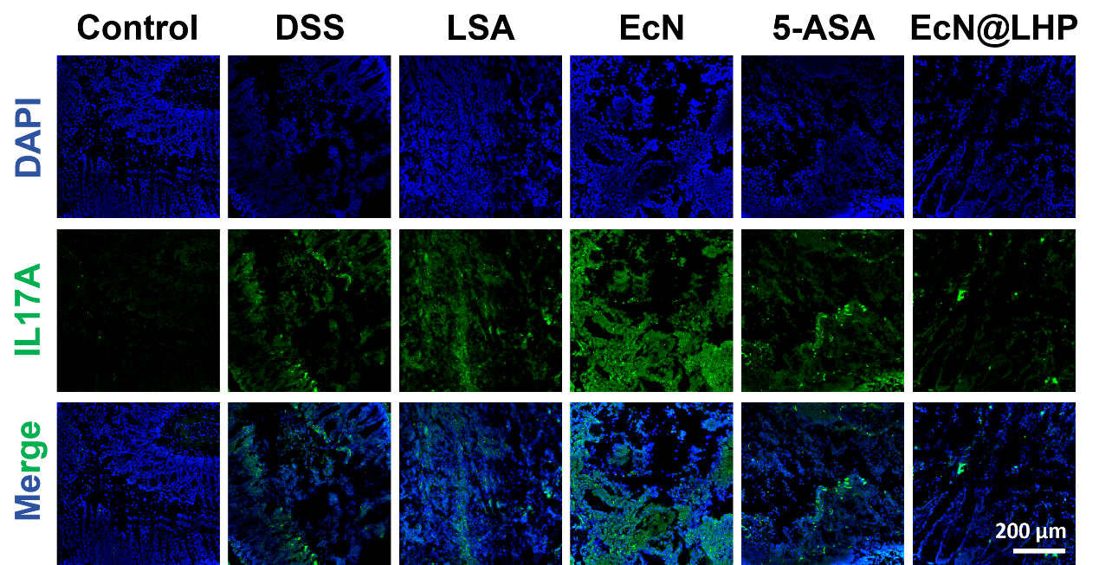
Fig. S50. Immunofluorescence analysis images of IL-17A (Th17 marker) in CAC.

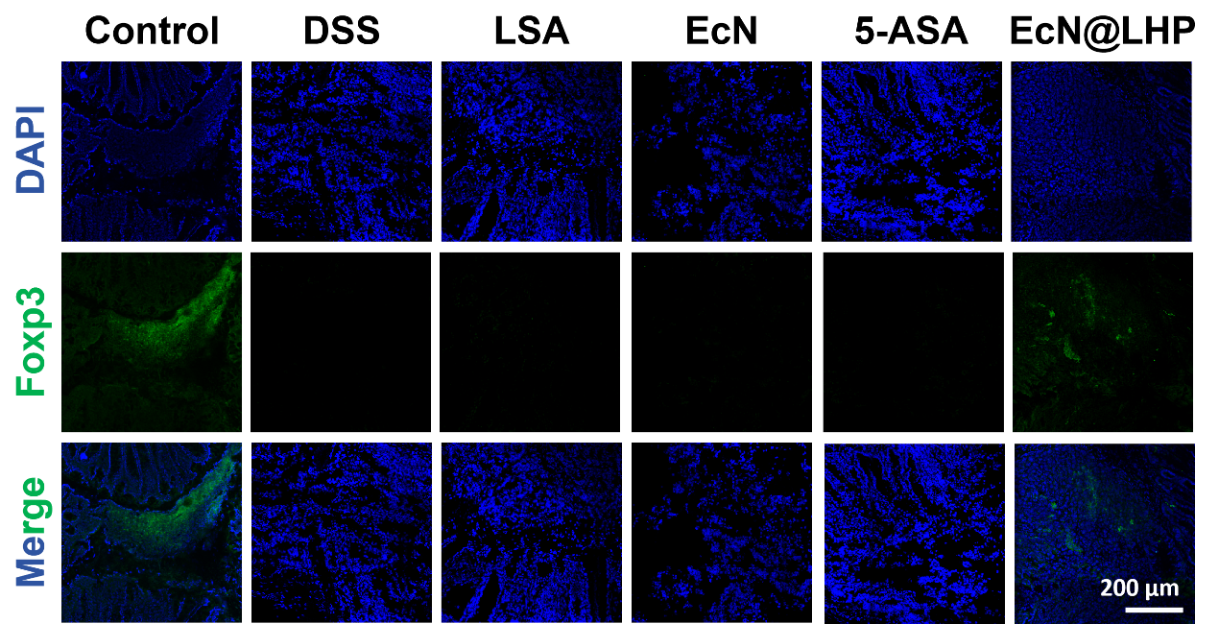
Fig. S51. Immunofluorescence analysis images of Foxp3 (Treg marker) in CAC.

Fig. S52. Semiquantitative analysis of CD86 (A), iNOS (B), Arg-1 (C), CD206 (D), Th17 (E) andTreg (F) positive areas/tissue regions in CAC. Data are presented as mean ± S.D (n=5). P values were analyzed by one-way ANOVA analysis followed by Tukey’s post-test (*P < 0.05, **P < 0.01, ***P < 0.001).

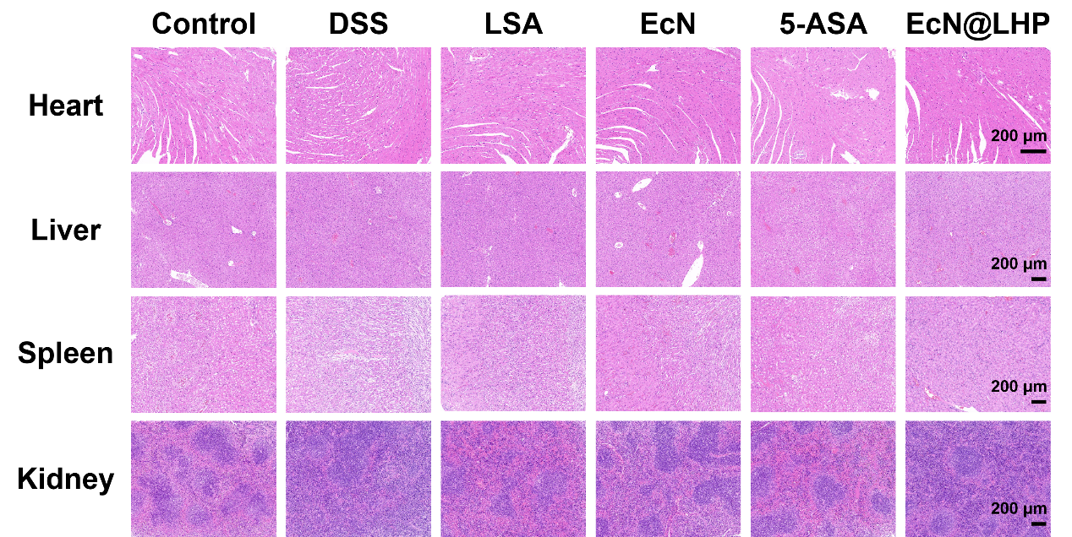
Fig. S53. H&E images of liver, spleen, kindey and heart after treatment with CAC.

